SUPPLEMENTAL DIGITAL CONTENT

Table S1: Study investigators and institutions.
Investigator Last, First name | Institution Name, City, Country | No. of Patients with  Follicular Lymphoma
Zelenetz, Andrew | Memorial Sloan Kettering Cancer Center  New York, USA | 10
Jurczak, Wojciech | 2Maria Sklodowska-Curie National Research Institute of Oncology  Krakow, Poland | 9
Ribrag, Vincent | Institut de Cancérologie Gustave Roussy  Villejuif, France | 9
Collins, Graham | GenesisCare Cancer and Radiotherapy Centre  Oxford, United Kingdom | 7
Linton, Kim | The Christie NHS Foundation Trust  Manchester, United Kingdom | 7
Lopez Jimenez, Javier | Hospital Universitario Ramon y Cajal  Madrid, Spain | 5
Bishton, Mark | Nottingham University Hospital  Nottingham, United Kingdom | 4
Dholaria, Bhagirathbhai | Vanderbilt University Ingram Cancer Center  Nashville, USA | 4
Mengarelli, Andrea | IRCCS Regina Elena National Cancer Institute  Roma, Italy | 4
Phillips, Tycel | University of Michigan Health System  Ann Arbor, USA | 4
Sungala, Nagendraprasad | Liverpool Hospital  Liverpool, United Kingdom | 4
Chan, Henry | Waitemata District Health Board North Shore  Auckland, New Zealand | 3
Lee, Jung-Hee | Asan Medical Center  Seoul, Republic of Korea | 3
Musuraca, Gerardo | Istituto Scientifico Romagnolo per lo Studio e la Cura dei Tumori I.R.S.T.  Meldola, Italy | 3
Sheehy, Oonagh | Belfast Health and Social Care Trust  Belfast, United Kingdom | 3
Van Den Neste, Eric | Cliniques Universitaires Saint-Luc  Brussels, Belgium | 3
Zinzani, Pier Luigi | IRCCS Azienda Ospedaliero-Universitaria di Bologna, and Istituto di Ematologia “Seràgnoli” Università di Bologna,  Bologna, Italy | 3
Alwan, Maan | Perth Blood Institute  West Perth, Australia | 2
Chen, Chien-Yuan | National Taiwan University Hospital  Taipei, Republic of China | 2
Delwail, Vincent | Centre Hospitalier Universitaire de Poitiers  Poitiers, France | 2
Eom, Ki-Seong | The Catholic University of Korea  Seoul, Republic of Korea | 2
Heintel, Daniel | Klinikum Ottakring  Vienna, Austria | 2
Lech-Maranda, Ewa | Instytut Hematologii i Transfuzjologii  Warsaw, Poland | 2
Mun, Yeung Chul | Ewha Womans University Mokdong Hospital  Seaoul, Republic of Korea | 2
Oh, Sung Yong | Dong-A University Hospital  Busa, Republic of Korea | 2
Pettitt, Andrew | Royal Liverpool University Hospital  Liverpool, United Kingdom | 2
Romejko-Jarosinska, Joanna | Narodowy Instytut Onkologii im. Marii Sklodowskiej-Curie - Panstwowy Instytut Badawczy  Warsaw, Poland | 2
Weber, Thomas | Department of Hematology and Oncology University Hospital Halle Saale  Halle, Germany | 2
Abrisqueta, Pau | Hospital Universitario Val d’Hebron  Barcelona, Spain | 1
Arcaini, Luca | Fondazione IRCCS Policlinico San Matteo  Pavia, Italy | 1
Arguinano-Perez, Jose Maria | Complejo Hospitalario de Navarra  Pamplona, Spain | 1
Chaudhry, Arvind | Medical Oncology Associates  Spokane, USA | 1
Chiu, Chang-Fang | China Medical University Hospital  Taichung City, Republic of China | 1
Crombie, Jennifer | Dana Farber Cancer Center  Boston, USA | 1
Czyz, Jaroslaw | Szpital Uniwersytecki nr 2 im dr. Jana Biziela  Bydoszcz | 1
Diamandidis, Dimitrios | Oncology Institute of Hope and Innovation  Henderson, USA | 1
Fu, Chieh-Lin | Cleveland Clinic Florida  Weston, USA | 1
Ganju, Vinod | Peninsula & South Eastern Haematology and Oncology Group  Frankston, Australia | 1
Heartin, Earnest | North Wales Cancer Treatment Centre  Denbighshire, United Kingdom | 1
Hoechstetter, Manuela | Staedtisches Klinikum Muenchen-Schwabing  Muenchen, Germany | 1
Jagadeesh, Deepa | Cleveland Clinic  Cleveland, USA | 1
Jo, Jae-cheol | Ulsan University Hospital  Ulsan, Republic of Korea | 1
Kenkre, Vaishalee | University of Wisconsin Cancer Center  Madison, USA | 1
Kim, Tae Min | Seoul National University  Seoul, Republic of Korea | 1
Laribi, Kamel | Hopital Le Mans  Le Mans, France | 1
Liberati, Anna Marina | A O Santa Maria Terni  Terni, Italy | 1
Maerevoet, Marie | Institut Jules Bordet  Brussels, Belgium | 1
Patel, Krish | Swedish Cancer Institute  Seattle, USA | 1
Rubio, Araceli | Miguel Servet Hospital  Zaragoza, Spain | 1
Schmitt, Clemens | Kepler Universitätsklinikum GmbH , Klinik für Interne 3 – Schwerpunkt  Linz, Austria | 1
Shah, Nimish | Norfolk and Norwich University Hospital NHS Foundation Trust  Norwich, United Kingdom | 1
Shin, Ho-Jin | Busan National University Hospital  Busam, Republic of Korea | 1
Sica, Antonello | UOC Oncoematologia – Vanvitelli  Napoli, Italy | 1
Snauwaert, Sylvia | A.Z. St.-Jan - Dienst Hematologie  Bruges, Belgium | 1
Tani, Monica | UOC Ematologia Ospedale Santa Maria delle Croci  Ravenna, Italy | 1
Tsao, Chao-Jung | Chi Mei Medical Center (CMMC) – Liouying  Tainan, Republic of Korea | 1
Tucker, David | Royal Cornwall Hospital  Truro, United Kingdrom | 1
Wright, Josh | Royal Hallamshire Hospital  Sheffield, United Kingdom | 1

Table S2: Prior therapies in the IS follicular lymphoma population.
Parameter, Number of Patients (%) | N = 121
Any prior systemic lymphoma therapy | 121 (100)
Combination of chemotherapy and anti-CD20 antibody | 118 (97.5)
Bendamustine combination | 74 (61.2)
CHOP combination | 64 (52.9)
CVP combination | 23 (19.0)
Other combinations | 47 (38.8)
Chemotherapy alone | 29 (24.0)
Bendamustine | 2 (1.7)
CHOP | 5 (4.1)
Other chemotherapy | 24 (19.8)
Anti-CD20 antibody alone | 36 (29.8)
Anti-CD20 antibody and lenalidomide | 20 (16.5)
Stem cell transplant | 28 (23.1)

Table S3: Objective responses by patient subsets in the IS follicular lymphoma population.

 |  | Best Response to Last Therapy |  | Number of Prior Therapies |  | Disease Progression to Chemoimmunotherapy
 | IS FL  N = 121  n (%) | Relapsed  N = 67  n (%) | Refractory  N = 54  n (%) | 2  N = 57  n (%) | >2  N = 64  n (%) | ≤24 months  N = 68  n (%) | >24 months  N = 53  n (%)
CR | 46 (38.0) | 28 (41.8) | 18 (33.3) | 25 (43.9) | 21 (32.8) | 24 (35.3) | 22 (41.5)
PR | 42 (34.7) | 23 (34.3) | 19 (35.2) | 23 (40.4) | 19 (29.7) | 26 (38.2) | 16 (30.2)
CR+PR | 88 (72.7) | 51 (75.1) | 37 (68.5) | 48 (84.3) | 40 (62.5) | 50 (73.5) | 38 (71.7)
SD | 15 (12.4) | 6 (9.0) | 9 (16.7) | 6 (10.5) | 9 (14.1) | 7 (10.3) | 8 (15.1)
PD | 6 (5.0) | 3 (4.5) | 3 (5.6) | 1 (1.8) | 5 (7.8) | 5 (7.4) | 1 (1.9)
NA | 12 (9.9) | 7 (10.4) | 5 (9.3) | 2 (3.5) | 10 (15.6) | 6 (8.8) | 6 (11.3)
CR = complete response, PR = partial response, SD = stable disease, PD = progressive disease, NA = not available

Table S4: Causes of death in the IS follicular lymphoma population (N = 121).

Cause of Death | Deaths During  Zandelisib Administration  n (%) | Deaths After  Zandelisib Discontinuation  n (%) | Total Deaths  During the Study  n (%)
Disease progression | 0 | 10 (8.3) | 10 (8.3)
Adverse Events
COVID-19 | 5 (4.1) | 2 (1.7) | 7 (5.8)
Hemorrhage | 0 | 1 (0.8) | 1 (0.8)
Tumor lysis syndrome | 1 (0.8) | 0 | 1 (0.8)
Cerebral abscess | 0 | 1 (0.8) | 1 (0.8)
Pneumonia | 1 (0.8) | 0 | 1 (0.8)
Unknown reason | 0 | 3 (2.5) | 3 (2.5)
Total | 7 (5.8) | 17 (14.0) | 24 (19.8)

Table S5: Adverse events leading to zandelisib discontinuation in the IS follicular lymphoma population (N = 121)

Adverse Event | At Any Time on Therapy  n (%) | In Cycles 1 to 3  n (%)
Diarrhea | 4 (3.3) | 3 (2.5)
COVID-19 events* | 3 (2.5) | 2 (1.7)
Colitis | 2 (1.7) | 0
Rash maculopapular | 1 (0.8) | 0
Rash* | 1 (0.8) | 1 (0.8)
Non-infectious pneumonitis | 1 (0.8) | 0
Acute kidney injury | 1 (0.8) | 0
Gastritis erosive | 1 (0.8) | 1 (0.8)
CMV colitis | 1 (0.8) | 0
Mucosal inflammation | 1 (0.8) | 0
Pneumonia | 1 (0.8) | 0
Systemic inflammatory response syndrome | 1 (0.8) | 1 (0.8)
Uveitis | 1 (0.8) | 1 (0.8)
Tumor lysis syndrome | 1 (0.8) | 1 (0.8)
Cardiac failure* | 1 (0.8) | 0
Total | 21 (17.4) | 10 (8.3)
* Denotes events considered unrelated to zandelisib by the investigator

Table S6: Adverse events in ≥5% of patients in IS follicular lymphoma population (N = 121)

 | Number of Patients (%)
Event Term | Grade 1-2 | Grade 3 | Grade 4 | Grade 5 | Total
Diarrhea | 38 (31.4) | 7 (5.8) | 0 | 0 | 45 (37.2)
Nausea | 23 (19.0) | 0 | 0 | 0 | 23 (19.0)
Pyrexia | 21 (17.4) | 2 (1.7) | 0 | 0 | 23 (19.0)
Neutropenia | 5 (4.1) | 6 (5.0) | 9 (7.4) | 0 | 20 (16.5)
Abdominal pain | 18 (14.9) | 1 (0.8) | 0 | 0 | 19 (15.7)
Decreased appetite | 16 (13.2) | 1 (0.8) | 0 | 0 | 17 (14.0)
Constipation | 16 (13.2) | 0 | 0 | 0 | 16 (13.2)
Neutrophil count decreased | 5 (4.2) | 4 (3.3) | 7 (5.8) | 0 | 16 (13.2)
Rash | 14 (11.6) | 2 (1.7) | 0 | 0 | 16 (13.2)
Cough | 14 (11.6) | 0 | 0 | 0 | 14 (11.6)
Headache | 14 (11.6) | 0 | 0 | 0 | 14 (11.6)
Anemia | 9 (7.5) | 4 (3.3) | 0 | 0 | 13 (10.7)
Asthenia | 12 (9.9) | 1 (0.8) | 0 | 0 | 13 (10.7)
Pruritus | 13 (10.7) | 0 | 0 | 0 | 13 (10.7)
Arthralgia | 11 (9.1) | 0 | 0 | 0 | 11 (9.1)
COVID-19 | 6 (5.0) | 2 (1.7) | 0 | 3 (2.5) | 11 (9.1)
Weight decreased | 11 (9.1) | 0 | 0 | 0 | 11 (9.1)
ALT increased | 9 (7.5%) | 1 (0.8) | 0 | 0 | 10 (8.3)
Dyspnea | 8 (6.6) | 2 (1.7) | 0 | 0 | 10 (8.3)
Rash maculopapular | 9 (7.4) | 1 (0.8) | 0 | 0 | 10 (8.3)
AST increased | 8 (6.7) | 1 (0.8) | 0 | 0 | 9 (7.4)
Back pain | 9 (7.4) | 0 | 0 | 0 | 9 (7.7)
Creatinine increased | 7 (5.8) | 1 (0.8) | 1 (0.8) | 0 | 9 (7.4)
Platelet count decreased | 5 (4.1) | 2 (1.7) | 2 (1.7) | 0 | 9 (7.4)
Urinary tract infection | 7 (5.8) | 2 (1.7) | 0 | 0 | 9 (7.4)
Vomiting | 8 (6.6) | 0 | 0 | 0 | 8 (6.6)
LDH increased | 7 (5.8) | 0 | 0 | 0 | 7 (5.8)
Dizziness | 7 (5.8) | 0 | 0 | 0 | 7 (5.8)
Hypokalemia | 4 (3.3) | 3 (2.5) | 0 | 0 | 7 (5.8)
Edema peripheral | 7 (5.8) | 0 | 0 | 0 | 7 (5.8)
Stomatitis | 4 (3.8) | 3 (2.5) | 0 | 0 | 7 (5.8)
Thrombocytopenia | 4 (3.3) | 2 (1.7) | 1 (0.8) | 0 | 7 (5.8)
Upper respiratory infection | 7 (5.8) | 0 | 0 | 0 | 7 (5.8)
WBC decreased | 5 (4.2) | 2 (1.7) | 0 | 0 | 7 (5.8)
COVID-19 pneumonia | 1 (0.8) | 3 (2.5) | 0 | 2 (1.7) | 6 (5.0)
Hyperglycemia | 5 (4.1) | 0 | 0 | 1 (0.8) | 6 (5.0)
Pain in extremity | 6 (5.0) | 0 | 0 | 0 | 6 (5.0)
Pneumonitis | 5 (4.2) | 1 (0.8) | 0 | 0 | 6 (5.0)
ALT = alanine aminotransferase, AST = aspartate aminotransferase, LDH = lactate dehydrogenase,
WBC = white blood cells
Figure S1: Boxplot of overall response rate for various baseline characteristics.

Figure S2: Duration of response in the IS follicular lymphoma population by patient subsets (N = 121)

A. Duration of response according to response to last therapy
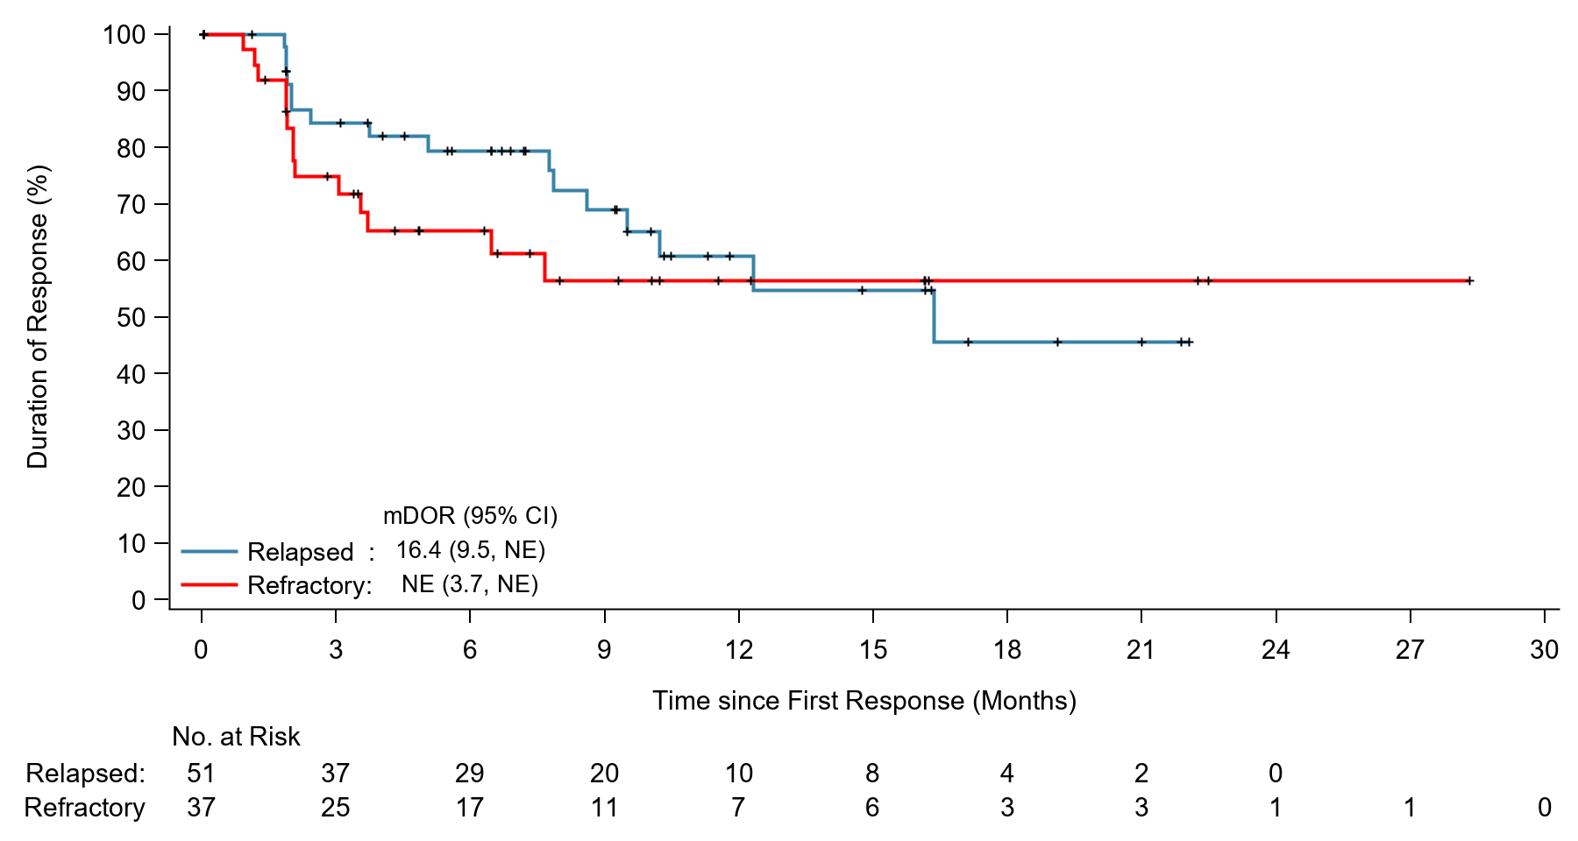

B. Duration of response according to the number of prior lines of systemic therapies

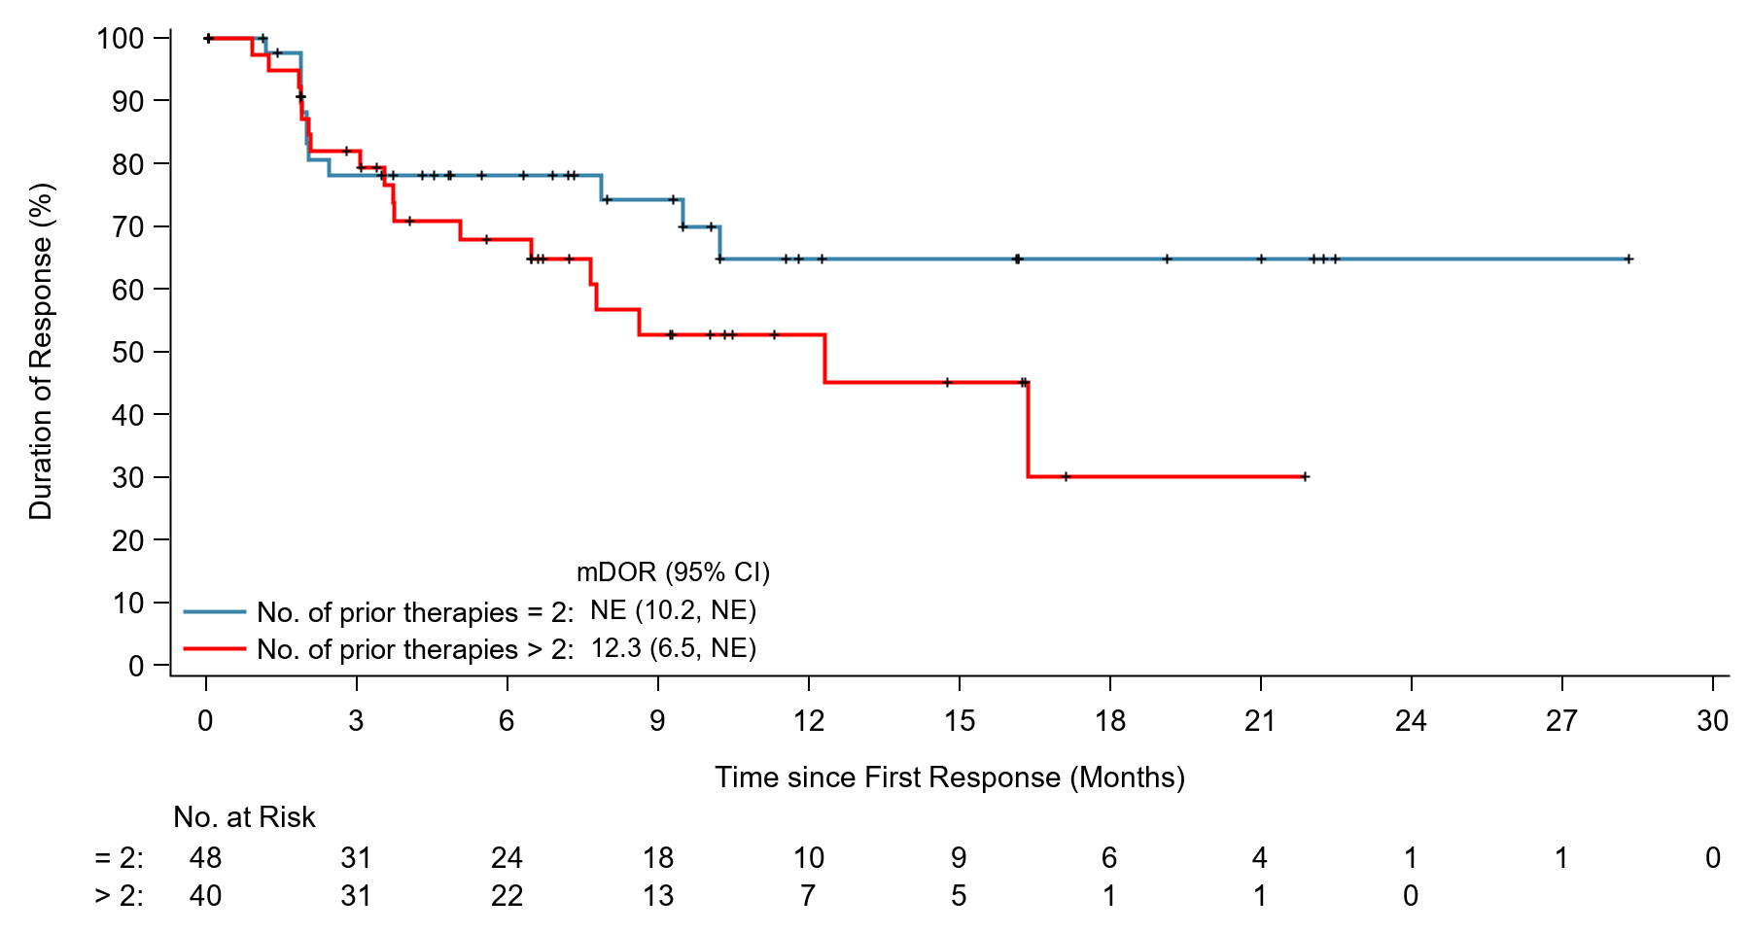

C. Duration of response according to presence or absence of POD24

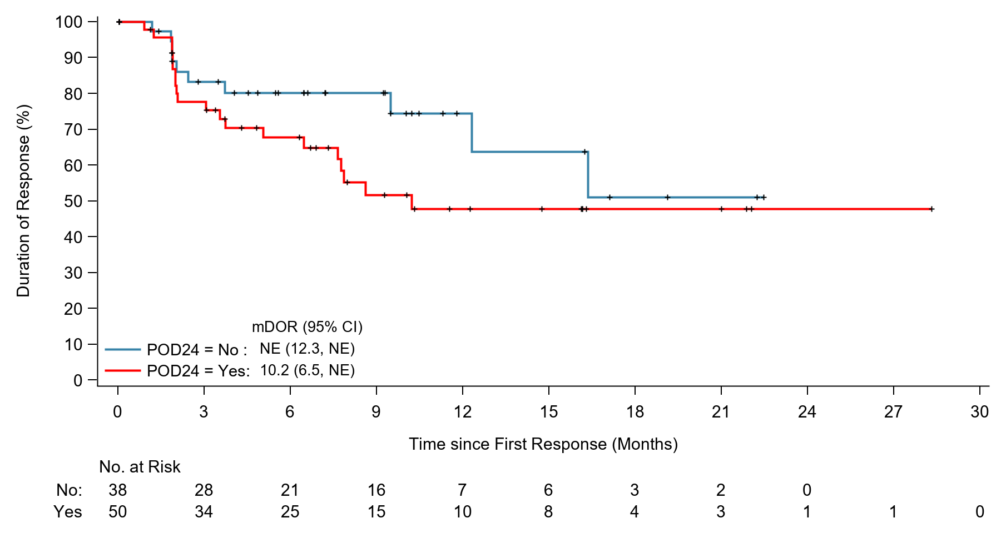

Figure S3: Overall survival in the IS follicular lymphoma population (N = 121)

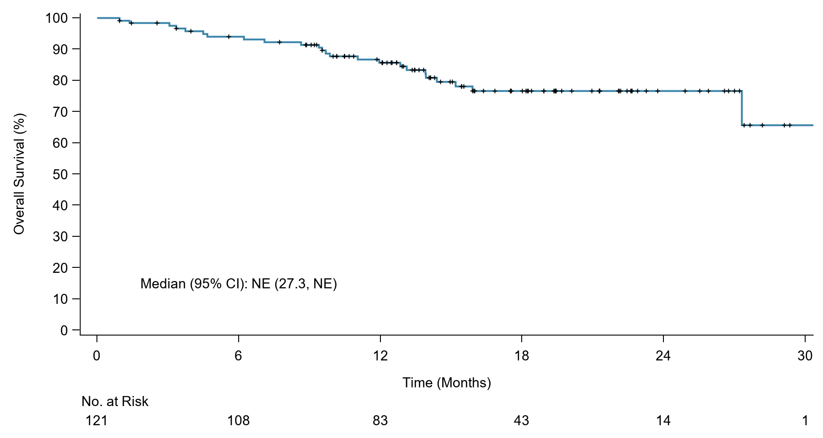

Figure S4: Cumulative hazard of grade 3 diarrhea or colitis in the IS follicular lymphoma population (N = 121)

