Supplementary Material

Table SM1. No. Patients (infusions) per year and country, sorted by GNI per Capita (x1000 USD) Pediatric group

 | No. Pediatric Patients (Infusions)
Country | 2017 | 2018 | 2019 | 2020 | 2021 | 2022 | 2023 | Total | GNI | UHC
India | 0 (0) | 0 (0) | 29 (30) | 4 (6) | 2 (3) | 5 (6) | 12 (12) | 52 (57) | 2.15 | 61
Ukraine | 0 (0) | 0 (0) | 8 (9) | 1 (2) | 0 (0) | 0 (0) | 0 (0) | 9 (11) | 4.12 | 73
Indonesia | 0 (0) | 0 (0) | 5 (8) | 2 (3) | 1 (4) | 1 (1) | 0 (0) | 9 (16) | 4.18 | 59
Guatemala | 0 (0) | 0 (0) | 5 (7) | 0 (1) | 2 (2) | 0 (0) | 0 (0) | 7 (10) | 4.94 | 57
Colombia | 0 (0) | 0 (0) | 18 (19) | 3 (5) | 1 (6) | 1 (3) | 0 (2) | 23 (35) | 6.19 | 78
BIH | 0 (0) | 0 (0) | 0 (0) | 1 (1) | 0 (0) | 1 (1) | 0 (1) | 2 (3) | 6.81 | 65
Belarus | 0 (0) | 0 (0) | 18 (20) | 20 (20) | 2 (3) | 3 (3) | 2 (2) | 45 (48) | 6.94 | 74
Thailand | 0 (0) | 0 (0) | 0 (0) | 1 (1) | 2 (2) | 2 (3) | 0 (0) | 5 (6) | 7.09 | 83
Brazil | 0 (0) | 1 (2) | 64 (81) | 9 (15) | 8 (12) | 3 (5) | 0 (1) | 85 (116) | 7.74 | 75
Mexico | 0 (0) | 0 (0) | 32 (33) | 1 (2) | 0 (0) | 2 (3) | 1 (1) | 36 (39) | 9.59 | 74
Turkey | 0 (0) | 0 (0) | 239 (267) | 96 (111) | 78 (110) | 57 (87) | 63 (94) | 533 (669) | 9.9 | 79
Argentina | 0 (0) | 0 (0) | 29 (31) | 11 (11) | 18 (22) | 20 (26) | 7 (8) | 85 (98) | 9.96 | 73
Malaysia | 0 (0) | 0 (0) | 0 (0) | 1 (1) | 3 (3) | 0 (0) | 3 (3) | 7 (7) | 10.71 | 76
Bulgaria | 1 (3) | 1 (4) | 30 (49) | 9 (10) | 8 (18) | 1 (1) | 2 (2) | 52 (87) | 11.2 | 70
Russia | 0 (0) | 0 (0) | 3 (3) | 0 (0) | 0 (0) | 1 (1) | 0 (0) | 4 (4) | 11.61 | 75
China | 0 (0) | 0 (0) | 4 (4) | 1 (1) | 0 (0) | 0 (0) | 0 (0) | 5 (5) | 11.88 | 82
Venezuela | 0 (0) | 4 (4) | 12 (16) | 1 (2) | 1 (3) | 2 (6) | 0 (2) | 20 (33) | 13.01 | 70
Chile | 0 (0) | 0 (0) | 28 (28) | 2 (3) | 0 (0) | 0 (0) | 0 (0) | 30 (31) | 14.78 | 80
Poland | 0 (0) | 0 (0) | 42 (68) | 3 (7) | 15 (31) | 11 (32) | 5 (7) | 76 (145) | 16.85 | 74
Croatia | 0 (0) | 0 (0) | 6 (6) | 6 (15) | 15 (19) | 1 (16) | 1 (7) | 29 (63) | 17.63 | 73
Hungary | 0 (0) | 0 (0) | 5 (5) | 0 (0) | 1 (1) | 0 (2) | 1 (2) | 7 (10) | 17.74 | 73
Latvia | 0 (0) | 2 (2) | 25 (39) | 2 (2) | 9 (15) | 5 (9) | 2 (5) | 45 (72) | 19.79 | 72
Greece | 0 (0) | 0 (0) | 0 (0) | 0 (0) | 2 (5) | 0 (0) | 0 (0) | 2 (5) | 20 | 78
Slovakia | 0 (0) | 0 (0) | 3 (3) | 0 (0) | 0 (0) | 0 (0) | 0 (0) | 3 (3) | 20.64 | 77
Portugal | 0 (0) | 0 (0) | 14 (14) | 0 (0) | 0 (0) | 0 (0) | 0 (0) | 14 (14) | 23.89 | 84
Czechia | 6 (6) | 5 (5) | 35 (38) | 3 (4) | 1 (1) | 0 (1) | 0 (0) | 50 (55) | 24.43 | 78
Estonia | 0 (0) | 0 (0) | 16 (16) | 1 (1) | 3 (3) | 0 (0) | 0 (0) | 20 (20) | 26.46 | 78
Slovenia | 0 (0) | 0 (0) | 20 (20) | 2 (2) | 5 (7) | 2 (2) | 4 (5) | 33 (36) | 28.28 | 80
Spain | 0 (0) | 0 (0) | 3 (3) | 1 (1) | 0 (1) | 0 (0) | 0 (0) | 4 (5) | 29.69 | 86
Taiwan | 0 (0) | 0 (0) | 0 (0) | 0 (0) | 1 (1) | 0 (0) | 0 (0) | 1 (1) | 33.059 | 82
Korea | 0 (0) | 0 (0) | 9 (9) | 0 (0) | 5 (5) | 9 (9) | 0 (0) | 23 (23) | 35.11 | 87
Italy | 0 (0) | 0 (0) | 24 (35) | 3 (5) | 1 (1) | 0 (0) | 0 (0) | 28 (41) | 35.99 | 83
Japan | 0 (0) | 0 (0) | 0 (0) | 0 (0) | 3 (4) | 1 (1) | 0 (0) | 4 (5) | 42.65 | 85
France | 0 (0) | 0 (0) | 3 (3) | 2 (2) | 4 (4) | 30 (33) | 13 (13) | 52 (55) | 44.16 | 84
UK | 0 (0) | 0 (0) | 8 (11) | 10 (10) | 2 (5) | 6 (8) | 1 (4) | 27 (38) | 44.48 | 88
Canada | 0 (0) | 0 (0) | 0 (0) | 0 (0) | 0 (0) | 1 (1) | 0 (0) | 1 (1) | 48.31 | 89
Belgium | 0 (0) | 0 (0) | 0 (0) | 0 (0) | 0 (0) | 5 (5) | 22 (22) | 27 (27) | 50.49 | 85
Germany | 0 (0) | 0 (0) | 4 (4) | 2 (3) | 0 (0) | 0 (0) | 0 (0) | 6 (7) | 51.66 | 86
Austria | 0 (0) | 0 (0) | 3 (3) | 0 (0) | 4 (4) | 2 (2) | 2 (2) | 11 (11) | 52.76 | 82
Finland | 0 (0) | 0 (0) | 5 (5) | 0 (0) | 0 (0) | 1 (1) | 0 (0) | 6 (6) | 53.51 | 83
Netherlands | 2 (2) | 4 (6) | 52 (70) | 10 (14) | 6 (7) | 1 (3) | 1 (1) | 76 (103) | 55.2 | 86
Australia | 0 (0) | 0 (0) | 1 (1) | 1 (1) | 4 (4) | 1 (2) | 0 (0) | 7 (8) | 57.17 | 87
Sweden | 0 (0) | 0 (0) | 6 (6) | 1 (1) | 1 (2) | 0 (0) | 0 (0) | 8 (9) | 59.54 | 87
Qatar | 0 (0) | 0 (0) | 5 (8) | 8 (13) | 0 (1) | 2 (3) | 0 (0) | 15 (25) | 62.31 | 74
Iceland | 0 (0) | 0 (0) | 0 (0) | 0 (0) | 1 (1) | 1 (1) | 2 (2) | 4 (4) | 63.46 | 87
Singapore | 0 (0) | 0 (0) | 1 (1) | 0 (0) | 25 (25) | 0 (0) | 0 (0) | 26 (26) | 64.01 | 86
Denmark | 0 (0) | 0 (0) | 2 (2) | 0 (0) | 0 (0) | 0 (0) | 0 (0) | 2 (2) | 68.3 | 85
United States | 0 (0) | 0 (0) | 8 (8) | 4 (5) | 3 (3) | 5 (5) | 1 (2) | 21 (23) | 70.93 | 83
Norway | 0 (0) | 1 (1) | 122 (162) | 26 (45) | 17 (25) | 8 (9) | 5 (10) | 179 (252) | 83.88 | 86
Switzerland | 0 (0) | 0 (0) | 2 (2) | 0 (0) | 0 (0) | 0 (0) | 0 (0) | 2 (2) | 90.6 | 87
Total | 9 (11) | 18 (24) | 948 (1147) | 248 (326) | 254 (363) | 191 (291) | 150 (210) | 1818 (2372)

Table SM2. No. Patients (infusions) per year and country, sorted by GNI per Capita (x1000 USD), Adult group

 | No. Adult Patients (Infusions)
Country | 2017 | 2018 | 2019 | 2020 | 2021 | 2022 | 2023 | Total | GNI | UHC
India | 0 (0) | 0 (0) | 45 (47) | 2 (4) | 1 (3) | 7 (7) | 24 (30) | 79 (91) | 2.15 | 61
Indonesia | 0 (0) | 0 (0) | 16 (16) | 10 (10) | 1 (1) | 1 (1) | 0 (0) | 28 (28) | 4.18 | 59
Guatemala | 0 (0) | 0 (0) | 11 (11) | 0 (4) | 21 (29) | 8 (9) | 2 (2) | 42 (55) | 4.94 | 57
Colombia | 0 (0) | 0 (0) | 8 (9) | 6 (10) | 8 (13) | 3 (3) | 24 (28) | 49 (63) | 6.19 | 78
South Africa | 1 (1) | 1 (2) | 32 (34) | 14 (19) | 2 (6) | 3 (6) | 1 (3) | 54 (71) | 6.53 | 67
BIH | 0 (0) | 0 (0) | 0 (0) | 1 (1) | 4 (5) | 6 (6) | 0 (1) | 11 (13) | 6.81 | 65
Belarus | 0 (0) | 0 (0) | 78 (78) | 36 (39) | 12 (12) | 10 (10) | 4 (5) | 140 (144) | 6.94 | 74
Thailand | 0 (0) | 0 (0) | 0 (0) | 0 (0) | 1 (1) | 1 (1) | 0 (0) | 2 (2) | 7.09 | 83
Brazil | 0 (0) | 0 (0) | 206 (237) | 26 (34) | 27 (35) | 12 (13) | 9 (10) | 280 (329) | 7.74 | 75
Mexico | 0 (0) | 0 (0) | 49 (65) | 4 (7) | 1 (3) | 1 (1) | 1 (2) | 56 (78) | 9.59 | 74
Turkey | 0 (0) | 0 (0) | 106 (120) | 86 (90) | 114 (126) | 64 (75) | 90 (100) | 460 (511) | 9.9 | 79
Argentina | 0 (0) | 1 (1) | 105 (112) | 61 (64) | 74 (87) | 66 (76) | 50 (59) | 357 (399) | 9.96 | 73
Malaysia | 0 (0) | 0 (0) | 0 (0) | 0 (0) | 0 (0) | 3 (3) | 0 (0) | 3 (3) | 10.71 | 76
Bulgaria | 3 (4) | 0 (1) | 18 (20) | 20 (24) | 11 (15) | 4 (5) | 3 (3) | 59 (72) | 11.2 | 70
Russia | 0 (0) | 0 (0) | 7 (7) | 1 (1) | 0 (0) | 0 (0) | 0 (0) | 8 (8) | 11.61 | 75
China | 0 (0) | 0 (0) | 1 (1) | 0 (0) | 0 (0) | 0 (0) | 2 (2) | 3 (3) | 11.88 | 82
Venezuela | 1 (1) | 6 (8) | 74 (95) | 17 (21) | 2 (3) | 0 (2) | 2 (2) | 102 (132) | 13.01 | 70
Romania | 0 (0) | 0 (0) | 87 (103) | 4 (5) | 3 (3) | 0 (0) | 0 (0) | 94 (111) | 14.16 | 71
Chile | 1 (1) | 10 (23) | 242 (598) | 29 (39) | 21 (39) | 31 (52) | 40 (46) | 374 (798) | 14.78 | 80
Uruguay | 0 (0) | 8 (8) | 13 (13) | 2 (10) | 12 (13) | 16 (19) | 15 (17) | 66 (80) | 16.08 | 79
Poland | 0 (0) | 0 (0) | 2 (2) | 0 (0) | 0 (0) | 0 (0) | 0 (0) | 2 (2) | 16.85 | 74
Croatia | 3 (3) | 2 (2) | 44 (50) | 22 (24) | 61 (78) | 27 (51) | 24 (42) | 183 (250) | 17.63 | 73
Hungary | 0 (0) | 0 (0) | 0 (0) | 0 (0) | 13 (32) | 0 (0) | 0 (0) | 13 (32) | 17.74 | 73
Latvia | 0 (0) | 0 (0) | 1 (1) | 0 (0) | 0 (0) | 0 (0) | 0 (0) | 1 (1) | 19.79 | 72
Greece | 0 (0) | 0 (0) | 11 (11) | 0 (0) | 0 (0) | 0 (0) | 0 (0) | 11 (11) | 20 | 78
Slovakia | 0 (0) | 0 (0) | 0 (0) | 0 (0) | 46 (46) | 27 (30) | 0 (0) | 73 (76) | 20.64 | 77
Lithuania | 11 (11) | 12 (20) | 143 (171) | 28 (33) | 12 (12) | 20 (21) | 5 (5) | 231 (273) | 21.74 | 70
Portugal | 0 (0) | 0 (0) | 31 (37) | 3 (4) | 3 (3) | 16 (17) | 0 (0) | 53 (61) | 23.89 | 84
Czechia | 0 (0) | 0 (0) | 60 (61) | 0 (0) | 5 (5) | 22 (24) | 44 (59) | 131 (149) | 24.43 | 78
Estonia | 0 (0) | 0 (0) | 4 (5) | 1 (1) | 0 (0) | 0 (0) | 0 (0) | 5 (6) | 26.46 | 78
Slovenia | 0 (0) | 0 (0) | 0 (0) | 1 (1) | 0 (0) | 1 (1) | 0 (0) | 2 (2) | 28.28 | 80
Spain | 0 (0) | 0 (0) | 2 (2) | 3 (3) | 0 (0) | 0 (0) | 1 (1) | 6 (6) | 29.69 | 86
Taiwan | 0 (0) | 0 (0) | 0 (0) | 1 (1) | 1 (1) | 0 (0) | 0 (0) | 2 (2) | 33.059 | 82
Kuwait | 0 (0) | 0 (0) | 2 (2) | 0 (0) | 6 (7) | 2 (2) | 1 (1) | 11 (12) | 34.29 | 70
Korea | 0 (0) | 0 (0) | 88 (105) | 53 (78) | 2 (2) | 1 (2) | 0 (0) | 144 (187) | 35.11 | 87
Italy | 0 (0) | 0 (0) | 6 (6) | 5 (6) | 2 (2) | 2 (2) | 1 (1) | 16 (17) | 35.99 | 83
Japan | 0 (0) | 0 (0) | 0 (0) | 0 (0) | 1 (1) | 2 (3) | 0 (0) | 3 (4) | 42.65 | 85
France | 0 (0) | 0 (0) | 0 (0) | 1 (1) | 2 (2) | 83 (89) | 15 (23) | 101 (115) | 44.16 | 84
UK | 0 (0) | 1 (2) | 29 (32) | 28 (39) | 14 (19) | 1 (2) | 0 (0) | 73 (94) | 44.48 | 88
New Zealand | 0 (0) | 0 (0) | 0 (0) | 1 (1) | 0 (0) | 8 (8) | 6 (6) | 15 (15) | 45.23 | 86
Canada | 0 (0) | 0 (0) | 0 (0) | 0 (0) | 0 (0) | 1 (1) | 0 (0) | 1 (1) | 48.31 | 89
Belgium | 0 (0) | 0 (0) | 0 (0) | 0 (0) | 1 (1) | 30 (30) | 26 (26) | 57 (57) | 50.49 | 85
Germany | 0 (0) | 0 (0) | 1 (1) | 0 (0) | 0 (0) | 0 (0) | 0 (0) | 1 (1) | 51.66 | 86
Austria | 0 (0) | 0 (0) | 2 (2) | 2 (2) | 21 (23) | 2 (2) | 3 (3) | 30 (32) | 52.76 | 82
Finland | 0 (0) | 2 (3) | 12 (14) | 1 (1) | 1 (2) | 3 (3) | 0 (0) | 19 (23) | 53.51 | 83
Netherlands | 0 (0) | 0 (0) | 0 (0) | 1 (1) | 3 (3) | 3 (4) | 1 (2) | 8 (10) | 55.2 | 86
Australia | 11 (13) | 22 (29) | 168 (214) | 32 (41) | 28 (34) | 22 (26) | 7 (10) | 290 (367) | 57.17 | 87
Sweden | 0 (0) | 0 (0) | 37 (43) | 4 (4) | 4 (4) | 2 (2) | 2 (2) | 49 (55) | 59.54 | 87
Qatar | 0 (0) | 0 (0) | 7 (8) | 0 (0) | 0 (0) | 0 (0) | 1 (1) | 8 (9) | 62.31 | 74
Iceland | 0 (0) | 0 (0) | 46 (87) | 74 (116) | 27 (37) | 7 (16) | 23 (41) | 177 (297) | 63.46 | 87
Singapore | 0 (0) | 0 (0) | 0 (0) | 0 (0) | 5 (5) | 2 (3) | 1 (1) | 8 (9) | 64.01 | 86
Denmark | 0 (0) | 0 (0) | 0 (0) | 0 (0) | 25 (26) | 0 (0) | 0 (0) | 25 (26) | 68.3 | 85
United States | 1 (1) | 1 (1) | 92 (110) | 19 (22) | 6 (7) | 5 (5) | 1 (1) | 125 (147) | 70.93 | 83
Ireland | 0 (0) | 2 (4) | 198 (246) | 68 (83) | 37 (49) | 24 (34) | 9 (12) | 338 (428) | 76.11 | 83
Norway | 0 (0) | 0 (0) | 1 (1) | 0 (0) | 0 (0) | 1 (1) | 0 (0) | 2 (2) | 83.88 | 86
Switzerland | 0 (0) | 0 (0) | 14 (14) | 0 (0) | 0 (0) | 0 (0) | 0 (0) | 14 (14) | 90.6 | 87
Total | 32 (35) | 68 (104) | 2099 (2791) | 667 (844) | 641 (795) | 550 (668) | 438 (547) | 4495 (5784)

Table SM3. Parameter estimates for GNI and UHC models by age group

Model | Dataset | Model terms | Estimate | Std. Error
GNI | Pediatric | Intercept | -5.113 | 0.535
 |  | $${\left(GNI/10\right)}^{-1}$$ | 1.649 | 0.399
 | Adult | Intercept | -2.708 | 0.462
 |  | $${\left(GNI/100\right)}^{-2}$$ | -0.057 | 0.036
 |  | $${\left(GNI/100\right)}^{-2}$$ | -0.022 | 0.013
 |  | $$*log⁡(GNI/100)$$
UHC | Pediatric | Intercept | -8.751 | 1.430
 |  | $${\left(UHC/100\right)}^{-2}$$ | 2.920 | 0.781
 | Adult | Intercept | 42.148 | 7.848
 |  | $${\left(UHC/100\right)}^{-2}$$ | -40.857 | 7.417
 |  | $${\left(UHC/100\right)}^{-2}$$ | -52.331 | 6.672
 |  | $$*log⁡(UHC/100)$$

Table SM4. Significance tests for GNI and UHC terms by age group
Model | Dataset | Model Terms | AIC | BIC | logLik | Dev | Chisq | Df | p-value
GNI | Pediatric | Null | 583.7 | 594.7 | -289.8 | 579.7
 |  | GNI | 570.0 | 586.5 | -282.0 | 564.0 | 15.7 | 1 | 7.49E-05
 | Adult | Null | 2133.5 | 2146.3 | -1064.7 | 2129.5
 |  | GNI | 2120.16 | 2145.8 | -1056.1 | 2112.2 | 17.3 | 2 | 0.000172
UHC | Pediatric | Null | 583.7 | 594.7 | -289.8 | 579.7
 |  | UHC | 573.7 | 590.2 | -283.9 | 567.7 | 12.0 | 1 | 0.000541
 | Adult | Null | 2105.4 | 2118.0 | -1050.7 | 2101.4
 |  | UHC | 2090.1 | 2115.3 | -1041.1 | 2082.1 | 19.3 | 2 | 6.39E-05
Null: model with intercept only; GNI: Model with gross national income per capita; UHC: model with universal health care index; AIC, BIC: Akaike, Bayesian Information Criterion; logLik: log-likelihood; Dev: deviance; Chisq: chi-squared distributed test statistic as the difference between deviances; df; degrees of freedom.

Table SM5. Classification table based on pediatric and adult logistic UHC models
The association test resulted in good classification (p-values 0.82 and 0.81 for GNI; 0.79 and 0.83 for UHC, respectively).
 |  |  | Observed |  | Predicted
Model | Age group | Predicted LDP probability | LDP=0 | LDP=1 | LDP=0 | LDP=1
GNI | Pediatric | [0.00258,0.00403] | 255 | 0 | 254 | 1
 |  | (0.00403,0.00635] | 121 | 0 | 120 | 1
 |  | (0.00635,0.00967] | 200 | 0 | 198 | 2
 |  | (0.00967,0.0181] | 176 | 2 | 175 | 3
 |  | (0.0181,0.0277] | 158 | 3 | 157 | 4
 |  | (0.0277,0.0359] | 178 | 7 | 179 | 6
 |  | (0.0359,0.0667] | 578 | 42 | 580 | 40
 |  | (0.0667,0.898] | 68 | 30 | 72 | 26
 | Adult | [0.00331,0.00527] | 509 | 0 | 507 | 2
 |  | (0.00527,0.00763] | 560 | 2 | 558 | 4
 |  | (0.00763,0.0175] | 368 | 4 | 367 | 5
 |  | (0.0175,0.0315] | 371 | 7 | 369 | 9
 |  | (0.0315,0.0388] | 422 | 14 | 421 | 15
 |  | (0.0388,0.0676] | 642 | 40 | 642 | 40
 |  | (0.0676,0.106] | 236 | 24 | 237 | 23
 |  | (0.106,0.138] | 444 | 69 | 445 | 68
 |  | (0.138,0.212] | 419 | 111 | 421 | 109
 |  | (0.212,1] | 153 | 101 | 158 | 96
UHC | Pediatric | [0.0029,0.00386] | 255 | 0 | 254 | 1
 |  | (0.00386,0.00636] | 128 | 0 | 127 | 1
 |  | (0.00636,0.0108] | 186 | 0 | 184 | 2
 |  | (0.0108,0.0134] | 165 | 2 | 165 | 2
 |  | (0.0134,0.0241] | 176 | 3 | 175 | 4
 |  | (0.0241,0.0368] | 178 | 7 | 179 | 6
 |  | (0.0368,0.0663] | 578 | 42 | 580 | 40
 |  | (0.0663,0.921] | 68 | 30 | 72 | 26
 | Adult | [0.00367,0.00512] | 509 | 0 | 507 | 2
 |  | (0.00512,0.00771] | 487 | 2 | 485 | 4
 |  | (0.00771,0.0172] | 467 | 4 | 465 | 6
 |  | (0.0172,0.0306] | 553 | 14 | 552 | 15
 |  | (0.0306,0.0403] | 214 | 7 | 213 | 8
 |  | (0.0403,0.0689] | 642 | 40 | 641 | 41
 |  | (0.0689,0.105] | 219 | 22 | 220 | 21
 |  | (0.105,0.139] | 477 | 74 | 478 | 73
 |  | (0.139,0.212] | 403 | 108 | 405 | 106
 |  | (0.212,0.999] | 153 | 101 | 158 | 96

Figure SM1: Distribution of GNI per Capita and UHC Index

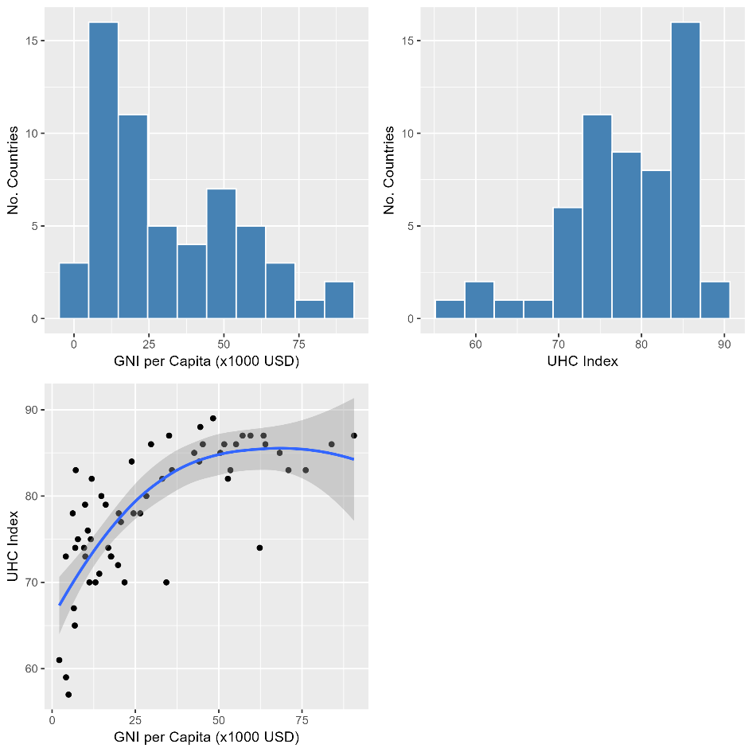

Figure SM3. Assessment of random effects distribution for pediatric GNI and UHC models

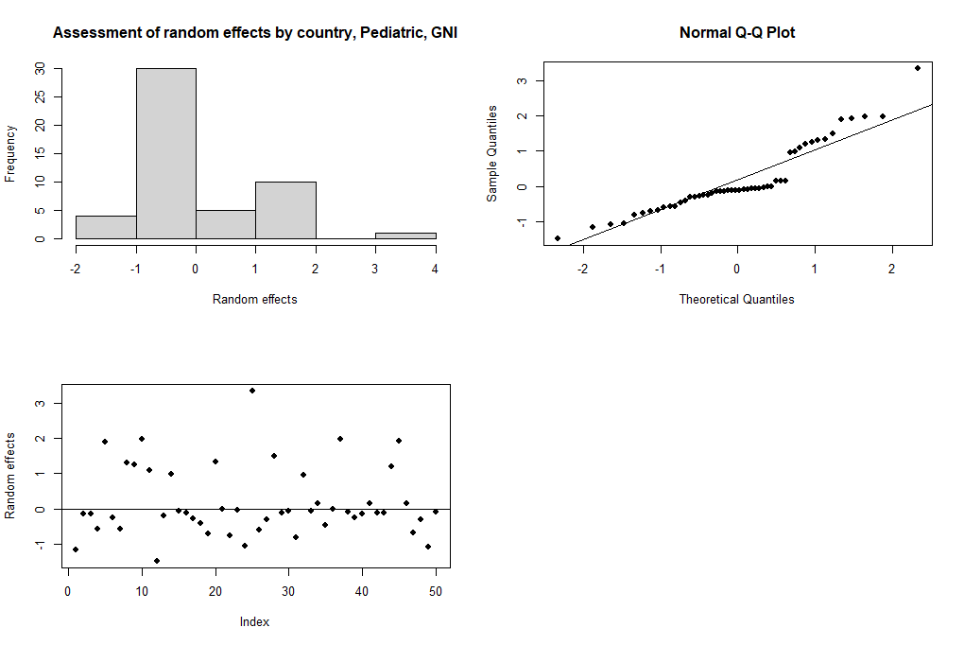
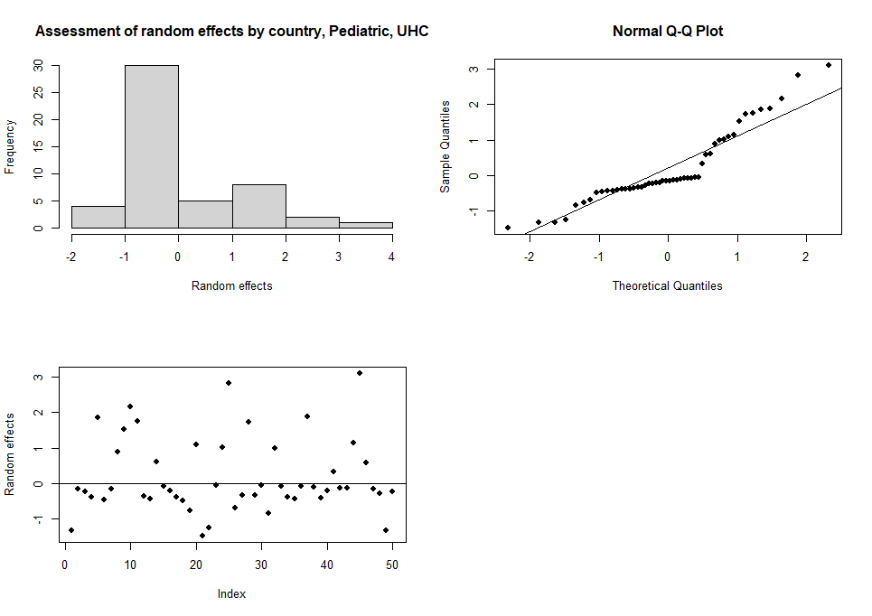

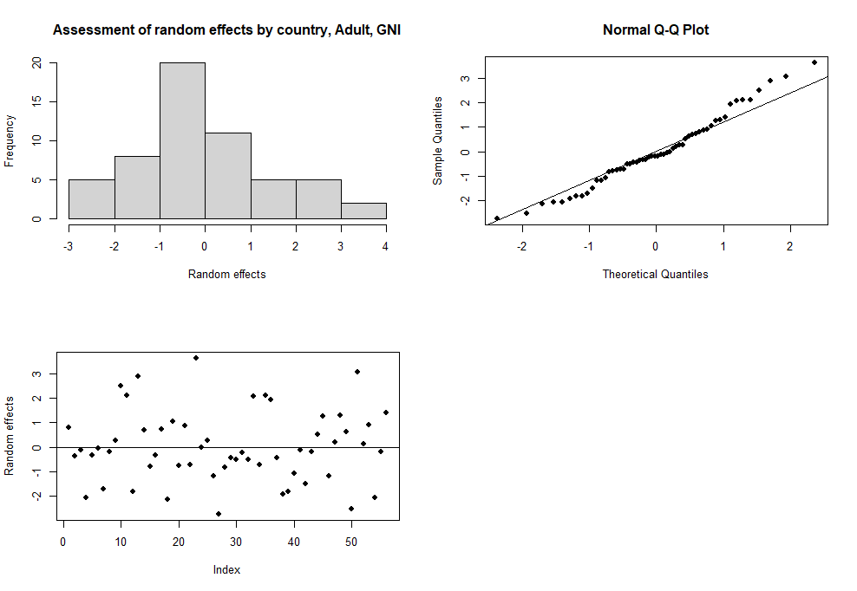
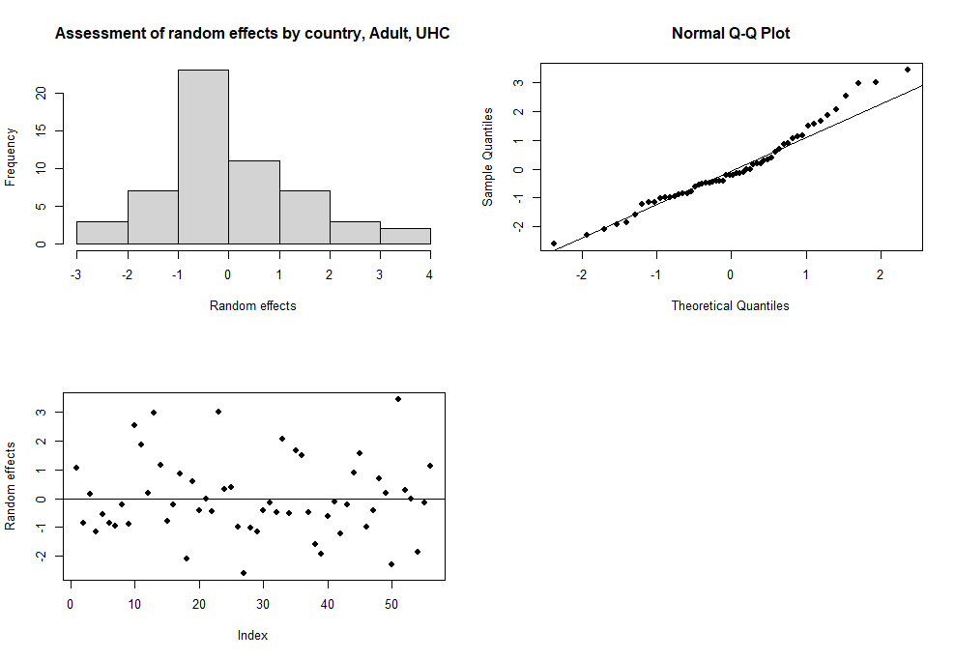
Figure SM2. Assessment of random effects distribution for adult GNI and UHC models

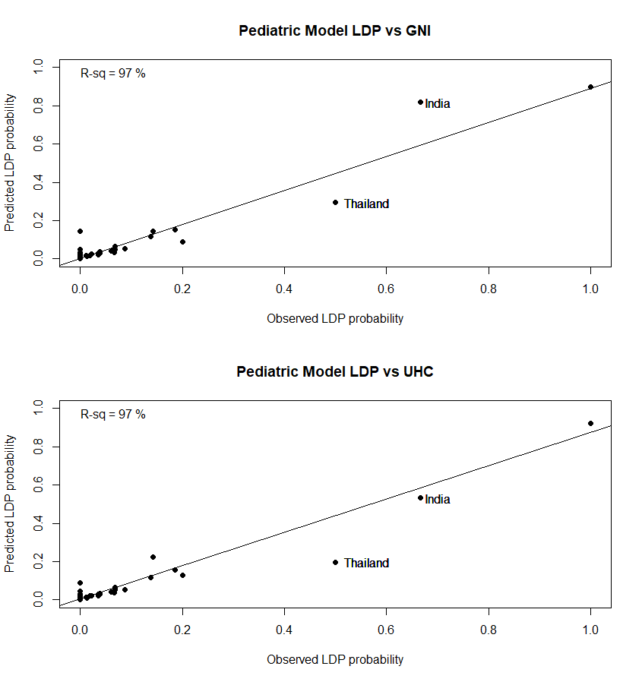
Figure SM3. Country-specific predicted vs. observed LDP percent, pediatric GNI and UHC models.

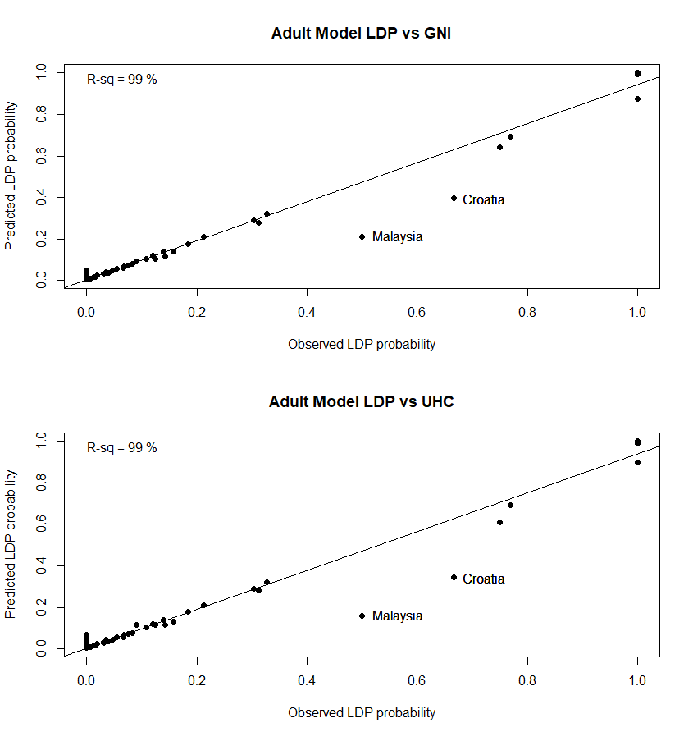
Figure SM4. Country-specific predicted vs. observed LDP percent, adult GNI and UHC models.

Hemophilia Care Centres affiliated to WAPPS-Hemo

Oregon Health and Science University, Portland
Centro Emofilia e Trombosi Angelo Bianchi Bonomi, Milan
Fundacion de la Hemofilia, Buenos Aires
London Health Sciences Center, Canada
Krajska Nemocnice Liberec
St. Paul’s Hospital, Vancouver
Wellington Regional Hospital
Hospital Universitario Virgen de la Arrixaca, Murcia, Spain
Nanfang Hospital, Guangzhou
Universitätsklinikum Bonn
Institute of Hematology and Blood Diseases Hospital Chinese Academy of Medical Science (Tianjin)
Hamilton Health Sciences
Haemophilia Comprehensive Care, Ljubljana
UHHS Cleveland. University Hospitals Health System
Hospital University & Politechnic La Fe, Valencia
Laiko General Hospital of Athens
Oulu University Hospital, Finland
Centro Hospitalar de Lisboa Central
Comprehensive Haemophilia Center Vienna
Hospital Torrecárdenas, Almeria, Spain
Hannover Medical School
Vivantes Clinic in Friedrichshain, Berlin
Charité Universitätsmedizin, Berlin
Kent and Canterbury Hospital, UK
Hospital Vall d'Hebron, Barcelona
Helsinki University Hospital
Royal London, UK
St. James's Hospital, Dublin
Centro Emofilia e Trombosi, Bari
Zurich University Hospital
Children's Hospital Colorado Anschutz Medical Campus, Aurora
National Taiwan University Hospital, Taipei
Hôpital Robert Debré, CHU de Reims, France
Center for Thrombosis and Hemorrhagic Diseases, IRCCS Humanitas Research Hospital
Second Affiliated Hospital of Kunming Medical University, China
Farwaniya General Hospital, Al Farwaniyah, Kuwait
AOU Città della Salute e della Scienza di Torino
Beijing Children’s Hospital
Shenzhen Children’s Hospital
National Haemophilia Center, Budapest
Queensland Paediatric Haemophilia Centre, Brisbane
IPS Especializada, Bogota
Auckland City Hospital Haemophilia Centre,
BC Children's Hospital, Vancouver
Alberta Children's Hospital, Calgary
China Medical University Children's Hospital, Taichung
Children's of Minnesota, Minneapolis
Janeway Children’s Health and Rehabilitation Centre, Newfoundland
University of Texas, Houston
Churchill Hospital, Oxford, UK
University Hospital Regensburg
Kaohsiung Medical University Hospital, Taiwan
Center for Bleeding and Clotting, Minneapolis
Taipei Veterans General Hospital
Swansea Haemophilia Centre
St. Joseph's Hospital - Center for Bleeding and Clotting Disorders, Tampa
Fondazione Policlinico universitario "Agostino Gemelli", Rome
Dětská klinika Ústí nad Labem, Czech Republic
Taipei Medical University Hospital Hemophilia Center
Hospital de la Santa Creu i Sant Pau, Barcelona
Universitaets - Kinderklinik Wien, Vienna
Laboratorio Clínico Hematológico, Antioquia, Colombia
CHEO Research Institute, Ottawa
GENA 100 - Germany
SickKids Hospital, Toronto
Aghia Sophia Children's Hospital, Athens
Peking Union Medical College Hospital, Beijing
Tulane University School of Medicine, New Orleans
Centro Hospitalar do Porto
University of Occupational and Environmental Health, Japan
CHU Dijon
CHU Caen (France)
Bern University Hospital
Hospital Universitario Cruces, Vizcaya, Spain
University Medical Center Utrecht
Hospital Universitario Donostia, Spain
Sahlgrenska University Hospital, Gothenburg
Centre de Ressources et de Compétences maladies hémorragiques constitutionnelles Lille
Emory University, Atlanta
Johns Hopkins All Children's Hospital, St. Petersburg, Florida
Arnold Palmer Hospital for Children, Orlando
Massachusetts General Hospital
Gulf States Hemophilia, Houston
St-Luc University Hospital, Brussels
Fiona Stanley Hospital Haemophilia Treatment Centre, Perth
MacKay Children's Hospital, Taipei
Kyung Hee University Hospital at Gangdong (Seoul)
Nemours Children's Specialty Care, Jacksonville
Shandong Hemophilia Clinic, Jinan, China
Weill Cornell Medical College (New York)
University of Louisville
Tampere University Hospital, Finland
St. Petersburg Hemophilia Centre
Ogikubo Hospital,Tokyo
Hôpital Trousseau, CHRU de Tours
Ankara City Hospital
Yonsei University Health System, Seoul, Korea
Korea Hemophilia Foundation Seoul Clinic
ONCOORIENTE SAS, Villavicencio, Colombia
Manitoba Health Sciences Centre
Gent University Hospital, Gent, Belgium
Omsk Regional Children's Clinical Hospital
University Hospital Motol, Prague
Northern Alberta Bleeding & Rare Blood Disorders Clinic - Kaye Edmonton Clinic
Skåne University Hospital, Malmö
Foothills Medical Centre, Calgary
Haemophilia Centre Copenhagen
Centro Emofilia di Padova
Exeter and Barnstaple Haemophilia Centre
Hospital Universitario Nuestra Señora de Candelaria, Tenerife, Spain
University Hospital Frankfurt, Germany
Center for Hemorrhagic and Thrombotic Diseases, University Hospital of Udine
St. Jude Affiliate Clinic at NH Hemby Children's Hospital, Charlotte
Stollery Children’s Hospital, Edmonton
Belarusian Centre for Paediatric Oncology and Haematology, Minsk
Centro Hospitalario Pereira Rossell, Montevideo
Hôpital Universitaire des Enfants Reine Fabiola, Huderf
Tokyo Medical University Hospital
Kaohsiung Veterans General Hospital
CTH-Cordoba
National Center of Hemostasis and Thrombosis, Martin, Slovakia
University Children's Hospital Berne
The Royal Children's Hospital, Melbourne
Hospital de Pediatria Prof. Dr. Juan P. Garrahan, Buenos Aires
University Medical Center Hamburg-Eppendorf
Medical University of Innsbruck (MUI)
Antwerp University Hospital, Edegem
Centro Médico Imbanaco, Cali, Colombia
University of Miami Hemophilia Treatment Center
Hemophilia Outreach Center, Wisconsin
Hospital General Universitario de Alicante
Hospital de Santa Maria, Lisbon
Hôpitaux Universitaires de Genève
National Hemophilia Centre, Bratislava
Medicarte, Medellín
University of Debrecen
University of North Carolina, Chapel Hill
Riley Children's Health, Indianapolis
Valley Children's Healthcare, Madera
Hokkaido University Hospital, Sapporo, Japan
Congenital Coagulopathies Unit, Balearic Islands
Indiana Hemophilia and Thrombosis Center, Indianapolis
Groote Schuur Hospital Comprehensive Care Centre
Akron Children's Hospital
Kaohsiung Chang Gung Memorial Hospital, Taiwan
Maxima Medisch Centrum, Veldhoven (NL)
HIEMI
Amrita Hospital, Kochi
University of Florida Hemophilia Treatment Center, Gainesville
Royal Adelaide Hospital
University Hospitals of Leicester
CHRU de Besançon
Children's Hospital of Michigan, Detroit
Győr OVSZ
Centre de traitement des Hémophiles Eaubonne-Montmorency
University Children's Hospital Zurich
Centre Hospitalier Le Mans, Le Mans
Linkou Chang Gung Hemophilia Center, Taiwan
Mayo Clinic, Rochester
Centro. Nacional de Hemofilia, Caracas
Saskatchewan Bleeding Disorders Program
Mary M Gooley Hemophilia Center, Rochester
CHR de la Citadelle, Liège
National Cheng Kung University hospital
Turku University Hospital, Finland
The Maine Hemophilia and Thrombosis Center
Hospital Teresa Herrera Materno Infantil, Coruna, Spain
The Children’s Hospital at Westmead, Australia
Ottawa Regional Adult Bleeding Disorders Program
Nationwide Children's Hospital, Columbus
Instituto Guatemalteco de Seguridad Social
Centro de Hemoterapia e Hematologia do Espirito Santo, Victoria , Brazil
The Moncton Hemophilia Clinic
IWK Health Centre, Halifax
Northwest Ohio Hemophilia Treatment Center (Toledo)
Minsk Scientific and Practical Center
The Bleeding and Clotting Disorders Institute, Peoria
Okinawa Prefectural Nanbu Medical Center
Heim Pál Gyermekkórház , Budapest
Calvary Mater Hospital / John Hunter Children's Hospital Newcastle (Aus)
University of Virginia Health System, Charlottesville
Taichung Veterans General Hospital
Hematology and Oncology Department, CHU Nord, St. Etienne
St. Michael's Hospital, Toronto
Central City Hospital Novy Urengoy
University of Iowa Children's Hospital
University of Wisconsin - Comprehensive Program for Bleeding Disorders
St. Jude Children's Research Hospital, Memphis
Hospital Regional Universitario de Málaga
Centro Hospitalar e Universitario de Coimbra, Portugal
L'hemostase de Strasbourg, Strasbourg
Olomouc: FN Olomouc - Hemato-onkologická klinika
Hospital Sant Joan de Déu, Barcelona
Azienda Ospedaliero Universitaria di Parma - SSD Centro Hub Emofilia e Malattie Emorragiche Congenite
Hospital Universitari Arnau de Vilanova de Lleida, Spain
The Women's and Childrens Hospital, Adelaide
Vanderbilt University Medical Center (Nashville)
Royal Prince Alfred Hospital, Sydney
Tainan Municipal Annan Hospital, Taiwan
Facuty of Medicine, Chiang Mai University
Aristotle University of Thessaloniki (Pediatric), Thessaloniki
University of Helsinki and Children´s Hospital
St. Elisabethen-Klinikum-Childrens Hemophilia Outpatient Clinic
Hemophilia Treatment Center of Chung Shan Medical University Hospital
Children's Hospital, Boston
Reykjavik Hemophilia Center, Iceland
Universitätsklinikum Würzburg, Germany
Rush University Medical Center (Chicago)
Montreal Children's Hospital
China Medical University Hsinchu Hospital
Perth Children's Hospital, Australia
Hamad General Hospital, Doha, Qatar
Nottingham University Hospital NHS Trust, UK
Azienda Ospedaliera Pugliese-Ciaccio
Hemofiliecentrum, UZ Leuven
Complejo Hospitalario de Navarra
Gerinnungsambulanz Heidelberg
South Texas Hemophilia Treatment Center, San Antonio
Policlinico di Palermo
CHU de Rouen
University Medical Center Hamburg-Eppendorf: Pediatric, Germany
Hemocentro Regional de Maringá
University Medical Centre, Ljubljana
Hemophilia Center of Western New York (Buffalo)
University Hospital Coventry & Warwickshire, Coventry
National Research Center for Hematology
Karolinska University Hospital, Stockholm
Luzerner Kantonsspital, Lucern (CH)
Hospital Virgen de las Nieves, Granada
Hospital Universitario Virgen del Rocío, Seville
St. George's University Hospital, London
University of California San Francisco Pediatric Hemophilia Treatment Center
Imako Children's Sunflower Clinic
Universitätsklinikum Düsseldorf
Hemophilia Treatment Center of Central PA, Hershey, US
Katowice Haemophilia Treatment Center, Poland
University Hospital - Brno (DN)
Chang Gung Medical Foundation
Rady Children's Hospital, San Diego
Hospital Clinic de Barcelona
Hospital Universitario Río Hortega, Valladolid, Spain
Chengdu Hemophilia Treatment Centre
Aarhus University Hospital: Pediatric Centre, Denmark
Hospital Tengku Ampuan Afzan, Kuantan, Malaysia
Centro Asistencial Regional de Hemoterapia (CARDHE), Argentina
University of Kentucky Hemophilia Treatment Center (Lexington)
Hong Kong Children's Hospital
Coimbra Pediatric Hospital
Hemophilia Comprehensive Care Team, Jakarta
Faculty Hospital Nitra
Veszprémi Területi Vérellátó
South Pest Central Hospital - National Institute of Hematology and Infectious Diseases, Budapest, Hungary
Oklahoma Center for Bleeding and Clotting Disorders
Hemocentro Unicamp, São Paulo
Hospital Roberto del Río, Santiago
University of Pécs, Department of Pediatric Hematology and Oncology
Washington Center for Bleeding Disorders
Princess Margaret Hospital
Ruan Rehacer IPS, Bogota
Hospital Alvaro Cunqueiro, Vigo, Spain
PYNEH
University Hospital Bristol
Klinik für Kinder- und JugendmedizinUniversitätsklinikum Jena
U.O. Pediatria Generale e Specialistica "B. Trambusti", Bari
Policlinico Umberto I - "Sapienza" Università di Roma
University of Szeged - Faculty of Medicine, Hungary
Hemostasis and Thrombosis Center, Rhode Island
Moscow Regional Children's Hematology Center
Orthopaedic Hemophilia Treatment Center, Los Angeles
University Hospital Ostrava Blood Centre
Hull and East Yorkshire Hospitals NHS Trust, Hull
Center for Inherited Blood Disorders, Orange County
Hematologia y oncologia del oriente SAS, Bogota
University Hospital Southampton, UK
Children's Medical Center Bleeding Disorders and Thrombosis Program
Ospedale S. Bortolo, Vicenza
Arkansas Center for Bleeding Disorders (Little Rock)
Nagoya University Hospital
Royal Free Hospital, London
Hospital Miguel Servet, Zaragoza
Dětská klinika FN Hradec Králové
CHU, University Hospital of Nancy
National Blood and Cancer Centre, Riyadh, Saudi Arabia
Gerinnungszentrum Rhein Ruhr, Duisburg
Castelfranco Veneto Haemophilia Centre - Istituto Oncologico Veneto, Padua
The Alfred Hospital, Melbourne
Chang Gung Memorial Hospital Keelung
Fundacion de la Hemofilia Rosario
Hämophiliezentrum LMU Klinikum
Fundación de Hemofilia de Salta, Argentina
Kuopio University Hospital, Kuopio, Finland
Erasmus MC, Sophia Children’s Hospital, Rotterdam
Morozov City Children's Clinical Hospital, Moscow, Russia
Complejo Asistencial Dr. Sótero del Río, Santiago
Haemophilia Centre of Perugia
Centre de ressources et de compétences maladies hémorragiques constitutionnelles, Hôpital de Versailles, André Mignot
University Hospital - Brno
Royal Hobart Hospital, Tasmanian HTC, Australia
Clinique Vasculaire et Coagulation, Angers
Intergral Solutions SD S.A.S, Bogota
Changhua Christian Hospital
Sheffield Children's Hospital
Hospital Universitario Marqués de Valdecilla
Mohács Hospital, Hungary
Tallinn Children's Hospital, Estonia
The Children's Hospital of Philadelphia
BloodCenter of Wisconsin
Union Hospital, Tongji Medical College, HUST, China
Lehigh Valley Hemophilia Treatment Center
Department of Pediatric Hematology and Oncology, Medical University of Łódź, Poland
Hemophilia Care and Research Center, Tri-Service General Hospital, Taiwan
North Dakota Hemostasis and Thrombosis Treatment Center
University Hospital Magdeburg
Chongqing Hemophilia Treatment Center, China
Clínica San Lucas, Neuquen
KK Women’s and Children’s Hospital, Singapore
Kurume University Hospital, Japan
John Bouhasin Center for Children with Bleeding Disorders, St. Louis
Cincinnati Children's Hospital Medical Center
Kingston General Hospital
Northern Jiangsu People's Hospital, Yangzhou, China
Westmead Hospital, Australia
Guangzhou Women and Children's Medical Center, China
Hemofilia Emssanar SAS
Radboud University Medical Centre: Pediatrics, Nijmegen, Netherlands
Guizhou Hemophilia Center
Laboratorio de Hematologia Integral
Royal Belfast Hospital for Sick Children
Samodzielny Zakład Opieki Zdrowotnej nad Matką i Dzieckiem
Medical University of Warsaw Paediatric Hematology and Oncology Clinic
Mahidol University Department of Pediatrics Ramthibodi Hospital
University Children's Hospital, Lublin, Poland
Hemocentro São José do Rio Preto
The Seventh Affiliated Hospital of Sun Yat-Sen University
The Second Hospital of Hebei Medical University
Hospital Humberto Notti, Mendoza
Steve Biko Hospital
East Carolina University Hemophilia Treatment Center
Utah Center for Bleeding and Clotting Disorders, Salt Lake City
Children's of Alabama
Stanford University Medical Center, Palo Alto
National Research Center of Pediatric Hematology, Oncology and Immunology
Unknown Athn Centre
Hospital Tunku Azizah Kuala Lumpur
Hemophilia treatment center of China
Hebei Children's Hospital
Samodzielny Publiczny Szpital Kliniczny
Matteo Di Minno
No 3 Peoples Hospital of Chengdu
Clinic of Pediatrics, Hematology and Oncology, University Clinical Centre in Gdansk
The First Affiliated Hospital of Kunming Medical University, China
Korea Hemophilia Foundation Busan Clinic
Royal Hallamshire Hospital, Sheffield, UK
Tungs' Taichung MetroHarbor Hospital, Hemophilia & Rare Disease Treatment Center, Taiwan
Shuang Ho Hospital
Division of Hematology, Medical University of Graz
Hospital Clínico Universitario de Santiago de Compostela, Spain
Centro Emofilia - Servizio Emostasi e Trombosi
Hospital Universitario Dr José Eleuterio Gonzalez, Mexico
Clinica Infantil Colsubsidio, Bogota
Hetényi Géza Hospital First Department of Internal Medicine
Hämophilie-Zentrum Rhein Main GmbH
Wake Forest University
Connecticut Children's Hemostasis and Thrombosis Program
The Children's Hospital at Montefiore, New York
Great Ormond Street Hospital, London
Hospital Universitario La Paz, Madrid
MVZ für Blutgerinnungsstörungen und Gefäßkrankheiten Limbach GmbH
Paediatric hematology Univ. Hosp. Tzaritza Giovanna ISUL
CHU Sainte Justine
Hospital of Lithuanian University of Health Sciences, Kaunas
HMQ- Complejo Hospitalario de Jaen, Spain
Department of Medicine, Tuen Mun Hospital
City Hospital N1 named after N.I. Pirogov
Service Hématologie Pédiatrique, CHU Hautepierre, Strasbourg
St. Thomas' Hospital, London
Phoenix Children's Hospital
King Faisal Specialist Hospital & Research Centre, Riyadh
Fondazione IRCCS Policlinico San Matteo
Hospital General Regional No. 1, Mexico City
Inha University Hospital, Incheon, South Korea
Instituto Nacional de Pediatria, Mexico
Hospital Universitario de Burgos, Spain
Tainan Hospital - Sinlau
Centro Hospitalar S. João, Porto
Children's Medical University Hospital, Latvia
Pontificia Universidad Católica de Chile
Clinical Center University of Sarajevo
Cooperative de Hospitales de Antioquia
Royal Hospital for Sick Children, Glasgow
CHUS - Hôpital Fleurimont, Sherbrooke, Quebec
Hospital Infantil de México Federico Gómez
Hospital Regional de Talca, Chile
University Clinical Hospital Mostar, Bosnia and Herzegovina
Universitätsklinikum Dresden, Medizinische Klinik I, Germany
Haemophilia Treatment Center Łódź, Poland
Praha: ÚHKT
Neurum, Medellín, Colombia
Palmetto Health Richland, Columbia
HOSPITAL DON BENITO VILLANUEVA
CBDR Centre
H&H LAB LABORATORIO DE REFERENCIA EN HEMOSTASIA
University of Michigan Hemophilia Treatment Center
Hospital Virgen de la Salud
National Children's Specialized Hospital - Okhmatdyt, Kiev, Ukraine
IPS Theraclinic
Christchurch Hemophilia Treatment Centre
Palmerston North Hospital, New Zealand
Birmingham CRS Hemophilia Clinic
University Hospital Centre Zagreb
University Clinical Centre Zagreb
Fundación Santa Fé
Hemostasis and Thrombosis Center of Nevada
OVSZ Székesfehérvár Regional Blood Supply
West Virginia University Hemophilia Treatment Center
Hospital Universitario de Salamanca, Spain
Varna Expert Center of coagulopathies and rare anemias
St. Luke's Hemophilia Center, Boise
The Children’s Hospital, Zhengjiang University School of Medicine, Hangzhou
Hôpital de l'Enfant-Jésus
First Affiliated Hospital of Guangxi Medical University, China
Servicio Medico Integral
Charlotte Maxeke Johannesburg Academic Hospital, South Africa
Universitätsklinik Muenster
PROTEHOS, Bucaramanga
Midland Regional Haemophilia Treatment Centre, New Zealand
Bloemfontein Adult Haemophilia Treatment Centre
Wroclaw Medical University
Hospital de Niños de la Santisima Trinidad
Cooperativa de Hospitales de Antioquia (COHAN)
Integral IPS
Pomeranian Medical University, Dept. of Pediatrics
AZ Sint-Jan Brugge AV, Belgium
The Roald Dahl Centre, Liverpool, UK
Hämophiliezentrum Münster
St. James' University Hospital, Leeds, UK
Royal Hospital, Muscat, Oman
Korea Hemophilia Foundation Gwangju Clinic
Oxford
Queen Elizabeth II Health Sciences Centre (Halifax)
North Hampshire
Hämophilie Therapiezentrum Kinderklinik Tübingen
Pauls Stradins University hospital
Plzeň: FN Plzeň - ÚKBH
Hospital Reina Sofia, Cordova, Spain
St. Marianna University School of Medicine Yokohama City Seibu Hospital
Department of Pediatric Onkology and Hematology
Utah Center for Bleeding and Clotting Disorders: Pediatrics, Salt Lake City
CHU de Poitiers
UC Davis Hemostasis and Thrombosis Center, Sacramento
Centro Emofilia e Coagulopatie Congenite-Papa Giovanni XXIII Hospital
Sapporo Tokushukai Hospital
Hospital General de Zona 46 IMSS, Tabasco, Mexico
Regional Reference Centre for Hemorrhagic and Thrombotic Hereditary Diseases in Paediatric Age Children Hospital Regina Margherita of Turin Piedmont Italy
University Hospital of Schleswig Holstein- Kiel, Germany
Dětská klinika Ústí nad Labem
Gerinnungsambulanz ITZ / HHU Düsseldorf
General Hospital Athens "Hippokrateio" Hemophilia Center, Greece
Oslo University Hospital
Klinikum Klagenfurt a.W.
Hämophilie-Ambulanz der Blutzentrale Linz
Azienda Ospedaliera Universitaria Federico II, Naples
University Hospital Pilsen
Ústí n.L.: Masarykova nemocnice - OKH
Hämophilie-Zentrum UKS Homburg
F. D. Roosevelt University Hospital
Hospital Universitario Central de Asturias, Oviedo
Dr. Gabrielle Martin Pediatric Hemalogist
Centro Emofilia Gaslini, Genova, italy
Ospedale Veris Delli Ponti Scorrano
Centro Emofilia Pescara
Policlinico di Catania - Centro Emofilia
North Estonia Medical Center, Tallinn
Ostrava: FN Ostrava - Klinika dětského lékařství
Giessen University Hospital
Kepler Universitätsklinikum
SZTE SZAKK Gyermekgyógyászati Klinika
Dětské oddělení Nemocnice České Budějovice
Landeskrankenhaus Bregenz
Emergency Hospital for Children
University Hospital of Lausanne
Haemophilia Center of Northern Greece
Hospital Universitario Guadalajara
Children's University Hospital (Krakow)
Békés Megyei Kórház Réthy Pál Tagkórház Haematológia Ambulancia
Fundeni Clinical Institute, Bucharest
WSZ
Oblastní nemocnice Kolín, THO
Zentrum für Labormedizin
Ostschweizer Kinderspital St. Gallen
Hospital Universitario Araba Txagorritxu, Vitoria-Gasteiz
Prince Sultan Military Medical City
Dětská klinika Plzeň
National Hemophilia Center
Timisoara Municipal Emergency Clinical Hospital

