Supporting information for “Representativeness of the Natura 2000 network for preserving plant biodiversity in the European Union”

Appendix S1. Surface area, number and density of vegetation plots from the European Vegetation Archive found inside and outside the Natura 2000 network for each combination of country and biogeographical region.
Countries | Biogeographical regions | Area |  | Number of plots |  | Plot density  (n/km²)
Countries | Biogeographical regions | Inside | Outside | Inside | Outside | Inside | Outside
Austria | Alpine | 8676.88 | 43996.72 | 2007 | 5326 | 0.23 | 0.12
Austria | Continental | 4302.60 | 26813.26 | 1539 | 2850 | 0.36 | 0.11
Belgium | Atlantic | 1772.94 | 17001.33 | 5587 | 2990 | 3.15 | 0.18
Belgium | Continental | 2111.66 | 9709.43 | 73 | 130 | 0.03 | 0.01
Bulgaria | Black Sea | 3985.32 | 3287.27 | 322 | 76 | 0.08 | 0.02
Bulgaria | Alpine | 10891.74 | 6432.18 | 4233 | 438 | 0.39 | 0.07
Bulgaria | Continental | 23819.79 | 63469.50 | 1556 | 2885 | 0.07 | 0.05
Croatia | Mediterranean | 7117.27 | 8318.40 | 231 | 1076 | 0.03 | 0.13
Croatia | Continental | 7262.07 | 23124.68 | 649 | 2309 | 0.09 | 0.1
Croatia | Alpine | 4964.19 | 3348.63 | 812 | 14 | 0.16 | 0
Cyprus | Mediterranean | 1615.26 | 3727.04 | 16 | 17 | 0.01 | 0
Czech Republic | Continental | 10577.63 | 64728.93 | 13418 | 48229 | 1.27 | 0.75
Czech Republic | Pannonian | 515.55 | 2873.38 | 493 | 2314 | 0.96 | 0.81
Denmark | Atlantic | 1148.94 | 11974.62 | 40388 | 26873 | 35.15 | 2.24
Denmark | Continental | 1886.55 | 26523.53 | 102203 | 63796 | 54.17 | 2.41
Estonia | Boreal | 7754.33 | 37098.06 | 256 | 988 | 0.03 | 0.03
Finland | Boreal | 29742.13 | 285719.31 | 73 | 1967 | 0 | 0.01
Finland | Alpine | 11758.35 | 3837.31 | 319 | 1128 | 0.03 | 0.29
France | Continental | 21617.58 | 161903.54 | 3527 | 3665 | 0.16 | 0.02
France | Mediterranean | 15624.28 | 49561.50 | 2859 | 2603 | 0.18 | 0.05
France | Atlantic | 21563.44 | 245198.24 | 4374 | 2936 | 0.2 | 0.01
France | Alpine | 10467.85 | 20229.47 | 4928 | 2598 | 0.47 | 0.13
Germany | Continental | 46793.83 | 235899.93 | 9138 | 16782 | 0.2 | 0.07
Germany | Atlantic | 6169.65 | 63801.64 | 2328 | 13645 | 0.38 | 0.21
Germany | Alpine | 1644.06 | 2635.90 | 435 | 288 | 0.26 | 0.11
Greece | Mediterranean | 34611.35 | 94246.65 | 2996 | 2419 | 0.09 | 0.03
Hungary | Pannonian | 19819.38 | 72910.76 | 287 | 179 | 0.01 | 0
Ireland | Atlantic | 8790.92 | 59926.44 | 8876 | 7696 | 1.01 | 0.13
Italy | Mediterranean | 31773.66 | 129471.28 | 14413 | 8412 | 0.45 | 0.06
Italy | Continental | 8688.28 | 78518.57 | 3616 | 3546 | 0.42 | 0.05
Italy | Alpine | 16216.09 | 34595.57 | 4228 | 3474 | 0.26 | 0.10
Latvia | Boreal | 7316.37 | 56965.26 | 3659 | 3175 | 0.5 | 0.06
Lithuania | Boreal | 7897.63 | 56258.07 | 0 | 442 | 0 | 0.01
Luxembourg | Continental | 642.17 | 1966.30 | 5 | 7 | 0.01 | 0
Netherlands | Atlantic | 5236.70 | 31554.77 | 44179 | 85845 | 8.44 | 2.72
Poland | Continental | 55893.40 | 245925.52 | 8134 | 22248 | 0.15 | 0.09
Poland | Alpine | 5152.90 | 5209.99 | 2116 | 774 | 0.41 | 0.15
Portugal | Macaronesian | 516.80 | 2303.58 | 4 | 195 | 0.01 | 0.08
Portugal | Mediterranean | 16665.95 | 66091.92 | 505 | 777 | 0.03 | 0.01
Portugal | Atlantic | 883.81 | 3844.35 | 51 | 14 | 0.06 | 0
Romania | Steppic | 7726.64 | 29011.56 | 209 | 393 | 0.03 | 0.01
Romania | Black Sea | 2103.17 | 1488.17 | 72 | 205 | 0.03 | 0.14
Romania | Pannonian | 2261.40 | 13099.44 | 168 | 343 | 0.07 | 0.03
Romania | Continental | 21070.17 | 109813.35 | 667 | 4209 | 0.03 | 0.04
Romania | Alpine | 19087.17 | 29962.22 | 3265 | 1525 | 0.17 | 0.05
Slovak Republic | Alpine | 11529.71 | 22590.89 | 8903 | 5919 | 0.77 | 0.26
Slovak Republic | Pannonian | 2722.41 | 11532.44 | 449 | 2316 | 0.16 | 0.20
Slovenia | Continental | 3467.57 | 9067.58 | 593 | 2217 | 0.17 | 0.24
Slovenia | Alpine | 4207.46 | 3544.46 | 3141 | 1270 | 0.75 | 0.36
Spain | Alpine | 4942.94 | 4275.67 | 2199 | 761 | 0.44 | 0.18
Spain | Mediterranean | 116194.82 | 317446.31 | 11291 | 9806 | 0.1 | 0.03
Spain | Atlantic | 13592.77 | 41695.69 | 4865 | 6156 | 0.36 | 0.15
Spain | Macaronesian | 3221.06 | 3667.04 | 869 | 266 | 0.27 | 0.07
Sweden | Boreal | 15359.16 | 328147.15 | 56 | 2720 | 0 | 0.01
Sweden | Continental | 836.39 | 14496.46 | 5 | 349 | 0.01 | 0.02
Sweden | Alpine | 38152.62 | 46918.63 | 119 | 127 | 0 | 0

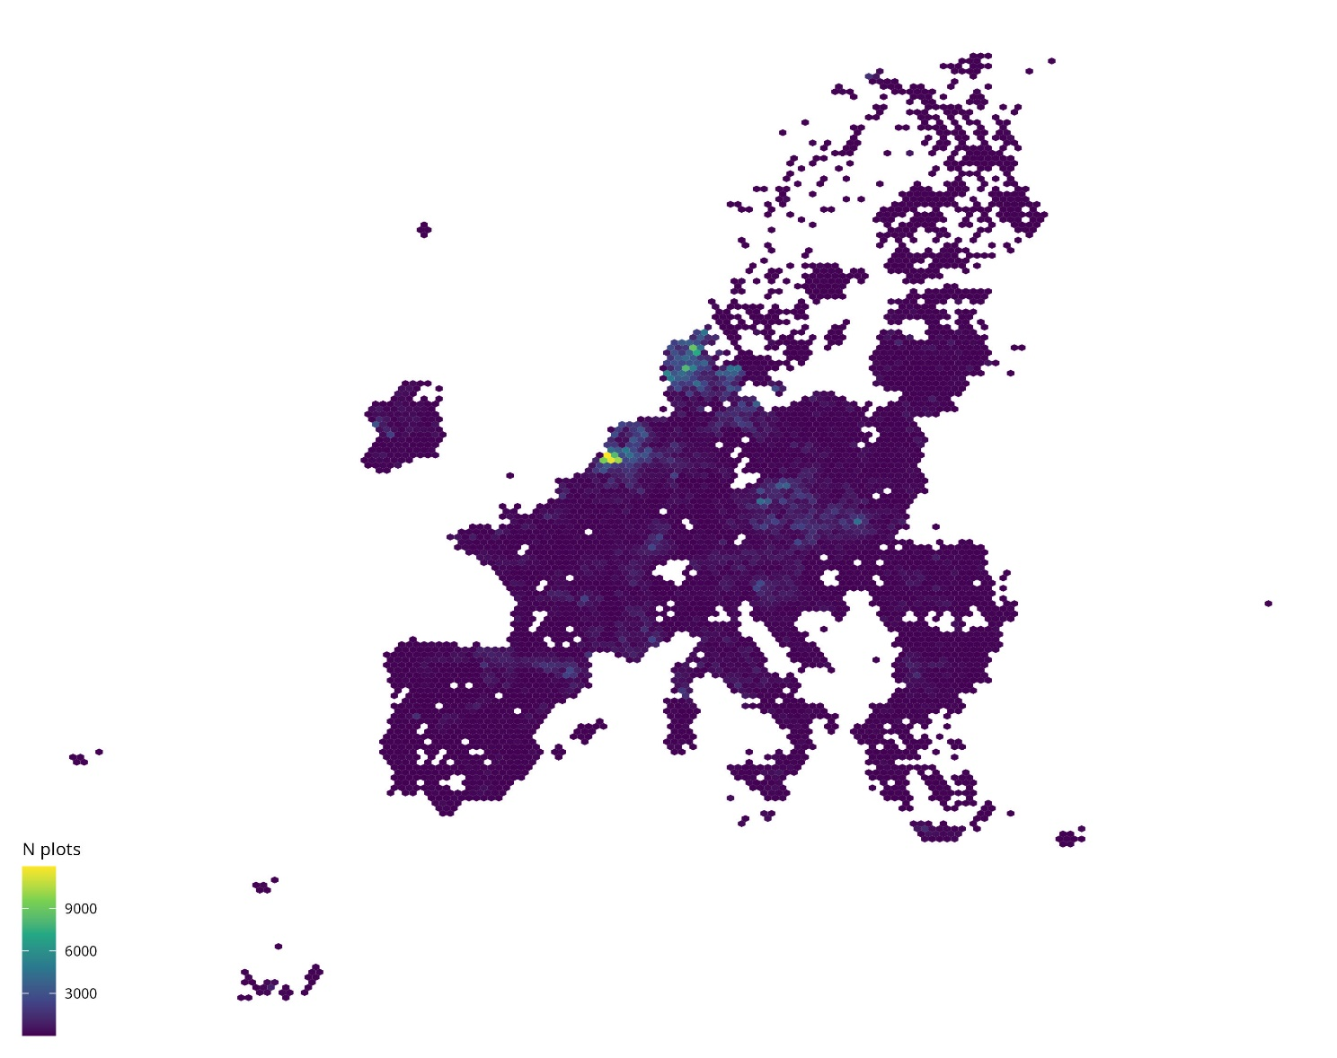
Appendix S2. Aggregated representation of sampling effort over Europe. Colours correspond to plot counts inside each hexagonal bin.

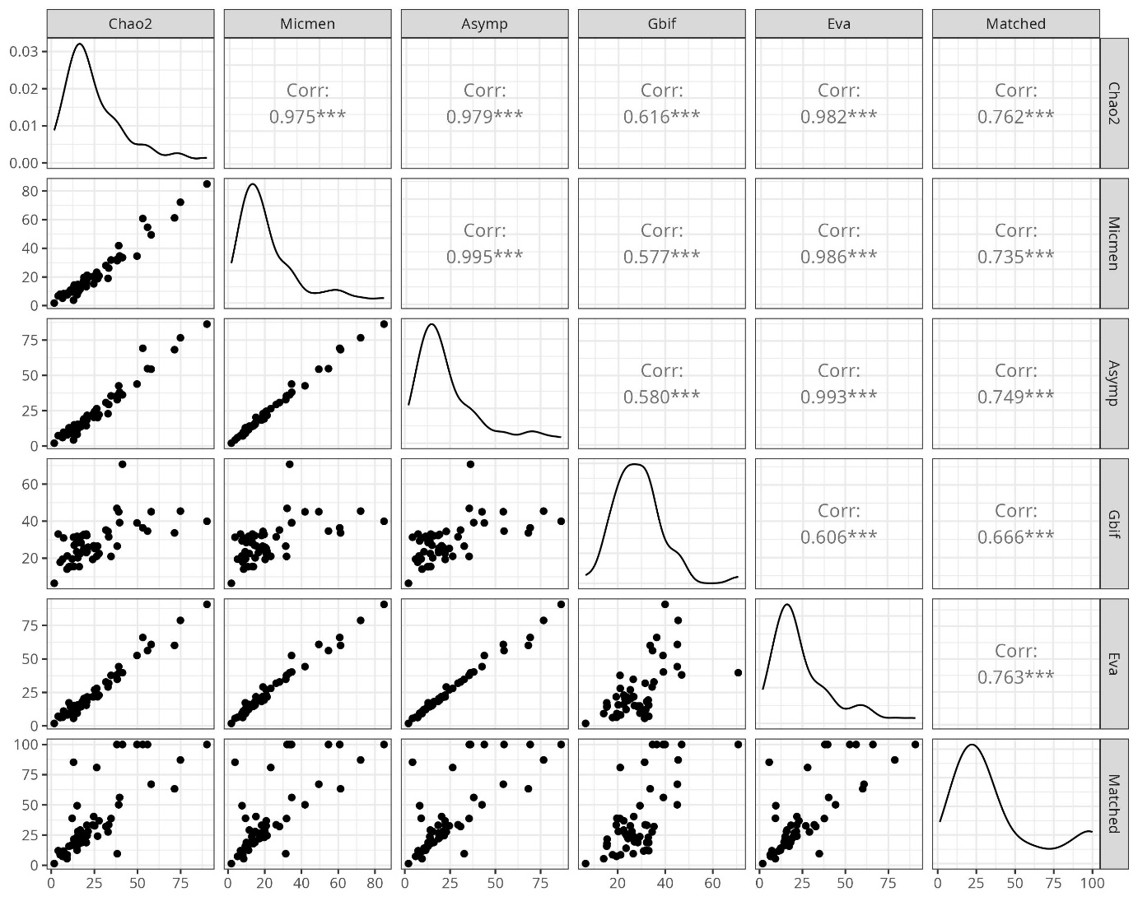
Appendix S3. Pairwise scatterplots and Pearson’s correlation coefficients between overall species richness directly observed using vegetation plots from the European Vegetation Archive (Eva), estimated with the Michaelis-Menten (Micmen), Asymptotic (Asymp) or Chao2 estimators, and derived using independent GBIF observations (Gbif) and the environmentally matched subset (Matched). Significance code: *** p < 0.001

Appendix S4. Species listed in the last EEA report (EEA, 2020) but not found in the EVA database, reported in alphabetical order.
Missing Habitats Directive plant species
Ac-Ce | Ch-Ib | Ib-Pl | Pl-Vi
Acis nicaeensis | Chaenorhinum serpyllifolium | Iberis runemarkii | Plantago malato-belizii
Aconitum corsicum | Chaerophyllum azoricum | Ionopsidium savianum | Platanthera obtusata
Aconitum firmum | Cheirolophus duranii | Iris lusitanica | Poa granitica
Aeonium saundersii | Cheirolophus junonianus | Iris marsica | Polygonum praelongum
Aichryson dumosum | Cheirolophus massonianus | Isoetes boryana | Polystichum drepanum
Alisma wahlenbergii | Chionodoxa lochiae | Isoetes malinverniana | Potentilla emilii-popii
Allium grosii | Cirsium latifolium | Isoplexis chalcantha | Primula apennina
Ammi trifoliatum | Cistus palhinhae | Isoplexis isabelliana | Primula scandinavica
Anarrhinum longipedicellatum | Clinopodium taygeteum | Jacobaea vulgaris | Prunus azorica
Androcymbium europaeum | Cochlearia polonica | Jasminum azoricum | Puccinellia phryganodes
Androcymbium psammophilum | Coincya rupestris | Juncus valvatus | Puccinellia pungens
Androcymbium rechingeri | Colchicum arenarium | Jurinea fontqueri | Pulsatilla grandis
Angelica lignescens | Consolida samia | Kunkeliella subsucculenta | Pulsatilla slavica
Anthyllis hystrix | Convolvulus fernandesii | Lactuca watsoniana | Pulsatilla subslavica
Antirrhinum charidemi | Convolvulus massonii | Laserpitium longiradium | Pulsatilla vulgaris
Antirrhinum lopesianum | Coronopus navasii | Leopoldia gussonei | Pyrus magyarica
Apium bermejoi | Corydalis gotlandica | Leuzea longifolia | Ranunculus kykkoensis
Aquilegia bertolonii | Crambe arborea | Limonium arborescens | Ranunculus weyleri
Aquilegia pyrenaica | Crambe laevigata | Limonium dendroides | Reseda decursiva
Arabis kennedyae | Crambe sventenii | Limonium dodartii | Rhaponticoides fraylensis
Arabis sadina | Cremnophyton lanfrancoi | Limonium insulare | Rhinanthus osiliensis
Arceuthobium azoricum | Crepis granatensis | Limonium lanceolatum | Rhynchosinapis erucastrum
Arctagrostis latifolia | Crepis tectorum | Limonium multiflorum | Ribes sardoum
Arctophila fulva | Crocus cyprius | Limonium pseudolaetum | Rosmarinus tomentosus
Arenaria ciliata | Crocus hartmannianus | Limonium spectabile | Rumex azoricus
Arenaria humifusa | Cyclamen fatrense | Limonium sventenii | Salvia veneris
Arenaria nevadensis | Dactylorhiza kalopissii | Linaria algarviana | Sambucus palmensis
Argyranthemum lidii | Daphne petraea | Linaria ficalhoana | Santolina impressa
Argyranthemum pinnatifidum | Daphne rodriguezii | Linaria hellenica | Saussurea alpina
Argyranthemum thalassophilum | Delphinium caseyi | Linaria ricardoi | Saxifraga cintrana
Argyranthemum winteri | Dendriopoterium pulidoi | Linaria tonzigii | Saxifraga portosanctana
Armeria berlengensis | Dianthus arenarius | Linum dolomiticum | Saxifraga presolanensis
Armeria helodes | Dianthus cintranus | Lotus azoricus | Saxifraga tombeanensis
Armeria neglecta | Dianthus laricifolius | Lotus callis-viridis | Saxifraga vayredana
Armeria sampaioi | Dianthus lumnitzeri | Lotus kunkelii | Scabiosa nitens
Artemisia campestris | Dianthus plumarius | Luzula arctica | Scilla beirana
Artemisia eriantha | Diplazium sibiricum | Lythrum flexuosum | Scilla morrisii
Artemisia laciniata | Diplotaxis ibicensis | Marcetella maderensis | Scrophularia grandiflora
Artemisia oelandica | Diplotaxis siettiana | Marsilea azorica | Semele maderensis
Asphodelus bento-rainhae | Diplotaxis siifolia | Marsilea batardae | Senecio caespitosus
Astragalus algarbiensis | Doronicum plantagineum | Melanoselinum decipiens | Senecio elodes
Astragalus alopecurus | Draba cacuminum | Minuartia smejkalii | Senecio lagascanus
Astragalus maritimus | Draba cinerea | Moehringia jankae | Sideritis cypria
Astragalus peterfii | Draba dorneri | Moehringia lateriflora | Sideritis cystosiphon
Asyneuma giganteum | Echium candicans | Moehringia tommasinii | Sideritis discolor
Athamanta cortiana | Erica azorica | Monanthes wildpretii | Sideritis incana
Atractylis arbuscula | Erodium astragaloides | Monizia edulis | Sideritis infernalis
Atractylis preauxiana | Erodium paularense | Musschia wollastonii | Sideritis javalambrensis
Avenula hackelii | Erodium rupicola | Myosotis azorica | Sideritis marmorea
Azorina vidalii | Erucastrum palustre | Myosotis lusitanica | Sideritis serrata
Bellevalia hackelii | Eryngium viviparum | Myosotis maritima | Silene hicesiae
Bencomia brachystachya | Erysimum pieninicum | Myrica rivas-martinezii | Silene hifacensis
Bencomia sphaerocarpa | Euphorbia bourgeana | Najas tenuissima | Silene holzmannii
Berberis maderensis | Euphorbia handiensis | Narcissus cavanillesii | Silene mariana
Beta patula | Euphorbia margalidiana | Narcissus fernandesii | Silene orphanidis
Biscutella neustriaca | Euphorbia stygiana | Narcissus pseudonarcissus | Silene rothmaleri
Biscutella sempervirens | Euphorbia transtagana | Narcissus scaberulus | Sinapidendron rupestre
Borderea chouardii | Euphrasia azorica | Narcissus segurensis | Sisymbrium cavanillesianum
Brassica glabrescens | Euphrasia grandiflora | Narcissus viridiflorus | Sisymbrium supinum
Brassica hilarionis | Euphrasia marchesettii | Narcissus yepesii | Solanum lidii
Braya linearis | Euphrasia nana | Naufraga balearica | Solenanthus albanicus
Bromus grossus | Ferula latipinna | Nepeta argolica | Sorbus maderensis
Bunium brevifolium | Fritillaria conica | Omphalodes kuzinskyanae | Sorbus teodori
Bupleurum capillare | Fritillaria gussichiae | Ononis maweana | Stemmacantha cynaroides
Calamagrostis chalybaea | Fritillaria obliqua | Onopordum carduelium | Stipa bavarica
Calendula maderensis | Fritillaria rhodocanakis | Onopordum nogalesii | Stipa danubialis
Calypso bulbosa | Galium cracoviense | Onosma tornensis | Stipa veneta
Caralluma burchardii | Galium litorale | Ophioglossum polyphyllum | Sventenia bupleuroides
Carduus myriacanthus | Gaudinia hispanica | Ophrys argolica | Symphytum cycladense
Carex malato-belizii | Gentianella anglica | Ophrys kotschyi | Syringa josikaea
Carex panormitana | Gentianella bohemica | Orchis scopulorum | Tanacetum ptarmiciflorum
Carlina onopordifolia | Geranium maderense | Ornithogalum reverchonii | Tephroseris longifolia
Centaurea akamantis | Globularia ascanii | Orobanche densiflora | Teucrium abutiloides
Centaurea attica | Globularia sarcophylla | Paeonia cambessedesii | Teucrium charidemi
Centaurea balearica | Goodyera macrophylla | Paeonia clusii | Teucrium lepicephalum
Centaurea borjae | Gypsophila papillosa | Paeonia officinalis | Teucrium turredanum
Centaurea heldreichii | Halimium verticillatum | Paeonia parnassica | Thymelaea broteriana
Centaurea horrida | Helianthemum alypoides | Palaeocyanus crassifolius | Thymus camphoratus
Centaurea jankae | Helianthemum bystropogophyllum | Papaver radicatum | Thymus carnosus
Centaurea kalambakensis | Helichrysum melitense | Parolinia schizogynoides | Thymus villosus
Centaurea kartschiana | Helichrysum sibthorpii | Pericallis hadrosoma | Tozzia carpathica
Centaurea lactiflora | Herniaria algarvica | Petagnaea gussonei | Tripolium sorrentinoi
Centaurea micrantha | Herniaria litardierei | Petrocoptis grandiflora | Trisetum subalpestre
Centaurea niederi | Herniaria lusitanica | Petrocoptis montsicciana | Tulipa cypria
Centaurea peucedanifolia | Himantoglossum jankae | Petrocoptis pseudoviscosa | Ulex densus
Centaurea pinnata | Hippuris tetraphylla | Phalaris maderensis | Veronica oetaea
Centaurea pontica | Holcus setiglumis | Phlomis brevibracteata | Vicia bifoliolata
Centaurea princeps | Hormathophylla pyrenaica | Phlomis cypria | Vincetoxicum pannonicum
Centaurea pulvinata | Hyacinthoides vincentina | Picris willkommii | Viola athois
Centaurium rigualii | Hymenostemma pseudanthemis | Pinguicula crystallina | Viola cazorlensis
Centaurium somedanum | Hyoseris frutescens | Pittosporum coriaceum | Viola delphinantha
Centranthus amazonum | Hypericum aciferum | Plantago algarbiensis | Viola jaubertiana
Ceropegia dichotoma | Iberis procumbens | Plantago almogravensis | Viola paradoxa

Appendix S5. Conservation priority species as defined by the EU Habitats Directive detected in some combinations of country and biogeographical region using vegetation plots from the European Vegetation Archive but missing from the EEA report (EEA, 2021).
Country | Biogeographical region | Species
Bulgaria | BLS | Klasea lycopifolia
Bulgaria | CON | Stipa zalesskii
Bulgaria | CON | Tulipa hungarica
Croatia | MED | Aquilegia kitaibelii
Croatia | MED | Asplenium adulterinum
Croatia | MED | Cerastium dinaricum
Czech Republic | CON | Lycopodium zeilleri
Denmark | ATL | Carex holostoma
France | ATL | Anchusa crispa
France | ATL | Centaurea corymbosa
France | ATL | Herniaria maritima
France | CON | Centaurea corymbosa
Germany | ATL | Myosotis rehsteineri
Germany | CON | Lycopodium zeilleri
Greece | MED | Mandragora officinarum
Italy | ALP | Centranthus trinervis
Italy | ALP | Crocus etruscus
Italy | CON | Primula glaucescens
Italy | MED | Colchicum corsicum
Italy | MED | Linaria coutinhoi
Italy | MED | Spergularia azorica
Lithuania | CON | Linaria loeselii
Poland | ALP | Galium sudeticum
Portugal | MED | Oenanthe divaricata
Portugal | MED | Sibthorpia peregrina
Romania | CON | Arnica montana
Romania | CON | Campanula romanica
Romania | STE | Dianthus diutinus
Slovak Republic | CON | Cirsium brachycephalum
Slovak Republic | PAN | Dianthus nitidus
Slovenia | PAN | Eleocharis carniolica
Spain | ALP | Erigeron frigidus
Spain | ATL | Euphorbia nevadensis
Spain | ATL | Pseudarrhenatherum pallens
Spain | MAC | Oenanthe divaricata
Spain | MED | Festuca henriquesii
Spain | MED | Woodwardia radicans

Appendix S6. Percentage (%) of priority species found exclusively within, exclusively outside, and shared between areas inside and outside the Natura 2000 network compared to the total reported by the EEA (also including unreported priority species that were only found in the EVA dataset) for each combination of country and biogeographical region of the EU (A). The % of missing species is also reported. GLM coefficients of the proportion of priority species found within the network against countries (B) and biogeographical regions (C) accounting for sampling effort. Black bars and dots indicate, respectively, the 95% confidence interval and the mean of the GLM coefficients. The dashed lines indicate the average pattern over Europe. Abbreviations: TOT - Total. See Figure 1 for additional abbreviations.
Appendix S7. Percentage (%) of native and priority species found exclusively within, exclusively outside, and shared between areas inside and outside the Natura 2000 network for each combination of country and biogeographical region of the EU. The percentage of land inside the network is also reported. Native species numbers were estimated using Chao2, based on the data contained in the European Vegetation Archive. Priority species numbers are based on raw counts. NAs indicate missing values in a particular combination of country and biogeographical region.
 | Native species |  |  | Priority species |  |  |  | % land in N2K
 | Shared | Inside | Outside | Shared | Inside | Outside | Missing | % land in N2K
Austria
TOT | 73.84 | 7.75 | 18.41 | 13.51 | 8.11 | 18.92 | 59.46 | 0.15
ALP | 69.69 | 11.35 | 18.96 | 15.38 | 11.54 | 15.38 | 57.69 | 0.16
CON | 71.72 | 7.93 | 20.35 | 8.33 | 8.33 | 20.83 | 62.50 | 0.14
Belgium
TOT | 69.90 | 9.18 | 20.92 | 16.67 | 0.00 | 33.33 | 50.00 | 0.13
ATL | 67.80 | 13.24 | 18.96 | 0.00 | 0.00 | 66.67 | 33.33 | 0.09
CON | 66.63 | 0.46 | 32.91 | 20.00 | 0.00 | 20.00 | 60.00 | 0.18
Bulgaria
TOT | 71.03 | 20.02 | 8.96 | 8.00 | 12.00 | 4.00 | 76.00 | 0.35
ALP | 54.48 | 38.94 | 6.58 | 8.33 | 8.33 | 0.00 | 83.33 | 0.63
BLS | 38.98 | 55.84 | 5.19 | 20.00 | 0.00 | 0.00 | 80.00 | 0.55
CON | 72.88 | 11.28 | 15.84 | 10.00 | 10.00 | 5.00 | 75.00 | 0.27
Croatia
TOT | 54.47 | 15.49 | 30.04 | 12.50 | 29.17 | 0.00 | 58.33 | 0.36
ALP | 25.24 | 73.00 | 1.76 | 0.00 | 47.06 | 0.00 | 52.94 | 0.60
CON | 59.20 | 9.13 | 31.66 | 25.00 | 12.50 | 0.00 | 62.50 | 0.24
MED | 42.64 | 22.70 | 34.66 | 13.33 | 26.67 | 0.00 | 60.00 | 0.46
Cyprus
TOT | 52.12 | 12.66 | 35.22 | NA | NA | NA | NA | 0.30
MED | 52.12 | 12.66 | 35.22 | NA | NA | NA | NA | 0.30
Czech Republic
TOT | 70.36 | 5.62 | 24.02 | 43.24 | 8.11 | 21.62 | 27.03 | 0.14
CON | 67.82 | 5.32 | 26.87 | 43.75 | 9.38 | 18.75 | 28.12 | 0.14
PAN | 61.38 | 5.31 | 33.31 | 15.38 | 0.00 | 38.46 | 46.15 | 0.15
Denmark
TOT | 77.73 | 6.64 | 15.63 | 37.50 | 12.50 | 0.00 | 50.00 | 0.07
ATL | 74.18 | 10.80 | 15.02 | 50.00 | 0.00 | 0.00 | 50.00 | 0.09
CON | 82.38 | 4.70 | 12.92 | 50.00 | 16.67 | 0.00 | 33.33 | 0.07
Estonia
TOT | 72.52 | 2.33 | 25.16 | 0.00 | 0.00 | 20.00 | 80.00 | 0.17
BOR | 72.52 | 2.33 | 25.16 | 0.00 | 0.00 | 20.00 | 80.00 | 0.17
Finland
TOT | 54.74 | 1.86 | 43.40 | 0.00 | 0.00 | 13.33 | 86.67 | 0.13
ALP | 84.66 | 5.06 | 10.28 | 0.00 | 0.00 | 12.50 | 87.50 | 0.75
BOR | 39.29 | 2.78 | 57.92 | 0.00 | 0.00 | 14.81 | 85.19 | 0.09
France
TOT | 87.06 | 6.39 | 6.55 | 38.81 | 22.39 | 8.96 | 29.85 | 0.13
ALP | 69.45 | 14.30 | 16.25 | 33.33 | 26.67 | 6.67 | 33.33 | 0.34
ATL | 76.18 | 5.83 | 17.98 | 48.00 | 16.00 | 8.00 | 28.00 | 0.08
CON | 83.14 | 9.71 | 7.15 | 36.84 | 26.32 | 15.79 | 21.05 | 0.12
MED | 78.68 | 10.14 | 11.18 | 31.43 | 14.29 | 11.43 | 42.86 | 0.24
Germany
TOT | 70.72 | 9.17 | 20.10 | 17.86 | 10.71 | 17.86 | 53.57 | 0.15
ALP | 66.76 | 18.18 | 15.06 | 28.57 | 14.29 | 14.29 | 42.86 | 0.38
ATL | 60.22 | 0.68 | 39.10 | 11.11 | 0.00 | 44.44 | 44.44 | 0.09
CON | 69.81 | 9.85 | 20.34 | 14.81 | 14.81 | 11.11 | 59.26 | 0.17
Greece
TOT | 51.97 | 27.21 | 20.81 | 5.00 | 16.67 | 5.00 | 73.33 | 0.27
MED | 51.97 | 27.21 | 20.81 | 5.00 | 16.67 | 5.00 | 73.33 | 0.27
Hungary
TOT | 48.53 | 34.66 | 16.82 | 5.88 | 8.82 | 2.94 | 82.35 | 0.21
PAN | 48.53 | 34.66 | 16.82 | 5.88 | 8.82 | 2.94 | 82.35 | 0.21
Ireland
TOT | 76.64 | 8.38 | 14.98 | 100.00 | 0.00 | 0.00 | 0.00 | 0.13
ATL | 76.64 | 8.38 | 14.98 | 100.00 | 0.00 | 0.00 | 0.00 | 0.13
Italy
TOT | 78.56 | 11.39 | 10.04 | 16.83 | 12.87 | 4.95 | 65.35 | 0.19
ALP | 69.76 | 15.49 | 14.75 | 24.39 | 12.20 | 2.44 | 60.98 | 0.32
CON | 77.23 | 9.43 | 13.34 | 11.43 | 5.71 | 8.57 | 74.29 | 0.10
MED | 72.95 | 17.75 | 9.29 | 14.06 | 18.75 | 4.69 | 62.50 | 0.20
Latvia
TOT | 73.03 | 22.92 | 4.05 | 6.67 | 13.33 | 6.67 | 73.33 | 0.11
BOR | 73.03 | 22.92 | 4.05 | 6.67 | 13.33 | 6.67 | 73.33 | 0.11
Lithuania
TOT | 0.00 | 0.00 | 100.00 | 0.00 | 0.00 | 16.67 | 83.33 | 0.12
BOR | 0.00 | 0.00 | 100.00 | 0.00 | 0.00 | 16.67 | 83.33 | 0.12
Luxembourg
TOT | 32.41 | 0.00 | 71.44 | NA | NA | NA | NA | 0.25
CON | 32.41 | 0.00 | 71.44 | NA | NA | NA | NA | 0.25
Malta
 | NA | NA | NA | NA | NA | NA | NA | NA
Netherlands
TOT | 76.82 | 5.92 | 17.25 | 75.00 | 0.00 | 25.00 | 0.00 | 0.14
ATL | 76.82 | 5.92 | 17.25 | 75.00 | 0.00 | 25.00 | 0.00 | 0.14
Poland
TOT | 66.28 | 10.09 | 23.64 | 21.05 | 15.79 | 13.16 | 50.00 | 0.20
ALP | 61.06 | 26.81 | 12.14 | 15.38 | 7.69 | 0.00 | 76.92 | 0.50
CON | 66.57 | 5.73 | 27.70 | 22.58 | 16.13 | 16.13 | 45.16 | 0.19
Portugal
TOT | 54.45 | 13.19 | 32.36 | 1.78 | 4.14 | 1.78 | 92.31 | 0.20
ATL | 50.76 | 31.77 | 17.47 | 9.09 | 4.55 | 4.55 | 81.82 | 0.19
MAC | 5.26 | 4.11 | 90.63 | NA | NA | NA | NA | 0.18
MED | 59.45 | 14.20 | 26.35 | 1.94 | 5.83 | 2.91 | 89.32 | 0.20
Romania
TOT | 65.14 | 13.62 | 21.23 | 15.91 | 9.09 | 15.91 | 59.09 | 0.22
ALP | 57.86 | 23.40 | 18.74 | 21.05 | 10.53 | 0.00 | 68.42 | 0.39
BLS | 30.99 | 13.21 | 55.80 | NA | NA | NA | NA | 0.59
CON | 55.59 | 4.78 | 39.63 | 3.45 | 6.90 | 31.03 | 58.62 | 0.16
PAN | 52.15 | 6.56 | 41.29 | 10.00 | 10.00 | 10.00 | 70.00 | 0.15
STE | 29.73 | 9.04 | 61.24 | 0.00 | 8.33 | 16.67 | 75.00 | 0.21
Slovak Republic
TOT | 70.10 | 12.07 | 17.82 | 9.76 | 19.51 | 9.76 | 60.98 | 0.29
ALP | 65.10 | 14.27 | 20.62 | 10.34 | 20.69 | 3.45 | 65.52 | 0.34
PAN | 58.99 | 2.97 | 38.05 | 4.17 | 8.33 | 16.67 | 70.83 | 0.19
Slovenia
TOT | 62.48 | 19.02 | 18.49 | 15.62 | 25.00 | 12.50 | 46.88 | 0.38
ALP | 60.92 | 29.93 | 9.16 | 15.00 | 40.00 | 10.00 | 35.00 | 0.54
CON | 52.40 | 9.37 | 38.24 | 8.70 | 8.70 | 21.74 | 60.87 | 0.28
Spain
TOT | 73.07 | 11.29 | 15.64 | 9.28 | 8.25 | 5.15 | 77.32 | 0.27
ALP | 67.43 | 17.16 | 15.41 | 17.65 | 23.53 | 5.88 | 52.94 | 0.54
ATL | 61.94 | 16.71 | 21.35 | 24.24 | 6.06 | 12.12 | 57.58 | 0.25
MAC | 53.22 | 14.43 | 32.35 | 0.00 | 6.56 | 8.20 | 85.25 | 0.47
MED | 73.90 | 12.98 | 13.11 | 9.76 | 9.76 | 3.25 | 77.24 | 0.27
Sweden
TOT | 33.64 | 3.47 | 62.89 | 0.00 | 0.00 | 15.91 | 84.09 | 0.12
ALP | 40.00 | 35.38 | 24.62 | NA | NA | NA | NA | 0.45
BOR | 25.50 | 0.00 | 74.85 | 0.00 | 0.00 | 18.75 | 81.25 | 0.04
CON | 8.15 | 1.63 | 90.21 | 0.00 | 0.00 | 9.09 | 90.91 | 0.05
Total
ALP | 75.20 | 15.40 | 9.40 | 19.49 | 20.34 | 4.24 | 55.93 | 0.39
ATL | 73.60 | 10.02 | 16.38 | 36.84 | 10.53 | 8.77 | 43.86 | 0.11
BLS | 48.27 | 44.57 | 7.16 | 14.29 | 0.00 | 0.00 | 85.71 | 0.56
BOR | 68.67 | 7.42 | 23.91 | 4.26 | 2.13 | 23.40 | 70.21 | 0.08
CON | 76.33 | 8.36 | 15.32 | 22.64 | 6.60 | 10.38 | 60.38 | 0.16
MAC | 43.43 | 10.13 | 46.44 | 0.00 | 3.23 | 4.03 | 92.74 | 0.39
MED | 72.60 | 16.78 | 10.63 | 9.82 | 11.90 | 4.17 | 74.11 | 0.25
PAN | 69.68 | 4.78 | 25.53 | 15.79 | 10.53 | 13.16 | 60.53 | 0.20
STE | 29.74 | 9.02 | 61.24 | 0.00 | 8.33 | 16.67 | 75.00 | 0.21

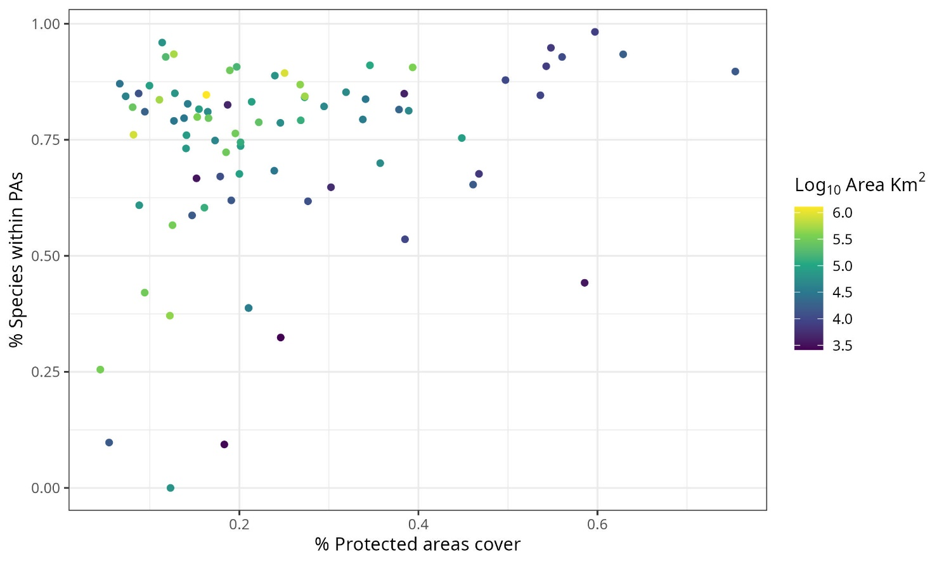Appendix S8. Percentage (%) of native species found within of the Natura 2000 network versus the percentage of land surface covered by the N2K network for each EU country, biogeographical region and their combination of country and biogeographical region of the EU.

Appendix S9. Percentage (%) of priority species found exclusively within, exclusively outside, and shared between areas inside and outside the Natura 2000 network compared to the total reported by the EEA for each combination of country and biogeographical region of the EU. Abbreviations: TOT - Total. See Figure 1 for additional abbreviations.

