Appendix S6. Evaluating the possible effect of sampling differences on alien biodiversity metrics
The worldwide distribution of the alien observed and dark diversities might bear some signal from varying sampling efforts across study regions. Since we analyze observed data, unrecorded but actually present alien species might have been included in dark diversity, even if, by the definition, dark diversity should include only currently absent species (Pärtel et al. 2011). By estimating the variability in alien plant species sampling across the world, we can examine the potential effects of sampling efforts on the patterns of alien observed and dark diversity.
Sampling differences among regions can be estimated by the sample coverage (8), a measure of sample completeness considering information on species abundance distributions (8). Sample coverage can be interpreted as a likelihood that an additional record from a region is a species that is already known from that region. Sample coverage can vary between 0 and 1. The method was elaborated by Anne Chao and Jost (2012), and it uses the number of singletons (species recorded just once), doubletons (species recorded twice), and the total number of recorded individuals. Those metrics were used to calculate the sample coverage through the R package iNEXT (Hsieh et al. 2016). Thus, we need to have data on the number of sampled individuals (in databases number of records) for each alien species known in a region. Unfortunately, the Plants of the World database does not include any abundance measures, just a record of presences. As the best substitute, we used the Global Biodiversity Information Facility (GBIF) and retrieved the number of records for observed alien plant species (based on the Plants of the World database) from all analyzed regions. This was added to our one record from the Plants of the World database. GBIF compiles very many different databases and should reflect the general botanical sampling intensity in regions. We mapped sample coverage at native and alien ranges across the world and correlated it with both, alien observed and dark diversity (Spearman correlation since data wasn’t normally distributed).
Fig. S5. Sample coverage of observed alien species in native (panel a) and alien ranges (panel b) across the world, based on united GBIF and Plants of the World databases.
Sample coverage at the native and alien range was generally high (median of 0.88, standard deviation = 0.37; and median 0.87, sd= 0.26, respectively), but it varied across the world. The tropical regions displayed lower sample coverage and at the alien ranges the smallest values were found in Africa and some regions in Asia. At the native range, sample coverage was weakly correlated with alien observed diversity (Spearman’s ρ = 0.16, p-value = 0.003) but especially weakly with alien dark diversity (Spearman’s ρ = -0.11, p-value = 0.047), our estimated metric. This suggests that our ecological indication wasn't strongly biased by sample coverage. Alien sample coverage had a weak positive but significant correlation with alien observed diversity (Spearman’s ρ = 0.19, p<0.001), and an even weaker negative correlation with the alien dark diversity size (Spearman’s ρ = -0.11, p-value = 0.036).
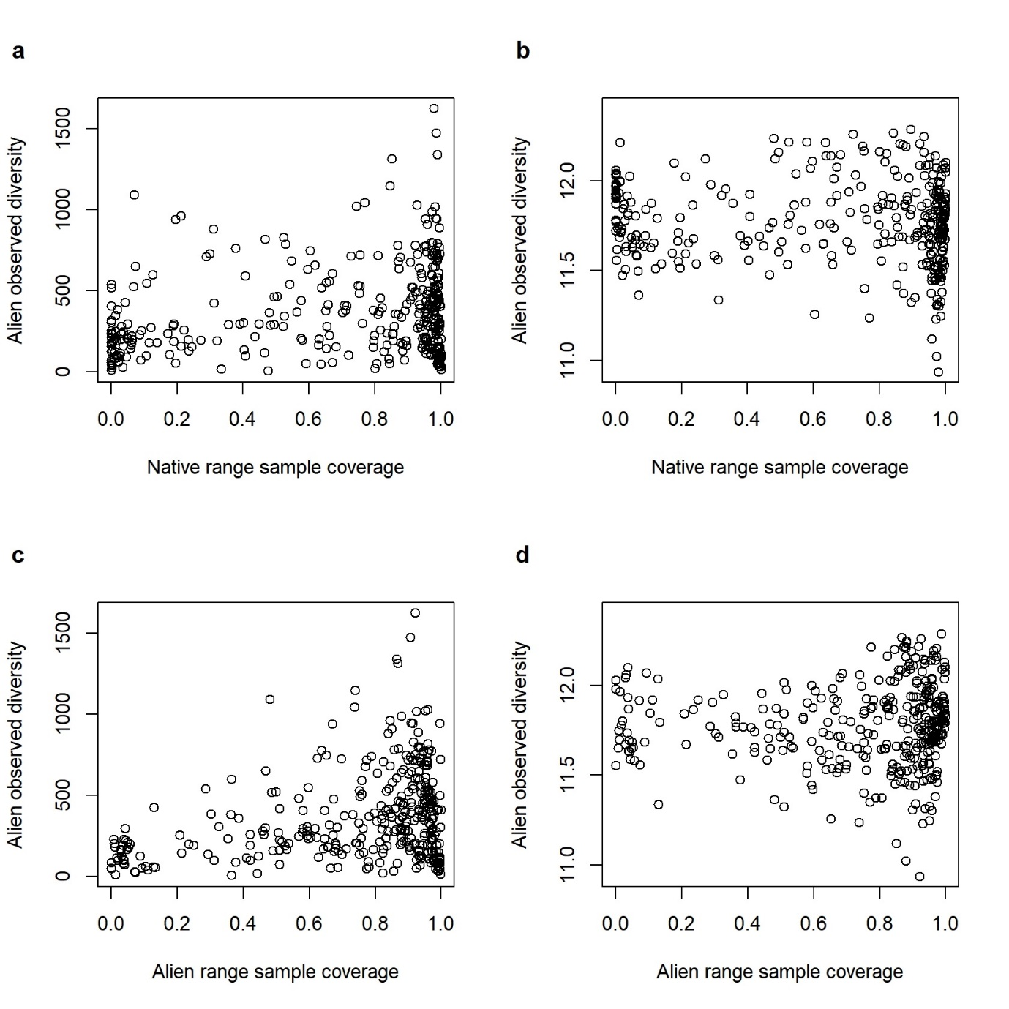
Fig. S6. Scatterplot of sample coverage in relation to both alien observed and dark diversity. The x-axis in all scatterplots contains the sample coverage in all studied regions. While the y-axis on the a and c panels presents the number of observed alien species, the y-axis on the b and d plots displays the alien dark diversity size.
We conclude that sample coverage, in general, does not contribute much to the global patterns of alien observed and dark diversity, but results for regions with low sample coverage must be taken with caution. Nevertheless, the low sample coverage influences alien observed rather than alien dark diversity.

Appendix S6 References
Chao, A., & Jost, L. (2012). Coverage-based rarefaction and extrapolation: Standardizing samples by completeness rather than size. Ecology, 93(12), 2533–2547. https://doi.org/10.1890/11-1952.1
GBIF. (2023). Derived dataset. Filtered export of GBIF occurrence data. Global Biodiversity Information Facility. https://doi.org/10.15468/dd.rxhez8
Hsieh, T. C., Ma, K. H., & Chao, A. (2016). iNEXT: An R package for rarefaction and extrapolation of species diversity (Hill numbers). Methods in Ecology and Evolution, 7(12), 1451–1456. https://doi.org/10.1111/2041-210X.12613
Pärtel, M., Szava-Kovats, R., & Zobel, M. (2011). Dark diversity: Shedding light on absent species. Trends in Ecology & Evolution, 26(3), 124–128. https://doi.org/10.1016/j.tree.2010.12.004

