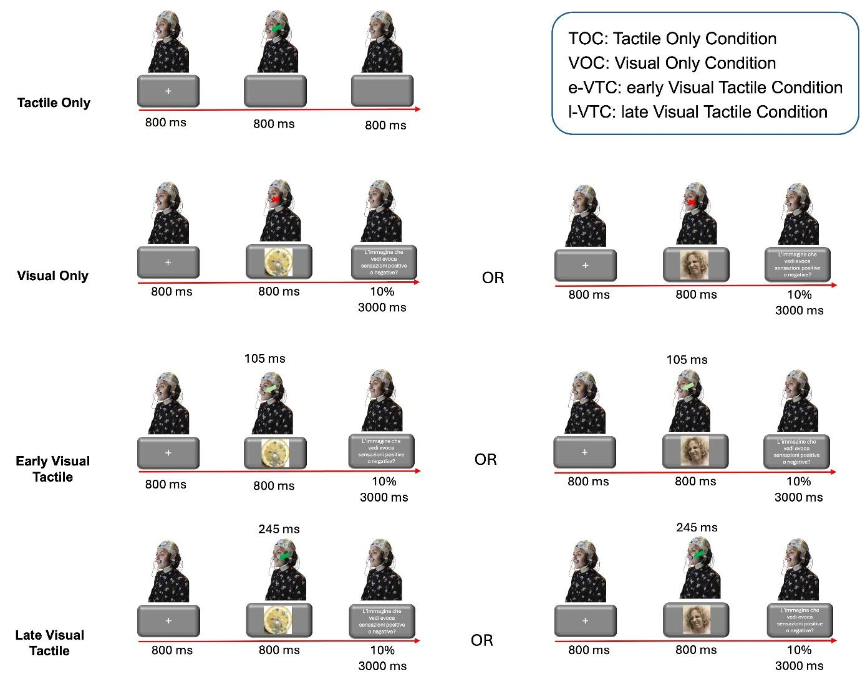Fig. 1. Trial structure for experimental conditions. Each trial began with a fixation cross, followed by the presentation of either a disgusting image, a disgusted face, or nothing (blank screen). In the Early Tactile condition, a tactile stimulation was delivered 105 ms after the visual stimulus onset, while in the Late Tactile condition, the stimulation was delivered at 245 ms after the visual stimulus onset. In the Visual Only condition, no tactile stimulation was provided. Additionally, in the pictures, only Late "Tactile Only" condition is included because we used only one in the analysis (see below). Finally, in 10% of the trials, participants gave a valence rating in response to the question: "Did the image you see evoke positive or negative feelings?".
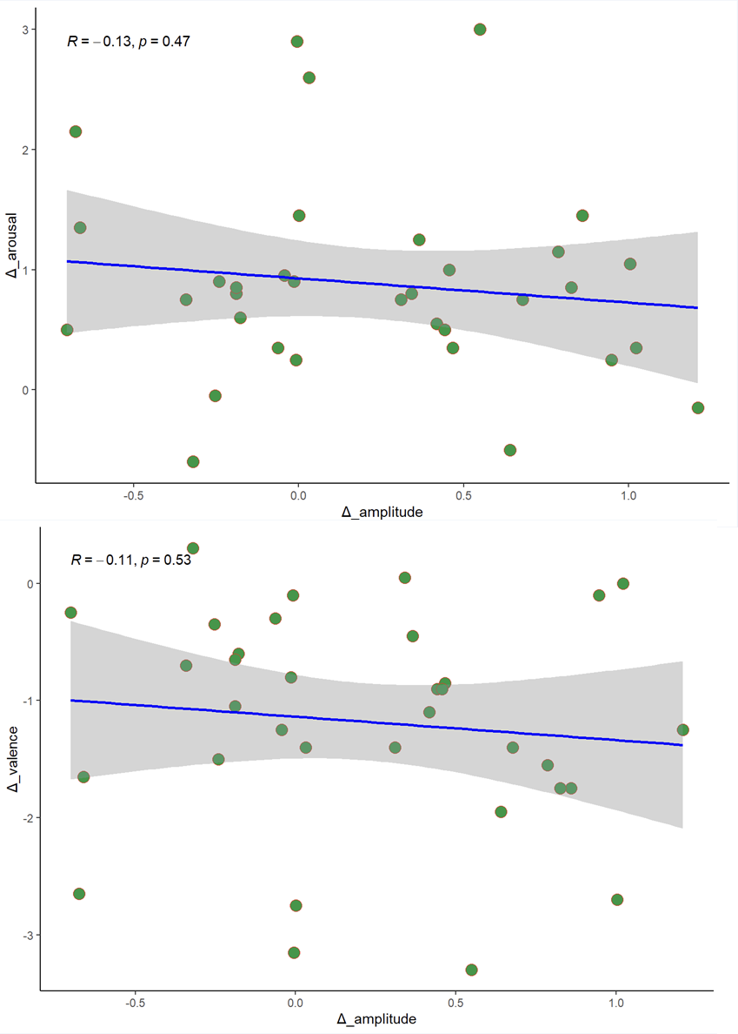
Fig 2. Plots depict not-significant correlation between signal amplitude difference between facial expressions and images SEPs in the early time window and arousal (top) and valence (bottom) scores.

