Assessment of Indoor Air Pollution from Cooking and Cleaning Activities in Italian Restaurant Kitchens
Marta Keller ^{a*}, Andrea Cattaneo ª, Davide Campagnolo ^{a*}, Francesca Borghi ^{b}, Alessio Carminati ª, Giacomo Fanti ª, Sabrina Rovelli ª, Carolina Zellino ª, Andrea Spinazzè ª, Victor G. Mihucz ^{c}, Carlo Dossi ^{d}, Domenico M. Cavallo ª
ª Department of Science and High Technology, University of Insubria, via Valleggio 11, 22100 Como, Italy
^{b} Department of Medical and Surgical Sciences, University of Bologna, via Pelagio Palagi 9, 40138 Bologna, Italy
^{c} Institute of Chemistry, Eötvös Loránd University, Pázmány Péter sétány 1/A, H-1117 Budapest, Hungary
^{d} Department of Theoretical and Applied Science, University of Insubria, via J.H. Dunant 3, 21100 Varese, Italy

*Corresponding authors:
Marta Keller
via Valleggio, 11 – 22100 Como – Italy
Tel.: +39 031 2386628; Fax: +39 031 2386630
E-mail address: marta.keller10@gmail.com
Davide Campagnolo
via Valleggio, 11 – 22100 Como – Italy
Tel.: +39 031 2386621; Fax: +39 031 2386630
E-mail address: davide.campagnolo@uninsubria.it

Supplementary material
Table SM1-Checklist submitted to each owner for each restaurant, to collect information on the cuisine and activities.
n | Question | Information
1 | Restaurant age (year)
2 | Kitchen area (m²)
3 | Wall height (m)
4 | Number doors of the kitchen
5 | Is there a door bordering the outside?
6 | Number people in kitchen
7 | Outdoor environments | - Rural  - Suburban  - Center  - Industrial area  - Other (specify)
8 | Outdoor sources | - Vehicular traffic  - Subway / train station  - Countryside  - Other (specify)
9 | Is there a “passe”? | - Yes  - No
10 | Kitchen ventilation | - Air vents  - Windows  - Other (specify)
11 | Number windows and orientation (N/S/E/W)
12 | Can the windows open? | - Yes  - No
13 | Types of window frame | - Metal  - Wood  - Aluminium  - Other (specify)
14 | Position of the air supply devices | - Absent  - Floor  - Walls  - Ceiling  - Other (specify)
15 | N hoods and size
16 | Hood types | - Telescopic (on the kitchen top)  - Built-in  - Integrated  - Island  - Other (specify)
17 | Number stoves and oven
18 | Type of stoves and oven | - Gas  - Induction  - Electric oven  - Gas oven  - Other (specify)
19 | What types of heating systems are there? | - Nothing  - Radiators  - Fan Coil  - Centralized  - On the floor  - Heat pumps  - Other (specify)
20 | What types of cooling systems are there? | - Nothing  - Windows  - Centralized  - On the floor  - Air conditioning  - Fan Coil  - Other (specify)
21 | Presence of sunscreen on the windows | - Curtains  - Shutters  - Venetian blinds  - Other (specify)  - None
22 | Control of sunscreen | - Manual  - Automatic  - Other (specify)
23 | Floor cleaning (frequency, last time it was cleaned, product type (brand))
24 | Windows cleaning (frequency, last time it was cleaned, product type (brand))
25 | Cleaning the work surface (frequency, last time it was cleaned, product type (brand))
26 | Dishwasher | - Waiter - Dishwasher  - Assistent Cook – Dishwasher  - Dishwasher
27 | Working hours of the dishwasher (start and end)
28 | Dish soap (product type (brand))
29 | Dishwasher detergent (product type (brand))

Table SM2- Detection range and limits of the on-line instrumentation used to monitor the selected air pollutants.
Pollutant | Operating principle | Range | LOD
O₃ | UV adsorption at 254 nm | 0 ppb-10 ppm | 0.003 ppm
TVOCs | Photo Ionization Detector | 0.00-20 ppm | 0.01 ppm
HCHO | Electrochemical Sensor | 0.00-10 ppm | 0.01 ppm
UFPs | Condensation Particle Counter | 0-500,000 pt/cm³ | 0.02 µm
NO₂ | Electrochemical Sensor | 0.00-0.25 ppm | 0.02 ppm
CO₂ | Non-dispersive Infra-Red analysis | 0-2500 ppm | 170 ppm
LOD= Limit of detection
Table SM3- Operating parameters of the ATD-GC-FID instrumentation.
ATD
Carrier gas | Helium
Oven Temperature | 280 °C
Primary Desorption Time | 6 min
Desorb Flow | 20 mL/min
Trap Law Temperature | -12 °C
Trap High Temperature | 300 °C
Trap Fast | 40 °C/s
Valve Temperature | 200 °C
Transfer Line Temperature | 200 °C
Trap Hold | 1 min
GC-FID
Carrier gas | Helium, 1 mL/min
Column Temperature program | 50 °C, 5 min; 2 °C/min to 100 °C; 10 °C/min to 200 °C; 200 °C, 10 min
FID temperature | 250 °C
Flame Composition | Hydrogen and Air
Total Run Time | 55 min

Table SM4- Operating parameters of the HPLC-UV instrumentation.
HPLC-PDA
Eluent A | Acetonitrile, 60%
Eluent B | MilliQ water, 40%
Pump flow | 1 mL/min
Pump Pressure | 80 bar
Oven Temperature | 40 °C
Injection Volume | 20 µL
Detector Operating Wavelength | 360 nm

Identification and quantification of organic molecules
The qualitative identification of the target Volatile Organic Compounds (VOCs) was conducted by comparing the retention times of peaks obtained in real samples with those from standard solutions. Each analyte's retention time was determined by analyzing every individual standard solution using the same procedure applied to real samples. An aliquot (1μL) of each standard was added to a Tenax TA tube. Chrom-Card software facilitated chromatographic analysis, particularly for quantitative determination. For this purpose, a single standard stock solution was prepared for each analyte by diluting 120 μL of the pure liquid analyte in 50 mL of pure heptane (Sigma Aldrich, Milwaukee, WI, USA). From these single-standard stock solutions, four multi-standards were prepared at approximately 80, 40, 20, and 5 μg/mL. Instrument calibration involved adding an aliquot (1μL) of each multi-standard solution into four different Tenax TA test tubes, covering a mass range from approximately 5 to 80 ng.
As for the VOCs, the qualitative identification of the target aldehydes was performed by comparing the retention times of the peaks obtained in the real samples with those obtained from the standard. These were prepared by diluting the analytes of interest in a solution of milliQ water and acetonitrile (40:60) to a concentration of approximately 0.1 μg/g. LabSolutions software was used for qualitative identification and quantitative analysis. For quantification, a single stock standard solution was prepared for each analyte by diluting it with a solution of milliQ water and acetonitrile (40:60). From these single standard stock solutions, four multistandard solutions were prepared at approximately 0.125, 0.1, 0.075 and 0.05 μg/g and assayed (20 μL) to calibrate the instrument.
The VOC and aldehyde calibration curves were calculated using heights rather than areas because the complexity of the real samples caused peak overlaps between target analytes and other sampled compounds, sometimes making it difficult to properly separate peaks and obtain an accurate area value (Zhang et al. 2017). The limits of detection (LOD) and quantification (LOQ) were determined as 3 and 10 times the standard deviation of the background noise divided by the slope (m) of the calibration curves. The LODs and LOQs were expressed both as mass (pg) and concentration in air (ng/m³), considering the average volume of air sampled during the field campaigns carried out in restaurants. Considering that all selected contaminants can have adverse effects on human health (Antonelli et al. 2020; Soni et al. 2018), it is crucial to have accurate methods for their evaluation. The LODs and LOQs determined are much lower than those present in the literature (Tokumura et al. 2016; Mandin et al. 2017). This is essential to allow the determination of organics at environmental concentration levels. Furthermore, all the analytes showed a good linearity in the investigated concentration range (Table SM5).

Table SM5- List of the investigated analytes and the values of slope (m), intercept (q), correlation coefficients (R²) and the calculated limits of detection (LODs) and limits of quantification (LOQs), both as mass and concentrations in air.
Analyte | m | q | R² | LOD (pg) | LOQ (pg) | LOD (ng/m³) | LOQ (ng/m³)
Benzene | 210.65 | 355.02 | 0.996 | 81.2 | 271 | 51 | 170
Toluene | 205.7 | 742.5 | 0.993 | 83.1 | 277 | 52.2 | 174
Ethylbenzene | 185.81 | 156.96 | 0.997 | 92.0 | 307 | 57.7 | 193
p-Xylene | 186.64 | 216.45 | 0.997 | 91.6 | 305 | 57.5 | 191
m-Xylene | 12757 | 28515 | 0.995 | 175 | 584 | 110 | 367
o-Xylene | 179.5 | 194.14 | 0.995 | 95.3 | 318 | 59.8 | 200
Styrene | 194.3 | 196.45 | 0.997 | 88.0 | 293 | 55.2 | 184
α-Pinene | 157.3 | 169.09 | 0.997 | 109 | 362 | 68.4 | 227
d-Limonene | 166.4 | 311.83 | 0.995 | 103 | 343 | 64.6 | 215
p-Cymene | 182.26 | 87.37 | 0.998 | 93.8 | 313 | 58.9 | 196
2-Butoxyethanol | 157.3 | 223.5 | 0.997 | 109 | 362 | 68.4 | 227
Formaldehyde | 63554 | 0 | 0.999 | 230 | 760 | 15.5 | 513
Acetaldehyde | 49019 | -53.211 | 0.999 | 290 | 980 | 19.6 | 661
Acrolein | 30968 | -105.23 | 0.995 | 470 | 1600 | 31.7 | 108
Propionaldehyde | 30099 | 63.189 | 0.999 | 480 | 1600 | 32.4 | 108
Benzaldehyde | 14320 | -80.592 | 0.999 | 10000 | 3400 | 67.4 | 229
Glutaraldehyde | 7304 | 0.5835 | 0.999 | 20000 | 6600 | 135 | 445

Figure SM1- Violin plots of the winter and summer campaigns of indoor pollutants investigated in restaurant kitchens. Light blue: winter campaign, dark red: summer campaign; *: p < 0.01 and **: p < 0.001 indicate statistically significant differences between seasons in the M-W test.
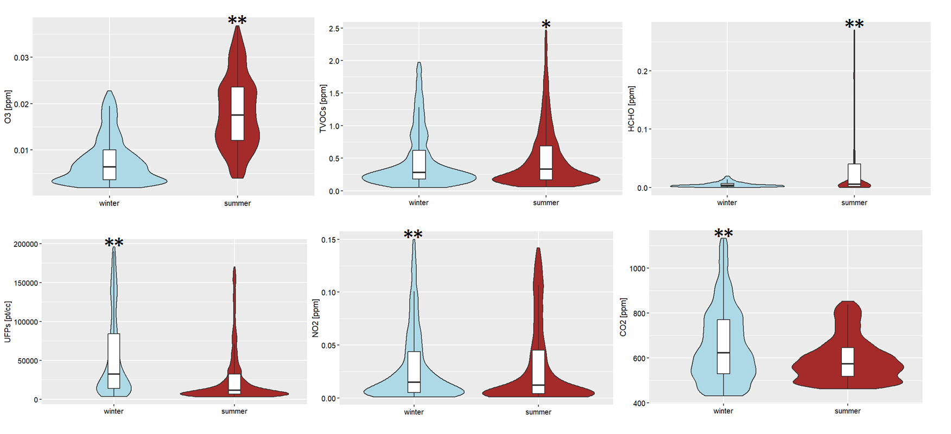

Figure SM2- Spearman correlation matrix showing relationships between pollutants and other additional parameters (winter campaign).
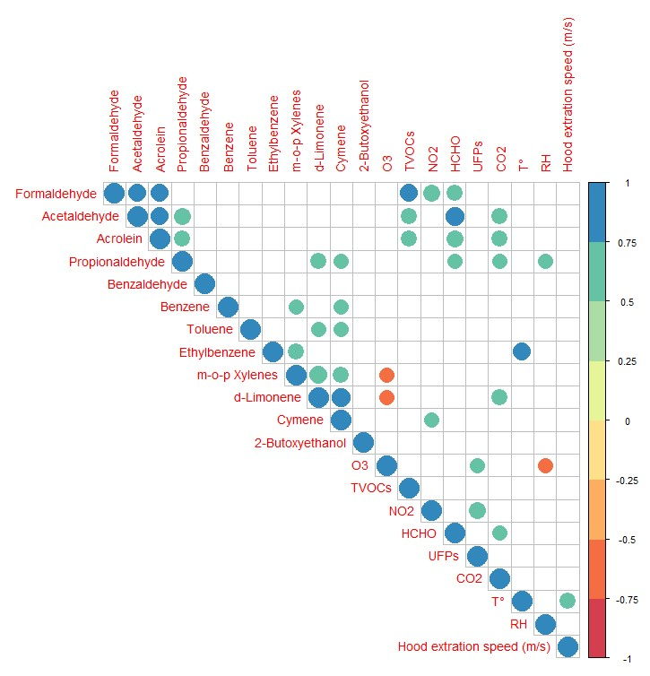
Figure SM3 – Spearman correlation matrix showing relationships between pollutants and other additional parameters (summer campaign).
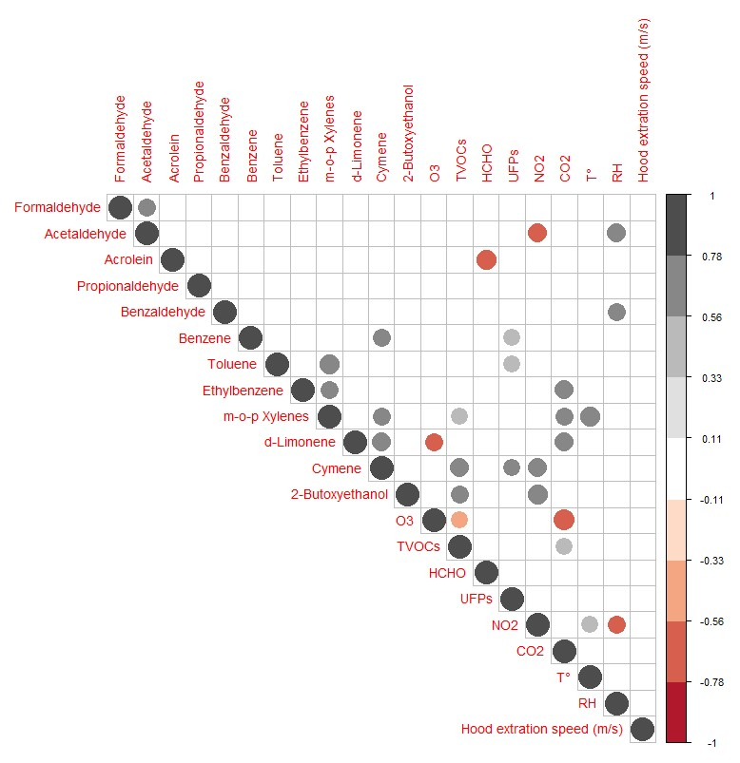

Table SM6-Indoor concentrations of VOCs (ug/m³) for the winter (WC) and summer (SC) campaigns for each investigated restaurant by time-integrated sampling.
ID | Sampling time |  | Benzene |  | Toluene |  | Ethylbenzene |  | p-Xylene |  | m-Xylene |  | o-Xylene |  | Styrene |  | α-Pinene |  | d-Limonene |  | p-Cymene |  | 2-Butoxyethanol
ID | WC | SC | WC | SC | WC | SC | WC | SC | WC | SC | WC | SC | WC | SC | WC | SC | WC | SC | WC | SC | WC | SC | WC | SC
RES_1 | 158 min | 120 min | 9.50 | 2.10 | 9.31 | 2.22 | 1.10 | 0.63 | 0.801 | 0.106 | 3.17 | 1.82 | 1.09 | <LOD | 0.0395 | <LOD | 0.170 | <LOD | 11.9 | 0.902 | 1.07 | 0.299 | 0.0589 | 0.625
RES_2 | 168 min | 190 min | 13.0 | 0.266 | 53.2 | 16.2 | 8.17 | 3.05 | 8.21 | 0.301 | 23.4 | 9.14 | 9.01 | 1.96 | 2.93 | 0.454 | 3.94 | <LOD | 80.1 | 44.0 | 3.88 | 1.43 | 5.38 | 0.156
RES_3 | 288 min | 190 min | 2.24 | 0.0299 | 5.48 | 0.181 | 1.22 | 2.02 | 0.729 | 0.0543 | 3.80 | 2.77 | <LOD | 1.28 | <LOD | <LOD | <LOD | 0.200 | 20.9 | 1.85 | <LOD | 0.102 | 35.4 | 2.59
RES_4 | 126 min | 99 min | 3.93 | 0.417 | 4.98 | 1.40 | 2.38 | 1.34 | 1.32 | <LOD | 6.21 | 1.76 | <LOD | 0.392 | <LOD | <LOD | 2.47 | 0.0279 | 48.5 | 5.73 | 2.37 | <LOD | <LOD | 0.720
RES_5 | 166 min | 226 min | 3.29 | 0.898 | 6.64 | 1.86 | 0.859 | 1.38 | 0.819 | <LOD | 3.37 | 2.38 | <LOD | 2.77 | <LOD | <LOD | 18.1 | 2.84 | 43.9 | 35.3 | 8.31 | 7.17 | <LOD | 19.6
RES_6 | 299 min | 284 min | 4.65 | 1.83 | 25.7 | 13.1 | 3.87 | 1.80 | 4.66 | 2.06 | 10.7 | 5.90 | 4.97 | 2.08 | 0.433 | <LOD | 2.50 | 1.33 | 40.4 | 3.32 | 10.4 | 1.18 | <LOD | 1.04
RES_7 | 111 min | 154 min | <LOD | 0.0534 | 36.4 | 0.351 | <LOD | 0.377 | <LOD | <LOD | <LOD | 0.665 | <LOD | 0.232 | <LOD | 0.363 | <LOD | 0.00777 | 9.94 | 6.83 | <LOD | 0.119 | 10.3 | 4.01
RES_8 | 193 min | 144 min | 4.02 | 0.0169 | 13.2 | 18.1 | 2.49 | 0.554 | 1.89 | 0.0183 | 7.64 | 2.53 | 2.25 | 1.86 | 2.18 | <LOD | 1.55 | <LOD | 30.3 | 7.77 | 1.48 | 0.100 | 114 | 5.66
RES_9 | 328 min | 150 min | 4.16 | 0.502 | 35.1 | 5.48 | 0.931 | 9.42 | 0.438 | 0.215 | 3.16 | 4.45 | <LOD | 2.70 | <LOD | 0.173 | 1.85 | 0.0912 | 37.2 | 66.2 | 3.74 | 7.98 | 7.65 | 5.41
RES_10 | 232 min | 90 min | 13.3 | <LOD | <LOD | <LOD | <LOD | 0.132 | <LOD | <LOD | 0.0544 | 0.773 | 1.11 | 0.782 | <LOD | <LOD | 3.34 | <LOD | <LOD | 2.29 | <LOD | <LOD | 1.48 | 1.41
RES_11 | 133 min | 145 min | n.a. | 1.39 | n.a. | 1.39 | n.a. | 2.41 | n.a. | 0.0578 | n.a. | 2.27 | n.a. | 2.70 | n.a. | 2.48 | n.a. | <LOD | n.a. | 4.77 | n.a. | 2.49 | n.a. | 16.9
RES_12 | 200 min | 145 min | <LOD | 0.690 | <LOD | 12.1 | 13.5 | 1.46 | <LOD | 9.94 | <LOD | <LOD | 0.917 | 6.71 | <LOD | 0.358 | <LOD | <LOD | <LOD | 6.92 | <LOD | 0.68 | 51.2 | 91.2
RES_13 | 133 min | 108 min | 0.212 | 0.677 | <LOD | 1.50 | 1.11 | 0.940 | <LOD | <LOD | 1.77 | 2.77 | <LOD | 1.82 | 0.252 | <LOD | <LOD | <LOD | 11.7 | 1.75 | 0.737 | <LOD | 6.80 | 0.431
RES_14 | 213 min | 114 min | 1.45 | 0.116 | 4.31 | 0.165 | 5.83 | 2.77 | 1.41 | 0.123 | 4.64 | 2.43 | 1.46 | 0.263 | <LOD | <LOD | 0.187 | <LOD | 14.6 | 6.86 | <LOD | 0.579 | 2.42 | 0.601
RES_15 | 212 min | 190 min | 14.0 | 3.53 | 8.62 | 0.804 | 1.58 | 0.133 | 0.708 | <LOD | 4.63 | 1.76 | 1.20 | 2.50 | 0.727 | <LOD | 0.732 | 1.79 | 27.5 | 35.6 | 3.97 | 4.32 | 4.31 | 2.08
LOD= Limit of detection; n.a. = not available

Table SM7- Indoor concentrations of aldehydes (ug/m³) for the winter (WC) and summer (SC) campaigns for each investigated restaurant, by time-integrated sampling.
ID | Sampling time |  | Formaldehyde |  | Acetaldehyde |  | Acrolein |  |  | Propionaldehyde |  | Benzaldehyde |  | Glutaraldehyde
ID | WC | SC | WC | SC | WC | SC | WC | SC | WC |  | SC | WC | SC | WC | SC
RES_1 | 150 min | 120 min | 3.30 | 2.04 | 5.53 | 9.72 | 16.2 | 99.0 | <LOD |  | <LOD | 47.6 | 17.2 | <LOD | <LOD
RES_2 | 150 min | 150 min | 2.65 | 5.44 | 14.9 | 13.3 | 27.3 | 19.4 | 19.3 |  | 14.7 | 40.9 | 3.52 | <LOD | 1.50
RES_3 | 200 min | 150 min | 6.51 | 2.72 | 60.0 | 20.6 | 52.3 | 19.9 | 36.9 |  | 66.6 | 2.28 | 8.79 | 1.00 | <LOD
RES_4 | 180 min | 100 min | 3.37 | 9.06 | 7.55 | 26.8 | 11.8 | 35.6 | 15.6 |  | 116 | 7.71 | 30.8 | 1.06 | <LOD
RES_5 | 150 min | 120 min | 11.4 | 2.99 | 18.4 | 8.48 | 77.5 | 41.9 | 66.6 |  | 6.83 | 13.2 | 37.4 | <LOD | 5.54
RES_6 | 150 min | 150 min | 7.50 | 0.772 | 79.2 | 4.62 | 23.6 | 48.4 | 58.4 |  | 36.6 | 10.4 | 49.5 | 2.90 | 5.01
RES_7 | 113 min | 150 min | 1.87 | 3.03 | 1.66 | 35.4 | 7.35 | 86.4 | 6.95 |  | <LOD | 16.7 | 5.71 | <LOD | <LOD
RES_8 | 150 min | 145 min | 2.27 | 1.22 | 11.8 | 5.13 | 7.23 | 30.6 | 46.6 |  | 48.8 | <LOD | 3.04 | <LOD | 3.28
RES_9 | 240 min | 150 min | 17.6 | 1.89 | 34.9 | 9.55 | 82.2 | 22.9 | 78.2 |  | 46.6 | 10.5 | 5.54 | <LOD | 2.04
RES_10 | 180 min | 87 min | 3.17 | <LOD | 3.57 | <LOD | 11.7 | 21.4 | 3.00 |  | <LOD | 9.51 | 6.17 | <LOD | 2.56
RES_11 | 150 min | 148 min | 4.35 | 4.77 | 8.38 | 7.14 | 9.53 | 10.4 | 2.88 |  | 5.68 | 9.37 | 4.46 | <LOD | 5.32
RES_12 | 184 min | 144 min | 7.79 | 6.33 | 15.0 | 10.0 | 19.7 | 25.4 | 16.6 |  | 16.8 | 19.6 | 5.09 | 3.08 | 2.84
RES_13 | 131 min | 110 min | 20.4 | 15.2 | 52.4 | 45.4 | 25.1 | 17.1 | 3.11 |  | 2.93 | 22.7 | 21.4 | <LOD | <LOD
RES_14 | 150 min | 134 min | 0.364 | 4.67 | 0.907 | 14.0 | 2.81 | 18.6 | 0.375 |  | 61.4 | 3.32 | 16.3 | <LOD | <LOD
RES_15 | 206 min | 190 min | 6.23 | 5.71 | 5.68 | 2.87 | 11.47 | 21.28 | 5.87 |  | 26.26 | 21.3 | 28.8 | <LOD | 4.05
LOD= Limit of detection; n.a. = not available

Table SM8- Guide values of pollutants measured in restaurant kitchens with reference times and sources.
Instruments | Pollutants | Long-term limit value | Short-term limit value | Source
On-line | O₃ | 100 µg/m³ (0.05 ppm) (8-h) | n.a. | WHO AQG 2021 ¹
On-line | TVOCs | 0.3 mg/m³ (0.09 ppm) (8-h) | n.a. | AIR - German Committee on Indoor Air Guide Values
On-line | NO₂ | 25 µg/m³ (0.013 ppm) (24-h) | 200 µg/m³ (0.11 ppm) (1-h) | WHO AQG 2021 ¹; WHO IAQG 2010 ²
On-line | CO₂ | 1000 ppm |  | ASHRAE 62.1
Off-line | Benzene | 5 µg/m³ (1-y) | n.a. | European Union Directive on air quality
Off-line | Toluene | 0.3 mg/m³ (GV-I) | 3 mg/m³ (GV-II) | AIR - German Committee on Indoor Air Guide Values
Off-line | Ethylbenzene | 0.2 mg/m³ (GV-I) | 2 mg/m³ (GV-II) | AIR - German Committee on Indoor Air Guide Values
Off-line | Styrene | 0.03 mg/m³ (GV-I) | 0.3 mg/m³ (GV-II) | AIR - German Committee on Indoor Air Guide Values
Off-line | 2-Butoxyethanol | 56 mg/m³ (8-h) | n.a. | DNELs for consumers ²
Off-line | α-Pinene | 4.5 mg/m³ (8-h) | 45 mg/m³ (1-h) | EU EPHECT project 2015
Off-line | d-Limonene | 9 mg/m³ (8-h) | 90 mg/m³ (1-h) | EU EPHECT project 2015
Off-line | p-Cymene | 0.22 mg/m³ (8-h) | n.a. | DNELs for consumers ²
Off-line | Formaldehyde | n.a. | 100 μg/m³ (30 min) | WHO IAQG 2010 ²
Off-line | Acetaldehyde | n.a. | 1.42 mg/m³ (1-h) | Air quality: UK guidelines for volatile organic compounds in indoor spaces
Off-line | Acrolein | 10 μg/m³ (8-h) | 21 μg/m³ (1-h) | EU EPHECT project 2015
Off-line | Propionaldehyde | 6.1 mg/m³ (8-h) | n.a. | DNELs available for workers in industrial settings ²
Off-line | Benzaldehyde | 0.02 mg/m³ (GV-I) | 0.2 mg/m³ (GV-II) | AIR - German Committee on Indoor Air Guide Values
Off-line | Glutaraldehyde | 0.2 mg/m³ (8-h) | n.a. | Air quality: UK guidelines for volatile organic compounds in indoor spaces
¹: World Health Organization Air Quality Guidelines
²: World Health Organization Indoor Air Quality Guidelines
³: Derived No-Effect Level

Table SM9- On-line winter concentrations of indoor pollutants for each investigated restaurant.
ID | Sampling time¹ | O₃ (ppm) |  | TVOCs (ppm) |  | HCHO (ppm) |  | UFPs * 10³ (pt/cm³) |  | NO₂ (ppm) |  | CO₂ (ppm)
ID | Sampling time¹ | Mean (SD) | Min-Max | Mean (SD) | Min-Max | Mean (SD) | Min-Max | Mean (SD) | Min-Max | Mean (SD) | Min-Max | Mean (SD) | Min-Max
RES_1 | 300 min | 0.0055 (0.0025) | 0.00060 - 0.0105 | n.a. | n.a. | 0.0016 (0.0046) | <LOD - 0.033 | 28 (24) | 8.4 – 145 | 0.023 (0.019) | <LOD - 0.13 | 598 (130) | 512-1371
RES_2 | 255 min | 0.0021 (0.00095) | <LOD - 0.0086 | 0.21 (0.058) | 0.12 - 0.42 | 0.0021 (0.00093) | 0.00062 - 0.0052 | 24 (13) | 6.8 – 70.4 | 0.014 (0.005) | <LOD - 0.028 | 919 (155) | 698-1215
RES_3 | 365 min | 0.0047 (0.0019) | 0.0011 - 0.010 | 1.5 (1.0) | 0.14 - 6.9 | 0.0049 (0.0027) | 0.0011 - 0.013 | 21 (25) | 3.2 – 155 | 0.0047 (0.010) | <LOD - 0.10 | 956 (297) | 612-1902
RES_4 | 315 min | 0.0031 (0.0012) | 0.00010 - 0.0095 | 0.24 (0.16) | <LOD - 0.96 | 0.0022 (0.0018) | <LOD - 0.010 | 37 (48) | 4.7 – 231 | 0.0061 (0.0083) | <LOD - 0.071 | 789 (66) | 681-946
RES_5 | 246 min | 0.0048 (0.0036) | 0.0015 - 0.028 | 1.3 (0.80) | <LOD - 5.7 | 0.014 (0.012) | <LOD - 0.072 | 54 (31.5) | 7.3 – 153 | 0.080 (0.052) | <LOD - 0.25 | 714 (143) | 543-1261
RES_6 | 395 min | 0.0042 (0.0022) | 0.0010 - 0.017 | n.a.. | n.a. | 0.0070 (0.0051) | 0.00021 - 0.029 | 60 (55) | 7.1 – 206 | 0.049 (0.036) | 0.001 - 0.21 | 811 (150) | 591-1248
RES_7 | 207 min | 0.0087 (0.0048) | <LOD - 0.019 | 0.13 (0.18) | 0.010 - 1.2 | n.a. | n.a. | 18 (17) | 3.5 – 86.1 | 0.011 (0.016) | <LOD - 0.12 | 442 (24) | 413-615
RES_8 | 290 min | 0.013 (0.011) | 0.0010 - 0.058 | 0.19 (0.086) | <LOD - 0.59 | 0.0012 (0.0012) | <LOD - 0.0060 | 86 (47) | 5.6 – 186.5 | 0.015 (0.022) | <LOD - 0.25 | 619 (46) | 458-701
RES_9 | 211 min | 0.020 (0.015) | 0.0051 - 0.18 | 0.52 (0.21) | <LOD - 1.3 | 0.014 (0.015) | <LOD - 0.081 | 247 (85) | 106 – 498 | 0.18 (0.070) | <LOD - 0.25 | 969 (204) | 482-1532
RES_10 | 317 min | 0.013 (0.0068) | 0.0037 - 0.055 | 0.22 (0.38) | <LOD - 2.7 | 0.0018 (0.0070) | <LOD - 0.071 | 72 (59) | 1.4 – 235 | 0.0086 (0.012) | <LOD - 0.11 | 445 (26) | 387-617
RES_11 | 247 min | 0.012 (0.010) | 0.0010 - 0.075 | 0.32 (0.088) | 0.18 - 0.81 | 0.0030 (0.0024) | <LOD - 0.014 | 157 (43) | 14 – 218 | 0.045 (0.041) | <LOD - 0.18 | 728 (105) | 571-978
RES_12 | 295 min | 0.010 (0.019) | <LOD - 0.17 | 0.53(0.40) | <LOD - 3.4 | 0.55 (0.40) | <LOD - 0.014 | 46 (39) | 2.5 – 158 | 0.023 (0.028) | <LOD - 0.18 | 489 (57) | 402-653
RES_13 | 241 min | 0.012 (0.0055) | 0.0043 - 0.034 | 0.33 (0.47) | 0.020 - 3.1 | 0.013 (0.032) | <LOD - 0.27 | 35 (25) | 2.3 – 114 | 0.016 (0.029) | <LOD - 0.18 | 546 (105) | 421-1438
RES_14 | 245 min | 0.0070 (0.0016) | 0.0037 - 0.011 | 0.17 (0.11) | <LOD - 0.53 | 0.00024 (0.00039) | <LOD - 0.0020 | 6.4 (14) | 1.7 – 139 | n.a. | n.a. | 539 (49) | 400-676
RES_15 | 311 min | 0.016 (0.0041) | 0.0059 - 0.026 | 1.6 (1.2) | <LOD - 6.5 | 0.0046 (0.014) | <LOD - 0.096 | 102 (49) | 9.1 – 167 | 0.083 (0.042) | <LOD - 0.25 | 539 (31) | 480-669
LOD= Limit of detection; n.a. = not available
¹ With the aim of accounting for short-term reference times of guide values (Table SM8), the sampling time here reported correspond to the time-averaging period for IAQ assessment in the case of O₃, TVOCs and CO₂, while 30-min and 1-h averages were calculated for HCHO and NO₂.

Table SM10- On-line summer concentrations of indoor pollutants for each investigated restaurant.
ID | Sampling time¹ | O₃ (ppm) |  | TVOCs (ppm) |  | HCHO (ppm) |  | UFPs * 10³ (pt/cm³) |  | NO₂ (ppm) |  | CO₂ (ppm)
ID | Sampling time¹ | Mean (SD) | Min-Max | Mean (SD) | Min-Max | Mean (SD) | Min-Max | Mean (SD) | Min-Max | Mean (SD) | Min-Max | Mean (SD) | Min-Max
RES_1 | 257 min | 0.022 (0.0050) | 0.010 - 0.039 | 0.14 (0.13) | 0.010 - 1.3 | 0.00093 (0.0022) | <LOD - 0.020 | 42 (36) | 5.4-154 | 0.012 (0.015) | <LOD - 0.096 | 460 (26) | 419-593
RES_2 | 284 min | 0.0036 (0.0015) | <LOD -0.013 | 0.31 (0.37) | 0.15 - 2.9 | 0.018 (0.048) | <LOD - 0.40 | 26 (26) | 3.9-172 | 0.0022 (0.0045) | <LOD - 0.038 | 678 (79) | 556-833
RES_3 | 399 min | 0.015 (0.0042) | 0.0077 - 0.034 | 0.68 (0.33) | 0.22 - 2.4 | 0.0026 (0.0013) | <LOD - 0.012 | 11 (13) | 2.8-86 | 0.0035 (0.0073) | <LOD - 0.065 | 685 (134) | 460-1155
RES_4 | 249 min | 0.021 (0.0041) | 0.0078 - 0.028 | 0.16 (0.068) | 0.080 - 0.49 | 0.0029 (0.030) | <LOD - 0.37 | 8.7 (12) | 3.9-109 | 0.00084 (0.00077) | <LOD - 0.0030 | 557 (36) | 502-770
RES_5 | 286 min | 0.0079 (0.0038) | 0.0010 - 0.024 | 2.1 (2.0) | 0.41 - 13 | 0.0026 (0.0025) | <LOD - 0.014 | 32 (27) | 5.4-110 | 0.083 (0.059) | <LOD - 0.23 | 729 (127) | 537-1276
RES_6 | 435 min | 0.022 (0.0091) | 0.0040 - 0.048 | 0.65 (1.5) | 0.070 - 26 | 0.0012 (0.0030) | <LOD - 0.023 | 42 (52) | 5.7-310 | 0.039 (0.041) | <LOD - 0.25 | 569 (61) | 475-745
RES_7 | 360 min | 0.016 (0.0043) | 0.0030 - 0.042 | 0.37 (0.35) | 0.010 - 2.9 | 0.0011 (0.0026) | <LOD - 0.022 | 4.7 (4.8) | 1.1-39 | 0.011 (0.017) | <LOD - 0.12 | n.a. | n.a.
RES_8 | 250 min | 0.015 (0.0063) | 0.0057 - 0.030 | 0.35 (0.22) | 0.11 - 1.5 | 0.00060 (0.0012) | <LOD - 0.0074 | 18 (8.5) | 5.8-49 | 0.016 (0.016) | <LOD - 0.11 | 662 (131) | 653-871
RES_9 | 240 min | 0.020 (0.0076) | 0.0062 - 0.035 | 0.53 (0.32) | 0.13 - 1.7 | 0.0012 (0.0017) | <LOD - 0.0072 | 151 (62) | 56-370 | 0.099 (0.048) | 0.0060 - 0.25 | 830 (202) | 527-1212
RES_10 | 258 min | 0.028 (0.0050) | <LOD - 0.063 | 0.11 (0.14) | 0.020 - 1.5 | 0.014 (0.048) | <LOD - 0.35 | 14 (16) | 2.3-151 | 0.018 (0.019) | <LOD - 0.087 | 481 (26) | 446-631
RES_11 | 265 min | 0.019 (0.0075) | 0.0075 - 0.035 | 0.43 (0.54) | <LOD - 5.4 | 0.090 (0.26) | <LOD - 2.7 | 12 (15) | 1.0-111 | 0.085 (0.049) | <LOD - 0.21 | 582 (50) | 469-706
RES_12 | 230 min | 0.017 (0.0062) | 0.0070 - 0.036 | 1.4 (0.62) | 0.37 - 4.0 | 0.0087 (0.0088) | <LOD - 0.060 | 30 (29) | 7.7-223 | 0.073 (0.078) | <LOD - 0.25 | 630 (68) | 492-862
RES_13 | 253 min | 0.052 (0.0064) | 0.038 - 0.067 | 0.25 (0.47) | <LOD - 4.5 | 0.010 (0.044) | <LOD - 0.47 | 18 (21) | 4.7-125 | 0.010 (0.015) | <LOD - 0.14 | 495 (16) | 470-587
RES_14 | 263 min | 0.023 (0.010) | 0.0051 - 0.046 | 0.18 (0.085) | 0.060 - 0.67 | 0.0038 (0.0060) | <LOD - 0.047 | 8.9 (17) | 2.4-165 | 0.011 (0.011) | <LOD - 0.074 | 585 (40) | 460-716
RES_15 | 300 min | 0.021 (0.011) | 0.0063 - 0.059 | 2.6 (2.6) | 0.090 – 14 | 0.0050 (0.0051) | <LOD - 0.029 | 129 (93) | 16-416 | 0.067 (0.058) | <LOD - 0.25 | 553 (61) | 458-849
LOD= Limit of detection; n.a. = not available
¹ With the aim of accounting for short-term reference times of guide values (Table SM8), the sampling time here reported correspond to the time-averaging period for IAQ assessment in the case of O₃, TVOCs and CO₂, while 30-min and 1-h averages were calculated for HCHO and NO₂.

Table SM11 – Indoor and outdoor concentrations and I/O ratios of benzene, nitrogen dioxide and ozone per each investigated restaurant.
ID | Benzene |  |  |  |  |  | Nitrogen Dioxide (NO₂) |  |  |  |  |  | Ozone (O₃)
ID | Indoor  WC | Outdoor  WC | I/O | Indoor  SC | Outdoor  SC | I/O | Indoor  WC | Outdoor  WC | I/O | Indoor  SC | Outdoor  SC | I/O | Indoor  WC | Outdoor  WC | I/O | Indoor  SC | Outdoor  SC | I/O
RES_1 | 9.5 | 1.8 | 5.3 | 2.1 | 0.84 | 2.5 | 0.023 | 0.026 | 0.9 | 0.012 | 0.003 | 4.5 | 0.005 | 0.011 | 0.5 | 0.022 | 0.049 | 0.5
RES_2 | 13.0 | 4.4 | 3.0 | 0.27 | 0.46 | 0.6 | 0.014 | 0.045 | 0.3 | 0.002 | 0.012 | 0.2 | 0.002 | 0.003 | 0.7 | 0.004 | 0.058 | 0.1
RES_3 | 2.2 | 1.1 | 2.0 | 0.030 | 0.42 | 0.1 | 0.005 | 0.024 | 0.2 | 0.004 | 0.009 | 0.4 | 0.005 | 0.016 | 0.3 | 0.015 | 0.070 | 0.2
RES_4 | 3.9 | 2.0 | 2.0 | 0.42 | 0.68 | 0.6 | 0.006 | 0.033 | 0.2 | 0.001 | 0.001 | 0.9 | 0.003 | 0.006 | 0.5 | 0.021 | 0.059 | 0.4
RES_5 | 3.3 | 2.1 | 1.6 | 0.90 | 0.62 | 1.4 | 0.080 | 0.029 | 2.8 | 0.083 | n.a. | n.a. | 0.005 | 0.022 | 0.2 | 0.008 | 0.060 | 0.1
RES_6 | 4.6 | 1.9 | 2.4 | 1.8 | 1.0 | 1.9 | 0.049 | 0.016 | 3.1 | 0.039 | 0.004 | 10 | 0.004 | 0.017 | 0.2 | 0.022 | 0.087 | 0.3
RES_7 | <LOD | 1.2 | < 1 | 0.053 | 1.1 | 0.05 | 0.011 | 0.012 | 0.9 | 0.011 | 0.003 | 3.8 | 0.009 | 0.026 | 0.3 | 0.016 | 0.053 | 0.3
RES_8 | 4.0 | 1.7 | 2.4 | 0.017 | 0.78 | 0.02 | 0.015 | 0.040 | 0.4 | 0.016 | 0.009 | 1.7 | 0.013 | 0.018 | 0.7 | 0.015 | 0.081 | 0.2
RES_9 | 4.2 | 0.68 | 6.1 | 0.50 | 0.60 | 0.8 | 0.180 | 0.017 | 11 | 0.099 | 0.008 | 12 | 0.020 | 0.035 | 0.6 | 0.020 | 0.076 | 0.3
RES_10 | 13.3 | 0.72 | 18 | <LOD | 0.74 | < 1 | 0.009 | 0.010 | 0.9 | 0.018 | 0.010 | 1.8 | 0.013 | 0.042 | 0.3 | 0.028 | 0.043 | 0.7
RES_11 | n.a. | 0.82 | n.a. | 1.4 | 1.0 | 1.3 | 0.045 | 0.013 | 3.5 | 0.085 | 0.005 | 18 | 0.012 | 0.029 | 0.4 | 0.019 | 0.067 | 0.3
RES_12 | <LOD | 1.2 | < 1 | 0.69 | 0.68 | 1.0 | 0.023 | 0.017 | 1.4 | 0.073 | 0.020 | 3.6 | 0.010 | 0.029 | 0.3 | 0.017 | 0.092 | 0.2
RES_13 | 0.21 | 1.3 | 0.2 | 0.68 | 0.62 | 1.1 | 0.016 | 0.007 | 2.3 | 0.010 | 0.005 | 2.3 | 0.012 | 0.048 | 0.2 | 0.052 | 0.085 | 0.6
RES_14 | 1.5 | 0.90 | 1.6 | 0.12 | 0.74 | 0.2 | n.a. | 0.013 | n.a. | 0.011 | 0.005 | 2.3 | 0.007 | 0.045 | 0.2 | 0.023 | 0.070 | 0.3
RES_15 | 14.0 | 1.0 | 13 | 3.5 | 0.50 | 7.1 | 0.083 | 0.019 | 4.4 | 0.067 | 0.006 | 11 | 0.016 | 0.056 | 0.3 | 0.021 | 0.060 | 0.3
LOD= Limit of detection; n.a. = not available

