Poly(butylene isophthalate-co-2,5-furandicarboxylate): Toward Sustainable and Moisture-Resistant Monolayer Food Packaging

- Supplementary information -

Matteo Venturi ª, Valentina Siracusa ^{b}, Elisa Boanini ^{c}, Elisabetta Salatelli ^{d}, Maurizio Fiorini ª, Michelina Soccio ^{a,e,f}, Nadia Lotti ^{a,e,g}
ª Department of Civil, Chemical, Environmental and Materials Engineering, University of Bologna, Via Terracini 28, Bologna, 40131, Italy.
^{b} Department of Chemical Science, University of Catania, Viale A, Doria 6, Catania 95125, Italy
^{c} Department of Chemistry “G. Ciamician”, University of Bologna, Via Gobetti 85, Bologna, 40129, Italy
^{d} Department of Industrial Chemistry “Toso Montanari”, Via Gobetti 85, Bologna, 40129, Italy
^{e} Interdepartmental Center for Industrial Research on Advanced Applications in Mechanical Engineering and Materials Technology, CIRI-MAM, Viale del Risorgimento 2, 40136, Bologna, Italy.
^{f} Interdepartmental Center for Industrial Research on Buildings and Construction CIRI-EC, Via del Lazzaretto 15/5, 40131, Bologna, Italy.
^{g} Interdepartmental Center for Industrial Agro-Food Research, CIRI-AGRO, Via Quinto Bucci 336, 47521, Cesena, Italy.

List of figures
Figure S1. ¹H-NMR spectra (400MHz) in CDCl₃ of the synthesized polymers. 3
Figure S2. ¹³C-NMR spectra (400MHz) in CDCl₃ of the synthesized polymers. 4
Figure S3. Fitting of glass transition temperature to Fox equation for the different synthesized copolymers revealed by DSC on the as-molded films. 5
Figure S4. Stress strain curves of the compression molded films prepared from the synthesized polymers stretched at a strain rate of 10 mm/min. 6
Figure S5. DSC thermograms (a) and XRD diffraction patterns (b) of semicrystalline and amorphous films employed for the comparison of permeabilities reported in Figure 7 and Table 5. 7

List of tables
Table S1. Thermal data retrieved from the DSC analysis of the polymer films immediately after compression molding. 5
Table S2. Thermal data for the semicrystalline (SC) and amorphous (A) films used for investigating the effect of crystallinity on the GTR reported in Figure 7 and Table 5. 7

Figure S1. ¹H-NMR spectra (400MHz) in CDCl₃ of the synthesized polymers.

Figure S2. ¹³C-NMR spectra (400MHz) in CDCl₃ of the synthesized polymers.

Table S1. Thermal data retrieved from the DSC analysis of the polymer films immediately after compression molding.
Sample | T_{g} (°C) | ∆C_{p} (°C) | T_{cc} (°C) | T_{m} (°C) | ∆H_{m}^{neat} (J/g)
PBI | 20.7 | 0.45 | 105.3 | 138.1 | -1.6
P(BI₉₀BF₁₀) | 21.0 | 0.52
P(BI₈₀BF₂₀) | 22.6 | 0.51
P(BI₇₀BF₃₀) | 24.2 | 0.42
P(BI₆₀BF₄₀) | 26.1 | 0.39
P(BI₅₀BF₅₀) | 26.9 | 0.40
P(BI₄₀BF₆₀) | 27.5 | 0.45
P(BI₃₀BF₇₀) | 30.0 | 0.43
P(BI₂₀BF₈₀) | 30.9 | 0.53
P(BI₁₀BF₉₀) | 30.5 | 0.51 | 109.3 | 159.2 | -1.6
PBF | 36.6 | 0.47 | 96.8 | 169.2 | -0.3

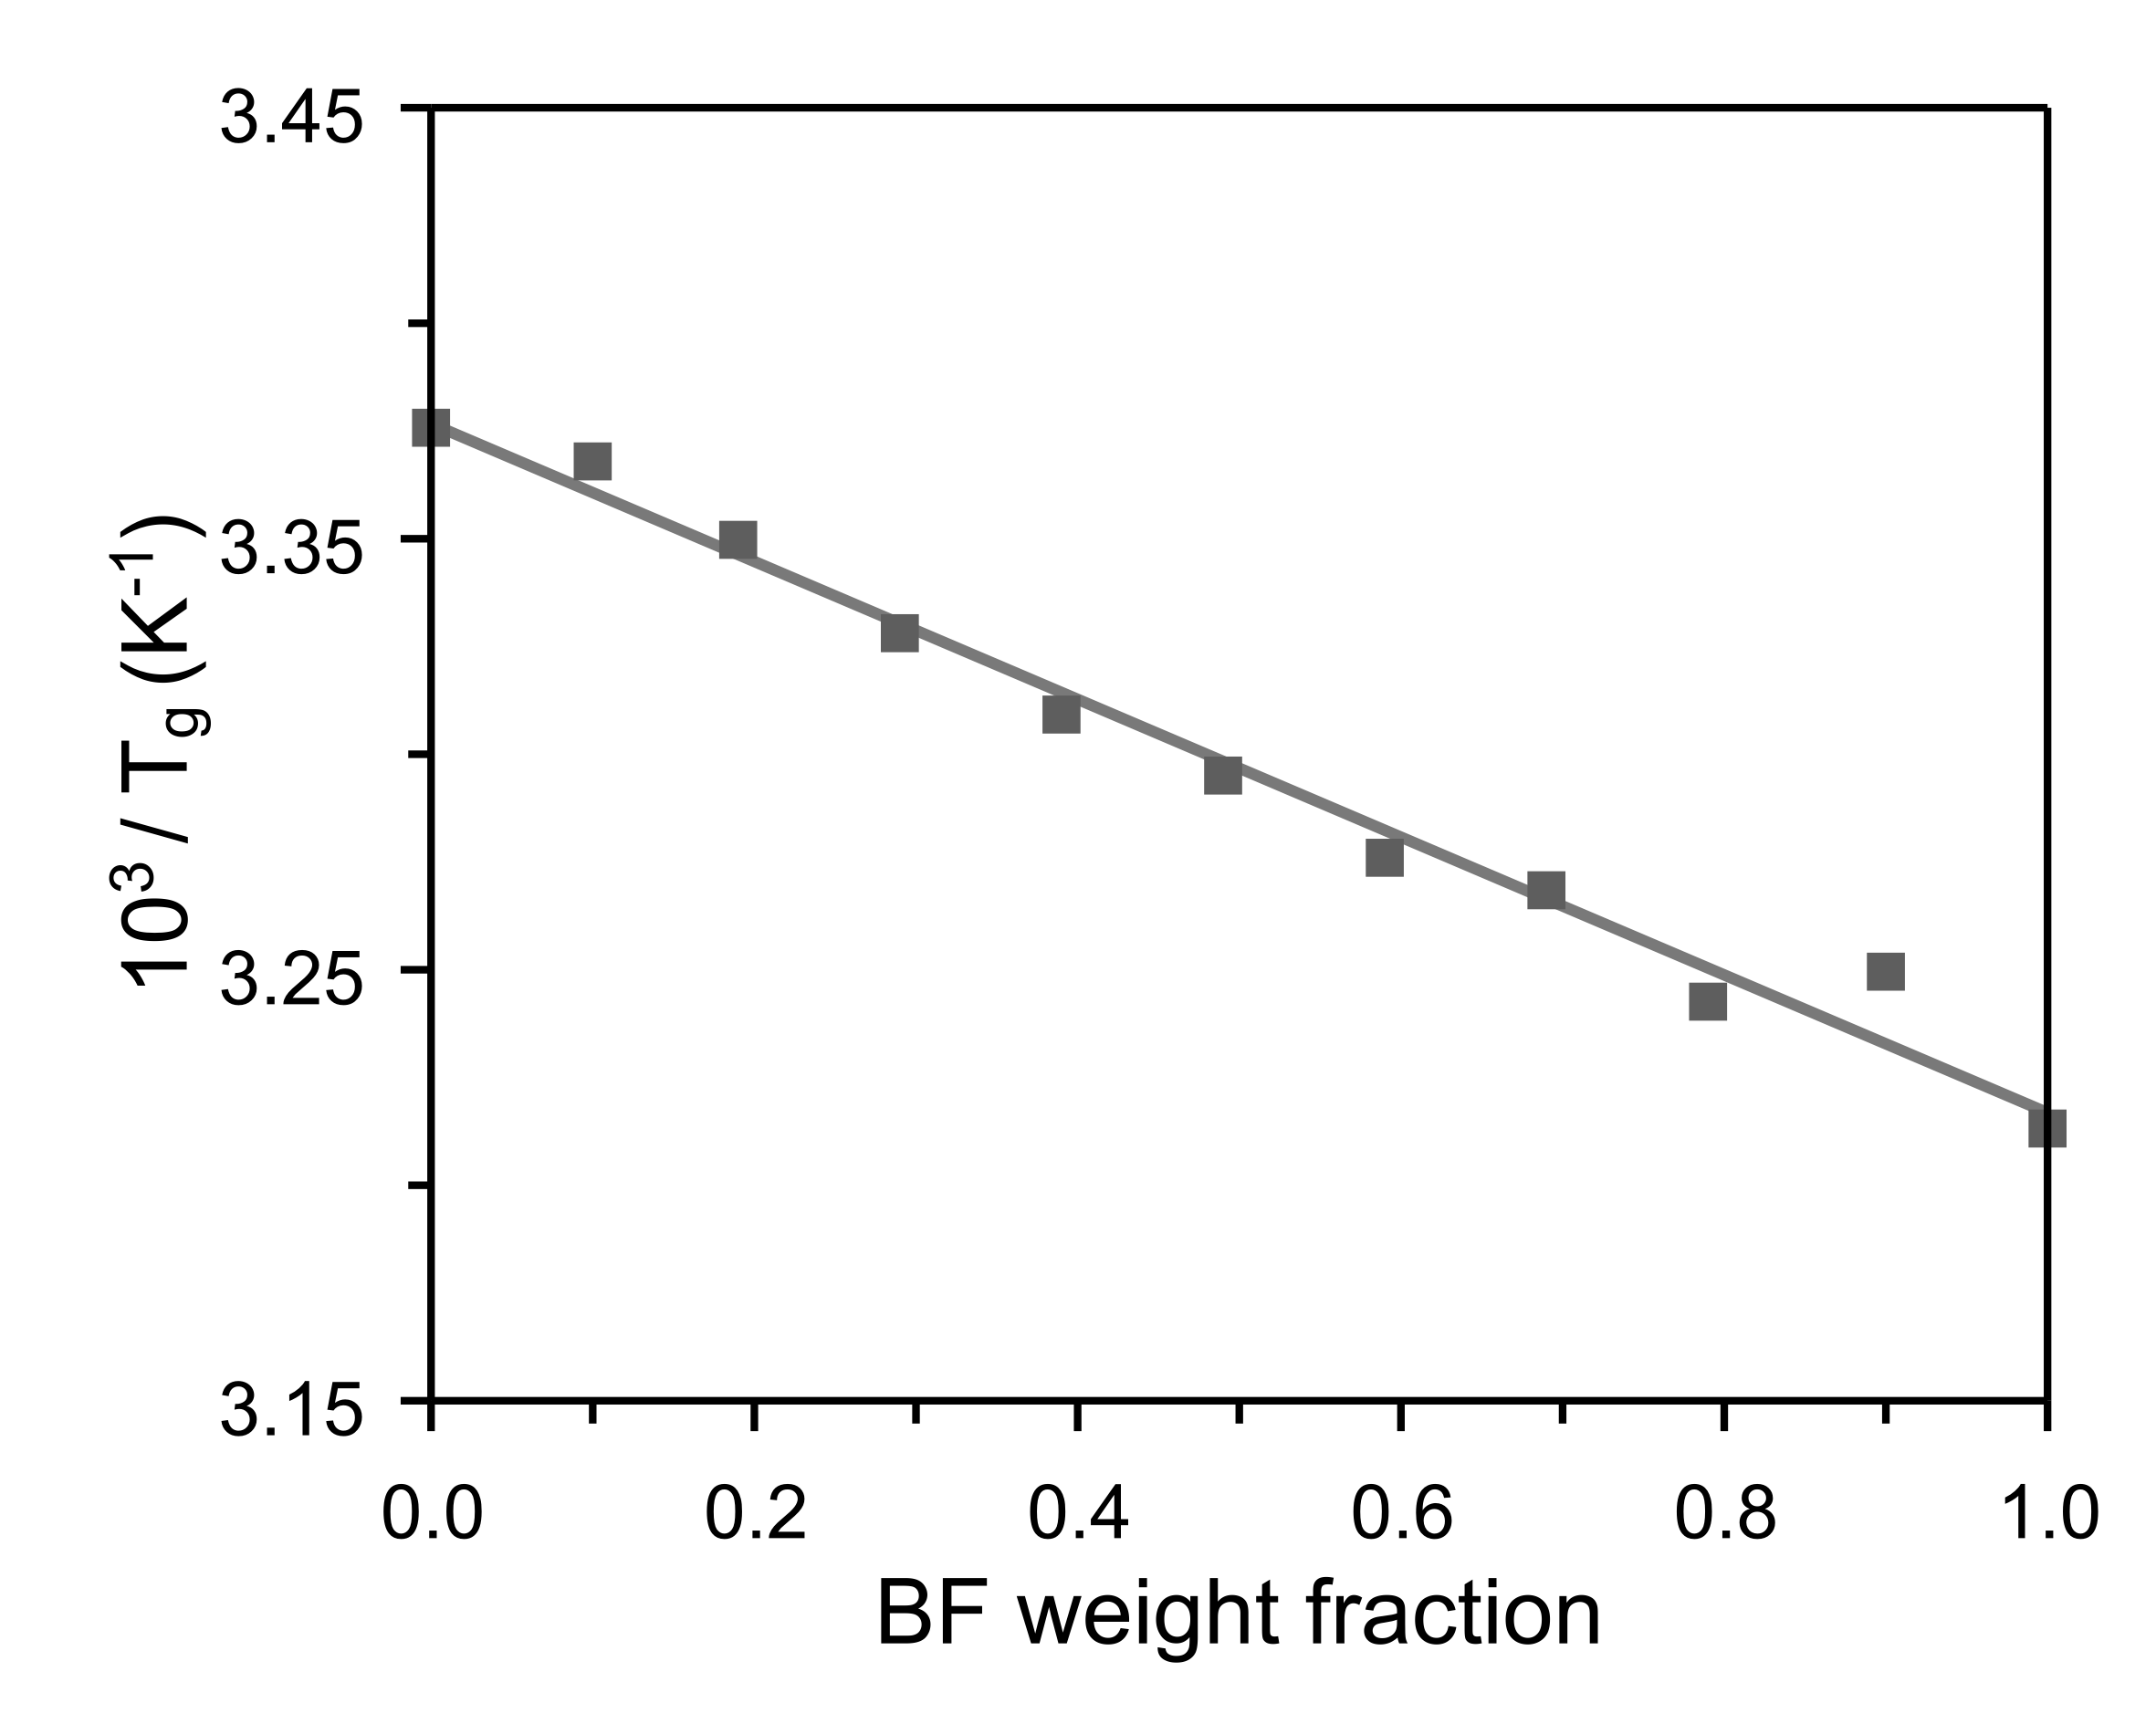
Figure S3. Fitting of glass transition temperature to Fox equation for the different synthesized copolymers revealed by DSC on the as-molded films.

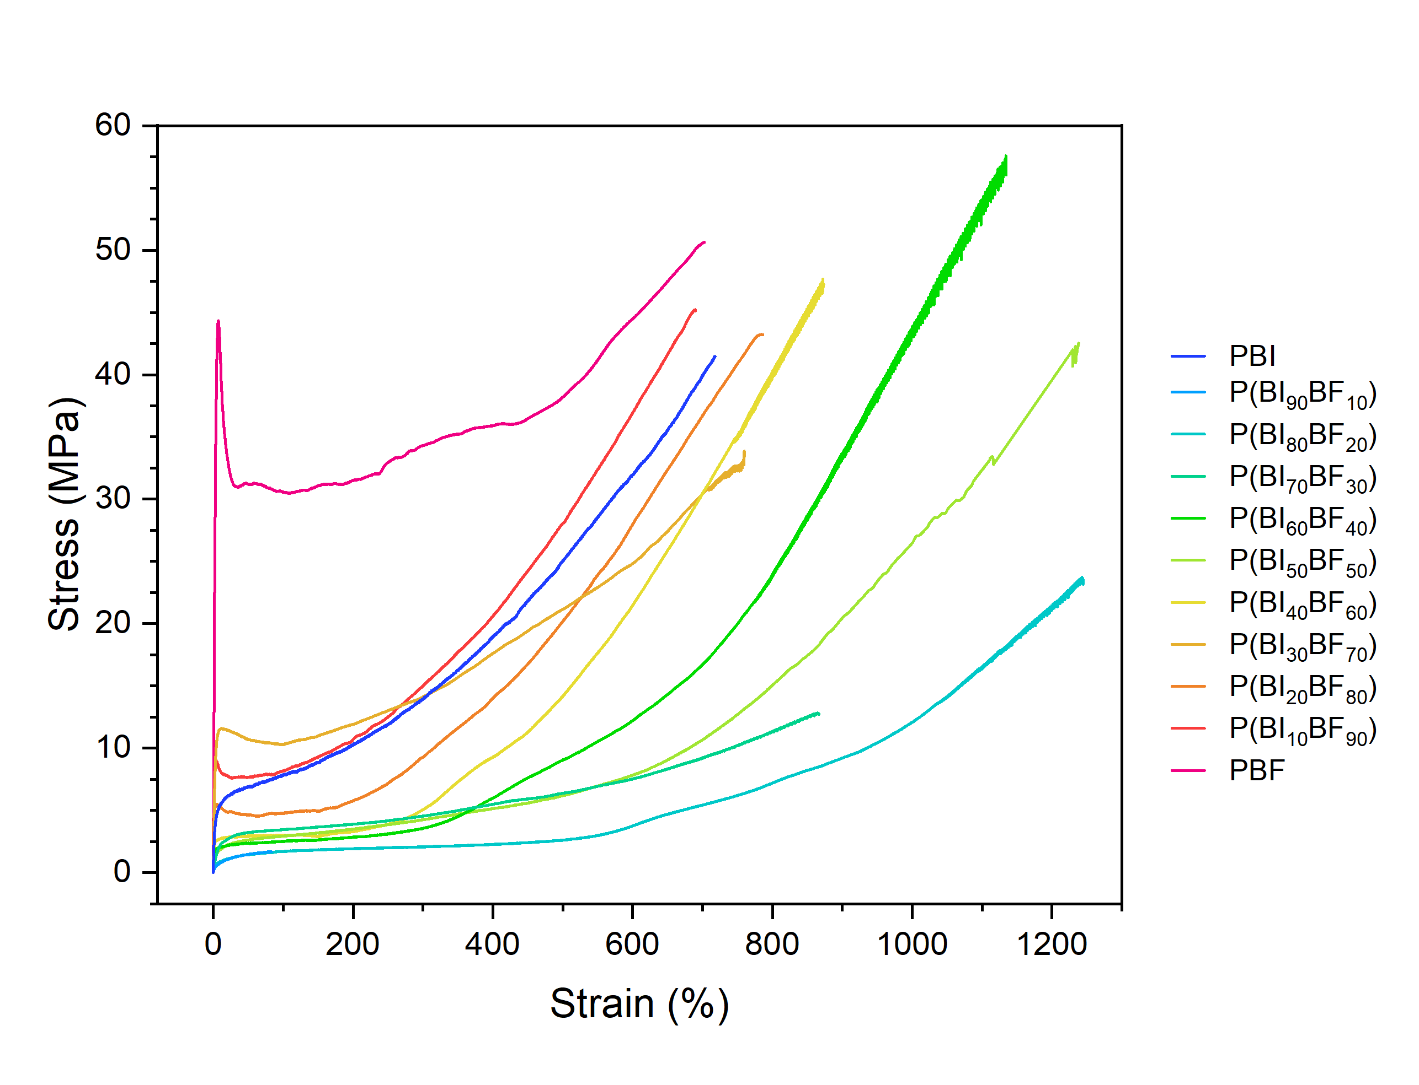
Figure S4. Stress strain curves of the compression molded films prepared from the synthesized polymers stretched at a strain rate of 10 mm/min.

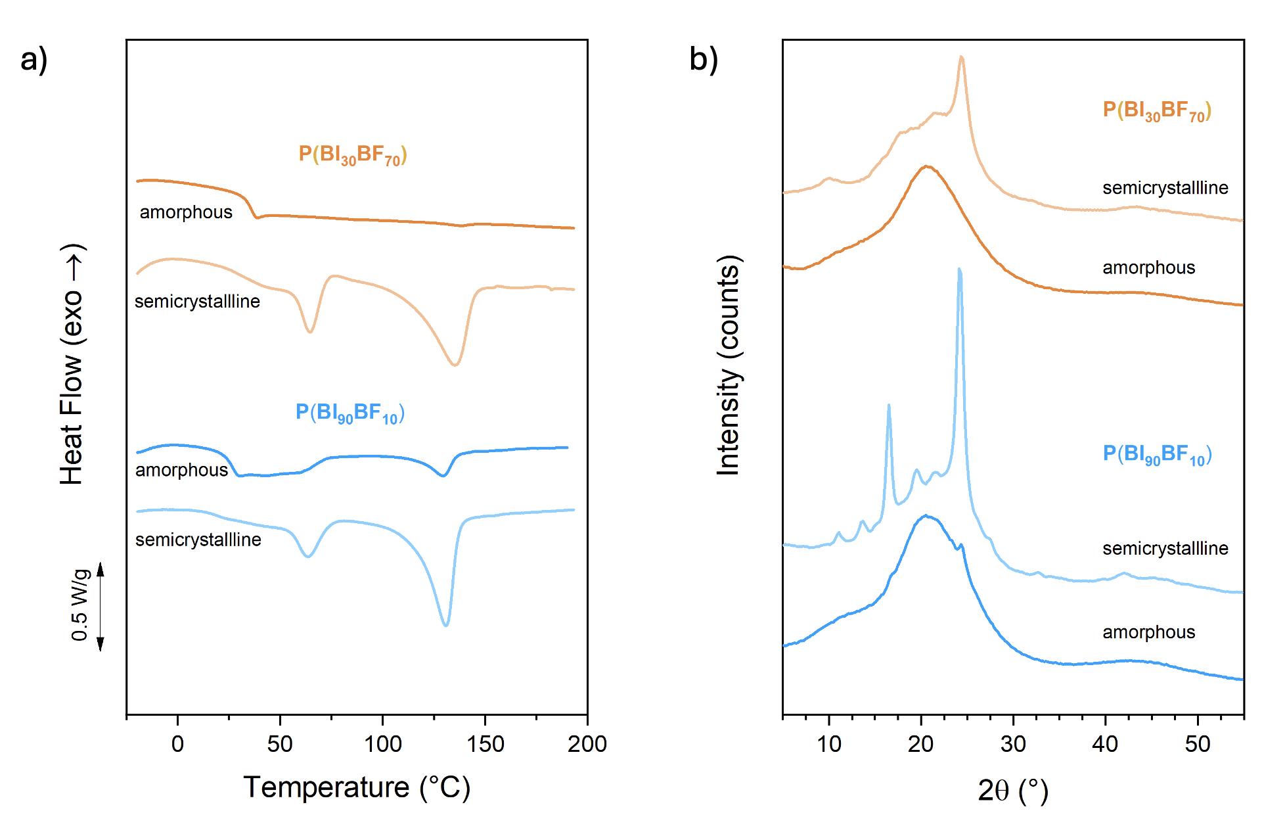
Figure S5. DSC thermograms (a) and XRD diffraction patterns (b) of semicrystalline and amorphous films employed for the comparison of permeabilities reported in Figure 7 and Table 5.

Table S2. Thermal data for the semicrystalline (SC) and amorphous (A) films used for investigating the effect of crystallinity on the GTR reported in Figure 7 and Table 5.
 |  | DSC |  |  |  |  |  | XRD
 |  | T_{g} (°C) | ∆C_{p} (°C) | T_{m} (°C) | T_{cc} (°C) | ∆H_{m}^{neat} (J/g) | X_{c} (%) | X_{c} (%)
P(BI₃₀BF₇₀) | A | 28.8 | 0.33 | 132.0 | - | 1.1 | 1 | 0
 | SC | 26.4 | 0.12 | 58.8  129.5 | 67.3 | 28.6 | 22 | 18
P(BI₉₀BF₁₀) | A | 21.3 | 0.36 | 124.1 | 75.4 | 2.4 | 2 | 4
 | SC | 14.6 | 0.06 | 57.8  125.0 | 79.6 | 34.8 | 31 | 30

