Clinical Pharmacokinetics

Supplementary Material

Fosfomycin dosing for oral prophylaxis against Gram-negative Enterobacterales in patients undergoing surgical intervention for benign prostatic hyperplasia
Pier Giorgio Cojutti, Pasquale Maria Berrino, Valeria Rotaru, Lorenzo Bianchi, Riccardo Schiavina, Eugenio Brunocilla, Pierluigi Viale and Federico Pea

Table S1. Comparison of different base direct response models according to the greatest reduction in OFV and AIC, the adequacy of pc-VPC and plausibility of parameter estimates.
Model number | Model Structure | Estimated Parameters | OFV | AIC | pc-VPC | Additional comments
1 | 1-compartment, proportional | ka, V, Cl, PR | 1314.75 | 1334.75 | Inadequate | RSE% ka 58.9
2 | 1-compartment, power | ka, V, Cl, PR, POW | 1305.44 | 1329.44 | Inadequate | ka 526.5; CV% ωka 2884; RSE% ka 233, a_prost 88.5
3 | 1-compartment,  saturable | ka, V, Cl, Emax, Km | 1327.22 | 1351.22 | Inadequate | RSE% ka 61.2; CV% ωka 340.22
4 | 1-compartment, proportional, ka-fixed | V, Cl, PR | 1319.45 | 1335.45 | Inadequate
5 | 1-compartment, power, ka-fixed | V, Cl, PR, POW | 1314.25 | 1334.25 | Adequate
6 | 1-compartment,  saturable,  ka-fixed | V, Cl, Emax, Km | 1316.35 | 1338.35 | Inadequate | RSE% a_prost 81.6
7 | 2-compartment, proportional | ka, Cl, V1, V2, Q, PR | 1312.17 | 1340.17 | Inadequate | RSE% on Q 363, V2 75; CV% ωV1 912, ωQ >1000, ωV2 386
8 | 2-compartment, power | ka, Cl, V1, V2, Q, PR, POW | 1310.14 | 1342.124 | Adequate | RSE% on V1 164, Q 144, V2 Nan; CV% ωV1 >1000, ωQ 734, ωV >1000
9 | 2-compartment,  saturable | ka, Cl, V1, V2, Q, Emax, Km | 1376.24 | 1408.24 | Inadequate | RSE% on V1 176, Q 184, V2 NaN, Km 220; CV% ωV1 >1000, ωQ >1000, ωV2 467, ωKm >1000
10 | 2-compartment, proportional, ka-fixed | ka, Cl, V1, V2, Q, PR | 1314.38 | 1338.38 | Inadequate | RSE% on CL 105, V1 289, Q 107; CV% ωV1 591, ωQ 449
11 | 2-compartment, power, ka-fixed | ka, Cl, V1, V2, Q, PR, POW | 1334.9 | 1362.9 | Inadequate | RSE% on CL 50.7, Q 333; CV% ωCl 231.7, ωQ >1000
12 | 2-compartment,  saturable, ka-fixed | ka, Cl, V1, V2, Q, Emax, Km | 1384.73 | 1412.73 | Adequate | RSE% on Q 1340, V2 992, Km 1230 ; CV% ωQ >1000, ωV2 457, ωKm >1000

Table S2. Univariate analysis to identify significant covariates of CL and V applied to model 5
CL | Coefficient | Statistics | p-value | V | Coefficient | Statistics | p-value
Age | -0.032 | -0.33 | 7.45e-1 | Age | -0.0067 | -0.068 | 9.46e-1
BMI | 0.095 | 0.96 | 3.39e-1 | BMI | 0.092 | 0.93 | 3.53e-1
S-Cr | 0.18 | 1.89 | 6.19e-2 | S-Cr | 0.024 | 0.24 | 8.07e-1
eGFR | -0.15 | -1.52 | 1.32e-1 | eGFR | -0.015 | -0.15 | 8.78e-1
Height | -0.013 | -0.14 | 8.92e-1 | Height | 0.11 | 1.08 | 2.83e-1
Weight | 0.18 | 1.83 | 7.09e-2 | Weight | 0.31 | 3.28 | 1.42e-3
PSA | 0.023 | 0.23 | 8.19e⁻¹ | PSA | 0.079 | 0.8 | 4.26e⁻¹
Prost_Vol | -0.055 | -0.56 | 5.77e-1 | Prost_Vol | -0.032 | -0.32 | 7.46e-1
BMI, body mass index; eGFR, estimated glomerular filtration rate; PSA prostatic specific antigen; Prost_Vol, prostatic volume; S-Cr, serum creatinine

Table S3. Comparison of base model vs. model with V parameterized by weight, applied to model 5
 | Base Model |  |  |  | Model with Weight on V
Fixed Effects
 | Value |  | S.E. | R.S.E.(%) | Value |  | S.E. | R.S.E.(%)
ka | 0.92 |  | - | - | 0.92 |  | - | -
V | 260.22 |  | 35.52 | 13.7 | 60.86 |  | 26.85 | 44.1
β_V_weight | - |  | - | - | 0.02 |  | 0.0054 | 26.9
CL | 17.24 |  | 2.07 | 12.0 | 14.68 |  | 2.11 | 14.4
PR | 0.67 |  | 0.07 | 10.4 | 0.26 |  | 0.019 | 7.09
POW | 1.18 |  | 0.043 | 3.63 | 1.57 |  | 0.028 | 1.80
Standard Deviation of the Random Effects
 | Value | C.V.(%) | S.E. | R.S.E.(%) | Value | C.V.(%) | S.E. | R.S.E.(%)
ω_ka | 1.09 | 151.02 | - | - | 1.09 | 151.02 | - | -
ω_V | 0.64 | 71.82 | 0.097 | 15.0 | 0.38 | 39.52 | 0.068 | 17.8
ω_CL | 0.52 | 55.95 | 0.083 | 15.9 | 0.76 | 87.86 | 0.094 | 12.4
ω_PR | 0.25 | 25.01 | 0.08 | 32.3 | 0.42 | 44.27 | 0.05 | 11.8
ω_POW | 0.16 | 15.85 | 0.029 | 18.5 | 0.095 | 9.5 | 0.015 | 15.4
Error Model Parameters
a_serum | 1.34 |  | 0.40 | 29.8 | 1.35 |  | 0.28 | 20.5
a_prostate | 1.42 |  | 0.43 | 30.3 | 1.01 |  | 0.34 | 34.0
Estimated log-likelihood and information criteria
OFV | 1314.25 |  |  |  | 1308.76
AIC | 1334.25 |  |  |  | 1330.76

Figure S1. Observed fosfomycin plasma and prostatic concentrations in the study population after two doses of 3g fosfomycin trometamol

Figure S2. Observed versus population and individual prediction plots of fosfomycin plasma and prostatic concentrations

Plasma

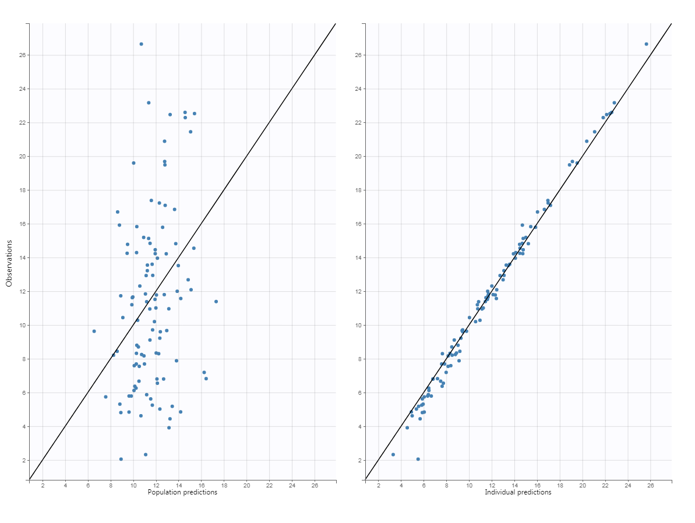
Prostate
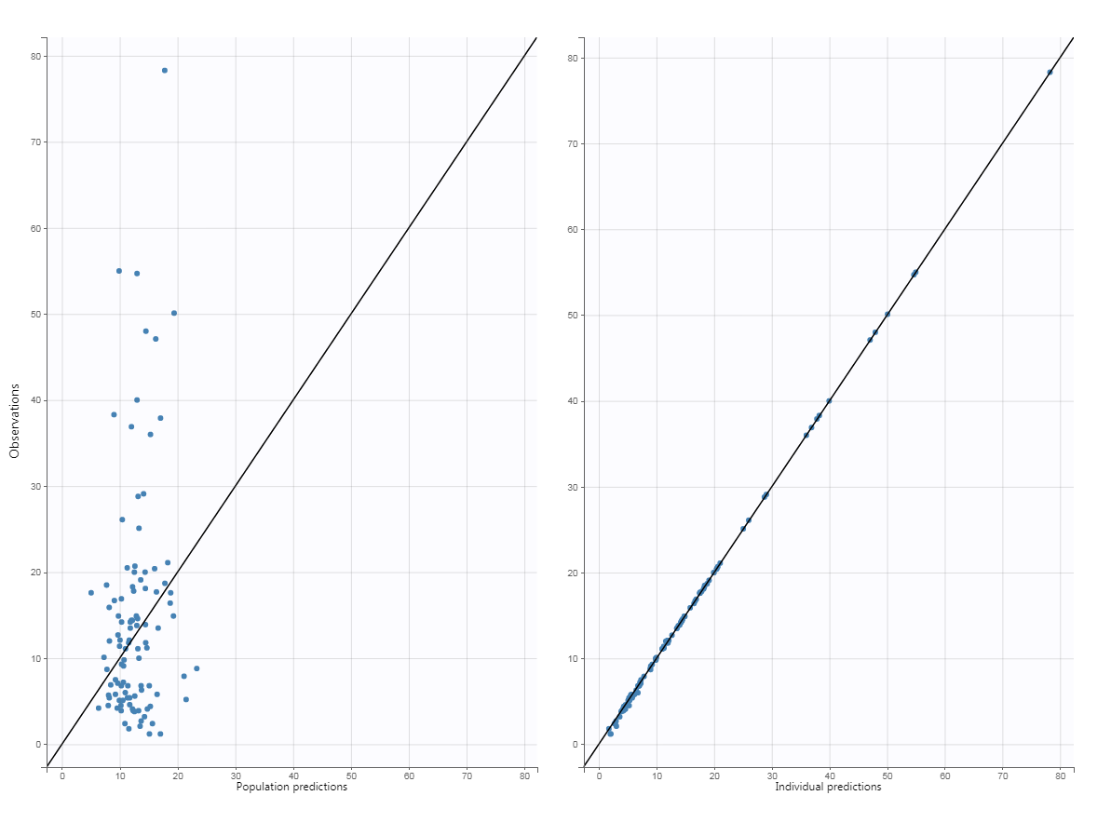

Figure S3. Population weighted residuals, Individual weighted residuals, and normalized prediction distribution errors with spline plot over time and population and individual predictions (after the first dose administered at time=0h and the second dose administered at time=12h)

Plasma
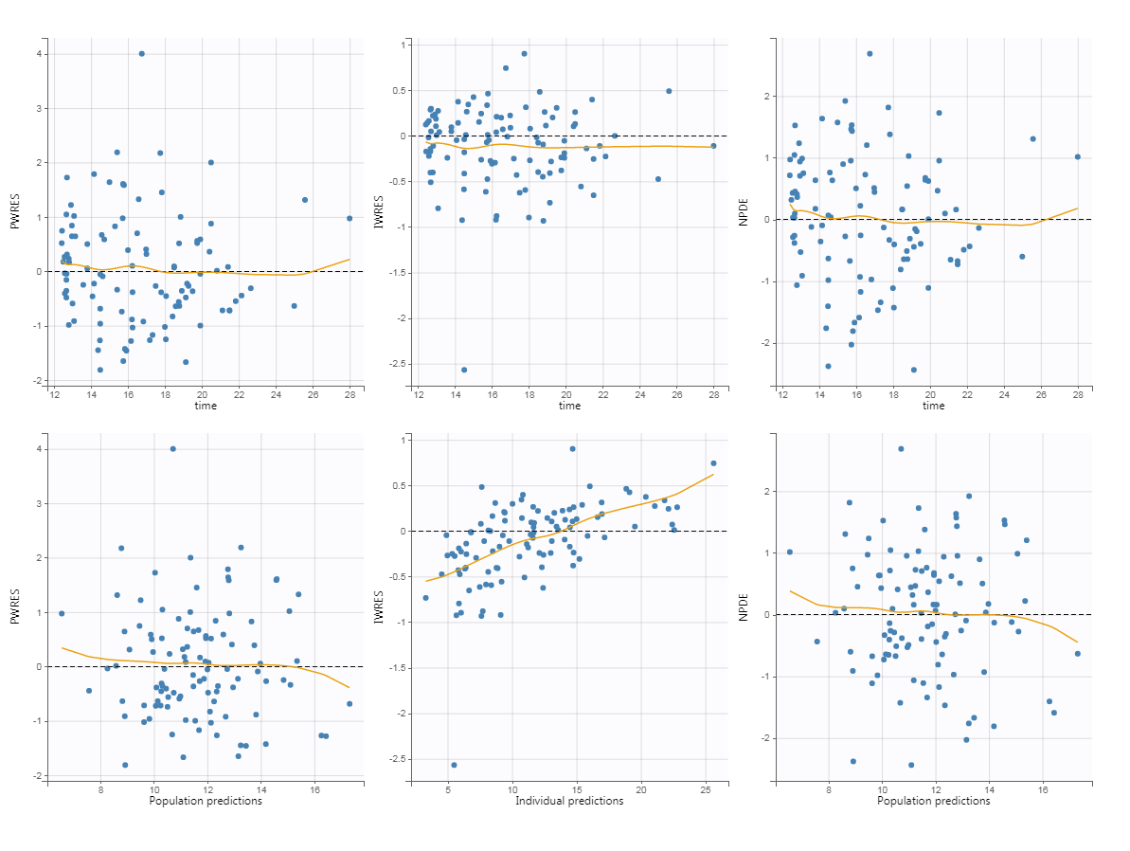
Prostate
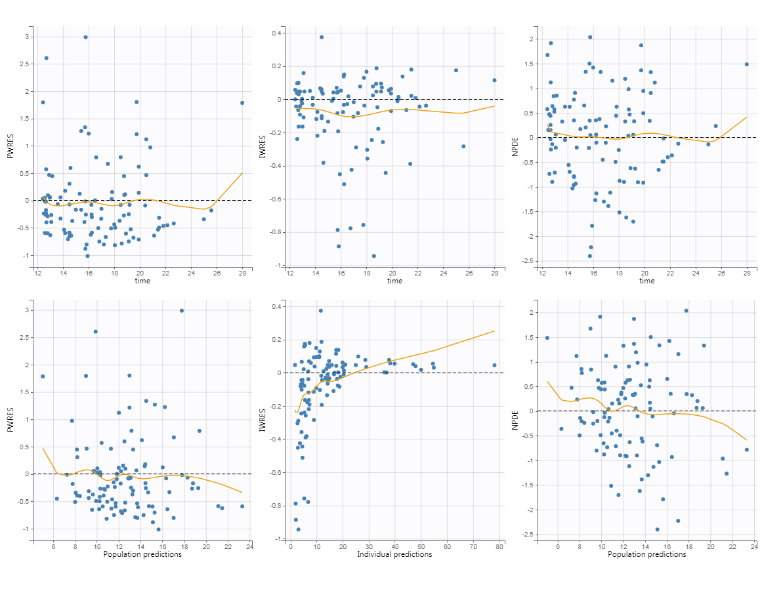

Figure S4. Distribution of the residuals plot

Plasma
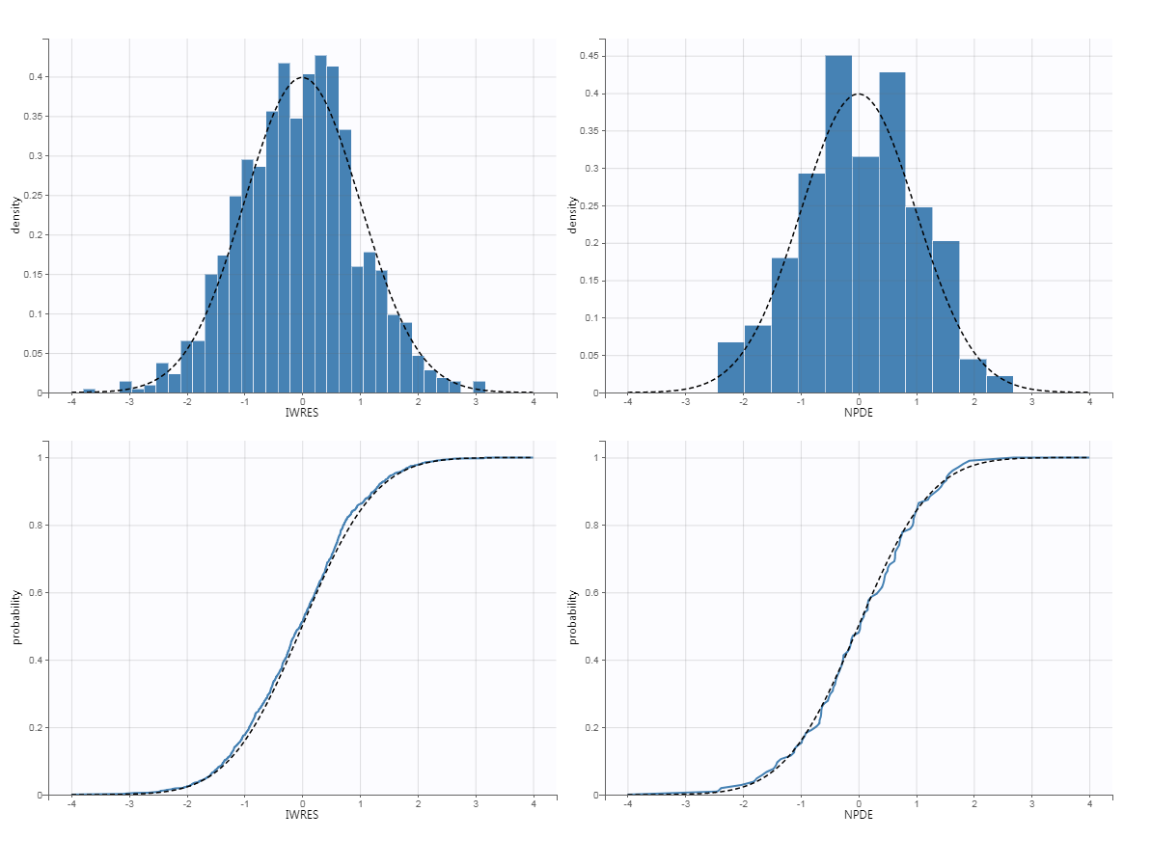
Prostate
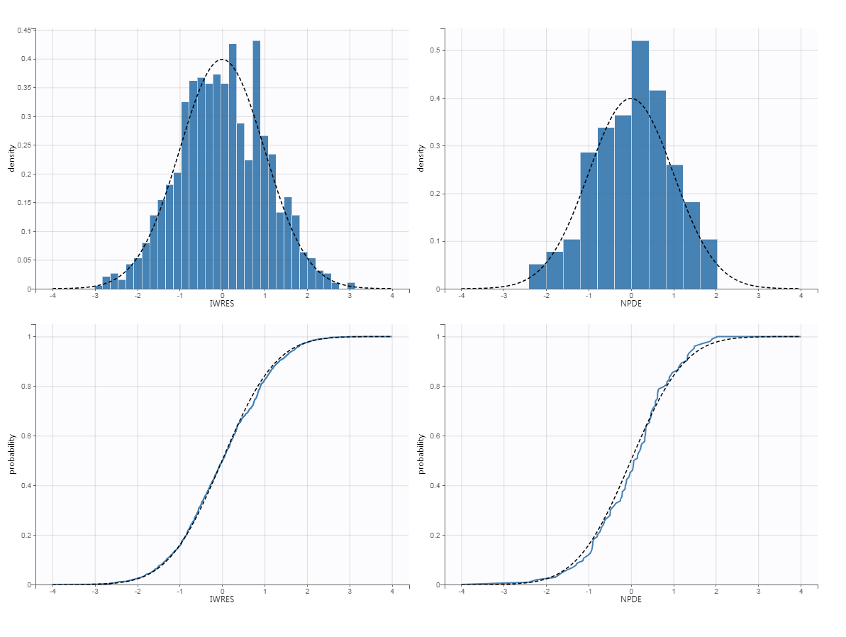

Figure S5. Visual Predictive Check Plot with Observed Data (after the first dose administered at time=0h and the second dose administered at time=12h)

Plasma
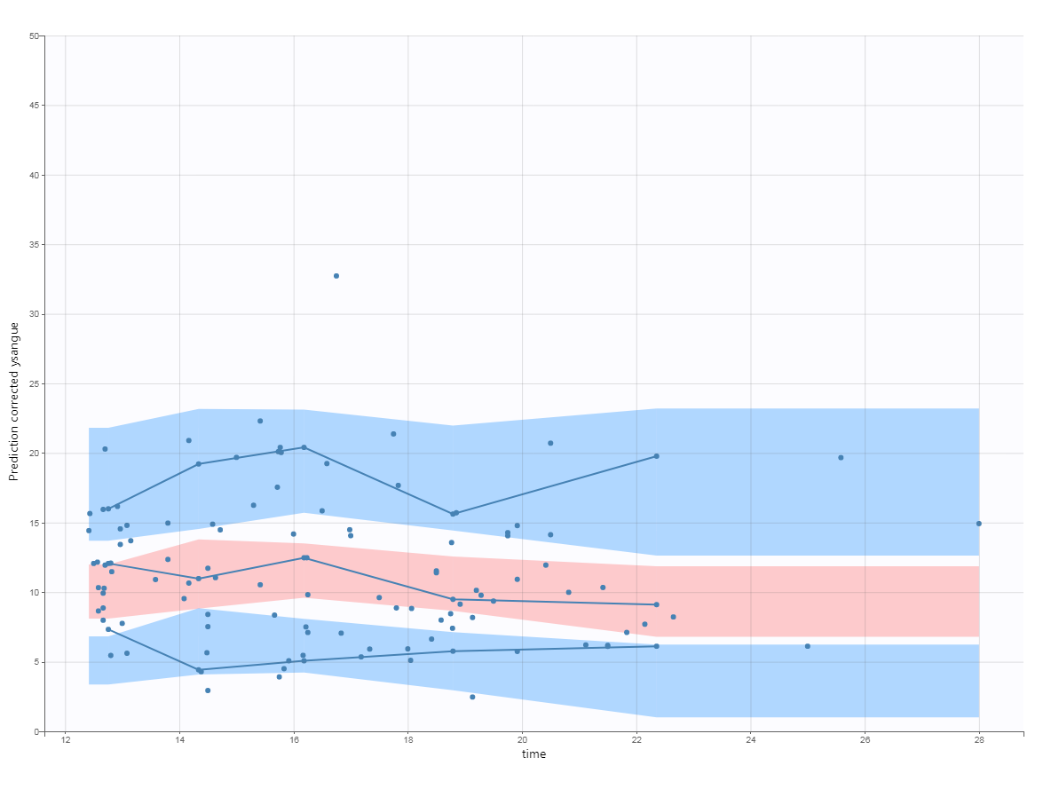
Prostate
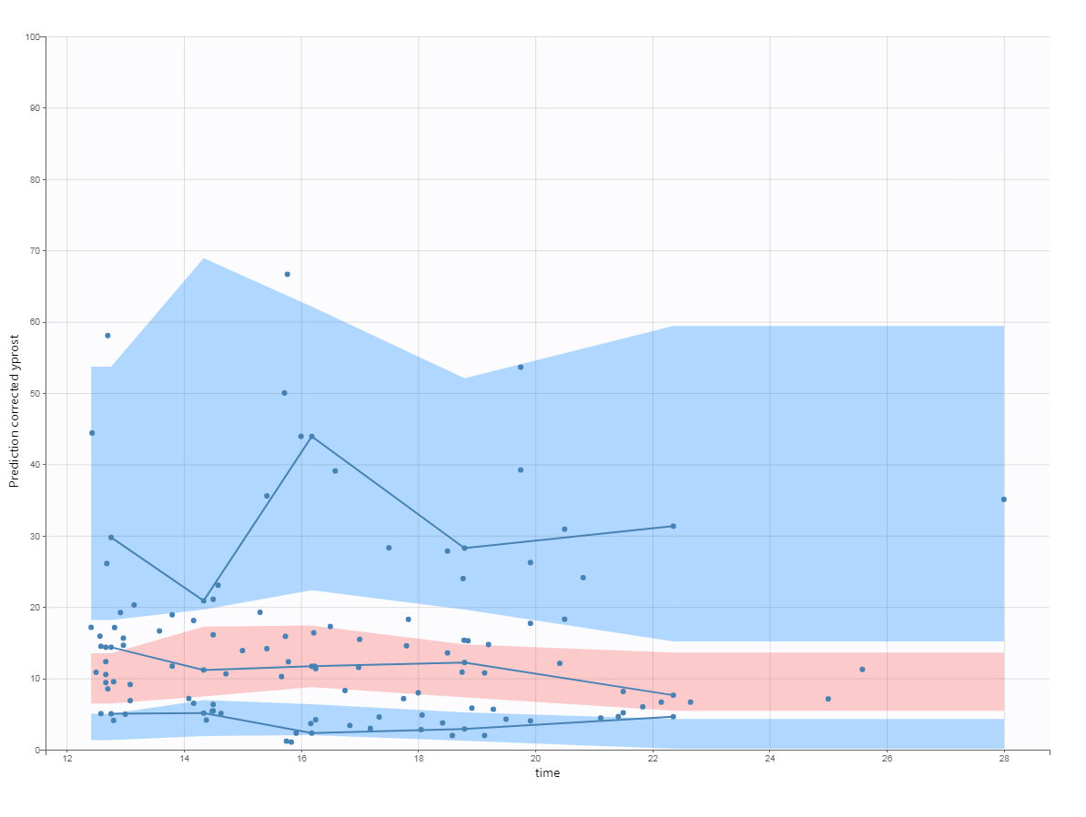

Figure S6. Concentration-time profiles of plasma individual predicted concentrations overlaid by the observed concentration for the first 20 patients included in the study
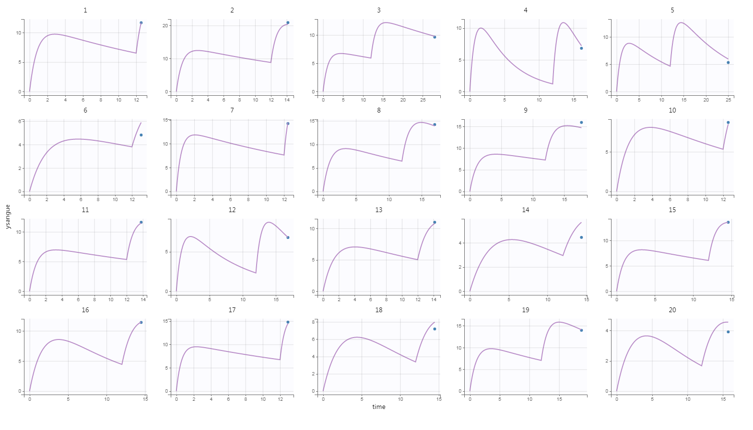
Figure S7. Concentration-time profiles of prostate individual predicted concentrations overlaid by the observed concentration for the first 20 patients included in the study
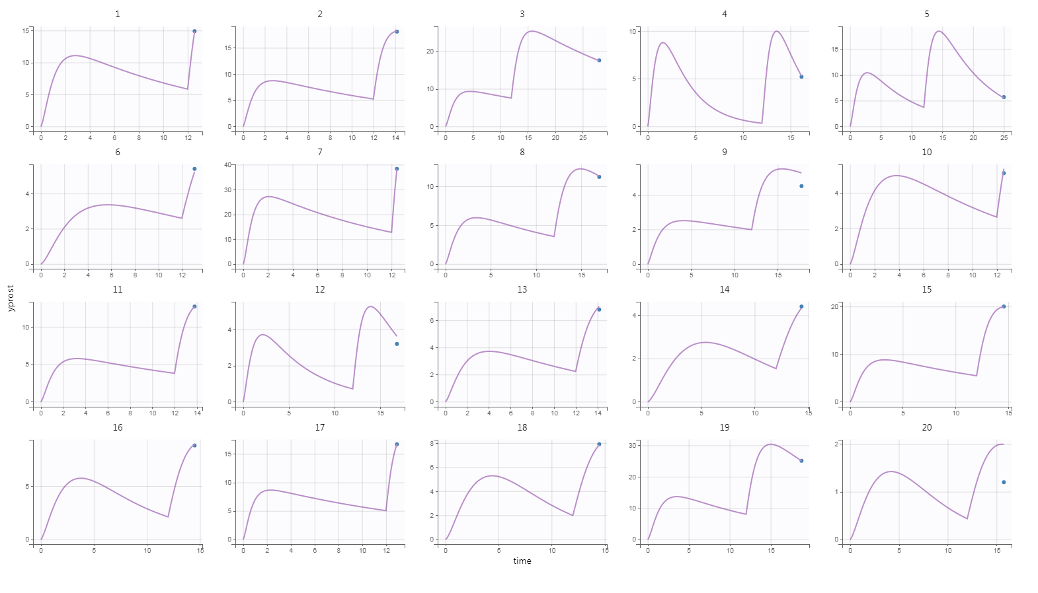
Model Code (in mlxtran language)
DESCRIPTION:
PKPD model. The PK data must be tagged with the lowest OBSERVATION ID value.
The administration is via a bolus.
The PK model has one compartment (volume V) and a linear elimination (clearance Cl).
The PD model is a direct Emax model (maximal effect Emax, and half-maximal effective concentration EC50).

[LONGITUDINAL]
input = {ka, V, Cl, PR, POW}

EQUATION:
Cc=pkmodel(ka,V,Cl)
Cp=PR*(Cc^POW)

;AUC calculation
ddt_AUC=Cp

OUTPUT:
output = {Cc, Cp}
table = {AUC}

