Climatic and biogeographic factors show contrasted effects on continental and volcanic ISARs

Cáceres-Polgrossi, L. (cac.polgrossi@gmail.com; 0000-0001-9350-9815)^{1,2}, Buldrini, F. (0000-0002-0376-6760)^{2,3}, Bruzzaniti, V.^{2,4}, Fernández-Palacios, J.M. (0000-0001-9741-6878)⁵, Testolin, R. (0000-0001-9741-6878)², Zannini, P. (0000-0003-2466-4402)⁴, & Chiarucci, A. (0000-0003-1160-235X)^{2,3}
¹World Ecology Conservation Group, Viale Stazione 2, Levico Terme, Trentino Alto-Adige, Italy
²BIOME Lab, Department of Biological, Geological & Environmental Sciences, Alma Mater Studiorum - University of Bologna, Bologna, Italy
³Centro Interuniversitario per le Biodiversità Vegetale Big Data - PLANT DATA, Department of Biological, Geological and Environmental Sciences, Alma Mater Studiorum University of Bologna, Bologna, Italy
⁴LifeWatch Italy, Lecce, Italy
⁵Grupo de Investigación Interuniversitario de Ecología y Biogeografía Insular, Universidad de La Laguna, San Cristóbal de la Laguna, Tenerife, Canary Islands, Spain

Table S1.1. Island features. Lat: latitude; Long: longitude; Iso: isolation ; Max. Elev : maximum elevation ; MAT : mean annual temperature ; PREC : annual precipitation ; Ecce: eccentricity.

N | Island | Archipelago | N Lat (°) | E Lon (°) | Iso (km) | Area (km²) | Max. Elev. (m) | Geological Origin | MAT (°C) | PREC (mm) | Ecce
1 | Palmaria | Spezzino | 44.04331296 | 9.8448545 | 1.02 | 1.644 | 191 | Continental | 15.7 | 960.4 | 1.01
2 | Isola del Tino | Spezzino | 44.02673879 | 9.8507205 | 2.72 | 0.129 | 122 | Continental | 16.1 | 935.7 | 1.69
3 | Gorgona | Tuscan | 43.42850283 | 9.8990374 | 34.32 | 2.152 | 190 | Continental | 16.1 | 727.1 | 1.34
4 | Capraia (Tuscan) | Tuscan | 43.03709889 | 9.8192406 | 29.51 | 18.94 | 447 | Oceanic | 15.8 | 616.1 | 1.21
5 | Elba | Tuscan | 42.77839502 | 10.287694 | 24.01 | 224.44 | 1019 | Continental | 15.9 | 650.9 | 1.5
6 | Pianosa (Tuscan) | Tuscan | 42.58489903 | 10.077196 | 44.93 | 10.54 | 29 | Continental | 16.9 | 554.8 | 1.2
7 | Montecristo | Tuscan | 42.33191782 | 10.309086 | 62.09 | 10.42 | 645 | Continental | 15.9 | 570.7 | 1.19
8 | Giglio | Tuscan | 42.35398209 | 10.901204 | 26.69 | 21.74 | 254 | Continental | 16.1 | 618.8 | 1.53
9 | Monte Argentario | Tuscan | 42.40576402 | 11.151047 | 0.01 | 60.41 | 635 | Continental | 15.8 | 741.0 | 1.3
10 | Giannutri | Tuscan | 42.25069321 | 11.104221 | 22.21 | 2.416 | 496 | Continental | 16.9 | 597.0 | 1.19
11 | Zannone | Pontine | 40.96855296 | 13.054862 | 28.12 | 1.064 | 142 | Oceanic | 17.4 | 755.5 | 1.46
12 | Gavi | Pontine | 40.93484296 | 13.000639 | 32.34 | 0.170 | 101 | Oceanic | 17.7 | 725.4 | 1.78
13 | Palmarola | Pontine | 40.93666674 | 12.857231 | 35.9 | 1.236 | 262 | Oceanic | 17.5 | 709.9 | 2.48
14 | Ponza | Pontine | 40.90804512 | 12.961482 | 35.94 | 7.551 | 280 | Oceanic | 17.3 | 716.6 | 2.43
15 | Santo Stefano | Pontine | 40.78970735 | 13.454256 | 46.97 | 0.309 | 89 | Oceanic | 17.6 | 701.5 | 1.32
16 | Ventotene | Pontine | 40.7933827 | 13.424698 | 47.07 | 1.363 | 139 | Oceanic | 17.5 | 697.7 | 3.04
17 | Procida | Campanian | 40.75738756 | 14.016826 | 4.39 | 4.068 | 91 | Oceanic | 17.2 | 750.1 | 1.53
18 | Vivara | Campanian | 40.74387879 | 13.994328 | 6.76 | 0.328 | 110 | Oceanic | 17.3 | 749.1 | 1.72
19 | Capri | Campanian | 40.55030679 | 14.225344 | 8.63 | 10.35 | 589 | Oceanic | 16.5 | 822.5 | 2.19
20 | La Castelluccia | Li Galli | 40.58175087 | 14.429857 | 2.67 | 0.010 | 51 | Continental | 17.6 | 864.7 | 1.48
21 | Gallo Lungo | Li Galli | 40.58247113 | 14.434787 | 2.92 | 0.044 | 54 | Continental | 17.6 | 868.6 | 2.16
22 | Isola di Cirella | Cirella | 39.69867381 | 15.801782 | 0.73 | 0.071 | 40 | Continental | 17.2 | 1156.2 | 1.17
23 | Dino | Dino | 39.87353577 | 15.774748 | 0.76 | 0.333 | 100 | Continental | 17.0 | 1114.0 | 2.13
24 | Stromboli | Aeolian | 38.79164061 | 15.216942 | 56.78 | 10.40 | 926 | Oceanic | 16.8 | 729.3 | 1.44
25 | Basiluzzo | Aeolian | 38.66302088 | 15.114336 | 44.63 | 0.246 | 165 | Oceanic | 18.3 | 616.0 | 1.38
26 | Panarea | Aeolian | 38.63560153 | 15.066803 | 42.9 | 3.155 | 421 | Oceanic | 17.6 | 629.2 | 1.25
27 | Lisca Bianca | Aeolian | 38.63924249 | 15.113887 | 42.08 | 0.031 | 33 | Oceanic | 18.5 | 627.1 | 1.27
28 | Scoglio Faraglione | Aeolian | 38.57938472 | 14.800828 | 44.11 | 0.004 | 35 | Oceanic | 18.4 | 649.3 | 1.47
29 | Salina | Aeolian | 38.5620686 | 14.839342 | 41.56 | 25.89 | 962 | Oceanic | 16.7 | 750.0 | 1.27
30 | Lipari | Aeolian | 38.48717653 | 14.936222 | 32.75 | 37.24 | 602 | Oceanic | 17.2 | 774.9 | 1.04
31 | Vulcano | Aeolian | 38.39453128 | 14.971015 | 22.94 | 20.72 | 499 | Oceanic | 17.3 | 808.8 | 1.81
32 | Filicudi | Aeolian | 38.57058375 | 14.563395 | 47.81 | 9.112 | 773 | Oceanic | 17.3 | 720.4 | 1.68
33 | Alicudi | Aeolian | 38.54260133 | 14.353018 | 54.48 | 4.893 | 675 | Oceanic | 17.0 | 690.1 | 1.12
34 | Ustica | Ustica | 38.70521464 | 13.1755 | 54.71 | 8.143 | 244 | Oceanic | 18.0 | 571.7 | 1.65
35 | Isola delle Femmine | Isola delle Femmine | 38.21008893 | 13.235993 | 0.83 | 0.169 | 35 | Continental | 18.6 | 674.9 | 1.51
36 | Levanzo | Egadi | 37.99930876 | 12.335299 | 13.64 | 6.048 | 278 | Continental | 17.7 | 583.6 | 1.61
37 | Marettimo | Egadi | 37.97035129 | 12.057817 | 36.39 | 12.21 | 686 | Continental | 17.0 | 742.0 | 2.11
38 | Favignana | Egadi | 37.92796487 | 12.318938 | 12.61 | 20.55 | 314 | Continental | 18.1 | 561.9 | 1.87
39 | Pantelleria | Pantelleria | 36.7875035 | 11.994541 | 78.7 | 83.92 | 836 | Oceanic | 17.5 | 628.4 | 1.55
40 | Linosa | Pelagie | 35.86543979 | 12.867963 | 163.72 | 5.605 | 195 | Oceanic | 18.9 | 429.4 | 1.38
41 | Lampedusa | Pelagie | 35.51336751 | 12.584851 | 135.82 | 20.29 | 133 | Continental | 19.0 | 383.6 | 3.11
42 | Isola dei Conigli | Pelagie | 35.5100124 | 12.558497 | 133.35 | 0.034 | 26 | Continental | 19.1 | 383.4 | 1.62
43 | Gozo | Maltese | 36.04703369 | 14.252476 | 84.81 | 66.22 | 30 | Continental | 18.6 | 564.1 | 2
44 | Comino | Maltese | 36.01165523 | 14.336196 | 85.11 | 2.878 | 74 | Continental | 18.9 | 540.7 | 1.35
45 | Malta | Maltese | 35.88803429 | 14.44023 | 95.06 | 245.81 | 253 | Continental | 18.7 | 569.7 | 2.03
46 | Fungus Rock | Maltese | 36.04690671 | 14.188748 | 86.64 | 0.008 | 60 | Continental | 19.1 | 516.9 | 1.46
47 | Pianosa (Tremiti) | Tremiti | 42.22492576 | 15.74721 | 34.05 | 0.141 | 15 | Continental | 17.1 | 432.9 | 2.12
48 | Il Cretaccio | Tremiti | 42.12246863 | 15.499288 | 23.31 | 0.058 | 113 | Continental | 16.9 | 473.0 | 1.37
49 | Capraia (Tremiti) | Tremiti | 42.13586231 | 15.513111 | 24.53 | 0.543 | 53 | Continental | 16.9 | 468.2 | 2.23
50 | San Domino | Tremiti | 42.11413679 | 15.486709 | 22.61 | 2.196 | 116 | Continental | 16.8 | 475.0 | 1.84
51 | San Nicola | Tremiti | 42.12412228 | 15.510621 | 23.3 | 0.502 | 75 | Continental | 16.9 | 472.3 | 3.71
52 | Pellestrina | Venice | 45.28513795 | 12.307699 | 6.96 | 3.720 | 3 | Continental | 14.7 | 852.7 | 6.87
53 | Lido | Venice | 45.38868192 | 12.354857 | 7.99 | 8.503 | 3 | Continental | 14.6 | 886.8 | 4.81
54 | Cavallino-Treporti | Venice | 45.46025881 | 12.494588 | 6.07 | 23.49 | 3 | Continental | 14.5 | 910.3 | 4.03
55 | Isola di Capo Passero | Capo Passero | 36.68669238 | 15.148676 | 0.82 | 0.318 | 21 | Oceanic | 18.8 | 572.3 | 2.28
56 | Faraglione di Mezzo | Cyclops | 37.55881027 | 15.162913 | 0.15 | 0.000 | 20 | Oceanic | 18.6 | 718.4 | 1.28
57 | Faraglione Grande | Cyclops | 37.5596587 | 15.165469 | 0.19 | 0.003 | 67 | Oceanic | 18.6 | 718.4 | 2.15
58 | Isola Lachea | Cyclops | 37.56140781 | 15.166451 | 0.22 | 0.015 | 35 | Oceanic | 18.6 | 718.4 | 1.11

Table S1.2. Island observed and estimated vascular plant species richness (S).

N | Island | Observed S | Estimated S | Std. error | 95% Lower | 95% Upper
1 | Palmaria | 136 | 150 | 7 | 142 | 172
2 | Isola del Tino | 33 | 53 | 11 | 40 | 89
3 | Gorgona | 152 | 208 | 21 | 180 | 264
4 | Capraia (Tuscan) | 238 | 262 | 11 | 249 | 294
5 | Elba | 524 | 603 | 20 | 572 | 654
6 | Pianosa (Tuscan) | 221 | 240 | 8 | 230 | 265
7 | Montecristo | 123 | 139 | 11 | 128 | 177
8 | Giglio | 158 | 178 | 9 | 167 | 205
9 | Monte Argentario | 282 | 401 | 34 | 351 | 487
10 | Giannutri | 115 | 145 | 15 | 127 | 189
11 | Zannone | 71 | 115 | 22 | 89 | 180
12 | Gavi | 40 | 52 | 8 | 44 | 79
13 | Palmarola | 110 | 152 | 16 | 130 | 197
14 | Ponza | 281 | 357 | 25 | 322 | 422
15 | Santo Stefano | 48 | 132 | 45 | 80 | 272
16 | Ventotene | 130 | 208 | 29 | 169 | 287
17 | Procida | 107 | 179 | 24 | 145 | 244
18 | Vivara | 117 | 205 | 31 | 162 | 290
19 | Capri | 102 | 173 | 26 | 137 | 246
20 | La Castelluccia | 24 | 42 | 12 | 29 | 83
21 | Gallo Lungo | 46 | 51 | 4 | 47 | 66
22 | Isola di Cirella | 50 | 72 | 12 | 58 | 112
23 | Dino | 74 | 101 | 13 | 85 | 140
24 | Stromboli | 141 | 179 | 17 | 157 | 228
25 | Basiluzzo | 18 | 26 | 8 | 20 | 58
26 | Panarea | 213 | 272 | 21 | 243 | 331
27 | Lisca Bianca | 19 | 22 | 3 | 20 | 34
28 | Scoglio Faraglione | 14 | 14 | 1 | 14 | 18
29 | Salina | 294 | 338 | 15 | 317 | 377
30 | Lipari | 366 | 409 | 15 | 388 | 449
31 | Vulcano | 217 | 254 | 14 | 235 | 295
32 | Filicudi | 273 | 365 | 30 | 323 | 444
33 | Alicudi | 197 | 263 | 20 | 233 | 316
34 | Ustica | 115 | 141 | 11 | 127 | 172
35 | Isola delle Femmine | 79 | 121 | 17 | 99 | 171
36 | Levanzo | 283 | 379 | 25 | 341 | 442
37 | Marettimo | 189 | 211 | 9 | 199 | 238
38 | Favignana | 289 | 354 | 18 | 327 | 399
39 | Pantelleria | 240 | 249 | 5 | 243 | 267
40 | Linosa | 219 | 245 | 16 | 227 | 298
41 | Lampedusa | 332 | 379 | 20 | 353 | 436
42 | Isola dei Conigli | 66 | 76 | 7 | 69 | 101
43 | Gozo | 377 | 426 | 15 | 404 | 465
44 | Comino | 120 | 152 | 13 | 135 | 191
45 | Malta | 504 | 530 | 10 | 517 | 559
46 | Fungus Rock | 36 | 157 | 82 | 72 | 441
47 | Pianosa (Tremiti) | 31 | 53 | 19 | 36 | 124
48 | Il Cretaccio | 31 | 43 | 8 | 34 | 71
49 | Capraia (Tremiti) | 151 | 177 | 11 | 162 | 209
50 | San Domino | 312 | 366 | 19 | 340 | 416
51 | San Nicola | 222 | 269 | 17 | 246 | 314
52 | Pellestrina | 49 | 56 | 5 | 51 | 73
53 | Lido | 125 | 166 | 16 | 144 | 212
54 | Cavallino-Treporti | 39 | 53 | 8 | 44 | 80
55 | Isola di Capo Passero | 225 | 240 | 7 | 231 | 261
56 | Faraglione di Mezzo | 10 | 12 | 3 | 10 | 29
57 | Faraglione Grande | 33 | 37 | 5 | 34 | 58
58 | Isola Lachea | 56 | 57 | 1 | 56 | 63
MIN |  | 10 | 12 | 1 | 10 | 18
MEAN |  | 156.3 | 195.0 | 15.9 | 174.7 | 242.3
MAX |  | 524 | 603 | 82 | 572 | 654

Table S1.3. Biogeographic and climatic variables for continental and oceanic islands (mean ± standard error). Different letters between levels (a,b) show significant differences (p-value < .05).

Origin | n | Area  (km²) | Isolation  (km) | Elevation  (m) | Eccentricity | Mean ann. temperature  (°C) | Annual precipitation  (mm)
Continental | 31 | 24.12 ± 10.53 a | 34.31 ± 6.94 a | 196.6 ± 44.6 a | 2.082 ± 0.225 a | 17.0 ± 0.2 a | 671.7 ± 37.6 a
Oceanic | 27 | 9.45 ± 3.37 a | 37.19 ± 6.30 a | 324.4 ± 58.3 a | 1.64 ± 0.095 a | 17.6 ± 0.1 b | 688.1 ± 16.0 a

Figure S1.4. Correlation test between continental ISAR intercepts (a, b and c) and slopes (d) with biogeographic and climatic variables (n = 12). To disentangle the influence from other biogeographic and climatic variables on the significant relationship resulted from the iterative analysis (i.e. isolation, annual precipitation and mean annual temperature; Figure 3a, c and d, respectively for intercepts and Figure 4d for slopes); we carried out correlation tests between the continental ISAR intercepts and slopes with the rest of biogeographic and climatic variables. MAT: mean annual temperature; PREC: annual precipitation.

a)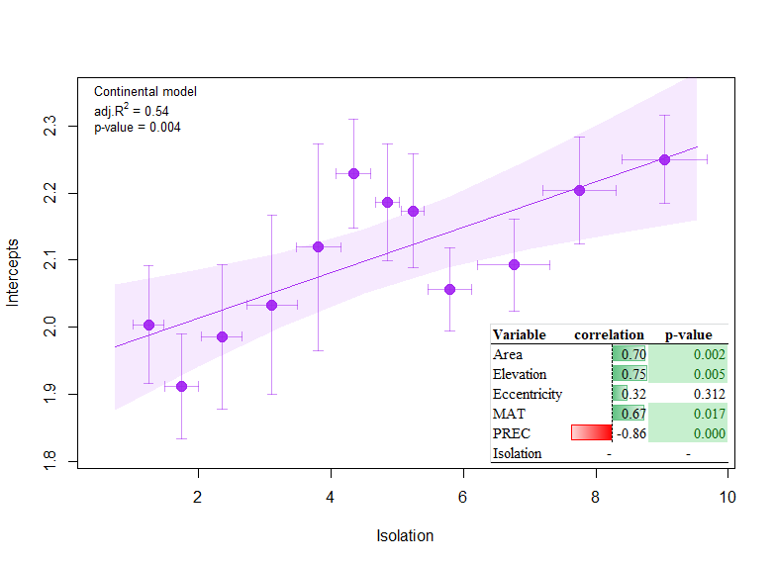
b) 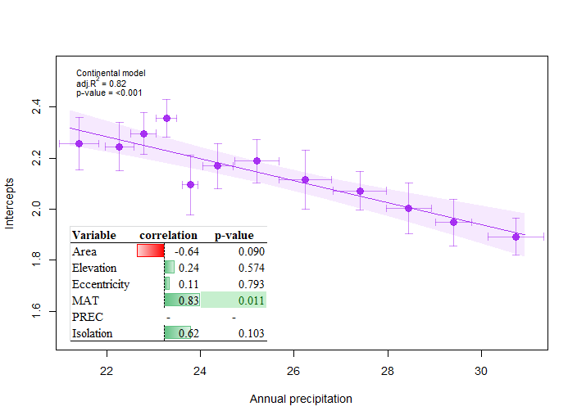

c) 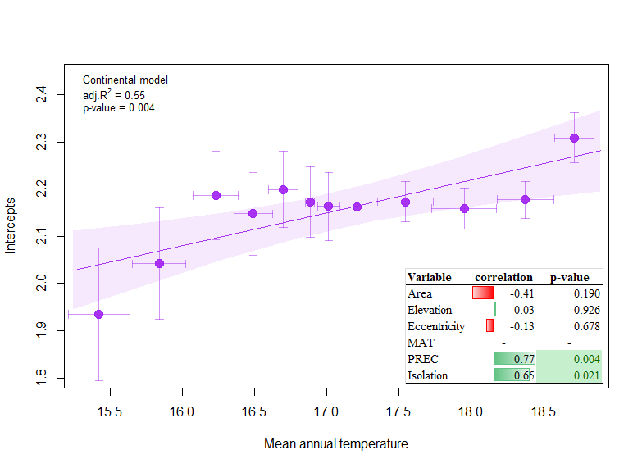
d) 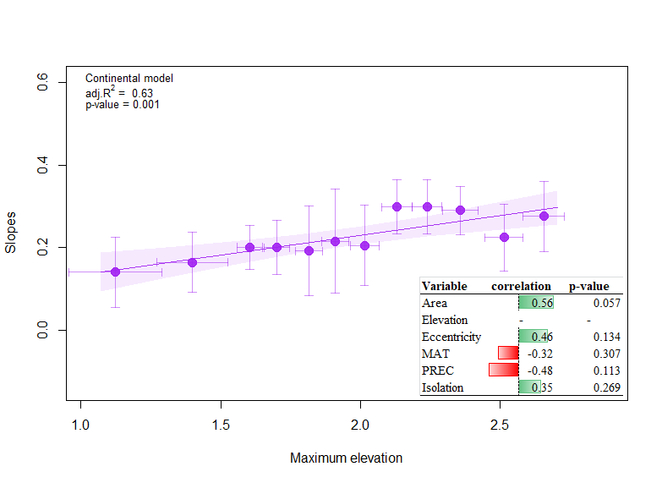
Figure S1.5. Correlation test between oceanic ISAR intercepts and slopes with biogeographic and climatic variables (n = 10). To disentangle the influence from other biogeographic and climatic variables on the significant relationship resulted from the iterative analysis (i.e. isolation, mean annual temperature and annual precipitation; Figure 3a, c and d, respectively for intercepts and Figure 4 a, b, c and d for slopes); we carried correlation tests between the continental ISAR intercepts and slopes with the rest of biogeographic and climatic variables. MAT: mean annual temperature; PREC: annual precipitation.

a)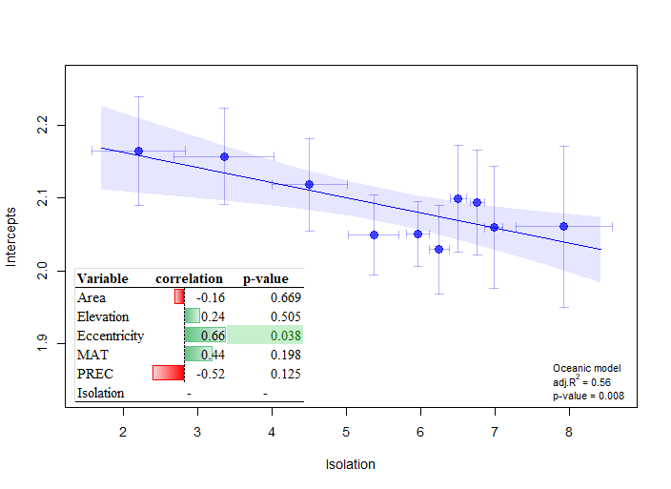
b)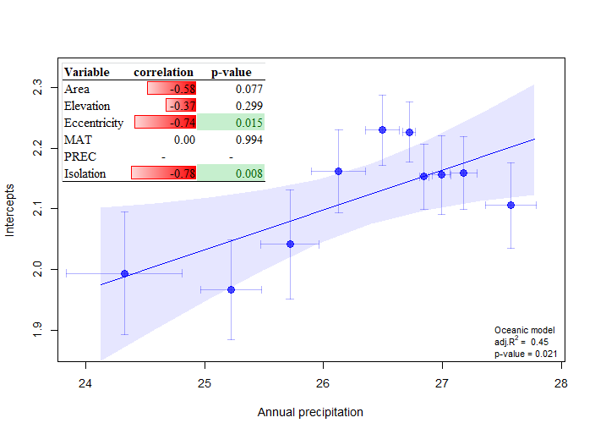

c)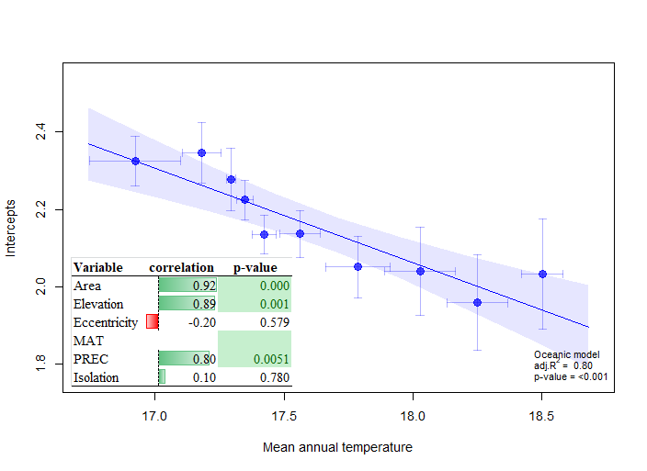
d)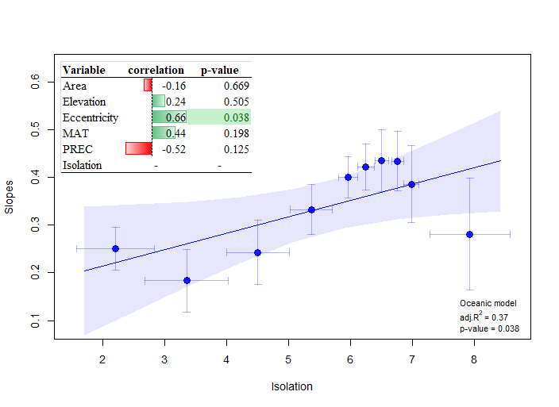

e)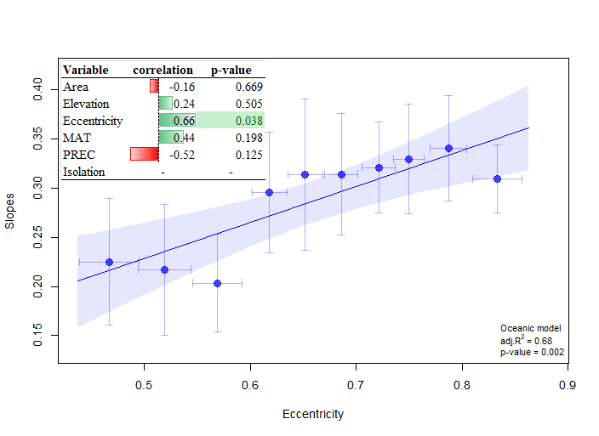
f)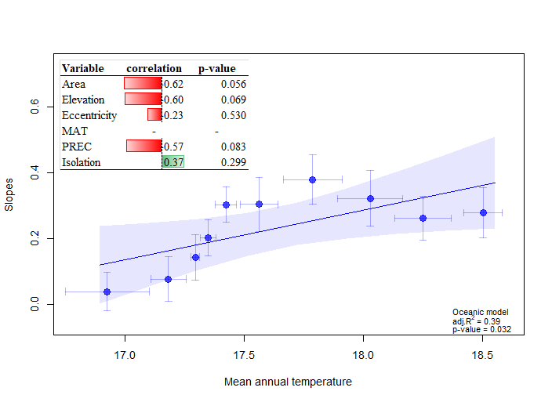

g)