Supplementary material of “A novel combined high-pressure CO₂ technology preserves quality and enhances health-promoting properties of fresh-cut organic cantaloupe melon”
Riccardo Zulliª, Zhe Chen^{b}, Fabio Santiª, Urszula Trych^{b}, Justyna Szczepańska-Stolarczyk^{b}, Magdalena Cywińska-Antonik^{b}, Pietro Andrigoª, Maria Allegra^{c}, Claudio Saitta^{c}, Martina Papa^{c}, Nicolina Timpanaro^{c}, Yasin Ozdemir^{d}, Seda Kayahan^{d}, Hasret Altunkanat^{d}, Aysun Ozturk^{d}, Alessandro Zambon^{e}, Simona Fabroni^{c,‡,}*, Krystian Marszalek^{b,‡,}*, Sara Spilimbergo^{a,‡,}*

ªDepartment of Industrial Engineering, University of Padova, Via Marzolo 9, 35131 Padova, Italy
^{b}Prof. Wacław Dąbrowski Institute of Agricultural and Food Biotechnology – State Research Institute, Department of Fruit and Vegetable Product Technology, 36 Rakowiecka St., 02-532 Warsaw, Poland
^{c}Council for Agricultural Research and Economics (CREA), Research Center for Olive, Fruit and Citrus Crops, Corso Savoia 190, 95024 Acireale, Italy
^{d}Atatürk Horticultural Central Research Institute, 77100, Yalova, Türkiye
^{e}Department of Civil, Chemical, Environmental, and Materials Engineering, University of Bologna, Via Terracini 28, 40131, Bologna, Italy

‡Equal contributing senior authors
*Corresponding authors: simona.fabroni@crea.gov.it, krystian.marszalek@ibprs.pl, sara.spilimbergo@unipd.it
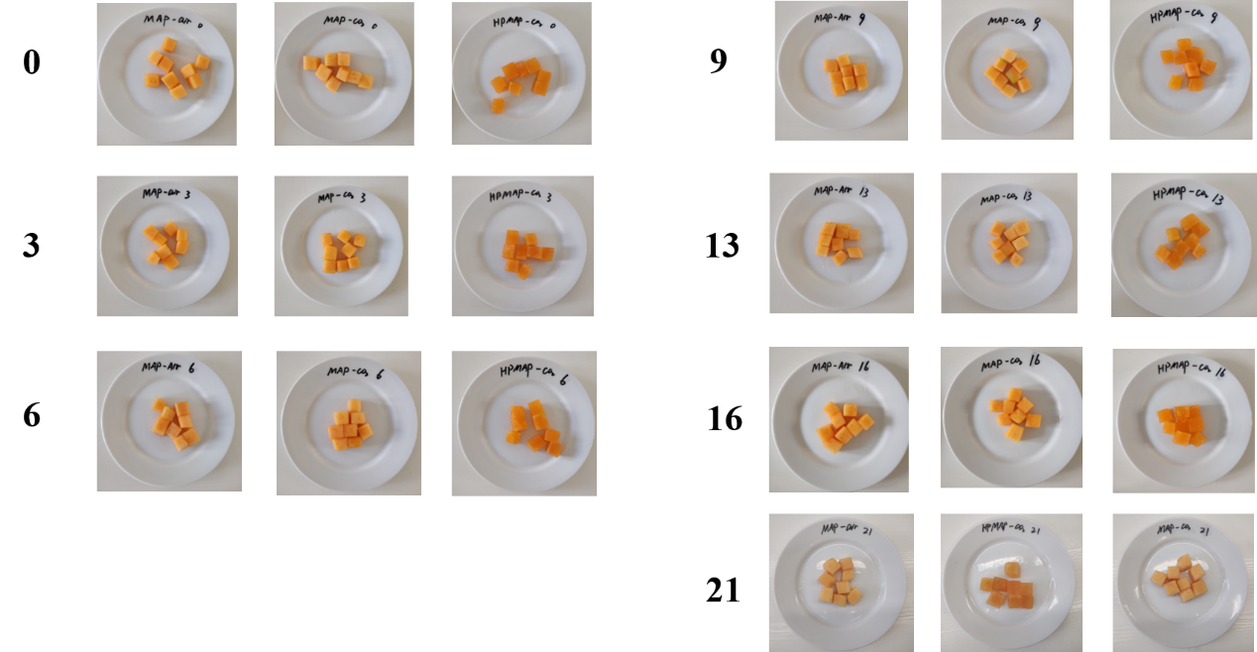
Figure S1. Pictures of the melon samples for the three compared treatments (MAPair, MAPCO₂, and HPMAPCO₂) during the refrigerated storage.

Table S1. Micro- and macro-element content in the three compared treatments (MAPair, MAPCO₂, and HPMAPCO₂) during the refrigerated storage of fresh-cut melon. Results are expressed in mg per 100 g of fresh sample. Different letters indicate statistically different values (α = 0.05) at the same time point. If no letters are present, values are not statistically different.
Storage time (days) | Sample | K | Ca | Mn | Mg | Cu | Fe | Zn | Na | P
0 | Fresh | 181.11 ± 009^{b} | 21.94 ± 0.25ª | 0.00 ± 0.00 | 14.33 ± 0.02ª | 0.00 ± 0.00 | 0.29 ± 0.00 | 0.00 ± 0.00 | 13.04 ± 0.02ª | 17.68 ± 0.03^{b}
0 | HPMAPCO₂ | 209.79 ± 0.49ª | 14.28 ± 0.01^{b} | 0.00 ± 0.00 | 12.29 ± 0.07^{b} | 0.00 ± 0.00 | 0.29 ± 0.00 | 0.00 ± 0.00 | 7.07 ± 0.03^{b} | 22.11 ± 0.07ª
6 | MAPair | 274.35 ± 3.44ª | 17.16 ± 0.04^{b} | 0.00 ± 0.00 | 12.50 ± 0.00^{b} | 0.00 ± 0.00 | 0.27 ± 0.00^{b} | 0.04 ± 0.00 | 6.92 ± 0.05^{b} | 23.80 ± 0.10ª
6 | MAPCO₂ | 292.19 ± 0.97ª | 21.19 ± 0.20^{c} | 0.00 ± 0.00 | 12.81 ± 0.04^{b} | 0.00 ± 0.00 | 0.56 ± 0.00ª | 0.02 ± 0.00 | 8.48 ± 0.04ª | 22.92 ± 0.06ª
6 | HPMAPCO₂ | 163.99 ± 0.78^{b} | 26.06 ± 0.20ª | 0.00 ± 0.00 | 15.20 ± 0.07ª | 0.00 ± 0.00 | 0.14 ± 0.00^{c} | 0.00 ± 0.00 | 5.18 ± 0.00^{b} | 19.24 ± 0.13^{b}
13 | MAPair | 215.72 ± 0.48^{b} | 20.72 ± 0.17^{b} | 0.00 ± 0.00 | 13.50 ± 0.07^{b} | 0.00 ± 0.00 | 0.29 ± 0.00^{b} | 0.05 ± 0.00 | 8.05 ± 0.03^{b} | 19.37 ± 0.09^{c}
13 | MAPCO₂ | 273.47 ± 2.94ª | 19.23 ± 0.06^{c} | 0.00 ± 0.00 | 13.32 ± 0.13^{b} | 0.00 ± 0.00 | 0.41 ± 0.00ª | 0.11 ± 0.00 | 12.91 ± 0.11ª | 22.12 ± 0.04ª
13 | HPMAPCO₂ | 186.50 ± 1.76^{c} | 28.44 ± 0.03ª | 0.00 ± 0.00 | 15.95 ± 0.03ª | 0.00 ± 0.00 | 0.32 ± 0.00^{b} | 0.00 ± 0.00 | 6.26 ± 0.05^{c} | 20.88 ± 0.05^{b}
21 | MAPair | 172.82 ± 2.11^{b} | 26.00 ± 0.38^{b} | 0.00 ± 0.00 | 13.48 ± 0.01^{b} | 0.00 ± 0.00 | 1.42 ± 0.00ª | 0.37 ± 0.00 | 10.79 ± 0.04^{b} | 16.79 ± 0.02^{c}
21 | MAPCO₂ | 248.19 ± 1.05ª | 32.27 ± 0.07ª | 0.00 ± 0.00 | 13.07 ± 0.08^{b} | 0.00 ± 0.00 | 1.22 ± 0.00^{b} | 0.13 ± 0.00 | 16.06 ± 0.09ª | 17.93 ± 0.03^{b}
21 | HPMAPCO₂ | 170.57 ± 0.98^{b} | 24.28 ± 0.19^{b} | 0.00 ± 0.00 | 14.91 ± 0.07ª | 0.00 ± 0.00 | 0.43 ± 0.00^{c} | 0.03 ± 0.00 | 7.44 ± 0.10^{c} | 21.11 ± 0.03ª

Table S2. Total polyphenols (expressed in mg GAE/100 g DW), DPPH antioxidant activity (expressed as mg Trolox/100 g DW) and total carotenoids (expressed as mg GAE/100 g DW) determined during the bio accessibility study on the freeze-dried samples, stomach phase, intestine phase and bio accessible fractions during the refrigerated storage of fresh-cut melon for the three treatments (MAPair, MAPCO₂, and HPMAPCO₂).
Storage time (days) | Sample | Total polyphenols (mg GAE/100 g DW) |  |  |  |  | DPPH antioxidant activity (mg TE/100 g DW) |  |  |  | Total carotenoids (mg GAE/100 g DW)
Storage time (days) | Sample | Freeze-dried sample | Stomach phase | Intestine phase | Bioaccessible fraction | Freeze-dried sample |  | Stomach phase | Intestine phase | Bioaccessible fraction | Freeze-dried sample | Stomach phase | Intestine phase | Bioaccessible fraction
0 | Fresh | 115.08 ± 1.61 | 130.94 ± 5.69 | 194.57 ± 2.73 | 86.41 ± 0.50 | 1650 ± 79.2 |  | 2381.44 ± 111.18 | 4579.06 ± 103.1 | 1156.47 ± 48.7 | 46.43 ± 3.08 | 48.19 ± 1.05 | 40.74 ± 0.18 | 12.51 ± 0.23
0 | HPMAPCO₂ | 111.53 ± 10.38 | 123.64 ± 11.05 | 227.05 ± 24.43 | 103.24 ± 10.95 | 1847.21 ± 42.01 |  | 3225.27 ± 11.13 | 5046.16 ± 25.41 | 1347.57 ± 1.54 | 48.4 ± 2.98 | 51.71 ± 4.71 | 44.56 ± 3.59 | 13.53 ± 1.38
6 | MAPair | 112.54 ± 3.42 | 125.53 ± 5.33 | 183.63 ± 19.11 | 80.84 ± 8.47 | 1608.6 ± 116.81 |  | 2373.67 ± 167.42 | 3965.57 ± 249.91 | 943.34 ± 34.17 | 46.04 ± 0.35 | 49.01 ± 0.29 | 41.34 ± 0.04 | 12.78 ± 0.05
6 | MAPCO₂ | 85.58 ± 1.64 | 89.42 ± 5.37 | 141.71 ± 8.19 | 62.49 ± 4.01 | 1541.4 ± 56.85 |  | 2347.98 ± 85.95 | 3992.55 ± 283.37 | 989.55 ± 57.3 | 56.81 ± 2.45 | 60.49 ± 4.26 | 51.55 ± 4.14 | 15.91 ± 1.05
6 | HPMAPCO₂ | 113.73 ± 2.28 | 137.41 ± 0.7 | 243.99 ± 8.8 | 104.23 ± 0.92 | 1935.93 ± 41.25 |  | 3140 ± 29.13 | 5664.44 ± 25.9 | 1550.32 ± 15.68 | 51.11 ± 1.26 | 56.07 ± 1.17 | 46.71 ± 1.53 | 14.57 ± 0.57
9 | MAPair | 107.06 ± 2.71 | 119.41 ± 4.46 | 174.65 ± 17.27 | 76.89 ± 7.66 | 1530.01 ± 103.24 |  | 2257.7 ± 147.63 | 3771.91 ± 218.3 | 897.34 ± 27.88 | 43.8 ± 0.56 | 46.62 ± 0.04 | 39.33 ± 0.24 | 11.58 ± 0.82
9 | MAPCO₂ | 81.69 ± 0.86 | 85.3 ± 2.6 | 135.19 ± 3.81 | 59.61 ± 2.06 | 1472.51 ± 97.88 |  | 2243.03 ± 148.47 | 3816.03 ± 383.49 | 945.62 ± 82.7 | 54.27 ± 3.95 | 57.82 ± 5.78 | 49.28 ± 5.41 | 14.98 ± 1.77
9 | HPMAPCO₂ | 109.38 ± 18.43 | 121.24 ± 19.98 | 222.79 ± 40.73 | 101.3 ± 18.36 | 1803.66 ± 96.05 |  | 3152.36 ± 250.26 | 4932.39 ± 399.35 | 1316.88 ± 98.51 | 47.41 ± 6.51 | 50.71 ± 8.44 | 43.68 ± 6.82 | 14.54 ± 1.17
14 | MAPair | 121.71 ± 8.49 | 139.56 ± 11.83 | 224.02 ± 23.86 | 98.88 ± 10.83 | 1383.4 ± 72.69 |  | 1925.56 ± 169.8 | 3485.52 ± 105.22 | 860.32 ± 36.92 | 54.54 ± 1.8 | 57.83 ± 4.62 | 49.25 ± 3.46 | 15.42 ± 1.06
14 | MAPCO₂ | 120.78 ± 2.62 | 142.23 ± 3.28 | 235.78 ± 9.48 | 104.33 ± 4.21 | 1697.4 ± 52.33 |  | 2300.12 ± 94.06 | 4055.69 ± 174.05 | 1036.58 ± 18.38 | 50.64 ± 2.08 | 54.4 ± 1.51 | 47.61 ± 1.27 | 15.04 ± 0.37
14 | HPMAPCO₂ | 119.44 ± 1.87 | 135.25 ± 1.46 | 247.94 ± 0 | 110.18 ± 0.03 | 1782.08 ± 118.38 |  | 3156.84 ± 246.64 | 4411.97 ± 37.6 | 1182.19 ± 4.03 | 51.52 ± 0.91 | 53.56 ± 2.03 | 43.66 ± 1.63 | 13.71 ± 0.44
21 | MAPair | 114.23 ± 4.72 | 132.16 ± 3.71 | 215.32 ± 8.04 | 92.31 ± 5.46 | 1305.24 ± 60.12 |  | 1807.58 ± 115.79 | 3325.81 ± 98.42 | 825.27 ± 22.06 | 55.38 ± 1.22 | 59.38 ± 2.74 | 49.11 ± 2.07 | 16.21 ± 0.18
21 | MAPCO2 | 119.58 ± 3.11 | 142.28 ± 3.23 | 238.81 ± 10.23 | 105.66 ± 4.05 | 1643.78 ± 51.42 |  | 2268.17 ± 92.51 | 4012.23 ± 135.51 | 1017.32 ± 16.13 | 47.65 ± 0.71 | 51.12 ± 1.61 | 45.84 ± 1.33 | 15.38 ± 0.32
21 | HPMAPCO2 | 115.25 ± 2.68 | 135.72 ± 2.96 | 249.28 ± 6.70 | 112.13 ± 1.38 | 1768.35 ± 65.98 |  | 3115.80 ± 126.69 | 4376.18 ± 42.35 | 1192.18 ± 7.28 | 48.11 ± 0.83 | 51.77 ± 1.36 | 41.19 ± 1.18 | 14.76 ± 0.46

