Supplementary Figure 1.
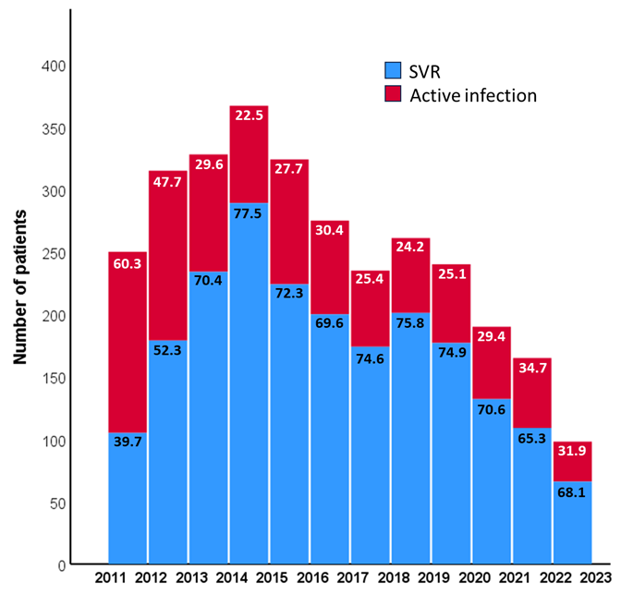
Supplementary Figure 2.
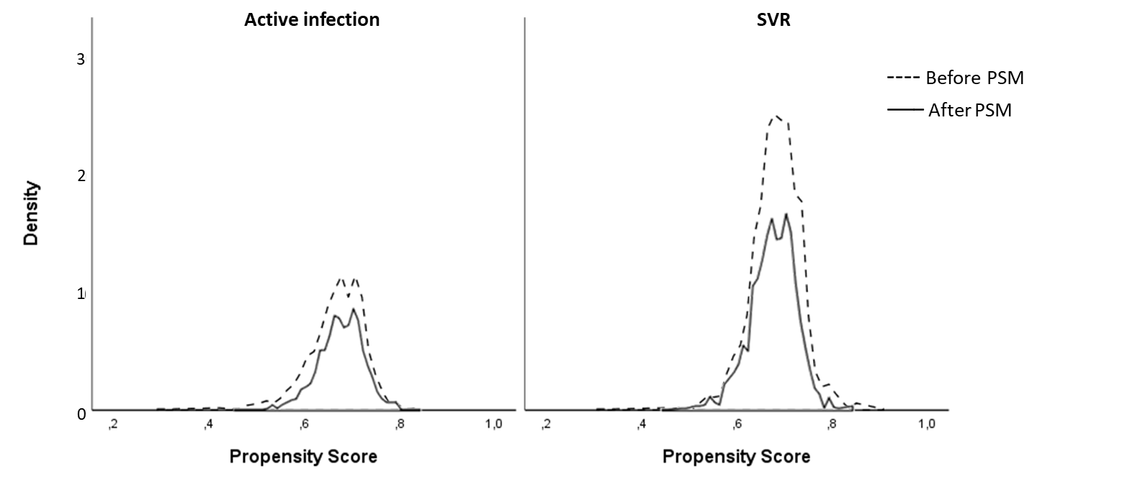
Supplementary Figure 3.
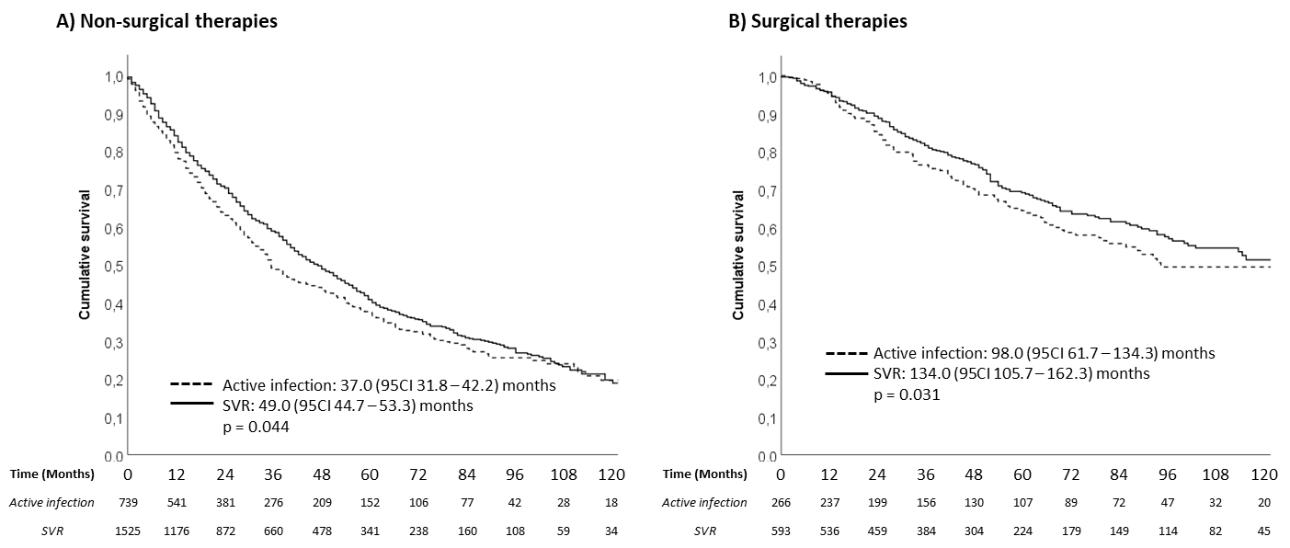
LEGEND TO SUPPLEMENTARY FIGURES
Supplementary Figure 1. Visual comparison of patient numbers between those with active HCV infection and those with negative HCV RNA over time. A) Area chart showing the annual number of patients with cleared (blue) and active infection (red) from 2012 to 2022. The area covered by each color corresponds to the number of patients in each category per year, illustrating trends over the 10-year period. B) Group bar chart comparing the annual number of patients with cleared (blue) and active infection (red) from 2012 to 2022. Each group represents a year, with the y-axis showing the number of patients and the x-axis representing the year. Data are absolute value and percentage for each group.
Supplementary Figure 2. Propensity score distributions before and after matching for active infection and sustained virological response (SVR) groups. The dashed lines represent the distribution of propensity scores prior to matching, while the solid lines indicate the distributions after matching. The alignment of the distributions post-matching illustrates the improved balance between the groups achieved through the propensity score matching process.
Supplementary Figure 3. Cumulative survival by viral status for non-surgical and surgical therapies. Kaplan-Meier survival curves stratified by viral status [active infection vs sustained virological response (SVR)] for patients undergoing non-surgical therapies (A) and surgical therapies (B).

SUPPLEMENTARY TABLE 1. Principal modality of hepatocellular carcinoma treatment subdivided according to Hepatitis C Virus infection status.
Treatment | Active infection  (n = 1,005) | SVR  (n = 2,118) | p
Surgical therapies
Liver transplantation | 88 (8.8) | 135 (6.4) | 0.016
Liver resection | 178 (17.7) | 458 (21.6) | 0.011
Ablative therapies
Radiofrequency ablation | 295 (29.4) | 653 (30.0) | 0.895
Ethanol injection | 55 (5.5) | 88 (4.2) | 0.562
Other ablative treatments | 17 (1.7) | 43 (2.0) | 0.496
Trans-arterial therapies
TACE | 183 (18.2) | 406 (19.2) | 0.678
TARE | 17 (1.7) | 29 (1.4) | 0.854
TAE | 9 (0.9) | 23 (1.1) | 0.433
Systemic therapies
Sorafenib | 75 (7.5) | 153 (7.2) | 0.865
Others | 29 (2.9) | 56 (2.6) | 0.732
Best supportive care, n (%) | 59 (5.9) | 74 (3.5) | 0.002
Data are shown as absolute value and percentage.
Abbreviations: TACE, Transcatheter arterial chemoembolization; TAE, Transarterial embolization; TARE, Transarterial Radioembolization.

SUPPLEMENTARY TABLE 2. Demographic and clinical characteristics of patients before and after propensity score matching (PSM).
 | Before PSM |  |  | After PSM
 | Active HCV infection | SVR |  | Active HCV infection | SVR
 | n=1,005 | n=2,118 |  | n=926 | n=1,852
Gender, male | 718 (71.4) | 1,492 (70.4) | 0.566 | 654 (70.6) | 1,310 (70.7) | 0.953
Age, years | 68.4 (56.7 – 76.8) | 70.0 (58.9 – 76.6) | 0.024 | 69.5 (57.3 – 77.3) | 69.5 (58.4 – 76.5) | 0.996
Body Mass Index, Kg/m² | 24.6 (22.5 – 27.0) | 25.0 (22.8 – 27.6) | 0.006 | 25.1 (23.8 – 25.9) | 25.1 (24.2 – 25.6) | 0.397
ECOG Performance Status, score
0-1 | 932 (92.7) | 2018 (95.3) | 0.004 | 869 (93.8) | 1,753 (94.6) | 0.383
≥2 | 73 (7.3) | 100 (4.7) | 0.004 | 57 (6.2) | 99 (5.4) | 0.383
Alanine aminotransferase, n × ULN | 1.5 (1.0 – 2.4) | 1.0 (1.0 – 2.0) | <0.001 | 2.0 (1.0 – 2.4) | 1.5 (1.0 – 2.3) | 0.012
Platelet count, x10⁹/L | 113 (76 – 167) | 122 (83 – 180) | 0.001 | 130 (85 – 205) | 133 (83 – 229) | 0.456
Model for End-stage Liver Disease, score | 9 (8 – 11) | 8 (7 – 11) | 0.036 | 9 (8 – 10) | 9 (8 – 10) | 0.665
Child-Turcotte-Pugh, class
A | 735 (73.1) | 1,617 (76.3) | 0.003 | 703 (75.9) | 1,397 (75.4) | 0.869
B | 238 (23.7) | 470 (22.2) | 0.003 | 209 (22.6) | 430 (23.2) | 0.869
C | 32 (3.2) | 31 (1.5) | 0.003 | 14 (1.5) | 25 (1.4) | 0.869
Modality of tumour diagnosis
surveillance | 569 (56.6) | 1436 (67.8) | <0.0001 | 568 (61.3) | 1178 (63.6) | 0.255
incidental | 346 (34.4) | 540 (25.4) | <0.0001 | 273 (29.5) | 535 (28.8) | 0.255
symptomatic | 90 (9.0) | 142 (6.7) | <0.0001 | 85 (9.2) | 139 (7.5) | 0.255
Gross pathology
uni-nodular | 522 (51.9) | 1,250 (59.0) | <0.0001 | 498 (53.8) | 1,013 (54.7) | 0.314
oligo-nodular (2-3 nodules) | 218 (21.6) | 444 (21.0) | <0.0001 | 204 (22.0) | 436 (23.4) | 0.314
multi-nodular (>3 nodules) | 265 (26.4) | 424 (20.0) | <0.0001 | 224 (24.2) | 403 (21.7) | 0.314
Diffuse/infiltrating type | 43 (4.3) | 60 (2.8) | 0.002 | 35 (3.8) | 49 (2.6) | 0.284
Massive type | 12 (1.2) | 29 (1.4) | 0.002 | 9 (1.0) | 21 (1.1) | 0.284
Median maximum diameter, cm | 2.5 (1.7 – 4.0) | 2.5 (1.6 – 4.0) | 0.076 | 2.5 (1.7 – 4.0) | 2.5 (1.6 – 4.0) | 0.641
Median α-fetoprotein level, ng/mL | 16.3 (6.8 – 87.1) | 12.0 (4.8 – 81.7) | <0.0001 | 29.9 (8.1 – 1,288.2) | 44.3 (6.4 – 1,328.5) | 0.922
Macro-vascular invasion, present | 126 (12.6) | 283 (13.5) | 0.112 | 106 (11.5) | 237 (12.8) | 0.328
Extra-hepatic spread, present | 42 (4.2) | 101 (4.7) | 0.462 | 36 (3.9) | 87 (4.7) | 0.379
Milan criteria, in | 543 (53.1) | 1,241 (58.6) | 0.004 | 513 (55.4) | 1,043 (56.3) | 0.646
The propensity score matching was conducted considering the following baseline characteristics: age, body mass index, ECOG performance status, platelet count, MELD score, Child-Turcotte-Pugh class, modality of tumor diagnosis, gross pathology, and α-fetoprotein level.
Data are shown as absolute value and percentage or median and interquartile range. Values in bold are statistically significant different (p<0.05).

SUPPLEMENTARY TABLE 3. Demographic and clinical characteristics of patients subdivided according to their main treatment and stratified in active HCV infection and SVR.
 | Best supportive care |  | Systemic therapies |  | Trans-arterial therapies |  | Ablative therapies |  | Liver resection |  | Liver transplantation
 | Active HCV infection | SVR | Active HCV infection | SVR | Active HCV infection | SVR | Active HCV infection | SVR | Active HCV infection | SVR | Active HCV infection | SVR
 | n=59 | n=74 | n=104 | n=209 | n=209 | n=458 | n=367 | n=782 | n=367 | n=458 | n=88 | n=135
Gender, male | 42 (71.2) | 52 (70.3) | 82 (78.8) | 160 (76.6) | 150 (71.8) | 318 (69.4) | 248 (67.6) | 509 (64.9) | 120 (67.4) | 338 (73.8) | 76 (86.4) | 115 (85.2)
Age, years | 69.6  (55.8 - 80.6) | 73.1  (58.3 - 79.5) | 64.2  (55.7 - 75) | 65  (56.8 - 76.7) | 68.8  (57.5 - 76.7) | 72.6  (60.2 - 77.9) | 72.3  (63.1 - 79.1) | 72.4  (63.4 - 77.5) | 68.3  (57.6 - 75.3) | 68.7  (59.4 - 74.6) | 54.3  (50.3 - 58.6) | 57.4  (52.4 - 61.4)
ECOG PS, score
0-1 | 27 (45.8) | 38 (51.4) | 90 (86.5) | 185 (88.5) | 202 (96.7) | 442 (96.5) | 353 (96.2) | 765 (97.6) | 176 (98.9) | 458 (100) | 84 (95.5) | 130 (96.3)
≥2 | 32 (54.2) | 36 (48.6) | 14 (13.5) | 24 (11.5) | 7 (3.3) | 16 (3.5) | 14 (3.8) | 19 (2.4) | 2 (1.1) | 0 (0) | 4 (4.5) | 5 (3.7)
MELD score | 13  (9 - 19) | 12  (9 - 16) | 9  (8 - 11) | 9  (7 - 11) | 9  8 - 11) | 9  (8 - 11) | 9  (8 - 11) | 8  (7 - 10) | 8  (7 - 9) | 8  (7 - 9) | 10  (8 - 13) | 10  (8 - 13)
Child-Turcotte-Pugh class
A | 32 (54.2) | 43 (58.1) | 74 (71.2) | 161 (77) | 153 (73.2) | 342 (74.7) | 279 (76) | 607 (77.6) | 133 (74.7) | 365 (79.7) | 64 (72.7) | 99 (73.3)
B | 20 (33.9) | 27 (36.5) | 29 (27.9) | 45 (21.5) | 49 (23.4) | 109 (23.8) | 81 (22.1) | 167 (21.4) | 39 (21.9) | 89 (19.4) | 20 (22.7) | 33 (24.4)
C | 7 (11.9) | 4 (5.4) | 1 (1) | 3 (1.4) | 7 (3.3) | 7 (1.5) | 7 (1.9) | 8 (1) | 6 (3.4) | 4 (0.9) | 4 (4.5) | 3 (2.2)
Macro-vascular invasion (present) | 28 (47.5) | 40 (54.1) | 48 (47.1) | 122 (58.7) | 26 (12.5) | 55 (12.1) | 10 (2.7) | 30 (3.8) | 9 (5.1) | 21 (4.6) | 5 (5.7) | 15 (11.2)
Extra-hepatic spread (present) | 9 (15.3) | 24 (32.4) | 28 (26.9) | 52 (24.9) | 1 (0.5) | 11 (2.4) | 3 (0.8) | 8 (1) | 1 (0.6) | 6 (1.3) | 0 (0) | 0 (0)
Milan criteria (in) | 7 (11.9) | 12 (16.2) | 4 (3.8) | 9 (4.3) | 86 (41.1) | 215 (46.9) | 281 (76.6) | 616 (78.6) | 108 (60.7) | 295 (64.4) | 48 (54.5) | 94 (69.6)
Data are shown as absolute value and percentage or median and interquartile range. Values in bold are statistically significant different (p<0.05).

