Supporting information

Metabolomic study of Cynara cardunculus L. growing at different altitudes reveals the flowering stage as the balsamic time.

Manuela Mandrone,ª Ilaria Chiocchio,*ª Simona Trincia,ª Antonio De Agostini,^{b} Cinzia Sanna^{b} Ferruccio Poliª

ªDepartment of Pharmacy and Biotechnology (FaBit), Alma Mater Studiorum, University of Bologna, Via Irnerio 42, 40126, Bologna, Italy. manuela.mandrone2@unibo.it, ferruccio.poli@unibo.it, simona.trincia2@unibo.it
^{b}Department of Life and Environmental Sciences, University of Cagliari, Via S. Ignazio da Laconi 13, 09123 Cagliari, Italy. cinzia.sanna75@unica.it, antonio.dea@unica.it

* Correspondence: Ilaria Chiocchio
+390512091294 (office)
email: ilaria.chiocchio2@unibo.it

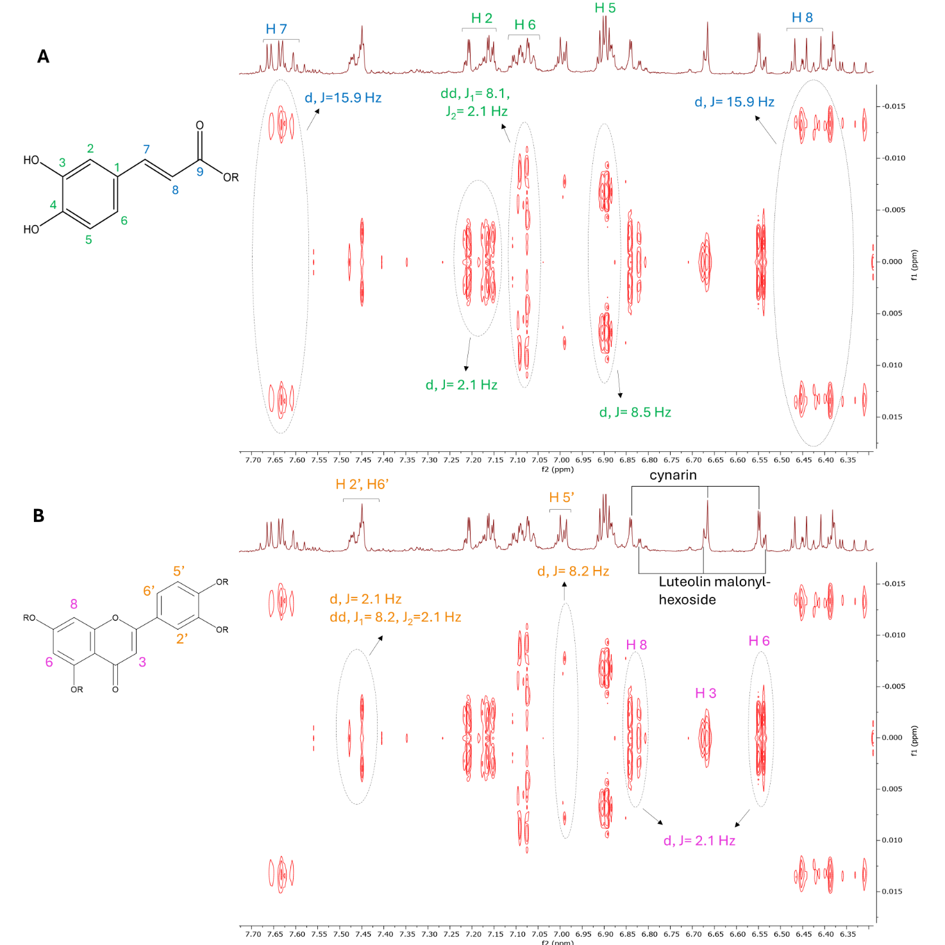Figure S1. J-res experiment of a representative sample (CYA-FL) showing the characteristic coupling constants of caffeoyl moiety (A) and flavanols moiety, indicating, where possible, signals putatively attributed to cynaroside and luteolin malonyl-hexoside (B).
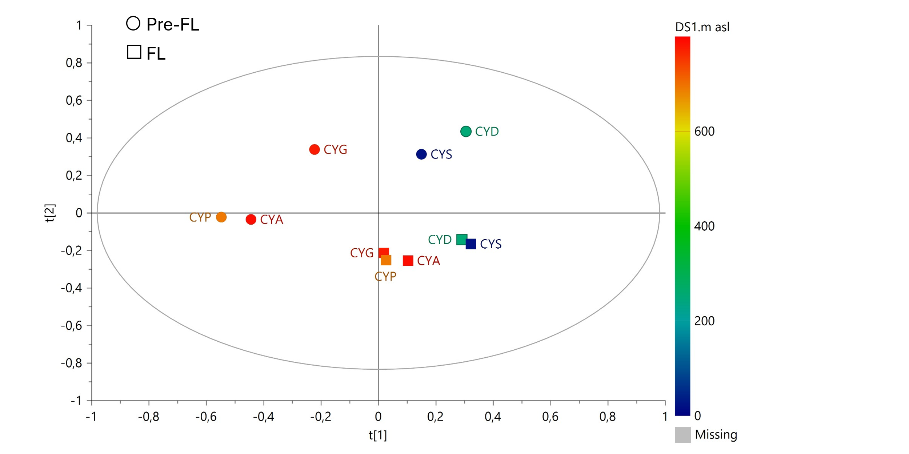
Figure S2. PCA using as x variables bucketed ¹H NMR spectra. Square symbols indicate samples collected at FL (flowering stage), while circles represent samples collected at Pre-FL (pre-flowering stage). Observation (samples) are colored according to altitude following a color gradient from blue (27 m a.s.l) to red (789 m a.s.l.).

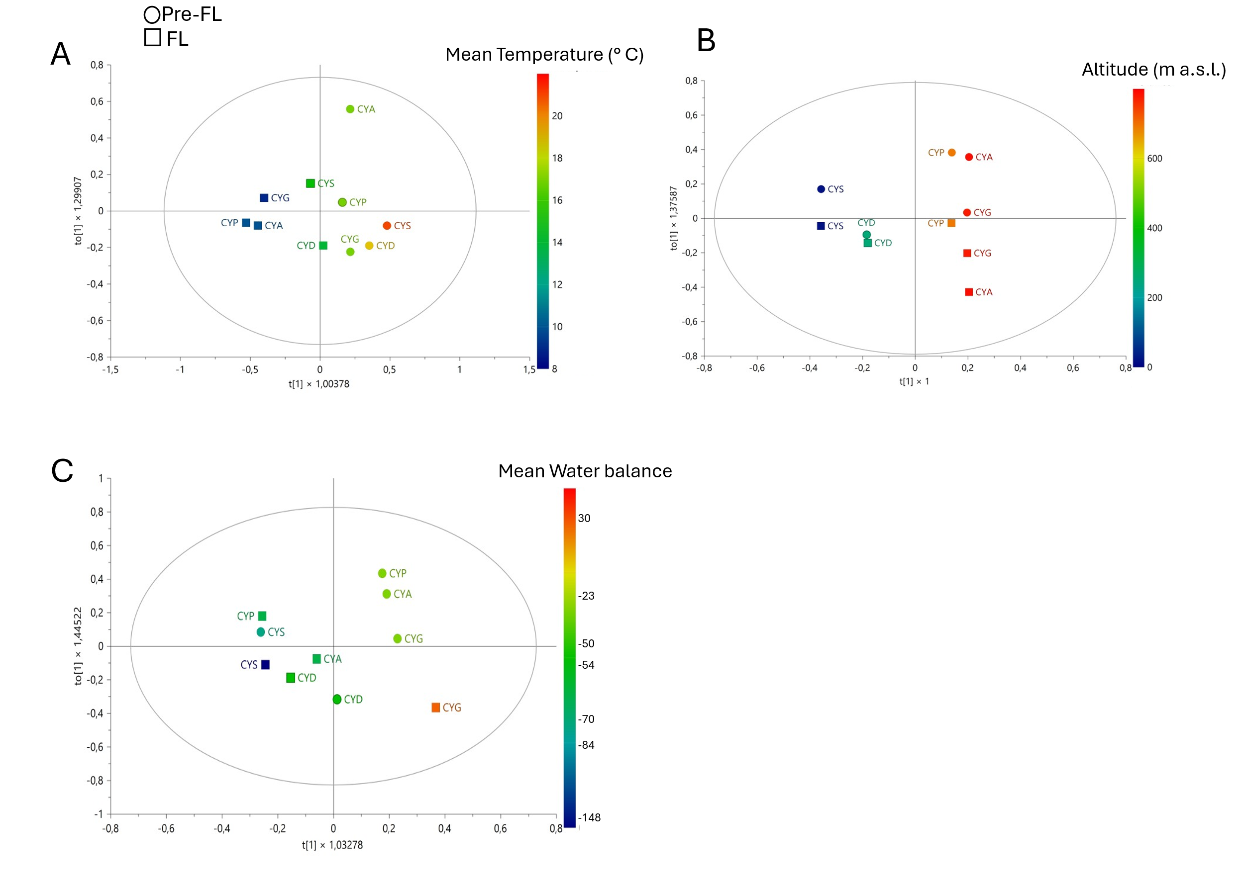
Figure S3. OPLS models built using as x variable bucketed ¹H NMR spectra and as y variable A) mean temperature B) altitude C) mean water balance

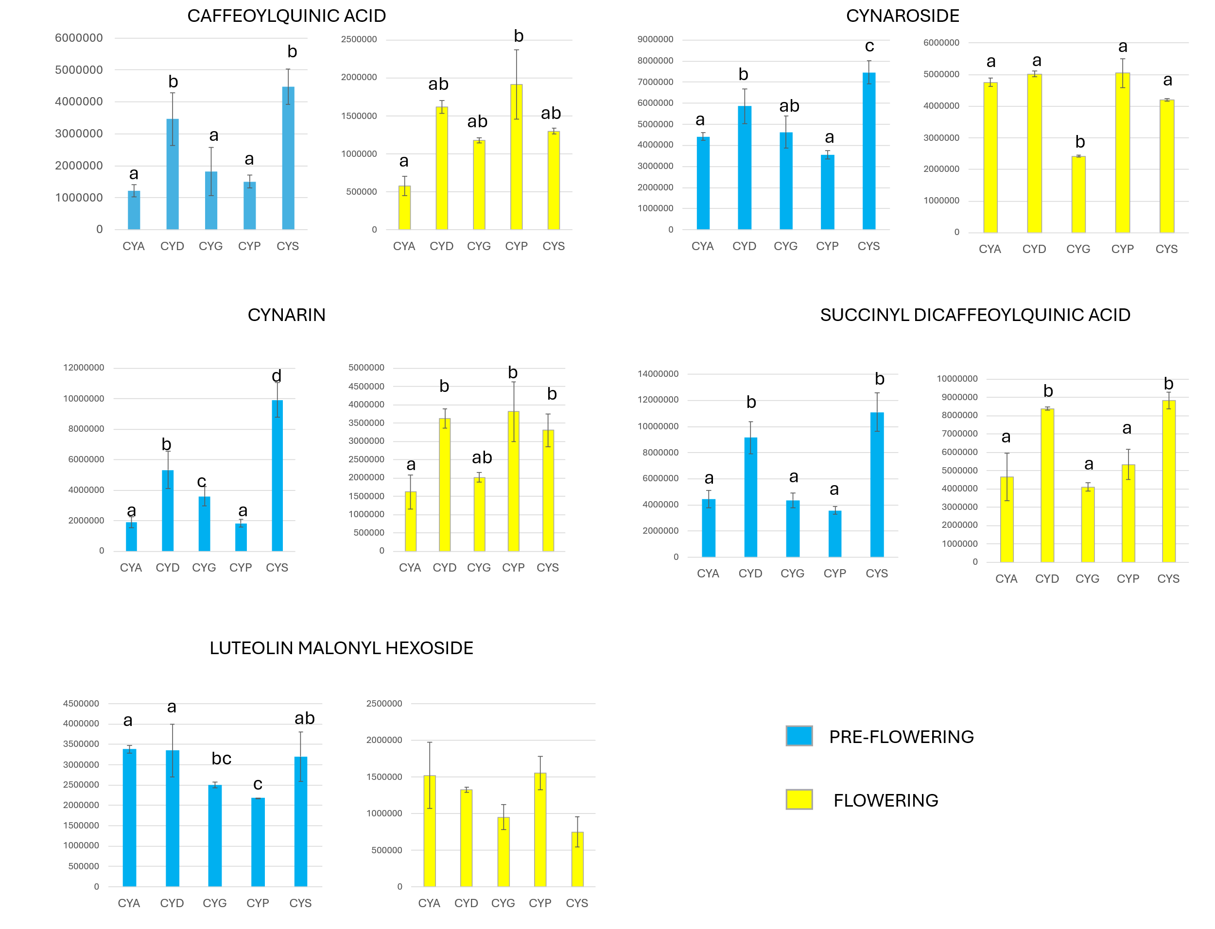Figure S4. Statistical analysis (two-way ANOVA) performed on intensity of chromatographic peaks (at λ 340) for the six tentatively identified compounds in each sample. Different letters within the same graph indicate significant differences in two way ANOVA test (p < 0.05).

Table S1. Semi-quantitative analysis by ¹H NMR of the metabolites detected in C. cardunculus. Values are expressed both as mg of metabolite / g of dry extract (DE) and as mg of metabolite / g of dry weight of plant material (DW). Chemical shift and number of protons responsible for the ¹H NMR signal used for the semi-quantification are reported. Acronyms on the sampling location in the first row are the same as figure 1. Pre-FL= pre-flowering stage, FL= flowering stage, N.D.= not detected.

 |  | CYA |  |  |  | CYD |  |  |  | CYG |  |  |  | CYP |  |  |  | CYS
 |  | Pre-FL |  | FL |  | Pre-FL |  | FL |  | Pre-FL |  | FL |  | Pre-FL |  | FL |  | Pre-FL |  | FL
Metabolite |  | mg/g DE | mg/g DW | mg/g DE | mg/g DW | mg/g DE | mg/g DW | mg/g DE | mg/g DW | mg/g DE | mg/g DW | mg/g DE | mg/g DW | mg/g DE | mg/g DW | mg/g DE | mg/g DW | mg/g DE | mg/g DW | mg/g DE | mg/g DW
Valine | δ 1, 3H | 9.12 | 3.23 | 2.76 | 0.98 | 2.56 | 1.12 | N.D. | N.D. | 6.68 | 2.71 | 3.45 | 1.35 | 7.99 | 3.20 | 3.04 | 1.08 | 4.28 | 1.76 | N.D. | N.D.
Acetic acid | δ 1.95, 3H | 1.38 | 0.49 | 2.36 | 0.83 | 1.71 | 0.75 | 2.15 | 0.89 | 1.41 | 0.57 | 2.30 | 0.90 | 2.47 | 0.99 | 1.52 | 0.54 | 1.36 | 0.56 | 3.40 | 1.36
Alanine | δ 1.49, 3H | 3.50 | 1.24 | 1.98 | 0.70 | 1.87 | 0.82 | 2.72 | 1.12 | 4.25 | 1.73 | 2.74 | 1.07 | 5.29 | 2.12 | 1.95 | 0.69 | 2.13 | 0.88 | 1.44 | 0.58
Succinic acid | δ 2.51, 4H | 12.21 | 4.32 | 22.26 | 7.89 | 7.00 | 3.06 | 8.32 | 3.42 | 5.68 | 2.31 | 12.31 | 4.80 | 11.21 | 4.49 | 9.44 | 3.34 | 6.51 | 2.68 | 6.99 | 2.80
Asparagine | δ 2.92, 1H | 52.55 | 18.61 | 16.55 | 5.86 | N.D. | N.D. | N.D. | N.D. | 32.36 | 13.15 | 22.91 | 8.95 | 79.07 | 31.69 | 31.75 | 11.25 | 9.98 | 4.11 | N.D. | N.D.
Choline | δ 3.22, 9H | 3.74 | 1.32 | 2.86 | 1.01 | 2.86 | 1.25 | 3.84 | 1.58 | 4.39 | 1.78 | 3.50 | 1.37 | 5.65 | 2.26 | 2.93 | 1.04 | 3.19 | 1.31 | 2.30 | 0.92
Chiro-inositol | δ 3.98, 2H | 57.02 | 20.19 | 64.33 | 22.78 | 49.86 | 21.82 | 88.09 | 36.23 | 64.58 | 26.23 | 73.08 | 28.53 | 55.05 | 22.07 | 66.45 | 23.53 | 48.44 | 19.92 | 73.03 | 29.27
Proline | δ 4.08, 1H | 58.33 | 20.66 | N.D. | N.D. | N.D. | N.D. | N.D. | N.D. | 107.22 | 43.56 | N.D. | N.D. | 74.53 | 29.87 | N.D. | N.D. | 40.59 | 16.69 | N.D. | N.D.
β-glucose | δ 4.58, 1H | 6.78 | 2.40 | 15.90 | 5.63 | 9.48 | 4.15 | 16.88 | 6.94 | 11.55 | 4.69 | 16.38 | 6.40 | 5.66 | 2.27 | 7.77 | 2.75 | 9.34 | 3.84 | 13.29 | 5.33
Sucrose | δ 5.41, 1H | 40.43 | 14.32 | 46.04 | 16.31 | 162.43 | 71.06 | 109.90 | 45.19 | 105.14 | 42.71 | 32.86 | 12.83 | 47.81 | 19.16 | 23.96 | 8.48 | 113.42 | 46.64 | 91.79 | 36.79
Cynaropicrin | δ 6.17, 1H | 7.10 | 2.51 | 21.64 | 7.66 | 8.42 | 3.69 | 56.01 | 23.03 | 15.15 | 6.16 | 37.33 | 14.57 | 13.69 | 5.49 | 24.36 | 8.63 | 16.50 | 6.78 | 60.81 | 24.37
Cynaroside | δ 6.83, 1H | 47.12 | 16.69 | 35.64 | 12.62 | 46.69 | 20.43 | 62.45 | 25.68 | 42.94 | 17.45 | 15.54 | 6.07 | 24.06 | 9.64 | 41.61 | 14.74 | 55.20 | 22.70 | 47.31 | 18.96
Luteolin malonyl- hexoside | δ 6.79, 1H | 23.09 | 8.18 | 13.42 | 4.75 | 21.24 | 9.29 | 15.20 | 6.25 | 19.39 | 7.88 | 4.93 | 1.93 | 11.32 | 4.54 | 11.48 | 4.07 | 17.28 | 7.11 | 9.93 | 3.98
Formic acid | δ 8.45, 1H | 0.31 | 0.11 | 0.69 | 0.24 | 0.79 | 0.35 | 1.31 | 0.54 | 0.48 | 0.19 | 0.60 | 0.23 | 0.40 | 0.16 | 0.61 | 0.22 | 0.77 | 0.32 | 0.81 | 0.32

Table S2. Multivariate da analysis models developed in this study with their parameters (R²X cum) and Q²(cum), and the parameters for the validation obtained by permutation test and CV-ANOVA.
Model | y var. |  | Class ID | Comp. number | R2X(cum) | R2Y(cum) | Q2(cum) | R2 prem. | Q2 perm. | Intercept on Y axis of Q-line | Intercept on Y axis of R-line | p | F
PCA | - | - |  | 2 | 0.611 | - | 0.263 | - | - |  |  | - | -
OPLS-DA | - | Phenological stage |  | 2 | 0.597 | 0.978 | 0.856 | 0.978 | 0.856 | -0.75 | 0.74 | 0.02 | 7.41
OPLS | Mean temperature | - |  | 5 | 0.818 | 0.999 | 0.949 | 0.999 | 0.949 | -0.299 | 0.99 | 0.16 | 5.33
OPLS | Altitude | - |  | 8 | 0.976 | 1 | 0.73 | 0.999 | 0.73 | 0.222 | 1 | 0.87 | 0.33
OPLS | Water  balance | - |  | 2 | 0.447 | 0.766 | -0.206 | 0.766 | -0.206 | -0.203 | 0.82 | 1 | 0
OPLS-3y | Mean Temperature  Altitude  Mean Water Balance | - |  | 4 | 0.805 | 0.872 | 0.421 | 0.903 | 0.529 | -0.612 | 0.685 | 0.123  0.749  1 | 4.47  0.56  0

Table S3. ¹H NMR signals of the most important metabolites detected in C. cardunculus leaves profiles.
Metabolite | Signals in ¹H NMR profile (δ, multiplicity, number of protons, coupling constant, part of the molecule connected)
Fatty acids | δ 1.57 (m), 1.29 (m), 1.25 (m), 0.88 (m)
Valine | δ 1.05 (d, 3, J = 7.03 Hz, CH₃-CH(NH₂)COOH), 1.00 (d, 3, J = 7.14 Hz, CH₃-CH(NH₂)COOH)
Threonine | 1.34 (3H, d, J=6.54 Hz)
Acetic acid | δ 1.95 (s, 3, CH₃-COOH)
Alanine | δ 1.48 (d, 3, J = 7.25 Hz, CH₃-CH(NH₂)COOH))
Cynaropicrin | δ 6.37 (d, 1, J = 1.40 Hz, CH₂=), 6.18 (d, 1, J = 3.30 Hz, CH₂=), 6.03 (d, 1, J = 1.40 Hz, CH₂=), 5.69 (d, 1, J = 3.30 Hz, CH₂=), 5.44 (d, 1, broad CH₂=), 5.33 (d, 1, broad), 5.17 (d, 1, J = 1.52 Hz, CH₂=), 5.14 (m, 1, CH-OC=O), 4.92 (d, 1, J = 1.52 Hz, H-C=), 4.33 (m, 1, CH-OH), 3.28 (m, 1, CH-(C=)CH), 3.00 (m, 1, CH-(C=)CH), 2.88 (m, 1, CH-(C=)CH), 2.40 (m, 1, CH₂-(C-O)C= ), 2.09 (m, 1, CH₂-(C-O)CH), 1.74 (m, 1, CH-(C-O)CH)
Proline | δ 4.08 (dd, 1, J = 8.64, 6.43 Hz, CH-N), 2.34 (m, 2, CH₂-), 2.08 (m, 2, CH₂-), 2.01 (m, 2, CH₂-))
Succinic acid | δ 2.50 (s, 4, CH₂–COOH)
Malic acid | δ 4.29 (dd, 1, J = 8.26, 3.97, CH(OH)-), 2.73 (dd, 2, J = 15.06, 3.77, -CH₂-COOH), 2.40 (dd, 2, J = 15.06, 3.00, -CH₂-COOH)
Asparagine | δ 2.95 (dd, 1, J = 4.20, 16.97 Hz, CH₂-CONH₂), 2.81 (dd, 1, J = 8.5, 17.09 Hz, CH₂-CONH₂)
Sucrose | δ 5.41 (d, 1, J = 3.8 Hz, H-1′ α-glucose), 4.17 (d, 1, J = 8.6 Hz, H-1 β-fructose)
β Glucose | δ 4.58 (d, 1, J = 7.8 Hz, H-1 β-anomeric CH)
α Glucose | δ 5.18 (d, 1, J = 3.7 Hz, H-1 α-anomeric CH)
Choline | δ 3.22 (s, 9, (CH₃)₃N⁺-CH₂CH₂OH)
Chiro-inositol | δ 3.56 (dd, 2, J = 2.71, 7.20 Hz, CH-OH), 3.73 (m, 2, CH-OH), 3.95 (d, 2, J = 2.50 Hz, CH-OH)
Phenylalanine | δ 7.32 (m, 5), Aromatic protons (Ph-)
Formic acid | δ 8.45 (s, 1), H-COOH
Trigonelline | δ 9.14 (s, 1, pyridinium H), 8.85 (m, 1, Ar-H)

