Supplemental Table 1. The 17-question survey and summary of expert responses
Number | Question | Responders, n/N | Summary of responses
Q1a | Is the administration of teclistamab and talquetamab to patients with MM in an outpatient setting during SUD feasible in your country?  - Yes  - No | 10/10 | - Yes: 8/10  - No: 2/10
Q1b | Is the administration of teclistamab and talquetamab to patients with MM in an outpatient setting during SUD already practiced in your country?  - Yes  - No | 8/10 | - Yes: 4/8  - No: 4/8
Q2a | Is the administration of teclistamab and talquetamab to patients with MM in an outpatient setting during the maintenance phase feasible in your country?  - Yes  - No | 10/10 | - Yes: 5/10  - No: 5/10
Q2b | Is the administration of teclistamab and talquetamab to patients with MM at the patient’s home during the maintenance phase already practiced in your country?  - Yes  - No | 5/10 | - Yes: 2/5  - No: 3/5
Q2c | Is at-home administration already practiced in your country for the following MM treatments?  (select all that apply)  - Bortezomib  - Carfilzomib  - Daratumumab  - Isatuximab  - Elranatamab  - Other (please specify)  - None of the above | 5/10 | - Bortezomib: 5/5  - Carfilzomib: 4/5  - Daratumumab: 5/5  - Isatuximab: 2/5  - Elranatamab: 0/5  - Other: 0/5  - None of the above: 0/5
Q3a | In your country, what are the possible forms/structures of an outpatient setting for the administration of teclistamab and talquetamab during the SUD phase?  (select all that apply / answer for your country, not only for your center)  - Outpatient department (i.e., day hospital), in an expert hospital  - Outpatient department (i.e., day hospital), in a community hospital  - Community care centers or healthcare facilities  - Administration at home, by a regular or specialized nurse  - Administration at home, with self-administration  - At the physician’s office (in case of private practice)  - Other (please specify)  - None of the above (only inpatient administration) | 10/10 | - Outpatient department (i.e., day hospital), in an expert hospital: 9/10  - Outpatient department (i.e., day hospital), in a community hospital: 6/10  - Community care centers or healthcare facilities: 0/10  - Administration at home, by a regular or specialized nurse: 0/10  - Administration at home, with self-administration: 0/10  - At the physician’s office (in case of private practice): 1/10  - None of the above (only inpatient administration): 1/10
Q3b | In your country, what are the possible forms/structures of an outpatient setting for the administration of teclistamab and talquetamab during the maintenance phase? (select all that apply / answer for your country, not only for your center)  - Outpatient department (i.e., day hospital), in an expert hospital  - Outpatient department (i.e., day hospital), in a community center  - Community care centers or healthcare facilities  - Administration at home, by a regular or specialized nurse  - Administration at home, with self-administration  - At the physician’s office (in case of private practice)  - Other (please specify)  - None of the above (only inpatient administration) | 10/10 | - Outpatient department (i.e., day hospital), in an expert hospital: 10/10  - Outpatient department (i.e., day hospital), in a community center: 9/10  - Administration at home, by a regular or specialized nurse: 6/10  - Community care centers or healthcare facilities: 4/10  - Administration at home, with self-administration: 2/10  - At the physician’s office (in case of private practice): 1/10
Q4 | What would be the main benefits of outpatient administration during the SUD phase and/or maintenance phase of teclistamab and talquetamab, for patients, physicians and institutions?  (rank all items)  - Saves time for patients  - More comfortable for patients  - Patients are less exposed to contagious diseases  - Saves time for physicians  - Saves capacity for hospital  - Cost-effective for the healthcare system  - Other (please specify) | 10/10 | Ranked in order of importance (highest to lowest):  - Saves capacity for hospital  - Saves time for patients  - More comfortable for patients  - Cost-effective for the healthcare system  - Patients are less exposed to contagious diseases  - Saves time for physicians
Q5 | What would be the main limitations and barriers of outpatient administration during the SUD phase and/or maintenance phase of teclistamab and talquetamab, for patients, physicians and institutions?  (rank all items)  - Lack of know-how on adverse events management  - Fear of serious adverse events  - Lack of efficiency / confidence in external structures  - Lack of published data on outpatient experiences  - Financial constraints / reimbursement rules  - Other (please specify) | 10/10 | Ranked in order of importance (highest to lowest):  - Fear of serious adverse events  - Lack of know-how on adverse events management  - Lack of efficiency / confidence in external structures  - Lack of published data on outpatient experiences  - Financial constraints / reimbursement rules  - Other: Lack of an efficient and reliable infrastructure for at-home administration
Q6a | What is the usual SUD schedule for teclistamab and talquetamab in your center?  (choose one answer)  - Day 1–3–5  - Day 1–4–8  - Other (please specify) | 10/10 | - Day 1–3–5: 4/10  - Day 1–4–8: 4/10  - Other: Day 1–3–8: 2/10
Q6b | Do you foresee any changes to your usual schedule in the future?  - Yes  - No  - If yes: please specify expected changes | 10/10 | - Yes: 2/10  - No: 8/10  For those who answered yes, no changes specified.
Q7 | For the successful management of the SUD in an outpatient setting, what criteria are needed to define the eligible patient population?  (rank all the items)  - Tumor burden  - Patient fitness  - Age  - Comorbidities  - Cognitive status  - Patient’s willingness  - Presence of a healthcare professional  - Presence of a caregiver  - Distance from hospital | 10/10 | Ranked in order of importance (highest to lowest):  - Cognitive status  - Presence of a caregiver  - Patient fitness  - Distance from hospital  - Patient’s willingness  - Comorbidities  - Age  - Tumor burden  - Presence of a healthcare professional
Q8 | In your country, do you foresee preemptive use of tocilizumab to prevent CRS?  - Yes  - No | 10/10 | - Yes: 5/10  - No: 5/10
Q9a | For the successful management of SUD in an outpatient setting, do you plan to use extra dexamethasone?  - Yes  - No | 10/10 | - Yes: 9/10  - No: 1/10
Q9b | Do you plan to use dexamethasone preemptively (other than what is recommended in the SmPC)?  - Yes  - No | 10/10 | - Yes: 5/10  - No: 5/10
Q10a | For the successful administration of the SUD in an outpatient setting, how can cases of CRS/ICANS/infections be effectively monitored and managed by physicians and nurses?  (rank all the items)  - Access to a nurse  - Access to an emergency department/night hospital  - Access to an intensive care unit, if needed  - Access to a hematology department, if needed (familiar with CRS/ICANS management)  - Other (please specify) | 10/10 | Ranked in order of importance (highest to lowest):  - Access to a hematology department, if needed (familiar with CRS/ICANS management)  - Access to an emergency department/night hospital  - Access to an intensive care unit, if needed  - Access to a nurse
Q10b | For the successful administration of the SUD in an outpatient setting, how can cases of CRS/ICANS/infections be effectively monitored and managed by patients?  (rank all the items)  - Ability to come to hospital in due time  - Reliable patient / ability to understand  - Patient knowledge of how to act, in case of specific adverse events  - Presence of a caregiver (spouse, neighbor, competent adult…)  - Other (please specify) | 10/10 | Ranked in order of importance (highest to lowest):  - Reliable patient/ability to understand  - Patient knowledge of how to act, in case of specific adverse events  - Presence of a caregiver (spouse, neighbor, competent adult…)  - Ability to come to hospital in due time
Q11 | What should be the minimum equipment a patient should keep at home for CRS/ICANS/infections monitoring?  (select all that apply)  - Thermometer  - Blood pressure monitor  - Pulse oximeter  - ICE testing  - Monitoring application  - Other (please specify) | 10/10 | - Thermometer: 10/10  - Blood pressure monitor: 7/10  - Pulse oximeter: 5/10  - ICE testing: 5/10  - Monitoring application: 0/10
Q12 | During the SUD phase in an outpatient setting, who should be the first person(s) for the patient to contact? (rank all the items)  • Onco-hematologist on duty  • Specialized nurse at hospital  • Private nurses  • General practitioners  • Emergency department  • Other (please specify) | 10/10 | Onco-hematologist on duty OR a specialized nurse at the hospital.
Q13a | Would you ever consider transitioning a patient from day hospital to home administration?  - Yes  - No | 10/10 | - Yes: 6/10  - No: 4/10
Q13b | If yes, when?  - After the SUD  - At the start of cycle 2  - Other (please specify) | 10/10 | - After the SUD: 10/10  - At the start of cycle 2: 10/10
Q14a | What are the enablers for at-home administration during the maintenance phase for patients?  (rank all items)  - Autonomous patient  - Patient willingness  - Presence of caregivers (spouse, neighbor, competent adult…)  - Patient far from the expert hospital  - Patient close to a community hospital  - Other (please specify) | 5/10 | Ranked in order of importance (highest to lowest):  - Patient willingness  - Autonomous patient  - Presence of caregivers (spouse, neighbor, competent adult…)  - Patient far from the expert hospital  - Patient close to a community hospital
Q14b | What are the enablers for at-home administration during the maintenance phase for physicians and nurses? (rank all items)  - Saves time and space at the hospital  - Does not generate a financial deficit / economically viable  - Physicians’ confidence in safety  - Specific procedure to monitor and manage the risk of infections  - Physicians’ motivation to coordinate the full patient care  - Resources / help given by the institution  - Readiness / set up for emergencies  - Other (please specify) | 6/10 | Ranked in order of importance (highest to lowest):  - Saves time and space at the hospital  - Resources/help given by the institution  - Does not generate a financial deficit / economically viable  - Physicians’ confidence in safety  - Specific procedure to monitor and manage the risk of infections  - Physicians’ motivation to coordinate the full patient care  - Readiness / set up for emergencies
Q15 | Do you already transfer patients receiving teclistamab or talquetamab treatment from expert hospitals to community hospitals/centers?  - Yes  - No | 10/10 | - Yes: 8/10  - No: 2/10
Q16 | What evolution do you anticipate in outpatient treatment with teclistamab and talquetamab over time in your country?  (choose one answer)  - Much more adoption  - A bit more adoption  - Same as today  - Less adoption  - Other (please specify) | 10/10 | - Much more adoption: 7/10  - A bit more adoption: 1/10  - Other: 2/10 (early in the process for some countries)
Q17a | In your country over the next 3 years, what percentage of patients do you expect to be treated in an outpatient department/day hospital during the SUD phase?  (choose one answer)  - None  - Less than 20%  - Between 20 to 50%  - Between 50 to 80%  - More than 80% | 10/10 | - None: 0/10  - <20%: 2/10  - 20–50%: 7/10  - 50–80%: 0/10  - >80%: 1/10
Q17b | In your country over the next 3 years, what percentage of patients do you expect to be treated at home during the maintenance phase?  (choose one answer)  - None  - Less than 20%  - Between 20 to 50%  - Between 50 to 80%  - More than 80% | 10/10 | - None: 4/10  - <20%: 1/10  - 20–50%: 2/10  - 50–80%: 1/10  - >80%: 2/10
CRS, cytokine release syndrome; ICANS, immune effector cell–associated neurotoxicity syndrome; ICE, immune effector cell–Associated encephalopathy score; MM, multiple myeloma; SmPC, summary of product characteristics; SUD, step-up dosing.
Supplemental Table 2. Teclistamab outpatient administration protocol used by the Cancer University Institute of Toulouse (IUCT), Toulouse, France
SOP (September 2024) | Selection:  - Clinical criteria: general condition preserved (ECOG PS < 3), no active infection, no high tumor burden or rapidly progressive disease  - Logistical criteria: patient willing to stay within 30 minutes of hospital for 48 hours after each step-up dose until the first full dose  Information:  Handout of an information note, drawn up with the network (attached), for the patient (and a copy for healthcare professionals, which is sent to the GP and the private nurse)  Anticipation of the means of monitoring (in consultation a week before the start of the step-up, so that the patient has time to buy the equipment and find a home nurse)  Prescription given in advance for:  - Prescription for the purchase of a blood pressure monitor and a pulse oximeter  - Two to three times daily monitoring, by a nurse: blood pressure, temperature, heart rate and oxygen saturation, to monitor cytokine release syndrome  - Prescription of paracetamol 1 g, repeated every 8 hours if necessary if fever is isolated  - Anticipated prescription and dispensing of dexamethasone 10 mg × 2 per day (sufficient quantity for 2 days) to be taken if grade 2 cytokine release syndrome, following telephone instructions from the doctor on call (making sure to note the number of the day hospital department during the day / of the service on call for evenings and public holidays, on the prescription)
Healthcare Professional Notice | 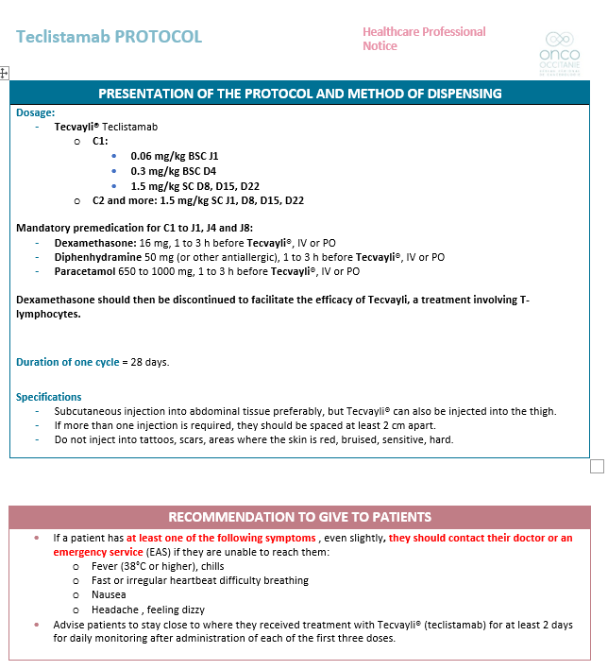  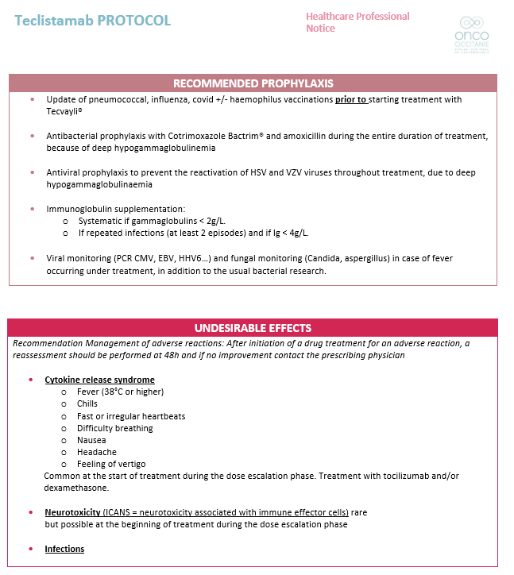
Patient Notice | 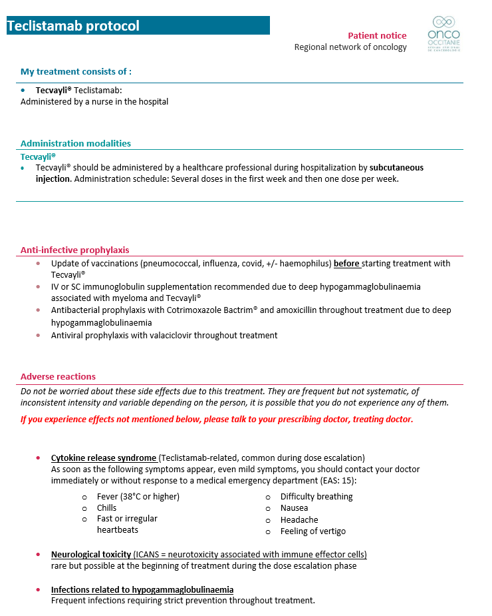
Patient Card (teclistamab) | 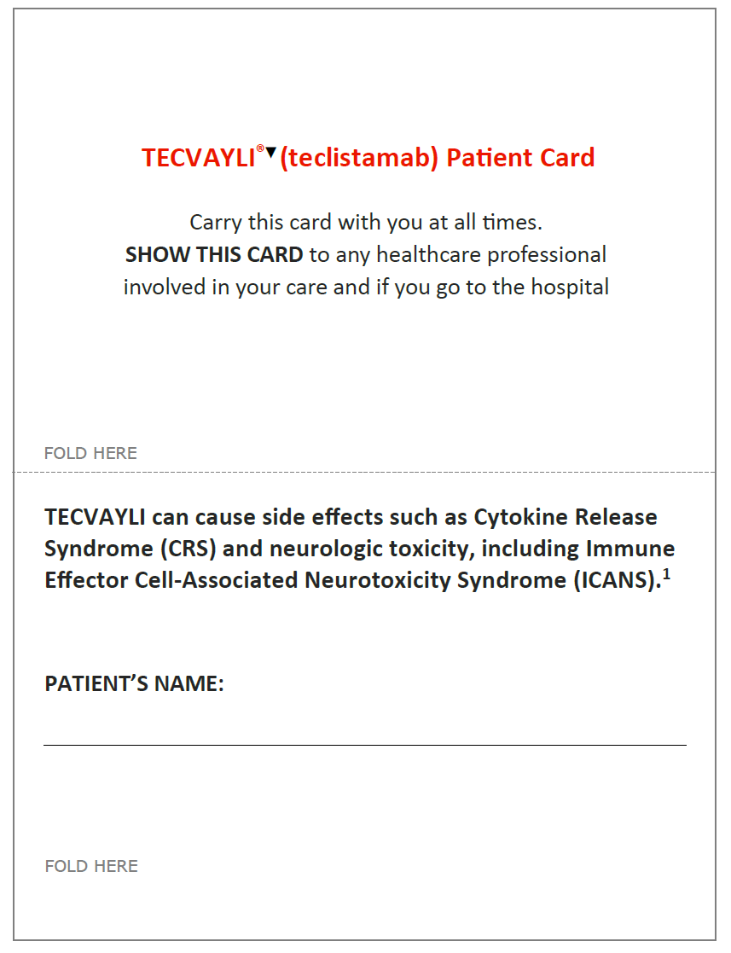  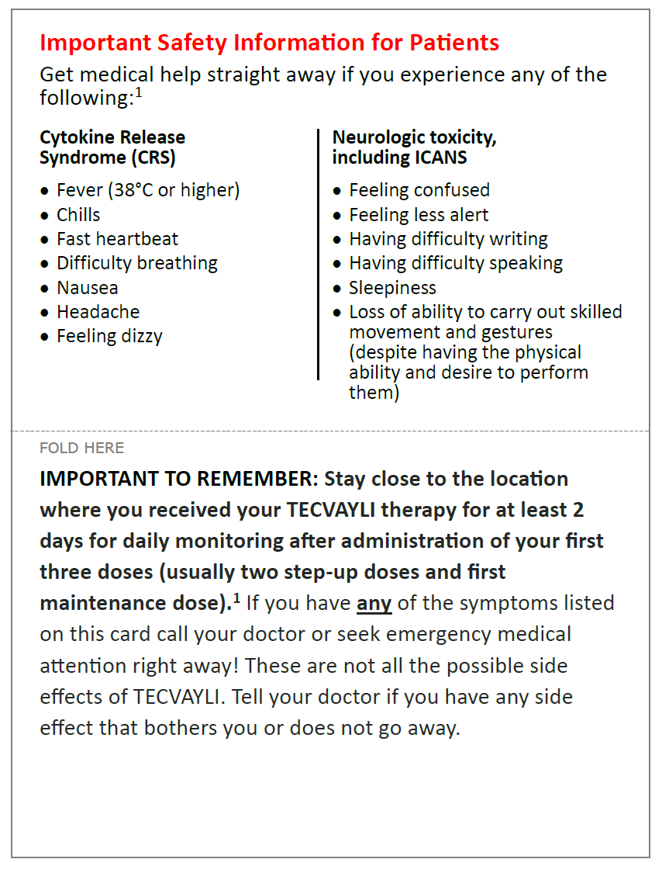  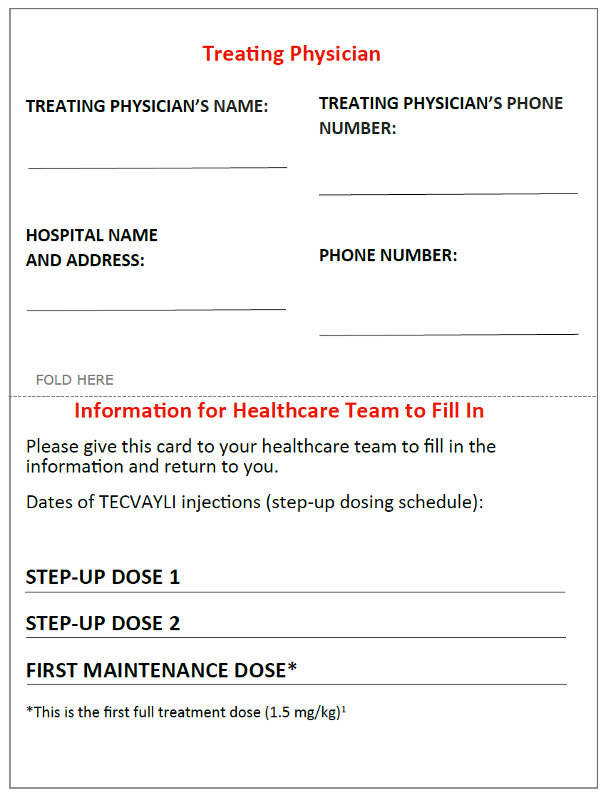  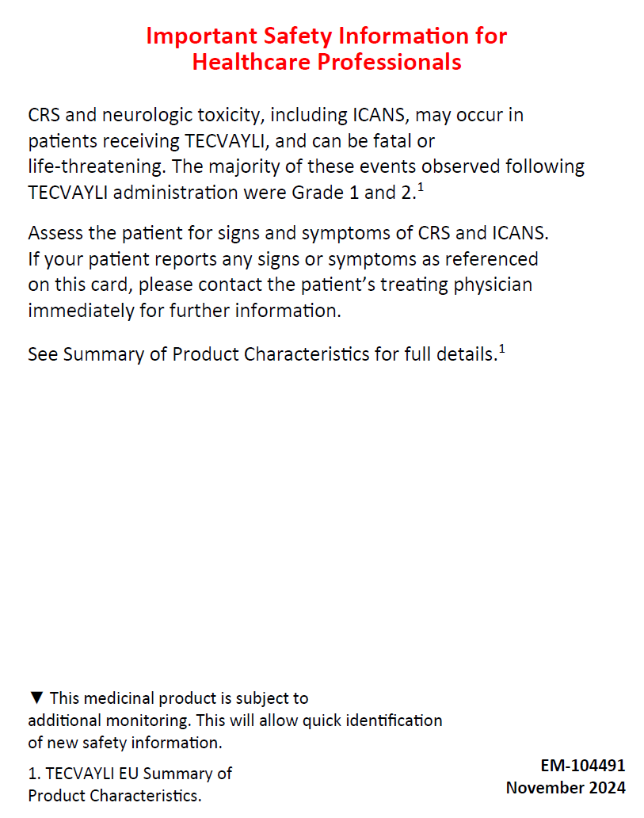
Patient Card (talquetamab) | 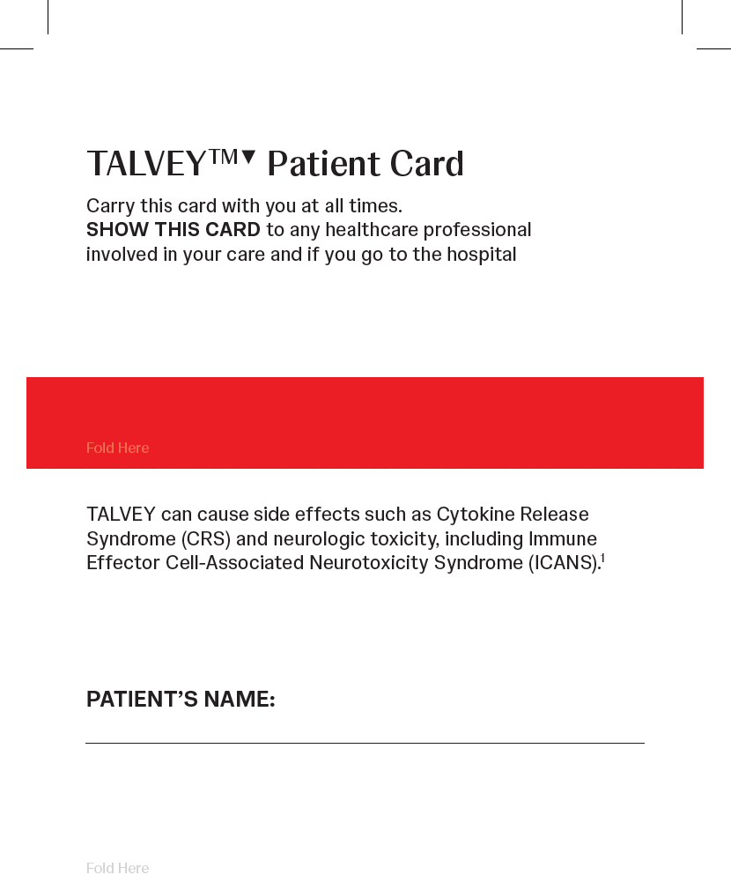  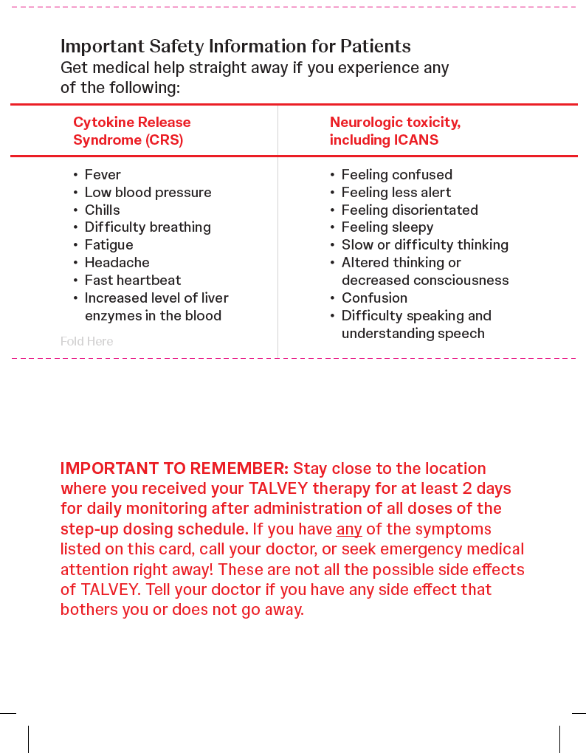  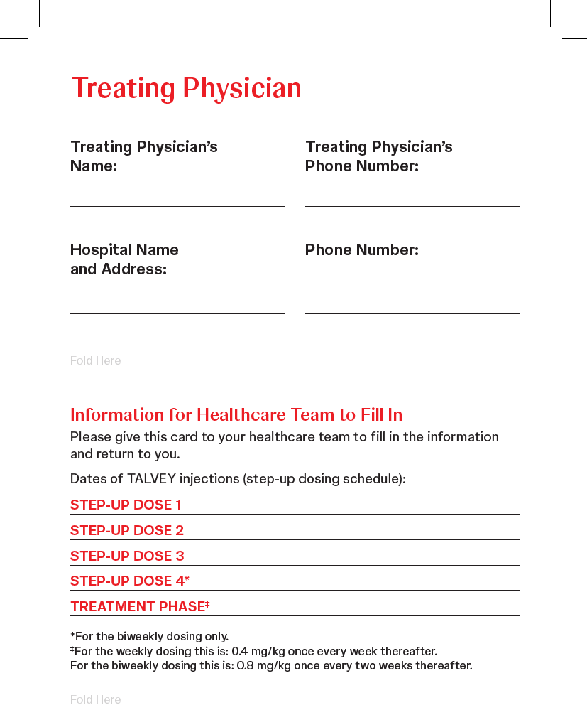  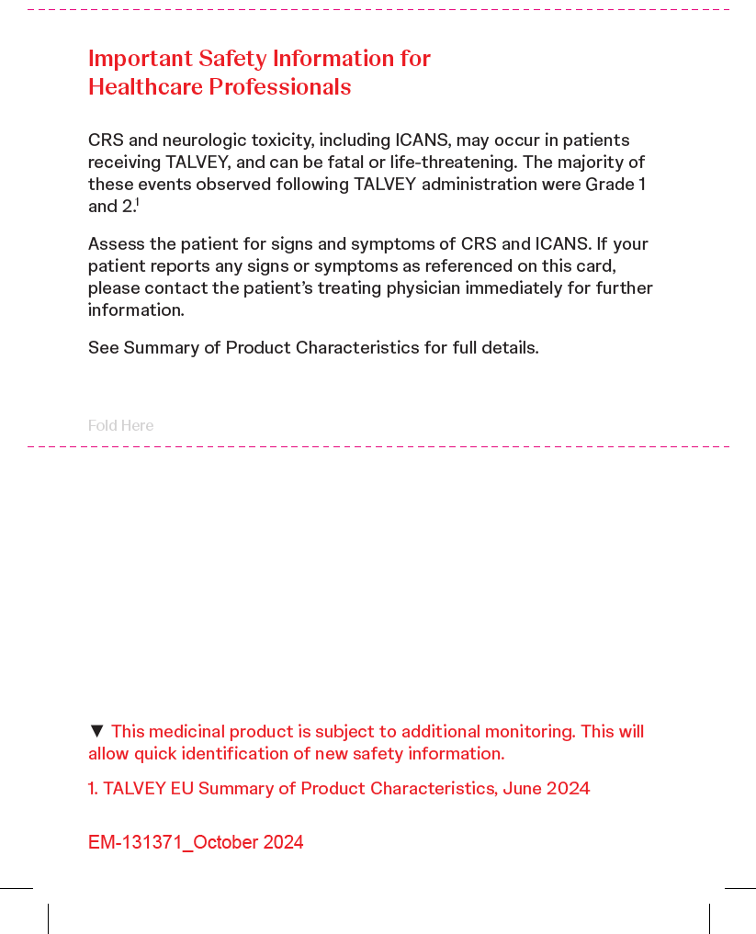
C, cycle; CRS, cytokine release syndrome; D, day; ECOG PS, Eastern Cooperative Oncology Group performance status; GP, general practitioner; ICANS, immune effector cell–associated neurotoxicity syndrome; IV, intravenous; PO, by mouth; SC, subcutaneous; SOP, standard operating procedure.

