– SUPPORTING INFORMATION –
Unlocking the ConPeT mechanism: Correspondence on “Catalytic Asymmetric Redox-Neutral [3+2] Photocycloadditions of Cyclopropyl Ketones with Vinylazaarenes Enabled by Consecutive Photoinduced Electron Transfer”
Marco Villa, Andrea Fermi, Francesco Calogero, Andrea Gualandi, Paola Franchi, Marco Lucarini, Barbara Ventura, Pier Giorgio Cozzi, Paola Ceroni

Table of Contents
SYNTHETIC PROCEDURES 2
PHOTOPHYSICAL CHARACTERIZATION 8
TRANSIENT ABSORPTION SPECTROSCOPY 12
EPR CHARACTERIZATION 14
ELECTROCHEMICAL AND SPECTROELECTROCHEMCIAL STUDY 15

SYNTHETIC PROCEDURES
General
Materials and general procedures.
Water was purified by reverse osmometry with an Elga Purelab Classic purification system (18.2 MΩ·cm).
¹H-NMR spectra were recorded on Varian Mercury 400, Inova 600, or Bruker 600 spectrometers. Chemical shifts are reported in ppm from TMS with the residual solvent resonance as the internal standard (CHCl₃: δ = 7.26 ppm). Data are reported as follows: chemical shift, multiplicity (s = singlet, d = duplet, t = triplet, q = quartet, dd = double duplet, m = multiplet), coupling constants (Hz). ¹³C-NMR spectra were recorded on Varian Mercury 400, Inova 600, or Bruker 600 spectrometers. Chemical shifts are reported in ppm from TMS with the solvent as the internal standard (CDCl₃: δ = 77.0 ppm).
All the reagents were purchased from commercial sources (Sigma-Aldrich, Alfa Aesar, Fluorochem, Strem Chemicals, TCI) and used without further purification unless specified. All reactions requiring an inert atmosphere were set up under argon in heat gun-dried glassware using standard Schlenk techniques unless specified. Anhydrous solvents were supplied by Aldrich in Sureseal® bottles and, unless specified, were used without further treatment.

Synthesis of 3,4,5,6-tetrakis(diphenylamino)phthalonitrile (4DPAPN)
A modified literature procedure was adopted for the synthesis of 4DPAPN.^{[1]} A 50 mL round-bottom flask was filled with dry DMF (10 mL) and diphenylamine (5.6 mmol, 948 mg, 6 equiv.) under inert atmosphere. NaH (60% suspension in mineral oil, 7.5 mmol, 300 mg, 8 equiv.) was slowly added and the mixture was stirred at 50 °C for 2 hours. 3,4,5,6-tetrafluorophthalonitrile (0.9 mmol, 187 mg, 1 equiv.) was added and the reaction mixture was stirred at room temperature at 18 hours. After that, the solution was cooled to 0°C and water (1 mL) was slowly added to quench the reaction. The organic phase was extracted in DCM (3 x 15 mL). The solution was dried over Na₂SO₄ and the solvent was carefully evaporated. The crude mixture was purified by column chromatography with (DCM 20 % in Hexane) to 4DPAPN with 48% yield as a bright yellow solid. Spectroscopic data matches the literature reports.^{[2]}
4DPAPN
¹H NMR (600 MHz, CDCl₃) δ 7.19 (t, J = 7.9 Hz, 10H), 6.97 (t, J = 7.4 Hz, 5H), 6.85 (t, J = 7.9 Hz, 10H), 6.77 (d, J = 7.7 Hz, 10H), 6.69 (t, J = 7.3 Hz, 5H), 6.43 (d, J = 7.8 Hz, 10H)

4DPAPN
¹³C NMR (151 MHz, CDCl₃) δ 150.4, 148.0, 144.9, 143.9, 129.0, 127.7, 123.9, 123.6, 122.4, 122.3, 117.0, 113.6.

Synthesis of phenyl(2-phenylcyclopropyl)methanone (1)
Phenyl(2-phenylcyclopropyl)methanol was synthetized by standard Johnson–Corey–Chaykovsky procedure slightly modifying the literature reported protocol.^{[3]}
To a heat gun dried two-necked round flask, under argon atmosphere, trimethylsulfoxonium iodide (3.6 mmol, 1.2 equiv., 700 mg) was solubilized in dry DMSO (9 mL). The solution was cooled to 0 °C and NaH (3.1 mmol, 1.05 equiv., 130 mg) was carefully added portion wise. Molecular hydrogen was allowed to evolve and the reaction mixture was allowed to stir at room temperature for 45 minutes. The solution was then cooled again at 0 °C and trans-chalcone (3 mmol, 1.0 equiv. 624 mg) was added to the reaction mixture. After disappearance of the chalcone (TLC), water was added (10 mL) and the reaction mixture was extracted with ether (3 x 20 mL). The crude product was purified by column chromatography with (EtOAc 10 % in Hexane) to afford phenyl(2-phenylcyclopropyl)methanone 1 with 68% yield (2 mmol, 453 mg) as a white solid. Spectroscopic data matches the literature reports.^{[3]}

Phenyl(2-phenyl cyclopropyl)methanone 1
¹H NMR (600 MHz, CDCl₃) mixture of diastereoisomers (20:1 trans:cis), peaks are given only for the major diastereoisomer: δ 8.00 (d, 2H, J = 7.8 Hz), 7.56 (m, 1H), 7.46 (m, 2H), 7.31 (m, 2H), 7.19 (m, 3H), 2.90 (dt, 1H, J = 8.6, 4.5 Hz,), 2.70 (ddd, 1H, J = 9.3, 6.7, 4.5 Hz), 1.93 (dt, 1H, J = 9.3, 4.5 Hz), 1.56 (m, 1H).

Phenyl(2-phenyl cyclopropyl)methanone 1
¹³C NMR (151 MHz, CDCl₃) mixture of diastereoisomers (20:1 trans:cis), peaks are given only for the major diastereoisomer δ 198.7, 140.6, 137.9, 133.1, 128.7, 128.2, 126.4, 126.3, 30.2, 29.4, 19.4.

Synthesis of bis(tetrabutylammonium)oxalate (TBAOx)
A modified literature procedure was adopted for the synthesis of TBAOx.^{[4]} Under argon atmosphere, a 25 mL two-necked round-bottom-flask, equipped with a magnetic stirring bar, was charged with oxalic acid dihydrate (1.0 equiv., 5 mmol, 630 mg). Tetra-n-butylammonium hydroxide, (40% w/w in methanol, 2.0 equiv., 10 mmol, 7.1 mL) was added dropwise to the supsension at room temperature. The solution was allowed to stir until disappearance of oxalic acid dihydrate was observed (2 h ca.). After the solvent was removed under reduced pressure, yielding first a gelatinous material and, after few hour under vacuum, a white powder. The desired TBAOx was obtained in quantitative yield (> 95%, 2.8 g). Spectroscopic data are in agreement with those reported in literature.^{[4]}

PHOTOPHYSICAL CHARACTERIZATION
General
Photophysical measurements. Optically diluted solutions with concentrations in the order of 10⁻⁴ or 10⁻⁶ M were prepared in spectroscopic or HPLC grade solvents for steady-state and time-resolved absorption and emission analysis. Absorption spectra were recorded at room temperature on a Varian Cary 300 spectrophotometer with 1 cm or 0.2 cm quartz cuvettes. Degassed solutions were prepared via 4 consecutive freeze-pump-thaw cycles and spectra were taken using home-made Schlenk quartz cuvette; alternatively, N₂-saturated solutions were prepared in a glove box using the same glassware. Steady-state emission, excitation spectra and time-resolved emission spectra were recorded at 298 K using an Edinburgh Instruments F920 or a Edinburgh Instruments FS5, equipped with a Hamamatsu R928 phototube. Samples were excited at 390 nm for steady-state measurements and at 340 or 405 nm for time-resolved measurements. For emission lifetimes < 10 µs the above-mentioned Edinburgh Instruments F920 fluorometer, equipped with a time-correlated single-photon counting (TCSPC) module was used. For the determination of excited state lifetimes through TCSPC, emission decays were fitted with single or multiple exponential functions; the associated χ² values (1 < χ² < 2) were determined using the EI FS5 or Edinburgh FLS920 software. The estimated experimental errors are 2 nm on the band maximum, 5% on the molar absorption coefficient and luminescence lifetime and 10% on the quantum yield.
Photoinduced generation of radical species. Irradiation of samples for the generation of radical species from 4DPAPN in the presence of a sacrificial electron donor (DIPEA or TBAOx) in CH₃CN were performed at room temperature on thoroughly stirred N₂-saturated solutions by using a Kessil lamp at 390 nm (40 W). Immediately after irradiation (10-30 s) the so-obtained solutions have been employed for further spectroscopic characterization and analysis.
Figure S1. Emission intensity decay of a deareated solution of 4DPAPN in the presence of 5.2 mM TBAOx in CH₃CN. λ_{exc} = 405 nm. λ_{em}=600 nm
Figure S2. Prompt emission intensity decay of an air-equilibrated CH₃CN solution of 4DPAPN (black line) and after addition of 1 (5 mM, red line) or TBAOx (5.2 mM, green line). λ_{exc} = 340 nm, λ_{em} = 550 nm.
Figure S3. Delayed Emission decay of a degassed CH₃CN solution of 4DPAPN (black line) and after addition of 1 (5 mM, red line) and TBAOx (5.2 mM, green line). λ_{exc} = 340 nm, λ_{em} = 550 nm.
Table S1. Key photophysical parameters for 4DPAPN in degassed CH₃CN solution at room temperature with and without 1 (5 mM) or TBAOx (5.2 mM).
 | λ_{abs} / nm | λ_{em} / nm | τª / ns | τ^{b} / µs
4DPAPN | 465 | 583 | 4.9 | 45
4DPAIN+ 1 | 465 | 583 | 4.9 | 45
4DPAPN + TBAOx | 465 | 583 | 4.9 | 0.9
ªLifetime of the prompt fluorescence.
^{b}Lifetime of the delayed (TADF) fluorescence; solution prepared in a nitrogen filled glove box with 20 ppm of oxygen.

The contribution of TADF to the overall emission is lower compared to the prompt emission. A strong quenching of the TADF emission (98%) results in a smaller decrease of the emission intensity (23%, Figure 2). This results clearly demonstrates that quenching experiments need to be performed on emission intensity decays of the prompt and TADF emission rather than on emission intensity.
Figure S4. Absorption spectra of a deareated solution of 4DPAPN in the presence of DIPEA (100 mM) before (black line) and after irradiation at 390 nm (red line).

TRANSIENT ABSORPTION SPECTROSCOPY
General
Transient absorption in the femtosecond range was performed by means of an Ultrafast Systems HELIOS (HE-VIS-NIR) femtosecond transient absorption spectrometer by using, as an excitation source, a Newport Spectra Physics Solstice-F-1K-230 V laser system, combined with a TOPAS Prime (TPR-TOPAS-F) optical parametric amplifier (pulse width:100 fs, 1 kHz repetition rate, selected output wavelength: 600 nm). The Solstice system was composed of a tunable (690–1040 nm) Mai Tai HP Ti:Sa femtosecond oscillator pumped by a Nd:YVO4 laser (Millennia), Ti:Sa regenerative amplifier pumped by an intracavity-doubled, Q-switched, diode-pumped Nd:YLF pulsed laser (Empower 30), optical pulse stretcher, and optical pulse compressor. The overall temporal resolution of the system is 300 fs. Air-equilibrated solutions in 0.2 cm optical path cells were analyzed under continuous stirring and irradiation with a 467 nm kessil lamp. The pump energy on the sample was 8 μJ/pulse. Surface Xplorer V4.5 software from Ultrafast Systems was used for the data acquisition and analysis. The 3D data surfaces were corrected for the chirp of the probe pulse prior to the analysis.
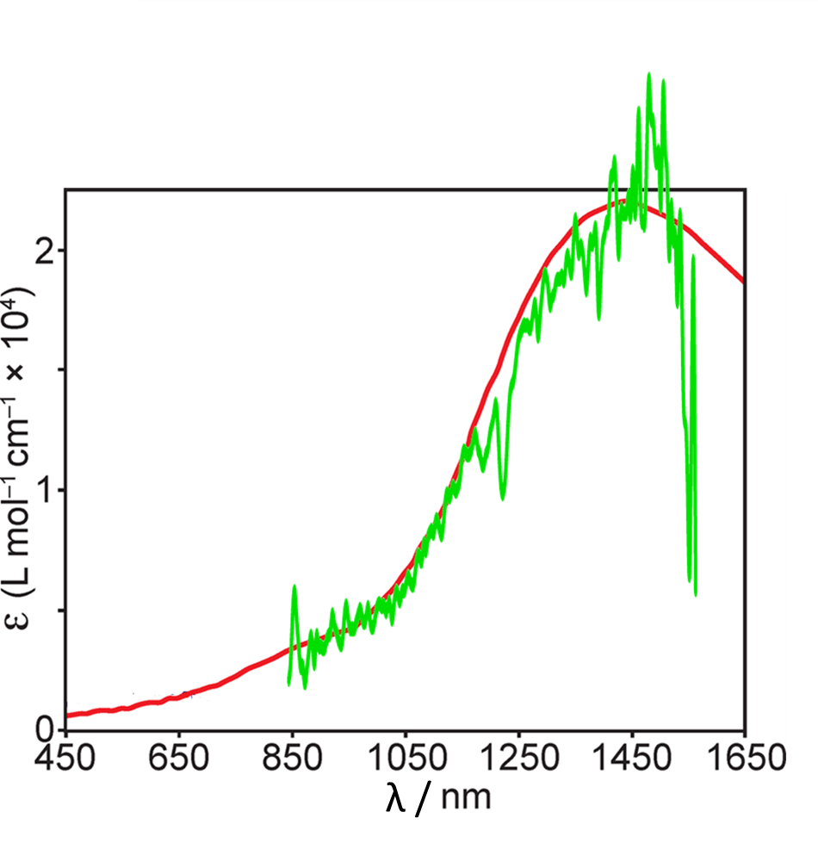
Figure S5. Comparison of the NIR transient absorption spectrum at 29.5 ps delay of a degassed acetonitrile solution of 4DPAPN•¯ (green line) and the solvated electron in acetonitrile (red line) as reported in ref. [5]
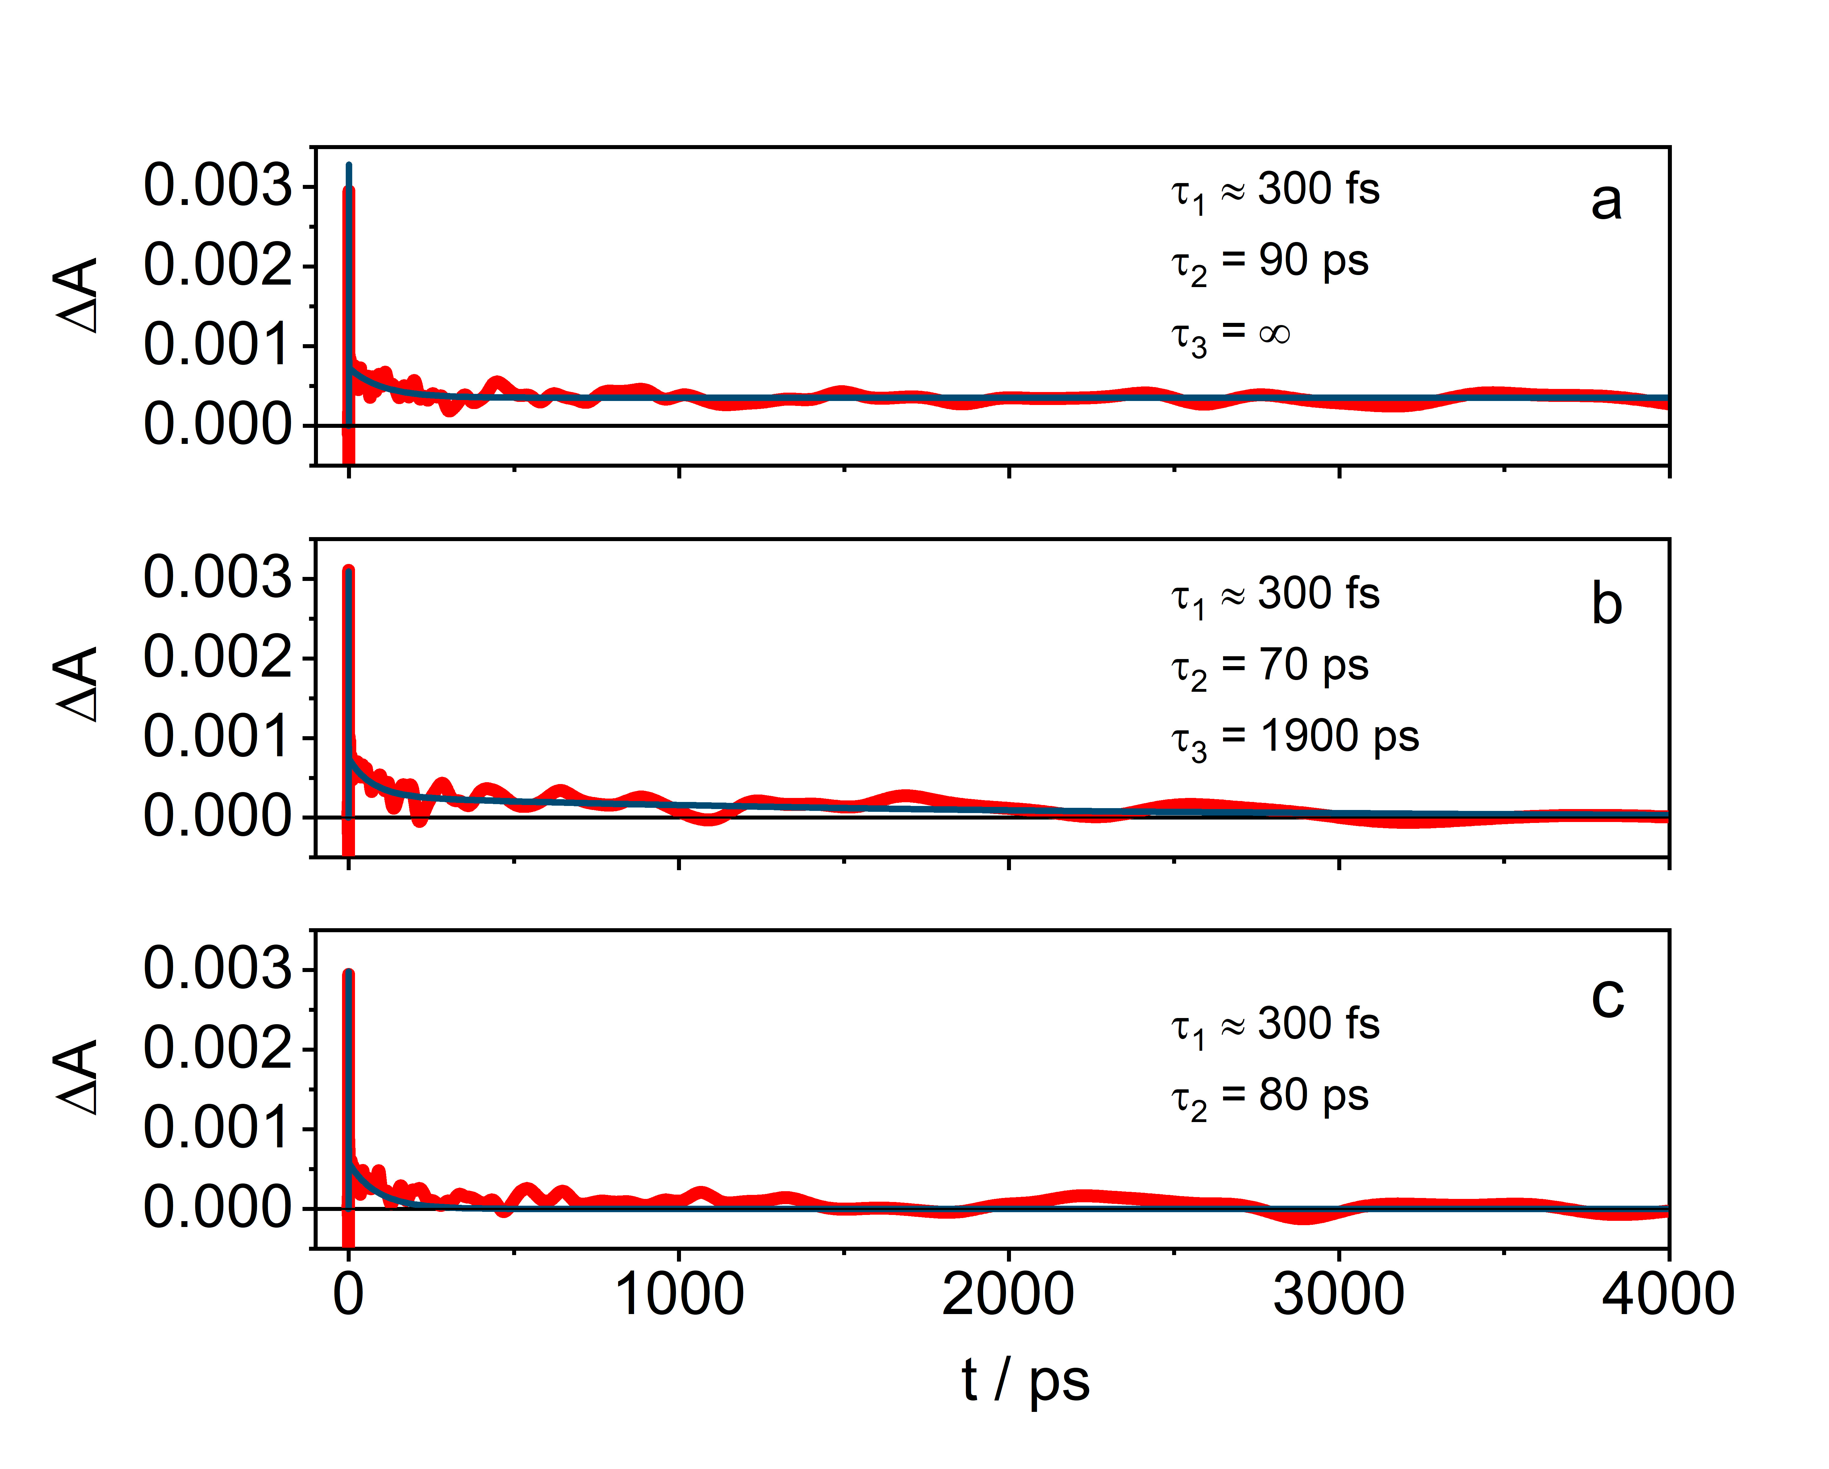
Figure S6. Temporal evolution of ΔA measured at 1440 nm (red lines) for degassed acetonitrile solutions of 4DPAPN•¯ in the absence (a) and in the presence of substrate 1 0.01 M (b) and 0.1 M (c). The fittings are reported as blue lines.

EPR CHARACTERIZATION
General
EPR spectra were recorded at room temperature using an ELEXYS E500 spectrometer equipped with a NMR gaussmeter for the calibration of the magnetic field.
The radical species were generated photochemically by using a Kessil lamp at 390 nm (40 W) or electrochemical by using a home-made cell consisted of an EPR flat cell (Wilmad WG-810) equipped with a 25×5×0.2 mm platinum gauze (cathode), a platinum wire (anode). The current was supplied and controlled by an AMEL 2051 general-purpose potentiostat.
An iterative least squares fitting procedure, based on the systematic application of the Monte Carlo method, was performed in order to obtain the experimental spectral parameters of the radical species.^{[6]}

Figure S7. EPR spectrum of the radical 4DPAPN•¯electrochemically generated under nitrogen atmosphere in CH₂Cl₂ containing 0.1 M TBAPF₆ at room temperature (a), and the corresponding theoretical simulation (b) obtained with the following spectroscopic parameters: a_{2N}=0.30 G, a_{2N}=0.69 G and a_{2N}=1.73 G.

ELECTROCHEMICAL AND SPECTROELECTROCHEMCIAL STUDY
General
Cyclic voltammetry experiments were carried out at room temperature in argon-purged dried CH₂Cl₂ using an EcoChemie Autolab 30 potentiostat in a 3-electrode setup. The working electrode consisted of a glassy carbon electrode (3 mm diameter), the counter electrode was a Pt spiral electrode and an Ag wire was used as quasi-reference electrode (AgQRE). Working electrode and quasi-reference electrodes were polished on a felt pad with 0.05 or 0.3 μm alumina suspension and sonicated in deionized water for 1 min before each experiment; the Pt wire was flame cleaned. Tetrabutylammonium hexafluorophosphate (TBAPF₆, 0.1 M) is added to the solution as a supporting electrolyte. Ferrocene (purified by sublimation at reduced pressure) is used as an internal reference (E^{Fc+/0} = 0.46 V vs SCE).
Spectroelectrochemical experiments were performed in an optically transparent thin-layer electrochemical (OTTLE) cell equipped with CaF₂ windows, two Pt minigrids as working and counter electrodes, and a Ag wire as a quasi-reference electrode. Solutions were prepared in anhydrous CH₃CN, degassed through Ar bubbling. Tetrabutylammonium hexafluorophosphate (TBAPF₆, ca. 0.1 M) was used as a supporting electrolyte. Upon application of a given potential, UV−vis−NIR absorption spectra were recorded with an Agilent Technologies 8543 diode array spectrophotometer.
Figure S8. Cyclic voltammograms from a sample of 4DPAPN (ca. 1.0 mM) in degassed CH₂Cl₂ at RT. A: reduction potential scans in the presence (dashed line) and without ferrocene, used as an internal standard. B: cathodic and anodic potential scan. Scan rate: 0.2 Vs⁻¹.

The EPR and electrochemical experiments demonstrate that the radical anion of 4DPAPN is formed electrochemically and it is stable on the timescale of seconds typical of the cyclic voltammogram experiments. However, the photogeneration of the same radical was not possible in the steady-state regime used in acetonitrile and that is likely related to the fast photoreactivity of the radical anion in this solvent. This prevented us from performing transient absorption spectroscopy of 4DPAPN•¯ in dichloromethane solution.

Figure S9. Evolution of the absorption spectra for a solution of 4DPAPN (ca. 0.85 mM, blue line; TBAPF₆ 0.1 M added as a supporting electrolyte) in degassed CH₃CN upon application of -2 V (vs. Ag QRE) through a three-electrode OTTLE cell. Scans are acquired each 10 s.

Supporting Notes and References
[1] E. Bassan, R. Inoue, D. Fabry, F. Calogero, S. Potenti, A. Gualandi, P. G. Cozzi, K. Kamogawa, P. Ceroni, Y. Tamaki, O. Ishitani, Sustainable Energy & Fuels 2023, 7, 3454-3463.
[2] Y. Wu, Z. Chen, Y. Yang, W. Zhu, B. Zhou, J. Am. Chem. Soc. 2018, 140, 42-45.
[3] S. Bazzi, E. Schulz, M. Mellah, Org. Lett. 2019, 21, 10033-10037.
[4] J. W. Beattie, D. S. White, A. Bheemaraju, P. D. Martin, S. Groysman, Dalton Trans. 2014, 43, 7979-7986.
[5] S. C. Doan, B. J. Schwartz, J. Phys. Chem. Lett. 2013, 4, 1471-1476.
[6] E. Mezzina, M. Fanì, F. Ferroni, P. Franchi, M. Menna, M. Lucarini, J. Org. Chem. 2006, 71, 3773-3777.

