Sample | Photo | Provenance | Context | Chronology of the context | Preserved Fragment | Chronology of the form | Decoration | Colour | Compositional group
CR08_01 | 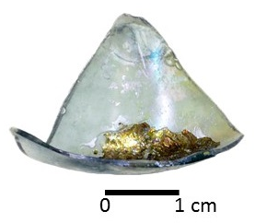 | Castle of Rontana | US 2011 | 14th  16th CE | Bottom | 14th  16th CE | small circles  (ø 0,5 cm) | Light blue | BA+PS
CR09_01 | 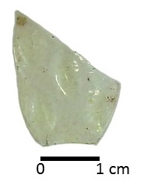 | Castle of Rontana | well 2 | 14th  end 15th CE | Wall | 14th  16th CE | rhombus  (0,4 x 0,9 cm ca.) | Light yellow | LA+S
CR09_02 | 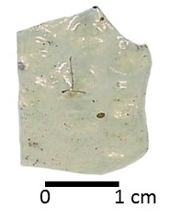 | Castle of Rontana | well 2 | 14th  end 15th CE | Wall | 14th  16th CE | small circles  (ø 0,4 cm ca.) | Colourless | LA+S
CR09_03 | 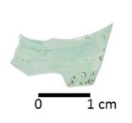 | Castle of Rontana | well 2 | 14th  end 15th CE | Wall | 14th  16th CE | circles  (ø 0,7 cm ca.) | Light blue | LA+S
CR09_04 | 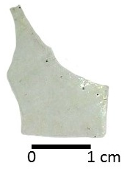 | Castle of Rontana | well 2 | 14th  end 15th CE | Wall | 14th  16th CE | horizontal ellipsis  (0,55 x 0,9 cm ca.) | Colourless | LA+S
CR09_05 | 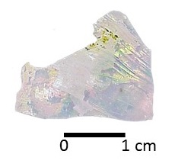 | Castle of Rontana | well 2 | 14th  end 15th CE | Wall | 14th  16th CE | circles  (ø 0,55 cm ca.) | Colourless | LA+PS
CR09_06 | 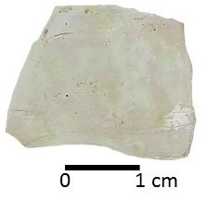 | Castle of Rontana | well 2 | 14th  end 15th CE | Wall | 14th  16th CE | "rice grains"  (0,4 x 0,65 cm ca.) | Colourless | LA+S
CR09_07 | 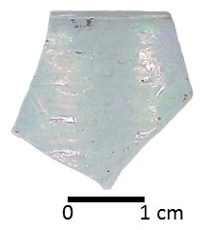 | Castle of Rontana | well 2 | 14th  end 15th CE | Rim | 14th  16th CE | circles  (ø 0,7 cm ca.) | Colourless | LA+S
CR09_08 | 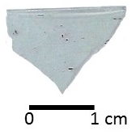 | Castle of Rontana | well 2 | 14th  end 15th CE | Rim | 14th  16th CE | circles  (ø 0,65 cm ca.) | Colourless | LA+S
CR09_09 | 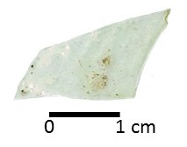 | Castle of Rontana | well 2 | 14th  end 15th CE | Wall | 14th  16th CE | vertical lines | Colourless | LA+S
CR09_10 | 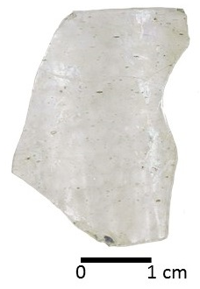 | Castle of Rontana | US 2019 | 14th  16th CE | Rim | 14th  16th CE | circles  (ø 0,55 cm ca.) | Colourless | LA+PS
CR10_01 | 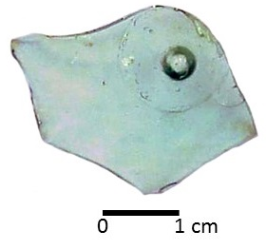 | Castle of Rontana | US 2087 | 15th CE | Bottom | 14th  16th CE | radial lines | Light blue | LA+PS
CR10_02 | 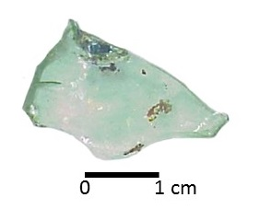 | Castle of Rontana | US 121 | 14th  16th CE | Bottom | 14th  16th CE | circles  (ø 0,5 cm ca.) | Light green | K₂O+PS
CR10_03 | 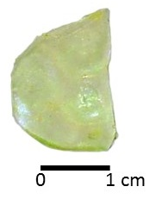 | Castle of Rontana | US 124 | 15th  16th CE | Wall | 14th  16th CE | circles  (ø 0,6-0,7 cm ca.) | Light yellow | BA+PS
CR11_01 | 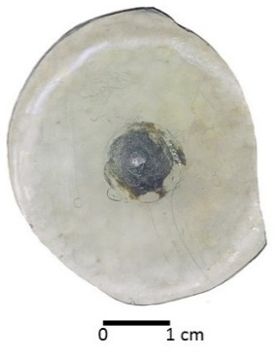 | Castle of Rontana | US 2079 | 14th  15th CE | Bottom | 14th  16th CE | circles  (ø 0,5 cm ca.) | Colourless | LA+PS
CR12_01 | 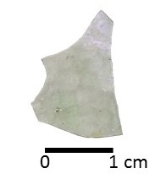 | Castle of Rontana | US 3150 | 14th  15th CE | Wall | 14th  16th CE | "rice grains”  (0,4 x 0,6 cm ca.) | Colourless | K₂O+PS
SV-D105 | 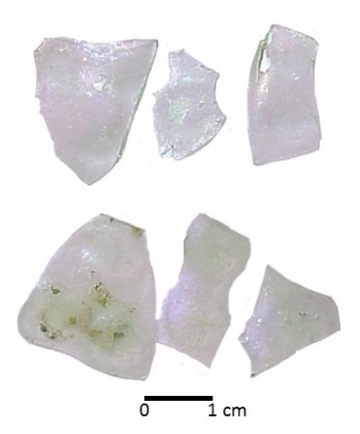 | Monastery of San Severo | US 20144 | 14th  15th CE | Walls | 14th  15th CE | circles  (ø 0,5 cm.) | Colourless | K₂O+PS
SV_D106 | 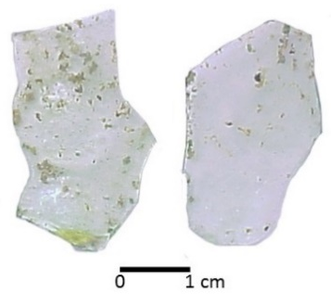 | Monastery of San Severo | US 20144 | 14th  15th CE | Walls | 14th  15th CE | circles  (ø 0,7 cm.) | Colourless | LA+S
SV_D107 | 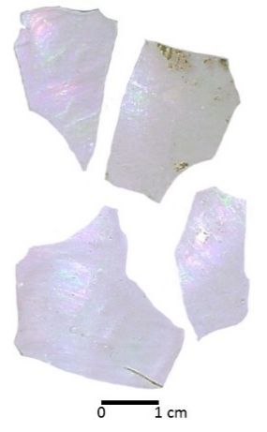 | Monastery of San Severo | US 20144 | 14th  15th CE | Walls | 14th  15th CE | circles  (ø 0,7 cm.) | Colourless | K₂O+PS
SV_D115 | 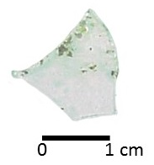 | Monastery of San Severo | US 20144 | 14th  15th CE | Wall | 14th  15th CE | circles  (ø 0,6 cm) | Colourless | LA+PS
SV_D116 | 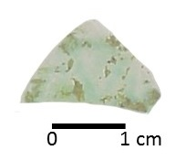 | Monastery of San Severo | US 20151 | 13th  15th CE | Wall | 14th  16th CE | circles  (ø 0,4 cm.) | Light green | LA+PS
SV_D117 | 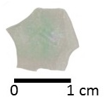 | Monastery of San Severo | US 20144 | 14th  15th CE | Wall | 14th  15th CE | circles  (ø 0,7 cm.) | Light green | BA+PS
SV_D118 | 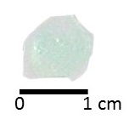 | Monastery of San Severo | US 20151 | 13th  15th CE | Wall | 14th  16th CE | circles  (ø 0,6 cm.) | Light Green | BA+PS
SV_D119 | 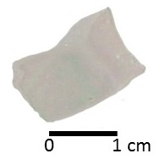 | Monastery of San Severo | US 20144 | 14th  15th CE | Wall | 14th  15th CE | circles  (ø 0,7 cm.) | Colourless | K₂O+PS
SV_D120 | 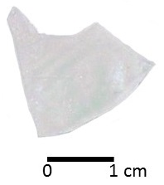 | Monastery of San Severo | US 20151 | 13th  15th CE | Wall | 14th  16th CE | circles  (ø 0,7 cm.) | Colourless | K₂O+PS
SV_D121 | 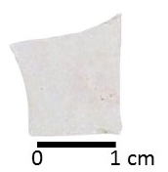 | Monastery of San Severo | US 20149 | 13th  15th CE | Wall | 14th  16th CE | smooth wall | Colourless | LA+PS
SV_D122 | 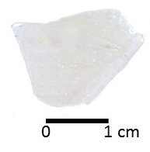 | Monastery of San Severo | US 20140 | 13th  15th CE | Wall | 14th  16th CE | smooth wall | Colourless | K₂O+PS
SV_D123 | 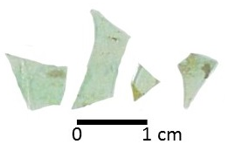 | Monastery of San Severo | US 20135 | end 14th  beginning 15th CE | Walls | 14th  16th CE | vertical lines | Light green | Outlier
SV-D124 | 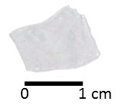 | Monastery of San Severo | US 20140 | 13th  15th CE | Wall | 14th  16th CE | "rice grains”  (0,4 x 0,6 cm ca.) | Colourless | LA+PS
SV-D125 | 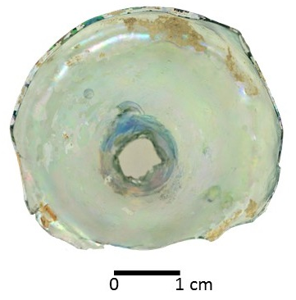 | Monastery of San Severo | US 20122 | 13th  15th CE | Bottom | 14th  16th CE | circles  (ø 0,4 cm.) | Light green | BA+PS
SV-D126 | 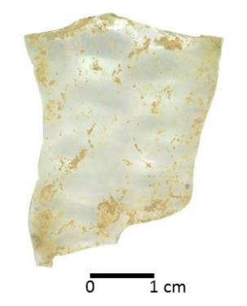 | Monastery of San Severo | US 20165 | 13th  15th CE | Wall | 14th  16th CE | circles  (ø 0,7 cm.) | Colourless | LA+PS
SV-D127 | 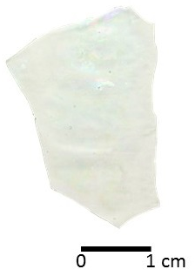 | Monastery of San Severo | US 20112 | 13th  15th CE | Wall | 14th  16th CE | circles  (ø 0,7 cm.) | Colourless | K₂O+PS
SV-D128 | 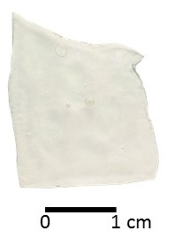 | Monastery of San Severo | US 20100 | 13th  15th CE | Wall | 14th  16th CE | rhombus  (0,4 x 0,9 cm ca.) | Colourless | K₂O+PS
SV-D129 | 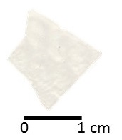 | Monastery of San Severo | US 20100 | 13th  15th CE | Wall | 14th  16th CE | rhombus  (0,4 x 0,9 cm ca.) | Colourless | LA+PS
Table S1 – Chrono-typological data of gambassini fragments selected for the study

