Supplementary material
In the current study, we explore the feasibility of utilizing electrical conductivity measurements to monitor the fermentation process for lactobionic acid production. Building upon this methodology, we extend our investigation to include the monitoring of alcoholic fermentation under enological conditions in this section. The experimental data have been taken from the manuscript by Colombié et al. ^{[22]}.
In the aforementioned paper, fermentation was conducted using a synthetic medium comprising 200 g/l of glucose, along with 6 g/l each of malic acid and citric acid. and a nitrogen source with 18.6% of NH₄CI was analysed. Since the study only reports the reduction in conductivity rather than the absolute values, it's not possible to account for the influence of mineral salts. Basing on the medium composition, neglecting the presence of the mineral salts, the identified equilibria are:
Ammonium
$K_{NH_{4}^{+}}=\frac{\left[NH_{4}OH\right]\left[H^{+}\right]}{\left[NH_{4}^{+}\right]}$
$\left[NH_{4}^{+}\right]=\left[{NH_{4}^{+}}_{in}\right]-\left[NH_{4}OH\right]$
Where $K_{NH_{4}^{+}}$=5.75 10⁻¹⁰ mol L⁻¹

Citric Acid
$K_{AcH}=\frac{\left[{AC}^{-}\right]\left[H^{+}\right]}{\left[AcH\right]}$
$\left[AcH\right]=\left[{AcH}_{in}\right]-\left[{AC}^{-}\right]$
Where $K_{ACH}$=7.44 10⁻⁴ mol L⁻¹

Malic Acid
$K_{AmH}=\frac{\left[{AM}^{-}\right]\left[H^{+}\right]}{\left[AmH\right]}$
$\left[AmH\right]=\left[{AmH}_{in}\right]-\left[{AM}^{-}\right]$
Where $K_{AmH}$=3.48 10⁻⁴ mol L⁻¹

Known variable | Unknown Variables | Equation to be solved | Relevant results
$$\left[H^{+}\right]$$ | $$\left[NH_{4}OH\right]\left[{LBA}^{-}\right]$$  $$\left[NH_{4}^{+}\right]$$  $$\left[{AC}^{-}\right]$$  $$\left[AcH\right]$$  $$\left[{AM}^{-}\right]$$  $$\left[AmH\right]$$ | Molar Balances:  $\left[NH_{4}^{+}\right]=\left[{NH_{4}^{+}}_{in}\right]-\left[NH_{4}OH\right]$  $$\left[AcH\right]=\left[{AcH}_{in}\right]-\left[{AC}^{-}\right]$$  $$\left[AmH\right]=\left[{AmH}_{in}\right]-\left[{AM}^{-}\right]$$  Equilibria:  $$K_{NH_{4}^{+}}=\frac{\left[NH_{4}OH\right]\left[H^{+}\right]}{\left[NH_{4}^{+}\right]}$$  $$K_{AcH}=\frac{\left[{AC}^{-}\right]\left[H^{+}\right]}{\left[AcH\right]}$$  $$K_{AmH}=\frac{\left[{AM}^{-}\right]\left[H^{+}\right]}{\left[AmH\right]}$$ | Evaluation of the conductivity changes
ST1 The equations used for evaluating the ion concentrations
Ion | Molar conductivity (l) [S L mol⁻¹ cm⁻¹]
H⁺ | 0.34982
OH⁻ | 0.1986
NH4⁺ | 0.0735
AC⁻ | 0.0702
AM⁻ | 0.0588
Fixing the $\left[H^{+}\right]$ it is possible to evaluate the concentrations of the different ions and using the molar conductivity shown in the Table ST2 evaluate the conductivity of the medium.

ST2 Molar conductivity
In Figure S1, the computed variation of the medium conductivity, Δl =l-l_{in} , evaluated respect to the conductivity measured at the beginning of the fermentation $\overline{l_{in}}$, is shown as a function of the pH. It is necessary to point out that, because of the carbon dioxide production, the pH of the medium tends to decrease, as experimentally observed by Colombié et al. ^{[22]} (compare the trend shown in Fig1S with the experimental trend shown in Figure 1a^{[22]}).

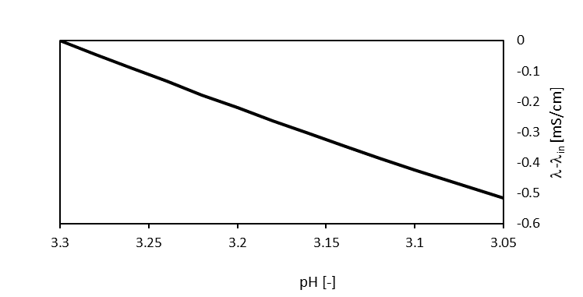
Fig S1 The conductivity trend as a function of the pH
Malic and citric concentration [g/l] | ΔpH exp. | Δl exp. [mS/cm] | Δl comp. Present work  [mS/cm] | Δl comp. Colombie work  [mS/cm]
"6-6" | 0.25 | -0.36 | -0.52 | -0.41
"3-3" | 0.5 | -0.23 | -0.23 | -0.12
"9-9" | 0.14 | -0.36 | -0.49 | -0.42
Colombié et al.^{[22]} analysed the behaviour of different media containing different concentrations of malic and citric acids. In Table ST3 the experimental values of the ΔpH measured and the Δl experimentally measured and computed according the proposed approach or the empirical equation suggested by Colombié et al. ^{[22]}.

ST3 Comparison between Δl experimentally measured and computed.
The results shown in the Table ST3 suggest that present model, without introducing any adjustable parameter, allows to qualitatively predict the evolution of the electrical conductivity in different media during the fermentation. From the quantitative point of view, present approach gives practically the same average error evaluated with Colombié empirical equation, without introducing any adjustable parameter.

