Economic uncertainty measures, experts and large language models

APPENDICES
CONTENTS

A1 Prompt engineering and language models page 2
A2 Selected binary plots of hits for the case of 25 jumps page 12
A3 HP jumps and hits test for Poland page 24
A4 FD jumps and hits test for Poland page 27
A5 HP jumps and hits test for US page 31
A6 FD jumps and hits test for US page 37
A7 Comparing hits for different UGE sets and type of jumps page 42
A8 Comparing test results for different indices and types of jumps page 47

Appendix 1. Prompt engineering and language models

A1.1. Comparison between chatbots and AI language models
To assess the robustness of our methodology, we compared different large language models (LLMs) and versions of the same LLM. Different chatbots exploit different LLMs. ChatGPT is a chatbot developed by OpenAI, which was founded in December 2015 and November 2022. It used GPT-3.5 (Generative Pre-trained Transformer 3.5); this release of LLM is trained on large internet datasets, aimed at processing text and answering questions. Specifically, ChatGPT was developed to provide human-like responses to prompts given in the form of questions or instructions. The actual LLMs used by OpenAI are GPT-4, released in March 2023 and updated in October 2023, and GPT-4o, released in May 2024.
We found our results to be robust to the use of alternative chatbots to that of OpenAI. We also use Microsoft Copilot. Indeed, Copilot focuses on tasks related to programming within the Microsoft application network, while OpenAI is claimed to perform more generic (and creative) tasks. We also tried Google’s Gemini, which could be an alternative to GPT-3, although OpenAI is characterized by a more consistent ability to retrieve specific information from large texts accurately.,
Our robust results are supported by Rathje et al. (2024), which show that ChatGPT is an effective tool for detecting various psychological constructs in text with little code and simple prompts, without much specific training data (few-shot or zero-shot learning). Wang et al. (2023) show that ChatGPT achieves remarkable performance on various NLP tasks and is a good NLG evaluator, achieving competitive correlation with human judgments in most cases.
A1.2. Prompt engineering
A useful feature of ChatGPT is that it can be trained by further conversation and improves over time through research breakthroughs. Unless opting out (we used both options, temporary chats without training and improving the model with training), the content of a prompt, the conversation and memories are used to improve capabilities, safety and accuracy in solving the specific asked question.
The LLM is made up of large strings of numbers, called “weights” or “parameters,” and code that interprets and executes those numbers. As the model learns, some of the numbers that make up the model change slightly to reflect what it has learned. This is the role of interacting by slightly changing the prompts or by using regenerations. Because many possible words could come next in a prompt, there is an element of randomness in the way the model can respond, and in many cases, the models will answer the same question in different ways. This happens, for example, when we ask ChatGPT the same prompt in different days or times within the same day.
To ensure the quality of UGE identification, we followed some strategies and tactics of prompt engineering.
- By adopting a persona, we gave clear instructions with details, using delimiters to clearly indicate distinct parts of the input, specifying the steps required to complete the task, providing examples, and specifying the desired number of events.
- We split the complex task into a workflow of simpler subtasks by dialoguing with summaries and filters from previous dialogues. For example, we asked to provide the exact date of a specific event like the Fukushima nuclear disaster in Japan, the storming of the US Capitol, the cut by FED of interest rates. Accordingly, we generated the answers and provided lists of UGEs with the correct dates.
- We gave the model time to “think”, asking for explanations as to why a specific event should have increased uncertainty, whether before or after, and this was implemented through dialogues and regenerations (maieutic prompting).
- We used external tools, like giving the model specific UGEs identified by the literature.
- We introduced systematic test changes so to produce iterative prompt refinement.
- We used in-context learning so to exploit the LLM’s ability to learn from prompts.
- Given our research question, which does not require solving a complex arithmetical problem by breaking it down into steps of reasoning, we did not use chain-of-thought, least-to-most and tree-of-thought prompting techniques.
As the interrelations with LLM lasted for many days, with various prompts submitted at different times within the same day, on different days, below are some examples of the prompts we used for the US. Of course, we tracked the number of times each event was mentioned in all our “interviews”. In other words, we assessed the truthfulness of the responses in terms of Self-Consistency and Universal Self-Consistency by prompting the LLM several times, keeping track of the answers and selecting the most consistent response out of all the responses, as suggested by Chen et al. (2023) and Krishna et al. (2024).
We started by asking, “Suppose you are an expert who must select the most relevant events in the period 2004-2021 that significantly increased economic, financial and political uncertainty in the United States. What is your list? Please provide the exact dates of the events”. This means that we have clearly specified the task in the timeframe and the types of events we are interested in (generated knowledge prompting to condition LLM on relevant facts). We took note of events to evaluate improvements in our interactions with the chatbot.
Then we asked, “Can you create, if possible with exact dates, a list of 80 events that, in the period between the beginning of 2004 and the end of 2021, greatly increased economic, financial and political uncertainty in the United States? For each event, indicate whether the increase of uncertainty occurred immediately after the event or with some delay or anticipation.'' This question was replicated by increasing the number of events up to 120 or by asking for additional events to be added to the list of 80 events. It was also regenerated at different times and days to obtain the frequencies of the most probable events.
On various days and times within the same day, we used directional-stimulus prompting that, despite coming at the cost of more token consumption, provides some examples of events to LLM so that it can better understand our intention and criteria for what kinds of answers we want. Iterations through regenerations also allow for increasing the truthfulness of LLM responses. Changing the order of the examples provided, in ChatGPT-3.5-4 there was no LLM bias towards the prediction of certain answers, e.g. those placed near the end of the prompt or common in the pre-training data (as was the case in ChatGPT-3, Zhao et al., 2021). An example of such a question (with examples provided both in chronological order and randomly) is as follows “From the list below, can you select the 80 most relevant events in the period 2004-2021 that greatly increased economic, financial, and political uncertainty in the United States? For each event, please indicate whether the increase in uncertainty occurred immediately after the event or with some delay or anticipation.”
To confirm the frequencies of responses on UGEs and to accomplish the “survey”, we opted for the final prompt for US, which was regenerated on different days and times within the same day: “Can you create a list of 80 events that occurred in the US between January 2004 and December 2021, which strongly increased economic, financial, and political uncertainty? Please provide the exact dates of these events when possible. Additionally, for each event, indicate whether the increase in uncertainty occurred immediately after the event, if it followed with some delay (lag), or if it was anticipated (lead). Please structure the response in order of relevance, from the most to the least relevant”.
A1.3. Uncertainty Generating Events for Poland and the US
The list of the most frequent uncertainty-generating events (UGEs) provided for Poland (27 events) and the US (40 events) by the panel of experts (only in the case of Poland), ChatGPT-3.5, ChatGPT-4o and Copilot, in response to our queries, and used for jumps and hits test are provided in Tables A1.1 – A1.4 (for Poland) and Tables A1.5 – A1.7 (for the US).

Table A1.1. Uncertainty Generating Events for Poland provided by the panel of experts
Date | Event
2004-05 | Poland's accession to the European Union.
2004-07 | A month of strong fluctuations in the zloty exchange rate.
2005-10 | Presidential election.
2007-06 | Decrease in stock indices.
2008-09 | The global financial crisis has begun.
2008-10 | The month in which the strongest effect of the financial crisis in Europe occurred.
2009-01 | Russian-Ukrainian conflict over gas supplies & gas supply restrictions.
2009-02 | Central Bank of Poland's proposal to delay Poland's entry into the Euro zone & WIG decline.
2010-04 | Smolensk disaster.
2010-05 | Culmination of the Eurozone debt crisis (Greece).
2011-11 | Plan to increase the retirement age.
2013-01 | Reform of the pension system.
2014-03 | The occupation of Crimea by Russia.
2014-05 | Moody's announced a negative financial forecast for Poland.
2014-06 | Russia's suspension of gas supplies to Ukraine & raid of ABW on 'Wprost' newspaper office.
2014-08 | Russia suspends imports of food products from the EU.
2015-10 | Parliament election.
2015-05 | Presidential election.
2015-12 | Introduction of bank tax from February 2016 & KOD march.
2016-06 | Brexit referendum.
2016-11 | US presidential election.
2016-01 | S&P announced a negative financial forecast for Poland.
2017-12 | Constitutional crisis: negative opinion of the European Commission.
2020-03 | The beginning of the Covid 19 pandemic.
2020-07 | Presidential election.
2020-12 | Start of vaccinations against Covid 19.
2021-02 | Draft amendments to the Act on the Supreme Court.

Table A1.2. Uncertainty Generating Events for Poland generated by GhatGPT-3.5
Date | Event
2004-05 | European Union Accession
2005-10 | Polish Presidential Elections
2006-01 | Russian-Ukrainian Gas Disputes 1
2007-12 | Poland Joins Schengen Area
2008-10 | Global Financial Crisis
2009-01 | Russian Energy Disputes
2010-02 | Launch of "Polish Deal" Economic Plan
2010-04 | Smolensk Plane Crash
2010-05 | Eurozone Debt Crisis
2012-04 | Poland's Adoption of the Euro Currency Delayed
2013-02 | EU Multiannual Financial Framework Negotiations
2013-09 | Polish Pension System Reforms
2014-03 | Russian Annexation of Crimea
2014-06 | Russian-Ukrainian Gas Disputes 3
2015-11 | Change of Government
2016-02 | Polish Banking Tax Introduced
2016-03 | Retail Sales Tax Plans Cause Concerns
2016-06 | Brexit Referendum
2016-09 | Poland's Banking Tax Changes
2016-11 | US Presidential Elections
2017-07 | Polish Constitutional Crisis
2019-11 | Poland's 2040 Energy Strategy
2020-03 | COVID-19 Pandemic
2020-05 | Polish Presidential Elections
2020-07 | EU Recovery Fund Agreement
2020-11 | Veto of EU Budget and Recovery Fund
2020-12 | COVID-19 Vaccination Rollout

Table A1.3. Uncertainty Generating Events for Poland generated by GhatGPT-4o
Date | Event
2004-05 | Poland joins the European Union.
2005-07 | Presidential elections where Lech Kaczyński becomes President of Poland.
2008-12 | Global financial crisis impacts Poland’s economy, leading to slower growth and higher unemployment.
2010-04 | Smolensk plane crash, killing President Lech Kaczyński and top military and political leaders.
2011-11 | Civic Platform (PO) wins parliamentary elections, continuing pro-EU policies.
2012-03 | ACTA (Anti-Counterfeiting Trade Agreement) protests against government’s intent to sign the treaty.
2014-03 | Russia annexes Crimea, heightening security concerns in Poland.
2015-06 | Migration crisis, with Poland resisting EU quotas for refugee resettlement.
2015-10 | Law and Justice (PiS) party wins the parliamentary elections.
2015-12 | Polish Constitutional Tribunal crisis begins, sparked by PiS reforms.
2016-01 | European Commission launches Rule of Law procedure against Poland over judicial reforms.
2016-07 | NATO summit in Warsaw.
2016-07 | Brexit vote in the UK, affecting over 1 million Polish immigrants living in the UK.
2017-03 | Polish government begins logging in the ancient Białowieża Forest, violating EU conservation laws.
2017-12 | European Commission triggers Article 7 against Poland over rule of law issues.
2018-07 | Poland’s Supreme Court law is introduced, forcing early retirement of judges, leading to protests and EU scrutiny.
2019-01 | Assassination of Gdańsk Mayor Paweł Adamowicz during a charity event.
2019-10 | PiS wins re-election with an expanded majority. Lead (anticipated).
2019-10 | EU Court of Justice rules Poland’s judicial reforms violate EU law.
2020-01 | Polish judicial reform escalates as Supreme Court rules new judges appointed by PiS-controlled judiciary are invalid.
2020-03 | COVID-19 pandemic and subsequent lockdowns in Poland.
2020-07 | Presidential election re-election of Andrzej Duda, supported by PiS.
2020-07 | Poland rejects EU Green Deal conditions, leading to tensions over climate change policies.
2020-07 | Poland vetoes the EU budget linked to rule of law conditions.
2020-09 | European Commission launches infringement procedure against Poland for undermining judicial independence.
2020-10 | Constitutional Tribunal ruling restricting abortion rights, sparking nationwide protests.
2020-10 | Covid-19 second wave and renewed restrictions.

Table A1.4. Uncertainty Generating Events for Poland generated by Copilot
Date | Event
2004-05 | Poland’s EU Accession.
2007-11 | Independence March Clashes.
2008-09 | Financial Crisis.
2008-11 | Independence March Clashes.
2009-11 | Independence March Clashes.
2010-04 | Smolensk Air Crash.
2010-06 | Presidential Election.
2010-11 | Independence March Clashes.
2011-10 | Parliamentary Election.
2011-11 | Independence March Clashes.
2012-11 | Independence March Clashes.
2013-11 | Independence March Clashes.
2014-02 | Ukrainian Crisis.
2014-11 | Independence March Clashes.
2015-05 | Presidential Election.
2015-10 | Parliamentary Election.
2015-11 | Independence March Clashes.
2016-03 | Constitutional Tribunal Crisis.
2016-06 | Brexit Referendum.
2016-11 | Independence March Clashes.
2017-11 | Independence March Clashes.
2017-12 | Constitutional Tribunal Crisis.
2018-07 | Judicial Reforms.
2018-11 | Independence March Clashes.
2019-10 | Parliamentary Election.
2019-12 | Judicial Reforms.
2020-03 | COVID-19 Pandemic.

Table A1.5. Uncertainty Generating Events for US generated by GhatGPT-3.5
Date | Event
2004-01 | US unemployment rate reaches 6.0%. Enron scandal. Introduction of the Euro currency leads to speculation about its impact on the US dollar.
2007-08 | Financial crisis begins with the collapse of the subprime mortgage market.
2008-09 | Lehmann Brothers bankruptcy. Stock market crash EESA.
2008-10 | US Congress passes Emergency Economic Stabilization Act, authorizing the Troubled Asset Relief Program (TARP) to address the financial crisis.
2008-11 | Barack Obama elected President.
2008-12 | Bernard Madoff arrested for running the largest Ponzi scheme in history.
2009-01 | Obama's inauguration amid ongoing financial crisis.
2009-02 | American Recovery and Reinvestment Act is signed into law, sparking debates over its effectiveness and implications for the economy.
2009-06 | General Motors files for bankruptcy.
2009-07 | Cash for Clunkers program launched.
2010-03 | Affordable Care Act (Obamacare) signed into law.
2010-04 | Deepwater Horizon oil spill begins.
2010-05 | Flash Crash occurs, shaking financial markets.
2010-07 | Dodd–Frank Wall Street Reform and Consumer Protection Act.
2011-04 | Standard & Poor's downgrades US credit rating outlook.
2011-07 | US Debt Ceiling Crisis European leaders and IMF agree to a second bailout package. Italy's debt 120% of GDP
2011-08 | Standard & Poor's downgrades the US credit rating for the first time, raising concerns about government debt and fiscal policy.
2011-09 | Occupy Wall Street movement begins.
2011-11 | Crisis in Italy Berlusconi resigns as prime minister.
2013-01 | Fiscal cliff negotiations lead to last-minute deal.
2013-06 | Edward Snowden leaks NSA surveillance programs.
2013-10 | Government shutdown occurs due to budgetary disagreements, leading to uncertainty about the functioning of government and potential economic impacts.
2015-06 | European officials and the IMF fail to strike a deal on Greece’s bailout program.
2016-06 | Brexit referendum.
2016-11 | Donald Trump wins the US presidential election.
2017-03 | Fed increases in the key interest rate by 0.25 percentage points (only the third time that the Fed increased rates since the financial crisis).
2017-04 | United States' airstrike on Syria.
2017-06 | The Financial CHOICE Act, which aimed to undo significant parts of the Dodd-Frank Wall Street Reform and Consumer Protection Act, was approved by the US House of Representatives.
2017-12 | Tax Cuts and Jobs Act.
2018-03 | Tariffs on Chinese goods. Senate decided exempting dozens of bank under $250 billion asset from Dodd Frank.
2018-07 | Trade war US China.
2019-01 | US government shutdown.
2019-03 | US-China trade negotiations breakdown.
2019-08 | Last escalation of trade war US China.
2019-12 | Start of Covid-19 Pandemic.
2020-01 | US drone strike kills Iranian General Qasem Soleimani, raising geopolitical tensions and increasing uncertainty about conflict escalation.
2020-03 | World Health Organization declares COVID-19 a pandemic, leading to widespread economic shutdowns and financial market turmoil.
2020-08 | IMF wrote about the disconnection between the performance of stock markets and the real economy.
2021-01 | Storming of the US Capitol.
2021-08 | US withdrawal from Afghanistan.

Table A1.6. Uncertainty Generating Events for US generated by GhatGPT-4o
Date | Event
2004-07 | Re-election campaign of George W. Bush begins.
2005-08 | Hurricane Katrina.
2007-03 | Subprime mortgage crisis intensifies.
2007-07 | Bear Stearns hedge fund collapse.
2007-08 | Subprime mortgage crisis emerges.
2007-11 | Recession officially begins in the US (later confirmed by NBER).
2008-07 | US enters formal recession.
2008-09 | Lehman Brothers bankruptcy.
2008-10 | Troubled Asset Relief Program (TARP) passed by Congress.
2008-11 | Election of Barack Obama as US President & GM and Chrysler approach the US government for bailouts.
2009-02 | American Recovery and Reinvestment Act signed into law.
2009-03 | Stock market bottom during the Great Recession.
2009-04 | Swine flu pandemic (H1N1).
2009-06 | GM files for bankruptcy.
2010-04 | Deepwater Horizon oil spill.
2010-05 | Flash crash in US stock market.
2011-07 | Debt ceiling crisis.
2011-08 | S&P downgrades US credit rating from AAA to AA+.
2012-06 | Supreme Court upholds the Affordable Care Act (Obamacare).
2013-10 | US government shutdown.
2014-03 | Russian annexation of Crimea.
2015-06 | Puerto Rico announces it cannot pay its public debt.
2015-12 | Federal Reserve raises interest rates for the first time since 2006.
2016-06 | Brexit referendum (UK votes to leave EU).
2016-11 | Election of Donald Trump as US President.
2017-01 | Inauguration of Donald Trump.
2017-08 | White supremacist rally in Charlottesville and President Trump's response.
2017-09 | Tax reform efforts in the Trump administration.
2018-03 | Trade war between US and China escalates; Trump announces tariffs on steel and aluminium imports.
2018-10 | Stock market correction (sharp declines in US markets).
2019-01 | Longest US government shutdown ends (35 days).
2019-09 | Impeachment inquiry against President Trump.
2019-10 | Impeachment of Donald Trump begins.
2020-01 | US kills Iranian General Qassem Soleimani.
2020-03 | COVID-19 pandemic begins in the US & CARES Act passes ($2 trillion stimulus package).
2020-04 | Federal Reserve cuts interest rates to near zero in response to COVID-19. Record US unemployment (14.8%) due to COVID-19 lockdowns.
2020-06 | Black Lives Matter protests after George Floyd's death.
2020-11 | US Presidential election (Joe Biden wins).
2021-01 | U.S. Capitol insurrection. Inauguration of Joe Biden.
2021-03 | American Rescue Plan Act signed into law ($1.9 trillion COVID-19 relief).

Table A1.7. Uncertainty Generating Events for Poland generated by Copilot
Date | Event
2004-11 | Presidential Election.
2004-12 | Indian Ocean Tsunami.
2005-08 | Energy Policy Act.
2005-09 | Hurricane Katrina.
2007-08 | Subprime Mortgage Crisis.
2008-09 | Financial Crisis.
2008-11 | Presidential Election.
2009-02 | American Recovery and Reinvestment Act.
2009-04 | H1N1 Pandemic.
2010-03 | Affordable Care Act Passage.
2010-05 | Flash Crash.
2010-07 | Dodd-Frank Act Passage.
2010-11 | Midterm Elections.
2011-08 | Debt Ceiling Crisis.
2012-11 | Presidential Election.
2012-12 | Sandy Hook Shooting.
2013-04 | Boston Marathon Bombing.
2013-10 | Government Shutdown.
2014-03 | Ebola Outbreak.
2014-11 | Midterm Elections.
2015-06 | Greek Debt Crisis.
2015-12 | Federal Reserve Interest Rate Hikes.
2016-01 | Zika Virus Outbreak.
2016-06 | Brexit Vote.
2016-11 | Presidential Election.
2017-02 | North Korea Missile Tests.
2017-06 | US Withdrawal from Paris Agreement.
2017-08 | Charlottesville Rally.
2017-10 | Las Vegas Shooting.
2017-12 | Tax Cuts and Jobs Act.
2018-02 | Parkland Shooting.
2018-03 | Trade War with China.
2018-05 | US Withdrawal from Iran Nuclear Deal.
2018-11 | Midterm Elections, California Wildfires .
2018-12 | Government Shutdown.
2019-01 | Government Shutdown.
2019-12 | Impeachment of Donald Trump.
2020-01 | US-China Trade Deal Phase One.
2020-03 | COVID-19 Pandemic.
2021-01 | Capitol Riot.

Additional References to Appendix A1
Chen, X., Aksitov R., Alon U., Ren J., Xiao K., Yin P., Prakash S., Sutton C., Wang X. and Zhou D. (2023), “Universal self-consistency for large language model generation”, https://arxiv.org/abs/2311.17311 .
Krishna, S., Agarwal, C. and Lakkaraju, H. (2024), “Understanding the effects of iterative prompting on truthfulness”, https://arxiv.org/pdf/2402.06625 .
Rathje, S., Mirea, D. M., Sucholutsky, I., Marjieh, R., Robertson, C. E., & Van Bavel, J. J. (2024), “GPT is an effective tool for multilingual psychological text analysis”. Proceedings of the National Academy of Sciences, 121 e2308950121.
Wang, J., Liang, Y., Meng, F., Sun, Z., Shi, H., Li, Z., Xu, J., Qu, J. and Zhou, J. (2023), “Is ChatGPT a good NLG evaluator? A preliminary study”, https://arxiv.org/abs/2303.04048.
Zhao, T. Z., Wallace, E., Feng, S., Klein, D. and Singh, S. (2021), “Calibrate before use: Improving few-shot performance of Language Models”, https://arxiv.org/abs/2102.09690

Appendix 2. Selected binary plots of hits for the case of 25 jumps
General Description of Figures A2.1 – A2.4
Figures A2.1 – A2.4 illustrate how the binary data are constructed for each type of the UGE sets, that is the panel of experts (for Poland only) and all used uncertainty indices (that is, three indices for Poland and six indices for the US). All figures below are for the case when there are 25 jumps (that is ).
Legend (common for all Figures)
- the vertical bars, black and grey, mark the dates of jumps;
- the black bars mark the dates when there are hits, that is, when UGEs coincide with jumps;
- the grey bars mark cases with no such coincidences (misses).
Figure A2.1. Location of jumps and hits, HP jumps, Poland
 | Experts | ChatGPT-3.5
EURQP_PL | 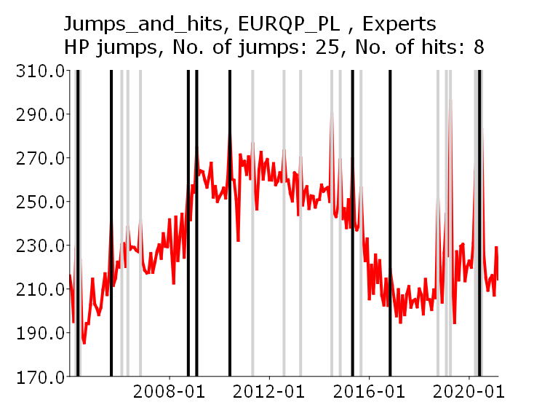 | 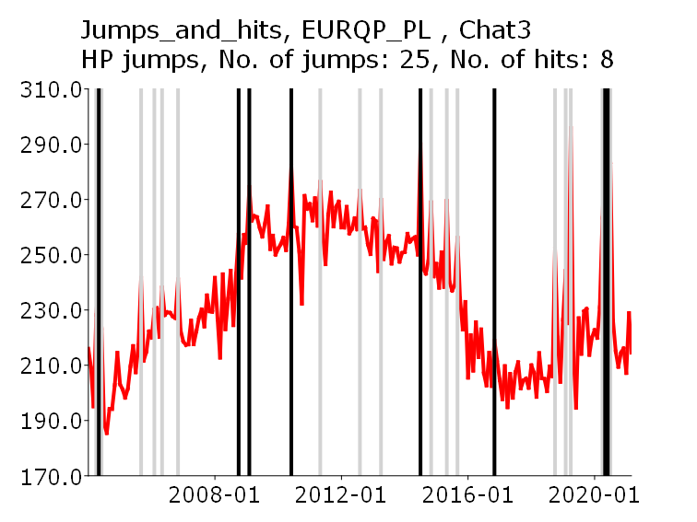
EURQP_EN | 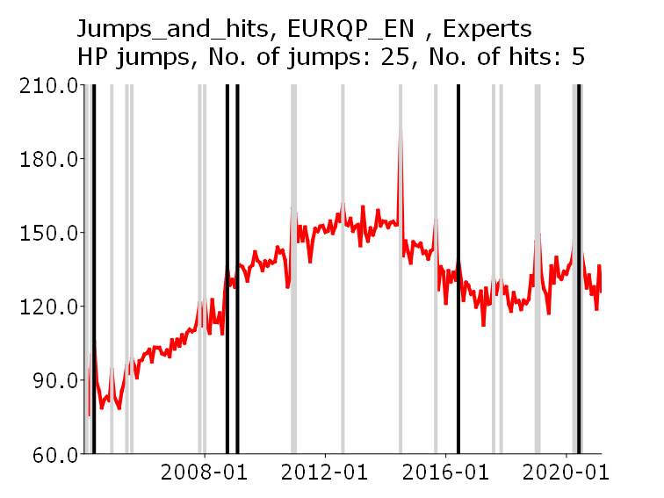 | 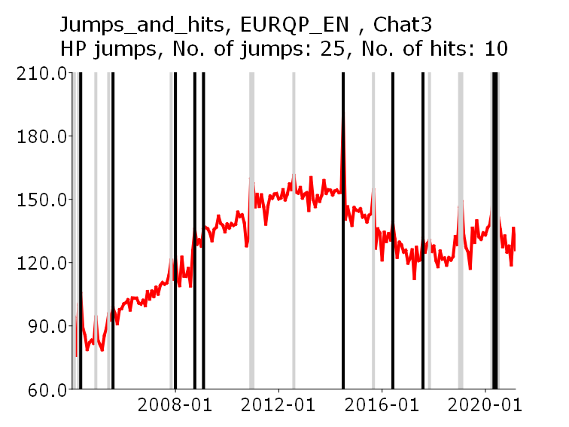

The Figure continues on the next page

Figure A2.1. Location of jumps and hits, HP jumps, Poland (cont.)
GEPU_KZ | 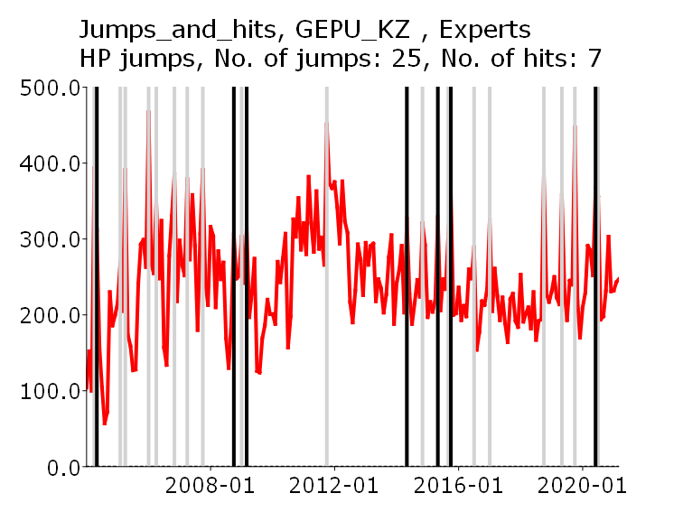 | 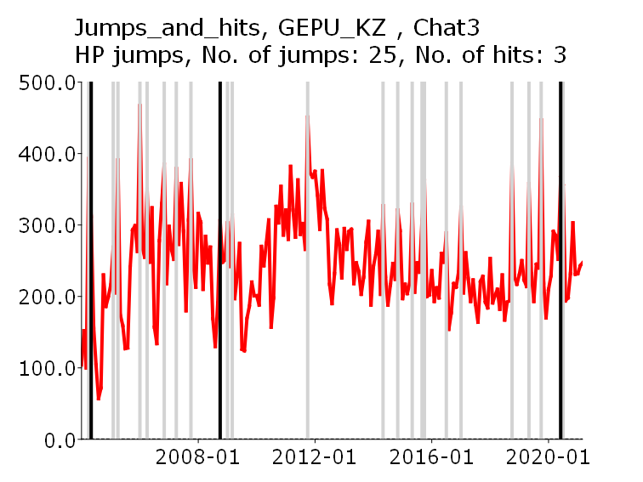
 | ChatGPT-4o | Copilot
EURQP_PL | 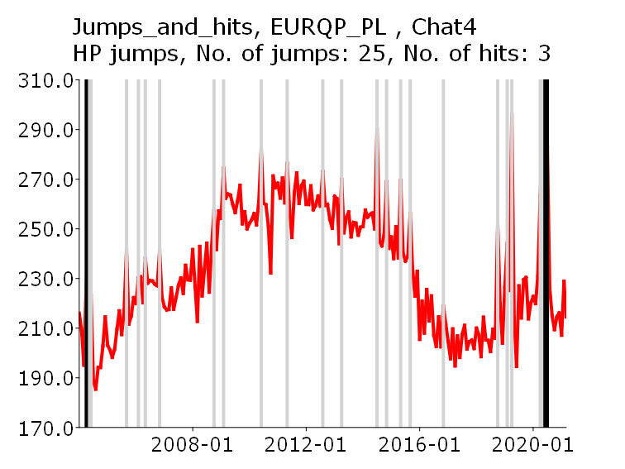 | 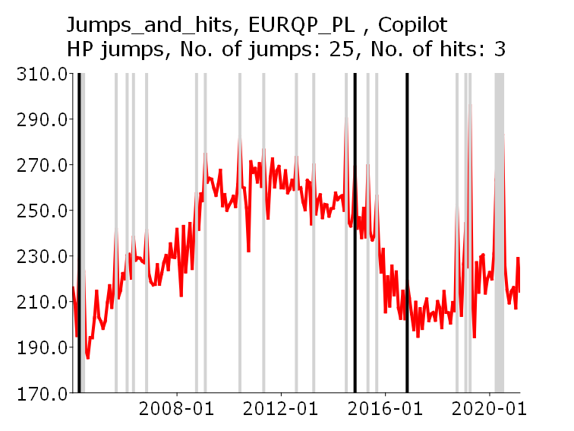
EURQP_EN | 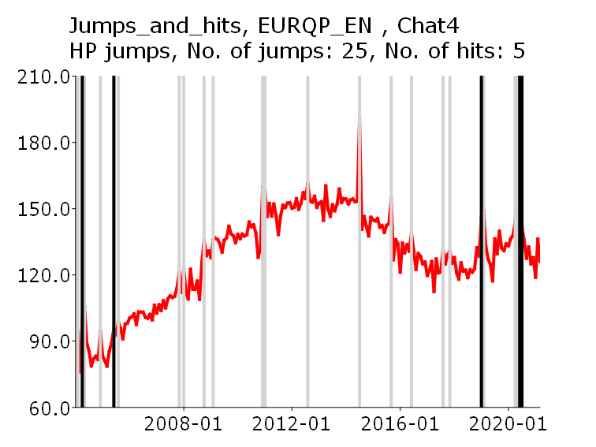 | 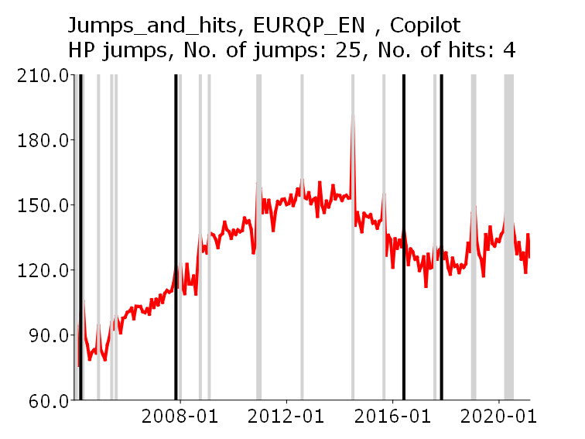
GEPU_KZ | 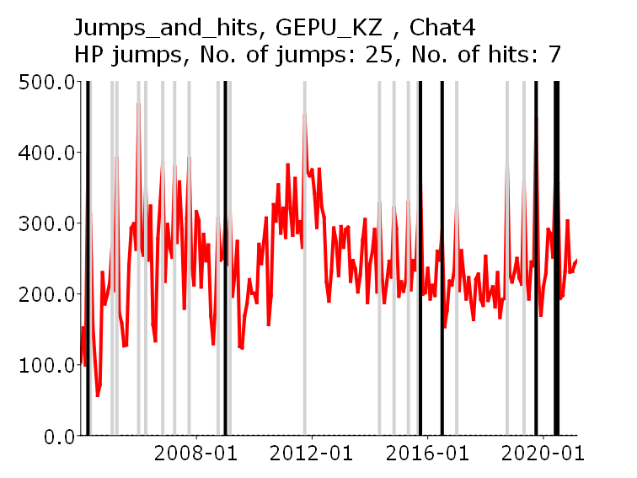 | 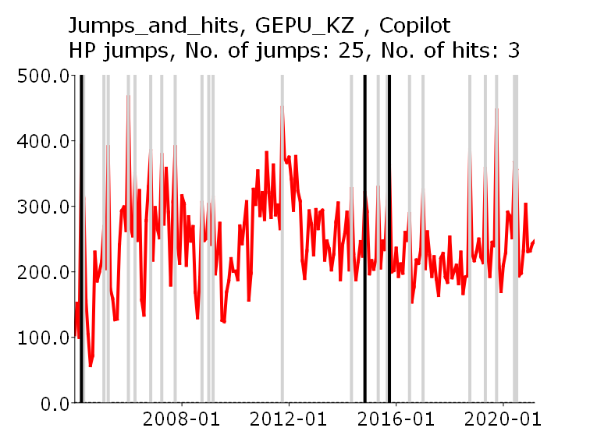
Figure A2.2 Location of jumps and hits, FD jumps, Poland
 | Experts | ChatGPT-3.5
EURQP_PL | 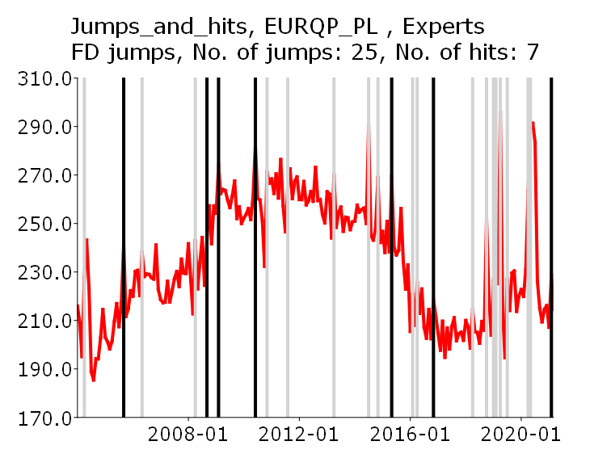 | 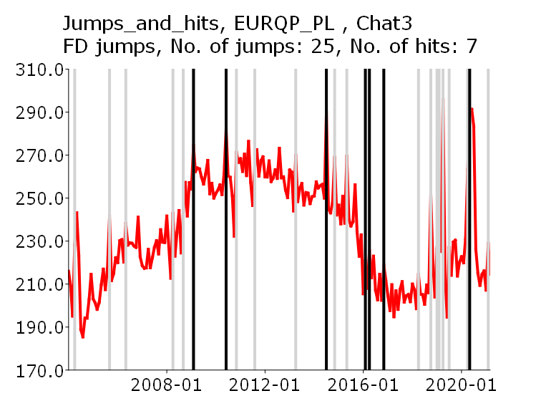
EURQP_EN | 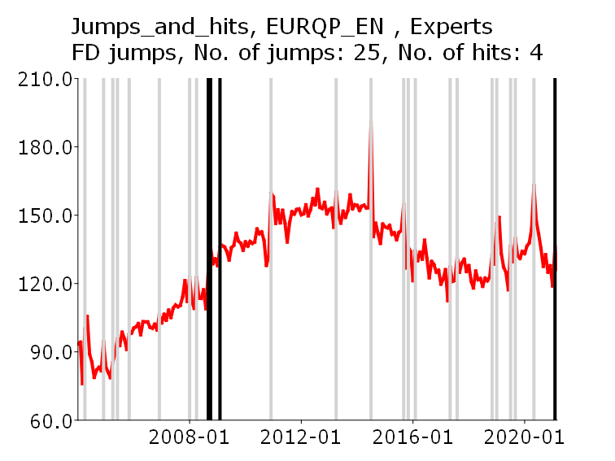 | 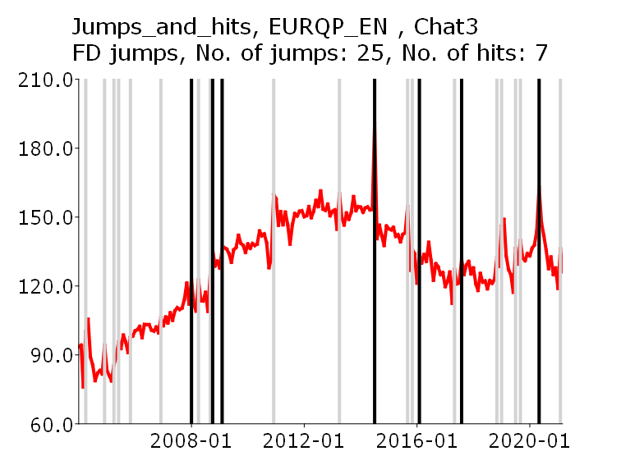
GEPU_KZ | 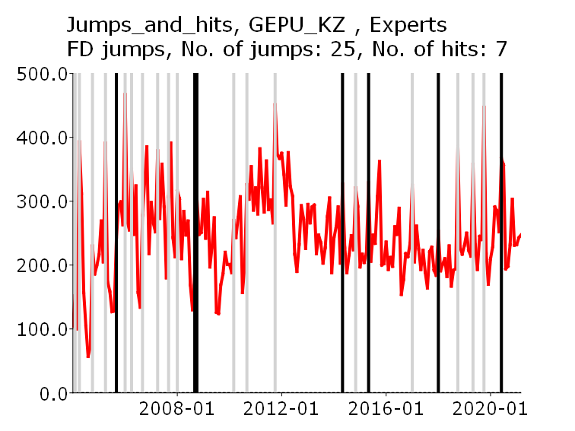 | 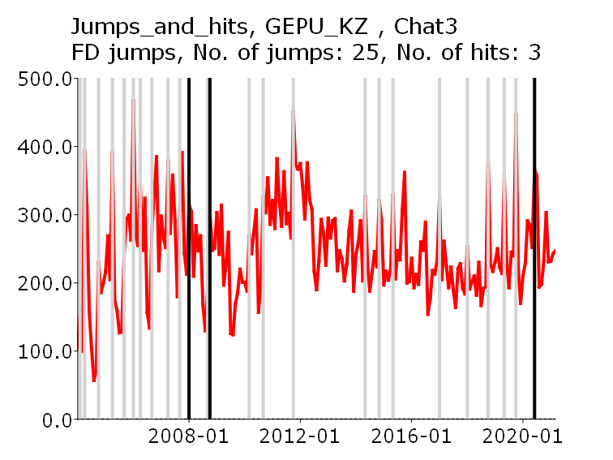

The Figure continues on the next page

Figure A2.2 Location of jumps and hits, FD jumps, Poland (cont.)
 | ChatGPT-4o | Copilot
EURQP_PL | 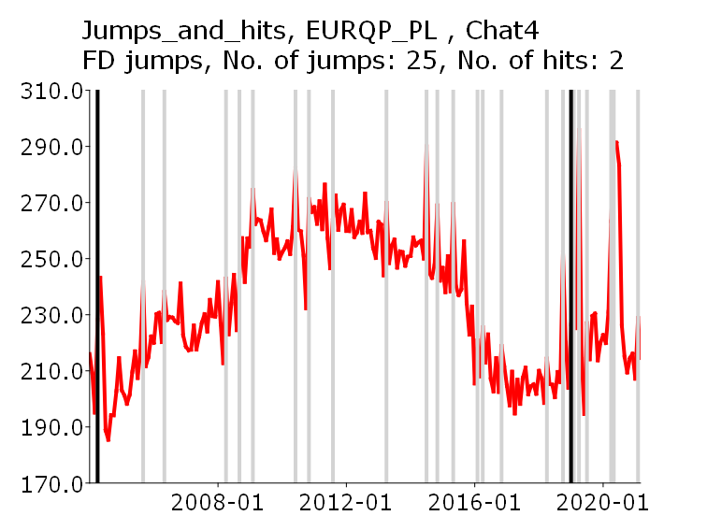 | 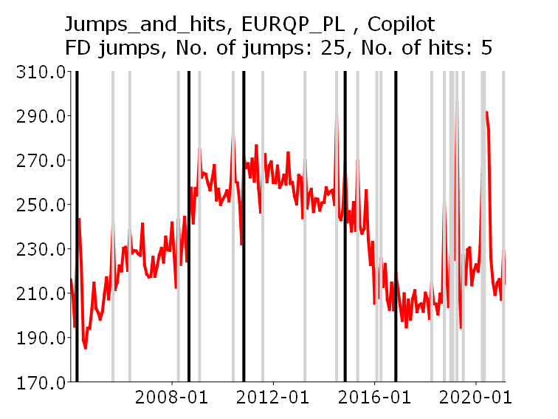
EURQP_EN | 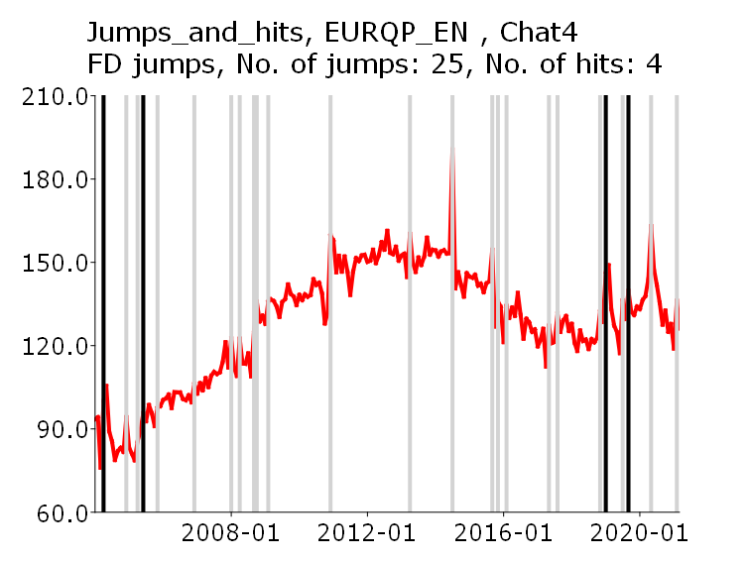 | 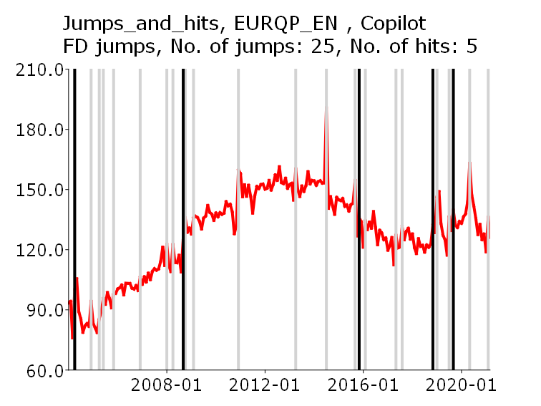
GEPU_KZ | 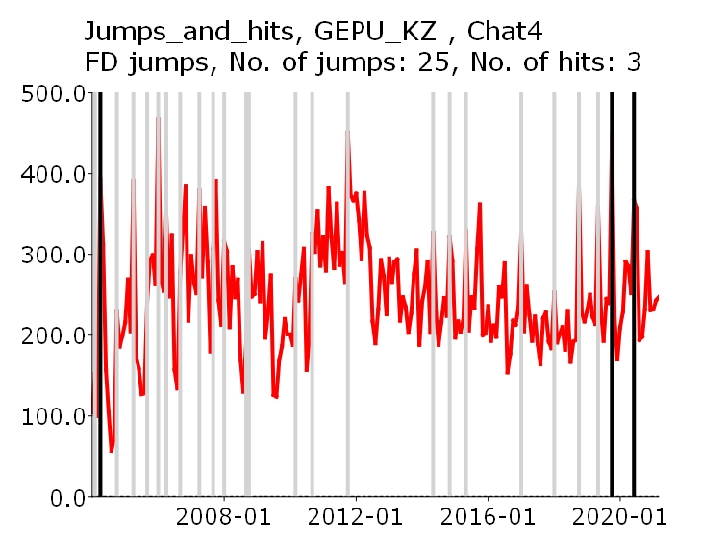 | 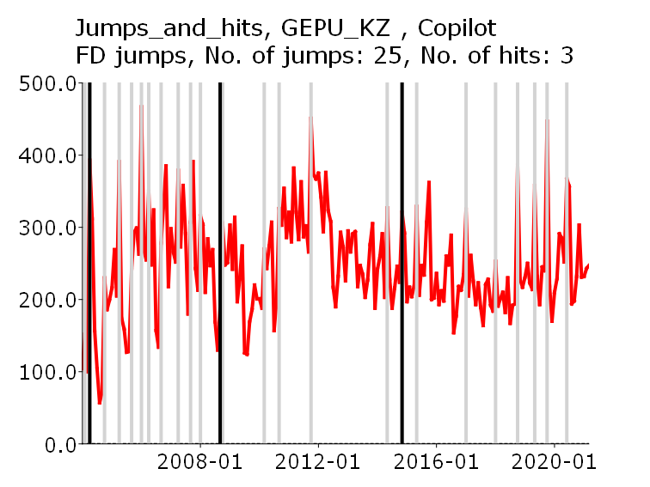

Figure A2.3. Location of jumps and hits, US, HP jumps, US.
(Note: There is no panel of experts in the US.)
 | ChatGPT-3.5
EPUus | 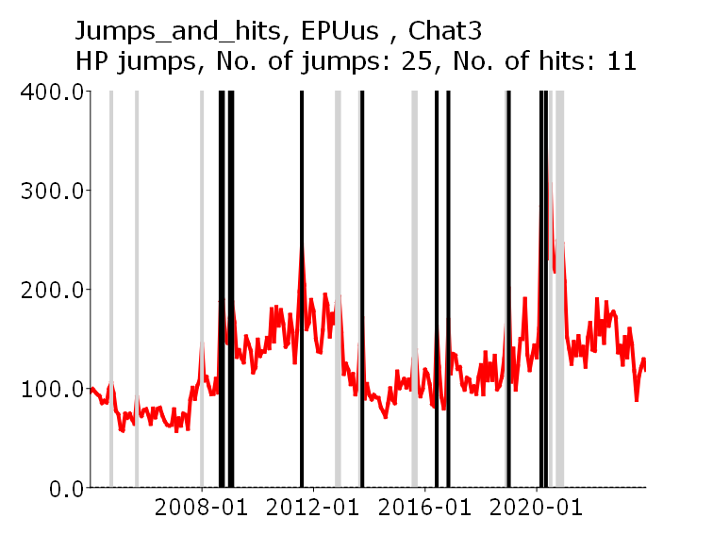
EURQus | 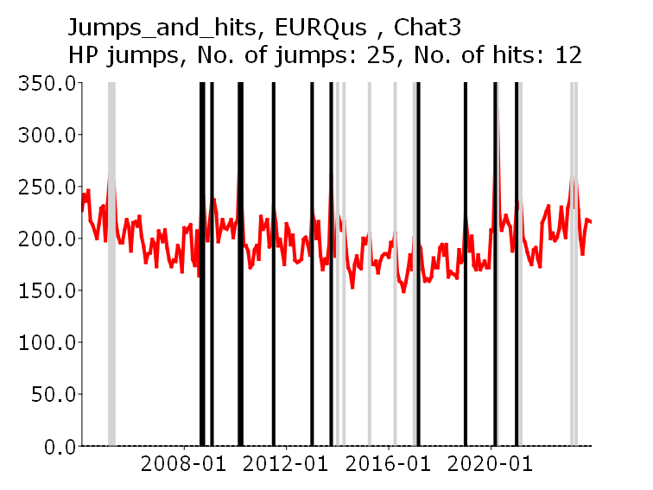
LMACROus | 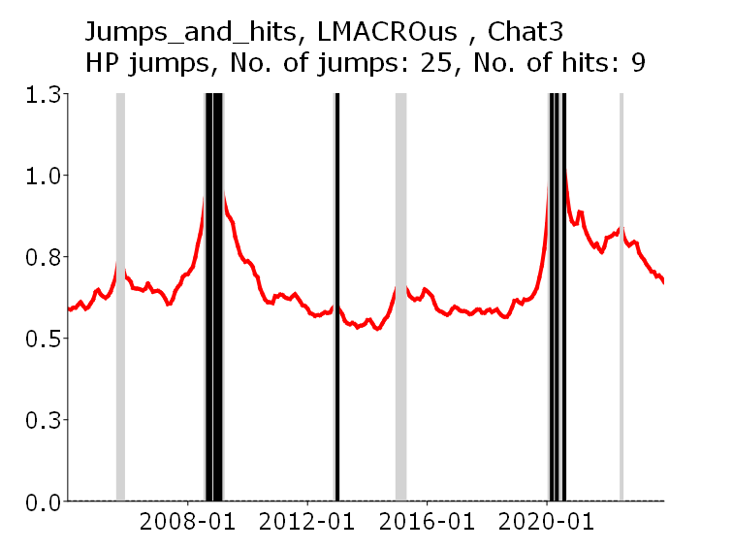

The Figure continues on the next page

Figure A2.3. Location of jumps and hits, US, HP jumps, US.
(Note: There is no panel of experts in the US.) (cont.)
LREAlus | 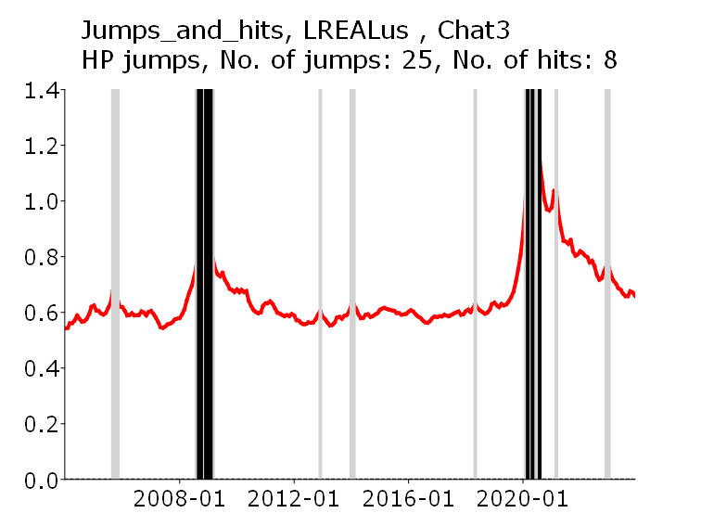
LFINus | 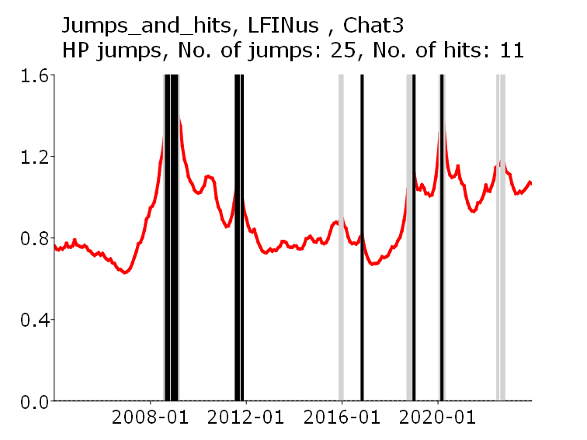
VIXus | 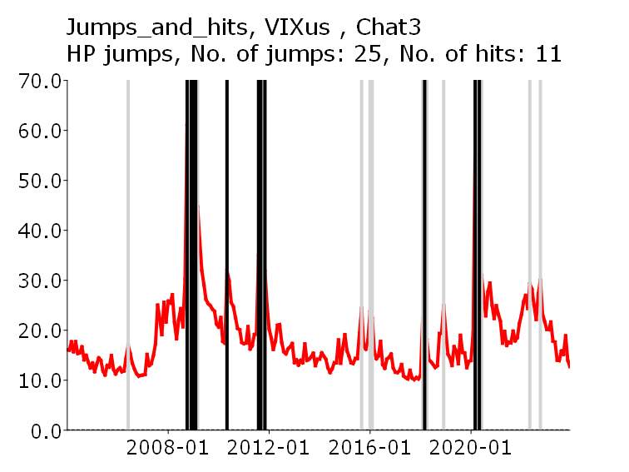

The Figure continues on the next page

Figure A2.3. Location of jumps and hits, US, HP jumps, US.
(Note: There is no panel of experts in the US.), (cont.)
 | ChatGPT-4o | Copilot
EPUus | 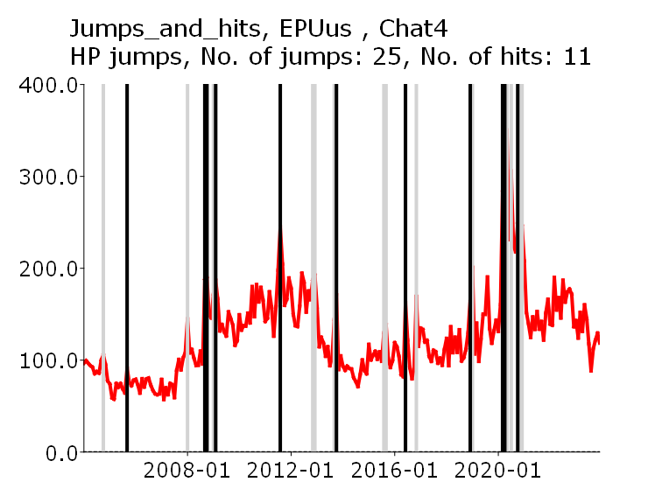 | 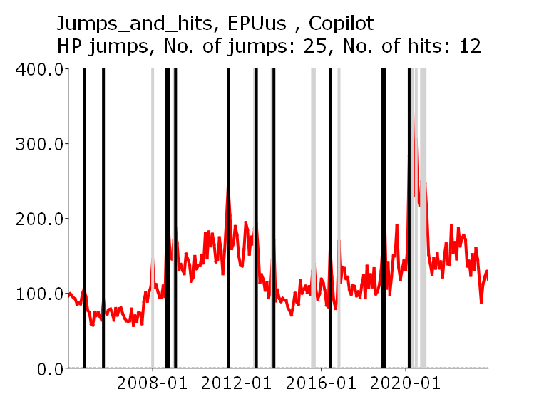
EURQus | 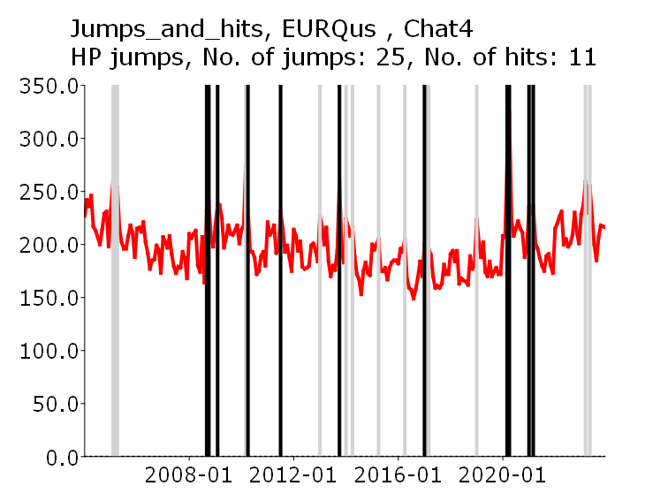 | 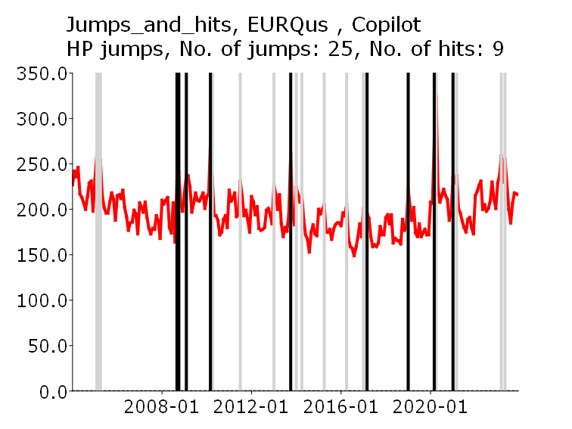
LMACROus | 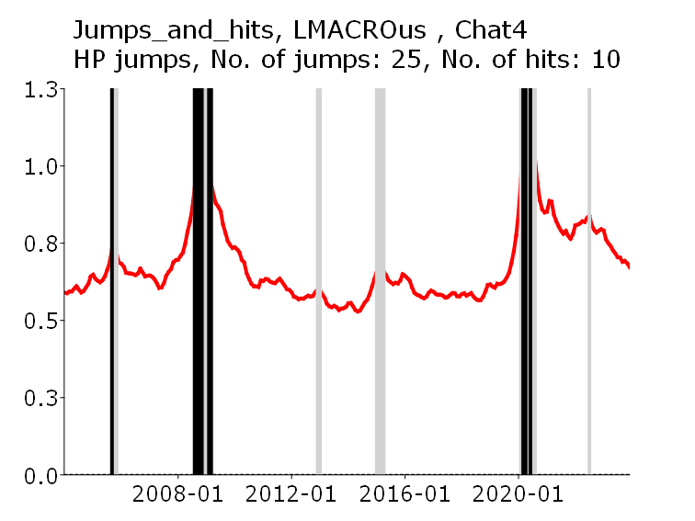 | 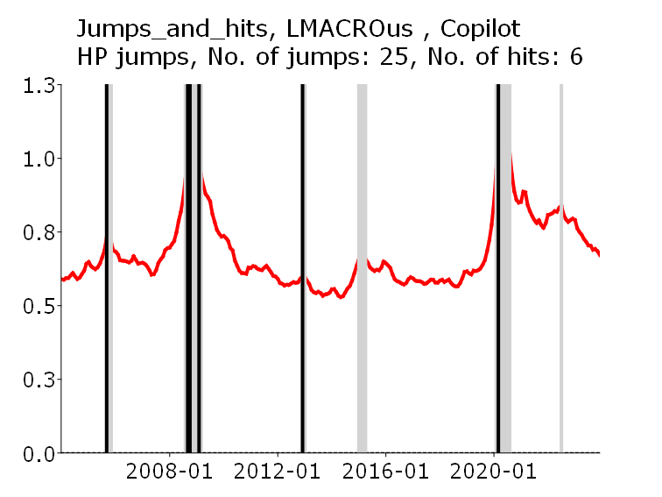

The Figure continues on the next page

Figure A2.3. Location of jumps and hits, US, HP jumps, US.
(Note: There is no panel of experts in the US.), (cont.)
LREAlus | 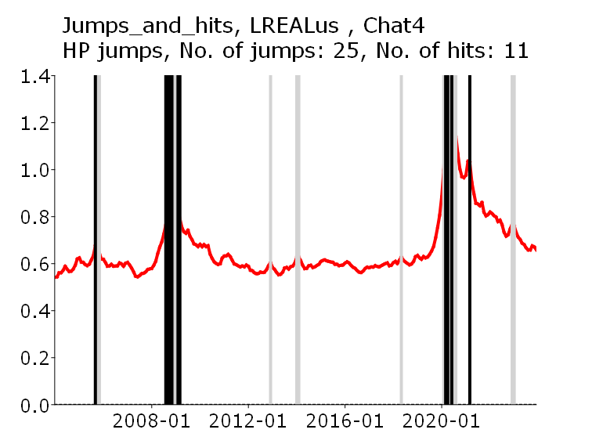 | 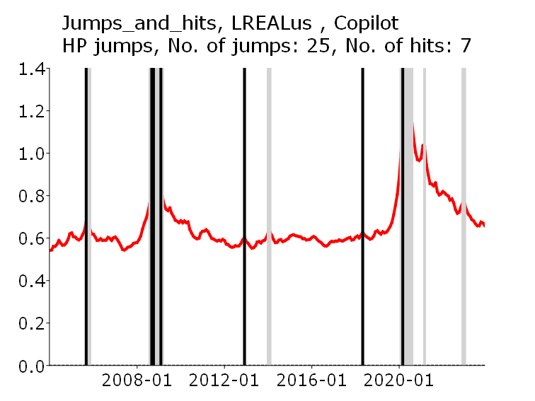
LFINus | 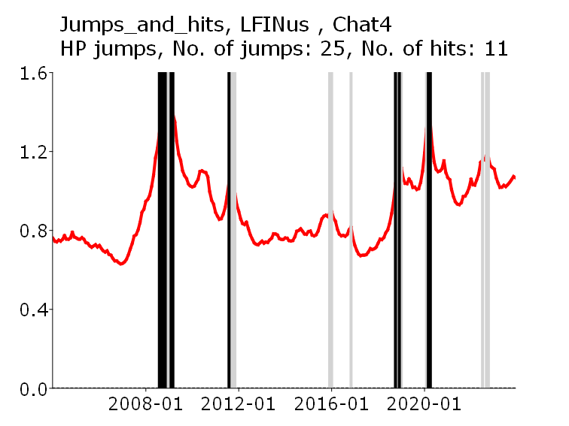 | 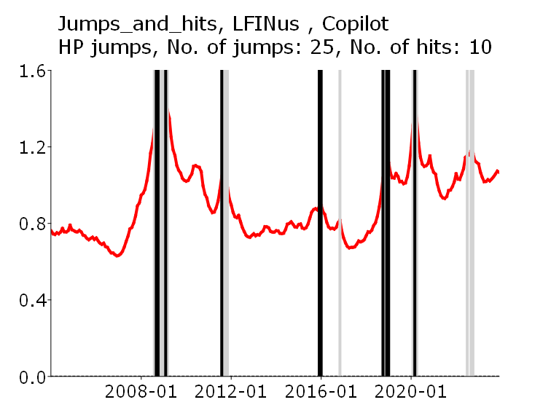
VIXus | 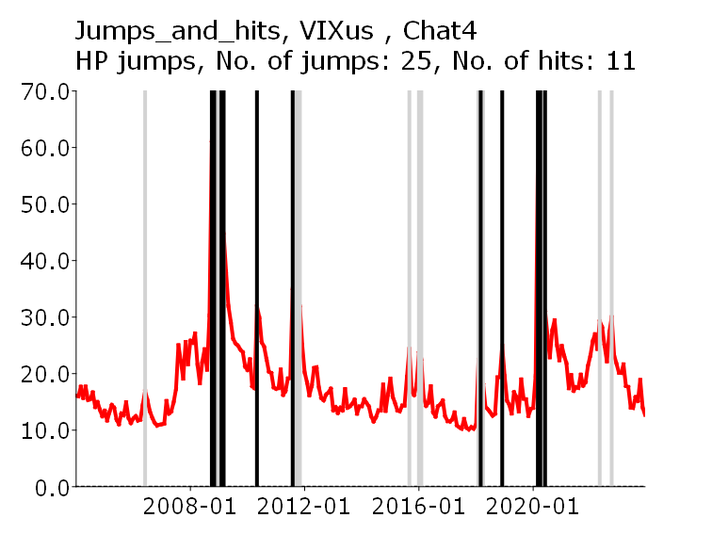 | 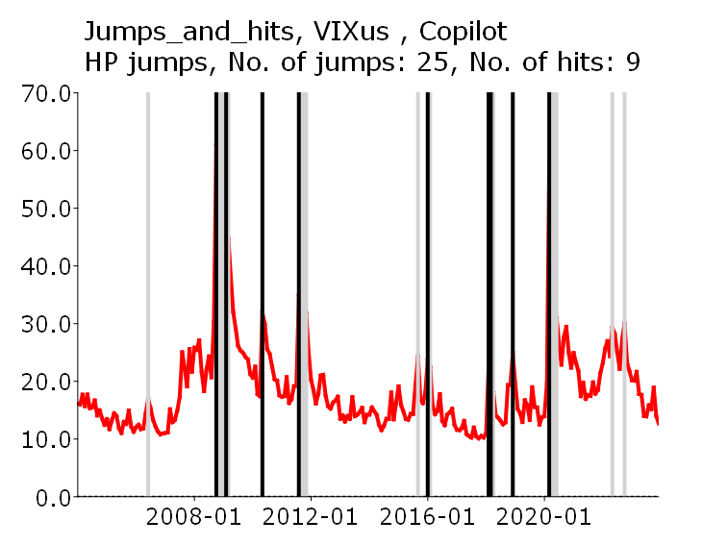

Figure A2.4. . Location of jumps and hits, US, FD jumps, US.
(Note: There is no panel of experts for the US.)
 | ChatGPT-3.5
EPUus | 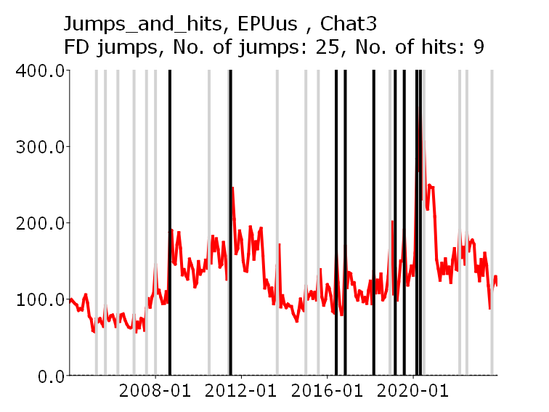
EURQus | 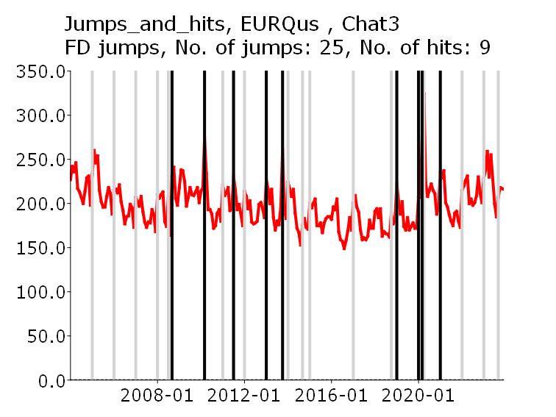
LMACROus | 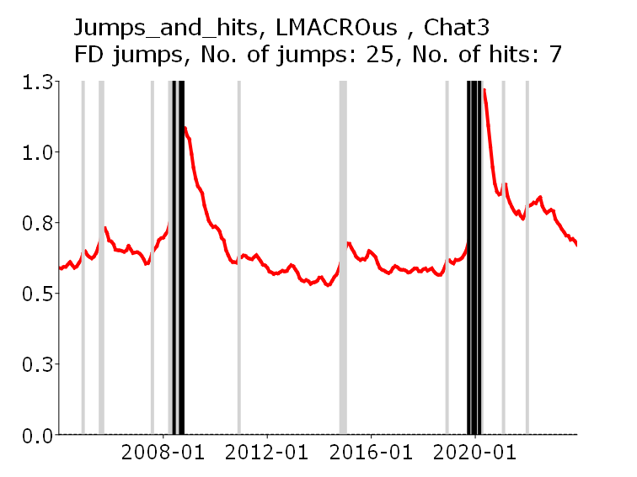

The Figure continues on the next page

Figure A2.4. . Location of jumps and hits, US, FD jumps, US.
(Note: There is no panel of experts for the US.) (cont.)
LREAlus | 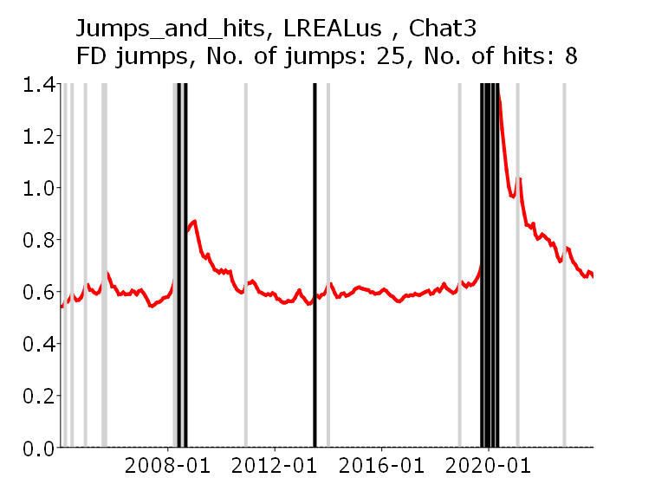
LFINus | 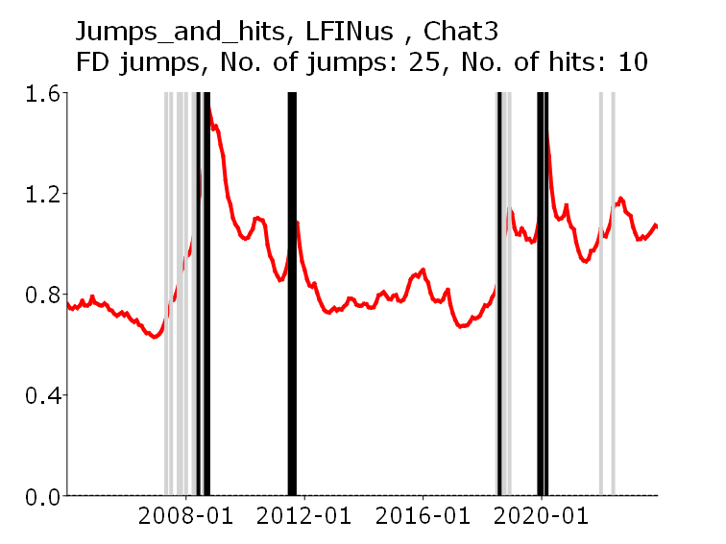
VIXus | 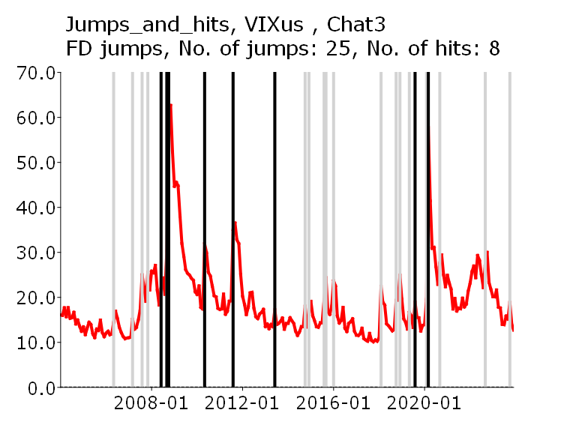

The Figure continues on the next page

Figure A2.4. . Location of jumps and hits, US, FD jumps, US.
(Note: There is no panel of experts for the US.) (cont.)
 | ChatGPT-4o | Copilot
EPUus | 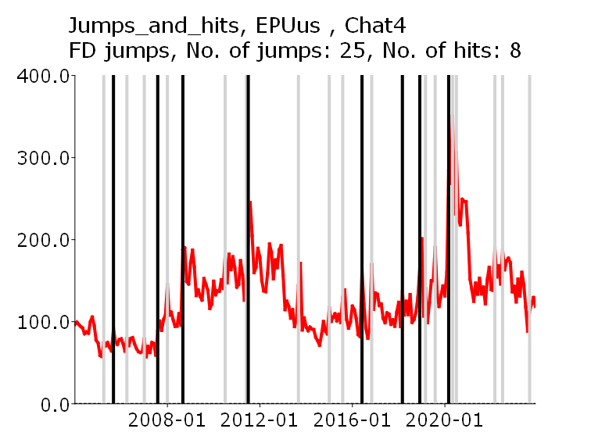 | 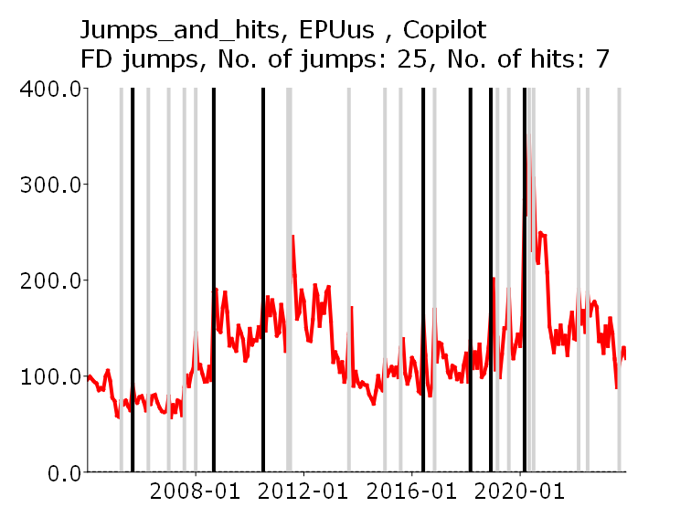
EURQus | 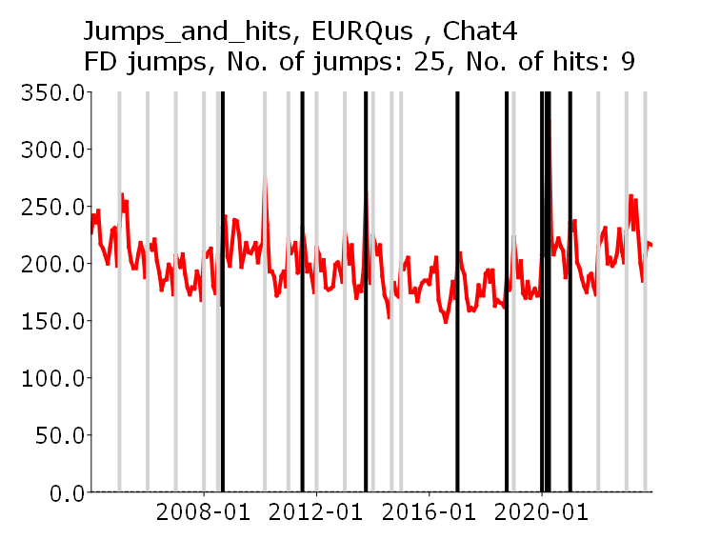 | 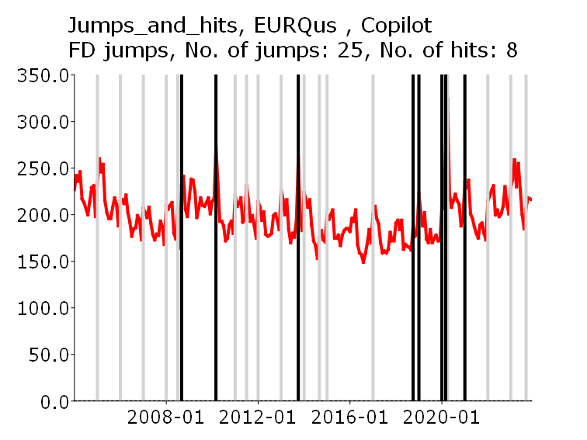
LMACROus | 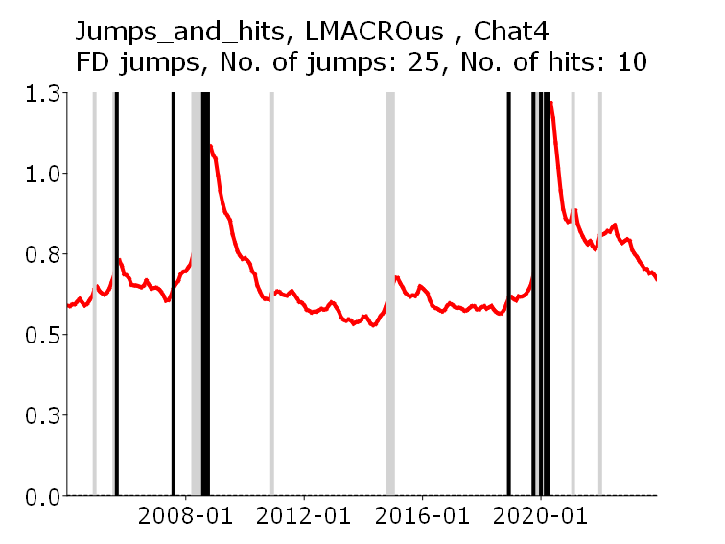 | 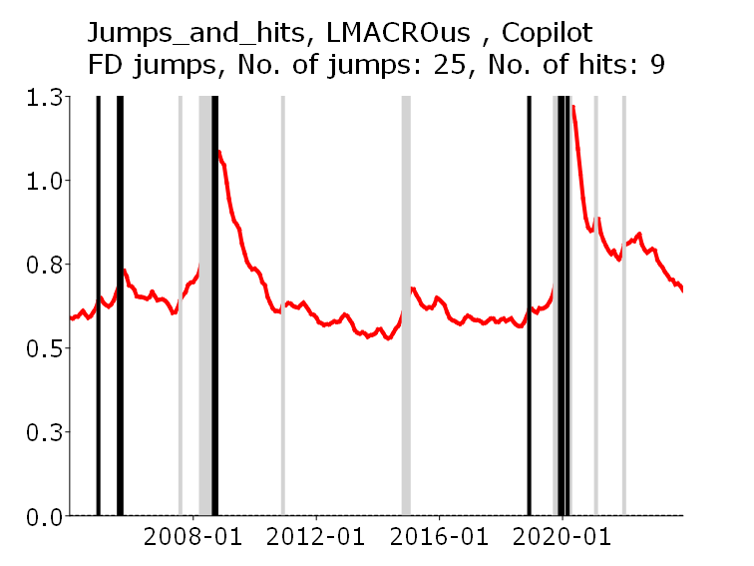

The Figure continues on the next page

Figure A2.4. . Location of jumps and hits, US, FD jumps, US.
(Note: There is no panel of experts for the US.) (cont.)
LREAlus | 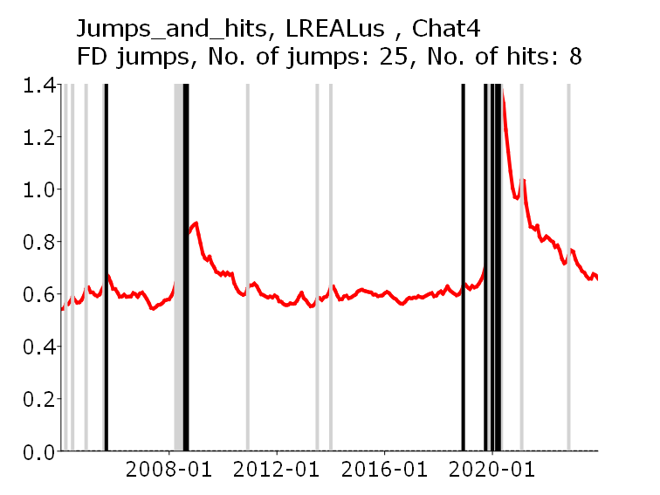 | 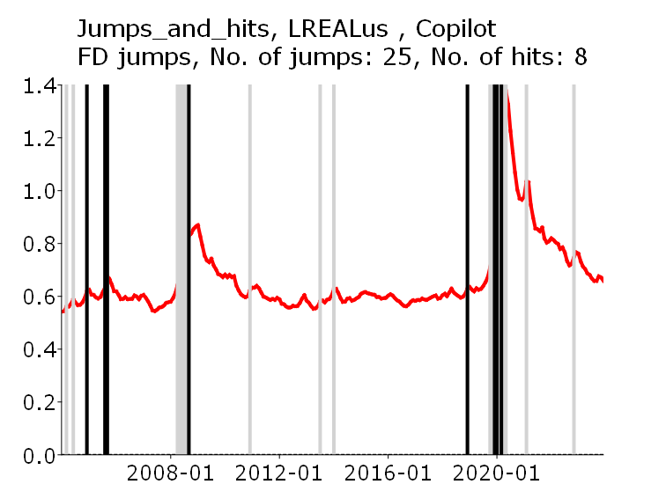
LFINus | 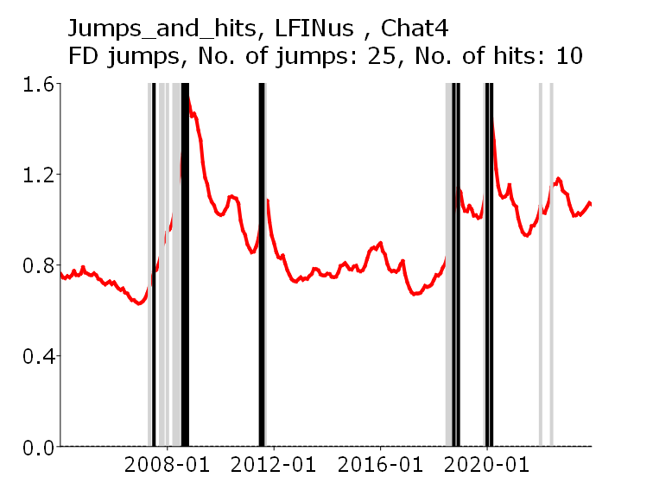 | 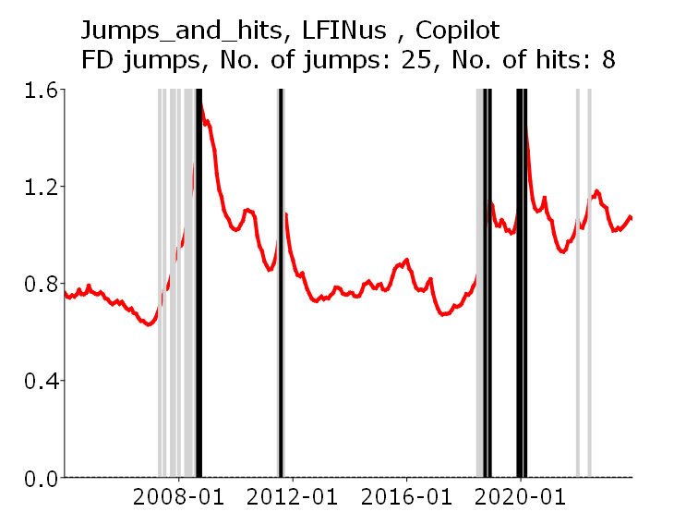
VIXus | 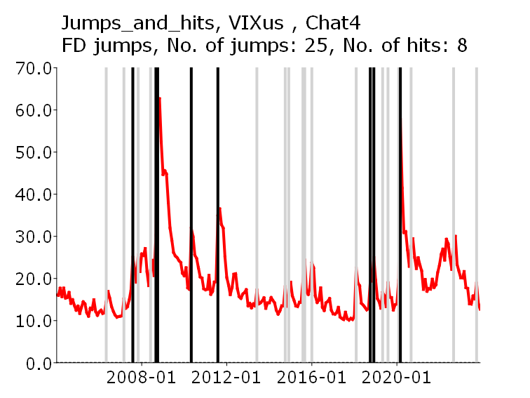 | 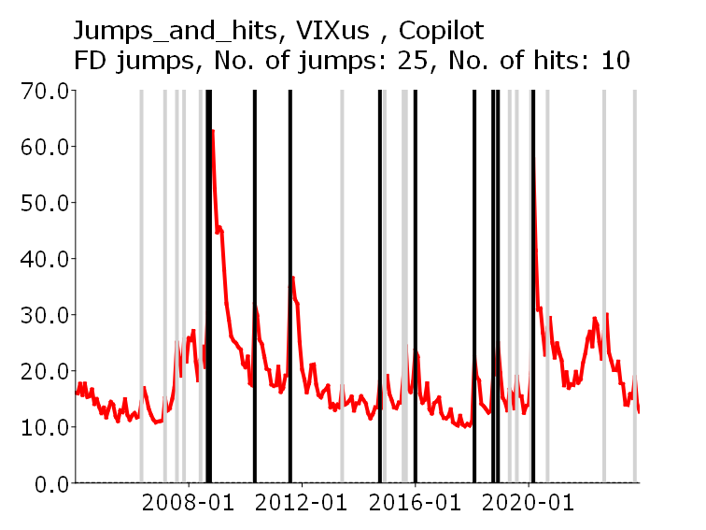

Appendix 3. HP jumps and hits tests for Poland
Figures A3.1 – A3.3 show testing results for HP jumps and hits tests with bootstrap bands for three uncertainty indices for Poland: EURQP_PL, EURQ_EN and GEPU_KZ correspondingly and UGEs identified by Experts, ChatGPT-3.5, ChatGPT-4o and Copilot.
Legend (common for all Figures)
The uncertainty index to which the test was applied differs from figure to figure. The rest of the legend is identical for all Figures. That is:
- red solid line: the expected values of the hypergeometric distribution for a given number of jumps, see (1);
- No. of hits blue solid line: the number of hits obtained for the given number of jumps for a given index;
- Boot up. joint bound dotted green line, joint reverse-logarithmic bootstrapped upper limits, that is, arguments of the 0.05 p-values of the corresponding hypergeometric distribution, corrected for the overlapping blocks effect;
- Indiv. up. bound Individual upper bounds, that is, arguments of the 0.05 p-values of the corresponding hypergeometric distribution;
- Up. bound, BY corr Joint upper bounds, that is, arguments of the 0.05 p-values of the corresponding hypergeometric distribution, corrected by the Benjamini-Yukateli (BY) correction;
- Grey shaded area: Confidence interval, where the upper limits are the arguments of the 0.05 p-values of the corresponding hypergeometric distribution, corrected by the Simes correction;
The horizontal axis shows the number of jumps gradually increasing from 5 (where only the five highest increments count as jumps) to 50.

Figure A3.1. HP jumps and hits test with bootstrapped bands for EURQP_PL, Poland.
UGEs defined by Experts | UGEs defined by ChatGPT-3.5
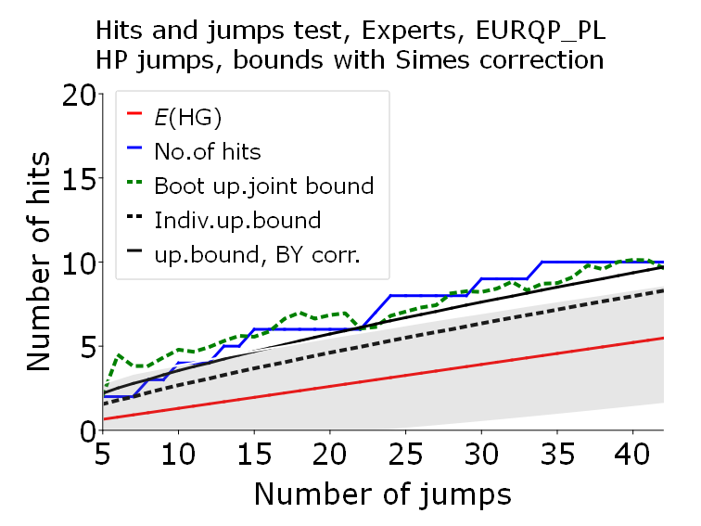 | 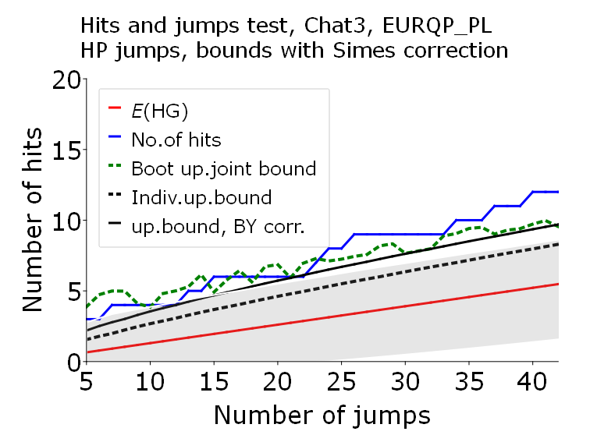
UGEs defined by ChatGPT-4o | UGEs defined by Copilot
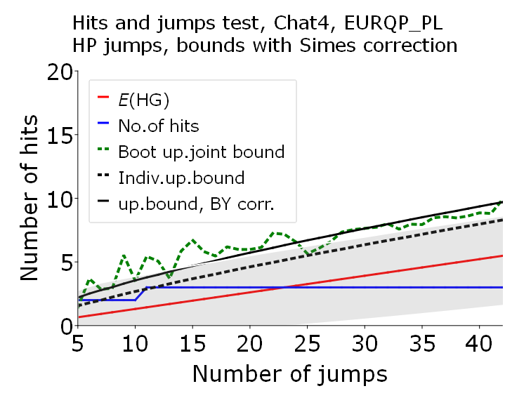 | 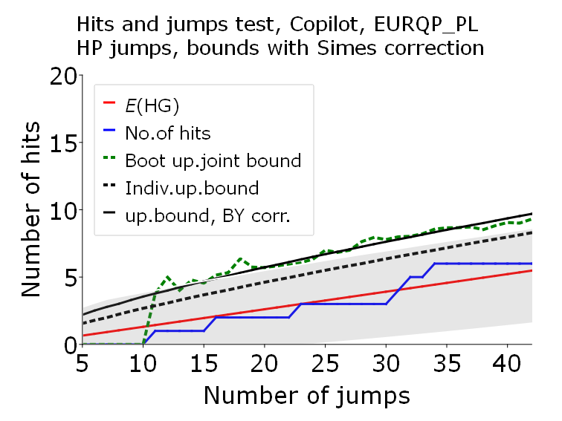

Figure A3.2. HP jumps and hits tests with bootstrapped bands for EURQP_EN, Poland
UGEs defined by Experts | UGEs defined by ChatGPT-3.5
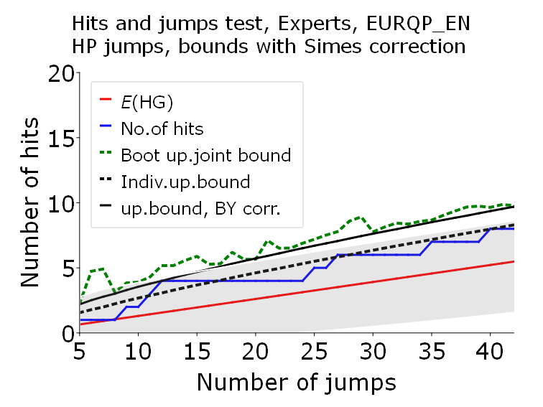 | 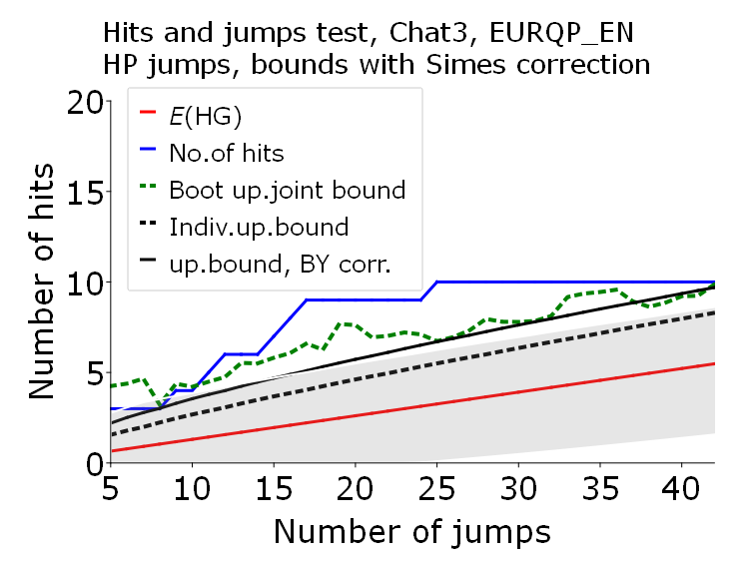

Figure A3.2 continued
UGEs defined by ChatGPT-4o | UGEs defined by Copilot
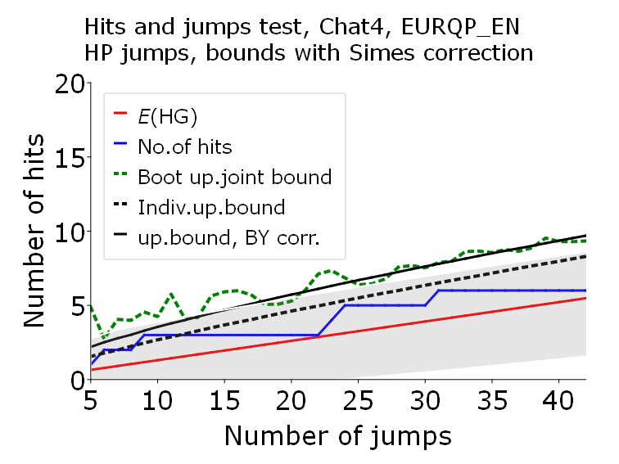 | 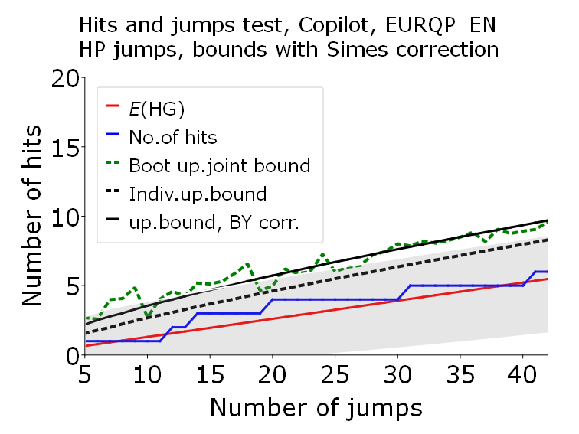

Figure A3.3. HP jumps and hits tests with bootstrap bands for GEPU_KZ, Poland.
UGEs defined by Experts | UGEs defined by ChatGPT-3.5
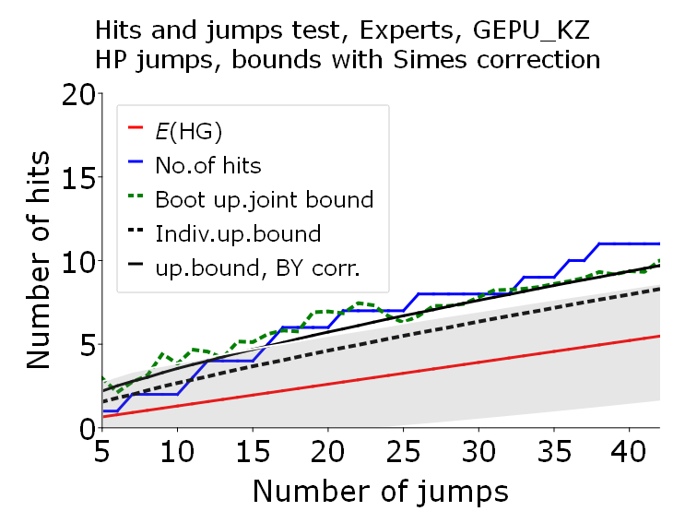 | 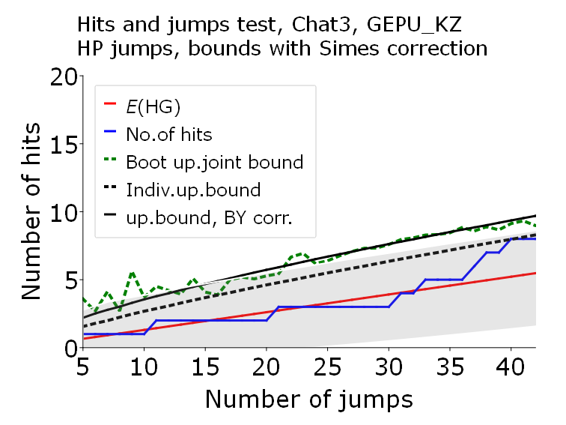
UGEs defined by ChatGPT-4o | UGEs defined by Copilot
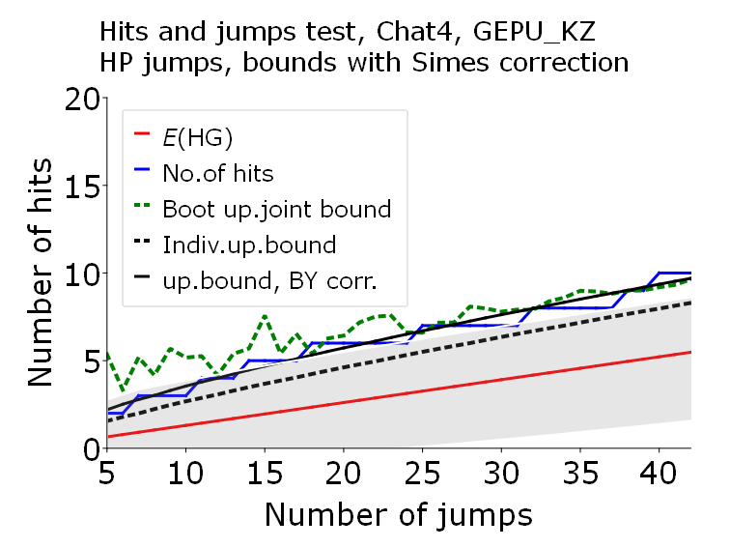 | 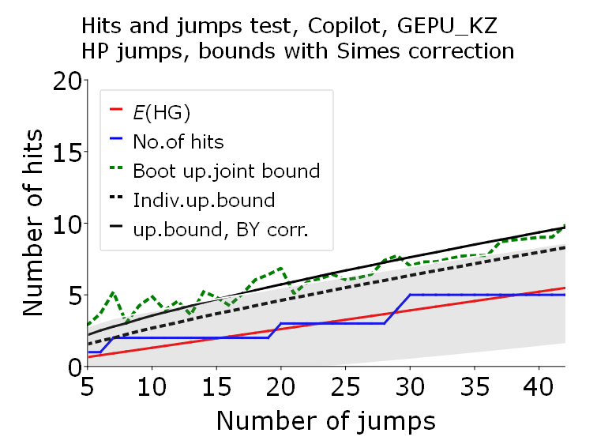

Appendix 4. FD jumps and hits tests for Poland
Figures A4.1 – A4.3 show testing results for FD jumps and hits tests with bootstrap bands for three uncertainty indices for Poland: EURQP_PL, EURQ_EN and GEPU_KZ correspondingly and UGEs identified by Experts, ChatGPT-3.5, ChatGPT-4o and Copilot.
Legend (common for all Figures)
The uncertainty index to which the test was applied differs from figure to figure. The rest of the legend is identical for all Figures. That is:
- red solid line: the expected values of the hypergeometric distribution for a given number of jumps, see (1);
- No. of hits blue solid line: the number of hits obtained for the given number of jumps for a given index;
- Boot up. joint bound dotted green line, joint reverse-logarithmic bootstrapped upper limits, that is, arguments of the 0.05 p-values of the corresponding hypergeometric distribution, corrected for the overlapping blocks effect;
- Indiv. up. bound Individual upper bounds, that is, arguments of the 0.05 p-values of the corresponding hypergeometric distribution;
- Up. bound, BY corr Joint upper bounds, that is, arguments of the 0.05 p-values of the corresponding hypergeometric distribution, corrected by the Benjamini-Yukateli (BY) correction;
- Grey shaded area: Confidence interval, where the upper limits are the arguments of the 0.05 p-values of the corresponding hypergeometric distribution, corrected by the Simes correction;
The horizontal axis shows the number of jumps gradually increasing from 5 (where only the five highest increments count as jumps) to 50.

Figure A4.1. FD jumps and hits test with bootstrapped bands for EURQP_PL, Poland.
UGEs defined by Experts | UGEs defined by ChatGPT-3.5
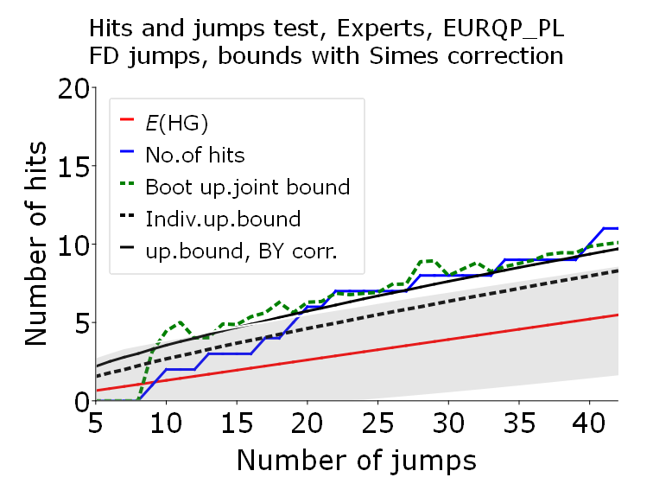 | 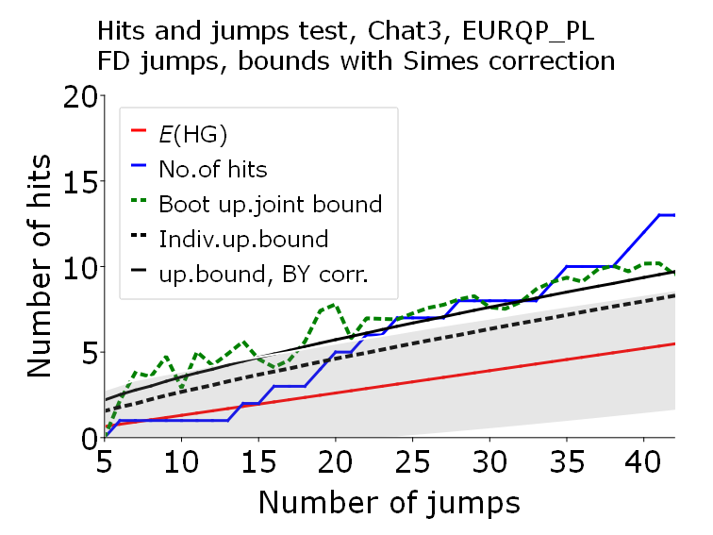
UGEs defined by ChatGPT-4o | UGEs defined by Copilot
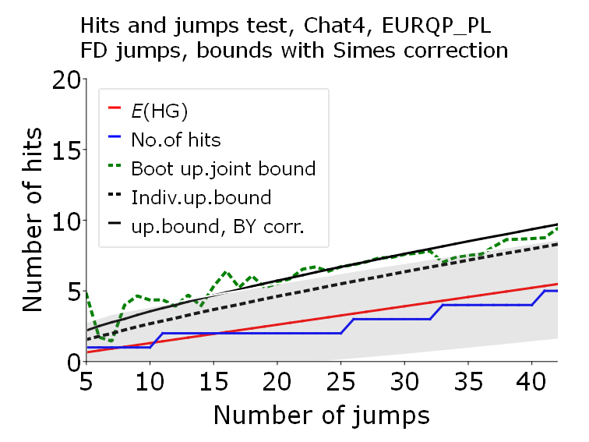 | 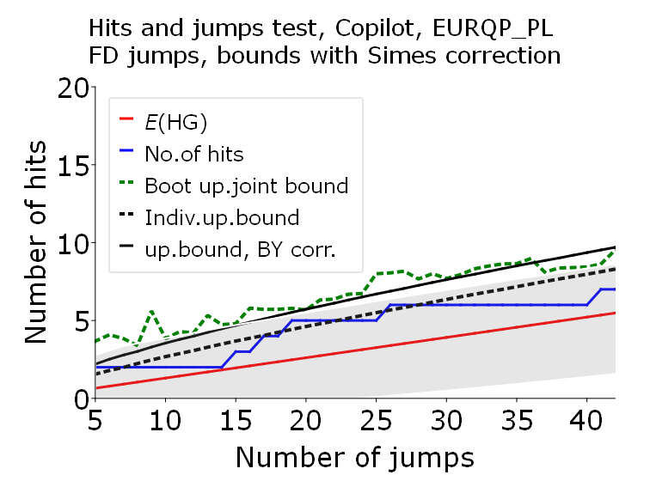

Figure A4.2. FD jumps and hits tests with bootstrapped bands for EURQP_EN, Poland.
UGEs defined by Experts | UGEs defined by ChatGPT-3.5
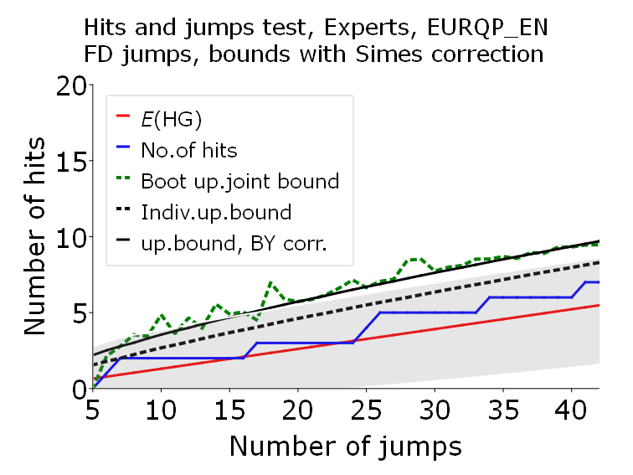 | 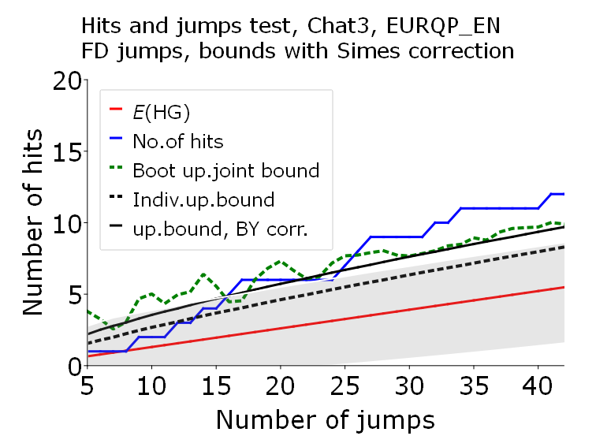
UGEs defined by ChatGPT-4o | UGEs defined by Copilot
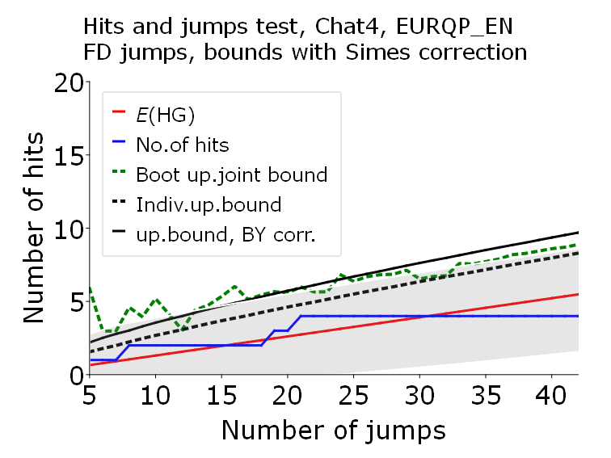 | 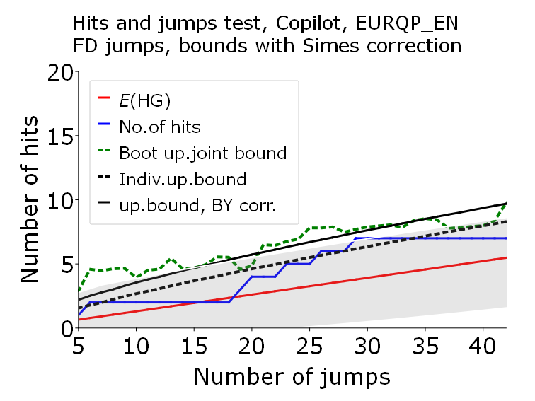

Figure A4.3. FD jumps and hits tests with bootstrapped bands for GEPU_KZ, Poland.
UGEs defined by Experts | UGEs defined by ChatGPT-3.5
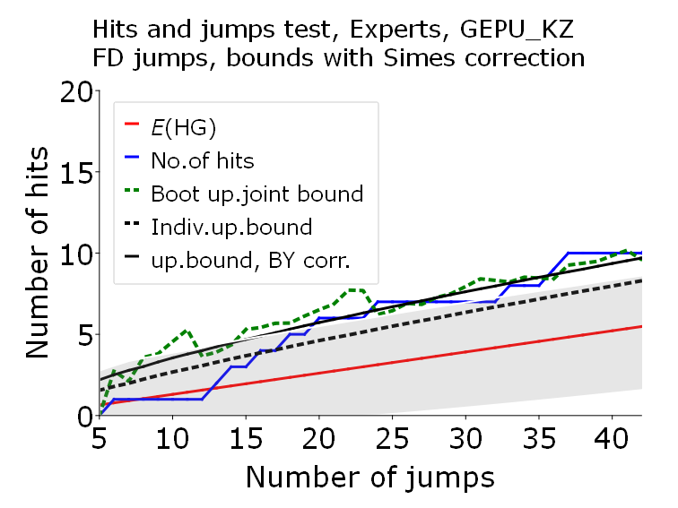 | 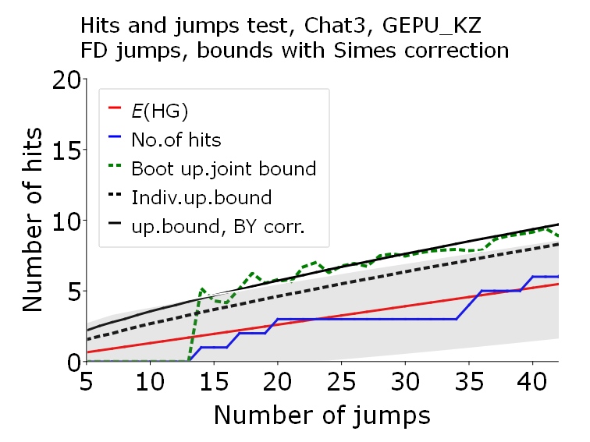
UGEs defined by ChatGPT-4o | UGEs defined by Copilot
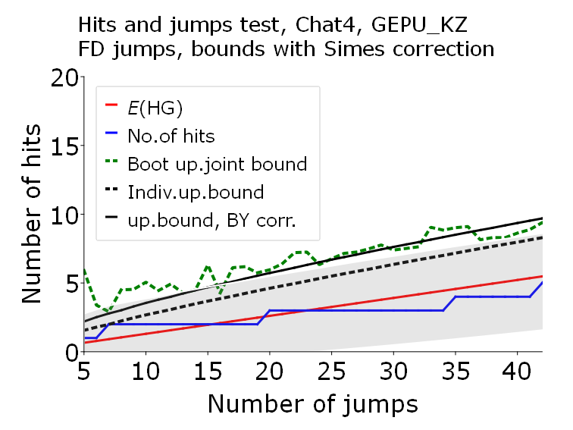 | 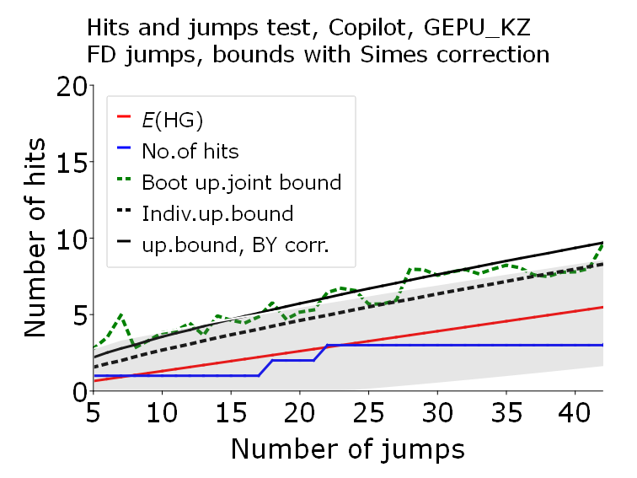

Appendix 5. HP jumps and hits tests for US
Figures A5.1 – A5.6 show testing results for HP jumps and hits tests with bootstrap bands for six uncertainty indices for the US: EPUus, EURQus, LMACROus, LREALus, LFINus and VIXus correspondingly and UGEs identified by ChatGPT-3.5, ChatGPT-4o and Copilot.
Legend (common for all Figures)
The uncertainty index to which the test was applied differs from figure to figure. The rest of the legend is identical for all Figures. That is:
- red solid line: the expected values of the hypergeometric distribution for a given number of jumps, see (1);
- No. of hits blue solid line: the number of hits obtained for the given number of jumps for a given index;
- Boot up. joint bound dotted green line, joint reverse-logarithmic bootstrapped upper limits, that is, arguments of the 0.05 p-values of the corresponding hypergeometric distribution, corrected for the overlapping blocks effect;
- Indiv. up. bound Individual upper bounds, that is, arguments of the 0.05 p-values of the corresponding hypergeometric distribution;
- Up. bound, BY corr Joint upper bounds, that is, arguments of the 0.05 p-values of the corresponding hypergeometric distribution, corrected by the Benjamini-Yukateli (BY) correction;
- Grey shaded area: Confidence interval, where the upper limits are the arguments of the 0.05 p-values of the corresponding hypergeometric distribution, corrected by the Simes correction;
The horizontal axis shows the number of jumps gradually increasing from 5 (where only the five highest increments count as jumps) to 50.

Figure A5.1. HP jumps and hits test with bootstrapped bands for EPUus, US.
 | UGEs defined by ChatGPT-3.5
No Experts for US. | 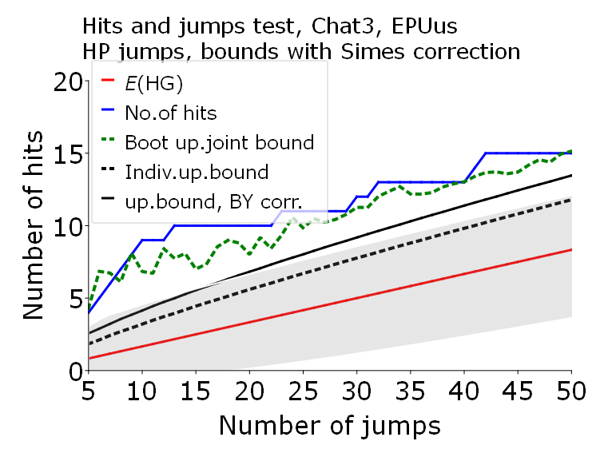
UGEs defined by ChatGPT-4o | UGEs defined by Copilot
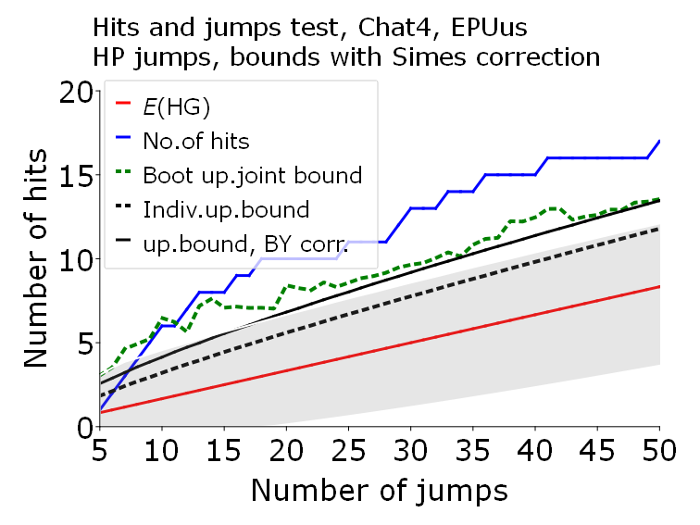 | 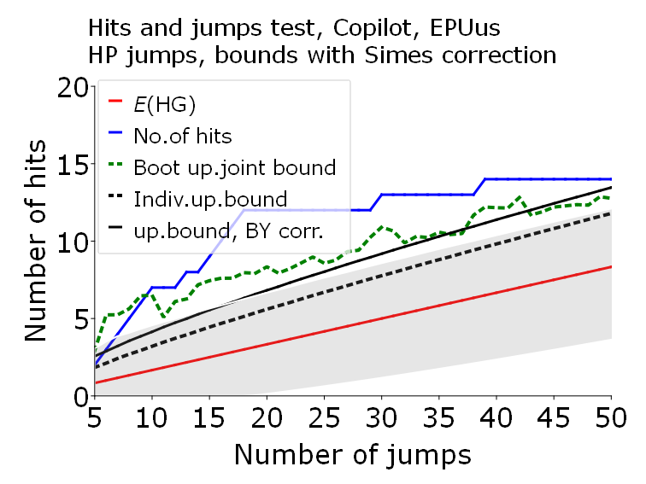

Figure A5.2. HP jumps and hits test with bootstrap bands for EURQus, US.
 | UGEs defined by ChatGPT-3.5
No Experts for US. | 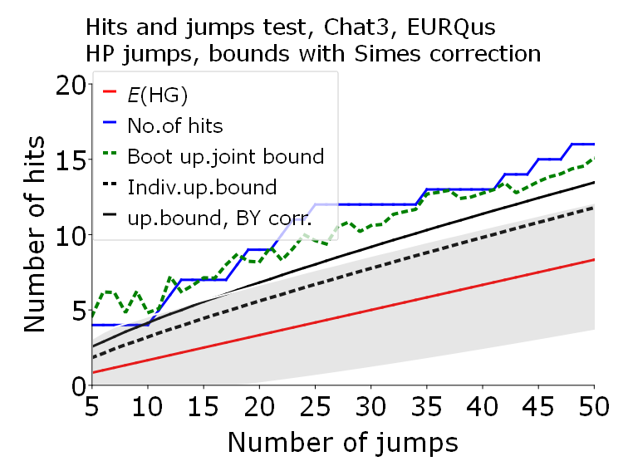
UGEs defined by ChatGPT-4o | UGEs defined by Copilot
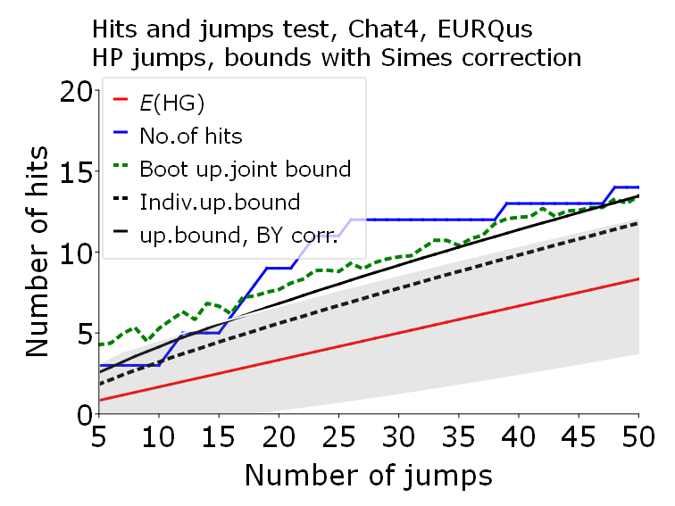 | 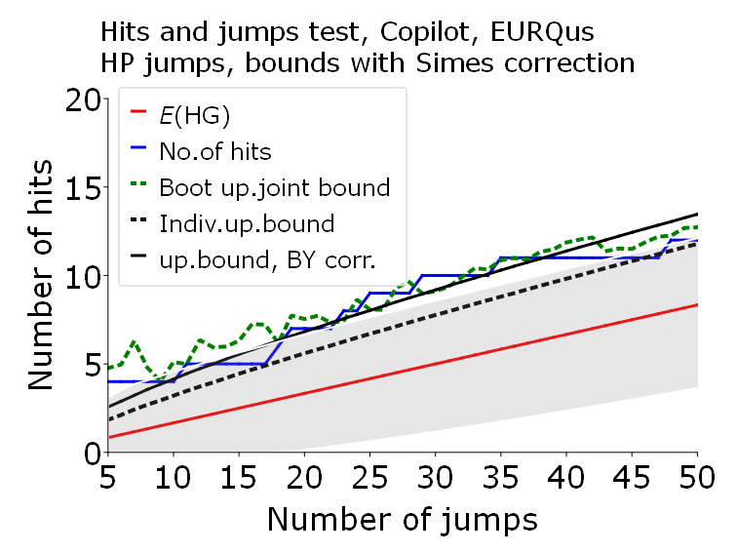

Figure A5.3. HP jumps and hits test with bootstrapped bands for LMACROus, US.
 | UGEs defined by ChatGPT-3.5
No Experts for US. | 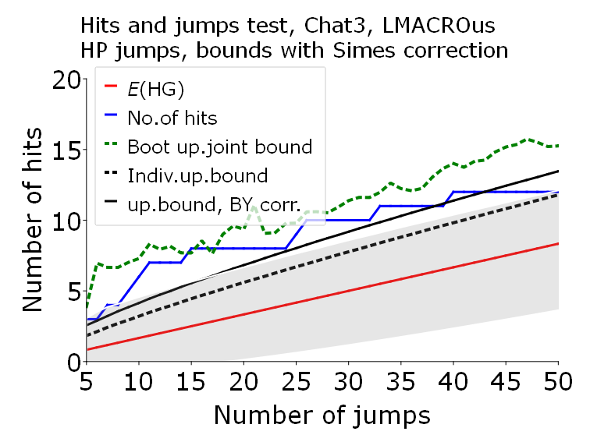

Figure A5.3 continued
UGEs defined by ChatGPT-4o | UGEs defined by Copilot
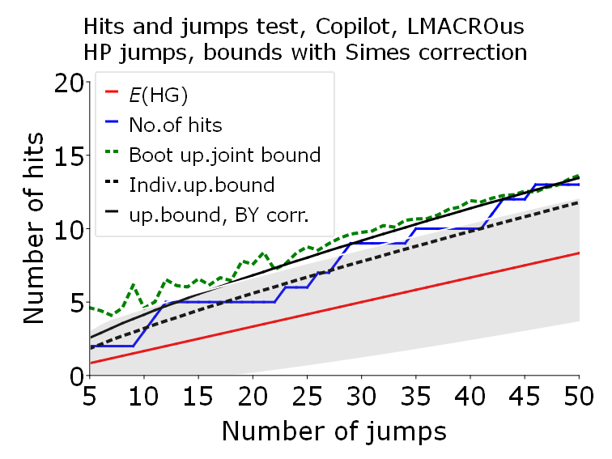 | 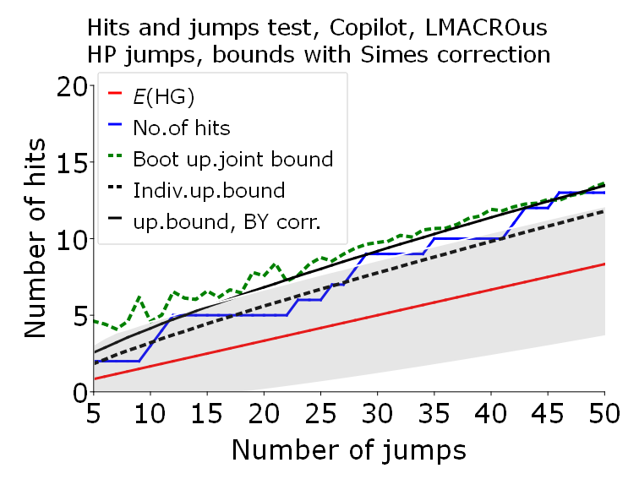

Figure A5.4. HP jumps and hits test with bootstrapped bands for LREALus, US.
 | UGEs defined by ChatGPT-3.5
No Experts for US. | 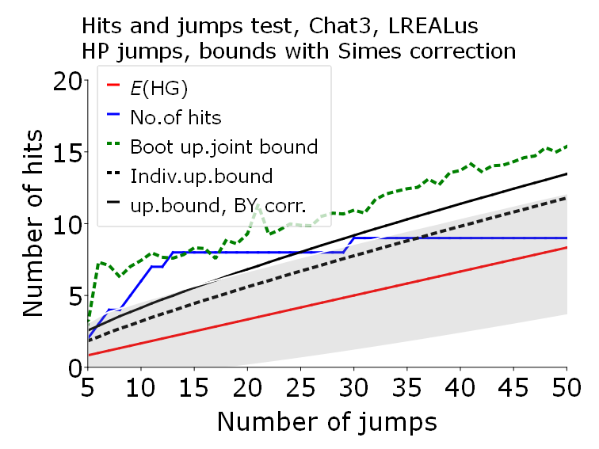
UGEs defined by ChatGPT-4o | UGEs defined by Copilot
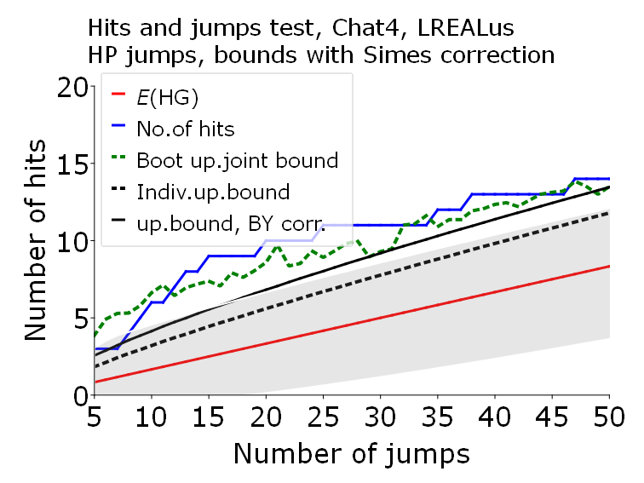 | 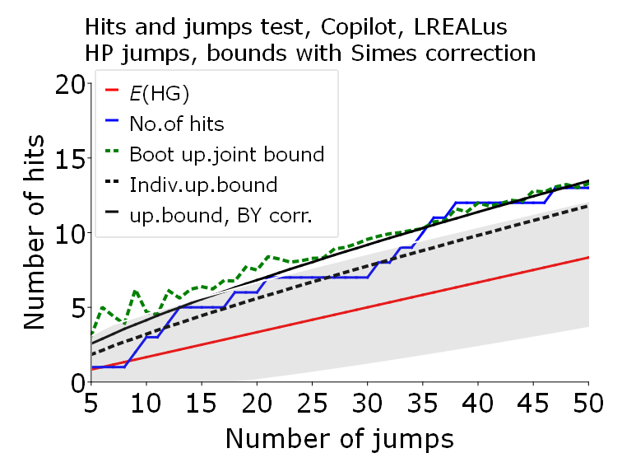

Figure A5.5. HP jumps and hits test with bootstrap bands for LFINus, US.
 | UGEs defined by ChatGPT-3.5
No Experts for US. | 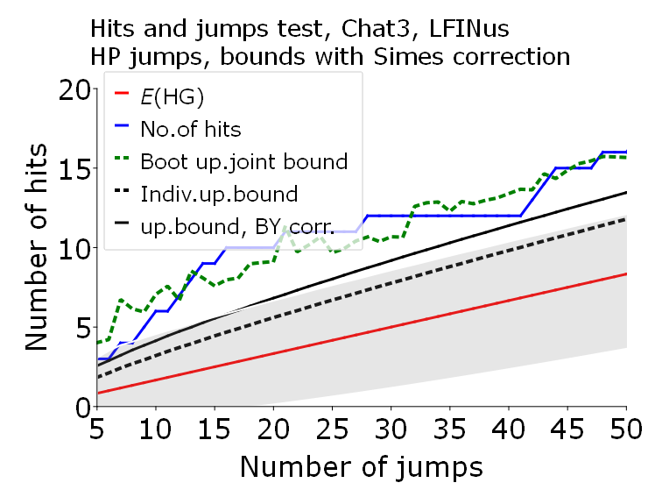
UGEs defined by ChatGPT-4o | UGEs defined by Copilot
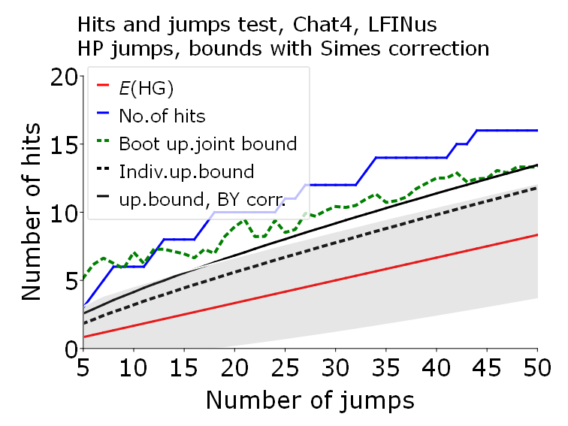 | 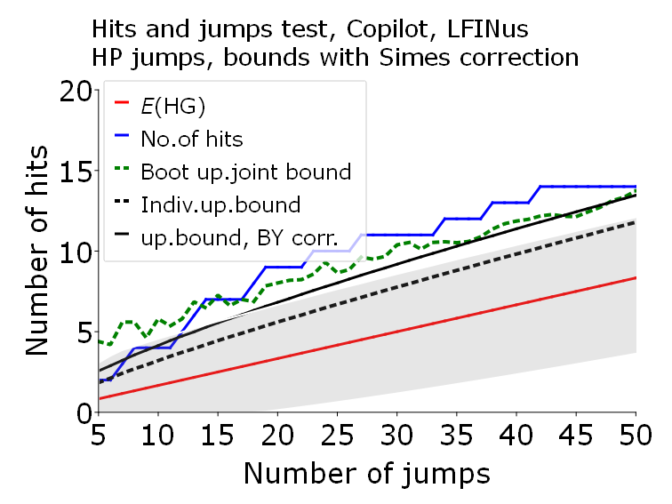

Figure A5.6. HP jumps and hits test with bootstrapped bands for VIXus, US.
 | UGEs defined by ChatGPT-3.5
No Experts for US. | 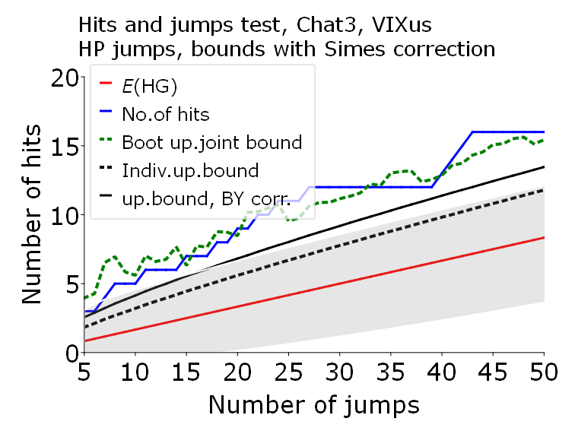
UGEs defined by ChatGPT-4o | UGEs defined by Copilot
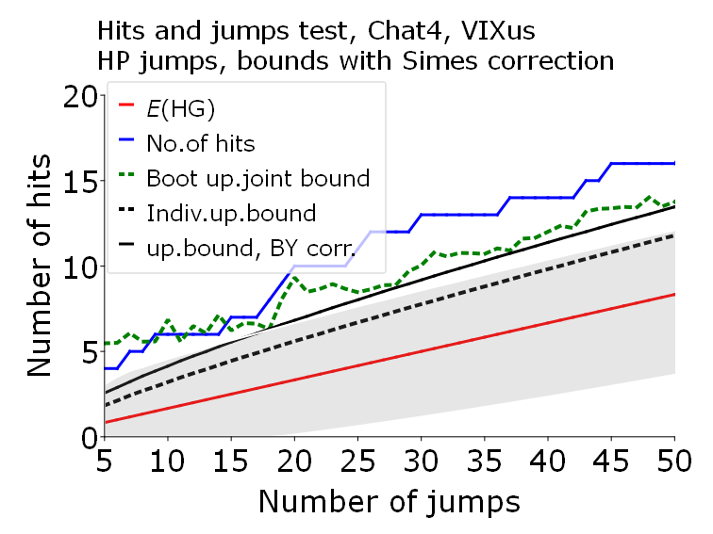 | 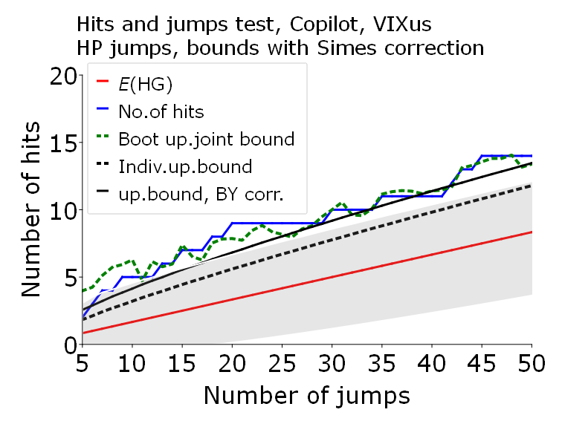

Appendix 6. FD jumps and hits tests for US
Figures A6.1 – A6.6 show testing results for HP jumps and hits tests with bootstrapped bands for six uncertainty indices for the US: EPUus, EURQus, LMACROus, LREALus, LFINus and VIXus correspondingly and UGEs identified by ChatGPT-3.5, ChatGPT-4o and Copilot.
Legend (common for all Figures)
The uncertainty index to which the test was applied differs from figure to figure. The rest of the legend is identical for all Figures. That is:
- red solid line: the expected values of the hypergeometric distribution for a given number of jumps, see (1);
- No. of hits blue solid line: the number of hits obtained for the given number of jumps for a given index;
- Boot up. joint bound dotted green line, joint reverse-logarithmic bootstrapped upper limits, that is, arguments of the 0.05 p-values of the corresponding hypergeometric distribution, corrected for the overlapping blocks effect;
- Indiv. up. bound Individual upper bounds, that is, arguments of the 0.05 p-values of the corresponding hypergeometric distribution;
- Up. bound, BY corr Joint upper bounds, that is, arguments of the 0.05 p-values of the corresponding hypergeometric distribution, corrected by the Benjamini-Yukateli (BY) correction;
- Grey shaded area: Confidence interval, where the upper limits are the arguments of the 0.05 p-values of the corresponding hypergeometric distribution, corrected by the Simes correction;
The horizontal axis shows the number of jumps gradually increasing from 5 (where only the five highest increments count as jumps) to 50.

Figure A6.1. FD jumps and hits test with bootstrapped bands for EPUus, US.
 | UGEs defined by ChatGPT-3.5
No Experts for US. | 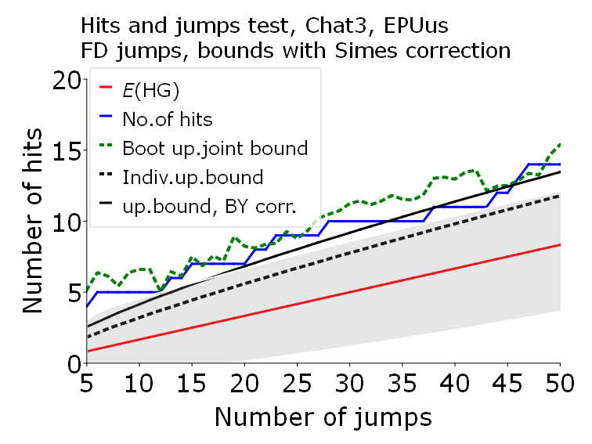
UGEs defined by ChatGPT-4o | UGEs defined by Copilot
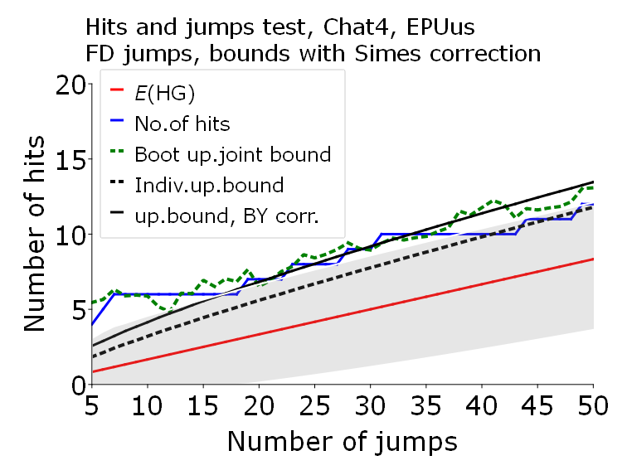 | 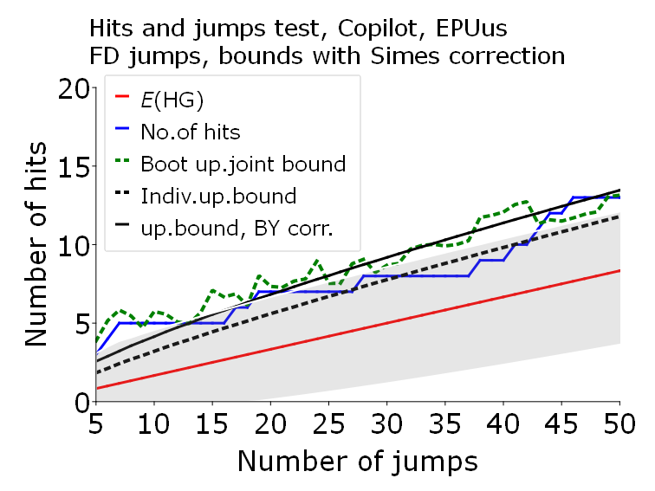

Figure A6.2. FD jumps and hits test with bootstrapped bands for EURQus, US.
 | UGEs defined by ChatGPT-3.5
No Experts for US. | 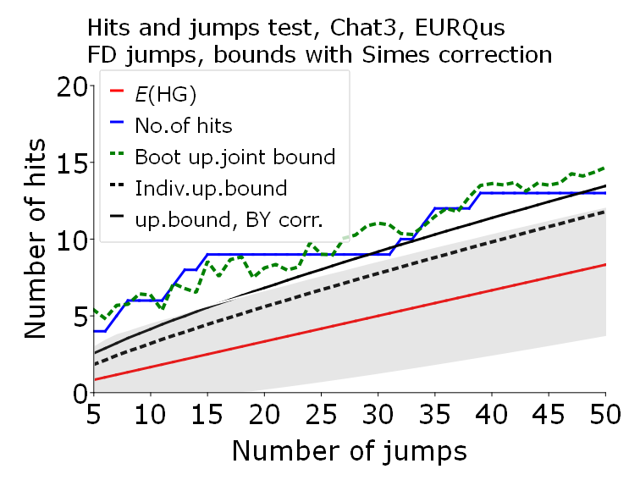

Figure A6.2 continued
UGEs defined by ChatGPT-4o | UGEs defined by Copilot
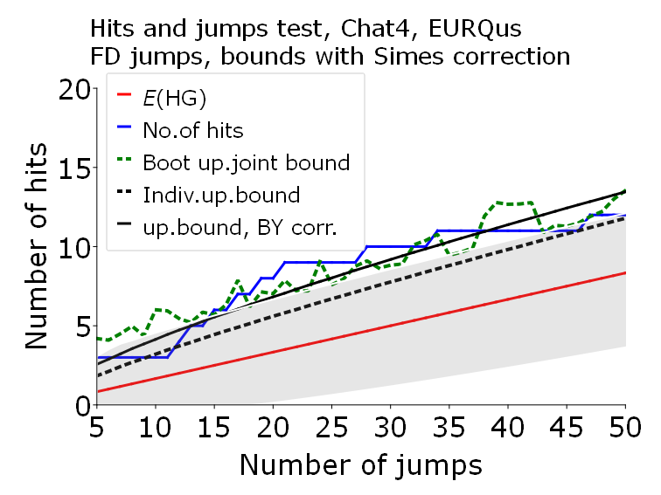 | 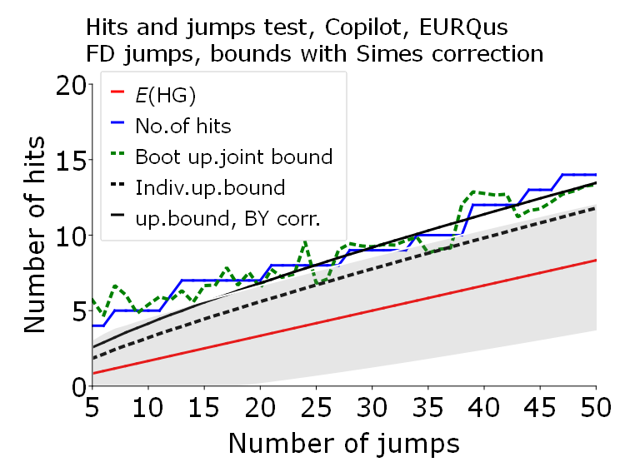

Figure A6.3. FD jumps and hits test with bootstrapped bands for LMACROus, US.
 | UGEs defined by ChatGPT-3.5
No Experts for US. | 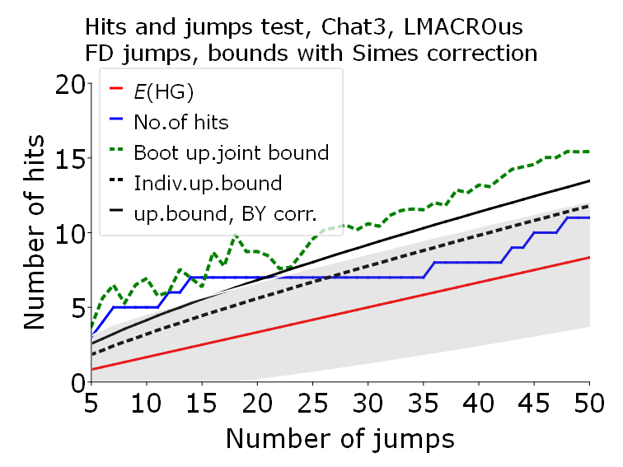
UGEs defined by ChatGPT-4o | UGEs defined by Copilot
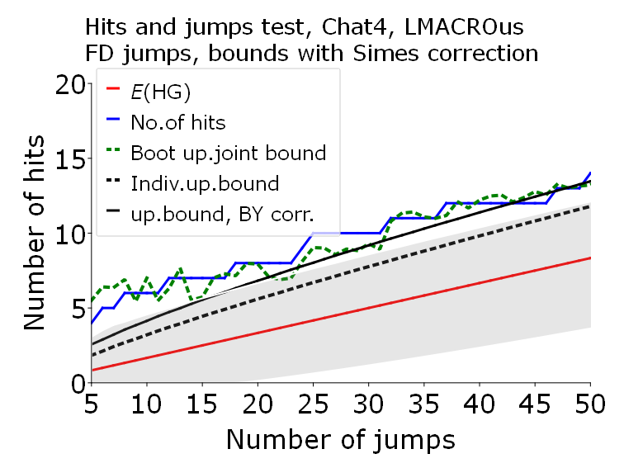 | 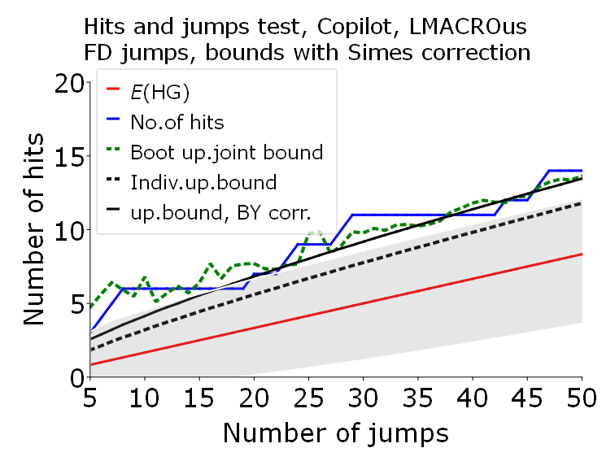

Figure A6.4. FD jumps and hits test with bootstrapped bands for LREALus, US.
 | UGEs defined by ChatGPT-3.5
No Experts for US. | 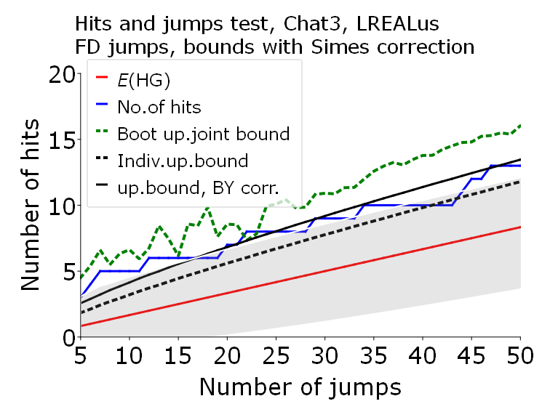
UGEs defined by ChatGPT-4o | UGEs defined by Copilot
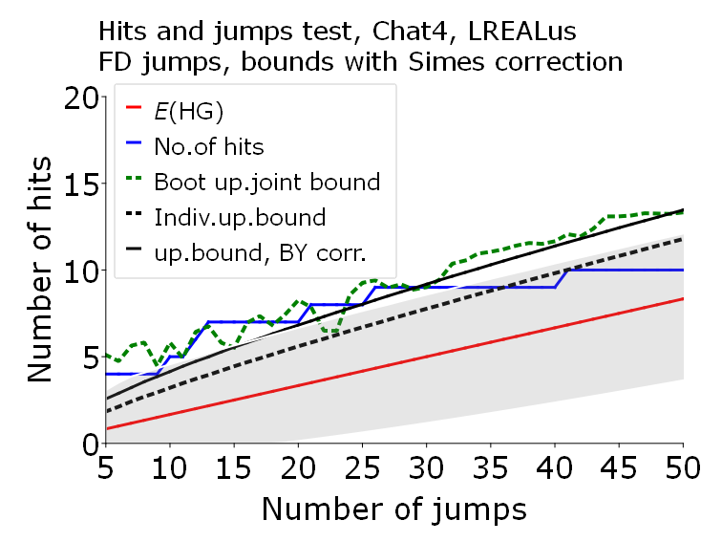 | 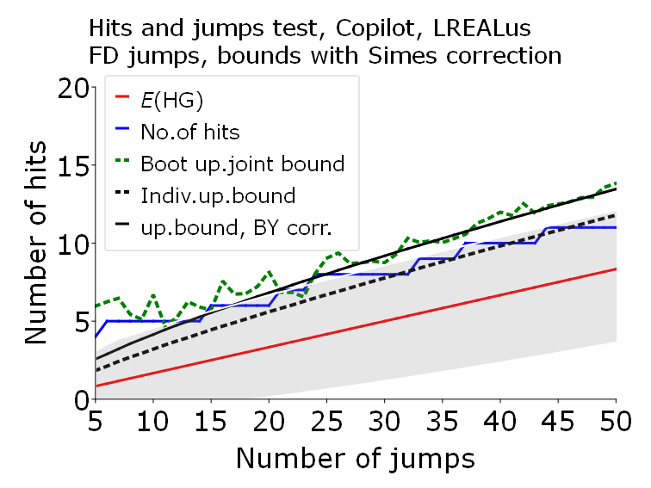

Figure A6.5. FD jumps and hits test with bootstrapped bands for LFINus, US.
 | UGEs defined by ChatGPT-3.5
No Experts for US. | 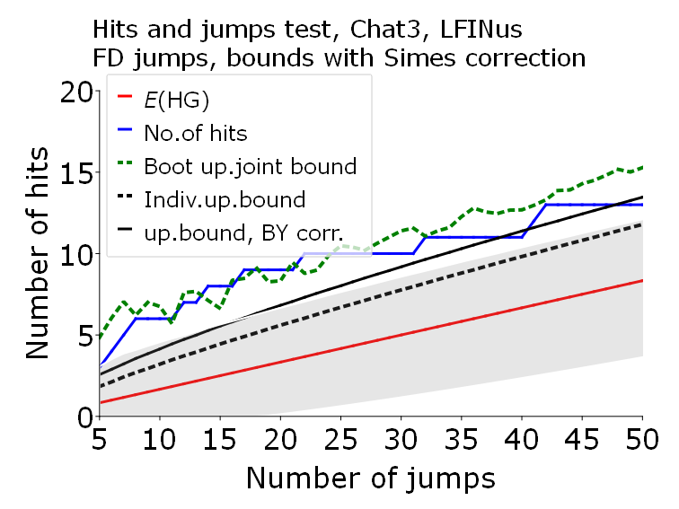

Figure A6.5 continued
UGEs defined by ChatGPT-4o | UGEs defined by Copilot
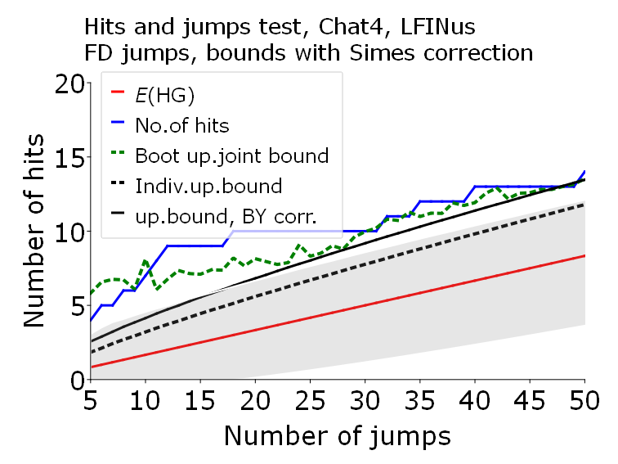 | 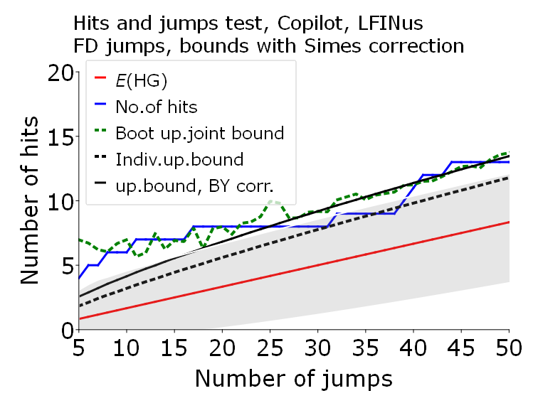

Figure A6.6. FD jumps and hits test with bootstrapped bands for VIXus, US.
 | UGEs defined by ChatGPT-3.5
No Experts for US. | 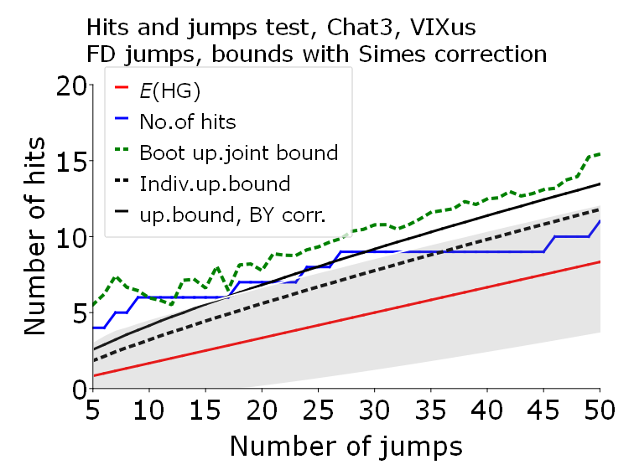
UGEs defined by ChatGPT-4o | UGEs defined by Copilot
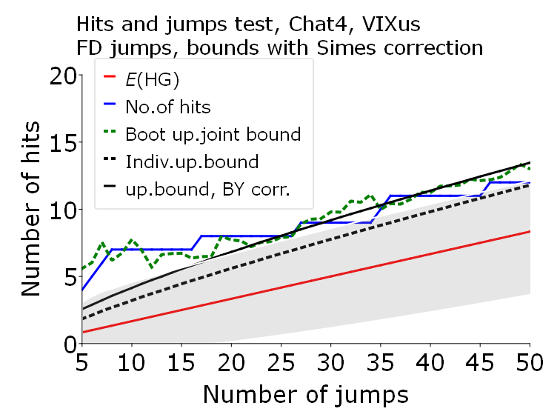 | 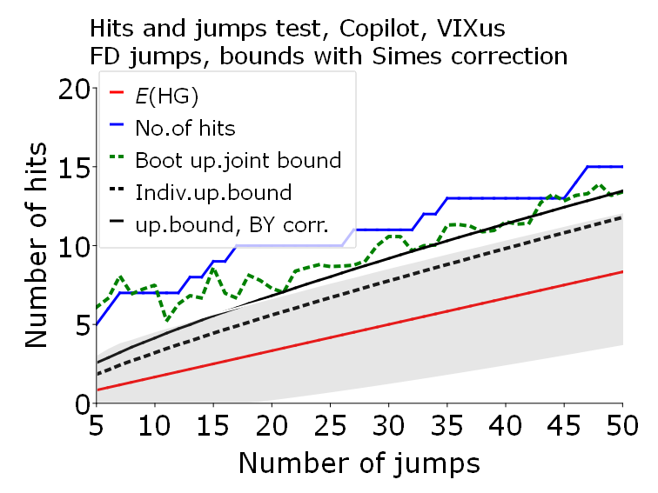

Appendix 7. Comparing hits for different UGE sets and types of jumps
Figures A7.1-A7.2 show testing results for HP jumps and hits tests ((left column) and FD jumps and hits tests (right column) for different UGEs sets for three uncertainty indices for Poland and the US.
Legend for Figure A 7.1
The uncertainty index to which the test was applied differs from figure to figure. The rest of the legend is identical for all Figures. That is:
- red solid line: the expected values of the hypergeometric distribution for a given number of jumps, see (1);
- Chat3 blue solid line: the number of hits obtained for the UGE set defined by ChatGPT-3.5 for a given number of jumps for a given index;
- Chat4 light green solid line : the number of hits obtained for the UGE set defined by ChatGPT-4o for given number of jumps for a given index;
- Experts dark green solid line: the number of hits obtained for the UGE set defined by Experts for given number of jumps for a given index;
- Copilot black solid line: the number of hits obtained for the UGE set defined by Copilot for given number of jumps for a given
- Grey shaded area: Confidence interval, where the upper limits are the arguments of the 0.05 p-values of the corresponding hypergeometric distribution, corrected by the Simes correction;
The horizontal axis shows the number of jumps gradually increasing from 5 (where only the five highest increments count as jumps) to 50.

Figure A7.1. Comparing hits for different UGE sets and types of jumps for Poland.
 | HP jumps | FD jumps
EURQP_PL | 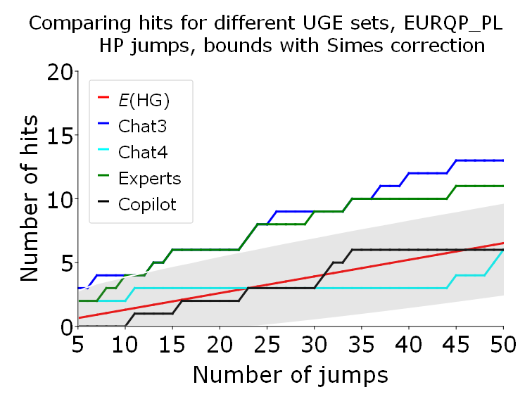 | 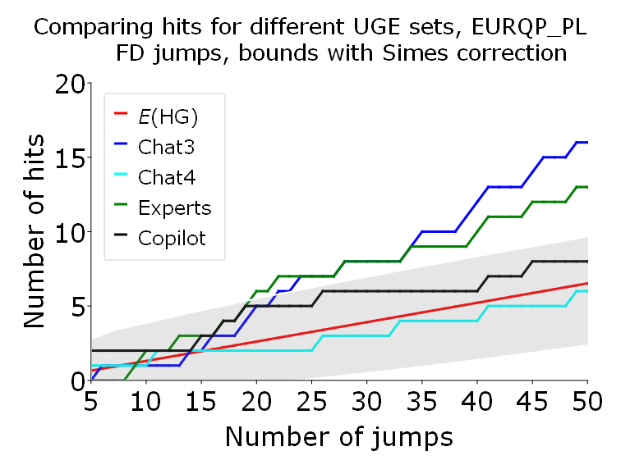
EURQPL_EN | 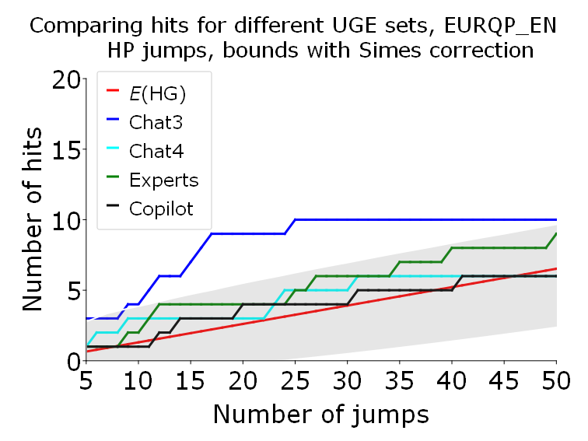 | 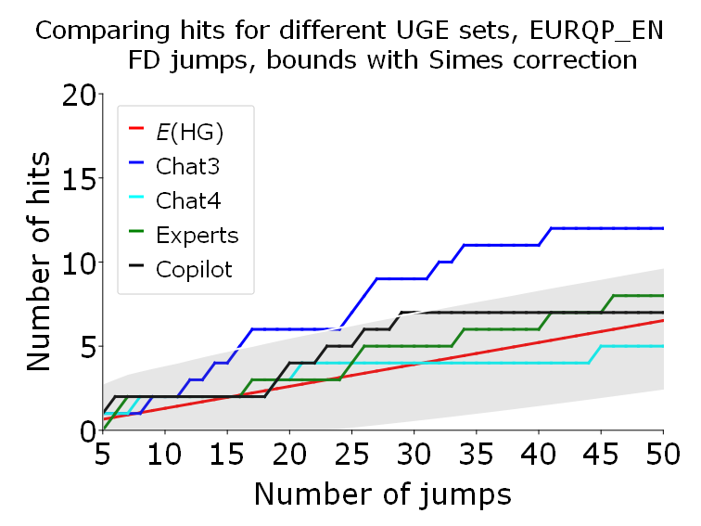
 | HP jumps | FD jumps
GEPU_KZ | 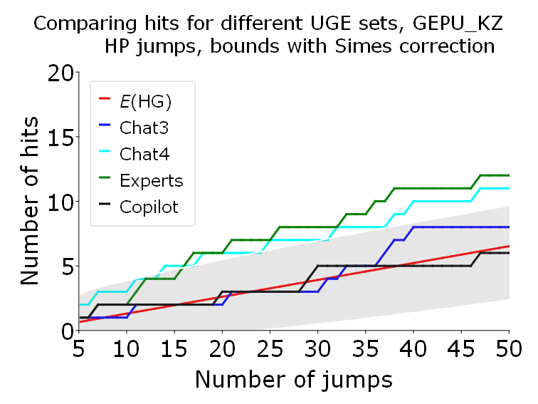 | 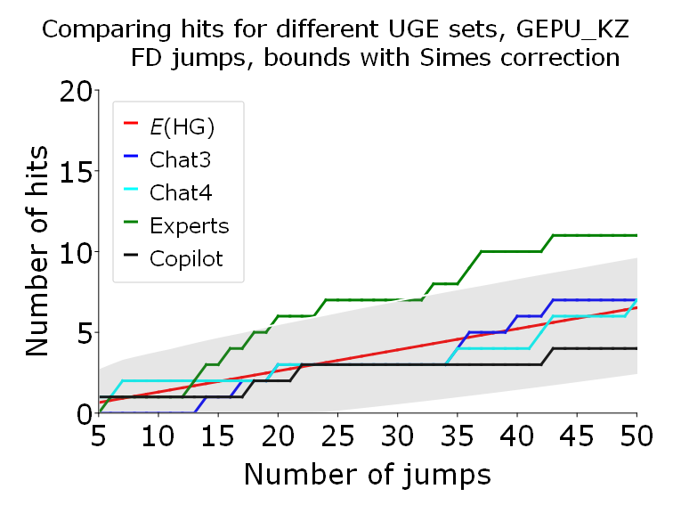

Legend for Figure A7.2
The uncertainty index to which the test was applied differs from figure to figure. The rest of the legend is identical for all Figures. That is:
- red solid line: the expected values of the hypergeometric distribution for a given number of jumps, see (1);
- Chat3 blue solid line: the number of hits obtained for the UGE set defined by ChatGPT-3.5 for a given number of jumps for a given index;
- Chat4 light green line denotes the number of hits obtained for the UGE set defined by ChatGPT-4o for given number of jumps for a given index;
- Copilot black line, denotes the number of hits obtained for the UGE set defined by Copilot for given number of jumps for a given
- Grey shaded area: Confidence interval, where the upper limits are the arguments of the 0.05 p-values of the corresponding hypergeometric distribution, corrected by the Simes correction;
The horizontal axis shows the number of jumps gradually increasing from 5 (where only the five highest increments count as jumps) to 50.

Figure A7.2. Comparing hits for different UGE sets and types of jumps for US.
 | HP jumps | FD jumps
EPUus | 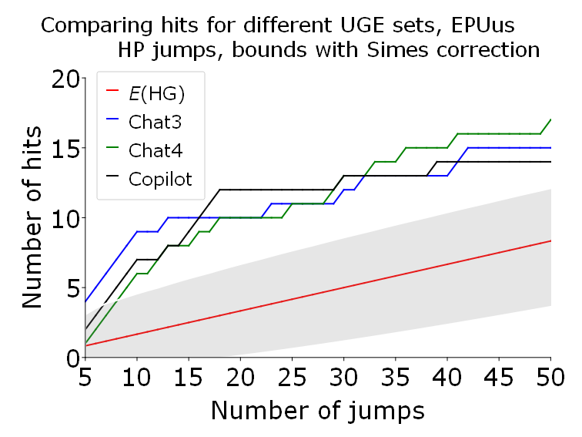 | 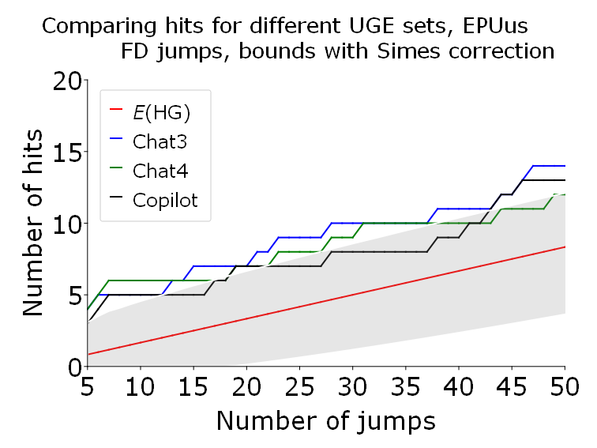
EURQus | 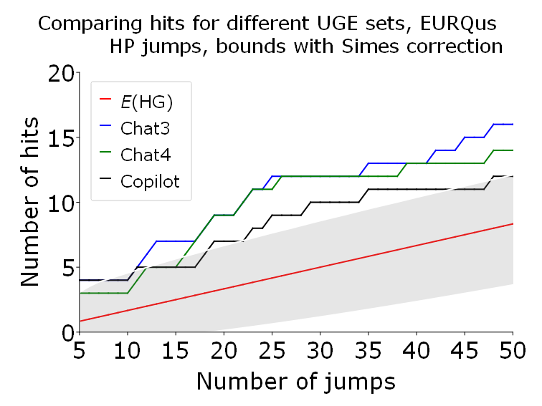 | 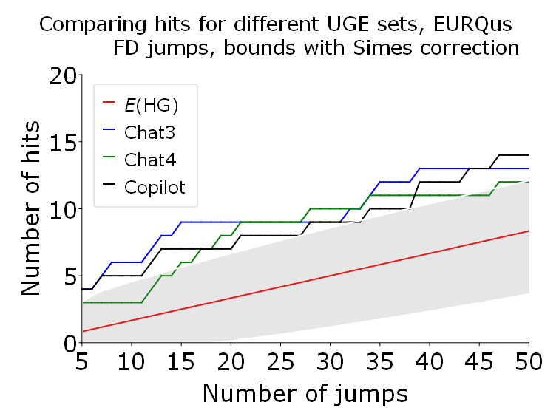
 | HP jumps | FD jumps
LMACROus | 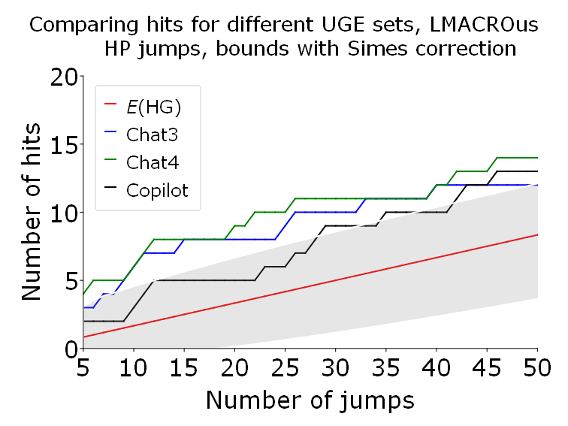 | 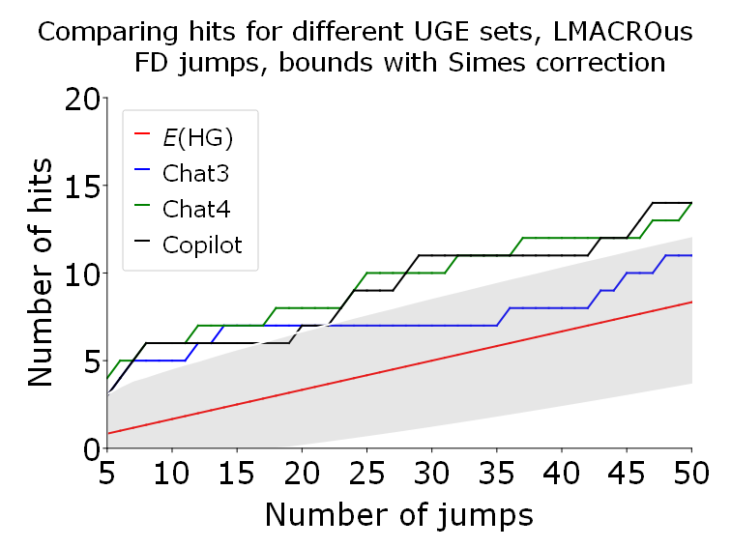
LREAlus | 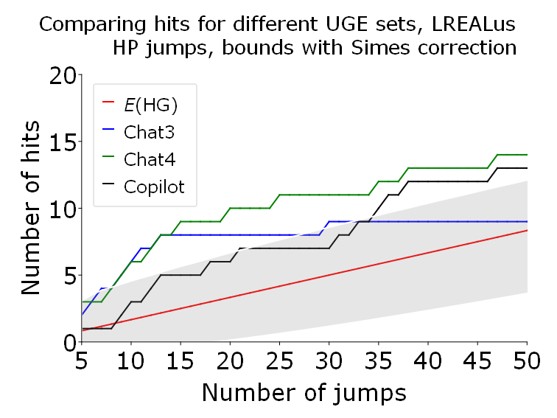 | 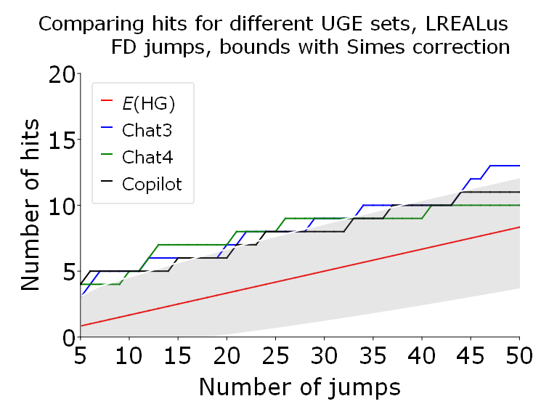
Figure A7.2 continued
LFINus | 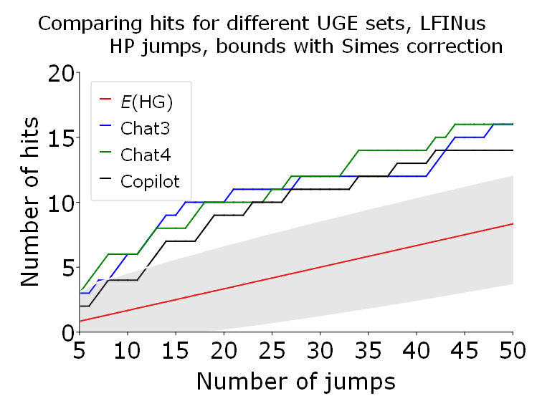 | 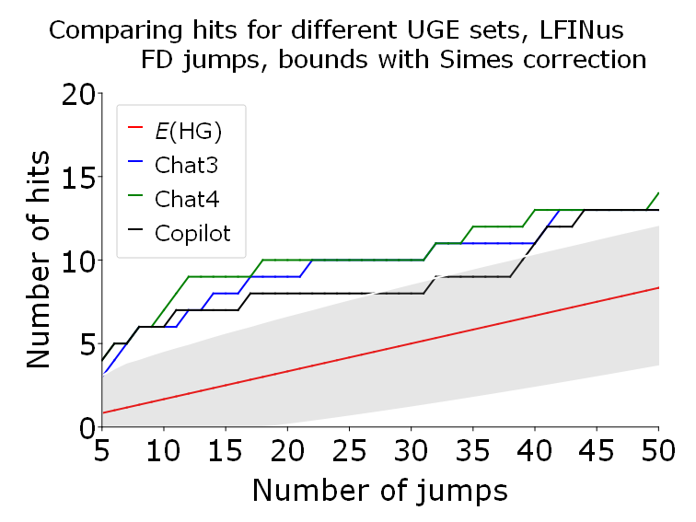
VIXus | 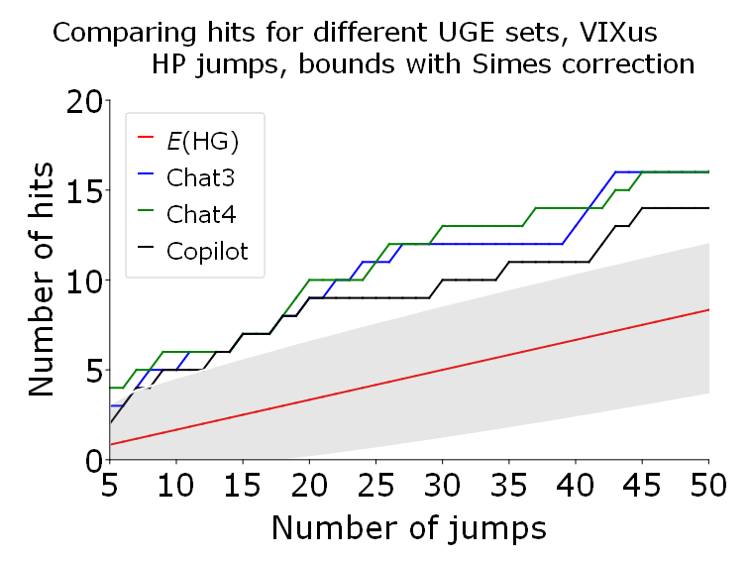 | 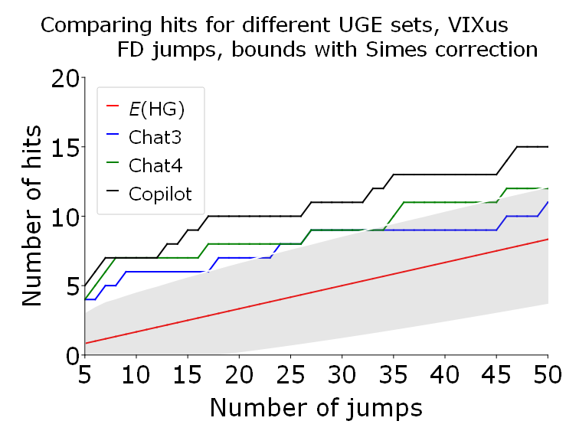

Appendix 8. Comparing test results for different indices and types of jumps
Figures A8.1 and A8.2 show the comparative performance of jumps and hits test for all set uncertainty of indices for Poland (Figure A8.1) and the US (Figure A8.2).
Figure A8.1. Comparing test results for different indices and types of jumps for Poland

Legend for Figure A8.1
The uncertainty index to which the test was applied differs from figure to figure. The rest of the legend is identical for all Figures. That is:
- red solid line: the expected values of the hypergeometric distribution for a given number of jumps, see (1);
- GEPU_KZ blue solid line: the number of hits obtained for GEPU_KZ for a given number of jumps;
- EURQP_PL black line: the number of hits obtained for EURQ_PL for a given number of jumps;
- EURQP_EN green line: the number of hits obtained for EURQ_PL for a given number of jumps
- Up. bound, BY corr Joint upper bounds, that is, arguments of the 0.05 p-values of the corresponding hypergeometric distribution, corrected by the Benjamini-Yukateli (BY) correction;
- Grey shaded area: Confidence interval, where the upper limits are the arguments of the 0.05 p-values of the corresponding hypergeometric distribution, corrected by the Simes correction;
The horizontal axis shows the number of jumps gradually increasing from 5 (where only the five highest increments count as jumps) to 50.

Figure A8.1. Comparing test results for different indices and types of jumps for Poland
 | HP jumps | FD jumps
Experts | 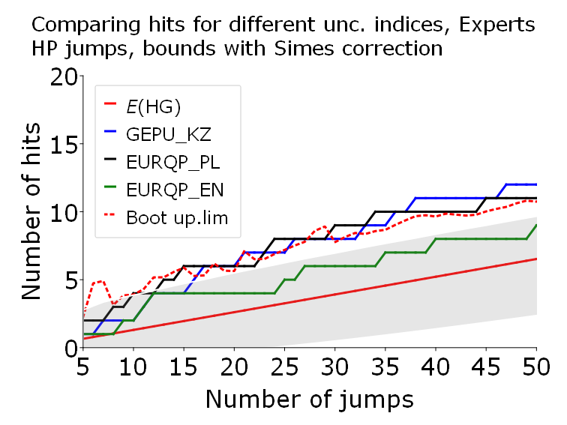 | 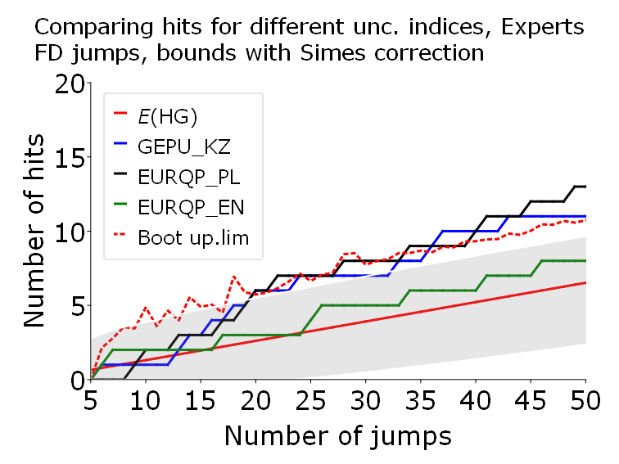
ChatGPT-3.5 | 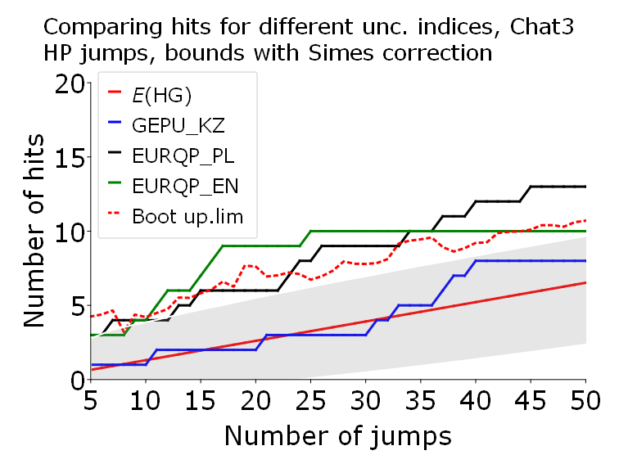 | 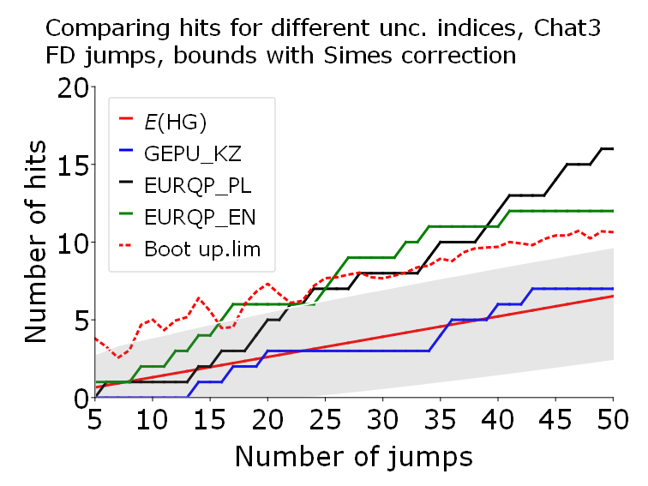
ChatGPT-4o | 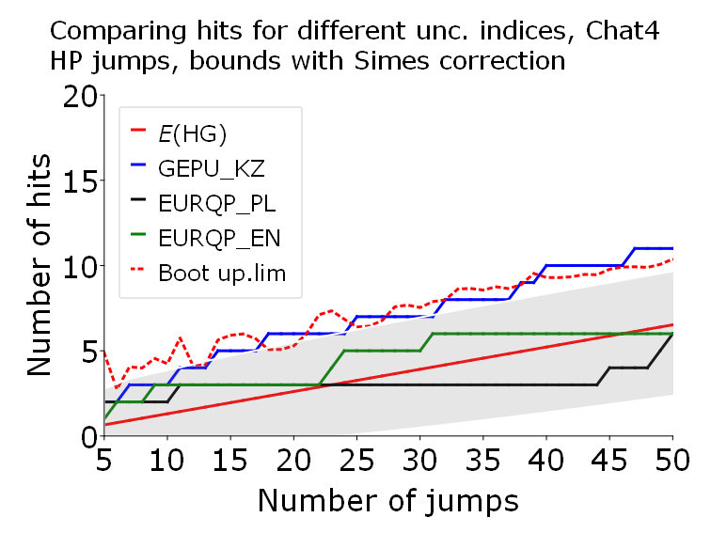 | 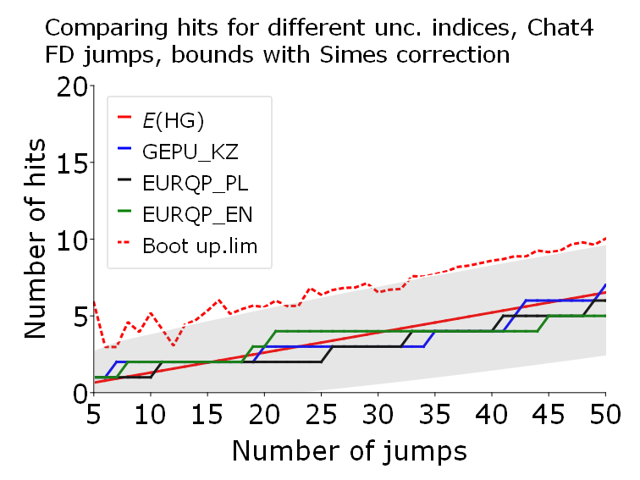
 | HP jumps | FD jumps
Copilot | 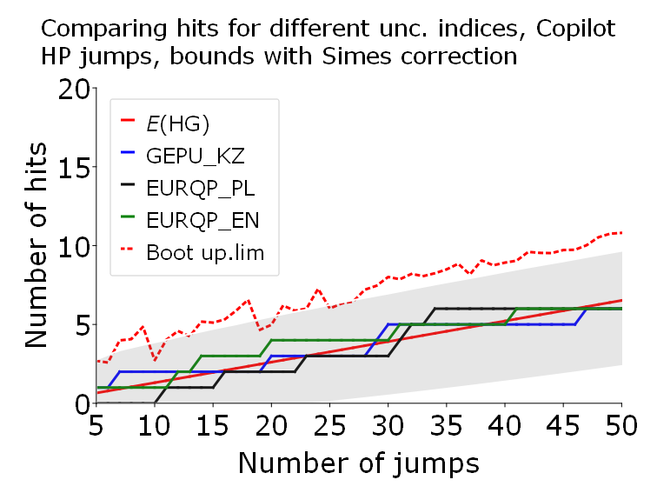 | 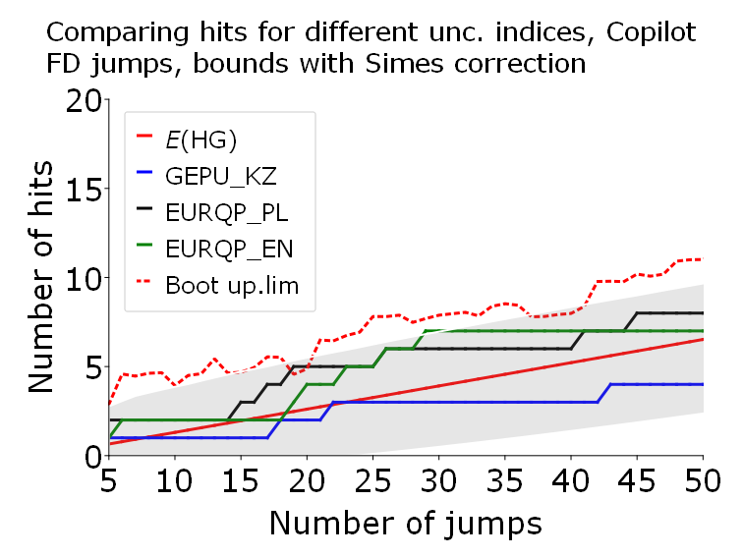
Legend for Figure A8.2
The uncertainty index to which the test was applied differs from figure to figure. The rest of the legend is identical for all Figures. That is:
- red solid line: the expected values of the hypergeometric distribution for a given number of jumps, see (1);
- EPUus blue solid line: the number of hits obtained for EPUus for a given number of jumps;
- EURQus black solid line: the number of hits obtained for EURQus for a given number of jumps;
- VIXus green solid line: the number of hits obtained for VIXus for a given number of jumps
- LFINus light green solid line: the number of hits obtained for LFINus for a given number of jumps;
- LMACRQus light grey solid line: the number of hits obtained for LMACRQus for a given number of jumps;
- LREALus cyan solid line: the number of hits obtained for LMACRQus for a given number of jumps
- Up. bound, BY corr Joint upper bounds, that is, arguments of the 0.05 p-values of the corresponding hypergeometric distribution, corrected by the Benjamini-Yukateli (BY) correction;
- Grey shaded area: Confidence interval, where the upper limits are the arguments of the 0.05 p-values of the corresponding hypergeometric distribution, corrected by the Simes correction;
The horizontal axis shows the number of jumps gradually increasing from 5 (where only the five highest increments count as jumps) to 50.

Figure A8.2. Comparing test results for different indices and types of jumps for US.
 | HP jumps | FD jumps
ChatGPT-3.5 | 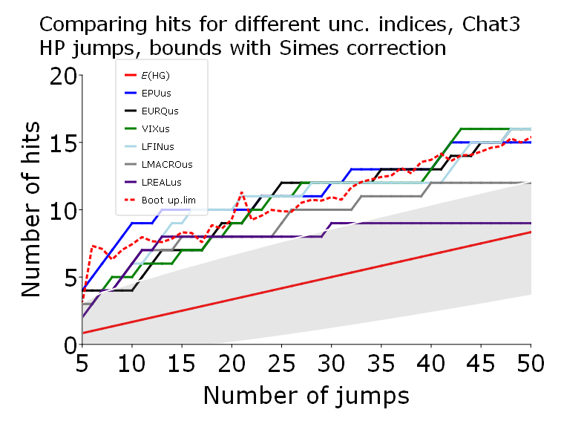 | 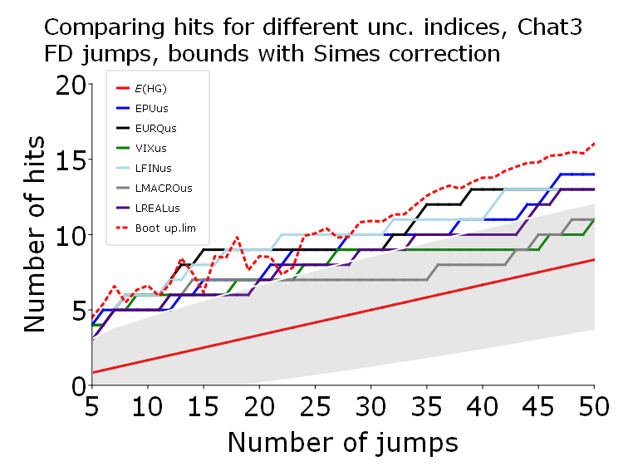
ChatGPT-4o | 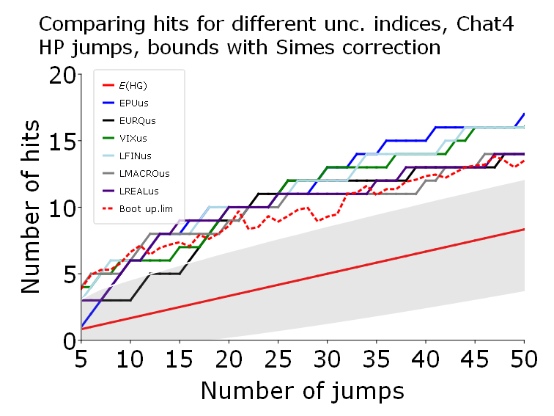 | 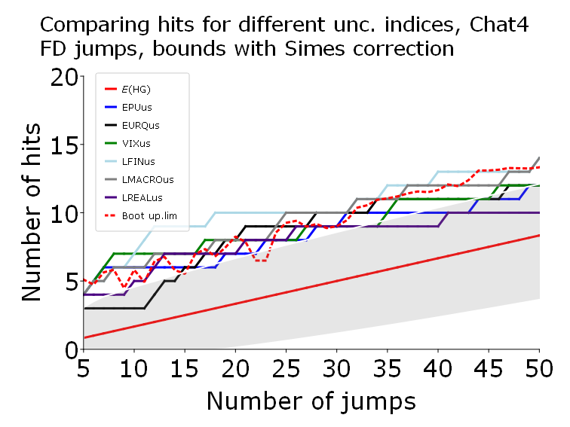
 | HP jumps | FD jumps
Copilot | 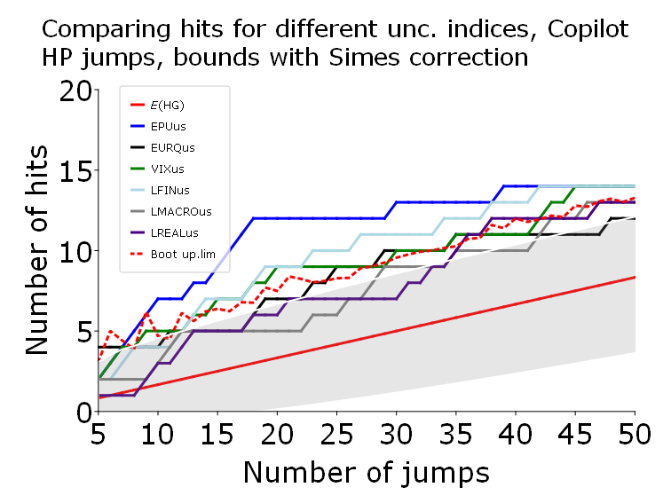 | 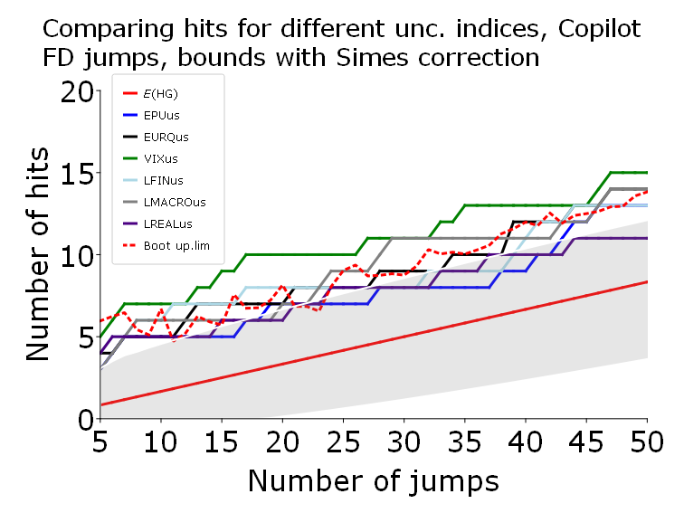

LLMs are subsets of Natural Language Processing (NLP) and Natural Language Generation (NLG) models, a broad area of AI focused on enabling machines to understand, interpret and generate human language.
GPT-4 has improved comprehension in specialised and technical domains (science, law and mathematics), creativity in long narrative texts, and stability and coherence across interactions. ChatGPT-4o further increases token number, can handle multimodal inputs like text and images, as well as idioms and metaphors.
On September 2020, Microsoft announced that it had licensed the LLM GPT-3 exclusively; only Microsoft will have access to GPT-3's underlying code, allowing it to embed, repurpose, and modify the model as it pleases.
Gemini sometimes provides inaccurate dates, or less detailed responses. Here is an example of the two answers to a somewhat crudely posed question “War in Ukraine exact starting day”: Gemini answered “The war in Ukraine began on Thursday, February 24, 2022. This marks the start of the full-scale Russian invasion of Ukraine, although the conflict between Russia and Ukraine has been ongoing since 2014.” ChatGPT-3.5 answered “The war in Ukraine began on February 24, 2022, when Russia launched a full-scale invasion of Ukraine. This marked the escalation of the ongoing conflict between the two countries, which had been simmering since 2014 with Russia's annexation of Crimea and support for separatists in eastern Ukraine”.
Other Chatbots are Meta AI (formerly Facebook) which uses Llama, released in February 2023, aiding with writing. However, it has a lower token limit than ChatGPT, meaning that it is less recommended to process lengthy prompts as those we used in ChatGPT to check robustness to alternative prompts. DataRobot is not tied to a specific LLM as it is dedicated to help organizations in building and deploying predictive models at scale (like random forest and gradient boosting machines). Hence, it has a scope not appropriate for our research. The same for IBM Watson as it is tailored to provide ideas for marketing campaigns. Anthropic Claude, again not tied to a specific LLM, can provide custom solutions to high-stakes industries as it checks AI systems about security and fairness.
The sequence of words in a prompt is transformed in tokens, and LLM tries to predict the most likely sequence to come after that sequence. A token roughly maps to a syllable in a word, or about 4 characters, and does this by assigning a probability to likely next sequences and then samples from those to choose one. The process repeats until some stopping criteria is met. LLMs learn these probabilities by training on large corpuses of text.
All experiments related to ChatGPT-3.5 were conducted between February and April 2024; new tasks for ChatGPT-3.5-4-4o and alternative chatbots were executed between September and October 2024.

