Supplementary materials

Macrocell | ID | Site | length (m) | hard defense structures | tanβ
M₁ | 3 | Cattolica Sud | 1230 | Y | 0.013 ± 0.003
M₁ | 4 | Cattolica Nord | 615 | Y* | 0.012 ± 0.002
M₁ | 12 | Misano Pennelli | 1680 | Y* | 0.012 ± 0.003
M₁ | 13 | Misano Scogliere | 755 | Y | 0.010 ± 0.001
M₁ | 14 | Riccione Sud | 1000 | Y* | 0.011 ± 0.001
M₁ | 15 | Riccione Centro | 1850 | Y* | 0.011 ± 0.002
M₁ | 16 | Riccione Porto | 570 | N | 0.010 ± 0.001
M₁ | 20 | Riccione Alba Sud | 840 | N | 0.010 ± 0.003
M₁ | 21 | Riccione Alba Nord | 1250 | N | 0.009 ± 0.001
M₁ | 23 | Fogliano Marina | 610 | N | 0.009 ± 0.001
M₁ | 24 | Miramare | 6190 | N | 0.008 ± 0.001
M₁ | 25 | Rimini Centro | 1350 | N | 0.010 ± 0.001
M₂ | 30 | Rivabella | 1660 | Y | 0.007 ± 0.001
M₂ | 31 | Viserba Zona Sud Sortie | 630 | Y* | 0.009 ± 0.003
M₂ | 32 | Viserba Sud | 520 | Y* | 0.007 ± 0.002
M₂ | 34 | Viserba Nord | 465 | Y* | 0.007 ± 0.001
M₂ | 35 | Viserbella | 1200 | Y | 0.008 ± 0.002
M₂ | 36 | Torre Pedrera | 1960 | Y* | 0.008 ± 0.001
M₂ | 37 | Igea Marina Sud | 515 | Y* | 0.008 ± 0.002
M₂ | 38 | Igea Marina Zona Sperimentale | 825 | Y* | 0.009 ± 0.002
M₂ | 39 | Igea Marina | 2630 | Y* | 0.009 ± 0.002
M₂ | 41 | Bellaria | 2690 | Y* | 0.009 ± 0.002
M₂ | 42 | San Mauro | 700 | Y* | 0.008 ± 0.002
M₂ | 43 | Savignano | 155 | Y | 0.008 ± 0.001
M₂ | 45 | Gatteo a Mare | 700 | Y | 0.009 ± 0.002
M₂ | 46 | Villamarina | 880 | Y | 0.008 ± 0.002
M₂ | 47 | Valverde | 1750 | Y* | 0.008 ± 0.002
M₂ | 48 | Cesenatico | 2015 | Y* | 0.008 ± 0.002
M₃ | 50 | Cesenatico Ponente | 825 | Y* | 0.007 ± 0.002
M₃ | 51 | Cesenatico Colonie | 775 | N | 0.006 ± 0.002
M₃ | 52 | Cesenatico Campeggio Zadina | 495 | N | 0.005 ± 0.002
M₃ | 54 | Zadina Tagliata | 1000 | N | 0.007 ± 0.003
M₃ | 55 | Cervia | 4420 | N | 0.005 ± 0.001
M₃ | 58 | Milano Marittima | 1365 | N | 0.005 ± 0.001
M₃ | 60 | Milano Marittima Nord | 1685 | Y* | 0.006 ± 0.001
M₃ | 61 | Milano Marittima Colonie | 540 | Y* | 0.007 ± 0.001
M₃ | 63 | Lido di Savio | 2070 | Y* | 0.007 ± 0.001
M₄ | 65 | Lido di Classe | 1220 | Y* | 0.007 ± 0.001
M₄ | 66 | Lido di Classe Nord | 580 | Y* | 0.008 ± 0.002
M₄ | 67 | Bevano Sud | 1000 | N | 0.007 ± 0.000
M₄ | 68 | Bevano Centro Sud | 1900 | N | 0.007 ± 0.001
M₄ | 70 | Bevano Centro Nord | 1300 | Y* | 0.008 ± 0.001
M₄ | 71 | Bevano Nord | 1000 | Y* | 0.008 ± 0.001
M₄ | 72 | Lido di Dante | 605 | Y* | 0.010 ± 0.002
M₄ | 73 | Sud Foce Fiumi Uniti | 600 | Y* | 0.009 ± 0.002
M₄ | 75 | Nord Foce Fiumi Uniti | 360 | Y* | 0.008 ± 0.002
M₄ | 76 | Lido Adriano | 2560 | Y* | 0.009 ± 0.003
M₄ | 77 | Punta Marina | 3730 | Y* | 0.008 ± 0.002
M₄ | 78 | Punta Marina Nord | 865 | Y* | 0.006 ± 0.001
M₄ | 79 | Marina di Ravenna | 3000 | N | 0.005 ± 0.001
M₅ | 81 | Porto Corsini | 1000 | N | 0.007 ± 0.001
M₅ | 82 | Marina Romea | 1300 | N | 0.008 ± 0.001
M₅ | 83 | Marina Romea Nord | 945 | N | 0.008 ± 0.001
M₅ | 85 | Foce Lamone-Casal Borsetti | 2110 | Y* | 0.011 ± 0.001
M₅ | 86 | Casal Borsetti Sud | 835 | Y* | 0.013 ± 0.002
M₅ | 88 | Casal Borsetti Nord | 520 | Y* | 0.015 ± 0.003
M₅ | 89 | Casal Borsetti Fio 82 | 630 | Y* | 0.013 ± 0.002
M₅ | 90 | Poligono Militare | 2500 | Y* | 0.010 ± 0.003
M₅ | 91 | Poligono Militare Nord | 430 | Y* | 0.009 ± 0.002
M₅ | 93 | Nord Foce Reno | 2000 | N | 0.010 ± 0.001
M₅ | 94 | Foce Gobbino Sud | 935 | N | 0.010 ± 0.001
M₅ | 96 | Foce Gobbino - Bagno Giamaica | 1510 | Y* | 0.010 ± 0.003
M₅ | 97 | Lido di Spina Sud | 900 | Y* | 0.009 ± 0.002
M₅ | 98 | Lido di Spina Nord | 2070 | N | 0.007 ± 0.001
M₅ | 100 | Lido degli Estensi | 1540 | N | 0.007 ± 0.001
M₆ | 102 | Porto Garibaldi | 1480 | Y | 0.009 ± 0.001
M₆ | 103 | Lido degli Scacchi | 2500 | Y | 0.012 ± 0.002
M₆ | 104 | Lido di Pomposa | 2230 | Y | 0.012 ± 0.002
M₆ | 105 | Lido delle Nazioni | 2910 | Y | 0.009 ± 0.001
M₆ | 106 | Bocca del Bianco | 1130 | Y* | 0.007 ± 0.001
M₆ | 107 | Pineta di Volano | 1600 | Y* | 0.004 ± 0.001
M₆ | 108 | Volano Zona Pennelli | 990 | Y* | 0.004 ± 0.002
M₆ | 109 | Lido di Volano | 1750 | N | 0.005 ± 0.001
M₆ | 110 | Scannone di Volano | 1950 | N | 0.006 ± 0.001
Table S1: List of the coastal management cells individuated in macrocells M₁-M₆, according to Aguzzi et al. (2016), considered in this study. Related length is indicated, together with the presence/absence of hard defense structures. Most of these were placed before 1984, and only in sites with the indication "Y*" some new placement or adaptation of structures has been carried out in the following years. The tanβ parameter is the estimated slope within each specific cell, computed as the average gradient from the upper beach down to the depth of closure of -8 m (-6 m for the M₆), along with its associated 1σ over time, based on data from the six topo-bathymetric campaigns.

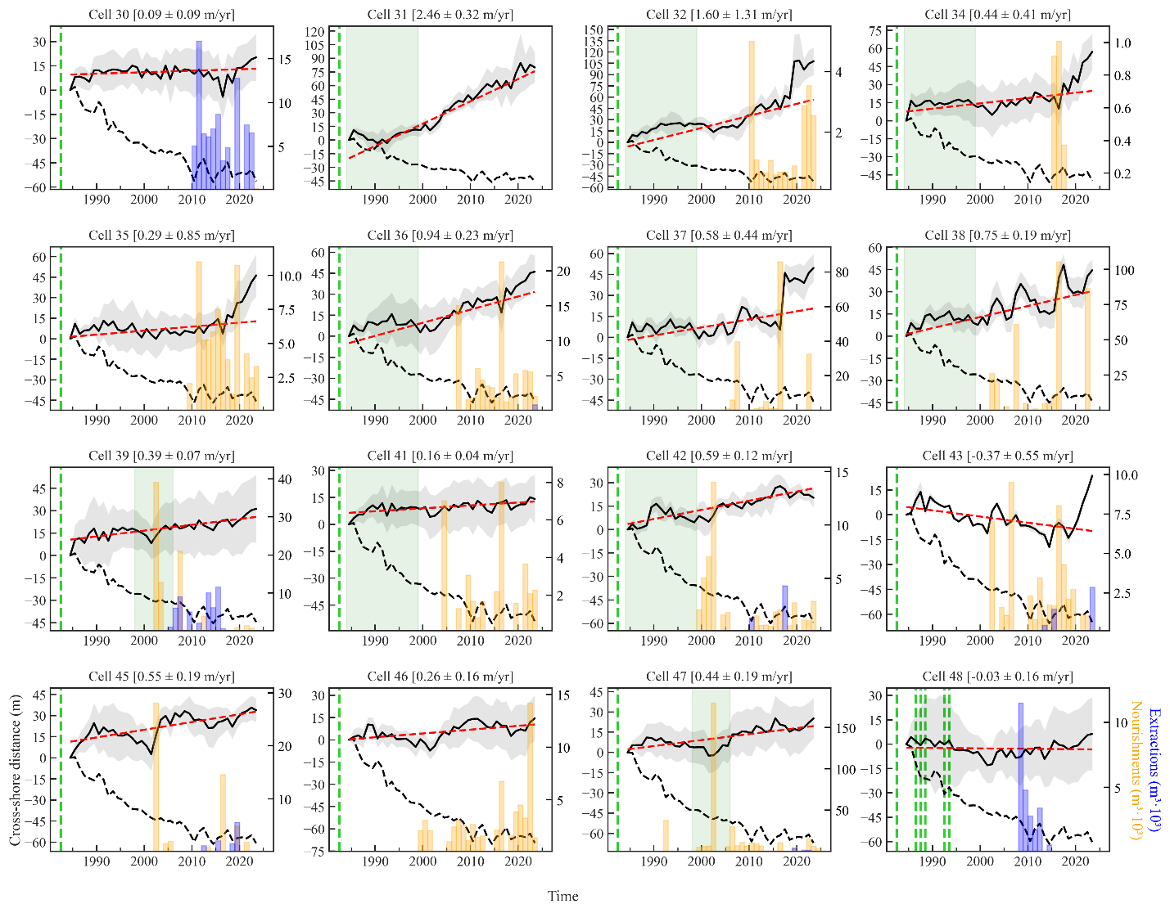
Figure S1: The solid black line represents the annual averaged shoreline position for each specific cell within the M₂, along with its associated 1σ uncertainty (gray shaded area) and the linear trend (red hatched line) over the 40-year period. The trend value and its related error are stated above the corresponding subplot. The black hatched line indicates the theoretical shoreline evolution for each cell, considering only the RSL change (see Section 3.3 in the main text). Both observed and theoretical shoreline positions are shown in meters of displacement (left y-axis) with respect to the 1984 average, which is set to zero. Positive (negative) values indicate a shift seaward (landward), corresponding to shoreline progradation (erosion) within a cell. Orange and blue bars indicate the occurrence of sediment nourishment and extraction activities, respectively, for each specific cell and year. Nourishment and extraction volumes are expressed in m³ x 10³ (refer to the right y-axis). Vertical green hatched lines indicate the placement of a new hard defense structure within a specific cell, while green-shaded areas denote the time range when the exact year of placement is unknown. A green hatched line at 1982 signifies that hard structures were already in place before 1984.

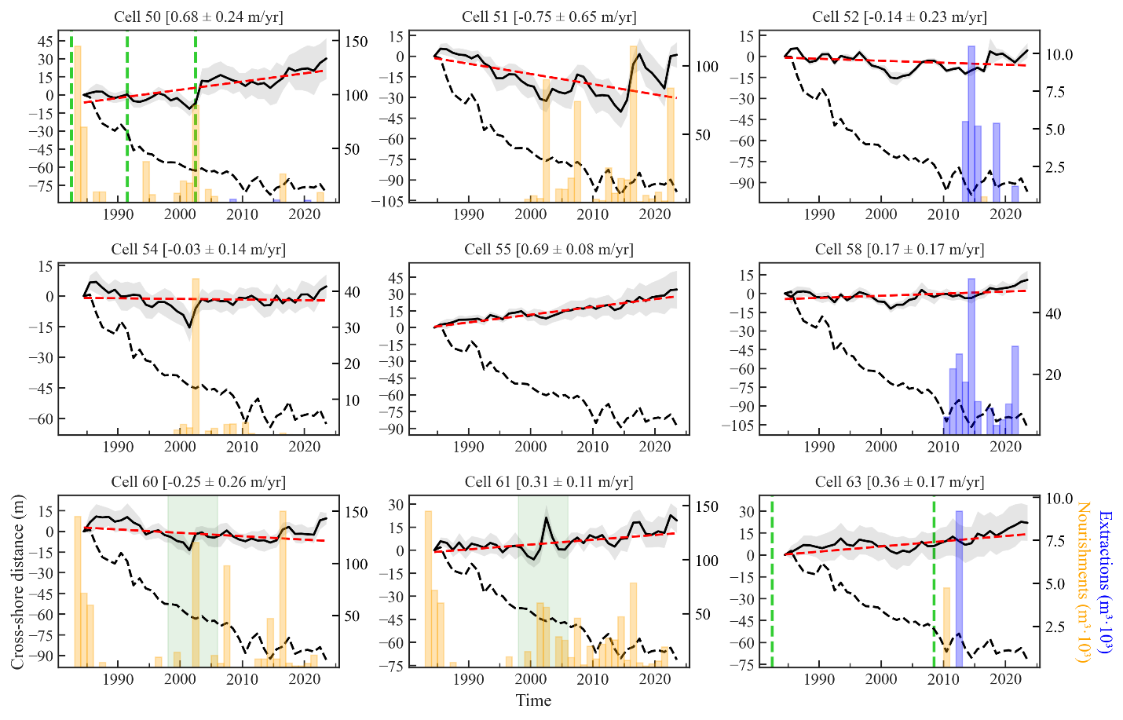
Figure S2: Same as Figure S1, but for M₃.

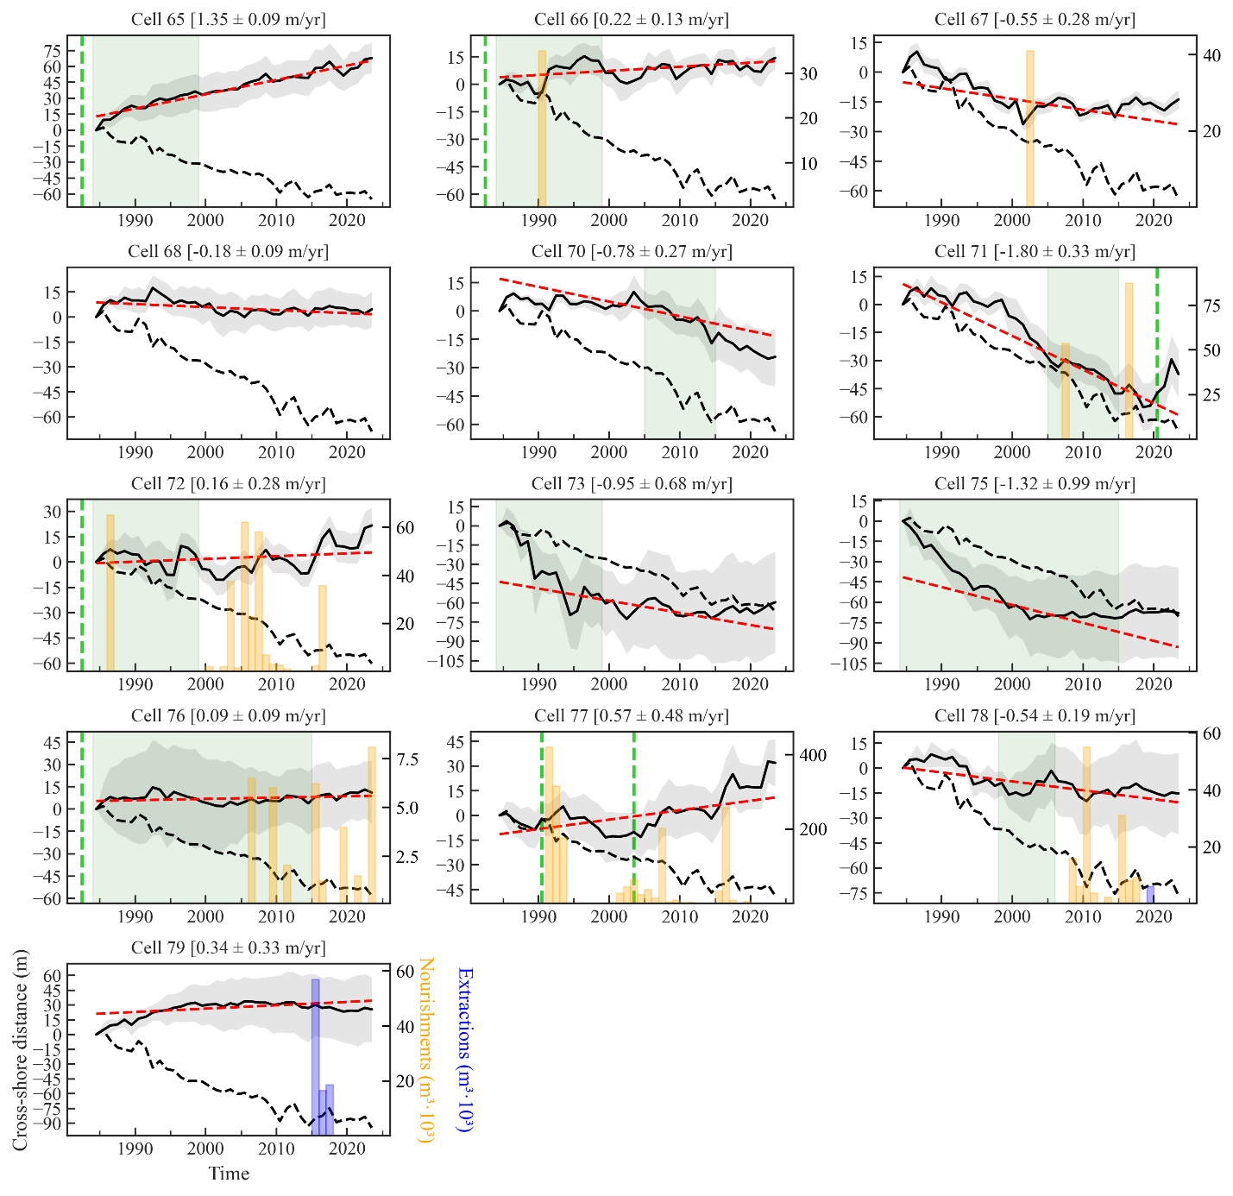
Figure S3: Same as Figure S1, but for M₄.

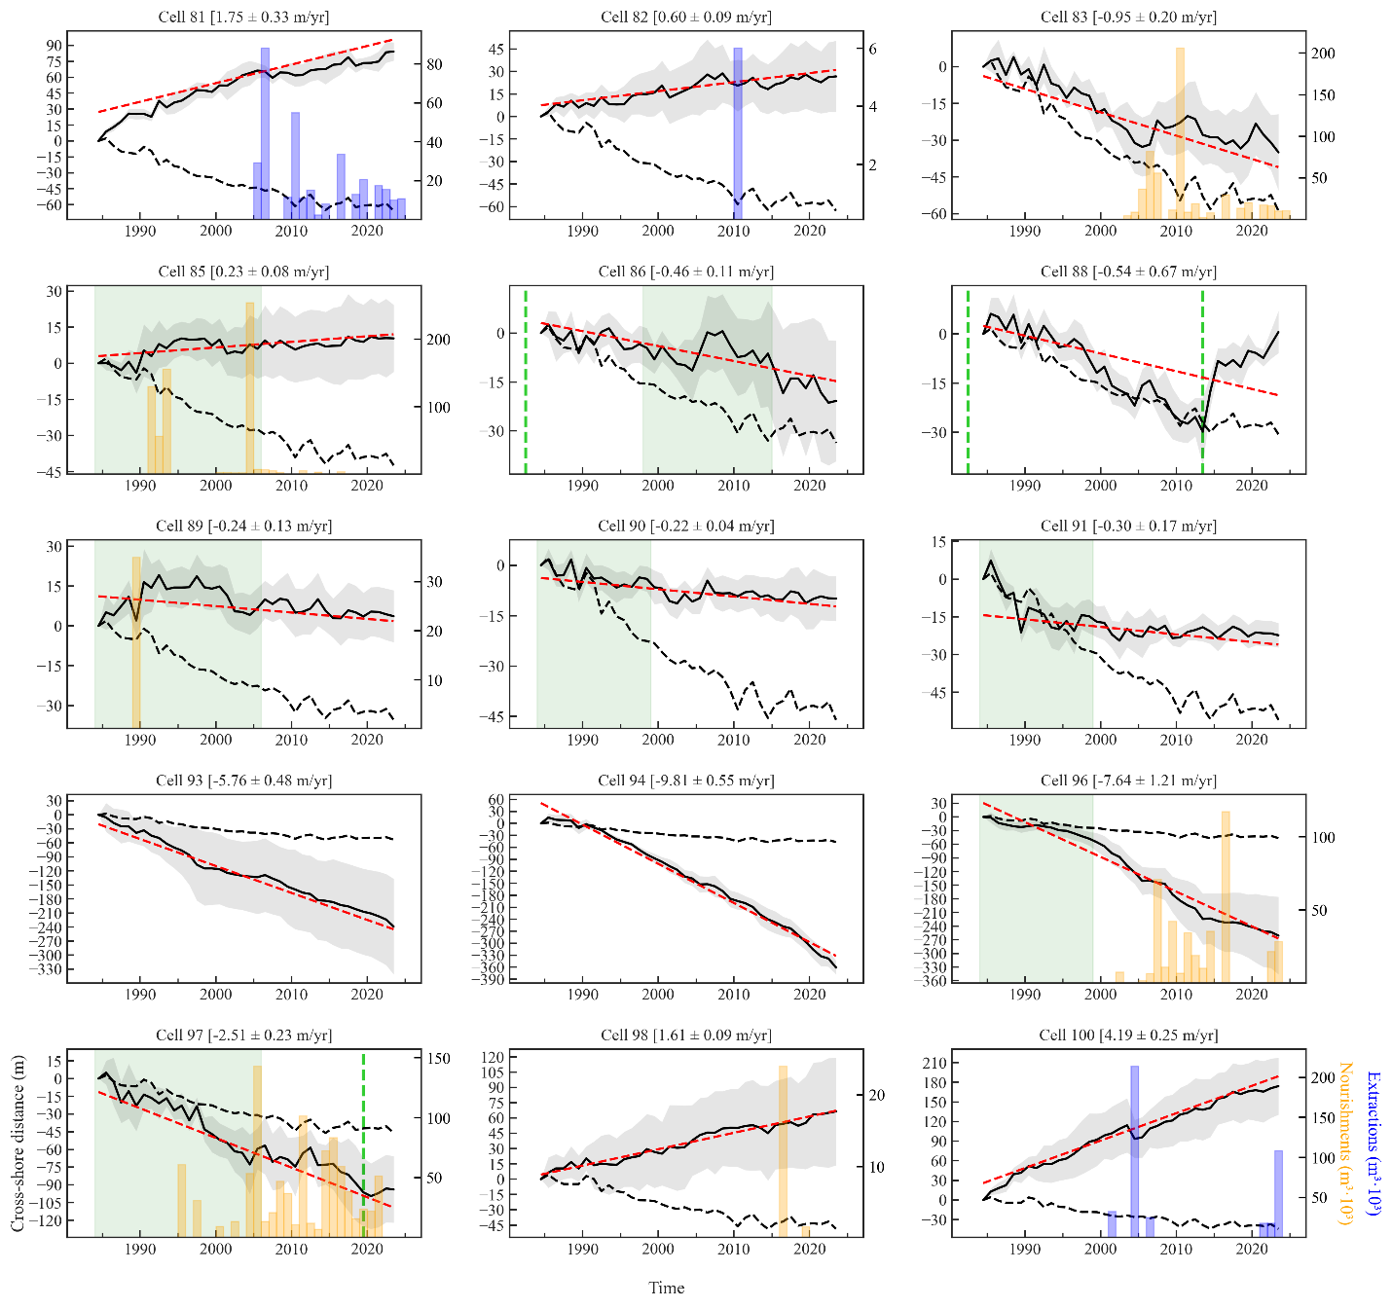
Figure S4: Same as Figure S1, but for M₅.

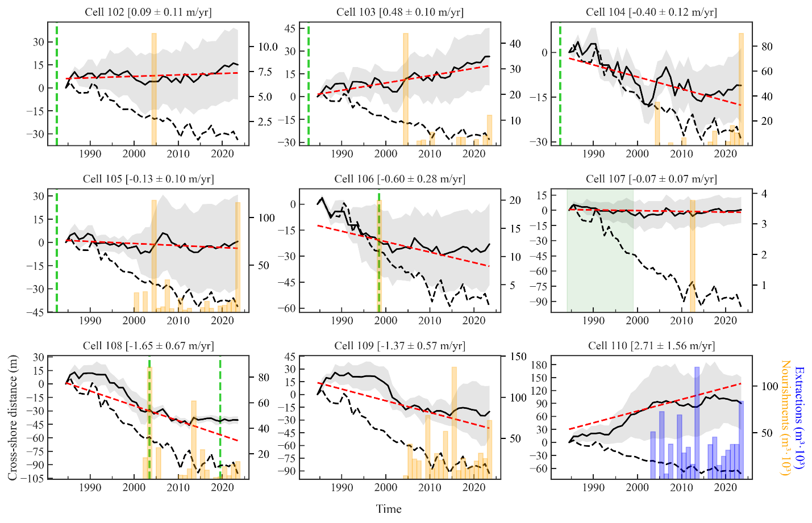
Figure S5: Same as Figure S1, but for M₆.

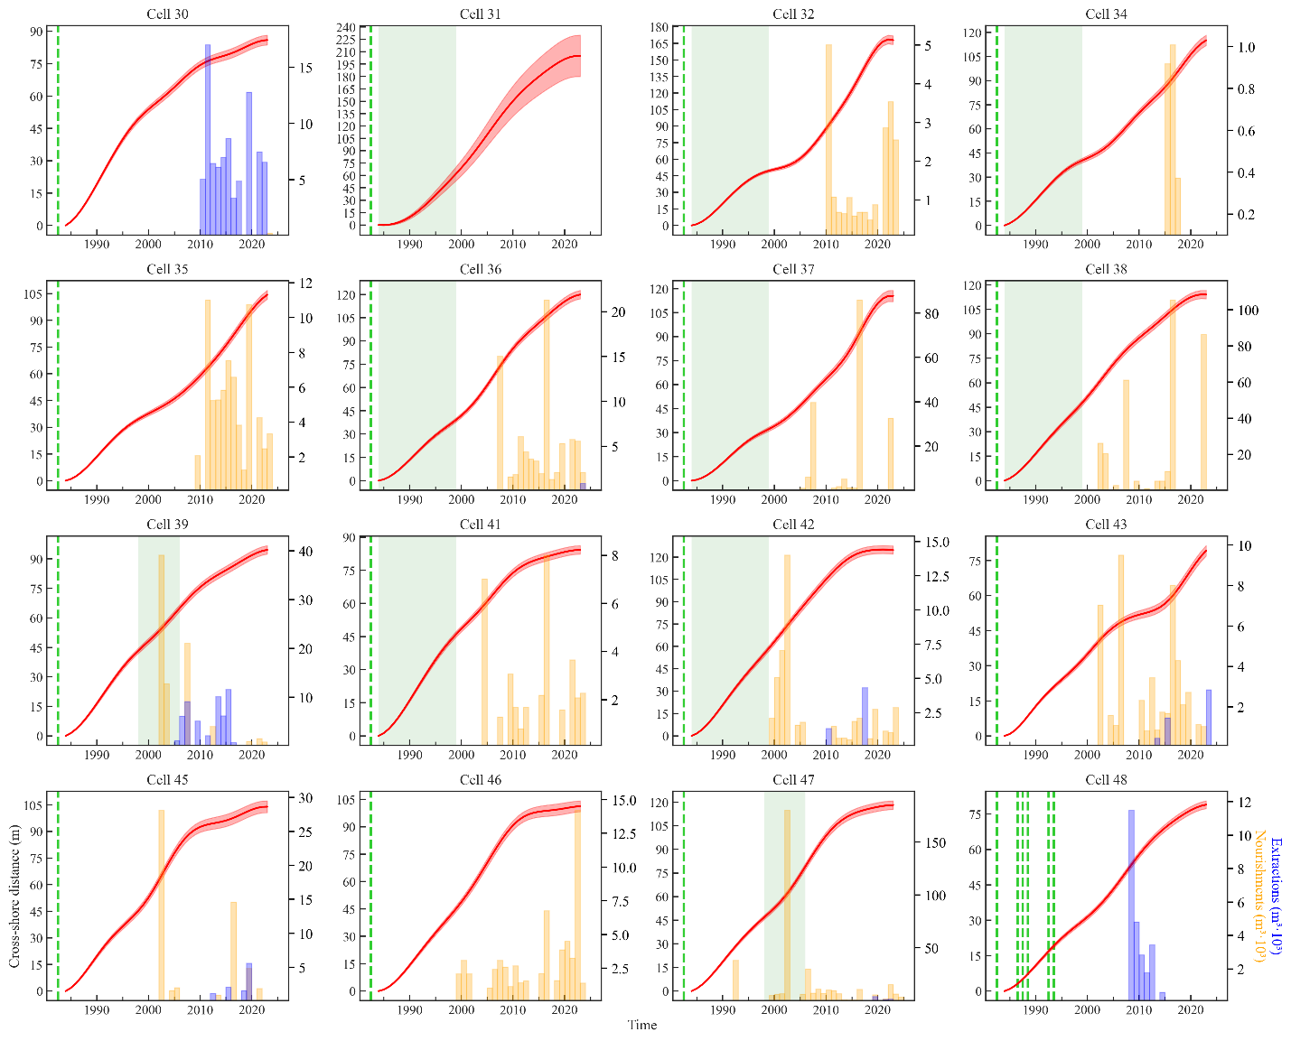
Figure S6. The solid red line represents the residual, non-linear shoreline behavior of cells within M₂ over the period 1984-2023, after removing the RSL contribution and oscillatory modes, with its associated 1σ uncertainty (red shaded area). As in Figure S1-S5, the left y-axis indicates meters of displacement (relative to 1984), while the right y-axis refers to volumes (m³ x 10³) of nourished/extracted sediment. The presence of hard defense structures within a cell is marked by a green hatched vertical line when the exact placement year is known or by a green shaded area when the onset is uncertain.
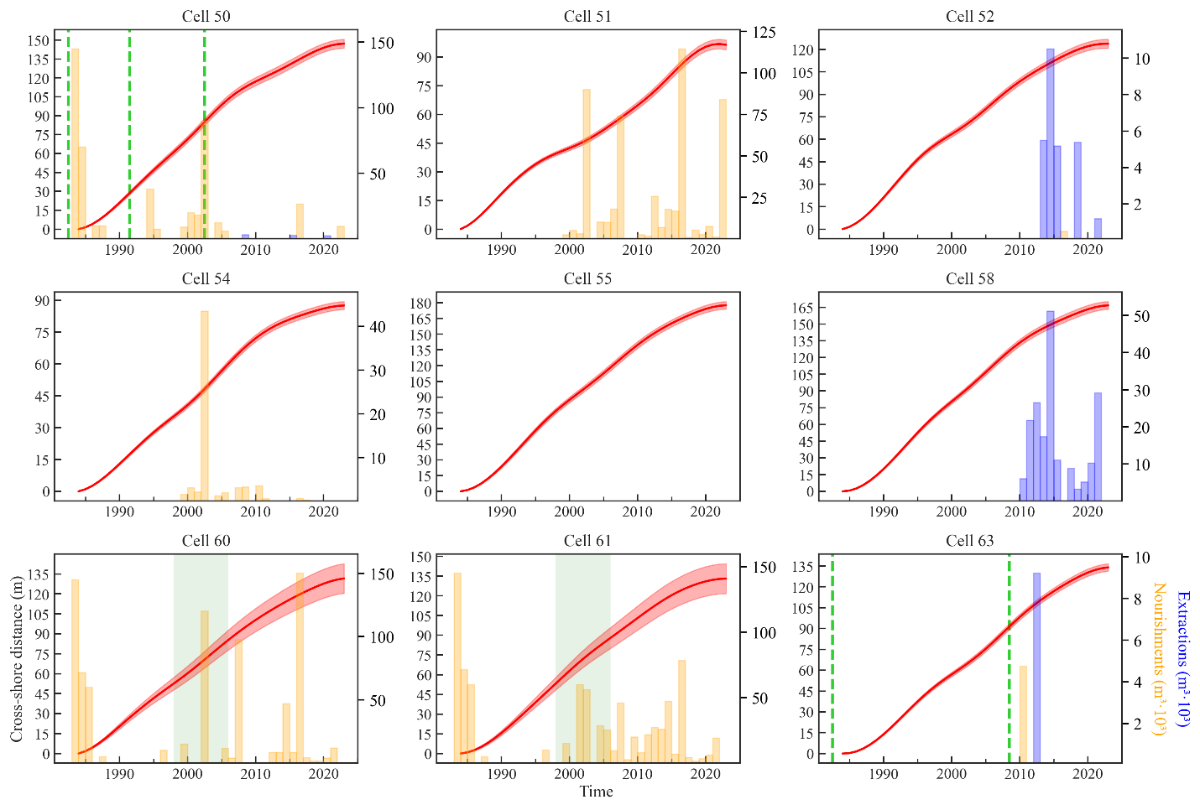
Figure S7: Same as Figure S6, but for M₃.

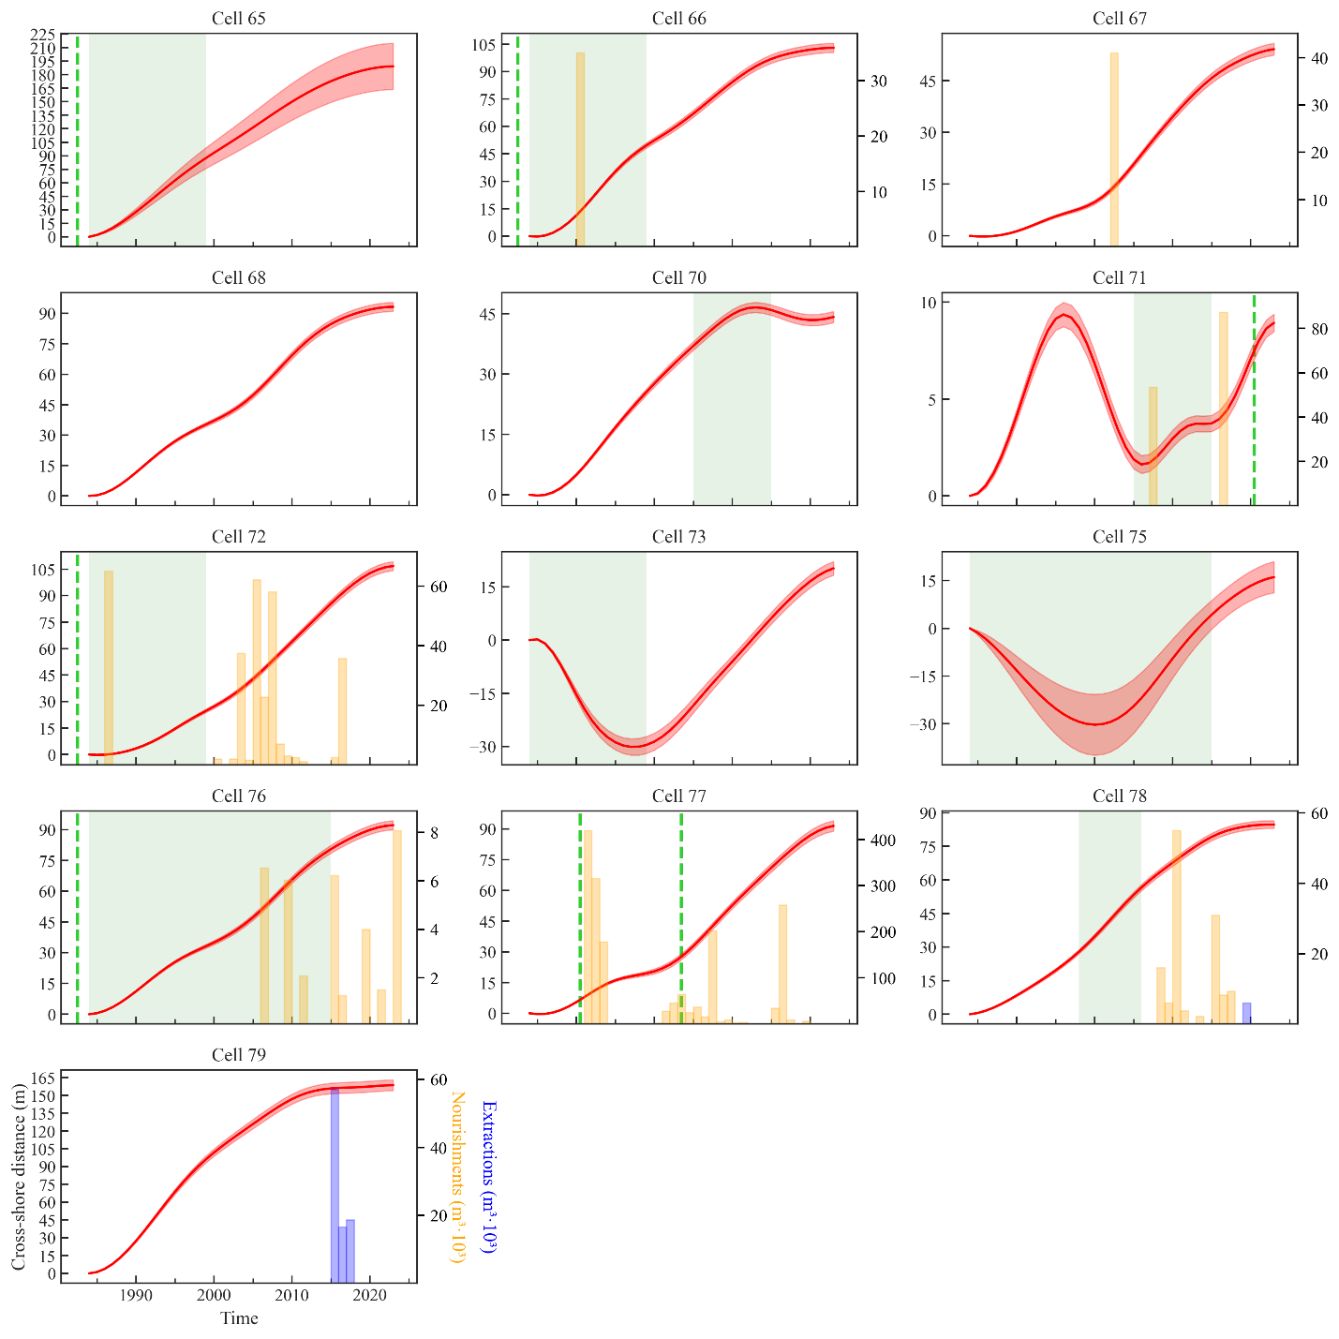
Figure S8: Same as Figure S6, but for M₄.

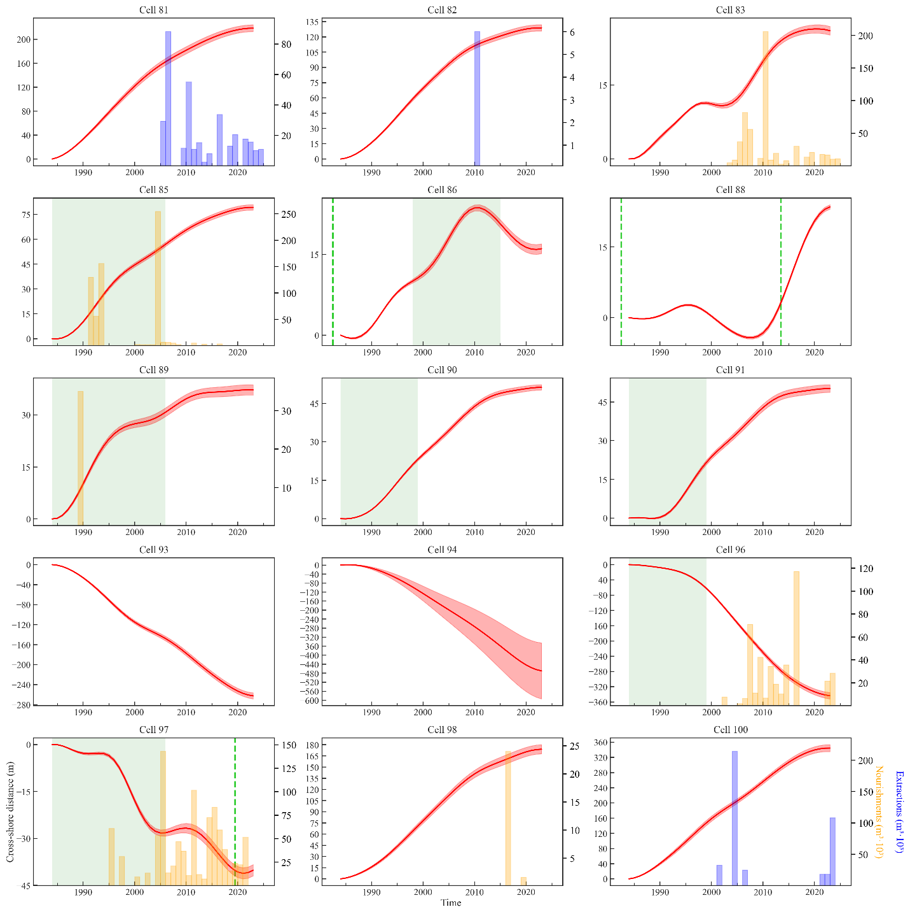
Figure S9: Same as Figure S6, but for M₅.

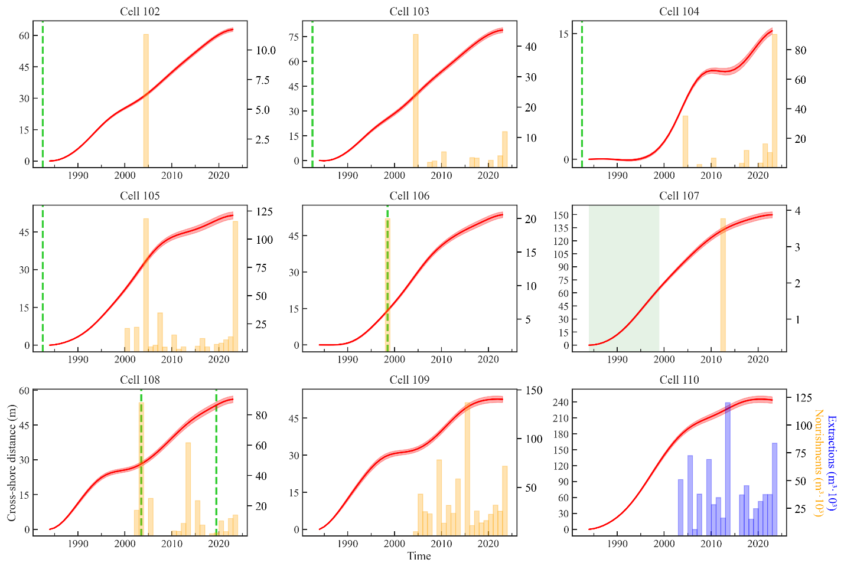
Figure S10: Same as Figure S6, but for M₆.

