Appendix S2. Validation test of dark diversity estimation methods.
Even if previous studies infer that the selected estimation method is valid to estimate dark diversity (Janíková & Lepš 2023, Tang et al. 2023, de Bello et al. 2016), it is still valuable to have an additional test to check the performance of our framework. Paganeli and colleagues (2024) guided authors to select proper estimation methods for their dark diversity studies. They affirm that a well-performing dark diversity estimation method should consistently assign relatively high scores to species that are observed but varying but usually lower scores from regions where the species is absent, reflecting the variable suitability across regions for the species. In our test, we used all alien plant species from our database (11,699) across all 367 regions, applying the leave-one-out cross-validation technique. This technique uses the remaining species to predict the dark diversity scores (the proxy for ecological suitability) for all remaining species across all regions, categorizing them into two groups: (a) observed as aliens (the method can provide scores even for present species) and (b) absent alien species. Subsequently, for each species, we calculated the median dark diversity score for all regions, dividing the regions into the two aforementioned groups. With over 11,000 data points, we conducted a Wilcoxon test to compare the scores between these two groups. The result was highly significant (p-value < 2.2e-16, Fig. S1). This validation test confirms that our method yielded the desired outcome for a well-performing dark diversity method (Paganeli et al. 2024).
However, we acknowledge that for a small set of species, the co-occurrence method might not be working too well —those represented by a small peak at score zero, which includes all species with less than 50% suitability. Those situations might be due to those species changing their ecology from native (from where the dark diversity was estimated) to the alien range, a suggestion of ecological fitting (Janzen 1985). This situation might also reflect recent shifts in regional ecological conditions that now render previously suitable habitats less suitable. Those defined as less suitable species could manage to survive but no longer reproduce, leading to a potential displacement of currently established alien species. For native species, the term for this process is extinction debt (Kuussaari et al. 2009). That output might also be produced by combinations of the above-mentioned reasons.
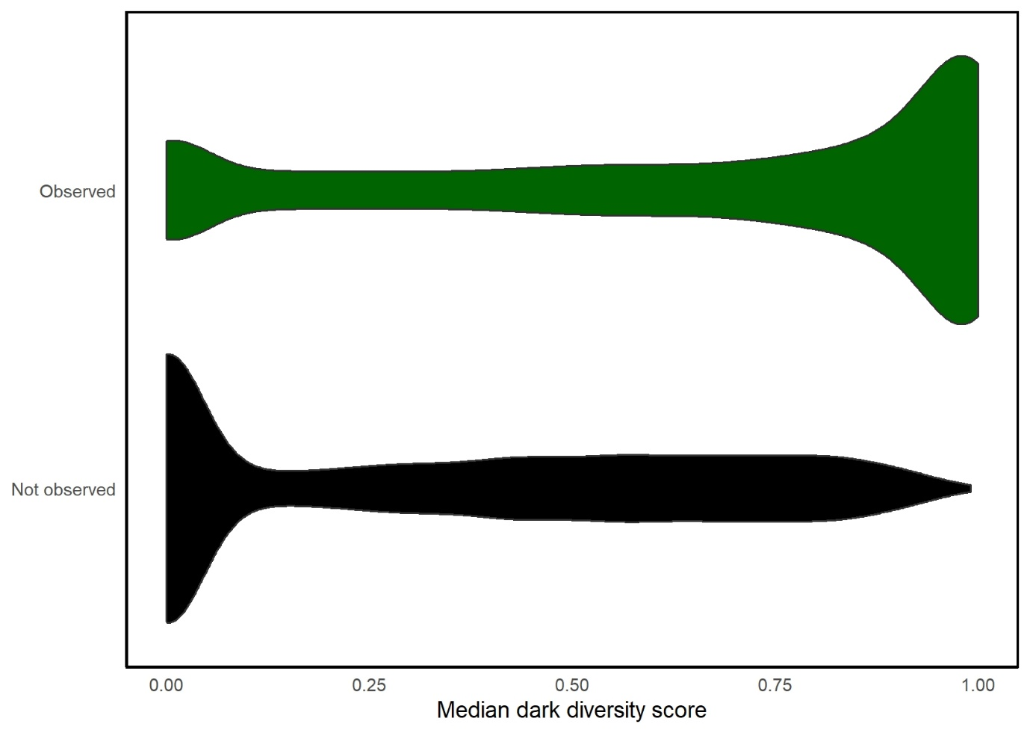
Fig. S1. Violin boxplots describing the dark diversity score (proxy of ecological suitability) for regions where the alien species were observed and where they were absent. The boxplots show a clear difference between the mean scores of alien species in regions where they were established and in regions where they are still absent.
Appendix S2 References
De Bello, F., Fibich, P., Zelený, D., Kopecký, M., Mudrák, O., Chytrý, M., ... & Pärtel, M. (2016). Measuring size and composition of species pools: A comparison of dark diversity estimates. Ecology and Evolution, 6(13), 4088–4101. https://doi.org/10.1002/ece3.2169
Janíková, E., & Lepš, J. (2023). Methods of species pool determination as predictors of survival in seeding and transplanting experiments. Functional Ecology, 37(9), 1870–1883. https://doi.org/10.1111/1365-2435.14321
Janzen, D. H. (1985). On ecological fitting. Oikos, 45(3), 308–310. https://doi.org/10.2307/3565560
Kuussaari, M., Bommarco, R., Heikkinen, R. K., Helm, A., Krauss, J., Lindborg, R., ... & Steffan-Dewenter, I. (2009). Extinction debt: A challenge for biodiversity conservation. Trends in Ecology & Evolution, 24(10), 564–571. https://doi.org/10.1016/j.tree.2009.04.011
Paganeli, B., Bevacqua, A., Šímová, I., Meynard, C. N., Lessard, J. P., et al. (2024). A roadmap to carefully select methods for dark diversity studies. Journal of Vegetation Science, 35(3), e13264. https://doi.org/10.1111/jvs.13264
Tang, L., Li, R., Wang, W., & Li, B. (2023). The probabilistic site-specific species pool and dark diversity in the terrestrialized urban mangroves. Ecological Indicators, 148, 110134. https://doi.org/10.1016/j.ecolind.2023.110134

