Supplementary material

Non-destructive, portable approach to assess the chemical and structural changes of Roman burnt bones
Lucrezia Gattiª & Zohreh Chahardoliª, Giorgia Sciuttoª, Francesca Seghi^{b}, Antonino Vazzana^{b}, Stefano Benazzi^{b}, Lea Legan^{c}, Fabio Cavalli^{d}, Rocco Mazzeoª, Silvia Prati^{*a}

ª University of Bologna, Department of Chemistry “G. Ciamician”, Ravenna Campus, Via Guaccimanni, 42 – 48121, Ravenna, Italy
^{b}University of Bologna, Department of Cultural Heritage, Ravenna Campus, Via degli Ariani, 1 – 48121, Ravenna, Italy
^{c} Institute for the Protection of Cultural Heritage of Slovenia, Conservation Centre, Poljanska cesta 40, 1000 Ljubljana, Slovenia
^{d} Research Unit of Paleoradiology and Allied Sciences, Laboratorio di Telematica Sanitaria-Struttura Complessa Informatica e Telecomunicazioni, Azienda Sanitaria Universitaria Giuliana Isontina, 34149 Trieste, Italy
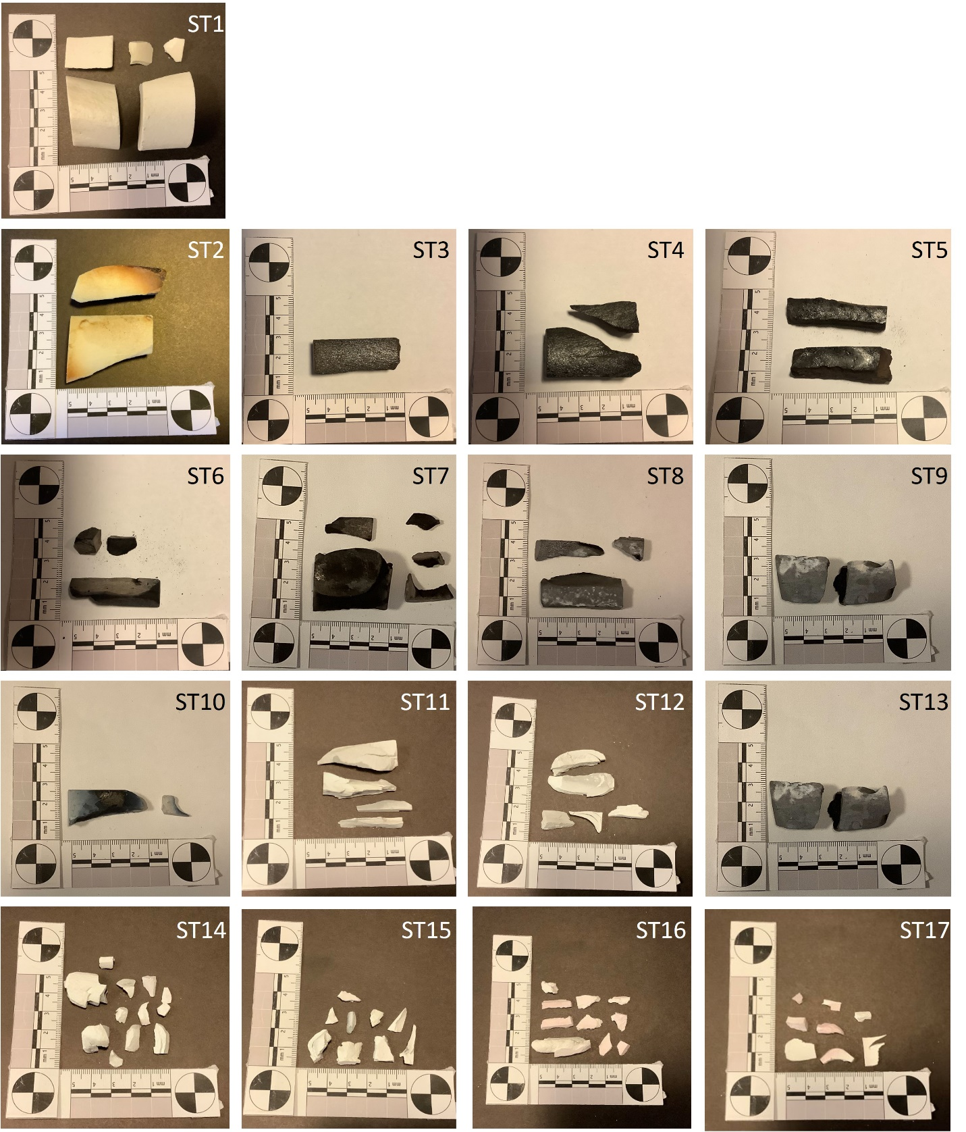
Figure S1. Standard modern samples burnt in controlled conditions at different temperatures for different times.

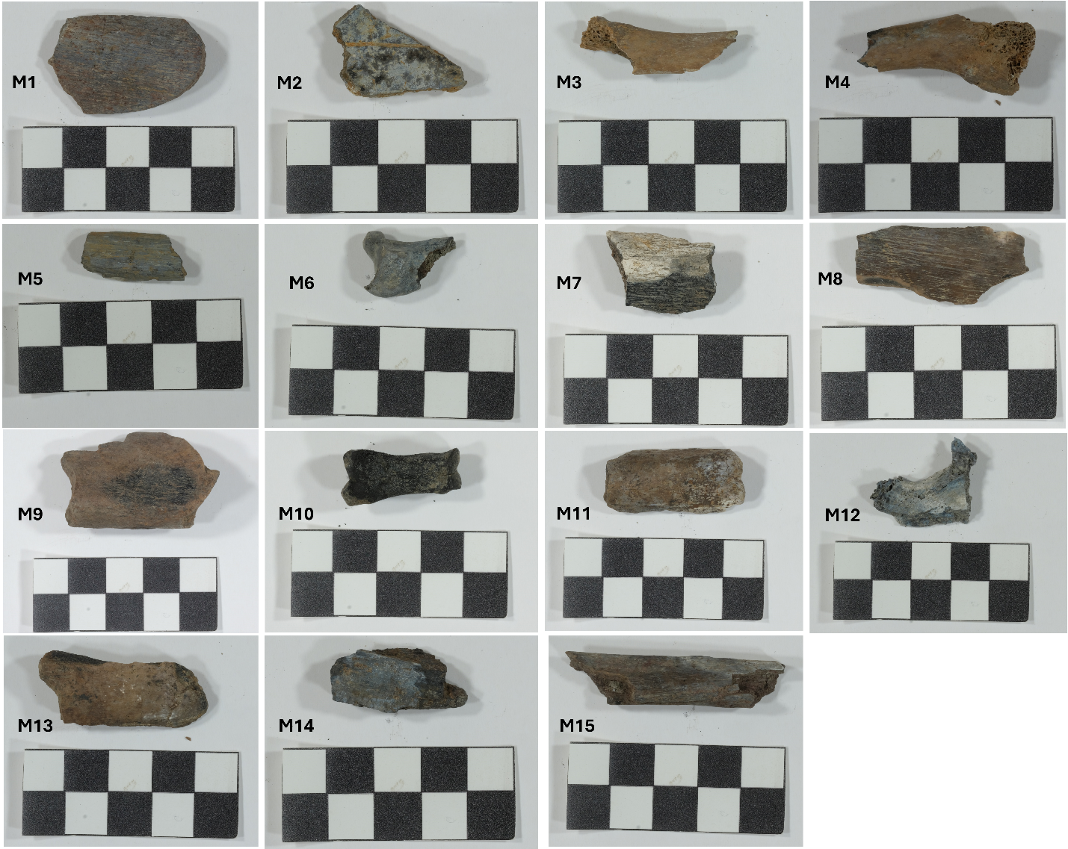
Figure S2. Archaeological samples investigated.

Portable FTIR results on standard bones

As previously reported [1], the FTIR spectra of the unburnt sample (S1) and the sample burnt at 300°C for 30 minutes (S2) present common features (Figure S3, Table 2). After brief exposure to 300°C, the sample still shows amide I (1690 cm⁻¹) and amide II (1595-1560 cm⁻¹) bands, as well as a significant contribution from the CH stretching bands in the range 2916-2849 cm⁻¹. Moreover, the carbonate band at 1448-1401 cm⁻¹ is still present.
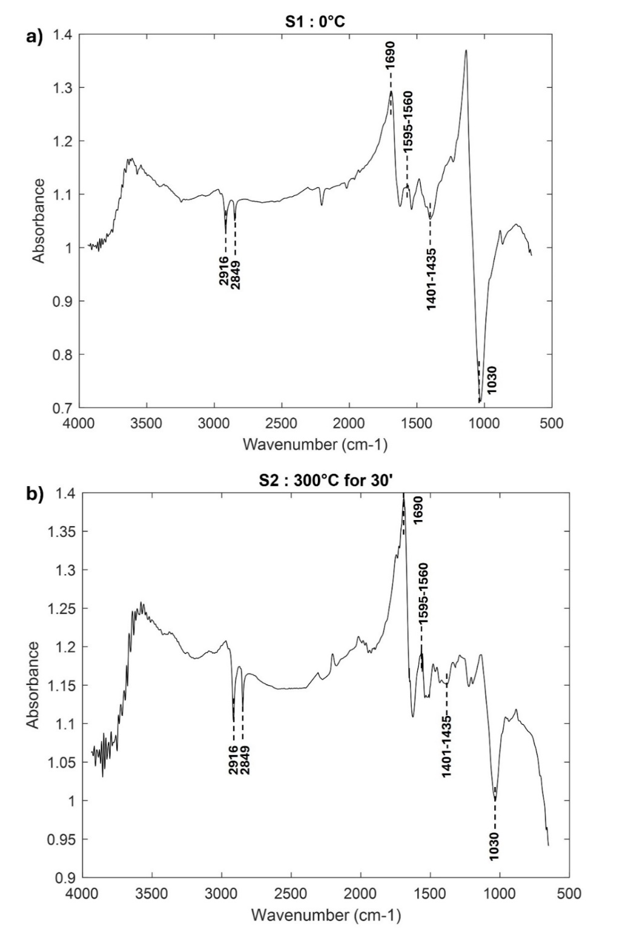
Figure S3. Portable FTIR spectra in the mid IR range of standard modern samples unburnt and burnt in controlled conditions at 300°C for 30 minutes. The average of the different points acquired is here reported.
When the exposure time at 300°C is increased to 60 to 120 minutes (S3-S5), the sample begins to degrade, providing similar spectroscopic features (Figure S4, S5 a, Table 2). The primary change is detected in the organic fraction due to incomplete combustion. Specifically, amide II is barely detectable, moreover weak signals at about 2204 and 2016 cm⁻¹, ascribable to cyanamide (ν₃ (NCN²⁻)) and cyanate (ν₃ (NCO⁻)), respectively, can be detected due to the starting of superficial charring. The presence of these compounds in presence of oxygen could be explained as the thermal decomposition of organic compounds, that temporarily produce intermediates [1].
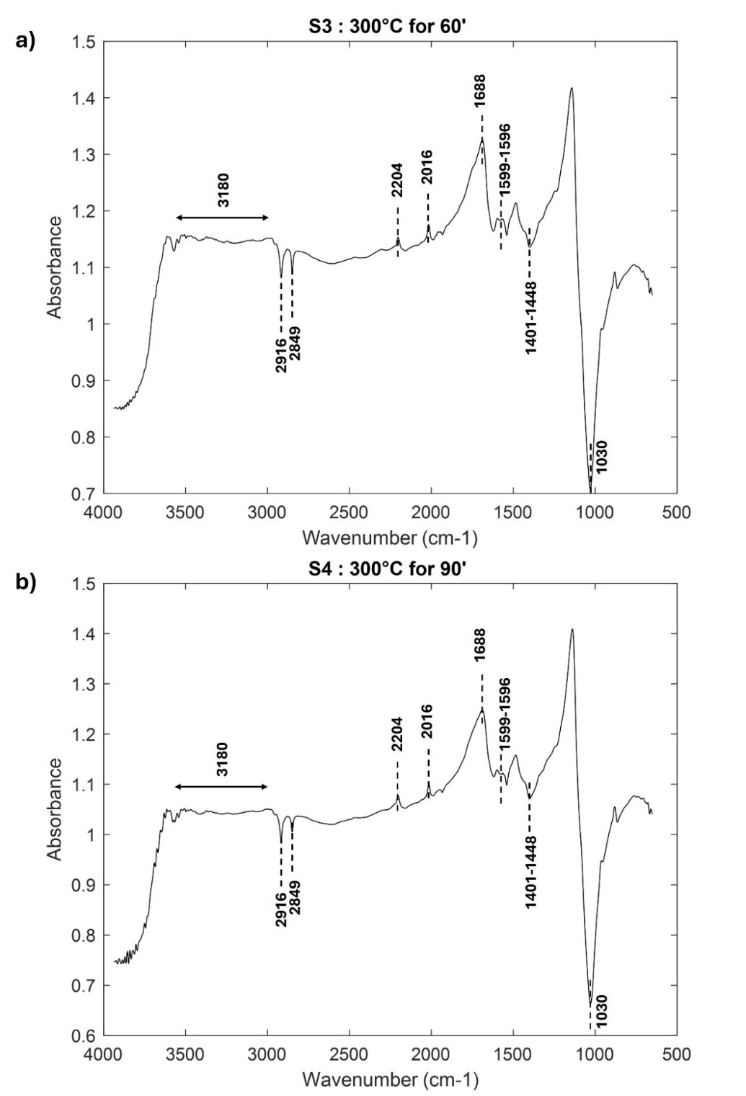
Figure S4. Portable FTIR spectra in the mid IR range of standard modern samples burnt in controlled conditions at 300°C for 60 and 90 minutes. The average of the different points acquired is here reported.
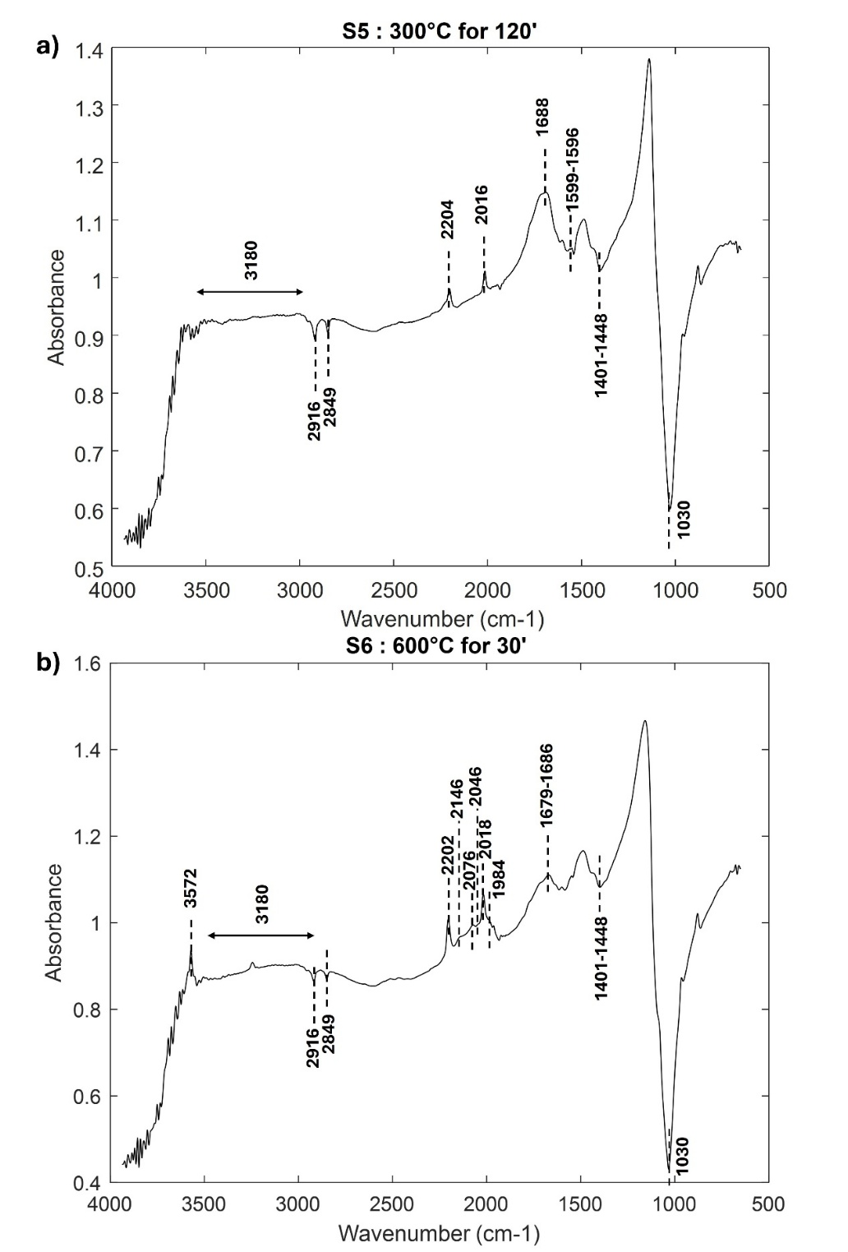
Figure S5. Portable FTIR spectra in the mid IR range of standard modern samples burnt in controlled conditions at 300°C for 120 minutes and at 600°C for 30 minutes. The average of the different points acquired is here reported.
Samples burnt at 600°C for 30 to 120 minutes (S6–S9) are characterized by the appearance of further peaks in the region 2000-2200 cm⁻¹, attributed to cyanate (ν₃ (NCO⁻)), cyanamide (ν₃ (NCN²⁻)), and phosphate ((PO₄)³⁻ 2 ν₃ overtones and ν₃ combinations), with the increase of their intensity (Figure S5 b, S6, S7 a, Table 2). Moreover, a sharp peak at 3572 cm-1 attributed to OH stretching appears. The band detected between 1679-1686 cm⁻¹ may be attributed to amide I or even more likely, to aromatic C=C and/or water bending modes [1,2].
Bone samples treated at 900°C for 30 minutes (S10) present some peculiar features (Figure S7 b, Table 2). Compared to the previous samples, the signal at about 1682 cm⁻¹ changes in shape, and the broad OH band characterizing all the spectra disappears, leaving only the sharp and narrow OH band at 3572 cm⁻¹.
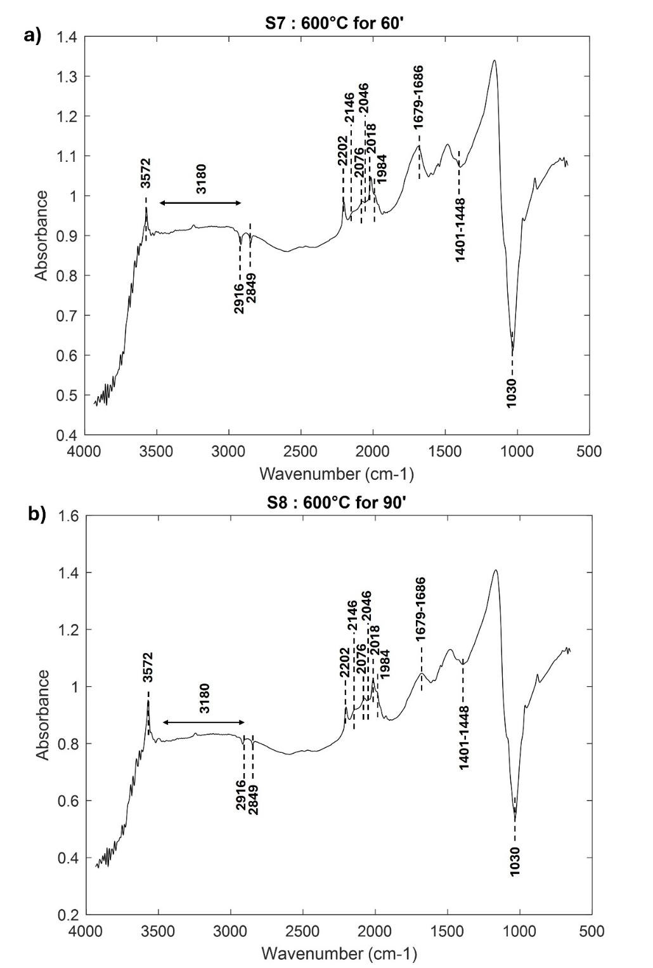
Figure S6. Portable FTIR spectra in the mid IR range of standard modern samples burnt in controlled conditions at 600°C for 60 and 90 minutes. The average of the different points acquired is here reported.
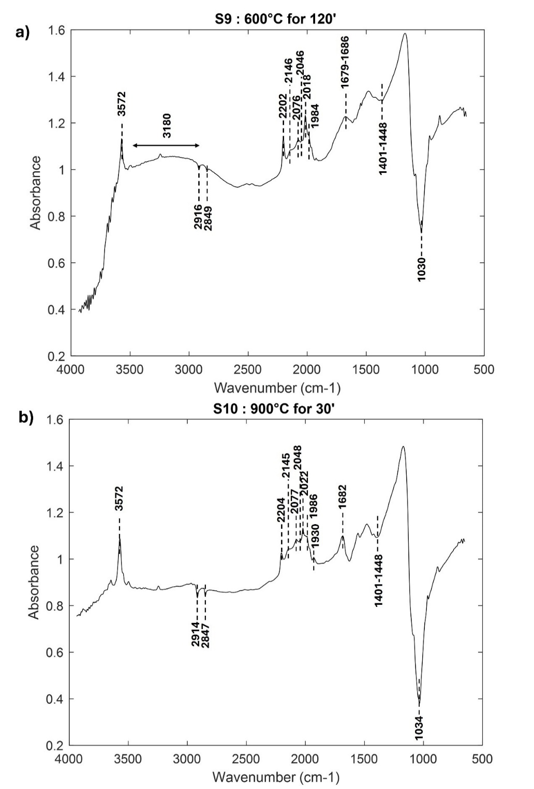
Figure S7. Portable FTIR spectra in the mid IR range of standard modern samples burnt in controlled conditions at 600°C for 120 and at 900°C for 30 minutes. The average of the different points acquired is here reported.
Bones exposed at 900°C for 60-120 minutes and at 1200°C (S11-S17) (Figure S8, S9, S10, S11, Table 2) still present the signal in the 2000-2200 cm⁻¹ region related to cyanates and cyanamide, with a slight decrease in the band at 2204 and 1986 cm⁻¹ in the S17 sample (Figure S10, Table2). Additionally, peaks at 3650, 3544 cm⁻¹, and 3496 cm⁻¹, respectively related to Ca–OH vibration, F–OH, and Cl–OH vibration, are detected. Moreover, the band related to ν₃(PO₄³⁻) splits (1036-1047, 1095-1110 cm⁻¹) due to the dehydroxylation of bioapatite and the progressive production of β-TCP (β-Tricalcium phosphate), and the carbonate band at 14001-1448 cm⁻¹ disappears.

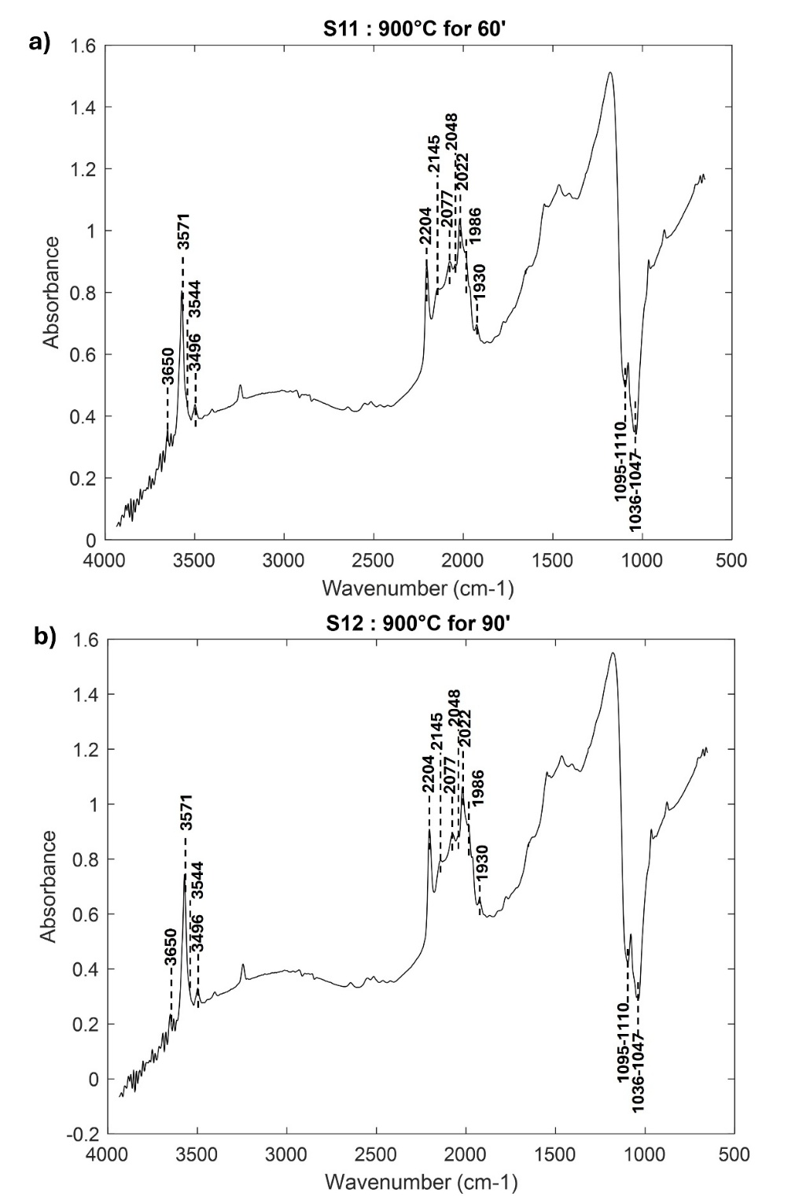
Figure S8. Portable FTIR spectra in the mid IR range of standard modern samples burnt in controlled conditions at 900°C for 60 and 90 minutes. The average of the different points acquired is here reported.

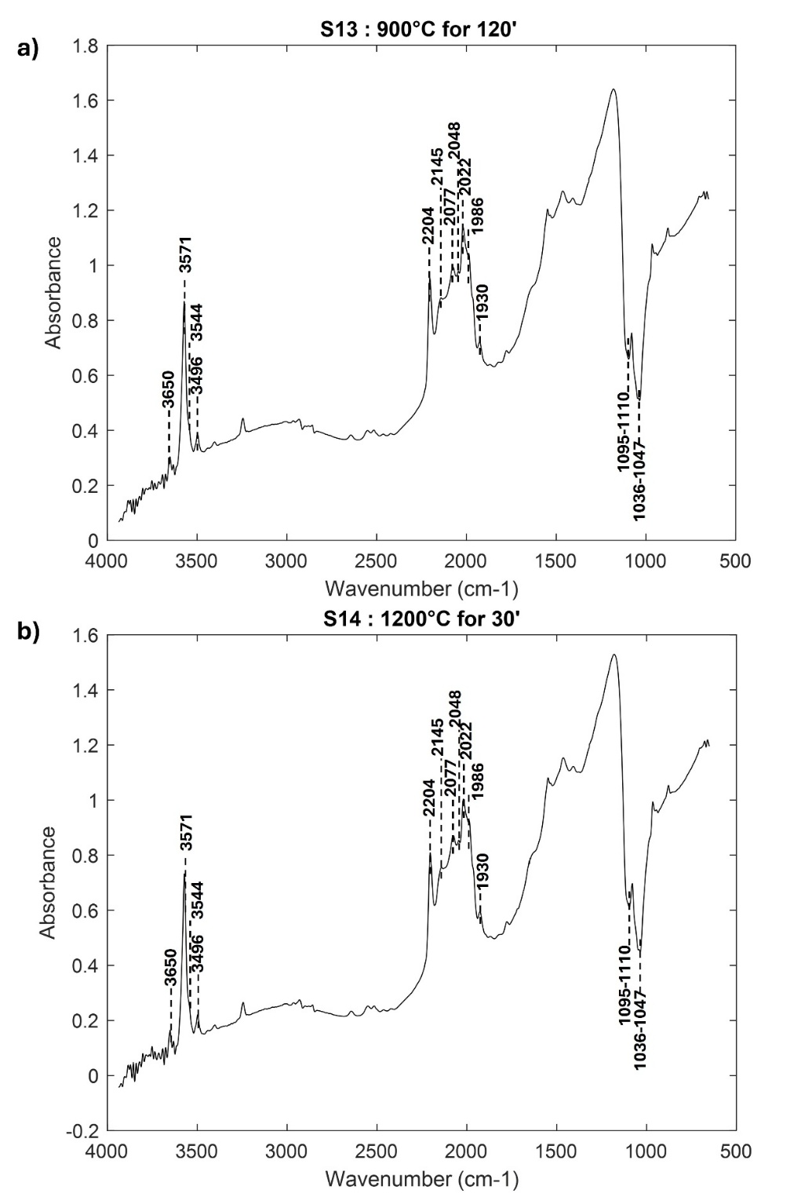
Figure S9. Portable FTIR spectra in the mid IR range of standard modern samples burnt in controlled conditions at 900°C for 120 and at 1200°C for 30 minutes. The average of the different points acquired is here reported.

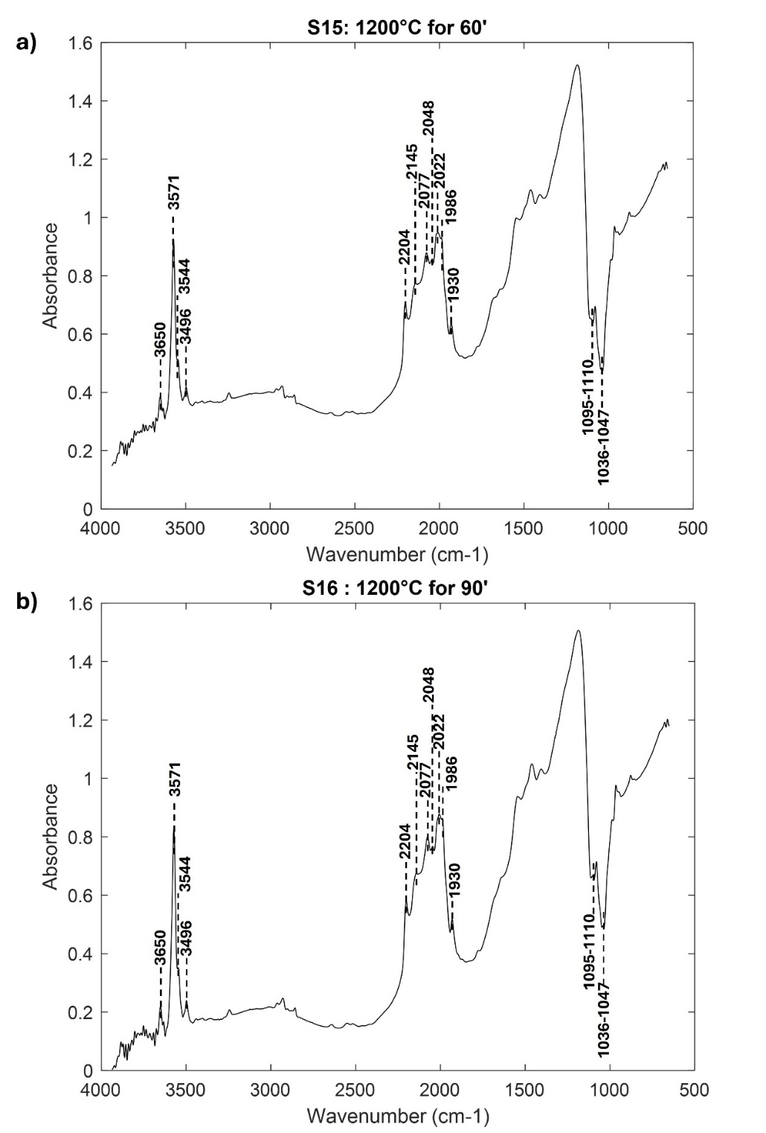
Figure S10. Portable FTIR spectra in the mid IR range of standard modern samples burnt in controlled conditions at 1200°C for 60 and 90 minutes. The average of the different points acquired is here reported.

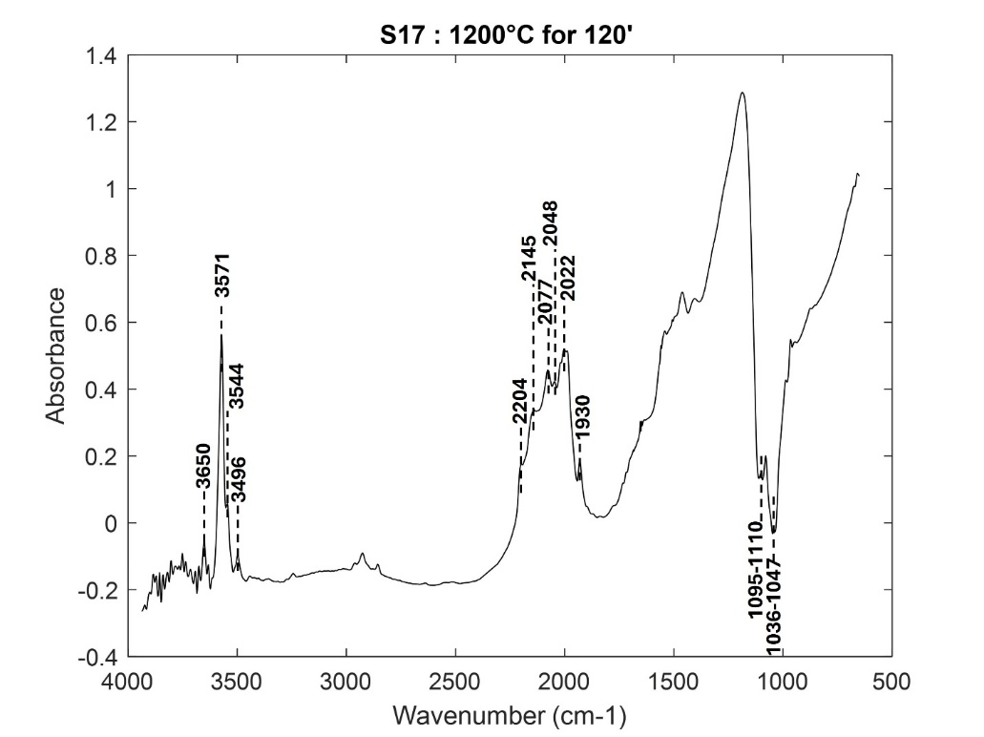
Figure S11. Portable FTIR spectra in the mid IR range of standard modern samples burnt in controlled conditions at 1200°C for 120 minutes. The average of the different points acquired is here reported.

Micro NIR results on standard bones

Standards of pure commercial collagen and pure commercial bioapatite were analyzed to assign the NIR bands (Table S1, Figure S12).
The second derivative MicroNIR spectra of raw bovine femur bone (S1) presented characteristic bands related to the N-H first overtone at 1508 and 1583 nm and the N-H second overtone at 1025 nm (Figure S12, Table 3), corresponding to the signals observed in gelatine from porcine skin (Figure S12). Additionally, the O-H first overtone appears at 1422 nm, such as the bands at 1180 nm and 1273 nm related to the C-H second overtone, and the band at 1347 nm (C-H combination).
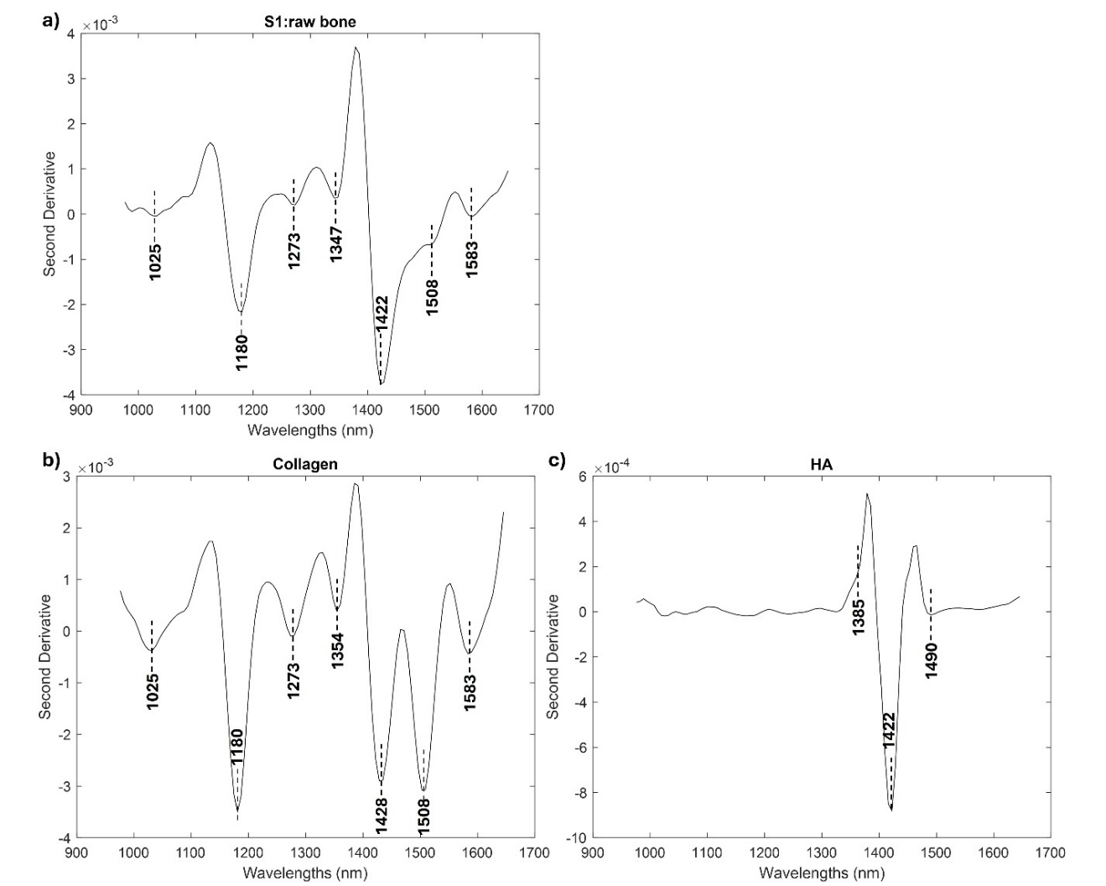
Figure S12. MicroNIR analysis of raw bone (S1) (a), pure commercial collagen (b) and pure commercial hydroxyapatite. Averaged second derivative spectra are here reported.

The MicroNIR spectra of bones heated at 300°C for varying durations exhibit notable variations in characteristic bands. As observed with the portable FTIR, the bones exposed to 300°C for 30 minutes (S2) show a strong resemblance to the spectra of the untreated raw bone (Figure S13 a). Specifically, the first and second overtones of N-H are prominently present, confirming with MicroNIR that after a brief exposure to a low temperature, no degradation occurs.
Standard S3 (300°C for 60 minutes) showed variable spectra depending on the point of analysis, with an overall decrease in intensity. Thus, the blackening of the surface led to a reduced amount of reflectance due to absorption processes. In some points, it is still possible to detect the band at 1180 nm, ascribable to the C-H 2nd overtone, and 1347 nm related to the C-H combination bands (Table 3, Figure S13 b) [3]. Additionally, the intensity of the O-H 1st overtone band decreases, and a new sharp and strong band appears at 951 nm (C-H 3rd overtone and/or O-H 2nd overtone), together with an absorption band at 1001 nm related to the combination vibration of the H-O-H bend and O-H stretch of water [4,5].
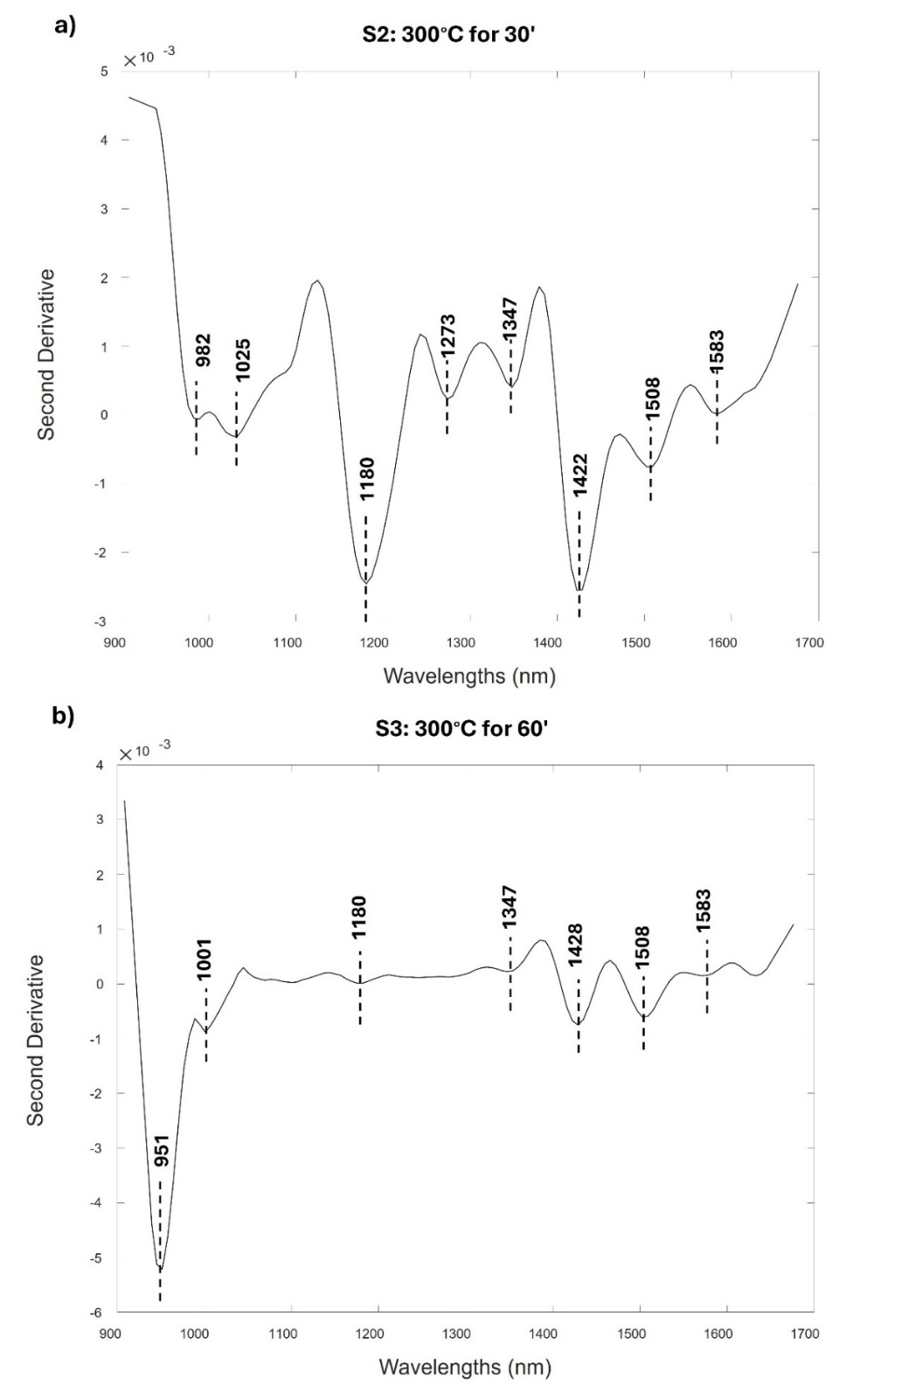
Figure S13. Micro-NIR spectra of standard modern samples burnt in controlled conditions at 300°C for 30 and 60 minutes. The 2nd derivative of the average spectra of the different points acquired is here reported.
Unlike the portable FTIR results, NIR spectra allow to distinguish standards S4 and S5 (300°C for 90 and 120 minutes, respectively) from the previous one (Table 3, Figure S14). These samples appear darker and shinier than the previous standard, with a further decrease in the signal. The spectra are quite variable, and in some points, mainly the bands related to the O-H 1st overtone (1428 nm) and O-H 2nd overtone (1007 nm) can be detected.
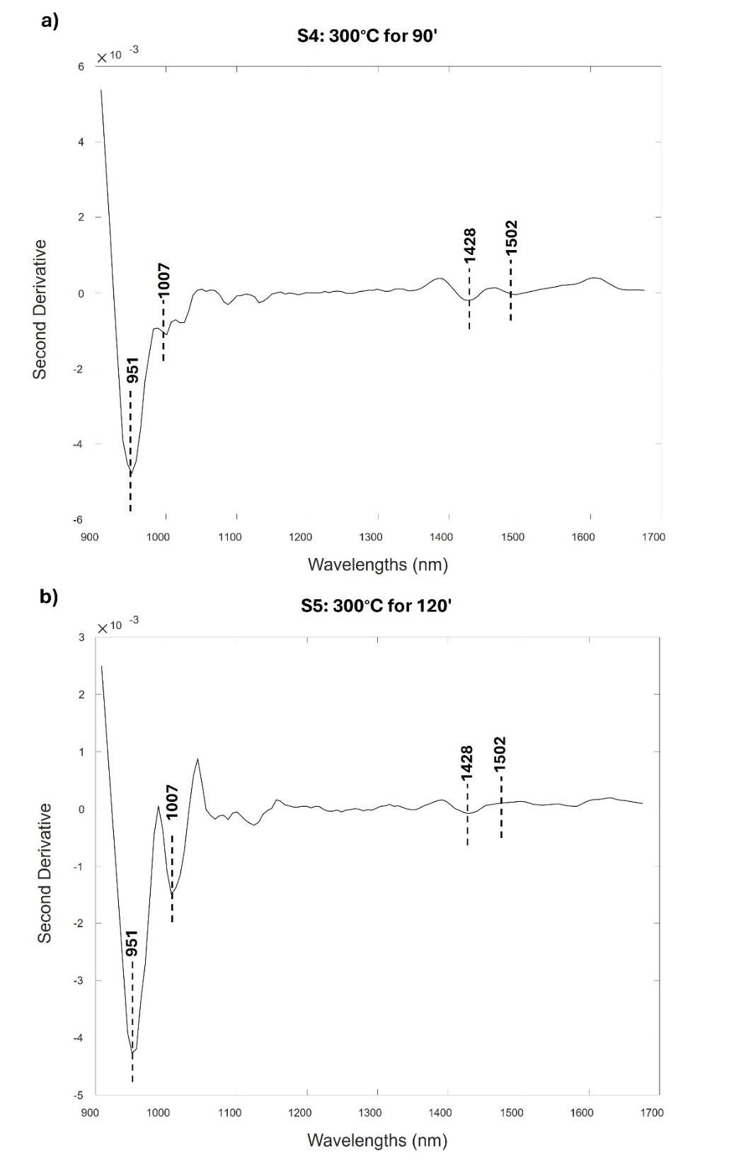
Figure S14. Micro-NIR spectra of standard modern samples burnt in controlled conditions at 300°C for 90 and 120 minutes. The 2nd derivative of the average spectra of the different points acquired is here reported.
Samples exposed to 600°C present different features depending on the duration of the exposure, unlike the results obtained using the portable FTIR. Standard S6 and S7 (600°C for 30 and 60 minutes) appear quite similar to the previous ones with a further reduction of the signal, even if a band at 1484 nm, ascribable to the Mg-OH 1st overtone, allows their discrimination (Table 3, Figure S15). The samples exposed to a temperature of 600°C for 90 minutes and 120 minutes (S8-S9) exhibited a shift in the peak associated with the O-H first overtone at 1434 nm, ascribable to the substitution of CO₃²⁻ in the OH⁻ site during the carbonization process (Table 3, Figure S16). Moreover, a second peak at 1391 nm can be identified, attributed to the OH combination ν_{sym}+ ν_{asym} [6], due to the carbonation process and the re-crystallization of bioapatite. These observations suggest significant alterations in the hydroxyl groups and the formation of new molecular structures within the bone matrix due to the extended thermal exposure. This phenomenon demonstrated substantial changes in the bone's chemical structure due to not only the elevated temperature exposure but also the prolonged exposure.
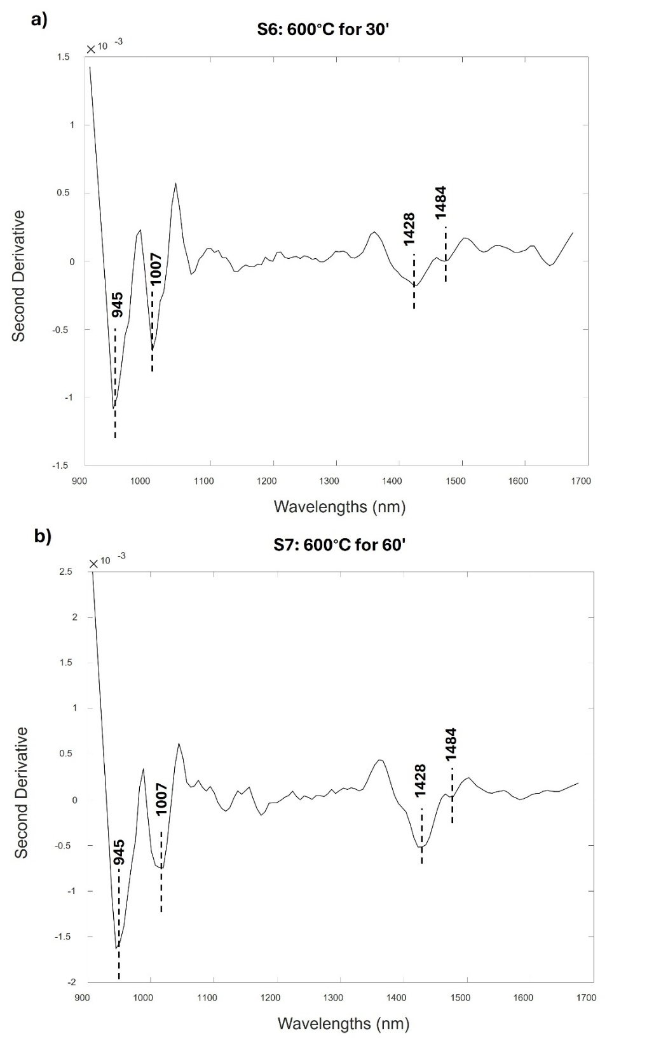
Figure S15. Micro-NIR spectra of standard modern samples burnt in controlled conditions at 600°C for 30 and 60 minutes. The 2nd derivative of the average spectra of the different points acquired is here reported.
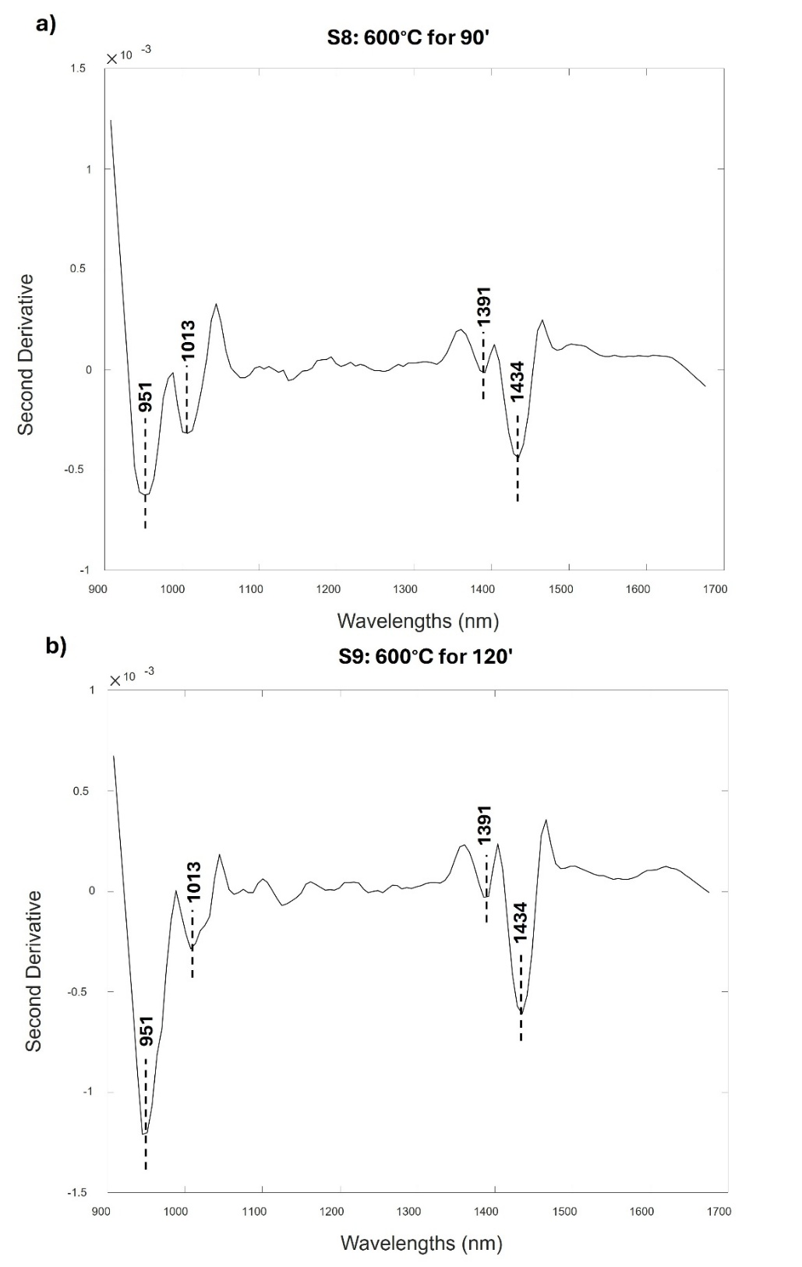
Figure S16. Micro-NIR spectra of standard modern samples burnt in controlled conditions at 600°C for 90 and 120 minutes. The 2nd derivative of the average spectra of the different points acquired is here reported.
Spectra of standard S10 are extremely low in intensity due to the dark colour and are not particularly significant (data not shown).
The MicroNIR spectra of bone samples subjected to thermal treatment at 900°C for varying durations (60, 90, 120 minutes, S11-S13) and to 1200°C for 30 minutes (S14) reveal notable spectral similarities (Table 3, Figure S17, S18), such as the disappearance of the peak at 1007 nm and the appearance of a shoulder at 1490 nm, which is ascribable to the Mg-OH 1st overtone. Moreover, the 1434 nm band appears sharper, suggesting a higher level of crystallinity, larger crystal sizes overall, and reduced porosity.
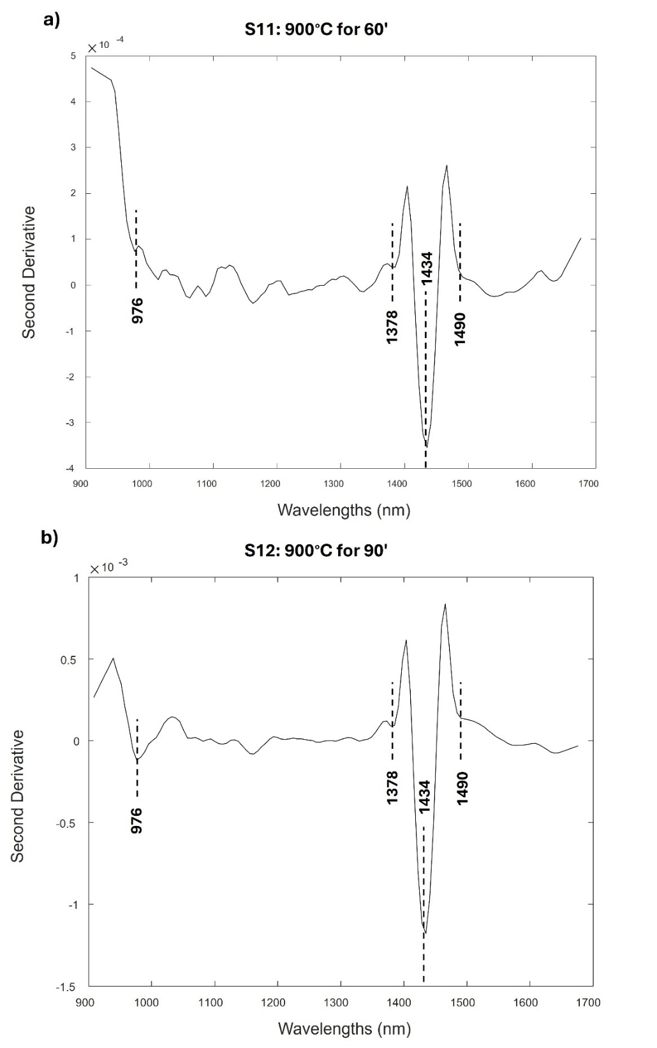
Figure S17. Micro-NIR spectra of standard modern samples burnt in controlled conditions at 900°C for 60 and 90 minutes. The 2nd derivative of the average spectra of the different points acquired is here reported.
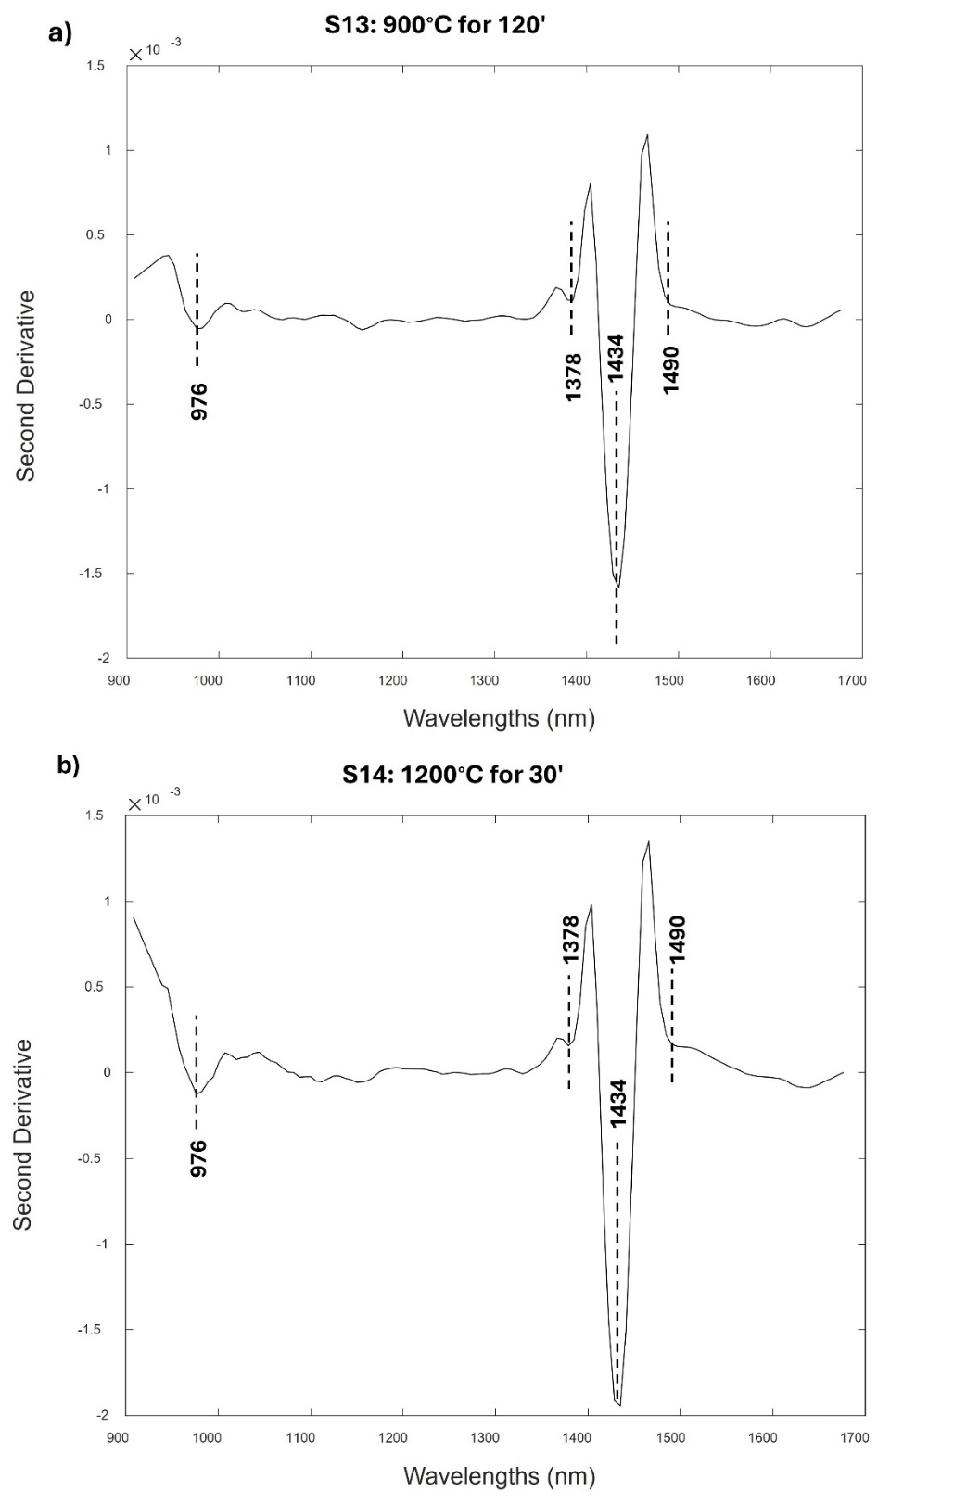
Figure S18. Micro-NIR spectra of standard modern samples burnt in controlled conditions at 900°C for 120 and at 1200°C for 30 minutes. The 2nd derivative of the average spectra of the different points acquired is here reported.
All the samples burnt at 1200°C for prolonged times (>60 minutes) (S15-17) showed similar spectral profile as the previous mentioned group (S11-13) making distinction among samples quite difficult (Table3, Figure S19, S20).

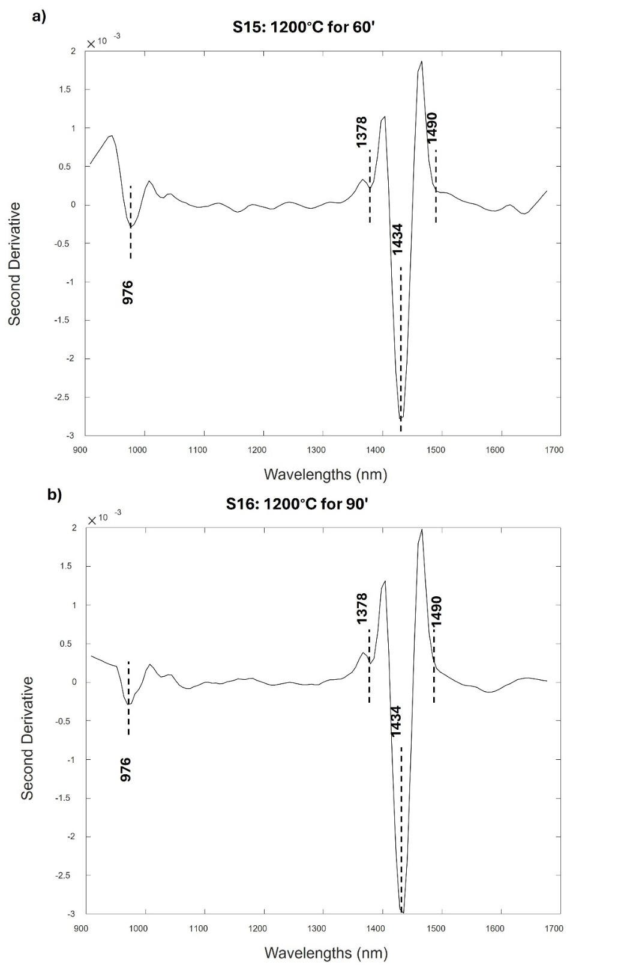
Figure S19. Micro-NIR spectra of standard modern samples burnt in controlled conditions at 1200°C for 60 and 90 minutes. The 2nd derivative of the average spectra of the different points acquired is here reported.
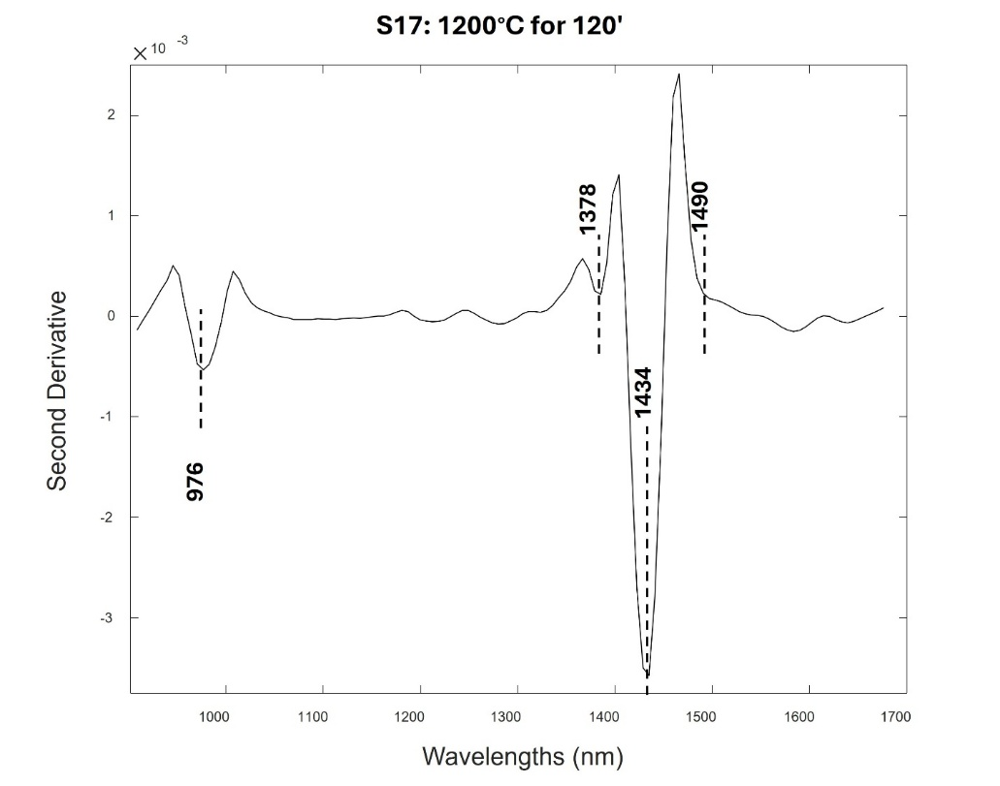
Figure S20. Micro-NIR spectra of standard modern samples burnt in controlled conditions at 1200°C for 120 minutes. The 2nd derivative of the average spectra of the different points acquired is here reported.

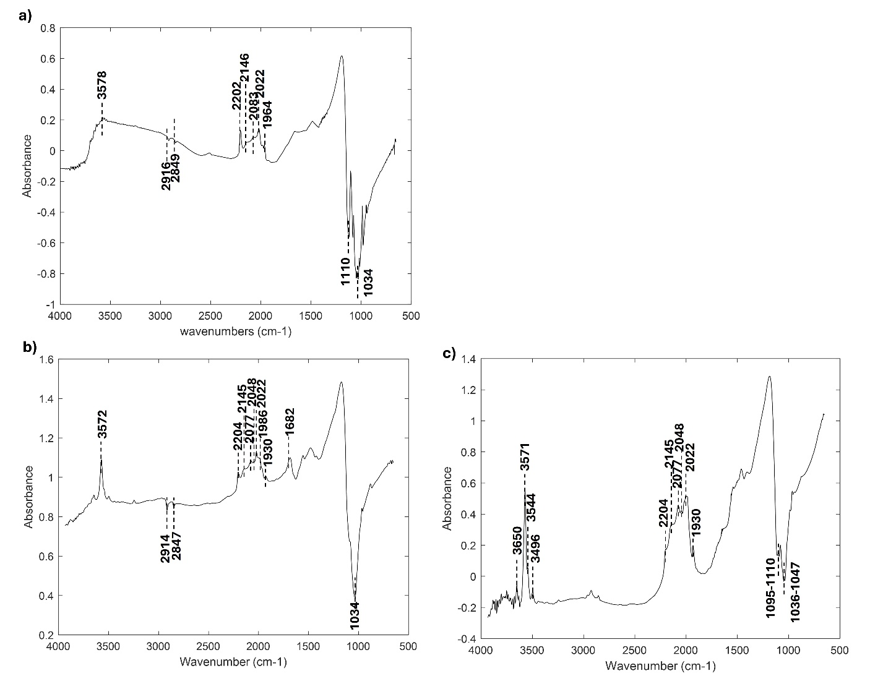
Figure S21. Average spectrum of sample M6, here reported as representative of the group, acquired by portable FTIR (a). The spectra of M12 and M14 are reported in Figure S29, S30. Comparison with standard samples S10 (BS5) (b) and S17(BS6) (c) acquired by portable FTIR.

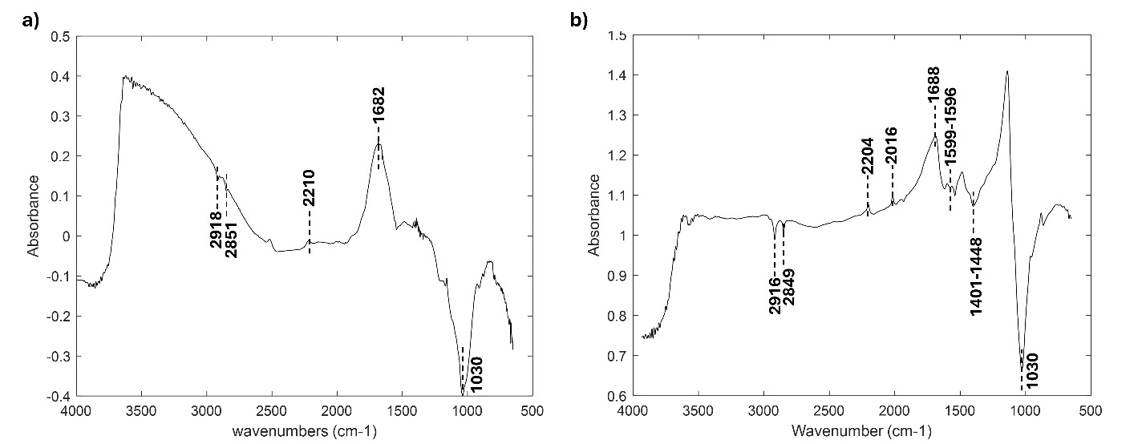
Figure S22. Average spectrum of sample M10 acquired by portable FTIR (a) and comparison with standard sample S4 (b) acquired by portable FTIR.

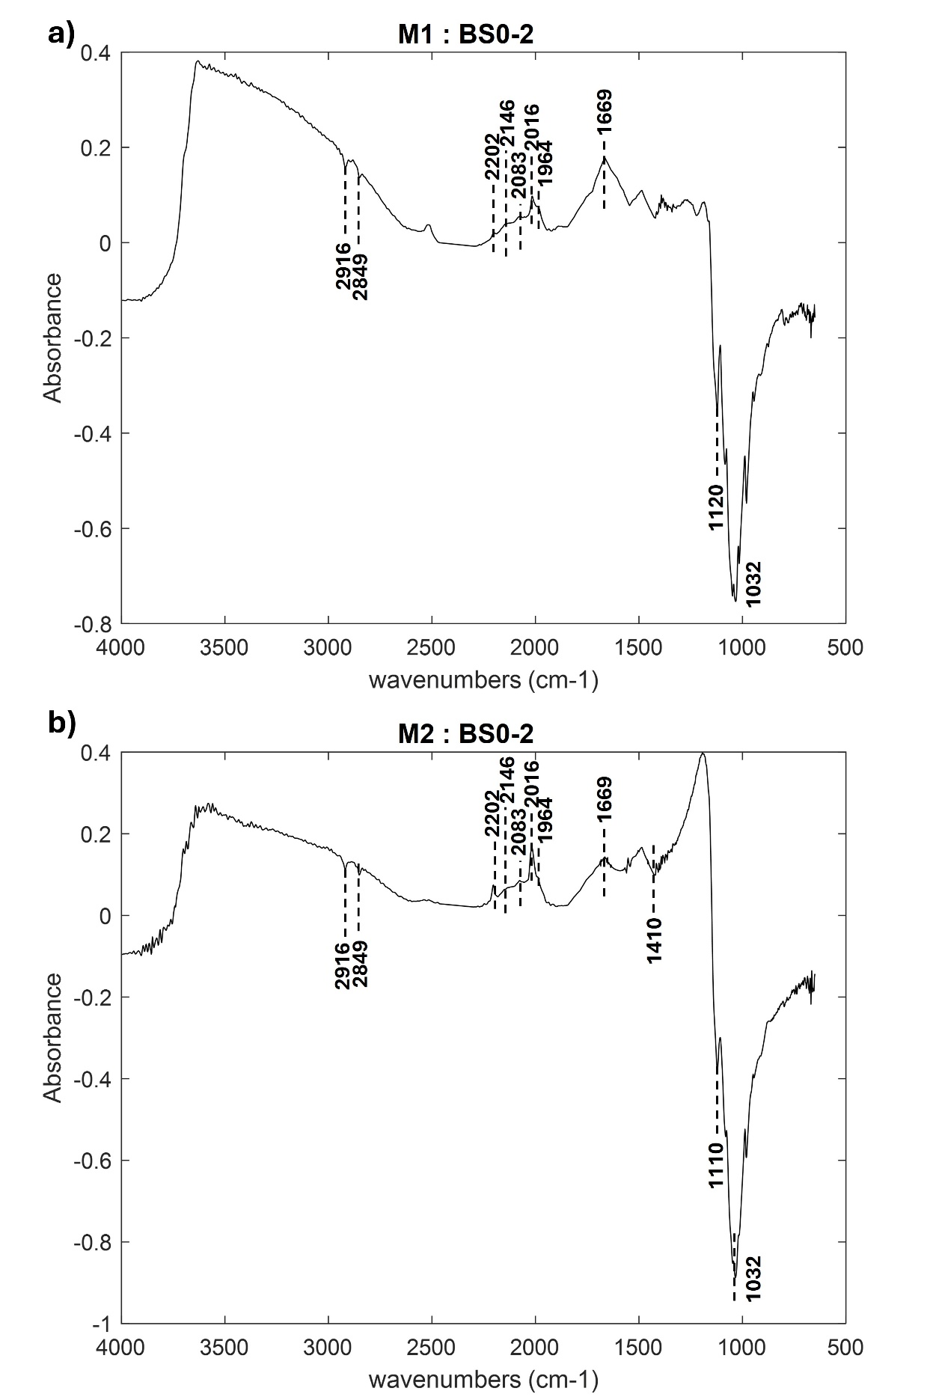
Figure S23. averaged spectra acquired by portable FTIR of archaeological samples: M1 (BS0-2) (a), M2 (BS0-2) (b). The attributed burning phases according to the portable FTIR are reported.
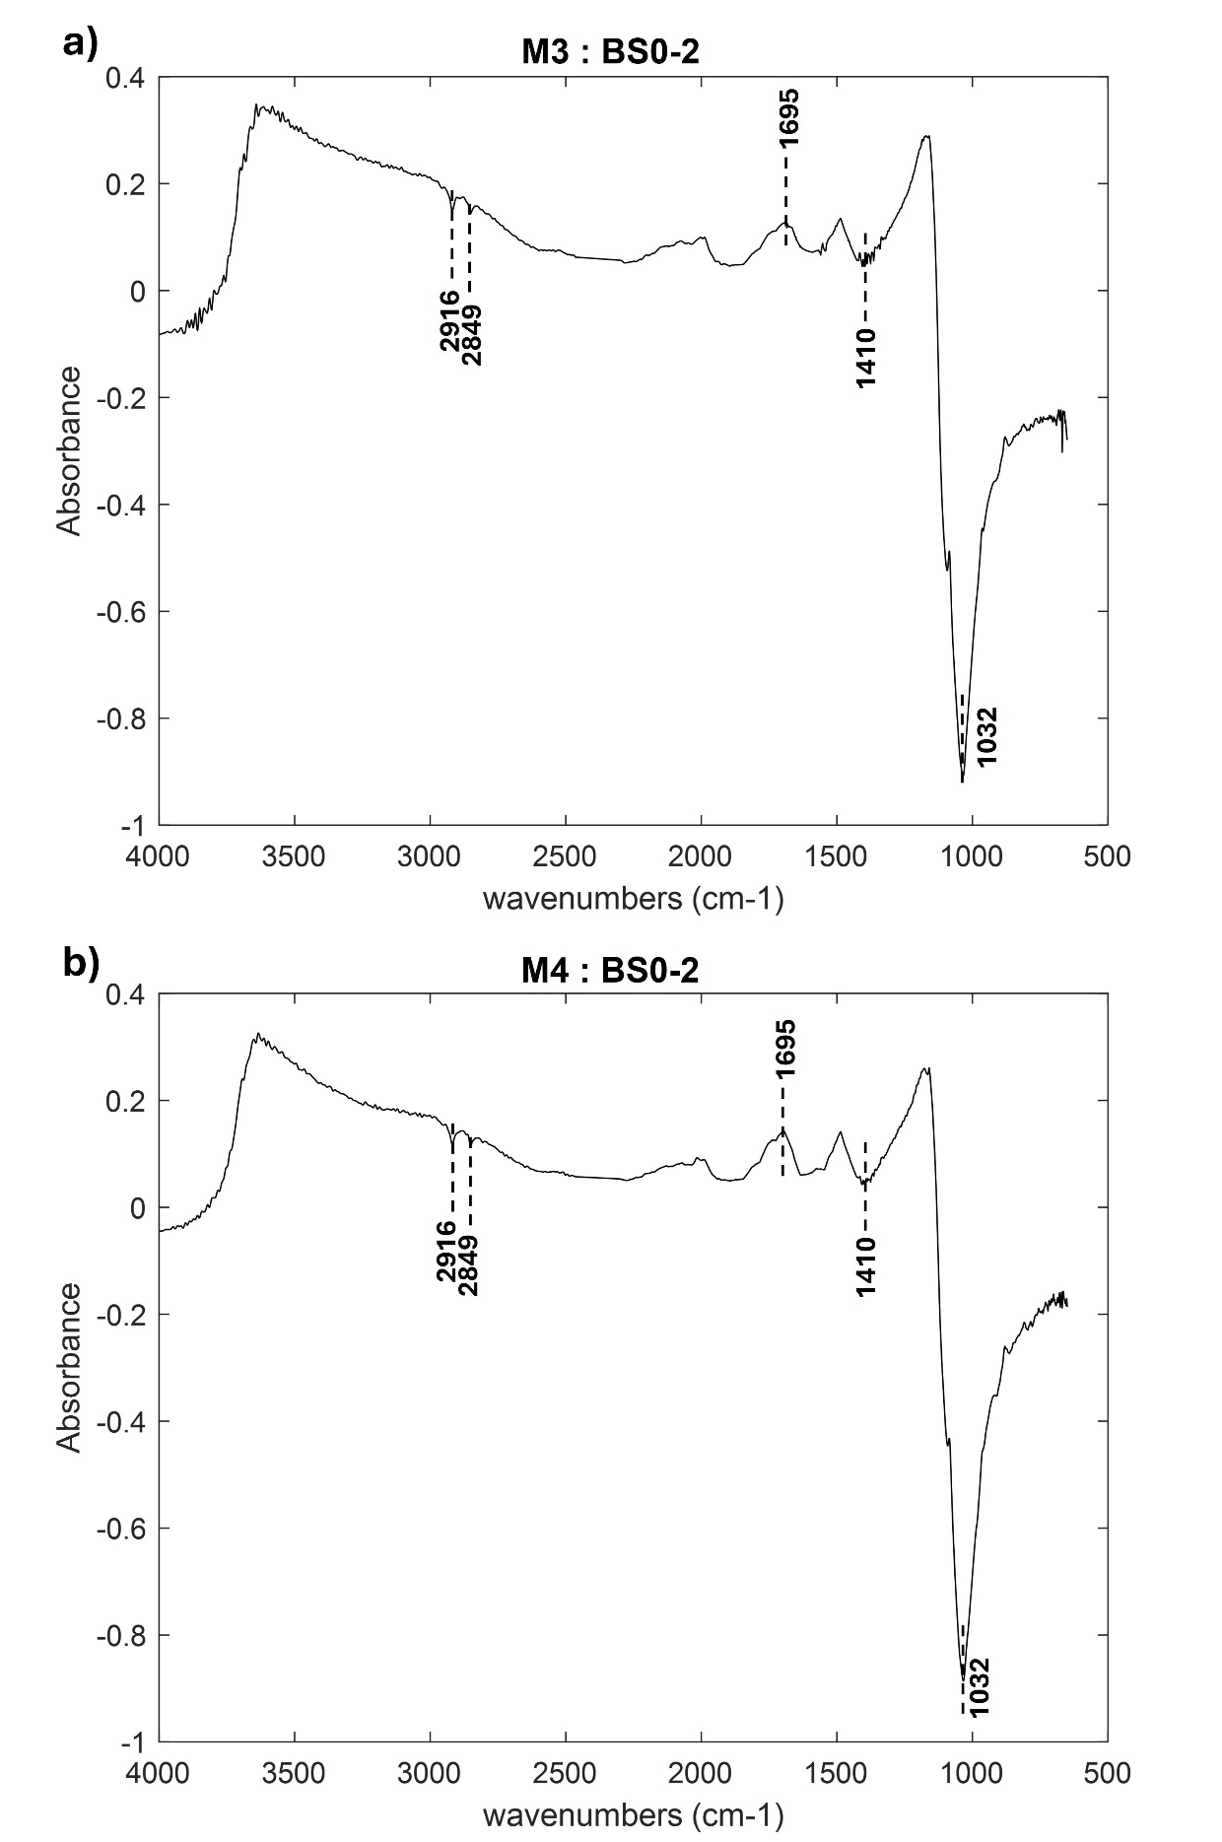
Figure S24. averaged spectra acquired by portable FTIR of archaeological samples: M3 (BS0-2) (a), M4 (BS0-2) (b). The attributed burning phases according to the portable FTIR are reported.
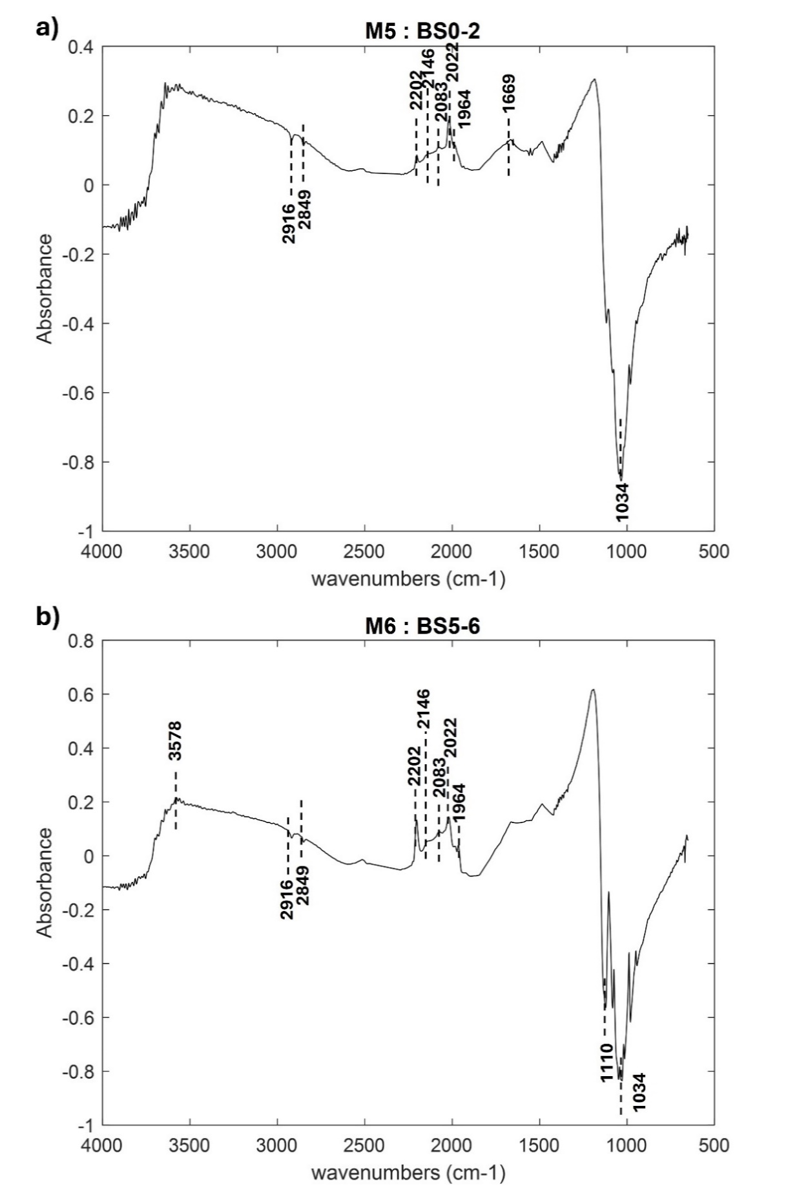
Figure S25. averaged spectra acquired by portable FTIR of archaeological samples: M5 (BS0-2) (a), M6 (BS5-6) (b). The attributed burning phases according to the portable FTIR are reported.
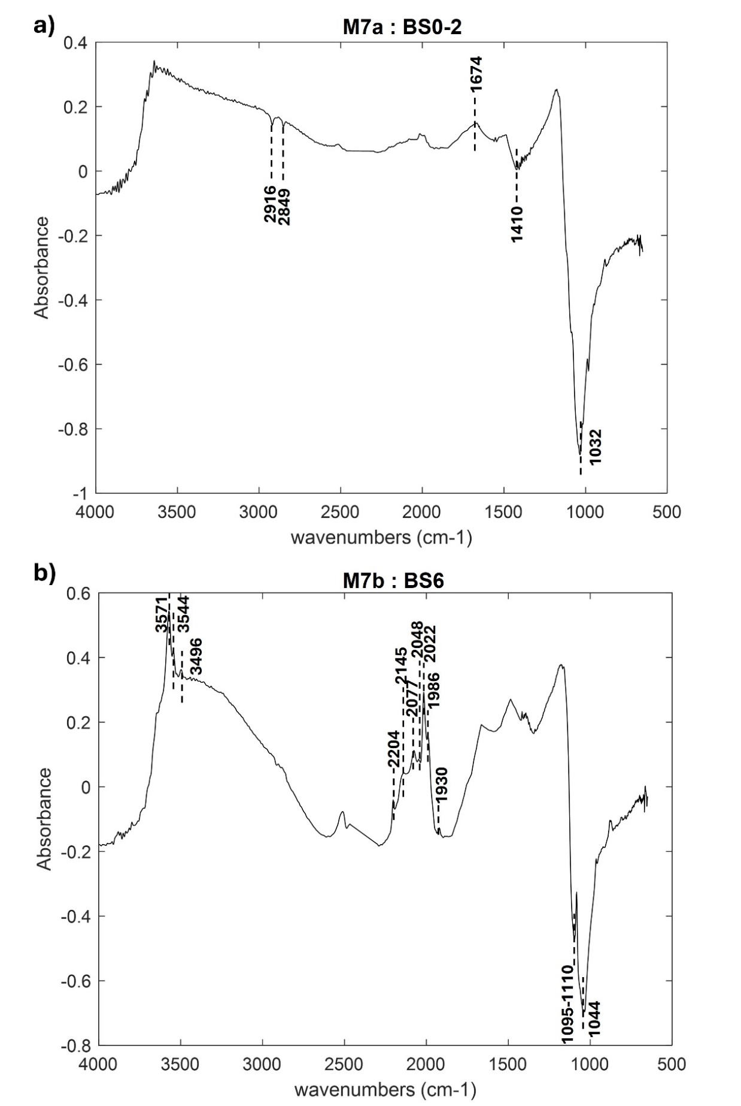
Figure S26. averaged spectra acquired by portable FTIR of archaeological samples: M7a (BS0-2) (a), M7b (BS6) (b). The attributed burning phases according to the portable FTIR are reported.
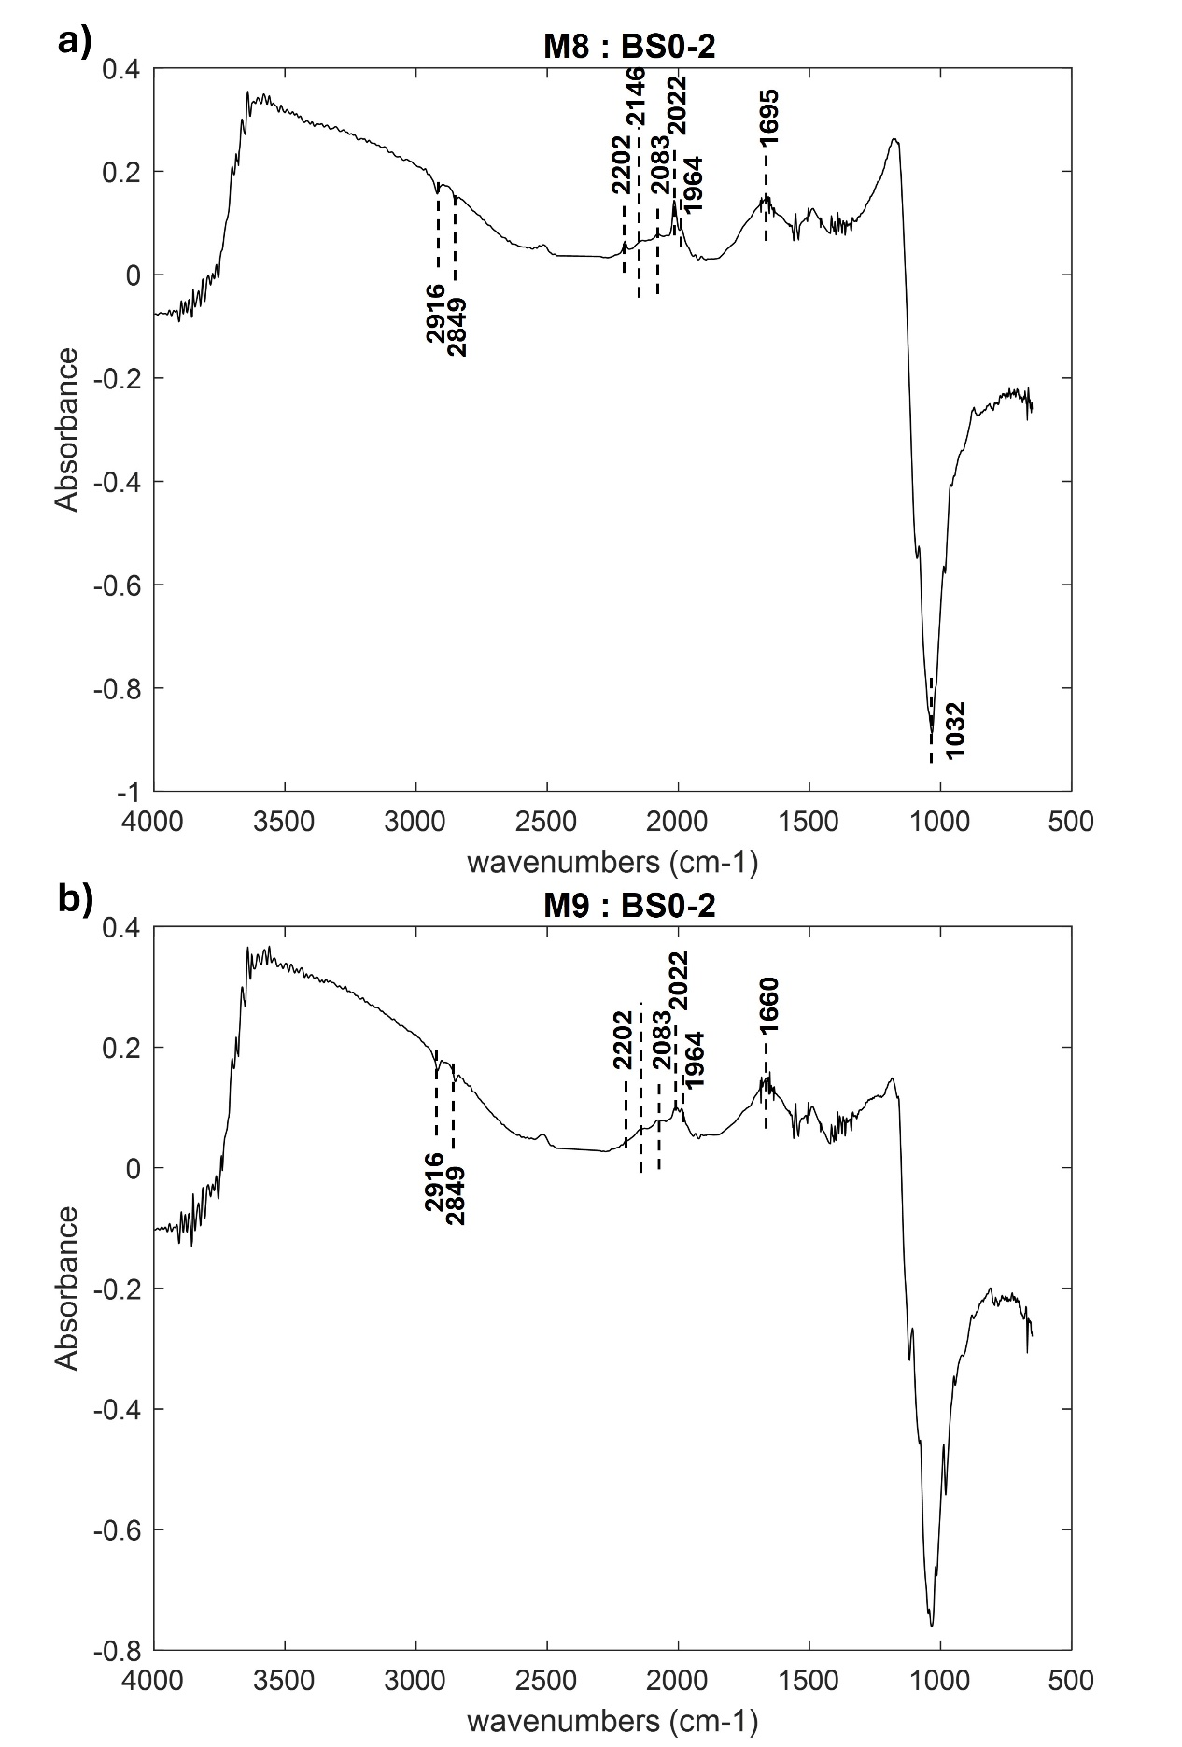
Figure S27. averaged spectra acquired by portable FTIR of archaeological samples: M8 (BS0-2) (a), M9 (BS0-2) (b). The attributed burning phases according to the portable FTIR are reported.
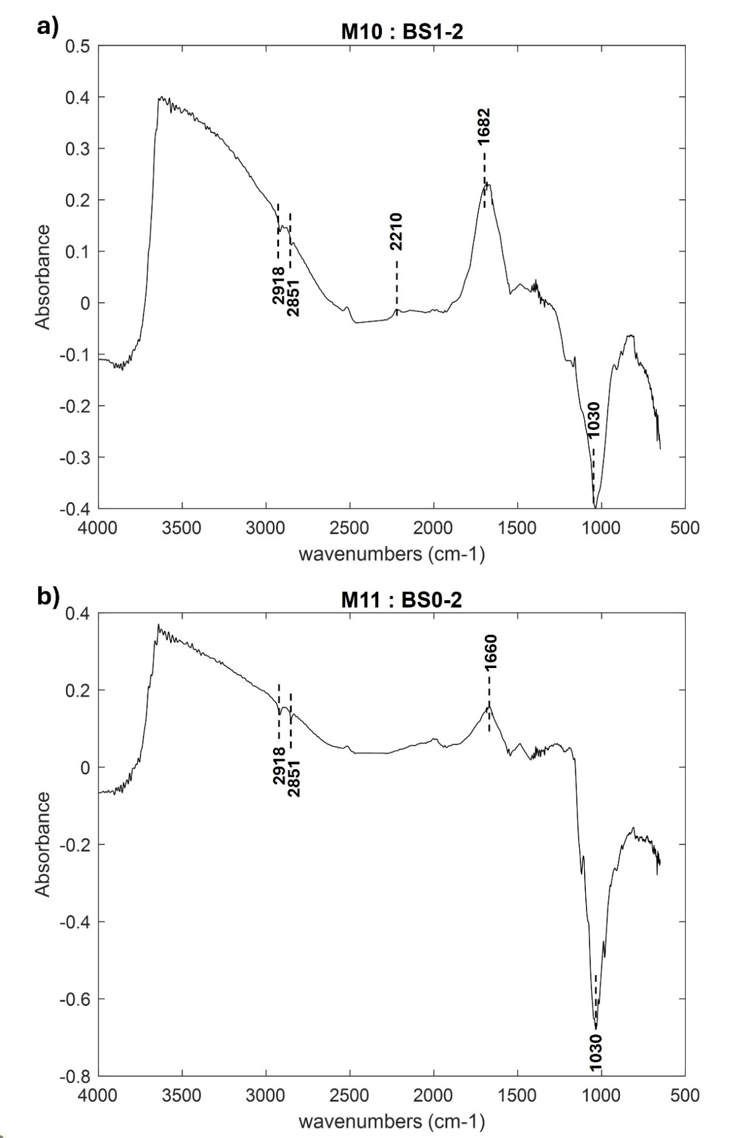
Figure S28. averaged spectra acquired by portable FTIR of archaeological samples: M10 (BS1-2) (a), M11 (BS0-2) (b). The attributed burning phases according to the portable FTIR are reported.
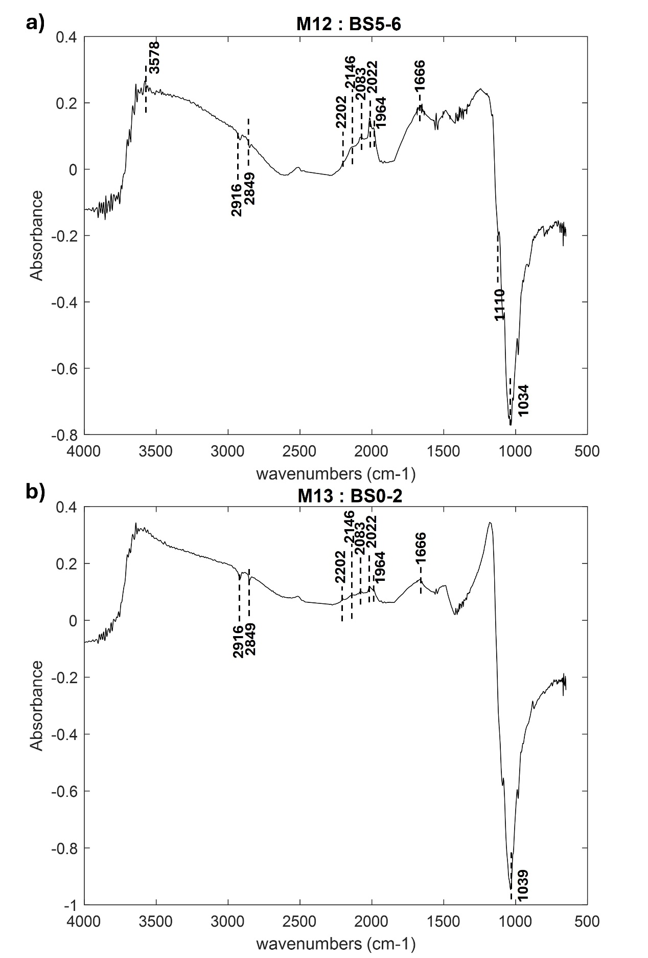
Figure S29. averaged spectra acquired by portable FTIR of archaeological samples: M12 (BS5-6) (a), M13 (BS0-2) (b). The attributed burning phases according to the portable FTIR are reported.
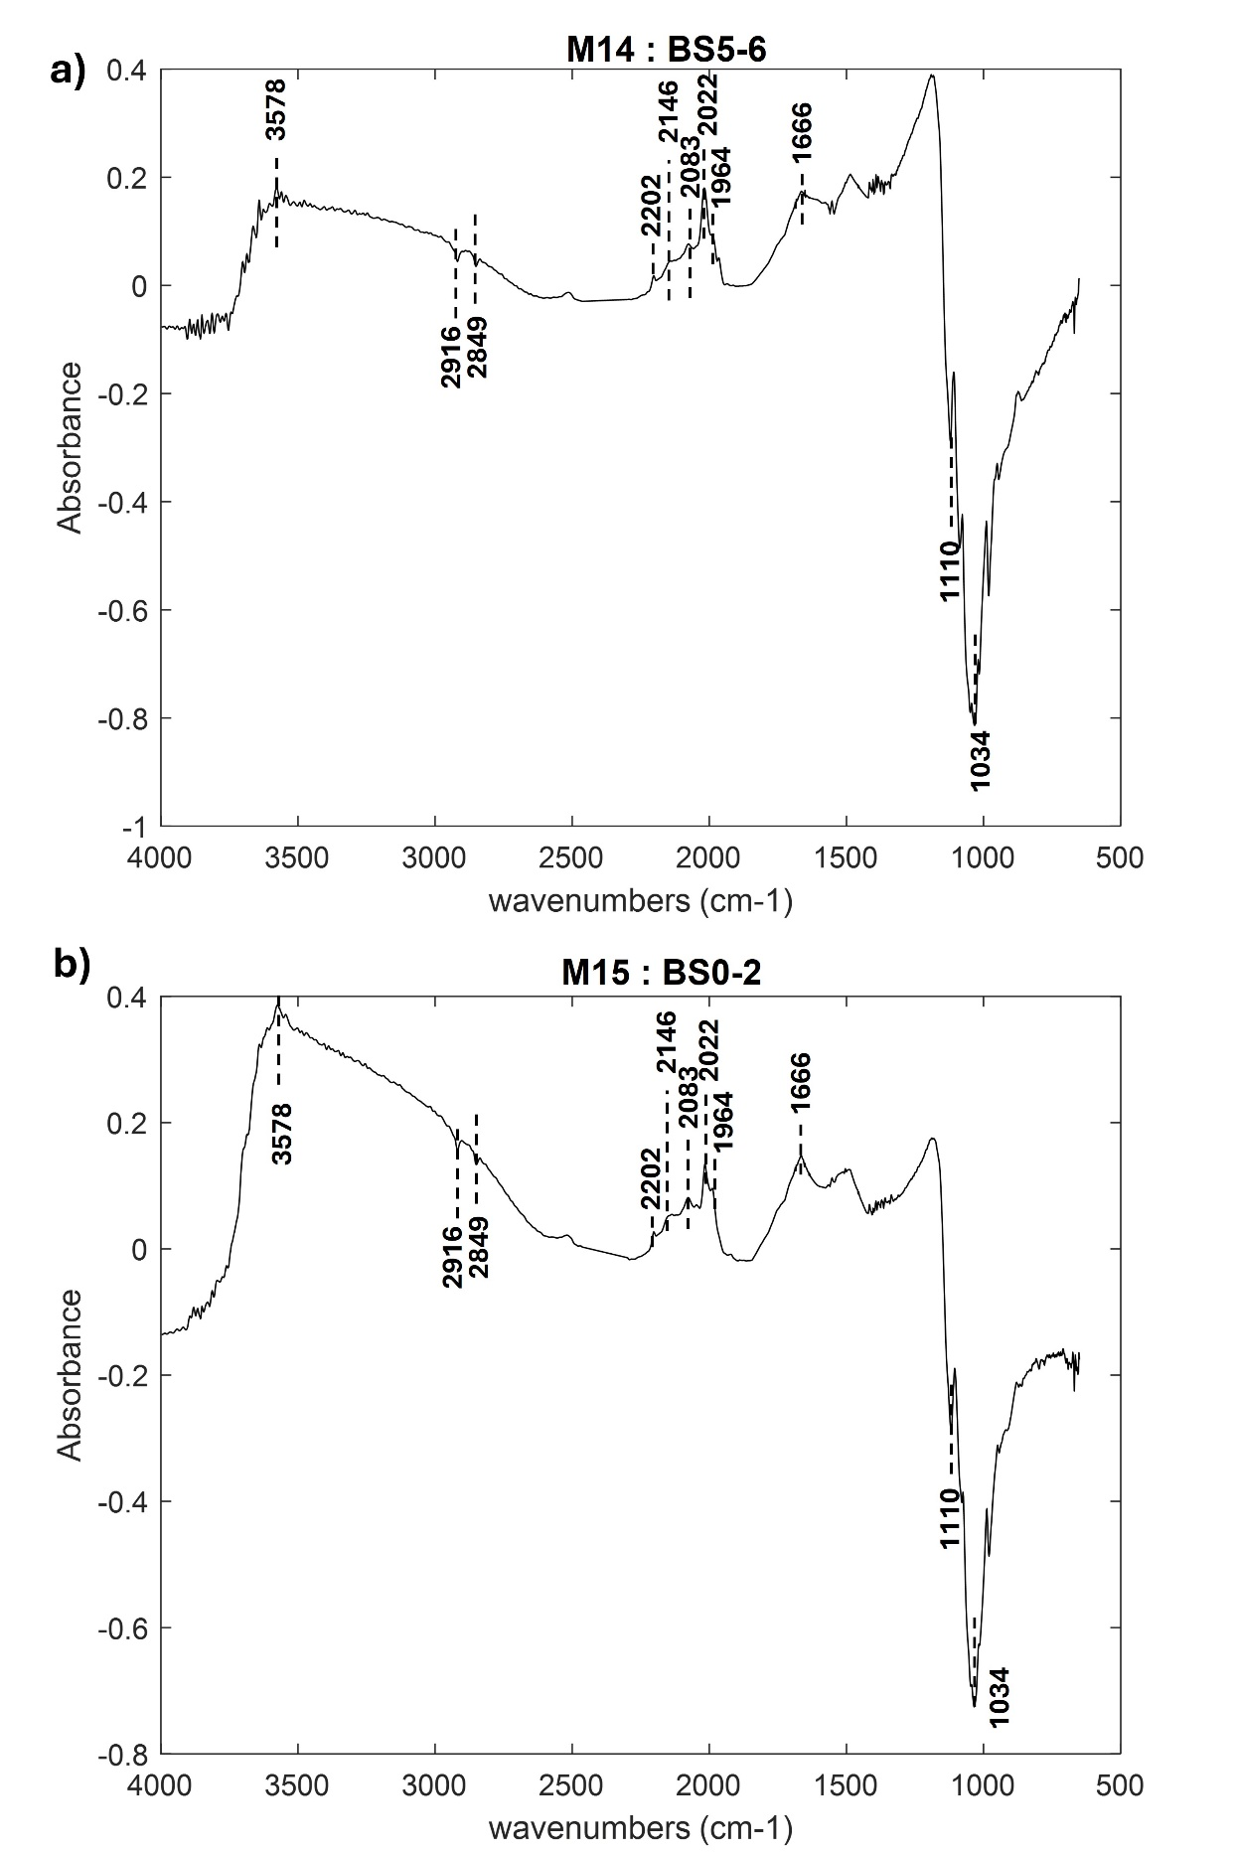
Figure S30. averaged spectra acquired by portable FTIR of archaeological samples: M14 (BS5-6) (a), M15 (BS0-2) (b). The attributed burning phases according to the portable FTIR are reported.
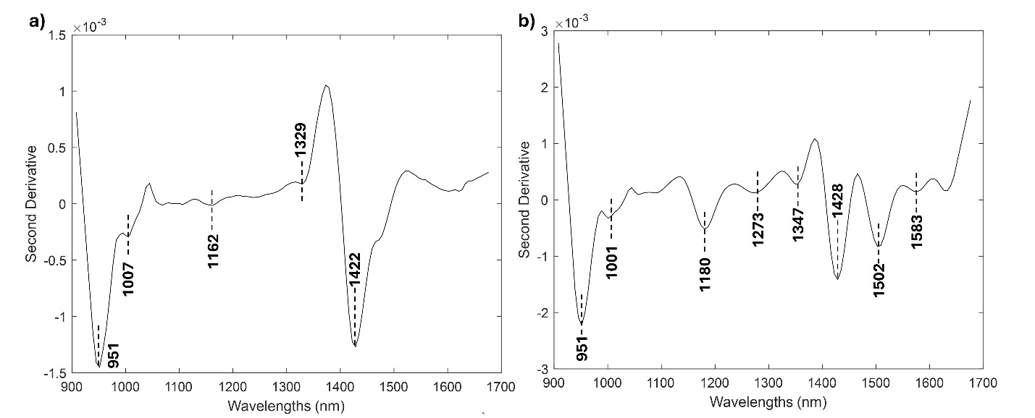
Figure S31. Averaged MicroNIR spectrum of M9 (a), reported here as example for the first group of samples identified in the PCA. The spectra of M1, M2, M5, M11, M13 and M15 are reported in Figure S33, S35 a, S38 b, S39 b, S40 b. Comparison with the reference S3 (BS1) (b) MicroNIR spectra.

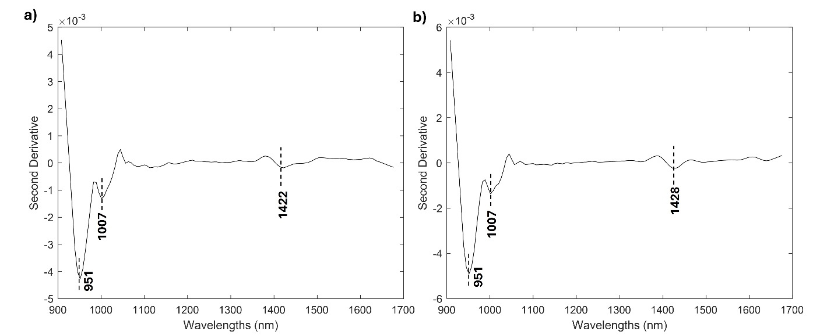
Figure S32. Averaged MicroNIR spectrum of M10 (a), reported here as example for the first group of samples identified in the PCA. The spectrum of M7a is reported in Figure S35. Comparison with the references S4 BS (2) (b) MicroNIR spectra.

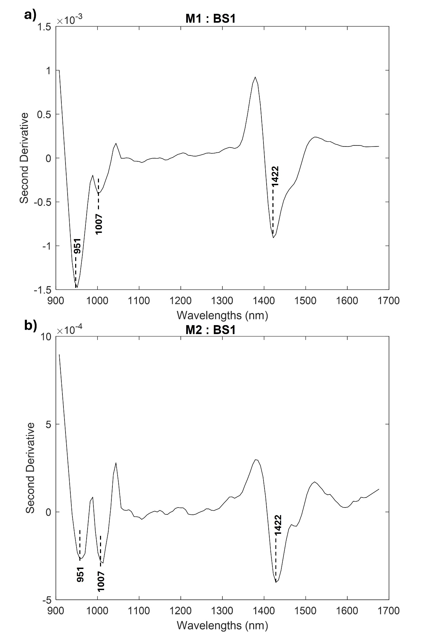
Figure S33. averaged spectra acquired by portable MicroNIR of archaeological samples: M1(BS1) (a), M2 (BS1) (b). The burning phases attributed based on MicroNIR are reported. If the spectrum was too noisy for an attribution it is reported as /.
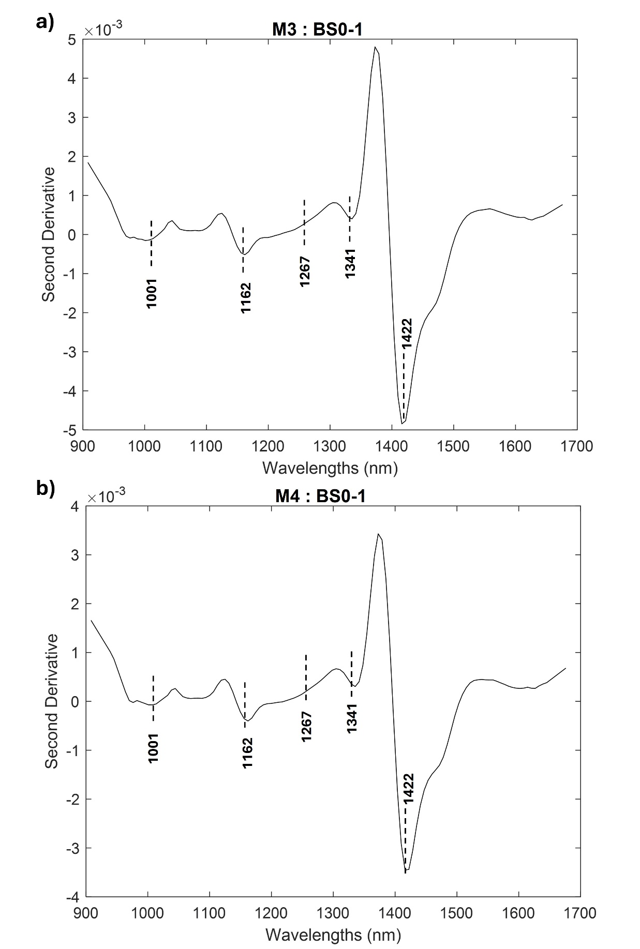
Figure S34. averaged spectra acquired by portable MicroNIR of archaeological samples: M3 (BS0-1) (a), M4 (BS0-1) (b). The burning phases attributed based on MicroNIR are reported. If the spectrum was too noisy for an attribution it is reported as /.
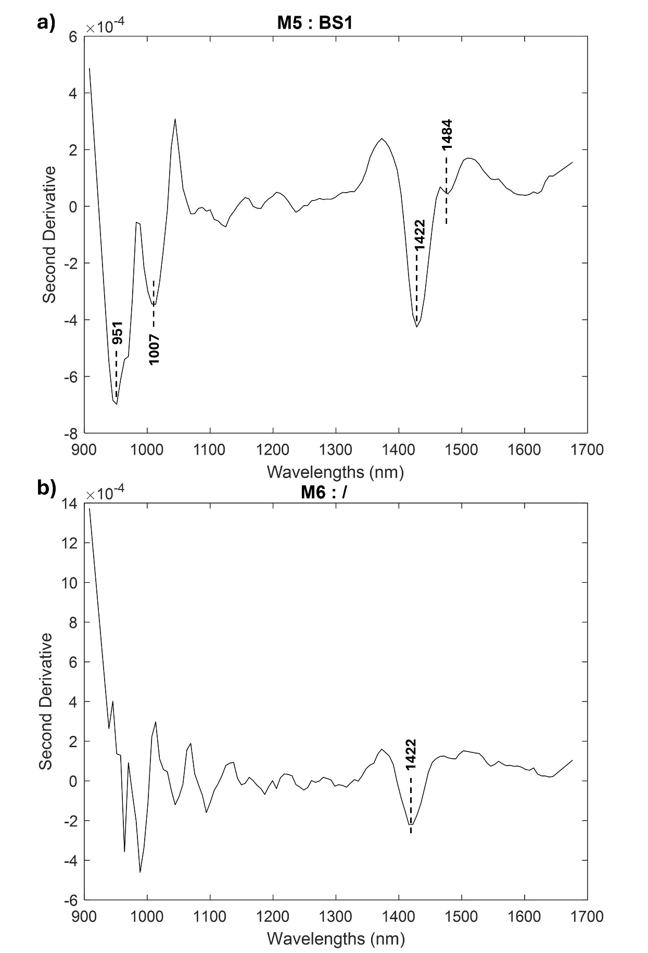
Figure S35. averaged spectra acquired by portable MicroNIR of archaeological samples: M5 (BS1) (a), M6 (/) (b). The burning phases attributed based on MicroNIR are reported. If the spectrum was too noisy for an attribution it is reported as /.
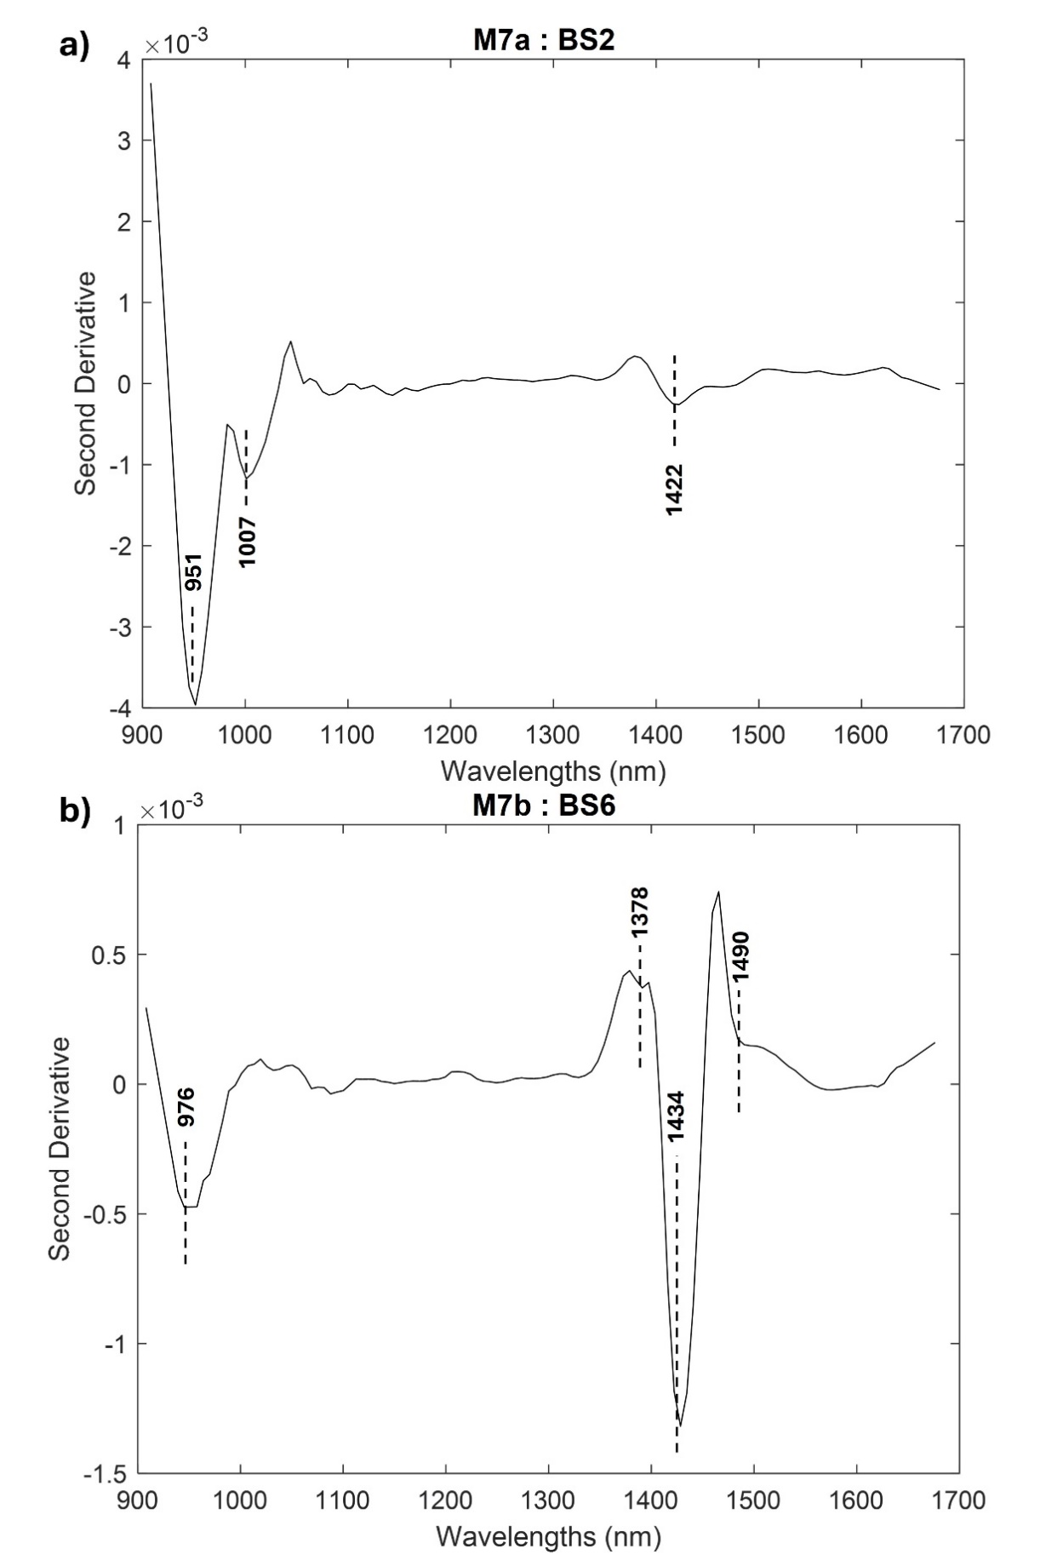
Figure S36. averaged spectra acquired by portable MicroNIR of archaeological samples: M7a (BS2) (a), M7b (BS6) (b). The burning phases attributed based on MicroNIR are reported. If the spectrum was too noisy for an attribution it is reported as /.
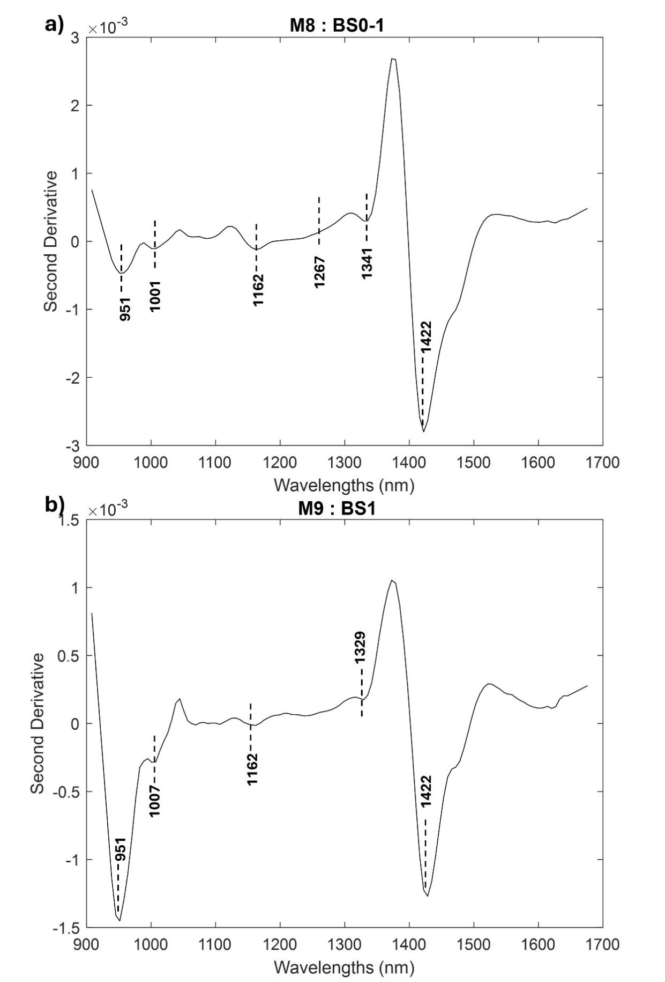
Figure S37. averaged spectra acquired by portable MicroNIR of archaeological samples: M8 (BS0-1) (a), M9 (BS1) (b). The burning phases attributed based on MicroNIR are reported. If the spectrum was too noisy for an attribution it is reported as /.
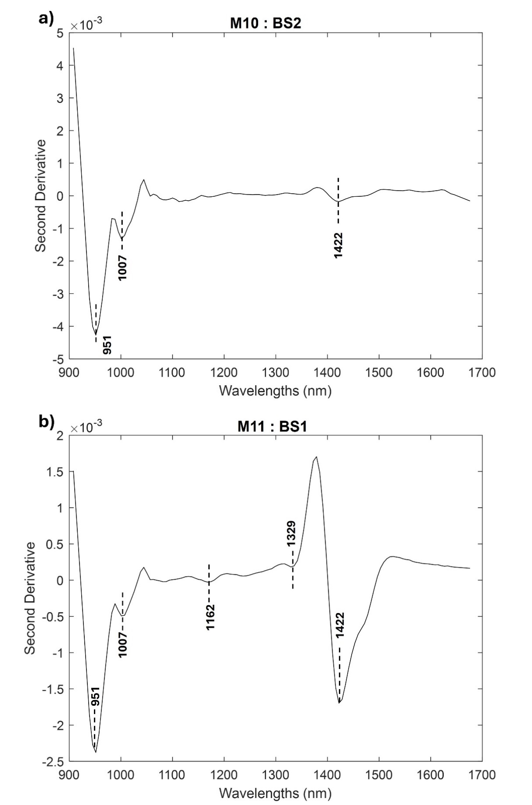
Figure S38. averaged spectra acquired by portable MicroNIR of archaeological samples: M10 (BS2) (a), M11 (BS1) (b). The burning phases attributed based on MicroNIR are reported. If the spectrum was too noisy for an attribution it is reported as /.
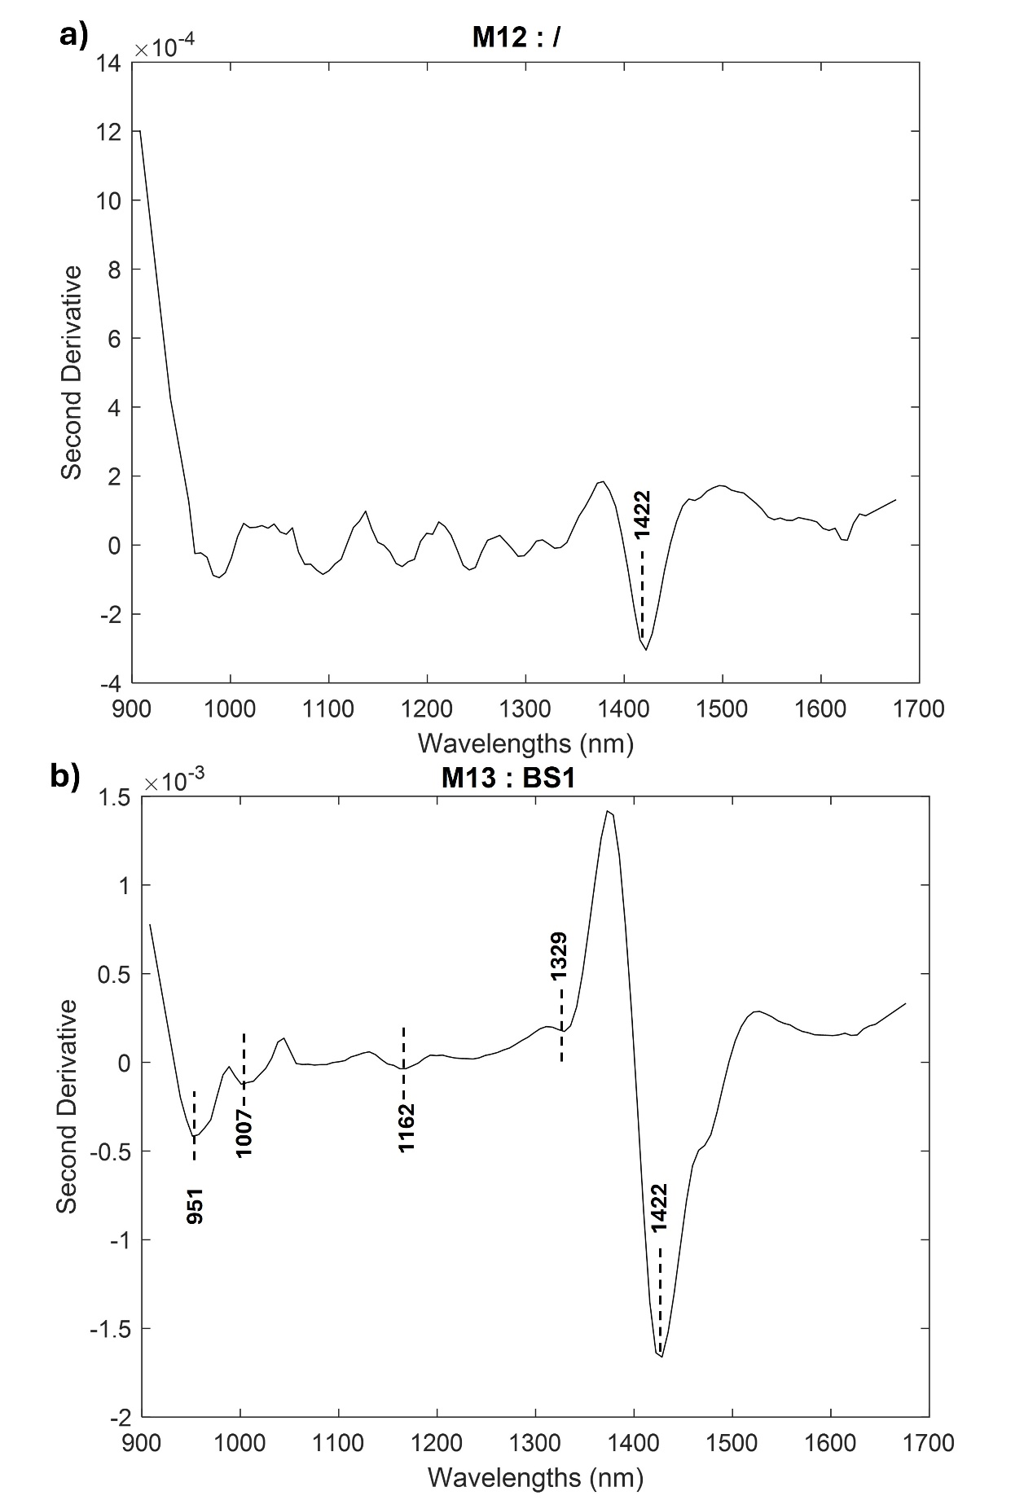
Figure S39. averaged spectra acquired by portable MicroNIR of archaeological samples: M12 (/) (a), M13 (BS1) (b). The burning phases attributed based on MicroNIR are reported. If the spectrum was too noisy for an attribution it is reported as /.
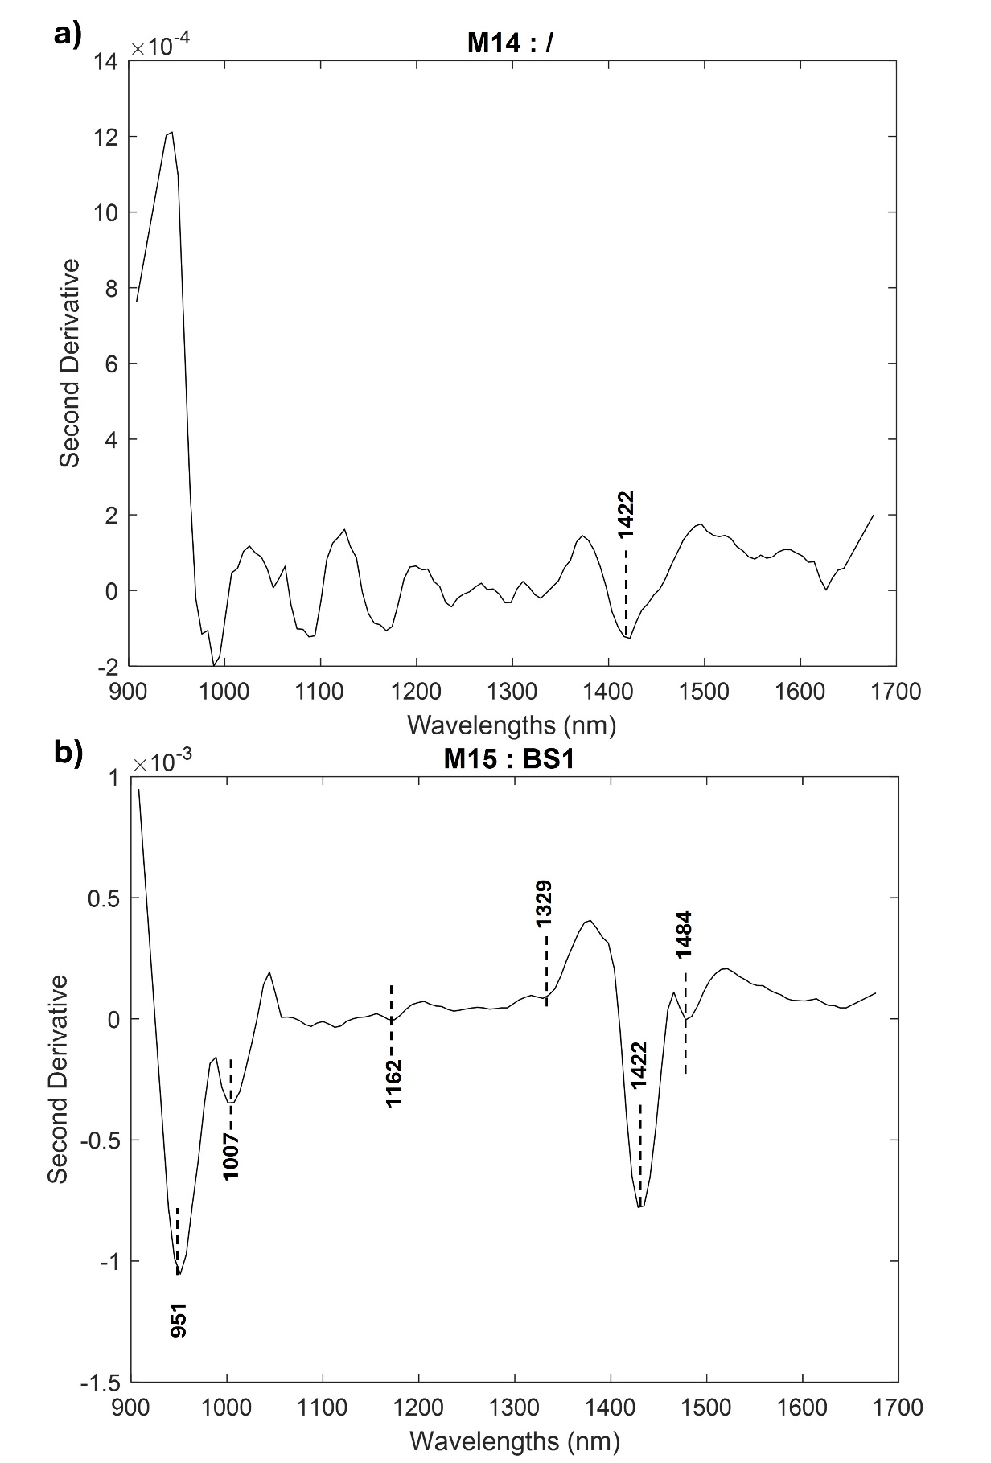
Figure S40. averaged spectra acquired by portable MicroNIR of archaeological samples: M14 (/) (a), M15 (BS1) (b). The burning phases attributed based on MicroNIR are reported. If the spectrum was too noisy for an attribution it is reported as /.
Table S1. Table of MicroNIR peaks detected in collagen and hydroxyapatite powder. The values are reported in nm.
Collagen | Hydroxyapatite | Attribution
1583 | - | NH 1st overtone
1508 | - | NH 2nd overtone
- | 1490 | Mg-OH 1st overtone
1428 | 1422 | OH 1st overtone
- | 1385 | OH combination ν_{sym}+ ν_{asym}
1354 | - | CH Combination (CH₃ – CH₂ – CH)
1273 | - | CH 2nd overtone
1180 | - | CH 2nd overtone
1025 | - | NH 2nd overtone

References
[1] L. Legan, T. Leskovar, M. Črešnar, F. Cavalli, D. Innocenti, P. Ropret, Non-invasive reflection FTIR characterization of archaeological burnt bones: Reference database and case studies, J. Cult. Herit. 41 (2020) 13–26. https://doi.org/10.1016/j.culher.2019.07.006.
[2] M.P.M. Marques, L.A.E. Batista De Carvalho, D. Gonçalves, E. Cunha, S.F. Parker, The impact of moderate heating on human bones: An infrared and neutron spectroscopy study, R. Soc. Open Sci. 8 (2021). https://doi.org/10.1098/rsos.210774.
[3] A.B. Eldin, Near Infra Red Spectroscopy (book chapter), (2011) 532.
[4] A.C. Power, J. Chapman, S. Chandra, J.J. Roberts, D. Cozzolino, Illuminating the flesh of bone identification – An application of near infrared spectroscopy, Vib. Spectrosc. 98 (2018) 64–68. https://doi.org/10.1016/j.vibspec.2018.07.011.
[5] Y. Ning, J. Li, W. Cai, X. Shao, Simultaneous determination of heavy metal ions in water using near-infrared spectroscopy with preconcentration by nano-hydroxyapatite, Spectrochim. Acta - Part A Mol. Biomol. Spectrosc. 96 (2012) 289–294. https://doi.org/10.1016/j.saa.2012.05.034.
[6] J. Kolmas, D. Marek, W. Kolodziejski, Near-Infrared (NIR) Spectroscopy of Synthetic Hydroxyapatites and Human Dental Tissues, Appl. Spectrosc. 69 (2015) 902–912. https://doi.org/10.1366/14-07720.

