Table S1. List of oligonucleotides used in this study, including their sequences (5’-3’) and their respective applications.
Oligonucleotides | Sequence 5’- 3’ | Application
SalI-Ton1b-F | GTCGACATGGACGACTACGCGCG | Ton1b cDNA isolation
XbaI-Ton1b-R | CTCAGATTACTCGGCACCATTGCCTG | Ton1b cDNA isolation
AvrII PrDx_5F | AGACCTAGGGCATGCAAATATGCAACA | Dx5promoter-Ton1b-Dx5terminator region isolation
AvrIITerDx5_R | ATACCTAGGGAGGCGTATGCTGCTGCA | Dx5promoter-Ton1b-Dx5terminator region isolation
Cre_RR | TGGTCGAAATCAGTGCGTTC | Screening PCR
WCS120_L | CCATCTGACCAGCCCTCTTT | Screening PCR
PrDx5_F | CATGCAGGCTACCTTCCACTA | Screening PCR and copy number PCR
Ton1_1770R | CTCATGTTCCGGTGCTCAGT | Screening PCR and copy number PCR
Ton1_L | TGTCTCAAACGAGGATGGCT | Screening PCR
Dx5_termR | AATGTGGCGGTTTCCCTTTC | Screening PCR
SSIIa_F | TGCGTTTACCCCACAGAGCAC | Copy number PCR
SSIIa_R | ACGCGCCATACAGCAAGTCATAA | Copy number PCR
CD_rtTon1_F | GGCCATAGAAGAGGAGGACC | Real- Time (qRT-PCR)
CD_rtTon1_R | ACGGTGAAGCATGCAGTTG | Real- Time (qRT-PCR)
GBS F | CAGAACAGAAACAGTGCGCT | Real- Time (q RT-PCR)
GBS R | TCCAGTTTTGCCCCATACCT | Real- Time (q RT-PCR)
TPP3F | AGTGGCCTGGTCGAGTCC | Real- Time (q RT-PCR)
TPP3R | GCGGCCACGATCTCCTCGAAC | Real- Time (q RT-PCR)
TPP7F | CCTTCCAACATGATGCCGTT | Real- Time (q RT-PCR)
TPP7R | GGACCTCCTCGATCTTGCG | Real- Time (q RT-PCR)
TPS7F | TAGCTCTGAGTCTGCACCTG | Real- Time (q RT-PCR)
TPS7R | TAGTGACTCCGCCGTTGATT | Real- Time (q RT-PCR)
Ton2-F | CAAGAAGAAACCTGAAGATGG | Real- Time (q RT-PCR)
Ton2-R | GCACCAGTAGCATCGTCAAT | Real- Time (q RT-PCR)
CEN1-F | TGTTGCGATGAGAGCCTTGG | Real- Time (q RT-PCR)
CEN1-R | CGGAACGCTTTTGTAAGCTC | Real- Time (q RT-PCR)
GW2A-F | CTGCTTCCTGTACTACCCAA | Real- Time (q RT-PCR)
GW2A-R | TCGTCTTGAAGTGCTTGCTG | Real- Time (q RT-PCR)
GW7_F | ACTTGGTGAGCTCTTCGGTG | Real- Time (q RT-PCR)
GW7_R | GCAGGCCGTACTCCACCA | Real- Time (q RT-PCR)
cACT_F | GGAATGGTCAAGGCTGGTT | Real- Time (q RT-PCR)
cACT_R | CTCCATGTCATCCCAGTTGC | Real- Time (q RT-PCR)

Table S2. Primers for Screening and PCR Conditions. Three primer pairs were designed for molecular screening.
Primer pairs | Amplicon size (pb) | PCR conditions | Sequence target
PrDx5_F/Ton1_1770R | 993 | 95°C x 3’; (95°C x 30’’, 61 x 30’’, 72 x 30’’) x 35; 72°C x 5’ | The pair anneals between the DX5 promoter and the Ton1 coding sequence.
Ton1_L/Dx5_termR | 593 | 95°C x 3’; (95°C x 30’’, 61 x 30’’, 72 x 30’’) x 35; 72°C x 5’ | The pair targets the region near the DX5 terminator.
WCS120_L/CreRR | 989 | 95°C x 3’; (95°C x 30’’, 61 x 30’’, 72 x 30’’) x 35; 72°C x 5’ | The pair amplifies a fragment of the CRE gene.

Table S3. Screening results of T1 plants for the presence of PrDx5::TON1b::TermDx5 and WCS120::Cre constructs. Number of T1 plants collected per line, specifying the number of positives and negatives for each construct based on PCR analysis. Lines labeled as “nt” (non-transformed) were used as internal negative controls, while “Svevo wt” represents the wild-type reference. The PrDx5::TON1b::TermDx5 was detected in 11 out of 85 plants, while 12 plants tested positive for the WCS120::Cre construct.

 |  | PrDx5::Ton1::TermDx5 |  | WCS120::Cre
Lines | N°of collected plants | Positives | Negatives | Positives | Negatives
T4C3 | 20 | 2 | 18 | 2 | 18
T4C6 | 9 | 3 | 6 | 1 | 8
T4C10B | 8 | 0 | 8 | 1 | 7
T4C23B | 13 | 0 | 12 | 1 | 11
T6C3B(nt) | 3 | 0 | 3 | 0 | 3
T10C1B | 0 | 0 | 0 | 0 | 0
T10C9 | 8 | 2 | 6 | 2 | 6
T10C14 | 2 | 0 | 2 | 0 | 2
T10C23 | 18 | 4 | 14 | 5 | 13
T14C4(nt) | 2 | 0 | 2 | 0 | 2
T14C6(nt) | 2 | 0 | 2 | 0 | 2
Svevo wt | 1 | 0 | 1 | 0 | 1
Tot. | 85 | 11 | 74 | 12 | 73

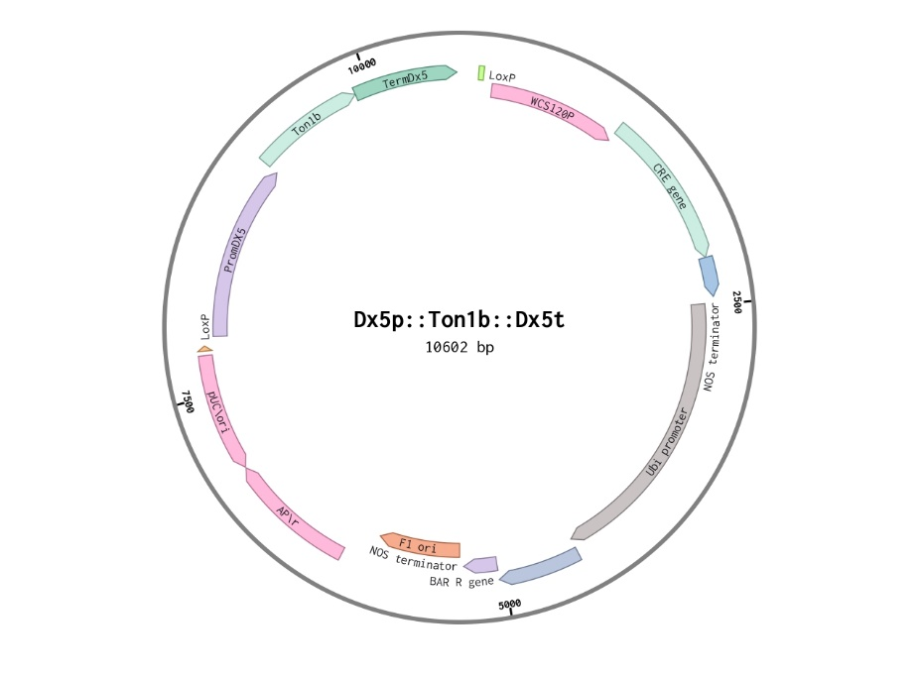
Figure S1. Circular plasmid map of the TaDX5p::TON1b-cDNA::TaDx5t+WCS120p-CreLox vector. The Dx5 promoter drives caryopsis-specific expression of TON1b, reducing pleiotropic effects in non-target tissues. The Cre/Lox system enables temperature-inducible recombination, with Cre recombinase controlled by the cold-responsive WCS120 promoter, activated under low-temperature conditions.

MSA
T-COFFEE, Version_11.00 (Version_11.00)
Cedric Notredame
SCORE=96
*
BAD AVG GOOD
*
TdTON1b-A1 : 97
TdTON1b-B1 : 97
AtTON1a : 94
AtTON1b : 94
OsTON1b : 97
HvTON1b : 97
ZmTON1b : 96
cons : 9
TdTON1b-A1 MDDYAREMMELKTLVTRTLEKKGVLAKIRAELRASVFEAIEEEDRVIEENEDGGNPALLGSCNDRAKQL
TdTON1b-B1 MDDYAREMMELKTLVTRTLEKKGVLAKIRAELRASVFEAIEEEDRVIEENEDGGNPALLGSCNDRAKQL
AtTON1a MDDYTREMMDLKTLVTRTLEKKGVLAKIRAELRASVFEAIEEEDRVIE-NNEGPPPALLGSCNDRARKL
AtTON1b MDDYTREMMDLKTLVTRTLEKKGVLAKIRAELRASVFEAIEEEDRVIE-NNEGLPPALLGSCNDRARQL
OsTON1b MDDYAREMMELKTLVTRTLEKKGVLAKIRAELRASVFEAIEEEDRVVE-NDDGGNPALLGSCNDRAKQL
HvTON1b MDDYAREMMELKTLVTRTLEKKGVLAKIRAELRASVFEAIEEEDRVIEENEDGGNPALLGSCNDRAKQL
ZmTON1b MDDYAREMMELKTLVTRTLEKKGVLAKIRAELRASVFEAIEEEDRVME-NDDGGNPALLGSCNDRAKQL
cons ****:****:************************************:* *::* ***********::*
TdTON1b-A1 HASPSGRLLTALIGEYLEWAQLSHTMKVYLPECNLPKDFWKNELKDFSNKNGAEGSRSAESGPMLLDVL
TdTON1b-B1 HASPSGRLLTALIGEYLEWAQLSHTMKVYLPECNLPKDFWKNELKDFSNKNGAEGSRSAESGPMLLDVL
AtTON1a HASPSGRLLSALICEYLDWAQLNHTLIVYQPESNLPKDSWKSELRDFNSNNGFELNRNGDSGPLLLDVL
AtTON1b HASPSGRLLSALICEYLDWAQLNHTLKVYQPECNSAKDSWKSEIRDFSINNGYELNRNEDSRPLLLDVL
OsTON1b HASPSGRLLTALVSEYLEWAQLSHTMKVYLPECNLPKDFWKNELKDFSNKSGAEGSRSAESGPMLLDVL
HvTON1b HASSSGRLLTALIGEYLEWAQLSHTMKVYLPECNLPKDFWKNELKDFSNKNGAEGSRSAESGPMLLDVL
ZmTON1b HASPSGRLLTALVCEYLEWAQLSHTMKVYLPECNLPKDFWKNELKDFSNKSGAEGSRSAESGPLLLDVL
cons ***.*****:**: ***:****.**: ** **.* .** **.*::**. :.* * .*. :* *:*****
TdTON1b-A1 EGYLKYE---------NLSQTRMA--GRRMINSEPEPTLNTEHRNMRRPPSSSSIAGMPPMGRQMPPSQ
TdTON1b-B1 EGYLKYE---------NLSQTRMA--GRRMINSEPEPTLNTEHRNMRRPPSSSSVAGMPPMGRQMPPSQ
AtTON1a EGFLKFE---------SMTQG-MG--SSSRRDSETESSSSLESRNPPRRSS--ASDSLPPQRRPVSASQ
AtTON1b EGFLKFE---------NMTQV-MG--GSSRRESETESSLSLDTRNPPRRSS--ASDSLPHQRRSVSASQ
OsTON1b EGYLKYE---------NLSQTRMAGTGRRIINSESDPALNAEHRNTRRPPSSSSVTGLPPMGRPMPSSQ
HvTON1b EGYLKYE---------NLSQTRMA--GRRMVNSESDPTLNTEHRNMRRPPSSSSVAGLPPMGRQMQPSQ
ZmTON1b EGYLKYEACTQGLLLMNLSQARMG--GRRMMSSESDPSLNAEHRSMRRAPS-ASVGNLPPMGRPISSSQ
cons **:**:* .::* *. . .**.:.: . : *. * .* : .:* * : .**
TdTON1b-A1 -TSDRRGGSSASNTRKDEYNWGYDA-DDLSEEVLRTSTALENIQLDRKARNLTTSWRHPGSGA------
TdTON1b-B1 -TSDRRGGSSASNTRKDEYNWGYDA-DDLSEEVLRTSTALENIQLDRKARNLTTSWRHPGNGA------
AtTON1a -ASDRRAGLSTSGYRKDEFNWRQGN-QDTHEEVTRASAALENLQLDRKTRNLTSSWRNVRDGTNE-EEG
AtTON1b -AS----GAATSGYRKDESNWRYDT-EDMPEEVMRASTALENLQLDRKTRNLTSSWRNVKDGTSEEEEG
OsTON1b -MSDRRGGSSASNARKDEYNWRYDA-DDISEEVLRASSALENVQLDRKARNLTTSWRHPGDGA------
HvTON1b -TSDRRGGSSASNTRKDEYNWGYDA-DDLSEEVLRTSTALENIQLDRKARNLTTSWRHPGNGA------
ZmTON1b QASDRRGGSSVSNTRKDEYNWRYDTTDDISEEVLRASTALESVQLDRKSRNLPTSWRHSGDGA------
cons * * :.*. **** ** . :* *** *:*:***.:*****:***.:***: .*:
TdTON1b-A1 -E
TdTON1b-B1 -E
AtTON1a RD
AtTON1b KD
OsTON1b -E
HvTON1b -E
ZmTON1b -E
cons :
Ser rich-region and Ser phosphorylation sites
PLL motif
LisH motif
TOF motif
Figure S2. Multiple sequence alignment of TON1b orthologs in monocot and dicot species. The alignment was performed using T-Coffee (Version 11.00). The sequences included are from Triticum turgidum subsp. durum (TdTON1b-A1, TdTON1b-B1), Arabidopsis thaliana (AtTON1a, AtTON1b), Oryza sativa (OsTON1b), Hordeum vulgare (HvTON1b), and Zea mays (ZmTON1b). Conserved motifs, including the LIS1 homology (LisH), TOF, and PLL motifs, are shown in bold. The serine-rich region and predicted serine phosphorylation sites are annotated according to Azimzadeh et al. (2008); the entire serine-rich region is in bold, and the individual predicted serine phosphorylation sites are underlined.

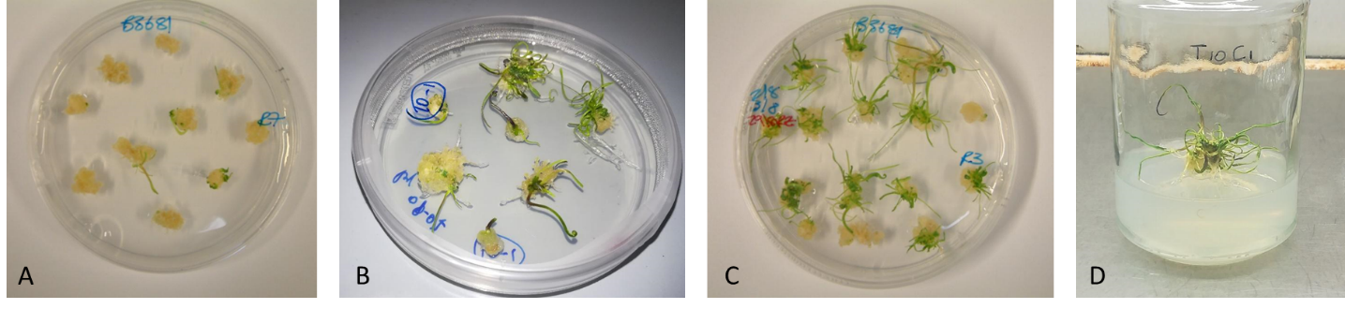
Figure S3. The image depicts all in vitro stages. Specifically: (A) callus induction, (B-C) selection and regeneration, and (D) rooting.

Figure S3. Number of construct copies detected in three independent intragenic lines (IP1, IP2, IP3). Values represent the mean ± standard deviation (SD). Quantification was performed by real-time PCR using the endogenous gene SSIIa as reference.

Null-seg
IP-1

