Electronic Supplementary Information (ESI)
Chlorella vulgaris meets TiO₂ NPs: effective sorbent/photocatalytic hybrid materials for water treatment application.
M Blosi*ª, A Brigliadori*ª, I Zanoniª, S Ortelli ª, S Albonetti ^{b} and AL Costaª
ªCNR-ISTEC, Institute of Science and Technology for Ceramics – National Research Council of Italy, Via Granarolo 64, I-48018 Faenza, RA, Italy
^{b} Dipartimento di Chimica Industriale “Toso Montanari”, University of Bologna, viale del Risorgimento 4, 40136, Bologna, Italy
* Corresponding author: magda.blosi@istec.cnr.it, andrea.brigliadori@istec.cnr.it

- FT-IR and UV analysis of TiO₂/C. vulgaris hybrid samples
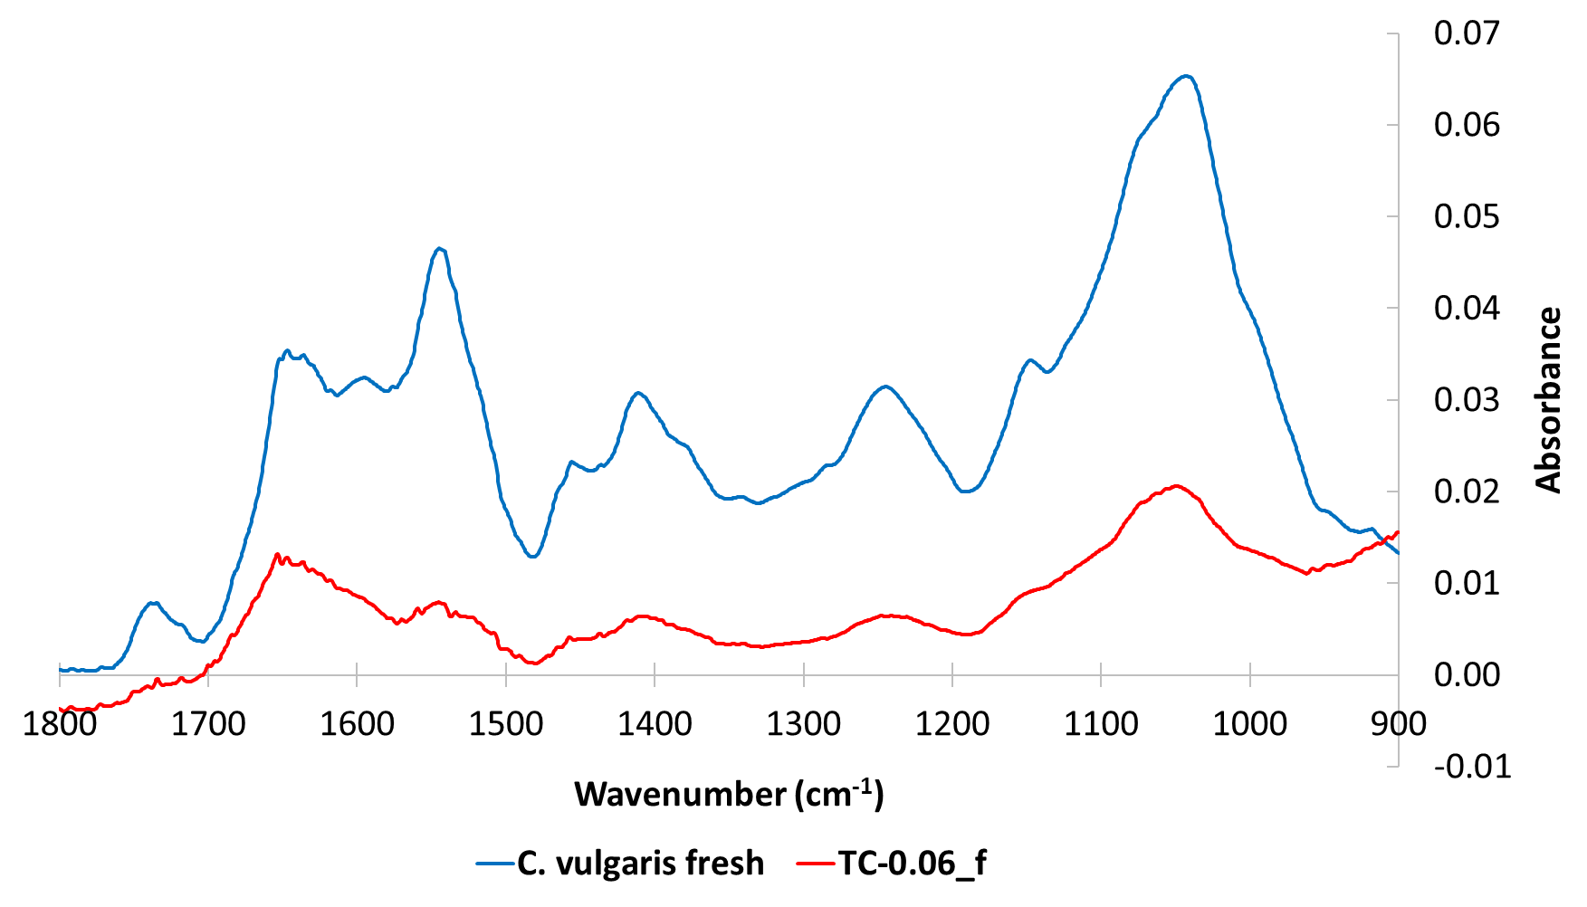
Fig. S1 – FT-IR spectra of CV_f and TC0.06_f samples.

FT-IR spectra collected for CV_f exhibited several peaks in the 1400–1800 cm⁻¹ region due to the peptide backbone absorbance and showing signals consistent with the literature (Hadjoudja et al., 2010). The peaks at 1390 and 1455 cm⁻¹ could be assigned to CH₂/CH₃ vibrations, C=O, C–N, N–H, typical of protein structures, a significant part of cell walls (Hadjoudja et al., 2010).
A double peak was observed at 1038 and 1079 cm⁻¹ and was probably caused by C–O stretching vibrations of alcoholic groups in carbohydrates, another main component of cell walls. Other common peaks of green algae were recorded at 1623cm⁻¹, 1548cm⁻¹, 1243cm⁻¹, corresponding to C=O stretching, C-N stretching and C-O stretching of phenols respectively (Kiefer et al., 1997).
The spectrum collected on sample TC-0.06_f, containing TiO₂, showed an unchanged profile with the same peaks, but with a clear absorption reduction, due to the dilution of the microalgae content in the hybrid material.

UV-Vis measurements were performed on the fresh biomass CV_f and the hybrid sample TC-0.06_f. The recorded absorption spectra shown in Figure S2 highlighted the peaks at 680 nm and 440 nm ascribed to the chlorophyll porphyrin ring, typical functional group of Chlorella vulgaris (Lichtenthaler and Buschmann, 2001). In the hybrid sample, despite the presence of titania increased the baseline along the visible range and in the UV portion, we can easily distinguish the algae peaks, suggesting that the two components (TiO₂ and C. vulgaris) can be coupled without affecting C. vulgaris functional groups.

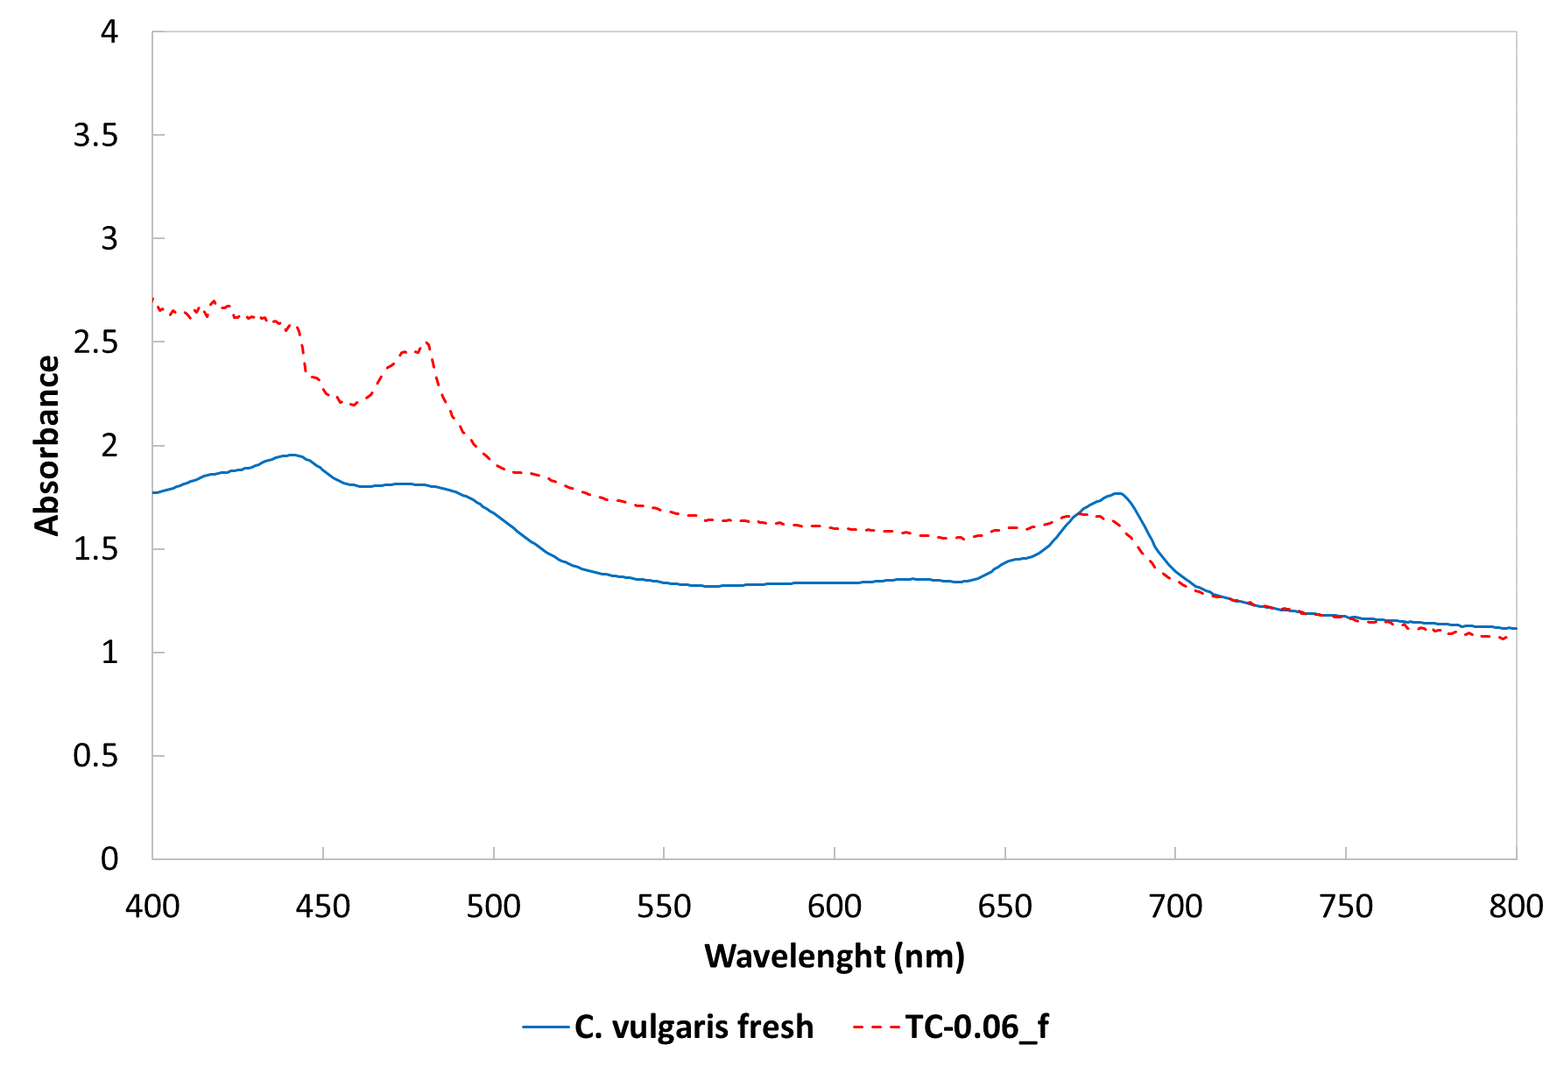
Fig. S2 – UV-Vis spectra collected for samples: CV_f and TC-0.06_f.

- Zeta potential evolution for increasing concentration of C. vulgaris

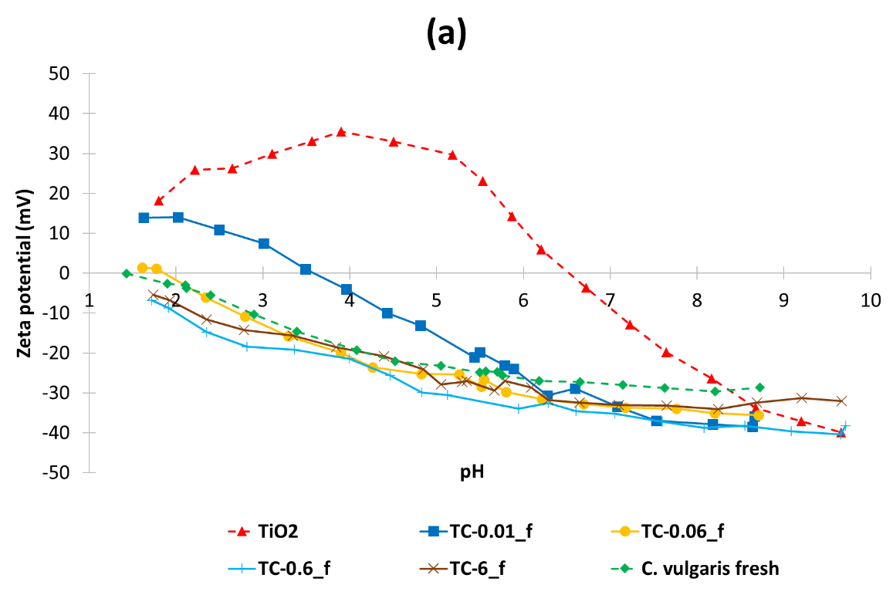

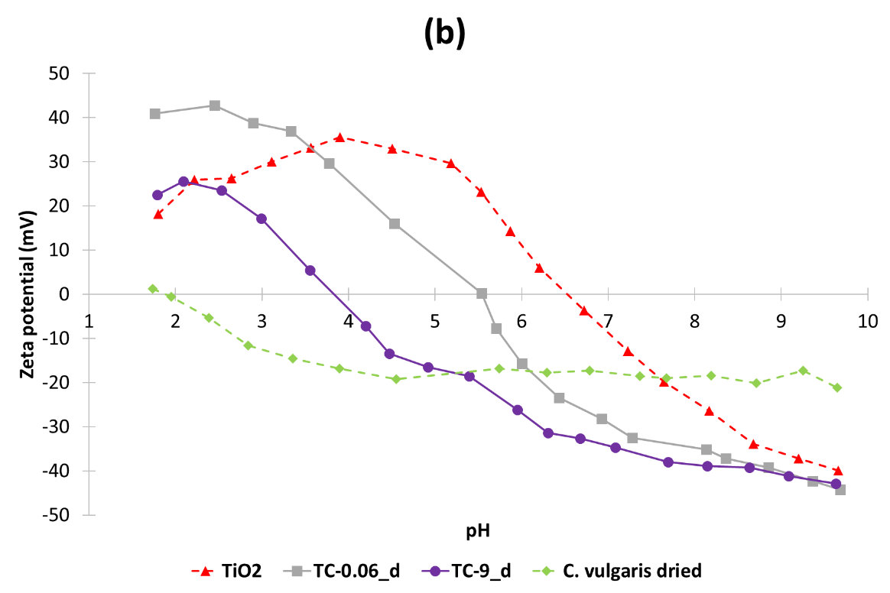

Fig. S3 – Z potential/pH curves for samples TiO₂/C. vulgaris prepared at increasing concentration of microalgae: (a) addition of fresh C. vulgaris in suspension, (b) addition of C. vulgaris in powder.

- Three components suspensions: SiO₂/TiO₂/C. vulgaris
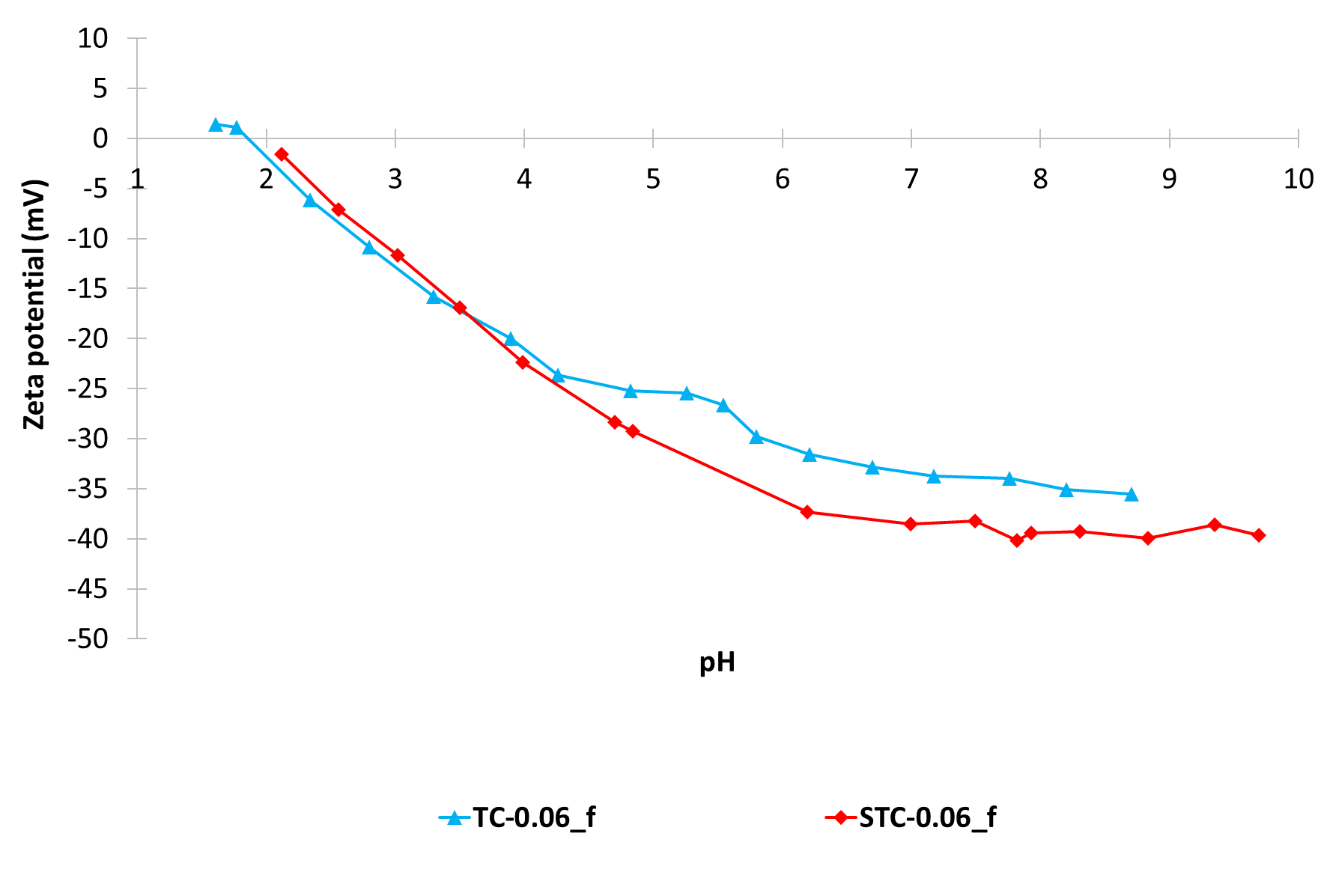
Fig. S4 – Z potential/pH titration curves of samples TC-0.06_f containing TiO₂ and C. vulgaris compared with sample STC-0.06_f containing SiO₂, TiO₂ and C. vulgaris.

- EDX characterization of sample TC-0.06_f_SF
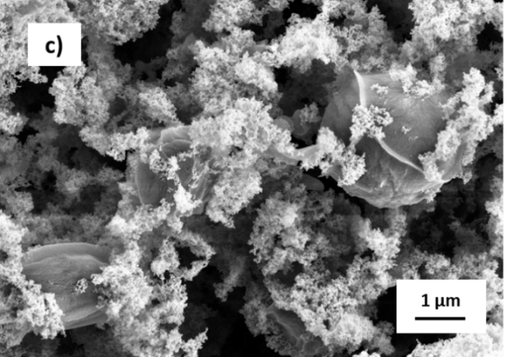
Fig. S5 – EDX mapping analysis performed on TC-0.06_f_SF, the images highlight the signals for carbon (C) and titanium (Ti).

- Band gap energy of hybrid samples
Band gap energies listed in Table S1 evidenced not relevant differences among the samples, which presented values closed to TiO₂ P25.
Despite the presence of silica boosted the photocatalytic performances, we did not appreciate any significant band gap variation for samples with silica, suggesting that it probably influenced TiO₂ phase in terms of improved dispersion for suspensions, increased surface area for granules and in general promoting the formation of radicals at the interface, but without modifying the band gap value.
Similarly, samples containing C. vulgaris showed a slight band gap increase, but very small and consistent with the associated error and finally not significant to justify the photodegradation slowing, which probably was only due to the physical coverage of TiO₂ surface by the biomass.

Table S1 – Band gap values determined on the prepared samples by means of DRS measurements.
Sample | Components | Eg (eV)
TiO₂_SF | TiO₂ | 3.17±0.02
T1S3_SF | TiO₂/SiO₂ | 3.19±0.02
TC-0.01_f_SF | TiO₂/C. Vulgaris | 3.18±0.02
TC-0.06_f_SF | TiO₂/C. Vulgaris | 3.21±0.02
TC-0.6_f_SF | TiO₂/C. Vulgaris | 3.21±0.02
STC-0.01_f_SF | TiO₂/SiO₂/C. Vulgaris | 3.19±0.02
STC-0.06_f_SF | TiO₂/SiO₂/C. Vulgaris | 3.21±0.02
TC-0.06_d_SF | TiO₂/C. Vulgaris | 3.17±0.02
TC-9_d_SF | TiO₂/C. Vulgaris | 3.20±0.02

- Biosorption of Cu²⁺: results from suspensions
Biosorption activity was assessed on suspensions as well, according to the procedure described in the experimental part. Basically, for suspensions we confirmed the same behaviors and trends assessed and described for granules. Only the coupling of TiO₂ with fresh microalgae promoted synergistic effects in terms of ion absorption, which was probably due to the dispersion acted by the inorganic component. As showed for granules, the absorption per gram of biomass resulted to be maximized for the lowest microalgae contents and the absorption capacity of the whole samples was optimized for intermediate concentrations (0.60% and 0.06% wt), in fact, high contents of C. vulgaris seem to hinder the dispersion action of TiO₂. Data collected for an increased algal concentration at 6% wt (TC-6_f) confirmed the reduction of the absorption capability for both the biomass and the whole sample.
As observed for granules, the presence of silica did not alter the results in terms of absorption performances and C. vulgaris added in dried form confirmed the absence of synergistic or advantageous performances.

Table S2 – Cu²⁺ absorption measured for the prepared hybrid materials in suspension.
Sample | Components | C vulgaris Biosorption* | Absorption | Theoretical Absorption**
 |  | (mg_{Cu2+/}g_{C. vulgaris}) | (mg_{Cu2+}/g_{sample}) |  | (mg _{Cu2+}/g_{sample})
TiO₂ |  |  | 0.78
SiO₂ |  |  | 0.58
T1S3 |  |  | 0.43
CV_f | C. vulgaris fresh | 103
TC-0.01_f | TiO₂/C. vulgaris | 7550 | 1.66 |  | 0.79
TC-0.06_f | TiO₂/C. vulgaris | 4230 | 3.29 |  | 0.84
TC-0.6_f | TiO₂/C. vulgaris | 548 | 3.69 |  | 1.04
TC-6_f | TiO₂/C. vulgaris | 45 | 3.38 |  | 6.91
STC-0.01_f | TiO₂/SiO₂/CV. | 9720 | 1.59 |  | 0.44
STC-0.06_f | TiO₂/SiO₂/CV. | 4990 | 3.42 |  | 0.49
CV_d | C. vulgaris dried | 15.31
TC-0.06_d | TiO₂/C. vulgaris | < 1 | 0.62 |  | 0.79
TC-9_d | TiO₂/C. vulgaris | 11.2 | 1.73 |  | 2.10
*absorption value normalized on C. vulgaris content after subtracting the inorganic phase contribution.
**: theoretical absorption calculated as weighted average on composition.

- Photocatalytic activity: results for suspensions
The photocatalytic results collected for samples in suspensions during the treatment of RhB were consistent with the granulated counterparts, evidencing a kinetic constant depletion for increasing content of microalgae. Despite all the samples reached an almost complete conversion within the testing time, the photodegradation velocity was reduced in presence of the biomass, which interacting with the TiO₂ surface probably covers and prevents the optimal irradiation of the inorganic photocatalyst. Even in suspension, the addition of silica contrasted the detrimental effect induced by C. vulgaris, boosting the photocatalytic performances of TiO₂ (Ortelli et al., 2016) and ensuring optimal photodegradation effectiveness of the hybrid suspensions.
As expected, in suspension as well, samples prepared with dried C. Vulgaris were less affected by the biomass underlining again the poor interaction with the inorganic phase if the microalgae are added in dried form.

Table S3 – Photocatalytic data collected on the prepared hybrid materials in suspension.
Description | Sample | Components | k x 10⁻²  (min⁻¹) | Conversion 60 min (%)
 | TiO₂ | TiO₂ | 10.38 | 99
 | T1S3 | SiO₂/TiO₂ | 11.47 | 100
Addition of fresh  C. vulgaris  (TiO₂/CV surface interaction in suspension) | TC-0.01_f | TiO₂/CV_f | 7.62 | 100
 | TC-0.06_f | TiO₂/CV_f | 3.54 | 96
 | TC-0.6_f | TiO₂/CV_f | 2.05 | 87
Addition of fresh  C. vulgaris and SiO₂ | STC-0.01_f | SiO₂/TiO₂/CV_f | 13.37 | 100
Addition of fresh  C. vulgaris and SiO₂ | STC-0.06_f | SiO₂/TiO₂/CV_f | 11.01 | 100
Addition of dried  C. vulgaris  (no TiO₂/CV surface interaction in suspension) | TC-0.06_d | TiO₂/CV_d | 10.45 | 100
 | TC-9_d | TiO₂/CV_d | 7.38 | 99

- Performance comparison between suspensions and granules
We highlighted the results dealing with the spray-freeze dried samples because granules provide important advantages in terms of applicability with respect to suspensions and represent the most useful and easy to handle form for this kind of catalysts. As expected, suspensions implied the maximum freedom grade for nanoparticles, promoting slightly higher performances. However, this gap is fully overcome by the great advantage in processability with solids. Figure S6 points out that no substantial differences in metal absorption and photocatalytic activity were detected passing from suspension to granules, further emphasizing the benefits of the presented technology.

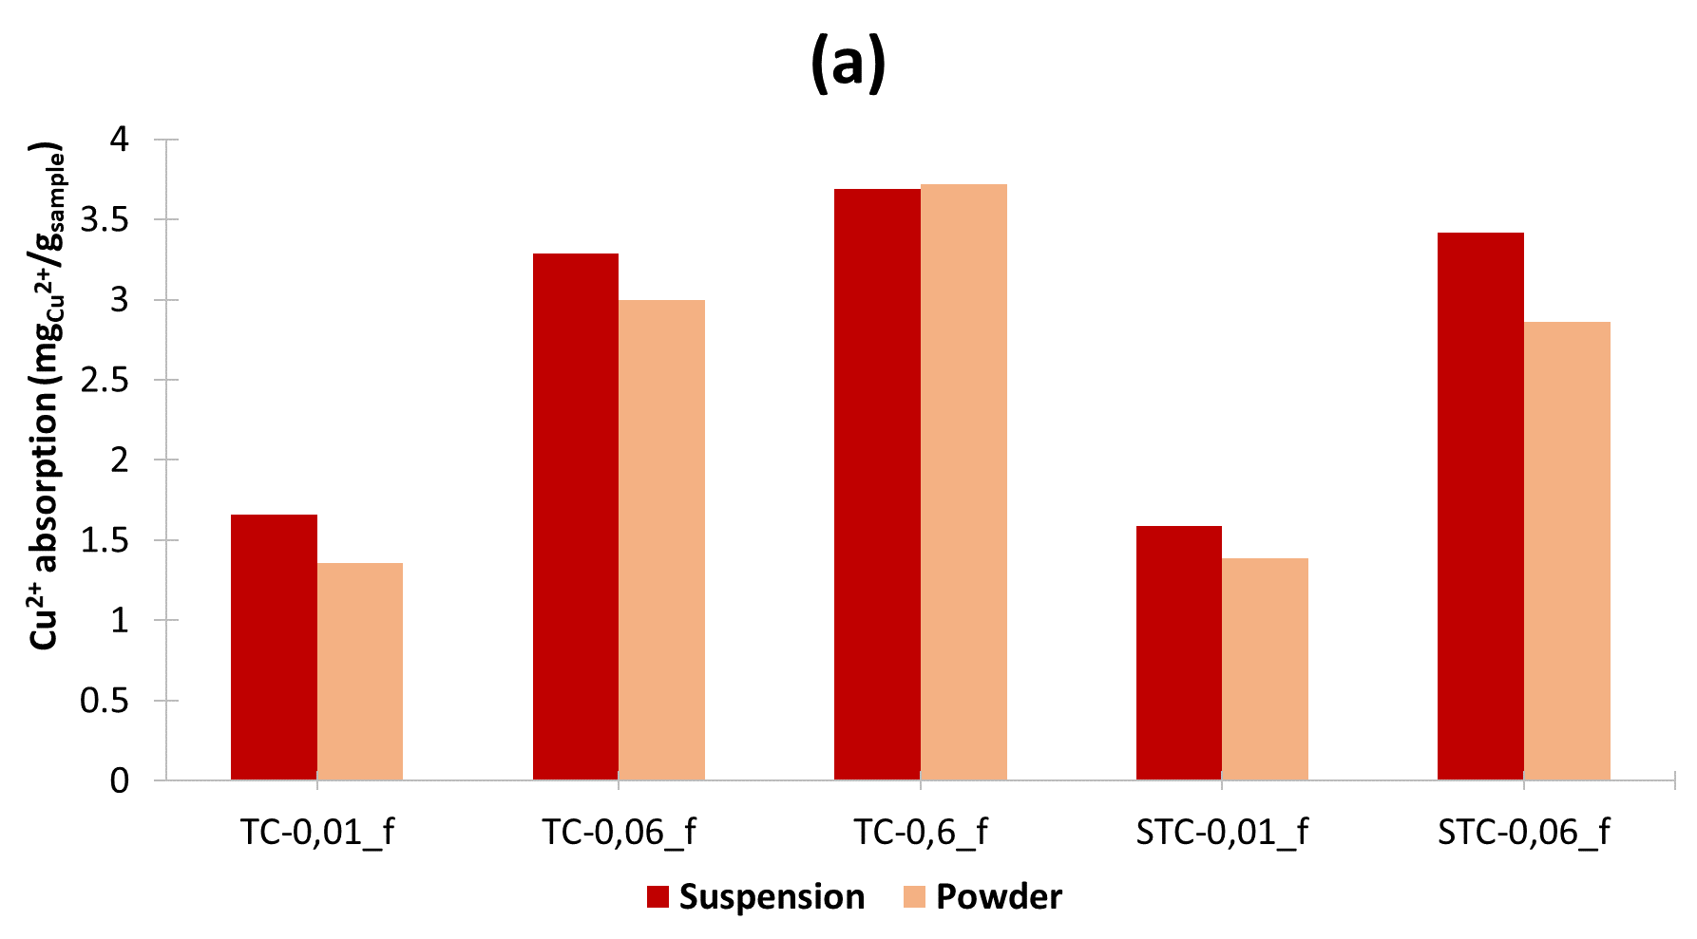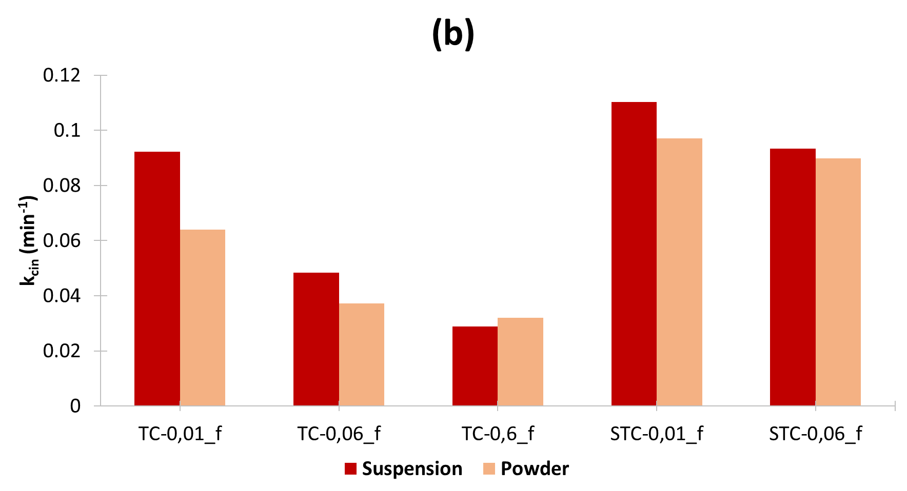
Fig S6 – Comparison between suspension and spray freeze-dried powder: a) metal absorption performance; b) photocatalytic activity (k values).

- Adsorption isotherms and kinetic models
Freundlich and Langmuir’s isotherms were applied to the experimental data. Table S4 shows the data results produced by the isotherms application with the corresponding R².
Based on R² values both the models fitted the biosorption mechanisms, however the Freundlich one should better describe the multilayer sorption onto a heterogeneous surface as like as the tested hybrid sample.
Q_{max} and K_{f} values of CV_f were in good agreement with literature data assessed for dead C. vulgaris (Ali et al., 2016).
q_{max} and Kf values calculated for the microalgae embedded into the hybrid sample STC-0.06_f resulted enhanced with respect to the microalgae alone (CV_f), a behavior aligned to the synergistic effects previously demonstrated by biosorption efficiency data. On the other hand, b and n parameters assessed for STC-0.06_f resulted reduced for the hybrid sample. We hypothesize that the complex nature and heterogeneity of sample STC-0.06_f, make the models not completely relevant for it.

Table S4 – Langmuir and Freundlich parameters calculated on CV_f and on fresh C. vulgaris embedded into the hybrid sample STC-0.06_f. Kinetic models applied to
Isotherm model | Sample code | q_{max}(mg/g) | b | R²
Langmuir | CV_f | 49.5 | 0.15 | 0.95
Langmuir | STC-0.06_f | 666.7 | 0.013 | 0.93
 |  | K_{f} | n | R²
Freundlich | CV_f | 4.7 | 1.99 | 0.95
Freundlich | STC-0.06_f | 13.6 | 0.71 | 0.96

Table S5 - Kinetic pseudo 2nd order moldel applied to CV_f and fresh C. vulgaris embedded into the hybrid sample STC-0.06_f.

Kinetic model |  |  | qe(mg/g) | k2 (g min⁻¹ mg⁻¹) | R²
Pseudo2^{n} Order | CV_f |  | 476 | 0.004 | 0.99
Pseudo2^{n} Order | STC-0.06_f |  | 5000 | 0.002 | 0.99

The experimental results were tested against pseudo-first and second kinetic models, but only the pseudo-second order provided good regression analysis (Table S5) as described by other papers (Dadrasnia et al., 2015) proving that pseudo-second-order model is more suitable for representing kinetic data in biosorption. We found kinetic constants values consistent with literature (Abbas et al., 2014) and the theoretical qe calculated for CV_f and for the biomass embedded into STC-0.06_f resulted in good agreement with our experimental data further confirming the strong synergistic effect described by our results.

References
Abbas, S.H., Ismail, I., Moustafa, T., Sulaymon, A.H., 2014. Biosorption of heavy metals: a review. Heavy Met. Sources, Toxic. Remediat. Tech. 3, 72–102.
Ali, M.H., Hussian, A.E.M., Abdel-Satar, A.M., Goher, M.E., Napiórkowska-Krzebietke, A., Abd El-Monem, A.M., 2016. The isotherm and kinetic studies of the biosorption of heavy metals by non-living cells of chlorella vulgaris. J. Elem. 21, 1263–1276. https://doi.org/10.5601/jelem.2016.21.1.1040
Dadrasnia, A., Wei, K.S.C., Shahsavari, N., Azirun, M.S., Ismail, S., 2015. Biosorption potential of Bacillus salmalaya strain 139SI for removal of Cr(VI) from aqueous solution. Int. J. Environ. Res. Public Health 12, 15321–15338. https://doi.org/10.3390/ijerph121214985
Hadjoudja, S., Deluchat, V., Baudu, M., 2010. Cell surface characterisation of Microcystis aeruginosa and Chlorella vulgaris. J. Colloid Interface Sci. 342, 293–299. https://doi.org/10.1016/j.jcis.2009.10.078
Kiefer, E., Sigg, L., Schosseler, P., 1997. Chemical and spectroscopic characterization of algae surfaces. Environ. Sci. Technol. 31, 759–764. https://doi.org/10.1021/es960415d
Lichtenthaler, H.K., Buschmann, C., 2001. Chlorophylls and Carotenoids: Measurement and Characterization by UV-VIS Spectroscopy. Curr. Protoc. Food Anal. Chem. 1, F4.3.1-F4.3.8.
Ortelli, S., Poland, C.A., Baldi, G., Costa, A.L., 2016. Silica matrix encapsulation as a strategy to control ROS production while preserving photoreactivity in nano-TiO2. Environ. Sci. Nano 3, 602–610. https://doi.org/10.1039/c6en00009f

