SsssSupporting Information:
Pursuing Antifouling Performance: Hydrophilic PES-Siloxene Membranes for Enhanced Biological Application
B. S. Moore¹, P. López-Porfiri¹, D. Mahalingam^{2,5}, E. Craddock¹, A. Albiladi¹, C. D'Agostino¹ J. Chew^{2,6}, D. Mattia^{2,5}, P. Gorgojo^{1,3,4}, and M. Pérez-Page^{1*}

¹Department of Chemical Engineering, University of Manchester, Engineering Building A, Booth St E, M13 9PL, Manchester, UK;
²Department of Chemical Engineering, University of Bath, Claverton Down, BA2 7AY, Bath, UK;
³Instituto de Nanociencia y Materiales de Aragón (INMA) CSIC-Universidad de Zaragoza, C/ Mariano Esquillor s/n, 50018, Zaragoza, Spain;
⁴Departamento de Ingeniería Química y Tecnologías del Medio Ambiente, Universidad de Zaragoza, C/ Pedro Cerbuna 12, 50009, Zaragoza, Spain.
⁵Centre for Integrated Materials, Processes & Structures, University of Bath, Claverton Down, BA2 7AY, Bath, UK;
⁶Centre for Digital, Manufacturing & Design, University of Bath, Claverton Down, BA2 7AY, Bath, UK

*Corresponding Author E-mail Address:
maria.perez-page@manchester.ac.uk (M. Perez-Page)

Keywords: Mixed Matrix Membrane, siloxene, functionalised graphene oxide, 2D material, nanomaterial

- Characterisation of Siloxene
Raman spectroscopy was used to ensure the synthesis of Siloxene, which is shown in Fig. S1. The presence of Si-Si vibrations can be seen at both 370 cm⁻¹ and 520 cm⁻¹, Si-O vibrations are visible in a small peak at 497 cm⁻¹, and S-H vibrations can be seen at 570 cm⁻¹, 1500 cm⁻¹, 2150 cm⁻¹, and 2250 cm⁻¹ [1,2].
Fig. S1. (a) Raman and (b) ATR-FTIR spectra of 2D Siloxene nanosheets, which were synthesised for this work.
The 2D siloxene nanosheets were captured using SEM imaging on a FEI Quanta 250 FEG-SEM & Gatan 3view, using a spot size of 3 and an accelerating voltage of 10 kV. Images can be seen in Fig. S2.

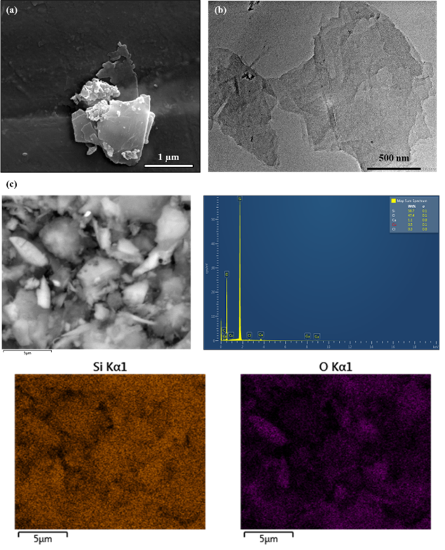
Fig. S2. (a) SEM and (b) TEM image of siloxene nanosheet. (c) EDX of the Siloxene powder, including: wt% of present elements and colour mappings of the Si and O present in the structure.

- Synthesis and Characterisation of 3-aminopropyltriethoxysilane functionalised Graphene Oxide (AGO)
Using a sonication probe, 100 mg of dried GO and 50 mg DCC catalyst were dispersed in 50 mL APTS. The mixture was refluxed at 80 °C for 12 h. The product was washed with ethanol, chloroform and DMF [3]. The resulting AGO was dispersed in DMF at known concentrations to prevent aggregation and redispersed via a sonication probe before use. ATR-FTIR analysis was conducted using a Bruker Vertex 70 FTIR-ATR system. XPS analysis was conducted using an Axis Ultra spectrometer (Kratos Analytical Limited, Manchester, UK) with a monochromatic Al Kα source (1486.7 eV).
Functional groups of GO and AGO were identified using ATR-FTIR, as shown in Fig. S3. The GO spectrum shows peaks referring to hydroxy (OH, 3300 cm⁻¹), carbonyl (C=O, 1750 cm⁻¹), aromatics (1400 cm⁻¹), alkoxy (R-O, 1000 cm⁻¹) and epoxy (R-O-R, 1040 cm⁻¹) groups. The AGO spectrum has minor differences; these include Si-O-Si (1050 cm⁻¹), Si-O-C (910 cm⁻¹) and CH₂ (2900 cm⁻¹), which confirm the bonding of the APTS to the GO [4].

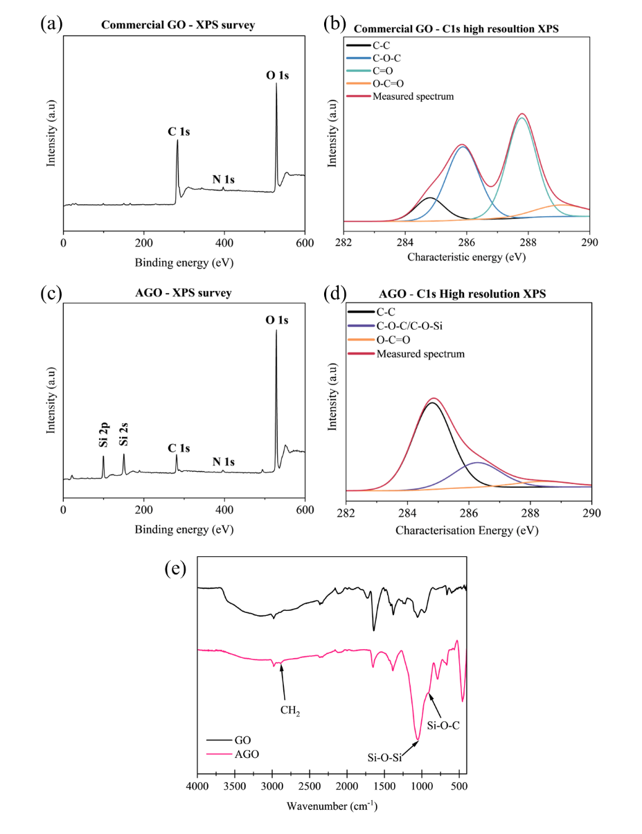
Fig. S3. XPS survey scan of (a) commercial GO and (c) AGO; XPS high-resolution scan of (b) commercial GO and (d) AGO; (e) ATR-FTIR Transmittance spectra of commercial GO and AGO.
XPS survey analysis confirmed the presence of C and O in GO and AGO in (a) and (c) of Fig. S3, respectively. Functionalisation of GO with APTS was confirmed in Fig. S3 (c) and (d) with N and Si peaks present in the spectra. Along with the loss of the C=O peak and development of the C-O-Si peak from Fig. S1 (b) to (d). Moreover, the reduction in the carbon intensity in Fig. S3 (a) compared to (c) shows that the ratio of carbon in the structure has reduced with the bonding of APTS to the GO backbone [5].
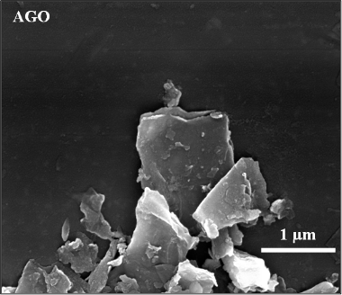
Fig. S4. SEM image of AGO nanosheet.
The 2D AGO nanosheets were captured using SEM imaging on a FEI Quanta 250 FEG-SEM with Gatan 3view. The image can be seen in Fig. S4.

- UV-Vis Calibration Curve of Bovine Serum Albumin
For each batch of bovine serum albumin (BSA), a UV-Vis calibration curve was created using different known concentrations at a wavelength of 280 nm. It was necessary to make two different calibration curves as the gradient of the curve lessened at higher BSA concentrations. Examples of these calibrations are displayed in Fig. S5.
Fig. S5. Calibration curve of BSA concentration (mg / mL) vs Absorbance (A.U). Dashed lines correspond to linear regression line: (a) low BSA concentration vs absorbance, R² = 0.9975; (b) high BSA concentration vs absorbance (%), R² = 0.9921.

- Characterisation of PES-Siloxene Membranes
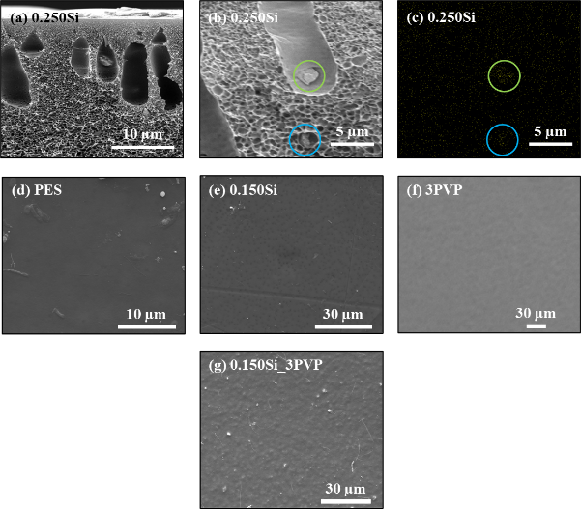Fig. S6. (a & b) Cross-section images of 0.250Si showing agglomeration of siloxene within the internal structure. (c) Silicon EDX of SEM image b, showing clusters of Si where the siloxene has agglomerated. Surface SEM images of PES-based membranes: (d) Pure PES, (e) PES-Siloxene, (f) PES with pore-formers, and (g) PES-Siloxene with pore-formers.

Table S1 Measured dry Pressure (bar) and Flow rate (l/min) for each of the PES and PES-Siloxene membranes, measured using capillary flow porometry using an IB-FT Porolux™ 1000 porometer.
PES |  | 3PVP |  | 0.025Si |  | 0.050Si
Pressure (bar) | Flow (l/min) | Pressure (bar) | Flow (l/min) | Pressure (bar) | Flow (l/min) | Pressure (bar) | Flow (l/min)
1.435 | 0.0266 | 7.316 | 0.06939 | 9.272 | 0.03215 | 13.11 | 0.004374
2.303 | 0.02777 | 7.513 | 0.05453 | 9.343 | 0.01121 | 13.33 | 0.04803
3.121 | 0.03041 | 7.815 | 0.02724 | 9.463 | 0.04065 | 13.54 | 0.008261
3.992 | 0.03141 | 8.076 | 0.08650 | 9.534 | 0.01387 | 13.75 | 0.04769
4.926 | 0.03225 | 8.372 | 0.03786 | 9.645 | 0.01793 | 13.97 | 0.04771
5.716 | 0.0319 | 8.608 | 0.08377 | 9.740 | 0.03767 | 14.16 | 0.009267
6.579 | 0.03232 | 8.902 | 0.1520 | 9.823 | 0.04029 | 14.38 | 0.008786
7.432 | 0.03243 | 9.163 | 0.09518 | 9.906 | 0.02010 | 14.61 | 0.014
8.297 | 0.03292 | 9.466 | 0.2184 | 10.00 | 0.03403 | 14.82 | 0.0157
9.146 | 0.03232 | 9.682 | 0.2017 |  |  | 15.04 | 0.01534
10.01 | 0.02986 | 10.01 | 0.2756

0.100Si |  | 0.150Si |  | 0.250Si |  | 0.150Si_3PVP
Pressure (bar) | Flow (l/min) | Pressure (bar) | Flow (l/min) | Pressure (bar) | Flow (l/min) | Pressure (bar) | Flow (l/min)
6.110 | 0.07501 | 8.169 | 0.02968 | 9.274 | 0.004391 | 5.035 | 2.633
6.403 | 0.03689 | 8.294 | 0.01771 | 9.353 | 0.003670 | 5.592 | 2.995
6.850 | 0.1019 | 8.538 | 0.08920 | 9.437 | 0.003725 | 6.107 | 3.384
7.262 | 0.09638 | 8.747 | 0.07927 | 9.528 | 0.005383 | 6.542 | 3.623
7.674 | 0.1212 | 8.854 | 0.04090 | 9.603 | 0.02460 | 7.113 | 4.057
8.100 | 0.1264 | 9.080 | 0.07090 | 9.665 | 0.002518 | 7.520 | 4.414
8.405 | 0.07532 | 9.250 | 0.03127 | 9.759 | 0.02342 | 7.985 | 4.692
8.802 | 0.1399 | 9.431 | 0.03145 | 9.833 | 0.01681 | 8.460 | 5.038
9.203 | 0.1499 | 9.633 | 0.07768 | 9.927 | 0.004806 | 9.004 | 5.489
9.640 | 0.1594 | 9.829 | 0.08946 | 10.00 | 0.02038 | 9.446 | 5.892
10.06 | 0.1611 | 10.06 | 0.1115 |  |  | 9.948 | 6.482

Table S2 Measured wet Pressure (bar) and Flow rate (l/min) for each of the PES and PES-Siloxene membranes, measured using capillary flow porometry using an IB-FT Porolux™ 1000 porometer using Porefil® (19.00 mN m⁻¹) as the wetting liquid.
PES |  | 3PVP |  | 0.025Si |  | 0.050Si
Pressure (bar) | Flow (l/min) | Pressure (bar) | Flow (l/min) | Pressure (bar) | Flow (l/min) | Pressure (bar) | Flow (l/min)
1.395 | 0.008638 | 7.225 | 0.009958 | 9.062 | 0.01003 | 12.85 | 0.009282
1.849 | 0.02391 | 7.471 | 0.07546 | 9.133 | 0.05024 | 13 | 0.003407
2.265 | 0.03053 | 7.613 | 0.01070 | 9.209 | 0.03090 | 13.15 | 0.02136
2.734 | 0.03592 | 7.776 | 0.03137 | 9.328 | 0.008428 | 13.32 | 0.006494
3.151 | 0.0369 | 7.984 | 0.01046 | 9.367 | 0.004533 | 13.45 | 0.005273
3.571 | 0.0365 | 8.143 | 0.04119 | 9.497 | 0.03302 | 13.58 | 0.005976
4.005 | 0.03424 | 8.333 | 0.05021 | 9.565 | 0.02214 | 13.75 | 0.04639
4.427 | 0.03212 | 8.524 | 0.01204 | 9.646 | 0.009723 | 13.86 | 0.005396
4.882 | 0.02938 | 8.751 | 0.07067 | 9.689 | 0.02508 | 14.01 | 0.03196
5.296 | 0.02956 | 8.891 | 0.06064 | 9.770 | 0.02917 | 14.15 | 0.006836
5.729 | 0.03204 | 9.101 | 0.05589 | 9.812 | 0.02492 | 14.29 | 0.008124
6.153 | 0.03412 | 9.268 | 0.03087 | 9.899 | 0.01067 | 14.43 | 0.02394
6.582 | 0.03546 | 9.494 | 0.08817 | 9.956 | 0.03815 | 14.58 | 0.007806
7.036 | 0.03643 | 9.646 | 0.08459 | 9.996 | 0.02364 | 14.74 | 0.01058
7.437 | 0.0379 | 9.809 | 0.03700 |  |  | 14.9 | 0.05167
7.873 | 0.03969 | 10.01 | 0.09821 |  |  | 15.02 | 0.01093
8.296 | 0.04117
8.736 | 0.04105
9.169 | 0.04105
9.606 | 0.03992
10.03 | 0.04208

0.100Si |  | 0.150Si |  | 0.250Si |  | 0.150Si_3PVP
Pressure (bar) | Flow (l/min) | Pressure (bar) | Flow (l/min) | Pressure (bar) | Flow (l/min) | Pressure (bar) | Flow (l/min)
6.022 | 0.01041 | 8.106 | 0.009996 | 9.179 | 0.009109 | 5.142 | 0.009757
6.356 | 0.09217 | 8.260 | 0.04807 | 9.221 | 0.01672 | 5.476 | 0.08183
6.591 | 0.08472 | 8.363 | 0.03350 | 9.286 | 0.003371 | 5.776 | 0.09741
6.792 | 0.01336 | 8.471 | 0.008372 | 9.370 | 0.002414 | 6.029 | 0.1497
7.080 | 0.07544 | 8.640 | 0.04952 | 9.460 | 0.002704 | 6.413 | 0.2879
7.375 | 0.02003 | 8.743 | 0.01158 | 9.501 | 0.002641 | 6.762 | 0.3976
7.629 | 0.08557 | 8.877 | 0.05338 | 9.557 | 0.001861 | 7.118 | 0.7258
7.863 | 0.02451 | 8.987 | 0.01276 | 9.606 | 0.001996 | 7.417 | 1.021
8.157 | 0.08945 | 9.132 | 0.02065 | 9.658 | 0.007208 | 7.697 | 1.874
8.419 | 0.03267 | 9.264 | 0.05553 | 9.737 | 0.02466 | 8.017 | 2.449
8.706 | 0.1080 | 9.355 | 0.02293 | 9.799 | 0.007067 | 8.331 | 2.826
8.962 | 0.1056 | 9.511 | 0.02679 | 9.843 | 0.02482 | 8.678 | 3.319
9.197 | 0.05066 | 9.642 | 0.07754 | 9.902 | 0.02263 | 9.028 | 3.908
9.508 | 0.1241 | 9.717 | 0.03947 | 9.940 | 0.01422 | 9.259 | 4.532
9.705 | 0.05739 | 9.896 | 0.08204 | 10.01 | 0.03722 | 9.557 | 5.022
10.07 | 0.1203 | 10.02 | 0.08752 |  |  | 9.924 | 6.044

- Characterisation of Commercial PES Biomax®
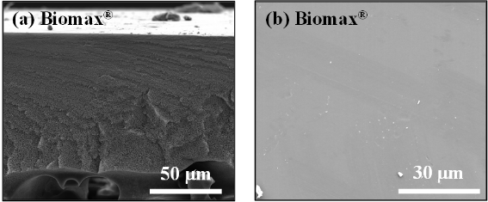
Fig. S7. (a) Cross-section and (b) surface SEM images of commercial Biomax®.

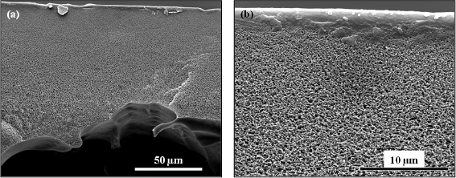
Fig. S8. Cross-section SEM images of commercial PES Biomax® at two different scales: (a) 50 µm and (b) 10 µm.

Fig. S8 shows the commercial PES Biomax® after completing PWP₁ of the antifouling testing. It shows clear compaction of the membrane at its surface that prevented permeation in further tests, including the J_{BSA} and PWP₂ steps of the process.

- Characterisation of PES-AGO Membranes
Table S3 Characterisation data of fabricated PES-AGO membranes: 0.100AGO and 0.100AGO_3PVP.
Membrane | 0.100AGO | 0.100AGO_3PVP
Thickness / µm | 27.6 (± 0.2) | 54.6 (± 0.3)
Porosity / % | 83.6 (± 2.2) | 86.7 (± 2.5)
Contact Angle / ° | 47 (± 1) | 49 (± 1)
Zeta Potential (mV) | -25.7 (± 0.0) | -25.1 (± 1.3)
PWP / LMHBar | 115.8 (± 11.7) | 593.0 (± 14.3)
BSA Rejection / % | 99.3 (± 0.2) | 94.8 (± 1.0)
FRR / % | 51.8 (± 1.9) | -
Sponge-like Material size / µm | 0.089 (± 0.007) | 0.300
Macrovoid/Sponge-like Ratio | 0.095 | 2.424

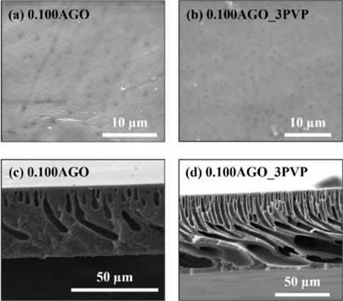
Fig. S9. SEM imaging showing surface and cross-section morphology of both 0.100AGO and 0.100AGO_3PVP.

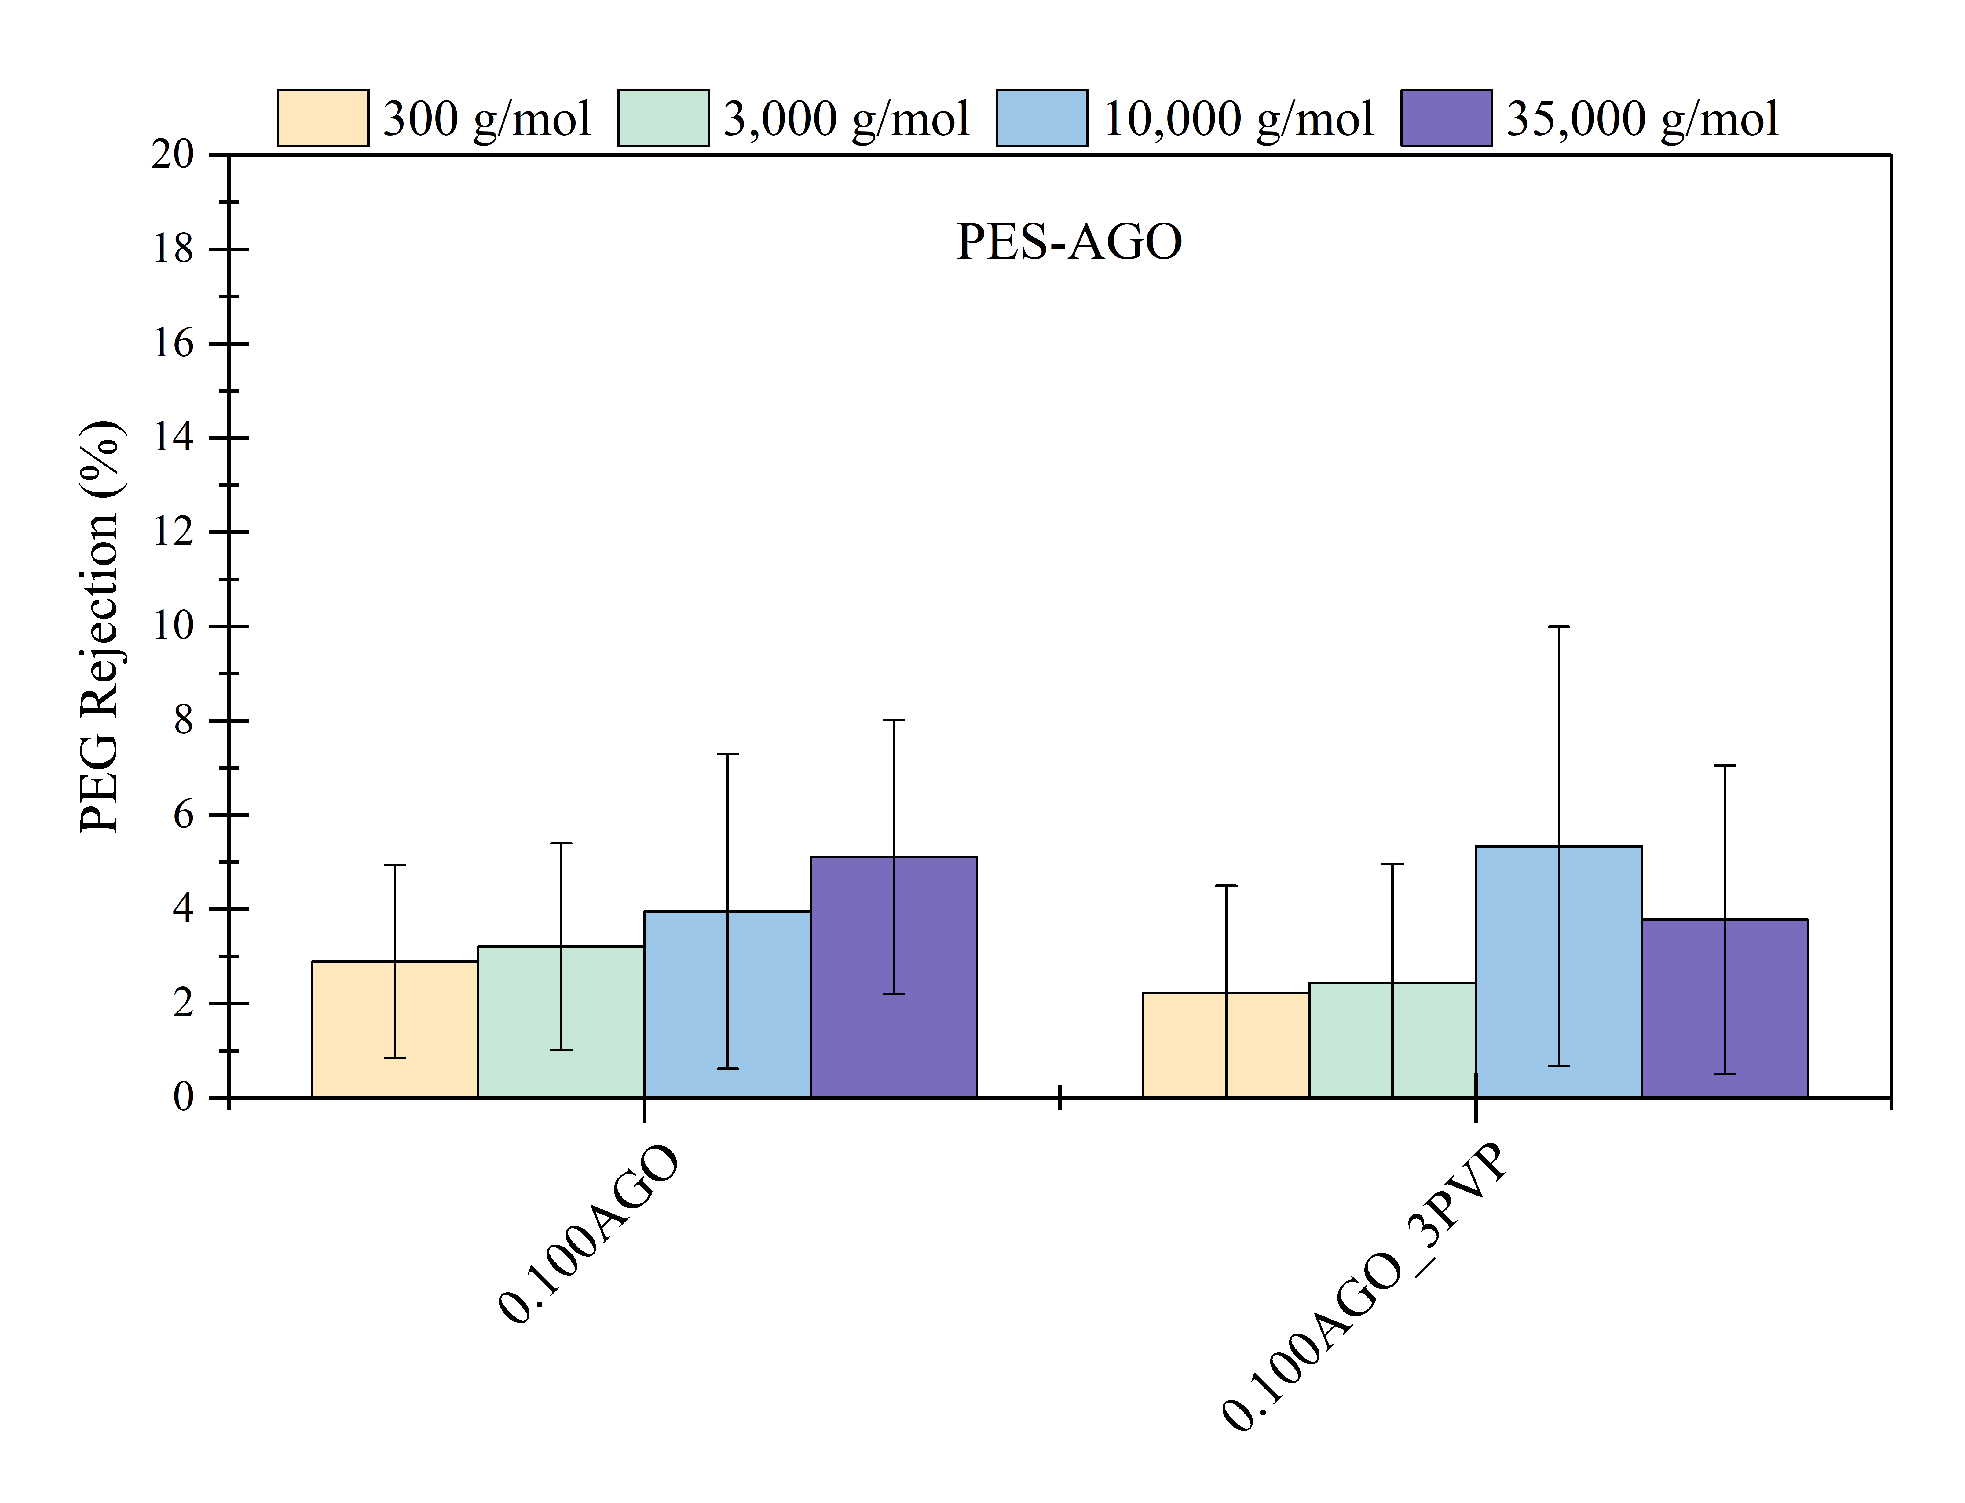
Fig. S10. Rejection (%) of Polyethylene glycol (PEG) at four different molecular weights (35,000, 10,000, 3,000 and 300 g mol⁻¹) in PES-AGO membranes.

Fig. S11. Flux recovery ratio (FRR), total flux decline ratio (R_{t}), reversible flux decline ratio (R_{r}), and irreversible flux decline ratio (R_{ir}), for membrane 0.100AGO, calculated using Eqs. 5, 6, 7, and 8, respectively.
When testing the PES-AGO membranes, there were some notable differences compared to the results from the literature [3]. Such differences are attributed to slight discrepancies in the membrane fabrication. After casting, the reported membranes were dried, while in this work, they were kept immersed in DI water until used. As a result, the dried membrane had a PWP of just 1.17 and 53.8 LMHBar for the 0.100AGO and 0.100AGO_3PVP, respectively, ~99% and ~91% lower than the obtained herein. Similarly, the porosity was also reduced at just ~22% and ~77%, respectively, compared to 83.6% and 86.7%. Although the techniques for attaining the MWCO are different, the literature membranes had a much lower MWCO, being able to reject low MW dyes, whereas the AGO membranes in this work showed less than 6% rejection for PEG (Fig. S8) at comparable testing solute MW. The observed effect denotes the relevance of fabricated membrane post-treatment and storage conditions to tailor the material performance. It is possible to shift between NF and UF of the same raw material and fabrication procedure.

References
[1] J. Ji, S. Mazinani, E. Ahmed, Y.M. John Chew, D. Mattia, Hydrophobic poly(vinylidene fluoride) / siloxene nanofiltration membranes, J. Memb. Sci. 635 (2021) 119447. https://doi.org/10.1016/j.memsci.2021.119447.
[2] H.D. Fuchs, M. Stutzmann, M.S. Brandt, M. Rosenbauer, J. Weber, A. Breitschwerdt, P. Deák, M. Cardona, Porous silicon and siloxene: Vibrational and structural properties, Phys. Rev. B 48 (1993) 8172–8189. https://doi.org/10.1103/PhysRevB.48.8172.
[3] J.M. Luque-Alled, A. Abdel-Karim, M. Alberto, S. Leaper, M. Perez-Page, K. Huang, A. Vijayaraghavan, A.S. El-Kalliny, S.M. Holmes, P. Gorgojo, Polyethersulfone membranes: From ultrafiltration to nanofiltration via the incorporation of APTS functionalized-graphene oxide, Sep. Purif. Technol. 230 (2020) 115836. https://doi.org/10.1016/j.seppur.2019.115836.
[4] S. Leaper, A. Abdel-Karim, B. Faki, J.M. Luque-Alled, M. Alberto, A. Vijayaraghavan, S.M. Holmes, G. Szekely, M.I. Badawy, N. Shokri, P. Gorgojo, Flux-enhanced PVDF mixed matrix membranes incorporating APTS-functionalized graphene oxide for membrane distillation, J. Memb. Sci. 554 (2018) 309–323. https://doi.org/10.1016/j.memsci.2018.03.013.
[5] Z. Xu, J. Zhang, M. Shan, Y. Li, B. Li, J. Niu, B. Zhou, X. Qian, Organosilane-functionalized graphene oxide for enhanced antifouling and mechanical properties of polyvinylidene fluoride ultrafiltration membranes, J. Memb. Sci. 458 (2014) 1–13. https://doi.org/10.1016/j.memsci.2014.01.050.

