Electronic Online Supplementary Materials (ESM)
Sensitivity Analyses: Moderation of effects by gender and socio-economic status

We checked if the theoretically relevant links that we investigated in our model were moderated by groups based on gender and socio-economic status (SES; low versus medium/high). Specifically, we tested if these variables moderated the associations between the study variables using multiple-group analyses. Before proceeding with these analyses, we also examined the invariance of our longitudinal measurement model. Specifically, we started with the assumption of longitudinal invariance within the groups, i.e., in our initial configural invariance model, measurement model parameters were constrained to be equal across the three waves, but were allowed to vary between groups, and then we ran increasingly constrained models representing weak, strong, and strict multi-group invariance (Little, 2013). To test for the moderation effects, we tested the multi-group invariance of (a) stability coefficients, (b) cross-lag coefficients, and (c) residual correlation coefficients. Results of analyses for gender and SES groups showed that a strict invariance could be established and that the structural parameters of a cross-lagged panel model were invariant. As such, we concluded that gender and SES did not moderate the links between variables of the study. Results for gender groups are presented in ESM Table 1, and for SES groups - in ESM Table 2.
ESM Table 1.
Results of cross-lagged panel model parameter invariance tests in gender groups (N = 916)
Model tested (model compared with) | Model fit statistics |  |  |  |  |  |  | Model comparison
Model tested (model compared with) | χ² | df | n_{par} | p | CFI | RMSEA [90% CI] | SRMR | Δχ² | Δdf | p | ΔCFI | ΔRMSEA
Multiple group measurement invariance tests
Configural | 2535.08 | 1730 | 430 | <.001 | .940 | .032 [.029 .035] | .060 | - | - | - | - | -
Weak (vs configural) | 2557.07 | 1740 | 420 | <.001 | .939 | .032 [.029 .035] | .061 | 21.77 | 10 | .016 | -.001 | .000
Strong (vs weak) | 2696.82 | 1750 | 410 | <.001 | .930 | .034 [.032 .037] | .063 | 185.62 | 10 | <.001 | -.009 | .002
Strict (vs strong) | 2753.48 | 1765 | 395 | <.001 | .927 | .035 [.032 .037] | .067 | 44.79 | 15 | <.001 | -.003 | .001
Multiple group structural invariance tests
M1 (vs strict) | 2833.34 | 1815 | 345 | <.001 | .924 | .035 [.032 .037] | .068 | 80.02 | 50 | .004 | -.003 | .000
M2 (vs M1) | 2866.18 | 1830 | 330 | <.001 | .923 | .035 [.033 .038] | .069 | 33.27 | 15 | .004 | -.001 | .000
M3 (vs M2) | 2932.54 | 1890 | 270 | <.001 | .923 | .035 [.032 .037] | .074 | 68.00 | 60 | .224 | .000 | .000
M4 (vs M3) | 2990.03 | 1920 | 240 | <.001 | .921 | .035 [.032 .037] | .075 | 56.23 | 30 | .003 | -.002 | .000
Note. CFI - Comparative Fit Index; RMSEA – Root Mean Square Error of Approximation; SRMR – Standardized Root Mean Square Residual; CI – Confidence Interval. n_{par} – the number of free parameters in the model. M1: cross-lagged panel model without any multi-group constraints; M2: cross-lagged panel model with stability coefficients constrained to be equal across two groups; M3: cross-lagged panel model with stability and cross-lag coefficients constrained to be equal across two groups; M4: cross-lagged panel model with stability, cross-lag, and residual correlation coefficients constrained to be equal across two groups.

ESM Table 2.
Results of cross-lagged panel model parameter invariance tests in SES groups (N = 916)
Model tested (model compared with) | Model fit statistics |  |  |  |  |  |  | Model comparison
Model tested (model compared with) | χ² | df | n_{par} | p | CFI | RMSEA [90% CI] | SRMR | Δχ² | Δdf | p | ΔCFI | ΔRMSEA
Multiple group measurement invariance tests
Configural | 2565.34 | 1730 | 430 | <.001 | .941 | .032 [.030 .035] | .063 | - | - | - | - | -
Weak (vs configural) | 2574.00 | 1740 | 420 | <.001 | .941 | .032 [.030 .035] | .063 | 9.43 | 10 | .491 | .000 | .000
Strong (vs weak) | 2591.66 | 1750 | 410 | <.001 | .941 | .032 [.030 .035] | .063 | 18.03 | 10 | .055 | .000 | .000
Strict (vs strong) | 2643.54 | 1765 | 395 | <.001 | .938 | .033 [.030 .036] | .066 | 38.64 | 15 | .001 | -.003 | .001
Multiple group structural invariance tests
M1 (vs strict) | 2755.63 | 1815 | 345 | <.001 | .934 | .034 [.031 .036] | .068 | 126.93 | 50 | .000 | -.004 | .001
M2 (vs M1) | 2766.27 | 1830 | 330 | <.001 | .934 | .033 [.031 .036] | .069 | 14.39 | 15 | .496 | .000 | -.001
M3 (vs M2) | 2815.47 | 1890 | 270 | <.001 | .935 | .033 [.030 .035] | .072 | 54.49 | 60 | .677 | .001 | .000
M4 (vs M3) | 2836.67 | 1920 | 240 | <.001 | .936 | .032 [.030 .035] | .072 | 27.60 | 30 | .591 | .001 | -.001
Note. CFI - Comparative Fit Index; RMSEA – Root Mean Square Error of Approximation; SRMR – Standardized Root Mean Square Residual; CI – Confidence Interval. n_{par} – the number of free parameters in the model. M1: cross-lagged panel model without any multi-group constraints; M2: cross-lagged panel model with stability coefficients constrained to be equal across two groups; M3: cross-lagged panel model with stability and cross-lag coefficients constrained to be equal across two groups; M4: cross-lagged panel model with stability, cross-lag, and residual correlation coefficients constrained to be equal across two groups.

Sensitivity Analyses: Replication of Findings Using Latent Difference Score Model
In addition to checking if the investigated effects are moderated by gender and SES status, we repeated our main analyses using the latent difference score model (McArdle, 2009; Newsom, 2015). Specifically, we investigated if within-person analyses replicate the findings of between-person analyses using cross-lagged panel models. We carried out these analyses in several steps. To begin with, we transformed the cross-lagged panel model without any constraints (Model 1 in the main text of the manuscript) into a latent difference score model. This was achieved by including a set of latent difference score factors to capture the change of pro-diversity and pro-equality values and identity styles that happened between T1 and T2, and between T2 and T3. A latent difference score factors were modeled by (a) fixing the means and disturbances of T2 and T3 latent level score variables to zero, (b) constraining all autoregressive (stability) paths between latent level score variables to one, (c) introducing new latent difference score variables for each occasion except the first one that are defined by a single loading on latent level score variable that is fixed to one, (d) regressing this latent difference score variable on all latent level score variables measured in previous occasion. A simplified example of fixed and estimated paths for two variables in this initial model is presented in ESM Figure 1 (Model A).
As this initial latent difference score model was just a respecified cross-lagged panel model without any constraints, it had the exact same fit as the initial cross-lagged panel model (see Model A in ESM Table 3 and Model 1 in Table 2 of the main text). Next, following the sequence of cross-lagged panel model analyses, we checked if a more parsimonious latent difference score model had a similar fit with data. Specifically, we constrained all cross-lagged paths linking level score and difference score variables to be time-invariant to evaluate if the effects were the same between different waves (Model B in ESM Figure 1 presents the simplified example for two variables). The imposition of the new constraints did not have any effect on the model-data fit (see ESM Table 3). Therefore, these constraints were retained. Finally, we tested a third model in which latent difference score variables representing change between T2 and T3 were regressed on difference score representing change between T1 and T2 (Model C in ESM Figure 1 presents the simplified example for two variables). In this case, the chi-square difference test showed a statistically significant improvement in model-data fit. However, both RMSEA and CFI did not show any significant improvement (ESM Table 3). As such, we retained and interpreted the more parsimonious model, which did not include these paths. ESM figure 2 presents the standardized results of this final model.
In general, the results of the latent difference score model have replicated the results of the cross-lagged panel model analyses. Specifically, we found that higher levels of the information-oriented identity style were related to a within-person increase in pro-diversity and pro-equality values over time, while higher levels of pro-diversity and pro-equality values were related to a within-person increase in information-oriented identity style. Also, stronger support for pro-diversity values was related to a within-person increase in pro-equality values, and more support to pro-equality values was related to a within-person increase in pro-diversity values over time.
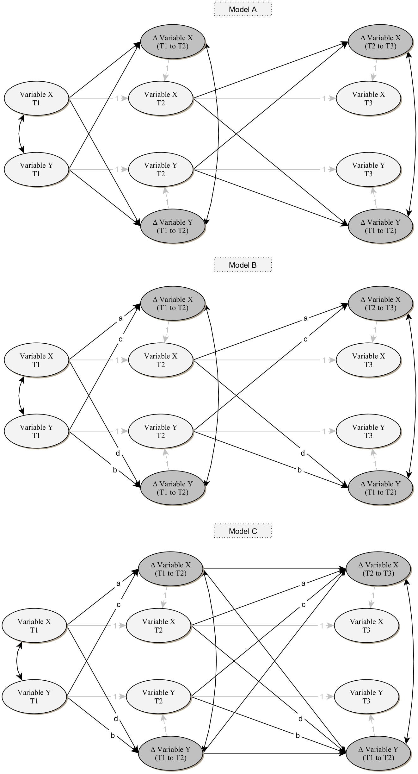
ESM figure 1. A simplified example of latent difference score models that were estimated in this ESM.

ESM Table 3.
Results of latent difference score model analyses (N = 916)
Model tested (model compared with) | Model fit statistics |  |  |  |  |  |  | Model comparison
Model tested (model compared with) | χ² | df | n_{par} | p | CFI | RMSEA [90% CI] | SRMR | Δχ² | Δdf | p | ΔCFI | ΔRMSEA
Model A | 1566.922 | 890 | 190 | <.001 | .954 | .029 [.026 .031] | .051 | - | - | - | - | -
Model B (vs Model A) | 1581.748 | 915 | 165 | <.001 | .955 | .028 [.026 .031] | .052 | 17.018 | 25 | .881 | .001 | -.001
Model C (vs Model B) | 1535.745 | 890 | 190 | <.001 | .956 | .028 [.026 .030] | .051 | 45.728 | 25 | .006 | .001 | .000
Note. CFI - Comparative Fit Index; RMSEA – Root Mean Square Error of Approximation; SRMR – Standardized Root Mean Square Residual; CI – Confidence Interval. n_{par} – the number of free parameters in the model. M1: cross-lagged panel model without any multi-group constraints; M2: cross-lagged panel model with stability coefficients constrained to be equal across two groups; M3: cross-lagged panel model with stability and cross-lag coefficients constrained to be equal across two groups; M4: cross-lagged panel model with stability, cross-lag, and residual correlation coefficients constrained to be equal across two groups.

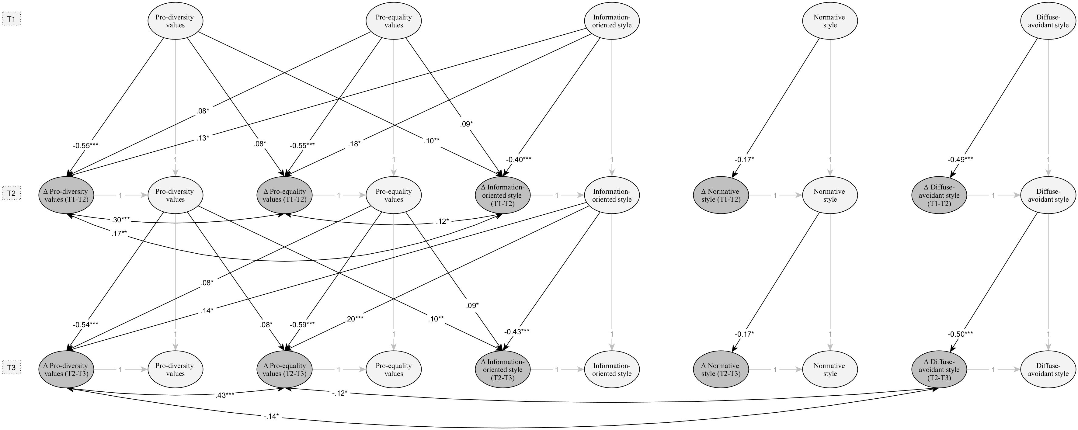
ESM figure 2. Standardized results of the latent difference score model linking identity styles with pro-diversity and pro-equality values. Paths in grey color are constrained to one. To increase figure clarity, associations between different identity styles, non-significant paths between all variables and correlations between T1 variables are omitted. *** p < .001; ** p < .01; * p < .05

Low SES was defined in this study as the status of receiving free meals at school. In Lithuania, this form of support is available for children from families facing financial challenges.
Here we use the term “level score” to refer to latent variable score (those modeled in cross-lagged panel model) and the term “difference score” to refer to the change in latent variable score between two measurement occasions.

