Adsorption of phospholipids onto layered silicate surface: the case of clinochlore
Gianfranco Ulian¹, Giacomo Trondoli¹, Francesca Ranellucci¹, Giovanni Valdrè^{1*}
¹Dipartimento di Scienze Biologiche, Geologiche e Ambientali, Università di Bologna “Alma Mater Studiorum”, Plesso di Mineralogia, Piazza di Porta San Donato 1, 40126 Bologna, Italy
*Correspondence to: Giovanni Valdrè (giovanni.valdre@unibo.it)

Supplemental Materials
Figure S1. Projected density of states (PDOS) and Crystal Orbital Overlap Population (COOP) of (a) BP01 and (b) BP04 systems, where the adsorption substrates were stoichiometric and Al-bearing brucite-like layers, respectively. In the PDOS, projections for all atoms of the DVPA molecule and the brucite-like layer substrate were reported as negative values. Positive PDOS are related to groups of atoms of the phospholipid [glycine backbone – Gly, aliphatic chains – C₅ (1) and C₅ (2), and the polar head, –PO₄H₂] and the oxygen and hydrogen atoms of the substrate exposed towards the molecule. Positive COOP values indicate bonding states, whereas negative ones are associated to antibonding states.

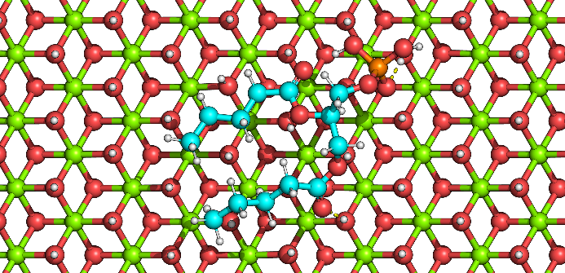 | 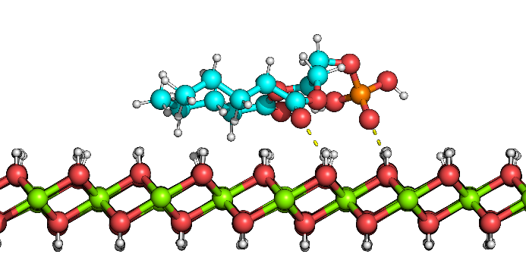
(a) | (b)
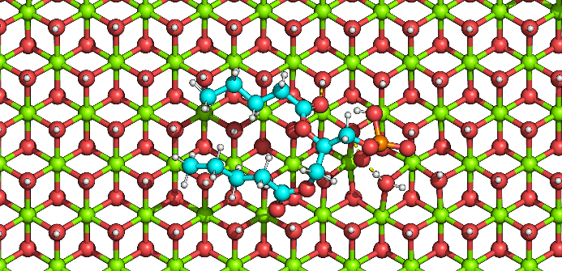 | 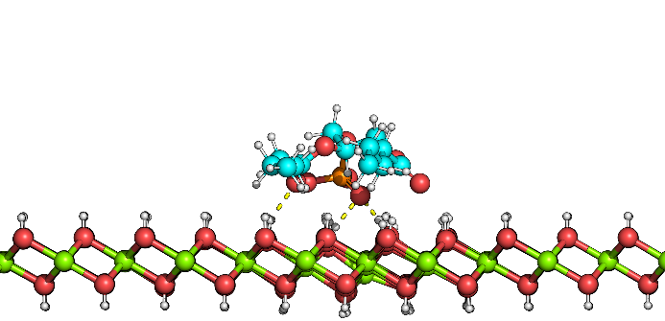
(c) | (d)
Figure S2. Views along (a) the [001] and (b) [100] directions of the relaxed BP02 model, with the DVPA starting configuration being vertical with the phosphate group pointing towards the stoichiometric (001) brucite-like slab layer. Views along (c) the [001] and (d) [100] directions of the geometrically optimized BP03 model, with the DVPA starting configuration being vertical with the phosphate group pointing outwards the stoichiometric (001) brucite-like slab layer. Hydrogen bonds (polar contacts) between the phospholipid and the (001) mineral surface are shown in yellow dashed lines. Colour coding for atoms: P – orange, Al – grey, Mg – green, O – red, C – cyan, H – white.

Figure S3. Projected density of states (PDOS) and Crystal Orbital Overlap Population (COOP) of (a) TP01 and (b) TP02 systems, where the adsorption substrates were stoichiometric and Al-bearing TOT layers, respectively. In the PDOS, projections for all atoms of the DVPA molecule and the brucite-like layer substrate were reported as negative values. Positive PDOS are related to groups of atoms of the phospholipid [glycine backbone – Gly, aliphatic chains – C₅ (1) and C₅ (2), and the polar head, –PO₄H₂] and the oxygen and hydrogen atoms of the substrate exposed towards the molecule. Positive COOP values indicate bonding states, whereas negative ones are associated to antibonding states.

Figure S4. Projected density of states (PDOS) and Crystal Orbital Overlap Population (COOP) of (a) BP05, (b) BP06, (c) BP07, and (d) BP08 systems, where the adsorption substrate was an stoichiometric brucite-like layer. In the PDOS, projections for all atoms of the DVPA molecule and the brucite-like layer substrate were reported as negative values. Positive PDOS are related to groups of atoms of the phospholipid [glycine backbone – Gly, aliphatic chains – C₅ (1) and C₅ (2), and the polar head, –PO₄H₂] and the oxygen and hydrogen atoms of the substrate exposed towards the molecule. Positive COOP values indicate bonding states, whereas negative ones are associated to antibonding states.

Figure S5. Projected density of states (PDOS) and Crystal Orbital Overlap Population (COOP) of (a) BP05, (b) BP06, (c) BP07, and (d) BP08 systems, where the adsorption substrate was an Al-bearing brucite-like layer. In the PDOS, projections for all atoms of the DVPA molecule and the brucite-like layer substrate were reported as negative values. Positive PDOS are related to groups of atoms of the phospholipid [glycine backbone – Gly, aliphatic chains – C₅ (1) and C₅ (2), and the polar head, –PO₄H₂] and the oxygen and hydrogen atoms of the substrate exposed towards the molecule. Positive COOP values indicate bonding states, whereas negative ones are associated to antibonding states.

Figure S6. Projected density of states (PDOS) and Crystal Orbital Overlap Population (COOP) of (a) TP03 and (b) TP04 systems, where the adsorption substrate was a TOT layer, and (c) TP05 and (d) TP06 models, with an Al-bearing TOT layer. In the PDOS, projections for all atoms of the DVPA molecule and the brucite-like layer substrate were reported as negative values. Positive PDOS are related to groups of atoms of the phospholipid [glycine backbone – Gly, aliphatic chains – C₅ (1) and C₅ (2), and the polar head, –PO₄H₂] and the oxygen and hydrogen atoms of the substrate exposed towards the molecule. Positive COOP values indicate bonding states, whereas negative ones are associated to antibonding states.

