Electron microscopy and multi-omics reveal mitochondrial dysfunction and structural remodeling in the hearts of elderly mice

Manuela Giovanna Basilicata¹*, Marco Malavolta^{2,3}*, Serena Marcozzi^{2,4}, Eduardo Sommella⁵, Lucia Scisciola¹, Fabrizio Merciai⁵, Gianluca Fulgenzi^{2,3}, Valentina Golino^{5,6}, Giovanni Tortorella¹, Tatiana Spadoni⁷, Laura Graciotti⁷, Tania Ciaglia⁵, Leonardo Schirone⁸, Valentina Valenti⁹, Sebastiano Sciarretta^{9,10}, Ceereena Ubaida-Mohien¹¹, Carmine Pizzi^{12,13}, Rafael De Cabo¹⁴, Pietro Campiglia⁵, Lucia Altucci^{15,16,17}, Michelangela Barbieri¹, Fabiola Olivieri^{2,3}, Luigi Ferrucci¹⁴ and Giuseppe Paolisso ^{1,18}

¹Department of Advanced Medical and Surgical Sciences, University of Campania “Luigi Vanvitelli”, Naples, Italy.
² Advanced Technology Center for Aging Research and Geriatric Mouse Clinic, IRCCS INRCA, 60121 Ancona, Italy.
³ Department of Clinical and Molecular Sciences (DISCLIMO), Polytechnic University of Marche, Ancona, Italy.
⁴ Scientific Direction, IRCCS INRCA, 60124 Ancona, Italy.
⁵ Department of Pharmacy, University of Salerno, Fisciano, SA, Italy.
⁶ National PhD Program in RNA Therapeutics and Gene Therapy, University of Naples Federico II, 80131 Napoli, Italy.
⁷ Department of Biomedical Sciences and Public Health, Polytechnic University of Marche, Ancona, Italy.
⁸ Department of Health and Life Science, European University of Rome.
⁹ Department of Medico-Surgical Sciences and Biotechnologies, University of Sapienza, Rome, Italy
¹⁰ IRCCS Neuromed, Pozzilli, Italy.
¹¹ Intramural Research Program, National Institute on Aging, National Institutes of Health, Baltimore, Maryland, USA.
¹² Department of Medical and Surgical Sciences-DIMEC-Alma Mater Studiorum, University of Bologna, Bologna, Italy.
¹³ Cardiovascular Division, Morgagni–Pierantoni University Hospital, Forlì, Italy.
¹⁴ National Institute on Aging, Baltimore, MD, USA.
¹⁵ Department of Precision Medicine University of Campania “Luigi Vanvitelli”, Naples, Italy
¹⁶ Program of Medical Epigenetics, Vanvitelli Hospital, Naples, 80138, Italy.
¹⁷ Biogem, Molecular Biology and Genetics Research Institute, Ariano Irpino, 83031, Italy.
¹⁸ UniCamillus International University of Health Sciences, 00161 Rome, Italy.
* These authors equally contributed as first author

Corresponding Author:
Prof. Giuseppe Paolisso
Department of Advanced Medical and Surgical Sciences, University of Campania 'Luigi Vanvitelli', Naples, Italy
e-mail: giuseppe.paolisso@unicampania.it

Tel: ++39.0815665135

Supplementary Material
Supplementary Methods

Animals and Experimental Design
Male C57BL/6J mice aged 6 months (young group, n = 9), 12 months (adult group, n = 12), 24 months (middle age group, n = 11), and 30 months (elderly group, n = 11) were enrolled in this study. All mice were bred and maintained at the Geriatric Mouse Clinic of IRCCS INRCA under SPF conditions. We included only male mice in this study to reduce variability related to hormonal cycles, which may influence cardiac physiology and mitochondrial function. That excluding female represents a limitation of the present work, as sex differences are known to affect cardiac aging, mitochondrial remodeling, and fibrotic pathways. Future studies including both sexes will be critical to determine whether the observed phenotypes are consistent across sexes or whether sex-specific trajectories of cardiac aging exist.
All the experimental protocols were approved by the Italian Ministry of Health (authorization n. 392/2019-PR). Mice were housed in SPF conditions at a maximum density of 4 per cage under a controlled environment, maintained on a 12:12 light-dark cycle (lights on at 6:00 a.m.), and had ad libitum access to food and water.

Biochemical parameters
Biochemical parameters were analyzed in a subset of animals in each age group: young (n = 6), adult (n = 6), middle age (n = 6), and elderly (n = 6). Blood samples were collected from the right retroorbital plexus of anesthetized mice. Anesthesia was induced by placing each mouse in an inhalation chamber with 4% isoflurane regulated with a calibrated vaporizer. Blood samples were collected, transferred into serum separator gel tubes (Microvette® CB 300 EDTA K2E tubes, cod.16.444.100, Sarstedt) and centrifuged for serum separation. Serum concentrations of glucose, albumin, and creatinine were determined using their appropriate kits (cod. CL35-400S, CL04-400S, and HP57-240 by Far Diagnostics, Italy, respectively) by an automated analyzer (COBAS MIRA, by Roche) according to the manufacturer’s instructions. Standard controls were run before each determination.

Echocardiography and electrocardiography (ECG) analysis
Echocardiography analysis was performed in a subset of animals in each age group: young (n = 6), adult (n = 9), middle age (n = 8), and elderly (n = 8) authorization n. 392/2019-PR and n. 59/2024-PR. Briefly, a high-frequency, high-resolution digital imaging platform with linear array technology and color Doppler mode for in vivo high-resolution micro-imaging was used (Vevo® 3100 Imaging System, FUJIFILM VisualSonics Inc., Toronto, Canada). To assess the cardiovascular function of mice, a high-frequency transducer probe (VisualSonics MS400, FUJIFILM VisualSonics, Inc., Toronto, Canada with a frequency range of 18–38 MHz) was used by a skilled cardiologist under the supervision of a veterinarian. Mice were anesthetized using (IsoFlo®) 1.35% + 2% O2, shaved and positioned on an electrically warmed surface.
ECG was recorded non-invasively in non-anesthetized, conscious mice using the ECGenie recording platform (Mouse Specifics, Inc.). All mice were allowed to acclimate for ~10 minutes. After the acclimation period, ECG signals were recorded while the mice passively established contact between the underside of their paws and the electrodes. Only data from continuous recordings of > 15 ECG signals were used in the analyses. Analysis of individual ECG signals was then performed using e-MOUSE physiologic waveform analysis software (Mouse Specifics, Inc.).

Electron Microscopy data
Heart was rapidly excised from avertin anesthetized mice. A cubic millimeter of posterior wall was dissected from the fresh tissue and submerged for 30 seconds in a myorelaxant solution (Phosphate buffer added with 50 mM of KCl) and then transferred to the fixative solution (2.5% glutaraldehyde, 0.5% paraformaldehyde, 0.7% tannic acid and 30 mM sucrose in 0.1 M of cacodylate buffer (pH 7.0) for 1 h at room temperature and after that stored in fixative at 4 C Until further processing. Hearth blocks were post fixed in 0.5% Osmium tetroxide in cacodylate buffer for 1 h then washed in distilled H2O. Blocks were dehydrated in acetone series and embedded in Epon-Araldyte resin. 50 nm thick section were obtained with Leica ultramicrotome (UM6 Leica, Germany) placed in 40 mesh copper grids, stained with lead citrate and imaged with a Philips CM12 electron microscope at 100 Kv.
Images at nominal magnification of 8800 x and resolution of 90.43 pix/µm were used to measure mitochondria. A multi-point spline was manually drawn to contour healthy mitochondria using ImageJ software, then the area, perimeter, minor axes, major axes, solidity, and circularity index, cristae score and mithocondrial number measured automatically by the software. To evaluate group differences while accounting for repeated measurements within individual animals, we employed Generalized Estimating Equations (GEE). Area and other variables measurements were collected in multiple replicates per mouse (100-300 measurements per animal) across three experimental groups (adult n = 3, middle age n = 2, and elderly n = 2). GEE models were fitted using a gamma distribution with a log link function to accommodate the positive skew and heteroscedasticity of the data. The mouse identifier (Mouse_ID) was included as the subject variable to adjust for intra-animal correlation. Estimated marginal means (EMMs) were computed for each group, and pairwise comparisons were performed using least significant difference (LSD) adjustment. All analyses were conducted using SPSS (Version 26, IBM Corp.).

Statistical analysis for Animal Design
Results were presented as mean ± SEM and p-value was determined by one-way ANOVA followed by Bonferroni post-hoc analyses using IBM SPSS Statistics version 29.0. The graphs were created using Graphpad Prism 9 software. A p value < 0.05 was used to determine significance for all statistical tests. * p < 0.05; ** p < 0.01; *** p < 0.001; **** p < 0.0001.

Spatial transcriptomics
Spatial transcriptomics was performed in a subset of animals in the groups: adult (n = 2), middle age (n = 2), and elderly (n = 2). Left ventricles were dissected, embedded in OCT, snap-frozen on dry ice and stored under liquid nitrogen.
Spatial transcriptomics was performed using BMKMANU S1000 RNA-seq with the BMKMANU S1000 Gene Expression kit (BMKGENE, ST03002) at BMKGENEMANU. Briefly, Spatial Transcriptomics slides were printed with 1-8 identical 6.8×6.8 mm capture areas, each with 2,000,000 spots contain barcoded primers (BMKMANU S1000). The primers are attached to the slide by the 5’ end and contain a cleavage site, a T7 promoter region, a partial read1 Illumina handle, a spot-unique spatial barcode, a unique molecular identifier (UMI), and Poly(dT)VN. The spots have a diameter of 2.5μm and are arranged in a centered regular hexagonal grid so that each spot has six surrounding spots with a center-to-center distance of 4.8μm. Tissue sectioning, blue staining, imaging, and first permeabilization were consistent with the user guide of the BMKMANU S1000 Tissue Optimization Kit (BMKMANU, ST03003). Secondary permeabilization (9 min) and library construction were also performed according to the user guide (supplementary material section s1). Reverse transcription (RT), second-strand cDNA synthesis, adaptor ligation and a second RT was generated, and libraries were constructed according to the performer’s protocol. Sequencing handles and indexes were added in an indexing PCR and the finished libraries were purified and quantified. Sequencing was performed on the Illumina NovaSeq 6000 with a sequencing depth of at least 50,000 reads per spot (100μm) and 150bp (PE150) paired end reads (performed by Biomarker Technologies Corporation, Beijing, China). We completed the upstream analysis through BSTMatrix (v1.0). The mapping was performed to the reference GRCh38_release95 human genome. The count matrixes data and the image adjusted by BSTViewer V4.4.8.1 and corresponding matrix were used for downstream analysis. Briefly, quality control and data analysis were carried out through steps of normalization, clustering and screening marker genes using R package Seurat (v5.1.0), followed by marker gene annotation. Visualization including UMAP and clustering was mainly done through R package using custom the R script. For the library construction sectioned slides were incubated at 37℃ for 1 min., fixed in 3.7%–3.8% formaldehyde (Sigma-Aldrich) in PBS (Medicago) for 30 min, and then washed in 1x PBS (Medicago). For staining, sections were incubated in Mayer’s hematoxylin (Dako, Agilent, Santa Clara, CA) for 4 min, bluing buffer (Dako) for 30 s, and Eosin (Sigma-Aldrich) diluted 1:5 in Tris-base (0.45M Tris, 0.5M acetic acid, pH 6.0) for 30 s. The slides were washed in RNase and DNase free water after each of the staining steps. After air-drying, the slides were mounted with 85% glycerol (Merck Millipore, Burlington, MA) and coverslips (Menzel-Glaser). Bright-field (BF) images were taken at 20x magnification using Metafer Slide Scanning platform (MetaSystems). Raw images were stitched with VSlide software (MetaSystems). The coverslip and glycerol were removed after imaging by immersing slides in RNase and DNase free water. The slides were inserted into slide cassettes to separate the tissue sections into individual reaction chambers (hereinafter wells). For pre-permeabilization, sections were incubated at 37℃ for 20 min with 0.5 U/ml collagenase (ThermoFisher) and 0.2 mg/ml BSA (NEB, Ipswich, MA) in HBSS buffer (ThermoFisher). Wells were washed with 0.1× SSC(Sigma-Aldrich), after which permeabilization was conducted at 37℃ for 7 min in 0.1% pepsin (Sigma-Aldrich) dissolved in 0.1M HCl (Sigma-Aldrich). After incubation, the pepsin solution was removed and wells washed with 0.1 × SSC.

Proteomic Sample Preparation and Analysis
Proteomics was performed in a subset of animals in the groups: adult (n = 2), middle age (n = 2), and elderly (n = 2). Chemicals LC–MS-grade Water (H2O) acetonitrile (ACN), methanol (CH3OH), isopropanol (IPA), 1-butanol (BuOH), methyl tert-butyl ether (MTBE), and additives formic acid (HCOOH), acetic acid (CH3COOH), ammonium formate (HCOONH4) and ammonium acetate (CH3COONH4), were all purchased from VWR (Milan, Italy). Deuterated and authentic lipid standards were purchased by Avanti Polar Lipids (Alabaster, AL, USA). Unless stated otherwise, other reagents were all purchased by Merck.
3 mg of cardiac ventricular tissues was lyophilized for 72 hours and subsequently homogenized through two 30-second steps at 500 g using a HT Lysing Homogenizer (OHAUS, Nänikon, Switzerland), protein content quantification was performed by BCA method (Thermo Fisher Scientific, Milan, Italy). Then iST (Preomics, Martinsried, Germany) sample preparation kit which includes all chemicals to denature, reduce and alkylate proteins, as well as the enzymes to perform a tryptic digestion and a final peptide cleanup was used according to the manufacturer’s instructions. Proteomic analysis was performed by nLC- HRMS using an Ultimate 3000 nanoLC (Thermo Fisher Scientific, Bremen, Germany) coupled to an Orbitrap Lumos tribrid mass spectrometer (Thermo Fisher Scientific) with an Easy nano electrospray ion source (Thermo Fisher Scientific). Peptides were trapped for 1 minute in a PepMap trap-Cartridge, 100 Å, 5 µm, 0.3 x 5 mm (Thermo Fisher), and separated onto a C18-reversed phase column (250 mm × 75 μm I.D, 2.0 µm, 100Å, Thermo). Mobile phases were A): 0,1% HCOOH in water v/v; B): 0,1% HCOOH in ACN/Water v/v 80/20. Peptides were separated using a linear gradient of 90 min. HRMS analysis was performed in data dependent acquisition (DDA), with MS1 range 400–1500 m/z, HCD fragmentation was used with normalized collision energy setting 27. Resolution was set at 120.000 for MS1 and 15.000 for MS/MS. Single charge and unassigned charge peptides were excluded. Quadrupole isolation was set to 3Da. Maximum ion injection times for MS (OT) and the MS/MS (OT) scans were set to auto and 50 ms respectively, and ACG values were set to standard. Dynamic exclusion: 30 s. For data processing, raw MS data were analysed using Proteome Discoverer v 2.5 (Thermo Fisher). The following parameters were used: enzyme trypsin, missed cleavages max 1, mass accuracy tolerance 10 ppm and 0,6 Da for precursors and fragments respectively. Sequest search and Percolator algorithm were used. Carbamidomethylcysteine was used as fixed modification while methionine oxidation as variable. Proteins were considered identified with at least one unique peptide, using a false discovery rate (FDR) thresholds of 0.01 (strict) and 1% (relaxed). Each analysis was performed in triplicate. For Proteome data processing, raw MS data were analysed using Proteome Discoverer v 2.5 (Thermo Fisher). The following parameters were used: enzyme trypsin, missed cleavages max 1, mass accuracy tolerance 10 ppm and 0,6 Da for precursors and fragments respectively. Sequest search Percolator and Inferys rescoring algorithm nodes were used. Carbamidomethylcysteine was used as fixed modification while methionine oxidation as variable. Proteins were considered identified with at least one unique peptide, using a false discovery rate (FDR) thresholds of 0.01 (strict) and 1% (relaxed). Each analysis was performed in triplicate. Proteomics Enrichment was performed by STRING (Szklarczyk et al. Nucleic Acids Res. 2015 43(Database issue): D447-52) significant proteins ID were uploaded in the multiple protein nodes against Mus Musculus background proteome, extension in Skyline (https://skyline.ms/project/home/begin.view) was used for in silico comparison of specific product ions.

Metabolome and lipidome Sample Preparation and Analysis
1 mg of lyophilized ventricle tissues was added to 100 µL of ice-cold MeOH/H2O (1:1 v/v %). Samples were shaken in a thermomixer (Eppendorf), put in an ultrasound bath, and subsequently centrifuged for 20 min at 4 °C and 20,238 rcf. Supernatants were discarded and pellets were extracted with 100 µL of MTBE containing a mix of deuterated standard and then, treated as previously described. Supernatants were dried using a SpeedVac (Savant, Thermo Scientific, Milan, Italy). Metabolome analyses were performed on a Thermo Vanquish Flex UHPLC system coupled online to a Exploris 120 hybrid quadrupole Orbitrap mass spectrometer (Thermo Fisher Scientific, Bremen, Germany) equipped with a heated electrospray ionization probe (HESI II). Lipidome analysis was performed on an Ultimate RS 3000 UHPLC (Thermo Fisher), coupled online to a TimsTOF Pro Quadrupole Time of Flight (Q-TOF) (Bruker Daltonics, Bremen, Germany) equipped with an Apollo II electrospray ionization (ESI) probe.

Metabolomics and lipidomics analyses
Metabo-lipidomics was performed in a subset of animals in the groups: adult (n = 2), middle age (n = 2), and elderly (n = 2). Metabolomics analyses were performed on a Vanquish Flex UHPLC system coupled online to an Exploris 120 hybrid quadrupole Orbitrap MS (Thermo Fisher Scientific, Bremen, Germany). In detail, metabolome analyses were performed in HILIC mode, separation was carried out with a BEH Amide column (100 × 2.1 mm; 1.7μm) protected with a Vanguard precolumn (5 × 2.1 mm; 1.7 μm) (Waters, Milan, Italy). The column temperature was set at 45 °C, and the flow rate was 0.400 mL/min. The mobile phase was (A): H2O/ACN 95/5 (v/v %) and (B): in H2O/ACN 5/ 95 (v/v %) both buffered with 10 mM CH3COONH4. The following gradient was employed: 0–0.1 min, 99 % B; 0.1–8 min, 99–50 % B; 8.0–8.5 min, 50-30 % B; 8.5-9.5 min isocratic at 30 % B; returning to 99% in 0.1 min, and then 4 min to recondition the column. the HESI source parameters were sheath gas pressure, 40 au. and 50 a.u. for positive and negative ionization mode, respectively; aux gas flow 15 a.u.; sweep gas flow, 0 a.u. Spray voltages were set to 3.3 kV and 3.0 kV for ESI (+) and ESI (-), Ion Transfer Tube (ITT) and Vaporizer temperature were set to 300 °C and 320 °C. MS data acquisition was performed in full scan-data dependent acquisition (FS-DDA) in the m/z 70-800, MS1 resolution was set to 60000, the AGC target was set to auto with a maximum injection time at 100 ms. MS/MS was employed with an isolation window of 1-5 Da, dynamic exclusion of 10s, resolution was set to 15.000, and HCD was used with normalized collision energies of 20, 40 and 60. The instrument was externally calibrated daily with FlexMix solution (Thermo Fisher) while at the beginning of every LC run the internal calibrant was injected (IC run start mode).
Lipidome analyses were performed on a Thermo Ultimate 3000 UHPLC coupled online with a quadrupole-time of flight MS TimsTof Pro (Bruker Daltonics, Bremen, Germany) equipped with an Apollo II ESI source. Lipid separation was performed with an Acquity UPLC CSHTM C18 column (50 × 2.1 mm; 1.7 μm, 130 Å) protected with a VanGuard CSHTM precolumn (5.0 × 2.1 mm; 1.7 μm, 130 Å) (Waters, Milford, MA, U.S.A). Column oven temperature was set at 65°C, flow rate was set to 0.55 mL/min, mobile phases composition was: (A): ACN/H2O 60:40 (v/v %) and (B): IPA/ACN 90:10 (v/v %) both buffered with 10 mM HCOONH4 and 0.1% HCOOH (v/v %), the following gradient has been employed: 0 min, 40% B; 0.4 min, 43% B; 0.425 min, 50% B; 0.9 min, 57% B; 2.0 min, 70% B; 2.950 min, 99% B; 3.3 min, 99% B; 3.31, 40% B and then 0.7 min for column re-equilibration. At the begininning of each run, the mass accuracy and mobility were recalibrated by injection of a mixture (1:1 v/v %) of 10 mM sodium formate calibrant solution and ESI-L Low Concentration Tuning Mix. Data-dependent parallel accumulation serial fragmentation (DDA-PASEF) acquisition mode was used. Both positive and negative ESI ionization were used, in separate runs, each sample was run in triplicate, 2 µL were injected. ESI source parameters: Nebulizer gas (N2) pressure: 4.0 Bar, Dry gas (N2): 10 L/min, Dry temperature: 280°C. Mass spectra were acquired in the range m/z 50–1500, with an accumulation and ramp time to 100 ms each. The ion mobility was scanned from 0.55 to 1.80 Vs/cm2. Precursors were isolated within ± 2 m/z and fragmented with an ion mobility-dependent collision energy ranging from 20 to 40 eV. The total acquisition cycle was of 0.32 s and comprised one full TIMS-MS scan and two PASEF MS/MS scans. Exclusion time was set to 0.1 min, Ion charge control (ICC) was set to 7.5 Mio. Additionally, a number of separate experiments was performed with different collision energy settings (TIMS-STEPPING: CE [eV] #1: 20-40 and CE [eV] #2: 35-50). Metabolomics analysis was performed by Compound Discoverer v.3.3 (Thermo Fisher Scientific) to normalize, align, detect and identify compounds. Features were extracted from 0-10 min and 0-11 min of the HILIC run, respectively, in the m/z=70-800 mass range. Data were aligned according to an adaptive curve alignment model. Compounds were detected using the following parameters settings: mass tolerance was set to 5 ppm, while retention time tolerance was set to 0.2 min; minimum peak intensity was set to 100000 AU and the signal-to-noise threshold for compound detection was set to 5. The peak rating filter was set to 3. To perform blank subtraction, we maintained max sample/max blank > 5. To predict elemental compositions of the compounds, the relative intensity tolerance was set to 30% for isotope pattern matching. For the mzCloud database search, both the precursor and fragment mass tolerance were set to 5 ppm. The databases used for matching compounds in ChemSpider for structural search were BioCyc, the Human Metabolome Database and KEGG, and the mass tolerance in ChemSpider Search was set to 5 ppm. The mass tolerance for matching compounds in Metabolika pathways was set to 5 ppm. Compounds were assigned by comparing annotations using the following nodes in order of priority: (1) mzCloud (2) Predicted Compositions; (3) MassList search; (4) ChemSpider Search; (5) Metabolika search. MetaboScape 2023b (Bruker) was used for lipidomics data processing and lipid annotation. Feature detection was set to 500 and 250 counts for positive and negative modes. The minimum number of data points was set to 100, and recursive feature extraction was used (75 points). Lipid annotation was first performed with a rule-based annotation, based on diagnostic-class specific fragments and their intensity in corresponding MS/MS spectra, and, subsequently, using the LipidBlast spectral library (http://prime.psc.riken.jp/compms/msdial/main.html). The following parameters were set Mass accuracy window: narrow 2 ppm, wide 10 ppm; mSigma: narrow 30, wide 250, MS/MS score: narrow 800, wide 150. Collision cross-section (CCS) %: narrow 1, wide 3.5. The spectra were processed in ESI+ using as adducts [M+H]+, [M+Na]+, [M+K]+, [M+H–H2O]+ and [M+NH4]+ ions, while in ESI− [M–H]-, [M+Cl]−, [M+HCOO]− and [M–H2O]−. CCS values were matched with those predicted by CCSbase platform (https://ccsbase.net/) and CCS-Predict tool by MetaboScape, Smart Formula™ (SF) was used for molecular formula assignement. Manual curation of each lipid was then performed following Lipidomics Standard Initiative (LSI) guidelines (https://lipidomics-standards-initiative.org/guidelines/lipid-species-identification/general-rules), specifically, besides MS/MS diagnostic ions, crucial aspects of lipid annotation such as: (a) lipid adducts in electrospray ionization; (b) regular retention behaviour, e.g., the equivalent carbon number (ECN) model used for RPLC; were carefully evaluated. LipidCreator tool (https://lifs-tools.org/lipidcreator.html).

Proteomics, lipidomics and metabolomics data analysis

Data Pre-processing
Proteomic and metabolomic datasets were normalized by the total ion current, while lipidomic data were normalized using class-specific internal standards. Missing values were imputed with one-fifth of the dataset’s minimum value. Data were subsequently log10-transformed and autoscaled to reduce heteroscedasticity and allow comparison across samples.

Multivariate Analysis
Multivariate analysis was performed to explore global trends and age-dependent clustering. Hierarchical clustering and principal component analysis (PCA) were applied to identify overall separation between experimental groups. These approaches allowed the identification of global remodeling of proteomic, metabolomic, and lipidomic profiles associated with aging.

Univariate Analysis
Univariate statistical analyses were conducted using N-way ANOVA (p < 0.05) to detect significantly altered features across age groups. Enrichment analyses were then carried out using STRING (https://string-db.org/), ShinyGO 0.82 (http://bioinformatics.sdstate.edu/go/), and LipidOne 2.0 (https://lipidone.eu/) to identify functional pathways and molecular processes significantly affected by aging.
Proteomics, metabolomics and lipidomics data processing
For proteome data processing, raw MS data were analysed using Proteome Discoverer v 2.5 (Thermo Fisher). The analysis was performed with the following parameters: enzyme trypsin, maximum of one missed cleavage, and a mass accuracy tolerance of 10 ppm for precursors and 0.6 Da for fragments The following parameters were used: enzyme trypsin, missed cleavages max 1, mass accuracy tolerance 10 ppm and 0,6 Da for precursors and fragments respectively. Sequest search Percolator and Inferys rescoring algorithm nodes were used. Carbamidomethylcysteine was used as fixed modification while methionine oxidation as variable. Proteins were considered identified with at least one unique peptide, using a false discovery rate (FDR) thresholds of 0.01 (strict) and 1% (relaxed). Each analysis was performed in triplicate.
Metabolomics analysis was performed by Compound Discoverer v.3.3 (Thermo Fisher Scientific) to normalize, align, detect and identify compounds. Features were extracted from 0-10 min and 0-11 min of the HILIC run, respectively, in the m/z=70-800 mass range. Data were aligned according to an adaptive curve alignment model. Compounds were detected using the following parameters settings: mass tolerance was set to 5 ppm, while retention time tolerance was set to 0.2 min; minimum peak intensity was set to 100000 AU and the signal-to-noise threshold for compound detection was set to 5. The peak rating filter was set to 3. To perform blank subtraction, we maintained max sample/max blank > 5. To predict elemental compositions of the compounds, the relative intensity tolerance was set to 30% for isotope pattern matching. For the mzCloud database search, both the precursor and fragment mass tolerance were set to 5 ppm. The databases used for matching compounds in ChemSpider for structural search were BioCyc, the Human Metabolome Database and KEGG, and the mass tolerance in ChemSpider Search was set to 5 ppm. The mass tolerance for matching compounds in Metabolika pathways was set to 5 ppm. Compounds were assigned by comparing annotations using the following nodes in order of priority: (1) mzCloud (2) Predicted Compositions; (3) MassList search; (4) ChemSpider Search; (5) Metabolika search. MetaboScape 2023b (Bruker) was used for lipidomics data processing and lipid annotation. Feature detection was set to 500 and 250 counts for positive and negative modes. The minimum number of data points was set to 100, and recursive feature extraction was used (75 points). Lipid annotation was first performed with a rule-based annotation, based on diagnostic-class specific fragments and their intensity in corresponding MS/MS spectra, and, subsequently, using the LipidBlast spectral library (http://prime.psc.riken.jp/compms/msdial/main.html). The following parameters were set: Mass accuracy window: narrow 2 ppm, wide 10 ppm; mSigma: narrow 30, wide 250, MS/MS score: narrow 800, wide 150. Collision cross-section (CCS) %: narrow 1, wide 3.5. The spectra were processed in ESI+ using as adducts [M+H]+, [M+Na]+, [M+K]+, [M+H–H2O]+ and [M+NH4]+ ions, while in ESI− [M–H]-, [M+Cl]−, [M+HCOO]− and [M–H2O]−. CCS values were matched with those predicted by CCSbase platform (https://ccsbase.net/) and CCS-Predict tool by MetaboScape, Smart Formula™ (SF) was used for molecular formula assignement. Manual curation of each lipid was then performed following Lipidomics Standard Initiative (LSI) guidelines (https://lipidomics-standards-initiative.org/guidelines/lipid-species-identification/general-rules), specifically, besides MS/MS diagnostic ions, crucial aspects of lipid annotation such as: (a) lipid adducts in electrospray ionization; (b) regular retention behaviour, e.g., the equivalent carbon number (ECN) model used for RPLC; were carefully evaluated. LipidCreator tool (https://lifs-tools.org/lipidcreator.html) extension in Skyline (https://skyline.ms/project/home/begin.view) was used for in silico comparison of specific product ions.
Proteomics Enrichment was performed by STRING (Szklarczyk et al. Nucleic Acids Res. 2015 43(Database issue): D447-52) significant proteins ID were uploaded in the multiple protein nodes against Mus Musculus background proteome.

Supplemental Figure
Figure S1:
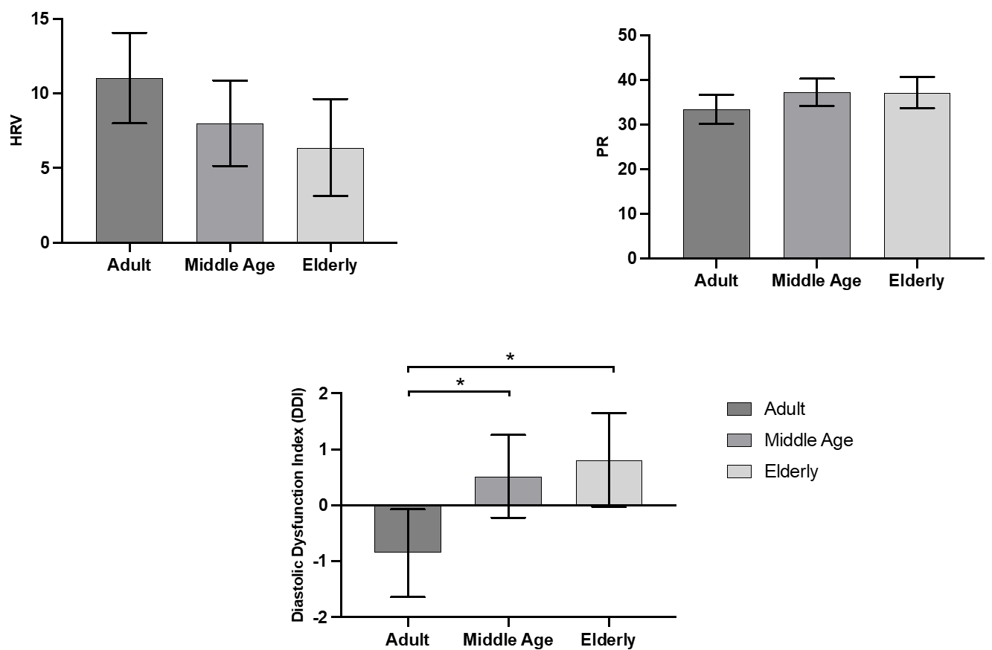
Figure S1: Electrocardiographic markers of diastolic function (PR interval, HRV) were used to calculate a Diastolic Dysfunction Index (DDI) in mice aged 12, 24, and 30 months. The DDI increased significantly with age, with 30-month-old mice showing the highest values, indicating advanced autonomic and electrical remodeling (one-way ANOVA, p < 0.05). This index distinguished between early and late aging stages.

Figure S2:
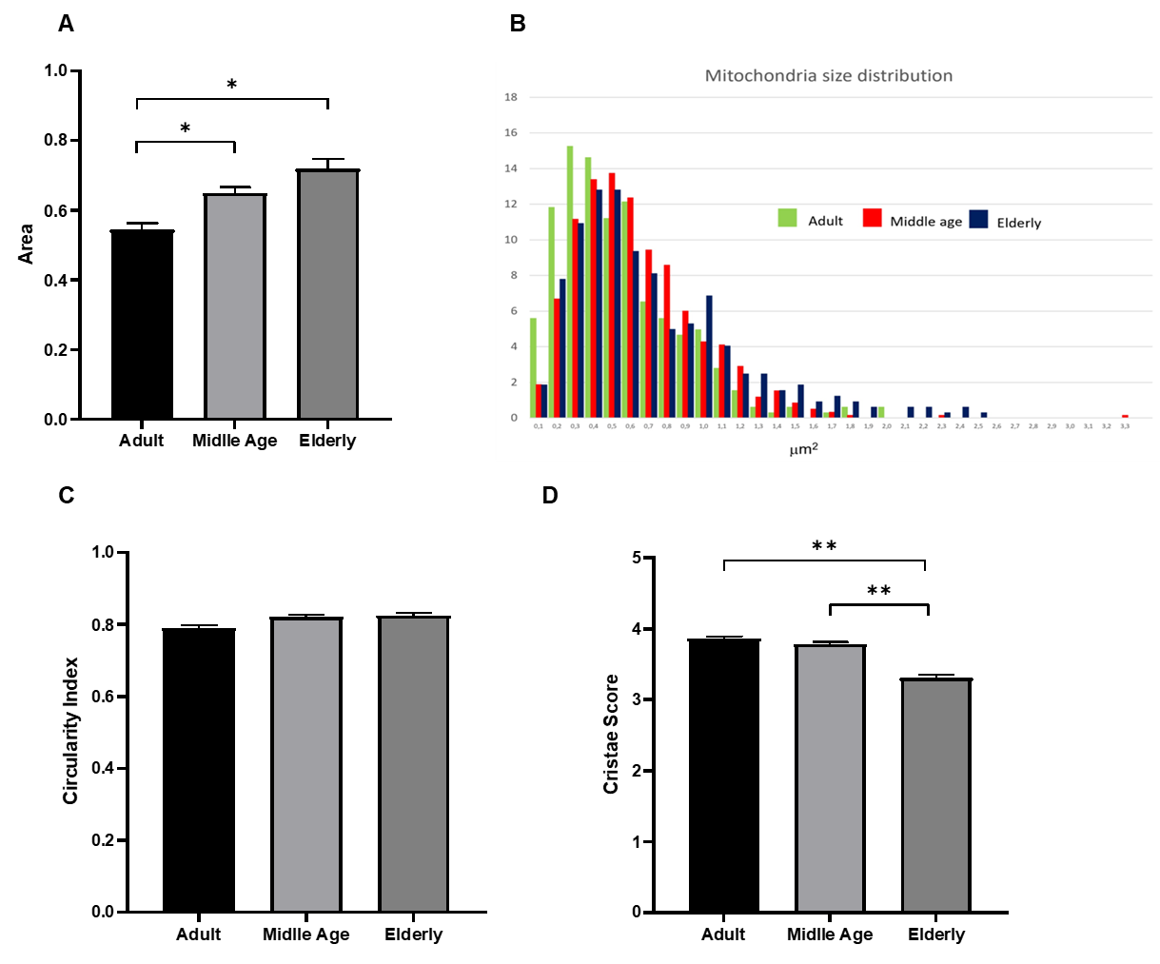
Figure S2: A Bar graph showing a significant increase in mitochondrial Area in the Middle age and Elderly groups compared to the Adult group (*=p<0.05). B Histogram of mitochondrial size distribution. The y-axis represents the frequency (number of mitochondria per size bin). The distribution shows a clear shift toward larger mitochondrial areas in the Middle age (red) and Elderly (blue) groups compared to the Adult group (green), indicating a trend toward increased mitochondrial size with aging. C Bar graph illustrating mitochondrial Circularity index across the three experimental groups. D Bar graph illustrating the mitochondrial Cristae score across the three experimental groups. A significant increase was detected in the elderly group compared with the adult (**p < 0.001) and middle-aged (p* < 0.005) groups.

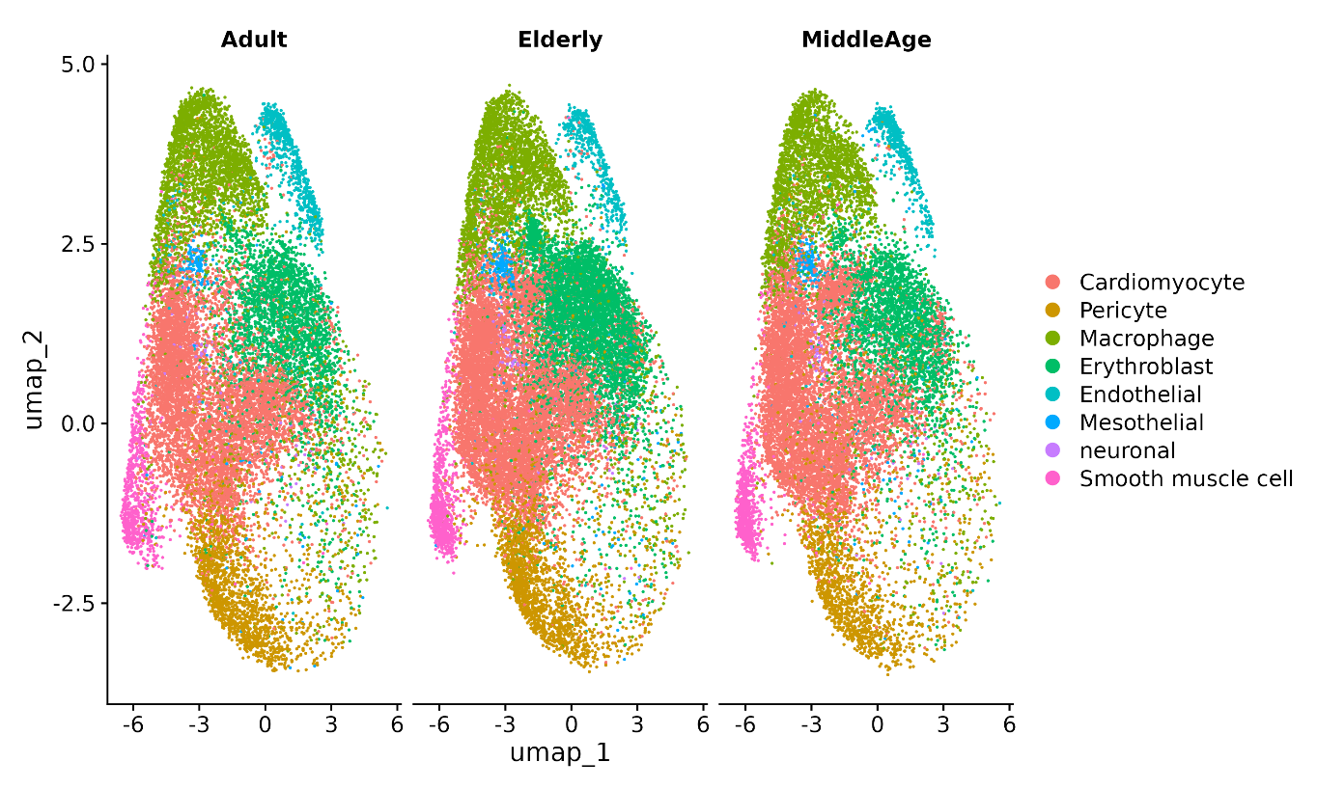
Figure S3: UMAP projection of single-cell transcriptomes from adult, middle-aged, and elderly hearts. Each dot represents a single cell, colored according to the annotated cell type. Major cardiac populations are highlighted, including cardiomyocytes, pericytes, macrophages, erythroblasts, endothelial cells, mesothelial cells, neurons, and smooth muscle cells. The distribution across age groups illustrates the preservation of major cell identities with age, while allowing the assessment of subtle shifts in cellular composition and transcriptomic remodeling.

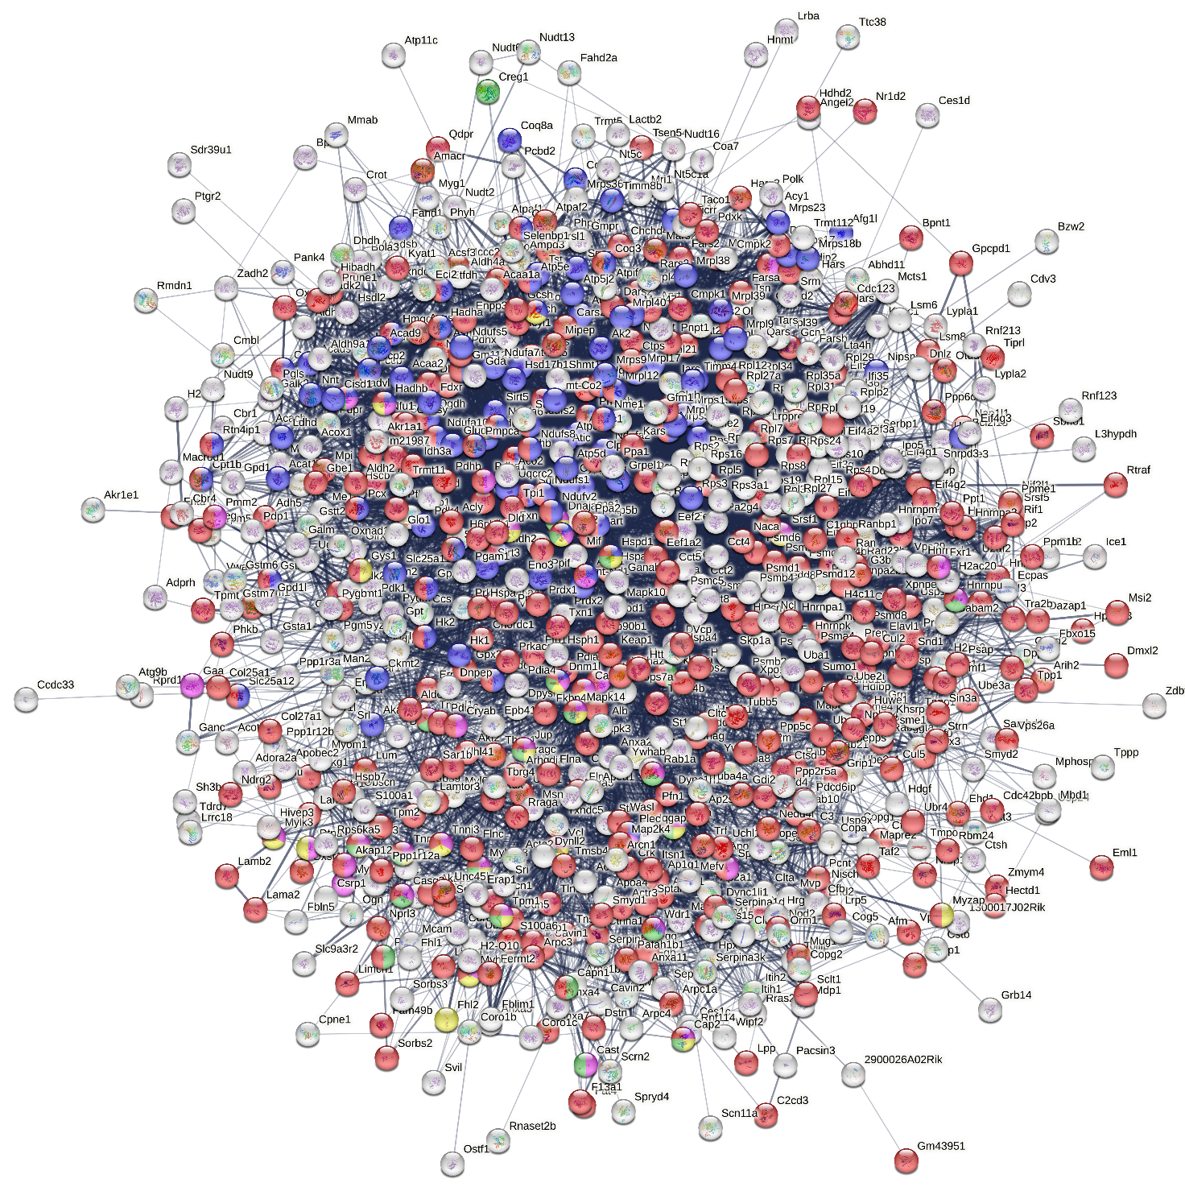
Figure S4: String protein-protein network of significant proteins from Anova, colored nodes belong to different enriched pathways, please see figure 3

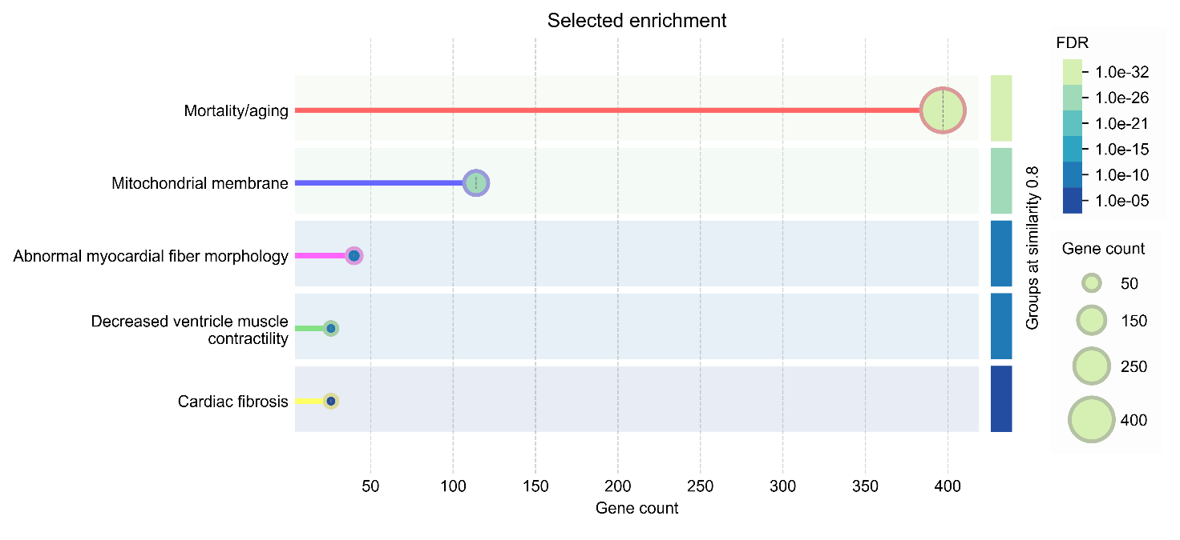
Figure S5: Most enriched pathways related to String network shown in figure Figure S4

Figure S6: loading plot with explicit metabolite labels shows the distribution of metabolites along the first two loading components (Loadings 1 and Loadings 2). Each point represents a metabolite, with position indicating its relative contribution to the model.
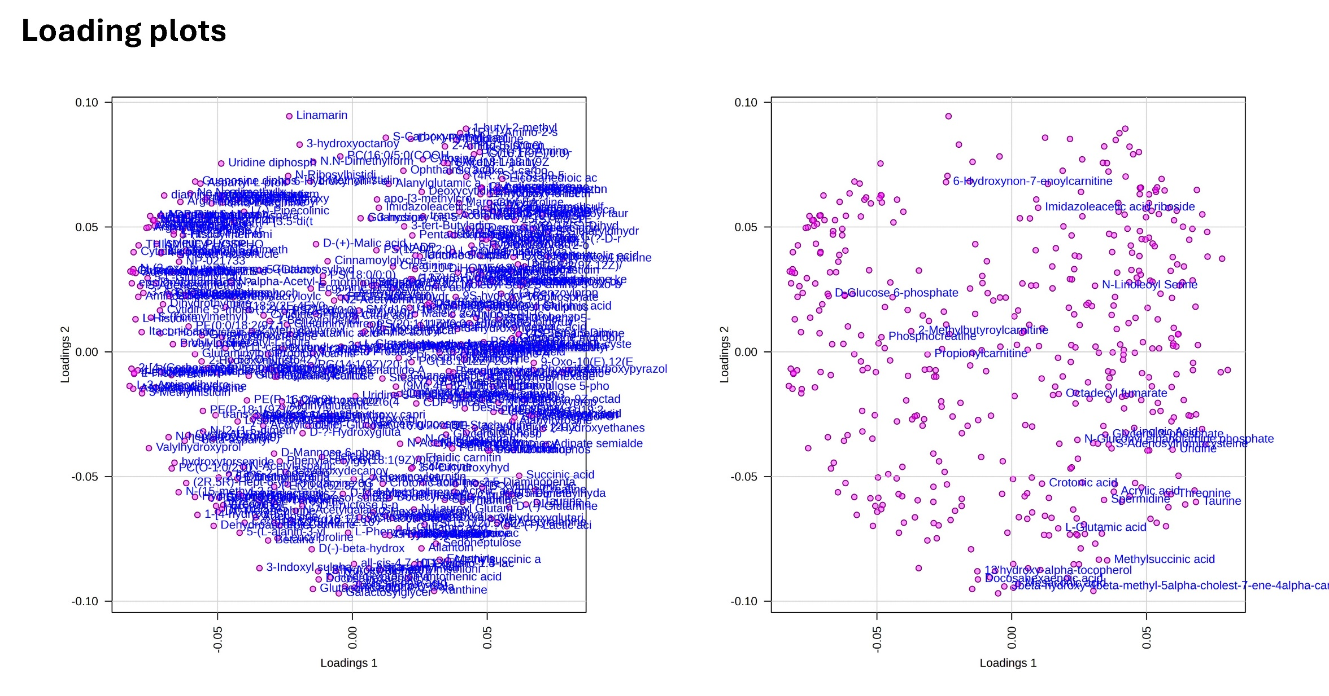

Table S1: Table S1: Standard echocardiographic parameters in mice at 6, 12, 24, and 30 months of age, including heart rate (HR), end-diastolic diameter (EDD), end-systolic diameter (ESD), fractional shortening (FS), ejection fraction (EF), and cardiac output (CO).
MEAN ± SD | HR [beats/min] | End-Diastolic Diameter [mm] | End-Systolic Diameter [mm] | FS [%] | EF [%] | Cardiac Output [ml/min]
Young | 458.6 ± 41.28 | 3.033 ± 0.338 | 1.75 ± 0.281 | 42.53 ± 4.362 | 74.93 ± 4.904 | 12.45 ± 2.673
Adult | 449.8 ± 54.19 | 3.194 ± 0.367 | 1.861 ± 0.299 | 42.39 ± 5.757 | 74.34 ± 6.464 | 14.26 ± 5.412
Middle Age | 418.8 ± 83.6 | 3.387 ± 0.31 | 2.162 ± 0.36 | 35.80 ± 8.96 | 69.80 ± 15.4 | 13.85 ± 4.95
Elderly | 424.6 ± 49.0 | 3.112 ± 0.45 | 1.962 ± 0.40 | 37.16 ± 7.04 | 67.81 ± 8.41 | 11.31 ± 4.28

Table S2-S4: Anova results from proteomics (S2), metabolomics (S3) and lipidomics (S4) reporting Unprot ID and metabolite-lipid annotation, respectively.

UniprotID | p.value | FDR
Q9JM14 | 6.03E-17 | 7.51E-14
P09813 | 1.19E-16 | 7.51E-14
Q3U0V1 | 2.00E-16 | 7.51E-14
P13634 | 2.05E-16 | 7.51E-14
Q91VF2 | 3.26E-16 | 9.57E-14
P62849 | 1.03E-15 | 2.24E-13
Q9DBD0 | 1.16E-15 | 2.24E-13
O09061 | 1.26E-15 | 2.24E-13
Q8BTM8 | 1.38E-15 | 2.24E-13
P52196 | 2.87E-15 | 4.21E-13
P06330 | 3.99E-15 | 5.32E-13
Q9WVH9 | 5.20E-15 | 6.35E-13
Q6P9R2 | 7.91E-15 | 8.92E-13
Q80X85 | 1.41E-14 | 1.48E-12
Q62407 | 8.17E-14 | 7.98E-12
Q60668 | 2.42E-13 | 2.21E-11
P17426 | 3.03E-13 | 2.62E-11
P42567 | 4.29E-13 | 3.26E-11
Q99JW2 | 4.42E-13 | 3.26E-11
P28656 | 4.61E-13 | 3.26E-11
Q8K1M6 | 4.67E-13 | 3.26E-11
Q8BGD8 | 4.98E-13 | 3.32E-11
P63166 | 1.46E-12 | 9.33E-11
P70227 | 2.44E-12 | 1.49E-10
Q9JJZ2 | 2.55E-12 | 1.49E-10
P13745 | 2.84E-12 | 1.60E-10
Q8R001 | 6.07E-12 | 3.30E-10
Q9DCH4 | 6.31E-12 | 3.30E-10
Q9Z1P6 | 6.76E-12 | 3.42E-10
O35887 | 1.41E-11 | 6.87E-10
Q91W90 | 1.86E-11 | 8.78E-10
P28665 | 3.23E-11 | 1.44E-09
Q9QY76 | 3.27E-11 | 1.44E-09
O70325 | 3.33E-11 | 1.44E-09
E9PVA8 | 4.88E-11 | 2.04E-09
Q9QZN0 | 5.30E-11 | 2.11E-09
Q9EQH2 | 5.42E-11 | 2.11E-09
P49138 | 5.48E-11 | 2.11E-09
Q9CZL5 | 8.38E-11 | 3.15E-09
Q8R104 | 1.06E-10 | 3.87E-09
Q61035 | 1.45E-10 | 5.18E-09
O55131 | 1.82E-10 | 6.37E-09
Q60866 | 2.12E-10 | 7.24E-09
Q64433 | 2.86E-10 | 9.53E-09
Q9EQK5 | 4.36E-10 | 1.41E-08
P28798 | 4.41E-10 | 1.41E-08
Q9QXK3 | 6.14E-10 | 1.91E-08
P54728 | 7.22E-10 | 2.19E-08
P61982 | 7.31E-10 | 2.19E-08
Q9WTX5 | 8.17E-10 | 2.40E-08
Q9CQE3 | 9.12E-10 | 2.62E-08
O08739 | 9.52E-10 | 2.65E-08
Q9WTR5 | 9.60E-10 | 2.65E-08
P26883 | 9.75E-10 | 2.65E-08
P47964 | 1.00E-09 | 2.66E-08
Q8BHL8 | 1.17E-09 | 3.06E-08
P97315 | 1.72E-09 | 4.42E-08
Q9QZE5 | 1.88E-09 | 4.76E-08
Q9D6R2 | 2.06E-09 | 5.11E-08
Q9CZR8 | 2.09E-09 | 5.11E-08
O08677 | 2.25E-09 | 5.42E-08
Q9ET26 | 2.29E-09 | 5.42E-08
Q8BHN3 | 2.42E-09 | 5.62E-08
P97384 | 2.67E-09 | 6.12E-08
Q02257 | 2.86E-09 | 6.45E-08
Q61941 | 3.06E-09 | 6.79E-08
Q7TT50 | 3.15E-09 | 6.90E-08
Q8CDI6 | 3.42E-09 | 7.37E-08
Q6P3D0 | 3.54E-09 | 7.53E-08
Q60590 | 4.30E-09 | 9.00E-08
P55302 | 4.40E-09 | 9.08E-08
P47738 | 4.50E-09 | 9.17E-08
P62889 | 4.72E-09 | 9.48E-08
B0F2B4 | 4.84E-09 | 9.60E-08
P05201 | 5.65E-09 | 1.10E-07
Q99J45 | 6.22E-09 | 1.20E-07
Q9WVJ2 | 6.63E-09 | 1.26E-07
P53996 | 7.32E-09 | 1.38E-07
Q9WUM3 | 7.88E-09 | 1.46E-07
Q9CQE8 | 8.21E-09 | 1.50E-07
Q99KR3 | 8.36E-09 | 1.51E-07
P54775 | 8.44E-09 | 1.51E-07
Q9CZ04 | 8.69E-09 | 1.54E-07
P17918 | 9.87E-09 | 1.72E-07
P97371 | 1.06E-08 | 1.83E-07
Q91YM4 | 1.09E-08 | 1.87E-07
P26443 | 1.26E-08 | 2.13E-07
P36993 | 1.30E-08 | 2.17E-07
Q9D8C4 | 1.35E-08 | 2.22E-07
Q8R1Q8 | 1.41E-08 | 2.29E-07
Q8K1C0 | 1.42E-08 | 2.29E-07
P29595 | 1.45E-08 | 2.31E-07
Q4VAA2 | 1.46E-08 | 2.31E-07
Q8CIG8 | 1.53E-08 | 2.38E-07
Q8BG05 | 1.72E-08 | 2.63E-07
Q69ZR2 | 1.72E-08 | 2.63E-07
Q9CSU0 | 1.74E-08 | 2.63E-07
Q9D7N3 | 1.80E-08 | 2.69E-07
Q9CPP6 | 2.02E-08 | 3.00E-07
Q9CQZ5 | 2.09E-08 | 3.05E-07
Q9JK81 | 2.10E-08 | 3.05E-07
P97765 | 2.31E-08 | 3.29E-07
Q99N94 | 2.32E-08 | 3.29E-07
O89079 | 2.33E-08 | 3.29E-07
Q91X72 | 2.36E-08 | 3.29E-07
Q63918 | 2.51E-08 | 3.44E-07
Q99KK9 | 2.51E-08 | 3.44E-07
Q9JJU8 | 2.65E-08 | 3.58E-07
Q80XI3 | 2.66E-08 | 3.58E-07
Q9WUA2 | 2.73E-08 | 3.63E-07
Q8BH61 | 2.85E-08 | 3.75E-07
Q80TM9 | 2.88E-08 | 3.75E-07
Q9DCS2 | 2.90E-08 | 3.75E-07
Q8K3J1 | 2.92E-08 | 3.75E-07
Q3UH68 | 3.13E-08 | 3.99E-07
Q8R5H1 | 3.37E-08 | 4.26E-07
P99027 | 3.63E-08 | 4.55E-07
Q61990 | 4.29E-08 | 5.33E-07
Q9D8W5 | 4.69E-08 | 5.78E-07
Q9ESB3 | 4.76E-08 | 5.79E-07
Q5SW19 | 4.78E-08 | 5.79E-07
Q3UV70 | 5.01E-08 | 6.03E-07
Q8CII2 | 5.26E-08 | 6.27E-07
Q9CQX8 | 6.71E-08 | 7.93E-07
O54724 | 6.77E-08 | 7.94E-07
O08715 | 6.92E-08 | 8.05E-07
Q8R5A0 | 7.43E-08 | 8.58E-07
Q99M01 | 7.53E-08 | 8.63E-07
Q99LY9 | 7.73E-08 | 8.78E-07
Q7TSH2 | 8.91E-08 | 1.00E-06
Q6PR54 | 9.81E-08 | 1.10E-06
Q9Z1K6 | 1.01E-07 | 1.12E-06
Q99MQ5 | 1.08E-07 | 1.19E-06
Q80X90 | 1.14E-07 | 1.25E-06
P62918 | 1.20E-07 | 1.30E-06
Q8BFY9 | 1.25E-07 | 1.34E-06
P70168 | 1.48E-07 | 1.58E-06
Q9Z0P5 | 1.77E-07 | 1.88E-06
P06909 | 2.02E-07 | 2.13E-06
P62855 | 2.04E-07 | 2.13E-06
P14131 | 2.31E-07 | 2.41E-06
O88668 | 2.66E-07 | 2.75E-06
P01864 | 3.00E-07 | 3.08E-06
Q62234 | 3.30E-07 | 3.36E-06
Q925T6 | 3.81E-07 | 3.85E-06
Q60613 | 3.94E-07 | 3.95E-06
Q7TPR4 | 4.14E-07 | 4.13E-06
P50544 | 4.23E-07 | 4.19E-06
Q61879 | 4.48E-07 | 4.41E-06
Q9CYT6 | 4.62E-07 | 4.51E-06
P62082 | 4.69E-07 | 4.55E-06
Q9CQ80 | 4.78E-07 | 4.61E-06
Q9JHU4 | 5.26E-07 | 5.04E-06
P47199 | 5.55E-07 | 5.28E-06
Q3TXS7 | 5.59E-07 | 5.29E-06
P49312 | 5.77E-07 | 5.42E-06
Q64523 | 6.70E-07 | 6.25E-06
Q8BH58 | 6.83E-07 | 6.34E-06
Q9CZN8 | 6.92E-07 | 6.38E-06
Q61545 | 7.09E-07 | 6.50E-06
Q9D1R9 | 7.14E-07 | 6.50E-06
O08600 | 8.05E-07 | 7.25E-06
Q8BP40 | 8.13E-07 | 7.25E-06
Q9D6J6 | 8.13E-07 | 7.25E-06
P70195 | 8.16E-07 | 7.25E-06
P68037 | 8.75E-07 | 7.70E-06
Q9CXT8 | 8.77E-07 | 7.70E-06
Q61584 | 8.96E-07 | 7.82E-06
P61089 | 9.10E-07 | 7.90E-06
Q8VEK3 | 9.37E-07 | 8.08E-06
Q6PH08 | 9.67E-07 | 8.29E-06
P50462 | 9.90E-07 | 8.44E-06
Q68FD5 | 1.01E-06 | 8.53E-06
Q7TNG5 | 1.03E-06 | 8.71E-06
O35857 | 1.04E-06 | 8.73E-06
Q9D8P4 | 1.05E-06 | 8.77E-06
P61979 | 1.09E-06 | 9.06E-06
P10630 | 1.15E-06 | 9.47E-06
Q6P2L7 | 1.17E-06 | 9.53E-06
Q6P069 | 1.17E-06 | 9.53E-06
Q99N87 | 1.24E-06 | 1.01E-05
Q60597 | 1.31E-06 | 1.06E-05
P53026 | 1.34E-06 | 1.07E-05
P50752 | 1.37E-06 | 1.09E-05
Q9D2N4 | 1.50E-06 | 1.19E-05
Q921H8 | 1.53E-06 | 1.20E-05
P80315 | 1.53E-06 | 1.20E-05
Q922R8 | 1.80E-06 | 1.41E-05
Q6PDI5 | 1.85E-06 | 1.43E-05
P07759 | 1.86E-06 | 1.43E-05
P70372 | 1.86E-06 | 1.43E-05
Q7TMY8 | 1.94E-06 | 1.48E-05
Q99N84 | 1.95E-06 | 1.48E-05
Q9D1Q6 | 1.96E-06 | 1.48E-05
Q9DC61 | 2.07E-06 | 1.56E-05
Q6ZWN5 | 2.11E-06 | 1.58E-05
Q61147 | 2.13E-06 | 1.58E-05
Q8VCM7 | 2.18E-06 | 1.61E-05
P62702 | 2.19E-06 | 1.61E-05
Q8BVU5 | 2.19E-06 | 1.61E-05
Q9JKF7 | 2.23E-06 | 1.62E-05
P49813 | 2.44E-06 | 1.77E-05
Q8BU30 | 2.51E-06 | 1.81E-05
O35350 | 2.52E-06 | 1.81E-05
Q3TEA8 | 2.63E-06 | 1.88E-05
Q3TCH7 | 2.65E-06 | 1.88E-05
Q91WS0 | 2.66E-06 | 1.89E-05
P47911 | 2.72E-06 | 1.91E-05
Q7TQ48 | 2.75E-06 | 1.93E-05
Q9Z1E4 | 2.86E-06 | 1.99E-05
Q00519 | 3.06E-06 | 2.12E-05
Q9WV92 | 3.18E-06 | 2.19E-05
P42859 | 3.19E-06 | 2.19E-05
Q9ESE1 | 3.23E-06 | 2.21E-05
P61082 | 3.29E-06 | 2.24E-05
P35385 | 3.45E-06 | 2.34E-05
Q99KQ4 | 3.60E-06 | 2.43E-05
Q9CX56 | 3.61E-06 | 2.43E-05
Q9R112 | 3.69E-06 | 2.46E-05
P25444 | 3.70E-06 | 2.46E-05
P46471 | 3.78E-06 | 2.50E-05
Q9Z2Q5 | 3.78E-06 | 2.50E-05
P02468 | 3.84E-06 | 2.52E-05
Q921M7 | 3.89E-06 | 2.54E-05
P35700 | 4.03E-06 | 2.62E-05
Q9QUR6 | 4.13E-06 | 2.67E-05
Q3TMH2 | 4.14E-06 | 2.67E-05
Q6P1B1 | 4.29E-06 | 2.76E-05
Q9Z1Q9 | 4.59E-06 | 2.94E-05
P48722 | 4.70E-06 | 3.00E-05
A2AN08 | 4.90E-06 | 3.11E-05
Q6P5E4 | 4.99E-06 | 3.15E-05
Q3UHB1 | 5.10E-06 | 3.21E-05
Q9DCX2 | 5.23E-06 | 3.27E-05
Q60649 | 5.25E-06 | 3.28E-05
Q9DB15 | 5.79E-06 | 3.60E-05
Q9QZ88 | 6.12E-06 | 3.78E-05
P35979 | 6.23E-06 | 3.84E-05
Q8QZR5 | 6.28E-06 | 3.85E-05
Q80VM7 | 6.38E-06 | 3.89E-05
Q8CH40 | 6.52E-06 | 3.96E-05
O70318 | 6.62E-06 | 4.01E-05
Q61578 | 6.99E-06 | 4.22E-05
Q99JY9 | 7.15E-06 | 4.29E-05
Q8K4L3 | 7.19E-06 | 4.30E-05
Q9JM76 | 7.96E-06 | 4.74E-05
P06728 | 8.32E-06 | 4.94E-05
Q9Z2C5 | 8.69E-06 | 5.14E-05
P63005 | 9.07E-06 | 5.34E-05
Q5SSW2 | 9.21E-06 | 5.40E-05
Q8VDM4 | 9.47E-06 | 5.53E-05
A6H611 | 9.53E-06 | 5.55E-05
Q8K0Z7 | 1.00E-05 | 5.81E-05
C0HKG6 | 1.02E-05 | 5.89E-05
P46412 | 1.04E-05 | 5.93E-05
Q9WVK4 | 1.04E-05 | 5.93E-05
Q62188 | 1.06E-05 | 5.99E-05
Q3UIJ9 | 1.06E-05 | 5.99E-05
Q9QZW0 | 1.07E-05 | 5.99E-05
Q9CQ07 | 1.07E-05 | 5.99E-05
A2AAJ9 | 1.07E-05 | 5.99E-05
Q8C0L9 | 1.11E-05 | 6.22E-05
Q920Q6 | 1.13E-05 | 6.30E-05
O70250 | 1.17E-05 | 6.51E-05
P20065 | 1.22E-05 | 6.76E-05
Q8K2H2 | 1.23E-05 | 6.79E-05
Q9EQ80 | 1.24E-05 | 6.81E-05
Q6DYE8 | 1.28E-05 | 6.98E-05
Q9CQR6 | 1.28E-05 | 6.98E-05
P35282 | 1.31E-05 | 7.12E-05
Q9CPR5 | 1.37E-05 | 7.36E-05
P97429 | 1.37E-05 | 7.36E-05
Q9R111 | 1.37E-05 | 7.36E-05
Q61553 | 1.38E-05 | 7.36E-05
P50171 | 1.42E-05 | 7.59E-05
P12367 | 1.48E-05 | 7.85E-05
Q9QXS1 | 1.50E-05 | 7.91E-05
Q9QZ06 | 1.51E-05 | 7.95E-05
Q9R1P3 | 1.52E-05 | 7.99E-05
E9Q4Z2 | 1.53E-05 | 7.99E-05
P58252 | 1.53E-05 | 7.99E-05
Q99JB8 | 1.54E-05 | 8.01E-05
P14115 | 1.55E-05 | 8.02E-05
Q8VE22 | 1.63E-05 | 8.42E-05
P80314 | 1.64E-05 | 8.42E-05
P09405 | 1.65E-05 | 8.47E-05
Q6EBV9 | 1.66E-05 | 8.48E-05
Q60675 | 1.67E-05 | 8.49E-05
Q9R1P4 | 1.69E-05 | 8.58E-05
P62301 | 1.72E-05 | 8.68E-05
P61202 | 1.73E-05 | 8.70E-05
P97351 | 1.77E-05 | 8.87E-05
Q9CXA2 | 1.83E-05 | 9.14E-05
Q3U186 | 1.85E-05 | 9.24E-05
Q8C0L8 | 1.86E-05 | 9.25E-05
Q8BKC5 | 1.89E-05 | 9.36E-05
Q8BKY8 | 1.96E-05 | 9.66E-05
Q9DCT1 | 1.99E-05 | 9.80E-05
Q9DBJ1 | 2.01E-05 | 9.86E-05
P62320 | 2.02E-05 | 9.88E-05
Q11011 | 2.06E-05 | 0.0001
P08030 | 2.10E-05 | 0.000102
Q60676 | 2.11E-05 | 0.000102
Q924D0 | 2.11E-05 | 0.000102
Q8K2Y7 | 2.20E-05 | 0.000106
Q3ULW6 | 2.21E-05 | 0.000106
Q61702 | 2.21E-05 | 0.000106
P61164 | 2.25E-05 | 0.000107
Q8VHX6 | 2.25E-05 | 0.000107
Q91YP0 | 2.28E-05 | 0.000108
Q9CXJ1 | 2.30E-05 | 0.000108
Q9CR57 | 2.36E-05 | 0.000111
Q8CC88 | 2.36E-05 | 0.000111
P23198 | 2.37E-05 | 0.000111
Q3TYA6 | 2.44E-05 | 0.000114
Q921H9 | 2.45E-05 | 0.000114
Q02053 | 2.49E-05 | 0.000115
Q6NZJ6 | 2.51E-05 | 0.000116
Q8BGC4 | 2.58E-05 | 0.000119
P26043 | 2.59E-05 | 0.000119
Q9D967 | 2.60E-05 | 0.000119
P40336 | 2.71E-05 | 0.000123
O55234 | 2.73E-05 | 0.000124
Q91VR2 | 2.94E-05 | 0.000133
A2A884 | 3.09E-05 | 0.000139
P23927 | 3.13E-05 | 0.000141
Q8BTY1 | 3.14E-05 | 0.000141
A3KMP2 | 3.16E-05 | 0.000141
P26369 | 3.20E-05 | 0.000143
Q9D0C4 | 3.22E-05 | 0.000143
Q9QYG0 | 3.43E-05 | 0.000152
Q9DB77 | 3.50E-05 | 0.000154
Q9Z2E2 | 3.67E-05 | 0.000162
P97443 | 3.73E-05 | 0.000164
Q9D113 | 3.76E-05 | 0.000165
P17710 | 3.87E-05 | 0.000169
Q8QZY1 | 3.88E-05 | 0.000169
P31750 | 3.89E-05 | 0.000169
P50580 | 3.95E-05 | 0.000171
Q9WU78 | 4.15E-05 | 0.000179
Q9CQ60 | 4.27E-05 | 0.000183
Q61838 | 4.35E-05 | 0.000186
Q61831 | 4.44E-05 | 0.00019
P06801 | 4.55E-05 | 0.000194
P03921 | 4.74E-05 | 0.000201
Q9CXI0 | 4.82E-05 | 0.000204
Q9JK42 | 4.84E-05 | 0.000204
Q3UTJ2 | 5.02E-05 | 0.000211
O88712 | 5.18E-05 | 0.000217
Q9D3D9 | 5.36E-05 | 0.000225
Q8BH64 | 5.39E-05 | 0.000225
O88952 | 5.56E-05 | 0.000232
P12970 | 5.59E-05 | 0.000232
Q04447 | 5.71E-05 | 0.000236
Q8VEA4 | 5.78E-05 | 0.000239
A2AUC9 | 5.99E-05 | 0.000247
Q91V92 | 6.04E-05 | 0.000248
Q01853 | 6.07E-05 | 0.000249
P13707 | 6.10E-05 | 0.000249
Q8JZN5 | 6.24E-05 | 0.000254
P01027 | 6.33E-05 | 0.000257
Q91VT4 | 6.62E-05 | 0.000268
Q9DCM2 | 6.65E-05 | 0.000269
Q6PD03 | 6.78E-05 | 0.000273
Q8C2A2 | 7.64E-05 | 0.000307
P62908 | 7.98E-05 | 0.000319
Q9JMA1 | 8.02E-05 | 0.00032
Q8BZF8 | 8.08E-05 | 0.000322
Q9CQC9 | 8.49E-05 | 0.000337
P23953 | 8.64E-05 | 0.000343
Q9R053 | 8.89E-05 | 0.000351
Q60520 | 9.02E-05 | 0.000355
Q5QNQ9 | 9.07E-05 | 0.000356
Q9DBB8 | 9.21E-05 | 0.000361
P61922 | 9.37E-05 | 0.000366
Q9CZS1 | 9.87E-05 | 0.000385
P62245 | 0.000102 | 0.000396
Q9WV32 | 0.000102 | 0.000396
Q9CWE0 | 0.000103 | 0.000397
P01867 | 0.000103 | 0.000397
Q9WTQ5 | 0.000104 | 0.0004
E9Q555 | 0.000105 | 0.000402
Q8BGD9 | 0.000106 | 0.000406
P97447 | 0.000109 | 0.000414
Q91YD9 | 0.000109 | 0.000415
P97450 | 0.00011 | 0.000419
Q9CQW1 | 0.000113 | 0.000427
Q8BML9 | 0.000113 | 0.000427
Q9D5V5 | 0.000113 | 0.000427
P27773 | 0.000114 | 0.00043
Q9JJH7 | 0.000115 | 0.00043
P62962 | 0.000117 | 0.000435
Q64727 | 0.000117 | 0.000435
P0CC03 | 0.00012 | 0.000447
P53395 | 0.000121 | 0.000448
P97855 | 0.000122 | 0.000453
Q68FH4 | 0.000123 | 0.000453
P30416 | 0.000124 | 0.000457
P56135 | 0.000125 | 0.000458
Q61234 | 0.000128 | 0.000469
Q61171 | 0.000128 | 0.000469
Q64674 | 0.000136 | 0.000496
Q8K2C6 | 0.000138 | 0.000504
Q05BC3 | 0.000139 | 0.000505
Q91W89 | 0.000151 | 0.000545
Q8BH59 | 0.000155 | 0.000558
Q6ZQ73 | 0.000155 | 0.000558
Q9CPU0 | 0.000155 | 0.000558
P59017 | 0.000156 | 0.000559
Q9D8N0 | 0.000158 | 0.000564
Q2TPA8 | 0.00016 | 0.00057
P60670 | 0.000161 | 0.000571
O88342 | 0.000162 | 0.000574
Q9JIY5 | 0.000167 | 0.000593
O70571 | 0.000168 | 0.000593
O35326 | 0.000169 | 0.000597
Q9D1P4 | 0.00017 | 0.000598
P01878 | 0.000171 | 0.000599
Q9CZM2 | 0.000172 | 0.0006
Q9D6Y9 | 0.000173 | 0.000605
Q921S7 | 0.000177 | 0.000615
P99026 | 0.000177 | 0.000615
P54923 | 0.000181 | 0.000629
Q01768 | 0.000183 | 0.000633
Q9DAK9 | 0.000187 | 0.000645
P14069 | 0.000197 | 0.000679
Q99MN1 | 0.000204 | 0.000699
Q8BYM8 | 0.00021 | 0.00072
P29341 | 0.000214 | 0.000732
Q8C1A5 | 0.000216 | 0.000736
Q99NB1 | 0.000216 | 0.000736
O54984 | 0.000218 | 0.000741
P47809 | 0.00022 | 0.000744
P14148 | 0.000222 | 0.000749
Q3THS6 | 0.000222 | 0.000749
O88569 | 0.000225 | 0.000757
Q9DBG3 | 0.000234 | 0.000786
Q8BVG4 | 0.000241 | 0.000805
O88587 | 0.000244 | 0.000816
P63101 | 0.000253 | 0.000842
P50431 | 0.000254 | 0.000843
Q9Z2I8 | 0.000254 | 0.000843
Q9D819 | 0.000258 | 0.000855
Q9WV35 | 0.000259 | 0.000855
Q8BMS4 | 0.000266 | 0.000877
P59325 | 0.000273 | 0.000898
Q9JII6 | 0.000274 | 0.000899
O08749 | 0.000275 | 0.000899
Q6P5F9 | 0.000276 | 0.0009
Q3TC72 | 0.000278 | 0.000905
E9Q286 | 0.000281 | 0.000912
Q63844 | 0.000281 | 0.000912
Q9WTP7 | 0.000282 | 0.000912
Q61166 | 0.000284 | 0.000917
Q60710 | 0.000288 | 0.000927
Q99JW4 | 0.000293 | 0.000943
Q9JHK4 | 0.0003 | 0.000962
Q8BIP0 | 0.000303 | 0.000971
O55106 | 0.000308 | 0.000985
P68372 | 0.000313 | 0.000997
P55284 | 0.000315 | 0.001001
Q9DBL1 | 0.000325 | 0.001033
O89053 | 0.000329 | 0.001041
P70698 | 0.00033 | 0.001041
Q9WU84 | 0.000335 | 0.001057
Q9D1L0 | 0.000344 | 0.001082
Q9CY58 | 0.000355 | 0.001115
Q8CI94 | 0.000358 | 0.00112
Q71FD7 | 0.000362 | 0.00113
O09167 | 0.000362 | 0.00113
P97290 | 0.000375 | 0.001166
Q8BFP9 | 0.000385 | 0.001195
Q9DCG9 | 0.000389 | 0.001207
Q8BVQ5 | 0.000393 | 0.001214
Q9Z2M7 | 0.000393 | 0.001214
Q91VK1 | 0.000397 | 0.001223
Q99K70 | 0.000398 | 0.001223
P05132 | 0.0004 | 0.001228
Q8VE95 | 0.000402 | 0.00123
P51859 | 0.000409 | 0.001248
Q9Z1J3 | 0.00041 | 0.001248
P61358 | 0.00041 | 0.001248
Q9R0H0 | 0.000415 | 0.00126
Q9JKR6 | 0.00042 | 0.001273
Q9D2G2 | 0.000433 | 0.00131
Q99KP6 | 0.00044 | 0.001326
Q61699 | 0.000458 | 0.00138
Q61703 | 0.000465 | 0.001397
O89023 | 0.000466 | 0.001399
Q91ZJ5 | 0.000471 | 0.001409
Q8QZS1 | 0.000478 | 0.001428
P62313 | 0.000485 | 0.001445
Q8CFI0 | 0.000486 | 0.001445
P47811 | 0.000489 | 0.001452
Q6IRU5 | 0.000503 | 0.00149
Q78PY7 | 0.000504 | 0.00149
P63325 | 0.000507 | 0.001495
Q8BPN8 | 0.000513 | 0.001509
P36552 | 0.000519 | 0.001526
Q8R081 | 0.000521 | 0.001527
Q61081 | 0.000522 | 0.001528
Q9CQT1 | 0.00053 | 0.001546
Q9CQ75 | 0.000545 | 0.001586
P70670 | 0.000545 | 0.001586
Q9Z0S1 | 0.000562 | 0.001632
Q9CXW2 | 0.000574 | 0.001662
P62077 | 0.000596 | 0.001723
Q6PDM2 | 0.0006 | 0.00173
Q61233 | 0.000604 | 0.00174
Q9D1P0 | 0.000606 | 0.001743
Q80X95 | 0.000609 | 0.001746
Q00623 | 0.00061 | 0.001746
Q8K3A0 | 0.000613 | 0.001751
Q8BP47 | 0.000616 | 0.001756
P18242 | 0.000617 | 0.001756
Q99KK7 | 0.000627 | 0.001782
Q9CQN7 | 0.00064 | 0.001815
Q9R1Z8 | 0.000643 | 0.001818
Q9CZY3 | 0.000644 | 0.001818
Q922Q5 | 0.000652 | 0.001837
Q8C0C7 | 0.000666 | 0.001873
G5E861 | 0.000669 | 0.001877
P03888 | 0.00067 | 0.001877
Q07076 | 0.000671 | 0.001877
Q91YY4 | 0.000673 | 0.00188
Q8C176 | 0.000677 | 0.001886
Q6X6Z7 | 0.000693 | 0.001927
O35658 | 0.000702 | 0.001948
Q8R146 | 0.000714 | 0.001978
Q6PEB6 | 0.000717 | 0.001982
P63280 | 0.000719 | 0.001982
Q8K3W0 | 0.000721 | 0.001982
P47962 | 0.000721 | 0.001982
Q64737 | 0.000725 | 0.001989
Q5M8N4 | 0.000731 | 0.002004
Q9CR09 | 0.000733 | 0.002005
Q9Z2W0 | 0.000746 | 0.002037
Q99MR9 | 0.00075 | 0.002044
Q8BFW7 | 0.000758 | 0.002062
O88531 | 0.000765 | 0.002073
P84244 | 0.000765 | 0.002073
P97461 | 0.000802 | 0.002169
Q9R269 | 0.000812 | 0.002193
P15388 | 0.000826 | 0.002225
Q9D4H8 | 0.000832 | 0.002239
Q62000 | 0.000846 | 0.002269
Q9JHL1 | 0.000847 | 0.002269
Q00897 | 0.000853 | 0.002282
P00405 | 0.000859 | 0.002293
P19536 | 0.000876 | 0.002331
Q921I1 | 0.000876 | 0.002331
Q7TQD2 | 0.00088 | 0.002338
P59999 | 0.000884 | 0.002343
O09161 | 0.000892 | 0.002357
Q8R1G2 | 0.000892 | 0.002357
Q6ZQB6 | 0.000895 | 0.002359
Q9D0R2 | 0.000908 | 0.002389
P09528 | 0.000918 | 0.002412
Q922B2 | 0.000937 | 0.002453
Q9JHU2 | 0.000938 | 0.002453
Q60932 | 0.000939 | 0.002453
Q8BMS1 | 0.000941 | 0.002454
Q9Z1N5 | 0.000948 | 0.002468
P51885 | 0.000963 | 0.002502
Q62348 | 0.000967 | 0.002508
P14869 | 0.000969 | 0.002509
P70398 | 0.000973 | 0.002511
Q8CFX1 | 0.000973 | 0.002511
Q8R2Y2 | 0.000977 | 0.002516
P22892 | 0.000978 | 0.002516
Q8CGB6 | 0.000984 | 0.002525
Q9CQA3 | 0.000989 | 0.002535
Q8K183 | 0.001021 | 0.002612
P35486 | 0.00103 | 0.00263
P56959 | 0.001059 | 0.0027
Q922B1 | 0.001088 | 0.002769
P63323 | 0.001093 | 0.002778
Q7TNG8 | 0.001115 | 0.002829
Q8K2B3 | 0.001123 | 0.002844
Q99KI0 | 0.001128 | 0.002848
E9QA28 | 0.001129 | 0.002848
P63038 | 0.001171 | 0.00295
Q811I0 | 0.001238 | 0.003114
O35737 | 0.001246 | 0.003128
Q61207 | 0.001249 | 0.00313
O08756 | 0.001257 | 0.003143
Q9QUH0 | 0.001268 | 0.003165
Q9DBB5 | 0.001278 | 0.003186
Q9DBR7 | 0.001318 | 0.00328
Q9CQM5 | 0.001332 | 0.003311
Q91VR5 | 0.00138 | 0.003422
Q91VM9 | 0.001423 | 0.003524
O70433 | 0.001437 | 0.003551
P0C605 | 0.001453 | 0.003585
O08585 | 0.001471 | 0.003625
Q3V384 | 0.001482 | 0.003644
Q6PAM1 | 0.001504 | 0.003693
Q5XJY5 | 0.001553 | 0.003808
Q9EPL8 | 0.001572 | 0.003848
Q9JJW5 | 0.001595 | 0.003897
P10639 | 0.001612 | 0.003932
A6X935 | 0.001622 | 0.003949
Q80SW1 | 0.001627 | 0.003949
Q9D0M5 | 0.001627 | 0.003949
Q6PB66 | 0.001673 | 0.004054
Q9D855 | 0.001685 | 0.004075
P62806 | 0.001709 | 0.004128
Q9WTS4 | 0.001734 | 0.004181
Q05920 | 0.001743 | 0.004195
Q5SS00 | 0.001753 | 0.004213
A2A791 | 0.001776 | 0.004262
Q3ULJ0 | 0.001838 | 0.004403
Q8CGY6 | 0.00185 | 0.004425
O35226 | 0.001867 | 0.004457
P04186 | 0.001919 | 0.004575
P53994 | 0.00196 | 0.004665
Q8C166 | 0.001996 | 0.004742
Q8BVW0 | 0.002022 | 0.004796
Q8K1R3 | 0.002083 | 0.004934
P62996 | 0.002134 | 0.005045
P57759 | 0.00219 | 0.005169
P17742 | 0.002196 | 0.005176
Q9CQV8 | 0.002264 | 0.005321
B1AY13 | 0.002265 | 0.005321
O35295 | 0.002274 | 0.005334
Q91WM2 | 0.002287 | 0.005353
O88696 | 0.00229 | 0.005353
P10922 | 0.002304 | 0.005378
Q8QZT1 | 0.002363 | 0.005507
Q9CR62 | 0.00237 | 0.005514
Q99LP6 | 0.002531 | 0.005879
O55060 | 0.002557 | 0.005931
Q8BKZ9 | 0.002623 | 0.00607
Q8C5H8 | 0.002626 | 0.00607
Q8JZU0 | 0.002629 | 0.00607
Q8K1Z0 | 0.002672 | 0.006159
O70400 | 0.002685 | 0.006179
Q9DBL7 | 0.002742 | 0.0063
P49935 | 0.002769 | 0.006353
P48999 | 0.002783 | 0.006375
Q9Z0X1 | 0.002865 | 0.006551
P34884 | 0.002873 | 0.006559
P62743 | 0.002953 | 0.006733
Q64010 | 0.002976 | 0.00677
P23116 | 0.002979 | 0.00677
P80318 | 0.003012 | 0.006835
Q9R0P9 | 0.003071 | 0.006957
Q924M7 | 0.003075 | 0.006957
P62827 | 0.003094 | 0.00699
Q8K0E8 | 0.003107 | 0.007006
P52825 | 0.003221 | 0.007253
Q9JLJ2 | 0.003252 | 0.007312
Q9D051 | 0.003313 | 0.007438
P80313 | 0.003464 | 0.007765
P32020 | 0.003484 | 0.007797
Q9D0E1 | 0.00349 | 0.0078
Q62417 | 0.003508 | 0.007827
Q6PEV3 | 0.003528 | 0.007855
Q61029 | 0.003531 | 0.007855
Q99J39 | 0.003588 | 0.00797
Q61133 | 0.003628 | 0.008046
Q61598 | 0.003637 | 0.008055
O54950 | 0.003667 | 0.008108
Q9CR21 | 0.003679 | 0.008124
Q3KQP7 | 0.003767 | 0.008304
P42208 | 0.003779 | 0.008319
Q06138 | 0.003903 | 0.008578
O55142 | 0.004001 | 0.00877
Q99L47 | 0.004002 | 0.00877
O08759 | 0.00401 | 0.008774
Q8CIB5 | 0.004174 | 0.009118
P17751 | 0.004258 | 0.009289
Q9QUG2 | 0.004309 | 0.009372
Q52KB6 | 0.004311 | 0.009372
O35660 | 0.004315 | 0.009372
Q8K0D5 | 0.004381 | 0.009501
Q99L13 | 0.004408 | 0.009544
Q499X9 | 0.004504 | 0.00974
O35386 | 0.004512 | 0.009742
Q9D7J9 | 0.004584 | 0.009883
P38060 | 0.004683 | 0.010082
P48678 | 0.004812 | 0.010343
Q99JI4 | 0.004866 | 0.010444
Q91Y97 | 0.004881 | 0.010461
Q8VIJ8 | 0.004952 | 0.010598
Q9DC71 | 0.005029 | 0.010747
Q8CIE6 | 0.005195 | 0.011085
P48758 | 0.005396 | 0.011498
Q8R086 | 0.005438 | 0.011571
Q9DCL9 | 0.005446 | 0.011571
Q7TSQ8 | 0.005569 | 0.011815
P12382 | 0.005587 | 0.011821
Q9JJ26 | 0.005588 | 0.011821
Q9DC50 | 0.005597 | 0.011823
Q80YV4 | 0.005625 | 0.011865
Q9D0K2 | 0.005657 | 0.011915
Q924T2 | 0.005671 | 0.011917
O89020 | 0.005674 | 0.011917
P62852 | 0.005758 | 0.012077
Q99KR7 | 0.005863 | 0.012278
P68254 | 0.005894 | 0.012326
P26231 | 0.005921 | 0.012364
Q9DBP5 | 0.00607 | 0.012658
Q8K3Z0 | 0.006169 | 0.012845
Q91VD9 | 0.006225 | 0.012944
Q8BVI4 | 0.006276 | 0.013031
P16546 | 0.006292 | 0.013048
Q91V12 | 0.006421 | 0.013294
Q91VN0 | 0.006446 | 0.013329
Q8CEI1 | 0.006523 | 0.013452
Q64475 | 0.006524 | 0.013452
Q8K1H1 | 0.006568 | 0.013524
Q9DCT8 | 0.006735 | 0.013848
P34022 | 0.0068 | 0.013961
Q8C050 | 0.006835 | 0.014014
Q8K157 | 0.006885 | 0.014078
Q9Z1D1 | 0.006897 | 0.014078
Q99JY0 | 0.006904 | 0.014078
P61027 | 0.006905 | 0.014078
Q99PT1 | 0.006934 | 0.014118
Q9D1N9 | 0.007032 | 0.014297
Q3UIZ8 | 0.00713 | 0.014476
Q61316 | 0.007231 | 0.014661
Q8R1B4 | 0.007269 | 0.014718
Q8VE38 | 0.007287 | 0.014735
Q91WK5 | 0.007304 | 0.014749
Q60823 | 0.007469 | 0.015061
Q8CAF4 | 0.007693 | 0.015492
Q8VEE1 | 0.007705 | 0.015495
P08113 | 0.007807 | 0.015673
Q8VCT4 | 0.007815 | 0.015673
Q6PD19 | 0.00785 | 0.015721
P80316 | 0.008095 | 0.016189
Q03265 | 0.008112 | 0.016202
Q91VA6 | 0.008366 | 0.016687
Q62448 | 0.008401 | 0.016734
O88685 | 0.008488 | 0.016883
Q8BIW1 | 0.008667 | 0.017216
Q11136 | 0.008696 | 0.017251
Q5XPI3 | 0.008805 | 0.017443
Q9DCN2 | 0.008824 | 0.017457
P62242 | 0.008906 | 0.017596
Q62422 | 0.008996 | 0.01775
Q60854 | 0.009079 | 0.01789
P97823 | 0.009222 | 0.018146
P21981 | 0.009253 | 0.018184
Q99JT2 | 0.009374 | 0.018397
P35564 | 0.009498 | 0.018614
O08553 | 0.009578 | 0.018747
P62631 | 0.009672 | 0.018906
P62071 | 0.009758 | 0.019048
P14211 | 0.009778 | 0.019062
P60229 | 0.009886 | 0.019247
P38647 | 0.009974 | 0.019393
P46935 | 0.010042 | 0.019499
Q9WTP6 | 0.010143 | 0.019669
P56394 | 0.010236 | 0.019824
Q921G7 | 0.010397 | 0.020109
Q9WUR2 | 0.010412 | 0.020111
P51125 | 0.010455 | 0.020166
Q9R1P0 | 0.010556 | 0.020335
Q9DCV4 | 0.010966 | 0.021097
P01837 | 0.011117 | 0.021355
P48962 | 0.011129 | 0.021355
Q8VCA8 | 0.011174 | 0.021408
Q91WD5 | 0.011186 | 0.021408
P21550 | 0.011287 | 0.021573
P07724 | 0.011391 | 0.021744
O35143 | 0.01141 | 0.021752
Q60674 | 0.011585 | 0.022037
P56480 | 0.01159 | 0.022037
P31786 | 0.011953 | 0.022671
Q9DCZ1 | 0.011954 | 0.022671
P14152 | 0.012011 | 0.022749
Q8VEM8 | 0.012026 | 0.022749
Q9CZ30 | 0.012178 | 0.023007
P56565 | 0.012277 | 0.023163
O88844 | 0.012324 | 0.023222
Q9R1L5 | 0.012394 | 0.023325
P15532 | 0.012731 | 0.023928
P58774 | 0.012806 | 0.024038
Q99LC3 | 0.012838 | 0.024067
Q8BRV5 | 0.01293 | 0.024209
Q9R0P5 | 0.013046 | 0.024367
P24527 | 0.013048 | 0.024367
P62892 | 0.013099 | 0.024413
P24549 | 0.013116 | 0.024413
Q8BG95 | 0.013122 | 0.024413
Q8BWT1 | 0.0132 | 0.024525
P56380 | 0.013265 | 0.024615
Q9CWH5 | 0.013469 | 0.024963
Q8K4F5 | 0.013551 | 0.025084
P48787 | 0.013683 | 0.025295
P56382 | 0.0139 | 0.025664
P07356 | 0.014033 | 0.025877
Q3URE1 | 0.014092 | 0.025954
P70699 | 0.014154 | 0.026034
P06745 | 0.014211 | 0.026107
Q07417 | 0.014438 | 0.026491
Q9CZX8 | 0.01467 | 0.026884
P42932 | 0.01473 | 0.02696
P83940 | 0.014825 | 0.0271
P26041 | 0.014913 | 0.027218
P26039 | 0.014944 | 0.027218
P08003 | 0.014946 | 0.027218
P09671 | 0.014997 | 0.027277
Q9DCD0 | 0.015093 | 0.027418
A3KFX0 | 0.015265 | 0.027696
Q9JII5 | 0.015505 | 0.028097
Q6ZWM4 | 0.015658 | 0.028323
Q9CWJ9 | 0.015668 | 0.028323
O08528 | 0.015965 | 0.028823
Q80W21 | 0.016044 | 0.028931
P08228 | 0.016083 | 0.028965
Q9R0Q6 | 0.016188 | 0.029119
O35639 | 0.016214 | 0.029129
Q9JLM9 | 0.016582 | 0.02974
Q924X2 | 0.016594 | 0.02974
Q60605 | 0.01662 | 0.02975
Q3UGR5 | 0.01687 | 0.030123
P63158 | 0.016888 | 0.030123
P99024 | 0.01689 | 0.030123
Q3ULD5 | 0.017199 | 0.030636
P58771 | 0.017441 | 0.03103
O09131 | 0.018021 | 0.032023
Q8K2M0 | 0.018086 | 0.032099
D3Z4I3 | 0.018242 | 0.032337
P47915 | 0.018568 | 0.032875
P48725 | 0.018611 | 0.032912
Q8CHT0 | 0.018661 | 0.032934
P01898 | 0.018669 | 0.032934
Q9WUB3 | 0.018822 | 0.033164
P08249 | 0.018954 | 0.033357
Q91VI7 | 0.019028 | 0.033448
Q9Z0R4 | 0.019453 | 0.034153
P68368 | 0.019584 | 0.034342
Q60936 | 0.019712 | 0.034526
Q9JI91 | 0.019736 | 0.034527
Q62261 | 0.019822 | 0.034635
Q61292 | 0.019856 | 0.034654
Q6P8J7 | 0.020186 | 0.035188
P62821 | 0.020276 | 0.035302
P24369 | 0.020316 | 0.03533
Q8BQ33 | 0.020659 | 0.035884
Q8VDQ1 | 0.020972 | 0.036371
O55126 | 0.020989 | 0.036371
Q9D0M3 | 0.021039 | 0.036414
Q9D273 | 0.02115 | 0.036563
Q9WTL7 | 0.021519 | 0.037157
Q9Z2X8 | 0.022038 | 0.038009
Q61239 | 0.02236 | 0.038519
Q62426 | 0.022404 | 0.03855
P17563 | 0.022821 | 0.039222
Q8VCH8 | 0.023213 | 0.039848
Q8R164 | 0.023298 | 0.039947
P62900 | 0.023547 | 0.040326
Q9D071 | 0.023592 | 0.040357
P23506 | 0.024762 | 0.042309
Q6A000 | 0.024812 | 0.042344
Q99MN9 | 0.024842 | 0.042344
P62737 | 0.024869 | 0.042344
O35943 | 0.025122 | 0.042725
Q8BSY0 | 0.025182 | 0.042777
Q2PZL6 | 0.025361 | 0.043031
Q9QZ23 | 0.025446 | 0.043125
P28474 | 0.02556 | 0.043269
Q8R0F8 | 0.025686 | 0.043432
Q9WUM4 | 0.026007 | 0.043924
Q689Z5 | 0.026122 | 0.044068
Q8CI51 | 0.026238 | 0.044212
O70468 | 0.02674 | 0.045007
Q9JKF1 | 0.026818 | 0.045086
O88653 | 0.027379 | 0.045959
P48036 | 0.0274 | 0.045959
Q70FJ1 | 0.027568 | 0.046189
Q9DB27 | 0.027859 | 0.046622
O09174 | 0.029133 | 0.048699
Q3U5Q7 | 0.029346 | 0.048987
A2ASS6 | 0.029372 | 0.048987
Q9CWG8 | 0.029615 | 0.049335
Q91WK1 | 0.029653 | 0.049342
P62196 | 0.030078 | 0.049955
Q99M87 | 0.030122 | 0.049955
Q8VDJ3 | 0.030123 | 0.049955

MetaboliteID | p.value | FDR
PGF2a ethanolamide | 7,58E-07 | 0,000352
trihomomethionine | 1,19E-05 | 0,002313
13(S)-HOTrE | 1,66E-05 | 0,002313
(±)9-HpODE | 1,99E-05 | 0,002313
Anserine | 3,70E-05 | 0,003284
cis-Aconitic acid | 4,25E-05 | 0,003284
Gamma-Glutamylcysteine | 8,07E-05 | 0,005352
FA 16:0;O | 0,000106 | 0,005467
[FA(18:0)-OH] | 0,000129 | 0,005468
Acetyltaurine | 0,000133 | 0,005468
FA 16:2 | 0,000162 | 0,005468
Linolenic acid | 0,000162 | 0,005468
(3-hydroxybutyrylcarnitine | 0,000166 | 0,005468
4-Trimethylammoniobutanal | 0,000177 | 0,005468
1D-myo-Inositol3-phosphate | 0,000191 | 0,005549
LPE 16:0 | 0,000255 | 0,00697
Uridine | 0,000308 | 0,007949
C36-phenolphthiodiolenone A | 0,000343 | 0,008221
Glucosamine 6-phosphate | 0,000354 | 0,008221
3-Dehydroxycarnitine | 0,0004 | 0,008833
Ribose1_5-diphosphate | 0,000502 | 0,010589
3_5-Dihydroxy-phenylglycine | 0,000622 | 0,012543
Maltose | 0,000796 | 0,015384
LINALYL BUTYRATE | 0,000955 | 0,016766
Cystathionine ketimine | 0,000969 | 0,016766
Linoleic Acid | 0,000976 | 0,016766
S-Lactoylglutathione | 0,001079 | 0,017784
[FA22:5] | 0,001112 | 0,017784
Pantetheine | 0,001198 | 0,018535
Carnosine(beta-alanyl-L-histidine) | 0,001251 | 0,018722
4-(L-Alanin-3-yl)-2-hydroxy-cis_cis-muconate6-semialdehyde | 0,001374 | 0,018965
Apigenin 7-sulfate | 0,001395 | 0,018965
S-(3-oxo-3-carboxy-n-propyl)cysteine | 0,001406 | 0,018965
Ile-cys | 0,001455 | 0,018965
beta-Aspartylaspartic acid | 0,001478 | 0,018965
Indole-2-carboxylic acid | 0,001577 | 0,018965
N,N-Dihydroxy-5-(methylsulfanyl)norvaline | 0,001592 | 0,018965
Succinic anhydride | 0,001594 | 0,018965
3-Anisic acid | 0,001745 | 0,020246
CAR 18:1;O | 0,001869 | 0,021146
PE 38:6 | 0,001934 | 0,021367
LPE 22:6 | 0,002024 | 0,021842
FA 14:1 | 0,002102 | 0,022163
Octanoylcarnitine | 0,002291 | 0,023627
Carnosine | 0,00243 | 0,024418
Hydroxymethylphosphonate | 0,002492 | 0,024418
19-Hydroxytestosterone | 0,002534 | 0,024418
Carnitine | 0,002583 | 0,024418
8(S),15(S)-DiHETE | 0,002631 | 0,024418
Hexanoylcarnitine | 0,002764 | 0,025146
Guanidineaceticacid | 0,003169 | 0,028274
2-(alpha-D-Galactosyl)-sn-glycerol3-phosphate | 0,003603 | 0,03103
D-Alanine methyl ester | 0,003611 | 0,03103
Adrenic acid | 0,003752 | 0,031562
Glucose 1-phosphate | 0,003809 | 0,031562
Oleic acid | 0,003892 | 0,031605
2-(2'-methylthio)ethylmalic-acid | 0,003951 | 0,031605
3-(3_4-Dihydroxypyridin-1-yl)-L-alanine | 0,004052 | 0,031863
N-Hydroxy-2-acetamidofluorene | 0,004262 | 0,032211
CAR 8:1 | 0,004267 | 0,032211
Indole-3-acetaldoxime | 0,004318 | 0,032211
Glutathione | 0,004464 | 0,032211
Cholesterol sulfate | 0,004492 | 0,032211
3-(3_4-Dihydroxyphenyl)pyruvate | 0,004512 | 0,032211
Lactose | 0,004645 | 0,032516
Glycerylphosphorylethanolamine | 0,004695 | 0,032516
Carbocysteine | 0,005428 | 0,036823
LPC 22:6 | 0,005524 | 0,036823
LPE 18:2 | 0,005555 | 0,036823
Prostaglandin E2 | 0,00643 | 0,04202
3-Hydroxydecanoylcarnitine | 0,006813 | 0,043905
PG 16:1 | 0,007387 | 0,046954
2,3-Bis(octanoyloxy)propanimidic acid | 0,007571 | 0,047444
streptamine 5-phosphate | 0,007669 | 0,047444
LPE 18:3 | 0,007839 | 0,047856
N-Acetylglucosaminitol | 0,008172 | 0,049243
Pseudouridine | 0,008436 | 0,049922
1-(Propyldisulfanyl)-1-(propylsulfinyl)propane | 0,008536 | 0,049922
Diethyl phthalate | 0,008607 | 0,049922

Lipid_ID | p.value | FDR
PG 18:1_18:2_B | 1.02E-12 | 5.57E-10
PC 18:0_22:4_A | 3.73E-11 | 8.09E-09
PG 18:2_20:4 | 4.45E-11 | 8.09E-09
PC 17:0_20:4_A | 8.45E-11 | 1.15E-08
PC 20:4_22:6_A | 1.76E-10 | 1.92E-08
PE 18:0_22:5_A | 6.41E-10 | 5.83E-08
TG 18:1_18:2_20:0 | 4.71E-09 | 3.67E-07
PG 18:2/18:2_B | 6.24E-09 | 3.99E-07
BMP 18:2_18:2 | 6.57E-09 | 3.99E-07
DG 18:1/18:1 | 8.87E-09 | 4.84E-07
DG 18:1_22:5 | 1.00E-08 | 4.98E-07
Cer 18:1;2O/26:0 | 1.57E-08 | 7.14E-07
PC 13:0_22:4 | 2.34E-08 | 9.84E-07
TG O-20:2_14:0_18:2 | 2.67E-08 | 9.85E-07
PC 16:2_22:6 | 2.71E-08 | 9.85E-07
TG 10:0_14:0_16:0 | 7.11E-08 | 2.43E-06
Cer 18:1;2O/24:0 | 7.78E-08 | 2.50E-06
PE 19:2_19:2 | 9.12E-08 | 2.77E-06
PG 18:2_22:6_A | 1.23E-07 | 3.53E-06
CE 18:3 | 1.51E-07 | 4.11E-06
SM 24:0;2O/18:1 | 1.79E-07 | 4.67E-06
LPE 20:4_B | 2.79E-07 | 6.92E-06
CE 18:2 | 3.67E-07 | 8.72E-06
HBMP 16:0_22:1_12:0 | 4.16E-07 | 9.48E-06
DG 18:1_18:2 | 5.32E-07 | 1.12E-05
PC O-34:2_A | 5.41E-07 | 1.12E-05
LPC 22:4 | 5.54E-07 | 1.12E-05
PC O-32:0_B | 5.78E-07 | 1.13E-05
HexCer 9:0;2O/44:11 | 6.50E-07 | 1.19E-05
PI 18:0_18:2 | 6.53E-07 | 1.19E-05
PE P-16:0_22:4_A | 1.15E-06 | 2.01E-05
PC 16:0_18:1 | 1.18E-06 | 2.01E-05
PE P-18:1_18:1 | 1.24E-06 | 2.04E-05
DG 16:0_18:1 | 1.52E-06 | 2.44E-05
Cer 18:1;2O/26:1 | 1.59E-06 | 2.49E-05
LPE 16:0 | 1.82E-06 | 2.77E-05
SM 18:1;2O/24:1_B | 1.92E-06 | 2.84E-05
PC O-36:4_A | 2.19E-06 | 3.09E-05
PC 20:4_22:6_B | 2.21E-06 | 3.09E-05
PE 16:0_18:0 | 2.27E-06 | 3.09E-05
DG 16:0_22:5 | 2.57E-06 | 3.42E-05
PE P-18:0_22:4_A | 3.54E-06 | 4.43E-05
LPE 20:4_A | 3.58E-06 | 4.43E-05
DG 16:0_18:2 | 3.65E-06 | 4.43E-05
HBMP 16:0_18:1_18:2 | 3.73E-06 | 4.43E-05
LPE 18:0 | 3.73E-06 | 4.43E-05
PE 38:5 | 3.84E-06 | 4.47E-05
PC 16:0_18:2_A | 4.05E-06 | 4.51E-05
PC O-36:2 | 4.05E-06 | 4.51E-05
PE P-20:0_20:4_A | 4.21E-06 | 4.59E-05
PC O-34:1 | 5.11E-06 | 5.47E-05
PE 18:3_22:6_A | 5.22E-06 | 5.48E-05
SM 44:2;2O | 5.88E-06 | 6.06E-05
PC 15:0_22:5 | 6.89E-06 | 6.97E-05
SPB 25:0;2O | 7.57E-06 | 7.52E-05
DG 18:2/18:2 | 8.20E-06 | 8.00E-05
SM 18:1;2O/24:1_A | 8.99E-06 | 8.61E-05
DG 18:2_20:1 | 9.77E-06 | 9.20E-05
PC 44:5 | 1.19E-05 | 0.00011
PI 36:4 | 1.33E-05 | 0.000121
LPC 20:4 | 1.40E-05 | 0.000126
SM 42:1;3O_B | 1.54E-05 | 0.000133
PE P-18:1_22:6_A | 1.55E-05 | 0.000133
PE 18:0/18:0 | 1.56E-05 | 0.000133
PC O-38:0 | 1.72E-05 | 0.000145
TG 16:0_16:1_17:0 | 1.83E-05 | 0.000152
PC 34:4_A | 2.03E-05 | 0.000163
SPB 24:0;2O | 2.04E-05 | 0.000163
DG 15:0_24:0 | 2.06E-05 | 0.000163
SM 34:2;2O | 2.12E-05 | 0.000165
SM 42:3;2O | 2.17E-05 | 0.000165
TG 16:0_16:0_16:1 | 2.17E-05 | 0.000165
SM 22:0;2O/21:2 | 2.31E-05 | 0.000173
HBMP 18:2_18:2_16:0_A | 2.43E-05 | 0.000179
HBMP 18:2_18:2_16:0_B | 2.48E-05 | 0.00018
PC 18:0_22:5_A | 2.61E-05 | 0.000188
PC 18:0_22:5_B | 2.65E-05 | 0.000188
PC 34:4_B | 2.69E-05 | 0.000188
HexCer 14:2;2O/40:9 | 2.81E-05 | 0.000194
TG 8:0_12:0_18:0 | 2.89E-05 | 0.000197
LPE P-18:1_A | 3.01E-05 | 0.000203
DG 16:1_18:2 | 3.18E-05 | 0.000211
PE 36:5 | 3.28E-05 | 0.000216
PI 18:2/18:2 | 3.41E-05 | 0.000221
PC 18:3_22:6 | 3.45E-05 | 0.000221
Cer 18:1;2O/23:0 | 3.48E-05 | 0.000221
BMP 22:6_22:6 | 3.53E-05 | 0.000221
PC 42:6_A | 3.64E-05 | 0.000226
Cer 18:2;2O/22:1 | 3.75E-05 | 0.000229
PC O-38:5 | 3.80E-05 | 0.000229
PC 17:0_20:4_B | 3.84E-05 | 0.000229
PE 34:0 | 3.85E-05 | 0.000229
TG 15:0_16:1_24:0 | 4.10E-05 | 0.000241
PC 36:0 | 4.16E-05 | 0.000242
DG 16:0/16:0 | 4.24E-05 | 0.000242
TG 18:1_18:2_18:2 | 4.25E-05 | 0.000242
TG 16:0_16:0_18:2 | 4.30E-05 | 0.000242
PC O-40:4 | 4.64E-05 | 0.000259
PC 42:3 | 5.13E-05 | 0.000283
PE P-18:0_20:4_A | 5.23E-05 | 0.000284
LPC P-18:1 | 5.28E-05 | 0.000284
TG 16:0_17:0_18:1 | 5.33E-05 | 0.000284
PI 18:2_20:4 | 5.36E-05 | 0.000284
TG 16:0_17:1_18:1 | 5.40E-05 | 0.000284
PC 17:0_18:2 | 5.57E-05 | 0.000289
PC 15:0_20:4 | 5.75E-05 | 0.000296
PC 19:0_20:4_A | 6.27E-05 | 0.00032
PC 14:0_17:0 | 6.56E-05 | 0.00033
PE 17:0_22:6 | 6.64E-05 | 0.00033
PE P-18:0_22:4_B | 6.65E-05 | 0.00033
CE 18:1 | 8.12E-05 | 0.000398
SM 18:1;2O/24:0 | 8.16E-05 | 0.000398
DG 18:1_20:3 | 8.48E-05 | 0.00041
TG 12:0_14:0_16:1 | 9.11E-05 | 0.000436
SM 13:1;2O/21:1 | 9.21E-05 | 0.000437
PC 14:0_22:6_A | 9.48E-05 | 0.000446
Hex2Cer 39:1;2O | 0.000105 | 0.000487
PC 18:0/18:0 | 0.000105 | 0.000487
TG 18:1_18:2_20:1 | 0.000113 | 0.000517
PC 22:5_22:5 | 0.000114 | 0.000519
PC 15:1_24:6_A | 0.000116 | 0.000522
PE 18:0_22:6_A | 0.000117 | 0.000522
Cer 18:1;2O/22:0 | 0.000122 | 0.000541
SM 18:1;2O/22:0 | 0.000123 | 0.000541
TG 15:0_16:0_16:1 | 0.000133 | 0.000578
PC 42:4 | 0.000133 | 0.000578
TG 15:0_16:1_18:1 | 0.000136 | 0.000584
LPE 18:1_B | 0.000147 | 0.000626
PE P-16:0_22:6 | 0.000148 | 0.000628
LPC 18:0 | 0.000155 | 0.000653
TG 13:0_14:0_16:1 | 0.000159 | 0.000663
TG 13:0_15:0_16:1 | 0.000166 | 0.000687
PC 16:1_22:6 | 0.000169 | 0.000694
PE 22:6_22:6 | 0.000183 | 0.000744
PE 40:8 | 0.000184 | 0.000744
PC 38:5 | 0.000186 | 0.000746
PC 20:4_20:5 | 0.000188 | 0.000749
SM 18:1;2O/20:0 | 0.000205 | 0.00081
Cer 18:2;2O/24:1 | 0.000207 | 0.000812
PC 34:3 | 0.00021 | 0.000821
PC 17:0_18:1 | 0.000223 | 0.000859
LPC 18:3 | 0.000223 | 0.000859
TG 16:0_18:2_18:2 | 0.000227 | 0.000868
LPI 18:0 | 0.000241 | 0.000914
TG 18:2/18:2/18:2 | 0.000262 | 0.000985
SM 20:1;2O/20:0 | 0.000268 | 0.000997
SM 44:1;2O | 0.00027 | 0.000997
DG 18:1_20:1 | 0.00027 | 0.000997
PC 19:0_20:4_B | 0.000276 | 0.001002
PC 34:0 | 0.000276 | 0.001002
PC O-44:5 | 0.000277 | 0.001002
PC 14:0_21:2 | 0.00028 | 0.001004
PC 18:2_20:4 | 0.000286 | 0.001019
PE 19:0_20:4 | 0.000301 | 0.001067
TG O-16:0_16:0_18:2 | 0.000315 | 0.001109
SM 32:1;2O/11:0 | 0.000317 | 0.001109
PC 22:6_22:6_A | 0.000319 | 0.001111
PC O-40:9 | 0.000323 | 0.001118
Cer 18:1;2O/24:1 | 0.000352 | 0.00121
PG 16:0_18:1_A | 0.00036 | 0.001228
PC O-40:8_A | 0.000363 | 0.00123
HexCer 18:1;2O/23:0 | 0.000371 | 0.00125
PC O-38:4 | 0.000387 | 0.001298
LPE P-18:1_B | 0.000392 | 0.001306
PC 16:1_18:2 | 0.000398 | 0.001319
SM 18:1;2O/23:0 | 0.000401 | 0.00132
TG 15:1_16:1_16:1 | 0.000408 | 0.001336
Hex2Cer 18:1;2O/22:0 | 0.000442 | 0.001436
LPC O-16:1 | 0.000451 | 0.001458
PE 18:2_22:6_A | 0.000455 | 0.001461
TG 18:1_18:2_22:1 | 0.000469 | 0.001496
PC 15:0_18:1 | 0.000495 | 0.001571
TG 16:0_16:1_16:1 | 0.00051 | 0.00161
TG 12:0_15:1_16:1 | 0.000523 | 0.001642
PC 19:0_18:1_B | 0.000546 | 0.001699
PC 38:6 | 0.000548 | 0.001699
SM 44:3;2O | 0.000566 | 0.001746
Cer 18:1;2O/21:0 | 0.000574 | 0.00176
LPE 18:1_A | 0.000608 | 0.001855
PI 38:5 | 0.000614 | 0.001862
PC 38:2 | 0.000632 | 0.001906
PI 18:1_18:2 | 0.000655 | 0.001965
SM 24:1;2O/17:0 | 0.000671 | 0.002003
PE 18:3_22:6_B | 0.000689 | 0.002043
PI 16:0_18:2 | 0.000712 | 0.002101
PE 34:3 | 0.000716 | 0.002101
PC 18:2_22:6_B | 0.000745 | 0.002176
PE 16:0_18:1 | 0.000756 | 0.002196
TG 14:1_16:1_16:1 | 0.000777 | 0.002244
PC 22:5_22:6_A | 0.000805 | 0.002314
PC 16:0_18:2_B | 0.000811 | 0.002318
PE P-20:0_20:4_B | 0.000828 | 0.002354
MLCL 18:1_18:1_18:2 | 0.000887 | 0.002511
LPE P-16:0 | 0.000893 | 0.002514
PI 40:6_A | 0.000902 | 0.002525
PC 19:0_18:2_B | 0.000956 | 0.002662
PE P-18:0_20:4_B | 0.000972 | 0.002693
PE 21:1_18:5 | 0.000993 | 0.002728
LPC 24:1 | 0.000994 | 0.002728
PC O-30:0 | 0.001007 | 0.002749
DG 18:0_18:1 | 0.001022 | 0.002776
PC 20:5_20:5 | 0.001057 | 0.002856
TG 14:0_14:1_16:1 | 0.00107 | 0.002877
TG 14:0_15:0_16:1 | 0.001077 | 0.002882
TG 13:0_16:1_16:1 | 0.001089 | 0.002899
Cer 18:1;2O/19:0 | 0.001103 | 0.002924
PC 34:5 | 0.001143 | 0.003016
Cer 18:2;2O/18:0 | 0.001177 | 0.003089
PC 15:1_24:5 | 0.001201 | 0.003126
TG 14:1_16:0_16:1 | 0.001202 | 0.003126
LPC 24:0 | 0.001281 | 0.003315
PI 18:0_20:3 | 0.001369 | 0.003526
CE 20:3 | 0.001388 | 0.003558
PC 18:0_22:6_A | 0.001446 | 0.00368
DG O-18:1_18:2 | 0.001449 | 0.00368
TG 14:0_16:0_16:1 | 0.001488 | 0.003761
PI 18:1_20:4 | 0.001526 | 0.00384
PC 22:1_24:6 | 0.001556 | 0.003897
CE 16:1 | 0.001598 | 0.003984
PE 16:0_22:6 | 0.001643 | 0.004078
CE 16:0 | 0.001728 | 0.004265
PC 16:0_16:1 | 0.001734 | 0.004265
SM 42:0;3O | 0.001837 | 0.004498
TG 18:1_18:2_22:6 | 0.001851 | 0.004513
TG 18:1_18:2_24:1 | 0.001953 | 0.00474
PG 18:2_22:6_C | 0.002017 | 0.004874
PC 14:0_21:1 | 0.002093 | 0.005034
SPB 26:0;2O | 0.002109 | 0.005051
PE P-20:1_22:6 | 0.002121 | 0.005056
LPC P-16:0 | 0.002217 | 0.005263
TG 14:1_16:1_18:1 | 0.002232 | 0.005277
PC O-36:4_B | 0.002267 | 0.005336
LPE 18:2_A | 0.002303 | 0.005397
PC 18:1_22:6_A | 0.00232 | 0.005414
PI 17:0_20:4 | 0.00237 | 0.005506
PI 16:0_20:4 | 0.002396 | 0.005543
PE 40:5 | 0.002493 | 0.005744
PE 18:2_22:6_B | 0.00254 | 0.005826
LPC 16:1_B | 0.002567 | 0.005865
SM 42:1;3O_A | 0.002719 | 0.006187
PC 19:2_18:4 | 0.002735 | 0.006196
LPC 17:0 | 0.002777 | 0.006257
PC 15:1_26:6_B | 0.002785 | 0.006257
TG 15:0_16:1_16:1 | 0.002831 | 0.006336
LPC 20:2 | 0.002865 | 0.006384
PC 17:0_22:5 | 0.002914 | 0.006467
PC 44:4 | 0.003079 | 0.006807
PE 18:1_20:4 | 0.003107 | 0.00684
PE 18:2_22:5 | 0.003243 | 0.00711
SM 18:2;2O/23:0 | 0.003255 | 0.00711
PC 18:0_18:1_A | 0.003292 | 0.007162
PE 18:1_22:6_B | 0.003336 | 0.007227
PC O-42:5 | 0.003377 | 0.007289
LPC 16:1_A | 0.003456 | 0.007428
PC 40:0 | 0.003477 | 0.007445
SM 12:1;2O/27:0 | 0.003522 | 0.007495
PC 16:0_17:0 | 0.003528 | 0.007495
PI 40:7 | 0.003555 | 0.007523
PC 16:0_22:6 | 0.003682 | 0.007733
PE P-17:0_22:6 | 0.003687 | 0.007733
Cer 18:2;2O/23:0 | 0.003697 | 0.007733
DG 18:0_22:6 | 0.00373 | 0.007773
PC O-34:3_B | 0.003765 | 0.007816
PE P-16:0_18:2 | 0.003884 | 0.008004
PC 20:3_22:6 | 0.003885 | 0.008004
PE 18:0_20:3 | 0.003929 | 0.008055
SM 40:2;2O | 0.003939 | 0.008055
PC 15:0_22:6 | 0.003989 | 0.008127
SM 30:3;2O/12:0 | 0.004155 | 0.008433
TG 16:0_18:1_18:2 | 0.004214 | 0.008522
SM 20:1;2O/21:1 | 0.004319 | 0.008699
Cer 18:1;2O/20:0 | 0.004334 | 0.008699
CL 18:2/18:2/18:2/18:2 | 0.004372 | 0.008712
PI 40:6_B | 0.004376 | 0.008712
DG 22:1_20:3 | 0.004388 | 0.008712
Cer 18:2;2O/24:2 | 0.004469 | 0.008836
PE 18:0_22:6_B | 0.004483 | 0.008836
PC O-38:6_B | 0.004743 | 0.009316
PS 16:0_22:6 | 0.004766 | 0.009328
TG 18:1_22:5_22:6 | 0.004815 | 0.00939
TG 18:2_18:2_22:6 | 0.004842 | 0.009408
SM 21:1;2O/16:0 | 0.004972 | 0.009626
PC 16:0/16:0 | 0.00508 | 0.009802
PC 22:5_22:6_B | 0.005191 | 0.009979
HexCer 15:3;2O/36:8 | 0.005288 | 0.01013
PC O-38:6_A | 0.005451 | 0.010406
LPC 14:0 | 0.005489 | 0.010442
PC 16:0_20:4 | 0.005589 | 0.010595
PE 18:1_18:2_A | 0.005769 | 0.010898
TG 16:0_16:1_21:0 | 0.005954 | 0.011211
PC 14:0_22:6_B | 0.005986 | 0.011219
PC 32:1 | 0.006 | 0.011219
DG 17:1_18:1 | 0.006154 | 0.011468
PG 16:0_18:2_B | 0.006208 | 0.01153
PC 15:1_24:6_B | 0.006267 | 0.011599
PE P-16:0_18:1 | 0.00631 | 0.011639
PE 16:1_22:6 | 0.006348 | 0.011639
PC 18:0_22:6_B | 0.006352 | 0.011639
PE 34:1 | 0.006534 | 0.011931
LPC 18:2_A | 0.006661 | 0.012122
LPC O-18:1 | 0.006907 | 0.012529
PG 15:0_18:1 | 0.006942 | 0.012551
LPE 18:2_B | 0.007009 | 0.01263
Cer 18:1;2O/18:0 | 0.007493 | 0.013458
PC 19:0_22:6_B | 0.007594 | 0.013594
LPC 16:0 | 0.007627 | 0.013608
DG 16:0_18:0 | 0.007696 | 0.013678
PC 32:3 | 0.007716 | 0.013678
DG 18:0_20:1 | 0.007808 | 0.013796
PE 16:0_18:2 | 0.008169 | 0.014388
PC 15:1_26:6_A | 0.008199 | 0.014394
PG 18:0_18:2 | 0.008572 | 0.015
PC 30:0 | 0.008677 | 0.015136
PC O-42:6 | 0.008802 | 0.015304
PC 16:0_18:0 | 0.009072 | 0.015681
TG 16:0_18:2_18:3 | 0.009076 | 0.015681
TG 18:2_18:2_20:1 | 0.009861 | 0.016985
SM 21:1;2O/19:1 | 0.009922 | 0.017035
PE P-18:0_18:1_B | 0.010469 | 0.017919
PI 16:1_18:2 | 0.010874 | 0.018536
LPE 22:6 | 0.010898 | 0.018536
PE P-18:0_22:6_B | 0.010982 | 0.018621
LPC 18:2_B | 0.011177 | 0.018893
TG 18:2_22:5_22:6 | 0.011481 | 0.019332
PE 15:0_22:6 | 0.011507 | 0.019332
PE 34:2 | 0.011621 | 0.019464
PC 14:0_23:0 | 0.011816 | 0.019729
HexCer 40:1;2O | 0.011934 | 0.019866
PE P-19:0_22:6 | 0.012079 | 0.020046
PC 22:6_22:6_B | 0.012136 | 0.02008
SM 18:1;2O/21:0 | 0.012358 | 0.020384
MLCL 16:2_18:0_18:2 | 0.012656 | 0.020814
PC 18:1_18:2 | 0.012698 | 0.02082
PC 18:0_18:2 | 0.013296 | 0.021735
LPC 18:1_A | 0.013374 | 0.021798
TG O-18:1_18:1_18:1 | 0.013691 | 0.022249
Hex2Cer 18:1;2O/24:0 | 0.013982 | 0.022654
PE 18:2/18:2 | 0.014122 | 0.022812
Cer 18:2;2O/20:0 | 0.014913 | 0.024019
Cer 18:2;2O/22:0 | 0.015133 | 0.024302
PE P-20:0_22:6_B | 0.015783 | 0.025271
Cer 18:2;2O/21:0 | 0.015891 | 0.025356
Cer 18:0;2O/22:0 | 0.015929 | 0.025356
LPC 22:6_B | 0.016231 | 0.025762
LPC 22:0 | 0.016303 | 0.025802
MLCL 18:2_18:2_18:2 | 0.016498 | 0.026034
PC 19:0_18:1_A | 0.016897 | 0.026588
PC 16:2_18:2 | 0.01726 | 0.027081
DG 16:0_17:0 | 0.017578 | 0.027454
Cer 18:0;2O/18:0 | 0.017599 | 0.027454
PE 18:1_18:2_B | 0.018213 | 0.028331
PC 32:2 | 0.018874 | 0.029276
PC 15:0_18:2 | 0.019123 | 0.029578
GM3 40:1;2O | 0.019742 | 0.03045
PC 38:0 | 0.02083 | 0.032037
PC 20:1_22:6 | 0.020934 | 0.032107
TG 18:2_18:2_18:3 | 0.021191 | 0.03241
PC 38:1 | 0.021423 | 0.032674
LPC 20:1_B | 0.022048 | 0.033532
Cer 18:2;2O/19:0 | 0.022474 | 0.034048
HexCer 13:0;2O/42:12 | 0.022511 | 0.034048
LPC 18:1_B | 0.02377 | 0.035851
PE P-18:0_18:1_A | 0.023867 | 0.035899
PC 17:0_24:1 | 0.024402 | 0.036603
PC 40:1 | 0.024559 | 0.03665
PC 20:0_19:2 | 0.024568 | 0.03665
PC 16:0_22:5 | 0.02495 | 0.037119
PC 18:0_22:4_B | 0.026221 | 0.038903
CE 18:0 | 0.026519 | 0.03924
PE 29:0_13:1 | 0.026622 | 0.039285
PC O-34:0 | 0.026882 | 0.039563
SM 15:2;2O/24:0 | 0.026964 | 0.039577
PC 18:0_22:6;O | 0.027202 | 0.039819
Cer 18:1;2O/17:0 | 0.027322 | 0.039888
PC 40:3 | 0.027474 | 0.040002
PE P-18:0_20:5 | 0.027993 | 0.040649
Hex2Cer 18:1;2O/20:0 | 0.028396 | 0.041029
LPG 18:1 | 0.028457 | 0.041029
PC O-34:3_A | 0.02848 | 0.041029
CE 20:1 | 0.028839 | 0.041437
CE 21:2 | 0.029194 | 0.041838
PC 38:8 | 0.029301 | 0.04188
PC 36:3 | 0.029499 | 0.042053
PE 20:1_22:6 | 0.029584 | 0.042065
PC 16:1_20:4 | 0.029878 | 0.042373
PC 9:0_34:6 | 0.030257 | 0.042798
PC 18:0_22:5_D | 0.0311 | 0.043877
PE 18:0_18:2_A | 0.031251 | 0.043977
PC 44:6 | 0.0316 | 0.044353
Cer 18:0;2O/20:0 | 0.031851 | 0.044591
PE 18:0_18:2_B | 0.03315 | 0.046292
PC 19:0_22:6_A | 0.033803 | 0.047082
PG 16:0_18:1_B | 0.035905 | 0.049884

