Supplementary Materials

Impact of supercritical carbon dioxide drying coupled with high-power ultrasounds on cod fish (Gadus morhua) quality and microbial safety
Riccardo Zulliª, Yago A.A. Bernardo^{b,c,d,e,f}, Marco Cardin^{a,g}, Stella Plazzotta^{h}, Carlos A. Conte-Junior^{d,e,f,i}, Sara Spilimbergo^{a,}*, Alessandro Zambon^{j,}*
ª Department of Industrial Engineering, University of Padova, Via Marzolo 9, 35131 Padova, Italy
^{b} Department of Food Technology, Institute of Technology, Federal Rural University of Rio de Janeiro, 23890-000 Seropédica, RJ, Brazil
^{c} Graduate Program in Food Science and Technology, Institute of Technology, Federal Rural University of Rio de Janeiro, 23890-000 Seropédica, RJ, Brazil
^{d} Center for Food Analysis, Technological Development Support Laboratory, Federal University of Rio de Janeiro, Cidade Universitária,21941-909 Rio de Janeiro, RJ, Brazil
^{e} Laboratory of Advanced Analysis in Biochemistry and Molecular Biology, Department of Biochemistry, Federal University of Rio de Janeiro, Cidade Universitária, 21941-909 Rio de Janeiro, Brazil
^{f} Analytical and Molecular Laboratorial Center, Institute of Chemistry, Federal University of Rio de Janeiro, Cidade Universitária, 21941-909 Rio de Janeiro, RJ, Brazil
^{g} Department of Food Science, University of Copenhagen, Rolighedsvej 26, DK-1958 Frederiksberg, Denmark
^{h} Department of Agricultural, Food, Environmental and Animal Sciences, University of Udine, Via delle Scienze 206, 33100 Udine, Italy
^{i} Graduate Program in Food Science, Institute of Chemistry, Federal University of Rio de Janeiro, Cidade Universitária, 21941-909 Rio de Janeiro, RJ, Brazil
^{j} Department of Civil, Chemical, Environmental, and Materials Engineering, University of Bologna, Via Terracini 28, 40131 Bologna, Italy
Corresponding authors: alessandro.zambon2@unibo.it, sara.spilimbergo@unipd.it

Table S1: Moisture content values (wet basis, %) of cod fish samples dried using air, at 40 and 60 °C, supercritical CO₂ (scCO₂), and supercritical CO₂ combined with high-power ultrasounds (scCO₂ + HPU). Superscript letters represent statistically different values in the same raw (treatment time).
Time (min) | Air 40 °C | Air 60 °C | scCO₂ | scCO₂ + HPU
0 | 81.22 ± 0.43 | 81.22 ± 0.43 | 81.22 ± 0.43 | 81.22 ± 0.43
30 | 75.47 ± 1.95ᵃ | 75.47 ± 1.69ᵃ | 75.85 ± 1.25ᵃ | 72.47 ± 1.99ᵇ
60 | 69.82 ± 1.71ᵃᵇ | 72.32 ± 2.48ᵃ | 71.70 ± 1.85ᵃᵇ | 69.22 ± 2.94ᵇ
90 | 64.46 ± 3.76ᵇ | 58.36 ± 4.32ᵇ | 69.45 ± 2.40ᵃ | 61.44 ± 6.85ᵇ
120 | 56.07 ± 8.51ᵇ | 52.85 ± 8.63ᵇ | 68.01 ± 5.04ᵃᵇ | 59.96 ± 8.35ᵃ
150 | 48.69 ± 7.23ᵇ | 50.05 ± 6.35ᵇ | 63.50 ± 9.77ᵃ | 59.29 ± 6.98ᵃ
180 | 43.17 ± 8.49ᵇ | 45.96 ± 6.97ᵇ | 59.77 ± 5.70ᵃ | 48.76 ± 3.52ᵇ
210 | 35.30 ± 7.06ᵇ | 34.17 ± 4.68ᵇ | 53.42 ± 6.50ᵃ | 39.32 ± 5.79ᵇ
240 | 35.04 ± 7.76ᵇ | 27.81 ± 5.79ᶜ | 44.56 ± 5.84ᵃ | 32.75 ± 2.21ᵇᶜ
300 | 31.14 ± 4.23ᵇ | 26.46 ± 2.93ᵃ | 37.15 ± 3.97ᵇ | 30.41 ± 3.68ᵃ
360 | 26.05 ± 2.53ᵇ | 18.38 ± 2.49ᵈ | 33.03 ± 2.87ᵃ | 21.96 ± 1.52ᶜ

Table S2: Water activity (-) of cod fish samples dried using air, at 40 and 60 °C, supercritical CO₂ (scCO₂), and supercritical CO₂ combined with high-power ultrasounds (scCO₂ + HPU). Superscript letters represent statistically different values in the same raw (treatment time).
Time (min) | Air 40 °C | Air 60 °C | scCO₂ | scCO₂ + HPU
0 | 0.974 ± 0.006 | 0.974 ± 0.006 | 0.974 ± 0.006 | 0.974 ± 0.006
30 | 0.942 ± 0.009ᵃ | 0.947 ± 0.008ᵃ | 0.926 ± 0.010ᵃ | 0.939 ± 0.008ᵃ
60 | 0.939 ± 0.006ᵃ | 0.936 ± 0.005ᵃ | 0.928 ± 0.011ᵃ | 0.933 ± 0.015ᵃ
90 | 0.932 ± 0.010ᵃ | 0.896 ± 0.06ᵇ | 0.928 ± 0.017ᵃ | 0.919 ± 0.019ᵃ
120 | 0.915 ± 0.006ᵃᵇ | 0.889 ± 0.009ᵇ | 0.926 ± 0.017ᵃ | 0.906 ± 0.027ᵃᵇ
150 | 0.901 ± 0.026ᵃᵇ | 0.878 ± 0.010ᵇ | 0.912 ± 0.019ᵃ | 0.893 ± 0.029ᵃᵇ
180 | 0.858 ± 0.041ᵇ | 0.867 ± 0.030ᵇ | 0.913 ± 0.012ᵃ | 0.886 ± 0.023ᵇ
210 | 0.830 ± 0.033ᵇ | 0.769 ± 0.025ᶜ | 0.892 ± 0.034ᵃ | 0.797 ± 0.051ᵇᶜ
240 | 0.829 ± 0.038ᵃ | 0.748 ± 0.032ᵇ | 0.839 ± 0.039ᵃ | 0.728 ± 0.046ᵇ
300 | 0.787 ± 0.055ᵃ | 0.666 ± 0.021ᵇ | 0.818 ± 0.022ᵃ | 0.709 ± 0.043ᵇ
360 | 0.750 ± 0.038ᵃ | 0.541 ± 0.055ᵇ | 0.762 ± 0.035ᵃ | 0.565 ± 0.051ᵇ

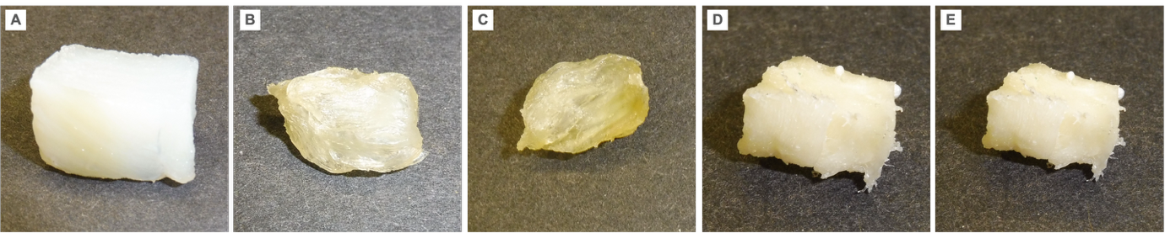
Figure S1: Pictures of (A) fresh cod fish and samples dried using air, at (B) 40 and (C) 60°C, (D) supercritical CO₂, and (E) supercritical CO₂ combined with high-power ultrasounds.

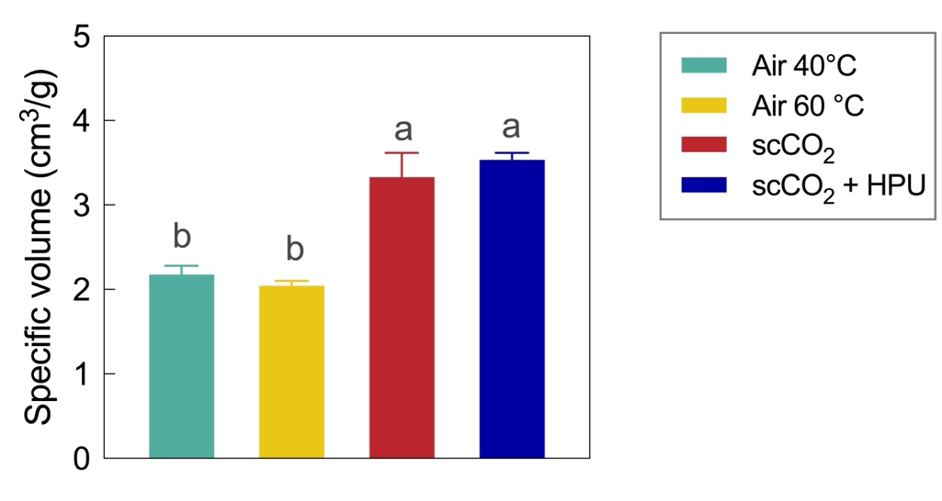
Figure S2: Specific volume (cm³/g) of cod fish samples dried using air, at 40 and 60°C, supercritical CO₂ (scCO₂), and supercritical CO₂ combined with high-power ultrasounds (scCO₂ + HPU). Different small letters (a and b) represent statistically different values (p-value < 0.05).

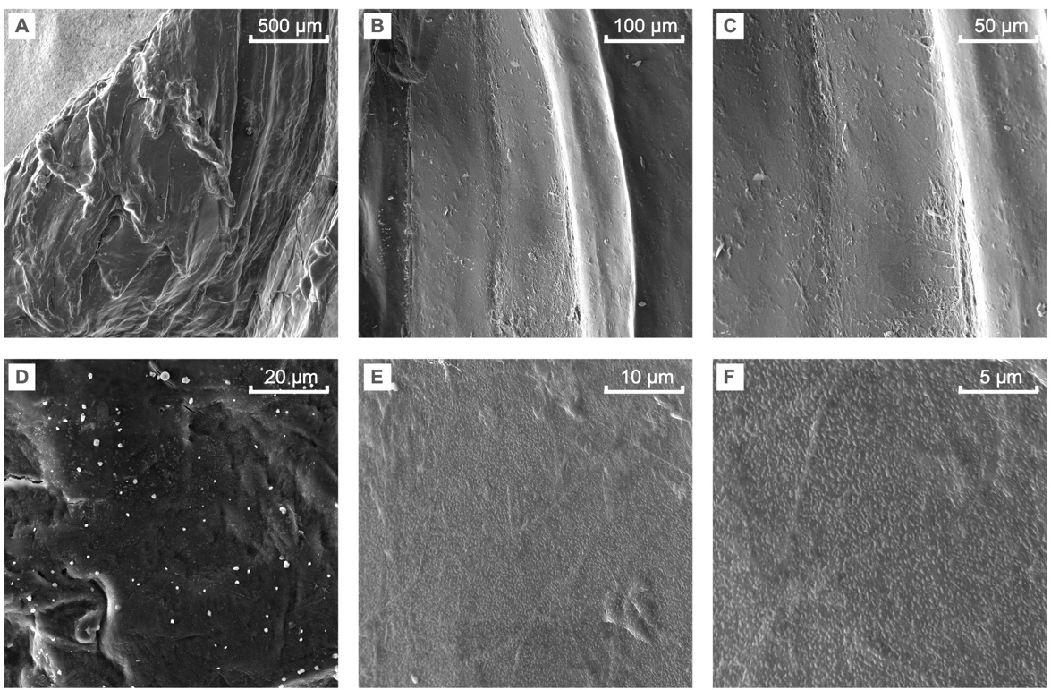
Figure S3: SEM picture of cod fish samples dried with air at 40°C at different magnitudes: (A) x100, (B) x400, (C) x800, (D) x2,000, (E) x5,000, and (F) x10,000.

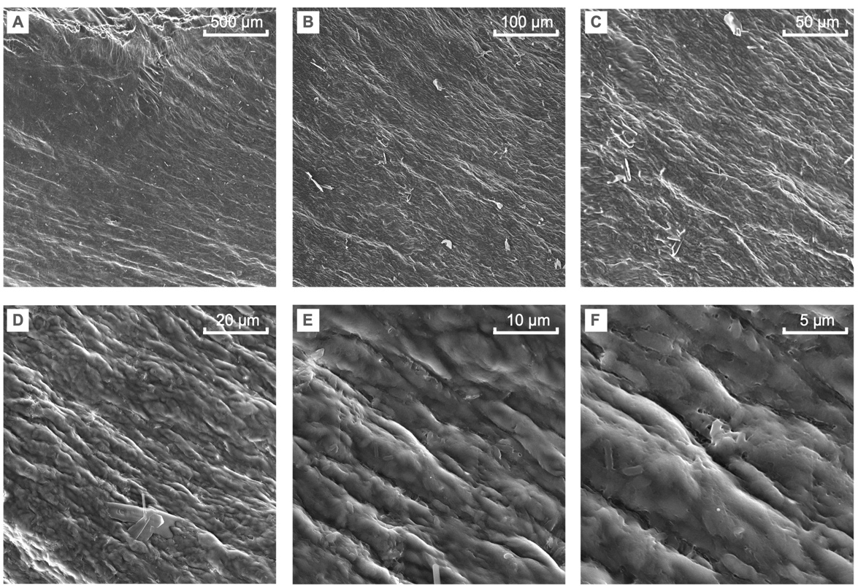
Figure S4: SEM picture of cod fish samples dried with hot air at 60°C at different magnitudes: (A) x100, (B) x400, (C) x800, (D) x2,000, (E) x5,000, and (F) x10,000.
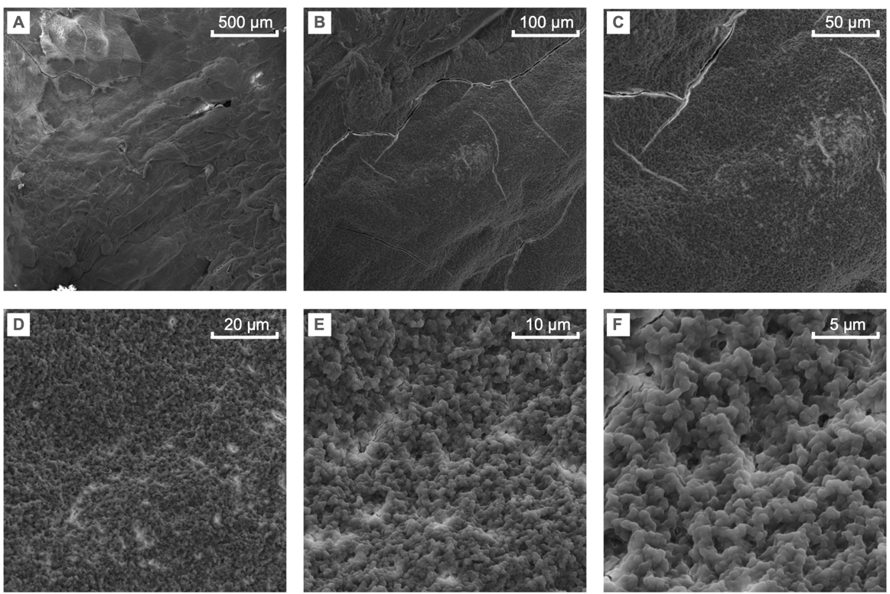
Figure S5: SEM picture of cod fish samples dried with supercritical CO₂ at different magnitudes: (A) x100, (B) x400, (C) x800, (D) x2,000, (E) x5,000, and (F) x10,000.

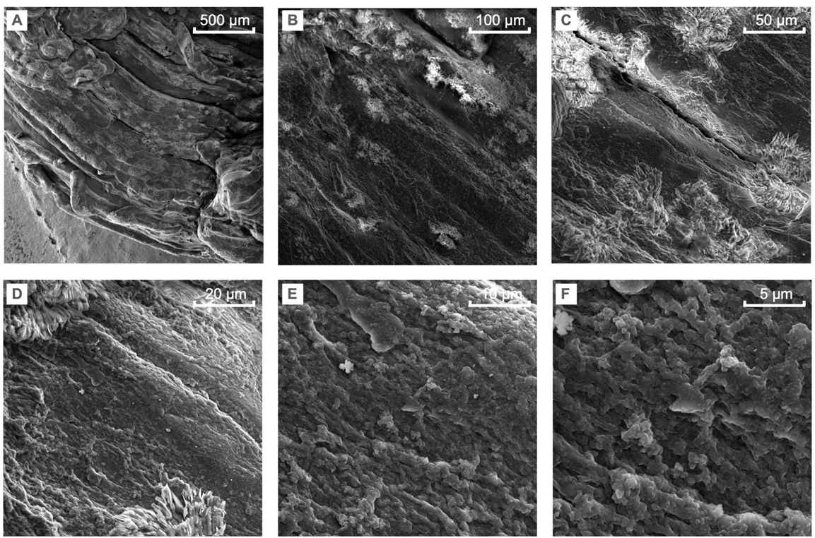
Figure S6: SEM picture of cod fish samples dried with supercritical CO₂ coupled with high-power ultrasounds at different magnitudes: (A) x100, (B) x400, (C) x800, (D) x2,000, (E) x5,000, and (F) x10,000.

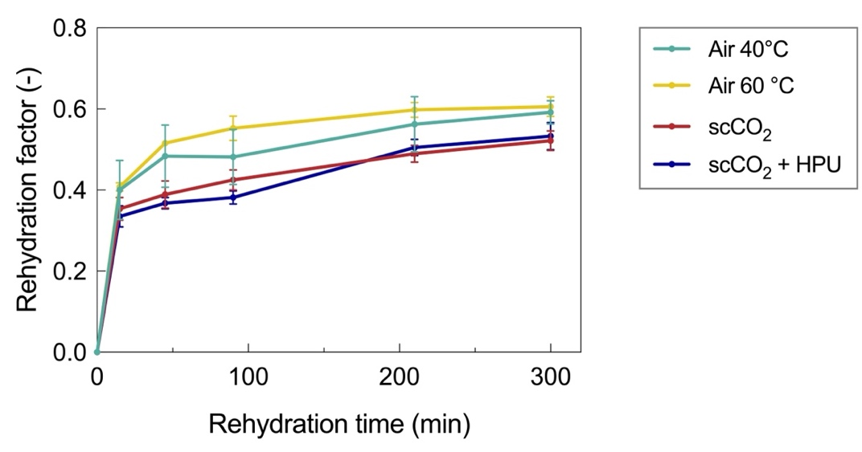
Figure S7: Rehydration factor in function of rehydration time cod fish samples dried using air, at 40 and 60°C, supercritical CO₂ (scCO₂), and supercritical CO₂ combined with high-power ultrasounds (scCO₂ + HPU).

