Appendix S3 - Variation decomposition of the species composition before and after accounting for pseudoturnover using three alternative approaches

Supplementary material to the paper:
Sabatini, F. M., M. D. Musciano, and A. Chiarucci. 2025. “Using Yearly Resolved Time‐Series to Disentangle Interannual Variability, Directional Change, and Pseudoturnover in Plant Community Composition.” Journal of Vegetation Science e70052. https://doi.org/10.1111/jvs.70052

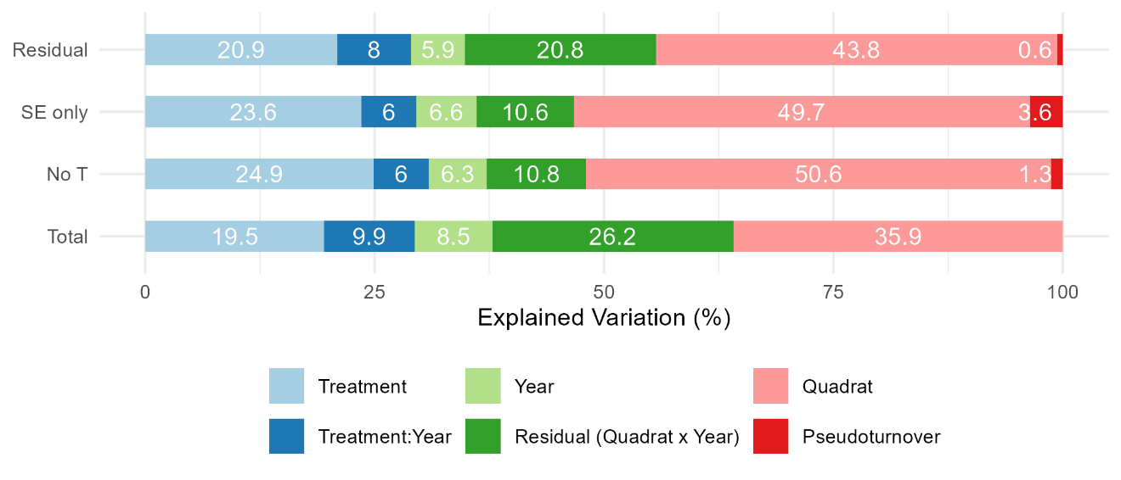
Appendix S3 - Variation decomposition of the species composition of the herb layer through PERMANOVA before (row “Total”) and after accounting for pseudoturnover using three alternative approaches (rows: “SE only”, “No T” and “Residual). Numbers in percentage. SE: Spring Ephemerals. T: Therophytes.

