Investigating Supply and Demand in European Cohesion Policy: Micro-foundations of Macro-behaviours
Appendix A. Field research information
Table A1. Information about interviews and workshops.
Type | Number of participants | Participants’ job titles | Organisation type | Date and length
Interview | 1 | CEO | Private company (both beneficiary and intermediary company) | 17th April 2018  105 minutes
Interview | 2 | Researchers | University | 11th June 2018  100 minutes
Interview | 1 | Journalist | Newspaper | 25th June 2018  140 minutes
Interview | 1 | Officer | LMA | 10th July 2018  150 minutes
Interview | 1 | Employee | European Structural Fund (ESF) funded project participant | 17th September 2018  50 minutes
Interview | 1 | Officer | Europe Direct | 20th September 2018  110 minutes
Interview | 1 | Researcher | University | 25th September 2018  110 minutes
Interview | 1 | Officer | LMA | 25th September 2018  80 minutes
Interview | 1 | CEO | Private company delivering ESF funded courses | 5th October 2018  60 minutes
Interview | 2 | Researchers | University | 5th October 2018  70 minutes
Interview | 2 | Officers | Open Coesione (Italian Open Government initiative about Cohesion Policy) | 2nd December 2018  100 minutes
Interview | 2 | Officers | LMA | 26th February 2019  150 minutes
Workshop | approx. 20 | LMA officers, EU officers, researchers |  | 26th October 2018  300 minutes
Workshop | approx. 15 | LMA officers, EU officers, researchers |  | 18th June 2019  120 minutes

Appendix B. Model calibration
To validate our model, whether the modelled supply-and-demand micro-operations at the LMA level reproduce the observed absorption macro-behaviour (i.e., reference mode). Thus, we calibrated the model to replicate the available data of the European Regional Development Fund (ERDF) absorption rate (calculated based on both EU and regional contributions) over the three latest policy cycles (i.e., 2000-2006, 2007-2013, and partially 2014-2020) in the selected region of Emilia Romagna (Aivazidou et al., 2020). In Figure A1, the red lines indicate the reference mode, while the blue ones refer to the model outputs. The patterns of both real data and simulations showcase an S-shaped growth (i.e., logistic function). In detail, the system initially starts to absorb the funds of each new cycle at a low pace (this pace is mainly attributed to the Commission pre-finance payments). Then, the absorption rate increases at an accelerating rate till it reaches approximately 95% and then the Commission, after assessing the regularity of the LMA operations, provides the final payments. Towards the end of the cycle, a saturation effect is evident; there are fewer funds in the pipeline, and, therefore, the absorption decelerates until it reaches 100%. As the model outputs reproduce the reference mode to a sufficient extent, we are confident that the developed structure adequately reproduces the real-world behaviour.
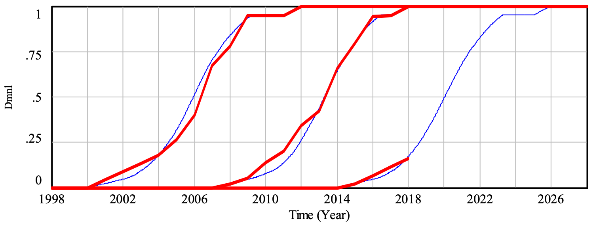
Figure B1. Model calibration based on absorption rate (dimensionless) [thick red line – reference mode; thin blue line – simulation].

Appendix C. LMA policies’ description
Table C1. Description of LMA policies to correct absorption gap.
Level of effort | Policy | Description | Causal link from “absorption gap” to …
Low (Soft policies) | Increase number of calls | To raise expenditure pace, LMAs increase the number of calls issued | “funds allocated in calls”
Low (Soft policies) | Increase communication | To overcome the low number of applications, LMAs attempt to increase the number of potential applicants aware of CP funding opportunities | “applications”
Medium (Moderate policies) | Extend call scope | To overcome the low number of applications, LMAs attempt to attract more applicants by extending the topics for which applicants can demand funding | “applications”
High (Hard policies) | Reduce project standards | To raise expenditure pace, LMAs begin to accept project proposals that would have previously been dismissed | “approved projects”
High (Hard policies) | Reduce regional co-finance | To raise the absorption rate, LMAs reduce the share of regional co-finance to the available CP funds | “total funds available”
High (Hard policies) | Use retrospective projects | To raise the absorption rate, the LMAs shift to CP scheme projects that received approval for other public funding | “approved projects”

