Supplementary Table 1. Univariate analysis of progression free survival and overall survival for each assessment prior to first, second and third line. PSA median values are 21 ng/ml, 25 ng/ml and 39 ng/ml for first, second and third line, respectively.
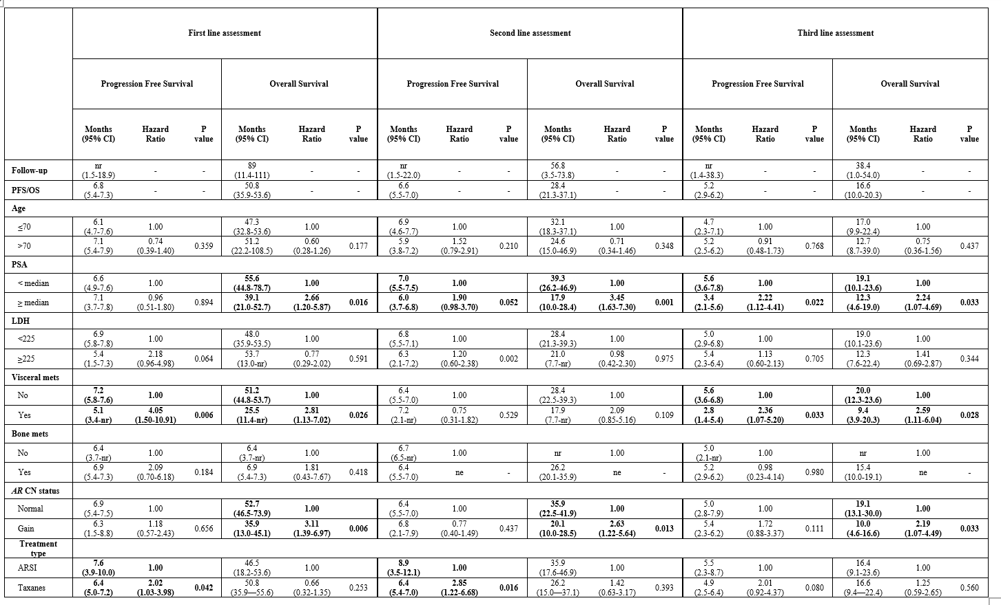
Abbreviations: PFS: progression free survival; OS: overall survival; PSA: prostate specific antigen; LDH: lactate dehydrogenase; mets: metastases; AR CN: Androgen receptor copy number; ARSI: androgen receptor signaling inhibitor; nr: not reached; ne: not estimable.

