Supplementary appendix
Non-selective beta-blockers enhance resolution of induced infections in animals and healthcare-associated infections in humans
Occhinegro A., Ventrella D., Rosa S., Alberti L., Amici R., Cerri M., Hitrec T., Tupone D., Cappellini A., Ratti S., Elmi A., Zannoni A., Felici S., Golinelli D., Luppi M., Lankadeva Y.R., May C.N., McAllen R.M., McKinley M.J., Passaglia P., Piscitiello E., Taddei L., Giannella M., Viale P.L., Bacci M.L., Rucci P., Lazzarotto T., Martelli D.
INDEX Page
Suppl. Methods 2
Suppl. Results 3
Figure S1 Experimental plan 4
Figure S2 Total white blood cells and leukocyte subsets in response to an infusion of
Escherichia coli (E.coli) in conscious propranolol-treated pigs and control pigs 5
Figure S3 Leukocyte subsets in response to an infusion of Escherichia coli (E.coli) in conscious
propranolol-treated pigs and control pigs 6
Figure S4 Flow cytometric evaluation of total neutrophils phagocytosis 7 Figure S5 Red blood cells indices measured throughout the study 8 Figure S6 Hemoglobin indices measured measured throughout the study 9
Figure S7 Platelets indices measured measured throughout the study 10
Figure S8 Clinical chemistry parameters measured throughout the study, indicators of renal function 11
Figure S9 Clinical chemistry parameters measured throughout the study, indicators of hepatic function 12
Figure S10 Electrolytes and cholesterol measured throughout the study 13
Figure S11 Flow chart of the study 14
Figure S12 Flow cytometric evaluation of neutrophils Forward Scatter-Area 15
Figure S13 Flow cytometric evaluation of percentage of not aggregated and aggregated neutrophils 16
Figure S14 Body temperature (°C) measured throughout the study 18
Figure S15 Flow cytometric evaluation of monocytes phagocytosis 19
Table S1 Characteristics of patients with HAIs 20
Table S2 Infections 21
Table S3 ATC codes 23

Supplementary methods
Surgical animal preparation (Day -5)
Five days before the bacterial challenge, animals were anesthetized, after 12-h fasting, for the surgical insertion of a double lumen central venous catheter (Mila central catheter 2/lum. 7FRx60cm; Alcyon Italia S.p.a., Italy) in the left jugular vein, and a telemetric capsule for the measure of temperature (Anipill capsule, BodyCAP, Hérouville-Saint-Clair, France). For such procedures, pigs were deeply sedated with an intramuscular (IM) injection of tiletamine-zolazepam (5 mg/kg; Zoletil®, Virbac S.r.l., Italy); after positioning the animals in lateral recumbency, a peripheral venous catheter was inserted in the auricular vein for fluid therapy (Lactated ringer, 8 ml/kg/h; S.A.L.F. S.p.a, Italy) and to induce general anesthesia with propofol (2-4 mg/kg; Proposure, Boehringer Ingelheim Animal Health Italia S.p.a, Italy). Anaesthesia was then maintained with 2-4 % sevoflurane in a 1:1 oxygen/air mixture upon oro-tracheal intubation. An advanced anaesthesia delivery unit (ADU; Datex-Ohmeda S/5, GE Healthcare, USA) was used to mechanically ventilate animals (volume-controlled ventilation, tidal volume 8-10 ml/kg) and to monitor standard intra-operatory parameters including heart and respiratory rates, peripheral oxygen saturation (SpO₂), capnometry and capnography (EtCO₂), electrocardiography, non-invasive blood pressure and temperature.
Haemoculture analysis
Blood samples for the detection of aerobic and anaerobic micro-organisms were taken from each animals using specific blood culture bottles BD BACTECTM, then loaded into the BD BACTECTM blood culture system. Once the haemocultures were positive for the presence of micro-organisms, 1 ml of blood was taken from each vial for seeding on solid medium. The volume of blood taken was diluted (serial dilutions 1:10) and 10 μl of the final diluted volume was seeded on a Columbia agar plate (horse blood 5%). After 24 hours of incubation, the colonies grown on the plate were counted and identified by Matrix-assisted laser desorption/ionization time-of-flight mass spectrometry (MALDI-TOF MS). For each positive sample, the procedure was performed in duplicate.
Complete blood count (CBC) and clinical chemistry
Blood samples were collected daily, at 10AM, on the day of surgery (Day -5), on the first propranolol dosing day (Day -2), during the day of the challenge 90 min, 3, 6, 12 and 24 hours after (averaged points on Day 1), and the following 14 days (from Day 2 to Day 14; detailed shown in Fig. S1).
For the complete blood count (CBC), blood was collected into anti-coagulant tubes (S-Monovette® K3 EDTA, Sarstedt, Germany) and analysed within 10 min using an automated haematology system (ADVIA 2021, Siemens Healthcare, Germany). For clinical chemistry, blood was collected into tubes containing a clot activator (S-Monovette® Serum Gel, Sarstedt, Germany) and centrifuged after 30 min to obtain serum, which was then analysed using an automated chemistry analyzed (AU480, Beckman Coulter, USA).
Rapid measurements of lactatemia and glycaemia were immediately performed upon blood collection using the Accutrend Plus® with BM-Lactate strips (Roche Diagnostics, Roche, Germany) and the FreeStyle Optimum Neo glucometer (Abbott Laboratories, USA) respectively.
Flow cytometric analysis
A flow cytometric phagocytosis assay was performed on blood samples collected before the start of propranolol treatment (T0), immediately before (T1) the bacterial challenge and then after 90 min (T2), 1 and 2 weeks (respectively T3 and T4) from the bolus administration. The blood samples collected with heparin as anticoagulant, were incubated, or not, with fluorescent E.coli Red BioParticles coniugated with a fluorogenic reagent that increases in fluorescence (emission filter 585/26) as the pH decreases in the surrounding environment (es. inside the lysosomes) (pHrodo™ BioParticles™ Conjugates for Phagocytosis and Phagocytosis Kit, InvitrogenTM, Waltham, MA, US).
For each point, a volume of 100 μl of whole blood was incubated, or not, at 0°C and 37°C with 20 μL of E.coli Red BioParticles solution, obtained by resuspending lyophilized E.Coli in 2·2 ml of appropriate buffer; all samples were set up in duplicates.
After 15 minutes the reaction was stopped with a 5 min incubation on ice and then lysis of the red blood cells was carried out. The samples appropriately washed and resuspended in 1ml of appropriate buffer were acquired on the flow cytometer.
The white blood cells were identified through their typical localization in a Forward Scatter-Height (FSC-H) vs Side Scatter-Height (SSC-H) dot plot in order to exclude any fragments of the lysed red blood cells.
Lymphocytic, granulocytic and monocytic populations were identified and appropriately gated to evaluate their specific physical and fluorescence characteristics. No further counterstaining was performed using conjugated antibodies towards specific cellular surface markers, in order to recognize more specifically each white blood cell subpopulation.
Granulocytes were analysed for their light scattering properties: the Forward Scatter values referred to the size of cells were exploit for evaluate the state of activation of neutrophils (Fig. S12; Longhurst et al., 1990), the SSC-H referred to the complexity of cells were useful to evaluate the abundance of intracellular granules and Side Scatter-Area (SSC-A) considered as a parameter indicative of the presence of cellular aggregates to derive the percentage of not aggregated and aggregated neutrophils (Fig. S13; Hogg et al., 1999).
On the other hand, according to the kit datasheet, we measure the Mean Fluorescence Intensity (MFI) emitted by granulocytes and monocytes after the incubation, as mirror of the amount of E.coli Red BioParticles phagocyted by phagocytes in blood samples (Fig. S4 and Fig. S15). For each evaluated parameters, a normalization of every timepoints value has been done on the value of the samples collected before the start of pharmacological treatment (T0).
Supplementary results
Complete blood count (CBC)
As a consequence of bacteria injection, the body temperature of animals showed an emphasised intradiurnal oscillatory pattern, regardless the experimental group (Fig. S14).
Red cell indices exhibited some significant differences between the propranolol-treated group and the control: the latter showed increased values of haematocrit (Hct; F_{(1,126)}=24·411, p<0·001; Fig. S5a), red blood cell count (RBC; F_{(1,126)}=21·254, p<0·001; Fig. S5b), and both haemoglobin (F_{(1,126)}=27·949, p<0·001; Fig. S6a) and cellular haemoglobin (F_{(1,126)}=28·871, p<0·001; Fig. S6f), mostly from the tenth to the
thirteenth day of the trial. On the contrary, an increase in propranolol-treated group emerged for red cell distribution width (RDW; F_{(1,126)}=47·591, p<0·001; Fig. S5c), cellular haemoglobin distribution width (CHDW; F_{(1,126)}=57·508, p<0·001; Fig. S6h) and percentage of reticulocytes (F_{(1,126)}=13·290, p<0·001; Fig. S5f).
Moreover, the platelet count (PLT) was significantly different between the control and the propranolol-treated group (F_{(1,126)}=4·639, p=0·033; Fig. S7a). As well as some indices that described the size and the variability of the size among platelets were significant different between the two experimental groups: platelet distribution width (PDW; F_{(1,126)}=29·420, p<0·001; Fig. S7d), platelet mass distribution width (PMDW; F_{(1,126)}=60·798, p<0·001; Fig. S7e), and platelet component distribution width (PCDW; F_{(1,126)}=30·335, p<0·001; Fig. S7f).
Clinical chemistry
Some parameters that are indicative of renal and hepatic function changed between the control and propranolol-treated groups, although they remained within physiological ranges. A significant difference emerged for urea (F_{(1,126)}=12·362, p<0·001; Fig. S8c), aminotransferase alanine (ALT; F_{(1,126)}=11·457, p<0·001; Fig. S9a), total proteins (F_{(1,126)}=7·719, p=0·006; Fig. S9e) and albumin to globulin ratio (F_{(1,126)}=12·078, p<0·001; Fig. S9g).
The levels of electrolytes were all within physiological ranges. Phosphorus (P), sodium (Na+), potassium (K+), chlorine (Cl-) did not differ between control and propranolol-treated group (Fig. S10) while magnesium (Mg; F_{(1,126)}=9·707, p=0·002; Fig. S10c) and calcium did so. Notably, calcium (Ca²⁺; F_{(1,126)}=20·921, p<0·001; Fig. S10a) and corrected calcium (the amount of circulating calcium corrected for the concentration of albumin; F_{(1,126)}=27·425, p<0·001; Fig. S10b) were less concentrated in the control group than in the propranolol-treated group.
Flow cytometric analysis
As explained in the main text, flow cytometry evaluation revealed a heightened FSC-A value in neutrophils from propranolol-treated pigs, particularly towards the trial's end (F_{(1,38)}=4·827, p=0·034; Fig. S12a-b), concurrent with increased aggregation (F_{(1,38)}=7·066, p=0·011; Fig. S13c-d), both considered parameters of neutrophils activation. In Figure S12c-d were reported Representative histograms of control pig FSC-A on T0 and T4. It was evident the shift to the right of the FSC-A values in T4 propranolol-treated pigs compared with the controls, mirror the increased neutrophil activation. In Figure S13e-f-g-h were reported Representative gating strategies adopted to differentiate not aggregated (gate R8 in yellow) and aggregated (gate R9 in brown) neutrophils in a SSC-H vs SSC-A dot plot evaluated before the start of pharmacological treatment (T0) and the last day of the study (T4). The percentage values of aggregated neutrophils remarkably increased in propranolol-treated pigs at T4 compared with T0, contrary to the control group. Moreover, the MFI, indicative of phagocytic capacity, exhibited an increasing trend in neutrophils from propranolol-treated pigs, especially one to two weeks post-infection (Fig. S4a-b), without reaching the statistical significance, though. In Figure S4c-d we report Representative histograms of control pig red fluorescence intensity (BL2-H) on T4 in both experimental group, in samples incubated and not incubated with E.coli Red BioParticles. The percentage of events which express major values of fluorescence intensity tended to be higher in propranolol-treated pig compared with control at T4. There was no difference in MFI emitted by monocytes (Fig. S15a-b). Even the Representative histograms (Fig. S15c-d) did not show any difference between the fluorescence intensity of propranolol-treated and control groups.

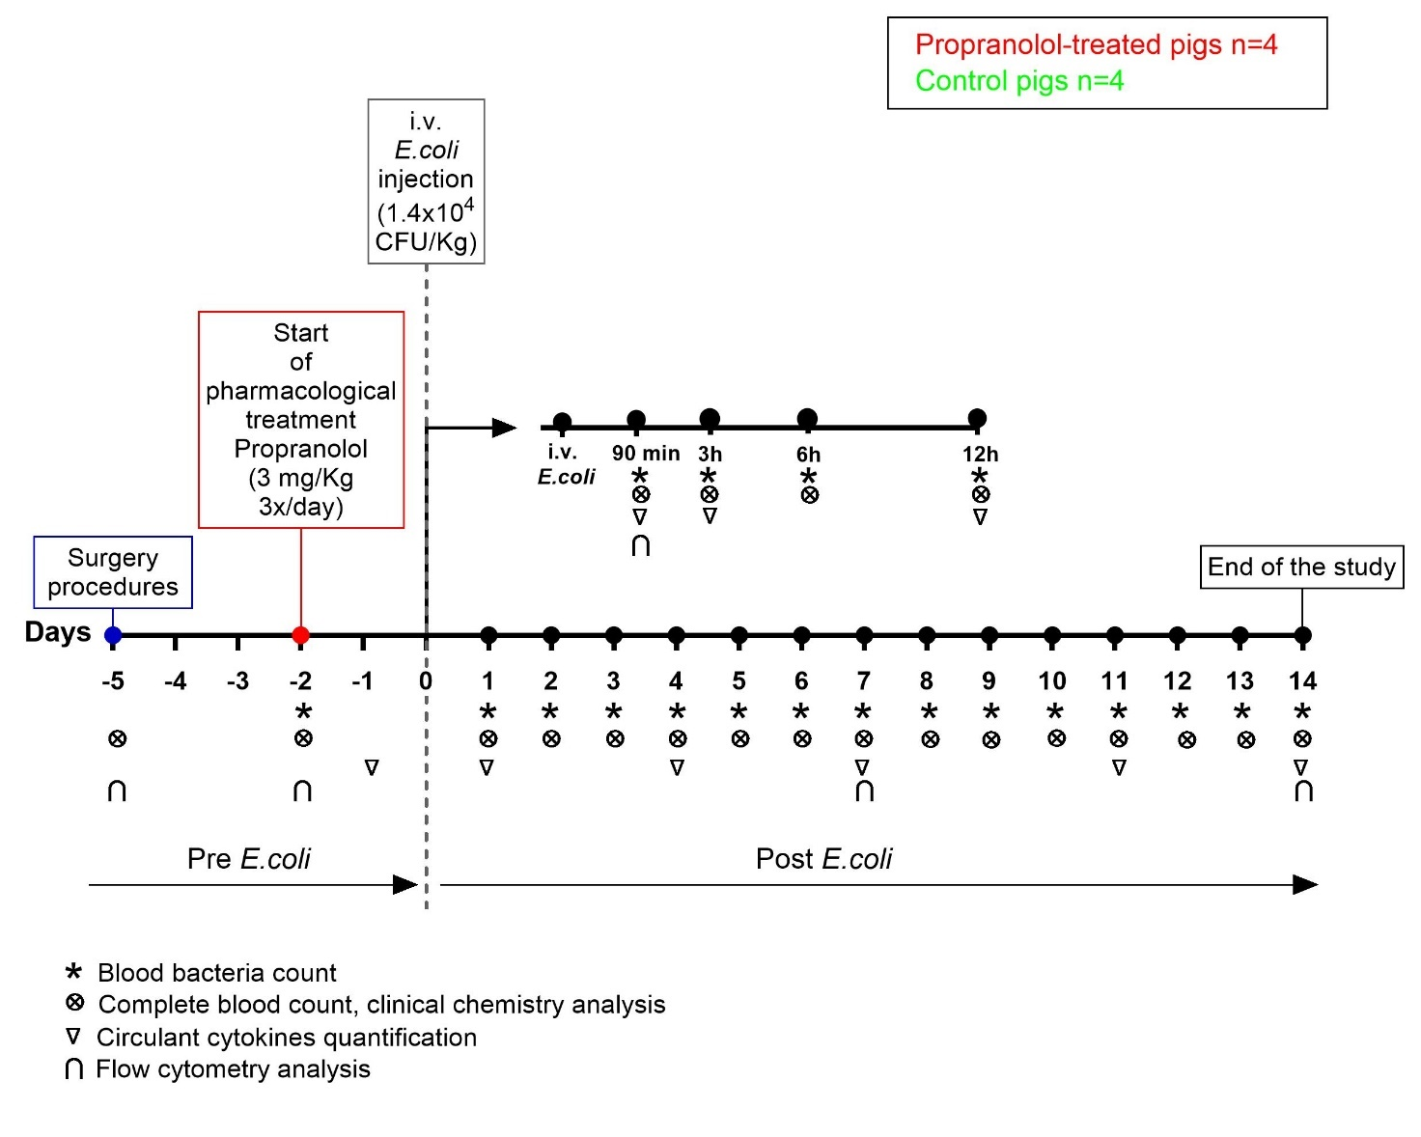
Figure S1. Experimental plan.
The chart shows the experimental plan of the preclinical study. The surgical procedures, consisting of the implantation of a venous catheter and a telemetric capsule for measuring body temperature, were performed on Day -5 (five days before the intravenous (i.v.) injection of Escherichia coli (E.coli)). Pharmacological treatment with propranolol (3 mg/Kg; 3x/day) was started on the Day -2 (two days before the i.v. injection of E.coli). On Day 0, E.coli was injected i.v. into pigs. After the injection, during the Day 0, blood was sampled after: 90 minutes, 3 hours, 6 hours, 12 hours. The animals were then followed for 14 days (from Day 1 to Day 14), and blood samples were collected daily for several analyses (indicated by symbols at the bottom). The two experimental groups, the propranol-treated group and the control group, each consist of 4 animals.

Figure S2. Total white blood cells and leukocyte subsets in response to an infusion of Escherichia coli (E.coli) in conscious propranolol-treated pigs and control pigs.
(a) Total white blood cell count (WBC), (b) total neutrophils, (c) percentage of neutrophils, (d) total monocytes, (e) percentage of monocytes concentration throughout the study in propranolol-treated pigs (red) and control pigs (green). Day 0 (dotted line) represents the intravenous (i.v.) injection of E.coli. Values at 90 minutes, 3, 6, 12, 24 hours after i.v. E.coli injection are averaged on Day 1. # indicates significant differences between control animals and propranolol-treated animals using one-way ANOVA. *p<0·05 indicates significant difference of specific timepoint comparisons between control and propranolol-treated groups. Data are expressed as mean ± standard error of the mean (SEM).
Figure S3. Leukocyte subsets in response to an infusion of Escherichia coli (E.coli) in conscious propranolol-treated pigs and control pigs.
(a) Total of lymphocytes, (b) percentage of lymphocytes, (c) total basophils, (d) percentage of basophils, (e) total eosinophils, and (f) percentage of eosinophils concentration throughout the study in propranolol-treated pigs (red) and control pigs (green). Day 0 (dotted line) represents the intravenous (i.v.) injection of E.coli. Values at 90 minutes, 3, 6, 12, 24 hours after i.v. E.coli injection are averaged on Day 1. # indicates significant differences between control animals and propranolol-treated animals using one-way ANOVA. *p<0·05 indicates significant difference of specific timepoint comparisons between control and propranolol-treated groups. Data are expressed as mean ± standard error of the mean (SEM).
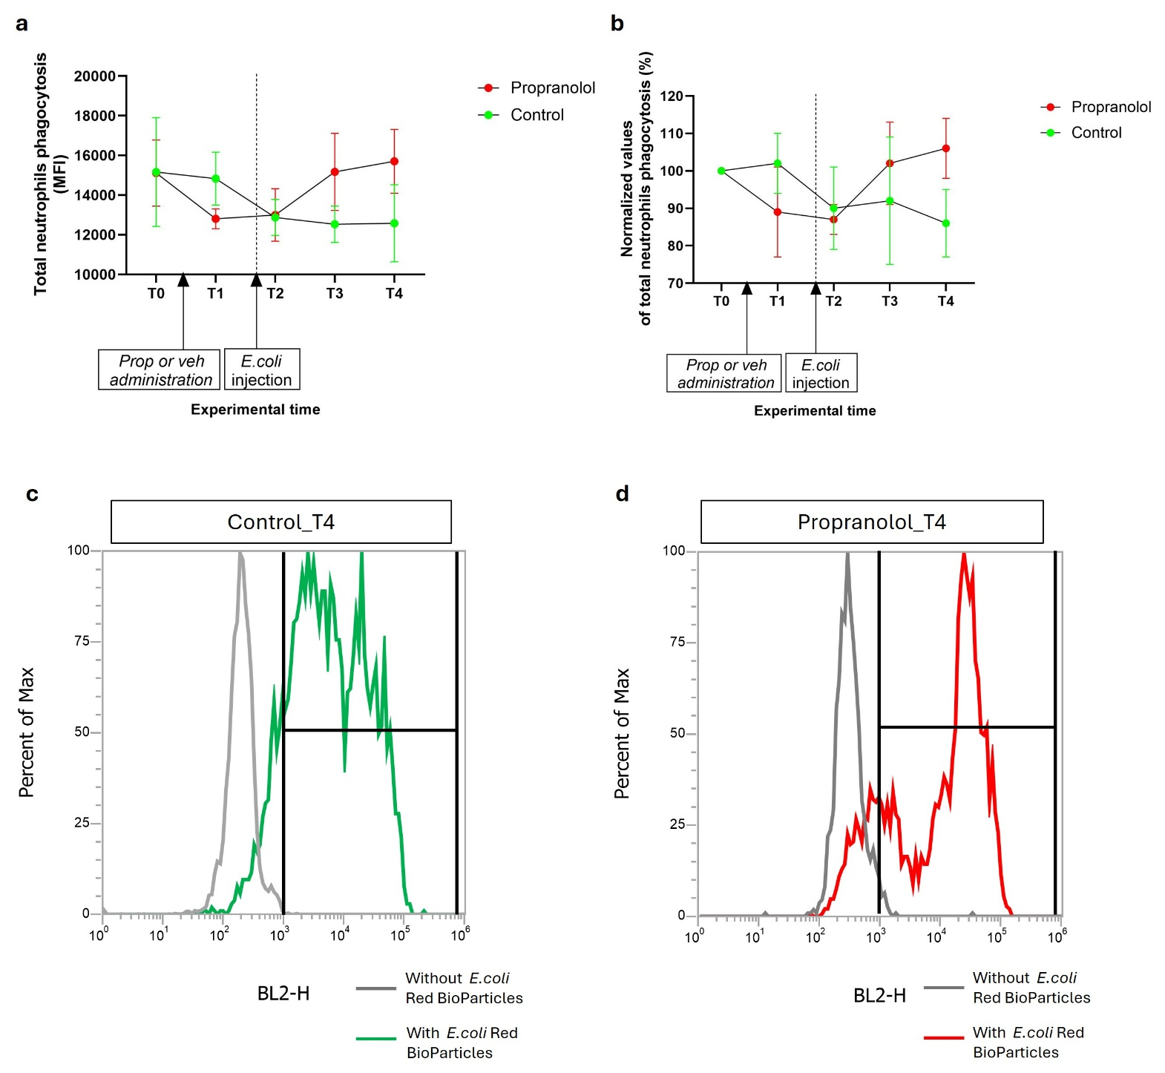
FigureS4. Flow cytometric evaluation of total neutrophils phagocytosis.
(a) Total neutrophil phagocytosis of E.coli Red BioParticles expressed in Mean Fluorescence Intensity (MFI), in control pigs (green) and propranolol-treated pigs (red). (b) Total neutrophils phagocytosis normalised values: each timepoint value was normalised to the value of the sample collected before the start of pharmacological treatment (T0), in control pigs (green) and propranolol-treated pigs (red). In each panel, T0 corresponds to blood sample collected before the start of pharmacological treatment; T1 corresponds to blood samples collected on the first day of pharmacological treatment; T2 corresponds to blood samples collected 90 minutes after the i.v. injection of E.coli (dotted line); T3 corresponds to blood samples collected 7 days after the i.v. injection of E.coli; T4 corresponds to blood samples collected 14 days after the i.v. injection of E.coli. Data are expressed as mean ± standard error of the mean (SEM). (c) Representative histogram overlay of red fluorescence intensity (BL2-H) of blood sample not incubated with E.coli Red BioParticles (grey line) and blood sample incubated with E.coli Red BioParticles (green line) in control pig at T4 (14 days after the i.v. injection of E.coli in vivo). (d) Representative histogram overlay of red fluorescence intensity (BL2-H) of blood sample not incubated with E.coli Red BioParticles (grey line) and blood sample incubated with E.coli Red BioParticles (red line) in propranolol-treated pig at T4 (14 days after the i.v. injection of E.coli in vivo).

Figure S5. Red blood cells indices measured throughout the study.
(a) Hematocrit value (Hct), (b) red blood cell count (RBC), (c) red cell distribution width (RDW), (d) mean corpuscular volume (MCV), (e) total reticulocytes and (f) percentage of reticulocytes concentration in blood samples of propranolol-treated pigs (red) and control pigs (green). Day 0 (dotted line) represents the intravenous (i.v.) injection of Escherichia coli (E.coli). Values at 90 minutes, 3, 6, 12, 24 hours after i.v. E.coli injection are averaged on Day 1. # indicates significant differences between control animals and propranolol-treated animals using one-way ANOVA. *p<0·05 indicates significant difference of specific timepoint comparisons between control and propranolol-treated groups. Data are expressed as mean ± standard error of the mean (SEM).

Figure S6. Hemoglobin indices measured throughout the study.
(a) Total hemoglobin, (b) mean corpuscular hemoglobin (MCH), (c) mean corpuscular hemoglobin concentration (MCHC), (d) hemoglobin concentration distribution width (HDW), (e) cellular hemoglobin content (CH, expressed in pg), (f) cellular hemoglobin content (CH, expressed in g/dl), (g) cellular hemoglobin concentration mean (CHCM), and (h) cellular hemoglobin distribution width (CHDW) concentration in blood samples of propranolol-treated pigs (red) and control pigs (green). Day 0 (dotted line) represents the intravenous (i.v.) injection of Escherichia coli (E.coli). Values at 90 minutes, 3, 6, 12, 24 hours after i.v. E.coli injection are averaged on Day 1. # indicates significant differences between control animals and propranolol-treated animals using one-way ANOVA. *p<0·05 indicates significant difference of specific timepoint comparisons between control and propranolol-treated groups. Data are expressed as mean ± standard error of the mean (SEM).
Figure S7. Platelets indices measured throughout the study.
(a) Platelets count, (b) mean platelet component (MPC), (c) plateletcrit (PCT), (d) platelet distribution width (PDW), (e) platelet mass distribution width (PMDW), (f) platelet component distribution width (PCDW) concentration in blood samples of propranolol-treated pigs (red) and control pigs (green). Day 0 (dotted line) represents the intravenous (i.v.) injection of Escherichia coli (E.coli). Values at 90 minutes, 3, 6, 12, 24 hours after i.v. E.coli injection are averaged on Day 1. # indicates significant differences between control animals and propranolol-treated animals using one-way ANOVA. *p<0·05 indicates significant difference of specific timepoint comparisons between control and propranolol-treated groups. Data are expressed as mean ± standard error of the mean (SEM).

Figure S8. Clinical chemistry parameters measured throughout the study: indicators of renal function.
(a) Creatinine, (b) enzymatic creatinine, (c) urea, and (d) uric acid concentration in blood samples of propranolol-treated pigs (red) and control pigs (green). Day 0 (dotted line) represents the intravenous (i.v.) injection of E.coli. Values at 90 minutes, 3, 6, 12, 24 hours after i.v. E.coli injection are averaged on Day 1. # indicates significant differences between control animals and propranolol-treated animals using one-way ANOVA. *p<0·05 indicates significant difference of specific timepoint comparisons between control and propranolol-treated groups. Data are expressed as mean ± standard error of the mean (SEM).
Figure S9. Clinical chemistry parameters measured throughout the study: indicators of hepatic function.
(a) Aminotransferase alanine (ALT), (b) aminotransferase aspartate (AST), (c) bilirubin, (d) γ-glutamyl transferase, (e) total proteins (sum of albumin and globulin), (f) albumin, and (g) ratio of albumin on globulin concentration in blood samples of propranolol-treated pigs (red) and control pigs (green). Day 0 (dotted line) represents the intravenous (i.v.) injection of Escherichia coli (E.coli). Values at 90 minutes, 3, 6, 12, 24 hours after i.v. E.coli injection are averaged on Day 1. # indicates significant differences between control animals and propranolol-treated animals using one-way ANOVA. *p<0·05 indicates significant difference of specific timepoint comparisons between control and propranolol-treated groups. Data are expressed as mean ± standard error of the mean (SEM).

Figure S10. Electrolytes and cholesterol measured throughout the study.
(a) Calcium (Ca²⁺), (b) corrected Ca²⁺, (c) magnesium (Mg), (d) chlorine (Cl⁻), (e) phosphorus (P), (f) potassium (K⁺), (g) sodium (Na⁺), and (h) cholesterol concentration in blood samples of propranolol-treated pigs (red) and control pigs (green). Day 0 (dotted line) represents the intravenous (i.v.) injection of Escherichia coli (E.coli). Values at 90 minutes, 3, 6, 12, 24 hours after i.v. E.coli injection are averaged on Day 1. # indicates significant differences between control animals and propranolol-treated animals using one-way ANOVA. *p<0·05 indicates significant difference of specific timepoint comparisons between control and propranolol-treated groups. Data are expressed as mean ± standard error of the mean (SEM).

Hospitalisations assessed for eligibility (N= 94605)
Hospitalisations included (N= 92649)

Excluded (N=1956)
♦Rehospitalized within 14 days with orthopaedic procedure code ICD-9 CM 76.xx-84.xx (N=621)
♦With infections present on admission (N=1335)

Data Analysis

With HAI (N=1756)
Without HAI (N=90893)

Figure S11. Flow chart of the study

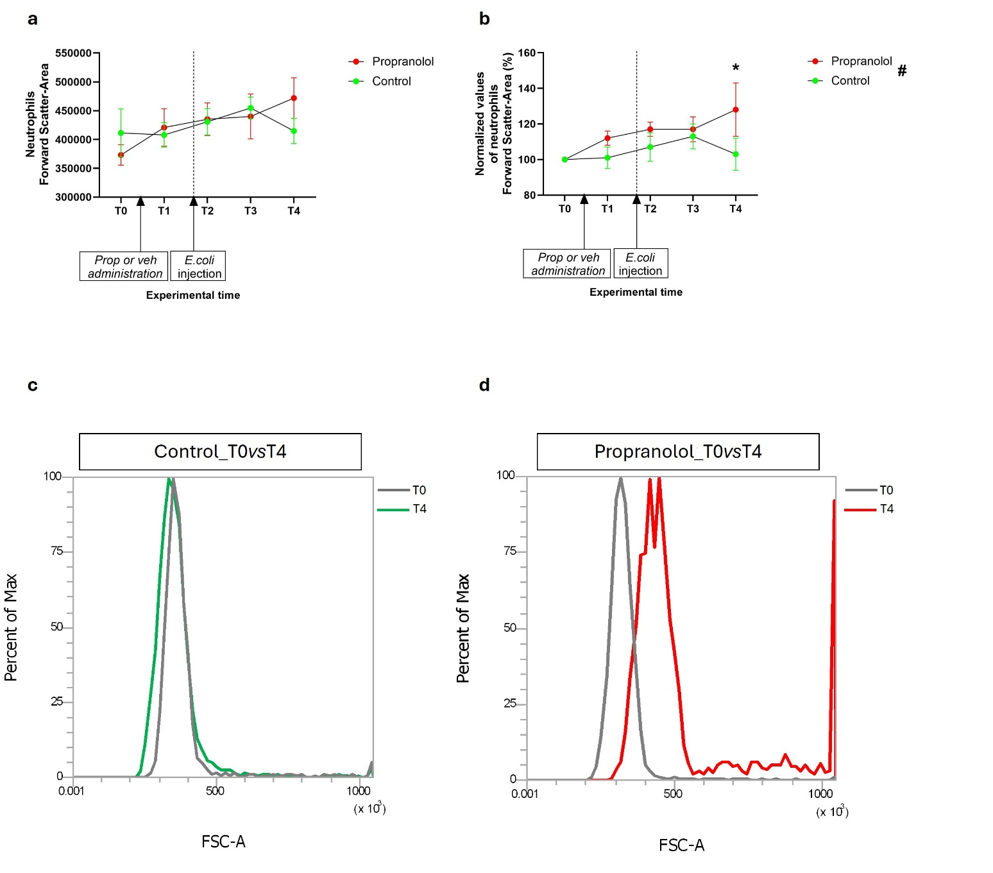
Figure S12. Flow cytometric evaluation of neutrophils Forward Scatter-Area (FSC-A).
(a) Neutrophils FSC-A evaluation as activation parameter in blood sample not incubated with E.coli Red BioParticles, in control pigs (green) and propranolol-treated pigs (red). (b) Neutrophil FSC-A normalized values: each timepoint value was normalized to the value of the sample collected before the start of pharmacological treatment (T0), in control pigs (green) and propranolol-treated pigs (red). In each panel, T0 corresponds to blood samples collected before the start of pharmacological treatment; T1 corresponds to blood sample collected on the first day of pharmacological treatment; T2 corresponds to blood samples collected 90 minutes after the i.v. injection of E.coli (dotted line); T3 corresponds to blood samples collected 7 days after the i.v. injection of E.coli; T4 corresponds to blood samples collected 14 days after the i.v. injection of E.coli. # indicates significant differences between control animals and propranolol-treated animals using one-way ANOVA. *p<0·05 indicates significant difference of specific timepoint comparisons between control and propranolol-treated groups. Data are expressed as mean ± standard error of the mean (SEM). (c) Representative histogram of control pig FSC-A on T0 (grey line) vs T4 (green line). (d) Representative histogram of propranolol-treated pigs FSC-A on T0 (grey line) vs T4 (red line).

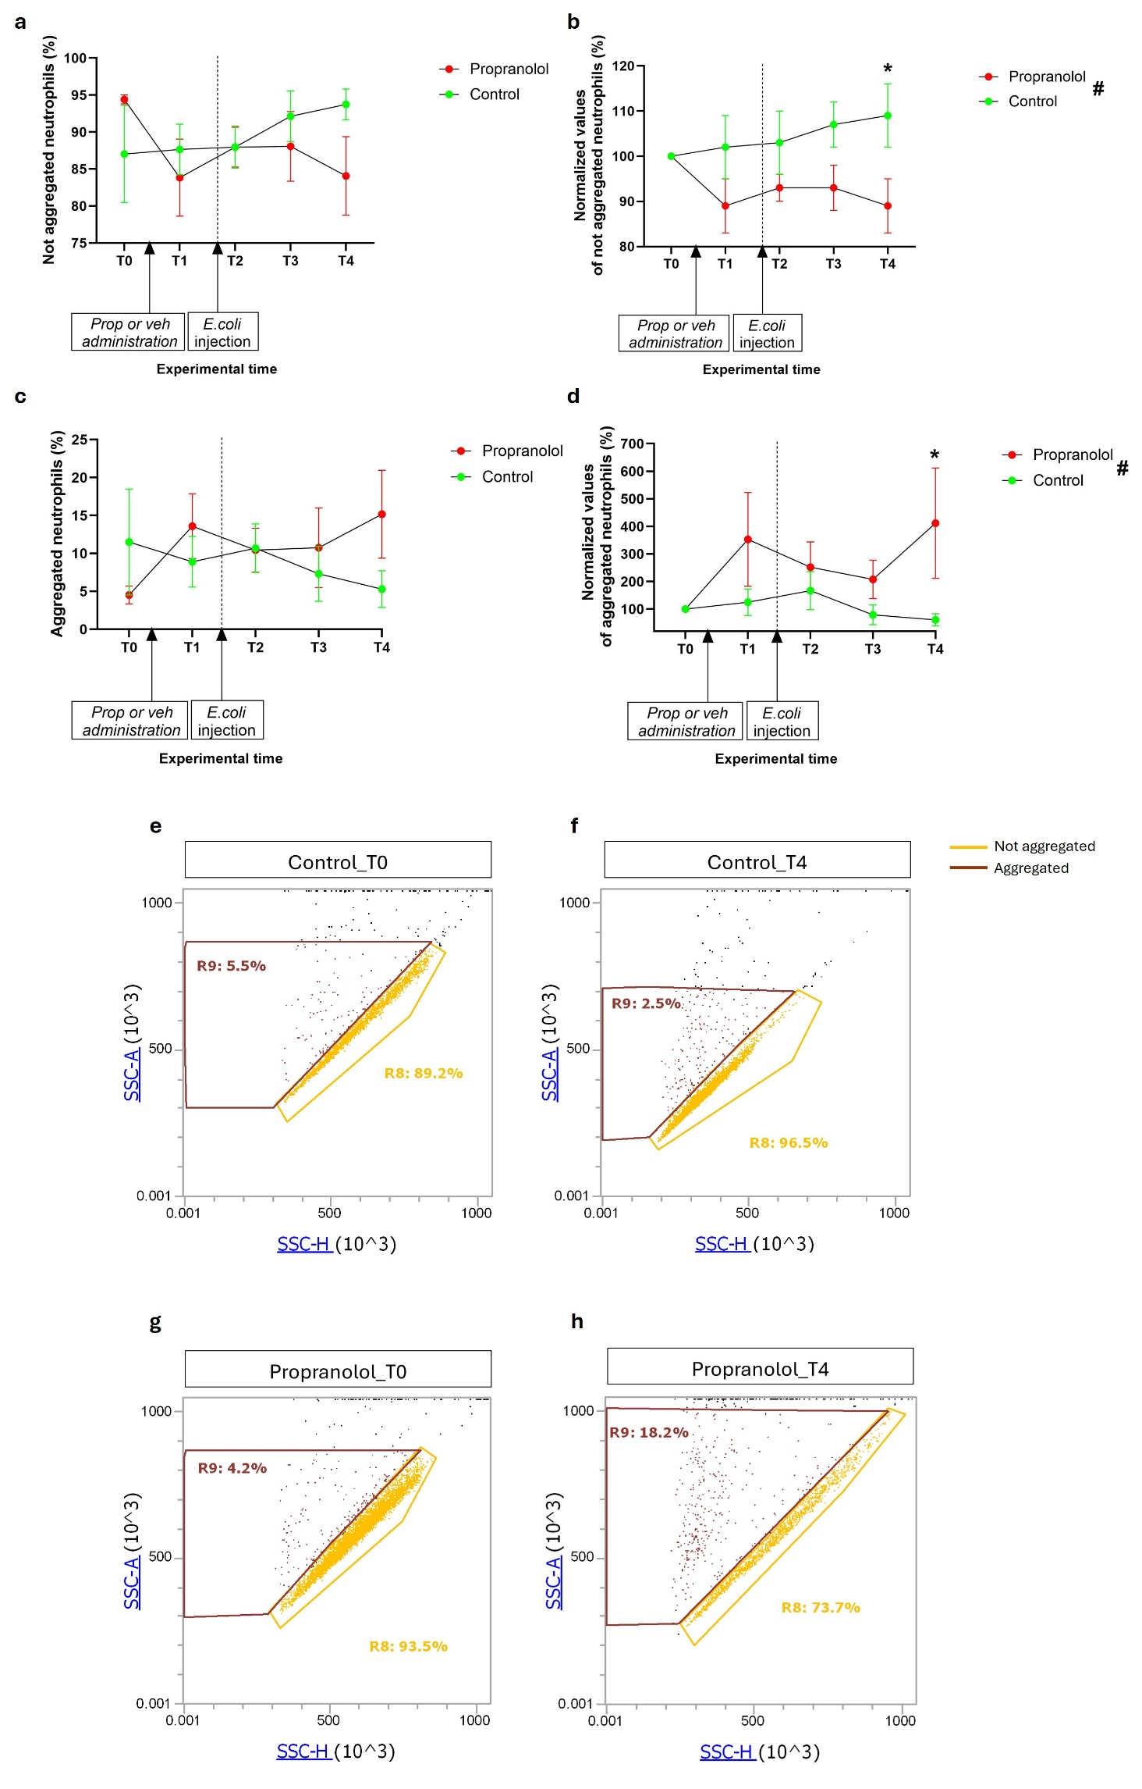
FigureS13. Flow cytometric evaluation of percentage of not aggregated and aggregated neutrophils.
(a) Percentage of non-aggregated neutrophils by evaluating Side Scatter-Height (SSC-H) vs SSC-Area (A) in blood sample not incubated with E.coli Red BioParticles, in control pigs (green) and propranolol-treated pigs (red). (b) Percentage of non-aggregated neutrophils normalized values: each timepoint value was normalized to the value of the sample collected before the start of pharmacological treatment (T0), in control pigs (green) and propranolol-treated pigs (red). (c) Percentage of aggregated neutrophils by evaluating side SSC-H vs SSC-A in blood sample not incubated with E.coli Red BioParticles, in control pigs (green) and propranolol-treated pigs (red). (d) Percentage of aggregated neutrophils normalised values: each timepoint value was normalized to the value of the sample collected before the start of pharmacological treatment (T0), in control pigs (green) and propranolol-treated pigs (red). In each panel, T1= first day of propranolol/vehicle administration; T2= 90 minutes after E.coli injection (dotted line); T3= 7 days after E.coli injection; T4= 14 days after E.coli injection. # indicates significant differences between control animals and propranolol-treated animals using one-way ANOVA. *p<0·05 indicates significant difference of specific timepoint comparisons between control and propranolol-treated groups. Data are expressed as mean ± standard error of the mean (SEM). (e) Representative gating strategy of not aggregated (gate R8 in yellow) and aggregated (gate R9 in brown) neutrophils in a SSC-H vs SSC-A dot plot evaluated before the start of pharmacological treatment (T0) in control pig. (f) Representative gating strategy of not aggregated (gate R8 in yellow) and aggregated (gate R9 in brown) neutrophils in a SSC-H vs SSC-A dot plot evaluated 14 days after the intravenous (i.v.) injection of E.coli (T4) in control pig. (g) Representative gating strategy of not aggregated (gate R8 in yellow) and aggregated (gate R9 in brown) neutrophils in a SSC-H vs SSC-A dot plot evaluated before the start of pharmacological treatment (T0) in propranolol-treated pig. (h) Representative gating strategy of not aggregated (gate R8 in yellow) and aggregated (gate R9 in brown) neutrophils in a SSC-H vs SSC-A dot plot evaluated after the i.v. injection of E.coli (T4) in propranolol-treated pig.

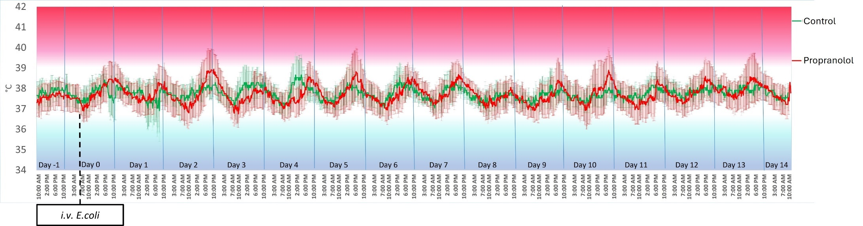

Figure S14. Body temperature (°C) measured throughout the study.
The body temperature recorded by Anipill capsule (BodyCAP, Hérouville-Saint-Clair, France) are reported. Day 0 (dotted line) is the day when the intravenous (i.v.) injection of Escherichia coli (E.coli) was given. Data are expressed as mean ± standard error of the mean (SEM) of control pigs (green) and propranolol-treated pig (red). The statistical difference between the two experimental groups was performed usign non-parametric Kruskal–Wallis test. No differences emerged.

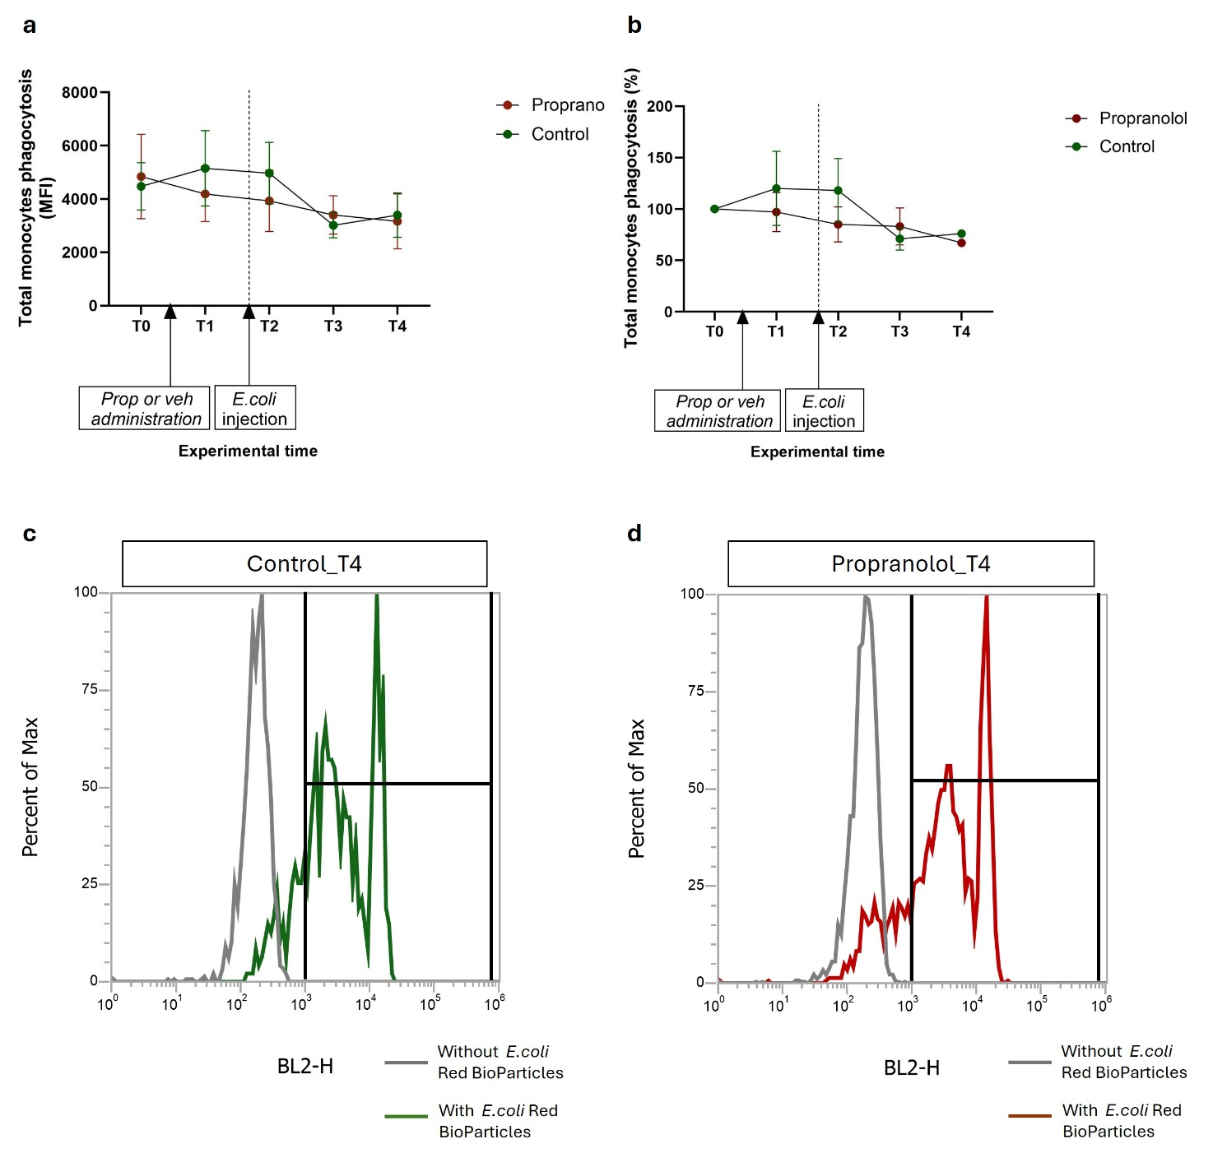

FigureS15. Flow cytometric evaluation of monocytes phagocytosis.
(a) Monocyte phagocytosis of E.coli Red BioParticles expressed in Mean Fluorescence Intensity (MFI), in control pigs (green) and propranolol-treated pigs (red). (b) Monocyte phagocytosis normalized values: each timepoint value was normalized to the value of the sample collected before the start of pharmacological treatment (T0), in control pigs (green) and propranolol-treated pigs (red). In each panel, T0 corresponds to blood sample collected before the start of pharmacological treatment; T1 corresponds to blood sample collected on the first day of pharmacological treatment; T2 corresponds to blood samples collected 90 minutes after the i.v. injection of E.coli (dotted line); T3 corresponds to blood samples collected 7 days after the i.v. injection of E.coli; T4 corresponds to blood samples collected 14 days after the i.v. injection of E.coli. Data are expressed as mean ± standard error of the mean (SEM). (c) Representative histogram overlay of red fluorescence intensity (BL2-H) of blood sample not incubated with E.coli Red BioParticles (grey line) and blood sample incubated with E.coli Red BioParticles (green line) in control pig at T4 (14 days after the i.v. injection of E.coli in vivo). (d) Representative histogram overlay of red fluorescence intensity (BL2-H) of blood sample not incubated with E.coli Red BioParticles (grey line) and blood sample incubated with E.coli Red BioParticles (red line) in propranolol-treated pig at T4 (14 days after the i.v. injection of E.coli in vivo).

Table S1 Characteristics of patients with HAIs

 | patients treated with non-selective β-blockers (C07AA) N=5 | patients treated with selective β1-blockers (C07AB) N=451 | patients non-treated N=1300
Female, n (%) | 4 (80.0%) | 251 (55.7%) | 697 (53.6%)
Age, mean (SD) | 73.0 (9.0) | 79.4 (10.7) | 76.6 (14.3)
Elixhauser index >=2, n (%) | 1 (20.0%) | 191 (42.4%) | 301 (23.2%)
infections by pathogen
GRAM - | 1 (20.0%) | 110 (24.4%) | 279 (21.5%)
GRAM + | 1 (20.0%) | 63 (14.0%) | 192 (14.8%)
Fungus | 0 (0.0%) | 1 (0.2%) | 9 (0.7%)
Mycobacterium | 0 (0.0%) | 0 (0.0%) | 1 (0.1%)
Mixed | 0 (0.0%) | 45 (10.0%) | 133 (10.2%)
Virus | 0 (0.0%) | 7 (1.6%) | 21 (1.6%)
COVID-19 | 0 (0.0%) | 44 (9.8%) | 120 (9.2%)
pathogen not listed | 3 (60.0%) | 181 (40.1%) | 545 (41.9%)

Table S2 ICD-9-CM codes by type of infection

Type | ICD-9-CM code |  | Type | ICD-9-CM code
Gram - | 008.00 |  | YEAST | 112.3
Gram - | 027.2 |  | YEAST | 112.4
Gram - | 036. 89 |  | YEAST | 112.5
Gram - | 038.40 |  | YEAST | 112.84
Gram - | 038.41 |  | YEAST | 112.89
Gram - | 038.42 |  | YEAST | 112.9
Gram - | 038.43 |  | YEAST | 117.3
Gram - | 038.44 |  | YEAST | 117.9
Gram - | 038.49
Gram - | 041.3 |  | MYCOBACTERIUM | 011.00
Gram - | 041.4 |  | MYCOBACTERIUM | 011.23
Gram - | 041.6 |  | MYCOBACTERIUM | 011.90
Gram - | 041.7 |  | MYCOBACTERIUM | 011.96
Gram - | 041.82 |  | MYCOBACTERIUM | 015.00
Gram - | 088.81 |  | MYCOBACTERIUM | 015.03
 |  |  | MYCOBACTERIUM | 015.04
Gram + | 008.45 |  | MYCOBACTERIUM | 015.05
Gram + | 034.0 |  | MYCOBACTERIUM | 015.25
Gram + | 035 |  | MYCOBACTERIUM | 015.56
Gram + | 037 |  | MYCOBACTERIUM | 017.00
Gram + | 038.0 |  | MYCOBACTERIUM | 017.20
Gram + | 038.10 |  | MYCOBACTERIUM | 017.23
Gram + | 038.11 |  | MYCOBACTERIUM | 017.25
Gram + | 038.19 |  | MYCOBACTERIUM | 018.85
Gram + | 038.2 |  | MYCOBACTERIUM | 030.9
Gram + | 039.0
Gram + | 039.1 |  | MIXED | 008.49
Gram + | 039.8 |  | MIXED | 008.5
Gram + | 041.00 |  | MIXED | 008.8
Gram + | 041.01 |  | MIXED | 009.0
Gram + | 041.02 |  | MIXED | 009.1
Gram + | 041.03 |  | MIXED | 009.2
Gram + | 041.04 |  | MIXED | 009.3
Gram + | 041.05 |  | MIXED | 031.2
Gram + | 041.09 |  | MIXED | 038.3
Gram + | 041.10 |  | MIXED | 038.8
Gram + | 041.11 |  | MIXED | 038.9
Gram + | 041.19 |  | MIXED | 040.0
Gram + | 041.2 |  | MIXED | 040.89
 |  |  | MIXED | 041.83
YEASTS AND FUNGI | 110.1 |  | MIXED | 041.84
YEASTS AND FUNGI | 110.8 |  | MIXED | 041.85
YEASTS AND FUNGI | 112.0 |  | MIXED | 041.89
YEASTS AND FUNGI | 112.1 |  | MIXED | 041.9
YEASTS AND FUNGI | 112.2 |  | MIXED | 102.6

Type | ICD-9-CM code |  |  |  |  | Type | ICD-9-CM code
VIRUS | 003.0 |  |  |  |  | PNEUMONIA | 480.x
VIRUS | 003.29 |  |  |  |  | PNEUMONIA | 481.x
VIRUS | 008.61 |  |  |  |  | PNEUMONIA | 482.x
VIRUS | 008.63 |  |  |  |  | PNEUMONIA | 482.x
VIRUS | 042 |  |  |  |  | PNEUMONIA | 483.x
VIRUS | 043.11 |  |  |  |  | PNEUMONIA | 484.x
VIRUS | 043.12 |  |  |  |  | PNEUMONIA | 485.x
VIRUS | 043.21 |  |  |  |  | PNEUMONIA | 486
VIRUS | 043.22 |  |  |  |  | PNEUMONIA | 4870
VIRUS | 043.31
VIRUS | 043.32 |  |  |  |  | MENINGITIS/ENCEPHALITIS | 323.x
VIRUS | 045.00 |  |  |  |  | MENINGITIS/ENCEPHALITIS | 320.3
VIRUS | 045.10 |  |  |  |  | MENINGITIS/ENCEPHALITIS | 320.82
VIRUS | 046.3
VIRUS | 052.7 |  |  |  |  | bacteraemia/sepsis | 790.7
VIRUS | 052.9 |  |  |  |  | bacteraemia/sepsis | 995.91
VIRUS | 053.10 |  |  |  |  | bacteraemia/sepsis | 995.92
VIRUS | 053.11 |  |  |  |  | bacteraemia/sepsis | 995.90
VIRUS | 053.19 |  |  |  |  | bacteraemia/sepsis | 995.93
VIRUS | 053.21 |  |  |  |  | bacteraemia/sepsis | 995.94
VIRUS | 053.9 |  |  |  |  | bacteraemia/sepsis | 785.52
VIRUS | 070.1 |  |  |  |  | bacteraemia/sepsis | 785.59
VIRUS | 070.30
VIRUS | 070.32 |  |  |  |  | cellulitis/tissue infections | 681.x
VIRUS | 070.51 |  |  |  |  | cellulitis/tissue infections | 682.x
VIRUS | 070.54 |  |  |  |  | cellulitis/tissue infections | 569.61
VIRUS | 070.70 |  |  |  |  | cellulitis/tissue infections | 728.86
VIRUS | 070.9 |  |  |  |  | cellulitis/tissue infections | 785.4
VIRUS | 078.10
VIRUS | 078.11 |  |  |  |  | ENDOCARDITIS | 421.x
VIRUS | 078.19 |  |  |  |  | ENDOCARDITIS | 422.92
VIRUS | 078.5 |  |  |  |  | ENDOCARDITIS | 424.90
VIRUS | 079.53 |  |  |  |  | ENDOCARDITIS | 424.91
VIRUS | 079.6 |  |  |  |  | ENDOCARDITIS | 424.99
VIRUS | 079.99
 |  |  |  |  |  | Urinary tract infections | 599.x
COVID_19 | 043.11 |  |  |  |  | Urinary tract infections | 595.0x
COVID_19 | 043.12 |  |  |  |  | Urinary tract infections | 595.9x
COVID_19 | 043.21
COVID_19 | 043.22 |  |  |  |  | Pyelonephritis | 590.x
COVID_19 | 04.331
COVID_19 | 043.32
COVID_19 | 079.82
OSTEOMIELITIS |  |  |  |  | OTHER infections |  |  | 996.6x
 |  | 711.00 |  |  |  |  |  | 999.3
 |  | 711.01 |  |  |  |  |  | 711.0
 |  | 711.02 |  |  |  |  |  | 711.9
 |  | 711.03 |  |  |  |  |  | 321.3
 |  | 711.04 |  |  |  |  |  | 510.0
 |  | 711.05 |  |  |  |  |  | 510.9
 |  | 711.06 |  |  |  |  |  | 513.0
 |  | 711.07 |  |  |  |  |  | 513.1
 |  | 711.09 |  |  |  |  |  | 519.01
 |  | 711.9 |  |  |  |  |  | 536.41
 |  | 376.03 |  |  |  |  |  | 670.00
 |  | 526.4 |  |  |  |  |  | 670.02
 |  | 730.0 |  |  |  |  |  | 670.04
 |  | 730.1 |  |  |  |  |  | 683.x
 |  | 730.2 |  |  |  |  |  | 958.3
 |  |  |  |  |  |  |  | 562.11
 |  |  |  |  |  |  |  | 540.9
 |  |  |  |  |  |  |  | 575.0

Table S3 ATC codes

The Anatomical Therapeutic Chemical Classification System is a system of alphanumeric codes developed by the World Health Organization (WHO) for the classification of drugs and other medical products. The active substances are classified in a hierarchy with five different levels. The system has fourteen main anatomical/pharmacological groups or 1st levels. Each ATC main group is divided into 2nd levels which could be either pharmacological or therapeutic groups. The 3rd and 4th levels are chemical, pharmacological or therapeutic subgroups and the 5th level is the chemical substance. The 2nd, 3rd and 4th levels are often used to identify pharmacological subgroups when that is considered more appropriate than therapeutic or chemical subgroups.

A Alimentary Tract And Metabolism
B Blood And Blood Forming Organs
C Cardiovascular System (excluding C07AA and C07AB)
D Dermatologicals
G Genito Urinary System And Sex Hormones
H Systemic Hormonal Preparations, Excl. Sex Hormones And Insulins
J Antiinfectives For Systemic Use
L Antineoplastic And Immunomodulating Agents
M Musculo-Skeletal System
N Nervous System
P Antiparasitic Products, Insecticides And Repellents
R Respiratory System
S Sensory Organs
V Various

C07AA Non-selective beta-blocking agents | C07AB Selective beta-blocking agents
C07AA01 Alprenolol | C07AB01 Practolol
C07AA02 Oxprenolol | C07AB02 Metoprolol
C07AA03 Pindolol | C07AB03 Atenolol
C07AA05 Propranolol | C07AB04 Acebutolol
C07AA06 Timolol | C07AB05 Betaxolol
C07AA07 Sotalol | C07AB06 Bevantolol
C07AA12 Nadolol | C07AB07 Bisoprolol
C07AA14 Mepindolol | C07AB08 Celiprolol
C07AA15 Carteolol | C07AB09 Esmolol
C07AA16 Tertatolol | C07AB10 Epanolol
C07AA17 Bopindolol | C07AB11 S-atenolol
C07AA19 Bupranolol | C07AB12 Nebivolol
C07AA23 Penbutolol | C07AB13 Talinolol
C07AA27 Cloranolol | C07AB14 Landiolol
C07AA57 Sotalol, associations
C07AA90 Carazolol

