Supplementary materials
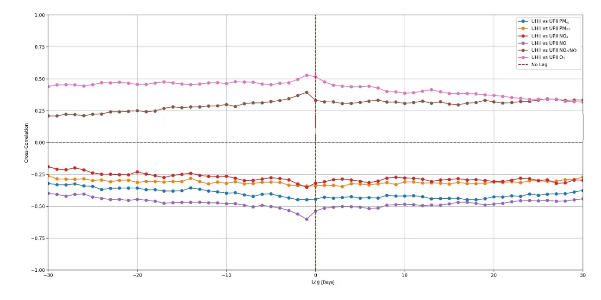
Figure S1: Lag-correlation analysis between UHII and the UPII components over a ±30-day time window. Each curve represents the cross-correlation for a specific pollutant, while the vertical dashed red line marks the zero-lag position.

Table S1: Descriptive statistics of UHII and UPII time series. The statistical indicators related to UHII are expressed in °C, those related to UPII for PM₁₀, PM_{2.5}, NO₂, NO, and O₃ are expressed in µg/m³, while the NO₂/NO ratio is dimensionless. Note that statistics for UPII are calculated as 24-hour daily averages, while for UHII time series refer to the 22:00–06:00 CET time window.
Variable | Mean | Standard deviation | Minimum | Maximum | 25th percentile | Median | 75th percentile
UHII | 2.0 | 1.0 | -2.5 | 5.0 | 1.4 | 2.0 | 2.6
UPII PM₁₀ | 5.6 | 7.2 | -17.8 | 62.0 | 1.1 | 4.5 | 9.0
UPII PM_{2.5} | 2.3 | 3.8 | -18.2 | 38.0 | 0.2 | 1.8 | 4.0
UPII NO₂ | 27.3 | 9.6 | -3.9 | 61.4 | 20.4 | 26.3 | 33.3
UPII NO | 18.8 | 20.2 | -81.1 | 140.0 | 6.0 | 11.0 | 24.3
UPII NO₂/NO | 0.3 | 4.8 | -26.0 | 13.7 | -2.4 | 1.2 | 3.8
UPII O₃ | -16.6 | 14.1 | -99.0 | 29.9 | -25.1 | -16.2 | -6.8

