Supplementary material:
Supplementary tables:
Supplementary Table (a). Women with and without fractures: continuous variables.
 | Without Fractures |  |  | With Fractures |  |  | P Value
 | N | Mean | Std. Deviation | N | Mean | Std. Deviation
Age | 67 | 49.58 | 12.24 | 40 | 52.60 | 10.34 | 0.298
Body Weight (kg) | 63 | 65.62 | 13.81 | 40 | 68.40 | 13.46 | 0.277
MELD score | 66 | 15.0 | 9.9 | 40 | 16.5 | 9.5 | 0.457
GOT | 60 | 89.08 | 109.12 | 39 | 103.77 | 223.65 | 0.895
GPT | 60 | 62.45 | 104.62 | 40 | 88.33 | 311.26 | 0.683
Total Bilirubin | 60 | 5.08 | 6.84 | 40 | 6.51 | 7.63 | 0.125
GGT | 59 | 63.90 | 49.48 | 40 | 57.50 | 68.06 | 0.188
ALP | 59 | 230.37 | 144.50 | 39 | 253.92 | 202.20 | 0.890
Urea | 58 | 27.26 | 17.67 | 38 | 25.64 | 18.86 | 0.589
Creatinine | 60 | 0.78 | 0.23 | 40 | 1.29 | 2.34 | 0.493
Blood glucose | 57 | 95.91 | 41.15 | 38 | 82.55 | 15.50 | 0.199
Albumin | 59 | 3.52 | 0.63 | 39 | 3.44 | 0.61 | 0.443
INR | 59 | 1.74 | 0.81 | 40 | 1.80 | 1.35 | 0.620
Platelet Count | 60 | 109.12 | 98.26 | 40 | 130.24 | 148.15 | 0.335
White blood cell | 60 | 4.75 | 3.26 | 39 | 5.55 | 4.07 | 0.176
Hemoglobin | 60 | 10.99 | 1.80 | 40 | 10.74 | 1.71 | 0.497
Lumbar BMD | 4 | 0.73 | 0.11 | 9 | 0.88 | 0.15 | 0.089
Lumbar T-score | 4 | -2.98 | 1.03 | 9 | -1.78 | 1.20 | 0.122
Lumbar Z-score | 4 | -1.93 | 0.48 | 8 | -0.88 | 1.33 | 0.172
Femur Neck BMD | 4 | 0.61 | 0.14 | 8 | 0.70 | 0.11 | 0.308
Femur Neck T-score | 4 | -2.18 | 1.28 | 8 | -1.48 | 0.93 | 0.396
Femur Neck Z-score | 4 | -1.20 | 0.85 | 8 | -0.69 | 0.91 | 0.393
Total Hip BMD | 4 | 0.76 | 0.14 | 7 | 0.85 | 0.19 | 0.571
Total Hip T-score | 4 | -1.78 | 0.62 | 7 | -1.17 | 1.39 | 0.506
Total Hip Z-score | 4 | -1.03 | 0.67 | 7 | -0.60 | 1.37 | 0.850
PTH [pg/mL] | 5 | 63.60 | 51.09 | 3 | 26.00 | 5.20 | 0.050
Calcium [mg/dl] | 59 | 8.82 | 0.53 | 39 | 9.01 | 0.81 | 0.295
Phosphate [mg/dL] | 51 | 3.01 | 0.81 | 31 | 3.25 | 0.65 | 0.185
Magnesium [mg/dl] | 46 | 1.99 | 0.25 | 30 | 1.90 | 0.36 | 0.158
Urinary Calcium [mg/24h] | 3 | 19.30 | 11.89 | 6 | 3.88 | 5.09 | 0.039
Urinary phosphate [g/24h] | 3 | 2.06 | 2.75 | 6 | 0.59 | 0.33 | 0.796
25OH Vitamin D [ng/mL] | 3 | 13.77 | 13.22 | 3 | 12.57 | 3.65 | 0.513
Bone specific alkaline phosphatase (BSAP) [microg/L] | 1 | 25.30 |  | 1 | 64.30 |  | 0.317
Estimated GFR | 61 | 84.59 | 22.32 | 38 | 73.35 | 27.77 | 0.038
Serum Creatinine | 60 | 0.78 | 0.27 | 38 | 1.11 | 1.10 | 0.156
BMI | 57 | 25.23 | 4.50 | 39 | 26.03 | 4.67 | 0.330

Supplementary Table (b). Women with and without fractures: categorical variables.
Variable | Category | Without Fractures | With Fractures | Total Number | P Value
Ethnicity | White Caucasian | 64 | 39 | 103 | 0.436
 | Other | 1 | 0 | 1
 | Total | 65 | 39 | 104
Arterial Hypertension |  | 9 | 9 | 18 | 0.339
 | Total | 60 | 40 | 100
Child–Pugh | Missing | 14 | 4 | 18 | 0.294
 | A | 13 | 5 | 18
 | B | 21 | 17 | 38
 | C | 19 | 14 | 33
 | Total | 67 | 40 | 107
Alcohol use |  | 7_{a} | 10_{b} | 17 | 0.046
 | Total | 67 | 40 | 107
Smoking |  | 5 | 6 | 11 | 0.214
 | Total | 67 | 40 | 107
Vitamin D3 intake |  | 0 | 1 | 1 | 0.193
 | Total | 67 | 40 | 107
PPI |  | 3 | 6 | 9 | 0.058
 | Total | 67 | 40 | 107
Calcium carbonate supplements |  | 0 | 1 | 1 | 0.193
 | Total | 67 | 40 | 107
Diabetes |  | 9 | 3 | 12 | 0.347
 | Total | 67 | 40 | 107
Corticosteroid use |  | 7 | 7 | 14 | 0.295
 | Total | 67 | 40 | 107
Ascites |  | 35 | 24 | 59 | 0.435
 | Total | 67 | 40 | 107
Encephalopathy |  | 26 | 16 | 42 | 0.903
 | Total | 67 | 40 | 107
Hepatocellular carcinoma |  | 21 | 10 | 31 | 0.484
 | Total | 67 | 40 | 107
GI Hemorrhage |  | 5 | 5 | 10 | 0.386
 | Total | 67 | 40 | 107
Portal thrombosis |  | 8 | 4 | 12 | 0.758
 | Total | 67 | 40 | 107
Etiology | Autoimmune | 6 | 4 | 10 | 0.591
 | Cholestatic | 6 | 5 | 11
 | Viral | 24 | 15 | 39
 | Alcohol | 2 | 4 | 6
 | Cryptogenic/rare | 15 | 6 | 21
 | Multifactorial | 14 | 6 | 20
 | Total | 67 | 40 | 107
Vertebral fractures |  | 0_{a} | 36_{b} | 36 | <0.001
 | Total | 67 | 40 | 107
Genant’s grade | Mild | n.a. | 24 | 24
 | Moderate | n.a. | 6 | 6
 | Severe | n.a. | 6 | 6
 | Total | n.a. | 36 | 36
DXA WHO classification | Normal BMD | 2 | 0 | 2 | 0.042
 | Low BMD/osteopenia | 1_{a} | 7_{b} | 8
 | Osteoporosis | 3 | 2 | 5
 | Total | 6 | 9 | 15

Supplementary Table (c). Men with and without fractures: continuous variables.
 | Without Fractures |  |  | With Fractures |  |  | P Value
 | N | Mean | Std. Deviation | N | Mean | Std. Deviation
Age | 144 | 52.92 | 11.02 | 115 | 53.99 | 8.43 | 0.767
Body Weight (kg) | 144 | 77.13 | 13.62 | 114 | 79.11 | 15.31 | 0.294
MELD score | 144 | 16.1 | 8.1 | 115 | 16.6 | 9.0 | 0.581
GOT | 137 | 83.45 | 60.80 | 109 | 74.47 | 59.96 | 0.166
GPT | 136 | 73.76 | 150.23 | 110 | 52.82 | 48.49 | 0.027
Total Bilirubin | 138 | 5.53 | 7.37 | 110 | 7.52 | 19.56 | 0.615
GGT | 136 | 85.56 | 78.52 | 109 | 87.08 | 105.84 | 0.578
ALP | 136 | 227.09 | 159.33 | 110 | 210.51 | 148.28 | 0.263
Urea | 135 | 36.95 | 33.20 | 108 | 35.50 | 33.25 | 0.815
Creatinine | 138 | 1.34 | 2.86 | 110 | 1.01 | 0.61 | 0.559
Blood glucose | 136 | 111.28 | 47.11 | 109 | 99.51 | 30.28 | 0.142
Albumin | 136 | 3.47 | 0.70 | 106 | 3.57 | 0.63 | 0.171
INR | 137 | 1.56 | 0.43 | 109 | 1.55 | 0.41 | 0.684
Platelet Count | 138 | 94.30 | 82.67 | 110 | 89.26 | 65.49 | 0.975
White blood cell | 136 | 5.49 | 3.94 | 110 | 4.80 | 2.25 | 0.323
Hemoglobin | 136 | 11.85 | 2.10 | 110 | 11.34 | 2.14 | 0.094
Lumbar BMD | 15 | 0.93 | 0.09 | 12 | 0.84 | 0.13 | 0.054
Lumbar T-score | 15 | -1.51 | 0.85 | 12 | -2.28 | 1.22 | 0.053
Lumbar Z-score | 15 | -1.12 | 0.92 | 12 | -1.82 | 1.18 | 0.071
Femur Neck BMD | 14 | 0.79 | 0.12 | 14 | 0.71 | 0.14 | 0.089
Femur Neck T-score | 14 | -1.11 | 0.89 | 14 | -1.63 | 0.89 | 0.160
Femur Neck Z-score | 14 | -0.29 | 0.91 | 14 | -0.82 | 0.93 | 0.135
Total Hip BMD | 15 | 0.97 | 0.14 | 14 | 0.89 | 0.18 | 0.097
Total Hip T-score | 15 | -0.42 | 0.92 | 14 | -1.04 | 1.03 | 0.066
Total Hip Z-score | 15 | -0.09 | 0.94 | 14 | -0.65 | 1.03 | 0.084
PTH [pg/mL] | 12 | 76.00 | 106.57 | 7 | 35.43 | 23.89 | 0.612
Calcium [mg/dl] | 131 | 8.79 | 0.61 | 110 | 8.85 | 0.64 | 0.567
Phosphate [mg/dL] | 107 | 3.14 | 0.73 | 92 | 3.09 | 0.68 | 0.544
Magnesium [mg/dl] | 97 | 1.91 | 0.26 | 92 | 1.99 | 0.33 | 0.142
Urinary Calcium [mg/24h] | 8 | 4.76 | 3.63 | 15 | 8.06 | 7.73 | 0.478
Urinary phosphate [g/24h] | 6 | 0.59 | 0.25 | 13 | 0.67 | 0.28 | 0.599
25OH Vitamin D [ng/mL] | 15 | 17.49 | 7.79 | 15 | 12.61 | 6.59 | 0.042
Bone specific alkaline phosphatase (BSAP) [microg/L] | 1 | 19.10 |  | 6 | 31.65 | 9.62 | 0.134
Albumin [g/dl] | 113 | 3.45 | 0.67 | 93 | 3.65 | 0.75 | 0.159
eGFR | 135 | 87.95 | 30.57 | 109 | 84.50 | 25.88 | 0.310
Serum Creatinine | 135 | 1.14 | 0.98 | 109 | 1.09 | 0.65 | 0.202
BMI | 137 | 25.25 | 3.55 | 109 | 25.99 | 4.02 | 0.113

Supplementary Table (d). Men with and without fractures: categorical variables.
Variable |  | Without Fractures | With Fractures | Total | P Value
Ethnicity | White Caucasian | 139 | 115 | 254 | 0.514
 | Other | 4 | 0 | 4
 | Total | 143 | 115 | 258
Arterial Hypertension |  | 34 | 21 | 55 | 0.317
 | Total | 137 | 108 | 245
Child–Pugh | Missing | 16 | 11 | 27 | 0.975
 | A | 31 | 24 | 55
 | B | 38 | 32 | 70
 | C | 59 | 48 | 107
 | Total | 144 | 115 | 259
Alcohol use |  | 55 | 46 | 101 | 0.767
 |  | 144 | 115 | 259
Smoking |  | 41 | 28 | 69 | 0.456
 | Total | 144 | 115 | 259
Vitamin D3 intake |  | 6 | 7 | 13 | 0.482
 | Total | 144 | 115 | 259
PPI |  | 31 | 23 | 54 | 0.764
 | Total | 144 | 115 | 259
Calcium carbonate supplements |  | 5 | 1 | 6 | 0.167
 | Total | 144 | 115 | 259
Diabetes |  | 47 | 29 | 76 | 0.192
 | Total | 144 | 115 | 259
Corticosteroids |  | 9 | 7 | 16 | 0.957
 | Total | 144 | 115 | 259
Ascites |  | 77 | 65 | 142 | 0.624
 | Total | 144 | 115 | 259
Encephalopathy |  | 57 | 40 | 97 | 0.428
 | Total | 144 | 115 | 259
Hepatocellular carcinoma |  | 63 | 55 | 118 | 0.513
 | Total | 144 | 115 | 259
GI Hemorrhage |  | 20 | 8 | 28 | 0.074
 | Total | 144 | 115 | 259
Portal thrombosis |  | 19 | 10 | 29 | 0.254
 | Total | 144 | 115 | 259
Etiology | Autoimmune Hepatitis | 2 | 0 | 2 | 0.698
 | Cholestatic disease | 4 | 7 | 11
 | Viral | 58 | 47 | 105
 | MASH | 1 | 1 | 2
 | Alcoholic | 19 | 17 | 36
 | Cryptogenic/Rare disease | 16 | 13 | 29
 | Multifactorial | 44 | 30 | 74
Vertebral fractures |  | 0_{a} | 109_{b} | 109 | <0.001
 | Total | 144 | 115 | 259
Genant’s grade | Mild | n.a. | 66 | 66 | n.a.
 | Moderate | n.a. | 37 | 37
 | Severe | n.a. | 6 | 6
 | Total |  | 109 | 109
DXA WHO classification | Normal BMD | 3_{a} | 2_{a} | 5 | 0.212
 | Low BMD/osteopenia | 8_{a} | 4_{a} | 12
 | Osteoporosis | 3_{a} | 7_{a} | 10
 | Total | 14 | 13 | 27

Supplementary Table e. Effect of corticosteroid exposure.
 |  | No Corticosteroids  N=336 | Corticosteroid use  N=30 | Total Number  N=366 | P Value
Fragility Fractures |  | 141 | 14 | 155 | 0.617
 | Total | 336 | 30 | 366
Etiology | Autoimmune Hepatitis | 2_{a} | 10_{b} | 12 | <0.001
 | Cholestatic disease | 10_{a} | 12_{b} | 22
 | Viral | 142_{a} | 2_{b} | 144
 | MASH | 2 | 0 | 2
 | Alcoholic | 40 | 2 | 42
 | Cryptogenic/Rare disease | 48 | 2 | 50
 | Multifactorial | 92_{a} | 2_{b} | 94
 | Total | 336 | 30 | 366
Vertebral Fractures |  | 132 | 13 | 145 | 0.664
 | Total | 336 | 30 | 366
DXA WHO classification | Normal BMD | 6 | 1 | 7 | 0.940
 | Low BMD/osteopenia | 16 | 4 | 20
 | Osteoporosis | 12 | 3 | 15
 | Total | 34 | 8 | 42
Subscript a and b within the same variable express P<0.05.

Supplementary Table f. Effect of diabetes on fracture risk.
 |  | No diabetes  N=278 | Diabetes  N=88 | Total  N=366 | P value
Fragility Fractures |  | 123 | 32 | 155 | 0.192
 | Total | 278 | 88 | 366
Etiology | Autoimmune Hepatitis | 10 | 2 | 12 | 0.015
 | Cholestatic disease | 21_{a} | 1_{b} | 22
 | Viral | 101_{a} | 43_{b} | 144
 | MASH | 2 | 0 | 2
 | Alcoholic | 26_{a} | 16_{b} | 42
 | Cryptogenic/Rare disease | 42 | 8 | 50
 | Multifactorial | 76 | 18 | 94
 | Total | 278 | 88 | 366
Vertebral fractures |  | 117 | 28 | 145 | 0.086
 | Total | 278 | 88 | 366
Genant’s vertebral fracture grade | Mild | 72 | 18 | 90 | 0.767
 | Moderate | 36 | 7 | 43
 | Severe | 9 | 3 | 12
 | Total | 117 | 28 | 145
DXA WHO classification | Normal BMD | 5 | 2 | 7 | 0.666
 | Low BMD/osteopenia | 16 | 4 | 20
 | Osteoporosis | 10 | 5 | 15
 | Total | 31 | 11 | 42
Subscript _{a} and _{b} within the same variable express P<0.05.

Supplementary figures
Figure S1. Flowchart of the patient selection process.
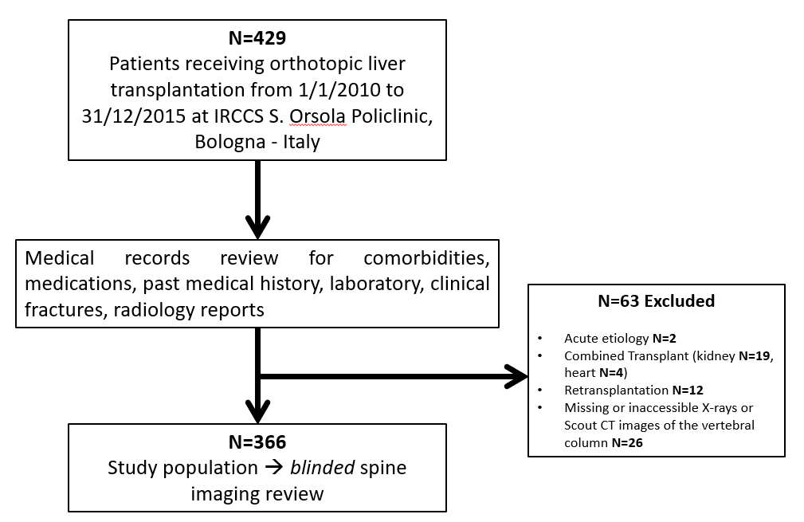

Figure S2. Percentage of fractured patients for each calendar year of the study period (P=0.639 for comparison).
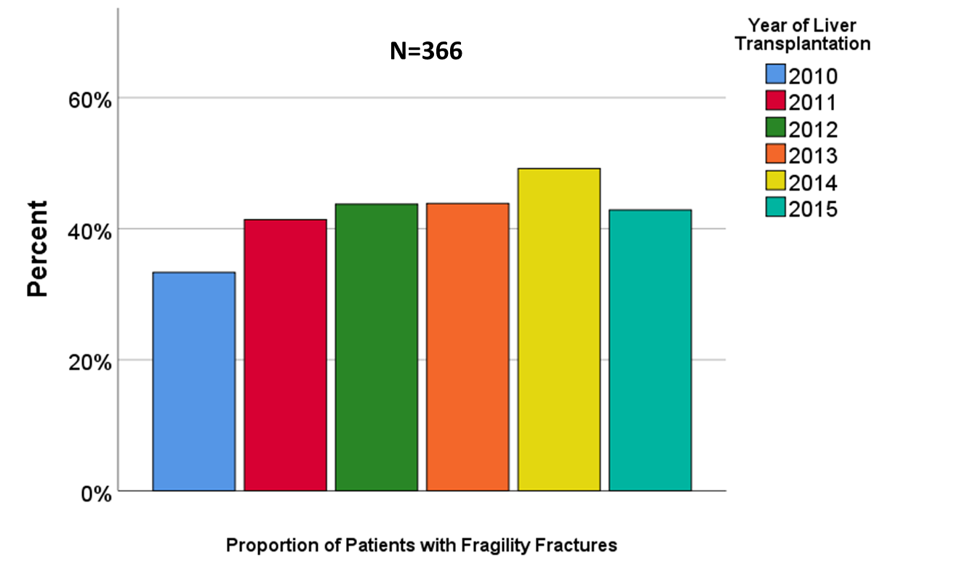
Figure S3. Percentage of fractured patients in each liver disease etiology (P=0.698).
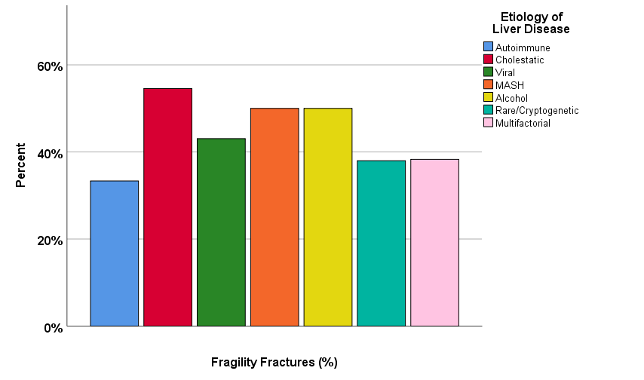

Figure S4. Types of vertebral fractures.

