Supplementary information 1

Extended details on sampled boreholes

Table S1: Summary of boreholes coordinates and drilling details

Figure S1: Representative macroscopic samples and photomicrographs

Figure S2: enclaves and xenoliths

Figure S3: thin section scans of 219/2007.0 gabbroic enclave

Figure S4: major elements

Figure S5a-c: trace elements

Figure S6: ¹⁴³Nd/¹⁴⁴Nd vs. Nd (ppm)

Figure S7: Sills major and trace elements compositional profiles

Figure S8: petrography and element profile for slash-shaped sills

Figure S9: Nb/Y and Zr/Y diagram (Fitton et al. 1997)

Figure S10: assimilants

Figure S11: Nb/La vs. Ba/La

Table S2: Total thicknesses (geochemical magma types and correlations)

Extended details on sampled boreholes
Nizhneimbakskaya 219
Borehole 219 is located at the western limit of the area covered by the Siberian Traps, ca. 630 km south of Noril’sk (63.65303 N, 88.24556 E) and at the western edge of the Lower Tunguska Basin. The Siberian Traps activity in the area is only preserved as sills, and the closest pipes (with magnetite) are reported ca. 100 km to the east. Borehole 219 reaches a depth of 4000 m and intercepted five thick sills (from 60m to 215m thick). Core samples are available from the two deepest sills, emplaced from 1915 to 2050m and from 3805 to 3960 m (called hereinafter 219D and 219E, respectively), and cuttings from sills B and C. The shallowest sill (samples not available) is emplaced in terrigenous Devonian sedimentary rocks (sandstone/siltstone) at 40 to 100 m depth, whereas the others are emplaced in Cambrian strata with marl-, halite- and evaporite/dolostone-dominated rocks.

Zheldonskaya 260
Borehole 260 is located within the southern portion of the Siberian Traps area (57.67583 N, 103.50472 E), 200 km northeast of the city of Bratsk. This borehole reaches a depth of 4509 m and is located in an area with a large number (and the largest density) of breccia pipes (mostly to the west of the borehole location) and pipes with magnetite ore (mostly to the east of the borehole location; Svensen et al. 2018). Borehole 260 intercepted two fairly thin sills (21 m and 86 m thick) emplaced from 2209 and 2230 m (260A) and from 3001 to 3095 m depth (260B). The top part of the sill 260B presents brecciated glass and septs of limestone. Both sills are emplaced in Cambrian strata: the shallowest emplaced within evaporite/dolostone-dominated rocks, and the deepest emplaced at the boundary between evaporite/dolostone- (above) and halite-dominated rocks (below). Three carbonates and one evaporite (anhydrite/halite dominated) were analysed from this borehole as well.

Suringdinskaya 274 and Majgunnskaya 275
Four sills were intercepted by borehole 274 (N 62.22000; E 98.23944); the uppermost is exceptionally thick (ca. 400m thick) and reaches almost to the surface, intruding Permian siltstones. The others are emplaced in marl-dominated and halite-dominated Cambrian sedimentary rocks (Fig.1). Three core samples from the bottom of the 110m thick sill 274C (emplaced from 1695 to 1800 m below the surface) were available, one showing a sharp contact with halite.
Borehole 275 (N 61.36736; E 94.13728) intercepted seven sills intruding Cambrian and Ordovician marl-dominated sediments. Two core samples were available from the roof of the deepest sill (275G, ca.100 m thick, from 2630 to 2825 m below the surface). One of the samples shows the upper contact of the sill with the intruded dolostones.

Verkhneilimpejskaya 277
This borehole was drilled ca. 500 km north of borehole 260, (N 62.10806; E 104.15917) and reaches down to 3000m. The location of 277 is the most central of the STLIP, just south of the southernmost occurrence of lava flows and in an area with abundant pyroclastic deposits and breccia pipes. The borehole intercepted five sills. The shallowest sill (277A, 260-560 m) is also the thickest and it intrudes Ordovician-Carboniferous marls, below the transition to Permian coal-bearing sandstones. Only cuttings are available for this sill, with a complete collection from every five meters down to 350 m, which then interrupts and starts again at 420m. The cuttings recovered immediately above or below the gap are dominated by sedimentary chips, suggesting that sill 277A is in fact a composite intrusion of (at least) two sills separated by sedimentary rocks. Hereinafter the sample numbers are split in 277A1 (the shallow part) and 277A2 (the deep part). Sills B, C and D are emplaced in halite-dominated Cambrian strata, whereas sill E intrudes evaporite/dolostone-dominated Cambrian sediments. The borehole ends within sill E. Cuttings from all the five sills were sampled and analysed, and only one core sample was available, from sill 277D.

Table S1: Summary of boreholes coordinates and drilling details
Well | Nickname | Nº | Eº | Rotor ELV, m | Well depth, m
Nizhneimbakskaya 219 | Lower Imbak 219 | 63.65303 | 88.24556 | 186.9 | 4000
Majgunnskaya 275 | Majgun 275 | 61.36736 | 94.13728 | 475.94 | 3800
Suringdinskaya 274 | Suringda 274 | 62.22000 | 98.23944 | 436.28 | 2679
Zheldonskaya 260 | Zheldon 260 | 57.67583 | 103.50472 | 475 | 4509
Verkhneilimpejskaya 277 | Upper Ilimpeya 277 | 62.10806 | 104.15917 | 450 | 3016

Figure S1: Representative macroscopic samples and photomicrographs
a-b) Core halves of a coarse-grained gabbroic sample (219E-3849.7) and of the contact between dolerite and evaporitic host-rock with halite, anhydrite and carbonate (274C-1797.5). c) Photomicrograph in crossed polars of a dolerite (219D-1976.2) showing a typical ophitic texture with a clinopyroxene oikocryst enclosing olivine and plagioclase. d) Thin section (ca. 2.5 cm width) cut from the same rock as in c). e) Example (sample 277/280) of a 1” epoxy mount employed for imaging and EMP analyses of granular samples. f) Microporphyritic structure of a chilled margin sample, plagioclase and olivine phenocrysts are visible in a quenched matrix of plagioclase, oxide and clinopyroxene microlites (sample 260/3025-3030; electron microprobe BSE image).

Figure S2: enclaves and xenoliths

The coarse-grained enclave (sample 219/2007.0A-B) found in sill 219D is evolved (MgO<4wt% in both the melanocratic and the leucocratic specimens) and plots to the evolved end of the array depicted by the dolerites for most major elements (cf Fig.S2). The two portions differ strongly in some major elements. The melanocratic portion (219/2007.0A) is enriched in K₂O and depleted in CaO, whereas the leucocratic specimen (219/2007.0B) is enriched in Na₂O and P₂O₅ and depleted in CaO, Fe₂O_{3tot} and slightly in MnO (Fig.4b; Fig.S3). Both specimens appear strongly altered, with sericitized plagioclase, and pyroxene substituted by chlorite and amphibole.
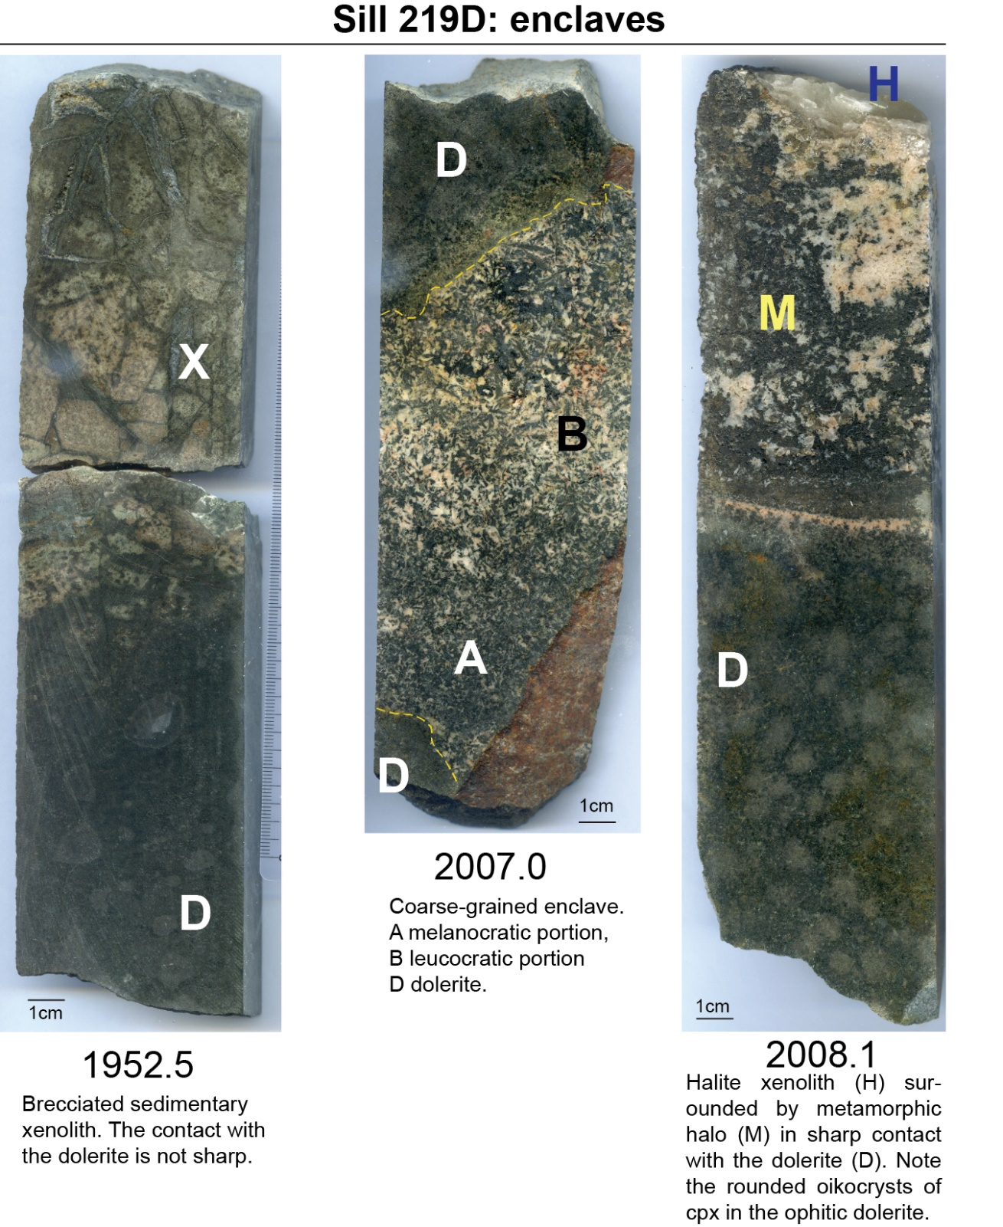

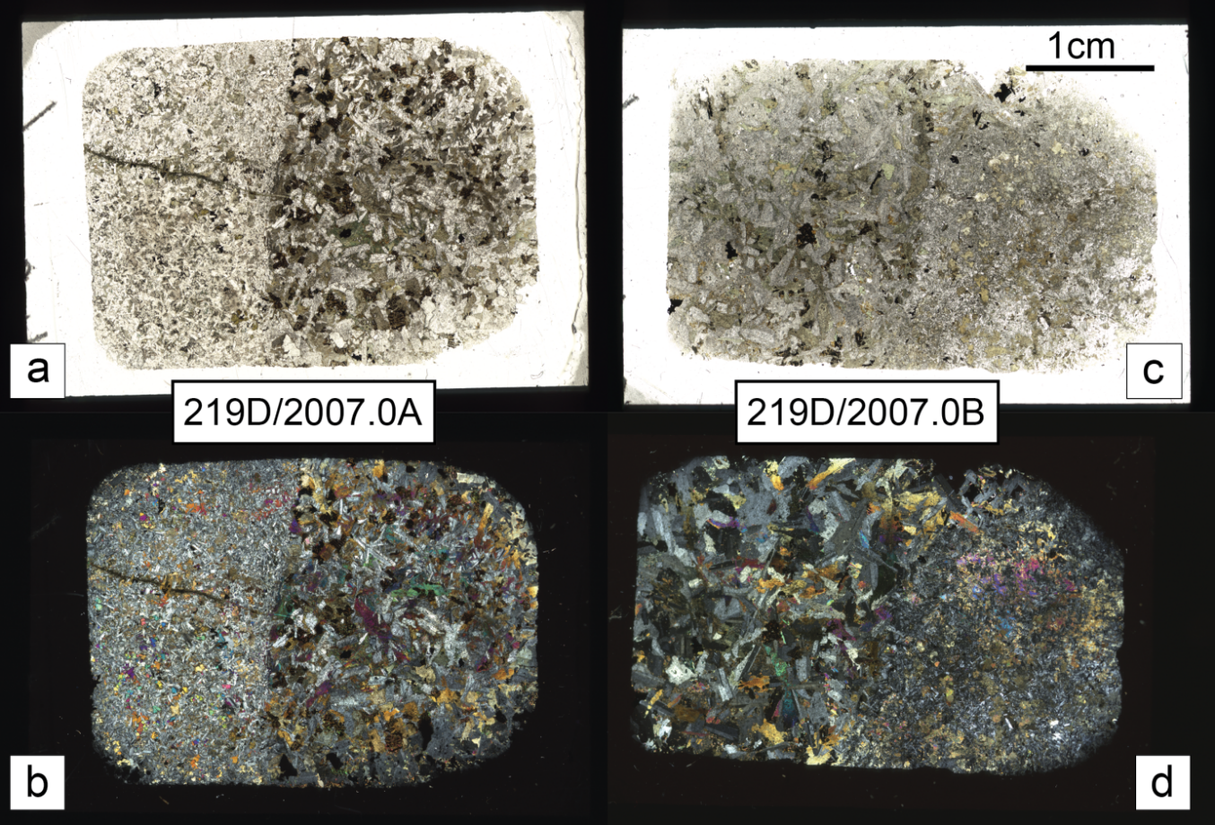
Figure S3: thin section scans of 219/2007.0 gabbroic enclave

Thin section scans of the melanocratic (219/2007.0A; a-b) and leucocratic (219/2007.0B, c-d) specimens of the gabbroic enclave (cf. Fig.S1 for a scan of the hand sample). Note in c cloudy, sericitized plagioclase and K-feldspars. Panels a and c in parallel polars, b and d in crossed polars.

Figure S4: major elements
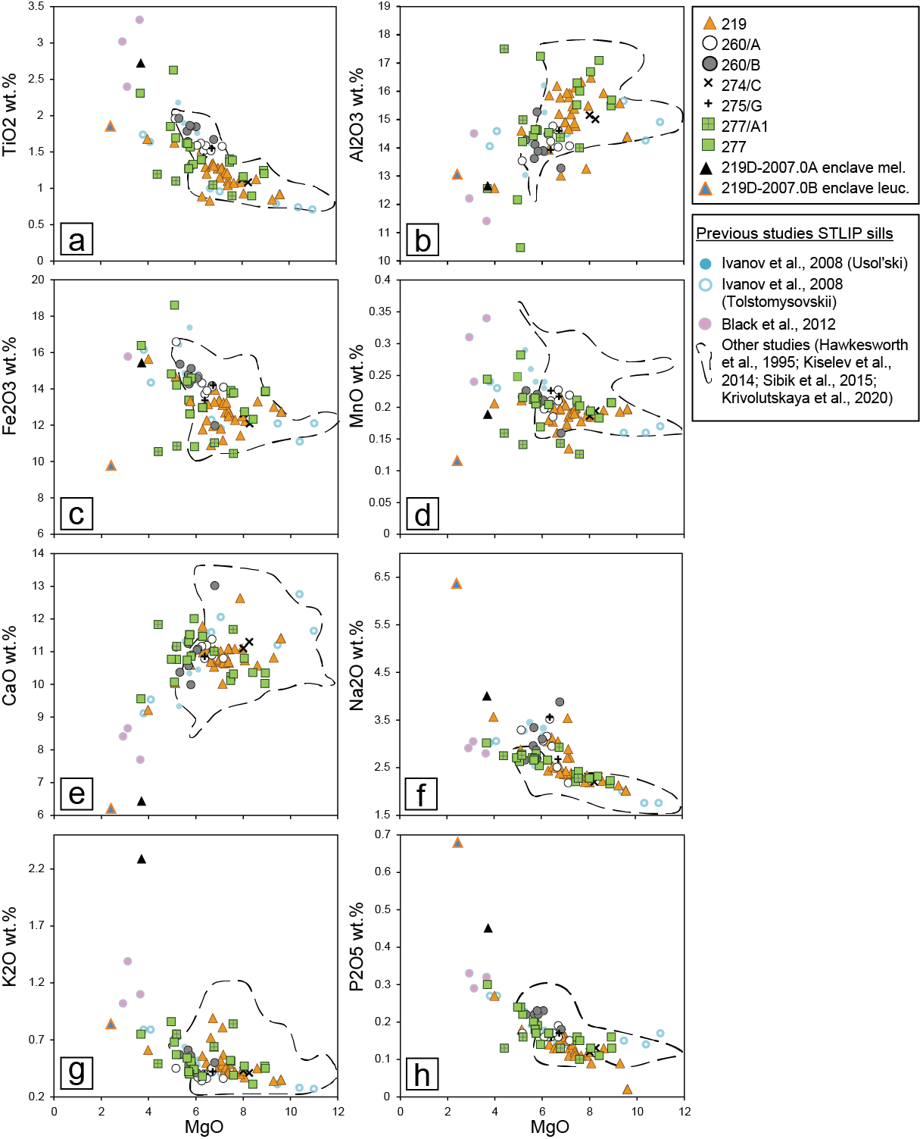

Figure S5a: trace elements for Nizhneimbakskaya 219
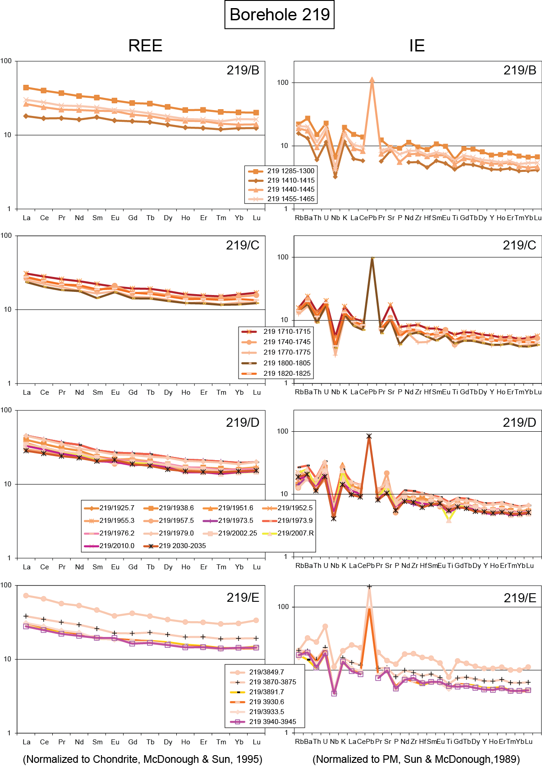

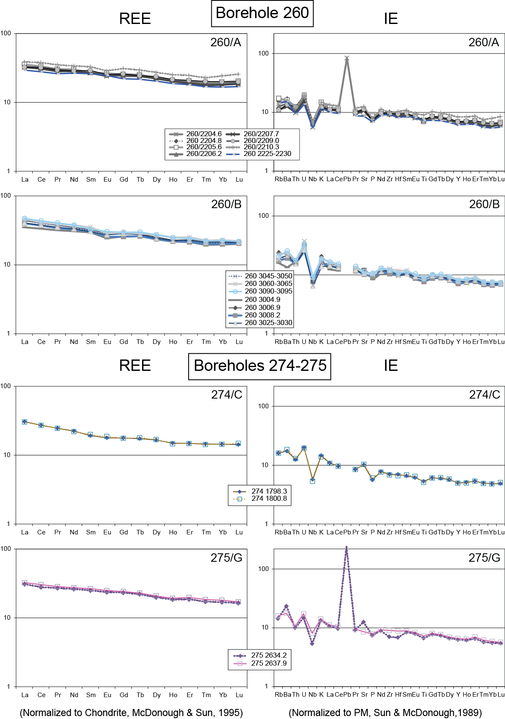
Figure S5b: trace elements for Zheldonskaya 260, Suringdinskaya 274 and Majgunnskaya 275

Figure S5c: trace elements for Verkhneilimpejskaya 277
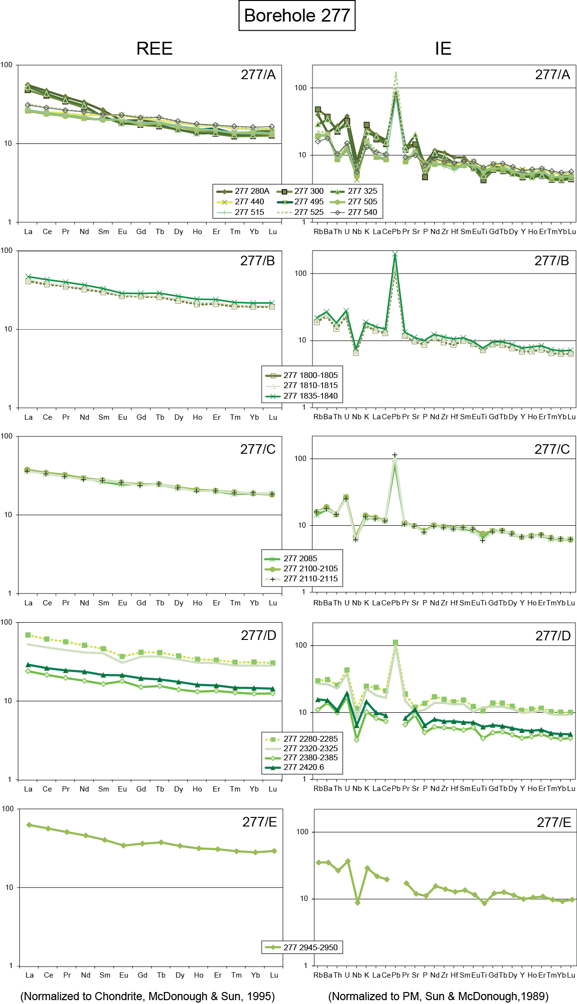

Figure S6: ¹⁴³Nd/¹⁴⁴Nd vs. Nd (ppm)
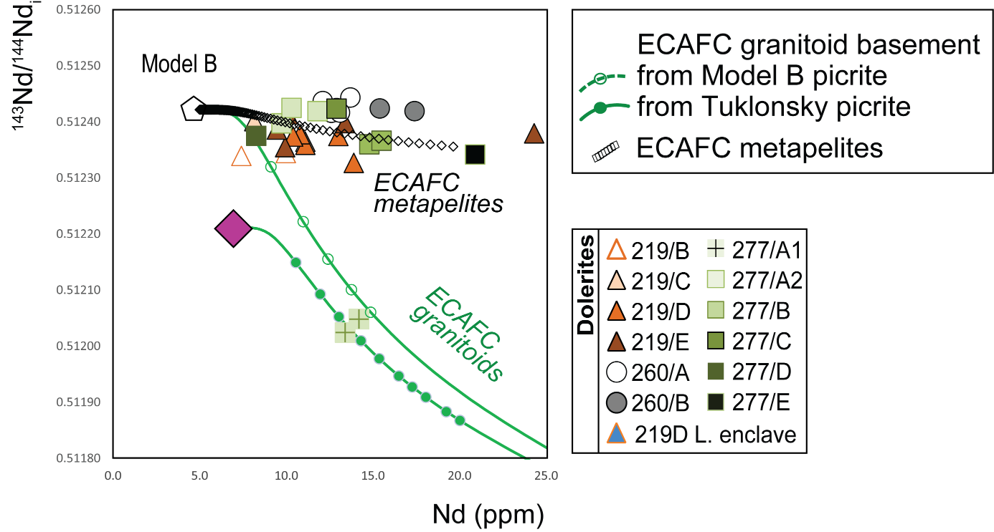

Figure S7: Sills major and trace elements compositional profiles
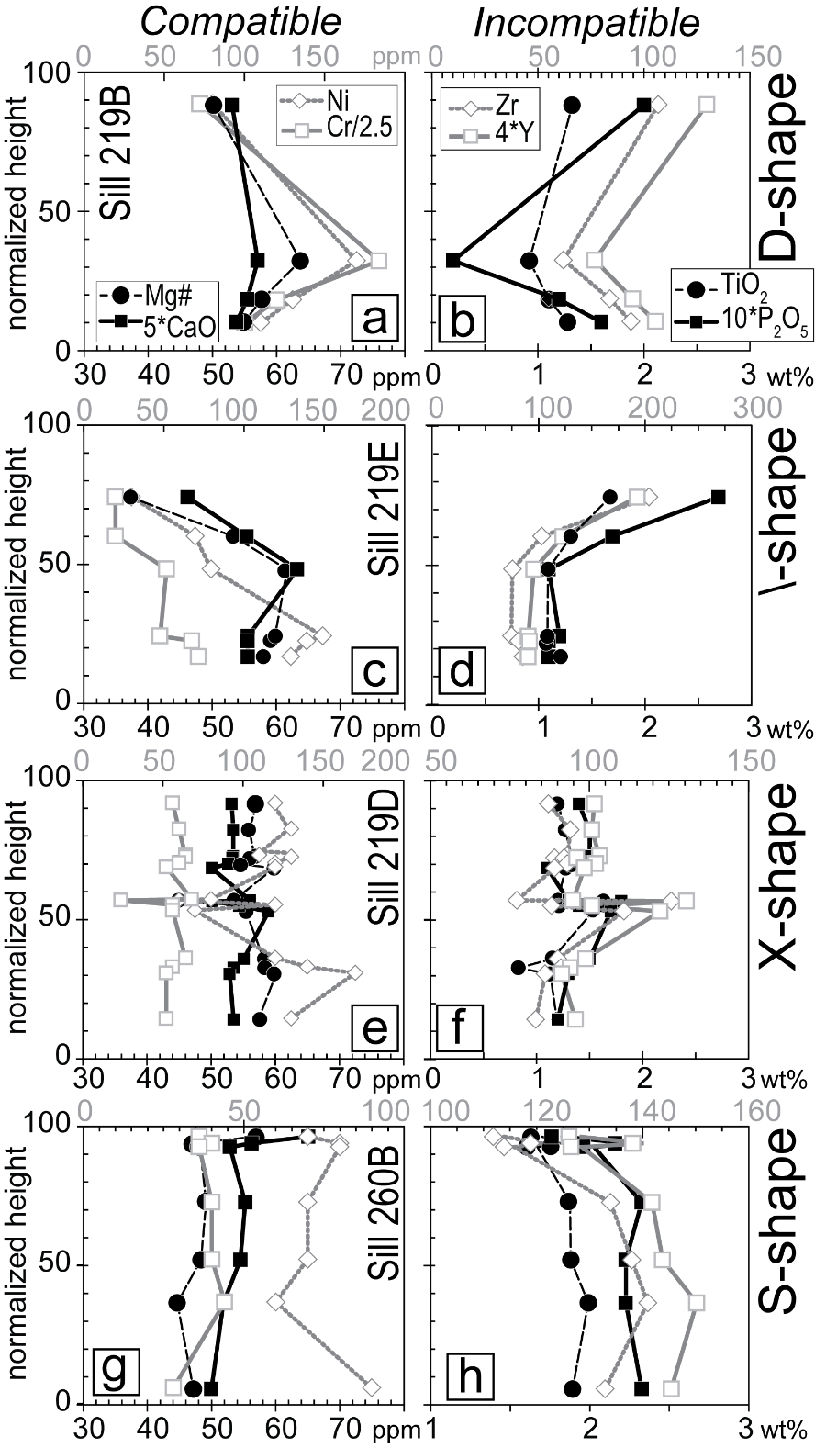

Major and trace element compositional profiles of 4 among the investigated sills. The chemical components are plotted using different scales to ease comparison of the depicted trends: major elements refer to the bottom axes (black numbers), trace elements to the top axes (gray numbers; all in ppm). To simplify the comparison between different sills, the vertical height (and hence the position of the samples) was normalized to 100. The melanocratic and leucocratic coarse-grained enclaves from sill 219D are not included in the profile.

Figure S8: petrography and element profile for slash-shaped sills
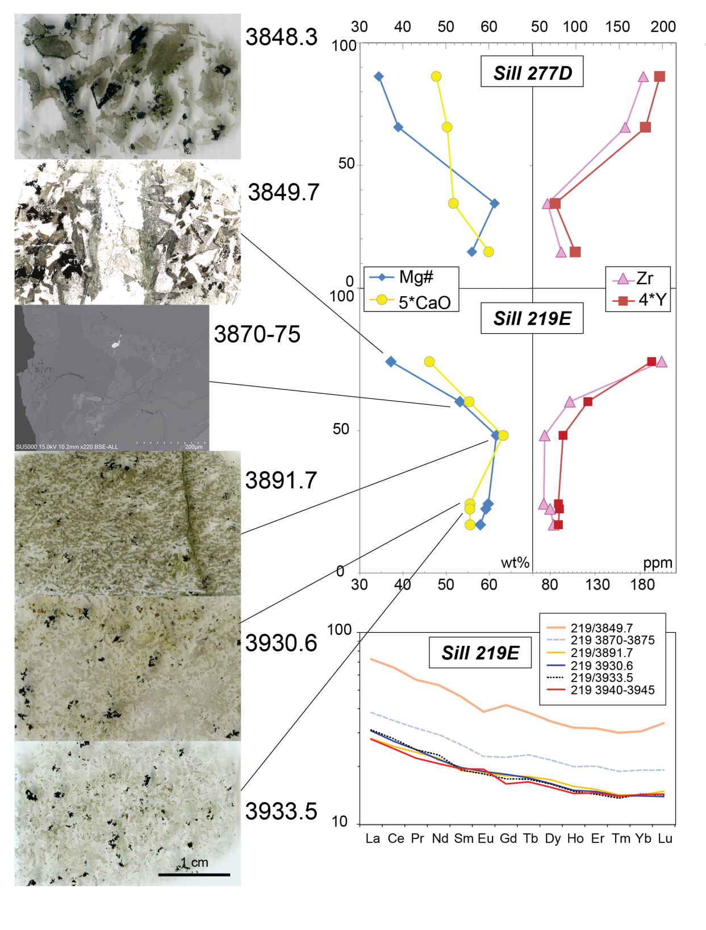
Major (5*CaO wt% and Mg#) and trace element (Zr ppm and 4*Y ppm) compositional profiles for sills 277D and 219E. REE profile (chondrite-normalized; McDonoungh & Sun, 1995) and thin section scans for the samples from 219E are also reported. Sample 3870-75 is a granulate sample, so a BSE image of a late-stage pocket is included instead (note different scale with respect to thin section scans).
Figure S9: Nb/Y and Zr/Y diagram (Fitton et al. 1997)

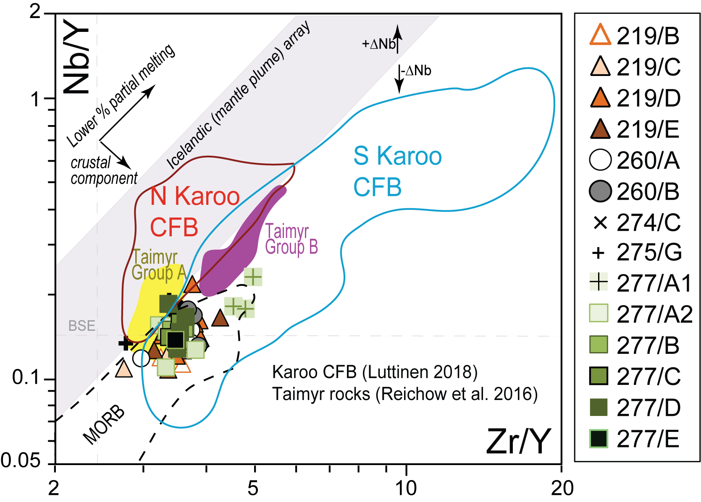

Figure S10: assimilants
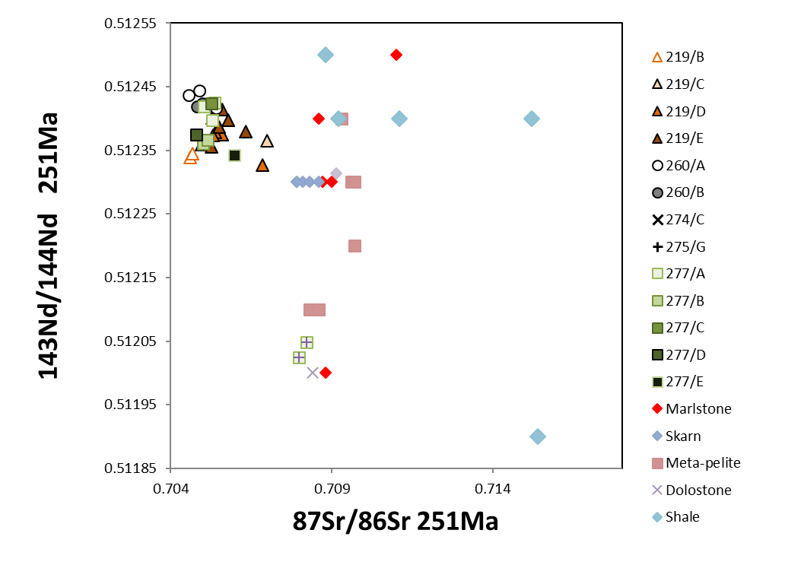 Compositions of considered assimilants from Pang et al. (2013)
We analysed 3 carbonate/dolostones (samples 260/2200, close to sill 260A, and samples 260/2998.45 and 260/3000.3 above sill 260B), and a halite/anhydrite dominated evaporite (260/3001.2) from borehole 260. All have high CaO (29.76 to 42.44 wt%). The three dolostones show high MgO (14.89-17.21 wt%) and very low Na₂O (0.14-0.39 wt%), the opposite for the anhydrite/halite dominated sediment (MgO = 0.62 wt%; Na₂O = 11.96 wt%). Only sample 260/2200 presents relatively high SiO₂ (10.43 wt%), Al₂O₃ (1.75 wt%) and K₂O (1.55 wt%), revealing the presence of a siliciclastic fraction.

Figure S11: Nb/La vs. Ba/La
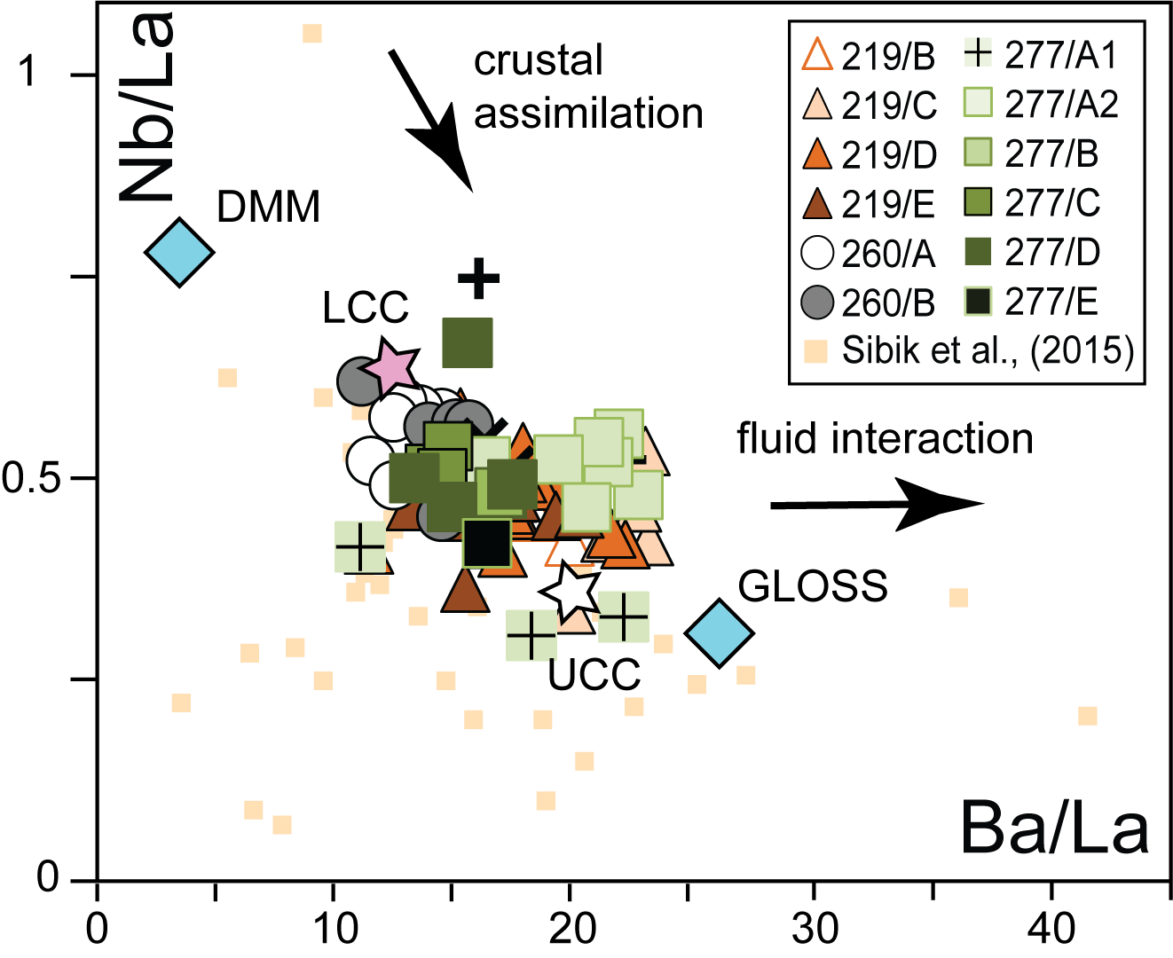

Data from other STLIP sills from Sibik et al. (2015)
LCC and UCC from Rudnick and Gao (2014)
GLOSS composition from Plank and Langmuir (1998)
DMM from Workman and Hart (2005)

Table S2: Total thicknesses (chemical magma types and correlations)

 | Magma type | Correlation | Cumulative thickness (m)
1 | 260B | Usols'kii sill | 97
2 | 260A-275G-277A2 | Upper sequence (Km-Hr-Sm) | 336
3 | 219B | Hr Fm. - Ambarninsky type II intrusives | 215
4 | 219C-E, 274C, 277B-E | Upper sequence (Mr-Mk) + Noril'sk type 5A | 811
5 | 277A1 | Nd Fm. + Talnakh type 5B | 64

Borehole | Magma types | Cumulative dolerite thickness (m)
Nizhneimbakskaya 219 | 3 and 4 (and ?) | 710
Zheldonskaya 260 | 1 and 2 | 107
Suringdinskaya 274 | 4 (and ?) | min 455
Majgunnskaya 275 | 2 (and?) | 478
Verkhneilimpejskaya 277 | 2, 4 and 5 | 707

