Supplementary materials

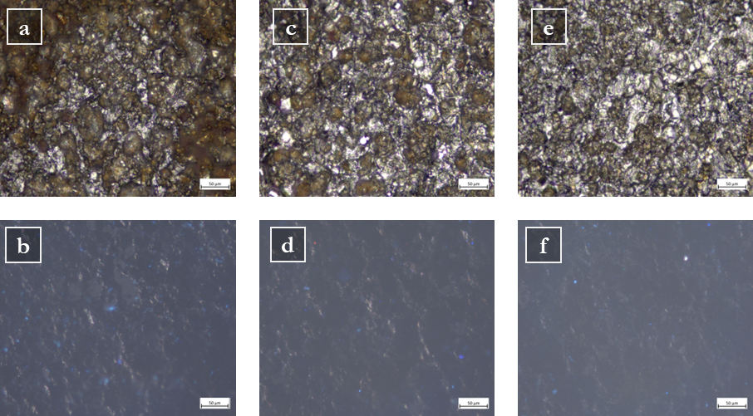
SM-Figure 1 Optical microscope images (20 × original magnification) in bright field (top row) and under UV light (bottom row) of chemically aged mild steel mock-up, coated with Paraloid® B72, after two gel applications of 10 (a, b), 20 (c, d), and 30 (e, f) minutes, respectively. The scale bar indicates 50 µm.

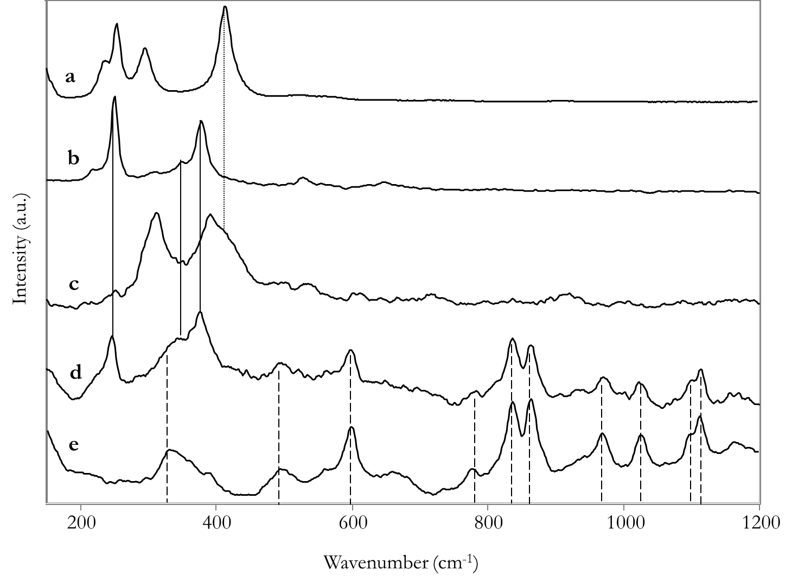
SM-Figure 2 Raman spectra of ferric chloride hexahydrate (a), mild steel mock-up after chemical ageing (b, c), mild steel mock-up after chemical ageing and Paraloid® B72 coating (d), and Paraloid® B72 (e). Raman bands common among the spectra and related to ferric chloride hexahydrate (a), mild steel chemically aged (b), and Paraloid® B72 (e) are highlighted by dotted, solid, and dashed lines, respectively.

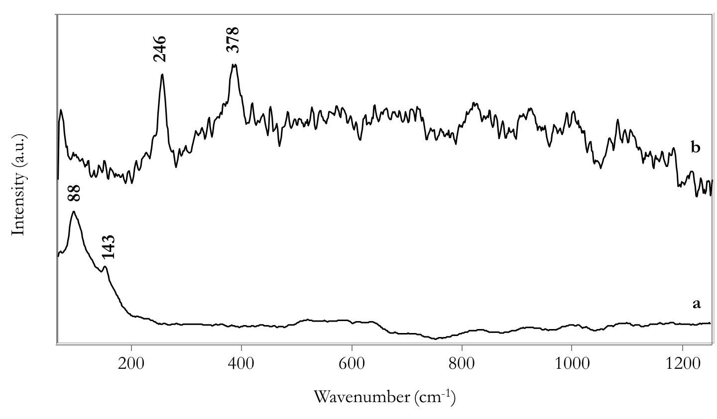

SM-Figure 3 Raman spectra collected from chemically aged mild steel mock-ups, coated with Paraloid® B72, after cleaning. Typical signals related to lattice vibrations (i.e., bare steel) (a) and remaining iron oxyhydroxides (i.e., lepidocrocite) (b) are reported in the figure.

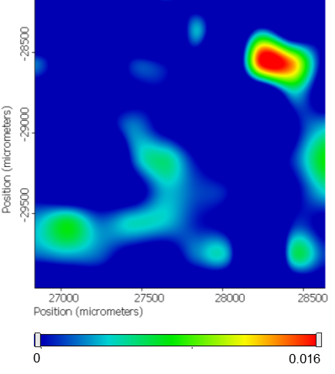 | 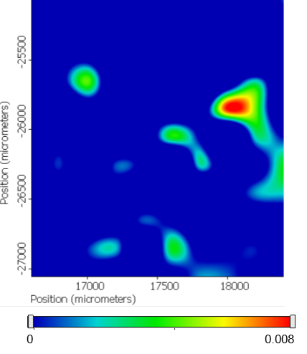
(a) | (b)
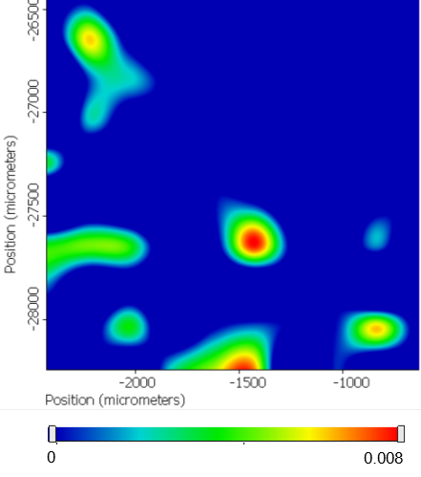
(c)

SM-Figure 4 FTIR chemigram maps collected in reflectance mode on the surface of mock-ups after 10- (a), 20- (b), and 30-minute (c) cleaning protocols. Resulting maps when considering the FTIR signal at 1045 cm⁻¹ related to both DFO and iron-DFO complexes. Absorbance scale bar reports values from min (blue) to max (red).

