Supplementary Materials
Table S1. Univariable and multivariable analyses of Cohort 1 and 2.
Overall Survival (Overall population) | Univariable Cox Regression |  | Multivariable Cox Regression
Overall Survival (Overall population) | HR (95%CI) | p-value | HR (95%CI) | p-value
Sex (females vs males) | 1.27 (0.91−1.53) | 0.141
Age ≥70y (Y vs N) | 1.05 (0.89−1.29) | 0.359
BMI (> 25 vs ≤ 25 kg/m²) | 0.65 (0.38−0.93) | 0.004 | 0.69 (0.54−0.88) | 0.001
Smokers vs no-smokers | 0.89 (0.73−1.14) | 0.221
ECOG PS (≥ 2 vs 0-1) | 2.95 (2.40−4.12) | <0.001 | 2.91 (2.20−3.67) | <0.001
Histology (pure UC vs variants) | 0.91 (0.71−1.31) | 0.545
Upper vs Lower urinary tract | 1.00 (0.81−1.32) | 0.759
Synchronous metastatic disease (Y vs N) | 1.30 (1.01−1.59) | 0.019 | 1.20 (1.02−1.39) | 0.022
Lymph node (Y vs N) | 0.86 (0.70−1.13) | 0.145
Lung metastases (Y vs N) | 1.22 (1.02−1.33) | 0.031 | 1.08 (0.98−1.32) | 0.269
Bone metastases (Y vs N) | 1.50 (1.19−1.99) | <0.001 | 1.43 (1.20-1.65) | <0.001
Liver metastases (Y vs N) | 1.85 (1.41−2.90) | < 0.001 | 1.55 (1.18-2.05) | <0.001
Brain metastases (Y vs N) | 2.82 (1.76−4.51) | <0.001 | 2.84 (1.76-4.58) | <0.001
Type of immunotherapy (pembrolizumab vs avelumab) | 1.45 (0.98−1.97) | 0.101
Propensity Score | 0.95 (0.91−1.01) | 0.122
BMI = Body Mass Index; ECOG-PS = Eastern Cooperative Oncology Group-Performance Status; Y = yes; N = no

Table S2. Univariable and multivariable analyses of Cohort 1.
Overall Survival (Overall population) | Univariable Cox Regression |  | Multivariable Cox Regression
Overall Survival (Overall population) | HR (95%CI) | p-value | HR (95%CI) | p-value
Sex (females vs males) | 1.12 (0.95−1.32) | 0.173
Age ≥70y (Y vs N) | 1.08 (0.93−1.26) | 0.286
BMI (> 25 vs ≤ 25 kg/m²) | 0.80 (0.68−0.93) | 0.005 | 0.79 (0.67−0.92) | 0.002
Smokers vs no-smokers | 0.88 (0.76−1.02) | 0.010
ECOG PS (≥ 2 vs 0-1) | 2.71 (2.20−3.35) | <0.001 | 2.94 (2.36−3.66) | <0.001
Histology (pure UC vs variants) | 0.91 (0.76−1.10) | 0.336
Upper vs Lower urinary tract | 0.99 (0.83−1.17) | 0.869
Synchronous metastatic disease (Y vs N) | 1.27 (1.09−1.48) | 0.002 | 1.25 (1.07−1.47) | 0.006
Lymph node (Y vs N) | 0.86 (0.73−1.01) | 0.064
Lung metastases (Y vs N) | 1.27 (1.08−1.48) | 0.003 | 1.12 (0.96−1.32) | 0.156
Bone metastases (Y vs N) | 1.52 (1.30−1.78) | <0.001 | 1.44 (1.22-1.69) | <0.001
Liver metastases (Y vs N) | 1.75 (1.46−2.09) | < 0.001 | 1.46 (1.21-1.75) | <0.001
Brain metastases (Y vs N) | 2.82 (1.76−4.51) | <0.001 | 2.84 (1.76-4.58) | <0.001
BMI = Body Mass Index; ECOG-PS = Eastern Cooperative Oncology Group-Performance Status; Y = yes; N = no

Table S3. Univariable and multivariable analyses of advanced UC patients with liver metastases from Cohort 1.

Overall Survival (Overall population) | Univariable Cox Regression |  | Multivariable Cox Regression
Overall Survival (Overall population) | HR (95%CI) | p-value | HR (95%CI) | p-value
Sex (females vs males) | 1.39 (0.98−1.97) | 0.066
Age ≥70y (Y vs N) | 1.12 (0.81−1.54) | 0.492
BMI (> 25 vs ≤ 25 kg/m²) | 0.69 (0.50−0.96) | 0.027 | 0.79 (0.68−0.92) | 0.003
Smokers vs no-smokers | 0.90 (0.65−1.25) | 0.536
ECOG PS (≥ 2 vs 0-1) | 2.83 (1.89−4.27) | <0.001 | 2.95 (2.37−3.66) | <0.001
Histology (pure UC vs variants) | 0.98 (0.66−1.46) | 0.935
Upper vs Lower urinary tract | 1.04 (0.74−1.47) | 0.816
Synchronous metastatic disease (Y vs N) | 1.55 (1.12−2.13) | 0.008 | 1.31 (1.12−1.53) | 0.001
Lymph node (Y vs N) | 1.00 (0.72−1.39) | 0.997
Lung metastases (Y vs N) | 1.17 (0.85−1.61) | 0.322
Bone metastases (Y vs N) | 1.45 (1.03−2.02) | 0.031 | 1.41 (1.20-1.67) | <0.001
Brain metastases (Y vs N) | 1.81 (0.84−3.87) | 0.129
BMI = Body Mass Index; ECOG-PS = Eastern Cooperative Oncology Group-Performance Status; Y = yes; N = no

Table S4. Univariable and multivariable analyses of Cohort 2.
Overall Survival (Overall population) | Univariable Cox Regression |  | Multivariable Cox Regression
Overall Survival (Overall population) | HR (95%CI) | p-value | HR (95%CI) | p-value
Sex (females vs males) | 1.44 (0.96−2.15) | 0.081
Age ≥70y (Y vs N) | 0.92 (0.64−1.32) | 0.643
BMI (> 25 vs ≤ 25 kg/m²) | 0.28 (0.19−0.43) | <0.001 | 0.36 (0.24−0.55) | <0.001
Smokers vs no-smokers | 0.91 (0.62−1.32) | 0.605
ECOG PS (≥ 2 vs 0-1) | 3.31 (2.40−4.59) | <0.001 | 2.65 (1.91−3.68) | <0.001
Histology (pure UC vs variants) | 0.92 (0.55−1.54) | 0.757
Upper vs Lower urinary tract | 1.10 (0.75−1.62) | 0.635
Synchronous metastatic disease (Y vs N) | 1.37 (0.95−1.97) | 0.092
Lymph node (Y vs N) | 0.87 (0.60−1.28) | 0.487
Lung metastases (Y vs N) | 1.20 (0.84−1.73) | 0.318
Bone metastases (Y vs N) | 1.44 (0.96−2.15) | 0.075
Liver metastases (Y vs N) | 2.07 (1.32−3.23) | 0.001 | 1.69 (1.07-2.68) | 0.025
BMI = Body Mass Index; ECOG-PS = Eastern Cooperative Oncology Group-Performance Status; Y = yes; N = no

Table S5. Univariable and multivariable analyses of advanced UC patients with liver metastases from Cohort 2.

Overall Survival (Overall population) | Univariable Cox Regression |  | Multivariable Cox Regression
Overall Survival (Overall population) | HR (95%CI) | p-value | HR (95%CI) | p-value
Sex (females vs males) | 0.61 (0.23−1.62) | 0.316
Age ≥70y (Y vs N) | 0.91 (0.41−2.04) | 0.826
BMI (> 25 vs ≤ 25 kg/m²) | 0.27 (0.09−0.80) | 0.018 | 0.38 (0.13−1.13) | 0.081
Smokers vs no-smokers | 2.13 (0.91−4.97) | 0.080
ECOG PS (≥ 2 vs 0-1) | 3.57 (1.88−6.81) | <0.001 | 3.11 (1.62−5.96) | <0.001
Histology (pure UC vs variants) | 0.87 (0.30−2.55) | 0.797
Upper vs Lower urinary tract | 0.27 (0.06−1.15) | 0.077
Synchronous metastatic disease (Y vs N) | 1.38 (0.61−3.14) | 0.443
Lymph node (Y vs N) | 1.21 (0.52−2.83) | 0.626
Lung metastases (Y vs N) | 1.17 (0.50−2.74) | 0.714
Bone metastases (Y vs N) | 1.24 (0.52−2.99) | 0.626
BMI = Body Mass Index; ECOG-PS = Eastern Cooperative Oncology Group-Performance Status; Y = yes; N = no

Figure S1. Selection process from the ARON-2 dataset.
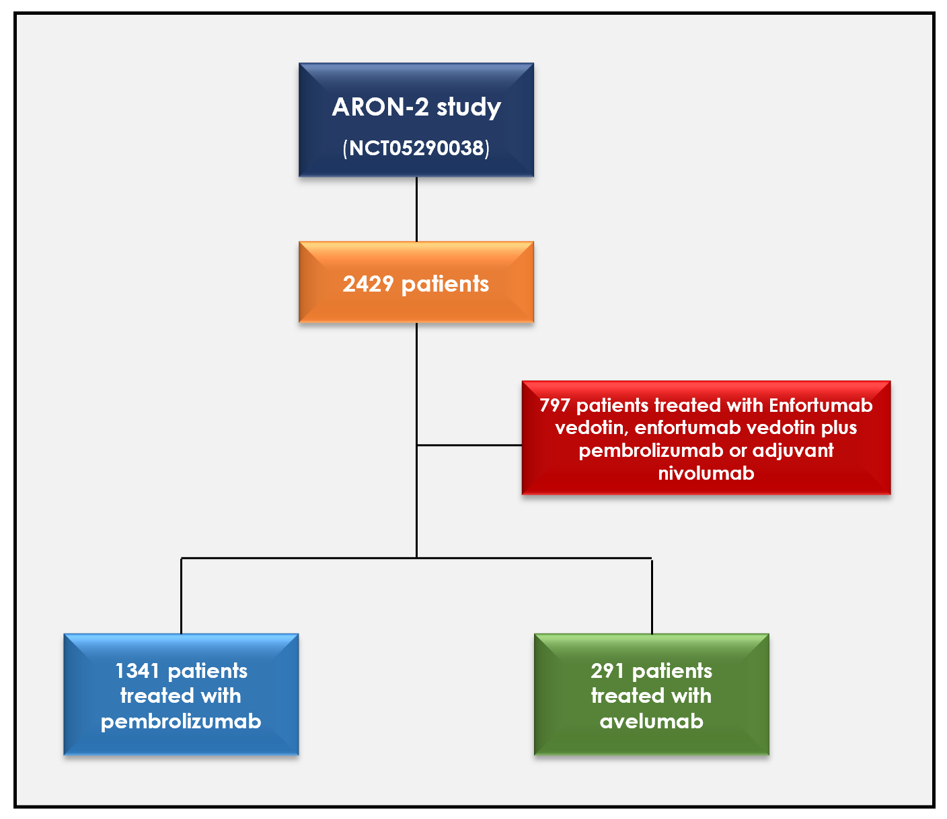

Figure S2. Map of Countries participating to the ARON-2 Study.

