Supplementary Information
Elucidating the Composition and Formation Mechanism of Slippery Films from Block Copolymers on Doped DLC Surfaces
Takeru Omiya^{1, 2, 3*}, Enrico Pedretti⁴, Albano Cavaleiro^{1, 3}, Rachel Gouttebaron⁵, Alexandre Felten⁵, Arménio C. Serra², Jorge F. J. Coelho^{2,3}, Maria Clelia Righi^{4*} and Fábio Ferreira^{1, 3}
¹University of Coimbra, CEMMPRE, ARISE, Department of Mechanical Engineering, Rua Luís Reis Santos, 3030-788 Coimbra, Portugal;
²University of Coimbra, CEMMPRE, ARISE, Department of Chemical Engineering, Rua Silvio Lima, 3030-790 Coimbra, Portugal;
³Laboratory for Wear, Testing & Materials, Instituto Pedro Nunes, Rua Pedro Nunes, 3030-199 Coimbra, Portugal;
⁴Department of Physics and Astronomy, University of Bologna, Bologna, 40127 Italy.
⁵Synthesis, irradiation & analysis of materials (SIAM) technological platform, University of Namur, Rue de Bruxelles 61 Namur 5000, Belgium.

*Corresponding authors: takeru.omiya@student.dem.uc.pt, clelia.righi@unibo.it

Generation and validation of the amorphous DLC bulk structures
The models for undoped and Si-doped DLC were generated with NVT molecular dynamics simulations through a melt-quench procedure. The use of such a method, which may at first seem only a computational device to obtain an amorphized structure, has actually a physical justification. In fact, the energetic beams used for the deposition induce thermal spikes of sub-picosecond duration within regions containing 50-100 atoms. These thermal spikes, that play a key role in the experimental growth of DLC coatings, closely resemble the fast cooling from liquid simulated with the melt-quench method [1].
For the initial structure of the melt-quench simulation, a cubic cell containing 640 atoms with the structure of crystalline diamond was created, and the volume was adjusted to reach the target density of 3.0 g/cm³, a typical value for DLC [1]. For the Si-doped DLC, 10% of C atoms were randomly replaced by Si.
The melt-quench procedure followed a sequence of steps similar to that used in a study of amorphous carbon with machine learning potentials [2]. First, the initial diamond structure was thermalized at 9000 K for 5 ps to obtain a liquid melt. Such a high temperature (much higher than the experimental melting point) ensures a complete randomization of the atoms, removing any residual feature from the initial crystalline structure. The high temperature liquid was then rapidly brought to 5000 K (in 1 ps) and stabilized at 5000 K for 3 ps. Then it was quenched from 5000 K to 300 K with a 5 ps ramp, finally annealing it at 300 K for 5 ps.
The radial pair distribution function (RDF) and the angular distribution function at the end of the quenching are reported in Figure S1a and Figure S2a for undoped and Si-doped DLC, respectively. In both RDFs the highest peak at r=1.5 Å correspond to the C-C bond length, while the second-highest peak at r=2.5 Å is related to the C-C second nearest neighbors. The shape of the RDF and the values of the two peaks are in perfect agreement with those reported both from experimental measures and simulations: 1.52-1.54 Å for the first nearest neighbors and 2.48-2.51 Å for the second nearest neighbors [3][1][4][5][6][7][8][9]. In the Si-DLC RDF (Figure S2a), a smaller peak at 1.85 Å corresponds to the Si-C bond length, also in agreement with the experimental values 1.86-1.89 Å [10][11]
In order to better characterize the amorphous structure, the bond angle distributions of 3-fold and 4-fold coordinated atoms were calculated and are reported in Figure S1b and Figure S2b for undoped and Si-doped DLC, respectively. The 3-fold coordination corresponds to the sp² hybridization, while the 4-fold coordination is associated with the sp³ hybridization. As visible from the figures, the angular distributions are centered at 118° (sp²) and 109° (sp³) for undoped DLC and 117° (sp²) and 110° (sp³) for Si-DLC, corresponding to the expected values of 120° for planar triangles and 109.5° for tetrahedra. A small peak at 60° (not shown in the figures) was also observed, associated with the presence of a small fraction of 3-membered rings, observed by multiple computational studies and confirmed experimentally [7][2][12].
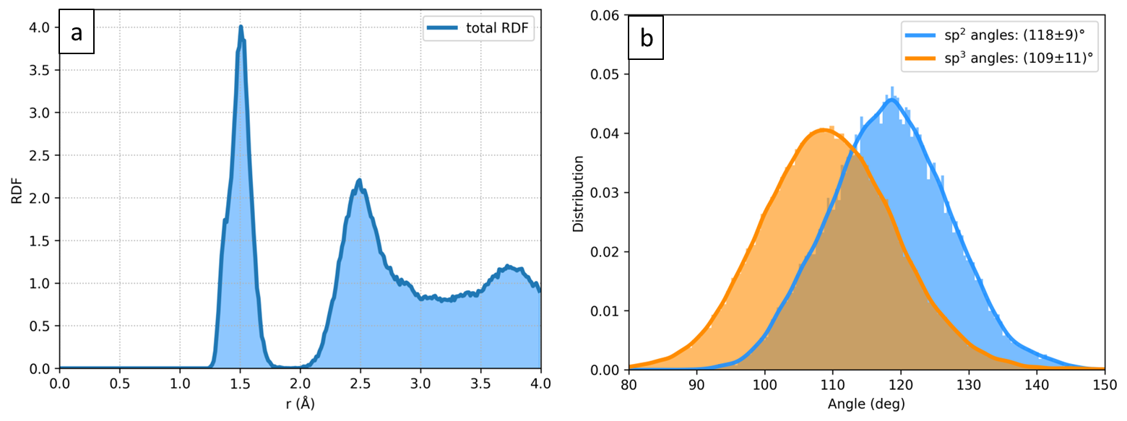
Figure S1. (a) radial pair distribution function (RDF) and (b) sp²/sp³ angular distribution for bulk undoped DLC after quenching. In the RDF, the C-C bond length at 1.5 Å and the second nearest neighbors peak at 2.5 Å are correctly reproduced. In the angular distribution, the sp² and sp³ bond angles are close to the expected values of 120° (triangular planar) and 109.5° (tetrahedron).
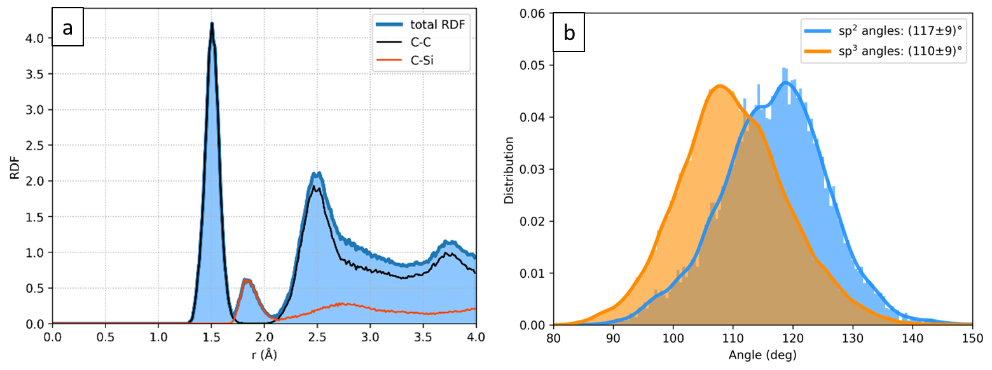
Figure S2. (a) radial pair distribution function (RDF) with the contributions from C-C and C-Si and (b) and sp²/sp³ angular distribution for bulk 10% Si-doped DLC after quenching. In the RDF, the C-C bond length at 1.5 Å, the C-Si bond length at 1.85 Å and the C-C second nearest neighbors peak at 2.5 Å are correctly reproduced. In the angular distribution, the sp² and sp³ bond angles are close to the expected values of 120° (triangular planar) and 109.5° (tetrahedron).

Another parameter that is often used to characterize DLC films is the sp³ content: a high sp³ fraction means that the structure is more tetrahedral (ta-C), and therefore more similar to diamond, while a low sp³ fraction (hence high sp² content) is associated with more graphitic structures. The undoped DLC model that we generated has a 57% sp³ fraction, which is lower than the experimental value of ~70% for DLCs with a density of 3.0 g/cm³. This may partially be due to a tendency of interatomic potentials to underestimate the sp³ content (50% [1] and 55% [2]), and partially due to the melt-quench procedure, since even fully ab initio simulations can result in an underestimation (65% [7]). The Si-doped DLC model has instead a significantly higher sp³ content equal to 75%, in agreement with the observations that Si doping reduces the graphitization of DLC [3], mainly due to the longer Si-C equilibrium bond length, which causes Si to form almost only quadruple coordination covalent structures [13].
This analysis of the structural properties of the amorphous models confirms that the CHGNet machine learning potential was able to generate realistic amorphous DLC structures, both undoped and Si-doped.

Generation and analysis of the undoped and Si-doped DLC surfaces
The slabs, with a thickness of ~10 Å, were cut from the previously generated bulk structures. To obtain more realistic models of the surfaces, allowing for reconstructions and healing of the dangling bonds created when cutting the bulk, the slabs were heated by ramping the temperature from 0 K to 600 K in 10 ps, then they were annealed at 600 K for 5 ps and quenched from 600 K to 300 K in 20 ps. This annealing temperature for the surface should be considered as fictitious and does not have a direct physical meaning, since it strongly depends on the interatomic potential and the computational procedure, and a suitable value has to be identified by trial and error [2]. Other annealing temperatures were tested, namely 1000K, 1500K and 2000K, but they resulted in too high level of graphitization of the slabs, with 2000K leading to an almost full graphitization even in the internal region of the slabs, so 600K was chosen as the optimal temperature to heal dangling bonds but avoid a complete surface graphitization.
The slabs after the annealing are represented in Figure S3 with a color coding to distinguish sp³ atoms (in purple), sp² atoms (in green) and sp atoms (in yellow). The lateral views (a,b) show that the surfaces became mostly sp²-like, while the inner region of the slabs partially retains the sp³ character. The sp³ fraction for the slabs are 17% and 49% for undoped and Si-doped DLC and are not too far from the values of 26% and 56% reported in Table 1 for the experimental coatings. In the top view of undoped DLC (c), a fully graphitic region with hexagonal lattice can be observed, while the Si-DLC surface (d) has a less graphitic nature. Both surfaces show a wide variety of local environments, containing also a few undercoordinated atoms, which is ideal for performing a statistical study of adsorption in a single “small” cell that includes many of the surface features and defects that can be form during the tribological test.
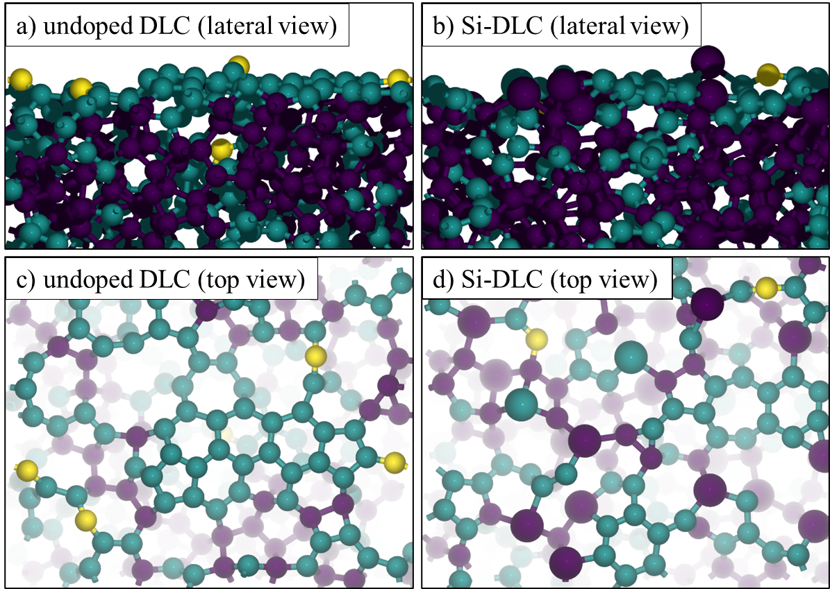
Figure S3. undoped DLC surface from lateral view (a) and top view (c), and Si-DLC surface from lateral view (b) and top view (d). The color code represents the coordination number (CN) of the atoms: yellow for CN=2 (sp hybridization) green for CN=3 (sp² hybridization and purple for CN=4 (sp³ hybridization). A graphitized region is clearly visible at the center of the undoped surface.

High-Load Test at 100 N
To support the generality of the observed tribological mechanism, an additional high-load test was conducted under a significantly higher load. The test was performed using the same tribometer as in the main study, under controlled conditions at 80 °C. A normal load of 100 N was applied for a continuous sliding duration of 20 minutes. The reciprocating motion involved a 3/8-inch diameter SiC ball sliding over a stroke length of 1 mm at a frequency of 5 Hz. Figure S4 presents the average coefficient of friction (CoF) values measured during the final 1-minute period of sliding, along with the standard deviation obtained from three independent tests. As shown in the figure, there was no significant difference in CoF between the two polymers on Pure DLC. However, on Si-DLC surfaces, the use of the functionalized copolymer resulted in a lower CoF compared to the non-functionalized counterpart. These results are consistent with those obtained under lower load conditions, thereby reinforcing the robustness and load-independence of the proposed lubrication mechanism.

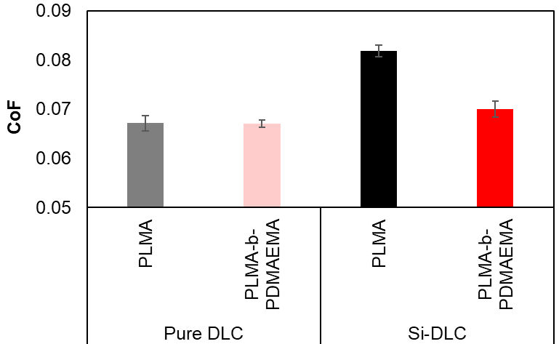
Figure S4. CoF during the last minute of the high-load test. The average CoF with the corresponding standard deviation was computed from three repeated tests.

Temperature-Dependent Tribological Tests
To investigate the influence of temperature on frictional behavior, additional reciprocating ball-on-disk tribological tests were conducted using a 3/8 inch SiC ball. The applied load was 3 N, corresponding to an estimated Hertzian contact pressure of approximately 1.0 GPa. The stroke length was set at 15 mm, and the tests were carried out at a frequency of 0.2 Hz, which corresponds to a sliding speed of 0.006 m/s. Each test was run for a total duration of 20 minutes. In order to assess the thermal responsiveness of the polymers, measurements were performed at two temperatures, 60 °C and 80 °C. The coefficient of friction was recorded continuously during each experiment.
Figure S5 shows the average coefficient of friction measured during the final one-minute interval of sliding, along with the standard deviation calculated from three independent tests. At both temperatures, the functionalized block copolymer PLMA-b-PDMAEMA exhibited consistently lower friction values than the homopolymer PLMA on Si-DLC surfaces. This trend supports previous findings that amino groups in PLMA-b-PDMAEMA strongly interact with silicon-containing surfaces, promoting the formation of stable tribofilms.

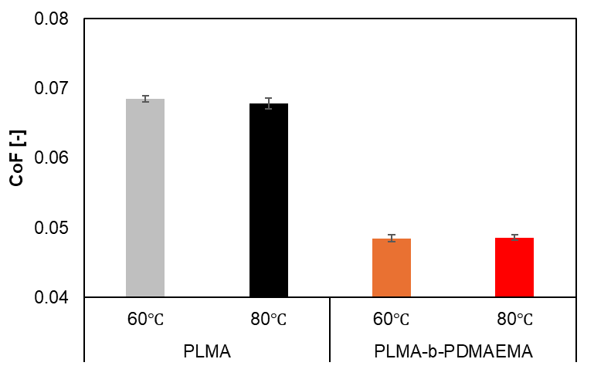
Figure S5. Temperature-dependent friction performance of PLMA and PLMA-b-PDMAEMA on Si-DLC surfaces at 60 °C and 80 °C.

References
[1] N. Marks, Modelling diamond-like carbon with theenvironment-dependent interaction potential, Journal of Physics: Condensed Matter 14 (2002) 2901. https://doi.org/10.1088/0953-8984/14/11/308.
[2] V.L. Deringer, G. Csányi, Machine learning based interatomic potential for amorphous carbon, Phys Rev B 95 (2017). https://doi.org/10.1103/PhysRevB.95.094203.
[3] J. Hilbert, F. Mangolini, J.B. McClimon, J.R. Lukes, R.W. Carpick, Si doping enhances the thermal stability of diamond-like carbon through reductions in carbon-carbon bond length disorder, Carbon N Y 131 (2018) 72–78. https://doi.org/10.1016/J.CARBON.2018.01.081.
[4] K.W.R. Gilkes, P.H. Gaskell, J. Robertson, Comparison of neutron-scattering data for tetrahedral amorphous carbon with structural models, Phys Rev B 51 (1995) 12303–12312. https://doi.org/10.1103/PhysRevB.51.12303.
[5] P. Kowalczyk, P.A. Gauden, A.P. Terzyk, Structural properties of amorphous diamond-like carbon: percolation, cluster, and pair correlation analysis, RSC Adv 2 (2012) 4292–4298. https://doi.org/10.1039/C2RA00985D.
[6] M. Bilek, D. McKenzie, Ab initio simulation of structure in amorphous hydrogenated carbon, Phys Rev B 62 (2000) 3071–3077. https://doi.org/10.1103/PhysRevB.62.3071.
[7] N.A. Marks, D.R. McKenzie, B.A. Pailthorpe, M. Bernasconi, M. Parrinello, Microscopic Structure of Tetrahedral Amorphous Carbon, Phys Rev Lett 76 (1996) 768–771. https://doi.org/10.1103/PhysRevLett.76.768.
[8] D.R. McKenzie, D. Muller, B.A. Pailthorpe, Z.H. Wang, E. Kravtchinskaia, D. Segal, P.B. Lukins, P.D. Swift, P.J. Martin, G. Amaratunga, P.H. Gaskell, A. Saeed, Properties of tetrahedral amorphous carbon prepared by vacuum arc deposition, Diam Relat Mater 1 (1991) 51–59. https://doi.org/10.1016/0925-9635(91)90011-X.
[9] P.H. Gaskell, A. Saeed, P. Chieux, D.R. McKenzie, Neutron-scattering studies of the structure of highly tetrahedral amorphous diamondlike carbon, Phys Rev Lett 67 (1991) 1286–1289. https://doi.org/10.1103/PhysRevLett.67.1286.
[10] F.H. Allen, O. Kennard, D.G. Watson, L. Brammer, A.G. Orpen, R. Taylor, Tables of bond lengths determined by X-ray and neutron diffraction. Part 1. Bond lengths in organic compounds, Journal of the Chemical Society, Perkin Transactions 2 (1987) S1–S19. https://doi.org/10.1039/P298700000S1.
[11] T. Takeshita, Y. Kurata, S. Hasegawa, Bonding properties of glow‐discharge polycrystalline and amorphous Si‐C films studied by x‐ray diffraction and x‐ray photoelectron spectroscopy, J Appl Phys 71 (1992) 5395–5400. https://doi.org/10.1063/1.350561.
[12] J. Robertson, Diamond-like amorphous carbon, Materials Science and Engineering: R: Reports 37 (2002) 129–281. https://doi.org/10.1016/S0927-796X(02)00005-0.
[13] H. Sun, L. Yang, H. Wu, L. Zhao, Effects of Element Doping on the Structure and Properties of Diamond-like Carbon Films: A Review, Lubricants 2023, Vol. 11, Page 186 11 (2023) 186. https://doi.org/10.3390/LUBRICANTS11040186.

