Supplementary Information
Synergistic effects of nitrogen-containing functionalized copolymer and silicon-doped DLC for friction and wear reduction
Takeru Omiya^{1, 2, 3*}, Enrico Pedretti⁴, Manuel Evaristo¹, Albano Cavaleiro^{1, 3}, Arménio Serra², Jorge Coelho^{2,3}, Fabio Ferreira^{1, 3} and Maria Clelia Righi^{4*}
¹University of Coimbra, CEMMPRE, ARISE, Department of Mechanical Engineering, Rua Luís Reis Santos, 3030-788 Coimbra, Portugal;
²University of Coimbra, CEMMPRE, ARISE, Department of Chemical Engineering, Rua Silvio Lima, 3030-790 Coimbra, Portugal;
³Laboratory for Wear, Testing & Materials, Instituto Pedro Nunes, Rua Pedro Nunes, 3030-199 Coimbra, Portugal;
⁴Department of Physics and Astronomy, University of Bologna, Bologna, 40127 Italy.
*Corresponding authors: takeru.omiya@student.dem.uc.pt, clelia.righi@unibo.it

Raman spectroscopy (Horiba Jobin Yvon, 532 nm, laser spot ~ 1 μm, 20-25 mW) was utilized to assess modifications in the bonding structure with changing composition (Figure S1). The analysis focused on the I_{D}/I_{G} ratio evolution, G peak position, and FWHM of G peak concerning Si content, offering valuable insights into the bonding structure and the impact of incorporating Si into DLC films. The overall trend with increasing Si content includes a decrease in the I_{D}/I_{G} ratio, a shift of the G peak position to lower wave numbers, and an increase in the FWHM of the G peak. This pattern aligns with findings from other authors, even in the presence of hydrogen in their films [1, 2]. This trend, marked by a simultaneous downshift of the G peak and a decrease in the I_{D}/I_{G} ratio, indicates a reduction in the average size of graphite-type sp²-bonded clusters and the promotion of sp³ bond formation due to the presence of Si [3].

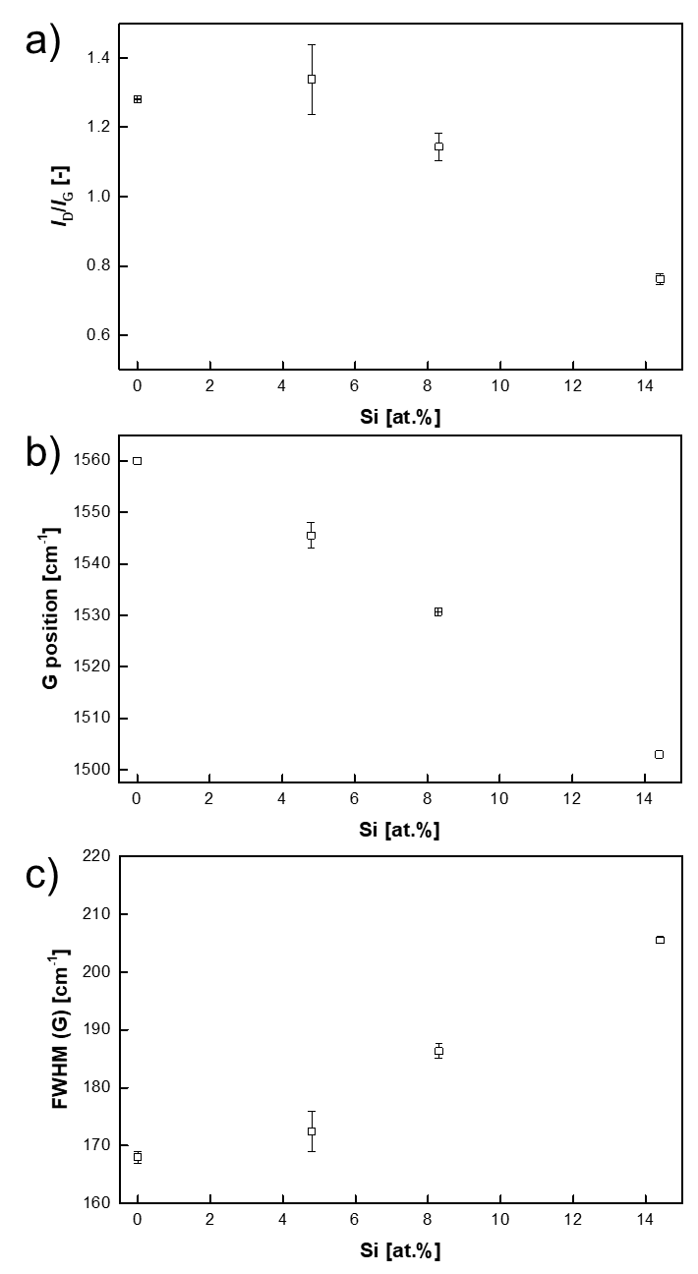
Figure S1. Analysis of the Raman spectra of DLC films deposited with increasing Si content, a) I_{D}/I_{G}, b) G position, c) FWHM G peak.

The XPS spectra recorded at two different take-off angles (0 and 50°) are shown, as an example in Figure S2 for Si2p peaks, for the sample Si-DLC 14.4%. The XPS analysis exhibits Si-C bonds (peak at 100.8 ± 0.2 eV) and Si-O-C bonds (peak at 102.6 ± 0.2 eV). The peak associated with Si-O-C increases in intensity as the emission angle rises, indicating the formation of Si-O-C bonds when the sample is exposed to the atmosphere. Although two angular measurements are not enough to determine the depth profile, the experimental data suggests that a uniform Si-O-C mixed oxide layer covers the Si-DLC substrate. Assuming an attenuation length (λ) of 2.5 nm for the Si2p photoelectrons, the thickness of this layer can be approximately calculated as d = 1.2 nm.

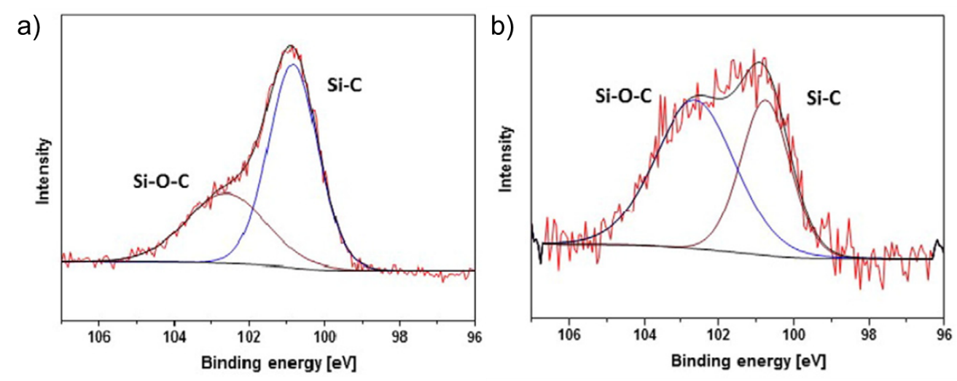
Figure S2. XPS for the Si-DLC 14.4% sample, spectra for Si2p at take-off angle 0° a) and 50° b).

Figure S3 shows the NMR spectrum of the block polymer PLMA₈₃-b-PDMAEMA₁₇ after purification.
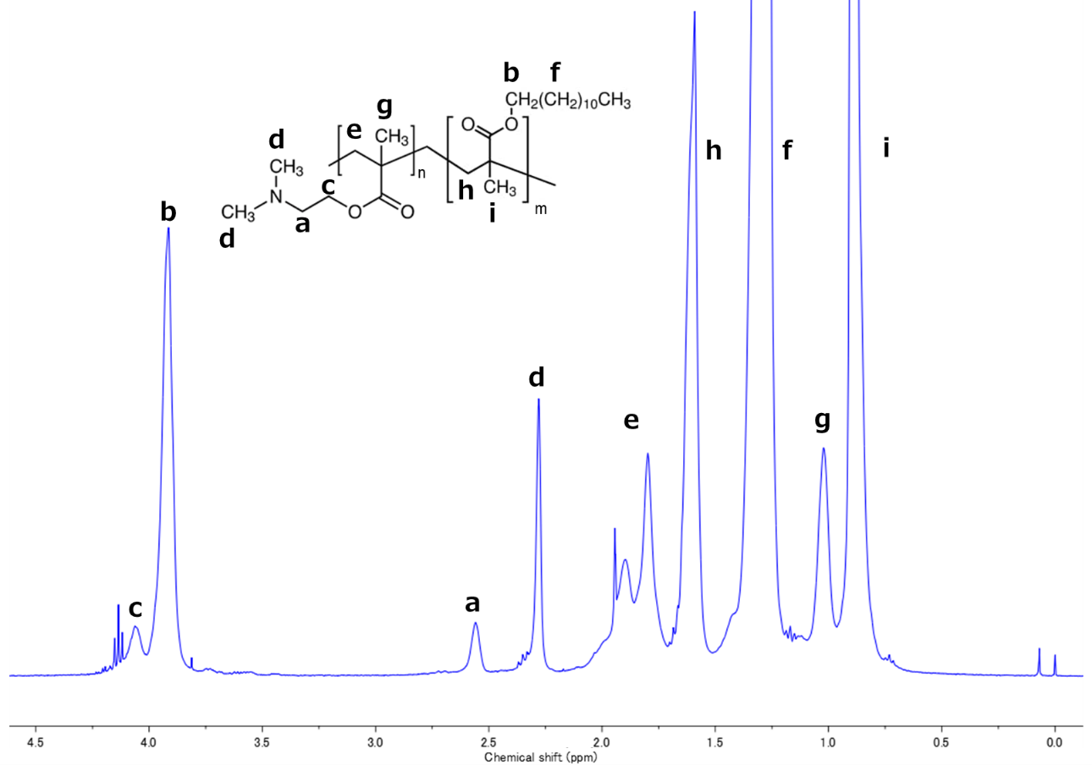
Figure S3. ¹H-NMR of block copolymer PLMA₈₃-b-PDMAEMA₁₇ by ATRP. Assignments: 2.56 ppm -CH₂- (PDMAEMA), 3.91 ppm -CH₂- (PLMA), 4.06 ppm -CH₂- (PDMAEMA).

A long-term wear test was conducted to assess the wear characteristics of functionalized polymers. Given the observed aggregation and poor reactivity of PLMA₈₃-b-PDMAEMA₁₇ with Si-DLC, this study conducted a comparative wear performance analysis between PLMA and PLMA₉₅-b-PDMAEMA₅. The coefficient of friction (CoF) for the entire 20 minutes during the long-term wear test is shown in Figure S4. During all tests, the friction decreased immediately after the start of the test, and the CoF stabilized after approximately 10 minutes. On 14.4% Si-DLC, the CoF was high in the presence of both PLMA and PLMA₉₅-b-PDMAEMA₅.
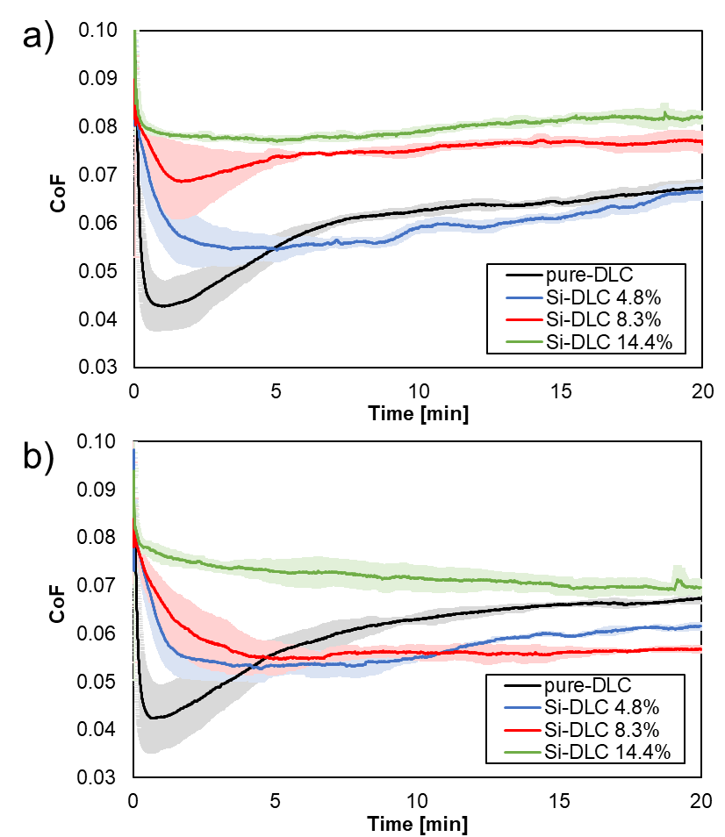
Figure S4. CoF during long-term wear tests in the presence of: (a) PLMA and (b) PLMA₉₅-b-PDMAEMA₅. Light-colored areas indicate standard deviations for multiple testing.
Construction of the amorphous DLC structure
To create the bulk of amorphous carbon, the crystalline structure of diamond in a cubic cell containing 1000 atoms was thermalized at 9000 K (much higher than the melting point) for 5 ps to obtain a liquid melt. This high temperature liquid was then rapidly brought to 5000 K (in 1 ps) and stabilized at 5000 K for 5 ps. Then it was quenched from 5000 K to 300 K with a 5 ps ramp, finally annealing it at 300 K for 5 ps.
The slab was then cut from the bulk, with a thickness of approximately 14 Å. To obtain a more realistic model of the surface, allowing for reconstructions, the slab was heated by ramping the temperature from 0 K to 2000 K in 10 ps, then it was annealed at 2000 K for 10 ps and quenched from 2000 K to 300 K in 20 ps. The final structure resulting from molecular dynamics simulations was optimized by means of ab initio calculations, using the same setup employed for the C(001) slab. The two opposite surfaces of the amorphous slab contain various local environments, clearly showing a partial graphitization in some regions. To capture the effect of the different environments, a substitutional Si atom was included at two different locations, one in a planar, graphitic-like region, and the other in non-planar, more amorphous region. The two surfaces before and after the insertion of the substitutional Si are reported in Figure S5.
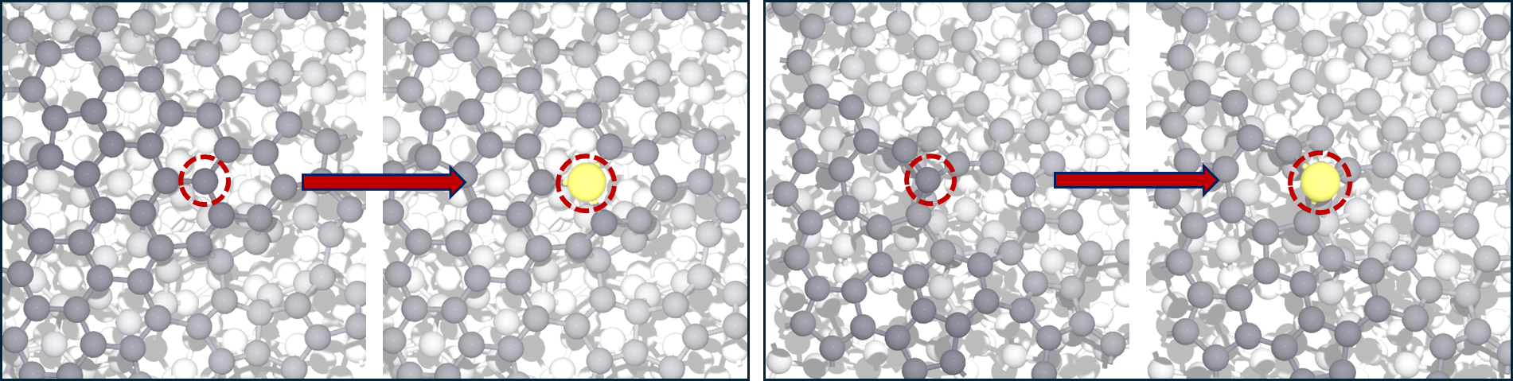
Figure S5. Substitutional doping of a C atom with Si for two different local environments of the amorphous DLC surface, seen from top view. Left: planar, graphitic-like region, right: non-planar, amorphous region. The C atoms are colored in gray (progressively more faded as they get deeper below the surface level), while Si atoms are colored in yellow.

Additional chemisorption configurations involving oxygen
We also report additional chemisorption configurations of DMAEMA and LMA on the crystalline C(001) surface, driven by the oxygen-surface interaction, which were not discussed in the main text as we deemed them less relevant to explain the experimental results, as detailed below.
The presence of the oxygen (double bonded to a C atom) in LMA and DMAEMA allows chemisorption on both substrates, as visible in Figure S6. On undoped diamond, the C=O double bond in the molecule saturates by forming two bonds with two carbons in the surface dimers. The formation of this bond, however, possesses an energy barrier with respect to the physisorption minimum. On Si-doped diamond, the oxygen of both molecules bonds with the Si of the substrate without an energy barrier starting from the same physisorption distance of undoped diamond.
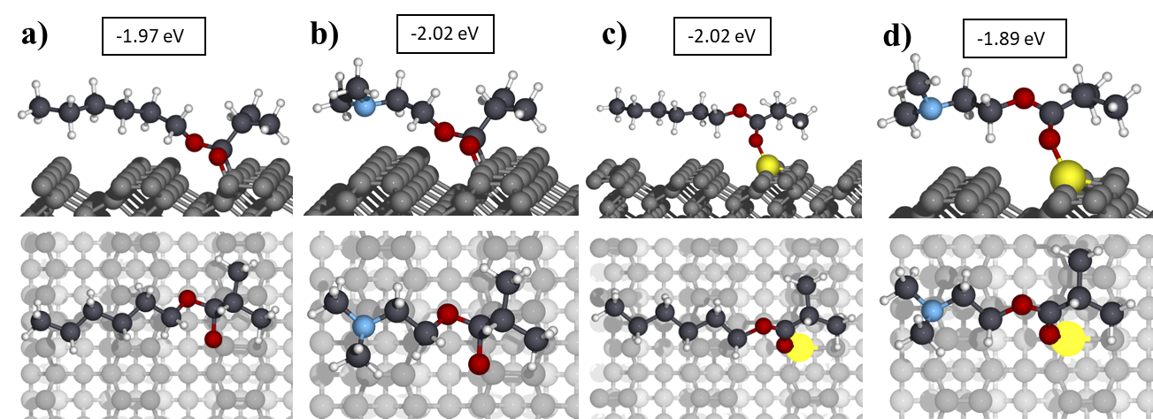
Figure S6. Additional chemisorption configurations involving the oxygen in the molecules. For the two substrates, lauryl methacrylate (a, c) and DMAEMA (b, d) are compared. The two molecules present very similar chemisorption energies and geometries for the bonds involving the oxygen.
We believe, however, that the chemical bonding of the oxygen atom is not the mechanism responsible for the reduction of friction coefficient observed experimentally, for two reasons. First, from the direct comparison of equivalent configurations for LMA and DMAEMA on both substates it is evident that the adsorption energy and geometry are very similar, so the formation of this bond cannot be responsible for the differences observed in the experiment. The second reason is that the oxygen is not at the termination of the two monomers, but is instead located on the opposite side, close to the polymer backbone. Therefore, in thermodynamic sliding conditions the oxygen may not be able to get close enough to the surface to form any bond. This is true especially for LMA, which has a very long hydrocarbon chain that does not interact with the substrate, most likely giving rise to a repulsion which prevents the region attached to the backbone, where the oxygens are located, to approach the surface and be able to bond to it.

References
[1] P. Papakonstantinou, J. Zhao, P. Lemoine, E. McAdams, J. McLaughlin, The effects of Si incorporation on the electrochemical and nanomechanical properties of DLC thin films, Diamond and related materials 11(3-6) (2002) 1074-1080.
[2] K.H. Er, M.G. So, The mechanical and structural properties of Si doped diamond-like carbon prepared by reactive sputtering, Journal of Ceramic Processing Research 12(2) (2011) 187-190.
[3] J. Robertson, Diamond-like amorphous carbon, Materials science and engineering: R: Reports 37(4-6) (2002) 129-281.

