Supplementary Material

Supplementary Table 1. Overview of REPAIR, TRITON and OPTIMA study designs
Study | TRITON¹ | REPAIR² | OPTIMA³
Summary | - Double-blind, randomized, placebo-controlled phase 3b study | - Open-label, single-arm, phase 4 study | - Open-label, single-arm, phase 4 study
Primary endpoint | - Change in PVR from baseline to Week 26 | - Change in PVR and RVSV from baseline to Week 26 | - Change in PVR from baseline to Week 16
Timing of primary endpoint | - Week 26 (± 1 week) | - Week 26 (± 2 weeks) | - Week 16 (± 1 week)
Key selection criteria | - PAH patients (18-75 years of age) diagnosed by RHC within 6 months prior to randomization showing:  - PVR ≥6 WU  - mPAP ≥25 mmHg  - PAWP or LVEDP ≤15 mmHg  - Negative vasoreactivity test mandatory in idiopathic, heritable, and drug/toxin-induced PAH (at study site or a previous RHC)  - Patients had a 6MWD ≥50 m  - Patients were excluded if previously treated with PAH therapy  - DLCO ≥40% of predicted* | - PAH patients (18-74 years of age) with confirmatory diagnosis by RHC performed between Day -28 and Day 1 showing:  - mPAP ≥25 mmHg and  - PCWP or LVEDP ≤12 mmHg and PVR ≥4 WU or  - PCWP ≤12 mmHg or LVEDP ≤15 mmHg and PVR ≥6 WU  - Patients were treatment-naïve or receiving stable background PDE5i for at least 3 months prior to screening  - Patients had a 6MWD of ≥150 m and were in WHO FC I-III  - DLCO ≥40% of predicted* | - Adult PAH patients were diagnosed with PAH within the previous 6 months with a resting mPAP ≥25 mmHg, PAWP ≤15 mmHg and, PVR ≥5 WU if PAWP was <12 mmHg or PVR ≥6.25 WU if PAWP was 12–15 mmHg  - Patients were treatment-naïve  - Patients had a 6MWD ≥50 m and were in WHO FC II to III  - DLCO ≥40% of predicted*
Study treatments | - Open-label macitentan 10 mg once daily and tadalafil 20 mg once daily were initiated on Day 1. Tadalafil was increased to 40 mg once daily on Day 8 ± 3 according to tolerability  - Double-blind selexipag or placebo were initiated on Day 15 ± 3 at 200 µg twice daily, then titrated up to Week 12 to reach an individualized maintenance dose (ranging from 200 to 1600 µg twice daily)  - Study treatments were provided until the end of treatment visit, which was planned approximately 4 months after the EOMOP visit (26 ± 1 weeks after enrollment of the last patients).  - Start and stop dates for macitentan and tadalafil were taken from the CRF study drug page | - Open-label macitentan 10 mg once daily was initiated on Day 1  - Physicians had the option to additionally initiate PDE5i after all screening assessments had been performed, up until 14 days after study treatment initiation, provided that dose optimization was complete by Day 14 at the latest  - Treatment continued until Week 52 or premature discontinuation of the study drug  - Rescue therapy prior to Week 26 was permitted only in the event of disease progression  - Start and stop dates for macitentan were taken from the CRF study drug page and for tadalafil were taken from the CRF concomitant medications page | - Open-label macitentan 10 mg once daily and tadalafil 20 mg once daily were initiated on Day 1  - Tadalafil was increased to 40 mg once daily on Day 8 ± 3 according to tolerability  - Study treatment continued until Week 16, or until PAH progression required administration of other PAH drugs  All patients had an end-of-study safety visit 30 days after the end of treatment
Patients | - 247 patients were randomized:  - 123 to receive initial triple oral therapy (macitentan, tadalafil, and selexipag)  - 4 patients received macitentan plus tadalafil only.  - 124 to receive initial double oral therapy (macitentan, tadalafil, and placebo)  - 1 patient did not receive study treatment | - 87 patients received ≥1 dose macitentan:  - 34 treatment-naive patients initiated macitentan as initial combination therapy with a PDE5i  - 22 treatment-naïve patients initiated macitentan as a monotherapy  - 31 patients initiated macitentan on top of stable background PDE5i | - 46 patients received ≥1 dose of macitentan and tadalafil
Observation period | - Treatment period: date of macitentan plus tadalafil initiation up to the end of treatment visit  - Follow-up of patients continued in a blinded fashion until EOMOP, regardless of any study treatment discontinuation(s)  - Safety period: end of all study treatments + 30 days | - Treatment period: date of macitentan initiation to 52 weeks (± 1 week), or premature study drug discontinuation  - Safety period: end of study treatment + 30 days | - Treatment period: date of macitentan plus tadalafil initiation to 16 weeks (± 1 week), or premature study drug discontinuation  - Safety period: end of both study treatments + 30 days
*DLCO was not collected during the study. 6MWD: 6-minute walk distance; CRF: case report form; DLCO: diffusing capacity of the lungs for carbon monoxide; EOMOP: end of the main observation period; LVEDP: left ventricular end diastolic pressure; mPAP: mean pulmonary arterial pressure; PAH: pulmonary arterial hypertension; PAWP: pulmonary arterial wedge pressure; PCWP: pulmonary capillary wedge pressure; PDE5i: phosphodiesterase 5 inhibitor; PVR: pulmonary vascular resistance; RHC: right heart catheterization; RVSV: right ventricular stroke volume; WHO FC: World Health Organization functional class; WU: Wood units.

Supplementary Table 2: Relevant exclusion criteria for the TRITON and REPAIR studies
Exclusions | TRITON​¹ | REPAIR​²
BMI | > 40 kg/m²​ or  >30 kg/m², when in conjunction with two other risk factors for HFpEF (see 'Other relevant exclusions') ​ | >35kg/m² ​  Scientific Committee could also exclude patients with BMI >30–34kg/m²​
Diabetes mellitus​ | Diabetes mellitus of any type, when in conjunction with two other risk factors for HFpEF (see 'Other relevant exclusions')​ | Known uncontrolled diabetes mellitus (in the opinion of the investigator)​
Coronary Artery Disease​  ​ | Coronary artery disease, when in conjunction with two other risk factors for HFpEF (see 'Other relevant exclusions'). i.e., any of the following:​  - History of stable angina or ​  - >50% stenosis in a coronary artery (by coronary angiography) or ​  - History of myocardial infarction or ​  - History of or planned coronary artery bypass grafting and/or coronary artery stenting ​ | Historical evidence of significant coronary artery disease established by: ​  - Stable angina or​  - 50% stenosis in a coronary artery (by percutaneous coronary intervention, angiography) or ​  - History of myocardial infarction or​  - History of coronary artery bypass grafting or ​  - Elevation of the ST segment on electrocardiogram​
Other relevant  exclusions | Presence of three or more of the following risk factors for HFpEF at screening: ​  - BMI > 30 kg/m² ​  - Diabetes mellitus of any type ​  - Essential hypertension  - Coronary artery disease  Acute myocardial infarction ≤ 12 weeks prior to screening  Known or suspected pulmonary veno-occlusive disease  Known permanent atrial fibrillation​  Presence of one or more of the following signs of relevant lung disease at any time up to screening: ​  - DLCO < 40% of predicted  - UNLESS computed tomography reveals no or mild interstitial lung disease ​  - FVC < 60% of predicted  - FEV1 < 60% of predicted | Atrial fibrillation, multiple premature ventricular or atrial contractions, or any other condition that would interfere with proper cardiac gating during MRI  Presence of one or more of the following signs of relevant lung disease at any time up to screening: ​  - DLCO < 40% of predicted  - eligible only if no or mild interstitial lung disease on computed tomography  - FVC < 60% of predicted​  - FEV1 < 60% of predicted ​  - Moderate to severe restrictive lung disease (i.e., total lung capacity < 60% of predicted value) at any time prior to enrollment​
BMI: body mass index; DLCO: diffusing capacity of the lungs for carbon monoxide; FEV1: forced expiratory volume in one second; FVC: forced vital capacity; HFpEF; heart failure with preserved ejection fraction; MRI: magnetic resonance imaging.

Supplementary Table 3: Preferred terms used in definition of comorbidities
Comorbidities | Definition
Obesity | BMI > 30 kg/m² at Screening  MedDRA definition (in situations when Baseline BMI is not available):  - MedDRA PTs including “obesity” (e.g., obesity, central obesity, obesity cardiomyopathy, maternal pre-pregnancy obesity, sarcopenic obesity).  Note: for TRTION/REPAIR, only BMI criteria was applied
Diabetes mellitus of any type | - MedDRA HLT Diabetes mellitus (including subtypes) and/or HLGT Diabetic complications
Essential hypertension | - MedDRA SMQ Hypertension (narrow)
Coronary heart disease | - MedDRA SMQ Ischemic heart disease (narrow) with both sub-SMQs (narrow)  - Myocardial infarction (SMQ)  - Other ischemic heart disease (SMQ)
Mild parenchymal lung disease (often associated with a low DLCO [45% of the predicted value]) | - DLCO <45% of predicted values  MedDRA definition (in situations when DLCO is not available):  - MedDRA PTs Lung diffusion test abnormal  - MedDRA PTs Lung diffusion test decreased  - SMQ Interstitial lung disease (narrow) and selected PTs from broad  - Antisynthetase syndrome  - Cystic lung disease  - Goodpasture's syndrome  - Granulomatosis with polyangiitis  - Granulomatous pneumonitis  - Langerhans' cell histiocytosis  - Lupus pneumonitis  - Lymphangioleiomyomatosis  - Pneumonitis chemical  - Polyarteritis nodosa  - Pulmonary haemosiderosis  - Pulmonary renal syndrome  - Pulmonary sarcoidosis  - Restrictive pulmonary disease  - Rheumatoid lung  - Sarcoidosis  - Systemic sclerosis pulmonary  - PT Emphysema  - PT Obstructive airways disorder  - PT Respiratory gas exchange disorder  Note: for TRTION/REPAIR, DLCO was not available and was based on Medical History
BMI: body mass index; DLCO: diffusing capacity of the lungs for carbon monoxide; HLGT: high level group term; HLT: high level term; MedDRA: Medical Dictionary for Regulatory Activities; PT: preferred term; SMQ: standardised MedDRA queries.
Supplementary Table 4: Non-invasive three-strata^{4–6}, non-invasive four-strata^{6,7} and REVEAL lite 2.0⁸ risk assessment methods
 | Three-strata^{4–6} | Four-strata^{6,7} | REVEAL Lite 2.0⁸
Risk categorization | Total score = sum of criteria ÷ 3, rounded to nearest integer | Total score = sum of criteria ÷ 3, rounded to nearest integer | Total score = sum of criteria (missing = 0), +6
Risk categorization | Categories: | Categories: | Categories:
Risk categorization | - 1 = low | - 1 = low | - 1 – 5 = low
Risk categorization | - 2 = intermediate | - 2 = intermediate-low | - 6 – 7 = intermediate
Risk categorization | - 3 = high | - 3 = intermediate-high | - 8 – 14 = high
Risk categorization |  | - 4 = high
Risk categorization | Missing values for 6MWD, NT-proBNP, WHO FC not permitted | Missing values for 6MWD, NT-proBNP, WHO FC not permitted | Must have ≥3 variables measured, including ≥2 of 6MWD, NT-proBNP, WHO FC
Variables
WHO FC | +1 = I or II | +1 = I or II | –1 = I
WHO FC | +2 = III | +3 = III | 0 = II
WHO FC | +3 = IV | +4 = IV | +1 = III
WHO FC |  |  | +2 = IV
6MWD | +1 = > 440 m | +1 = > 440 m | –2 = ≥ 440 m
6MWD | +2 = 440 – 165 m | +2 = 440 – 320 m | –1 = < 440 – 320 m
6MWD | +3 = < 165 m | +3 = 319 – 165 m | +1 = < 165 m
6MWD |  | +4 = < 165 m
NT-proBNP | +1 = < 300 ng/L | +1 = < 300 ng/L | –2 = < 300 pg/mL
NT-proBNP | +2 = 300 – 1400 ng/L | +2 = 300 – 649 ng/L | +2 = ≥ 1100 pg/mL
NT-proBNP | +3 = > 1400 ng/L | +3 = 650 – 1100 ng/L
NT-proBNP |  | +4 = > 1100 ng/L
Systolic blood pressure | – | – | +1 = < 110 mmHg
Heart rate | – | – | +1 = > 96 bpm
eGFR/renal insufficiency | – | – | +1 = < 60 mL/min/1.73 m² (or defined by clinical judgment if eGFR is not available)
6MWD: 6-minute walk distance; bpm: beats per minute; eGFR: estimated glomerular filtration rate; LOCF: last observation carried forward, including baseline; NT-proBNP: N-terminal pro-brain natriuretic peptide; WHO FC: World Health Organization functional class.

Supplementary Table 5. Concomitant medications at baseline
 | Patients receiving initial macitentan plus tadalafil in TRITON and REPAIR
 | Overall set  N=148* | Patients without  cardiac comorbidities  N=62 | Patients with  1-2 cardiac comorbidities  N=78
Concomitant medications, n (%)
Insulins and analogs | 5 (3.4) | 0 | 5 (6.4)
Blood glucose lowering drugs, excluding insulins | 6 (4.1) | 0 | 6 (7.7)
Selective calcium channel blockers with mainly vascular effects | 16 (10.8) | 4 (6.5) | 11 (14.1)
Selective calcium channel blockers with direct cardiac effects | 4 (2.7) | 1 (1.6) | 3 (3.8)
Angiotensin II receptor blockers, plain | 9 (6.1) | 0 | 9 (11.5)
Angiotensin II receptor blockers, combinations | 5 (3.4) | 0 | 5 (6.4)
ACE inhibitors, plain | 18 (12.2) | 2 (3.2) | 16 (20.5)
ACE inhibitors, combinations | 1 (0.7) | 0 | 1 (1.3)
High-ceiling diuretics | 53 (35.8) | 17 (27.4) | 35 (44.9)
Low-ceiling diuretics, thiazides | 9 (6.1) | 0 | 9 (11.5)
Low-ceiling diuretics, excluding thiazides | 1 (0.7) | 0 | 1 (1.3)
Diuretics | 1 (0.7) | 0 | 1 (1.3)
Potassium-sparing agents | 22 (14.9) | 6 (9.7) | 15 (19.2)
Diuretics and potassium-sparing agents in combination | 5 (3.4) | 2 (3.2) | 3 (3.8)
Oxygen | 26 (17.6) | 9 (14.5) | 14 (17.9)
Adrenergics, inhalants | 25 (16.9) | 9 (14.5) | 15 (19.2)
Other drugs for obstructive airway diseases, inhalants | 8 (5.4) | 3 (4.8) | 4 (5.1)
Other systemic drugs for obstructive airway diseases | 4 (2.7) | 2 (3.2) | 2 (2.6)
Other cardiac preparations | 3 (2.0) | 0 | 3 (3.8)
Antiarrhythmics, class I and III | 4 (2.7) | 2 (3.2) | 2 (2.6)
Beta blocking agents | 24 (16.2) | 2 (3.2) | 21 (26.9)
*Includes 8 patients with pulmonary comorbidities and no cardiac comorbidities who were excluded from the subgroups. ACE: angiotensin-converting enzyme.
Supplementary Table 6. Adverse events of special interest and those leading to discontinuation or death
 | Patients receiving initial macitentan plus tadalafil in TRITON and REPAIR
 | Overall set  N=148* | Patients without cardiac comorbidities  N=62 | Patients with 1-2 cardiac comorbidities  N=78
Patients with ≥ 1 AE of special interest†, n (%)
Edema and fluid retention | 67 (45.3) | 25 (40.3) | 37 (47.4)
Anemia | 21 (14.2) | 10 (16.1) | 9 (11.5)
Liver events | 13 (8.8) | 6 (9.7) | 7 (9.0)
Hypotension | 10 (6.8) | 4 (6.5) | 5 (6.4)
Patients with ≥ 1 AE leading to macitentan discontinuation, n (%) | 18 (12.2) | 5 (8.1) | 11 (14.1)
Anemia | 2 (1.4) | 0 | 1 (1.3)
Liver function test increased | 2 (1.4) | 2 (3.2) | 0
Pulmonary veno-occlusive disease | 2 (1.4) | 1 (1.6) | 1 (1.3)
Alanine aminotransferase increased | 1 (0.7) | 0 | 1 (1.3)
Back pain | 1 (0.7) | 0 | 1 (1.3)
Dyspnea | 1 (0.7) | 0 | 1 (1.3)
Gastrointestinal hemorrhage | 1 (0.7) | 0 | 1 (1.3)
Hemorrhagic stroke | 1 (0.7) | 1 (1.6) | 0
Hepatic enzyme increased | 1 (0.7) | 0 | 1 (1.3)
Edema | 1 (0.7) | 0 | 1 (1.3)
Edema peripheral | 1 (0.7) | 0 | 0
Oxygen saturation decreased | 1 (0.7) | 0 | 1 (1.3)
Right ventricular failure | 1 (0.7) | 1 (1.6) | 0
Sepsis | 1 (0.7) | 0 | 1 (1.3)
Sudden cardiac death | 1 (0.7) | 0 | 1 (1.3)
Patients with ≥ 1 AE leading to tadalafil discontinuation, n (%) | 10 (6.8) | 4 (6.5) | 6 (7.7)
Back pain | 1 (0.7) | 0 | 1 (1.3)
Face edema | 1 (0.7) | 1 (1.6) | 0
Gastrointestinal hemorrhage | 1 (0.7) | 0 | 1 (1.3)
Hemorrhagic stroke | 1 (0.7) | 1 (1.6) | 0
Hepatic enzyme increased | 1 (0.7) | 0 | 1 (1.3)
Oxygen saturation decreased | 1 (0.7) | 0 | 1 (1.3)
Pain in extremity | 1 (0.7) | 0 | 1 (1.3)
Periorbital edema | 1 (0.7) | 1 (1.6) | 0
Pulmonary veno-occlusive disease | 1 (0.7) | 1 (1.6) | 0
Right ventricular failure | 1 (0.7) | 1 (1.6) | 0
Sepsis | 1 (0.7) | 0 | 1 (1.3)
Sudden cardiac death | 1 (0.7) | 0 | 1 (1.3)
AEs leading to death, by Preferred Term, n (%) | 8 (5.4)‡ | 2 (3.2) | 6 (7.7)
Right ventricular failure | 2 (1.4) | 1 (1.6) | 1 (1.3)
Accidental death | 1 (0.7) | 0 | 1 (1.3)
Cardiac arrest | 1 (0.7) | 0 | 1 (1.3)
Deep vein thrombosis postoperative | 1 (0.7) | 0 | 1 (1.3)
Gastrointestinal hemorrhage | 1 (0.7) | 0 | 1 (1.3)
Hemorrhagic stroke | 1 (0.7) | 1 (1.6) | 0
Hypoxia | 1 (0.7) | 1 (1.6) | 0
Overdose | 1 (0.7) | 0 | 1 (1.3)
Pneumonia aspiration | 1 (0.7) | 1 (1.6) | 0
Pulmonary embolism | 1 (0.7) | 0 | 1 (1.3)
Pulmonary veno-occlusive disease | 1 (0.7) | 1 (1.6) | 0
Respiratory arrest | 1 (0.7) | 1 (1.6) | 0
Respiratory failure | 1 (0.7) | 1 (1.6) | 0
Sepsis | 1 (0.7) | 0 | 1 (1.3)
Sudden cardiac death | 1 (0.7) | 0 | 1 (1.3)
Sudden death | 1 (0.7) | 0 | 1 (1.3)
Toxicity to various agents | 1 (0.7) | 0 | 1 (1.3)
Urinary tract infection | 1 (0.7) | 1 (1.6) | 0
Preferred terms are based on MedDRA version 22.0. Treatment-emergent adverse events with onset during the macitentan and tadalafil combination treatment exposure period. *Includes 8 patients with pulmonary comorbidities and no cardiac comorbidities who were excluded from the subgroups. †Multiple preferred terms combined. ‡One death is not included here as it occurred prior to end of main observation period in TRITON, but after the end of the safety observation window. AE: adverse event.
Supplementary Table 7. Breakdown of adverse events leading to discontinuations, by patient
Drug discontinued | Cardiac comorbidity status | AE(s) leading to discontinuation, Preferred Term(s), by patient | Day of event onset*
Macitentan only | Patients without cardiac comorbidities | Liver function test increased | 659
Macitentan only | Patients without cardiac comorbidities | Liver function test increased | 414
Macitentan only | Patients with 1-2 cardiac comorbidities | Anemia | 249
Macitentan only | Patients with 1-2 cardiac comorbidities | Alanine aminotransferase increased | 55
Macitentan only | Patients with 1-2 cardiac comorbidities | Pulmonary veno-occlusive disease† | 15
Macitentan only | Patients with 1-2 cardiac comorbidities | Dyspnea | 13
Macitentan only | Patients with 1-2 cardiac comorbidities | Edema | 207
Tadalafil only | Patients without cardiac comorbidities | Face edema / Periorbital edema | 7 / 3
Both macitentan and tadalafil | Patients without cardiac comorbidities | Pulmonary veno-occlusive disease‡ | 14
Both macitentan and tadalafil | Patients without cardiac comorbidities | Hemorrhagic stroke | 839
Both macitentan and tadalafil | Patients without cardiac comorbidities | Right ventricular failure | 365
Both macitentan and tadalafil | Patients with 1-2 cardiac comorbidities | Back pain / Pain in extremity | 5 / 12
Both macitentan and tadalafil | Patients with 1-2 cardiac comorbidities | Gastrointestinal hemorrhage | 61
Both macitentan and tadalafil | Patients with 1-2 cardiac comorbidities | Hepatic enzyme increased | 84
Both macitentan and tadalafil | Patients with 1-2 cardiac comorbidities | Oxygen saturation decreased§ | 3
Both macitentan and tadalafil | Patients with 1-2 cardiac comorbidities | Sepsis | 461**
Both macitentan and tadalafil | Patients with 1-2 cardiac comorbidities | Sudden cardiac death*** | 14
*In reference to the start of macitentan and tadalafil combination therapy. †Patient was newly diagnosed with PVOD (PVOD demasking) and right ventricular failure of moderate intensity. The event was assessed by the investigator as serious, severe in intensity, and related to macitentan and tadalafil. ‡Patient was newly diagnosed with PVOD unmasked by dual specific therapy with macitentan and tadalafil. The event was assessed by the investigator as nonserious, moderate in intensity, and related to macitentan and tadalafil. §Event was assessed by the investigator as nonserious, moderate in intensity, and related to macitentan and tadalafil. In parallel to the AE Oxygen Saturation Decrease, the patient experienced an AE of Suspicion of PVOD. **Based on imputed date. ***Patient (54-years-old female, ex-tobacco user, with medical history of myocardial infarction, renal failure and premature menopause) died on Day 14 (reported event sudden cardiac death). The event was assessed by the investigator as serious, severe in intensity, possibly related to PAH progression and not related to study medications. AE: adverse event; PAH: pulmonary arterial hypertension; PVOD: pulmonary veno-occlusive disease.

Supplementary Figure 1. Patient disposition
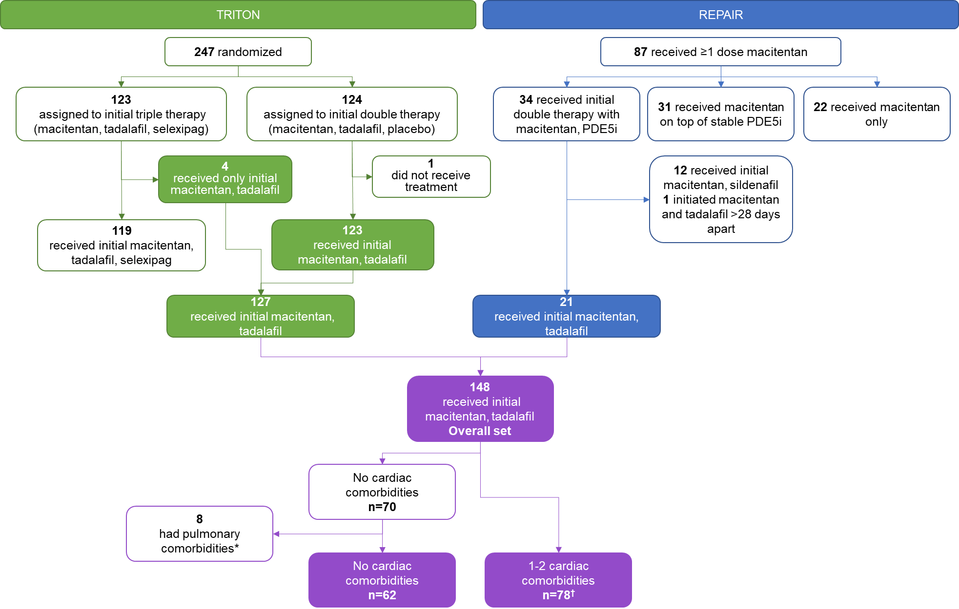
*n=7 from TRITON and n=1 from REPAIR. †Includes 13 patients who additionally had pulmonary comorbidities reported and two patients in TRITON with a recorded BMI ≤ 30 kg/m² at screening and a BMI > 30 kg/m² at baseline (i.e., at randomization). BMI: body mass index.
Supplementary Figure 2. Number of cardiac comorbidities by age category
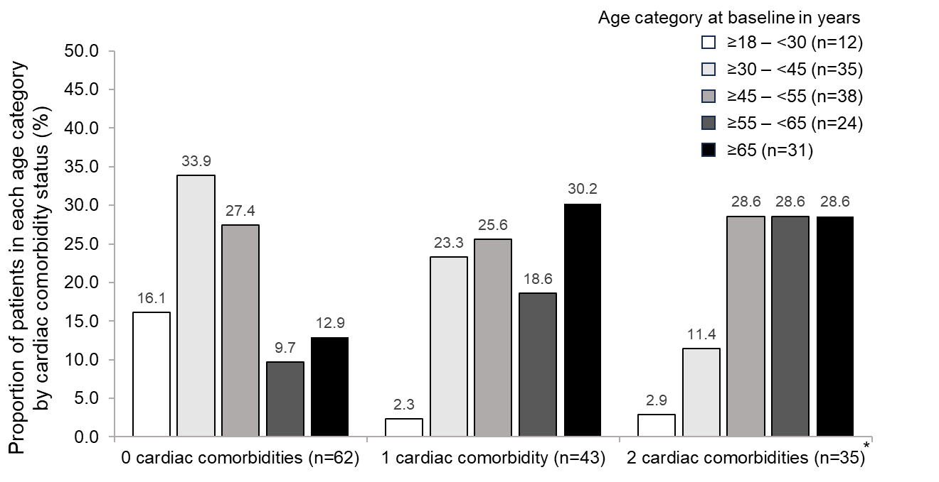
*Includes two patients in TRITON with a recorded BMI ≤ 30 kg/m² at screening and a BMI > 30 kg/m² at baseline (i.e., at randomization). BMI: body mass index.

Supplementary Figure 3. Change from baseline in risk status using A) four-strata^{6,7}, or B) REVEAL Lite 2.0⁸ risk-assessment methods.
A) Four-strata risk category^{6,7}
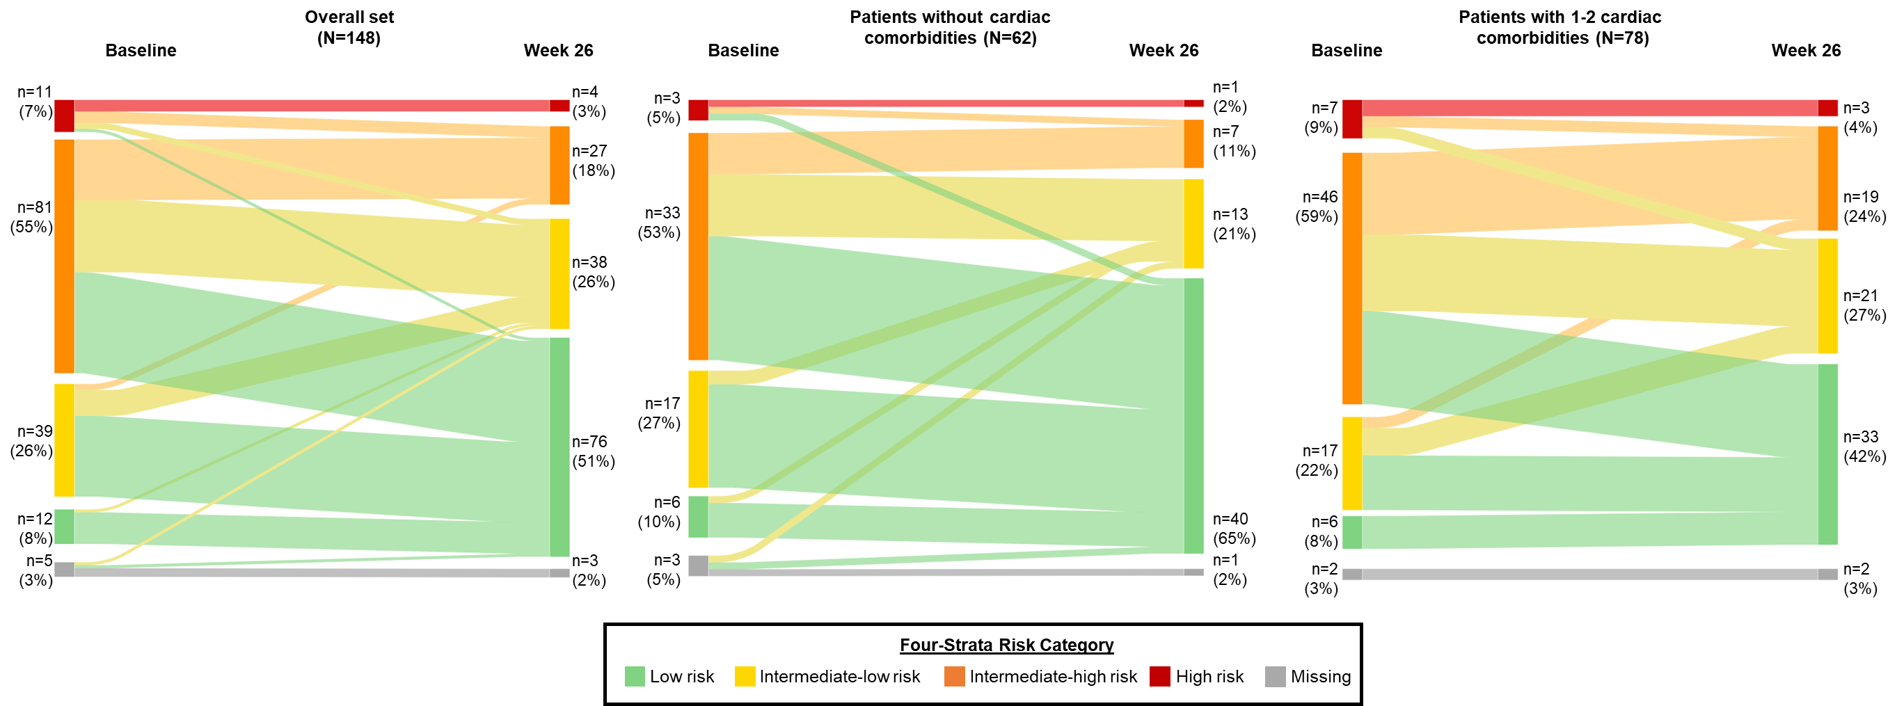

B) REVEAL Lite 2.0 risk category⁸
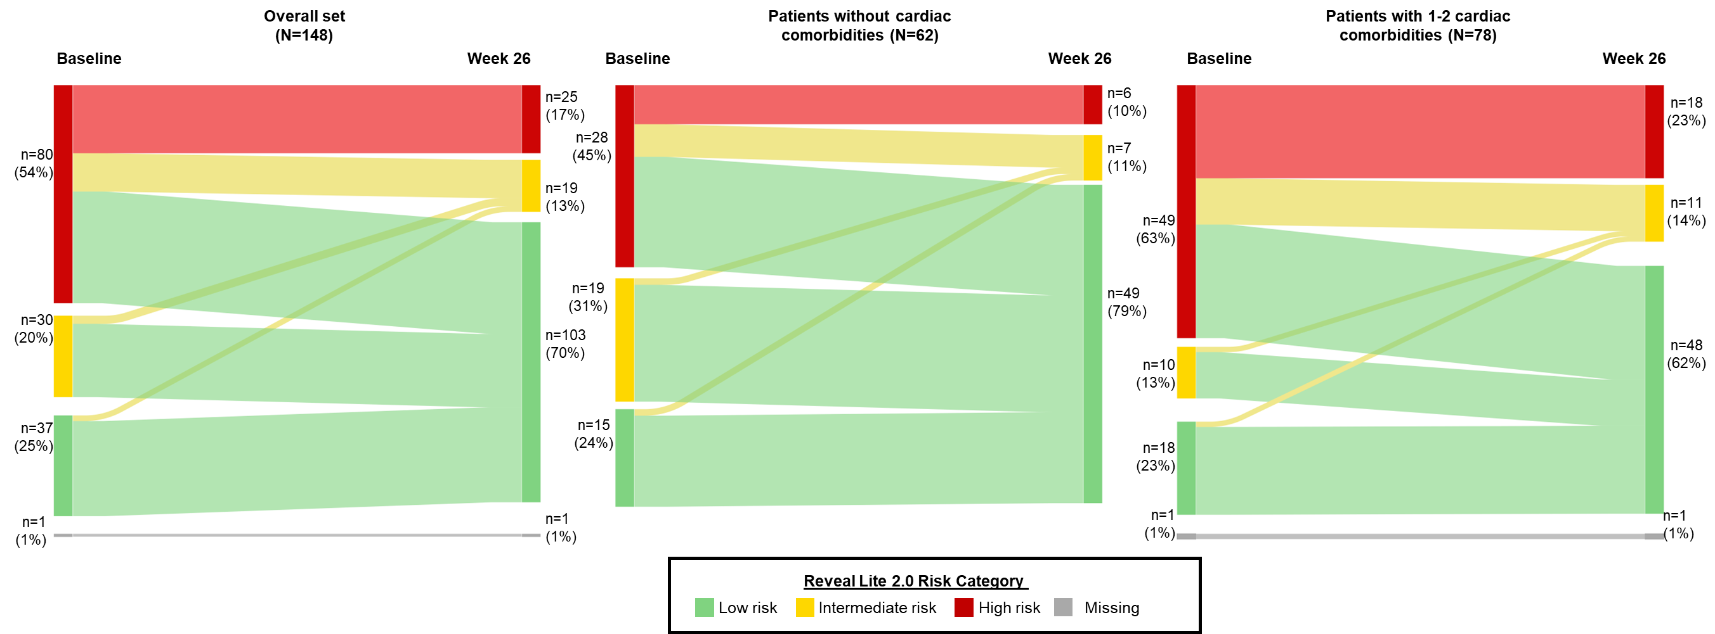
Percentages may not add to 100 due to rounding. A) Four-strata risk score defined by: low = 1, intermediate-low = 2, intermediate-high=3, high = 4^{6,7}. Patients in the overall set: 95 (64.2%) improved (64 [43.2%] to low, 27 [18.2%] to intermediate low, 4 [2.7%] to intermediate high), 45 (30.4%) remained unchanged and 3 (2.0%) worsened (1 [0.7%] to intermediate low, 2 [1.4%] to intermediate high); patients without cardiac comorbidities: 44 (71.0%) improved (34 [54.8%] to low, 9 [14.5%] to intermediate low, 1 [1.6%] to intermediate high), 14 (22.6%) remained unchanged and 1 (1.6%) worsened (to intermediate low); patients with 1-2 cardiac comorbidities: 45 (57.7%) improved (27 [34.6%] to low, 16 [20.5%] to intermediate low, 2 [2.6%] to intermediate high), 29 (37.2%) remained unchanged and 2 (2.6%) worsened (to intermediate high). B) REVEAL Lite 2.0 risk score defined by: low = 1-5, intermediate = 6-7, high = ≥8⁸. Patients in the overall set: 82 (55.4%) improved (68 [45.9%] to low, 14 [9.5%] to intermediate), 63 (42.6%) remained unchanged and 2 (1.4%) worsened (to intermediate); patients without cardiac comorbidities: 40 (64.5%) improved (35 [56.5%] to low, 5 [8.1%] to intermediate), 21 (33.9%) remained unchanged and 1 (1.6%) worsened (to intermediate); patients with cardiac comorbidities: 40 (51.3%) improved (31 [39.7%] to low, 9 [11.5%] to intermediate), 36 (46.2%) remained unchanged and 1 (1.3%) worsened (to intermediate).

Supplementary Figure 4. Change from baseline in risk status using A) four-strata^{6,7}, or B) REVEAL Lite 2.0⁸ risk-assessment methods for patients in OPTIMA³
A) Four-strata risk category^{6,7} B) REVEAL Lite 2.0 risk category⁸ 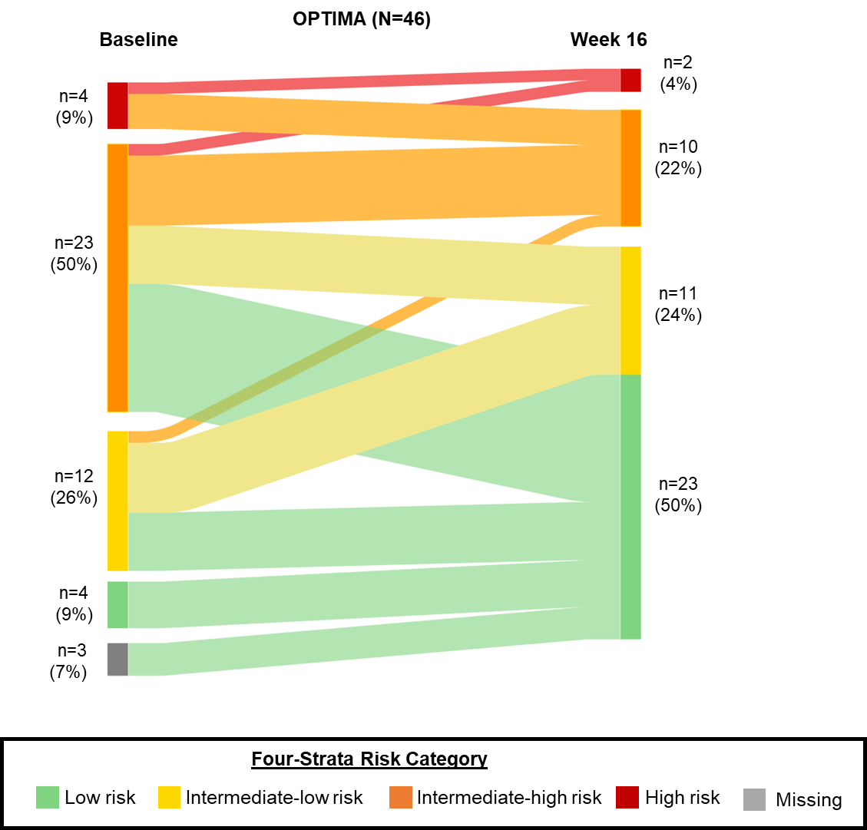 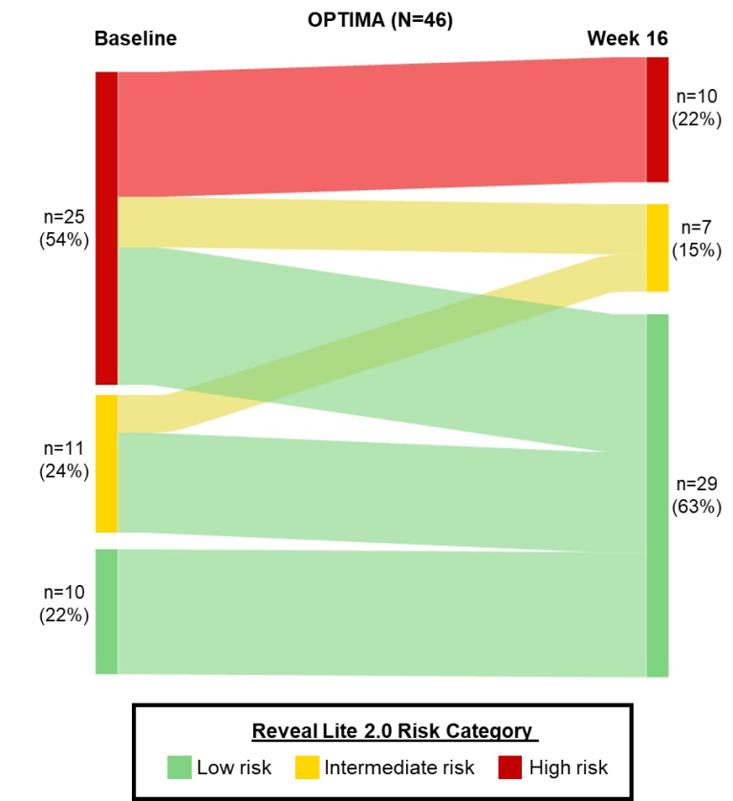
Percentages may not add to 100 due to rounding. A) Defined by four-strata risk score: low = 1, intermediate-low = 2, intermediate-high = 3, high = 4^{6,7}. 24 (52.2%) patients improved (16 [34.8%] to low, 5 [10.9%] to intermediate-low, 3 [6.5%] to intermediate-high), 17 (37.0%) remained unchanged and 2 (4.3%) worsened (1 [2.2%] to intermediate-high, 1 [2.2%] to high). B) Defined by REVEAL Lite 2.0 risk score: low = 1-5, intermediate = 6-7, high = ≥8⁸. 23 (50.0%) patients improved (19 [41.3%] to low, 4 [8.7%] to intermediate) and 23 (50.0%) remained unchanged.

REFERENCES
1. Chin KM, Sitbon O, Doelberg M, Feldman J, Gibbs JSR, Grünig E, Hoeper MM, Martin N, Mathai SC, McLaughlin VV, Perchenet L, Poch D, Saggar R, Simonneau G, Galiè N. Three- Versus Two-Drug Therapy for Patients With Newly Diagnosed Pulmonary Arterial Hypertension. J Am Coll Cardiol 2021; 78:1393–1403.
2. Vonk Noordegraaf A, Channick R, Cottreel E, Kiely DG, Marcus JT, Martin N, Moiseeva O, Peacock A, Swift AJ, Tawakol A, Torbicki A, Rosenkranz S, Galiè N. The REPAIR Study: Effects of Macitentan on RV Structure and Function in Pulmonary Arterial Hypertension. JACC Cardiovasc Imaging 2022; 15:240–253.
3. Sitbon O, Cottin V, Canuet M, Clerson P, Gressin V, Perchenet L, Bertoletti L, Bouvaist H, Picard F, Prévot G, Bergot E, Simonneau G. Initial combination therapy of macitentan and tadalafil in pulmonary arterial hypertension. Eur Respir J 2020; 56:2000673.
4. Kylhammar D, Kjellstrom B, Hjalmarsson C, Jansson K, Nisell M, Soderberg S, Wikstrom G, Radegran G, SveFph, Spahr. A comprehensive risk stratification at early follow-up determines prognosis in pulmonary arterial hypertension. Eur Heart J 2017; 39:4175–4181.
5. Hoeper MM, Kramer T, Pan Z, Eichstaedt CA, Spiesshoefer J, Benjamin N, Olsson KM, Meyer K, Vizza CD, Vonk-Noordegraaf A, Distler O, Opitz C, Gibbs JSR, Delcroix M, Ghofrani HA, Huscher D, Pittrow D, Rosenkranz S, Grunig E. Mortality in pulmonary arterial hypertension: prediction by the 2015 European pulmonary hypertension guidelines risk stratification model. Eur Respir J 2017; 50:1700740.
6. Hoeper MM, Pausch C, Olsson KM, Huscher D, Pittrow D, Grünig E, Staehler G, Vizza CD, Gall H, Distler O, Opitz C, Gibbs JSR, Delcroix M, Ghofrani HA, Park D-H, Ewert R, Kaemmerer H, Kabitz H-J, Skowasch D, Behr J, Milger K, Halank M, Wilkens H, Seyfarth H-J, Held M, Dumitrescu D, Tsangaris I, Vonk-Noordegraaf A, Ulrich S, Klose H, Claussen M, Lange TJ, Rosenkranz S. COMPERA 2.0: A refined 4-strata risk assessment model for pulmonary arterial hypertension. Eur Respir J 2022; 60:2102311.
7. Boucly A, Weatherald J, Savale L, de Groote P, Cottin V, Prévot G, Chaouat A, Picard F, Horeau-Langlard D, Bourdin A, Jutant EM, Beurnier A, Jevnikar M, Jaïs X, Simmoneau G, Montani D, Sitbon O, Humber M. External validation of a refined four-stratum risk assessment score from the French pulmonary hypertension registry. Eur Respir J 2022; 59:2102419.
8. Benza RL, Kanwar MK, Raina A, Scott JV, Zhao CL, Selej M, Elliott CG, Farber HW. Development and Validation of an Abridged Version of the REVEAL 2.0 Risk Score Calculator, REVEAL Lite 2, for Use in Patients With Pulmonary Arterial Hypertension. Chest 2021; 159:337–346.

