Supplemental Materials for
Reasoning supports utilitarian resolutions to moral dilemmas across diverse measures
Indrajeet Patil¹*✉, Micaela Maria Zucchelli²*✉, Wouter Kool^{1,3}, Stephanie Campbell¹, Federico Fornasier⁴, Marta Calò⁴, Giorgia Silani⁵, Mina Cikara¹, & Fiery Cushman¹
¹Department of Psychology, Harvard University, Cambridge, MA, USA.
²Department of Psychology, University of Bologna, Bologna, Italy.
³ Department of Psychological & Brain Sciences, Washington University in St. Louis, St. Louis, MO, USA.
⁴Department of Life Sciences, University of Trieste, Trieste, Italy.
⁵Department of Applied Psychology: Health, Development, Enhancement and Intervention, University of Vienna, Austria.

✉Correspondence and requests for materials should be addressed to:
Indrajeet Patil (patilindrajeet.science@gmail.com) or
Micaela Maria Zucchelli (micaela.zucchelli3@unibo.it)
*These authors contributed equally to this work.

Supplemental Text S1: Details about reasoning measures used in Study 1a-b, Study 3a-e
- Need for Cognition (NFC):
Need for cognition or NFC (Cacioppo, Petty, & Kao, 1984) is a widely-used measure to assess the degree to which individuals are intrinsically motivated to engage in cognitive deliberation, i.e. how much they find thinking enjoyable and how frequently they engage in reflection without an external incentive to do so. Participants reported agreement with statements (e.g., “I really enjoy a task that involves coming up with new solutions to problems”) on a 9-point Likert scale (-4: very strong disagreement, 0: neither agreement nor disagreement, +4: very strong agreement).
- Cognitive Reflection Test (CRT):
We used the new psychometrically improved six-item version of CRT (Finucane & Gullion, 2010) to gauge how well (and not fast or effortful) people think, i.e. cognitive style of thinking. This measure consists of items featuring a problem which has an intuitively appealing answer that immediately comes to one’s mind (Frederick, 2005) but upon careful reflection turns out to be incorrect. In other words, CRT measures individuals' ability to suppress an intuitive and spontaneous wrong answer in favor of a reflective and deliberative right answer.
For example, consider the following question: If it takes 2 nurses 2 minutes to measure the blood pressure of 2 patients, how long would it take 200 nurses to measure the blood pressure of 200 patients?
If one were to rely solely on an intuitive style of thinking, 200 minutes will be the most appealing answer, but a reflective style of thinking entails engaging further in analytic processing and overriding this initial response to conclude that the correct answer is 2 minutes. Importantly, participants completed the CRT measure either before or after the moral judgment task, but it was one of the many questionnaires administered and thus the order effects were not relevant to the current study (cf. Paxton, Ungar, & Greene, 2012). For each participant, CRT score was computed to be the sum of correct responses (score range: 0-6). We had predetermined to leave out any participant who didn’t answer any one of the CRT items. No participant was excluded based on this criterion.
- Rational Experiential Inventory (REI):
The Rational Experiential Inventory (Norris, Pacini & Epstein, 1998) was designed to assess to what degree people engage in two modes of thinking: a fast, intuitive automatic thinking and a slower logical thinking. Theoretically motivated by Cognitive-Experiential Self-Theory (CEST; Epstein, 1973), the various versions of the REI distinguish between two cognitive styles: (i) a rational style, measured by modified version of Need for Cognition (NFC) scale (Cacioppo & Petty, 1982) that emphasizes a conscious, analytical approach; (ii) an experiential style, measured by the Faith in Intuition (FI) scale, that emphasizes a pre-conscious, affective, holistic approach.
The REI scale is composed of 40 items. Participants judge to what extent the items describe them, using a 5-point ratings system (1 = definitely not true of myself to 5 = definitely true of myself). Rational Ability (RA), which indexes ability to think logically and analytically (e.g., “I have a logical mind”), and Rational Engagement (RE), which gauges reliance on and enjoyment of thinking in an analytical, logical manner (e.g., “Thinking hard and for a long time about something gives me little satisfaction”), together form the Rationality component of REI. On the other hand, Experiential Ability (EA), which measures the ability with respect to one's intuitive impressions and feelings (e.g., “When it comes to trusting people, I can usually rely on my gut feelings”), and Experiential Engagement (EE), which assesses reliance on and enjoyment of feelings and intuitions in making decisions (e.g., “I often go by my instincts when deciding on a course of action”), composed the Experientiality one. Following CEST theory, Epstein et al. (1996) suggested the two processing modes to be independent of each other, so that it is possible to score high (or low) on both rationality and experientiality. For our purposes the REI-40 version (Pacini and Epstein, 1999) was used, with 20 items each for the rationality and experientiality measures. Although the entire scale was administered, we focus here only on the rational component of REI given its relevance to our hypothesis. Data and analysis for the experiential component can be found in the associated datafiles uploaded to OSF.
The items of Rational-Experiential Inventory are listed below:
1. I have a logical mind.
2. I prefer complex problems to simple problems.
3. I believe in trusting my hunches.
4. I am not a very analytical thinker.
5. I trust my initial feelings about people.
6. I try to avoid situations that require thinking in depth about something.
7. I like to rely on my intuitive impressions.
8. I don’t reason well under pressure.
9. I don’t like situations in which I have to rely on intuition.
10. Thinking hard and for a long time about something gives me little satisfaction.
11. Intuition can be a very useful way to solve problems.
12. I would not want to depend on anyone who described himself or herself as intuitive.
13. I am much better at figuring things out logically than most people.
14. I usually have clear, explainable reasons for my decisions.
15. I don’t think it is a good idea to rely on one’s intuition for important decisions.
16. Thinking is not my idea of an enjoyable activity.
17. I have no problem thinking things through carefully.
18. When it comes to trusting people, I can usually rely on my gut feelings.
19. I can usually feel when a person is right or wrong, even if I can’t explain how I know.
20. Learning new ways to think would be very appealing to me.
21. I hardly ever go wrong when I listen to my deepest gut feelings to find an answer.
22. I think it is foolish to make important decisions based on feelings.
23. I tend to use my heart as a guide for my actions.
24. I often go by my instincts when deciding on a course of action.
25. I’m not that good at figuring out complicated problems.
26. I enjoy intellectual challenges.
27. Reasoning things out carefully is not one of my strong points.
28. I enjoy thinking in abstract terms.
29. I generally don’t depend on my feelings to help me make decisions.
30. Using logic usually works well for me in figuring out problems in my life.

- Actively Open-Minded Thinking (AOT) scale:
Actively Open-Minded Thinking scale (Baron, 1993, Baron et al., 2015; Haran et al.,2013) assesses the disposition to be fair towards different conclusions even if they go against one’s initially favored conclusion, to spend sufficient time on a problem before giving up, and to consider carefully the opinions of others in forming one’s own. It is composed by 11 items. Participants answer on a 5-point scale from "Completely disagree" to "Completely agree" with respect to each item proposed. It has been found to correlate with various other measures of reflective thinking, however, its original purpose was to show that the way people think is related to their beliefs about how they should think. Research by Stanovich et al. (Macpherson & Stanovich, 2007; Sa, West, & Stanovich, 1999; Stanovich & West, 1998) found a reduced susceptibility, of AOT, to belief bias (Evans et al., 1983) probably related to the desire to be more informed before making an estimate or prediction.
Here the items of AOT scale:
- Allowing oneself to be convinced by an opposing argument is a sign of good character.
- People should take into consideration evidence that goes against their beliefs.
- People should revise their beliefs in response to new information or evidence.
- Changing your mind is a sign of weakness.
- Intuition is the best guide in making decisions.
- It is important to persevere in your beliefs even when evidence is brought to bear against them.
- One should disregard evidence that conflicts with one’s established beliefs.
- People should search actively for reasons why their beliefs might be wrong

- Belief Bias (BB):
Belief Bias is the tendency to judge the strength of arguments based on the believability of their conclusion rather than how strongly they support that conclusion. Consequently, a person is more likely to accept arguments that supports a conclusion that aligns with his beliefs and prior knowledge, while rejecting arguments in disagreement with them. One context in which this phenomenon is particularly studied is that of syllogism reasoning (e.g., Evans et al., 1983; Evans et al., 1994; Evan & Curtis-Holmes, 2005; Thompson & Evans, 2012).
A syllogism is a kind of logical argument that applies deductive reasoning to arrive at a conclusion based on two or more propositions that are asserted or assumed to be true.
When the believability of the conclusion is incongruent with its logical validity, the syllogisms is defined ‘conflict’ syllogism, as opposed to the ‘control’ syllogism, in which a response based on believability would be the same as a response based on logical validity or both are unbelievable and logically invalid.
In the former case, when the conclusion following the premises is logically invalid but believable, individuals often produce belief bias, considering as logic valid the conclusion because it is congruent with their prior beliefs. Therefore, the tendency to produce belief bias was explored administering conflict syllogistic reasoning problems, in which the conclusion was logically invalid but believable.
Syllogism is a logical argument, composed of three parts (usually represented in a three-line form): a general statement (the major premise), a specific statement (the minor premise), from which a conclusion is deduced. For instance:

All birds have two legs and wings (the major premise).
A dove is a bird (the minor premise).
A dove has two legs and wings (the conclusion).

The task required is to judge if the conclusion logically follows the premises. However, the conclusion can logically follow or not from the two premises and it could be believable or not in relation to reality.
An example of a conclusion logically valid but unbelievable is the following:
All human are animals.
All animals are immortal.
Therefore, all human are immortal.

On the other hand, an example of a conclusion logically invalid but believable (conflict syllogisms) is:
All quadrupeds are mammals.

All quadrupeds are animals.

So, all mammals are animals.

The latter type of syllogistic problems, in which the conclusion is logically invalid but believable, are usually employed to study the phenomenon of Belief Bias, which is induced by the plausibility of the conclusion. So, Belief Bias allows to measure the tendency of individuals to accept a logically invalid but believable conclusion, or the ability to suppress this intuitive and spontaneous answer, in favor of a reflective and deliberative right answer, based on the logically validity of the arguments instead of on their believability.

So, for our purposes, only syllogisms in which conclusions are logically invalid but believable, are employed. They are taken from previous studies which employed them in the domain of morality (Baron et al., 2015) or from some of the major studies which explored belief bias in the context of syllogisms reasoning (Thomson & Evans, 2012; Morley, Evans & Handle, 2004).
Below we provide the list of syllogistic problems employed:

Invalid, believable (Baron et al., 2015)
All flowers have petals.
Roses have petals.
Therefore, roses are flowers.
The conclusion logically follows the premises?

Invalid, believable (Baron et al., 2015)
All wives are married.
Some women are married.
Therefore, some women are wives.
The conclusion logically follows the premises?

Invalid, believable (Baron et al., 2015)
All things that have a motor need oil.
Automobiles need oil.
Therefore, automobiles have a motor.
The conclusion logically follows the premises?

Invalid, believable (Morley, Evans & Handle, 2004)
Not highly trained dog are vicious.
Some vicious dog are police dog.
Therefore, some highly trained dog are not police dog.
The conclusion logically follows the premises?

Invalid, believable (Baron et al., 2015)
All living things need water.
Roses need water.
Therefore, roses are living things.
The conclusion logically follows the premises?

Invalid-believable (Thomson & Evans 2012)
No addictive things are inexpensive.
Some cigarettes are inexpensive.
Therefore, some addictive things are not cigarettes.
The conclusion logically follows the premises?

Invalid, believable (Thomson & Evans 2012)
Some vitamin tablets are opprobines.
No nutritional things are opprobines.
Therefore, some nutritional things are not vitamin tablets.
The conclusion logically follows the premises?

Invalid, believable (Thomson & Evans 2012)
No well-educated people are Pennes.
Some judges are Pennes.
Therefore, some well-educated people are not judges.
The conclusion logically follows the premises?

- Internal reliability for measures
Measure | Part 1: Classical | Part 2: PD
NFC | 0.89 | 0.89
CRT | NA | 0.84
REI – RA | 0.86 | 0.85
REI – RE | 0.83 | 0.85
Rationality | 0.91 | 0.90
BB | 0.75 | 0.73
AOT | 0.67 | 0.66

Table S1-1: Internal reliability (Cronbach α) for all measures used in Study 1a-b and 3a

- Two step tasks:
Task details
We focused on two variations of the two-step task (Daw, Gershman, Seymour, Dayan, & Dolan, 2011; Kool, Cushman, & Gershman, 2016), both of which are able to distinguish contributions of model-free and model-based systems by introducing situations in which the model-based system can use its explicit model of the task structure to overcome the limitations of using direct action-reward associations. Scripts for all RL tasks available at: https://github.com/wkool/shockgames.
In the original version of the two-step task (Daw et al., 2011), henceforth referred to as the “Daw two-step task”, each trial starts in a state that offers two choice options that lead to two second-stage states with different probabilities (Figure 2a, 2b in the main text). Specifically, each choice leads to one second-stage state with 70% probability through a common transition, but to the other state with 30% through a rare transition. Each of these second-stage states offers another choice between two options that are associated with a chance of earning some reward. These reward probabilities change randomly and independently across the experiment, so there always is a need to learn. Through these rare transitions, the Daw two-step task can distinguish between model-based and model-free contributions towards choice behavior. To see this, imagine a trial on which the participant chooses an option, transitions through a rare transition to a second-stage state, and then receives a reward. How would this affect decision-making on the subsequent trial? If the agent were fully model-based, she would be more likely to switch action preferences to the other option at the start of the next trial, since this choice option has a higher chance of leading to the state in which the reward on the previous trial was earned. A fully model-free agent, on the other hand, would become more likely to repeat the chosen on the previous trial option, because this was the action that previously led to the reward.
A recently developed version of the two-step task by Kool, Cushman, and Gershman (Kool et al., 2016) can similarly distinguish between these two choice strategies, but through different means. In this “Kool two-step task”, each trial starts in one of two starting states, each of which offers a choice between two options. This first-stage choice determines which of two second-stage states is encountered. Importantly, in each first-stage state, the participant can visit either second-stage state: one choice options always lead to one second-stage state, and the other always to the other. Again, these second-stage states are associated with an opportunity to earn reward. Dissociating model-based from model-free control follows a slightly different logic in the Kool task than in the Daw task. The key difference between them is that a model-based strategy can generalize experiences learned from one starting state to the other, because this strategy plans toward the second-stage goals. However, a model-free strategy is unable to do so, because it only learns action-reward associations (Doll, Duncan, Simon, Shohamy, & Daw, 2015). Therefore, if a model-free agent visits a second-stage state from one starting state and earns a large reward, then on the next trial it will not be able to use this information in the other starting state, because it has only updated its belief about the action it took in the starting state on the previous trial.
Participants’ behavior on these two tasks reflects a mixture of both model-free and model-based control (Daw et al., 2011; Kool, Cushman, & Gershman, 2018). To more concretely measure this individual difference, researchers typically fit a dual-system RL model to behavior on this task. In this model, both systems compute expected values for the actions at the first-stage, which are then combined according to a mixture parameter w that represents the relative balance between model-free (w = 0) and model-based control (w = 1), with higher values of w indicating greater contribution of model-based control in choice behavior.
Dual-system RL model
Since we wanted to assess individual differences in the degree of model-based control, we employed a dual-systems RL model (for more detail, see Kool et al., 2016). This model consists of a model-free system and a model-based system that both represent values for the actions at the first-stage state. The model-free system learns state-action values for all first- and second-stage states through a simple temporal difference-learning algorithm (Sutton & Barto, 1998). It achieves this by simply increasing the value of actions that lead to outcomes that are more positive than expected (i.e., that produce a positive prediction error) and decreasing the value of actions that lead to outcomes that are less positive than expected (a negative prediction error). The model-based algorithm, on the other hand, works by learning a transition function that maps the first-stage state-action pairs to a probability distribution over the subsequent states, and then combining this function with the second-level model-free values (i.e., the immediate reward predictions) to compute cumulative state-action values by iterative expectation. In other words, the agent first decides which first-stage action leads to which second-stage state, and then learns the reward values for the second-stage actions.
Model-fitting procedure
We used maximum a posteriori estimation with empirical priors, implemented using the mfit toolbox (Gershman, 2016) parameters to fit each of the seven free parameters in the computational models to observed data for each participant separately. For our current purpose, the most important of these is the weighting (or mixture) parameter w, which dictates the relative contribution of the model-based and model-free system for the first-stage choices. The model also includes an inverse-temperature parameter β, which controls the exploration-exploitation tradeoff between choice options give their difference in value. This parameter transforms these values to a choice probability through a logistic function ranging from equal likelihoods across actions (pure exploration), toward always picking the option with the highest value (pure exploitation). The learning rate parameter α indexes the degree to which the model-free system updates action values after a reward outcome, an eligibility trace parameter λ controls the degree to which outcome information at the second stage transferred to the first-stage actions, and “stickiness” parameters π and ρ that capture perseveration on either the response or the stimulus choice. Based on prior work (Gershman, 2016), we used weak priors for the distributions for the inverse temperature, β ~ Gamma(4.82, 0.88), and stickiness parameters, π, ρ ~ N (0.15, 1.42), and flat priors for all other parameters. To avoid local optima in the estimation solution, we ran the optimization 100 times for each participant with randomly selected initializations for each parameter.
Exclusion criteria
We excluded participants from analysis if they failed to respond within the response deadline on more than 10% of all trials, and we excluded all trials that timed out before the participant made a response. Furthermore, we excluded participants who showed an unusually high degree of response or choice stickiness (|π| > 0.5 or |ρ| > 0.5), because such values reflect choice behavior that either repeats the same choice option or physical button presses (or alternates between them from trial to trial), irrespective of their value. In other words, these participants used a choice strategy that did not involve any model-free or model-based evaluation, which diminishes the interpretability of the other RL parameters in the model (such as w, the degree of model-based control). Finally, in order to eliminate participants with patterns of ‘random’ responding, we simulated completely random behavior on each task 1000 times and fit the dual-system RL model to these synthetic datasets. From these fits, we extracted the 95th percentile log-likelihood score (which is a measure that indicates the degree to which the model fits the data). We reasoned that for any participant who showed a worse fit to the RL model than this score, we were not able to infer that they meaningfully performed the task, and therefore excluded them from further analysis.

Supplemental Text S2: Additional figures for Study 1a-b
(i) Cognitive Reflection Test (CRT) and “Utilitarian” moral judgments
For “fumes” vignette, two missing data points were removed and therefore sample size was 107.
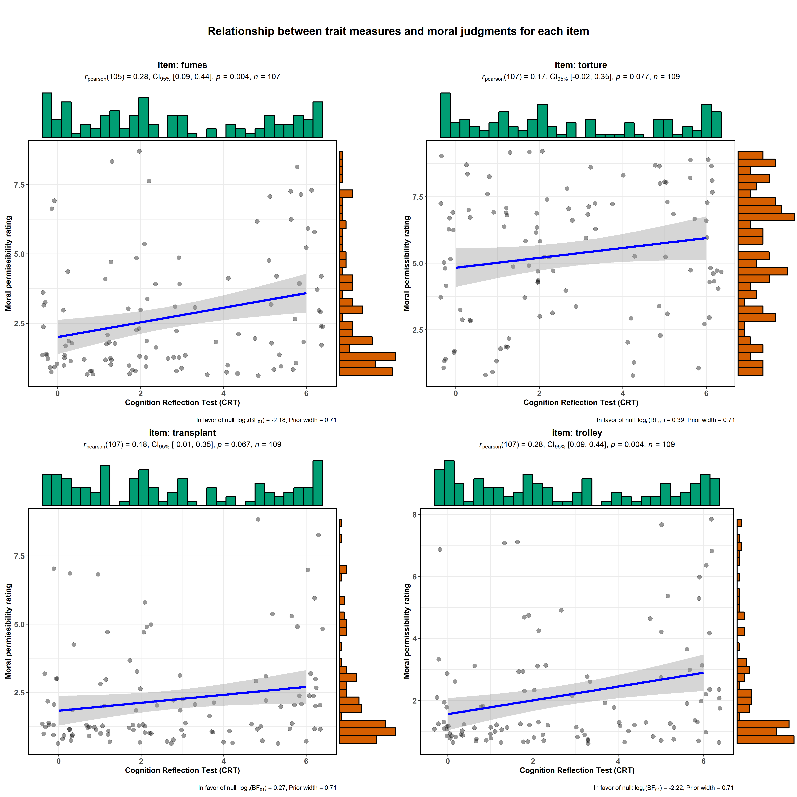Figure S2-1: Relationship between CRT and moral judgments for each item.

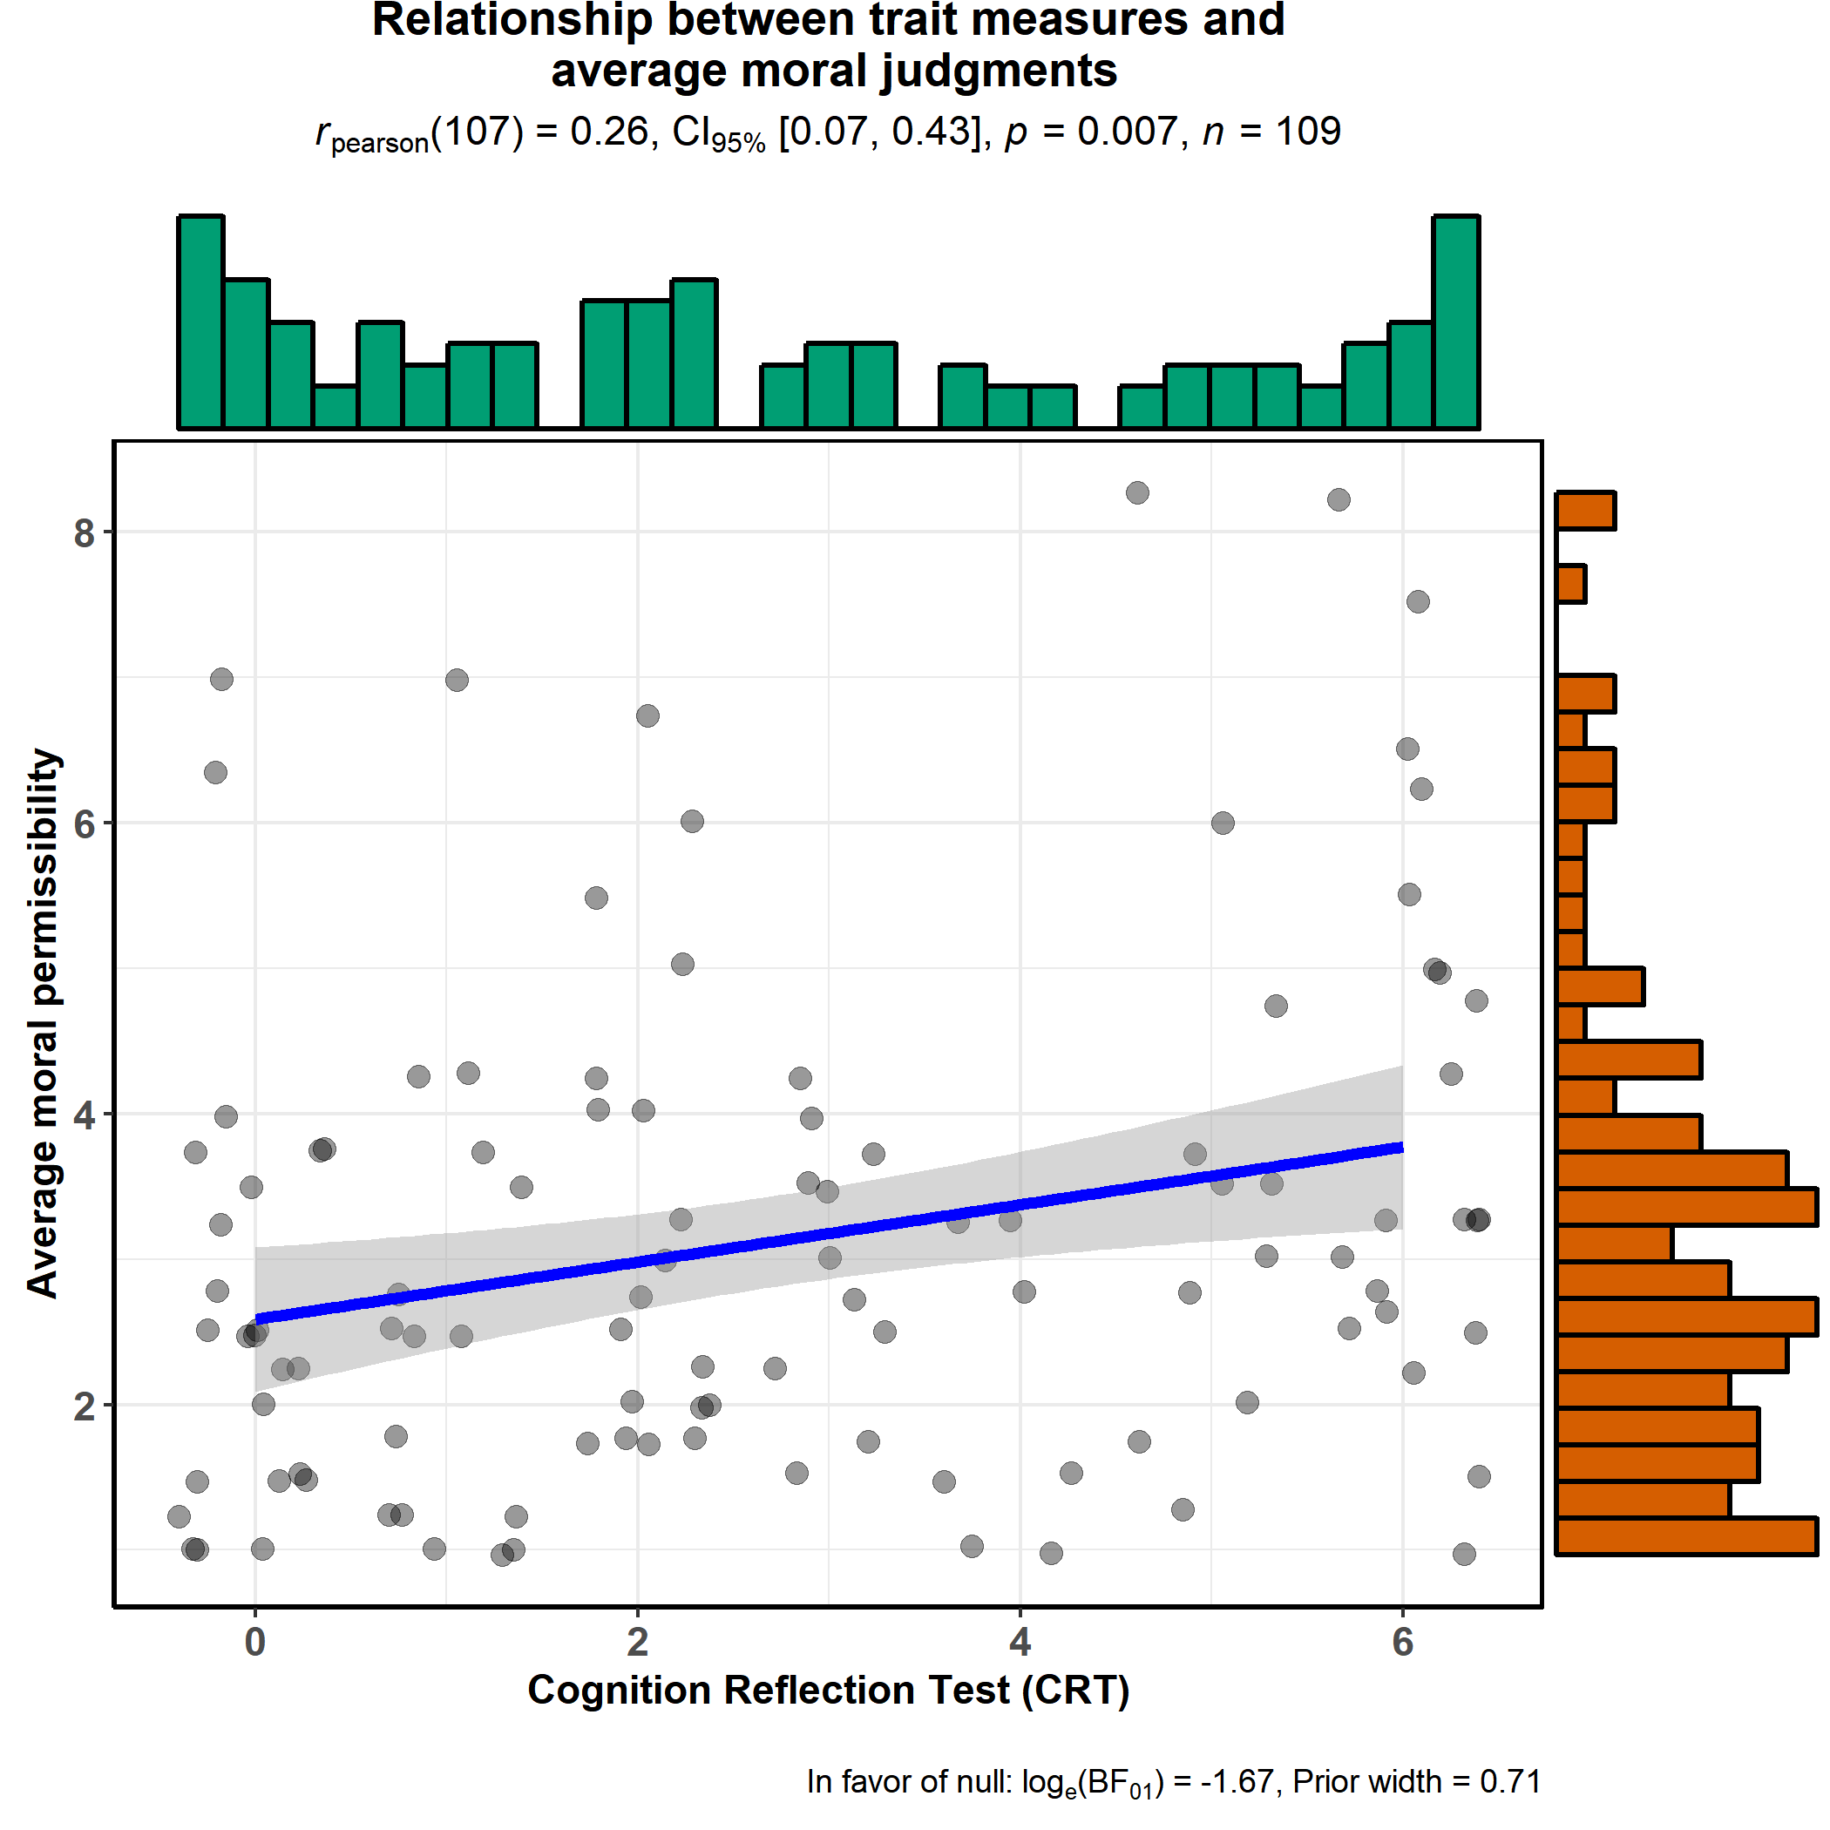
Figure S2-2: Relationship between CRT and average of moral judgments for the four scenarios considered. Those higher in CRT, tend to judge the utilitarian option as more morally permissible.

(ii) Need for Cognition and “Utilitarian” moral judgments

Figure S2-3: Relationship between NFC and moral judgments for each item.

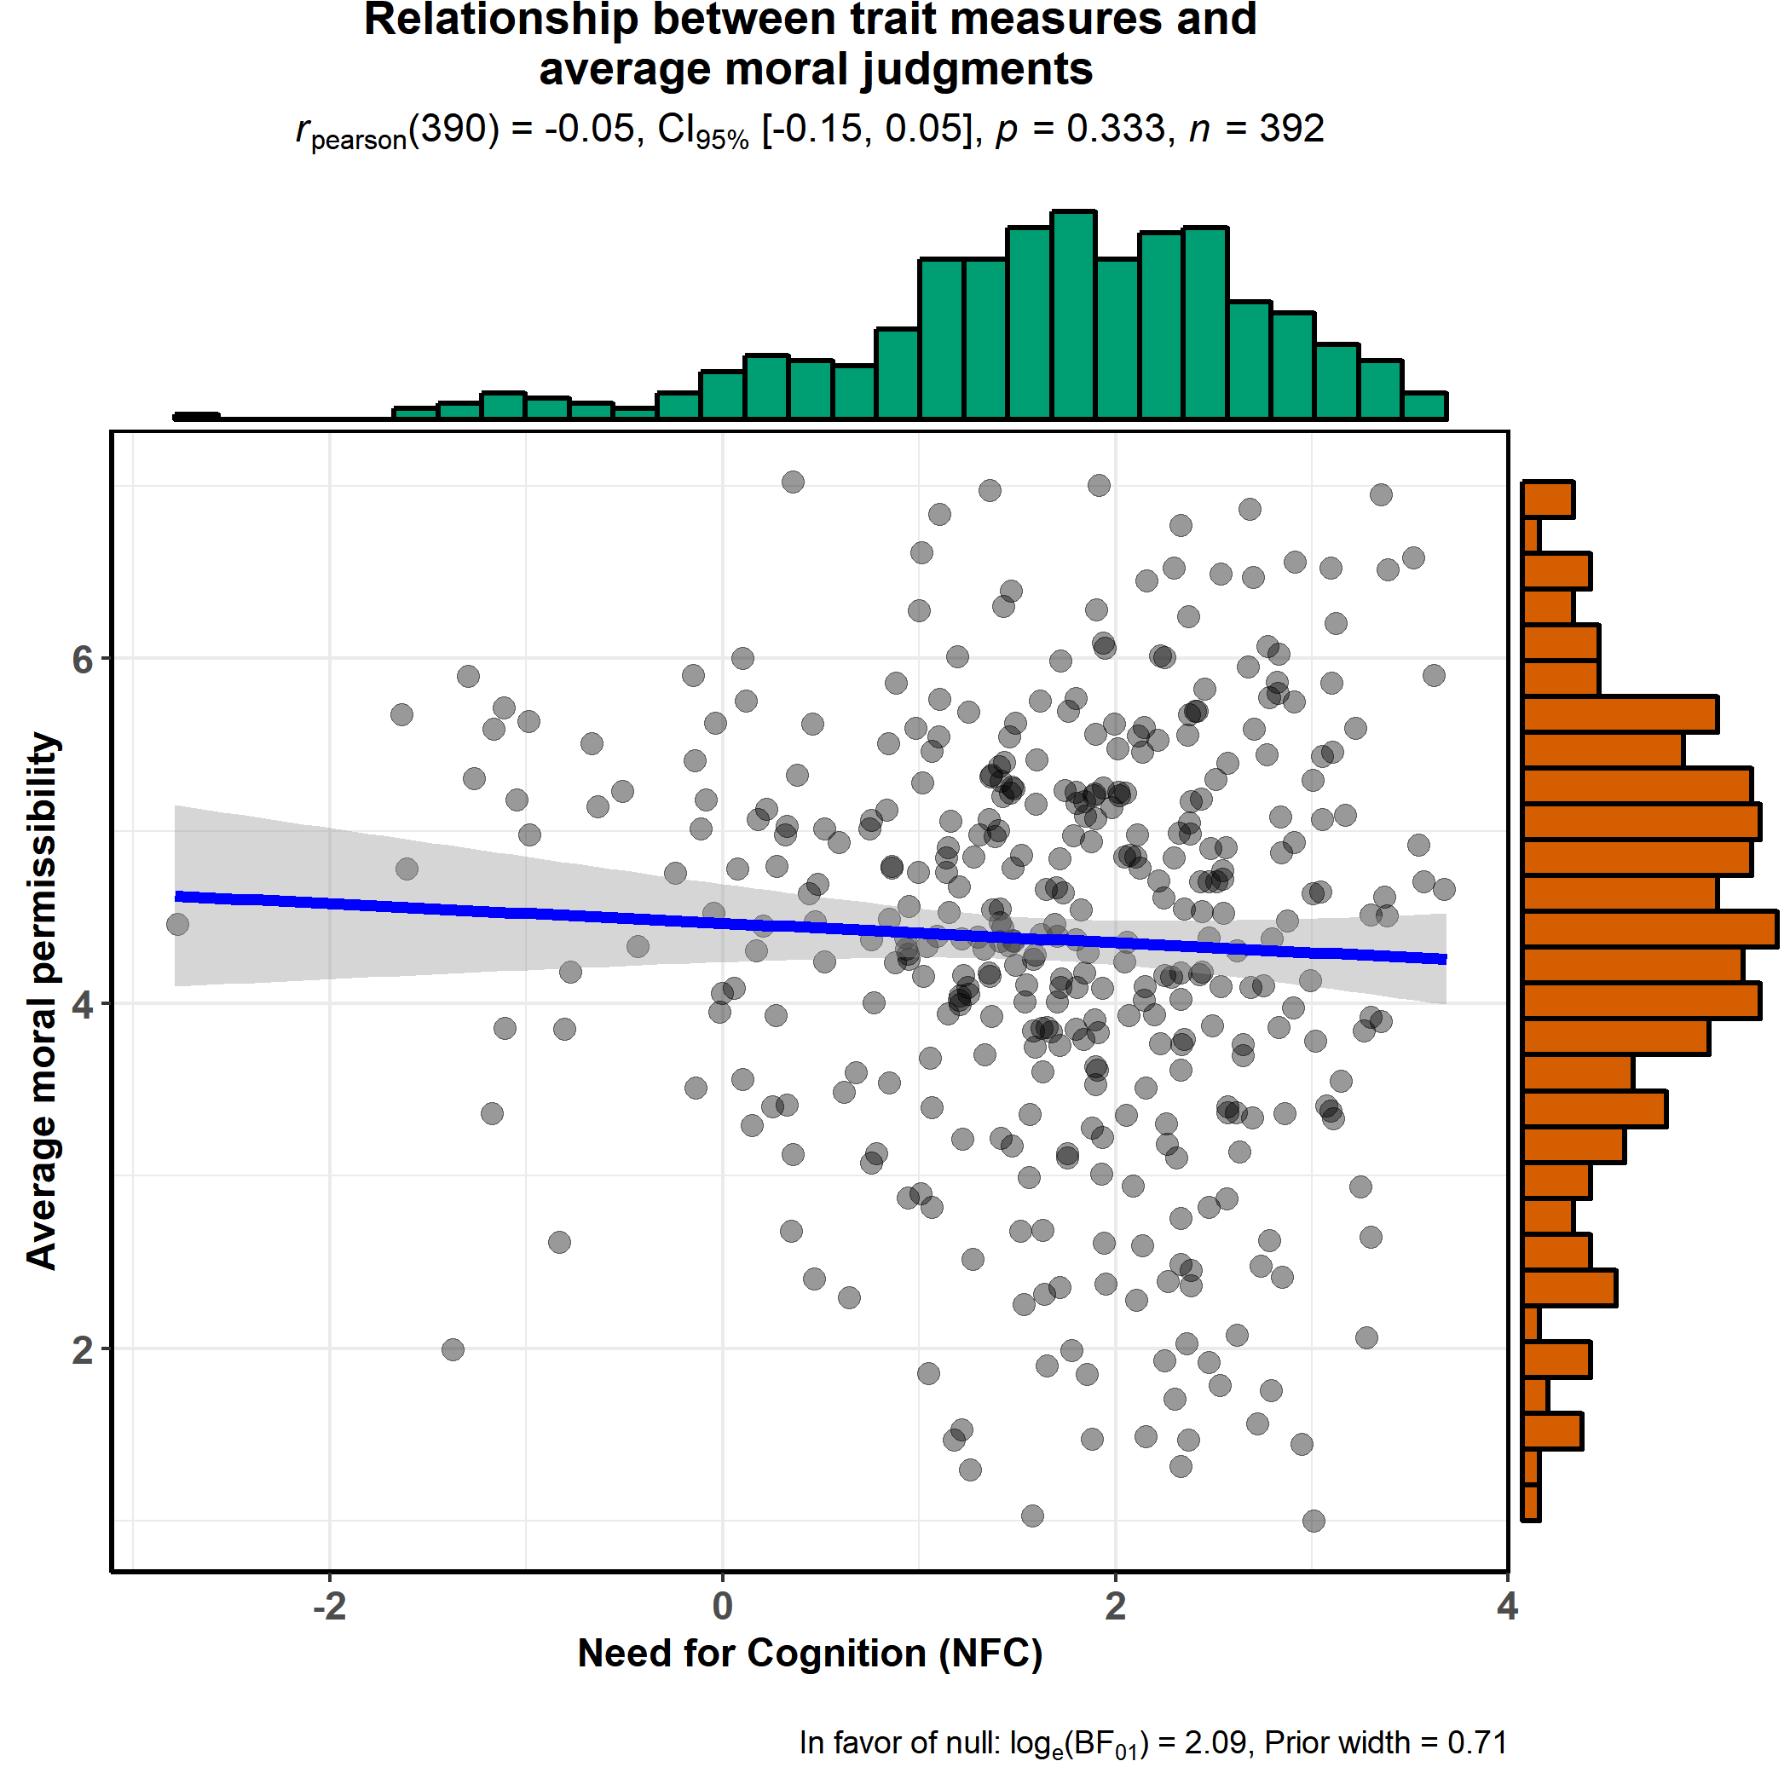
Figure S2-4: Lack of relationship between NFC and average of moral judgments for the 13 scenarios considered

(iii) Actively Open-Minded Thinking and “Utilitarian” moral judgments

Figure S2-5: Relationship between AOT and moral judgments for each item.

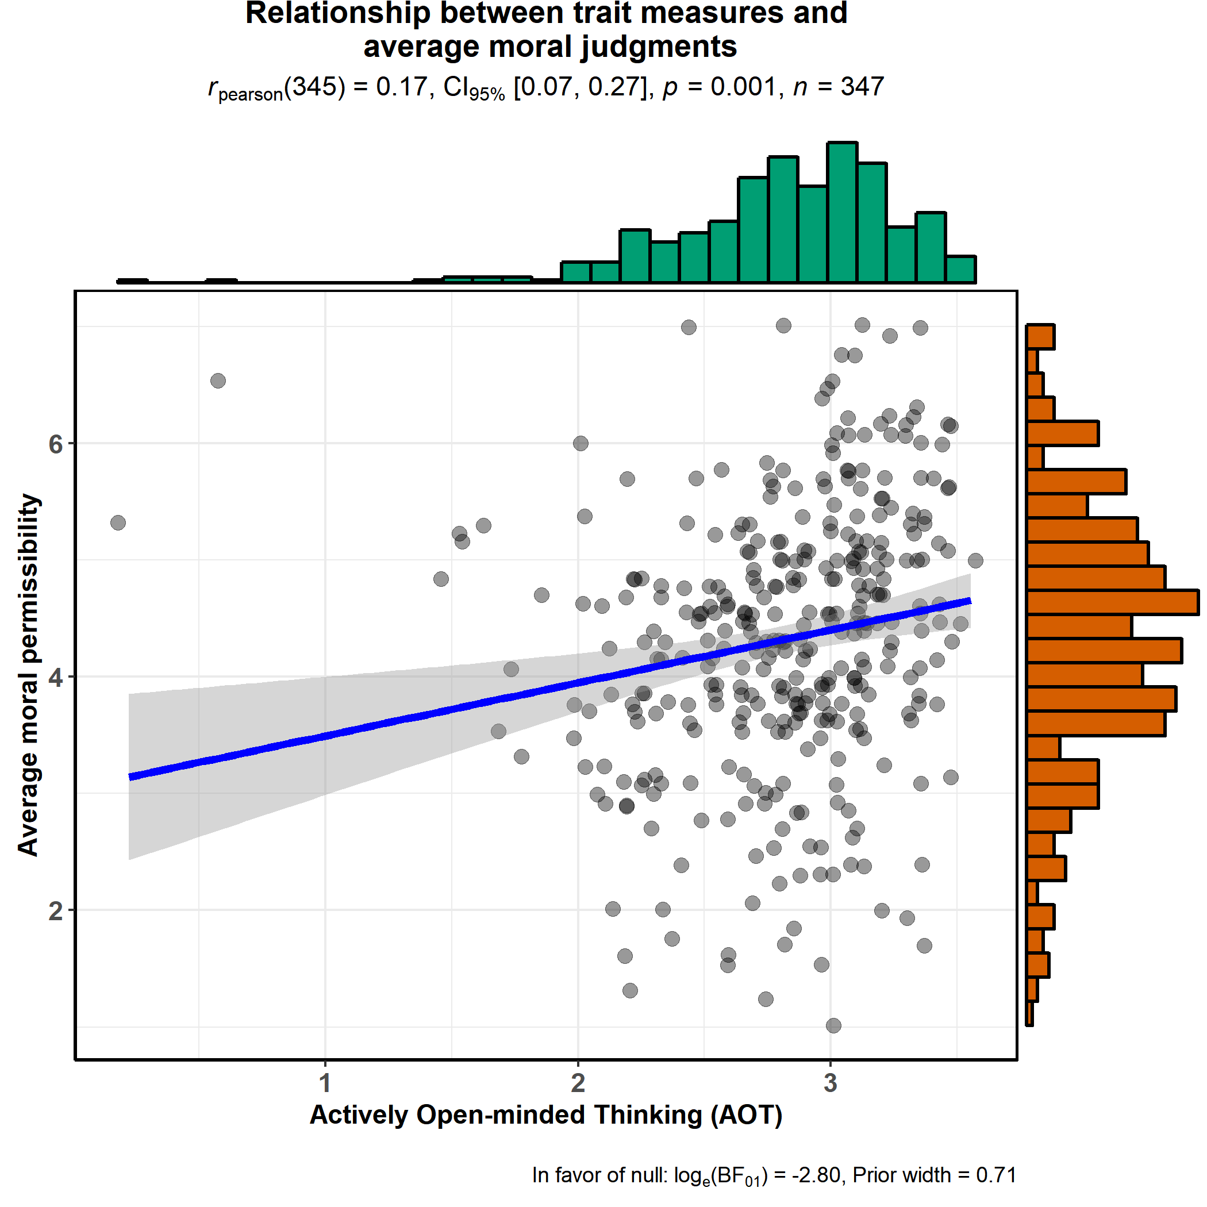
Figure S2-6: Relationship between AOT and average of moral judgments for the 13 scenarios considered. People higher in engaging in flexible or open-minded thinking and avoiding dogmatic or categorical thinking, tend to judge the utilitarian option as more morally permissible.

(iv) Rational Experiential Inventory (REI) and “Utilitarian” moral judgments.

Figure S2-7: Relationship between REI and moral judgments for each item.

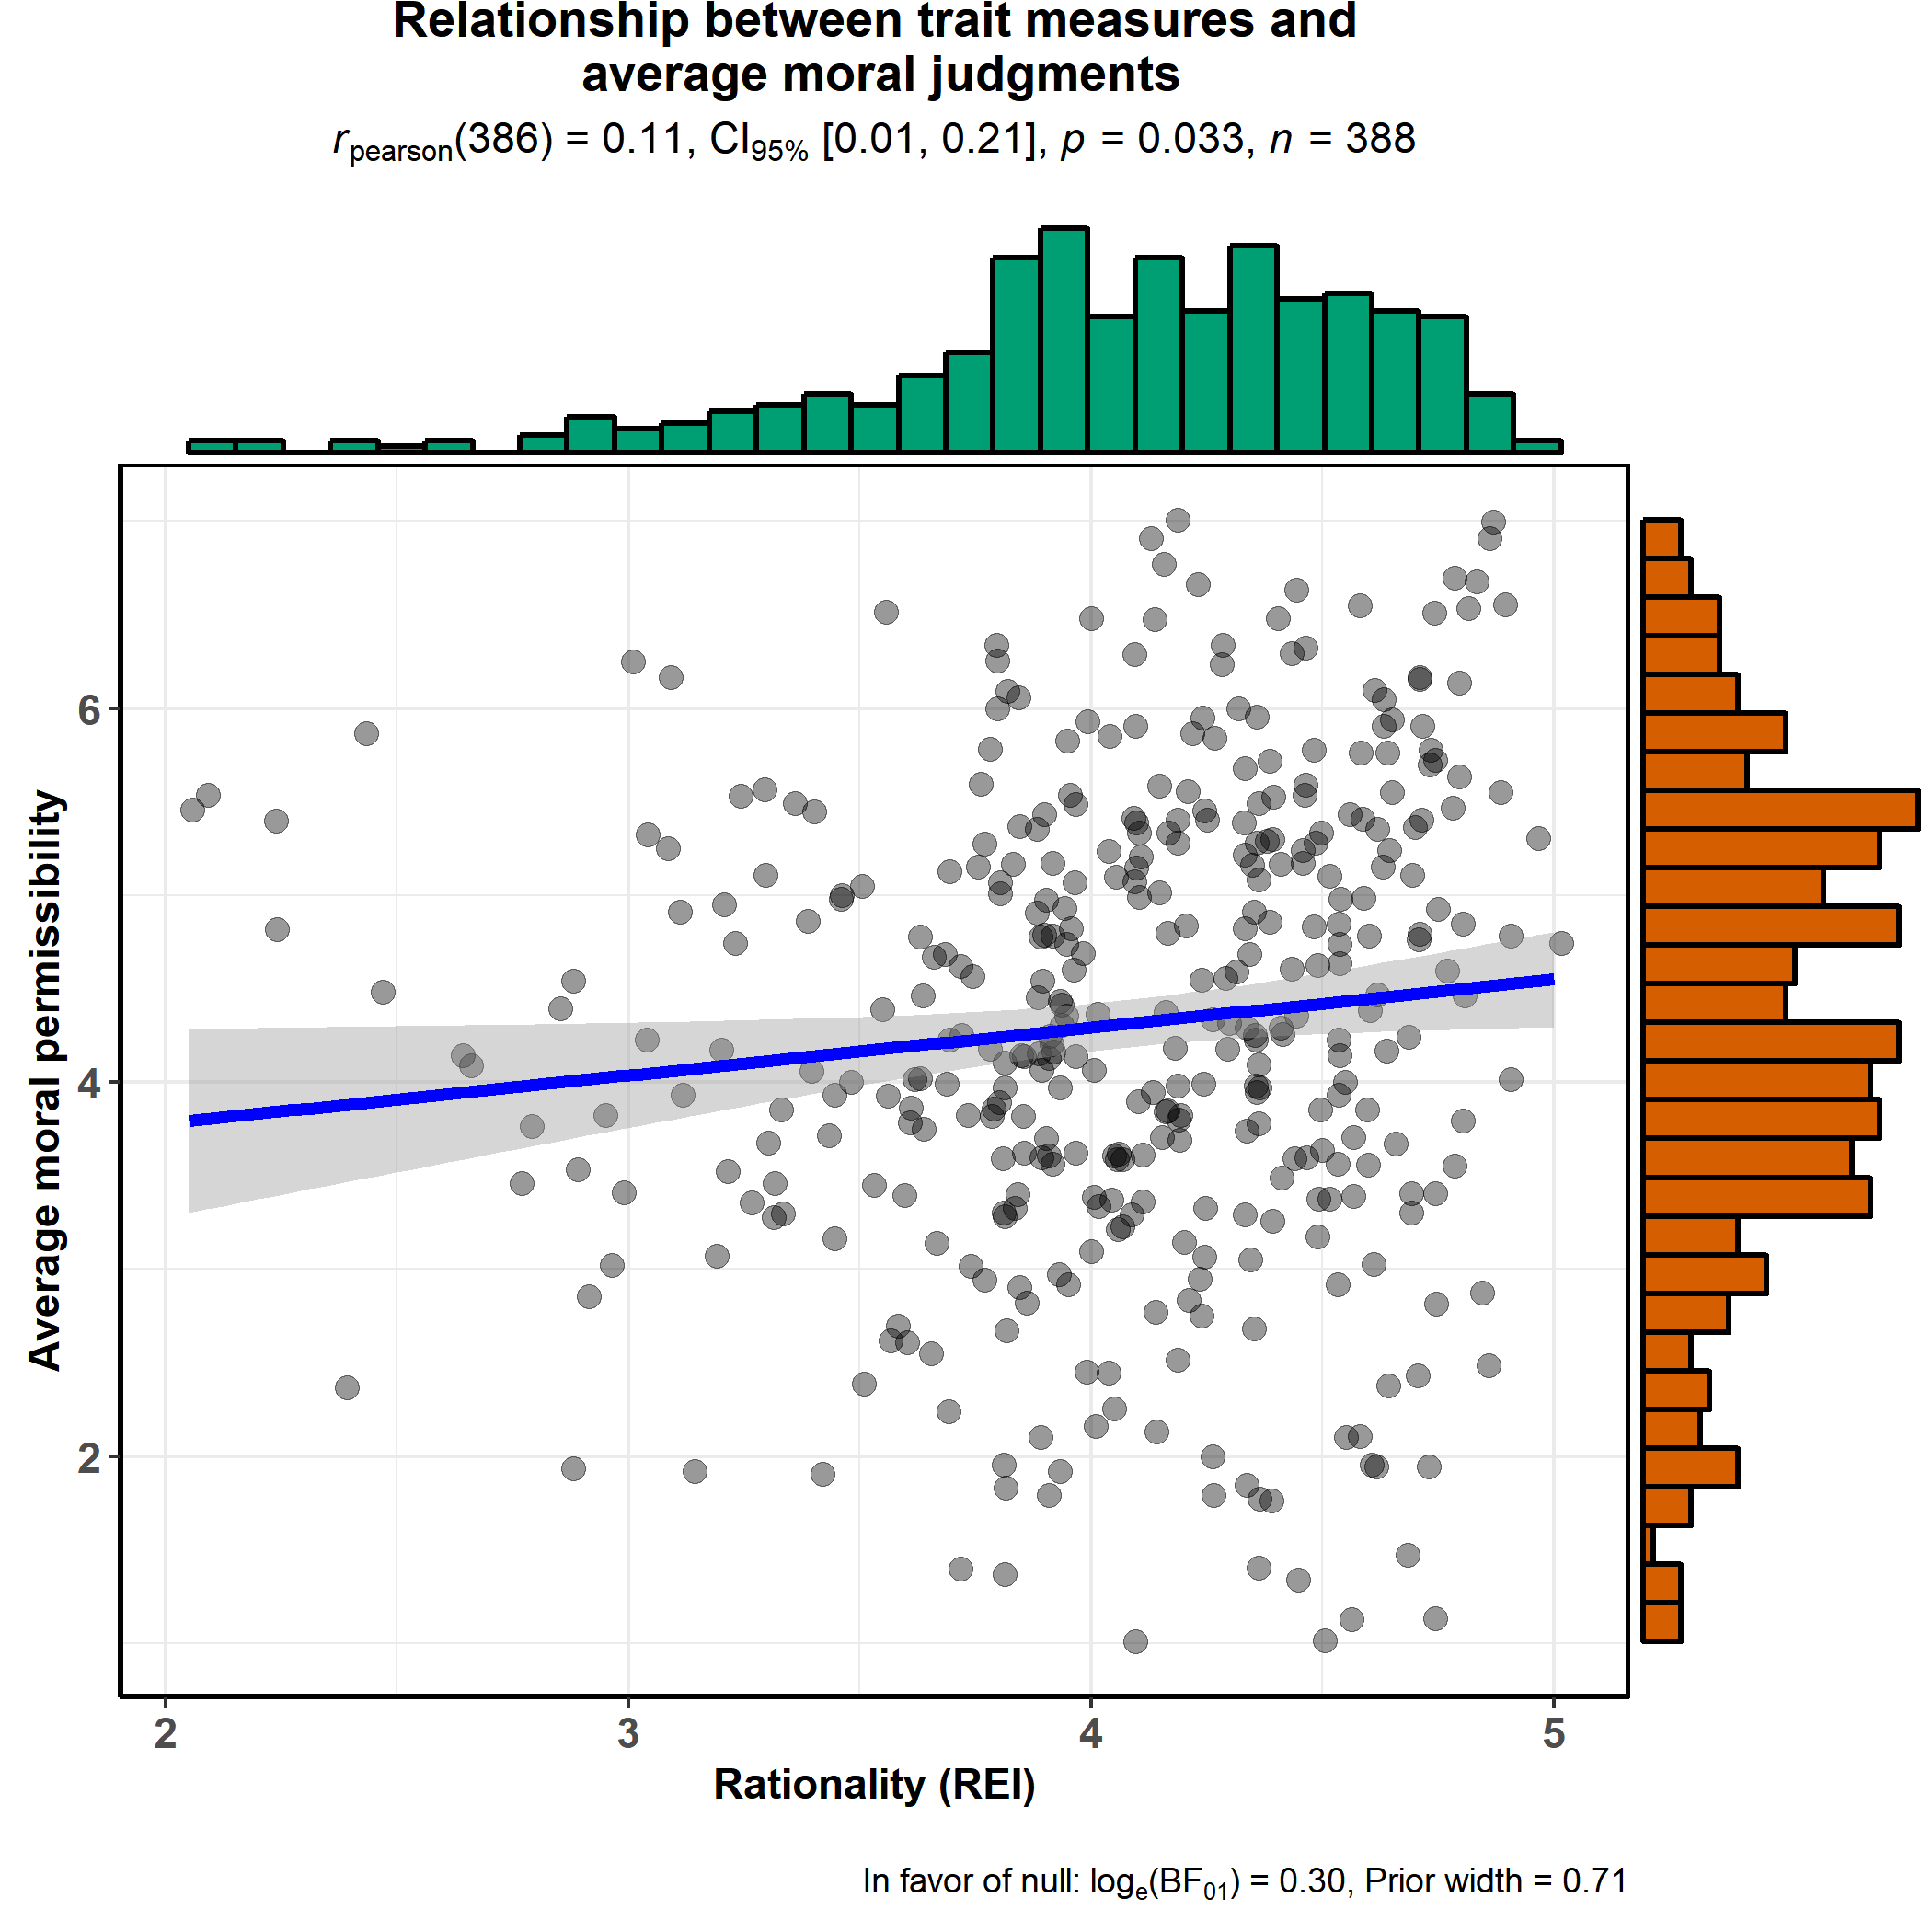
Figure S2-8: Considering the overall REI a positive relationship emerged: those higher in rationality judge the sacrifice of few, to save many, as more morally permissible.

(v) Belief Bias and “Utilitarian” moral judgments

Figure S2-9: Relationship between BB and moral judgments for each item

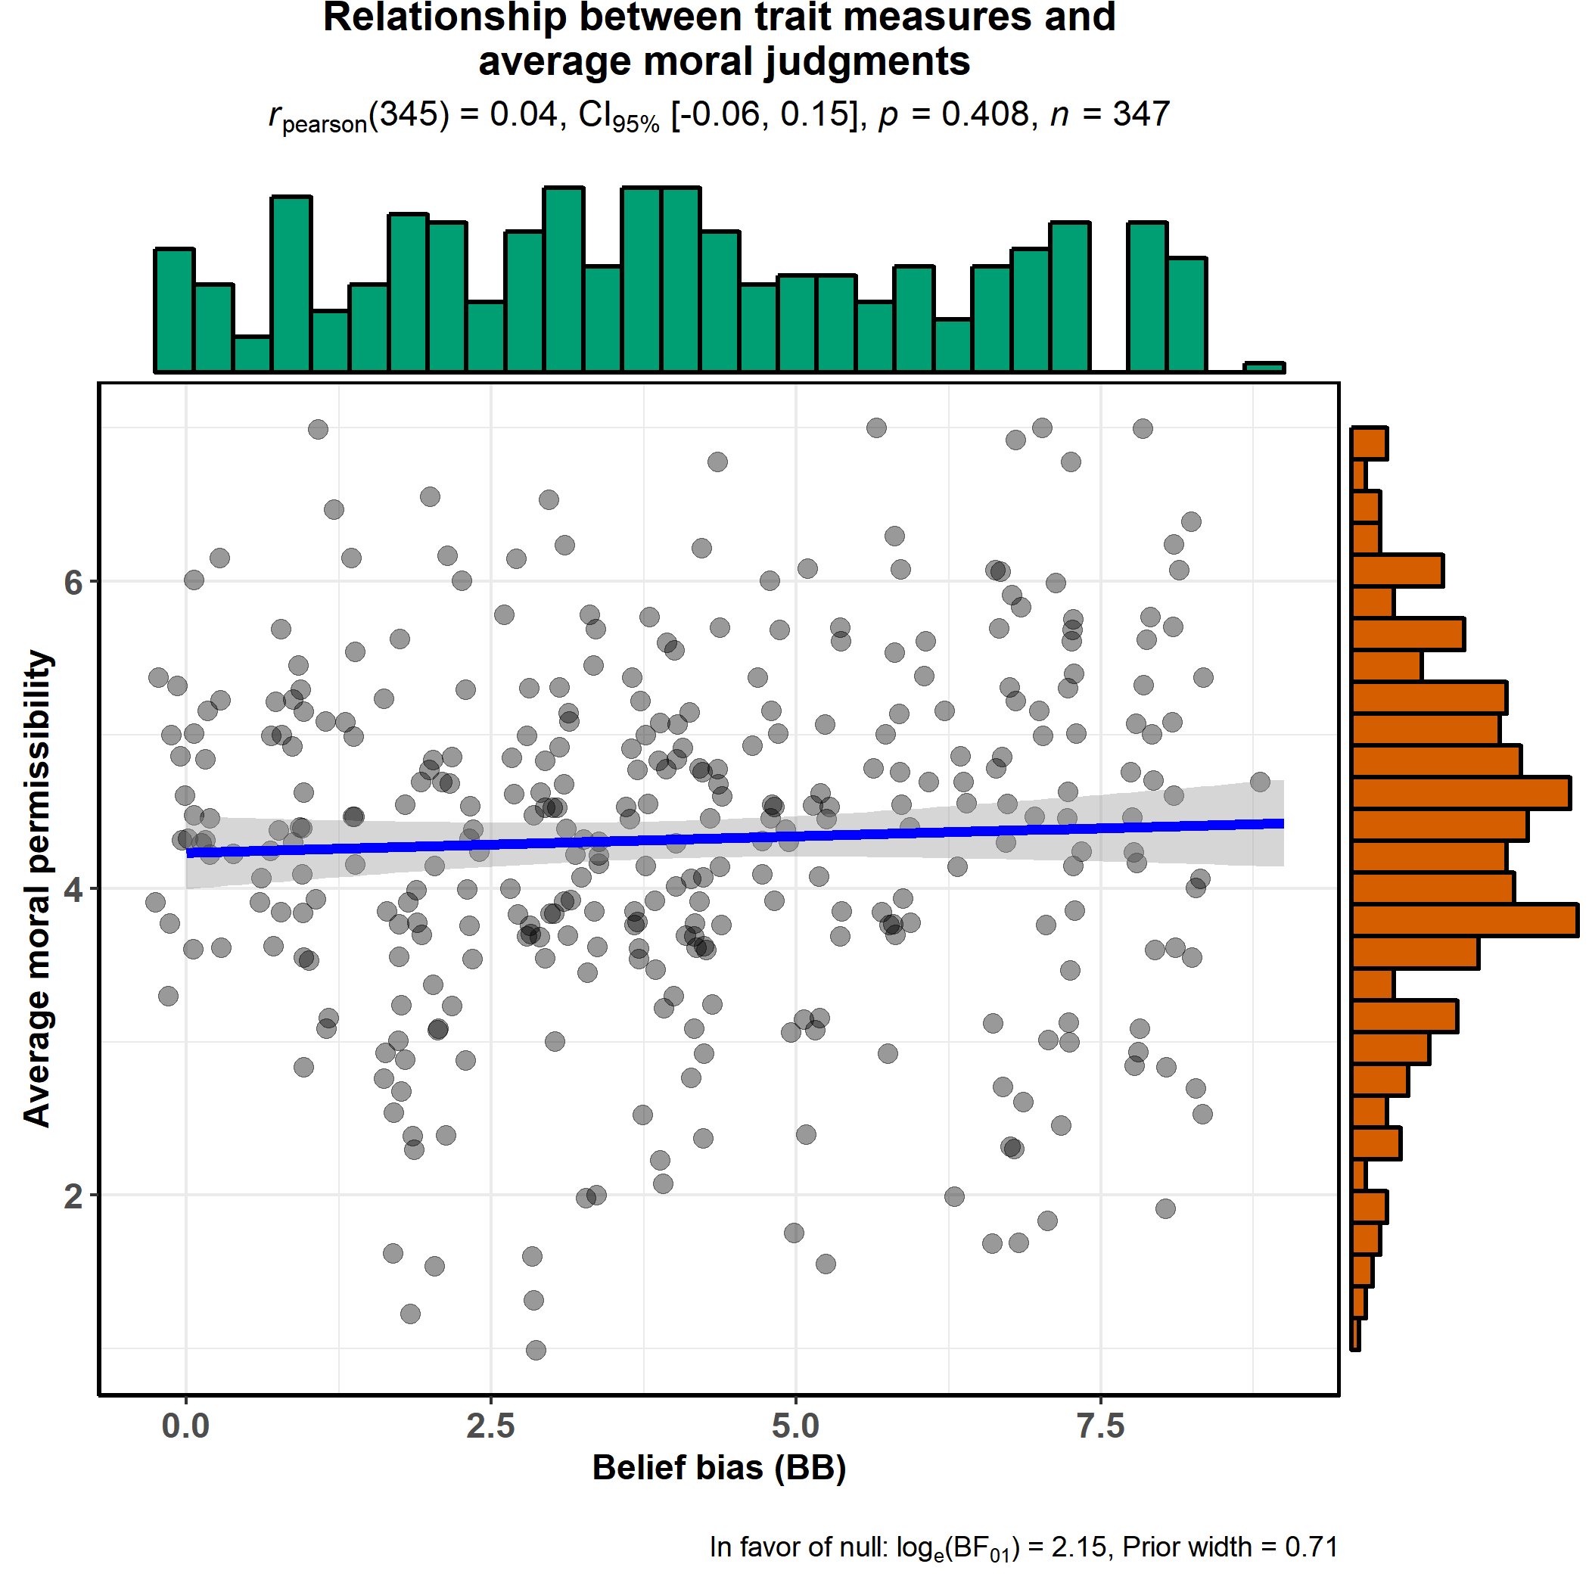
Figure S2-10: Lack of relationship between BB and average of moral judgments for the 13 scenarios considered.
Tendency to uncritically accept evidence when it supports prior beliefs did not predict the tendency to consider the utilitarian option as morally permissible.

Supplemental Text S3:
Additional figures for Study 3a with Process Dissociation (PD) method
(i) Cognitive Reflection Test (CRT) and PD parameters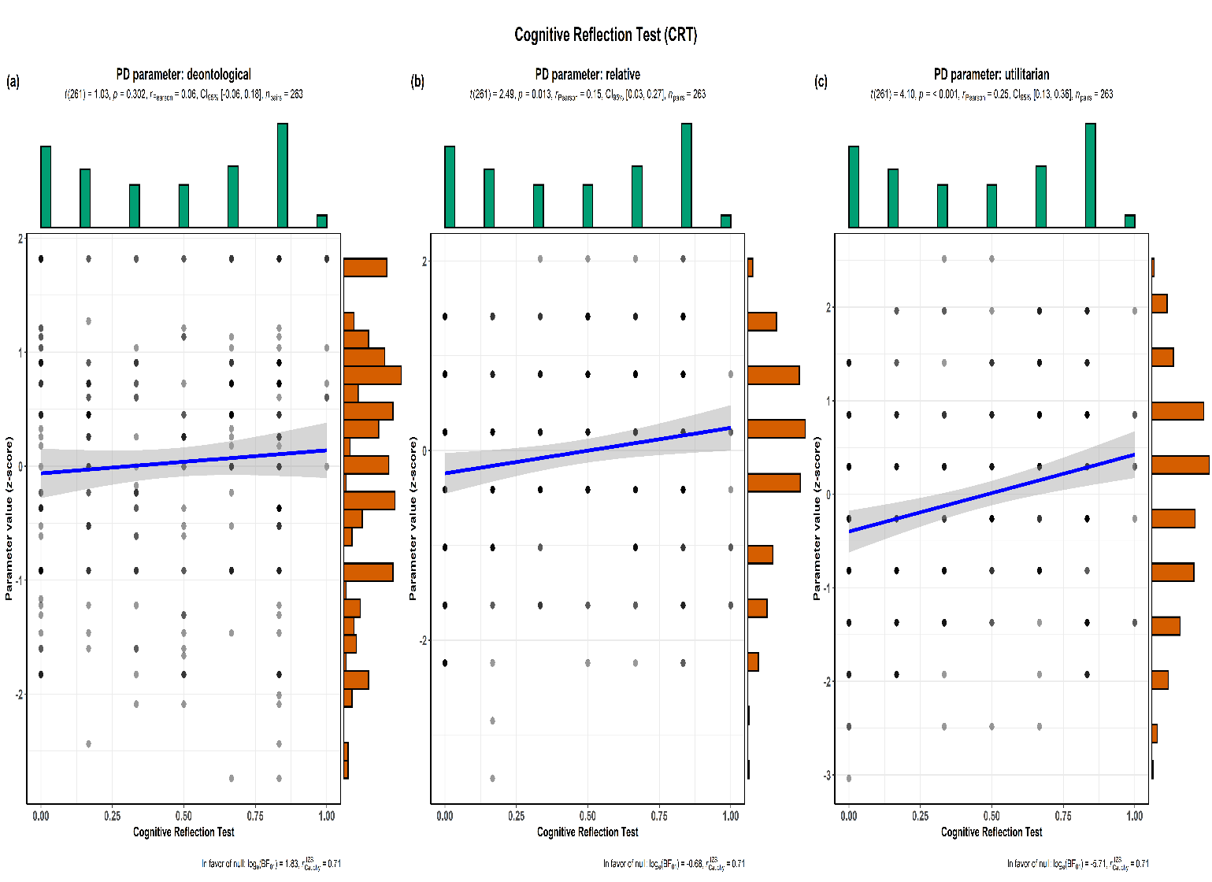
Figure S3-1: Lack of relationship between CRT and PD parameter
.
(ii) Nee d for Cognition and PD parameters
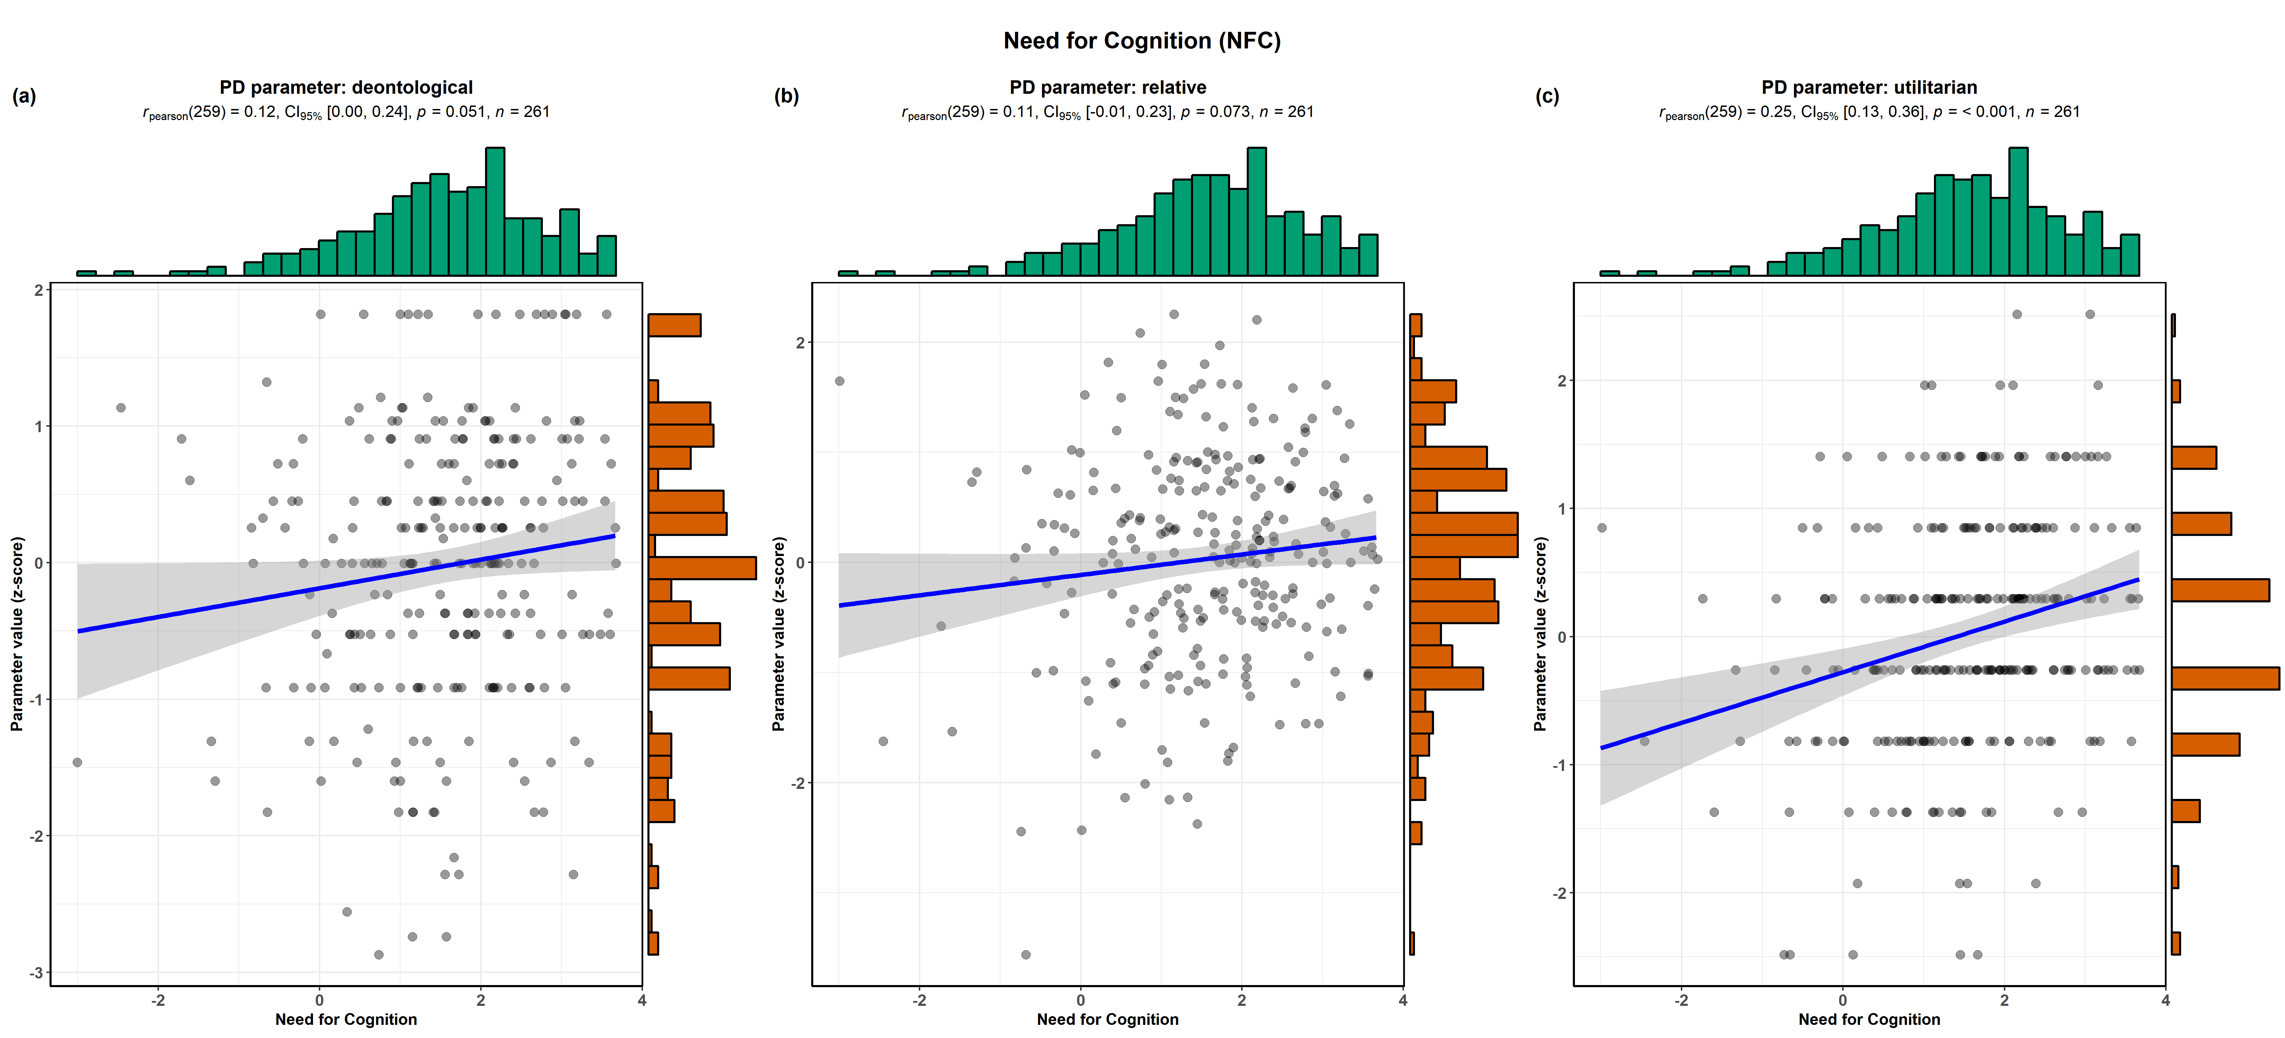
Figure S3-2: Positive relationship between NFC and PD parameter

(iii) Actively Open-Minded Thinking and PD parameters
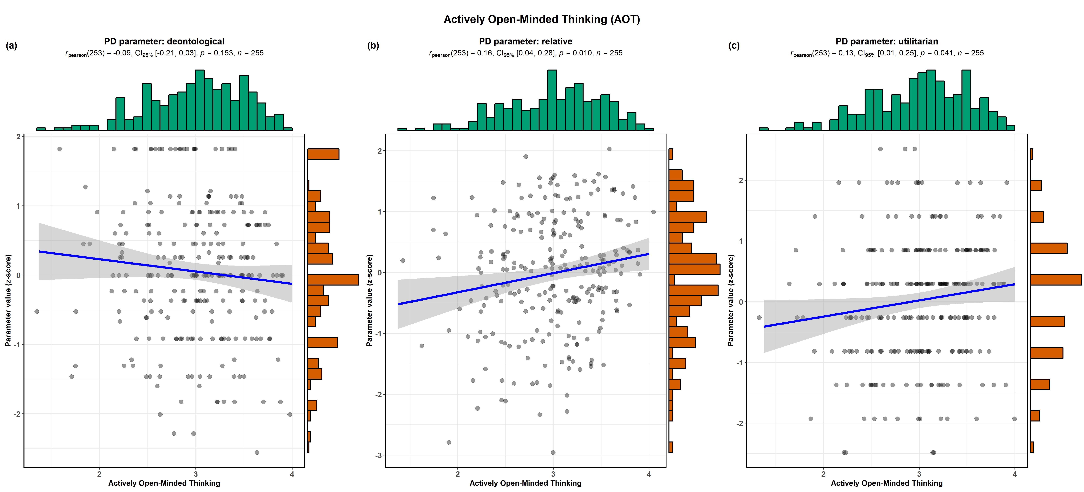

Figure S3-3: Positive relationship between AOT and PD parameter
.
(iv) Rational Experiential Inventory (rationality component) and PD parameters
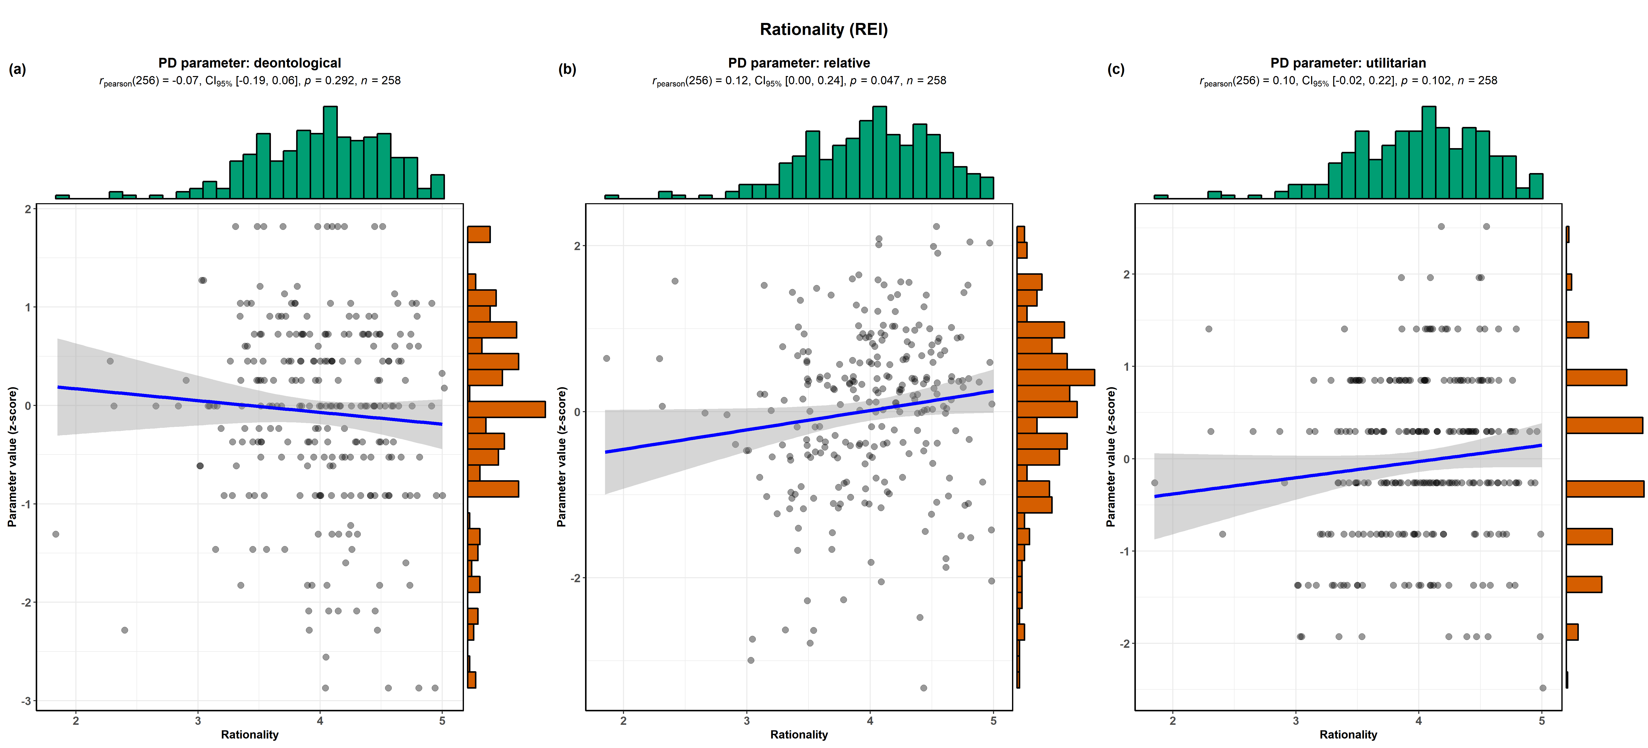

Figure S3-4: Lack of relationship between REI and PD parameter
. (v) Belief Bias and PD parameters

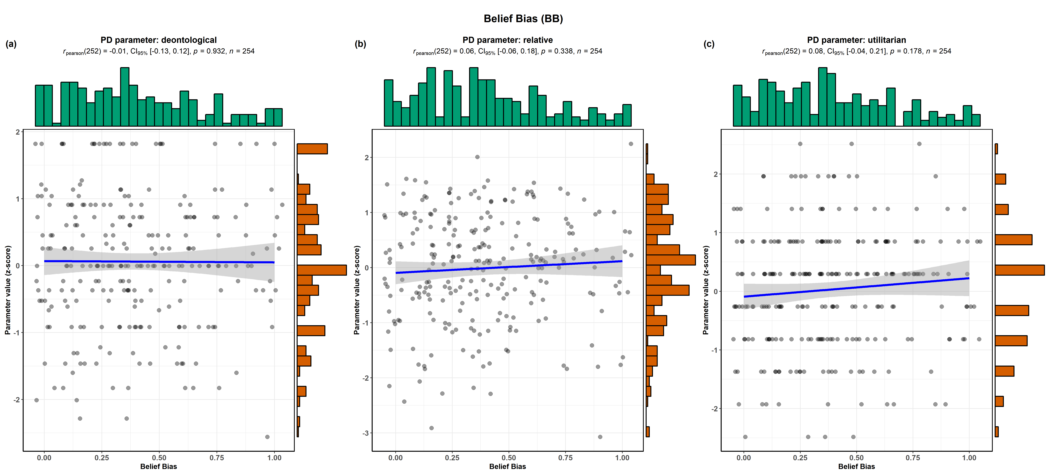

Figure S3-5: Lack of relationship between BB and PD parameter

Additional figures of Study 3b-e results
w: weighting parameter from the two-step task
- w (Daw non-moral) and PD parameters
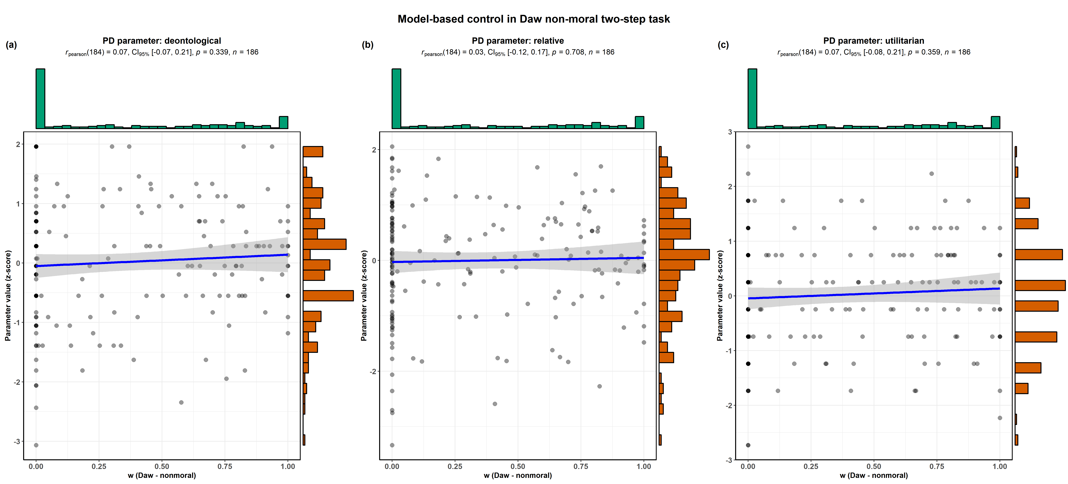

Figure S3-6: Lack of relationship between w (Daw non-moral) and utilitarian PD parameters
- w (Kool moral) and PD parameters
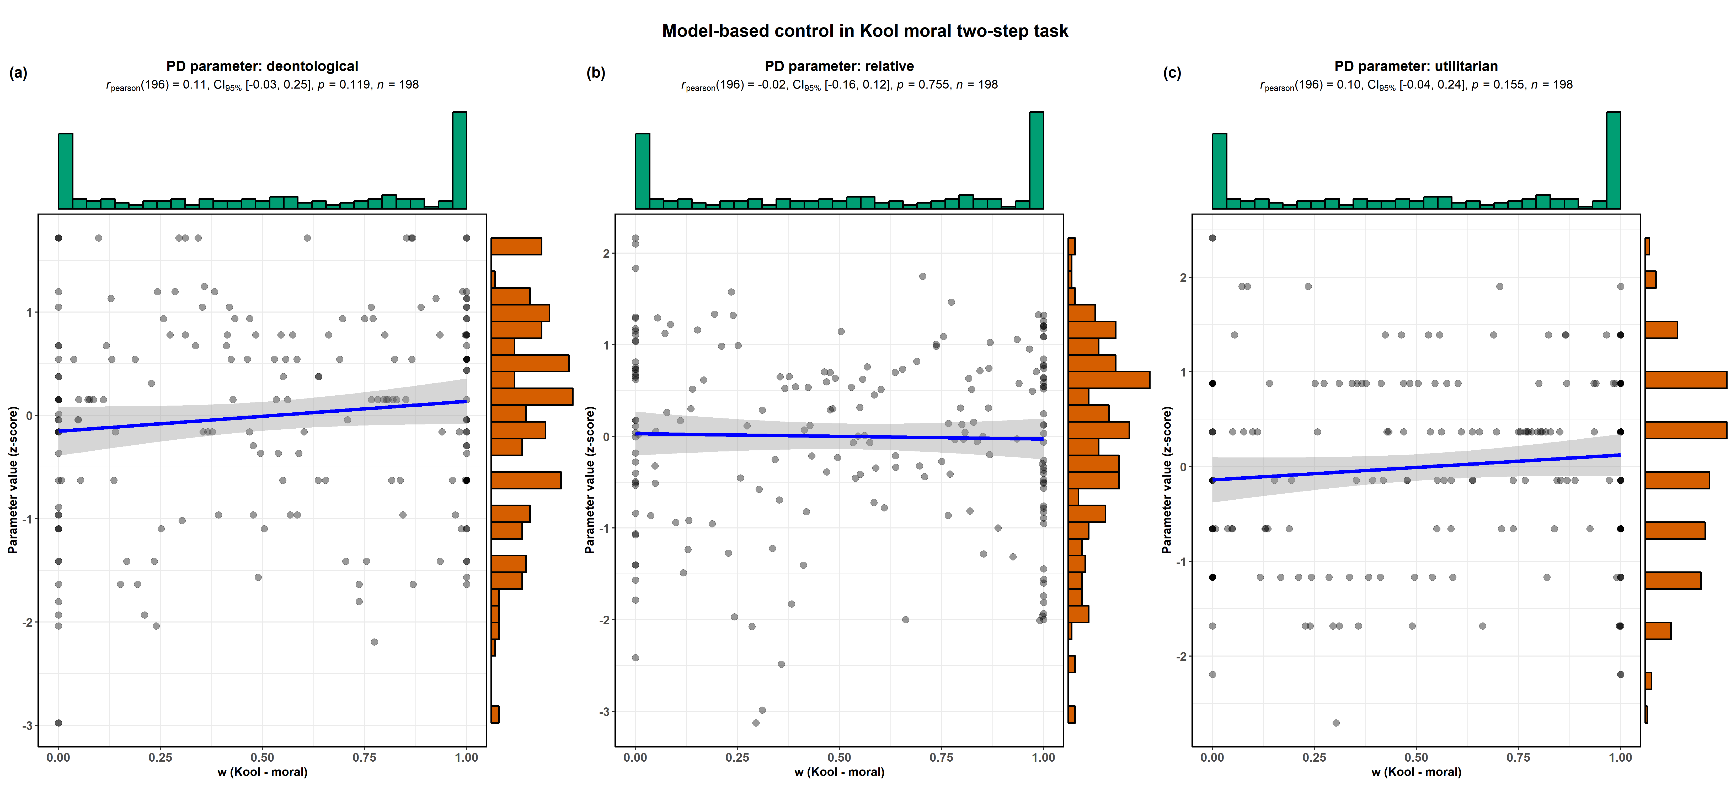
Figure S3-7: Lack of relationship between w (Kool moral) and utilitarian PD parameter

- w (Kool non - moral) and PD parameters
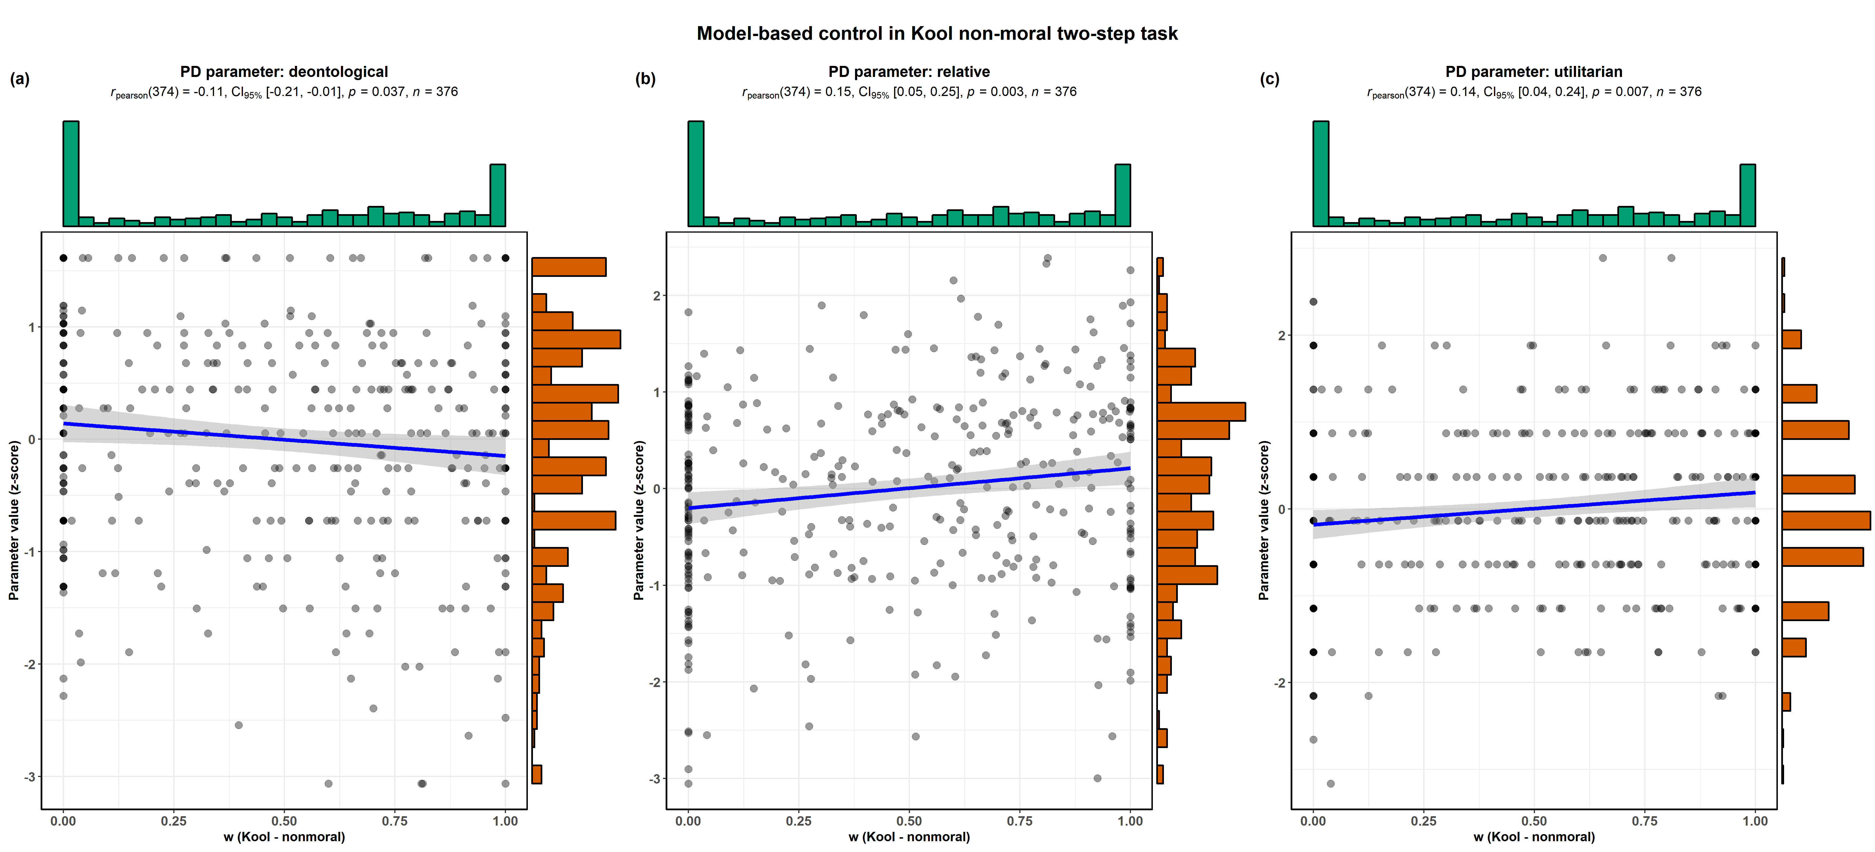

Figure S3-8: Positive relationship between w (Kool non- moral) and utilitarian PD parameter

- w (Daw moral) and PD parameters
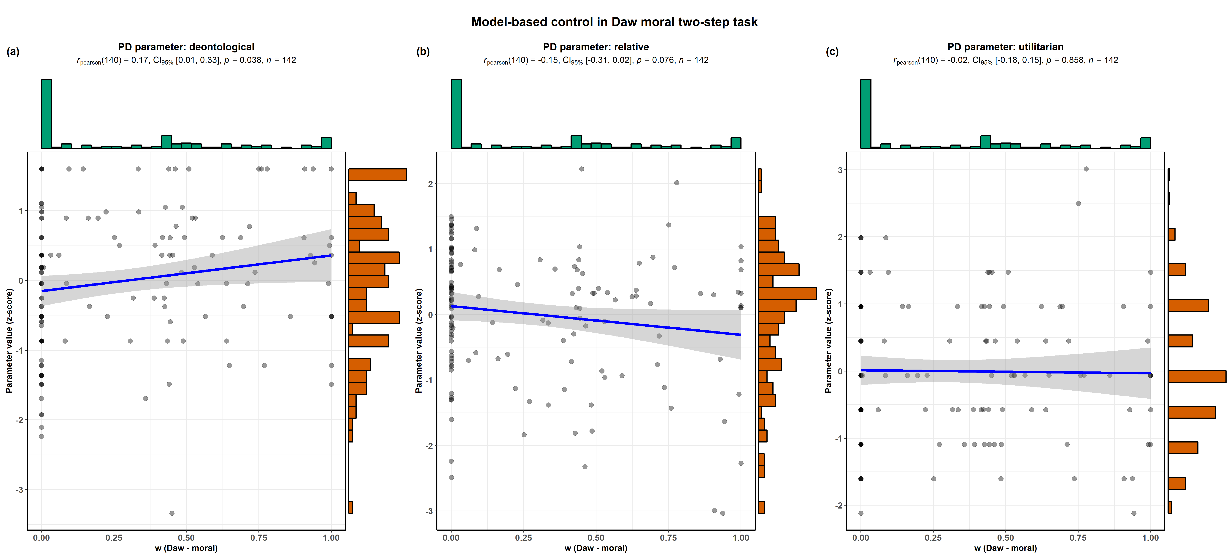

Figure S3-9: Lack of relationship between w (Daw moral) and utilitarian PD parameter

Supplemental Text S4: Meta-analysis with estimates from robust linear regression
Robust linear regression with high breakdown point and high efficiency regression was carried out using the robust R package. CRT is not included in this analysis because the model had a perfect fit and therefore estimates could not be reliably found.
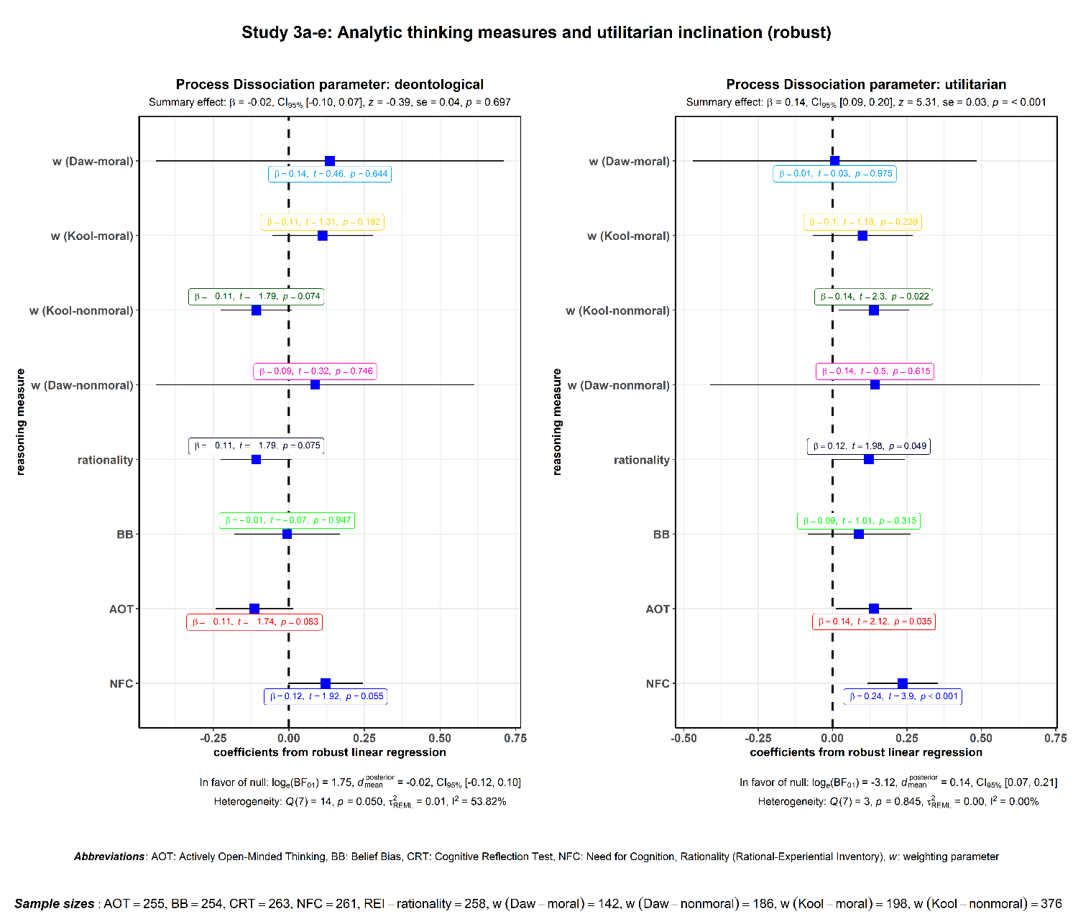
Figure S4-1: Meta-analysis with estimates from robust linear regression

It is worth noting here that NFC is not solely responsible for a significant effect in meta-analysis presented in the main text with simple linear regression. If meta-analysis is carried out after leaving out NFC, it still reveals a significant meta-analytic effect (although a magnitude is smaller): β = 0.10, se = 0.02, z = 4.31, p < 0.001. This analysis rules out the possibility that the effect is solely being driven by NFC.

Supplemental Text S5: Additional methodological details and supplemental discussion about Study 2
Participants
Regarding the exclusion criteria, there was no restriction on handedness (8 left-handed, as assessed using self-report). They all had normal or corrected-to-normal vision. Rule-out criteria for participation included Italian as a secondary language, presence of a diagnosed psychiatric illness and/or history of psychiatric treatment, history of significant neurological illness or brain injury, and current usage of psychoactive drugs. All data from one participant was excluded from the final analysis as he was consuming clinically prescribed psychoactive drugs and did not divulge this information in pre-scanning telephone interview.
Material
Three classes of traditional moral scenarios were used: non-moral dilemmas (n = 10), impersonal moral dilemmas (n = 10), and personal moral dilemmas (n = 10) (see below for detailed description of the scenarios). The scenarios were text-based and all featured the first-person narrative. All scenarios were presented in the traditional moral dilemma format. All scenarios featured first-person narrative. Non-moral scenarios posed practical problems and lacked any moral content, e.g. whether you should repair your old VCR for €80 or get a new one for €100. Both impersonal and personal moral dilemmas were chosen (and translated in Italian) from previously published batteries of moral dilemmas (Greene et al., 2004; Lotto, Manfrinati, & Sarlo, 2014; Moore et al., 2008) and posed a conflict between actively harming less number of individuals for the welfare of the many. Personal dilemmas featured actions which were more emotionally arousing and demanded agents (read participants) to carry out actions using personal force that violated others’ personal rights (cf. Greene et al., 2009) e.g. pushing a large man to his death so that his body can stop a trolley that is about to kill five people. Compared to personal dilemmas, impersonal cases featured actions which were less emotionally arousing and implicated the agent in the scenarios in less personal manner, e.g. switching a trolley from a track with five people to an alternative track with just one individual. In both impersonal and personal moral dilemmas, a number of situational antecedents that previous research has shown to affect moral judgments varied freely in order to increase heterogeneity and thus decrease predictability of experimental stimuli, e.g. whether the sacrificial actions benefited self or other (Lotto et al., 2014), whether the victim’s death was inevitable (Moore et al., 2008), kill-save ratios (e.g., 1:6, 1:100, etc.; (Trémolière & Bonnefon, 2014), etc. (for a more detailed breakdown, see Supplemental S5 Table 1). The only common denominator between each type of moral dilemma was that they pitted the deontological injunction against violating someone’s rights by harming them in personal or impersonal manner against the utilitarian option of saving more number of lives (cf. criticism of Greene’s dilemma battery by Kahane and Shackel (2008)).
The word count for non-moral practical dilemmas (M = 71, 95% CI [62.37, 79.63]) was significantly less than both impersonal (M = 109.80, 95% CI [96.10, 123.50]; p < 0.001) and personal (M = 95.50, 95% CI [87.50, 103.50]; p < 0.001) moral dilemmas, but the latter two did not differ in their word-length (p > 0.1). As a result, there were systematic differences (F (1.497,70.349) = 114.9, p < 0.001, ε = 0.748) in the average amount of time taken by participants to read each type of scenario. Specifically, the time taken to read non-moral (M = 18.56 s), impersonal (M = 28.26 s) and personal (M = 24.90 s) scenarios were all significantly different from each other (ps < 0.001). But this confound has little bearing on our measure of interest, viz. cortical thickness. Each dilemma description was presented using a single screen and participants could read this screen at their own pace. We had decided a priori to exclude data from any participant with average reading time significantly less than the group average (unidirectional outlier as determined by Tukey’s outlier labelling rule (Tukey, 1977) for a given type of scenario to leave out inattentive participants. No participant met this criteria and data from all valid participants was retained.
The two screens corresponding to questions were presented in the same order for all participants. First screen contained behavior (“Would you [nature of action] in order to [outcome of the proposed action]?”) and second screen contained judgment (“Is it appropriate for you to [nature of action] in order to [outcome of the proposed action]?”) questions and each lasted for 5 s. All questions had a gain framing (“in order to save lives” or “in order to avoid deaths”; (Shenhav & Greene, 2010). Participants reported their answer using “Yes” or “No” options. All trials with RT < 0.5 s were excluded to avoid inattentive responses. After each scenario, participants viewed a fixation cross on the screen for a jittered ITI with a mean of 2 seconds (jitter range: 0-2 s) (for schematics of the task design, see the figure below).
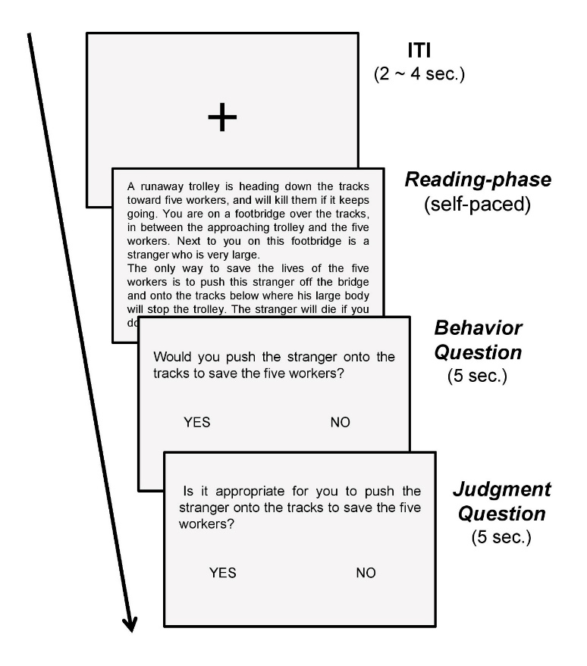
Figure S5-1: MRI task design

Table S5-1. Moral dilemmas and situational antecedents

Experimental protocol:
Subjects were completely agnostic to the purpose of the experiment and did not receive any information about the nature of the experiment apart from the fact that it involved decision-making in social context. There were no practice trials before the actual experiment as the experimental protocol employed was easily comprehensible and participants were verbally instructed about the nature of stimuli and handling the response pad before they entered the scanner. For all tasks, the stimuli were presented in a rapid event-related design. Scenarios were presented in the scanner using a visual display presented on an LCD panel and back-projected onto a screen positioned at the front of the magnet bore. Subjects were positioned supine in the scanner to be able to view the projector display using a mirror above their eyes. The behavioral data were collected using a Lumina response box (LP-400, Cedrus Corporation, San Pedro, USA). The stimuli were presented using Cogent 2000 (Wellcome Department of Imaging Neuroscience, http://www.fil.ion.ucl.ac.uk/Cogent2000.html) running on MATLAB platform. The text of the stories was presented in a black 21-point Arial font on a white background with a resolution of 800 × 600.
Cortical thickness analysis
CAT12 (Righart et al., 2017) uses a projection scheme which considers blurred sulci to create a correct cortical thickness map. This map is also subsequently used to generate a reconstruction of the central surface (CS), which represents the surface within the outer surface (or boundary) between grey matter (GM) and cerebrospinal fluid (CSF) and the inner surface (or boundary) between GM and white matter (WM). Compared to the inner or outer surface, the CS allows a better representation of the cortical sheet (Van Essen et al., 2001), since neither sulcal or gyral regions are over- or underestimated (Scott & Thacker, 2005).
During preprocessing, the initial step involved segmenting T1 images into different tissue classes. The probability tissue maps (TPMs) for CSF, GM, and WM were combined in one probability image segmented (Tohka, Zijdenbos, & Evans, 2004) (denoted by “SEG” images). This segmentation was used for separation of the hemispheres and removal of the cerebellum with hindbrain, resulting in a map called SEP. This map created a masked version of segmentation with filled ventricular and subcortical regions (SEGPF - Dahnke et al., 2011). To take into account the small sulci with thicknesses of around 1 mm, SEGPF was linearly interpolated to 0.5 × 0.5 × 0.5 mm³ (Hutton et al., 2008; Jones, Buchbinder, & Aharon, 2000).
For each GM voxel, to take better into account asymmetrical regions and partial volume information, the distance from the inner boundary was estimated within the GM, using a voxel-based distance method; specifically, the Eikonal equation with a non-uniform speed function F(x) to find the closest boundary voxel B(x) of a GM voxel x without passing a different boundary (Dahnke, Yotter, & Gaser, 2013). The result is a WM distance map (WMD), whose values at the outer GM boundary represent the GM thickness. These values at the outer boundary were then projected back to the inner boundary, resulting in a GM thickness map (GMT). Therefore, in the projection-based framework, cortical thickness can be described as the sum of the inner (WMD) and outer (CSFD) boundary distance. The relation between the GMT and WMD maps allow the creation of a percentage position (PP) map that is used to create the CS in the middle (50% level) of the GM.
A topology correction based on spherical harmonics was used to correct the topology of the surfaces generated with the PBT and the Laplacian approach (Yotter et al., 2011). The surface data were smoothed with kernels of 15 mm to reduce effects of possible registration errors. Vertices in the medial wall were removed (Yotter et al., 2011). Finally, prior to carrying out vertex specific statistical analysis, data quality was assessed using ‘sample homogeneity for surface data’ routine in CAT12. One participant’s data was consistently found to be an outlier on several quality measures and was therefore removed. Final analysis was thus based on surface data from 48 participants.

Behavioral results
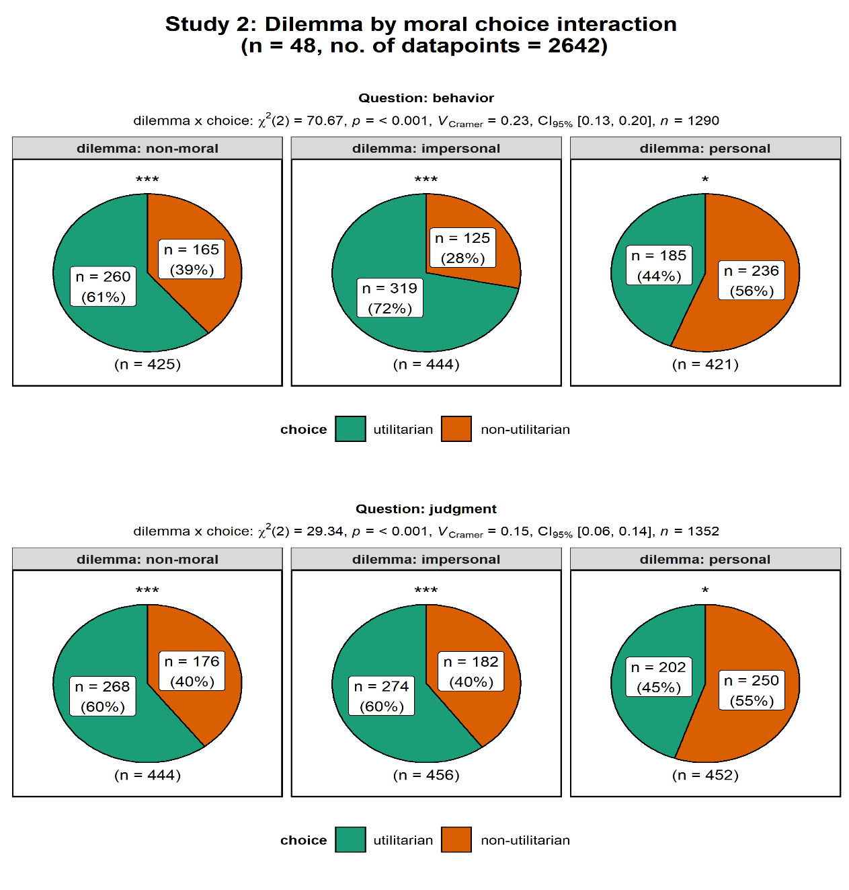
Figure S5-2: Dilemmas by moral choice interaction

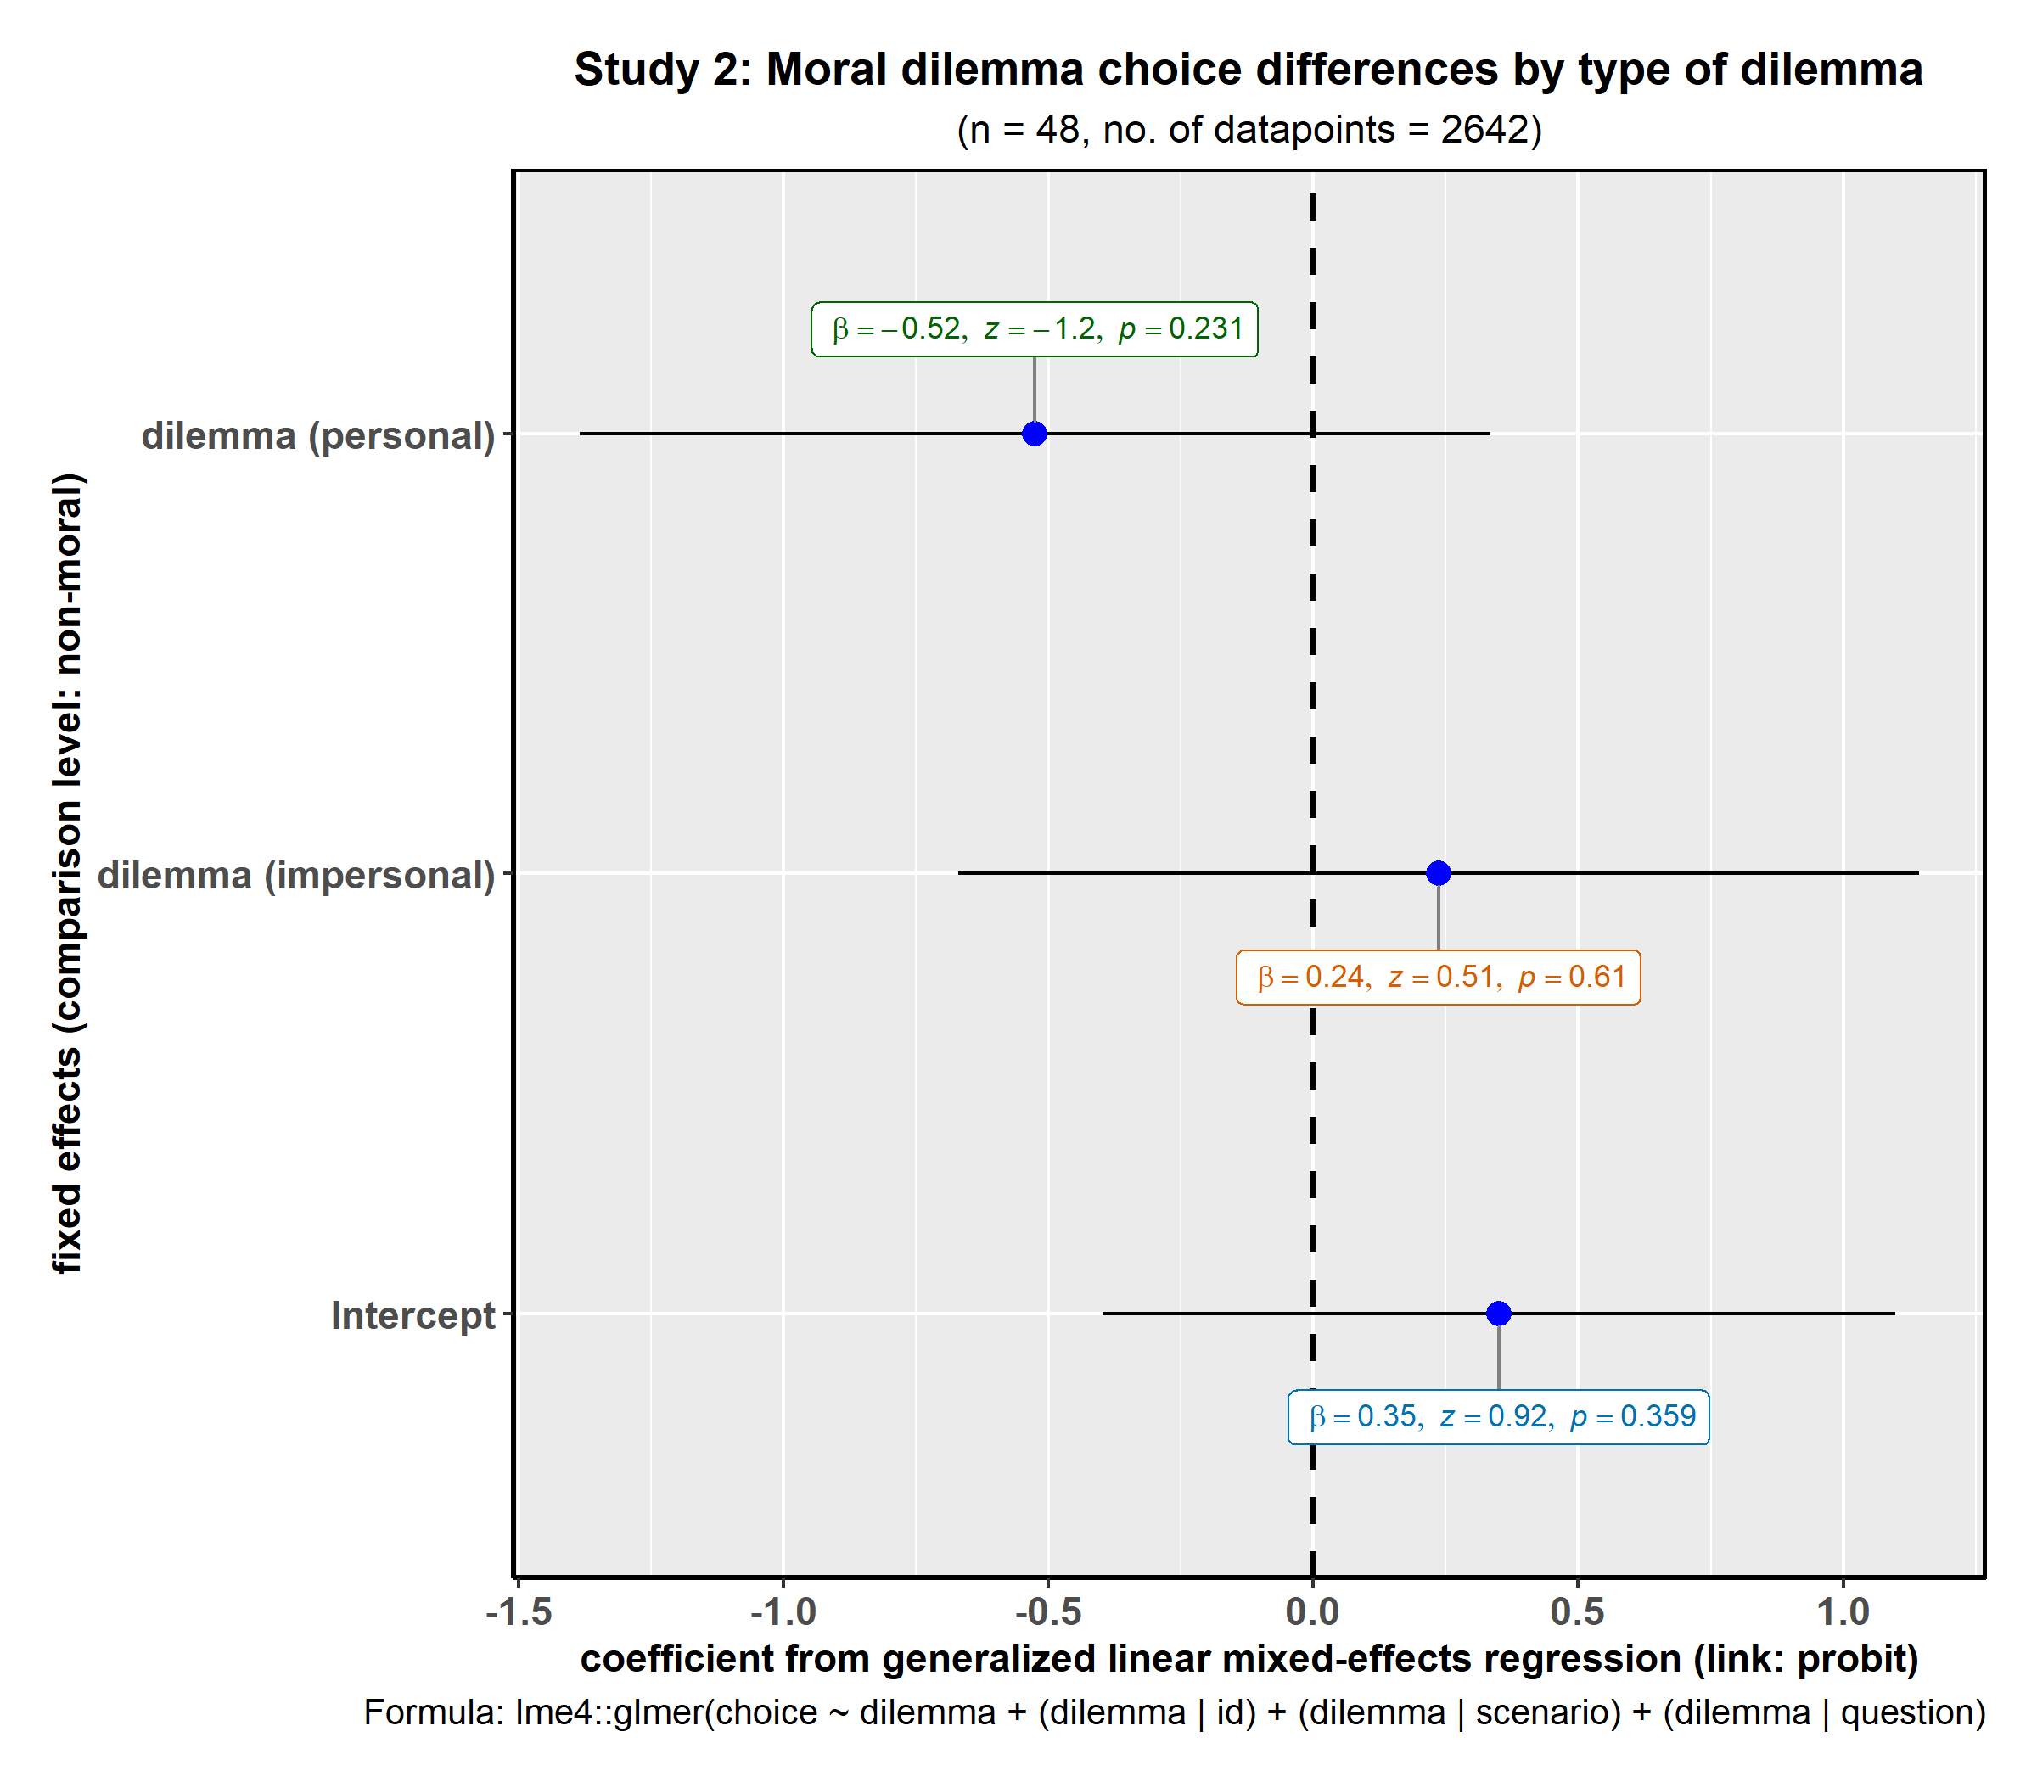
Figure S5-3: Results from generalized linear mixed-effects model predicting choice by type of dilemma

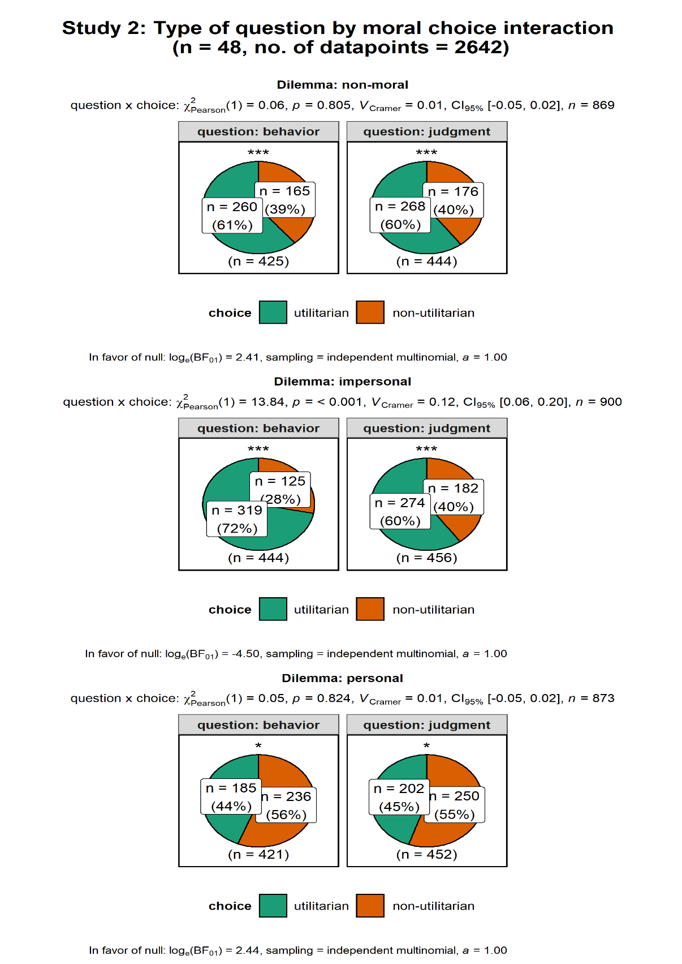

Figure S5-4: Interaction between type of question and moral choice (for each type of dilemma)

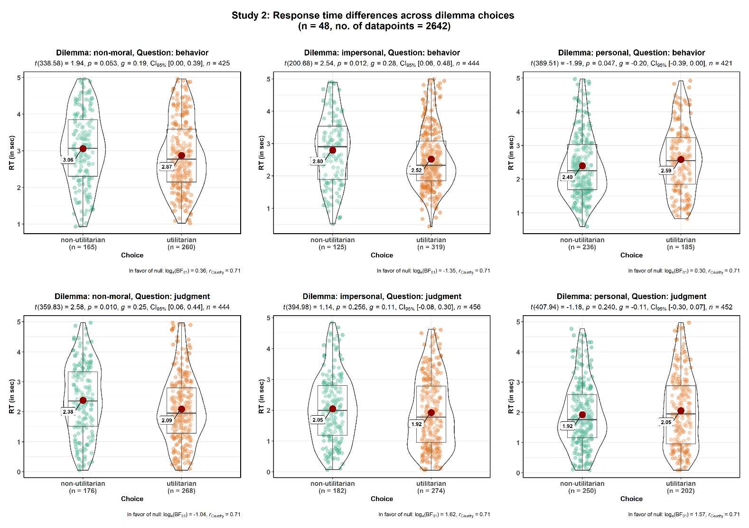
Figure S5-5: Response time difference across dilemma choices (for each type of Dilemma - non moral, personal, impersonal - and Question- judgment , behaviour)

Cortical thickness analysis results (n = 48)
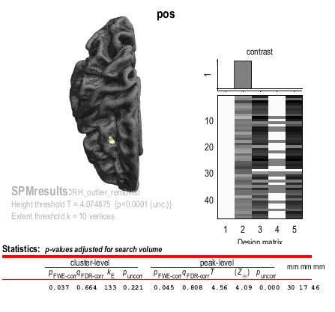
Figure S5-6: A significant positive association between cortical thickness and average utilitarian moral judgment scores at the right dorsolateral Prefrontal Cortex (dlPFC).

Supplemental discussion
Results revealed that interindividual variation in the local cortical thickness of dorsolateral prefrontal cortex (dlPFC) was associated with greater frequency of utilitarian decisions. The fact that this “operation” involves dlPFC shouldn’t be surprising given its critical role in controlled reasoning processes and abstract reasoning (Miller & Cohen, 2001). In particular, recent models, e.g., integration-and-selection model (Buckholtz & Marois, 2012), have suggested that the primary function of dlPFC could be to flexibly combine representations synthesized in multiple streams of information in order to select the most contextually appropriate action, depending on the adaptive requirements imposed by the task. An exemplificative case is in the domain of norm enforcement, where this region permits to integrate information about (i) the severity of the criminal offense (i.e., the harm caused) and (ii) the blameworthiness of the offender (i.e., mental state at the time of the offense), selecting the most contextually appropriate punishment among competing response options (Buckholtz & Marois, 2012; Buckholtz et al., 2015; Patil, Calò, Fornasier, Cushman, & Silani, 2017).
More specifically, and more abstractly, an array of response options and goal representations are transmitted from dlPFC to dorsal striatum, which uses learned action-outcome associations to bias response selection (Buckholtz & Marois, 2012). This is achieved thanks to the ability of dlPFC in maintaining stable representations of abstract information over time (Dehaene & Changeux, 1995; Goldman-Rakic, 1991) and to its several projections from others multimodal association areas, motor cortex and subcortical zones, which allow to coordinate different external and internal inputs, to promote adaptive behavior (Duncan, 2010; Fuster, 1993; Mesulam, 1998; Miller & Cohen, 2001; Passingham & Sakai, 2004).
In the specific case of moral dilemmas this can mean maintaining representations of both information about (i) benefits (e.g. lives saved) and (ii) costs (e.g. lives lost) by dlPFC, and the response selection at the time of decision making, by dorsal striatum, in favour of the action that has the expected best probability of maximizing reward (Balleine, Delgado, & Hikosaka, 2007; McNamee et al., 2015), the highest number of saved lives. Involvement of dlPFC in cost-benefit analysis has been also found in other contexts, such as decision making between pairs of stimuli (which involve different levels of effort and delay to obtain the reward), specifically for time-delay decisions-making, due to the cited maintenance abilities of this area (Hosokawa, Kennerley, Sloan, & Wallis, 2013).
We might ask about what exactly a thicker right dlPFC means with respect to tendency of responding affirmatively to cause harm when this is necessary for producing better outcomes. In brain morphometry, it is often assumed that a larger cortical thickness or greater grey matter density is associated with better computational efficacy of that region, which in turn leads to enhanced task performance (Dickerson et al., 2008; Kanai & Rees, 2011; Wagstyl & Lerch, 2018). Therefore, individuals with greater cortical thickness in r-dlPFC could tend to agree to instrumental harm for the greater good because the higher cortical thickness in r-dlPFC would afford enhanced computational efficiency in maintaining and handling multiple abstract representations and integrating them to select the contextual, utility-maximizing option, over the emotional arousal elicited by the outcome of harming someone, although this remains a speculative account.
This anatomical result is consistent with evidence obtained from functional studies, which indicate an increased activation of dlPFC in psychopathic individuals due to their necessity to rely more on abstract reasoning processes to choose a morally appropriate option, in the absence of appropriate input from emotion-related regions (Glenn, Raine, Schug, Young, & Hauser, 2009) or less endorsing of utilitarian choices, when dlPFC function is disrupted, due to the lack of the cognitive control over the emotional response (Jeurissen, Sack, Roebroeck, Russ, & Pascual-Leone, 2014).
In conclusion, the present results show that the inter-individual differences in utilitarian option engagement are associated with cortical thickness differences in the right dorsolateral prefrontal cortex, a key region implicated in reasoning.

Supplemental Text S6: Details and Descriptions of the moral dilemmas used across studies
- Classical dilemmas used in Study 1a
- A runaway trolley is heading down the tracks toward five workmen who will be killed if the trolley proceeds on its present course. You are on a footbridge over the tracks, in between the approaching trolley and the five workmen. Next to you on this footbridge is a stranger who happens to be very large. The only way to save the lives of the five workmen is to push this stranger off the bridge and onto the tracks below where his large body will stop the trolley. The stranger will die if you do this, but the five workmen will be saved.
Pushing the stranger onto the tracks is:

- Enemy soldiers have taken over your village. They have orders to kill all remaining civilians. You and some of your townspeople have sought refuge in the cellar of a large house. Outside you hear the voices of soldiers who have come to search the house for valuables. Your baby begins to cry loudly. You cover his mouth to block the sound. If you remove your hand from his mouth his crying will summon the attention of the soldiers who will kill you, your child, and the others hiding out in the cellar. To save yourself and the others you must smother your child to death.
Smothering your child is:

- You are on a cruise ship when there is a fire on board, and the ship has to be abandoned. The lifeboats are carrying many more people than they were designed to carry. The lifeboat you are in is sitting dangerously low in the water -- a few inches lower and it will sink. The seas start to get rough, and the boat begins to fill with water. If nothing is done it will sink before the rescue boats arrive and everyone on board will die. However, there is an injured person who will not survive in any case. If you throw that person overboard the boat will stay afloat and the remaining passengers will be saved.
Throwing this person overboard is:

- You are a waiter. You overhear one of your customers say that he is about to go to jail and that in his last forty-eight hours of freedom he plans to infect as many people as possible with HIV. You know him well enough to know that he is telling the truth and that he has access to many potential victims. You happen to know that he has a very strong allergy to poppy seeds. If he eats even one he will go into convulsions and have to be hospitalized. for at least forty-eight hours.
Causing this man to have a serious allergy attack is:

- You are part of a group of ecologists who live in a remote stretch of jungle. The entire group, which includes eight children, has been taken hostage by a group of paramilitary terrorists. One of the terrorists takes a liking to you. He informs you that his leader intends to kill you and the rest of the hostages the following morning. He is willing to help you and the children escape, but as an act of good faith he wants you to kill one of your fellow hostages whom he does not like. If you refuse his offer all the hostages including the children and yourself will die. If you accept his offer then the others will die in the morning but you and the eight children will escape.
Killing one of your fellow hostages is:

- You are negotiating with a powerful and determined terrorist who is about to set off a bomb in a crowded area. Your one advantage is that you have his teen-age son in your custody. There is only one thing that you can do to stop him from detonating his bomb, which will kill thousands of people if detonated. To stop him, you must contact him over the satellite hook-up that he has established and, in front of the camera, break one of his son's arms and then threaten to break the other one if he does not give himself up.
Breaking the terrorist's son's arm is:

- You are the captain of a military submarine travelling underneath a large iceberg. An onboard explosion has caused you to lose most of your oxygen supply and has injured one of your crew who is quickly losing blood. The injured crew member is going to die from his wounds no matter what happens. The remaining oxygen is not sufficient for the entire crew to make it to the surface. The only way to save the other crew members is to shoot dead the injured crew member so that there will be just enough oxygen for the rest of the crew to survive.
Killing the fatally injured crew member is:

- You are the leader of a small army that consists of warriors from two tribes, the hill tribe and the river tribe. You belong to neither tribe. During the night a hill tribesman got into an argument with a river tribesman and murdered him. The river tribe will attack the hill tribe unless the murderer is put to death, but the hill tribe refuses to kill one of its own warriors. The only way for you to avoid a war between the two tribes that will costs hundreds of lives is to publicly execute the murderer by cutting off his head with your sword.
Cutting off this man's head is:

- It is wartime and you and your two children, ages eight and five, are living in a territory that has been occupied by the enemy. At the enemy's headquarters is a doctor who performs painful experiments on humans that inevitably lead to death. He intends to perform experiments on one of your children, but he will allow you to choose which of your children will be experimented upon. You have twenty-four hours to bring one of your children to his laboratory. If you refuse to bring one of your children to his laboratory he will find them both and experiment on both of them.
Bringing one of your children to the laboratory is:

- You are the leader of a mountaineering expedition that is stranded in the wilderness. Your expedition includes a family of six that has a genetically caused vitamin deficiency. A few people's kidneys contain large amounts of this vitamin. There is one such person in your party. The only way to save the lives of the six members of this family is to remove one of this man's kidneys so that the necessary vitamins may be extracted from it. The man will not die if you do this, but his health will be compromised. The man is opposed to this plan, but you have the power to do as you see fit.
Forcibly removing this man's kidney is:

- A viral epidemic has spread across the globe killing millions of people. You have developed two substances in your home laboratory. You know that one of them is a vaccine, but you don't know which one. You also know that the other one is deadly. Once you figure out which substance is the vaccine you can use it to save millions of lives. You have with you two people who are under your care, and the only way to identify the vaccine is to inject each of these people with one of the two substances. One person will live, the other will die, and you will be able to start saving lives with your vaccine.
Killing one of these people with a deadly injection is:

- You are the leader of a small group of soldiers. You are on your way back from a completed mission deep in enemy territory when one of your men has stepped in trap that has been set by the enemy and is badly injured. The trap is connected to a radio device that by now has alerted the enemy to your presence. They will soon be on their way. If the enemy finds your injured man they will torture him and kill him. He begs you not to leave him behind, but if you try to take him with you your entire group will be captured. The only way to prevent this injured soldier from being tortured is to shoot him yourself.
Shooting this soldier is:

- You, your husband, and your four children are crossing a mountain range on your return journey to your homeland. You have inadvertently set up camp on a local clan's sacred burial ground. The leader of the clan says that according to the local laws, you and your family must be put to death. However, he will let yourself, your husband, and your three other children live if you yourself will kill your oldest son.
Killing your oldest son is:

- Process dissociation approach dilemmas used in Study 3a-e
In our experiment ten moral dilemmas, each with two versions: congruent and incongruent, were administered.
1. Incongruent: Time Machine
You find a time machine and travel back to the year 1920. While checking into a hotel, you meet a young Austrian artist and veteran of the First World War. You realize this is Adolf Hitler before his rise to power in Nazi Germany. He is staying in the hotel room next to yours and the doors are not locked. It would be easy to simply smother him with a pillow in his sleep and disappear, stopping the Second World War and the Nazi party before they even start. However, he has not committed any crimes yet and it seems wrong to hurt an innocent person.
Is it appropriate for you to kill an innocent young Hitler in order to prevent the Second World War?

2. Congruent: Time Machine
You find a time machine and travel back to the year 1920. While checking into a hotel, you meet a young petty criminal. You realize this is George Brackman, a man who later on abducted a child and held her for a week until her family paid him some ransom money. He is staying in the hotel room next to yours and the doors are not locked. It would be easy to simply smother him with a pillow in his sleep and disappear, stopping the abduction and ransom demands before they even start. However, he has not committed any crimes yet and it seems wrong to hurt an innocent person.
Is it appropriate for you to kill George Brackman in order to prevent him from taking a child hostage?

3. Incongruent: Car Accident
You are driving through a busy city street when all of a sudden a young mother carrying a child trips and falls into the path of your vehicle. You are going too fast to break in time; your only hope is to swerve out of the way. Unfortunately, the only place you can swerve is currently occupied by a little old lady. If you swerve to avoid the young mother and baby, you will seriously injure or kill the old lady.
Is it appropriate to swerve and hit the old lady in order to avoid the young mother and child?

5. Incongruent: Hard Times
You are the head of a poor household in a developing country. Your crops have failed for the second year in a row, and it appears that you have no way to feed your family. Your sons, ages eight and ten, are too young to go off to the city where there are jobs, but your daughter could fare better. You know a man from your village who lives in the city and who makes sexually explicit films featuring girls such as your daughter. In front of your daughter, he tells you that in one year of working in his studio your daughter could earn enough money to keep your family fed for several growing seasons.
Is it appropriate for you to employ your daughter in the pornography industry in order to feed your family?

4. Congruent: Car Accident
You are driving through a busy city street when all of a sudden a young mother carrying a child trips and falls into the path of your vehicle. You are going too fast to break in time; your only hope is to swerve out of the way.
Unfortunately, the only place you can swerve is currently occupied by a group of children on their way to elementary school. If you swerve to avoid the young mother and baby, you will seriously injure or kill several of them.
Is it appropriate to swerve and hit the schoolchildren in order to avoid the young mother and child?

6. Congruent: Hard Times
You are the head of a poor household in a developing country. Your sons, ages eight and ten, work on the family farm every day in order to teach them the value of hard work and providing for others. Your daughter, however, cannot work on the farm due to the heavy lifting required. You worry that she will not learn the value of money if she does not work. You know a man from your village who lives in the city and who makes sexually explicit films featuring girls such as your daughter. In front of your daughter, he tells you that in one year of working in his studio your daughter could earn enough money to keep your family fed for several growing seasons.
Is it appropriate for you to employ your daughter in the pornography industry in order to teach her the value of money?

7. Incongruent: Crying Baby
It is war time. Enemy soldiers have taken over your village. They have orders to kill all remaining civilians. You and some of your townspeople have sought refuge in the cellar of a large house. Outside you hear the voices of soldiers who have come to search the house for valuables.
A baby with no parents begins to cry loudly. You cover her mouth to block the sound. If you remove your hand from the baby’s mouth her crying will summon the attention of the soldiers who will kill you and the others hiding out in the cellar. To save yourself and the others you must smother the child to death.
Is it appropriate for you to smother the child in order to save yourself and the other townspeople from being killed?

9. Incongruent: Relationship
You are divorced now and your former spouse lives far away. You don’t expect to see your former spouse for a very long time. However, you have recently started dating a new person that is positively wonderful. Your new partner is head over heels in love for the first time and you feel equally strong about your partner. You want to do everything in your power to keep the relationship progressing smoothly to what you believe will be a second marriage.
Unfortunately, your new partner has told you many times that dating someone who is divorced is totally unacceptable. It is expressly forbidden in your partner’s religion. Your partner doesn’t know about your ex- spouse. You consider simply pretending that you have never been divorced so that your current relationship can continue.
Is it appropriate for you to leave your new partner in the dark about your previous relationship in order to keep her/him happy and the relationship alive?

8. Congruent: Crying Baby
It is war time. Enemy soldiers have taken over your village. They have orders to capture all remaining civilians to make them work quarrying stone in a mine. You and some of your townspeople have sought refuge in the cellar of a large house. Outside you hear the voices of soldiers who have come to search the house for valuables.
A baby with no parents begins to cry loudly. You cover her mouth to block the sound. If you remove your hand from her mouth the crying will summon the attention of the soldiers who will capture you and the others hiding out in the cellar. To save yourself and the others from laboring in the mine you must smother the child to death.
Is it appropriate for you to smother the child in order to save yourself and the other townspeople from being captured?

10. Incongruent: Relationship
You are divorced now and your former spouse lives far away. You don’t expect to see your former spouse for a very long time. However, you have recently started dating a new person that is positively wonderful. Your new partner is head over heels in love for the first time and you feel equally strong about your partner. You want to do everything in your power to keep the relationship progressing smoothly to what you believe will be a second marriage.
Unfortunately, your ex-spouse gave you a very serious and incurable Sexually Transmitted Disease (STD). Your partner does not know about it. You consider simply pretending that you don’t know about the STD so that your current relationship can continue.
Is it appropriate for you to leave your new partner in the dark about your STD in order to keep her/him happy and the relationship alive?

11. Incongruent: Abortion
You are a surgeon. A young woman you know becomes pregnant, but her body reacts in an unusual fashion. She develops a severe case of preeclampsia, a dangerous syndrome that leads to rapid increases in blood pressure. The only treatment is to deliver the baby.
Unless the baby is delivered soon, the mother will die. However, the baby is too young to survive on its own. If it is delivered, it will die. So, although it is very difficult for her, the mother asks you to abort the baby.
Is it appropriate for you to perform an abortion in order to save the mother’s life?

13. Incongruent: Torture
You are a police officer, and have recently caught a criminal you have been hunting for some time. He is allegedly responsible for rigging a series of explosive devices: some that have already gone off and some that have yet to detonate.
He places explosives outside city cafes and sets them to go off at a time when people are drinking coffee on the patios. In this manner, he has injured many people and might injure many more.
Now that the criminal is in custody, you want to know where the unexploded bombs are so you can defuse them. He refuses to talk, so you decide to use “aggressive interrogation techniques” like holding his head under water and beating him.
Is it appropriate for you to use “aggressive interrogation techniques” in order to find and defuse the unexploded bombs?

12. Congruent: Abortion
You are a surgeon. A young woman you know becomes pregnant, but she is not yet ready for children. She has not finished high school, has no income, and was abandoned by the father.
If she has the baby now, she will be stuck as a single mother on welfare for the rest of her life. This will make things very hard on her and the baby. She thinks that it would be smarter to wait and have children later. So, although it is very difficult for her, she asks you to abort the baby.
Is it appropriate for you to perform an abortion in order to let the mother live a better life?

14. Congruent: Torture
You are a police officer, and have recently caught a criminal you have been hunting for some time. He is allegedly responsible for rigging a series of explosive devices: some that have already gone off and some that have yet to detonate.
He places explosives outside city cafes and sets them to go off at a time when no one is around. His explosives are inside paint cans so that they spray nearby objects with paint. In this manner, he has sprayed many cafes with paint and might spray many more.
Now that the criminal is in custody, you want to know where the unexploded bombs are so you can defuse them. He refuses to talk, so you decide to use “aggressive interrogation techniques” like holding his head under water and beating him.
Is it appropriate for you to use “aggressive interrogation techniques” in order to find and defuse the unexploded bombs?

15. Incongruent: Vaccine Policy
You are a doctor in a health clinic overrun by patients with a serious disease. You just received a shipment of drugs that can cure the disease but the drugs have their own severe side-effects.
If you administer the drugs to your patients, a small number will die from the side effects but most will live. If you do not, most will die from the disease.
Is it appropriate for you to administer the drug to your patients?

17. Incongruent: Animal Research
You have been hired by a pharmaceutical company to conduct research on their products. Since products must be fit for human use, they are first tried out on animals. Your job is to find out the effects various chemicals have on rats, pigeons, rabbits, and monkeys. Most chemicals have only minor effects on the animals, but some cause them discomfort or even permanent damage.
The chemicals you are researching are slated to form part of a new AIDS drug cocktail that will give new hope to millions of AIDS victims around the world. You anticipate saving many lives with the chemicals.
Is it appropriate to test these chemicals on animals?

16. Congruent: Vaccine Policy
You are a doctor in a health clinic overrun by patients with the latest flu virus. You just received a shipment of drugs that can cure the flu but the drugs have their own severe side-effects.
If you administer the drugs to your patients, a small number will die from the side effects but most will live. If you do not, most will continue to suffer from the effects of the flu virus for some time.
Is it appropriate for you to administer the drug to your patients?

18. Congruent: Animal Research
You have been hired by a pharmaceutical company to conduct research on their products. Since products must be fit for human use, they are first tried out on animals. Your job is to find out the effects various chemicals have on rats, pigeons, rabbits, and monkeys. Most chemicals have only minor effects on the animals, but some cause them discomfort or even permanent damage.
The chemicals you are researching are slated to form part of a new acne facial cleanser that will give new hope to people with pimples and greasy skin. You anticipate making many people feel better about their appearance with the chemicals.
Is it appropriate to test these chemicals on animals?

19. Incongruent: Border Crossing
You are a soldier guarding a border checkpoint between your nation and one troubled by insurgent violence. You notice a young man in a cheap car approaching the checkpoint with a determined look on his face. You suspect he means to bomb the checkpoint, killing all the soldiers inside. He is rapidly approaching your station.
Is it appropriate for you to shoot and kill the approaching man?

20. Congruent: Border Crossing
You are a soldier guarding a border checkpoint between your nation and one troubled by insurgent violence. You notice a young man in a cheap car approaching the checkpoint with a determined look on his face. You suspect he means to cross the border in order to work illegally inside your country. He is rapidly approaching your station.
Is it appropriate for you to shoot and kill the approaching man?

- Classical moral dilemmas
List of all the dilemmas used for cortical thickness analysis study
Non-moral scenarios
1. Two trips
You are bringing home some plants from the store. You have lined the trunk of your car with plastic to catch the mud from the plants, but your trunk will not hold all of the plants you have bought.
You could bring all of the plants home in one trip, but you would need to put some of the plants in the back seat. If you put the plants in the back seat, the mud from the plants will ruin your fine leather upholstery, which would cost thousands of dollars to replace.
Would you make two trips home to avoid ruining the upholstery of your car?
Is it appropriate for you to make two trips home to avoid ruining the upholstery of your car?

2. Mutual Fund
You are at home one day when the mail arrives. You receive a letter from a company that provides financial services. You have heard of this company, which has a good reputation. They have invited you to invest in a mutual fund. The minimum investment for this fund is €1000.
You already know a lot about this particular mutual fund. It has performed poorly over the past few years. Based on what you know, there is no reason to think that it will perform any better in the future.
Would you invest €1000 in this mutual fund in order to make money?
Is it appropriate for you to invest €1000 in this mutual fund in order to make money?
3. VCR
Your VCR breaks and you bring it to the local repair shop. The woman working in the shop looks at the VCR and tells you that it will cost €80 to fix it.
Earlier this morning, you noticed an advertisement in the newspaper. A new model of VCR is available from the same company that made your old VCR. The new model performs the same functions as your old VCR, but is better and uses less electricity. This new VCR is now on sale for €100.
Would you have your old VCR fixed instead of spending money on a new one?
Is it appropriate for you to have your old VCR fixed instead of spending money on a new one?

4. Jogging
You intend to accomplish two things this afternoon: going for a jog and doing some paperwork. In general you prefer to get your work done before you exercise.
The weather is nice at the moment, but the weather forecast says that in a couple of hours it will start to rain. You very much dislike jogging in the rain, but you don’t care what the weather is like while you do paperwork.
Would you do your paperwork now with the intention of jogging in a couple of hours in order to get your work done before you exercise?
Is it appropriate for you to do your paperwork now with the intention of jogging in a couple of hours in order to get your work done before you exercise?
5. Pharmacy
You have a very bad headache. You go to the pharmacy looking for your favorite brand of headache medicine. When you get there, you find that the pharmacy is out of the brand that you are looking for.
You have known the pharmacist at this store for a long time, and you trust him. He says he has a generic medicine that is “exactly the same” as the name-brand medicine that you wanted. In the past, he has always given you good advice.
Would you keep looking for the name-brand medicine you came for, instead of buying the generic medicine?
Is it appropriate for you to keep looking for the name-brand medicine you came for, instead of buying the generic medicine?
6. Meeting
You need to travel to a nearby city in order to attend a meeting that starts at 2:00 PM. You can either take the train or the bus. The train will get you there just in time for your meeting no matter what.
The bus is scheduled to arrive an hour before your meeting. However, the bus sometimes is several hours late because of traffic. It would be nice to have an extra hour before the meeting, but it is very important that you arrive on time.
Would you take the train instead of the bus in order to ensure that you are not late for your meeting?
Is it appropriate for you to take the train instead of the bus in order to ensure that you are not late for your meeting?

7. Scenery
An old friend invites you to spend the weekend at his summer home. This house is up the coast from where you live. You plan to drive, and you can take either the highway or the coastal road.
The highway will get you there in about three hours, but the scenery along the highway is very boring. The coastal road will get you to your friend’s house in about three hours and fifteen minutes, and the scenery along the coastal road is very beautiful.
Would you take the coastal road in order to see the beautiful scenery as you drive?
Is it appropriate for you take the coastal road in order to see the beautiful scenery as you drive?

8. Brownies
You have decided to make a batch of brownies for yourself. You open your recipe book and find a recipe for brownies.
The recipe calls for a cup of chopped walnuts. You don’t like walnuts, but you do like macadamia nuts. As it happens, you have both kinds of nuts available to you.
Would you substitute macadamia nuts for walnuts in order to avoid eating walnuts?
Is it appropriate for you to substitute macadamia nuts for walnuts in order to avoid eating walnuts?

9. Survey
A representative of a reputable, national survey organization calls you at your home while you are having a quiet dinner by yourself.
The representative explains that if you are willing to spend a half an hour answering questions about a variety of topics her organization will send you a check for €200.
Would you interrupt your dinner in order to earn €200?
Is it appropriate for you to interrupt your dinner in order to earn €200?

10. Classes
You are beginning your senior year of college. In order to fulfill your graduation requirements you need to take a history class and a science class by the end of the year.
During the fall term, the history class you want to take is scheduled at the same time as the science class you want to take. During the spring term the same history class is offered, but the science class is not.
Would you take the history class during the fall term in order to help you fulfil your graduation requirements?
Is it appropriate for you to take the history class during the fall term in order to help you fulfil your graduation requirements?

Moral impersonal
1. Vaccination
You work for the Government Health Agency. You must decide whether to promote a new vaccine. This vaccine will protect almost everyone who takes it from a deadly disease. However, the vaccine also carries a risk. A very small number of healthy people who take it will get the disease from the vaccine.
You have carefully studied the safety of the vaccine. The chance that someone will die because they did not take the vaccine is much greater than the chance that they will die from the vaccine.
Would you tell people to use this vaccine to prevent the disease?
Is it appropriate for you to tell people to use this vaccine to prevent the disease?

2. Hospital fumes
You are the late-night watchman in a hospital. Due to an accident in the building next door, there are deadly fumes rising up through the hospital’s ventilation system. In a certain room of the hospital are three patients. In another room there is a single patient. If you do nothing the fumes will rise up into the room containing the three patients and cause their deaths.
The only way to avoid the deaths of these patients is to hit a certain switch, which will cause the fumes to bypass the room containing the three patients. As a result of doing this, the fumes will enter the room containing the single patient, causing his death.
Would you hit the switch in order to avoid the deaths of the three patients?
Is it appropriate for you to hit the switch in order to avoid the deaths of the three patients?

3. Trolley
You are the driver of a runaway trolley approaching a fork in the tracks. On the tracks going to the left is a group of five railway workers. On the tracks going to the right is a single railway worker.
If you do nothing, the trolley will go to the left, causing the five workers to die. The only way to avoid the deaths of these five workers is to hit a switch on your dashboard that will make the trolley go to the right, leading to the death of the single worker.
Would you hit the switch to avoid the deaths of the five workers?
Is it appropriate for you to hit the switch to avoid the deaths of the five workers?

4. Motor boat
You are driving your motor boat in a small bay when your attention is drawn to cries of help from five people who are drowning at the end of a very narrow channel which is right in front of you. Between you and the people who are drowning, to one side of the channel, is another person who is calmly swimming.
If you do nothing, these five people would drown soon. You can steer towards the end of the channel at high speed. But you know that the person who is swimming in between will be hit by the motorboat and die, but the other five people will be saved.
Would you speed towards the narrow channel to save the five swimmers?
Is it appropriate for you to speed towards the narrow channel to save the five swimmers?

5. Burning Car
You are the operator of a bridge in a huge parking complex. The bridge you operate connects two different floors. You see that an out of control car is approaching the bridge and is on fire. You see that on the top floor there are five people walking and on the bottom floor, there is one person walking. The floors they are walking on are so narrow that only one car can pass through at any given time. Right now, the bridge is in the upward position.
If you don't do anything, the car would continue its course on the top floor and kill those five people in its way. But if you move the bridge in the downward position, the car would go on the bottom floor and would kill the one person walking there.
Would you move the bridge in the downward position in order to avoid the death of the five people?
Is it appropriate for you to move the bridge in the downward position order to avoid the death of the five people?

6. Lifting magnet
You are the controller of a lifting magnet in a junkyard. Lifting magnets lift the heavy magnetic objects at some height and transport them to another place and drop them. The magnet, in automatic mode, is moving a car at some height from one place to another on the right side of the platform. Suddenly, you realize that if the magnet continues on its course, the magnet would drop the car on five people standing below. On the left, there is one person standing.
You can take control of the magnet. If you do nothing, the magnet would proceed to the right and drop the car attached to it, causing the death of the five people standing below. You can turn the magnet to left side of the platform, causing the death of the single person standing there.
Is it appropriate for you to turn the magnet in order to avoid the death of the five people?
Would you turn the magnet in order to avoid the death of the five people?

7. Peer
You are in charge of operating an automatic coast-guard boat. From your operating station, you can see that there are five swimmers on your right who are being approached by sharks. But you also see that there is one swimmer on the left who is also being approached by sharks.
Right now, the boat you are operating is moving towards the person on the left. If you don't do anything, it can reach that one swimmer and he can be saved, but then the five swimmers on the right would get killed by sharks. You can save these five swimmers, only if you turn the boat to the right, but then the swimmer on the left would be killed.
Would you turn the boat in order to avoid the death of the five swimmers?
Is it appropriate for you to turn the boat in order to avoid the death of the five swimmers?

8. Rescue helicopter
You are the sole paramedic riding on a rescue helicopter, responding to a devastating flood. You have rescued several critically injured people and you have been treating them to keep them alive. Suddenly, the pilot notifies you that there has been an engine malfunction and the helicopter can no longer support the weight of you, the pilot, and all the injured people on board.
If the helicopter crashes, it will kill everyone on board. In order to avoid a crash, you realize that you must lighten the load enough to keep the helicopter aloft. Because all of the equipment is bolted down, and you are needed by the injured people, the only way to do this is to cut the cable that is raising up the last rescued person. This will lighten the load enough to keep the helicopter in the air, but it will also kill the person who is dropped.
Would you kill this injured person in order to save yourself and everyone else on board?
Is it appropriate for you to kill this injured person in order to save yourself and everyone else on board?

9. Cargo
You are in charge of the Maritime Police. You have received a message that the captain and a seaman of a cargo ship are healthy carriers of a lethal and contagious virus. They do not know that they are infected, and are travelling towards a small gulf where a number of fishermen live. The communications system of the cargo ship is not working and, therefore, they cannot be contacted.
If nothing is done, there can be an epidemic stemming from the virus the captain and a seaman is carrying and a number of people would die. You can launch a missile and sink the cargo ship to avoid it anchoring and thus spreading the virus. You know that the captain and seaman will die, but the fishermen will be saved.
Is it appropriate for you to launch a missile at the ship to save the fishermen?
Would you launch a missile at the ship to save the fishermen?

10. Nurse
You are a nurse who is in charge of a machine which controls drug dosage levels in patients’ blood. Because of a technical failure, the machine is supplying a lethal dose of the drug to four patients. Another patient, in a single room, is hooked up to the same machine and has not undergone any variation in dosage.
If nothing is done, these four patients would die due to lethal poisoning caused by drug overdose. You can press the button to block the drug supply to the four patients. You know that the overdose of drug will be redirected to the patient in the single room, who will die, but the other four will be saved.
Would you divert the drug supply to save lives of four patients?
Is it appropriate for you to divert the drug supply to save lives of four patients?

Moral personal
1. Footbridge
A runaway trolley is heading down the tracks toward five workers, and will kill them if it keeps going. You are on a footbridge over the tracks, in between the approaching trolley and the five workers. Next to you on this footbridge is a stranger who is very large.
The only way to save the lives of the five workers is to push this stranger off the bridge and onto the tracks below where his large body will stop the trolley. The stranger will die if you do this, but the five workers will be saved.
Would you push the stranger onto the tracks to save the five workers?
Is it appropriate for you to push the stranger onto the tracks to save the five workers?

2. Rebels
You are part of a group of scientists living in a far away jungle. Rebels capture the whole group, including eight children. One rebel likes you, and tells you that his leader is going to kill all of you the next morning.
He is willing to let you and the children escape, but as an act of friendship, he wants you to kill one of the other hostages, whom he dislikes. If you refuse his offer all of the hostages will die. If you accept, then the others will die in the morning, but you and the eight children will escape.
Would you refuse to kill your fellow hostage despite the rebel’s threats?
Is it appropriate for you to refuse to kill your fellow hostage despite the rebel’s threats?

3. Sinking ship
You are on a cruise ship when a fire breaks out, forcing everyone to abandon ship. The lifeboats are carrying many more people than they should. The seas start to get rough, and your lifeboat begins to fill with water.
If you do nothing, the boat will sink before help arrives and everyone on board will die. However, there is an injured person on board who may or may not survive when help comes. If you throw this person overboard, the boat will stay afloat and the rest of the passengers will be saved.
Would you throw this injured person overboard to save the boat from sinking?
Is it appropriate for you to throw this injured person overboard to save the boat from sinking?

4. Miners
You are leading a rescue team for seven miners that are stuck in an underground mine, which is flooding. Six miners are trapped at the bottom and will drown if not rescued soon. One miner is trapped higher in the elevator shaft and will not drown.
The only way to rescue the six at the bottom is to quickly send down the mine elevator. If you do this, the one miner in the shaft will be crushed to death. If you do not send down the elevator, you will have enough time to rescue the one miner in the shaft.
Would you send down the mine elevator to rescue the six miners at the bottom?
Is it appropriate for you to send down the mine elevator to rescue the six miners at the bottom?

5. Vitamins
You are leading a group that is lost in the wilderness. Your group includes a family of six with a genetic vitamin deficiency. A few people’s kidneys contain large amounts of this vitamin. There is one such person in your group.
The only way to save the lives of the six family members is to remove one of this man’s kidneys and take the necessary vitamins from it. He will not die if you do this, but his health will get worse. He does not want to give his kidney, but you have the power to do what you choose.
Would you remove this man’s kidney to save the vitamin-deficient family?
Is it appropriate for you to remove this man’s kidney to save the vitamin-deficient family?

6. Torture
You are negotiating with a powerful and determined terrorist. He is about to set off a bomb that will kill thousands of people. Your one advantage is that you have his teen-age son under your control.
There is only one thing you can do to stop him from setting off his bomb. You can contact him over the video connection that he has created and break one of his son’s arms. You can then threaten to break the other one if he does not give himself up.
Would you break the boy’s arm to keep the terrorist from killing thousands of people with his bomb?
Is it appropriate for you break the boy’s arm to keep the terrorist from killing thousands of people with his bomb?

7. Epidemic
An epidemic has spread worldwide killing millions of people. You have developed two substances in your underground shelter. One of them is a cure but the other one is deadly. You don’t know which is which.
Two people have run downstairs to your shelter trying to avoid the epidemic. The only way to identify the cure is to inject each of these people with one of the two substances. One person will live but the other will die. Then you will be able to start saving lives with the cure.
Would you kill one of these people with a deadly injection to identify a cure that will save millions of lives?
Is it appropriate for you kill one of these people with a deadly injection to identify a cure that will save millions of lives?

8. Crying baby
Enemy soldiers have taken over your village. They have orders to kill all remaining civilians. You and some of your townspeople have sought refuge in the cellar of a large house. Outside you hear the voices of soldiers who have come to search the house for valuables.
Your baby begins to cry loudly. You cover his mouth to block the sound. If you remove your hand from his mouth his crying will summon the attention of the soldiers who will kill you, your child, and the others hiding out in the cellar. To save yourself and the others you must smother your child to death.
Would you smother your child in order to save yourself and the other townspeople?
Is it appropriate for you to smother your child in order to save yourself and the other townspeople?

9. Savannah
You are carrying out research into the behavior of lions in the Savannah of Central Africa. From an observation tower, you can see four people hiding behind a bush. They are being followed by a lion and are trying to get away from it. The lion has seen them and is heading for the bush. Meanwhile, another person has been able to climb the observation tower and is standing near you.
If you do nothing, the lion is going to find the four people hiding in the bush and kill them. You can push off the person standing near you so that the lion is drawn towards him. You know that this person will be mauled to death, but the other four will have time to escape.
Would you push this person to save these four people from the lion?
Is it appropriate for you to push this person to save these four people from the lion?

10. Transplant
You are a young doctor working in the emergency surgery ward of your local hospital. Four of the patients under your care in your ward are dying from grave injury to vital organs as a result of a serious car accident. You have another patient in the ward who is now in good health and ready to be sent home.
If nothing is done, these four patients are going to die. You can anaesthetise the patient in good health and remove his vital organs to transplant them in the patients who are dying. You know that this patient will die, but the other four can be saved.
Would you do this organ transplant surgery to save four people?
Is it appropriate for you to do this organ transplant surgery to save four people?

References
Balleine, B. W., Delgado, M. R., & Hikosaka, O. (2007). The Role of the Dorsal Striatum in Reward and Decision-Making. Journal of Neuroscience, 27(31), 8161–8165. https://doi.org/10.1523/JNEUROSCI.1554-07.2007
Buckholtz, J. W., & Marois, R. (2012). The roots of modern justice: cognitive and neural foundations of social norms and their enforcement. Nature Neuroscience, 15(5), 655–661. https://doi.org/10.1038/nn.3087
Buckholtz, J. W., Martin, J. W., Treadway, M. T., Jan, K., Zald, D. H., Jones, O., & Marois, R. (2015). From Blame to Punishment: Disrupting Prefrontal Cortex Activity Reveals Norm Enforcement Mechanisms. Neuron, 87(6), 1369–1380. https://doi.org/10.1016/j.neuron.2015.08.023
Cacioppo, J. T., Petty, R. E., & Kao, C. F. (1984). The efficient assessment of need for cognition. Journal of Personality Assessment, 48(3), 306–307. https://doi.org/10.1207/s15327752jpa4803_13
Dahnke, R., Yotter, R. A., & Gaser, C. (2013). Cortical thickness and central surface estimation. NeuroImage, 65, 336–348. https://doi.org/10.1016/j.neuroimage.2012.09.050
Daw, N. D., Gershman, S. J., Seymour, B., Dayan, P., & Dolan, R. J. (2011). Model-based influences on humans’ choices and striatal prediction errors. Neuron, 69(6), 1204–1215. https://doi.org/10.1016/j.neuron.2011.02.027
Dehaene, S., & Changeux, J. (1995). Neuronal Models of Prefrontal Cortical Functions. Annals of the New York Academy of Sciences, 769(1), 305–320. https://doi.org/10.1111/j.1749-6632.1995.tb38147.x
Dickerson, B. C., Fenstermacher, E., Salat, D. H., Wolk, D. A., Maguire, R. P., Desikan, R., … Fischl, B. (2008). Detection of cortical thickness correlates of cognitive performance: Reliability across MRI scan sessions, scanners, and field strengths. NeuroImage, 39(1), 10–18. https://doi.org/10.1016/J.NEUROIMAGE.2007.08.042
Doll, B. B., Duncan, K. D., Simon, D. A., Shohamy, D., & Daw, N. D. (2015). Model-based choices involve prospective neural activity. Nature Neuroscience, 18(5), 767–772. https://doi.org/10.1038/nn.3981
Duncan, J. (2010). The multiple-demand (MD) system of the primate brain: mental programs for intelligent behaviour. Trends in Cognitive Sciences. https://doi.org/10.1016/j.tics.2010.01.004
Finucane, M. L., & Gullion, C. M. (2010). Developing a tool for measuring the decision-making competence of older adults. Psychology and Aging, 25(2), 271–288. https://doi.org/10.1037/a0019106
Frederick, S. (2005). Cognitive Reflection and Decision Making. Journal of Economic Perspectives, 19(4), 25–42. https://doi.org/10.1257/089533005775196732
Fuster, J. M. (1993). Frontal lobes. Current Opinion in Neurobiology, 3(2), 160–165. https://doi.org/10.1016/0959-4388(93)90204-C
Gershman, S. J. (2016). Empirical priors for reinforcement learning models. Journal of Mathematical Psychology, 71, 1–6. https://doi.org/10.1016/J.JMP.2016.01.006
Glenn, A. L., Raine, A., Schug, R., Young, L., & Hauser, M. (2009). Increased DLPFC activity during moral decision-making in psychopathy. Molecular Psychiatry, 14(10), 909–911. https://doi.org/10.1038/mp.2009.76
Goldman-Rakic, P. S. (1991). Chapter 16 Cellular and circuit basis of working memory in prefrontal cortex of nonhuman primates. Progress in Brain Research, 85(C), 325–336. https://doi.org/10.1016/S0079-6123(08)62688-6
Greene, J., Cushman, F., Stewart, L., Lowenberg, K., Nystrom, L., & Cohen, J. D. (2009). Pushing moral buttons: the interaction between personal force and intention in moral judgment. Cognition, 111(3), 364–371. https://doi.org/10.1016/j.cognition.2009.02.001
Greene, J. D., Nystrom, L. E., Andrew, D., Darley, J. M., Cohen, J. D., & Brand, G. (2004). The Neural Bases of Cognitive Confl ict and Control in Moral Judgment. Neuron, 44, 389–400.
Hosokawa, T., Kennerley, S. W., Sloan, J., & Wallis, J. D. (2013). Single-Neuron Mechanisms Underlying Cost-Benefit Analysis in Frontal Cortex. Journal of Neuroscience, 33(44), 17385–17397. https://doi.org/10.1523/JNEUROSCI.2221-13.2013
Hutton, C., De Vita, E., Ashburner, J., Deichmann, R., & Turner, R. (2008). Voxel-based cortical thickness measurements in MRI. NeuroImage, 40(4), 1701–1710. https://doi.org/10.1016/j.neuroimage.2008.01.027
Jeurissen, D., Sack, A. T., Roebroeck, A., Russ, B. E., & Pascual-Leone, A. (2014). TMS affects moral judgment, showing the role of DLPFC and TPJ in cognitive and emotional processing. Frontiers in Neuroscience, 8(February), 18. https://doi.org/10.3389/fnins.2014.00018
Jones, S. E., Buchbinder, B. R., & Aharon, I. (2000). Three-dimensional mapping of cortical thickness using Laplace’s equation. Human Brain Mapping, 11(1), 12–32. https://doi.org/10.1002/1097-0193(200009)11:1<12::AID-HBM20>3.0.CO;2-K
Kahane, G., & Shackel, N. (2008). Do abnormal responses show utilitarian bias? Nature, 452(7185), E5; author reply E5-6. https://doi.org/10.1038/nature06785
Kanai, R., & Rees, G. (2011). The structural basis of inter-individual differences in human behaviour and cognition. Nature Reviews Neuroscience, 12(4), 231–242. https://doi.org/10.1038/nrn3000
Kool, W., Cushman, F. A., & Gershman, S. J. (2016). When Does Model-Based Control Pay Off? PLOS Computational Biology, 12(8), e1005090. https://doi.org/10.1371/journal.pcbi.1005090
Kool, W., Cushman, F., & Gershman, S. J. (2018). Competition and Cooperation Between Multiple Reinforcement Learning Systems. In R. W. Morris & A. Bornstein, A. M. Shenhav (Eds.), Goal-Directed Decision Making: Computations and Neural Circuits (pp. 153–178). Academic Press. https://doi.org/10.1016/B978-0-12-812098-9.00007-3
Lotto, L., Manfrinati, A., & Sarlo, M. (2014). A New Set of Moral Dilemmas: Norms for Moral Acceptability, Decision Times, and Emotional Salience. Journal of Behavioral Decision Making, 27(1), 57–65. https://doi.org/10.1002/bdm.1782
McNamee, D., Liljeholm, M., Zika, O., & O’Doherty, J. P. (2015). Characterizing the Associative Content of Brain Structures Involved in Habitual and Goal-Directed Actions in Humans: A Multivariate fMRI Study. Journal of Neuroscience, 35(9), 3764–3771. https://doi.org/10.1523/JNEUROSCI.4677-14.2015
Mesulam, M. M. (1998). From sensation to cognition. Brain. https://doi.org/10.1093/brain/121.6.1013
Miller, E. K., & Cohen, J. D. (2001). An Integrative Theory of Prefrontal Cortex Function. Annual Review of Neuroscience, 24(1), 167–202. https://doi.org/10.1146/annurev.neuro.24.1.167
Moore, A. B., Clark, B. A., & Kane, M. J. (2008). Who shalt not kill? Individual differences in working memory capacity, executive control, and moral judgment. Psychological Science, 19(6), 549–557. https://doi.org/10.1111/j.1467-9280.2008.02122.x
Passingham, D., & Sakai, K. (2004). The prefrontal cortex and working memory: Physiology and brain imaging. Current Opinion in Neurobiology. https://doi.org/10.1016/j.conb.2004.03.003
Patil, I., Calò, M., Fornasier, F., Cushman, F., & Silani, G. (2017). The behavioral and neural basis of empathic blame. Scientific Reports, 7, 5200. https://doi.org/10.1038/s41598-017-05299-9
Paxton, J. M., Ungar, L., & Greene, J. (2012). Reflection and reasoning in moral judgment. Cognitive Science, 36(1), 163–177. https://doi.org/10.1111/j.1551-6709.2011.01210.x
Righart, R., Schmidt, P., Dahnke, R., Biberacher, V., Beer, A., Buck, D., … Mühlau, M. (2017). Volume versus surface-based cortical thickness measurements: A comparative study with healthy controls and multiple sclerosis patients. PLoS ONE, 12(7), e0179590. https://doi.org/10.1371/journal.pone.0179590
Scott, M. L. J., & Thacker, N. A. (2005). Robust tissue boundary detection for cerebral cortical thickness estimation. International Conference on Medical Image Computing and Computer-Assisted Intervention, 8(Pt 2), 878–885. Retrieved from https://link.springer.com/chapter/10.1007/11566489_108
Shenhav, A., & Greene, J. (2010). Moral judgments recruit domain-general valuation mechanisms to integrate representations of probability and magnitude. Neuron, 67(4), 667–677. https://doi.org/10.1016/j.neuron.2010.07.020
Sutton, R. S., & Barto, A. G. (1998). Reinforcement Learning: An Introduction (1st ed.). Cambridge, Massachusetts: MIT Press.
Tohka, J., Zijdenbos, A., & Evans, A. (2004). Fast and robust parameter estimation for statistical partial volume models in brain MRI. NeuroImage, 23(1), 84–97. https://doi.org/10.1016/j.neuroimage.2004.05.007
Trémolière, B., & Bonnefon, J.-F. (2014). Efficient Kill-Save Ratios Ease Up the Cognitive Demands on Counterintuitive Moral Utilitarianism. Personality & Social Psychology Bulletin, 40(7), 923–930. https://doi.org/10.1177/0146167214530436
Tukey, J. W. (1977). Exploratory data analysis. Reading, MA. https://doi.org/10.1007/978-1-4419-7976-6
Van Essen, D. C., Drury, H. a., Dickson, J., Harwell, J., Hanlon, D., & Anderson, C. H. (2001). An Integrated Software Suite for Surface-based Analyses of Cerebral Cortex. Journal of the American Medical Informatics Association, 8(5), 443–459. https://doi.org/10.1136/jamia.2001.0080443
Wagstyl, K., & Lerch, J. P. (2018). Cortical Thickness (pp. 35–49). Humana Press, New York, NY. https://doi.org/10.1007/978-1-4939-7647-8_3
Yotter, R. A., Dahnke, R., Thompson, P. M., & Gaser, C. (2011). Topological correction of brain surface meshes using spherical harmonics. Human Brain Mapping, 32(7), 1109–1124. https://doi.org/10.1002/hbm.21095

