Appendix S4 - Change in species richness and total cover with time before correcting for pseudoturnover

Supplementary material to the paper:
Sabatini, F. M., M. D. Musciano, and A. Chiarucci. 2025. “Using Yearly Resolved Time‐Series to Disentangle Interannual Variability, Directional Change, and Pseudoturnover in Plant Community Composition.” Journal of Vegetation Science e70052. https://doi.org/10.1111/jvs.70052

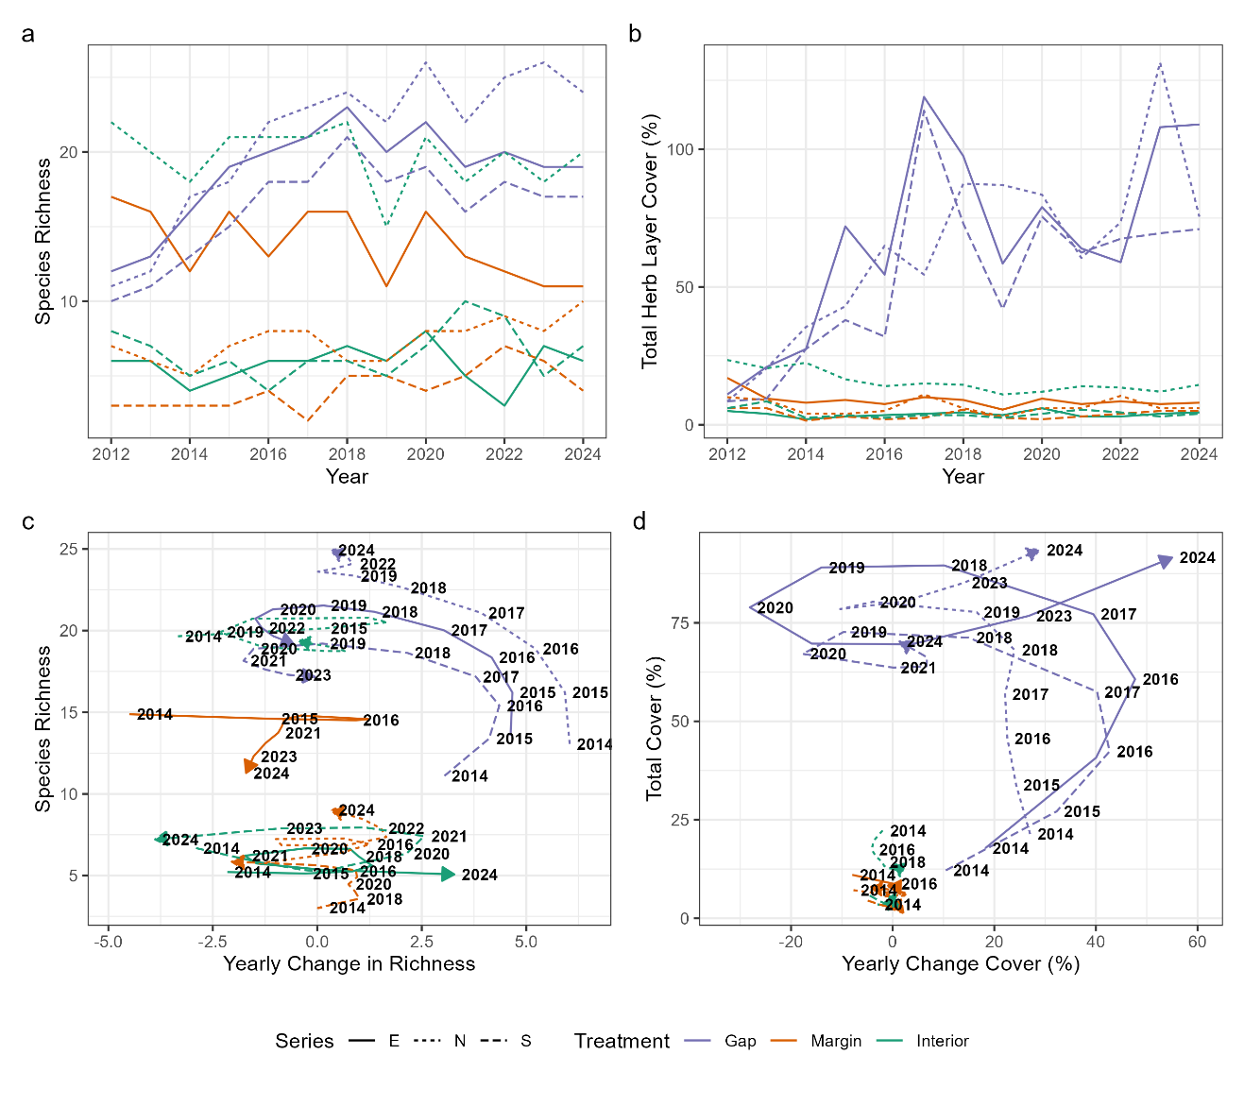
Appendix S4 – Change in species richness (a) and total cover (b) with time, and helical graphs of species richness (c) and total cover (d), before correcting for pseudoturnover.

