Supplementary Table S1. Composition of standard diet.
Ingredients, % |  | Calculated composition
Corn and barley flaked | 20.00 | Dry matter (%) | 89.97
Barley | 19.80 | Crude protein (%) | 19.00
Wheat | 10.00 | Fat (%) | 5.48
Wheat Middlings | 10.00 | Crude fibre (%) | 3.74
Soybean Meal 48% crude protein | 7.00 | Ash (%) | 4.50
Corn Extra Fine | 5.00 | NDF (%) | 14.10
Soft Bran | 5.00 | ADF (%) | 4.60
Extruded Rice | 5.00 | ADL (%) | 0.77
Sweet Whey Spray | 4.50 | Starch (%) | 35.57
Swine Plasma | 2.80 | Sugars (%) | 7.99
Soy Oil | 2.00 | Metabolised energy, kcal/kg | 3283.00
Soy protein concentrate | 1.50 | Ca (%) | 0.61
Fiber Concentrate | 1.00 | P (%) | 0.72
Potato protein concentrate | 1.00 | Avail. P (%) | 0.47
Beet Pulp | 1.00 | Na (%) | 0.25
Coconut Oil | 1.00 | K (%) | 0.82
Aroma | 0.09 | Cl (%) | 0.51
L-Lysine | 0.62 | Mg (%) | 0.12
Dicalcium Phosphate | 0.60 | S (%) | 0.15
Sodium Chloride | 0.40 | Fe (mg/kg) | 160.70
Calcium Formate | 0.30 | Cu (mg/kg) | 106.00
Formic Acid and Sodium Formate Buffered Solution | 0.30 | Zn (mg/kg) | 24.05
Vitamin B Premix | 0.25 | Mg (mg/kg) | 84.38
L-Threonin | 0.24 | Se (mg/kg) | 0.45
DL-Methionine | 0.21 | Lysine SID (%) | 1.25
Val-Ileu-Leu-His Premix | 0.20 | Methionine SID (%) | 0.40
L-Triptophan | 0.05 | Threonine SID (%) | 0.27
Iron Sulphate 21.5% | 0.05 | Tryptophan SID (%) | 0.81
Vit A-D3-E 50-4-50 | 0.04 | Methionine + Cysteine SID (%) | 0.75
Vit E 50% | 0.02 | Valine SID (%) | 0.85
Copper Sulphate | 0.02 | Isoleucine SID (%) | 0.71
Manganese Oxide | 0.01 | Leucine SID (%) | 1.36
Potassium Iodide | 0.0001 | Histidine SID (%) | 0.45
Zn Sulphate (40%) for SO₄ group | 0.028 | Arginine SID (%) | 1.01
Zn Glycinate (25%) for Gly group | 0.044
Hizox (77%) for Hi group | 0.014

Supplementary Table S2. Real Time assay and probes.
Target gene | Gene complete name | Assay Id | TaqMan®
Target gene | Gene complete name | Assay Id | Assay Catalogue
NFKB2 | Nuclear Factor Kappa B Subunit 2 | Ss06883741_g1 | 4331182
GPX-2 | Glutathione Peroxidase 2 | Ss03387478_u1 | 4351372
SLC39A4 | Solute Carrier Family 39 Member 4 | Ss06910319_gH | 4351372
SLC30A7 | Solute Carrier Family 30 Member 7 | Ss03819782_s1 | 4351372
CLAUD4 | Claudin-4 | Ss03375006_u1 | 4351372
HMBS | Hydroxymethylbilane Synthase | Ss03388782_g1 | 4351372

Supplementary Table S3. Effect of Zinc form and weaning age on performance parameters of Early and Normal piglets at the same physiological age.
Item | Early | Normal | SEM | P-value
 |  |  |  | Diet¹ | Age²
Body weight, g
Age 26-28 | 7037 | 8679 | 173.5 | 0.89 | <0.0001
Age 33-35 | 8521 | 9047 | 198.5 | 0.73 | 0.06
Age 40-42 | 11148 | 11419 | 336.5 | 0.85 | 0.56
Average daily gain, g/d
Age 26-28 to 33-35 | 218.2 | 53.4 | 11.295 | 0.95 | <0.0001
Age 33-35 to 40-42 | 377 | 331 | 22.5 | 0.96 | 0.14
Feed intake, g/d
Age 26-28 to 33-35 | 310 | 110 | 11.55 | 0.76 | <0.0001
Age 33-35 to 40-42 | 509 | 415 | 24.9 | 0.86 | 0.008
Gain to Feed
Age 26-28 to 33-35 | 0.695 | 0.39 | 0.08 | 0.33 | 0.005
Age 33-35 to 40-42 | 0.74 | 0.79 | 0.03 | 0.53 | 0.19
¹SO₄: ZnSO₄, Gly: Zn-Glycinate, Hi: porous form of ZnO; ²Early: 21 days at weaning (6753.75±37 g), Normal: 26 days at weaning (9160±66 g).

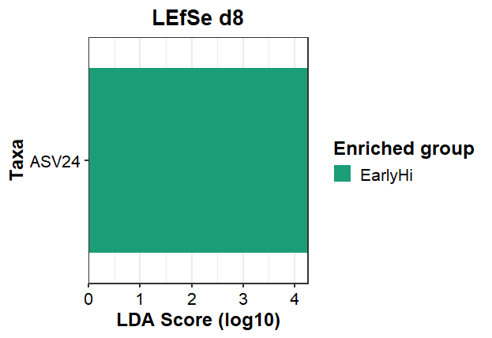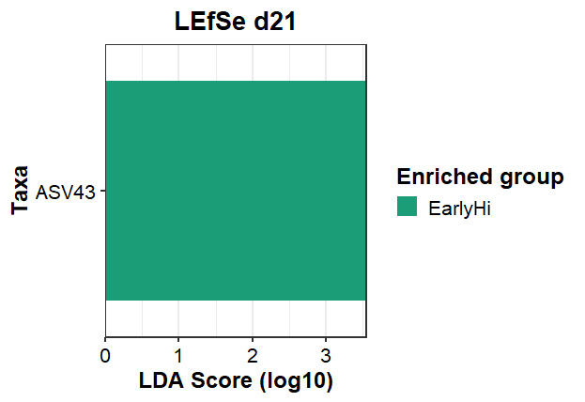
A
B

Supplementary Figure S1. Effect of Zinc administration and age at weaning category on taxa abundance at ASVs level in jejunum content samples of post-weaning piglets at d8 and d21 calculated on singular base. EarlyHi: porous form of ZnO, 21 days at weaning (6753.75±37 g).

