SUPPLEMENTARY MATERIAL

Supplementary Table 1. List of gait and posture parameters that can be set for real-time feedback.
Parameter | Definition
Cadence | Number of steps per minute
Step length | The distance travelled by the foot between two successive instances of heel contact with the ground
Gait speed | The ratio between the step length and the step duration (two successive heel contacts with the ground)
Asymmetry | Difference in step length between left and right foot
Step height | Minimum height of foot during swing phase
Swing phase duration | Time interval between period between toe-off and heel strike
Trunk posture inclination | Antero-posterior tilt of the body measured by the sensor on the chest.

N | Site | Sex | Age | Hoen and Yahr stage | Disease duration [yrs] | Training period [days] | Training sessions [#] | Adherence  [%] | Duration of each session [min] | Distance covered in each session [km] | Average gait speed [m/s] | Number of steps per session [#] | Praising vocal feedback [%]
1 | IT | F | 71 | 2 | 8 | 416 | 121 | 71.6 | 26.5 ± 7.4 | 1.1 ± 0.4 | 0.7 ± 0.2 | 2308 ± 674 | 62.7
2 | IT | F | 56 | 2 | 3 | 297 | 191 | 127.1 | 29.1 ± 0.6 | 2.5 ± 0.2 | 1.4 ± 0.1 | 3421 ± 142 | 77
3 | IT | M | 58 | 2 | 6 | 296 | 120 | 87.8 | 27.8 ± 5.8 | 2.4 ± 0.5 | 1.4 ± 0.1 | 3159 ± 671 | 74.6
4* | IT | F | 49 | 2 | 8 | 68 | 7 | 23 | 28.8 ± 3.7 | 2.1 ± 0.8 | 1.2 ± 0.4 | 3692 ± 459 | 76.6
5 | IT | F | 64 | 2 | 4 | 291 | 144 | 111.2 | 28.9 ± 4.23 | 1.6 ± 0.5 | 0.9 ± 0.2 | 3420 ± 586 | 60.5
6 | IT | F | 46 | 2 | 6 | 279 | 107 | 88 | 29.5 ± 2.7 | 2.7 ± 1.9 | 1.1 ± 0.2 | 3009 ± 338 | 93
7 | IT | M | 66 | 2 | 12 | 268 | 41 | 67.8 | 27.9 ± 6.1 | 2.2 ± 0.6 | 1.3 ± 0.2 | 3370 ± 771 | 66.8
8 | IT | M | 65 | 2 | 8 | 285 | 113 | 77.2 | 25.1 ± 7.9 | 1.7 ± 0.6 | 1.1 ± 0.2 | 2983 ± 961 | 52.2
9 | IT | M | 72 | 3 | 8 | 576 | 138 | 131.6 | 25.8 ± 7.6 | 0.8 ± 0.3 | 0.5 ± 0.1 | 2603 ± 842 | 64.7
10 | IT | M | 70 | 3 | 4 | 172 | 76 | 98.6 | 28.5 ± 4.4 | 1.8 ± 0.3 | 1.1 ± 0.1 | 3100 ± 498 | 73
11 | ISR | M | 79 | 3 | 8 | 169 | 37 | 13 | 7.6 ± 5.32 | 0.3 ± 0.2 | 0.7 ± 0.1 | 779 ± 558 | 47.8
12 | ISR | M | 74 | 3 | 21 | 280 | 49 | 35.1 | 25. 8 ± 12.3 | 1.6 ± 0.9 | 1.0 ± 0.1 | 2557 ± 1284 | 56.4
13 | ISR | M | 70 | 2 | 11 | 367 | 101 | 39.8 | 18.6 ± 4.6 | 1.1 ± 0.4 | 1.0 ± 0.2 | 1960 ± 566 | 84.3
14 | ISR | M | 73 | 2 | 7 | 225 | 44 | 54.3 | 36.0 ± 13.7 | 2.9 ± 1.1 | 1.3 ± 0.1 | 4298 ± 1606 | 67.6
15* | ISR | M | 73 | 3 | 3 | - | - | - | - | - | - | - | -
16 | ISR | M | 71 | 3 | 16 | 247 | 50 | 20.6 | 13.1 ± 7.7 | 0.5 ± 0.3 | 0.7 ± 0.2 | 1450 ± 939 | 42.4
17 | ISR | M | 79 | 3 | 16 | 147 | 33 | 43.2 | 24.8 ± 7.8 | 1.4 ± 0.5 | 0.9 ± 0.1 | 2704 ± 864 | 74.6
18 | ISR | M | 75 | 3 | 17 | 222 | 20 | 11.8 | 16.8 ± 6.6 | 0.8 ± 0.3 | 0.8 ± 0.1 | 1848 ± 764 | 47.3
19 | ISR | M | 38 | 3 | 15 | 263 | 27 | 16.01 | 19.3 ± 9.4 | 0.8 ± 0.7 | 0.7 ± 0.4 | 1938 ± 802 | 31.8
20* | ISR | M | 57 | 2 | 10 | 34 | 7 | 15.4 | 9.6 ± 0.9 | 0.4 ± 0.2 | 0.7 ± 0.4 | 862 ± 152 | 32.1
Supplementary Table 2. Adherence of GT training and statistics of training sessions of all the participants. Values are reported as mean ± standard deviation.

Legend: ‘*’ drop-out; ‘-‘ training session results not computed due (drop-out)

Supplementary Table 3. Liker scale scores assigned by the participants at the end of their gait training period. Questions: 1) Ease of use: How satisfied are you with how easy it is to use your assistive device? 2) Received assistance: How satisfied are you with the quality of the professional services (information, attention) you received for using your assistive device? 3) GT effectiveness: How satisfied are you with how effective your assistive device is (the degree to which your device meets your needs)? Responses: 5 totally agree, 4 agree, 3 neutral, 2 disagree, 1 totally disagree.
N | Ease-of-use | Received assistance | GT effectiveness
1 | 5 | 5 | 5
2 | 5 | 5 | 5
3 | 4 | 5 | 5
4* | 5 | 5 | 4
5 | 5 | 5 | 5
6 | 4 | 5 | 3
7 | 5 | 5 | 4
8 | 5 | 5 | 5
9 | 2 | 4 | 4
10 | 4 | 5 | 5
11 | 3 | NA | NA
12 | 4 | 4 | 4
13 | 5 | 5 | 5
14 | 2 | NA | NA
15* | NA | NA | NA
16 | NA | NA | NA
17 | 4 | 5 | 5
18 | NA | NA | NA
19 | 4 | 5 | 5
20* | 3 | NA | NA
Legend: ‘*’ drop-out; ‘NA’ data not available.

Supplementary Table 4. Clinical measures, physical capacity and training sessions statistics related to each participant. Clinical measures and physical capacity are referred to PRE and POST clinical evaluations. Training sessions statistics are computed in the first and last two months (PRE and POST, respectively).
N | MDS-UPDRS III |  | BBS |  | MiniBEST |  | TUG single task [s] |  | TUG dual task [s] |  | 10MWT [m/s] |  | Duration [min] |  | BF praising [%]
 | T0 | T1 | T0 | T1 | T0 | T1 | T0 | T1 | T0 | T1 | T0 | T1 | T0 | T1 | T0 | T1
1 | 29 | 22 | 55 | 56 | 27 | 25 | 11.81 | 10.24 | 15.25 | 12.54 | 1.09 | 1.18 | 27.31 | 27.52 | 57.78 | 67.75
2 | 12 | 14 | 56 | 56 | 28 | 28 | 8.27 | 8.41 | NA | 10.04 | 1.28 | 1.54 | 22.14 | 27.03 | 84.51 | 72.9
3 | 14 | 11 | 56 | 56 | 28 | 28 | 8.01 | 7.06 | NA | 8.02 | 1.30 | 1.71 | 25.43 | 27.31 | 75.87 | 80.04
4* | 17 | - | 55 | - | 28 | - | 8.1 | - | 7.62 | - | 1.01 | - | - | - | - | -
5 | 29 | 11 | 55 | 56 | 28 | 28 | 8.64 | 7.91 | 9.45 | 7.34 | 1.15 | 1.71 | 29.26 | 27.06 | 90.47 | 92.09
6 | 17 | 15 | 56 | 56 | 28 | 27 | 9.26 | 9.15 | 10.03 | 9.12 | 1.20 | 1.50 | 28.89 | 29.99 | 53.86 | 56.95
7 | 31 | 15 | 54 | 53 | 24 | 25 | 9.37 | 7.47 | 10.34 | 7.35 | 1.30 | 1.71 | 26.55 | 30.13 | 66.94 | 65.98
8 | 23 | 8 | 56 | 56 | 28 | 28 | 7.29 | 6.89 | 7.95 | 6.8 | 1.82 | 1.46 | 25.79 | 24.6 | 59.88 | 50.75
9 | 50 | 42 | 48 | 44 | 23 | 18 | 11.96 | 14.9 | 13.13 | 15.11 | 1.20 | 1.03 | 26.6 | 28.09 | 57.26 | 71.6
10 | 37 | 44 | 47 | 51 | 19 | 22 | 14.1 | 18.33 | 18.12 | 25.18 | 1.40 | 1.02 | 28.66 | 28.97 | 78.65 | 67.84
11 | 70 | 90 | 48 | 36 | 21 | 16 | 17.6 | 18.5 | NA | 22.69 | 0.79 | 0.80 | 9.19 | 5.81 | 50.51 | 43.59
12 | 52 | 62 | 40 | 40 | 14 | 17 | 20 | 25 | 28.41 | 28.9 | NA | NA | 24.64 | 21.33 | 57.64 | 57.01
13 | 30 | 25 | NA | NA | 20 | 29 | 11.6 | 15.4 | 14.7 | NA | 1.20 | 1.14 | 17.49 | 20.11 | 79.27 | 88.91
14 | 33 | 51 | 56 | 56 | 28 | 32 | 8.2 | 9.1 | 9.6 | 9.45 | 1.31 | 1.20 | 35.29 | 34.4 | 70.94 | 66.22
15* | 23 | - | 50 | - | 20 | - | 16.9 | - | 42.18 | - | NA | - | - | - | - | -
16 | 35 | 36 | 45 | 55 | 24 | 28 | 12.4 | 12.2 | 15.59 | 13.81 | 1.24 | 0.99 | 13.73 | 13.43 | 41.22 | 33.23
17 | 34 | 34 | 48 | 52 | 21 | 22 | 11.3 | 11.83 | 20.5 | 26.78 | NA | NA | 29.75 | 18.98 | 75.32 | 72.3
18 | 35 | NA | NA | NA | 22 | NA | 11.5 | NA | 16.37 | NA | 0.85 | 0.82 | 15.86 | 10.19 | 43.59 | 51.57
19 | 63 | 60 | 44 | 49 | NA | 19 | 13.25 | 12.41 | NA | 26.06 | 0.95 | 0.91 | 15.94 | 19.72 | 38.51 | 16.58
20* | 9 | - | 56 | - | 32 | - | 8.94 | - | 9.66 | - | NA | - | - | - | - | -
Legend: ‘T0’ pre-intervention, ‘T1’ post-intervention, ‘*’ drop-out; ‘NA’ data not available; ‘-‘ training session results not computed due (drop-out), BBS: Berg Balance Scale, TUG: Timed Up and Go, BF: biofeedback.

Supplementary Figure 1. Training duration and corresponding gait speed achieved in each trial performed by two participants with different H&Y stages: H&Y 2 in yellow (2A), H&Y 3 in red (2B). The dashed line represents the mean value over the 9 months.
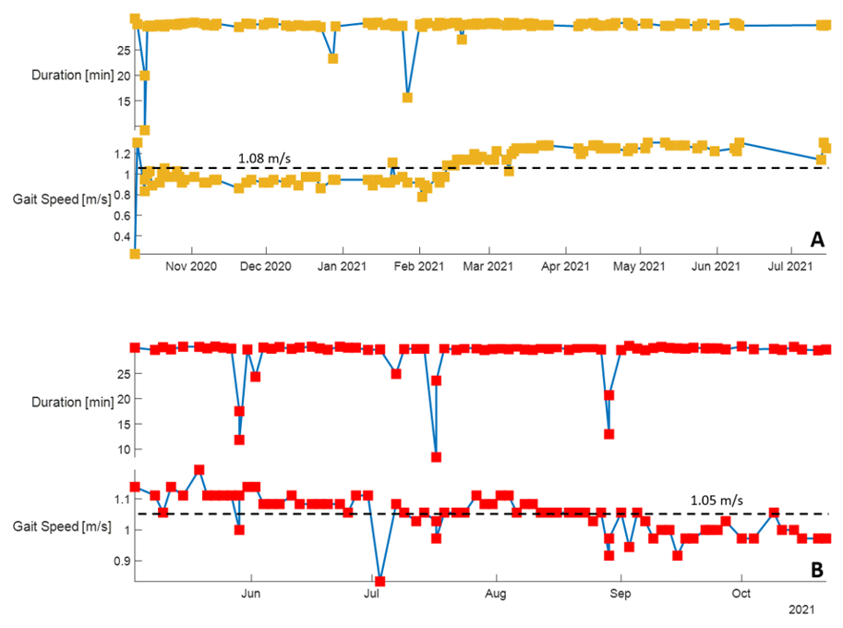

Supplementary Figure 2. Duration, distance covered, mean gait speed reached, and number of strides done during training sessions performed by an Italian participant who suffered a knee injury in the second half of the training period. The red- and orange-shaded areas highlight the COVID-19 lockdown and the period when the participant suffered a knee injury, respectively.
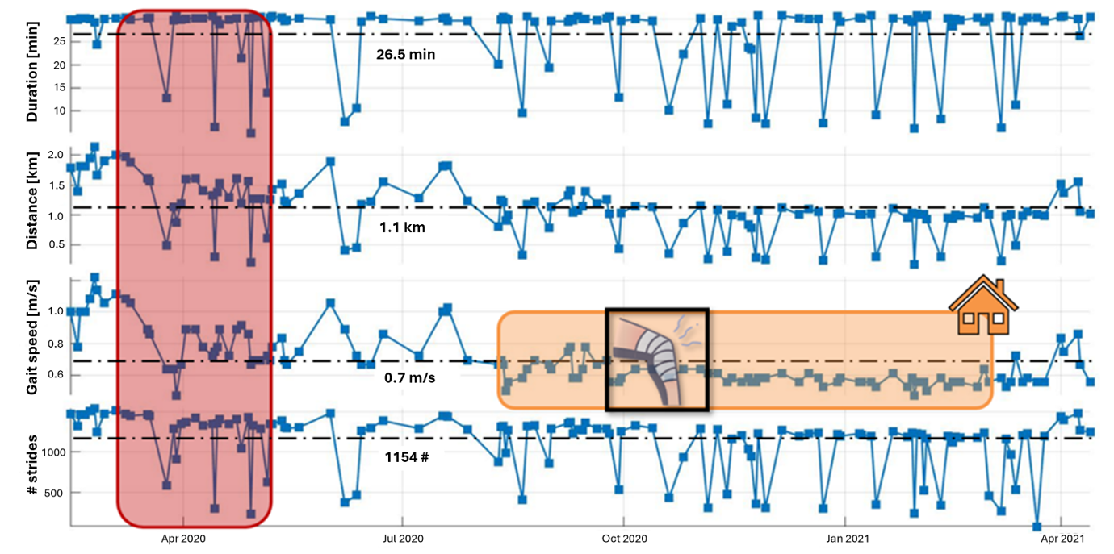

Supplementary Figure 3. Distribution of the personalized biofeedback messages played over the whole training period for an Italian participant.
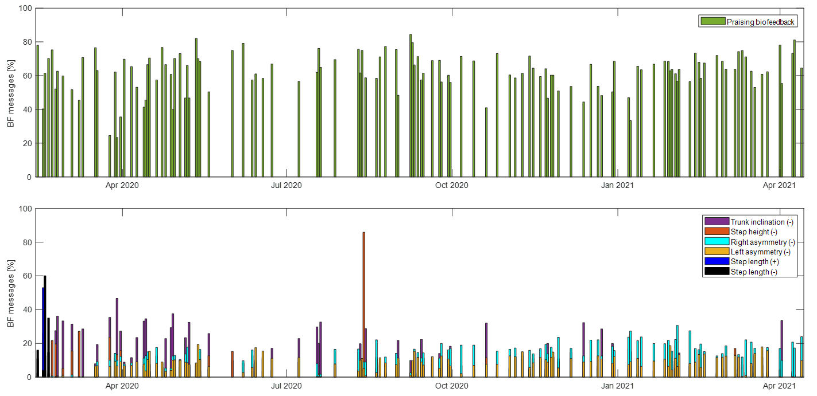

Supplementary Table 5. Details of responders on MDS-UPDRS III and gait speed. The total is computed excluding participants who dropped out. Legend:
N | MDS-UPDRS III |  |  | Gait speed  10MWT [m/s] |  |  | Responders MDS-UPDRS III | Responders Gait speed 10MWT | Responders  MDS-UPDRS III & Gait speed 10MWT
N | T0 | T1 | T1-T0 | T0 | T1 | T1-T0 | Responders MDS-UPDRS III | Responders Gait speed 10MWT | Responders  MDS-UPDRS III & Gait speed 10MWT
1 | 29 | 22 | -7 | 1,09 | 1,18 | 0,09 | yes | yes | yes
2 | 12 | 14 | 2 | 1,28 | 1,54 | 0,26 | no | yes | no
3 | 14 | 11 | -3 | 1,3 | 1,71 | 0,41 | yes | yes | yes
4* | 17 | - | - | 1,01 | - | - | no | yes | -
5 | 29 | 11 | -18 | 1,15 | 1,71 | 0,56 | yes | yes | yes
6 | 17 | 15 | -2 | 1,2 | 1,5 | 0,3 | yes | yes | yes
7 | 31 | 15 | -16 | 1,3 | 1,71 | 0,41 | yes | yes | yes
8 | 23 | 8 | -15 | 1,82 | 1,46 | -0,36 | yes | no | no
9 | 50 | 42 | -8 | 1,2 | 1,03 | -0,17 | yes | no | no
10 | 37 | 44 | 7 | 1,4 | 1,02 | -0,38 | no | no | no
11 | 70 | 90 | 20 | 0,79 | 0,8 | 0,01 | no | yes | no
12 | 52 | 62 | 10 | NA | NA | NA | no | NA | NA
13 | 30 | 25 | -5 | 1,2 | 1,14 | -0,06 | yes | no | no
14 | 33 | 51 | 18 | 1,31 | 1,2 | -0,11 | no | no | no
15* | 23 | - | - | NA | - | - | no | - | -
16 | 35 | 36 | 1 | 1,24 | 0,99 | -0,25 | no | no | no
17 | 34 | 34 | 0 | NA | NA | NA | no | NA | NA
18 | 35 | NA | NA | 0,85 | 0,82 | -0,03 | NA | no | no
19 | 63 | 60 | -3 | 0,95 | 0,91 | -0,04 | yes | no | no
20* | 9 | - | - | NA | - | - | no | yes | -
Total | 34.94 ±  15.97 | 33.75 ± 23.99 | -1.19 ±  10.67 | 1.21 ±  0.24 | 1.25 ±  0.33 | 0.04 ±  0.29 | 9/15 (50%) | 6/15 (40%) | 5/15 (33%)
Legend: ‘T0’ pre-intervention;, ‘T1’ post-intervention; ‘*’ drop-out.

