SUPPLEMENTARY MATERIAL
Supplementary Methods and Materials 2
Supplementary Table 1 5
Supplementary Figure 1 6
Supplementary Figure 2 7
Supplementary Figure 3 8
Supplementary Figure 4 9
Supplementary Figure 5 10
Supplementary Figure 6 11
Supplementary Figure 7 12
Supplementary Figure 8 13
References 14

SUPPLEMENTARY METHODS AND MATERIALS
Sample size calculation
To calculate the sample sizes, the positive predictive values (PPV) of the FIT in the Dutch and Italian screening programmes were estimated using the annual evaluation of the Dutch CRC screening programme (version 2019) resulting in the 40% for the Netherland and in 23% in a programme with a FIT cut-off of 20 µg Hb/g feces. Moreover, to estimate the proportion of FIT-positive individuals with a FIT≥47 µg Hb/g feces out of a group of individuals with a FIT≥20 µg Hb/g feces we used data from the Dutch pilot screening program in which up to 30,000 individuals were invited for four consecutive screening rounds. In this database, and across all four rounds, 57% of the individuals with a FIT result of 20 mcg Hb/g or higher also had a FIT result of 47 mcg Hb/g or higher. Then, using Rstudio (version 1.2.5019) and the package samplingbook (function sample.size.prop) we calculated that with a sample size of 800 participants, the proportion of AN at colonoscopy in Italy and the Netherlands, and a recruitment ratio of 3:2 (480 participants in Italy and 320 in the Netherlands) we would reach a sample size of 594 participants (of which 237 would have AN) and a 95%CI of 3.9% on either side for analysis on group I, and 480 participants (of which 110 would have AN) and a 95%CI of 5.6% on either side for analysis B.
CELTiC analysis
Blood samples were collected and treated (within 1 hour of collection) in each center. At least 1 ml blood was collected in an EDTA tube immediately before colonoscopy. Samples were then mixed with 1 ml of nuclease-free water (Merck, Darmstadt, Germany). The solution was subsequently transferred to a prepared 12 ml tube with 6 ml of TRIzol™ LS reagent (ThermoFisher Scinetific, Waltham, Massachusetts, USA) and mixed again. Treated samples were stored at -80°C. Analysis (RNA extraction, reverse transcription, and real time PCR) of the samples was conducted at the unit of Histology, Embryology and Applied Biology of the Department of Medical and Surgical Sciences, University of Bologna. Samples collected in the Netherlands were transported on dry ice by air carrier and stored at 80°C upon arrival.
Total RNA was extracted as previously reported (Ferlizza et al., 2020). In short, treated samples were divided over four tubes of 1.5ml. Then, each aliquot was added with 0.2 ml chloroform, incubated at RT, centrifuged at 12,000 g for 15 min and the transparent water-based upper phases containing total RNA transferred to new tubes. To precipitate the RNA, 0.5 ml of cold (-20°C) isopropyl alcohol was added to each aliquot, incubated at RT and the tubes centrifuged at 12,000 g for 20 min. Finally, the RNA pellet was washed twice with 1 ml of cold (-20°C) 75% alcohol and suspended in 20 µl nuclease-free water. Quantity and quality of the RNA samples were checked and measured by a Nanodrop ND-2000 spectrophotometer (ThermoFisher Scientific, Waltham, Massachusetts, USA) and the integrity tested by agarose gel electrophoresis. We considered a 260/280 nm ratio of 1.8 or greater and the presence of two clear bands (18s and 28s) on 1% agarose gel as acceptable.
Total RNA (300 ng) was reverse transcribed in cDNA with a commercial kit (RevertAid RT Reverse Transcription, Thermo Fisher Scientific TM, Waltham, MA, USA) and amplified using the iTaq universal SYBR Green Supermix (Bio-Rad, Hercules, CA, USA), according to the manufacturer’s instructions. Real-time PCRs were performed with the CFX96 instrument (Bio-Rad) in duplicate, at 95°C for 10 min, followed by 40 cycles of 95 °C for 15 s and 60 °C for 1 min, with melting curve analysis. Each qPCR run included a negative control without the cDNA template and a positive control of cDNA derived from the HT-29 cell line, in which all the tested genes are expressed. Primer sequences and the calibration test have been previously described (Rodia et al., 2016). Expression values of each of the four markers of the CELTiC panel were measured as ΔCq (Quantification Cycle) after normalization on the beta 2 microglobulin (B2M; NCBI reference sequence: NM_004048) housekeeping gene expression (Hamm et al., 2016). B2M was selected after a comprehensive meta-analysis previously performed showing the lowest variability between healthy and CRC.

CELTiC score Model
$$CELTiC=$$

$$\frac{1}{1+e^{-\left(5.294201+0.2299539×age-0.9291234×sex-0.3910535×Δ{cq}_{LGALS4}-0.182439×Δ{cq}_{CEACAM6}-1.116752×Δ{cq}_{TSPAN8}\right)}}​​$$

Supplementary table 1. Participant characteristics per participating center.
 | Amsterdam (n = 215) |  | Bologna (n = 486) |  | Rotterdam (n = 108)
 | n (%) | mean (SD) | n (%) | mean (SD) | n (%) | mean (SD)
Sex
Male | 121 (56%) | - | 240 (49%) | - | 59 (55%) | -
Female | 94 (44%) | - | 246 (51%) | - | 49 (45%) | -
Age | 215 (100%) | 64.7 (6.8) | 486 (100%) | 59.5 (6.2) | 108 (100%) | 65.7 (6.2)
ASA score
I | 82 (38%) | - | 450 (93%) | - | 11 (10%) | -
II | 130 (56%) | - | 36 (7%) | - | 50 (46%) | -
III | 3 (1.4%) | - | 0 (0%) | - | 47 (44%) | -
Follow-up
Adequate colonoscopy† | 207 (96%) | - | 461 (95%) | - | 106 (98%) | -
CT colonography‡ | 5 (2.3%) | - | 12 (2.5%) | - | 0 (0%) | -
Inadequate follow-up | 3 (1.4%) | - | 13 (2.7%) | - | 2 (1.9%) | -
CELTiC score | 215 (100%) | 0.35 (0.32) | 486 (100%) | 0.14 (0.21) | 108 (100%) | 0.32 (0.30)
CEACAM6 | 215 (100%) | 13.6 (1.2) | 486 (100%) | 13.6 (1.3) | 108 (100%) | 13.2 (1.5)
LGALS4 | 215 (100%) | 15.5 (0.9) | 486 (100%) | 15.4 (0.9) | 108 (100%) | 15.7 (1.3)
TSPAN8 | 215 (100%) | 11.2 (1.8) | 486 (100%) | 12.3 (2.5) | 108 (100%) | 11.4 (1.5)
COL1A2 | 215 (100%) | 11.0 (1.9) | 486 (100%) | 12.1 (2.2) | 108 (100%) | 11.4 (1.8)
AN | 55 (26%) | - | 132 (27%) | - | 39 (36%) | -
CRC | 7 (3.3%) | - | 22 (4.5%) | - | 1 (1%) | -
AA | 48 (22%) | - | 110 (23%) | - | 38 (35%) | -
LR | 96 (45%) | - | 142 (29%) | - | 31 (29%) | -
NCOL | 64 (30%) | - | 212 (44%) | - | 38 (35%) | -
†Adequate colonoscopy: any colonoscopy where cecal intubation was achieved, and a BBPS of ≥6 points and ≥2 points per segment. ‡CT colonograghy was only offered if the colonoscopy was inadequate, or if the endoscopist deemed the patient unfit for colonoscopy. AA = advanced adenoma, CRC = colorectal cancer, LR = low-risk polyps (includes non-advanced adenoma and serrated lesions), NCOL = negative colonoscopy despite positive FIT.

Supplementary figure 1. Cumulative distribution functions of CELTiC by disease outcomes (full cohort). A: AN and participants without disease. B: CRC, AA, and participants without disease.
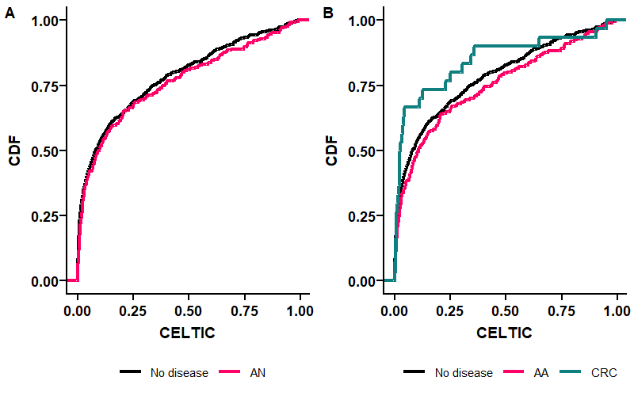

Supplementary figure 2. Boxplot of each of the four CELTiC markers by AN status (full cohort).
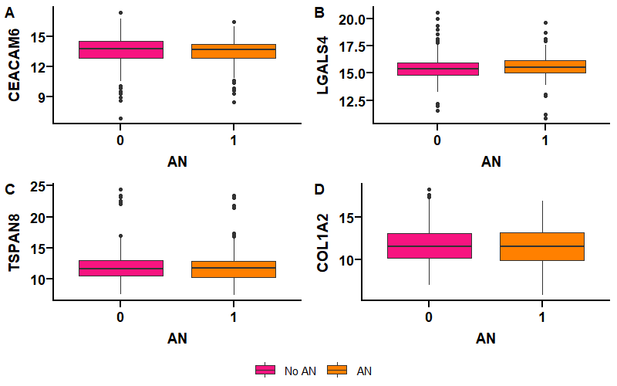

Supplementary figure 3. Cumulative distribution functions of each of the four CELTiC markers by AN status in group I.
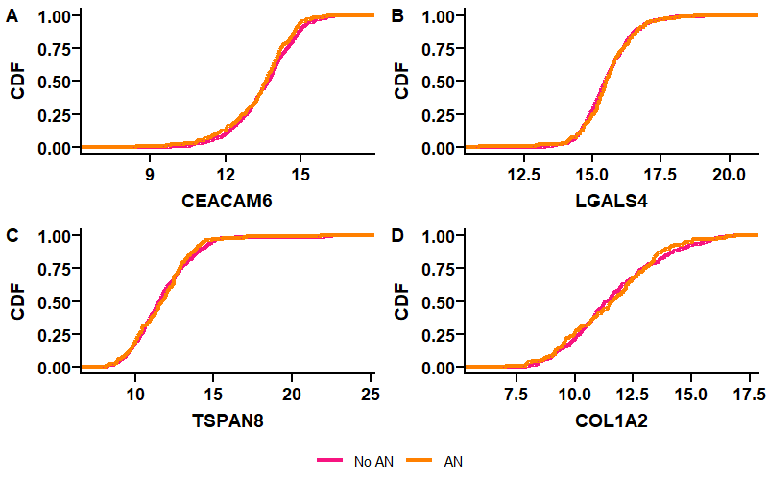

Supplementary figure 4. Cumulative distribution functions of each of the four CELTiC markers by AN status in group II.
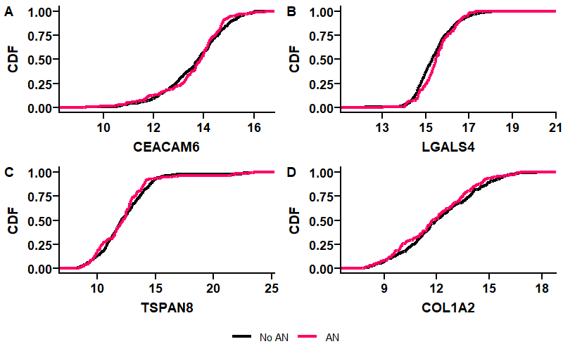
Supplementary figure 5. Cumulative distribution functions of each of the four CELTiC markers by additional outcomes (full cohort).
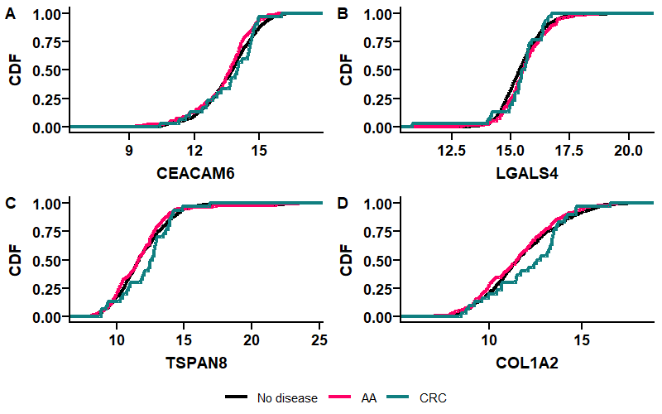

Supplementary figure 6. Levels of each of the four CELTiC markers by outcome.
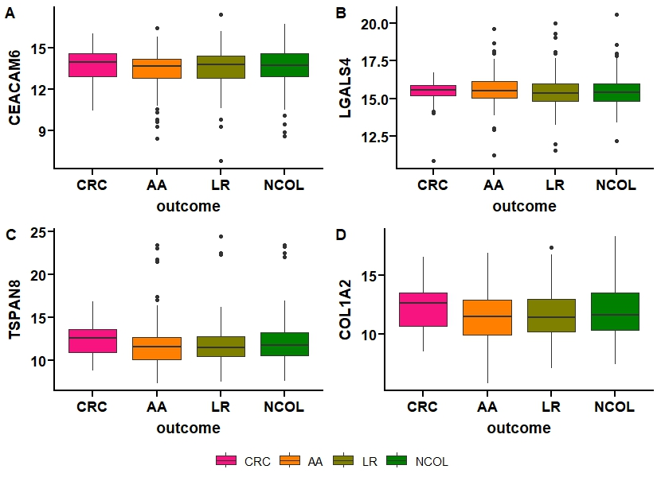

Supplementary figure 7. CELTiC score by outcome.
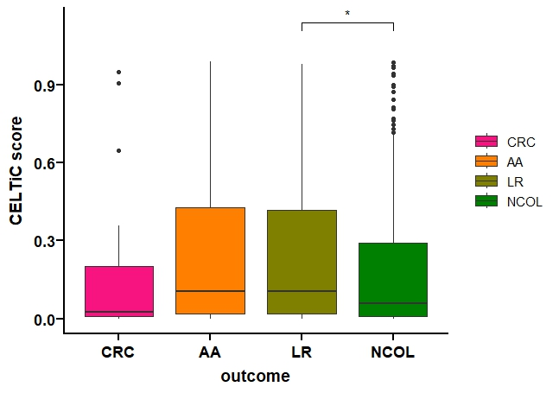
* p < 0.05.

Supplementary figure 8. Performance of CELTiC for detecting AN in (A) Italian participants and (B) Dutch participants.
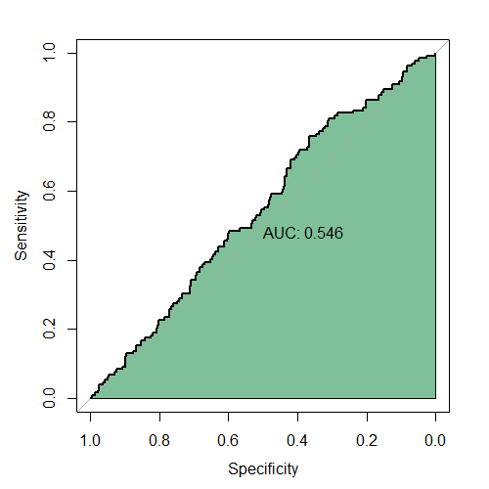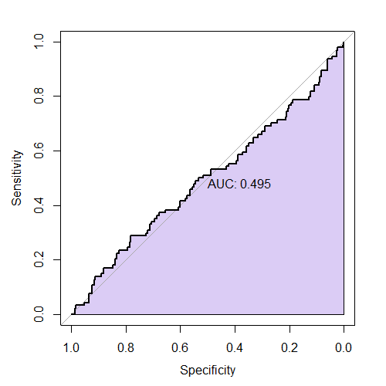
B
A

References
Ferlizza, E., Solmi, R., Miglio, R., Nardi, E., Mattei, G., Sgarzi, M., & Lauriola, M. (2020). Colorectal cancer screening: Assessment of CEACAM6, LGALS4, TSPAN8 and COL1A2 as blood markers in faecal immunochemical test negative subjects. Journal of Advanced Research, 24, 99-107. doi:https://doi.org/10.1016/j.jare.2020.03.001
Hamm, A., Prenen, H., Van Delm, W., Di Matteo, M., Wenes, M., Delamarre, E., . . . Mazzone, M. (2016). Tumour-educated circulating monocytes are powerful candidate biomarkers for diagnosis and disease follow-up of colorectal cancer. Gut, 65(6), 990-1000. doi:10.1136/gutjnl-2014-308988
Rodia, M. T., Ugolini, G., Mattei, G., Montroni, I., Zattoni, D., Ghignone, F., . . . Solmi, R. (2016). Systematic large-scale meta-analysis identifies a panel of two mRNAs as blood biomarkers for colorectal cancer detection. Oncotarget, 7(21), 30295-30306. doi:10.18632/oncotarget.8108

