Supplementary material for

Mediterranean strictly protected forests are cooler
Francesco Solano¹, Chiara Mansi², Michele Baliva², Daniele Canestrelli², Alessandro Chiarucci³, Raffaele Manicone⁴, Maurizio Maugeri⁵, Giuseppe Modica⁶, Jordan Palli^{2*}, Giovanni Quilghini⁷, Gianluca Piovesan²
¹Department of Agriculture and Forest Sciences, University of Tuscia, via San Camillo de Lellis s/n, 01100 Viterbo, Italy
²Department of Ecological and Biological Sciences, University of Tuscia, Largo dell’Università s/n, 01100 Viterbo, Italy
³BIOME Lab, Department of Biological, Geological, and Environmental Sciences, Alma Mater Studiorum - University of Bologna, Via Irnerio 42, Bologna 40126, Italy
⁴Comando Unità Forestali Ambientali ed Agroalimentari (CUFAA), Raggruppamento Carabinieri Biodiversità, Via Giosuè Carducci 5, 00187 Roma, Italy
⁵Department of Environmental Science and Policy, Università degli Studi di Milano, Via Celoria 10, 20133 Milan, Italy
⁶Dipartimento di Scienze Veterinarie, Università degli studi di Messina, Viale G. Palatucci s/n, I-98168 Messina, Italy
⁷Reparto Carabinieri Biodiversità Follonica, Via Bicocchi 2, 58022 Follonica, Italy

* Corresponding author: Jordan Palli, jo.palli@unitus.it

Contents of this file
Figures S1 to S10
Table S1

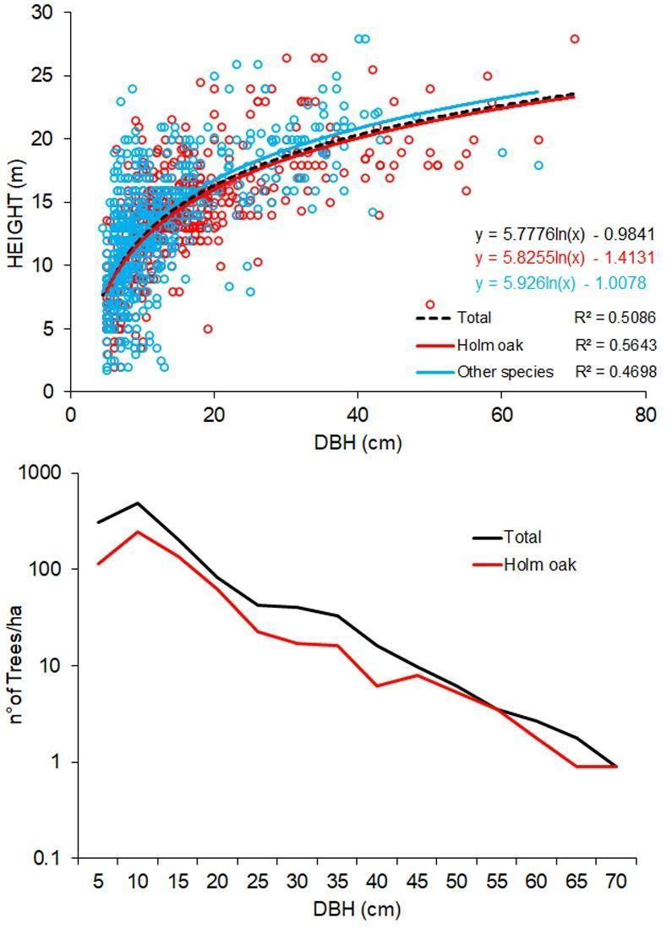
Figure S1. Stand height-curve developed from tree attributes measured in the field in a 13,500 m² sample transect in the strict reserve (SR) of Poggio Tre Cancelli study area (above). Frequency distribution of tree diameter classes derived from the surveyed sample transect (below).

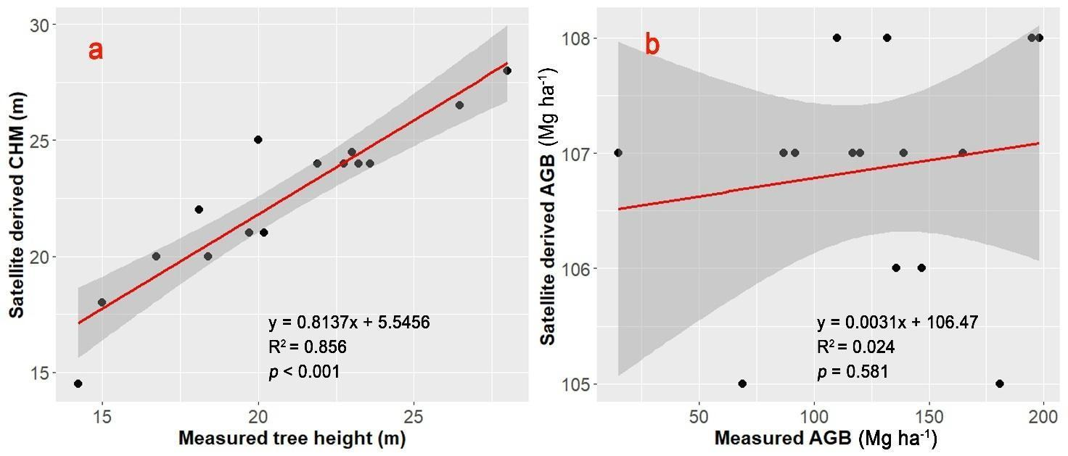
Figure S2. Validation model of the CHM by (Lang et al., 2023) (left-a) and the global aboveground biomass dataset by (Harris et al., 2021) (right-b) using in-situ tree height measurements and calculated above ground biomass in the strict reserve sample transect.

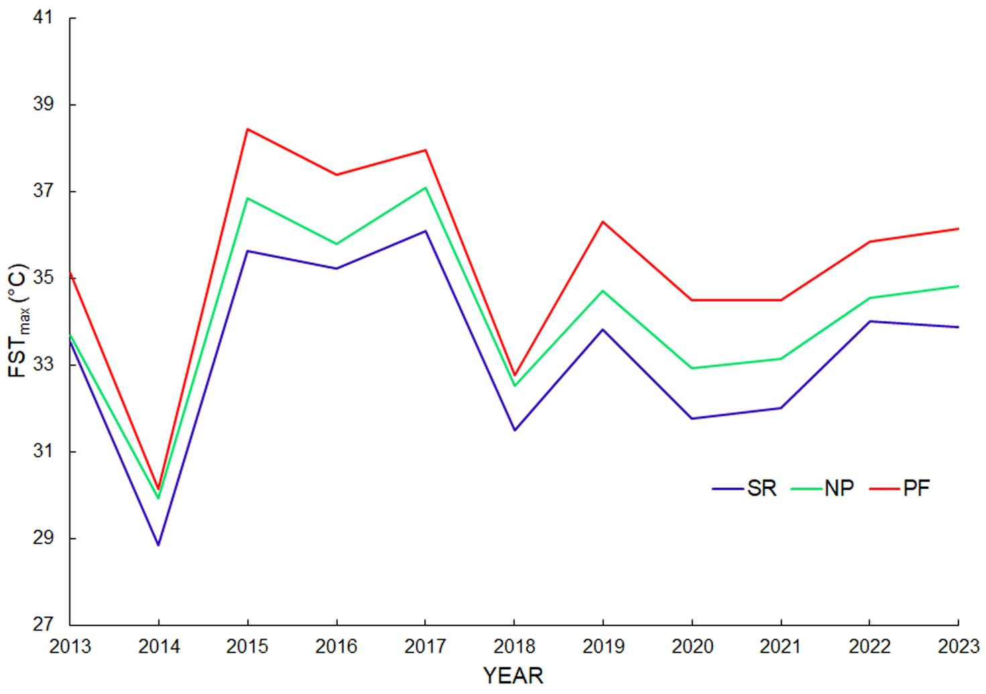
Figure S3. The figure illustrates the temporal trends of maximum forest surface temperature (FSTₘₐₓ, °C) from 2013 to 2023 across the three forest management zones: Strict Reserve (SR), Natural Park (NP), and Productive Forest (PF). The figure highlights consistently lower canopy temperatures in the strictly protected area compared to managed forests, with intermediate values observed in the natural park.

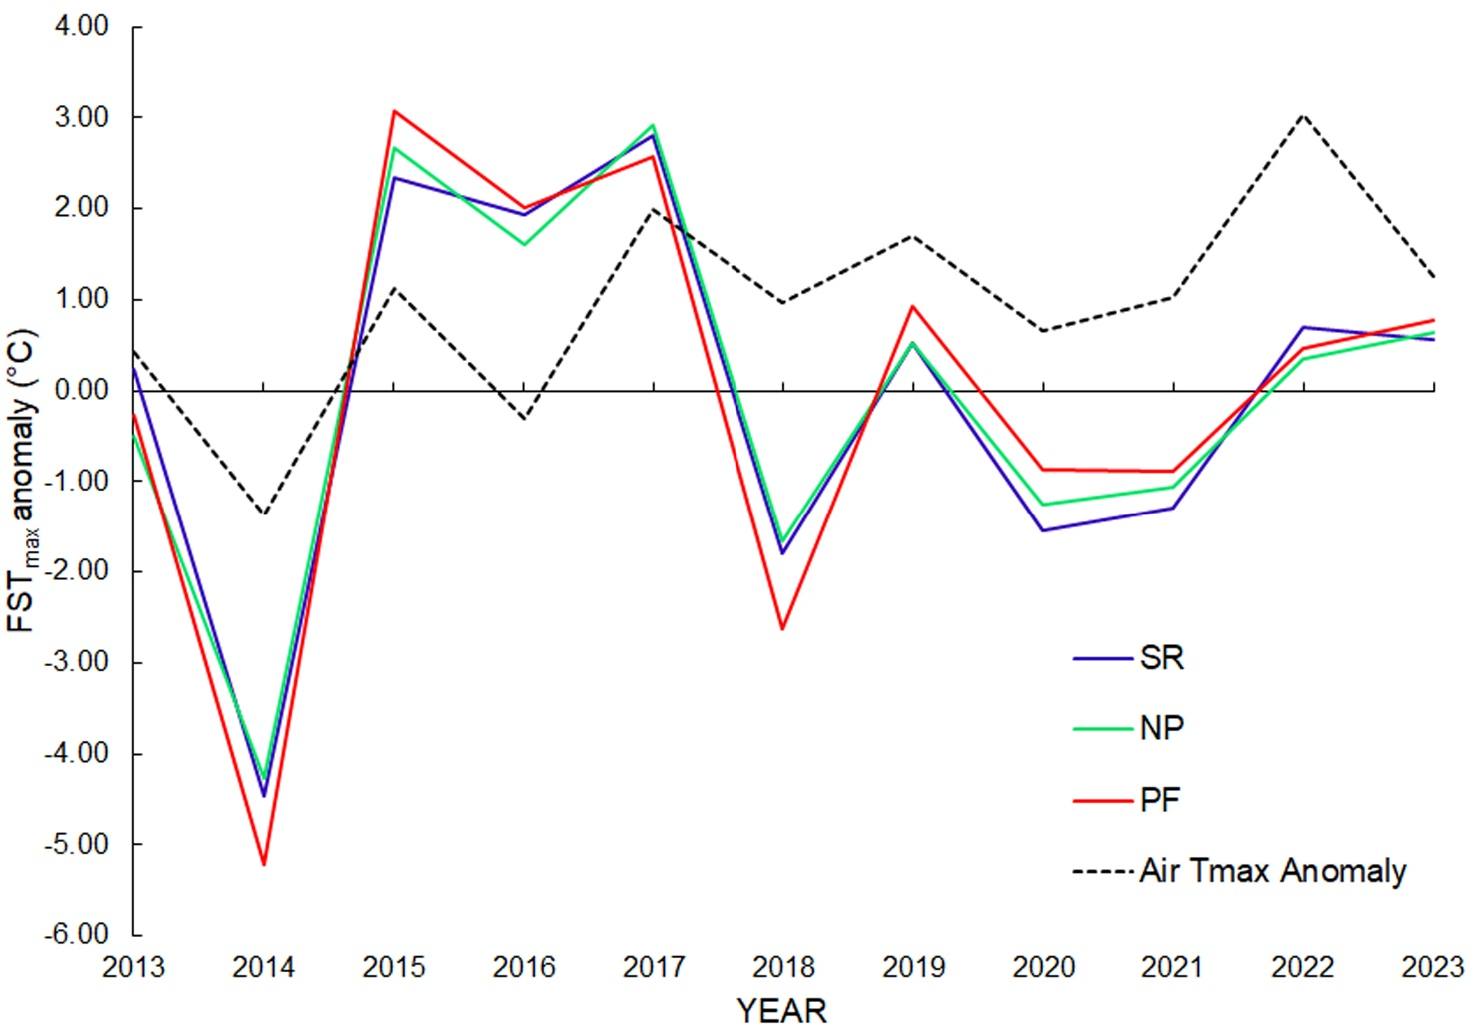
Figure S4. The figure illustrates the comparison between forest surface temperature anomalies (FST_{max} anomaly) and air temperature anomalies (T_{max} anomaly) for the period 2013-2023 during summer months across different forest management regimes: strict reserve (SR), natural park (NP), and productive forests (PF). It is evident that all forest management types show a similar variation of temperature anomalies that align with fluctuations in air temperature, particularly during periods of pronounced warming. From 2013 to 2014, a drop in both forest surface and air temperature anomalies was observed, with a rapid increase following that period. Coppice forest stands (PF) often demonstrated higher temperature anomalies, suggesting greater sensitivity to air temperature changes compared to strict reserves (SR), which exhibited comparatively moderated responses. Forests under stricter protection (SR) appear less responsive to sharp changes in air temperature, implying a potential buffering effect linked to the preservation measures. The overall comparison highlights that while forest surface temperatures generally follow air temperature variations, management practices influence the degree of anomaly.

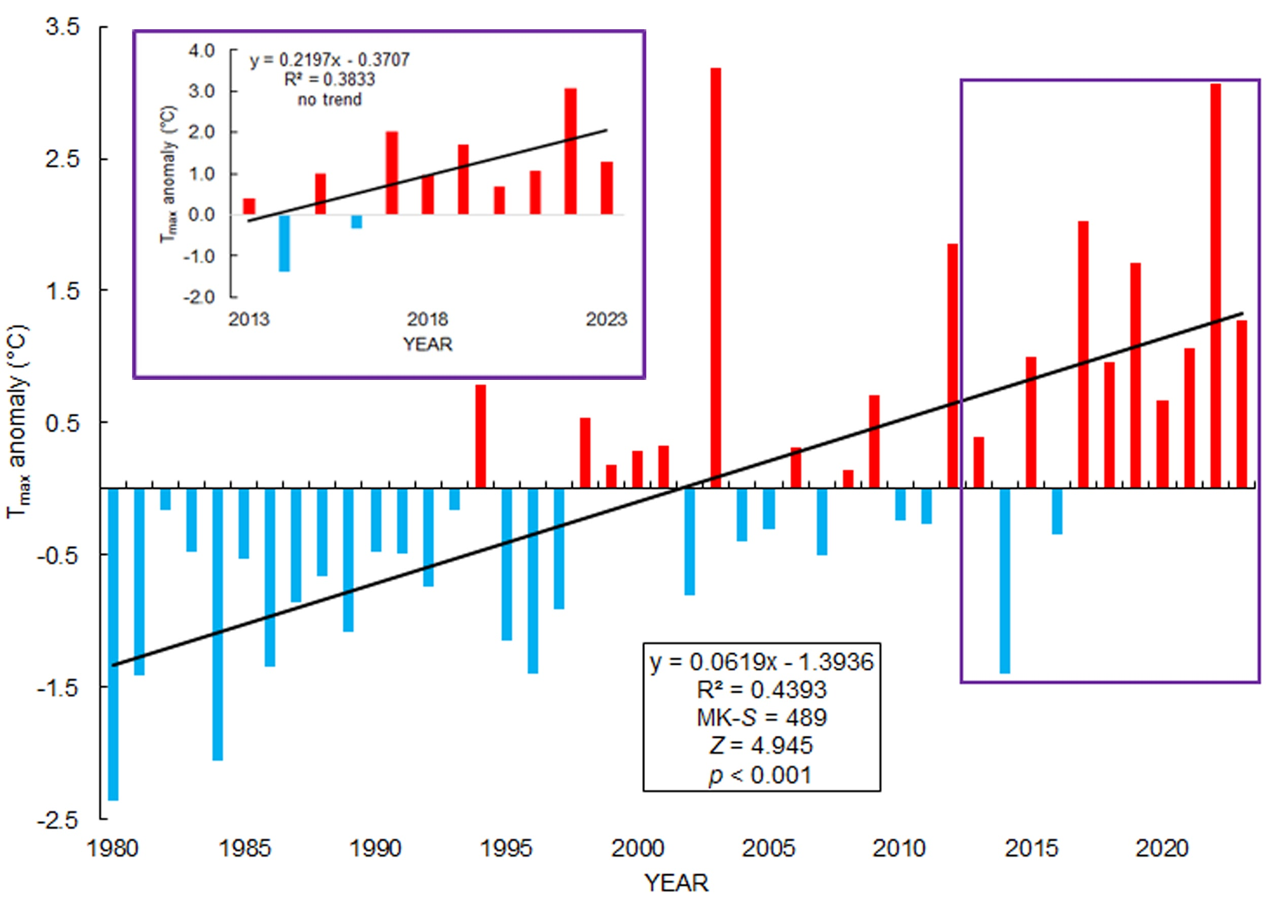

Figure S5. Trend analysis of the annual summer maximum temperature anomalies from 1980 to 2023. The inset box in the top left corner shows the trend for the last 11 years, using a time window that coincides with the forest surface temperature measurements derived from satellites.

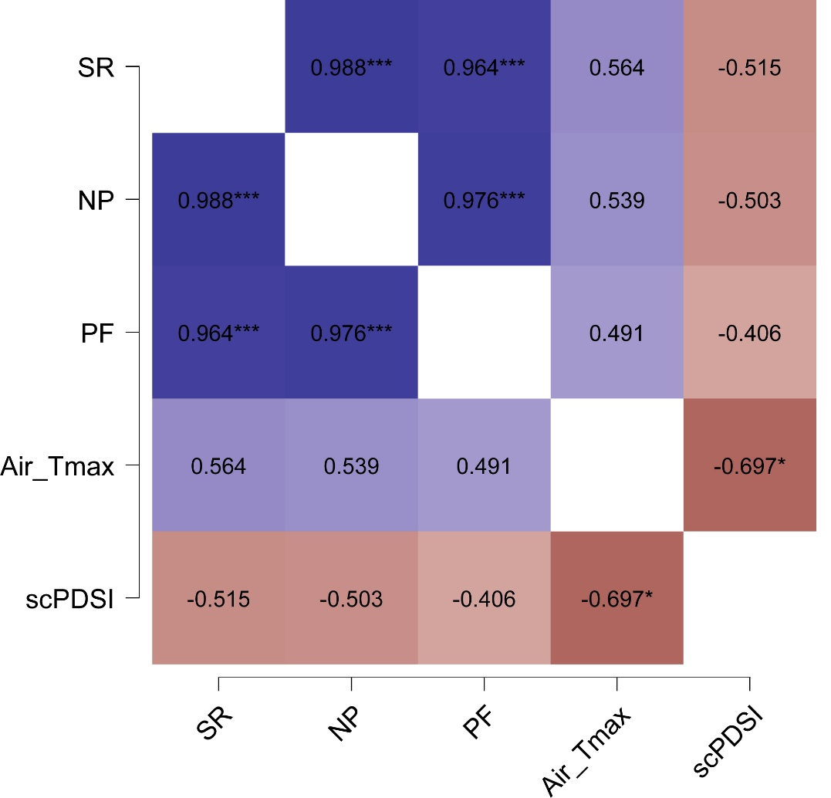

Figure S6. Correlation heatmap for Spearman’s order correlation coefficient (rho) between the maximum forest surface temperature (FST_{max}) across the different forest management classes strict reserve (SR), natural park (NP), and productive forests (PF) in the study area for the period 2013-2023. Maximum air temperature (Air_T_{max}) and the self-calibrated Palmer Drought Severity Index (scPDSI) are also analyzed. Blue colors correspond to positive correlation coefficients; red colors correspond to negative correlation coefficients. The saturation of colors reflects the absolute value of the correlation coefficient. *p < 0.05 if the correlation is significant at alpha = 0.05 level. **p < 0.01 if the correlation is significant at alpha = 0.01 level. ***p < 0.001 if the correlation is significant at alpha = 0.001 level.

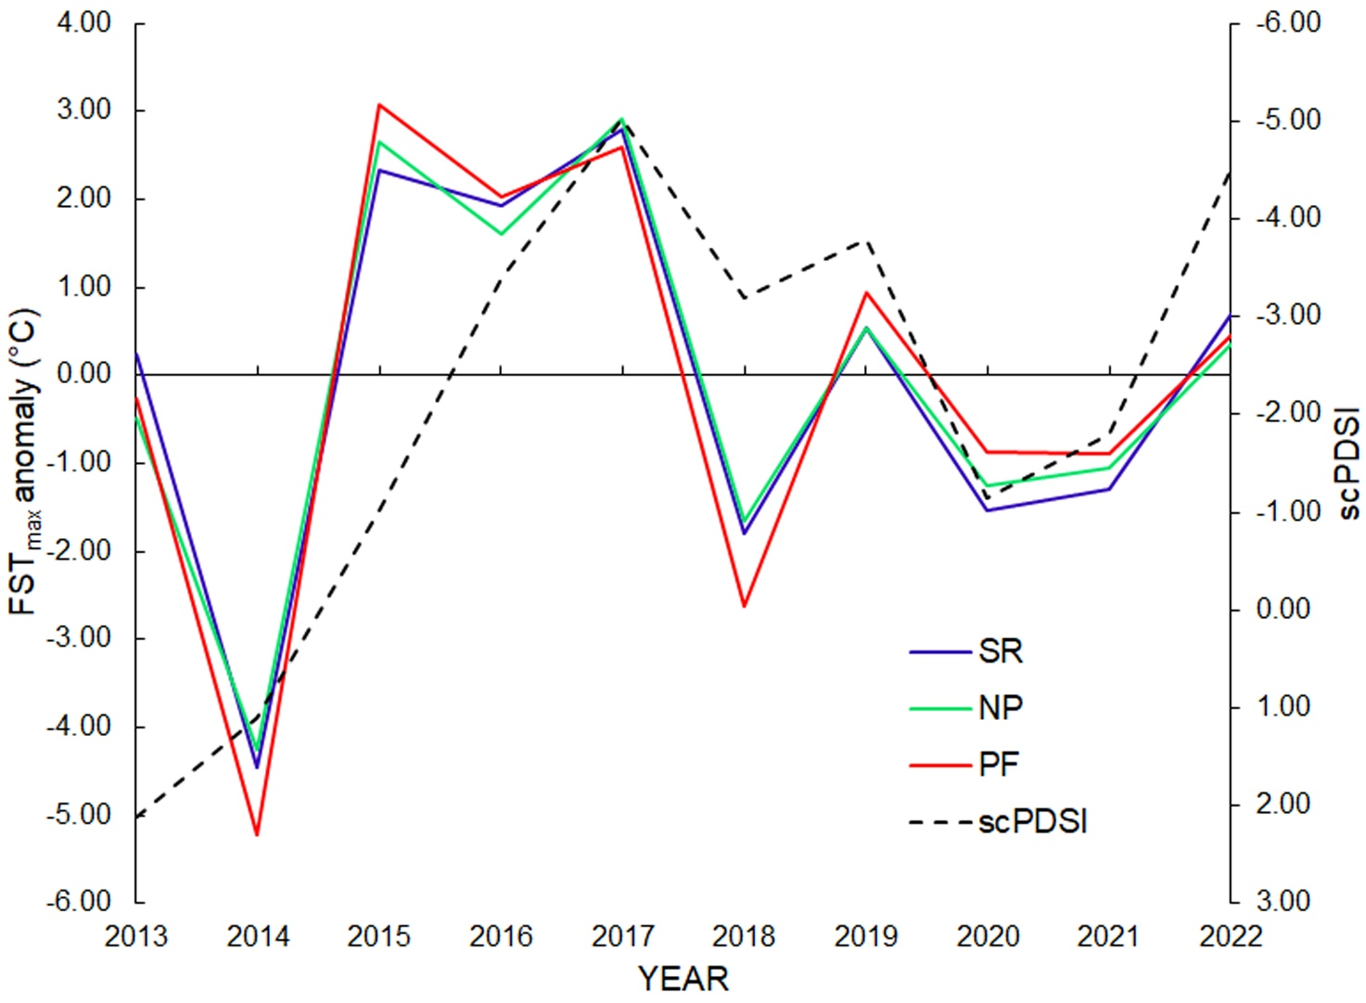
Figure S7. The figure illustrates the trends in maximum forest surface temperature anomalies (FST_{max} anomaly) for the period 2013-2023 during summer months across different forest management regimes: strict reserve (SR), natural park (NP), and productive forests (PF) alongside the self-calibrated Palmer Drought Severity Index (scPDSI). The correlation data indicates a negative non-significant correlation between canopy surface temperature fluctuations and drought conditions. Notably, during periods of severe drought (evident in negative scPDSI values), all forest management regimes display a tendency towards positive temperature anomalies. The strict reserve (SR) tends to exhibit lower temperature anomalies compared to other management types, suggesting that stricter protection measures may mitigate temperature extremes during drought conditions.
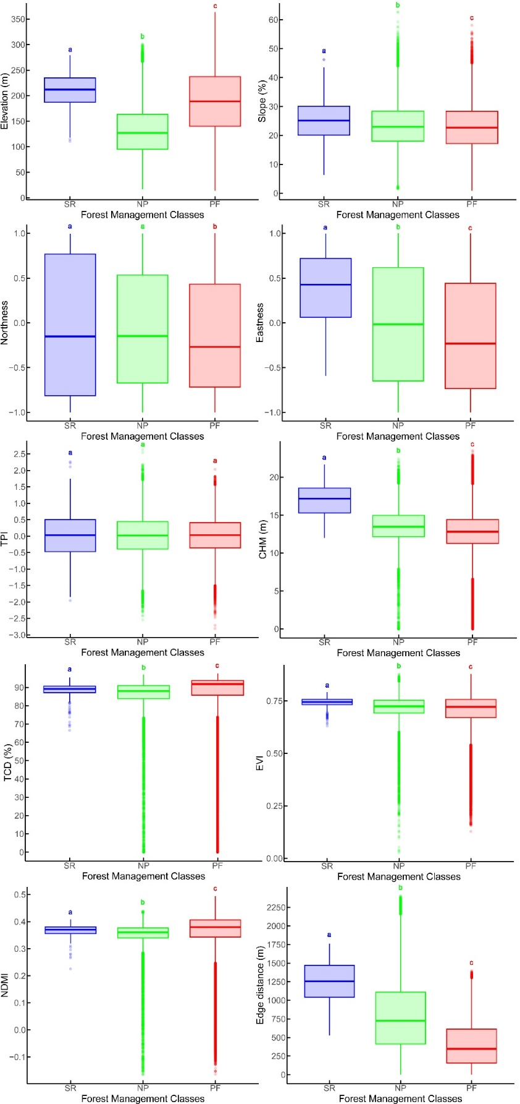
Figure S8. Descriptive statistics of the geomorphological-topographical (Elevation, Slope, Easteness, Northness, TPI), forest structural (CHM), forest functional (TCD, EVI, NDMI), and forest edge effect (Edge distance) parameters used for modeling maximum Forest surface temperature (FST_{max}). Medians not sharing any letter are significantly different by Dunn’s post-hoc pairwise comparison test at the α = 0.05 level of significance adopting Benjamini-Hochberg correction.

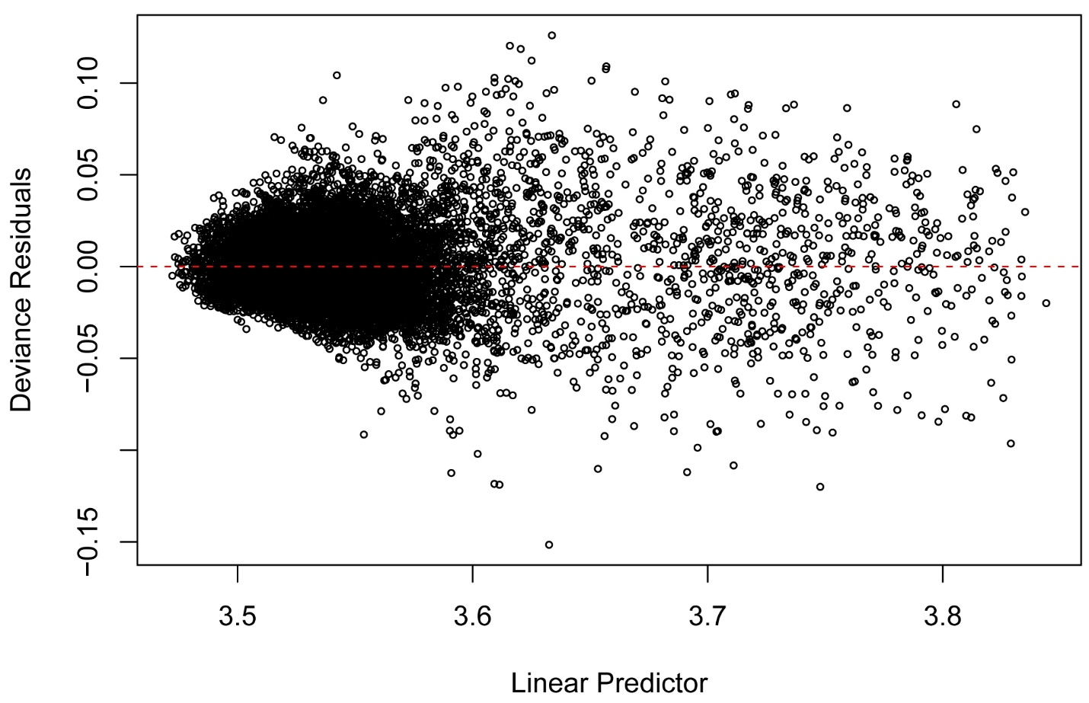
Figure S9. Generalized Additive Model (GAM) diagnostic plot displaying the deviance residuals against the linear predictor (log-transformed fitted values). The red dashed line indicates a residual value of zero.

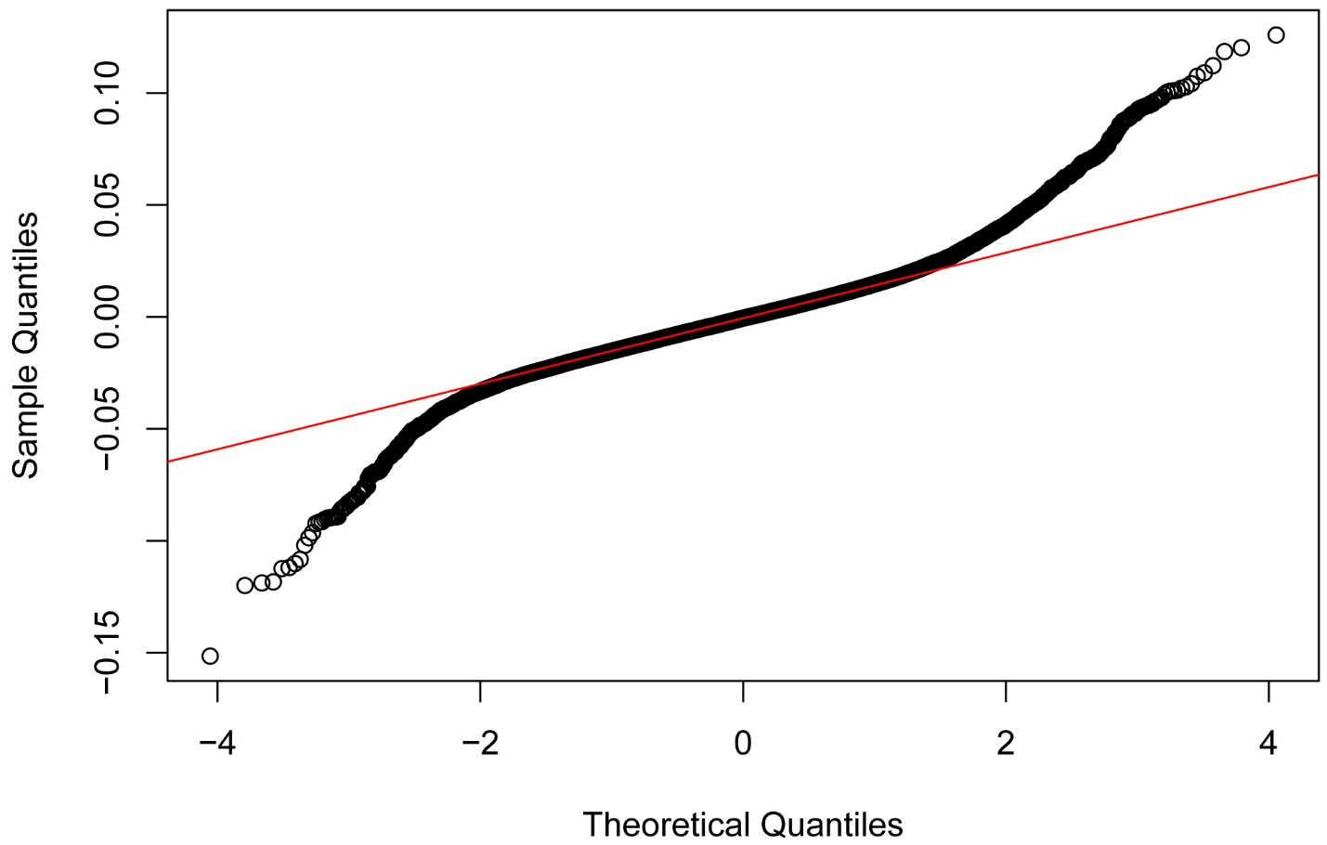
Figure S10. Normal Q-Q Plot of deviance residuals for the Generalized Additive Model (GAM). This diagnostic plot compares the quantiles of the model deviance residuals against the quantiles of a theoretical normal distribution. The red line represents the expected distribution if the residuals were perfectly normally distributed.

Table S1. Summary table of multiple regression model predicting FST_{max} based on the value of topographical predictors. Management classes were considered as factor variables. SR is the reference site.
 |  |  |  |  |  |  | Collinearity Statistics
Model |  | Unstandardized | Standard Error | Standardized | t | p | Tolerance | VIF
H₀ | (Intercept) | 34.613 | 0.006 |  | 5617.2 | <.001
H₁ | (Intercept) | 36.607 | 0.049 |  | 749.3 | <.001
 | Elevation | -0.011 | 9.060×10⁻⁵ | -0.405 | -124.6 | <.001 | 0.867 | 1.153
 | Slope | -0.046 | 6.315×10⁻⁴ | -0.207 | -72.6 | <.001 | 0.989 | 1.011
 | Northness | -0.33 | 0.008 | -0.119 | -42.1 | <.001 | 0.995 | 1.005
 | Eastness | 0.47 | 0.008 | 0.174 | 61.2 | <.001 | 0.991 | 1.009
 | TPI | 0.309 | 0.008 | 0.108 | 37.3 | <.001 | 0.97 | 1.031
Forest management classes
 | NP | 0.117 | 0.044 |  | 2.6 | 0.008
 | PF | 2.008 | 0.044 |  | 45.8 | <.001

