Twin diplomacy: Strategic co-author selection and resolution outcomes at the UNSC

Online appendix
Table of contents
1. Universe of cases 3
2. Sampled sponsors and targets 26
3. Networks for individual years 30
4. Variable descriptives 44
5. Regression models 47
6. Interview data 50
7. Robustness: Regression models with alternative explanations 57
8. Robustness: Regression models with fixed effects 60
9. Co-sponsorship within Council procedure: An overview 61
10. References 64

1. Universe of cases
Table AI. Sampled countries-years. Data on civilian casualties was taken from UCDP, data on atrocities from TMK. Years with less than 50 civilian casualties were included if they are both preceded and followed by a year meeting the threshold criterion

Full country name | ISO | Years included
Afghanistan | AFG | 1990-2018
Angola | AGO | 1990-2003
Azerbaijan | AZE | 1992-1993
Bangladesh | BGD | 1991-1992
Bosnia and Herzegovina | BIH | 1992-1995
Burkina Faso | BFA | 2018-2018
Burundi | BDI | 1995-2006; 2015-2018
Cameroon | CMR | 1994; 2014-2018
Central African Republic | CAF | 2006-2018
Chad | TCD | 1992-1995; 1998; 2005-2007; 2015
China | CHN | 2008
Colombia | COL | 1990-2007
Congo (Republic of) | COG | 1993; 1997-1999
Ivory Coast (Côte d’Ivoire) | CIV | 2000-2004; 2011
Croatia | HRV | 1993; 1995
DR Congo | COD | 1990-2018
Egypt | EGY | 1995-1997; 2005; 2015-2018
Eritrea | ERI | 1999
Ethiopia | ETH | 1990-1991; 2003-2007; 2012; 2015-2018
Georgia | GEO | 1993; 1995; 2008
Guatemala | GTM | 1990-1995
India | IND | 1990-2018
Indonesia | IDN | 1990-1991; 1998-2004
Iran | IRN | 1993; 2018
Iraq | IRQ | 1991-1996; 2003-2018
Israel | ISR | 1994-1996; 2001-2009; 2012-2014
Kenya | KEN | 2007-2008; 2013-2017
Lebanon | LBN | 1990; 1996; 2006; 2012-2013
Liberia | LBR | 1990-1996; 1999-2003
Libya | LBY | 2011; 2014-2018
Mali | MLI | 1990-1992; 1994; 2013; 2016-2018
Mexico | MEX | 2010-2011
Mozambique | MOZ | 1990-1992; 2018
Myanmar | MMR | 1991-2008; 2011-2012; 2015-2018
Niger | NER | 1990; 1998; 2015, 2018-2018
Nigeria | NGA | 1990; 1994; 1999-2004; 2008-2018
Pakistan | PAK | 1998-2004; 2007-2018
Peru | PER | 1990-1994
Philippines | PHL | 1990-1991; 2000-2004; 2007-2011; 2015; 2018
Russia | RUS | 1994-1996; 1999-2005; 2011
Rwanda | RWA | 1990-1998
Senegal | SEN | 1992-1993; 1997-1998
Serbia | SRB | 1991-1992; 1998-1999
Somalia | SOM | 1990-1996; 1999-2001; 2006-2018
South Africa | ZAF | 1990-1994
South Sudan | SSD | 2012-2018
Sri Lanka | LKA | 1990-2000; 2006-2009; 2018
Table AI (continued)
Sudan | SDN | 1990-2018
Syria | SYR | 2011-2018
Thailand | THA | 2004-2013
Turkey | TUR | 1990-1995; 2011; 2015-2017
Uganda | UGA | 1990-1991; 1995-2006; 2010
Ukraine | UKR | 2014-2018
Yemen | YEM | 1995; 2011; 2014-2018
Table AII. Included draft resolutions, topics, co-sponsors and voting outcomes (binary)
ID | Year | Draft | Co-sponsors | Topic | Adopted | Veto | Unanimity
1 | 1991 | S/22298 | Belgium; France; Romania; United Kingdom; Union of Soviet Socialist Republics; United States; Zaire | IRQ-KWT | 1 | 0 | 0
2 | 1991 | S/22448 | Belgium; France; United Kingdom; United States | IRQ | 1 | 0 | 0
3 | 1991 | S/22613 | Belgium; France; Romania; Union of Soviet Socialist Republics; United Kingdom; United States; Zaire | IRQ-KWT | 1 | 0 | 0
4 | 1991 | S/22686 | France; Union of Soviet Socialist Republics; United Kingdom; United States | IRQ | 1 | 0 | 1
5 | 1991 | S/22698 | Belgium; France; Union of Soviet Socialist Republics; United Kingdom; United States | IRQ-KWT | 1 | 0 | 1
6 | 1991 | S/22941 | Belgium; France; Union of Soviet Socialist Republics; United Kingdom; United States | IRQ | 1 | 0 | 0
7 | 1991 | S/22942 | France; Union of Soviet Socialist Republics; United Kingdom; United States | IRQ | 1 | 0 | 1
8 | 1991 | S/23045 | Belgium; France; Romania; Ukrainian Soviet Socialist Republic; United Kingdom; United States | IRQ | 1 | 0 | 0
9 | 1991 | S/23067 | Austria; Belgium; France; Union of Soviet Socialist Republics; United Kingdom | YUG | 1 | 0 | 1
10 | 1991 | S/23134 | Belgium; France; Romania; Union of Soviet Socialist Republics; United Kingdom; United States | IRQ | 1 | 0 | 1
11 | 1992 | S/23927 | Belgium; France; Hungary; Morocco; United Kingdom; United States | BIH | 1 | 0 | 1
12 | 1992 | S/24037 | Belgium; France; Russian Federation; United Kingdom; United States | YUG | 1 | 0 | 0
Table AII (continued)
13 | 1992 | S/24421 | Belgium; France; Russian Federation; United Kingdom; United States | BIH | 1 | 0 | 0
14 | 1992 | S/24422 | France; Russian Federation; United Kingdom; United States | BIH-YUG | 1 | 0 | 1
15 | 1992 | S/24488 | Belgium; France; Russian Federation; United Kingdom; United States | IRQ-KWT | 1 | 0 | 0
16 | 1992 | S/24554 | Belgium; France; Morocco; United Kingdom; United States | BIH | 1 | 0 | 0
17 | 1992 | S/24570 | Belgium; France; Hungary; Japan; Russian Federation; United Kingdom; United States | YUG | 1 | 0 | 0
18 | 1992 | S/24605 | Belgium; France; United Kingdom | IRQ | 1 | 0 | 0
19 | 1992 | S/24618 | Belgium; France; Hungary; Morocco; United Kingdom; United States; Venezuela | YUG | 1 | 0 | 1
20 | 1992 | S/24636 | Austria; Belgium; France; Morocco; Russian Federation; United Kingdom; United States | BIH | 1 | 0 | 0
21 | 1992 | S/24977 | Belgium; France; Morocco; United Kingdom | BIH | 1 | 0 | 1
22 | 1993 | S/25440 | France; Morocco; Pakistan; Spain; United Kingdom; United States | BIH | 1 | 0 | 0
23 | 1993 | S/25558 | Cape Verde; Djibouti; France; Morocco; Pakistan; Spain; United Kingdom; United States; Venezuela | BIH-YUG | 1 | 0 | 0
24 | 1993 | S/25870 | France; Russian Federation; Spain; United Kingdom; United States | BIH | 1 | 0 | 0
25 | 1993 | S/25798 | France; Russian Federation; Spain; United Kingdom; United States | BIH | 1 | 0 | 1
26 | 1993 | S/25966 | France; Russian Federation; Spain; United Kingdom; United States | BIH-HRV-MKD | 1 | 0 | 1
27 | 1993 | S/25997 | Afghanistan; Albania; Algeria; Cape Verde; Comoros; Djibouti; Egypt; Estonia; Indonesia; Iran; Jordan; Latvia; Libya; Malaysia; Morocco; Pakistan; Senegal; Syria; Tunisia; Türkiye; United Arab Emirates; Venezuela | BIH | 0 | 0 | 0
Table AII (continued)
28 | 1994 | S/1994/224 | France; Russian Federation; Spain; United Kingdom; United States | BIH | 1 | 0 | 1
29 | 1994 | S/1994/465 | France; Russian Federation; Spain; United Kingdom | BIH | 1 | 0 | 1
30 | 1994 | S/1994/487 | France; Russian Federation; Spain; United Kingdom | BIH-HRV-MKD | 1 | 0 | 1
31 | 1994 | S/1994/775 | Argentina; Czechia; France; New Zealand; Russian Federation; Spain; United Kingdom; United States | RWA | 1 | 0 | 1
32 | 1994 | S/1994/1084 | Argentina; Czechia; Djibouti; France; Germany; Nigeria; Oman; Pakistan; Russian Federation; Rwanda; Spain; United Kingdom; United States | BIH | 1 | 0 | 0
33 | 1994 | S/1994/1085 | Czechia; France; Germany; Russian Federation; Spain; United Kingdom; United States | BIH-YUG | 1 | 0 | 0
34 | 1994 | S/1994/1119 | France; Spain; United Kingdom | SOM | 1 | 0 | 0
35 | 1994 | S/1994/1120 | France; Nigeria; New Zealand; Rwanda; Spain; United Kingdom | BIH-HRV-MKD | 1 | 0 | 1
36 | 1994 | S/1994/1164 | Argentina; France; Oman; Rwanda; United Kingdom; United States | IRQ | 1 | 0 | 1
37 | 1994 | S/1994/1168 | Argentina; France; New Zealand; Russian Federation; Spain; United Kingdom; United States | RWA | 1 | 0 | 0
38 | 1994 | S/1994/1317 | France; Germany; Russian Federation; Spain; United Kingdom; United States | BIH | 1 | 0 | 1
39 | 1994 | S/1994/1358 | Bosnia and Herzegovina; Croatia; Djibouti; Egypt; Nigeria; Oman; Pakistan; Rwanda; Türkiye | BIH-HRV-YUG | 0 | 1 | 0
40 | 1995 | S/1995/21 | Czechia; France; Germany; Italy; United Kingdom | BIH-YUG | 1 | 0 | 0
41 | 1995 | S/1995/242 | Argentina; Czechia; France; Germany; Italy; Russian Federation; United Kingdom; United States | HRV | 1 | 0 | 1
42 | 1995 | S/1995/243 | Argentina; Czechia; France; Germany; Italy; Russian Federation; United Kingdom; United States | BIH-HRV | 1 | 0 | 1
Table AII (continued)
43 | 1995 | S/1995/292 | Argentina; Oman; Rwanda; United Kingdom; United States | IRQ | 1 | 0 | 1
44 | 1995 | S/1995/395 | France; Germany; Italy; Russian Federation; United Kingdom; United States | HRV | 1 | 0 | 1
45 | 1995 | S/1995/394 | Botswana; Honduras; Indonesia; Nigeria; Oman; Rwanda | ISR | 0 | 1 | 0
46 | 1995 | S/1995/478 | Czechia; France; Germany; Honduras; Netherlands; Oman; United Kingdom | BIH | 1 | 0 | 0
47 | 1995 | S/1995/560 | France; Germany; Italy; United Kingdom; United States | BIH | 1 | 0 | 1
48 | 1995 | S/1995/724 | Argentina; Czechia; France; Germany; Honduras; Italy; Russian Federation; Rwanda; United Kingdom; United States | BDI | 1 | 0 | 1
49 | 1995 | S/1995/979 | Argentina; Czechia; France; Germany; Honduras; Italy; Russian Federation; Rwanda; United Kingdom; United States | HRV | 1 | 0 | 1
50 | 1995 | S/1995/994 | Argentina; Czechia; France; Germany; Honduras; Italy; Russian Federation; United Kingdom; United States | HRV | 1 | 0 | 1
51 | 1995 | S/1995/995 | Argentina; Czechia; France; Germany; Honduras; Italy; Russian Federation; United Kingdom; United States | BIH | 1 | 0 | 1
52 | 1995 | S/1995/1033 | Argentina; Czechia; France; Germany; Italy; Russian Federation; United Kingdom; United States | BIH | 1 | 0 | 1
53 | 1996 | S/1996/69 | Botswana; Chile; Egypt; Guinea-Bissau; Honduras; Indonesia | ERI-SDN | 1 | 0 | 1
54 | 1996 | S/1996/221 | France; Germany; Italy; United Kingdom; United States | IRQ | 1 | 0 | 1
55 | 1996 | S/1996/292 | Algeria; Bahrain; Comoros; Djibouti; Egypt; Iraq; Jordan; Kuwait; Lebanon; Libya; Mauritania; Morocco; Oman; Qatar; Saudi Arabia; Sudan; Syria; Tunisia; United Arab Emirates; Yemen | ISR-LBN | 0 | 0 | 0
56 | 1996 | S/1996/304 | France; Germany; Honduras; Italy; Poland; Russian Federation; United Kingdom; United States | LBN | 1 | 0 | 1
57 | 1996 | S/1996/293 | Botswana; Chile; Egypt; Guinea-Bissau; Honduras | ERI-SDN | 1 | 0 | 0
Table AII (continued)
58 | 1996 | S/1996/426 | United Kingdom; United States | IRQ | 1 | 0 | 1
59 | 1996 | S/1996/664 | Botswana; Egypt; Guinea-Bissau | SDN | 1 | 0 | 0
60 | 1996 | S/1996/708 | Botswana; Chile; Egypt; Germany; Guinea-Bissau; Honduras; Indonesia; Republic of Korea; Russian Federation; United Kingdom; United States | BDI | 1 | 0 | 1
61 | 1996 | S/1996/865 | France; Germany; Italy; Kazakhstan; Kyrgyzstan; Republic of Korea; Russian Federation; Tajikistan; United States; Uzbekistan | AFG | 1 | 0 | 1
62 | 1996 | S/1996/1026 | Portugal; Russian Federation; United States | AGO | 1 | 0 | 1
63 | 1997 | S/1997/669 | Portugal; Russian Federation; United States | AGO | 1 | 0 | 1
64 | 1998 | S/1998/284 | France; Germany; Italy; Japan; Portugal; Sweden; United Kingdom; United States | YUG | 1 | 0 | 0
65 | 1998 | S/1998/353 | Costa Rica; France; Gambia; Kenya; Portugal; Slovenia; Sweden; United Kingdom; United States | RWA | 1 | 0 | 1
66 | 1998 | S/1998/386 | Costa Rica; France; Japan; Kenya; Portugal; Slovenia; Sweden; United Kingdom; United States | YUG | 1 | 0 | 1
67 | 1998 | S/1998/476 | Costa Rica; Japan; Slovenia; Sweden | IND-PAK | 1 | 0 | 1
68 | 1998 | S/1998/668 | France; Germany; Italy; Japan; Portugal; Russian Federation; Sweden; United Kingdom; United States | MKD | 1 | 0 | 1
69 | 1998 | S/1998/749 | Portugal; Russian Federation; United States | AGO | 1 | 0 | 1
70 | 1998 | S/1998/810 | Costa Rica; France; India; Iran; Japan; Kazakhstan; Kenya; Kyrgyzstan; Portugal; Russian Federation; Slovenia; Sweden; Tajikistan; Türkiye; United Kingdom; United States; Uzbekistan | AFG | 1 | 0 | 1
71 | 1998 | S/1998/850 | Kenya; Portugal; Russian Federation; Slovenia; United States | AGO | 1 | 0 | 1
72 | 1998 | S/1998/882 | France; Germany; Italy; Japan; Portugal; Slovenia; Sweden; United Kingdom; United States | XKX | 1 | 0 | 0
Table AII (continued)
73 | 1998 | S/1998/952 | Portugal; Russian Federation; United States | AGO | 1 | 0 | 1
74 | 1998 | S/1998/992 | Bahrain; France; Germany; Italy; Japan; Portugal; Slovenia; Sweden; United Kingdom; United States | XKX | 1 | 0 | 0
75 | 1998 | S/1998/1082 | France; Germany; Italy; Japan; Portugal; Slovenia; Sweden; United Kingdom; United States | YUG | 1 | 0 | 0
76 | 1998 | S/1998/1135 | Portugal; Russian Federation; United States | AGO | 1 | 0 | 1
77 | 1999 | S/1999/27 | Brazil; Canada; France; Gabon; Malaysia; Namibia; Portugal; Russian Federation | AGO | 1 | 0 | 1
78 | 1999 | S/1999/201 | Canada; France; Germany; Italy; Netherlands; Slovenia; United Kingdom; United States | MKD | 0 | 1 | 0
79 | 1999 | S/1999/328 | Belarus; India; Russian Federation | YUG | 0 | 0 | 0
80 | 1999 | S/1999/521 | Canada; Portugal; Russian Federation; United States | AGO | 1 | 0 | 1
81 | 1999 | S/1999/517 | Argentina; Bahrain; Bosnia and Herzegovina; Brazil; Egypt; Gabon; Gambia; Iran; Jordan; Kuwait; Malaysia; Morocco; Namibia; Pakistan; Qatar; Saudi Arabia; Senegal; Slovenia; Türkiye; United Arab Emirates; Yemen | MNE-XKX | 1 | 0 | 0
82 | 1999 | S/1999/661 | Bahrain; Canada; France; Gabon; Germany; Italy; Japan; Netherlands; Russian Federation; Slovenia; Ukraine; United Kingdom; United States | XKX | 1 | 0 | 0
83 | 1999 | S/1999/1054 | Canada; Netherlands; Russian Federation; Slovenia; United Kingdom; United States | AFG | 1 | 0 | 1
84 | 1999 | S/1999/1083 | Brazil; Canada; France; Namibia; Netherlands; Portugal; Slovenia; United Kingdom; United States | TLS | 1 | 0 | 1
85 | 2000 | S/2000/1202 | India; Kyrgyzstan; Russian Federation; Tajikistan; United States | AFG | 1 | 0 | 0
86 | 2001 | S/2001/270 | Bangladesh; Colombia; Jamaica; Mali; Mauritius; Singapore; Tunisia | ISR | 0 | 1 | 0
87 | 2001 | S/2001/916 | Bangladesh; Colombia; Jamaica; Mali; Mauritius; Singapore; Tunisia; Ukraine | SDN | 1 | 0 | 0
Table AII (continued)
88 | 2001 | S/2001/1199 | Egypt; Tunisia | ISR | 0 | 1 | 0
89 | 2002 | S/2002/546 | Portugal; Russian Federation; United States | AGO | 1 | 0 | 1
90 | 2002 | S/2002/1063 | Bulgaria; France; Ireland; Norway; United Kingdom | ISR | 1 | 0 | 0
91 | 2002 | S/2002/1168 | Bulgaria; France; Ireland; Norway; United Kingdom; United States | AGO | 1 | 0 | 1
92 | 2003 | S/2003/381 | Angola; Bulgaria; Cameroon; Chile; China; France; Germany; Guinea; Mexico; Pakistan; Russian Federation; Spain; United Kingdom; United States | IRQ | 1 | 0 | 1
93 | 2003 | S/2003/556 | Spain; United Kingdom; United States | IRQ | 1 | 0 | 0
94 | 2003 | S/2003/812 | Angola; Bulgaria; Cameroon; Chile; Guinea; Spain; United Kingdom; United States | IRQ | 1 | 0 | 0
95 | 2003 | S/2003/891 | Pakistan; South Africa; Sudan; Syria | ISR | 0 | 1 | 0
96 | 2003 | S/2003/980 | Guinea; Malaysia; Pakistan; Syria | ISR | 0 | 1 | 0
97 | 2003 | S/2003/992 | Cameroon; Spain; United Kingdom; United States | IRQ | 1 | 0 | 1
98 | 2003 | S/2003/1100 | Bulgaria; Chile; China; France; Germany; Guinea; Mexico; Russian Federation; Spain; United Kingdom | ISR | 1 | 0 | 1
99 | 2003 | S/2003/1107 | Bulgaria; Chile; Guinea; Spain; United Kingdom; United States | IRQ | 1 | 0 | 1
100 | 2004 | S/2004/240 | Algeria; Libya | ISR | 0 | 1 | 0
101 | 2004 | S/2004/311 | France; Germany; United Kingdom; United States | IRQ | 0 | 1 | 0
102 | 2004 | S/2004/400 | Algeria; Yemen | ISR | 1 | 0 | 0
103 | 2004 | S/2004/460 | Romania; United Kingdom; United States | IRQ | 1 | 0 | 1
104 | 2004 | S/2004/611 | Chile; France; Germany; Romania; Spain; United Kingdom; United States | SDN | 1 | 0 | 0
105 | 2004 | S/2004/744 | Germany; Romania; Spain; United Kingdom; United States | SDN | 1 | 0 | 0
106 | 2004 | S/2004/783 | Algeria; Pakistan; Tunisia | ISR | 0 | 1 | 0
107 | 2004 | S/2004/892 | Chile; France; Germany; Romania; Spain; United Kingdom; United States | CIV | 1 | 0 | 1
108 | 2005 | S/2005/494 | Romania; United Kingdom; United States | IRQ | 1 | 0 | 1
Table AII (continued)
109 | 2005 | S/2005/704 | Denmark; Japan; Romania; United Kingdom; United States | IRQ | 1 | 0 | 1
110 | 2006 | S/2006/57 | Denmark; France; Greece; Slovakia; United Kingdom; United States | LBN | 1 | 0 | 1
111 | 2006 | S/2006/186 | France; United Kingdom; United States | LBN | 1 | 0 | 1
112 | 2006 | S/2006/255 | Argentina; Denmark; France; Japan; Peru; Slovakia; United Kingdom; United States | SDN | 1 | 0 | 0
113 | 2006 | S/2006/296 | Argentina; Congo; Denmark; France; Ghana; Greece; Peru; Slovakia; United Kingdom; United Republic of Tanzania; United States | SDN | 1 | 0 | 1
114 | 2006 | S/2006/298 | Denmark; France; Slovakia; United Kingdom; United States | LBN | 1 | 0 | 0
115 | 2006 | S/2006/392 | France; United Kingdom; United States | LBN | 1 | 0 | 1
116 | 2006 | S/2006/629 | United Kingdom; United States | IRQ | 1 | 0 | 1
117 | 2006 | S/2006/640 | Denmark; France; Ghana; Greece; Slovakia; United Kingdom; United States | LBN | 1 | 0 | 1
118 | 2006 | S/2006/699 | Argentina; Denmark; France; Ghana; Greece; Slovakia; United Kingdom; United Republic of Tanzania; United States | SDN | 1 | 0 | 0
119 | 2006 | S/2006/775 | Denmark; France; Ghana; Greece; Slovakia; United Kingdom; United States | SDN | 1 | 0 | 1
120 | 2006 | S/2006/919 | Denmark; Japan; Slovakia; United Kingdom; United States | IRQ | 1 | 0 | 1
121 | 2006 | S/2006/940 | Congo; Ghana; United Republic of Tanzania; United States | SOM | 1 | 0 | 1
122 | 2006 | S/2006/1013 | Argentina; Denmark; France; Greece; Japan; Peru; Russian Federation; Slovakia; United Kingdom; United Republic of Tanzania; United States | AFG | 1 | 0 | 1
123 | 2007 | S/2007/14 | United Kingdom; United States | MMR | 0 | 1 | 0
124 | 2007 | S/2007/96 | Congo; Ghana; Panama; Slovakia; South Africa; United Kingdom; United States | SOM | 1 | 0 | 1
125 | 2007 | S/2007/390 | United Kingdom; United States | IRQ-KWT | 1 | 0 | 0
126 | 2007 | S/2007/468 | Belgium; Congo; France; Italy; Peru; Slovakia; United Kingdom | SDN | 1 | 0 | 1
Table AII (continued)
127 | 2007 | S/2007/482 | Italy; Panama; Slovakia; United Kingdom; United States | IRQ | 1 | 0 | 1
128 | 2007 | S/2007/572 | United Kingdom; United States | SDN | 1 | 0 | 1
129 | 2007 | S/2007/642 | Belgium; France; Italy; United Kingdom; United States | SDN | 1 | 0 | 1
130 | 2007 | S/2007/738 | Slovakia; United Kingdom; United States | IRQ | 1 | 0 | 1
131 | 2008 | S/2008/213 | Belgium; Costa Rica; Croatia; France; Italy; United Kingdom; United States | COD | 1 | 0 | 1
132 | 2008 | S/2008/248 | Croatia; France; Germany; Russian Federation; United Kingdom; United States | GEO | 1 | 0 | 1
133 | 2008 | S/2008/283 | Belgium; Costa Rica; Croatia; France; Italy; United Kingdom; United States | SDN | 1 | 0 | 1
134 | 2008 | S/2008/351 | Australia; Belgium; Canada; Croatia; Denmark; France; Greece; Italy; Japan; Netherlands; Norway; Panama; Republic of Korea; Spain; United Kingdom; United States | SOM | 1 | 0 | 1
135 | 2008 | S/2008/376 | Afghanistan; Belgium; Croatia; France; Italy; Russian Federation; United Kingdom; United States | AFG | 1 | 0 | 1
136 | 2008 | S/2008/424 | Belgium; Burkina Faso; Croatia; France; Italy; Russian Federation; United Kingdom; United States | AFG | 1 | 0 | 1
137 | 2008 | S/2008/529 | Italy; United Kingdom; United States | IRQ | 1 | 0 | 1
138 | 2008 | S/2008/633 | Belgium; Canada; Croatia; Denmark; France; Greece; Italy; Japan; Lithuania; Malaysia; Netherlands; Norway; Panama; Portugal; Republic of Korea; Singapore; Spain; United Kingdom; United States | SOM | 1 | 0 | 1
139 | 2008 | S/2008/716 | Belgium; Costa Rica; France; Italy; South Africa; United Kingdom; United States | COD | 1 | 0 | 1
140 | 2008 | S/2008/748 | Australia; Belgium; Canada; Croatia; Denmark; France; Greece; Italy; Japan; Malaysia; Netherlands; Norway; Portugal; Republic of Korea; Singapore; Spain; Ukraine; United Kingdom; United States | SOM | 1 | 0 | 1
Table AII (continued)
141 | 2008 | S/2008/787 | Russian Federation; United States | ISR | 1 | 0 | 0
142 | 2008 | S/2008/789 | Belgium; Croatia; France; Greece; Liberia; Panama; Republic of Korea; Spain; United States | SOM | 1 | 0 | 1
143 | 2008 | S/2008/800 | Belgium; France; United Kingdom | COD | 1 | 0 | 1
144 | 2008 | S/2008/801 | Belgium; France | COD | 1 | 0 | 1
145 | 2008 | S/2008/805 | United Kingdom; United States | IRQ | 1 | 0 | 1
146 | 2009 | S/2009/37 | Burkina Faso; Burundi; Italy; Libya; Türkiye; Uganda; United States | SOM | 1 | 0 | 1
147 | 2009 | S/2009/406 | United Kingdom; United States | IRQ | 1 | 0 | 1
148 | 2009 | S/2009/607 | Belgium; Bulgaria; Canada; Cyprus; Denmark; France; Germany; Greece; Italy; Liberia; Luxembourg; Marshall Islands; Moldova; Netherlands; Norway; Panama; Portugal; Republic of Korea; Romania; Russian Federation; Seychelles; Singapore; Somalia; Spain; Sweden; Türkiye; Ukraine; United Kingdom; United States | SOM | 1 | 0 | 1
149 | 2009 | S/2009/647 | Austria; Burkina Faso; Croatia; France; Mexico; Türkiye; United Kingdom; United States | AFG | 1 | 0 | 1
150 | 2009 | S/2009/660 | Japan; Uganda; United Kingdom; United States | IRQ | 1 | 0 | 1
151 | 2010 | S/2010/49 | France; Türkiye; Uganda; United Kingdom; United States | SOM | 1 | 0 | 1
152 | 2010 | S/2010/256 | France; Gabon; Uganda; United Kingdom; United States | COD | 1 | 0 | 1
153 | 2010 | S/2010/407 | Japan; Türkiye; United Kingdom; United States | IRQ | 1 | 0 | 1
154 | 2010 | S/2010/592 | Austria; Bosnia and Herzegovina; Brazil; Canada; China; Denmark; France; Gabon; Germany; Greece; Japan; Lebanon; Mexico; Nigeria; Norway; Russian Federation; Somalia; Türkiye; Uganda; Ukraine; United Kingdom; United States | SOM | 1 | 0 | 1
155 | 2011 | S/2011/15 | Bosnia and Herzegovina; France; Gabon; Germany; Lebanon; Nigeria; South Africa; United Kingdom; United States | CIV | 1 | 0 | 1
Table AII (continued)
156 | 2010 | S/2010/632 | Austria; Bosnia and Herzegovina; China; France; Gabon; Japan; Lebanon; Nigeria; Russian Federation; Türkiye; Uganda; United Kingdom; United States | IRQ | 1 | 0 | 1
157 | 2010 | S/2010/633 | Austria; Bosnia and Herzegovina; China; France; Gabon; Japan; Lebanon; Nigeria; Russian Federation; Türkiye; Uganda; United Kingdom; United States | IRQ | 1 | 0 | 1
158 | 2010 | S/2010/636 | Austria; Bosnia and Herzegovina; China; Gabon; Japan; Lebanon; Nigeria; Russian Federation; Türkiye; Uganda; United Kingdom; United States | IRQ | 1 | 0 | 0
159 | 2010 | S/2010/649 | France; Gabon; Japan; Mexico; Nigeria; Türkiye; Uganda; United Kingdom; United States | SOM | 1 | 0 | 1
160 | 2011 | S/2011/95 | Bosnia and Herzegovina; Colombia; France; Gabon; Germany; Lebanon; Nigeria; Portugal; South Africa; United Kingdom; United States | LBY | 1 | 0 | 1
161 | 2011 | S/2011/142 | France; Lebanon; United Kingdom; United States | LBY | 1 | 0 | 0
162 | 2011 | S/2011/202 | France; Nigeria | CIV | 1 | 0 | 1
163 | 2011 | S/2011/228 | Colombia; Denmark; France; Gabon; India; Italy; Lebanon; Nigeria; Portugal; Russian Federation; Spain; Ukraine | SOM | 1 | 0 | 1
164 | 2011 | S/2011/299 | France; Lebanon | CIV | 1 | 0 | 1
165 | 2011 | S/2011/369 | France; Germany; United Kingdom; United States | AFG | 1 | 0 | 1
166 | 2011 | S/2011/368 | France; Germany; Portugal; United Kingdom; United States | AFG | 1 | 0 | 1
167 | 2011 | S/2011/389 | Colombia; Gabon; Nigeria; South Africa; United States | SDN-SSD | 1 | 0 | 1
168 | 2011 | S/2011/390 | France; Gabon; United Kingdom; United States | COD | 1 | 0 | 1
169 | 2011 | S/2011/385 | France; Germany; Portugal; Russian Federation; United Kingdom; United States | ISR-SYR | 1 | 0 | 1
170 | 2011 | S/2011/458 | France; United States | CIV | 1 | 0 | 1
171 | 2011 | S/2011/470 | France; Gabon; Germany; United Kingdom | SOM | 1 | 0 | 1
Table AII (continued)
172 | 2011 | S/2011/580 | Bosnia and Herzegovina; Colombia; France; Gabon; Germany; Lebanon; Portugal; United Kingdom; United States | LBY | 1 | 0 | 1
173 | 2011 | S/2011/595 | France; Germany; Nigeria; Portugal; United Kingdom | SOM | 1 | 0 | 1
174 | 2011 | S/2011/612 | France; Germany; Portugal; United Kingdom | SYR | 1 | 0 | 0
175 | 2011 | S/2011/651 | France; Germany; Portugal; United Kingdom; United States | YEM | 1 | 0 | 1
176 | 2011 | S/2011/650 | Denmark; France; Gabon; Germany; Greece; India; Italy; Lebanon; Nigeria; Norway; Portugal; Russian Federation; Spain; Ukraine; United Kingdom; United States | SOM | 1 | 0 | 1
177 | 2011 | S/2011/669 | Bosnia and Herzegovina; France; Germany; Lebanon; Nigeria; Portugal; Russian Federation; United Kingdom; United States | LBY | 1 | 0 | 1
178 | 2011 | S/2011/670 | France; Nigeria; Portugal; Russian Federation; United Kingdom; United States | LBY | 1 | 0 | 1
179 | 2011 | S/2011/725 | France; Germany; India; Norway; Russian Federation; United Kingdom; United States | SOM | 1 | 0 | 1
180 | 2011 | S/2011/752 | France; Germany; Lebanon; Portugal; United Kingdom; United States | LBY | 1 | 0 | 1
181 | 2011 | S/2011/770 | France; United Kingdom; United States | SDN-SSD | 1 | 0 | 1
182 | 2011 | S/2011/779 | Russian Federation; United States | ISR-SYR | 1 | 0 | 1
183 | 2011 | S/2011/785 | France; Gabon; Germany; United Kingdom; United States | CAF | 1 | 0 | 1
184 | 2012 | S/2012/77 | Bahrain; Colombia; Egypt; France; Germany; Jordan; Kuwait; Libya; Morocco; Oman; Portugal; Qatar; Saudi Arabia; Togo; Tunisia; Türkiye; United Arab Emirates; United Kingdom; United States | SYR | 0 | 1 | 0
185 | 2012 | S/2012/219 | Colombia; France; Germany; Morocco; Portugal; United Kingdom; United States | SYR | 1 | 0 | 1
186 | 2012 | S/2012/245 | China; Colombia; France; Germany; Morocco; Pakistan; Portugal; Russian Federation | SYR | 1 | 0 | 1
Table AII (continued)
187 | 2012 | S/2012/279 | France; Germany; South Africa; Togo; United Kingdom; United States | SDN-SSD | 1 | 0 | 1
188 | 2012 | S/2012/484 | Russian Federation; United States | ISR-SYR | 1 | 0 | 1
189 | 2012 | S/2012/485 | France; Germany; United States | COD | 1 | 0 | 1
190 | 2012 | S/2012/538 | France; Germany; Portugal; United Kingdom; United States | SYR | 0 | 1 | 0
191 | 2012 | S/2012/560 | France; Germany; Portugal; United Kingdom | SYR | 1 | 0 | 1
192 | 2012 | S/2012/582 | France; Germany; United Kingdom; United States | SDN | 1 | 0 | 0
193 | 2012 | S/2012/673 | France; Germany; Italy; Spain; United Kingdom; United States | LBN | 1 | 0 | 1
194 | 2012 | S/2012/708 | France; Germany; Italy; Morocco; Portugal; South Africa; United Kingdom | SOM | 1 | 0 | 1
195 | 2012 | S/2012/812 | France; United Kingdom | SOM | 1 | 0 | 1
196 | 2012 | S/2012/844 | United Kingdom; United States | SDN-SSD | 1 | 0 | 1
197 | 2012 | S/2012/858 | Colombia; France; Germany; Morocco; Portugal; South Africa; Togo; United Kingdom; United States | COD | 1 | 0 | 1
198 | 2012 | S/2012/861 | France; Germany; Greece; India; Italy; Spain; Ukraine; United States | SOM | 1 | 0 | 1
199 | 2012 | S/2012/929 | France; Portugal; Togo; United Kingdom; United States | AFG | 1 | 0 | 1
200 | 2012 | S/2012/935 | France; Russian Federation; United States | ISR-SYR | 1 | 0 | 1
201 | 2013 | S/2013/45 | Argentina; Australia; France; Luxembourg; Morocco; Republic of Korea; Rwanda; Togo; United Kingdom; United States | CAF | 1 | 0 | 1
202 | 2013 | S/2013/92 | Australia; France; Luxembourg; United Kingdom; United States | SDN | 1 | 0 | 1
203 | 2013 | S/2013/132 | France; Togo; United Kingdom; United States | SOM | 1 | 0 | 1
204 | 2013 | S/2013/195 | France; Togo; United States | COD | 1 | 0 | 1
205 | 2013 | S/2013/242 | Australia; France; Luxembourg; Morocco; Republic of Korea; Rwanda; Togo; United Kingdom; United States | MLI | 1 | 0 | 1
206 | 2013 | S/2013/259 | Australia; France; Luxembourg; Republic of Korea; Rwanda; Togo; United Kingdom; United States | SOM | 1 | 0 | 1
Table AII (continued)
207 | 2013 | S/2013/318 | Republic of Korea; Rwanda; Togo; United Kingdom; United States | SDN-SSD | 1 | 0 | 1
208 | 2013 | S/2013/379 | Australia; France; Morocco; Russian Federation; United Kingdom; United States | IRQ-KWT | 1 | 0 | 1
209 | 2013 | S/2013/376 | Australia; France; Luxembourg; Russian Federation; United Kingdom; United States | ISR-SYR | 1 | 0 | 1
210 | 2013 | S/2013/404 | Australia; Luxembourg; Republic of Korea; United States | SSD | 1 | 0 | 1
211 | 2013 | S/2013/438 | France; Republic of Korea; United Kingdom; United States | ERI-SOM | 1 | 0 | 1
212 | 2013 | S/2013/448 | Rwanda; Togo; United Kingdom | SDN | 1 | 0 | 1
213 | 2013 | S/2013/511 | France; Spain | LBN | 1 | 0 | 1
214 | 2013 | S/2013/598 | Australia; France; Luxembourg; Morocco; Togo; United Kingdom; United States | CAF | 1 | 0 | 1
215 | 2013 | S/2013/653 | Australia; France; Luxembourg; Rwanda; Togo; United Kingdom; United States | SOM | 1 | 0 | 1
216 | 2013 | S/2013/660 | Azerbaijan; Burundi; Ethiopia; Gabon; Ghana; Kenya; Mauritania; Mauritius; Morocco; Namibia; Rwanda; Senegal; Togo; Uganda | KEN | 0 | 0 | 0
217 | 2013 | S/2013/673 | Australia; France; Luxembourg; Morocco; Republic of Korea; Rwanda; Spain; Togo; United Kingdom; United States | SOM | 1 | 0 | 1
218 | 2013 | S/2013/717 | Congo; France; Gabon; Luxembourg; Morocco; Republic of Korea; Rwanda; Togo; United Kingdom; United States | CAF | 1 | 0 | 1
219 | 2013 | S/2013/744 | Australia; France; Russian Federation; United Kingdom; United States | ISR-SYR | 1 | 0 | 1
220 | 2013 | S/2013/760 | Australia; France; Luxembourg; Republic of Korea; Rwanda; Togo; United Kingdom; United States | SSD | 1 | 0 | 1
221 | 2014 | S/2014/54 | Australia; Chad; Chile; France; Lithuania; Luxembourg; Nigeria; Republic of Korea; Rwanda; United Kingdom; United States | CAF | 1 | 0 | 1
Table AII (continued)
222 | 2014 | S/2014/115 | Australia; France; Jordan; Lithuania; Luxembourg; Republic of Korea; United Kingdom; United States | SYR | 1 | 0 | 1
223 | 2014 | S/2014/125 | Australia; France; Jordan; Lithuania; Republic of Korea; Russian Federation; United Kingdom; United States | YEM | 1 | 0 | 1
224 | 2014 | S/2014/137 | Australia; Republic of Korea; United Kingdom; United States | SOM | 1 | 0 | 1
225 | 2014 | S/2014/188 | Chad; France; Jordan; Lithuania; Luxembourg; Nigeria; Republic of Korea; Rwanda; United Kingdom; United States | LBY | 1 | 0 | 1
226 | 2014 | S/2014/189 | Albania; Australia; Austria; Belgium; Bulgaria; Canada; Croatia; Cyprus; Czechia; Denmark; Estonia; Finland; France; Georgia; Germany; Greece; Hungary; Iceland; Ireland; Italy; Japan; Latvia; Liechtenstein; Lithuania; Luxembourg; Malta; Montenegro; Netherlands; New Zealand; Norway; Poland; Portugal; Republic of Moldova; Romania; Slovakia; Slovenia; Spain; Sweden; Türkiye; Ukraine; United Kingdom; United States | UKR | 1 | 0 | 0
227 | 2014 | S/2014/222 | Australia; France; Luxembourg; United States | COD | 1 | 0 | 1
228 | 2014 | S/2014/236 | Australia; France; Lithuania; Luxembourg; Nigeria; Republic of Korea; United Kingdom; United States | SDN | 1 | 0 | 1
229 | 2014 | S/2014/252 | Australia; France; Jordan; Lithuania; Luxembourg; Nigeria; Republic of Korea; Rwanda; United Kingdom; United States | CAF | 1 | 0 | 1
230 | 2014 | S/2014/367 | Australia; Chad; France; Lithuania; Luxembourg; Nigeria; Republic of Korea; United Kingdom; United States | SSD | 1 | 0 | 1
231 | 2014 | S/2014/375 | Chad; France; United Kingdom; United States | SDN-SSD | 1 | 0 | 1
232 | 2014 | S/2014/409 | Australia; France; Lithuania; Luxembourg; United Kingdom; United States | AFG | 1 | 0 | 1
Table AII (continued)
233 | 2014 | S/2014/377 | Australia; Chad; France; Lithuania; Luxembourg; Nigeria; Republic of Korea; Rwanda; United Kingdom; United States | SOM | 1 | 0 | 1
234 | 2014 | S/2014/348 | Albania; Andorra; Australia; Austria; Belgium; Botswana; Bulgaria; Canada; Central African Republic; Chile; Côte d'Ivoire; Croatia; Cyprus; Czechia; Democratic Republic of the Congo; Denmark; Estonia; Finland; France; Georgia; Germany; Greece; Hungary; Iceland; Ireland; Italy; Japan; Jordan; Latvia; Libya; Liechtenstein; Lithuania; Luxembourg; Malta; Marshall Islands; Mexico; Monaco; Montenegro; Netherlands; New Zealand; Norway; Panama; Poland; Portugal; Qatar; Republic of Korea; Republic of Moldova; Romania; Samoa; San Marino; Saudi Arabia; Senegal; Serbia; Seychelles; Slovakia; Slovenia; Spain; Sweden; Switzerland; Former Yugoslav Republic of Macedonia; Türkiye; Ukraine; United Arab Emirates; United Kingdom; United States | SYR | 0 | 1 | 0
235 | 2014 | S/2014/437 | Russian Federation; United States | ISR-SYR | 1 | 0 | 1
236 | 2014 | S/2014/490 | Australia; Chad; Chile; France; Jordan; Lithuania; Luxembourg; Republic of Korea; Rwanda; United Kingdom; United States | SYR | 1 | 0 | 1
237 | 2014 | S/2014/510 | Argentina; Australia; Belgium; Canada; Chad; Chile; France; Germany; Indonesia; Ireland; Italy; Jordan; Lithuania; Luxembourg; Malaysia; Netherlands; New Zealand; Nigeria; Philippines; Republic of Korea; Rwanda; Ukraine; United Kingdom; United States; Viet Nam | UKR | 1 | 0 | 1
238 | 2014 | S/2014/757 | Australia; France; Luxembourg; Republic of Korea; Rwanda; United Kingdom; United States | SOM | 1 | 0 | 0
Table AII (continued)
239 | 2014 | S/2014/589 | Australia; Chad; Chile; France; Jordan; Lithuania; Luxembourg; Nigeria; Republic of Korea; Rwanda; United Kingdom; United States | IRQ-SYR | 1 | 0 | 1
240 | 2014 | S/2014/628 | France; Republic of Korea; United Kingdom; United States | SDN-SSD | 1 | 0 | 1
241 | 2014 | S/2014/629 | Australia; France; Germany; Italy; Jordan; Luxembourg; Republic of Korea; Rwanda; United Kingdom | LBY | 1 | 0 | 1
242 | 2014 | S/2014/728 | France; United Kingdom; United States | SDN-SSD | 1 | 0 | 1
243 | 2014 | S/2014/803 | Australia; Croatia; Cyprus; Denmark; France; Italy; Lithuania; Luxembourg; Netherlands; Republic of Korea; Rwanda; Spain; United Kingdom; United States | SOM | 1 | 0 | 1
244 | 2014 | S/2014/844 | Australia; France; Lithuania; Luxembourg; Republic of Korea; United Kingdom; United States | SSD | 1 | 0 | 1
245 | 2014 | S/2014/897 | Australia; Chad; Chile; France; Jordan; Lithuania; Luxembourg; Republic of Korea; Rwanda; United Kingdom; United States | SYR | 1 | 0 | 1
246 | 2014 | S/2014/904 | Russian Federation; United States | ISR-SYR | 1 | 0 | 1
247 | 2015 | S/2015/100 | Angola; Armenia; Australia; Austria; Belarus; Belgium; Bulgaria; Cambodia; Chad; Chile; China; Croatia; Cyprus; Czechia; Denmark; Egypt; Finland; France; Germany; Greece; Hungary; Iceland; Iraq; Italy; Japan; Jordan; Kazakhstan; Lebanon; Luxembourg; Malaysia; Malta; Montenegro; Morocco; Netherlands; New Zealand; Nicaragua; Nigeria; Norway; Philippines; Poland; Portugal; Republic of Korea; Romania; Russian Federation; Serbia; Slovakia; Slovenia; Somalia; Spain; Sweden; Syria; Tunisia; Türkiye; United Kingdom; United States; Venezuela | IRQ-SYR | 1 | 0 | 1
Table AII (continued)
248 | 2015 | S/2015/116 | Angola; Chad; France; Jordan; Lithuania; Malaysia; New Zealand; Spain; United Kingdom; United States | YEM | 1 | 0 | 1
249 | 2015 | S/2015/134 | France; United Kingdom; United States | SDN-SSD | 1 | 0 | 1
250 | 2015 | S/2015/153 | Australia; Chile; France; Lithuania; Luxembourg; New Zealand; Norway; United Kingdom; United States | SSD | 1 | 0 | 1
251 | 2015 | S/2015/161 | Albania; Australia; Austria; Belgium; Bulgaria; Canada; Croatia; Cyprus; Czechia; Denmark; Estonia; Finland; France; Germany; Hungary; Iceland; Ireland; Israel; Italy; Latvia; Lithuania; Luxembourg; Malta; Montenegro; Netherlands; Norway; Poland; Portugal; Republic of Korea; Romania; Serbia; Slovakia; Slovenia; Spain; Sweden; United Kingdom; United States | SYR | 1 | 0 | 0
252 | 2015 | S/2015/216 | Angola; Lithuania; Spain; United Kingdom; United States | LBY | 1 | 0 | 1
253 | 2015 | S/2015/245 | France; Jordan; United Kingdom; United States | YEM | 1 | 0 | 0
254 | 2015 | S/2015/290 | Angola; Chad; Chile; France; Jordan; Lithuania; Nigeria; Spain; United Kingdom; United States | CAF | 1 | 0 | 1
255 | 2015 | S/2015/380 | France; Lithuania; United Kingdom; United States | SSD | 1 | 0 | 1
256 | 2015 | S/2015/474 | Russian Federation; United States | ISR-SYR | 1 | 0 | 1
257 | 2015 | S/2015/531 | France; United Kingdom; United States | SDN-SSD | 1 | 0 | 1
258 | 2015 | S/2015/567 | Angola; Chad; France; Jordan; Lithuania; Malaysia; New Zealand; Nigeria; Spain; United Kingdom; United States; Venezuela | SOM | 1 | 0 | 1
259 | 2015 | S/2015/570 | Angola; France; Jordan; Spain; United Kingdom; United States | IRQ | 1 | 0 | 1
260 | 2015 | S/2015/602 | France; Jordan; Lithuania; Malaysia; New Zealand; Spain; United Kingdom; United States | SYR | 1 | 0 | 1
261 | 2015 | S/2015/810 | Lithuania; United Kingdom; United States | ERI-SOM | 1 | 0 | 0
Table AII (continued)
260 | 2015 | S/2015/562 | Australia; Belgium; Canada; France; Germany; Ireland; Israel; Italy; Lithuania; Malaysia; Netherlands; New Zealand; Philippines; Romania; Spain; Ukraine; United Kingdom; United States | UKR | 0 | 1 | 0
262 | 2015 | S/2015/768 | Australia; Austria; Belgium; Bulgaria; Canada; Croatia; Cyprus; Czechia; Denmark; Estonia; Finland; France; Germany; Greece; Hungary; Ireland; Italy; Latvia; Lithuania; Luxembourg; Malaysia; Malta; Montenegro; Netherlands; New Zealand; Norway; Poland; Portugal; Romania; Slovakia; Slovenia; Spain; Sweden; Thailand; United Kingdom | LBY | 1 | 0 | 0
264 | 2015 | S/2015/840 | Angola; Chad; France; Jordan; Lithuania; Malaysia; New Zealand; Nigeria; Spain; United Kingdom; United States | SOM | 1 | 0 | 1
265 | 2015 | S/2015/850 | France; Lithuania; Malaysia; New Zealand; Spain; United Kingdom; United States | SOM | 1 | 0 | 1
266 | 2015 | S/2015/972 | Albania; Angola; Armenia; Australia; Austria; Belarus; Belgium; Bosnia and Herzegovina; Bulgaria; Canada; Chile; Costa Rica; Croatia; Cyprus; Czechia; Denmark; Egypt; Estonia; Finland; France; Germany; Greece; Hungary; Iceland; Iraq; Ireland; Israel; Italy; Japan; Jordan; Kazakhstan; Latvia; Lebanon; Liechtenstein; Lithuania; Luxembourg; Malaysia; Malta; Montenegro; Morocco; Netherlands; New Zealand; Nicaragua; Nigeria; Norway; Philippines; Poland; Portugal; Qatar; Romania; Russian Federation; Saudi Arabia; Senegal; Serbia; Slovakia; Slovenia; Spain; Sweden; Switzerland; Syria; Tajikistan; Former Yugoslav Republic of Macedonia; Togo; Tunisia; Türkiye; United Kingdom; United States; Venezuela | IRQ-SYR | 1 | 0 | 1
Table AII (continued)
267 | 2015 | S/2015/995 | Angola; Lithuania; New Zealand; Spain; United States | AFG | 1 | 0 | 1
268 | 2015 | S/2015/1004 | Russian Federation; United States | ISR-SYR | 1 | 0 | 1
269 | 2015 | S/2015/1001 | Angola; Chile; France; Jordan; Lithuania; Malaysia; New Zealand; Nigeria; Spain; United Kingdom; United States | SYR | 1 | 0 | 1
270 | 2016 | S/2016/185 | Russian Federation; United States | SYR | 1 | 0 | 1
271 | 2016 | S/2016/273 | Angola; Egypt; France; Japan; Malaysia; New Zealand; Senegal; Spain; Ukraine; United Kingdom; United States; Uruguay | SOM | 1 | 0 | 1
272 | 2016 | S/2016/289 | France; Japan; Ukraine; United Kingdom; United States; Uruguay | COD | 1 | 0 | 1
273 | 2016 | S/2016/301 | France; Japan; Spain | BDI | 1 | 0 | 1
274 | 2016 | S/2016/578 | Russian Federation; United States | ISR-SYR | 1 | 0 | 1
275 | 2016 | S/2016/576 | Angola; Egypt; France; Japan; Malaysia; Senegal; Spain; Ukraine; United Kingdom; United States | MLI | 1 | 0 | 1
276 | 2016 | S/2016/591 | Angola; France; Japan; New Zealand; Spain; Ukraine; United Kingdom; United States | SOM | 1 | 0 | 1
277 | 2016 | S/2016/838 | Australia; Austria; Belgium; Bulgaria; Canada; Croatia; Cyprus; Czechia; Denmark; Estonia; Finland; France; Germany; Greece; Hungary; Iceland; Ireland; Italy; Japan; Kazakhstan; Latvia; Lithuania; Luxembourg; Malaysia; Malta; Netherlands; New Zealand; Norway; Palau; Poland; Portugal; Romania; Serbia; Slovakia; Slovenia; Spain; Sweden; Ukraine; United Kingdom | LBY | 1 | 0 | 0
278 | 2016 | S/2016/939 | France; Japan; Malaysia; New Zealand; Spain; Ukraine; United Kingdom; United States; Uruguay | SOM | 1 | 0 | 1
279 | 2016 | S/2016/1026 | Egypt; New Zealand; Spain | SYR | 0 | 1 | 0
280 | 2016 | S/2016/1064 | Russian Federation; United States | ISR-SYR | 1 | 0 | 1
Table AII (continued)
281 | 2016 | S/2016/846 | Andorra; Australia; Austria; Belgium; Bulgaria; Canada; Costa Rica; Croatia; Cyprus; Czechia; Denmark; Estonia; Finland; France; Georgia; Germany; Greece; Hungary; Iceland; Ireland; Italy; Latvia; Lithuania; Luxembourg; Malta; Mexico; Monaco; Morocco; Netherlands; Norway; Poland; Portugal; Qatar; Romania; San Marino; Saudi Arabia; Senegal; Slovakia; Slovenia; Spain; Sweden; Türkiye; Ukraine; United Arab Emirates; United Kingdom; United States | SYR | 0 | 1 | 0
282 | 2016 | S/2016/1077 | Egypt; New Zealand; Spain | SYR | 1 | 0 | 1
283 | 2016 | S/2016/1138 | Russian Federation; Türkiye | SYR | 1 | 0 | 1
284 | 2017 | S/2017/172 | Albania; Australia; Austria; Belgium; Bulgaria; Canada; Croatia; Cyprus; Czechia; Denmark; Estonia; Finland; France; Germany; Greece; Iceland; Ireland; Israel; Italy; Japan; Latvia; Liechtenstein; Lithuania; Luxembourg; Malta; Montenegro; Netherlands; New Zealand; Norway; Poland; Portugal; Qatar; Romania; Saudi Arabia; Slovakia; Spain; Sweden; Türkiye; Ukraine; United Arab Emirates; United Kingdom; United States | SYR | 0 | 1 | 0
285 | 2017 | S/2017/268 | France; Italy; Japan; Sweden; Ukraine; United Kingdom; United States | COD | 1 | 0 | 1
286 | 2017 | S/2017/315 | France; United Kingdom; United States | SYR | 0 | 1 | 0
287 | 2017 | S/2017/547 | Russian Federation; United States | ISR-SYR | 1 | 0 | 1
288 | 2017 | S/2017/615 | Ethiopia; France; Italy; Japan; Kazakhstan; Senegal; Sweden; Ukraine; United Kingdom; United States | ISR-SYR | 1 | 0 | 1
289 | 2017 | S/2017/734 | France; Italy; Japan; Sweden; Ukraine; United Kingdom; United States | SOM | 1 | 0 | 1
290 | 2017 | S/2017/927 | France; Italy; Japan; Sweden; Ukraine; United Kingdom; United States; Uruguay | SOM | 1 | 0 | 1
291 | 2017 | S/2017/993 | Egypt; Ethiopia; Senegal | COD | 1 | 0 | 1
Table AII (continued)
292 | 2017 | S/2017/788 | Australia; Austria; Bahrain; Belgium; Bulgaria; Cambodia; Canada; Croatia; Cyprus; Czechia; Denmark; Djibouti; Estonia; Ethiopia; Finland; France; Germany; Hungary; Iceland; Iraq; Israel; Italy; Japan; Kazakhstan; Latvia; Lithuania; Luxembourg; Morocco; Netherlands; Nigeria; Norway; Oman; Peru; Poland; Qatar; Saudi Arabia; Senegal; Slovakia; Slovenia; Spain; Sweden; Türkiye; Ukraine; United Arab Emirates; United Kingdom; United States; Uruguay | IRQ | 1 | 0 | 1
293 | 2017 | S/2017/827 | Austria; Belgium; Bulgaria; Croatia; Cyprus; Czechia; Denmark; Estonia; Finland; France; Germany; Greece; Hungary; Ireland; Italy; Japan; Latvia; Lithuania; Luxembourg; Malta; Montenegro; Netherlands; Poland; Portugal; Romania; Serbia; Slovakia; Slovenia; Spain; Sweden; Ukraine; United Kingdom | LBY | 1 | 0 | 1
294 | 2017 | S/2017/884 | Albania; Australia; Austria; Belgium; Bulgaria; Canada; Croatia; Cyprus; Czechia; Denmark; Estonia; Finland; France; Germany; Greece; Hungary; Iceland; Ireland; Israel; Italy; Japan; Latvia; Liechtenstein; Lithuania; Luxembourg; Malta; Montenegro; Netherlands; Norway; Poland; Portugal; Qatar; Republic of Korea; Romania; Slovakia; Slovenia; Spain; Türkiye; Ukraine; United Kingdom; United States | SYR | 0 | 1 | 0
295 | 2017 | S/2017/962 | France; Italy; Japan; Sweden; Ukraine; United Kingdom; United States | SYR | 0 | 1 | 0
296 | 2017 | S/2017/1063 | Egypt; Japan; Sweden | SYR | 1 | 0 | 0
297 | 2017 | S/2017/1074 | Russian Federation; United States | ISR-SYR | 1 | 0 | 1
Table AII (continued)
298 | 2018 | S/2018/146 | Côte d'Ivoire; Equatorial Guinea; France; Kuwait; Netherlands; Peru; Poland; Sweden; United Kingdom; United States | SYR | 1 | 0 | 1
299 | 2018 | S/2018/321 | Albania; Australia; Bulgaria; Canada; Denmark; Estonia; Finland; France; Germany; Italy; Latvia; Lithuania; Montenegro; Netherlands; Norway; Peru; Poland; Qatar; Republic of Moldova; Slovenia; Sweden; Former Yugoslav Republic of Macedonia; Türkiye; Ukraine; United Kingdom; United States | SYR | 0 | 1 | 0
300 | 2018 | S/2018/647 | Russian Federation; United States | ISR-SYR | 1 | 0 | 1
301 | 2018 | S/2018/887 | Belgium; Croatia; Cyprus; Czechia; Estonia; Germany; Greece; Hungary; Ireland; Italy; Japan; Malta; Netherlands; Poland; Slovakia; Slovenia; Spain; Sweden; United Kingdom | LBY | 1 | 0 | 1
302 | 2018 | S/2018/961 | Bolivia; China; Côte d'Ivoire; Equatorial Guinea; Ethiopia; France; Kazakhstan; Kuwait; Netherlands; Peru; Poland; Russian Federation; Sweden; United Kingdom; United States | COD | 1 | 0 | 1
303 | 2018 | S/2018/1110 | Kuwait; Sweden | SYR | 1 | 0 | 0

2. Sampled sponsors and targets
Table AIII. Sponsors abbreviations based on 3-digit ISO code
Acronym | Name | Comment
AFG | Afghanistan
AGO | Angola
ALB | Albania
AND | Andorra
ARE | United Arab Emirates
ARG | Argentina
ARM | Armenia | Independence in 1991
AUS | Australia
AUT | Austria
AZE | Azerbaijan | Independence in 1991
BDI | Burundi
BEL | Belgium
BFA | Burkina Faso | Burkina before 2013
Table AIII (continued)
BGD | Bangladesh
BGR | Bulgaria
BHR | Bahrein
BIH | Bosnia and Herzegovina | Independence in 1992
BLR | Belarus | Independence in 1991
BOL | Plurinational State of Bolivia
BRA | Brazil
BWA | Botswana
CAF | Central African Republic
CAN | Canada
CHE | Switzerland
CHL | Chile
CHN | People’s Republic of China
CIV | Côte d’Ivoire
CMR | Cameroon
COD | Democratic Republic of the Congo | Zaire before 1997
COG | Republic of the Congo | People’s Republic of Congo before 1992
COL | Colombia
COM | Comoros
CPV | Cabo Verde | Cape Verde before 2014
CRI | Costa Rica
CYP | Cyprus
CZE | Czechia | Installment in 1993
DEU | Germany
DJI | Djibouti
DNK | Denmark
DZA | Algeria
EGY | Egypt
ESP | Spain
EST | Estonia | Independence in 1991
ETH | Ethiopia
FIN | Finland
GAB | Gabon
GBR | United Kingdom
GEO | Georgia | Independence in 1991
GHA | Ghana
GIN | Guinea
GMB | Gambia
GNB | Guinea-Bissau
GNQ | Equatorial Guinea
GRC | Greece
HND | Honduras
HRV | Croatia | Independence in 1991
HUN | Hungary
IDN | Indonesia
IND | India
IRL | Ireland
IRN | Islamic Republic of Iran
IRQ | Iraq
ISL | Iceland
ISR | Israel
ITA | Italy
JAM | Jamaica
Table AIII (continued)
JOR | Jordan
JPN | Japan
KAZ | Kazakhstan | Independence in 1991
KEN | Kenya
KGZ | Kyrgyzstan | Independence in 1991
KHM | Cambodia
KOR | Republic of Korea
KWT | Kuwait
LBN | Lebanon
LBR | Liberia
LBY | Libya
LIE | Liechtenstein
LTU | Lithuania | Independence in 1990
LUX | Luxembourg
LVA | Latvia | Independence in 1991
MAR | Morocco
MCO | Monaco
MDA | Moldova
MEX | Mexico
MHL | Marshall Islands
MKD | Republic of North Macedonia | Independence in 1991
MLI | Mali
MLT | Malta
MNE | Montenegro | Independence in 2006
MRT | Mauritania
MUS | Mauritius
MYS | Malaysia
NGA | Nigeria
NIC | Nicaragua
NLD | Netherlands
NMB | Namibia | Independence in 1990 (ISO abbreviation would be NAM, but it is the same as the Non-Aligned Movement)
NOR | Norway
NZL | New Zealand
OMN | Oman
PAK | Pakistan
PAN | Panama
PER | Peru
PHL | Philippines
PLW | Palau
POL | Poland
PRT | Portugal
QAT | Qatar
ROU | Romania
RUS | Russian Federation | Installment in 1991
RWA | Rwanda
SAU | Saudi Arabia
SDN | Sudan
SEN | Senegal
SGP | Singapore
SMR | San Marino
SOM | Somalia
Table AIII (continued)
SRB | Serbia | Serbia and Montenegro before 2006
SVK | Slovenia | Independence in 1991
SVN | Slovakia | Installment in 1993
SWE | Sweden
SYC | Seychelles
SYR | Syrian Arab Republic
TCD | Chad
TGO | Togo
THA | Thailand
TJK | Tajikistan | Independence in 1991
TUN | Tunisia
TUR | Turkey
TZA | United Republic of Tanzania
UGA | Uganda
UKR | Ukraine | Independence in 1991
URY | Uruguay
USA | United States of America
UZB | Uzbekistan | Independence in 1991
VEN | Bolivarian Republic of Venezuela
VNM | Viet Nam
WSM | Samoa
YEM | Yemen | North Yemen before 1990
ZAF | South Africa

Table AIV. Distribution of the drafts in the dataset. Also features the 28 categories into which drafts where aggregated for the target random effects (the individual country names would have created few observations and too many different levels for the analysis)
Country name | Observations | Summarized for random effect
Afghanistan | 13
Angola | 10
Bosnia-Herzegovina | 17 | Yugoslavia
Bosnia-Herzegovina/Croatia | 1 | Yugoslavia
Bosnia-Herzegovina/Croatia/North Macedonia | 3 | Yugoslavia
Bosnia-Herzegovina/Croatia/Yugoslavia | 1 | Yugoslavia
Bosnia-Herzegovina/Yugoslavia | 4 | Yugoslavia
Burundi | 3
Central African Republic | 7
Côte d’Ivoire | 5
Croatia | 4 | Yugoslavia
DR Congo | 14
Eritrea/Somalia | 2 | Somalia
Eritrea/Sudan | 2 | Sudan
Georgia | 1
India/Pakistan | 1
Iraq | 34
Iraq/Kuwait | 6 | Iraq
Iraq/Syria | 3
Israel | 11
Israel/Lebanon | 1
Israel/Syria | 16
Table AIV (continued)
Kenya | 1
Kosovo | 3
Lebanon | 8
Libya | 13
Mali | 2
Montenegro/Kosovo | 1 | Yugoslavia
Myanmar | 1
North Macedonia | 2 | Yugoslavia
Rwanda | 3
Somalia | 36
South Sudan | 6
South Sudan/Sudan | 10 | South Sudan
Sudan | 16
Syria | 26
Timor-Leste | 1
Ukraine | 3
Yemen | 3
Yugoslavia | 8

3. Networks for individual years
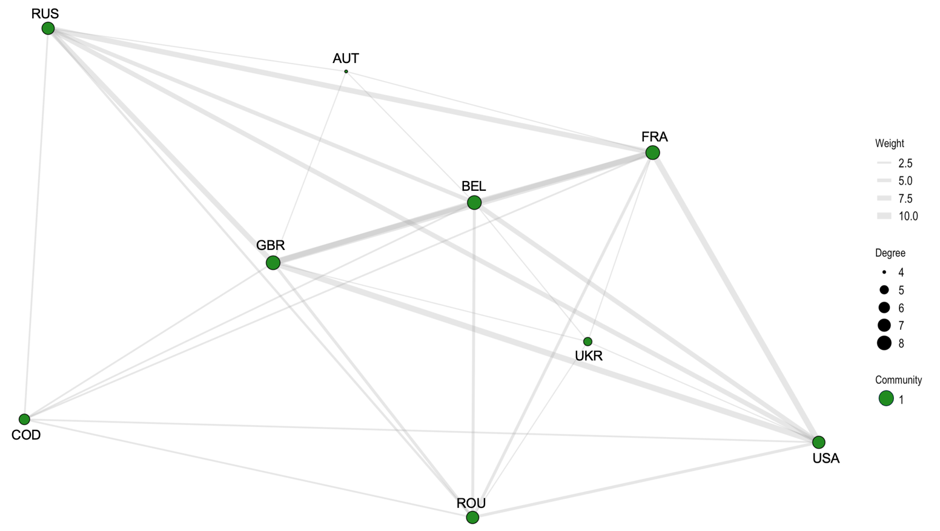
Figure A1. Network structure for year 1991

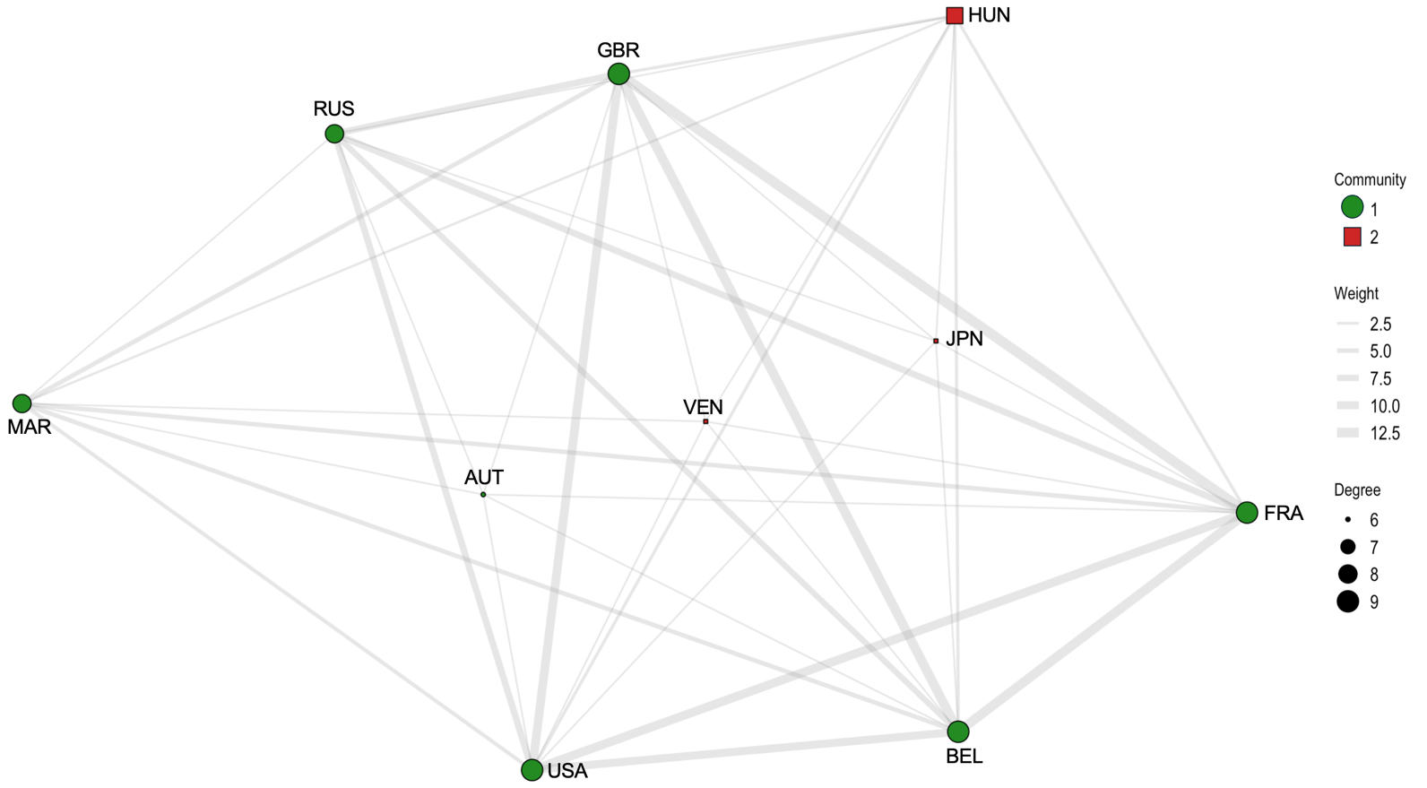
Figure A2. Network structure for year 1992

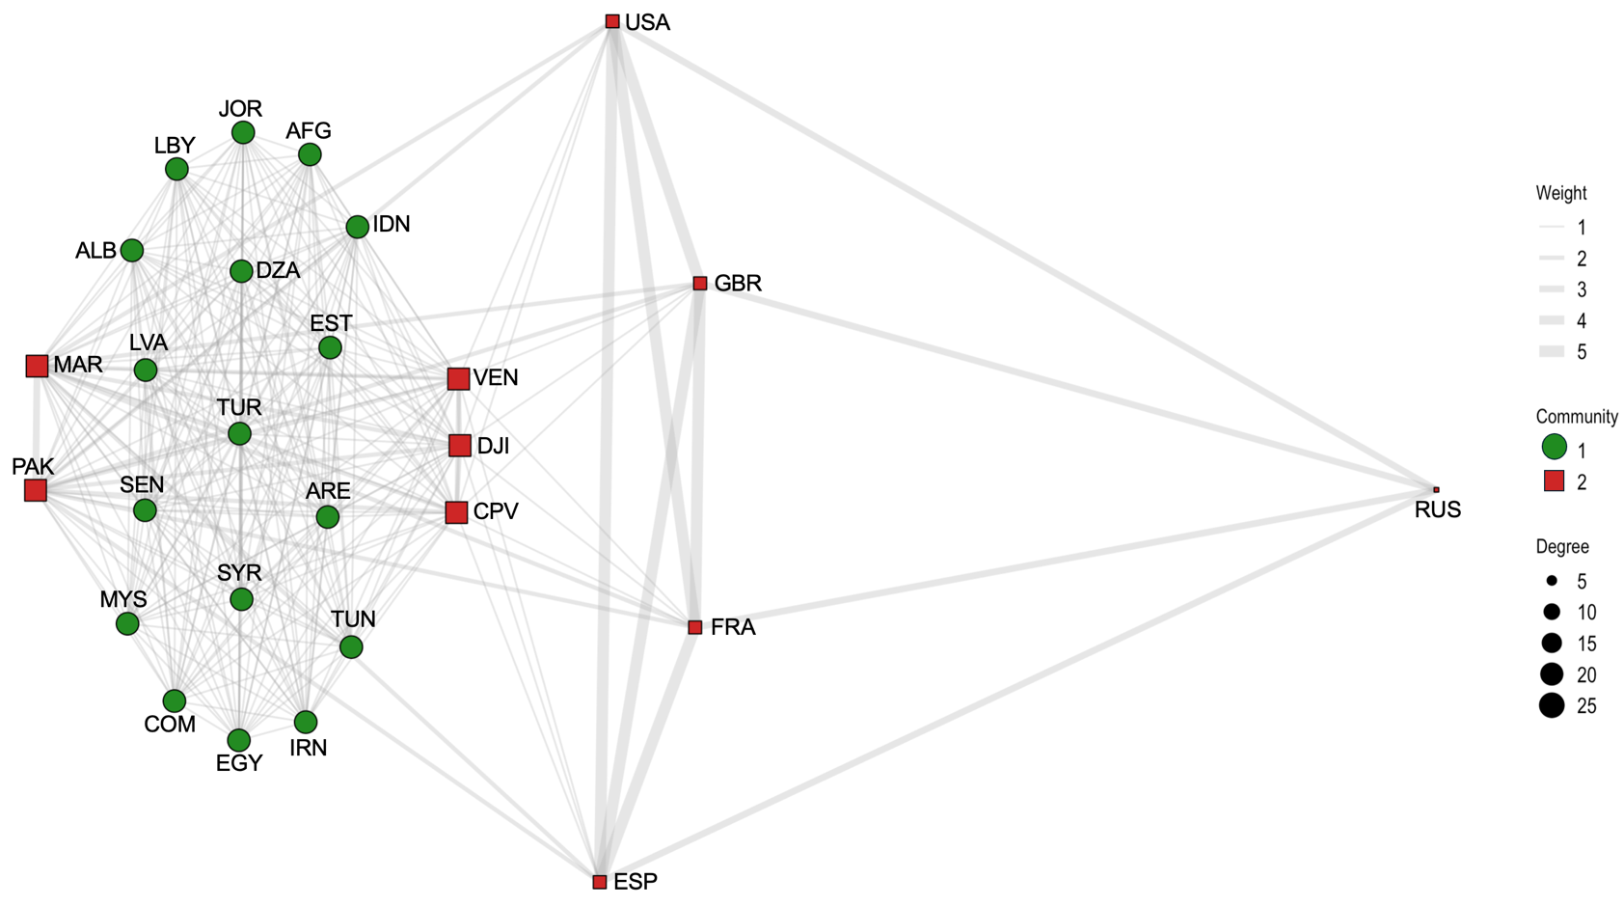
Figure A3. Network structure for year 1993

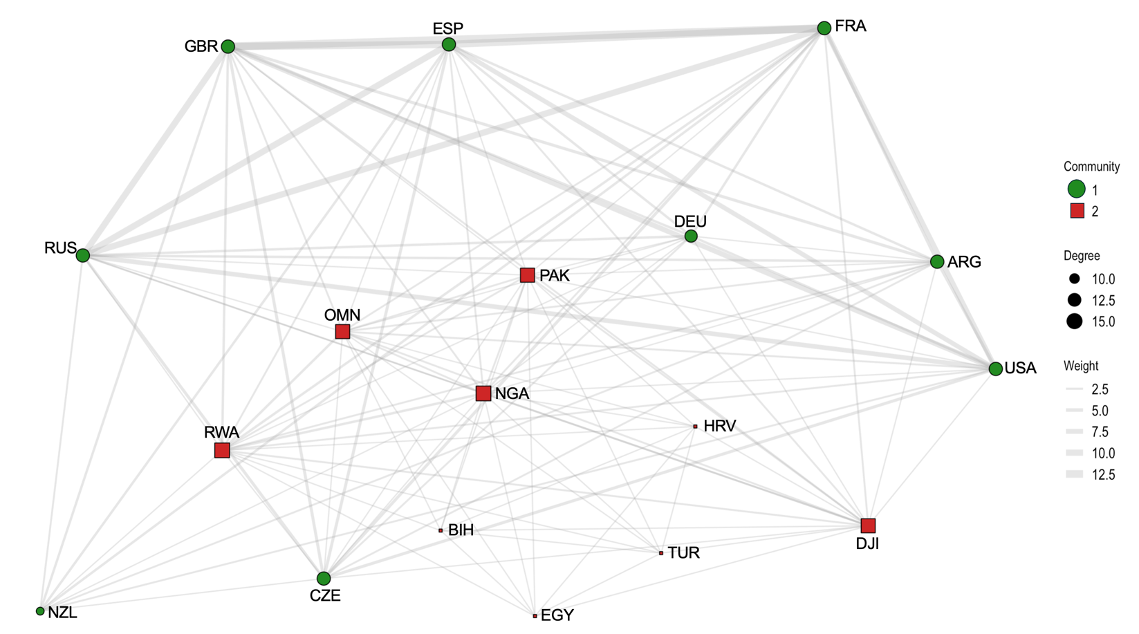
Figure A4. Network structure for year 1994

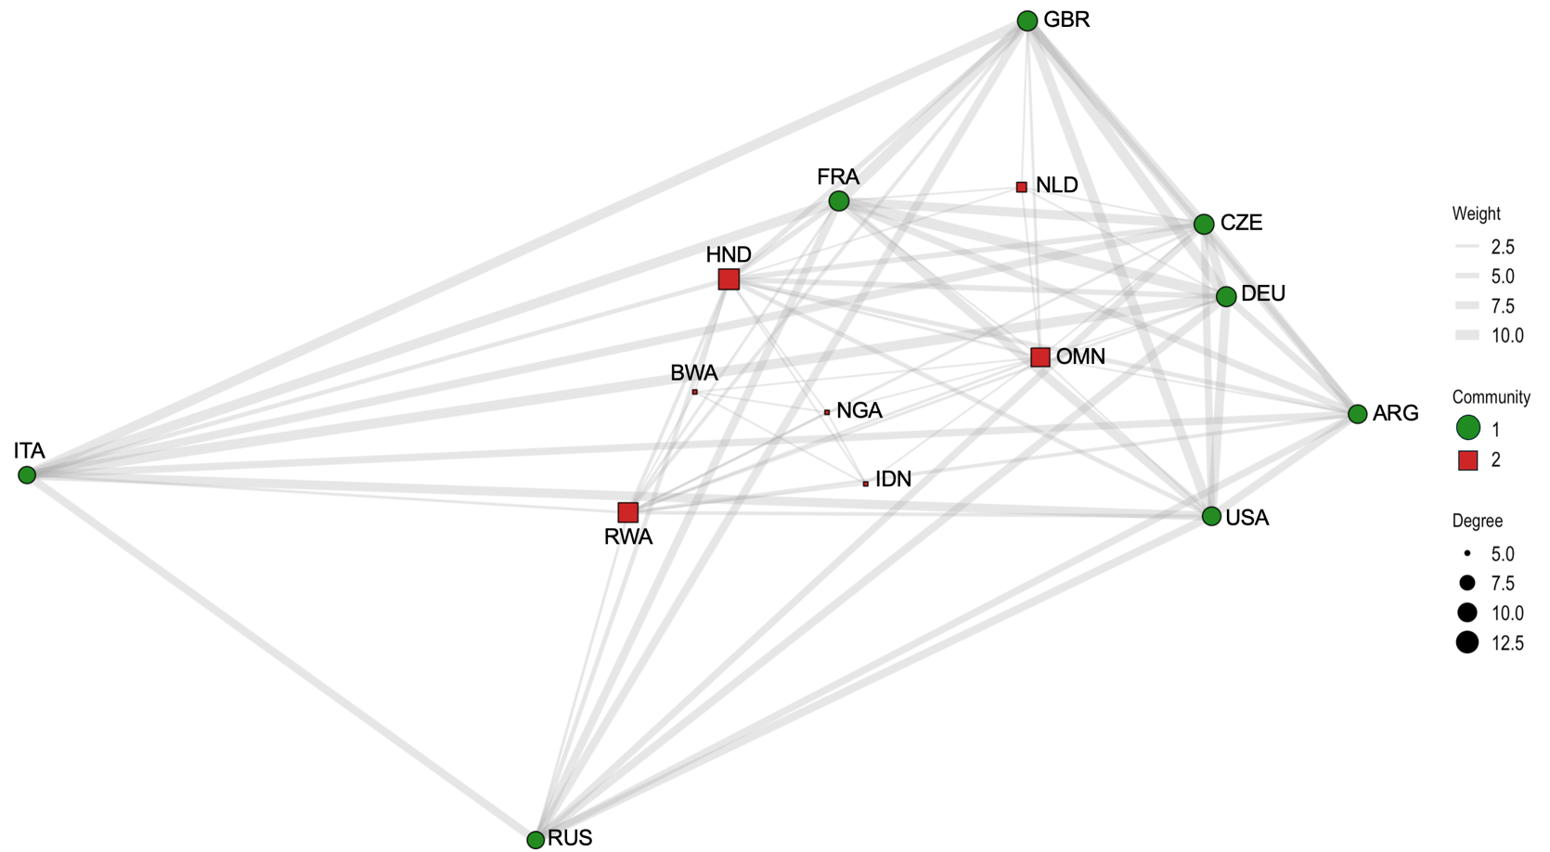
Figure A5. Network structure for year 1995

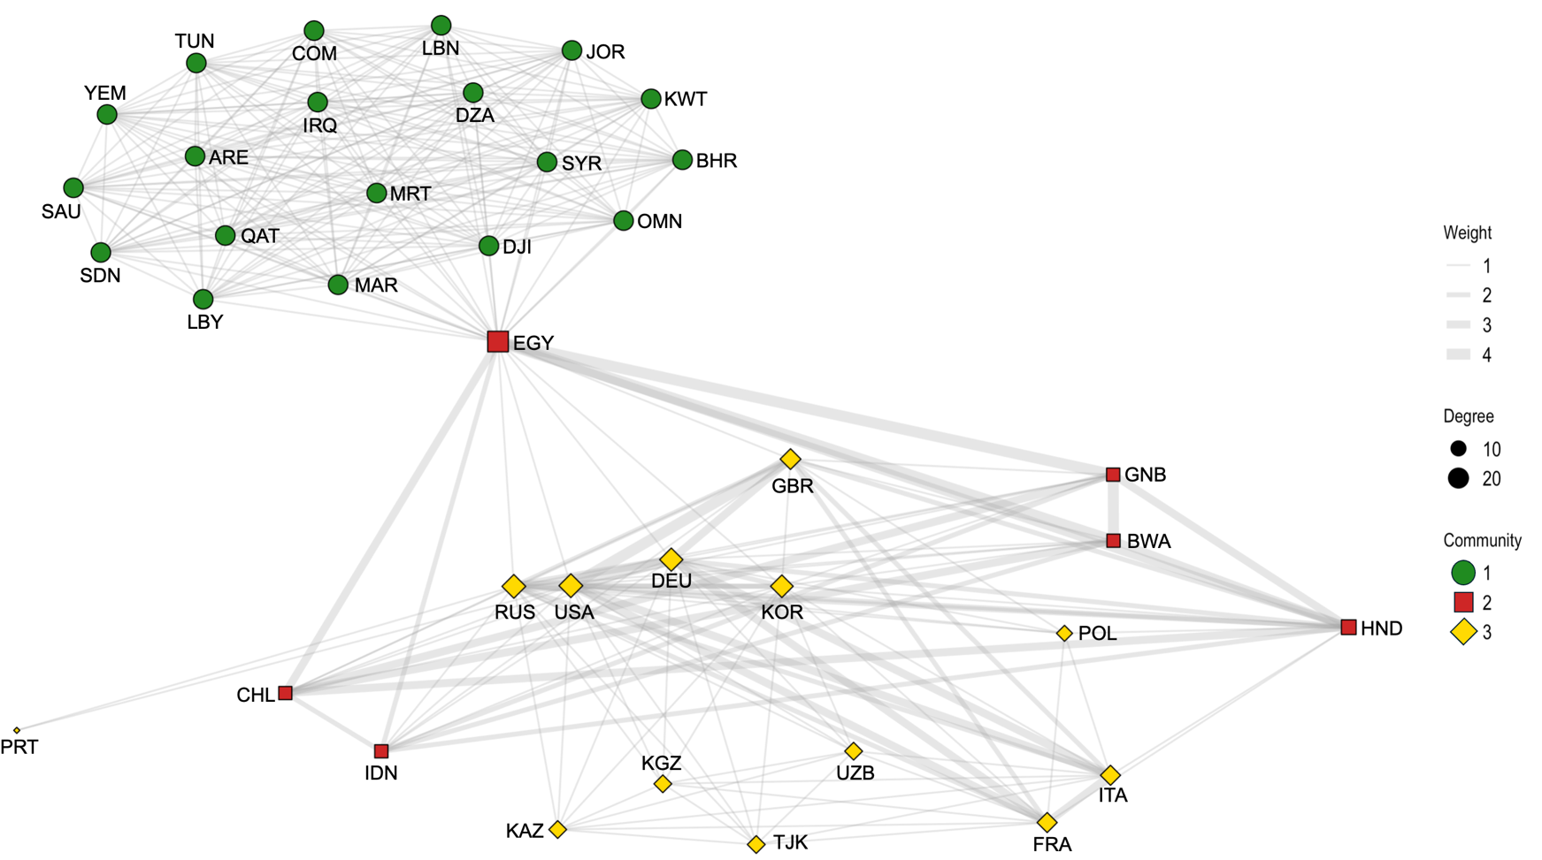
Figure A6. Network structure for year 1996

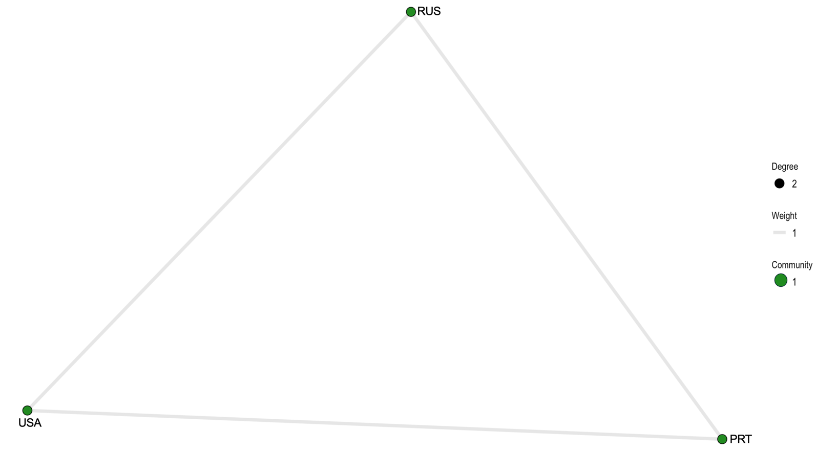
Figure A7. Network structure for year 1997
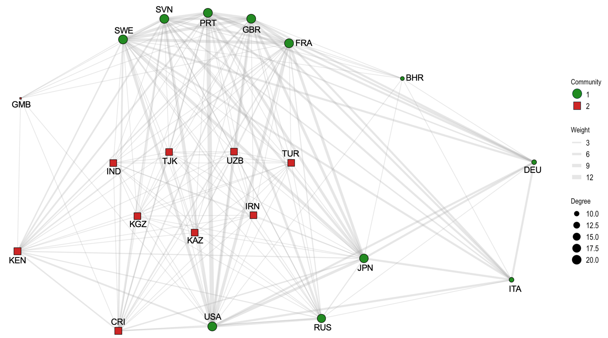
Figure A8. Network structure for year 1998

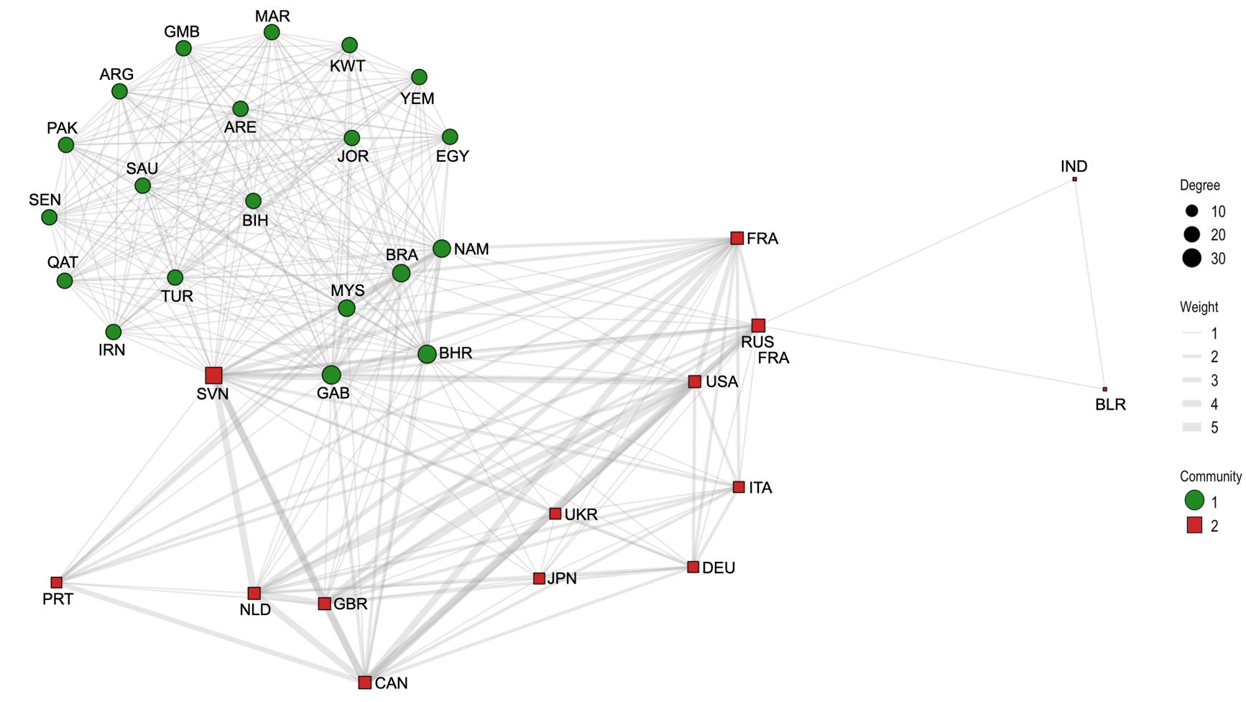
Figure A9. Network structure for year 1999
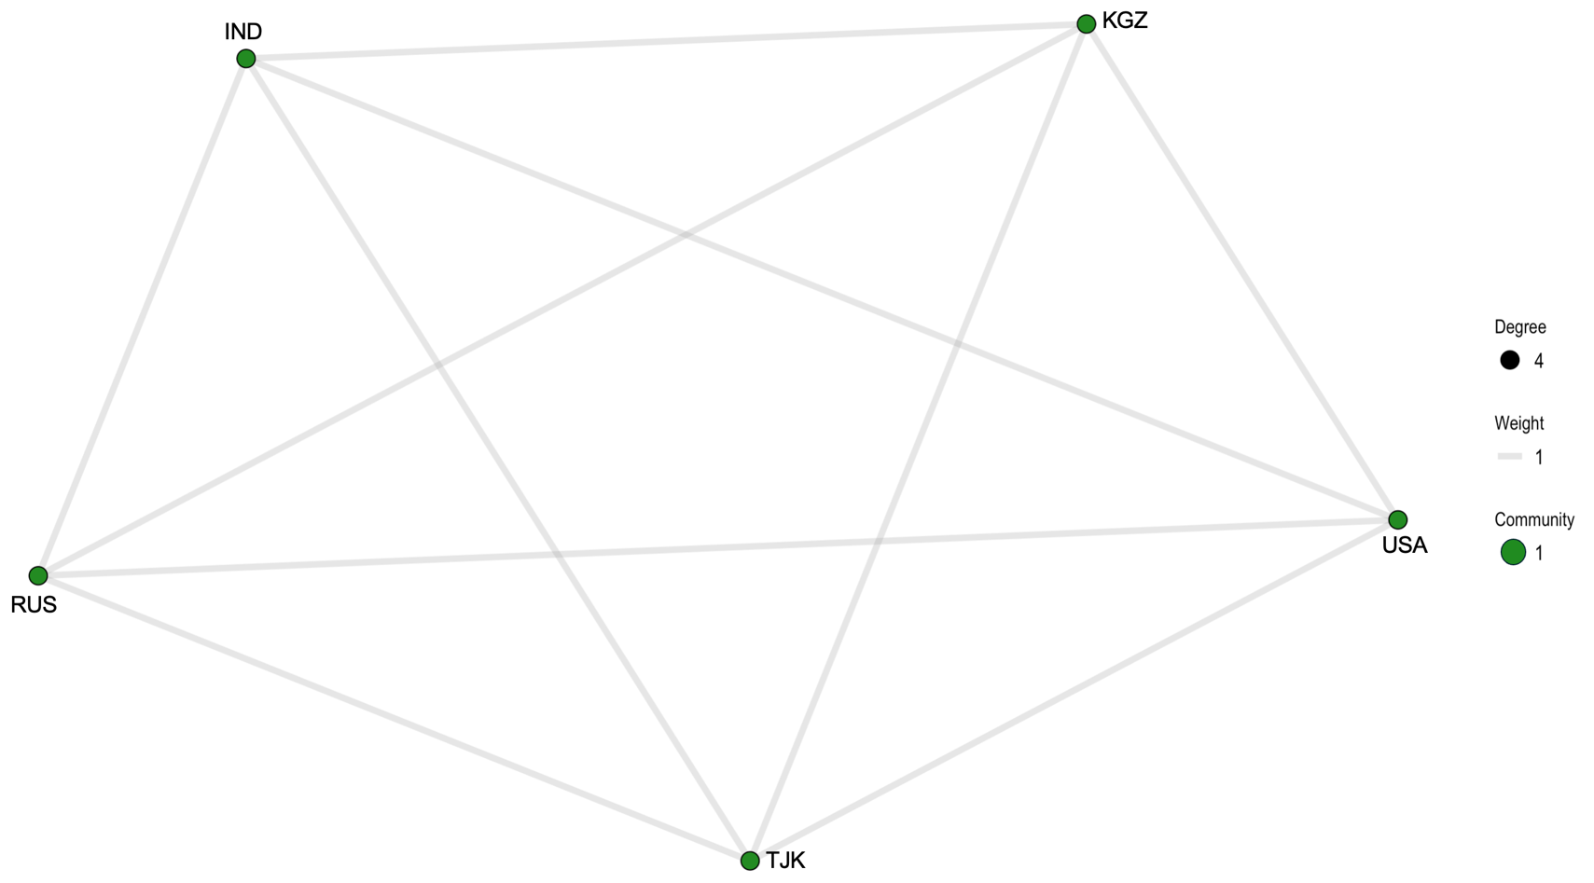
Figure A10. Network structure for year 2000

Figure A11. Network structure for year 2001
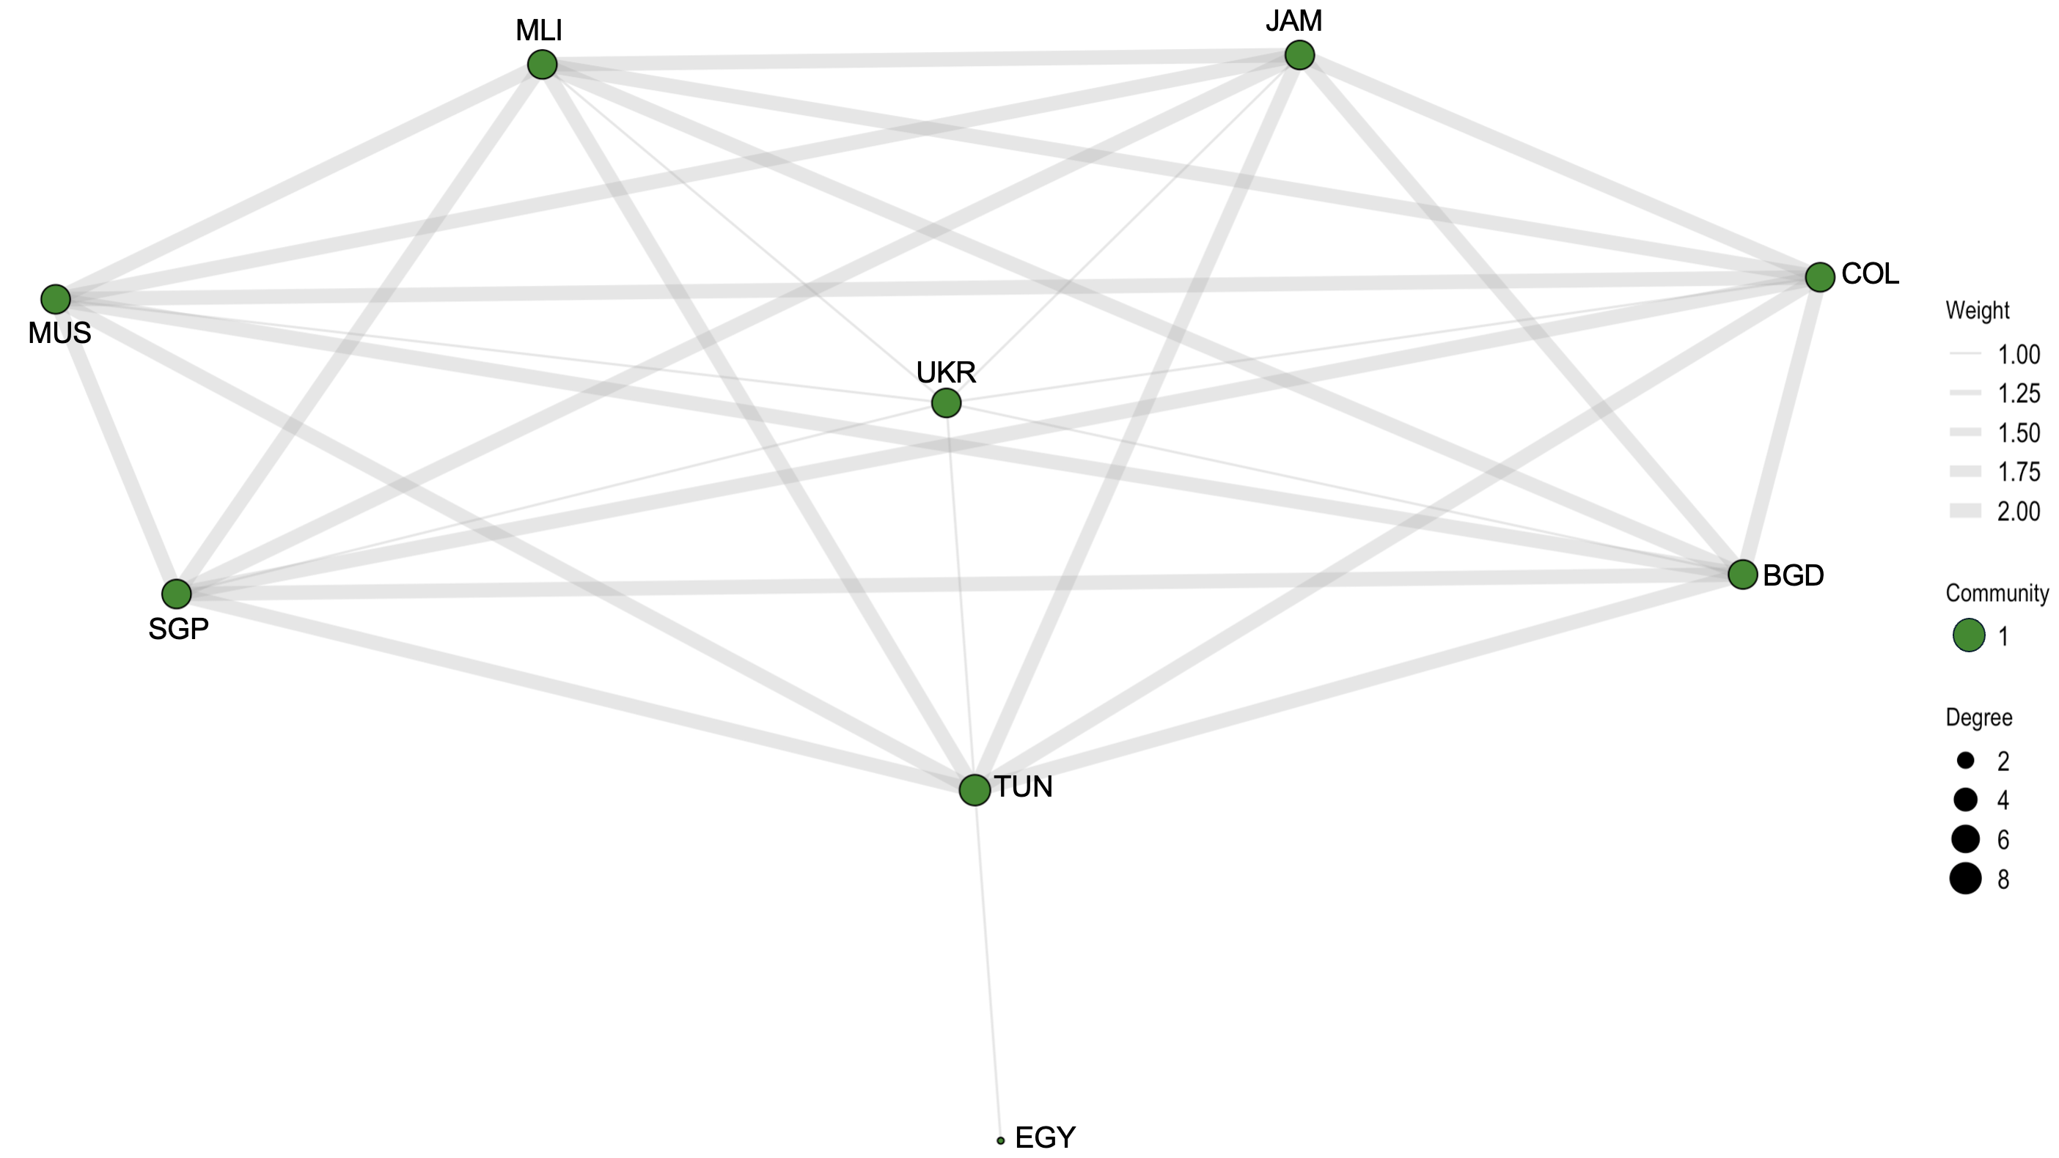

Figure A12. Network structure for year 2002

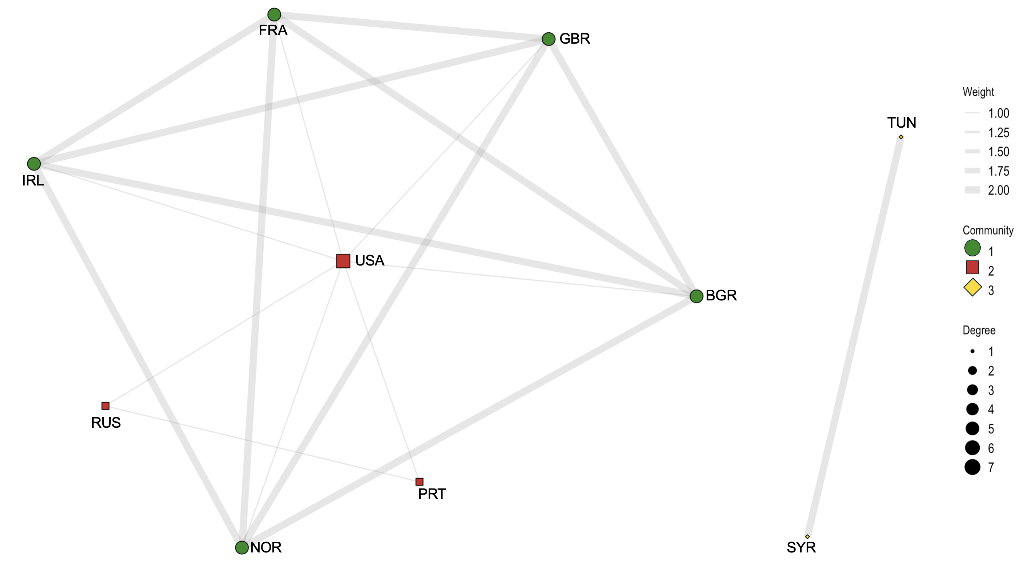

Figure A13. Network structure for year 2003

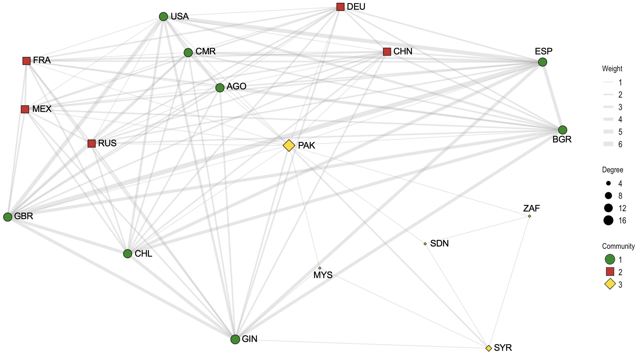

Figure A14. Network structure for year 2004

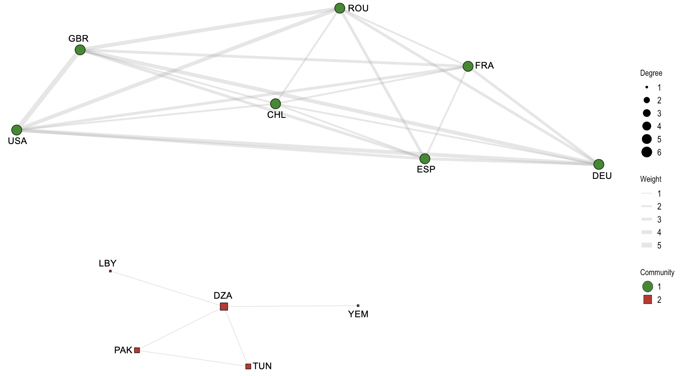

Figure A15. Network structure for year 2005

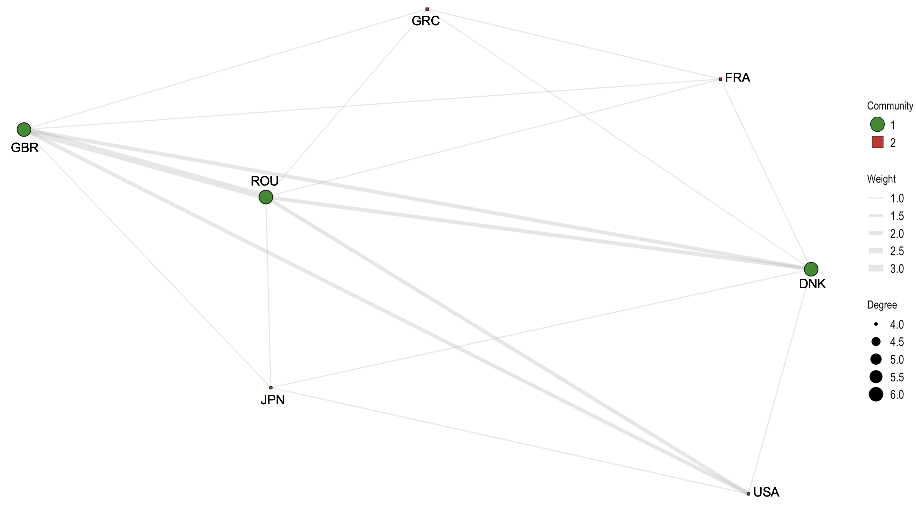

Figure A16. Network structure for year 2006

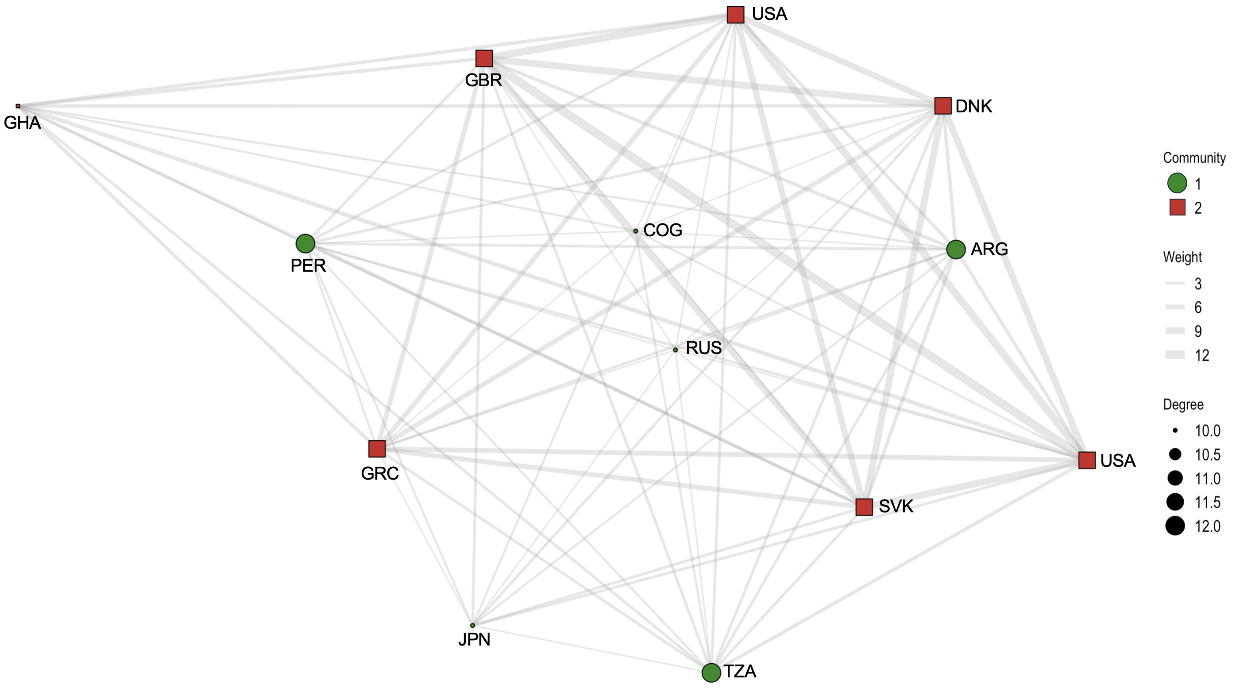

Figure A17. Network structure for year 2007

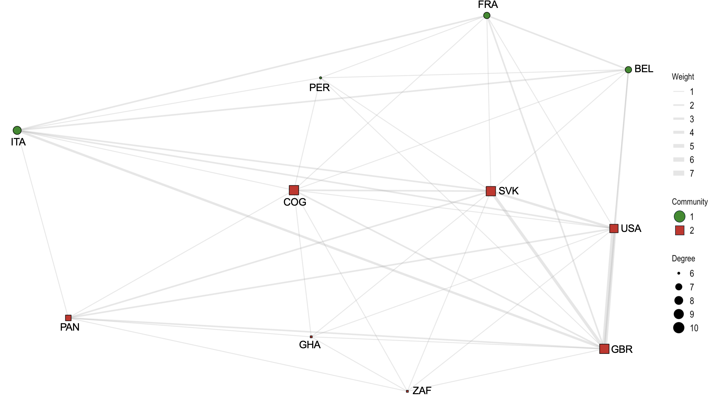

Figure A18. Network structure for year 2008

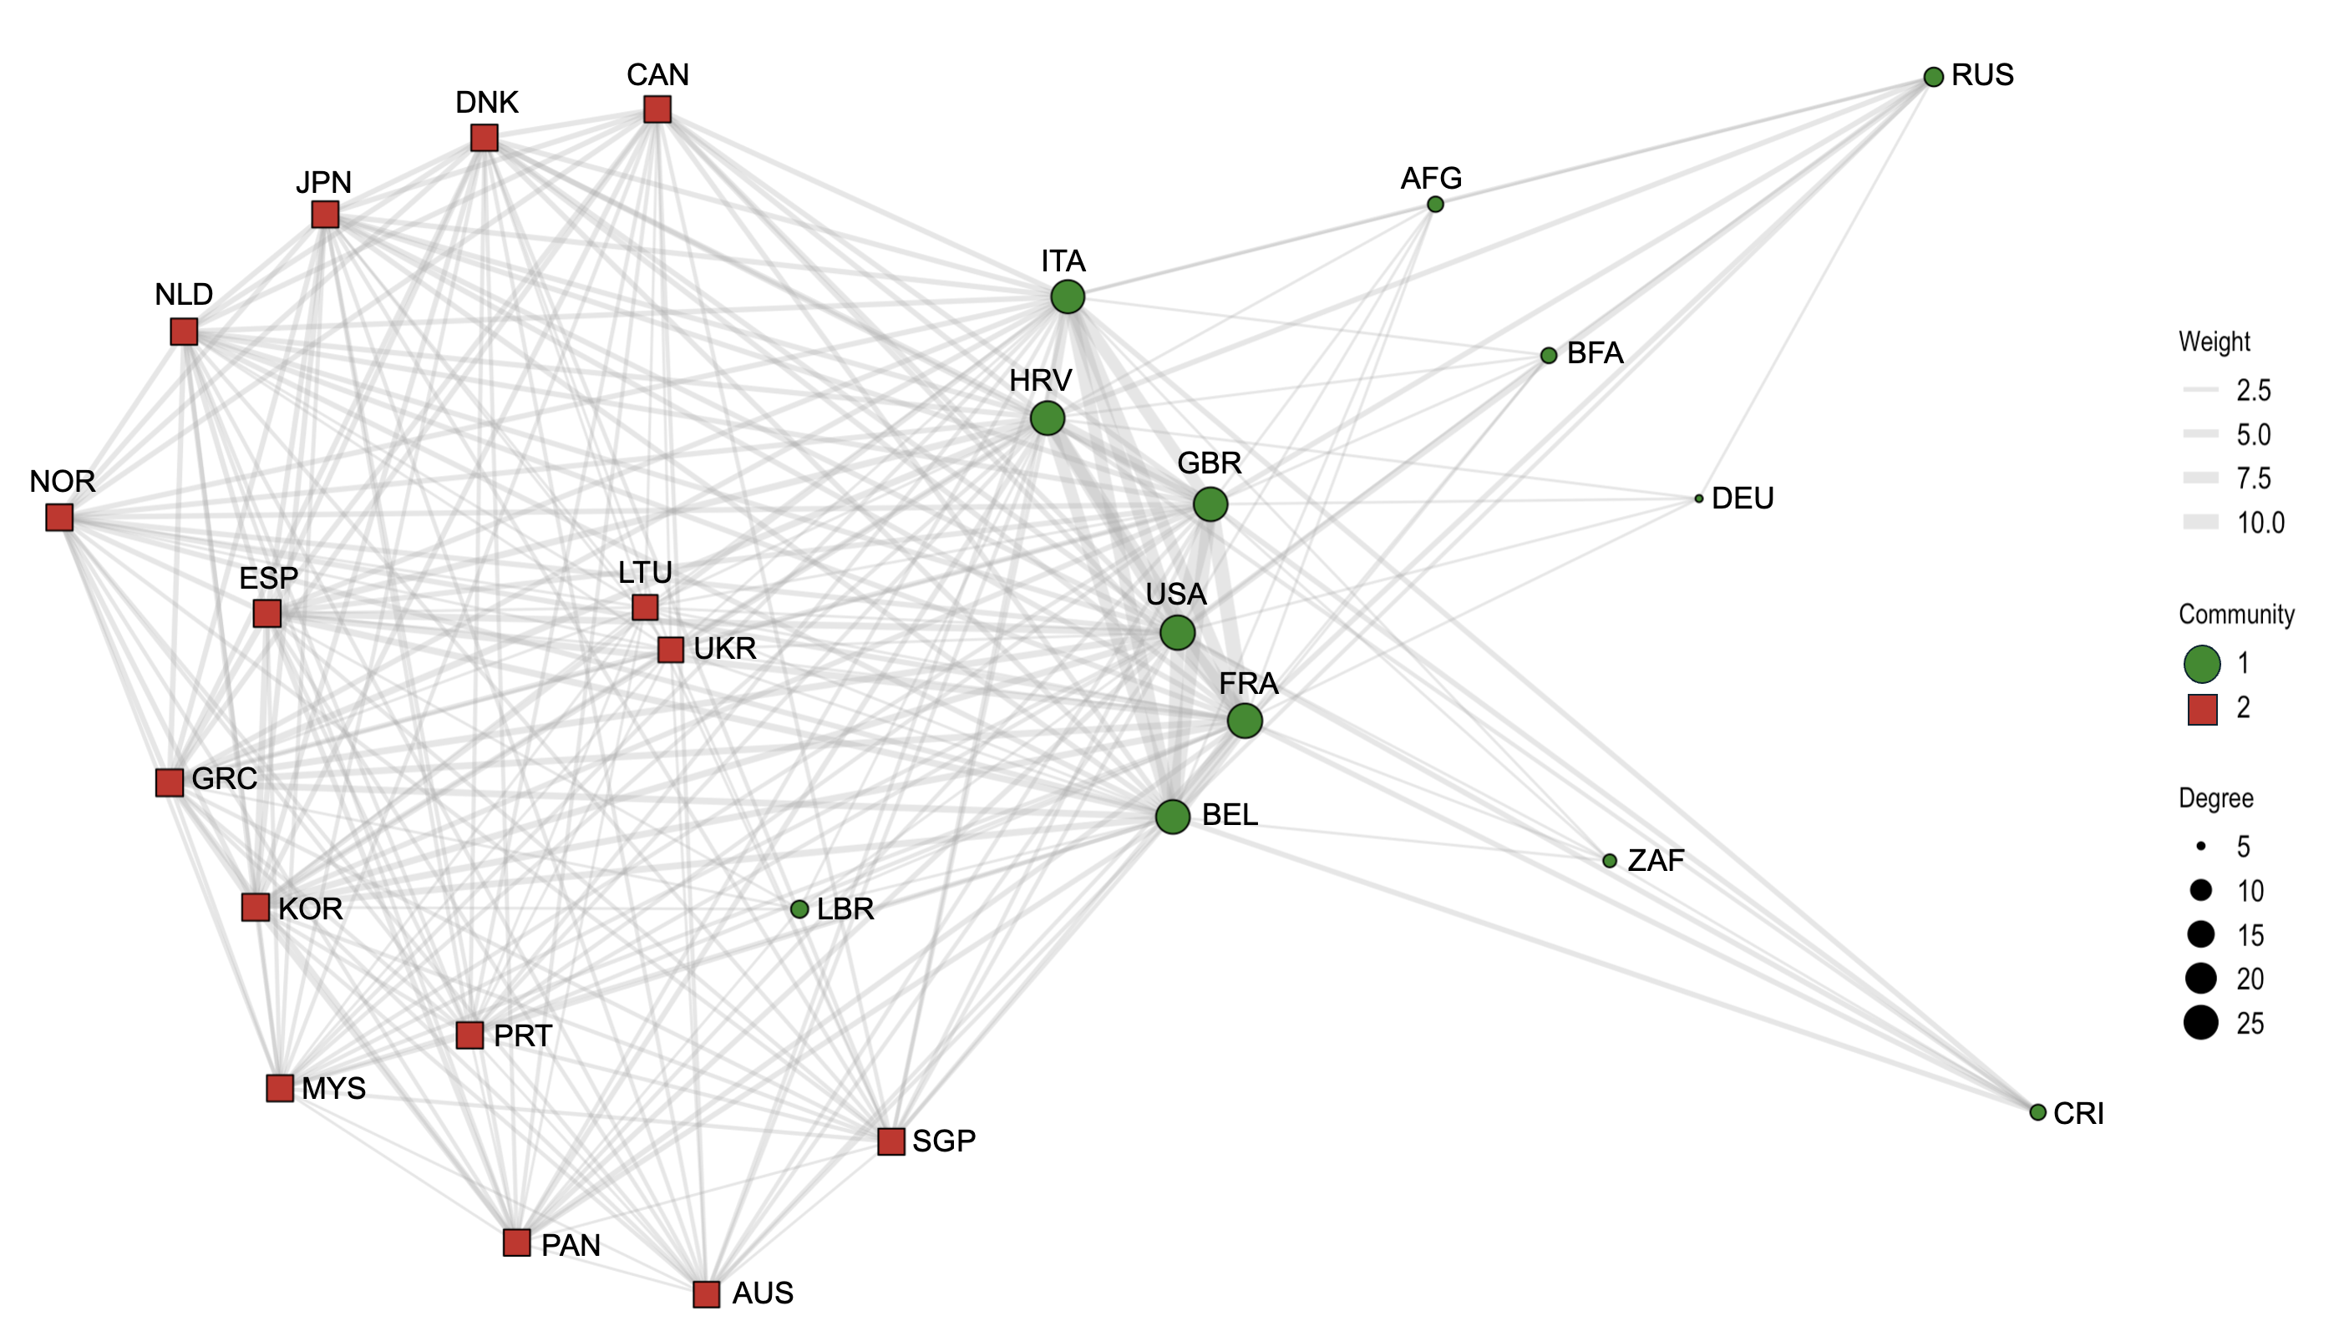

Figure A19. Network structure for year 2009

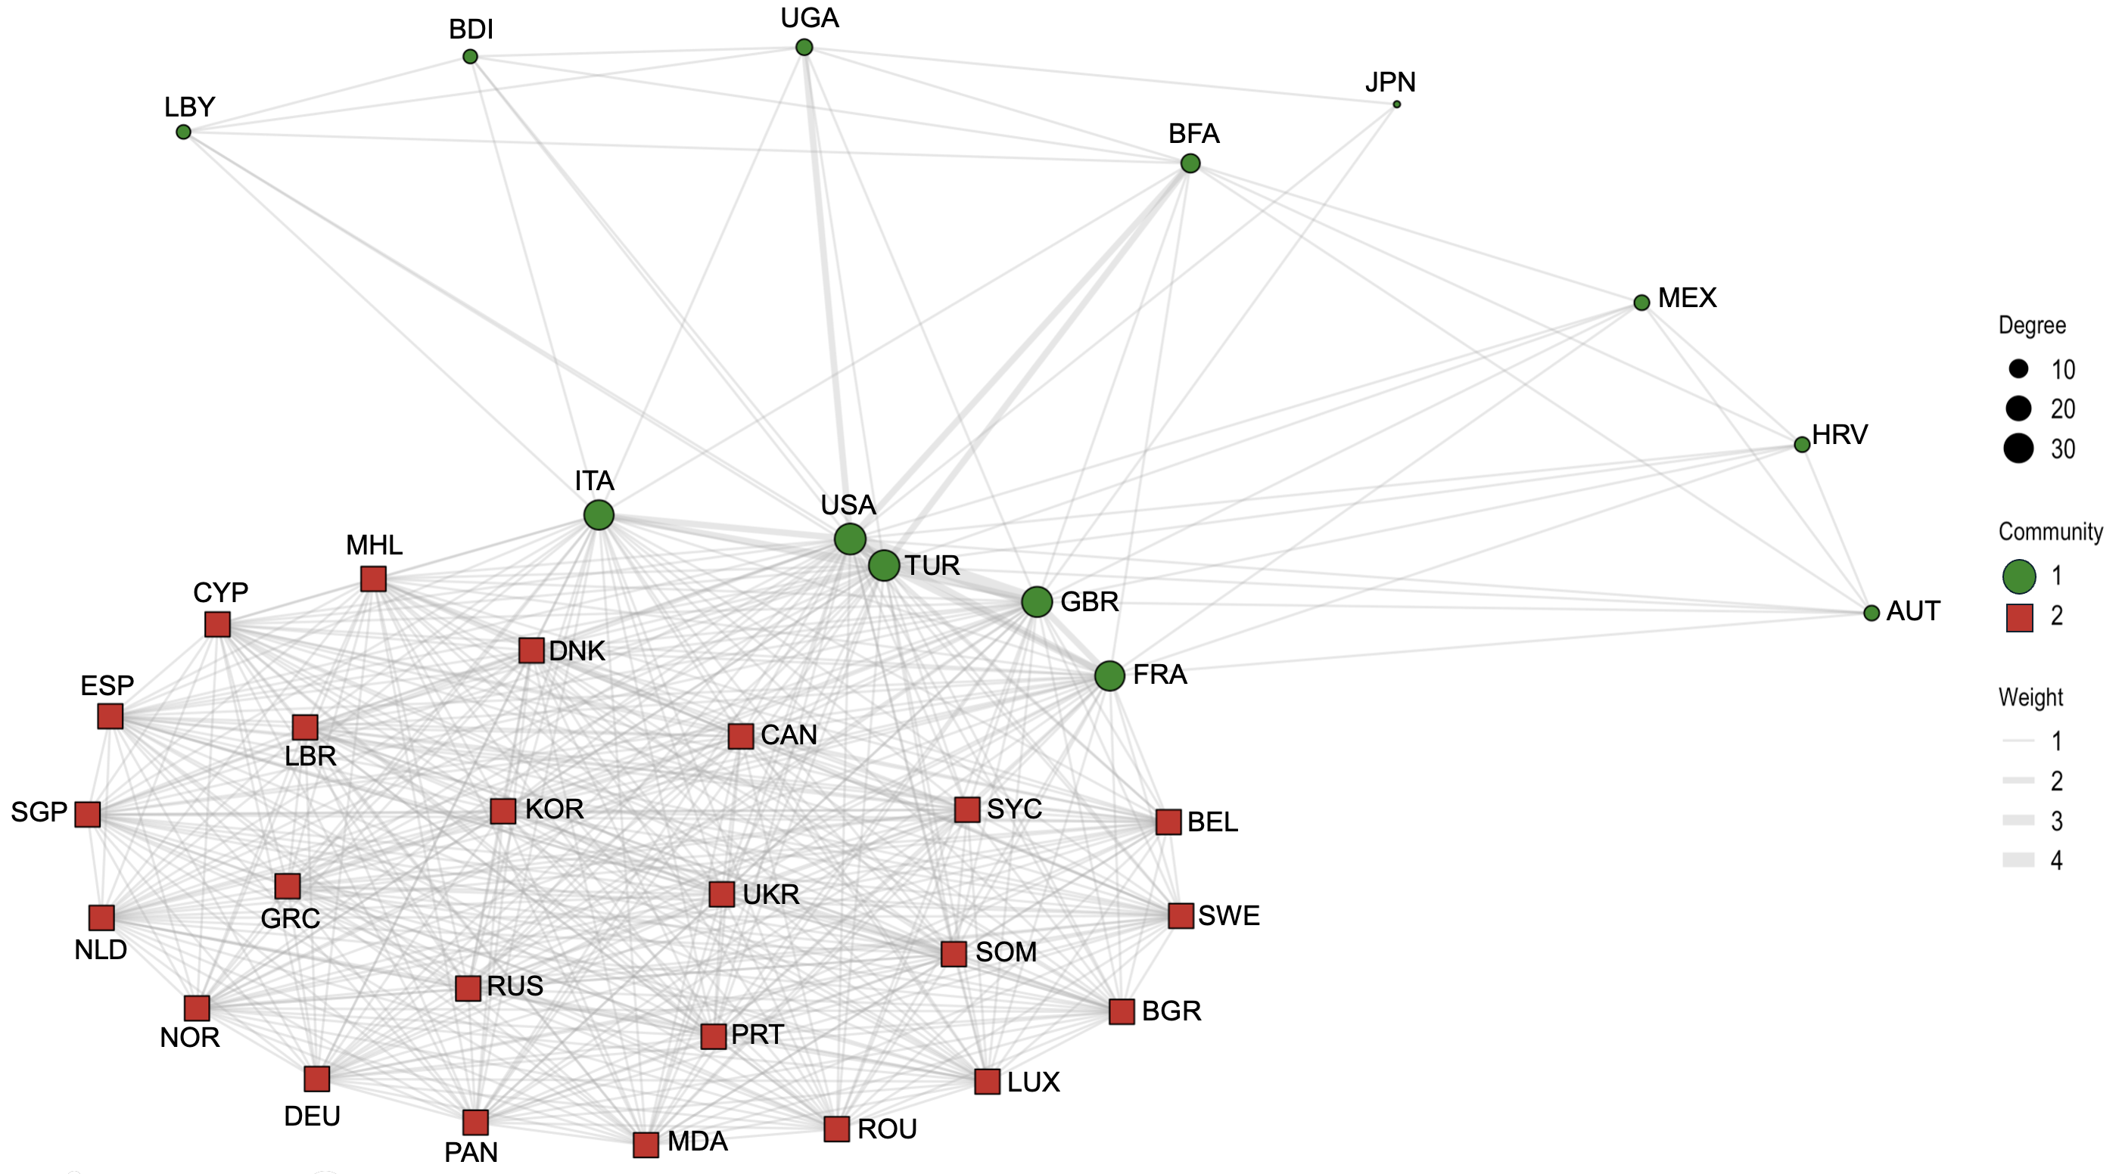

Figure A20. Network structure for year 2010

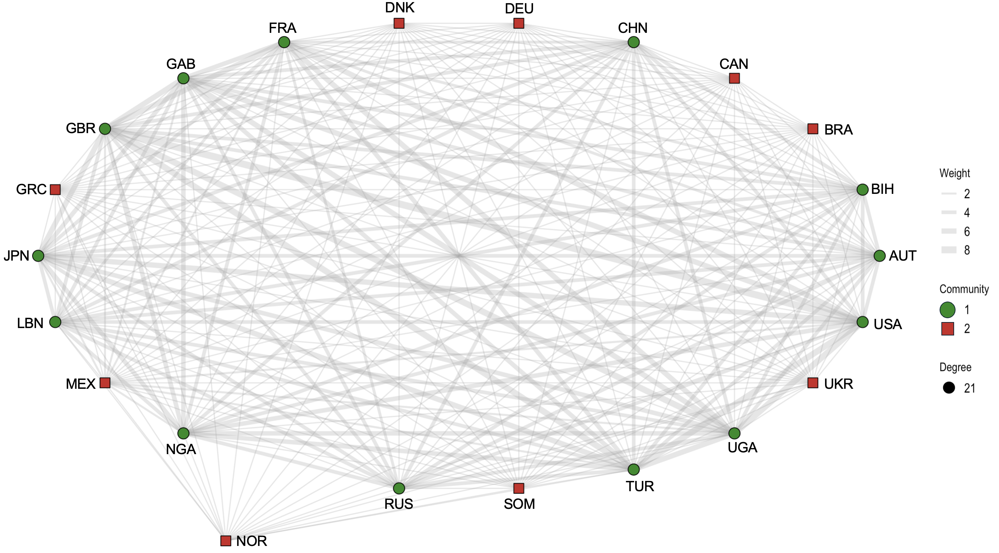

Figure A21. Network structure for year 2011

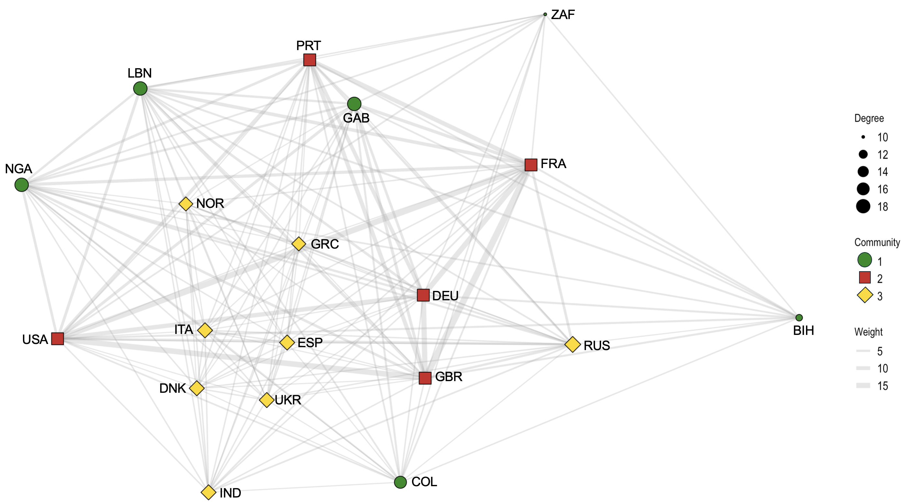

Figure A22. Network structure for year 2012

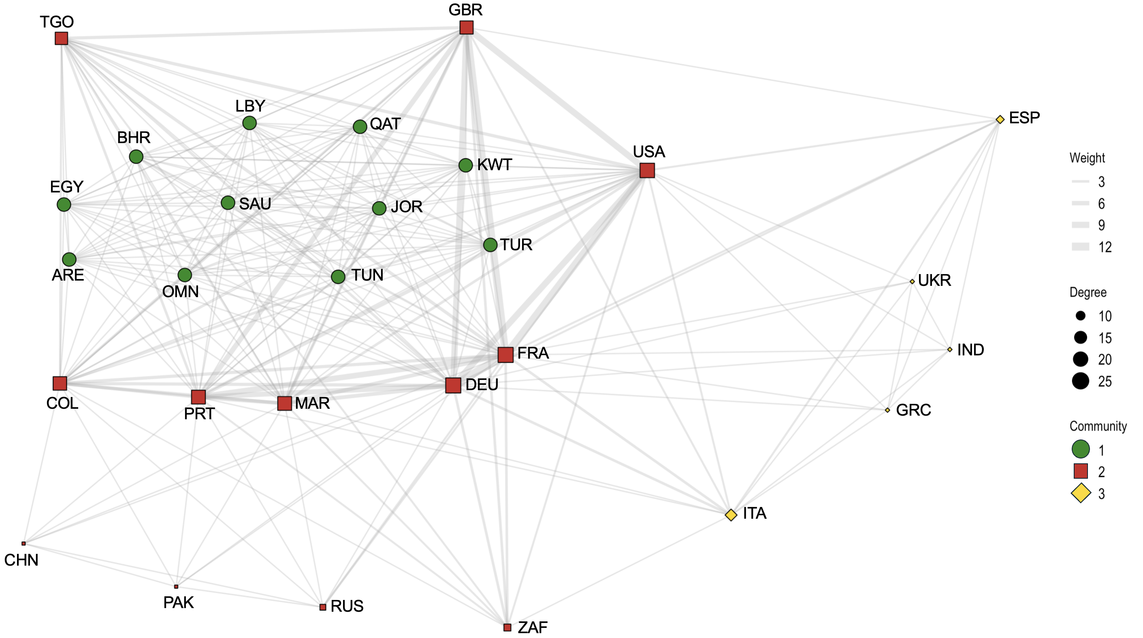

Figure A23. Network structure for year 2013

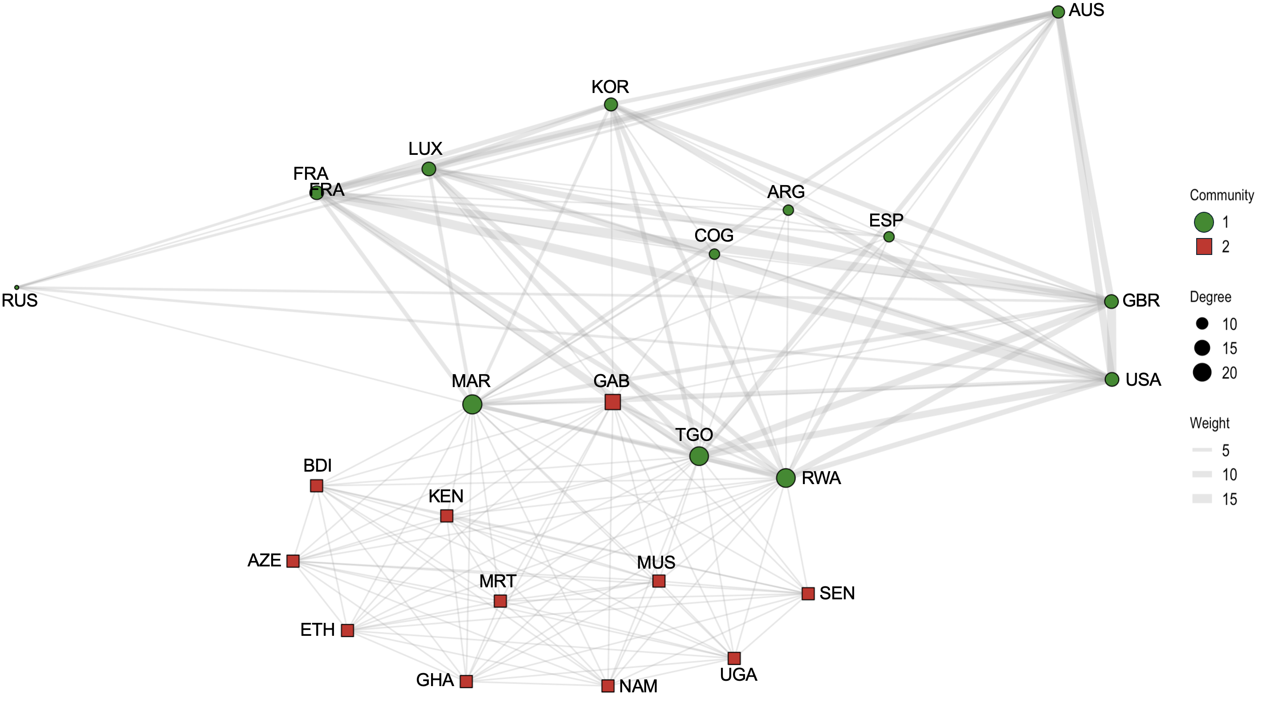

Figure A24. Network structure for year 2014

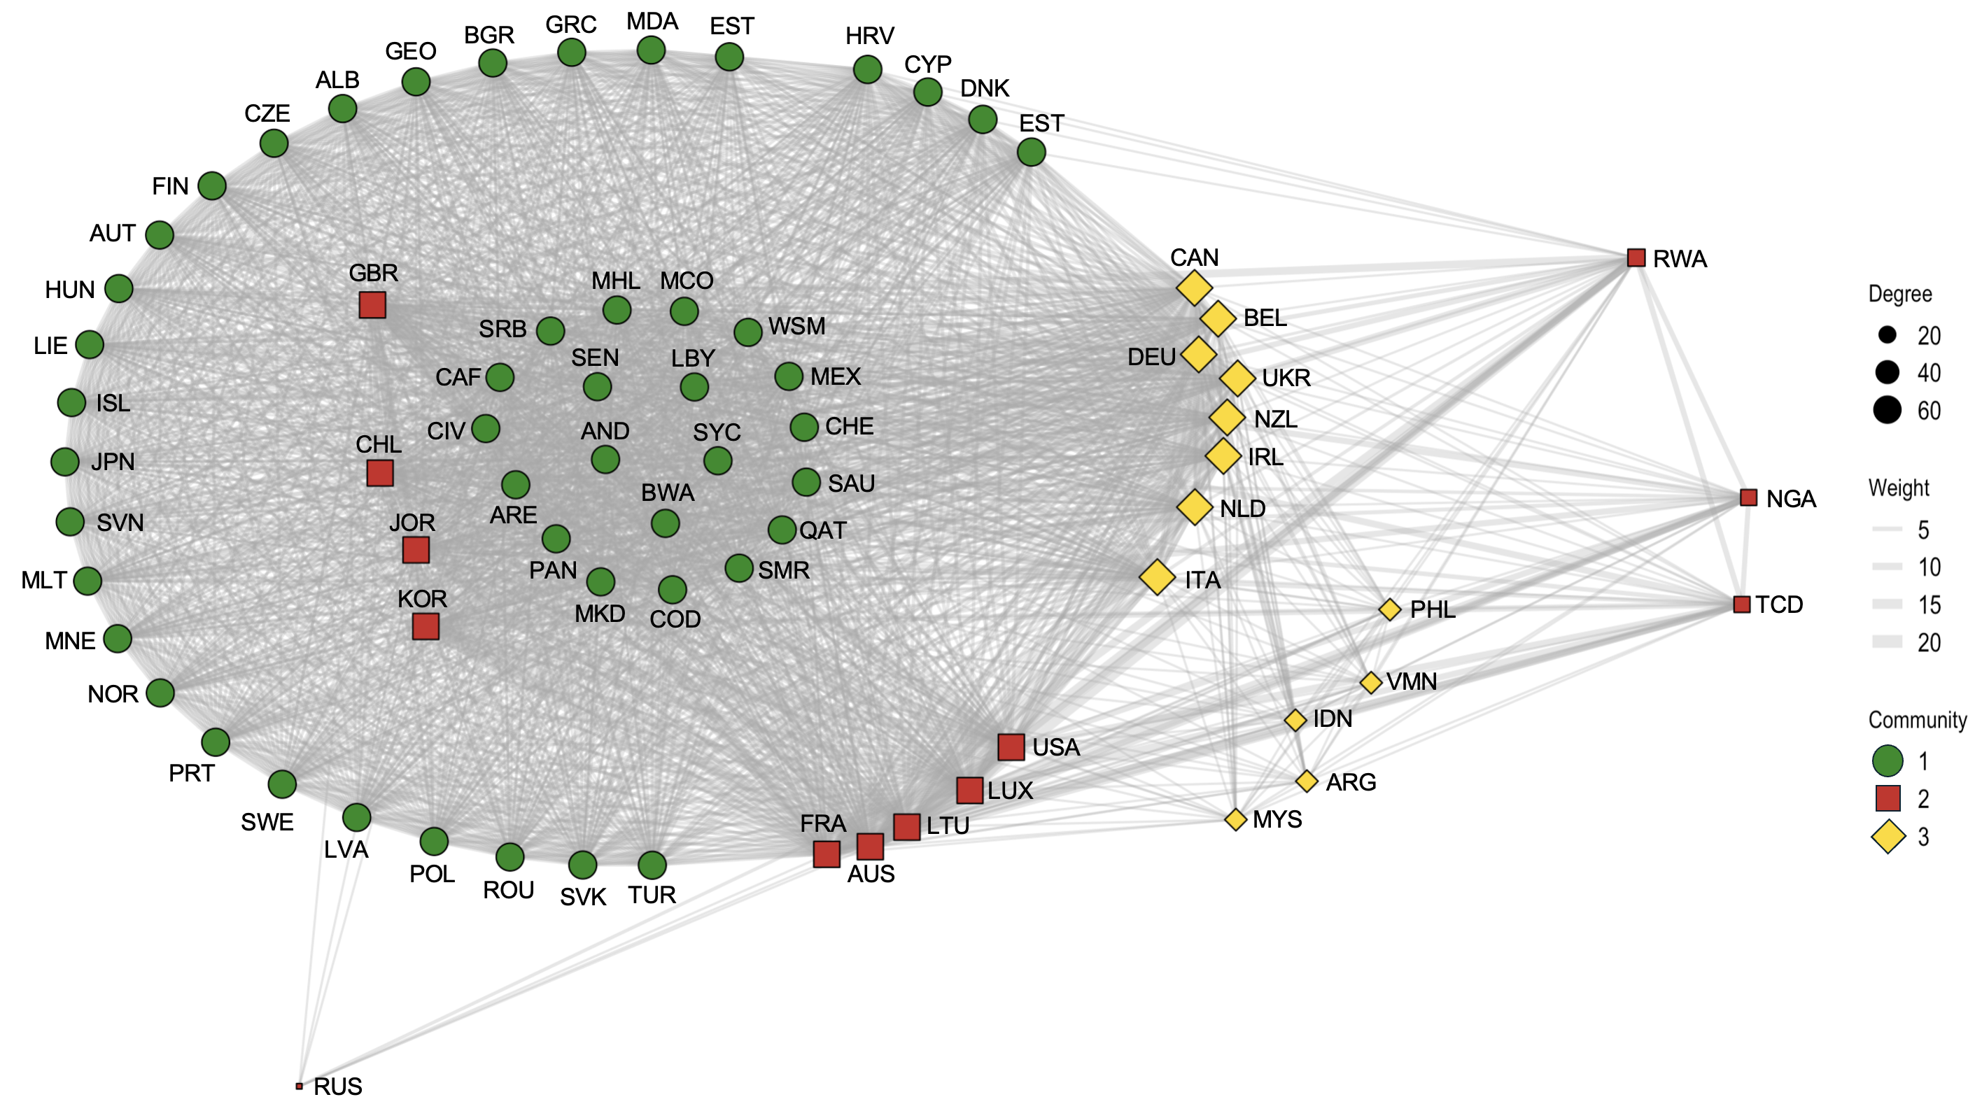

Figure A25. Network structure for year 2015

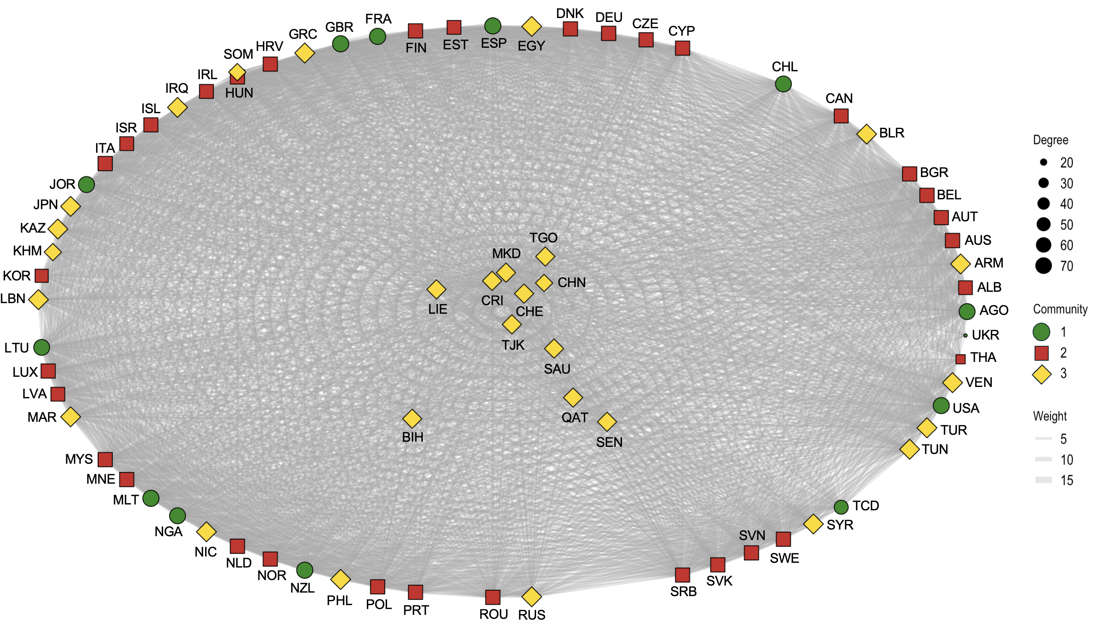

Figure A26. Network structure for year 2016
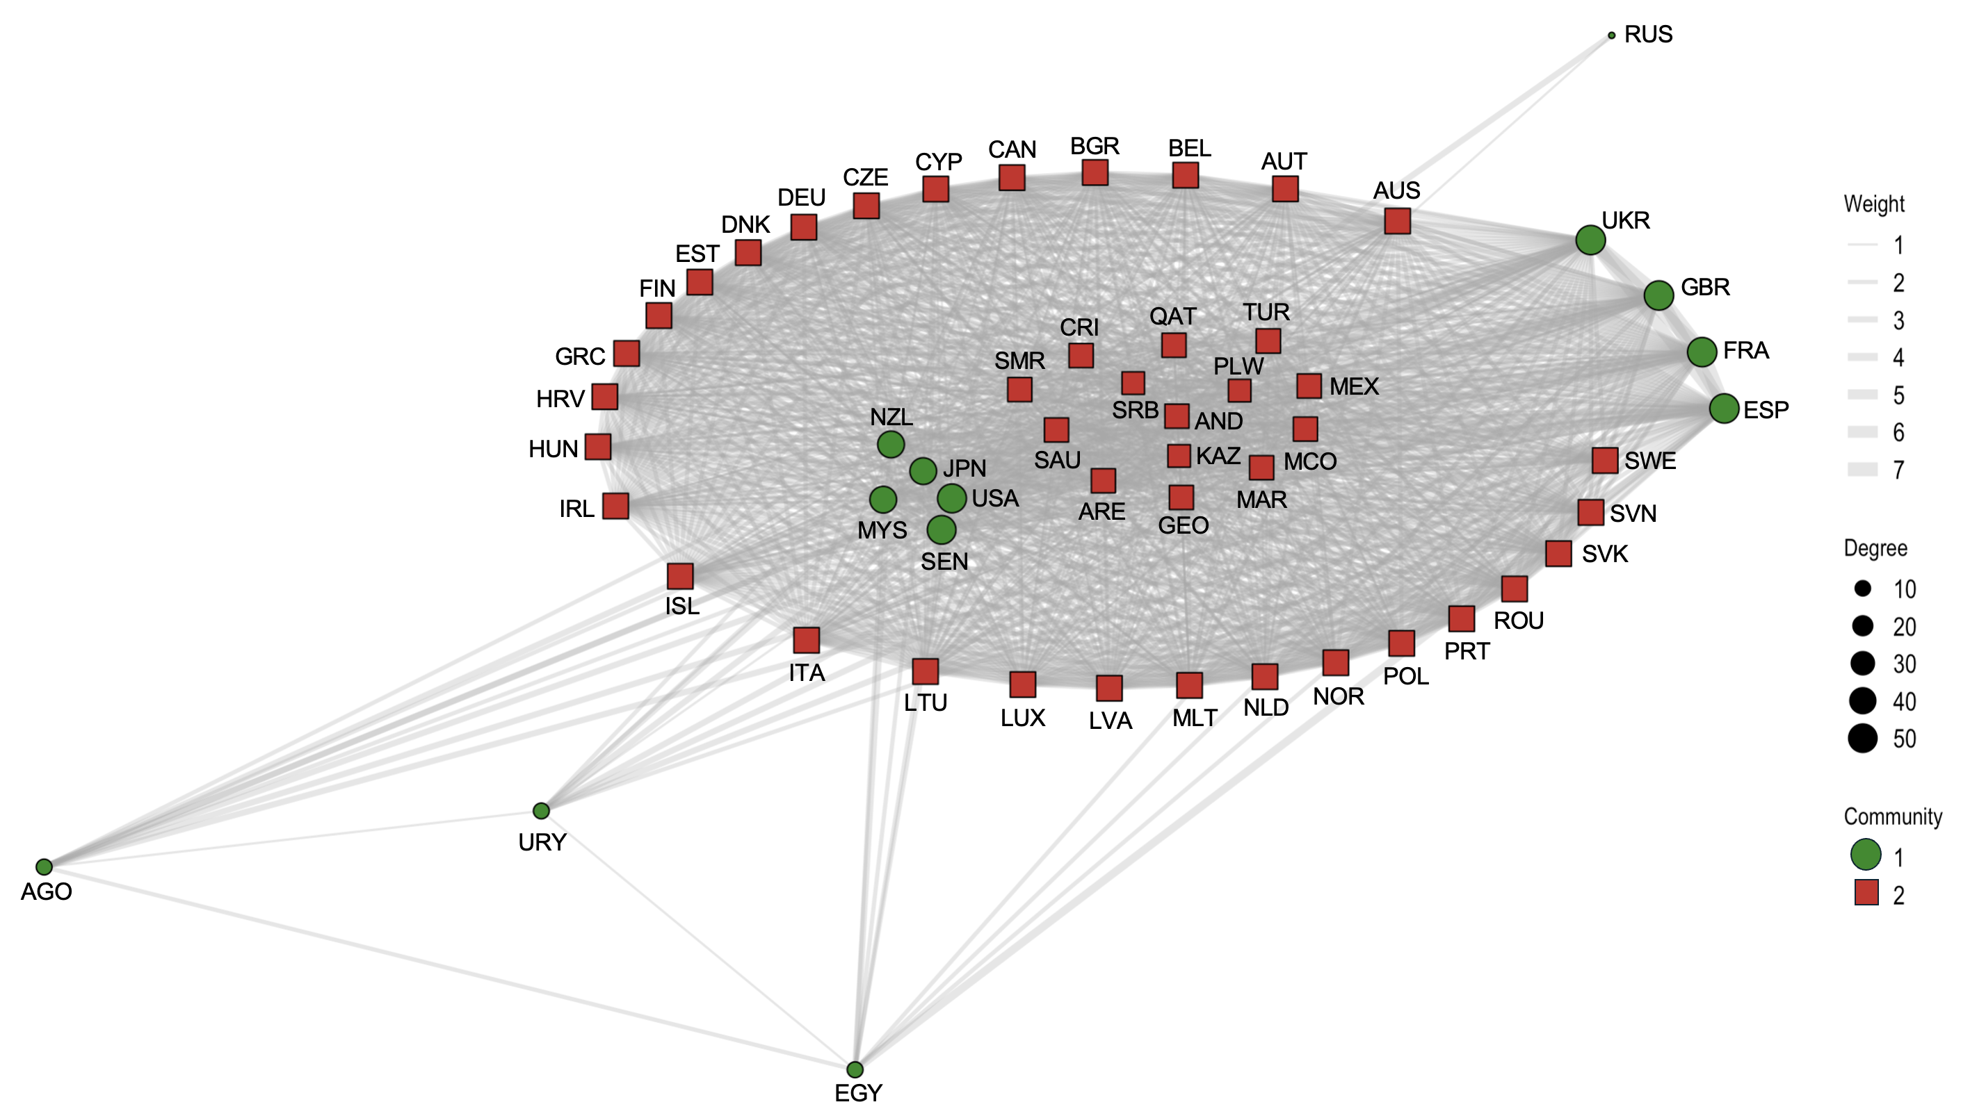

Figure A27. Network structure for year 2017

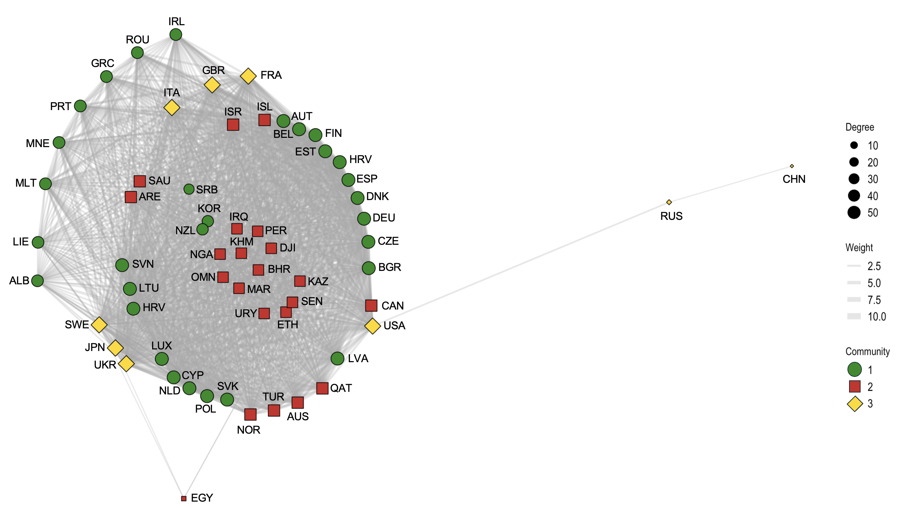

Figure A28. Network structure for year 2018

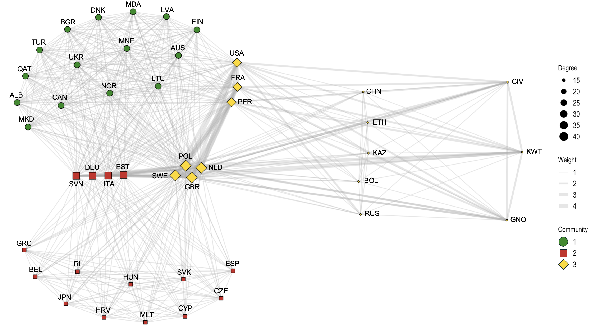

4. Variable descriptives
Table AV. Descriptives of continuous variables in the models printed in the article
Variable | Type | Minimum | Maximum | Median | Mean
Number of cooperations (DV) | Count | 0.00 | 22.00 | 1.00 | 1.485
Polity (diff) | Continuous | 0.00 | 10.00 | 2.00 | 2.914
GDPc (log diff) | Continuous | 0.00 | 11.564 | 9.725 | 9.387
Polity (mean) | Continuous | 0.00 | 10.00 | 8.500 | 7.682
GDPc (log mean) | Continuous | 6.00 | 11.485 | 9.842 | 9.493
Topic concentration | Continuous | 0.091 | 1.00 | 0.440 | 0.528
Topic persistence | Continuous | 3.448 | 16.818 | 4.774 | 5.489
Polity (standard deviation) | Continuous | 0.00 | 12.021 | 3.130 | 3.445
GDPc (log standard deviation) | Continuous | 5.519 | 10.494 | 9.789 | 9.644
Regional diversity | Continuous | 0.071 | 1.00 | 0.429 | 0.446
Group diversity | Continuous | 0.00 | 3.00 | 0.500 | 0.647
Numbers of sponsors | Count | 2.00 | 68.00 | 6.00 | 8.333

Variables included in the regression models for the effect of similarity on collaborations:
- Number of collaborations: Number of co-drafted resolutions by a dyad in a calendar year. Author’s coding based on UNSCRA data.
- Polity (diff): Absolute difference in Polity5 scores between the states in the dyad. Author’s coding based on Polity5 data.
- GDPc (log diff): Log difference in GDP per capita between the states in the dyad. Author’s coding based on World Bank data.
- Polity (mean): Mean Polity5 score of the states in the dyad. Author’s coding based on Polity5 data.
- GDPc (log mean): Mean GDP per capita of the states in the dyad. Author’s coding based on World Bank data.
- Topic concentration: Herfindahl-Hirschman Index as sum of squared proportions of each dyad’s collaborations across different files. Author’s coding based on UNSCRA data.
- Topic persistence: Temporal persistence rate of each topic weighted by the average percentage of a dyad’s yearly collaborations devoted to each topic. Author’s coding based on UNSCRA data.

Variables included in the regression models for the effect of similarity on adoption likelihood:
- Polity (standard deviation): Standard deviation in Polity5 scores between the states in the drafting coalition. Author’s coding based on Polity5 data.
- GDPc (log standard deviation): Standard deviation in GDP per capita scores between the states in the drafting coalition. Author’s coding based on World Bank data.
- Regional diversity: Number of regions (Africa, Asia-Pacific, Eastern Europe, Latin America-Caribbean, Western Europe and Others) represented by the states in the drafting coalition divided by the number of drafters. Author’s coding.
- Group diversity: Number of political-economic groups (AOSIS, ASEAN, AU, CELAC, EU, G77, LAS, LDC, LLDC, NAM, OIC and PIF) represented by the states in the drafting coalition divided by the number of drafters. Author’s coding.
- Number of sponsors: Number of sponsors. Author’s coding based on UNSCRA data.
Political and economic diversity are operationalized differently across regression models. They are measured as the absolute difference between country values in models examining the effect of similarity on the frequency of cooperation, reflecting a focus on bilateral differences gauged on a dyadic level. In contrast, the models assessing the effect of similarity on the likelihood of adoption use within-group standard deviations, because the draft resolution represents the unit of analysis and the interest lies in capturing internal diversity among the group of sponsors.
Table AVI. Descriptives of categorical/binary variables in the models printed in the article
Variable | Type | Distribution | Mean
Cooperations (DV) | Binary | 0 = 77.17%; 1 = 22.83% | 0.77
Region | Binary | 0 = 25.61%; 1= 74.39% | 0.26
Group | Binary | 0 = 32.51%; 1 = 67.49% | 0.33
P5 | Categorical | Dyad: No P5 states = 77.58%; Dyad: One P5 states = 20.78%; Dyad: Both P5 states = 1.63% | /
UNSC members | Categorical | Dyad: No UNSC members = 44.41%; Dyad: One UNSC member = 38.63%; Dyad: Both UNSC members = 16.96% | /
Adopt (DV) | Binary | 0 = 8.58%, 1 = 91.42% | 0.91
Veto (DV) | Binary | 0 = 92.74%; 1 = 7.26% | 0.07
Unanimous adoption (DV) | Binary | 0 = 26.73%; 73.27% | 0.72
BRICS | Binary | 0 = 52.81%; 1 = 47.19% | 0.47
P3 + P2 | Binary | 0 = 70.63%; 1 = 29.37% | 0.29
Text: Use of force | Binary | 0 = 83.50%; 1 = 16.50% | 0.17
Table AVI (continued)
Text: Atrocities | Binary | 0 = 88.45%; 1 = 11.55% | 0.12
Text: Shaming | Binary | 0 = 79.12%, 1 = 20.79% | 0.21

Variables included in the regression models for the effect of similarity on collaborations:
- Collaborations: Binary variable indicating whether (1) or not (0) two states in the dyad have co-drafted at least one resolution in the calendar year. Author’s coding based on UNSCRA data.
- Region: Binary variable indicating whether (1) or not (0) the states in the dyad are located in the same region (Africa, Asia-Pacific, Eastern Europe, Latin America-Caribbean, Western Europe and Others). Author’s coding.
- Group: Binary variable indicating whether (1) or not (0) the states in the dyad are members of at least one shared political-economic group (AOSIS, ASEAN, AU, CELAC, EU, G77, LAS, LDC, LLDC, NAM, OIC and PIF). Author’s coding.
- P5: Categorical variable indicating whether none, one or both states in the dyads refer to a P5 member. Author’s coding.
- UNSC members: Categorical variable indicating whether none, one or both states in the dyads are members of the Security Council. Author’s coding.

Variables included in the regression models for the effect of similarity on adoption likelihood:
- Adopt: Binary variable indicating whether (1) or not (0) the resolution was adopted (i.e. at least nine affirmative votes and no P5 veto). Author’s coding based on data from the United Nations Library.
- Veto: Binary variable indicating whether (1) or not (0) the resolution was vetoed by the P5. Author’s coding based on data from the United Nations Library.
- Unanimous adoption: Binary variable indicating whether (1) or not (0) the resolution was unanimously adopted (i.e. fifteen affirmative votes). Author’s coding based on data from the United Nations Library.
- BRICS: Binary variable indicating whether (1) or not (0) Brazil, India or South Africa served as elected members at the Security Council. Author’s coding.
- P3 + P2: Binary variable indicating whether (1) or not (0) both a P3 (i.e. France, United Kingdom and United States) and P2 (i.e. China and Russia) states have co-drafted the resolution. Author’s coding based on UNSCRA data.
- Text: Use of force: Binary variable indicating whether (1) or not (0) the draft resolution refers to the use of force (i.e. “all necessary means/measures”). Author’s coding based on data from the United Nations Library.
- Text: Use of force: Binary variable indicating whether (1) or not (0) the draft resolution refers to mass atrocities (i.e. “mass atrocity”, “genocide”, “war crimes”, “crimes against humanity” and “ethnic cleansing”). Author’s coding based on data from the United Nations Library.
- Text: Shaming: Binary variable indicating whether (1) or not (0) the draft resolution engages in shaming (i.e. “condemn”, “denounce” and “deplore” against an identified target). Author’s coding based on data from the United Nations Library.

5. Regression models
Table AVII. Models with interaction effect for GDP and Polity

 |  | (6) Two-stage Heckman | (7) Two-stage Heckman
 | Polity (diff) | -0.053*** | -0.001
 |  | (0.015) | (0.006)
 | GDPc (log diff) | -0.018** | 0.019
 |  | (0.008) | (0.096)
 | Region | 0.094*** | 0.089***
 |  | (0.020) | (0.020)
 | Group | 0.191*** | 0.169***
 |  | (0.023) | (0.023)
 | Polity (mean) | 0.046*** | 0.057***
 |  | (0.008) | (0.008)
 | GDPc (log mean) | 0.146*** | 0.151**
 |  | (0.020) | (0.080)
 | Dyad: Both P5 states | 0.232*** | 0.246***
 |  | (0.057) | (0.075)
 | Dyad: One P5 state | 0.066*** | 0.069***
 |  | (0.023) | (0.023)
 | Dyad: Both UNSC members | 0.919*** | 0.918***
 |  | (0.030) | (0.034)
 | Dyad: One UNSC member | 0.151*** | 0.163***
 |  | (0.027) | (0.023)
 | Polity diff * mean | 0.009***
 |  | (0.002)
 | GDPc diff * mean (log) |  | -0.003
 |  |  | (0.010)
 | IMR | -1.652*** | -1.702***
 |  | (0.082) | (0.105)
 | Intercept | -1.396*** | -1.531**
 |  | (0.448) | (0.806)
 | Observations | 12465 | 12465
 | Groups: Pair | 4916 | 4916
 | Groups: Year | 28 | 28
 | Variance: Pair | 0.01 | 0.01
 | Variance: Year | 0.15 | 0.14
 | AIC | 32250.29 | 32213.05
 | BIC | 32369.18 | 32331.94
 | Pseudo R2 | 0.08 | 0.08
Robust standard error with parametric bootstrapping in parentheses. ***p<0.01, **p<0.05, *p<0.1. Models have a negative binomial specification. For Pseudo R2, McFadden is used. For P5, “Dyad: No P5 states” is the reference. For UNSC member, “Dyad: No UNSC members” is the reference.

Figure A29. Frequency of collaboration across Polity5 score

Figure A30. Frequency of collaboration across GDP per capita
Table AVIII. Model with categorical variable for group membership

 | (8) Two-stage Heckman | (9) LASSO
Polity (diff) | -0.013** | -0.010
 | (0.006)
GDPc (log diff) | -0.012 | -0.002
 | (0.009)
Region: Cross-region |  | -0.055
Region: APG | 0.030
 | (0.062)
Region: EEG | 0.157*** | 0.077
 | (0.032)
Region: GAFS | 0.062 | -0.070
 | (0.138)
Region: GRULAC | 0.073 | -0.019
 | (6.726)
Region: WEOG | 0.094***
 | (0.029)
Group: AOSIS | -0.096 | -0.390
 | (0.319)
Group: ASEAN | -0.014
 | (0.336)
Group: AU | -0.068 | -0.016
 | (0.141)
Group: CELAC | -0.075
 | (6.776)
Group: EU | 0.287*** | 0.167
 | (0.026)
Group: G77 | -0.366*** | -0.345
 | (0.068)
Group: LAS | -0.036 | -0.273
 | (0.076)
Group: LDC | 0.141 | 0.147
 | (0.155)
Group: LLDC | -0.125 | -0.155
 | (0.164)
Group: NAM | 0.321*** | 0.247
 | (0.080)
Group: OIC | 0.005 | -0.108
 | (0.054)
Polity (mean) | 0.024*** | 0.006
 | (0.009)
GDPc (log mean) | 0.104*** | 0.049
 | (0.023)
Dyad: Both P5 states | 0.188*** | 0.274
 | (0.058)
Dyad: One P5 state | 0.016 | 0.033
Table AVIII (continued)
 | (0.024)
Dyad: Both UNSC members | 1.008*** | 0.784
 | (0.031)
Dyad: One UNSC member | 0.162*** | 0.208
 | (0.024)
IMR | -1.528*** | -2.113
 | (0.076)
Intercept | -0.848*** | 0.291
 | (0.234)
Observations | 12465 | 12465
Groups: Pair | 4916
Groups: Year | 28
Variance: Pair | 0.01
Variance: Year | 0.15
AIC | /
BIC | /
Pseudo R2 | /
Robust standard error with parametric bootstrapping in parentheses *** p<0.01, ** p<0.05, *p<0.1. The Model 8 has negative binomial specification. For the Pseudo R2, McFadden is used. Binary variables are used for groups due to the non-exclusive nature. For P5, “Dyad: No P5 states” is the reference. For UNSC member, “Dyad: No UNSC members” is the reference.

Figure A31. Plot LASSO cross-validation curve

6. Interview data
The regression analysis in this article was enriched by primary interview data. More in detail, I draw from a pool of 74 interviews with high-level diplomats from the permanent missions to the United Nation and dedicated offices in the Ministries of Foreign Affairs. The requirement for diplomats to be selected was that they served their mission during their Security Council mandate after 1990, having direct experience with the organization. The interviews had a mean duration between 30 minutes and almost 2 hours. This project has been authorized by the Ethics Committee of the University of [eliminated for anonymity] under reference number [eliminated for anonymity]. Respondents had the possibility to sign forms of informed consent and personal data protection. The interviews were all conducted online in four languages (English, German, Italian or French) between November 2023 and January 2025 by the author. Participants were interviewed in their strongest language to ensure an authentic expression of their perspectives. Conversations were transcribed and coded with MAXQDA in the original language to preserve linguistic nuances or cultural specificities that could be lost in translation. While the author’s fluence across all languages minimized potential interview disparities, variations in the cultural communication styles and skills of interviewees (e.g., some spoke in their native language, yet others had to use their second or third language) may have influenced the conversational flow and the depth of conversations. Addressing the potential effects, transcripts were systematically reviewed to ensure comparability across language groups before any translation for the article. As diplomats, most interviewees had excellent skills in the language that they were interviewed in (i.e. comparable to a C1 level).
In the sampling design, I opted for a “one-diplomat-per-country” strategy. I was not interested in interviewing more than one candidate per state.⁠ Such strategy has the benefit of increasing representativeness, instead of diversifying information within a single country. As a result, I was able to speak to individuals from all five regional groups including four of the P5: Africa (GAFS), Asia-Pacific (APG), Eastern Europe (EEG), Latin America-Caribbean (GRULAC) and Western Europe-Others (WEOG). At the same time, this approach had the disadvantage of limiting the potential of snowball sampling. Interviewees wanted to suggest other diplomats in their mission to continue conversations, but cross-missions connections remained scarce. As a result, all missions were contacted directly through their official email address. If no reply was received from the Secretariat after several attempts, possible interviewees were identified based on the United Nations phonebook and contacted via email/LinkedIn. Different regional groups demonstrated variance in openness. As a result, some regions are over-represented compared to others (e.g., WEOG compared to APG). However, the geographical distribution is judged as reasonably representative considering the research scope and the Security Council constituting a “hard to reach” population (Albaret and Deas 2023). Table AIX contains information on the background, position and length of all interviews. Interviews signed with an asterisk (*) refer to delegations where at least one individual had already been interviewed. Such a replication of interviews in one delegation was due to (1) diplomats suggested talking to a colleague after a topic remained unanswered during the conversation, (2) the intent to cross-check information or (3) diversification when a delegation served multiple Council terms. Under some exceptional circumstance (e.g., diplomats from authoritarian regimes concerned about their security), there was the possibility of answering the questions in a written format. It limited the possibility of probing, but opened up new interview contexts (e.g. authoritarian regimes) or interviewees that are not open to improvised conversations (e.g., military personnel with security classification). The interviewees were asked whether they agreed to recording the conversation. In exchange for participation in the interview, their anonymity was guaranteed. Respondents are hence just cited based on their region of origin.
Table AIX. Information of interviewees

N | Region | Position in delegation | Date | Duration | Record
1 | P5 | Foreign Policy Advisor | 02-11-2023 | 46 min | Yes
2 | WEOG | First Secretary | 10-11-2023 | 36 min | Yes
3 | WEOG | Diplomat at Foreign Ministry | 27-11-2023 | 37 min | Yes
4 | WEOG | Permanent Representative | 29-11-2023 | 41 min | Yes
5 | GRULAC | Political Coordinator | 30-11-2023 | Ca. 1 hour | No
6 | GRULAC | Attaché | 04-12-2023 | 48 min | Yes
7 | APG | Permanent Representative | 11-12-2023 | 48 min | Yes
8 | GRULAC | Permanent Representative | 21-12-2023 | 1 hour 19 min | Yes
9 | GAFS | Permanent Representative | 19-01-2024 | 37 min | Yes
10 | WEOG | First Secretary | 19-01-2024 | 57 min | Yes
11 | WEOG* | Political Coordinator | 19-01-2024 | 57 min | Yes
12 | GRULAC | Legal Advisor | 02-02-2024 | 57 min | Yes
13 | WEOG | First Secretary | 12-02-2024 | 47 min | Yes
14 | WEOG | First Secretary | 14-02-2024 | 28 min | Yes
15 | EEG | Deputy Permanent Representative | 18-02-2024 | 1 hour | Yes
16 | GAFS | Deputy Political Coordinator | 21-02-2024 | 56 min | Yes
17 | P5 | Political Coordinator | 28-02-2024 | Ca. 45 min | No
18 | GRULAC | Deputy Permanent Representative | 13-03-2024 | 48 min | Yes
19 | EEG | Deputy Permanent Representative | 03-04-2024 | 51 min | Yes
20 | GAFS | Second Secretary | 19-04-2024 | 51 min | Yes
21 | GRULAC | Minister Counsellor | 13-05-2024 | 40 min | Yes
22 | APG | First Secretary | 14-05-2024 | 52 min | Yes
23 | WEOG | Political Coordinator | 15-05-2024 | 1 hour 48 min | Yes
24 | WEOG | Counsellor for Political Affairs | 16-05-2024 | 51 min | Yes
25 | WEOG | Second Secretary | 17-05-2024 | 39 min | Yes
26 | GAFS | Attaché | 18-05-2024 | 1 hour 3 min | Yes
Table AIX (continued)
27 | WEOG | First Secretary | 30-05-2024 | Written | /
28 | P5 | Permanent Representative | 04-06-2024 | 49 min | Yes
29 | P5* | Permanent Representative | 05-06-2024 | Ca. 45 min | No
30 | GRULAC | Political Coordinator | 06-06-2024 | 1 hour 20 min | Yes
31 | APG | First Secretary | 10-06-2024 | 37 min | Yes
32 | EEG | Deputy Permanent Representative | 13-06-2024 | 50 min | Yes
33 | GRULAC | First Secretary | 26-06-2024 | 1 hour 23 min | Yes
34 | GRULAC* | First Secretary | 26-06-2024 | 1 hour 23 min | Yes
35 | WEOG | First Secretary | 28-06-2024 | 1 hour 2 min | Yes
36 | APG | Counsellor | 02-07-2024 | Ca. 45 min | No
37 | WEOG | Deputy Permanent Representative | 08-07-2024 | 55 min | Yes
38 | APG | First Secretary | 10-07-2024 | Written | /
39 | GAFS | First Counsellor | 12-07-2024 | 38 min | Yes
40 | WEOG* | First Secretary | 15-07-2024 | 43 min | Yes
41 | WEOG* | First Secretary | 16-07-2024 | 38 min | Yes
42 | GRULAC | Counsellor | 17-07-2024 | 41 min | Yes
43 | EEG | First Secretary | 19-07-2024 | 31 min | Yes
44 | EEG* | First Secretary/Legal Advisor | 23-07-2024 | 50 min | Yes
45 | APG | Counsellor | 24-07-2024 | Ca. 1 hour | No
46 | GRULAC | Deputy Political Coordinator | 24-07-2024 | 1 hour 3 min | Yes
47 | GRULAC | Political Coordinator | 27-07-2024 | 49 min | Yes
48 | WEOG | Counsellor | 29-07-2024 | 40 min | Yes
49 | WEOG | Second Secretary | 30-07-2024 | 31 min | Yes
50 | GRULAC | Legal Advisor/Deputy PR | 30-07-2024 | 32 min | Yes
51 | EEG | Second Secretary | 31-07-2024 | 47 min | Yes
52 | GAFS | Second Counsellor | 31-07-2024 | Ca. 1 hour | No
53 | APG | Permanent Representative | 06-08-2024 | 28 min | Yes
54 | P5* | Second Secretary | 06-08-2024 | Ca. 45 min | No
55 | EEG | Deputy Permanent Representative | 16-08-2024 | 51 min | Yes
56 | GAFS | Second Counsellor | 19-08-2024 | Written | /
57 | EEG | Counsellor | 20-08-2024 | 1 hour 5 min | Yes
58 | P5 | First Secretary | 22-08-2024 | Ca. 45 min | No
59 | WEOG | Ambassador/Deputy PR | 23-08-2024 | 42 min | Yes
60 | EEG | Second Secretary | 26-08-2024 | 32 min | Yes
61 | EEG* | Counsellor | 29-08-2024 | Written | /
62 | EEG | Attaché | 02-09-2024 | Ca. 1 hour | No
63 | EEG* | Deputy Permanent Representative | 06-09-2024 | 54 min | Yes
64 | EEG* | Attaché | 07-09-2024 | Written | /
65 | GAFS | Minister Counsellor | 09-09-2024 | Written | /
66 | WEOG | Military advisor | 12-09-2024 | Written | /
67 | GAFS | Minister Plenipotentiary | 30-09-2024 | 1 hour 28 min | Yes
68 | EEG | First Secretary | 30-09-2024 | 35 min | Yes
69 | GRULAC | Deputy Permanent Representative | 11-10-2024 | 32 min | Yes
Table AIX (continued)
70 | WEOG* | Minister Counsellor | 16-10-2024 | 51 min | Yes
71 | GAFS | Minister Counsellor | 23-10-2024 | Ca. 45 min | No
72 | GAFS | Political Coordinator | 21-11-2024 | Written | /
73 | GRULAC* | Legal Counsellor | 29-12-2024 | Written | /
74 | GRULAC | Political Coordinator | 03-01-2025 | 55 min | Yes

The interviews were conducted in a semi-structured manner. As introduction, the respondents’ position in the delegation and files of responsibility were clarified. While the interviews were conducted to as part of a larger project on Security Council dynamics, for the sake of this article the following broad questions were posed to all interviewees:
- If you think back at your mandate at the Security Council, how do you remember it? What were key milestones?
- Do you think (country) was successful in both bringing national objectives to the Council while also maintaining international peace and security under Article 1?
- If applicable: In these years, you have authored (number) resolutions. Why did you decide to select these specific topics?
- If applicable: Please guide me through the legislative procedure starting from the moment you decided to work on this specific draft to the vote.
- If applicable: For the resolutions that you personally negotiated, what was your strategy in involving other delegations?
- If applicable: For the resolutions that you co-authored, who has approached whom? Which delegation was in the lead? Did you have influence on the resolution content?
- If applicable: Why have you not co-authored resolutions during the two-year mandate?
- It is a common criticism that the P5 do not like it when the E10 draft resolutions. How do you feel about that statement?
- Please share some insights about your (regional group at the United Nations). How much coordination was going on at the inside?
In addition to the standardized questionnaire, multiple follow-up questions were adapted based on the interviewee’s responses. For instance, if a respondent reported having worked on Libya but the related drafts were prepared by other delegations, he/she was asked to evaluate the work of the penholders or estimate the degree of influence his/her delegation had on the draft content despite not serving as the lead. Given that diplomats are trained to using speech as profession (Nick 2001), their answers were on average exhaustive (5-10 minutes) and went well beyond simply answering the questions. The interviews were verbatim transcribed and analyzed using MAXQDA based on descriptive and open coding protocol (Saldaña 2021) for thematic analysis (Fereday and Muir-Cochrane 2006). It has the objective of identifying, analyzing and reporting themes found in text corpora (Nowell et al. 2017). Codes were derived in an abductive manner (Vila- Henninger et al. 2022). While initial codes were data-driven for the purpose of “meaning condensation” (Kvale 1996, 196), these labels were categorized and organized into hierarchies to identify connections (Baralt 2011). The coding was performed in five stages: (1) immersion in the data, (2) generation of initial codes, (3) coding of the document, (4) review, aggregation and separation of codes into themes and (5) re-coding. Over 6,000 codes were applied in total. All documents were coded by the author, which limits problems related to inter-code reliability. While the full coding scheme can be requested from the author, codes that refer to the co-sponsorship logics at the center of this article are summarized in Table AX.
A final point is warranted on the temporal scope and relevance of the interview material. While the interviews were conducted recently, the interviewees have served in the Council during the past three decades. For example, Interviewee #23 was deployed to New York for a UNSC term as early as 1999. The time coverage of the interviews reflects the opportunities and constraints of studying IOs with high personnel turnover. The rotation of diplomatic staff, combined with the temporal distance from the 1990 (i.e. delegates at the United Nations in the 1990 often have mainly retired), naturally limits the pool of individuals with firsthand experience from the early years. This limitation is mitigated by the breadth of time periods represented across the sample. The collective experience of all participants creates overlapping temporal windows that, when aggregated, provide comprehensive coverage extending from the post-Cold War period to the contemporary Council dynamics. It serves the research design due to its analytical role assigned to the qualitative data. Rather than functioning as evidentiary support for particular years, the delegates’ reflections illustrate institutional dynamics, practices and patterns that contextualize the quantitative findings across multiple time periods. This approach leverages the comparative advantage of interviews. As a result, the conclusions remain valid for current Council logics.
Table AX. Codes, description and sub-codes for the purpose of this article
Code | Description | Sub-codes
Co-author decision | Discussion whether (or not) the delegation authored or co-authoring a draft resolution during the specific Council mandate | - Drafted  - Not drafted
Table AX (continued)
Reason for drafting | Delegation’s motivations for authoring or co-authoring a Council resolution | - Influence on content  - Political message  - Network-building/peers  - National interest/priority  - Visibility/prestige  - Experience/expertise  - Response to crisis  - Unsatisfaction status quo
Reason for not drafting | Delegation’s motivations for not authoring or co-authoring a Council resolution | - No interest  - Lack of capacity/interest  - Domestic constraints  - Concern over opposition/veto  - Short mandate  - Focus on thematic issues  - Preference for supporting roles  - Focus on other Council roles
Decision to co-author | Decision to co-author compared to drafting alone | - Resource sharing  - Speed/efficiency  - Burden-sharing/risk mitigation  - Increased legitimacy  - Draft complexity  - Expertise of other delegation
Co-author selection | Factors explaining the selection of specific co-authors | - Historical precedent  - Allies  - Cost reduction/efficiency  - Trust/familiarity  - Resource complementarity  - Anticipated support  - Topic expertise/reputation  - Strategic exclusion  - Domestic constraints  - P5 pressure
Co-author experience | Evaluation about experience in co-drafting UNSC resolutions | - Positive  - Negative
Benefit similarity co-authors | Benefits of working with similar states as co-authors | - Shared values/ideology  - Trust and cooperation tradition  - Speed negotiation  - Message consistency  - Institutional alignment  - Cohesion/block positioning  - Exclusion of spoilers  - Predictability outcomes  - Mutual support assurance
Drawback similarity co-authors | Drawback of working with similar states as co-authors | - Echo chamber  - Veto vulnerability  - Legitimacy/representativeness concerns  - Limited innovation  - Reduced adaptability  - Geographic/demographic gaps  - Alternative drafts
Table AX (continued)
Benefit diversity co-authors | Benefits of working with diverse states as co-authors | - Legitimacy  - Inclusion/global representation  - Diversification and complementarity  - Regional expertise  - Bridge-building to P5  - Adoption likelihood  - Innovation potential  - Future networking-building  - Learning opportunities
Drawback diversity co-authors | Drawback of working with diverse states as co-authors | - Draft dilution  - Slow negotiations  - Coordination complexities  - Competing priorities  - Information asymmetries  - Tokenism/symbolic inclusion  - Communication barriers

7. Robustness: Regression models with alternative explanations
For the robustness checks, the following additional variables were included:
- Trade: Variable containing the summary of the export from country A to country B and the export from country B to country A based on World Bank data in 2015 standard $US.
- Contingency: Binary variable on whether (1) or not (0) the two countries in the dyad share a land border based on CEEPI-GeoDist data (e.g., Italy and Austria).
- Language: Binary variable on whether (1) or not (0) the two countries in the dyad share a common official language based on CEEPI-GeoDist data (e.g., the USA and Canada both have English as the official language).
- Colony: Information on colonial relationships was obtained from the CEEPI-GeoDist dataset. Colonial relation indicates whether (1) or not (0) one country in the dyad was a colonizer of the other after 1945 (e.g., Haiti and France). Same colonizer indicates whether (1) or not (0) the two countries in the dyad had the same colonizer after 1945 (e.g., Mali and Chad were both colonized by France).
- Alliance: Binary variable on whether (1) or not (0) the two countries in the dyad were in a formal alliance based on the Formal Alliances (v4.1) dataset from the Correlates of War project (e.g., Poland and Spain are NATO Allies).
- Same country: Binary variable on whether (1) or not (0) the two countries in the dyad used to be the same country based on CEEPI-GeoDist data (e.g., Bosnia-Herzegovina and Serbia used to be Yugoslavia).
- Ideal point difference: Difference in the ideal points (Bailey et al. 2017) between the two countries in the dyad. Ideal points have been rescaled to a 0-10 index for interpretation.

Table AXI. Robustness check with alternative explanations
 | (10) Two-stage Heckman | (11) Two-stage Heckman
Polity (diff) | -0.027*** | -0.029***
 | (0.009) | (0.008)
GDPc (log diff) | -0.018 | -0.011
 | (0.015) | (0.014)
Region | 0.054 | 0.000
 | (0.046) | (0.048)
Group | 0.116*** | 0.114***
 | (0.042) | (0.042)
Polity (mean) | 0.036*** | 0.013
 | (0.011) | (0.012)
GDPc (log mean) | 0.160*** | 0.091***
 | (0.030) | (0.032)
Dyad: Both P5 states | 0.465*** | 0.120***
 | (0.068) | (0.093)
Dyad: One P5 state | 0.152*** | 0.091
 | (0.043) | (0.045)
Dyad: Both UNSC members | 0.826*** | 0.933
 | (0.064) | (0.057)
Dyad: One UNSC member | -0.050 | -0.048
 | (0.060) | (0.054)
Topic concentration |  | -0.546***
 |  | (0.083)
Topic persistence |  | 0.045***
 |  | (0.008)
Trade (log) | -0.000 | -0.017*
 | (0.008) | (0.009)
Contingency | -0.027 | 0.029
 | (0.072) | (0.069)
Language | 0.022 | 0.053
 | (0.048) | (0.050)
Colony: Colonial relation | -0.009 | -0.032
 | (0.102) | (0.102)
Colony: Same colonizer | 0.056 | 0.131
 | (0.102) | (0.099)
Alliance | 0.121*** | 0.135***
 | (0.046) | (0.046)
Same country | -0.262 | -0.359
 | (0.395) | (0.355)
Ideal points (diff) | -0.062*** | -0.048***
 | (0.012) | (0.013)
IMR | -0.702*** | -0.399***
 | (0.109) | (0.095)
Intercept | -1.543*** | -0.822***
 | (0.252) | (0.260)
Observations | 3265 | 3265
Groups: Pair | 1702 | 1702
Table AXI (continued)
Groups: Year | 22 | 22
Variance: Pair | 0.01 | 0.00
Variance: Year | 0.19 | 0.22
AIC | 8591.86 | 8508.41
BIC | 8731.95 | 8660.68
Pseudo R2 | 0.77 | 0.77
Robust standard error with parametric bootstrapping in parentheses. ***p<0.01, **p<0.05, *p<0.1. Both models have a negative binomial specification. For Pseudo R2, McFadden is used. For P5, “Dyad: No P5 states” is the reference. For UNSC member, “Dyad: No UNSC members” is the reference.

Table AXII. Effect diversity on adoption likelihood with ideal points
 | (12) Adoption | (13) Unanimous | (14) Veto
Polity | -0.855*** | -0.219* | 0.300
 | (0.266) | (0.117) | (0.217)
GDPc (log) | 1.475** | 1.174** | -1.233**
 | (0.675) | (0.456) | (0.627)
Region | 5.030 | 0.609 | -4.880
 | (4.168) | (1.683) | (4.003)
Group | 2.642* | 1.300* | -0.381
 | (1.397) | (0.696) | (1.302)
Number sponsors | 0.039 | -0.045 | -0.002
 | (0.055) | (0.032) | (0.045)
BRICS | -1.597 | -0.487 | 1.129
 | (1.213) | (0.424) | (1.075)
P3 + P2 | 21.111 | 1.161** | -19.021
 | (11103.420) | (0.504) | (7776.158)
Text: Use of force | 20.888 | -0.789 | -18.809
 | (17872.250) | (0.586) | (14437.780)
Text: Atrocities | -3.279** | -0.076 | 1.777
 | (1.512) | (0.765) | (1.363)
Text: Shaming | -2.192* | -0.440 | 1.178
 | (1.218) | (0.478) | (1.017)
Ideal points | 3.448** | 0.443 | -0.918
 | (1.487) | (0.498) | (1.196)
Intercept | -14.722** | -10.029** | 9.290
 | (6.642) | (4.070) | (5.802)
Observations | 269 | 269 | 269
Groups: Target | 28 | 28 | 28
Groups: Year | 25 | 25 | 25
Variance: Target | 3.48 | 2.29 | 3.83
Variance: Year | 0.00 | 0.00 | 0.00
AIC | 83.89 | 263.74 | 91.18
BIC | 134.22 | 314.07 | 141.5
Pseudo R2 | 0.32 | 0.09 | 0.24
Standard error in parentheses. *** p<0.01, ** p<0.05, *p<0.1. For Pseudo R2, McFadden is used. P3 = France, the United Kingdom and the United States. P2 = China and Russia. Targets have been aggregated into 28 categories to support the model compositionality.

8. Robustness: Regression models with fixed effects
Table AXIII. Robustness check with fixed effects
 | (15) Two-stage Heckman | (16) Adoption | (17) Unanimous | (18) Veto
Polity (diff) | -0.013
 | (0.015)
GDPc (log diff) | -0.024
 | (0.028)
Group | 0.326***
 | (0.085)
Polity (mean) | -0.010
 | (0.029)
GDPc (log mean) | -0.163
 | (0.179)
Dyad: Both UNSC members | 1.294***
 | (0.041)
Dyad: One UNSC member | 0.094***
 | (0.028)
Polity (SD) |  | 0.139 | 0.189 | 5.699e+13***
 |  | (0.779) | (0.167) | (3.068e+06)
GDPc (log SD) |  | -15.210 | 0.315 | -4.046e+14***
 |  | (12.380) | (0.583) | (9.571e+06)
Region diversity |  | -14.880 | 1.315 | -2.222e+15***
 |  | (21.540) | (1.092) | (3.543e+07)
Group diversity |  | 18.000 | -0.572 | -4.945e+13***
 |  | (11.280) | (0.921) | (1.501e+07)
Number sponsors |  | 0.017 | -0.062 | 1.917e+13***
 |  | (0.105) | (0.043) | (7.692e+05)
P3 + P2 |  | 75.58 | 1.036 | -5.957e+14***
 |  | (6534.000) | (0.699) | (1.325e+07)
Text: Use of force |  | 37.740 | -1.576** | -1.176e+14***
 |  | (8281.000) | (0.772) | (1.330e+07)
Text: Atrocities |  | 0.872 | -0.652 | 3.419e+14***
 |  | (2.774) | (0.934) | (1.658e+07)
Text: Shaming |  | -13.98 | -0.324 | 5.325e+14***
 |  | (9.688) | (0.601) | (1.143e+07)
IMR | -0.975***
 | (0.050)
Intercept | 1.064 | 128.900 | 31.45 | 4.135e+15***
 | (1.714) | (32590.000) | (4717.000) | (9.148e+07)
Observations | 12465 | 303 | 303 | 303
FE: Year | Yes | Yes | Yes | Yes
FE: Dyad | Yes | No | No | No
FE: Target | No | Yes | Yes | Yes
AIC | 37257.07 | 148.35 | 295.14 | 920.97
BIC | 74053.80 | 386.03 | 532.81 | 1158.65
Pseudo R2 | 0.26 | 0.89 | 0.52 | -4.026
Standard error in parentheses. ***p<0.01, **p<0.05, *p<0.1. Model 1 uses a negative binomial specification and robust standard errors with parametric bootstrapping. For P5, “Dyad: No P5 states” is the reference. For UNSC member, “Dyad: No UNSC members” is the reference. Targets have been aggregated into 28 categories.

9. Co-sponsorship within Council procedure: An overview
Council outcomes usually result from extended legislative processes (Sievers and Daws 2014 for a review). Compared to the Assembly, the doctrinal reference to the Security Council is sparse: ten articles in the Charter of the United Nations and 61 Provisional Rules of Procedure govern the institution. These latter are designated as “provisional” despite their 75-year-long existence to underscore inherent flexibility on procedural matters (Wood and Sthoeger 2022). On the other hand, formal rules are the necessary starting point to understand decision-making. As Conrad and Monroe (2021, 605) contend, scholars can better understand IOs “by developing theories that explicitly make assumptions about the legislative process”. Differently put, IOs are political systems that transform inputs from their environment into decisions (Rittberger et al. 2019). Scholars have developed different frameworks to operationalize the policy processes (Blavoukos and Bourantonis 2013; Reinalda and Verbeek 2004; Zartman and Berman 1982), ultimately producing stage typologies that challenge the simplistic perspectives of bargaining as mutual concessions that automatically lead to convergence (Dörfler 2023). While orderly models sweep under the rug some difficulties, the related process is summarized in five stages.
First, items must be formally placed on the agenda before any substantive action can be taken. This initial step has a gatekeeping function, determining which of the many conflicts receive Council attention. Between 50-80% of the items each year are either slated for regular debates or recurring (Scherzinger 2023), while the remainder is usually set by the President in addition to newly emerging issues. Unlike a judicial body, the Council has no formal duty to consider all potential conflicts (Spain 2013). In fact, there is at times implicit consensus among Council members that some issues should remain outside the agenda. For instance, the civil war in Sri Lanka was treated in an Informal Interactive Dialogue rather than being added to the agenda – a procedural choice limiting the Council’s ability to take binding actions, but also allowed for debates without these political implications of formality (Sievers and Daws 2014). The current studies on agenda-setting examine factors that determine the likelihood and the speed of crises making it to the agenda (e.g., Allen and Yuen 2020; 2022; Binder and Golub 2020; Lundgren et al. 2023; Lundgren and Klamberg 2022). Both the P5’s strategic interest and conflict severity seem determinants. Procedurally, adopting an item requires nine affirmative votes by members yet does not allow for a veto. It renders agenda-setting one of the few procedural steps in which the five permanent members cannot unilaterally bloc actions. Only after an item is successfully placed on the agenda, concrete decisions can be taken.
Second, once the agenda is adopted, consultations begin – initiating the substantive phase of deliberations. Meetings can take different formats. Allen and Yuen (2022) distinguish between (1) public, (2) private, (3) informal and (4) Arria-formula meetings. The behind-closed-door nature of private and informal sessions allow for the most candid exchanges between delegates (Kasparek 2023; Schia 2013; Wood and Sthoeger 2022), but public meetings remain the only format accessible to outsiders. Meetings are typically called by the President at the requests of Council members, the General Assembly or the Secretary-Generals (Article 35 and 11(3)). In addition, the sessions are strategically timed to coincide with expiring mandates for continuity. During public meetings, the fifteen Council members have the opportunity to read the carefully drafted positions in a standardized speaking format of 5-10 minutes. Their verbatim transcripts are later published on the United Nations website, where they are employed as proxies for state preferences in the associated literature (Baturo et al. 2017; Baturo and Gray 2023; Kentikelenis and Voeten 2021; Sakamoto 2023; Watanabe and Zhou 2022). Statements are pre-determined policy positions instead of spontaneous engagement (Scherzinger 2023), making them suitable for quantitative analysis. Crucially, all non-Council members can attend these meeting and are permitted to speak under Article 31-32 if they are a “party to the dispute” or their direct interests are considered at stake. But outsiders do not participate in the voting and their authority works thus through informal channels (Hurd 2007). Public meetings also frequently feature briefings by speakers like the Special Representatives of the Secretary-General for specialized insights. In theory, an infinite number of meetings can be held without taking any formal decisions.
Third, a draft resolution is composed in parallel. It is usually one or more delegations (called “lead negotiators” or “initial drafters”) taking over the responsibility of writing a zero version and negotiating their contents with other Council members. There are two paths to becoming a lead. On the one hand, a delegation can independently assess that a draft on a topic is needed and start writing. On the other hand, a so-called “penholding” mechanism was elaborated in 2008-2009 to distribute workload more evenly. As a result, a delegation designated as the pen for an item in a given year (e.g., Japan on Afghanistan in 2024) drafts related documents, calls meetings and ensures its presence on the busy agenda (Boutellis 2022; Gregory 2023; Loiselle 2020). Despite its burden-sharing intent, most files remain concentrated in the hands of the P3 (France, the United Kingdom and the United States). However, there also items negotiated by the E10 (e.g., “Syria humanitarian”) or through collaborative E10-P3 networks (e.g., Haiti post-2021). The distribution of files reflects both the inherent power dynamics and the issue-specific expertise in the Council. Only the formal members can serve as the lead, but other states have the possibility to co-sponsor drafts (Rule 38). This role extends beyond the missions sitting at the Council, as all 193 states in the United Nations are eligible for sponsorship. Practices vary by resolution type. On thematic drafts, broad co-sponsorship represents the tool to involve the broader membership into decision-making and is read as a cue for political support (Dijkhuizen and Onderco 2019; Mesquita et al. 2022; Monteleone 2015; Seabra and Mesquita 2022). Extensively sponsored drafts are hence relatively common (e.g., 134 sponsors for 2014/673 on Ebola in West Africa), but co-sponsors only sign finalized draft without having major influence on the language. Contrarily, sponsorship circles are contained for country-specific drafts. 4.82 states have on average sponsored drafts according to UNSCRA. Co-sponsorship in these latter stands for concrete drafting privileges and authority over their content (Brosig and Lecki 2022; Finke 2021), where states use their co-sponsorship as a bargaining chip to influence the draft.
Fourth, whether as the designated penholder or ad hoc lead, the most challenging task faced by the drafter refers to negotiating the resolution with Council members and external stakeholders (e.g., host countries). Such a bargaining unfolds primarily through informal bi- and multilateral settings, where they are invisible to outsiders (Gowan 2024; Wood 2017). Luck (2006, 17) has argued that like “the proverbial iceberg, much of the Council’s work […] occurs beneath the surface”. The decision to conduct negotiations in behind-closed-door settings is the result of a efficiency-transparency balance (Kleine and Huntington 2024; Tørstad 2023). Scholars present contrasting accounts of how these negotiations unfold in practice. While some argue that drafts are first agreed between the P5 and only later extended to the E10 (Gifkins 2021; Loiselle 2020; Ross 2007; Scherzinger 2023), others report more democratic processes in which even the E10 have a negotiating authority (Boutellis 2022; Nortvedt and Røysamb 2023; Xavier Do Monte 2016). The opposing perspective show a degree of case-dependent flexibility. Today, drafting is mainly conducted at the expert level rather than involving ambassadors (Sievers and Daws 2014). At this stage, a compromise draft must be created to satisfy a sufficient number of states – while unanimity is favored – to secure at least nine yes-votes. Scholars using formal models of bargaining (Blavoukos and Bourantonis 2013; Dörfler 2023; Scharpf 1997) represent these negotiations through the lens of preference alignment: delegations come to the Council with a maximum objective and a minimum goal acceptable, with the key challenge being identifying overlaps alongside the Pareto frontier. Recent Council deadlocks show an inherent divergence in states’ preferences over how crises should be resolved (Allen and Yuen 2022; Binder 2022; Hanania 2019). This polarization not only reflects varying priorities, but fundamental contrasts in the understanding of international norms. States hence need to only positive power to enforce their preferred language (Börzel and Zürn 2021), but skills to avoid undesired results (Daßler et al. 2024). For that sake, diplomats use multiple instruments from the “creative diplomacy” toolkit (Dunton et al. 2023) including appeals to precedent, issue linkage and pressure.
Fifth, when consensus exists or consultations reach a plateau (Sievers and Daws 2014), a draft is submitted at the request of the sponsors and tabled in a meeting (i.e. “printed in blue”). There is the convention according to which drafts are put to the vote only if all members have received them 24 hours earlier. However, the procedural courtesy is waived “on grounds of urgency” on time-sensitive matters or when sponsors want to limit the possibilities for opposition formation (Adler-Nissen and Pouliot 2014; Gharekhan 2006). Multiple parallel drafts can be prepared on the same agenda item, where they are considered in order of submission (Rule 36). Moreover, all drafts can be withdrawn and revised at any stage before the vote (Rule 35). The adoption of a resolution requires at least nine affirmative votes plus no P5 veto. When a draft fails to pass – either due to insufficient support or the exercise of a veto – it can be re-tabled with or without amendments. This iterative process can allow for the eventual passage of modified texts if they accommodate the concerns raised. Before or after the votes, states often have the possibility to explain their decisions (Kentikelenis and Voeten 2021) in what is known as the explanation of vote (EOV). While voting instructions are typically prescribed by capitals, the speech is written by the delegation in New York. It creates a speech-vote divergence for nuanced messaging.
Given a multi-stage process, the authorship role at the center of this article is influenced by two main stages. First, while the drafting functions as agenda-setting by itself, states can only write resolutions on items that are on the formal agenda. It hence serves as a scope condition for this analysis. Second, the penholder system renders the distribution of authorships non-random and non-independent. Especially the P3 control many files, which affects the nature of cooperation between states. To account for such a dependence, the regression models include variables for the topic concentration and persistence of state dyads.

10. References
Adler-Nissen, Rebecca, and Vincent Pouliot. 2014. “Power in Practice: Negotiating the International Intervention in Libya.” European Journal of International Relations 20(4): 889–911. doi:10.1177/1354066113512702.
Allen, Susan, and Amy Yuen. 2020. “Action or Inaction: United Nations Security Council Activity.” Journal of Peace Research 57(5): 658–65. doi:10.1177/0022343319900222.
Allen, Susan, and Amy Yuen. 2022. Bargaining in the UN Security Council: Setting the Global Agenda. Oxford: Oxford University Press.
Baturo, Alexander, Niheer Dasdani, and Slava J. Mikhaylov. 2017. “Understanding State Preferences with Text as Data: Introducing the UN General Debate Corpus.” Research & Politics 4(2): 1–9. doi:10.1177/2053168017712821.
Baturo, Alexander, and Julia Gray. 2023. “The Incentives of Leaders in International Organizations: Evidence from the UN General Assembly.” International Interactions: 1–30. doi:10.1080/03050629.2023.2288615.
Binder, Martin. 2022. “The UN and the Development of Friendly Relations Based on Equal Rights: The United Nations and Great Power Politics.” International Peacekeeping 29(4): 22–26. doi:10.1080/13533312.2022.2098650.
Binder, Martin, and Jonathan Golub. 2020. “Civil Conflict and Agenda-Setting Speed in the United Nations Security Council.” International Studies Quarterly 64(2): 419–30. doi:10.1093/isq/sqaa017.
Blavoukos, Spyros, and Dimitris Bourantonis. 2013. “The Role and Power of the Chairs in International Organizations.” In Routledge Handbook of International Organization, ed. Bob Reinalda. London: Routledge.
Börzel, Tanja A., and Michael Zürn. 2021. “Contestations of the Liberal International Order: From Liberal Multilateralism to Postnational Liberalism.” International Organization 75(2): 282–305. doi:10.1017/S0020818320000570.
Boutellis, Arthur J. 2022. Lessons from E10 Engagement on the Security Council. New York: International Peace Institute.
Brosig, Malte, and Markus Lecki. 2022. “The African Three (A3) at the UN Security Council: Translating Agency into Influence?” Politikon 49(3): 254–73. doi:10.1080/02589346.2022.2122003.
Conrad, Courtenay R., and Nathan W. Monroe. 2021. “Legislative Process in International Organizations.” International Studies Review 23(3): 605–15. doi:10.1093/isr/viaa060.
Daßler, Benjamin, Tim Heinkelmann-Wild, and Andreas Kruck. 2024. “How Negative Institutional Power Moderates Contestation: Explaining Dissatisfied Powers’ Strategies Towards International Institutions.” Review of International Organizations: 1–38. doi:10.1007/s11558-024-09574-z.
Dijkhuizen, Frederieke, and Michal Onderco. 2019. “Sponsorship Behaviour of the BRICS in the United Nations General Assembly.” Third World Quarterly 40(11): 2035–51. doi:10.1080/01436597.2019.1622411.
Dörfler, Thomas. 2023. “Compartmentalised Diplomacy in the United Nations Security Council: Breaking the Impasse.” Journal of International Relations and Development 26(3): 579–603. doi:10.1057/s41268-023-00309-y.
Dunton, Caroline, Marion Laurence, and Gino Vlavonou. 2023. “Pragmatic Peacekeeping in a Multipolar Era: Liberal Norms, Practices, and the Future of UN Peace Operations.” Journal of Intervention and Statebuilding 17(3): 215–34. doi:10.1080/17502977.2023.2217579.
Finke, Daniel. 2021. “Regime Type and Co-Sponsorship in the UN General Assembly.” International Interactions 47(3): 559–78. doi:10.1080/03050629.2020.1865947.
Gharekhan, Chinmaya R. 2006. The Horseshoe Table. An Inside View of the Security Council. New Delhi: Dorling Kindersley.
Gifkins, Jess. 2021. “Beyond the Veto: Roles in UN Security Council Decision-Making.” Global Governance 27(1): 1–24. doi:10.1163/19426720-02701003.
Gowan, Richard. 2024. “Accommodation Available: China, Western Powers and the Operation of Structural Power in the UN Security Council.” Global Policy 15(2): 29–37. doi:10.1111/1758-5899.13347.
Gregory, Julia. 2023. Sharing the Pen in the UN Security Council: A Win for Inclusive Multilateralism? New York: International Peace Institute. https://theglobalobservatory.org/2023/04/sharing-the-pen-un-security-council-inclusive-multilateralism/.
Hanania, Richard. 2019. “Are Liberal Governments More Cooperative? Voting Trends at the UN in Five Anglophone Democracies.” Journal of Conflict Resolution 63(6): 1403–32. doi:10.1177/0022002718794848.
Hurd, Ian. 2007. After Anarchy: Legitimacy and Power in the United Nations Security Council. Princeton: Princeton University Press.
Kasparek, Stefanie I. 2023. “Behind Closed Doors: Informal Governance and Agenda-Setting in the United Nations Security.” In Online. https://io-workshop.github.io/files/Junior%20Symposium%20Paper_Draft_Kasparek.pdf.
Kentikelenis, Alexander, and Erik Voeten. 2021. “Legitimacy Challenges to the Liberal World Order: Evidence from United Nations Speeches, 1970–2018.” Review of International Organizations 16(4): 721–54. doi:10.1007/s11558-020-09404-y.
Kleine, Mareike, and Samuel Huntington. 2024. “Negotiating with Your Mouth Full: Intergovernmental Negotiations Between Transparency and Confidentiality.” Review of International Organizations: 1–32. doi:10.1007/s11558-024-09572-1.
Loiselle, Marie-Eve. 2020. “The Penholder System and the Rule of Law in the Security Council Decision-Making: Setback or Improvement?” Leiden Journal of International Law 33(1): 139–56. doi:10.1017/S0922156519000621.
Luck, Edward C. 2006. UN Security Council: Practice and Promise. Oxon: Routledge.
Lundgren, Magnus, and Mark Klamberg. 2022. “Selective Attention: The United Nations Security Council and Armed Conflict.” British Journal of Political Science: 1–22. doi:10.1017/S0007123422000461.
Lundgren, Magnus, Jonas Tallberg, Thomas Sommerer, and Theresa Squatrito. 2023. “When Are International Organizations Responsive to Policy Problems?” International Studies Quarterly 67(3): 1–16. doi:10.1093/isq/sqad045.
Mesquita, Rafael, Rodrigo Martins, and Pedro Seabra. 2022. “Estimating Ideal Points from UN General Assembly Sponsorship Data.” International Interactions 48(6): 1233–52. doi:10.1080/03050629.2022.2115038.
Monteleone, Carla. 2015. “Coalition Building in the UN Security Council.” International Relations 29(1): 45–68. doi:10.1177/0047117814552140.
Nortvedt, Jenny, and Maria Gilen Røysamb. 2023. “Penneførerrollen i FNs sikkerhetsråd: en mulighet for innflytelse.” Internasjonal Politikk 81(2): 240–53. doi:10.23865/intpol.v81.5495.
Reinalda, Bob, and Bertjan Verbeek. 2004. “The Issue of Decision-Making within International Organizations.” In Decision Making Within International Organizations, eds. Bob Reinalda and Bertjan Verbeek. London: Routledge.
Rittberger, Volker, Bernhard Zangl, Andreas Kruck, and Hylke Dijkstra. 2019. International Organization. Third Edition. Bedford Square: Bloomsbury Academic.
Ross, Carne. 2007. Independent Diplomat: Dispatches from an Unaccountable Elite. Ithaca: Cornell University Press.
Sakamoto, Takuto. 2023. “Threat Conceptions in Global Security Discourse: Analyzing the Speech Records of the United Nations Security Council, 1990–2019.” International Studies Quarterly 67(3): 1–16. doi:10.1093/isq/sqad067.
Scharpf, Fritz W. 1997. “Economic Integration, Democracy and the Welfare State.” Journal of European Public Policy 4(1): 18–36. doi:10.1080/135017697344217.
Scherzinger, Johannes. 2023. “Searching for Themes in a Chamber Full of Noise? How Language Affects United Nations’ Actions and Decisions.” Freie Universität Berlin.
Schia, Niels Nagelhus. 2013. “Being Part of the Parade – ‘Going Native’ in the United Nations Security Council.” Political and Legal Anthropology Review 36(1): 138–56. doi:10.1111/plar.12007.
Seabra, Pedro, and Rafael Mesquita. 2022. “Beyond Roll-Call Voting: Sponsorship Dynamics at the UN General Assembly.” International Studies Quarterly 66(2): 1–15. doi:10.1093/isq/sqac008.
Sievers, Loraine, and Sam Daws. 2014. The Procedure of the UN Security Council. Oxford: Oxford University Press.
Spain, Anna. 2013. “The U.N. Security Council’s Duty to Decide.” Harvard National Security Journal 4: 320–84.
Tørstad, Vegard. 2023. “Can Transparency Strengthen the Legitimacy of International Institutions? Evidence from the UN Security Council.” Journal of Peace Research: 1–18. doi:10.1177/00223433221123996.
Watanabe, Kohei, and Yuan Zhou. 2022. “Theory-Driven Analysis of Large Corpora: Semisupervised Topic Classification of the UN Speeches.” Social Science Computer Review 40(2): 346–66. doi:10.1177/0894439320907027.
Wood, Michael. 2017. “The Interpretation of Security Council Resolutions, Revisited.” Max Planck Yearbook of United Nations Law Online 20(1): 1–35. doi:10.1163/13894633_02001002.
Wood, Michael, and Eran Sthoeger. 2022. The UN Security Council and International Law. Cambridge: Cambridge University Press.
Xavier Do Monte, Izadora. 2016. “The Pen Is Mightier than the H-Bomb: Language and Power in the United Nations Security Council.” Interventions 18(5): 669–86. doi:10.1080/1369801X.2015.1131180.
Zartman, I. William, and Maureen R. Berman. 1982. The Practical Negotiator. New Haven: Yale University Press.

The General Assembly has 163 rules plus nine annexes.
Arria formula meetings refer to informal sessions of the Council, which does not have any obligation to follow the official requirements of typical meetings (e.g., presence of all 15 members).

