Long-term outcomes from pembrolizumab monotherapy in patients with advanced NSCLC, PD-L1 expression ≥50%, and poor performance status: transformer-based AI to characterize prognostic complexity
Cortellini A, et al.

Supplementary Materials

Supplementary Methods.
The Pembro-real 5Y cohort was created by pooling data from an existing registry, identified as Pembro-real IT¹⁻⁵, and additional data collected through an ad-hoc international registry, forming a single registry, henceforth referred to as Pembro-real 5Y⁶.
The primary eligibility criteria required patients to have received first-line pembrolizumab monotherapy outside of clinical trials, with a PD-L1 TPS of ≥50%, and to have initiated treatment by May 31, 2018. To ensure sufficient follow-up for assessing long-term outcomes, the minimum data cut-off for patients still alive was set at May 1, 2023. Patients from centers that did not participate in the updated Pembro-real IT study were excluded due to the lack of follow-up data, which prevented their inclusion in long-term outcome analyses. After harmonizing variables between the two registries, consecutive patients were screened for eligibility through medical record reviews conducted by their treating teams at each participating center. Patients lost to follow-up were excluded from the analysis. The final study population included patients treated between November 2015 and May 2018 at 61 institutions across 14 countries worldwide. Patient selection process has been already reported in details using the ESMO Guidance for Reporting Oncology real-World Evidence (ESMO-GROW) flow chart^{6,7}. Patients alive beyond the 5-year mark were censored at the date of their last clinical follow-up for OS.
The large panel of baseline variables used in both the analytical approaches included clinic-pathologic oncological characteristics, demographics, concomitant medications and comorbidities: age at pembrolizumab initiation (continuous); biological sex (male vs. female); ethnicity (white vs. black/African-American vs. Asian vs. Hispanic vs. others); body mass index according to the World Health Organization (obese vs. overweight vs. normal-weight vs. underweight); primary tumor histology (squamous cell carcinoma vs. adenocarcinoma vs. other histologies/not otherwise specified); smoking status (never smokers vs. former smokers [≥ 1 year] vs. current smokers); PD-L1 TPS value (≥90% vs. <90%); presence of central nervous system (CNS) metastases (yes vs. no); bone metastases (yes vs. no); liver metastases (yes vs. no); lung metastases (yes vs. no); pleural metastases (yes vs. no); adrenal gland metastases (yes vs. no); other metastatic sites (yes vs. no); number of metastatic sites (> 3 vs. ≤ 3); corticosteroids administration at baseline within the 30 days before treatment commencement (doses ≥10 mg/day prednisone or equivalent vs. doses <10 mg/day prednisone or equivalent vs. none); proton pump inhibitors (PPI) at baseline within the 30 days before treatment commencement (yes vs. no); systemic antibiotics at baseline within the 30 days before treatment commencement (yes vs. no); statins at baseline within the 30 days before treatment commencement (yes vs. no); metformin at baseline within the 30 days before treatment commencement (yes vs. no); other glucose lowering medications (including insulin) at baseline within the 30 days before treatment commencement (yes vs. no); epidermal growth factor receptor mutation status (positive vs. negative vs. not assessed); anaplastic lymphoma kinase translocation status (positive vs. negative vs. not assessed); ROS-1 translocation status (positive vs. negative vs. not assessed); Kirsten rat sarcoma virus receptor mutation status (positive vs. negative vs. not assessed); BRAF mutation status (positive vs. negative vs. not assessed); tumor mutational burden (TMB) was classified as high and non-high as previously described⁸, following harmonization of the score provided by different platforms⁹; arterial hypertension (yes vs no); myocardial infarction (yes vs no); other cardiovascular conditions (yes vs no); type 2 diabetes (yes vs no); pulmonary disease (yes vs no); dyslipidemia (yes vs no); autoimmune disease (yes vs no); other comorbidities (yes vs no).
Patients were monitored for safety evaluation in clinical practice as clinically indicated by their treating teams. To reflect the real-world nature of this study, irAEs were adjudicated and graded retrospectively by site investigators based on treating physician documentation in medical records, following CTCAE criteria. These events are defined as 'real-world irAEs' (rw-irAEs) to acknowledge the potential variability in reporting and grading across centers. Rw-irAEs were defined as adverse events with a putative immunological basis as a direct result of pembrolizumab treatment and grouped into all grade rw-irAEs and grade 3/4 (G3/4) irAEs. The rw-irAEs were further categorized based on the organ/system involved as follows: skin rw-irAEs, thyroid rw-irAEs, gastrointestinal rw-irAEs, liver rw-irAEs, pulmonary rw-irAEs, rheumatologic rw-irAEs, neuromuscular rw-irAEs, renal rw-irAEs, other endocrine rw-irAEs, and other rw-irAEs. We first reported the incidence of all grade rw-irAEs and G3/G4 during the first 2 years of treatment among the whole study population, and subsequently, we reported the incidence of rw-irAEs occurring beyond the first 2 years of treatment among patients with a minimum treatment duration of 24 months

Statistical details
We used descriptive statistics to report baseline clinic-pathologic features of interest, assessing differential distribution through the chi-square/Fisher’s exact tests as appropriate. Factors reported as median value were compared using the Kurkas-Wallis test. The 5-year survival rate was reported as a crude rate with 95% confidence intervals (95% CI). Binomial confidence intervals were used for small sample size rates, preventing the upper bound from exceeding the valid probability range and ensuring more accurate interval estimation. Median follow-up was estimated using the reverse Kaplan-Meier method, while the median OS and treatment duration were computed using the Kaplan-Meier method and compared with the log-rank test. In the safety analysis, the incidence of irAEs was reported as a crude rate.
Due to the dataset’s high dimensionality and multicollinearity among predictors, we employed a regularized regression approach to evaluate prognostic variables while minimizing overfitting. The dataset encompassed diverse demographic, clinical, molecular, and treatment-related factors, many of which were highly correlated. Additionally, the limited number of events and small sample size posed challenges for conventional regression models, making variable selection crucial for interpretability. To address these issues, we applied an Elastic Net regression framework for both overall survival (OS) and 5-year survival. Specifically, we used an Elastic Net Cox regression model for OS and an Elastic Net logistic regression model for the dichotomous 5-year survival outcome. This method, which blends L1 (lasso) and L2 (ridge) penalties, was chosen to handle collinearity while enabling a broad assessment of prognostic factors. We set an alpha value of 0.7 to balance variable selection and coefficient shrinkage, while the penalty parameter (λ) was optimized via 10-fold cross-validation to ensure model stability without excessive feature elimination.
Following variable selection, we refitted standard regression models on the identified predictors to obtain clinically interpretable effect estimates: hazard ratios (HRs) with 95% confidence intervals (CIs) for OS, and odds ratios (ORs) with 95% CIs for 5-year survival. Although this two-step approach facilitated an initial broad screening followed by a focused evaluation, we acknowledge its limitations, including potential overfitting and the risk of omitting relevant variables. Model performance was assessed via the C-statistic (concordance index) for OS and the area under the curve (AUC) for 5-year survival, providing additional measures of predictive accuracy. However, we recognize that these metrics are inherently influenced by dataset characteristics and variable selection constraints.
All p-values were 2-sided, with significance predefined at <0.05. Analyses were performed using R-studio software, R Core Team (2021). R: A language and environment for statistical computing. R Foundation for Statistical Computing, Vienna, Austria, and MedCalc® Statistical Software version 20 (MedCalc Software Ltd, Ostend, Belgium; https://www.medcalc.org; 2021).
As previously described, NAIM is a transformer-based AI model that handles missing data without relying on imputation. Instead, it employs a masked self-attention mechanism to infer missing values directly from the available data. Numerical features were normalized to a [0,1] range, while categorical variables were converted into numerical representations. The model’s initial feature embedding layer transformed these inputs into trainable vectors, with each clinical characteristic assigned an embedding. At this stage, missing values were already accounted for by assigning them a fixed, non-trainable vector. The model’s core component then applied masked self-attention to generate predictions using only the available patient data.
To ensure robustness, a 5-fold cross-validation strategy was implemented, stratified by the target variable to preserve class distribution across training and testing sets. The model, built in Python using the PyTorch framework, was evaluated through multiple performance metrics, including AUC, accuracy, F1-score, MCC, and G-mean, each capturing different dimensions of predictive accuracy. In addition to test set results, we also reported training performance to explore correlations between the target variable and the features analyzed.
To enhance interpretability, SHAP values were employed to quantify the contribution of each variable in shaping clinical outcomes. These values were visualized using summary plots, ranking features based on their absolute influence. High values (red) and low values (blue) were positioned to reflect their impact on predictions—red dots on the right indicated a positive correlation with the outcome, while blue dots on the left suggested a negative association. Missing data points were displayed in gray.

Explanation of analytical approaches for a clinical audience
To facilitate interpretation by a clinical readership, we provide a simplified description of the modeling approaches.
Elastic Net regression extends classical regression by combining two forms of “penalty” on coefficients (lasso and ridge), which reduces the influence of noise and prevents overfitting when many variables are correlated. In practice, Elastic Net selects the most informative baseline factors while down-weighting redundant ones, allowing us to retain interpretability (hazard ratios and odds ratios) while minimizing instability.
NAIM is an artificial intelligence framework inspired by architectures used in natural language processing. Each clinical variable is first converted into a numerical “embedding,” which allows the model to handle categorical and continuous features in a unified way. Through a mechanism called “masked self-attention,” NAIM learns to weigh the relevance of each available feature for outcome prediction while ignoring missing values. Unlike conventional regression, which assumes linear and static relationships, NAIM can capture complex, non-linear, and time-dependent interactions between prognostic factors.
To avoid the “black box” effect, we employed SHAP (SHapley Additive exPlanations) values, which quantify the contribution of each variable to the model’s prediction for each patient. These were visualized in summary plots, ranking factors by their overall importance and indicating whether high or low values were associated with better or worse outcomes. This provides clinicians with an accessible map of which features most strongly influenced the model’s predictions.
The NAIM architecture and implementation were developed in-house by Paolo Soda, Camillo Maria Caruso, and Valerio Guarrasi (Research Unit of Artificial Intelligence and Computer Systems, Department of Engineering, Università Campus Bio-Medico di Roma, Rome, Italy), who are responsible for code development, testing, and reproducibility of the analyses; the code is not open access but can be made available for academic research purposes upon reasonable request.

1. Cortellini A, Tiseo M, Banna GL, et al. Clinicopathologic correlates of first-line pembrolizumab effectiveness in patients with advanced NSCLC and a PD-L1 expression of ≥ 50%. Cancer Immunology, Immunotherapy. 2020/11/01 2020;69(11):2209-2221. doi:10.1007/s00262-020-02613-9
2. Cortellini A, Cannita K, Tiseo M, et al. Post-progression outcomes of NSCLC patients with PD-L1 expression ≥ 50% receiving first-line single-agent pembrolizumab in a large multicentre real-world study. European Journal of Cancer. 2021/05/01/ 2021;148:24-35. doi:https://doi.org/10.1016/j.ejca.2021.02.005
3. Banna GL, Tiseo M, Cortinovis DL, et al. Host immune-inflammatory markers to unravel the heterogeneous outcome and assessment of patients with PD-L1 ≥50% metastatic non-small cell lung cancer and poor performance status receiving first-line immunotherapy. Thoracic Cancer. 2022;13(3):483-488. doi:https://doi.org/10.1111/1759-7714.14256
4. Cortellini A, Friedlaender A, Banna GL, et al. Immune-related Adverse Events of Pembrolizumab in a Large Real-world Cohort of Patients With NSCLC With a PD-L1 Expression ≥ 50% and Their Relationship With Clinical Outcomes. Clinical Lung Cancer. 2020/11/01/ 2020;21(6):498-508.e2. doi:https://doi.org/10.1016/j.cllc.2020.06.010
5. Banna GL, Cortellini A, Cortinovis DL, et al. The lung immuno-oncology prognostic score (LIPS-3): a prognostic classification of patients receiving first-line pembrolizumab for PD-L1 ≥ 50% advanced non-small-cell lung cancer. ESMO Open. 2021/04/01/ 2021;6(2):100078. doi:https://doi.org/10.1016/j.esmoop.2021.100078
6. Cortellini A, Garbo E, Brunetti L, et al. 534 Determinants of 5-year survival in patients with advanced NSCLC with PD-L1 ≥50% treated with first line pembrolizumab outside of clinical trials: results from the Pembro-real 5Y global registry. Journal for ImmunoTherapy of Cancer. 2024;12(Suppl 2):A604-A606. doi:10.1136/jitc-2024-SITC2024.0534
7. Castelo-Branco L, Pellat A, Martins-Branco D, et al. ESMO Guidance for Reporting Oncology real-World evidence (GROW). Annals of Oncology. 2023/12/01/ 2023;34(12):1097-1112. doi:https://doi.org/10.1016/j.annonc.2023.10.001
8. Ricciuti B, Wang X, Alessi JV, et al. Association of High Tumor Mutation Burden in Non–Small Cell Lung Cancers With Increased Immune Infiltration and Improved Clinical Outcomes of PD-L1 Blockade Across PD-L1 Expression Levels. JAMA Oncology. 2022;8(8):1160-1168. doi:10.1001/jamaoncol.2022.1981
9. Vokes NI, Liu D, Ricciuti B, et al. Harmonization of Tumor Mutational Burden Quantification and Association With Response to Immune Checkpoint Blockade in Non–Small-Cell Lung Cancer. JCO Precision Oncology. 2019;(3):1-12. doi:10.1200/po.19.00171
Supplementary Table 1: Participating centers list.
Participating center (Overall cohort / Patients included in the analysis) | N | (%) | N | (%)
Papardo Hospital, Messina, Italy | 2 | 0.2% | - | -
University of Naples Federico II, Naples, Italy | 4 | 0.4% | - | -
Henry Dunant Hospital Center, Athens, Greece | 28 | 2.6% | 1 | 0.6%
IRCCS Istituto Tumori "Giovanni Paolo II", 70124 Bari, Italy | 16 | 1.5% | 2 | 1.2%
Beaumont Hospital, Beaumont RCSI Cancer Centre, Dublin, Ireland | 9 | 0.8% | 1 | 0.6%
University of Brescia, ASST Spedali Civili, 25123 Brescia, Italy | 4 | 0.4% | - | -
Chelsea and Westminster Hospital, London, United Kingdom | 6 | 0.6% | - | -
Fondazione Policlinico Universitario Campus Bio-Medico, Roma, Italy | 20 | 1.9% | 2 | 1.2%
University G. D'Annunzio of Chieti-Pescara, Chieti, Italy | 9 | 0.8% | - | -
Centre Hospitalier Intercommunal, Creteil, France | 14 | 1.3% | 4 | 2.5%
Dana-Farber Cancer Institute, Boston, Massachusetts, United States | 132 | 12.4% | 31 | 19.3%
Careggi University Hospital, Florence, Italy | 14 | 1.3% | 6 | 3.7%
University Hospital Frankfurt, Frankfurt, Germany | 20 | 1.9% | 3 | 1.9%
Cantonal Hospital Fribourg, Fribourg, Switzerland | 14 | 1.3% | - | -
Medical University of Gdańsk, Gdańsk, Poland | 11 | 1.0% | 3 | 1.9%
Fondazione Policlinico Universitario A. Gemelli IRCCS, Rome, Italy | 22 | 2.1% | 7 | 4.3%
Guy's and St Thomas' Hospitals NHS Trust, London, United Kingdom | 48 | 4.5% | 7 | 4.3%
Hospital Universitario 12 De Octubre, Madrid, Spain | 6 | 0.6% | - | -
Hospital Clinic of Barcelona, Barcelona, Spain | 16 | 1.5% | 3 | 1.9%
Hospital Sírio-Libanês, São Paulo, SP, Brazil | 5 | 0.5% | - | -
Hospital Universitario Infanta Leonor, Madrid, Spain | 3 | 0.3% | - | -
University Hospital, Geneva, Switzerland | 19 | 1.8% | - | -
Catalan Institute of Oncology (ICO), L'Hospitalet, Barcelona, Spain | 15 | 1.4% | - | -
IRCCS National Cancer Institute Regina Elena, Rome, Italy | 21 | 2.0% | 2 | 1.2%
Hammersmith Hospital Campus, Imperial College London, London, United Kingdom | 27 | 2.5% | 1 | 0.6%
Fondazione IRCCS Istituto Nazionale dei Tumori, Milan, Italy | 26 | 2.4% | 4 | 2.5%
IRCCS Ospedale Policlinico San Martino, Genoa, Italy | 16 | 1.5% | 2 | 1.2%
King Hussein Cancer Center, Amman, Jordan | 10 | 0.9% | 2 | 1.2%
Santa Maria Goretti Hospital, Latina, Italy | 6 | 0.6% | - | -
Azienda Ospedaliero-Universitaria di Perugia, Perugia, Italy | 14 | 1.3% | 3 | 1.9%
Fondazione IRCCS Ca' Granda Ospedale Maggiore Policlinico, Milan, Italy | 8 | 0.8% | 1 | 0.6%
AORN dei Colli Monaldi, Naples, Italy | 7 | 0.7% | - | -
Montefiore Medical Center, Albert Einstein College of Medicine, Bronx, New York, United States | 11 | 1.0% | 3 | 1.9%
IRCCS San Gerardo dei Tintori, Monza, Italy | 12 | 1.1% | 2 | 1.2%
Department of Oncology, IRCCS Sacro Cuore "Don Calabria", Negrar, Italy | 3 | 0.3% | - | -
Niguarda Cancer Center, Grande Ospedale Metropolitano Niguarda, Milan, Italy | 5 | 0.5% | - | -
Northumbria Healthcare NHS Foundation Trust, Cramlington, United Kingdom | 14 | 1.3% | - | -
University of Piemonte Orientale, Novara, Italy | 14 | 1.3% | 1 | 1.2%
University of Turin, San Luigi Hospital, Orbassano, Italy | 31 | 2.9% | - | -
The Ohio State University Comprehensive Cancer Center, Columbus, OH, United States | 21 | 2.0% | 3 | 1.9%
University Hospital of Parma, Parma, Italy | 20 | 1.9% | 3 | 1.9%
Istituto Nazionale Tumori, IRCCS "Fondazione G. Pascale" Naples, Italy | 10 | 0.9% | 1 | 0.6%
Ospedale P. Pederzoli, Peschiera del Garda (VR), Italy | 5 | 0.5% | - | -
Fondazione IRCCS Policlinico San Matteo, Pavia, Italy | 13 | 1.2% | - | -
AUSL della Romagna, Ravenna, Italy | 9 | 0.8% | - | -
Erasmus MC Cancer Institute, University Medical Center, Rotterdam, the Netherlands | 36 | 3.4% | 10 | 6.2
Rush University Medical Center Chicago IL, United States | 9 | 0.8% | - | -
Azienda Ospedaliero Universitaria Sant'Andrea, Rome, Italy | 22 | 2.1% | 2 | 1.2%
Hospital de la Santa Creu I Sant Pau, Barcelona, Spain | 10 | 0.9% | 3 | 1.9%
Stanford Cancer Institute, Stanford University, Stanford, CA, United States | 16 | 1.5% | 4 | 2.5%
"G. Mazzini" Hospital of Teramo, Teramo, Italy | 8 | 0.8% | - | -
Azienda Ospedaliera Santa Maria of Terni, Terni, Italy | 6 | 0.6% | - | -
The UCL Cancer Institute, University College London Hospitals NHS Trust, London, UK | 18 | 1.7% | - | -
Cliniques Universitaires St-Luc, UCLouvain, Brussels, Belgium | 33 | 3.1% | 7 | 4.3%
Azienda Sanitaria Universitaria Friuli Centrale (ASUFC), Udine, Italy | 17 | 1.6% | 4 | 2.5%
"Sapienza" University of Rome, Rome, Italy | 4 | 0.4% | - | -
AUSL Latina (Aprilia) - University of Rome "Sapienza", Italy | 3 | 0.3% | - | -
ASST Sette Laghi, Ospedale di Circolo e Fondazione Macchi, Varese, Italy | 18 | 1.7% | 1 | 0.6%
Versilia Hospital, Azienda USL Toscana Nord Ovest, Lido di Camaiore, Italy | 6 | 0.6% | 2 | 1.2%
Yale School of Medicine, New Haven, Connecticut, United States | 84 | 7.9% | 22 | 13.7%
Roswell Park Comprehensive Cancer Center, Buffalo, NY, United States | 33 | 3.1% | 3 | 1.9%
Total | 1063 | 100.0% | 161 | 100%

Supplementary Table 2: Cumulative incidence of real-world immune related adverse events of any grade and grade 3/4 occurred during the first 2 years of treatment (whole study population) and occurred after the first 2 years of treatment (population with minimum treatment exposure of 24 months).

 | First 2 years safety population  (N=161 pts) |  | Treatment beyond 2 years safety population  (N=11 pts)
 | Any grade (%) | Grade 3-4 (%) | Any grade (%) | Grade 3-4 (%)
Overall | 46 (28.6) | 12 (7.5) | 6 (54.5) | 2 (18.2)
Skin | 11 (6.8) | 1 (0.6) | 1 (9.1) | -
Thyroid | 104 (10.1) | 2 (0.2) | - | -
Gastro-intestinal | 8 (5.0) | 3 (1.9) | 2 (18.2) | 1 (9.1)
Liver | 4 (2.5) | 4 (2.5) | 1 (9.1) | 1 (9.1)
Pneumonitis | 7 (4.3) | 2 (1.2) | 1 (9.1) | -
Rheumatologic | 4 (2.5) | - | - | -
Neuromuscular | - | - | - | -
Renal | 4 (2.5) | 2 (1.2) | 1 (9.1) | -
Other endocrine | 3 (1.9) | - | - | -
Others | 10 (6.2) | 6 (3.7) | - | -

Supplementary Figure 1: Analytical framework of the Pembro-Real 5Y study in patients with ECOG PS ≥2.
Two complementary analytical approaches were applied: (i) conventional modeling with Elastic Net regression (Cox regression for OS, logistic regression for 5-year survival), which provides interpretable hazard ratios (HRs) and odds ratios (ORs); and (ii) NAIM, a transformer-based artificial intelligence (AI) model leveraging masked self-attention to handle missing data and capture non-linear interactions, with feature-level interpretability through SHAP (SHapley Additive exPlanations) values. Outputs from both approaches were integrated for interpretative and clinical purposes. NSCLC, non-small cell lung cancer; PD-L1, programmed death ligand-1; TPS, tumor proportion score; ECOG PS, Eastern Cooperative Oncology Group performance status; OS, overall survival; HR, hazard ratio; OR, odds ratio; AI, artificial intelligence; AUC, area under the receiver operating characteristic curve; MCC, Matthews correlation coefficient; G-Mean, geometric mean; SHAP, SHapley Additive exPlanations.
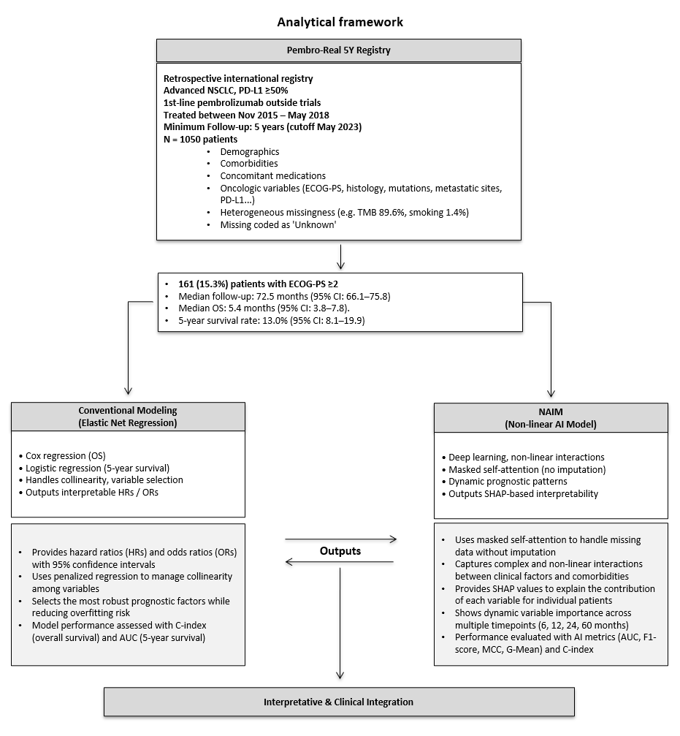

Supplementary Figure 2: Histogram plot presenting the ridge regression coefficients for each variable from the multivariable analysis of the risk of death (overall survival). Variables excluded by the Elastic Net regression had their coefficients set to zero. Coefficients are arranged in descending order by value; positive coefficients (bars extending to the right of the 0 reference point) indicate an increased risk of death, while negative coefficients (bars extending to the left) indicate a decreased risk of death. Bars representing variables with a statistically significant impact on the outcome (hazard ratios with 95% confidence intervals not crossing unity) are highlighted in red, whereas those without significant impact are shown in blue.

Supplementary Figure 3: Histogram plot presenting the Elastic Net regression coefficients for each variable from the multivariable analysis of the 5 year survival. Variables excluded by the Elastic Net regression had their coefficients set to zero. Coefficients are arranged in descending order by value; positive coefficients (bars extending to the right of the 0 reference point) indicate an increased risk of death, while negative coefficients (bars extending to the left) indicate a decreased risk of death. Bars representing variables with a statistically significant impact on the outcome (odds ratiosos with 95% confidence intervals not crossing unity) are highlighted in red, whereas those without significant impact are shown in blue.

