Active land governance mitigates wildfire impacts

Supplementary materials and methods

2. Materials and methods
- Dataset source used

Table S1. Dataset source characteristics.
Data | Source | Type | Extent | Reference year(s) | Variable(s)
Agro-forest districts | Italian National Statistical Institute (ISTAT) | Vector | Italy | 2007 | -
Fire perimeters | Italian national geoportal | Vector | Italy | 2007-2017 | ES, Burn Severity, WUI
Digital Elevation Model | http://www.sinanet.isprambiente.it/it/sia-ispra/download-mais/dem20/view | Raster 20 m | Italy | 2012 | flammability
Canopy cover | https://land.copernicus.eu/pan-european/high-resolution-layers/forests/tree-cover-density/status-maps/2015 | Raster 20 m | Europe | 2015 | flammability
CORINE Land Cover | http://groupware.sinanet.isprambiente.it/uso-copertura-e-consumo-di-suolo/library/copertura-del-suolo/corine-land-cover | Vector 25 ha (MMU¹) | Italy | 2006 | flammability
Global Forest Change | https://earthenginepartners.appspot.com/science-2013-global-forest/download_v1.7.html | Raster 30 m | Global | 2000-2019 | Burn severity
Forest biomass | https://figshare.com/articles/dataset/Forest_Biomass_Map_zip/13251746 | Raster 100 m | Europe | 2010 | biomass density (within Burn severity)
Fire Weather Index | https://cds.climate.copernicus.eu/cdsapp#!/dataset/cems-fire-historical?tab=overview | Raster 0.25º | Global | 1979-2018 | fwi_p90, fwi_wstd
Climate | https://www.worldclim.org/data/worldclim21.html | Raster 1 km | Global | 1970-2000 | tmax, prec, bio9
CORINE land cover | http://groupware.sinanet.isprambiente.it/uso-copertura-e-consumo-di-suolo/library/copertura-del-suolo/corine-land-cover | Vector 25 ha (MMU¹) | Italy | 2012 | WUI
Habitat quality | Italian National Superior Institute for Environmental Protection and Research (ISPRA) | Raster 40 m | Italy | 2012 | ES
Pollination potential | Italian National Superior Institute for Environmental Protection and Research (ISPRA) | Raster 100 m | Italy | 2012 | ES
Organic carbon storage | Italian National Superior Institute for Environmental Protection and Research (ISPRA) | Raster 10 m | Italy | 2012 | ES
Soil erosion | Italian National Superior Institute for Environmental Protection and Research (ISPRA) | Raster 10 m | Italy | 2012 | ES
CORINE Land Cover | http://groupware.sinanet.isprambiente.it/uso-copertura-e-consumo-di-suolo/library/copertura-del-suolo/corine-land-cover | Vector 25 ha (MMU¹), 5 ha (MMU LCC²) | Italy | 1990/2006 | aband_p, managed_p
Socio-economic | Sallustio et al., 2018 | tabular | Italy | 2012 | marginality, unsuitable,  agr_value, protected_p
Socio-economic | Ferrara et al., 2019 | tabular (municipal scale) | Italy | 2007 | pop_dens, agr_state, farm_size,  pop_growth, built-up, pas
LIFE forestry projects | LIFE GoProFor | tabular (item scale) | Europe | 1999-2012 | life_bud
FSC forest certifications | Forest Stewardship Council (FSC) Italy | tabular (item scale) | Italy | 2003-2012 | for_cert
PEFC forest certifications | Programme for the Endorsement of Forest Certification schemes (PEFC) Italy | tabular (item scale) | Italy | 2003-2012 | for_cert
RDP measures | Colonico et al., 2022 | tabular (municipal scale) | Europe | 2007-2013 | rdp_agr, rdp_for, rdp_marg
Landsat images | Francini et al., 2022b | Raster 30m | Global | 1997-2006 | for_harv
¹ MMU = Minimum Mapping Unit; ² MMU LCC = Minimum Mapping Unit for Land Cover Changes.

2.1. Study area and experimental design
- State of the art on fire drivers in Italy
Table S2 resumes major findings on wildfire drivers’ characterization at a national scale in Italy. According to these, a major role is played by geographical features, e.g., elevation, slope, and aspect (Barbati et al., 2015; Ferrara et al., 2019) as well as a latitudinal gradient (Ferrara et al., 2019), showing fire activity predisposition for high, steep, southern exposed and located territories. Land cover aspects were also considered; testing that forest cover and landscape diversification (Mancini et al., 2018b; Ferrara et al., 2019) are positively correlated with fire activity (not in terms of fire size). Complex relations with territorial features (human and natural) were modelled in terms of distances (Barbati et al., 2015; Mancini et al., 2018a), showing that human activities are inversely correlated to fire spread but increase ignitions (Mancini et al., 2018a; Ferrara et al., 2019).

Socio-economic variables were widely studied, and results show that fires are less present in densely populated areas and in areas with stronger economic and social systems (Mancini et al., 2018b; Ferrara et al., 2019; Michetti and Pinar 2019). Additionally, lower built-up (dwellings and infrastructures) concentration increases fire activity although it reduces fire frequency and size (Mancini et al., 2018b; Ferrara et al., 2019). Land abandonment is unambiguously associated with an increase of fire activity (Ferrara et al., 2019; Ascoli et al., 2021), while land use change towards managed land reduces burned area and fire frequency. Finally, RDP measures for fire prevention are associated with a decrease of fire hazard (Colonico et al., 2022).

Table S2. Main results from previous studies on wildfire drivers in Italy at national scale.
Drivers’ subgroups | Variable | Observed correlation with fire activity | Dependent variable(s) | Citation
Flammability | elevation | n.s.¹ | fire occurrence, fire recurrence | Barbati et al., 2015
 |  | increase | fire frequency, fire intensity, burn severity | Ferrara et al., 2019
 | slope | increase | fire frequency, fire intensity, burn severity | Ferrara et al., 2019
 | slope roughness | decrease | fire occurrence, fire recurrence | Barbati et al., 2015
 | aspect (southern exposure) | increase | fire occurrence, fire recurrence | Barbati et al., 2015
 | latitudinal gradient | decrease | fire frequency, fire intensity, burn severity | Ferrara et al., 2019
 | forest cover rate | increase | fire frequency, fire intensity, burn severity | Ferrara et al., 2019
 | distance from built-up | increase | fire incidence (burnt forest area on total forest area) | Mancini et al., 2018a
 |  | decrease | fire frequency, fire recurrence | Mancini et al., 2018a
 | distance from settlements and roads | n.s.¹ | fire occurrence, fire recurrence | Barbati et al., 2015
 | distance from grassland and wetland | n.s.¹ | fire occurrence, fire recurrence | Barbati et al., 2015
 | distance from agricultural areas | n.s.¹ | fire occurrence, fire recurrence | Barbati et al., 2015
 | landscape diversification | increase | fire occurrence, fire density | Mancini et al., 2018b
 |  | decrease | fire size | Mancini et al., 2018b
Society and land tenure | population density | decrease | fire frequency, fire intensity, burn severity | Ferrara et al., 2019
 | unemployment | increase | fire occurrence, fire density, fire size | Mancini et al., 2018b
 |  | increase | fire frequency, fire intensity, burn severity | Ferrara et al., 2019
 | activity rate | decrease | fire size, fire density | Mancini et al., 2018b
 | rural poverty | increase | fire occurrence | Mancini et al., 2018b
 |  | increase | fire frequency, fire intensity, burn severity | Ferrara et al., 2019
 | social inequalities | increase | fire occurrence | Mancini et al., 2018b
 | average farm size | increase | fire frequency, fire intensity, burn severity | Ferrara et al., 2019
 | education level | decrease | fire regime | Michetti-Pinar, 2019
 | illegal activities | increase | fire frequency, total burnt area | Michetti-Pinar, 2019
 | deregulated urban expansion | increase | fire frequency, fire intensity, burn severity | Ferrara et al., 2019
 | rural areas with low urbanization | increase | fire intensity, burn severity | Ferrara et al., 2019
 |  | decrease | fire frequency | Ferrara et al., 2019
 | road length in municipal area | increase | fire density | Mancini et al., 2018b
 |  | decrease | fire size | Mancini et al., 2018b
Land abandonment | land abandonment | increase | fire frequency, fire intensity, burn severity | Ferrara et al., 2019
 | land abandonment | increase | burnt areas, fire frequency | Ascoli et al., 2021
Land governance | RDP measures for fire prevention (see list in Table S5) | decrease | fire hazard | Colonico et al., 2022
 | land use change towards cultivated land | decrease | burnt area, fire frequency | Ascoli et al., 2021
¹ n.s. = not significant.

2.2.2. Burn severity
- Forest biomass
We calculated the mean aboveground forest biomass density (Mg/ha) for each agro-forest district from a European map of forest biomass density (Avitabile et al., 2020), a 100x100 m raster referred to the year 2010. To resume the information at agro-forest district level, we calculated a mean of all the pixels falling within the same agro-forest district. Additionally, we calculated the mean tree canopy cover and total forest area of all the agro-forest districts, respectively, from a European tree canopy cover map (https://land.copernicus.eu/pan-european/high-resolution-layers/forests/tree-cover-density/status-maps/2015) and CORINE Land Cover map (Feranec et al., 2016), to explore the correlation of these variables with forest biomass and validate the latter.

- Use and validation of GFC dataset
To assess the capacity of GFC in detecting high fire severity areas, we repeated the same methodology to derive high fire severity area per agroforest district by using an alternative Landsat-based map of forest disturbances in Europe for the period 1986-2016 (Senf and Seidl, 2020). Similarly, the European forest disturbance map often assigns the year of the disturbance to one year after the fire occurred. Thus, we calculated the area detected as stand-replacing disturbance corresponding to the year of the fire event as well as the following year within the perimeter of each single fire. Since the European forest disturbance map covers forest disturbances until 2016, we could only calculate high fire severity areas for the period 2007-2015. We confronted the high fire severity area per agro-forest district in the period 2007-2015 using both maps, i.e., Hansen et al., (2013) and Senf and Seidl (2020), and we found that the results at agro-forest district level were highly correlated (Pearson’s r = 0.91), indicating that both disturbance maps produce a similar gradient of high fire severity area across Italy. Therefore, we decided to keep the results derived from the Global Forest Change 2000–2019 data given that we could estimate the gradient of high severity area for the whole study period (i.e., from 2007 to 2017).
We also compared GFC capability of identifying high fire severity areas with NBR data. We built a burn severity atlas for Italy using the fire perimeters of those wildfires ≥ 100 ha in the period 2007-2017 (i.e., in total 1580 wildfires) using Google Earth Engine and the methodology described in Parks et al. (2018b). For each wildfire, we calculated the mean dNBR, as well as and the proportion of forest cover loss obtained from the Global Forest Change (GFC) product (Hansen et al., 2013). Despite the great variability, we found that the proportion of forest cover loss tends to grow with mean dNBR (Pearson’s correlation coefficient = 0.63), as shown in Figure S1. Therefore, we found another reason to consider forest cover loss as a suitable proxy to characterize high burnt severity in our study area.

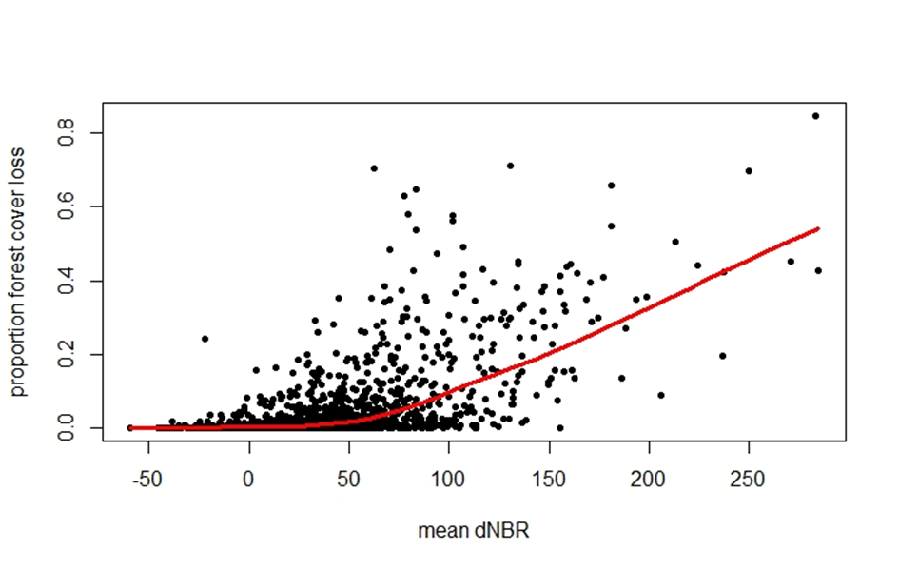
Figure S1. Scatter plot of two variables used to describe the burnt severity of 1580 wildfires ≥ 100 ha in Italy from 2007 to 2017. The red line represents the smooth curve fitted with local polynomial regression (LOESS).
2.3.2.2. Flammability
- CORINE Land Cover classes used for fuel models generation

Table S3. Correspondence between CORINE Land Cover classes and standard fuel models used to generate the raster fuel model theme necessary to run the basic fire activity simulation in Flammap.
CLC¹ class | CLC¹ code | FM² code | FM² number
Continuous urban fabric | 111 | NB1 | 91
Discontinuous urban fabric | 112 | NB1 | 91
Industrial or commercial units | 121 | NB1 | 91
Road and rail networks and associated land | 122 | NB1 | 91
Port areas | 123 | NB1 | 91
Airports | 124 | NB1 | 91
Mineral extraction sites | 131 | NB9 | 99
Dump sites | 132 | NB9 | 99
Construction sites | 133 | NB9 | 99
Green urban areas | 141 | SH1 | 141
Sport and leisure facilities | 142 | NB3 | 93
Intensive non-irrigated arable land | 2111 | GR1 | 101
Extensive non-irrigated arable land | 2112 | GR1 | 101
Permanently irrigated arable land | 212 | SH1 | 141
Rice fields | 213 | NB3 | 93
Vineyards | 221 | SH1 | 141
Fruit trees and berry plantations | 222 | SH1 | 141
Olive groves | 223 | SH1 | 141
Intensive tree plantations | 224 | TL1 | 181
Pastures, meadows and other permanent grasslands | 231 | GR1 | 101
Annual crops associated with permanent crops | 241 | GR1 | 101
Complex cultivation patterns | 242 | TL1 | 181
Land principally occupied by agriculture | 243 | SH1 | 141
Agro-forestry areas | 244 | GR1 | 101
Forests dominated by Quercus ilex and Q. suber | 3111 | SH8 | 148
Forests dominated by Q. cerris, Q. petraea, Q. pubescens | 3112 | TL6 | 186
Forests dominated by Acer-Fraxinus-Ostrya | 3113 | TL4 | 184
Forests dominated by Castanea sativa | 3114 | TL8 | 189
Forests dominated by Fagus sylvatica | 3115 | TL6 | 186
Forests dominated by Salix-Populus-Alnus | 3116 | TL2 | 182
Forests dominated by non-native broadleaves | 3117 | TL2 | 182
Forests dominated by Pinus pinea, P. pinaster, P. halepensis | 3121 | TU3 | 163
Forests dominated by P. nigra, P. sylvestris, P. uncinata | 3122 | TL5 | 185
Forest dominated by Picea abies and Abies alba | 3123 | TL1 | 181
Forest dominated by Larix decidua and P. cembra | 3124 | TU5 | 165
Forests dominated by non-native conifers | 3125 | TL1 | 181
Mixed forests dominated by Q. ilex and Q. suber | 31311 | SH8 | 148
Mixed forests dominated by Q. cerris, Q. petraea, Q. pubescens | 31312 | TL6 | 186
Mixed forests dominated by Acer-Fraxinus-Ostrya | 31313 | TL4 | 184
Mixed forests dominated by C. sativa | 31314 | TL8 | 189
Mixed forests dominated by F. sylvatica | 31315 | TL6 | 186
Mixed forests dominated by Salix-Populus-Alnus | 31316 | TL2 | 182
Mixed forests dominated by non-native broadleaves | 31317 | TL2 | 182
Mixed forests dominated by P. pinea, P. pinaster, P. halepensis | 31321 | TU3 | 163
Mixed forests dominated by P. nigra, P. sylvestris, P. uncinata | 31322 | TL5 | 185
Mixed forests dominated by P. abies and Abies alba | 31323 | TL1 | 181
Mixed forests dominated by L. decidua and P. cembra | 31324 | TU5 | 165
Mixed forests dominated by non-native conifers | 31325 | TL1 | 181
Continuous natural grasslands | 3211 | GR2 | 102
Discontinuous natural grasslands | 3212 | GR1 | 101
Moors and heathland | 322 | GS1 | 121
High maquis | 3231 | SH7 | 147
Low maquis | 3232 | GS2 | 122
Transitional woodland-shrub | 324 | GS1 | 121
Beaches, dunes, sands | 331 | NB9 | 99
Bare rocks | 332 | NB9 | 99
Sparsely vegetated areas | 333 | GR1 | 101
Burnt areas | 334 | SH1 | 141
Glaciers and perpetual snow | 335 | NB2 | 92
Inland marshes | 411 | SH1 | 141
Peat bogs | 412 | NB8 | 98
Salt marshes | 421 | GR9 | 109
Salines | 422 | NB8 | 98
Intertidal flats | 423 | NB8 | 98
Water courses | 511 | NB8 | 98
Water bodies | 512 | NB8 | 98
Coastal lagoons | 521 | NB8 | 98
Estuaries | 522 | NB8 | 98
Sea and ocean | 523 | NB8 | 98
No data | 999 | NB9 | 99
Unclassified land surface | 990 | NB9 | 99
Unclassified water bodies | 995 | NB8 | 98
¹ CLC = CORINE Land Cover; ² FM = standard Fuel Model according to Scott (2005).

- Regional forest type maps comparison
We chose CORINE Land Cover to generate the fuel model map because it is the most appropriate land cover dataset available at national level. Regional forest type maps may be more accurate, but the lack of a national harmonized forest type map hampers the use of such data in this study. To acquire a preliminary understanding about the importance of the fuel model map in basic fire activity simulation, we used the Piedmont region’s forest type map. We assigned a standard fuel model to each forest type, while the remaining data (elevation, slope, aspect, and canopy cover) did not change. We ran the simulation with the same parameters as we did with CLC data and calculated the average fireline intensity in each of the 75 agro-forest districts of the Piedmont. We found that the average values of fireline intensity, from CORINE and forest type-based simulations for Piedmont, were highly correlated (Spearman's ρ = 0.89), which indicates that the gradient of flammability across landscape units in the Piedmont is similar when CORINE or regional forest type data are applied to the fire activity simulations.

2.3.3.1. Society and land tenure
- Marginality and unsuitability
The meaning of marginality and unsuitability herein is the same as the definition given in the article by Sallustio et al. (2018), and thus as indexes of low profitability of agricultural land. Specifically, marginal land represents land suitable for agriculture but with low profitability, while unsuitable land stands for land incompatible with intense agricultural activities due to topographic constraints (i.e., mechanization). According to Sallustio et al. (2018), low profitability can be assumed as a forerunner of possible future land abandonment.

2.3.3.2. Land abandonment
- CORINE Land Cover classes and associated macro-classes for land use-land cover transitions

Table S4. CORINE Land Cover classes and merged macro-classes.
Corine Land Cover |  | Harmonization
Code | Description | Code | Description
111 | Continuous urban fabric | UR | Urban
112 | Discontinuous urban fabric | UR | Urban
121 | Industrial or commercial units | UR | Urban
122 | Road and rail networks and associated land | UR | Urban
123 | Port areas | UR | Urban
124 | Airports | UR | Urban
131 | Mineral extraction sites | UR | Urban
132 | Dump sites | UR | Urban
133 | Construction sites | UR | Urban
141 | Green urban areas | UR | Urban
142 | Sport and leisure facilities | UR | Urban
211 | Non-irrigated arable land | CR | Cropland
212 | Permanently irrigated land | CR | Cropland
213 | Rice fields | CR | Cropland
221 | Vineyards | CR | Cropland
222 | Fruit trees and berry plantations | CR | Cropland
223 | Olive groves | CR | Cropland
231 | Pastures | GR | Grassland
241 | Annual crops associated with permanent crops | CR | Cropland
242 | Complex cultivation patterns | CR | Cropland
243 | Land principally occupied by agriculture with … | CR | Cropland
244 | Agro-forestry areas | CR | Cropland
311 | Broad-leaved forest | FO | Forest
312 | Coniferous forest | FO | Forest
313 | Mixed forest | FO | Forest
321 | Natural grasslands | GR | Grassland
322 | Moors and heathland | SH | Shrubland
323 | Sclerophyllous vegetation | SH | Shrubland
324 | Transitional woodland-shrub | SH | Shrubland
331 | Beaches, dunes, sands | UV | Unvegetated
332 | Bare rocks | UV | Unvegetated
333 | Sparsely vegetated areas | SH | Shrubland
334 | Burnt areas | FO | Shrubland
335 | Glaciers and perpetual snow | UV | Unvegetated
411 | Inland marshes | UV | Unvegetated
412 | Peat bogs | UV | Unvegetated
421 | Salt marshes | UV | Unvegetated
422 | Salines | UV | Unvegetated
423 | Intertidal flats | UV | Unvegetated
511 | Water courses | UV | Unvegetated
512 | Water bodies | UV | Unvegetated
521 | Coastal lagoons | UV | Unvegetated
522 | Estuaries | UV | Unvegetated
523 | Sea and ocean | UV | Unvegetated
999 | NO DATA | 999 | No Data

2.3.3.3. Land governance
- RDP measures related to indirect fire prevention

Table S5. 2007-2013 Rural Development Plan (RDP) measures directly and indirectly related to fire hazard mitigation and adaptation (Colonico et al., 2022, modified) and relative weights for the Principal Component Analysis (PCA).
RDP measure | Funds destination | RDP1 | RDP2 | RDP3
M2.2.6 | Restoring forestry potential and introducing prevention actions | +6.99 | +28.94 | -0.32
M1.2.1 | Modernization of agricultural holdings | +13.61 | -7.02 | +4.92
M2.1.4 | Agro-environmental payments | +15.83 | -3.12 | 0.00
M2.1.1 | Natural handicap payments to farmers in mountain areas | +0.58 | +1.56 | +37.89
M2.1.2 | Payments to farmers in areas with handicaps, other than mountain areas | +0.46 | -5.51 | +4.38
M1.1.1 | Vocational training and information actions | +10.92 | +0.85 | -10.56
M1.1.2 | Setting up of young farmers | +10.87 | -12.32 | +5.10
M1.2.4 | Cooperation for development of new products, processes and technologies in the agriculture and food sector and in the forestry sector | +15.75 | +0.64 | -9.70
M1.2.2 | Improvement of the economic value of forests | +1.06 | +0.51 | +8.68
M1.2.3 | Adding value to agricultural and forestry products | +12.08 | -6.53 | -3.03
M1.2.5 | Infrastructure related to the development and adaptation of agriculture and forestry | +3.06 | +1.63 | +7.73
M2.2.5 | Forest-environment payments | 0.00 | +7.50 | +7.55
M2.2.7 | Non-productive investments | +8.80 | +23.87 | +0.15

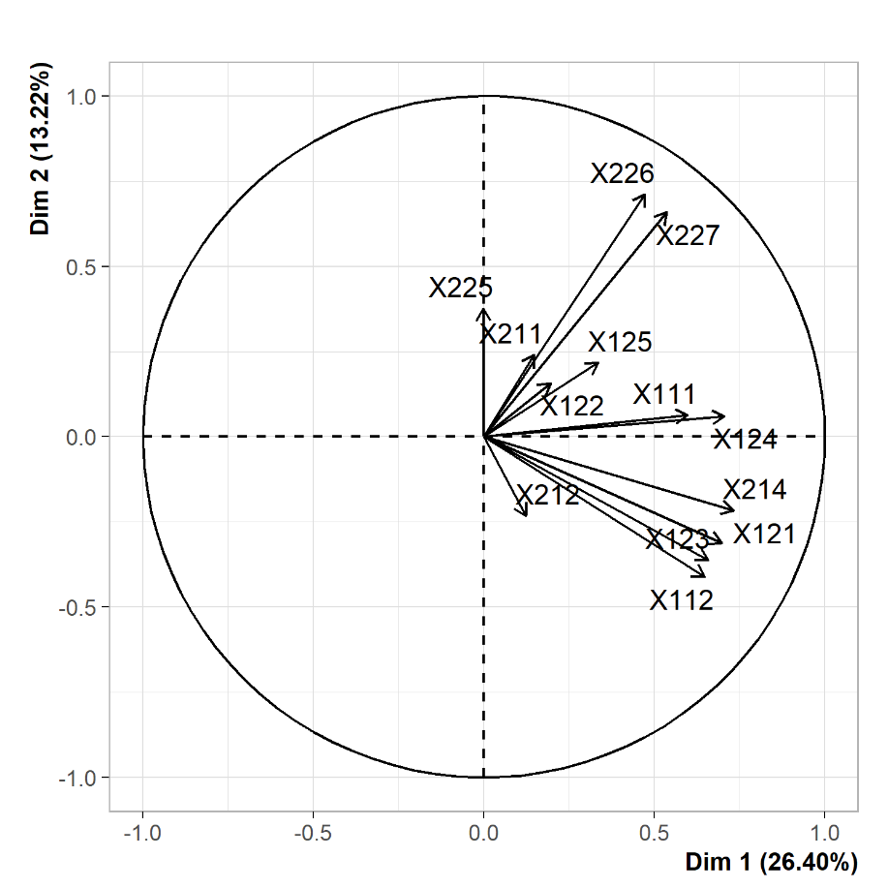
Figure S2. Principal Component Analysis biplot used for Rural Development Plan (RDP) measures reduction.

Supplementary results

3. Results
- Variable reduction biplots and variable contribution

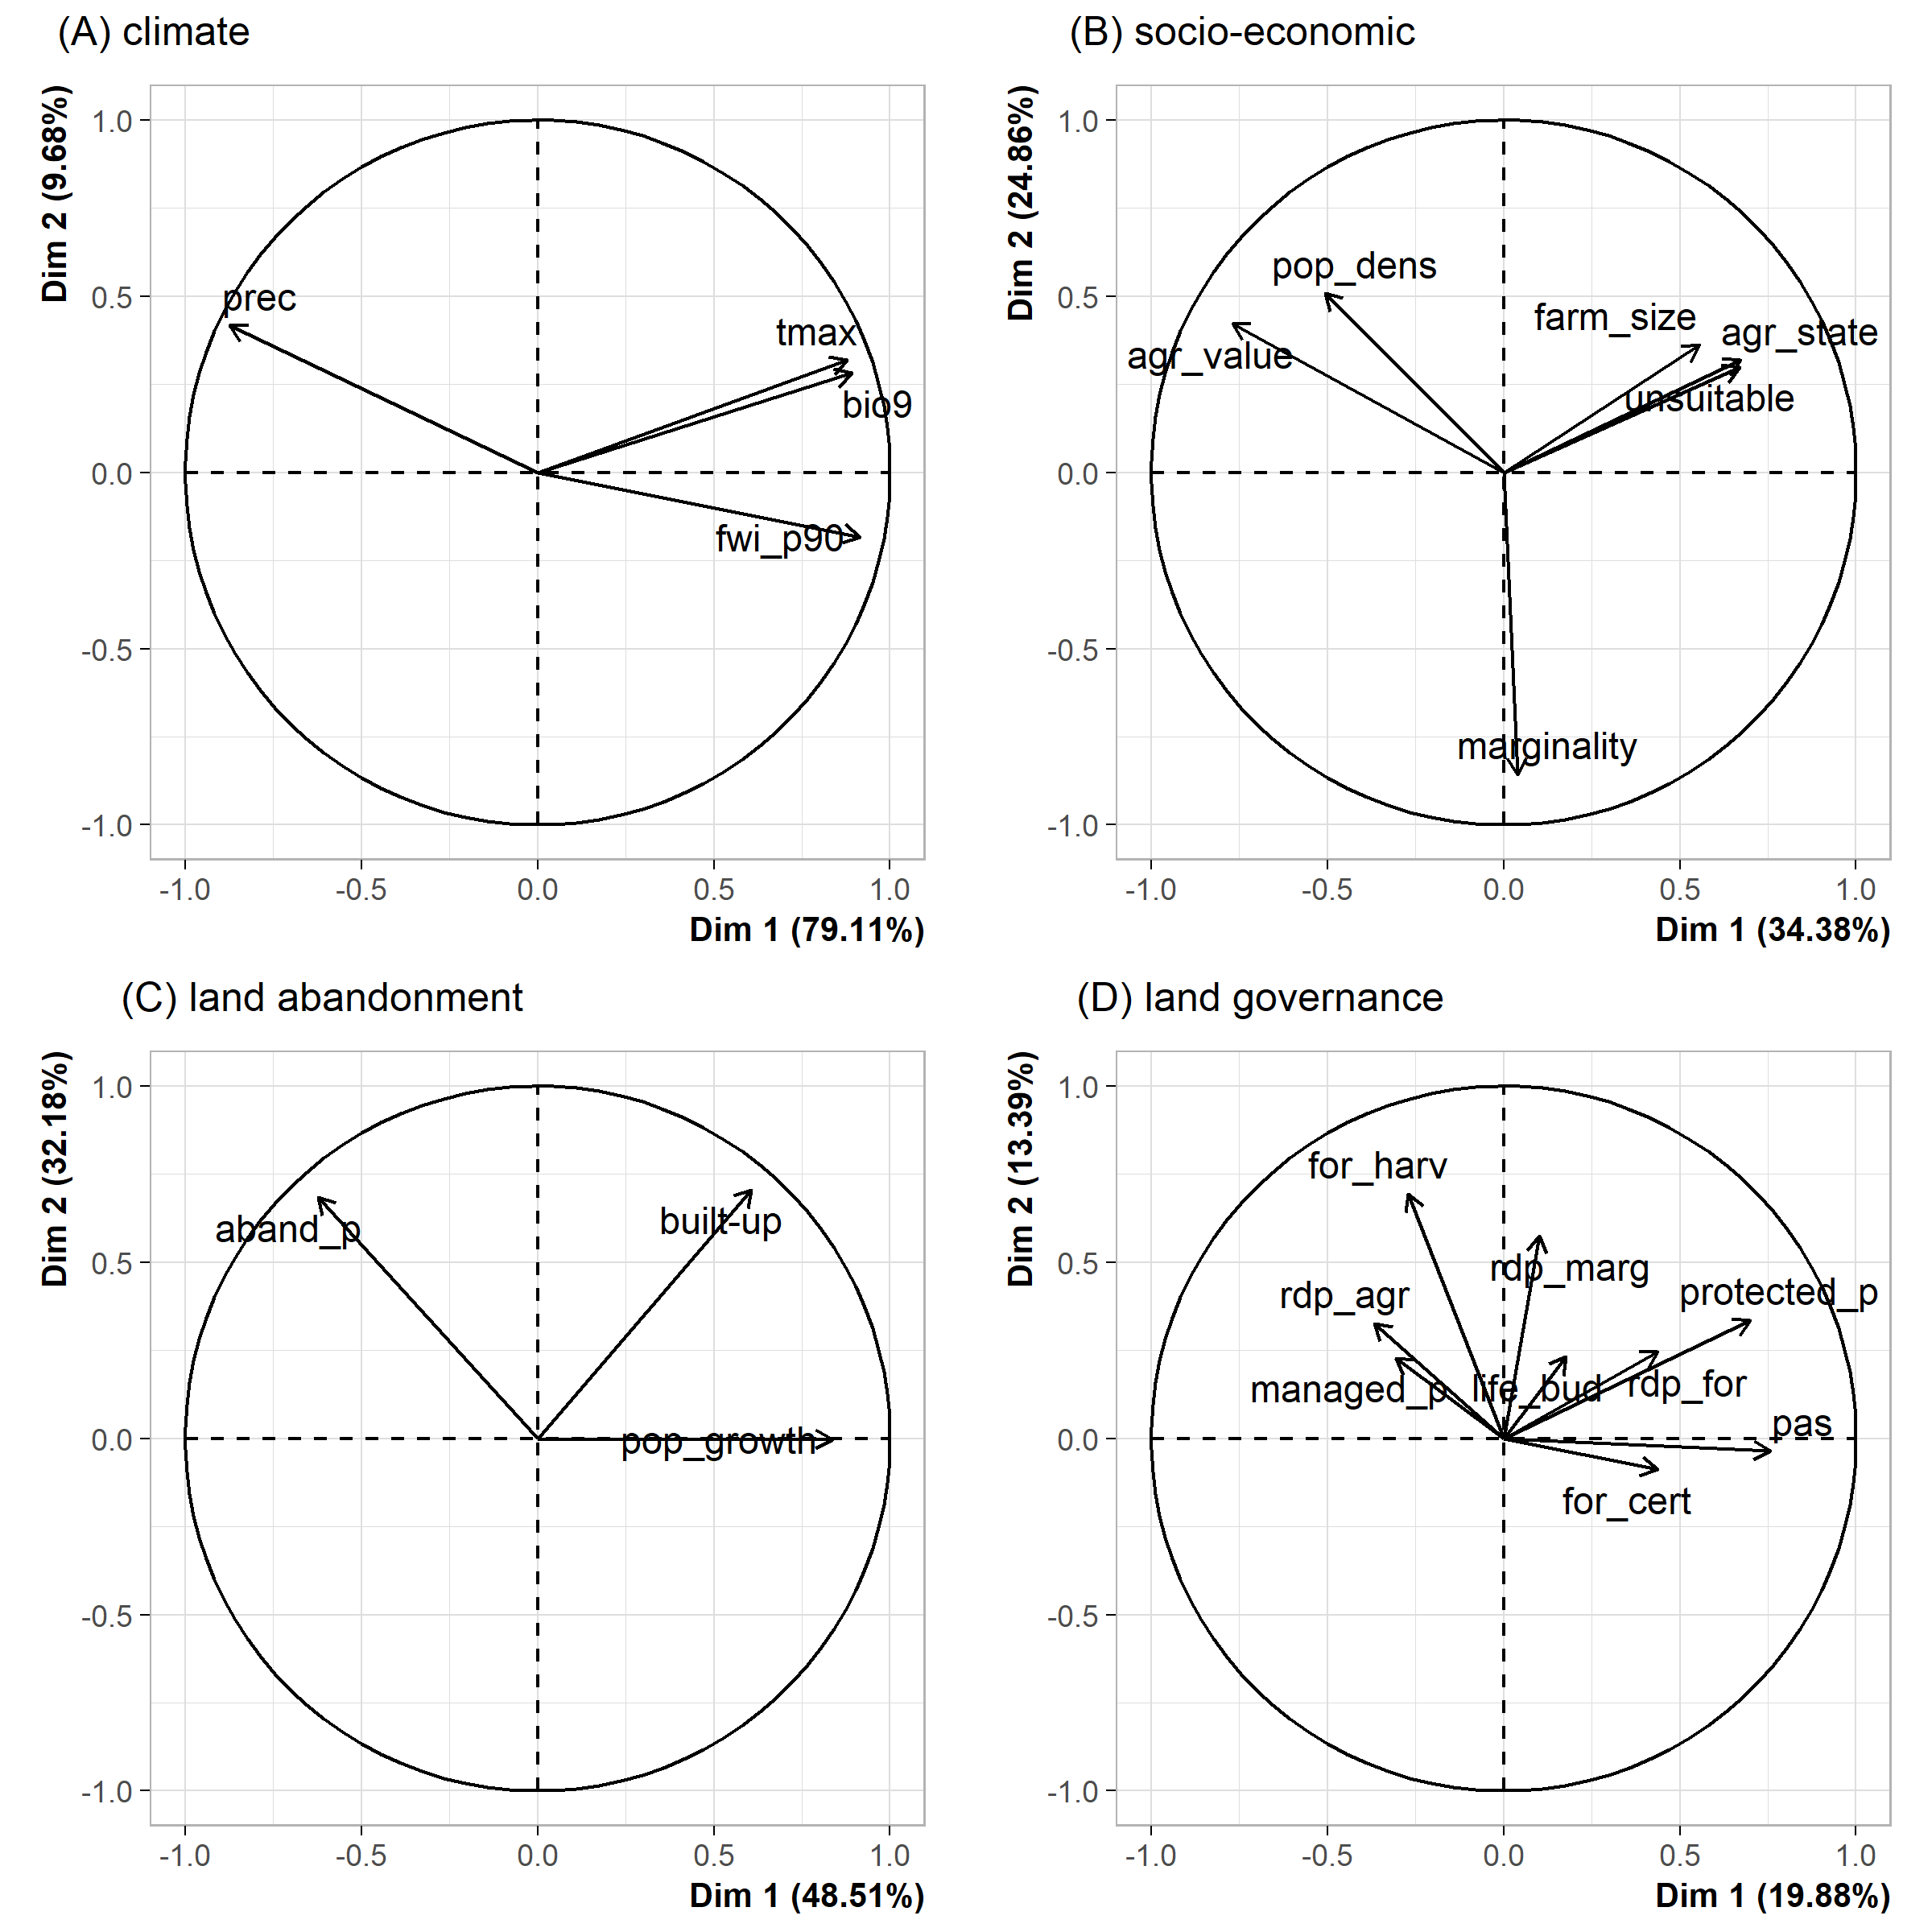
Figure S3. Principal Component Analysis biplots used for variable reduction of the four drivers’ subgroups of climate (A), socio-economic (B), land abandonment (C) and land governance (D). To directly represent the processes of interest, once extracted, the signs of the principal components from socio-economic (S1 and S2) and land abandonment (LA1) were inverted. Variable names are explained in Table 1 in the main text.

Table S6. Variable contribution to the Principal Components (PCs) (Dimensions) within the variable reduction process, with a correlation sign (+, -). PCs from socio-economic (S1 and S2) and land abandonment (LA1) are represented with an inverted sign, as they were used in the main analyses. Variable names are explained in Table 1 in the main text.
Drivers’ subgroups | Variable contribution (%) | Dim.1 | Dim.2 | Dim.3 | Dim.4
climate |  | C1
 | tmax | +24.35 | - | - | -
 | prec | -24.12 | - | - | -
 | bio9 | +25.07 | - | - | -
 | fwi_p90 | +26.45 | - | - | -
Society and land tenure |  | S1 | S2
 | pop_dens | +12.47 | -17.29 | - | -
 | agr_state | -21.98 | -6.81 | - | -
 | farm_size | -14.99 | -8.74 | - | -
 | marginality | -0.08 | +49.20 | - | -
 | unsuitable | -21.77 | -6.00 | - | -
 | agr_value | +28.70 | -11.94 | - | -
land abandonment |  | LA1
 | aband_p | +26.60 | - | - | -
 | pop_growth | -48.06 | - | - | -
 | built-up | -25.33 | - | - | -
land governance |  | LG1 | LG2 | LG3 | LG4
 | managed_p | -5.21 | +4.32 | -28.19 | -19.06
 | pas | +32.01 | -0.11 | -0.73 | +0.12
 | protected_p | +27.43 | +9.36 | +0.42 | -4.22
 | life_bud | +1.77 | +4.43 | +14.78 | -3.61
 | for_cert | +10.64 | -0.65 | -1.03 | +34.10
 | rdp_agr | -7.54 | +8.84 | +35.26 | +6.95
 | rdp_for | +10.73 | +4.97 | +3.84 | -14.65
 | rdp_marg | +0.59 | +27.36 | -15.69 | +17.01
 | for_harv | -4.07 | +39.95 | -0.05 | +0.27

- Drivers’ Principal Component Analysis

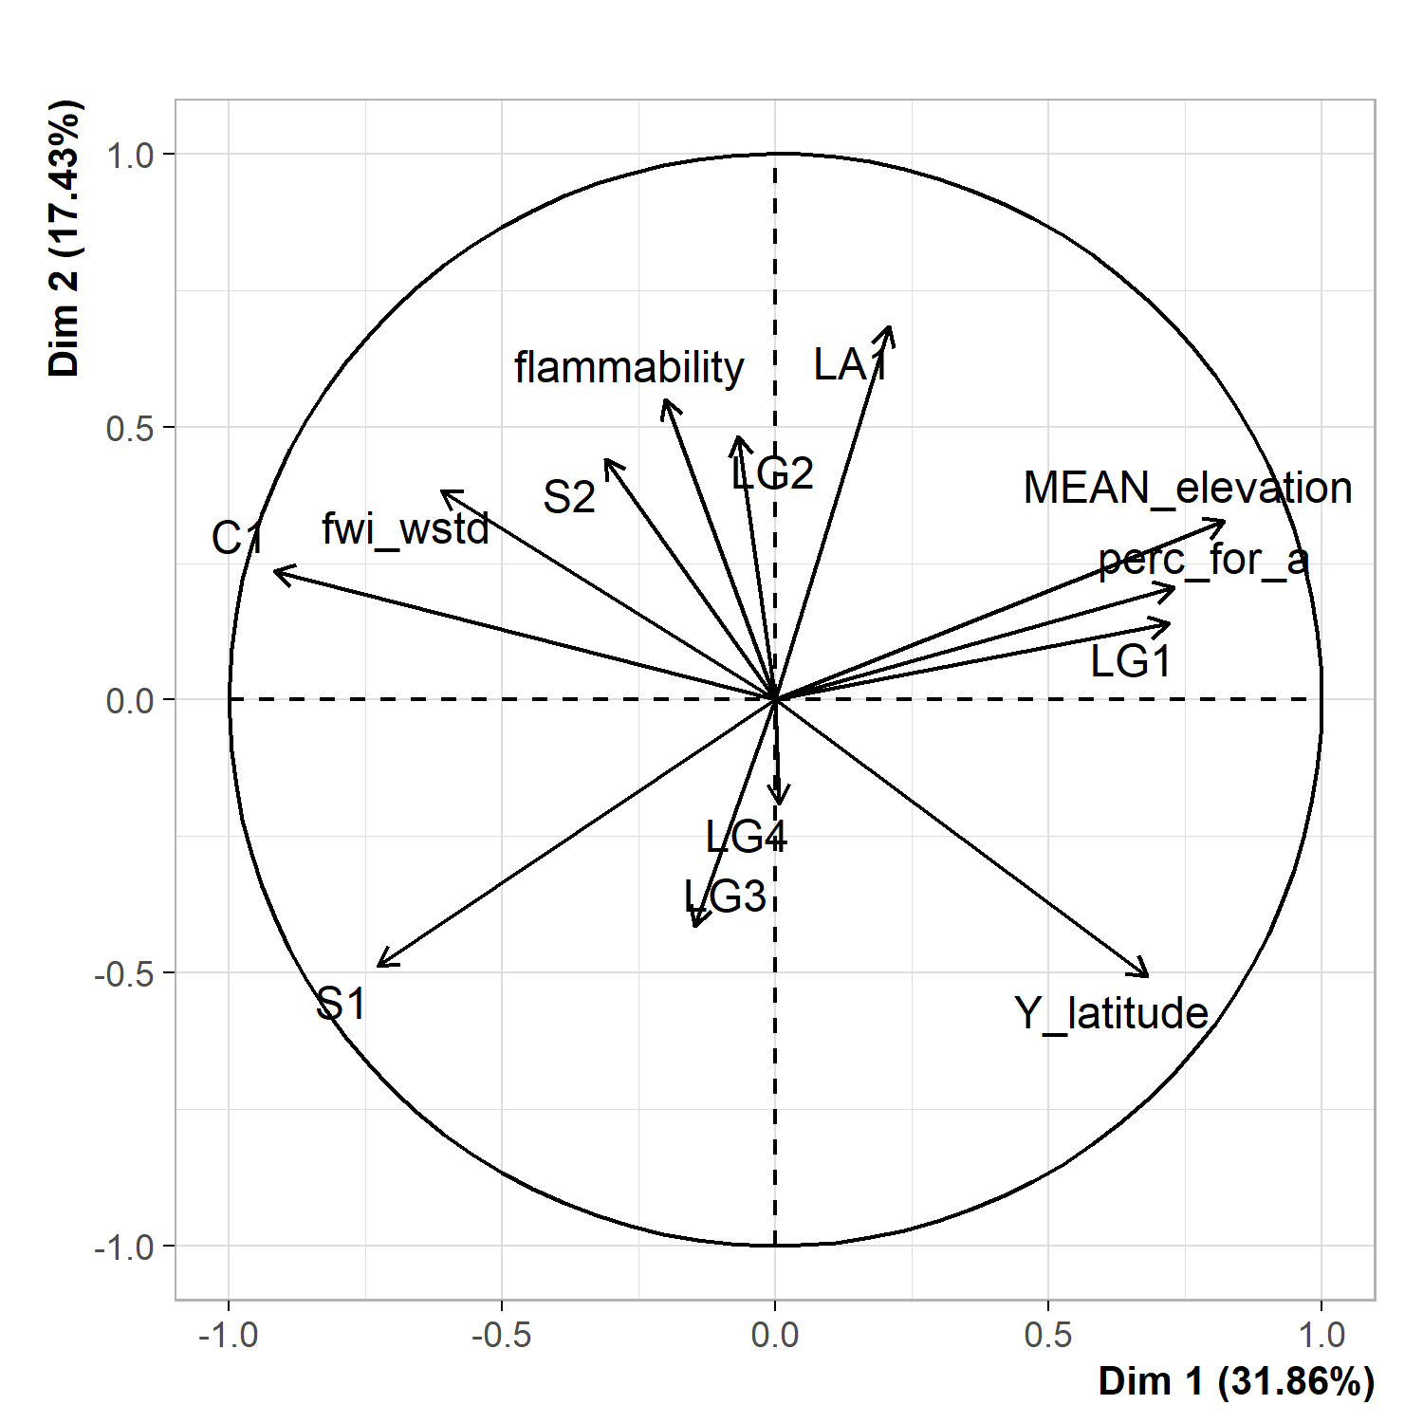

Figure S4. Drivers’ Principal Component Analysis with underlying gradients. Variable names are explained in Table S6 in the supplementary material.

To simplify the interpretation of the drivers’ PCA (Figure S4) we introduced support variables: AFD average elevation (“MEAN_elevation”), AFD centroid latitude (“Y_latitude”) and AFD forest cover percentage (“perc_for_a”; based on CLC 2012).

Three main gradients can be identified when observing the drivers distribution on the biplot: a climate gradient, given by the alignment between warm and dry climate (C1) and latitude (Y_latitude), an altitude gradient, realized by the opposition between elevation (MEAN_elevation) and high profitability and densely populated areas (S1), and a flammability gradient, resulting from the vectors of flammability (flammability) and intensive agriculture (LG3). Climate gradient is strictly related to the morphology of Italy, that covers several degrees of latitude, crossing different climate zones. As expected, FWI (fwi_wstd) and flammability (flammability) are correlated with C1 and increase in the southbound direction. Interestingly, sustainable forest management (LG4) lies close to LG3, in the opposite direction of flammability, while land abandonment (LA1), marginal, hardly accessible and less developed areas (S2) and rural and marginal areas governance (LG2) are correlated to flammability. Finally, forest and mountain areas governance (LG1) is related to elevation and forest cover and opposed to high profitability and densely populated areas.

- GAMM
We show here the results from the GAMM for the impacts on burned ecosystem services. Model assumptions were assessed graphically using Pearson residuals. The GAMM shows a strong non-linear relationship for flammability (Figure S6; similarly to the trend observed in the RF model), positive for fire weather and land abandonment, and negative for socio-economic and land governance variables, although the relationship with S1 and LG1 were not statistically significant (Table S7). The results also revealed significant interactions between some land governance variables (LG3, LG4) and fwi_wstd, suggesting that the fire regulatory capacity of active land management may have decreased as fire weather values increased.

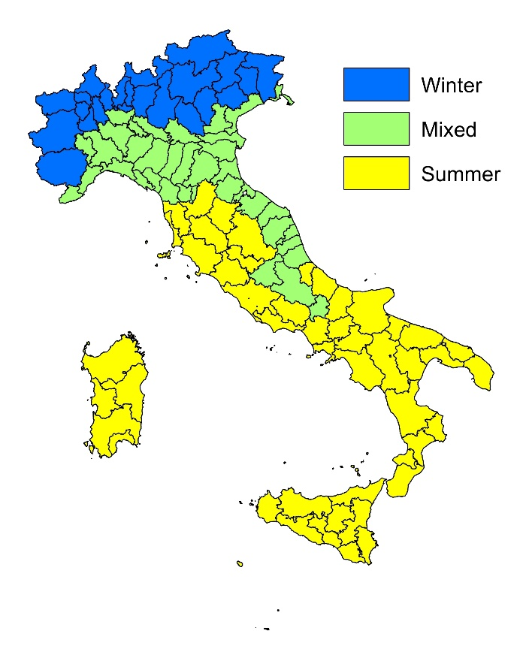
Figure S5. Regions used to stratify the data according to fire seasonality and climate type. Winter: fires are more frequent from November to April. Mixed: fires are relatively frequent the whole year. Summer: fires are more frequent from May to October. Source: Ascoli et al. (2021).

Table S7. Results from GAMM for the impacts on ecosystem services. Conditional R² = 0.67, marginal R² = 0.49.

Fixed effects | Estimate | Std.error | Significance
S1 | -0.04 | 0.08 | -
S2 | -0.29 | 0.06 | ***
LA1 | 0.33 | 0.06 | ***
LG1 | 0.05 | 0.08 | -
LG2 | -0.21 | 0.05 | ***
LG3 | -0.18 | 0.06 | **
LG4 | -0.12 | 0.06 | *
fwi_wstd | 0.17 | 0.08 | *
flammability | (s) |  | ***
LG3:fwi_wstd | 0.15 | 0.06 | *
LG4:fwi_wstd | 0.13 | 0.05 | *
Significance codes: P < 0.001 “***”; P < 0.01 “**”; P < 0.05 “*”; P > 0.05 “-”. (s) = smooth term.

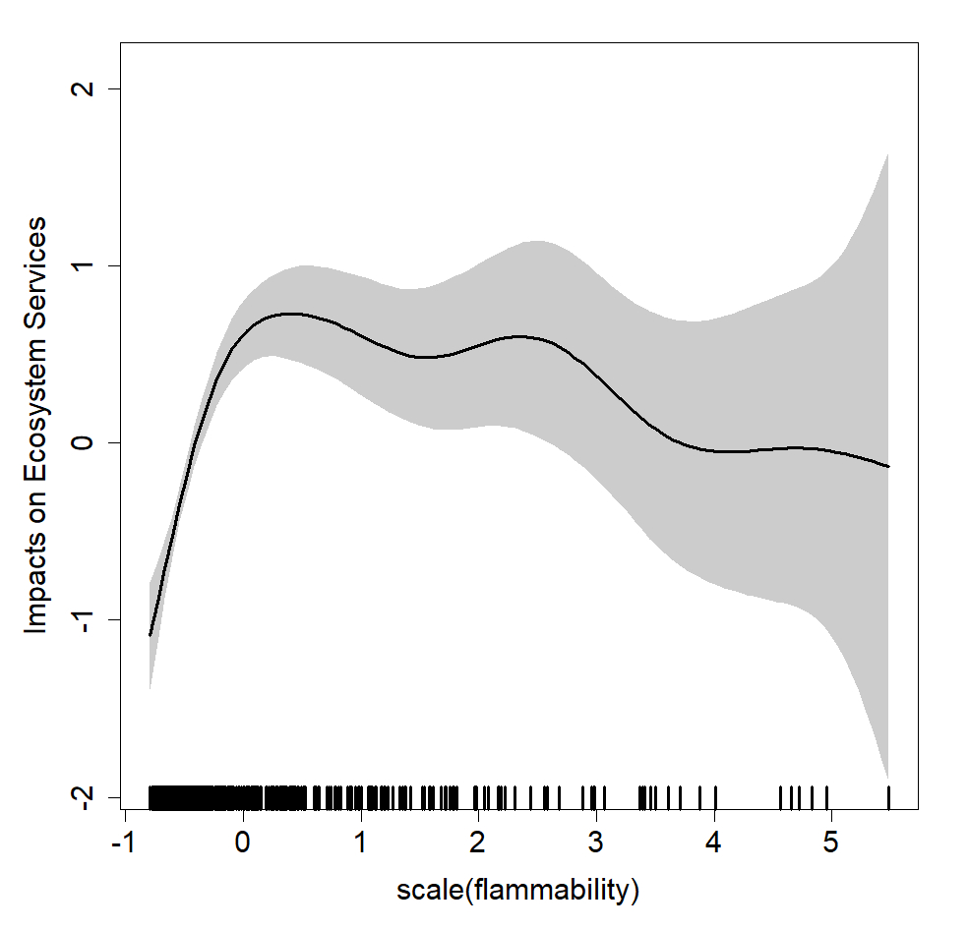
Figure S6. Relationship between the response variable ES (Impacted ecosystem services) and the driver flammability in the GAMM. Shade areas represent 95% confidence intervals of the predictions.

- RF Interactions
We assessed interactions for the ecosystem services model, considering the most important land governance variable (LG4, i.e., sustainable forest management), according to VIMP results (Fig. 3), and four predominant drivers of flammability, climate (C1), weather (fwi_wstd) and land abandonment (LA1). Results are shown in Figure S7.

Figure S7. Interactions tested with Random Forest: LG4 – flammability (A); LG4 – climate (B); LG4 – weather (C); LG4 – land abandonment (D). ES = impacts on ecosystem services; flammability = mean potential fireline intensity; C1 = warm and dry climate; LA1 = land abandonment; LG4 = sustainable forest management; fwi_wstd = mean FWI (Fire Weather Index) associated to wildfire events.

