In immune complex-mediated idiopathic MPGN and C3 Glomerulopathy hierarchical clustering strategy helps to sort out disease patterns and further untangle complexities

Ariela Benigni et al.

Supplementary material

Table of contents
Supplementary Figure S1. Flow diagram showing the selection of patients for clustering analysis from the Italian Registry of membranoproliferative glomerulonephritis (MPGN).
Supplementary Methods. Biochemical and genetic screening.
Supplementary methods. Imputation
Supplementarymethods. Clustering procedure.
Supplementary methods. Cluster Assessment.
Supplementary methods. Cluster characterization
Supplementary methods. Statistical analysis
Supplementary methods. Classification of novel patients into the established clusters.
Supplementary Table S1. Details of immunofluorescence data in patients classified according to histological classification
Supplementary Table S2. Details of immunofluorescence data in patients classified according to clusters.
Supplementary Figure S2. Distribution of the histologic groups across the 5 clusters.
Supplementaryl Table S3. Cluster classification of patients from the Iatropoulos’ study
Supplementary Figure S3. Kaplan-Meier survival analysis assessing the proportion of patients developing end-stage renal disease (ESRD) over time across treatment categories
Supplementary Table S4. Patients with likely pathogenetic variants or rare CNVs in the DECODE cohort.
Supplementary Figure S4. Differences in distribution of rare functional LPVs/CNVs across the 5 clusters.
Supplementary Table S5. Kidney parameters at the last available follow-up in patients according to the clusters.
Supplementary Table S6. Multivariate analysis of the variables associated with end-stage renal disease in the whole cohort.
Supplementary Figure S5. Kaplan-Meier analysis for survival from ESRD according to histologic groups.
Supplementary Table S7. Outcome of the first kidney graft at the last available follow-up in patients according to the clusters.
Supplementary results. Evaluation of loss-of-recall in MPGN patient classification.
Supplementary Figure S6. Loss-of-recall of the individual variables averaged over SVM, 3-NN, and 9-NN classification models.
Supplementary Table S8. Loss-of-recall of the individual variables in patient classification.
Supplementary Table S9. Loss-of-recall of the diagnostic groups in patient classification. All variables of a group were removed from classification model training and prediction.
Supplementary Figure S7. Cluster prediction with classification probabilities of newly enrolled patients with primary C3G/IC-MPGN.
Supplementary References.
Supplementary text. A user-friendly classification platform for MPGN patients. Detailed description of the function of the classification computational tool and of the underlying methodology.
Supplementary Figure S1

Flow diagram showing the selection of patients for clustering analysis from the Italian Registry of membranoproliferative glomerulonephritis (MPGN). Of the 173 patients included in the Iatropoulos study, 168 were incorporated into the current analysis. Four patients were excluded due to having more than 15% missing data, and one additional patient was excluded following a re-evaluation of the kidney biopsy and clinical history, which led to reclassification as IC-MPGN secondary to monoclonal gammopathy.² C3G: C3 glomerulopathy; IC: immune-complex; IF: immunofluorescence, EM: electron microscopy.

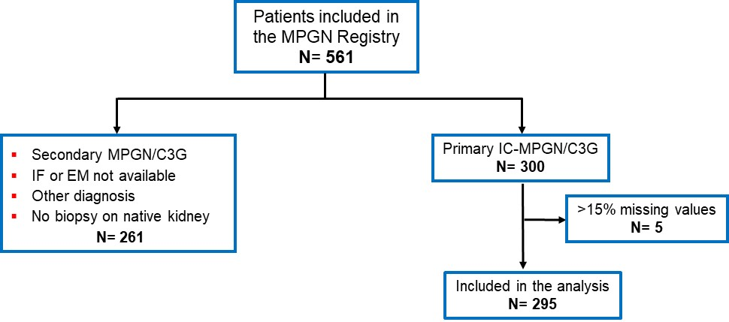

Supplementary Methods. Biochemical and genetic screening
Screening of CFH, CD46, CFI, CFB, C3, THBD and DGKE coding sequences was performed by next generation sequencing ^{S1}. Rare functional variants (missense, nonsense, splicing, frameshift, ins/del) with maximum Minor Allelic Frequency (maxAF ≤ 0.001 and CADD score ≥10 or with functional evidence supporting pathogenicity were selected and defined as likely pathogenic variants (LPV) ^{S2}. Multiplex Ligation-dependent Probe Amplification (MLPA) was used to evaluate the presence of novel or rare copy number variations (CNVs) in CFH, CFHR3, CFHR1, CFHR4, CFHR2, and CFHR5 genes ^{S3}. The presence of NeFs was assessed on plasma-purified IgGs as reported ^{S4,5}. Anti-FH and anti-FB antibodies were assessed by ELISA ^{S1,6}. Characterization of NeFs as C3NeF (properdin-independent IgG stabilizing the C3 convertase) and C5NeF (properdin-dependent IgG stabilizing the C5 convertase) was performed by microwell-western blot technique as previously reported ^{S7}.

Supplementary methods. Imputation
After removing 5 patients with more than 5 missing values, the imputation was performed in two steps. First, Immunofluorescence (C3 on IF, IgA on IF, IgG on IF, IgM on IF, C1q on IF, Fibrinogen on IF in table S1) and electron microscopy (Mesangial deposits on EM, Subepithelial deposits on EM, Subendothelial deposits on EM, Intramembranous highly electron-dense ribbon-like deposits on EM in table S1) variables were imputed by using the median of the diagnosis for each variable. Subsequently, all 29 variables were imputed using IRMI as implemented in the R package VIM ^{S8}. The number of rare alleles was treated as a count variable, proportion and scale variables (% and 0 to 3+ scale in table S1) were treated as semi-continuous variables, binary and 0-1-2 variables were treated as categorical variables and the remaining variables were treated as continuous variables. Plasma sC5b-9 first value was log-transformed before imputation and transformed back after it. Imputation was run by setting the median as method for the initialization of missing values.
Supplementary methods. Clustering procedure
Like in our previous study ^{S2}, among the many cluster methods we chose hierarchical clustering because it is appropriate for relatively small dataset and does not require assumptions about the number of clusters ^{S9–12}.
After imputation, the data were submitted to the principal component analysis (PCA) for mixed data implemented in the R package PCAmixdata ^{S13}. As previously done ^{S2}, binary variables were set as qualitative variables, except for NeF positivity, and the rest as quantitative variables. The first 19 principal components contain 85% of the variance and were retained for the cluster analysis.
Hierarchical clustering was performed on the Euclidean distance of the output of the mixed PCA using the “ward.D2” method in base R ^{S14}.

Supplementary methods. Cluster Assessment
We used the package NbClust ^{S15} to assess the optimal number of clusters. This package returns the optimal number of clusters according to several indices. NbClust was run with the default option for index (all) and maximum cluster equal to 10. Of the 23 indices, 7 suggested 2 clusters, 5 suggested 4 clusters, 4 proposed 3 clusters, 4 proposed 10 clusters, 2 proposed 9 clusters and 1 proposed 8 clusters, while the two graphical methods returned 3 and 5 clusters respectively.
Ultimately, we decided for the 5 cluster solution to achieve a good balanced distribution (the 4 clusters option would have resulted results in a large group comprising almost half of the patients that are divided between cluster 1 and cluster 2 in the 5-cluster configuration, Figure 1).
The stability of each cluster was assessed by a resampling procedure. For 10,000 times the 80 percent of patients were resampled without replacement and the cluster procedure was repeated setting the number of clusters to 5. For each iteration, the Jaccard index was computed between each of the original clusters and each of the newly obtained. The maximum index was taken as a measure of that cluster similarity. The results are reported in the table below. The median of the Jaccard index of the 10,000 simulations ranged from 0.35 (cluster 5) to 0.6 (cluster 3), which are in line with values obtained with the 4 clusters in our previous publication.

Cluster | 2.5 quantile | median | average | 97.5 quantile
Cluster1 | 0.246 | 0.431 | 0.430 | 0.627
Cluster2 | 0.278 | 0.458 | 0.463 | 0.683
Cluster3 | 0.229 | 0.605 | 0.551 | 0.833
Cluster4 | 0.345 | 0.565 | 0.560 | 0.744
Cluster5 | 0.193 | 0.345 | 0.358 | 0.586

Supplementary methods. Cluster characterization

The 29 variables, and the results of characterization of NeFs as C3NeF (properdin-independent IgG stabilizing the C3 convertase) and C5NeF (properdin-dependent IgG stabilizing the C5 convertase) ^{S7}, of anti-factor B (FB) and anti-FH factor H (FH) antibodies in serum/plasma, as well as follow-up information, were used to assess the identified clusters.

Supplementary methods. Statistical analysis
Summary statistics of the clusters’ parameters were done excluding missing imputed data.
We used ANOVA for continuous variable and the chi-square test for categorical variables with correction for multiple comparisons. We compared the outcome of the clusters with respect to time-to-ESRD using a Kaplan-Meier estimator and Cox proportional Hazards analysis. Patients lost to follow-up were censored at their last known visit or contact date with the Registry. Patients who received complement inhibitors were censored at the last visit before the first dose. P values <0.05 were considered statistically significant.

Supplementary methods. Classification of novel patients into the established clusters
We performed leave-one-out bootstrapping across the 295 patients to assess statistical learning methods for classification of new patients into the established cluster scheme. Resulting recall of the clusters was lowest for Learning Vector Quantization (LVQ1: 78%, LVQ3: 82%) and Random Forest (about 80%) models. Both methods were trained in 1,000 iterations and recall was accordingly averaged to retrieve a reliable estimation of classification quality. Support Vector Machine (SVM; 89%) and k-Nearest Neighbors classification (k-NN; 85%-87% depending on k) showed better performance and classification results. Confusion maps of SVM, 3-NN, and Random Forest are very similar, reflecting overall good classification of these models (recall ≥ 80%), however with subtle differences and better recall in SVM (89%) and 3-NN (87%). We consequently selected SVM and k-NN approaches for utilization in the patient classification tool for support of clinical diagnosis.

Confusion maps of SVM, 3-NN, and Random Forest classification models. Numbers indicate individual patients.

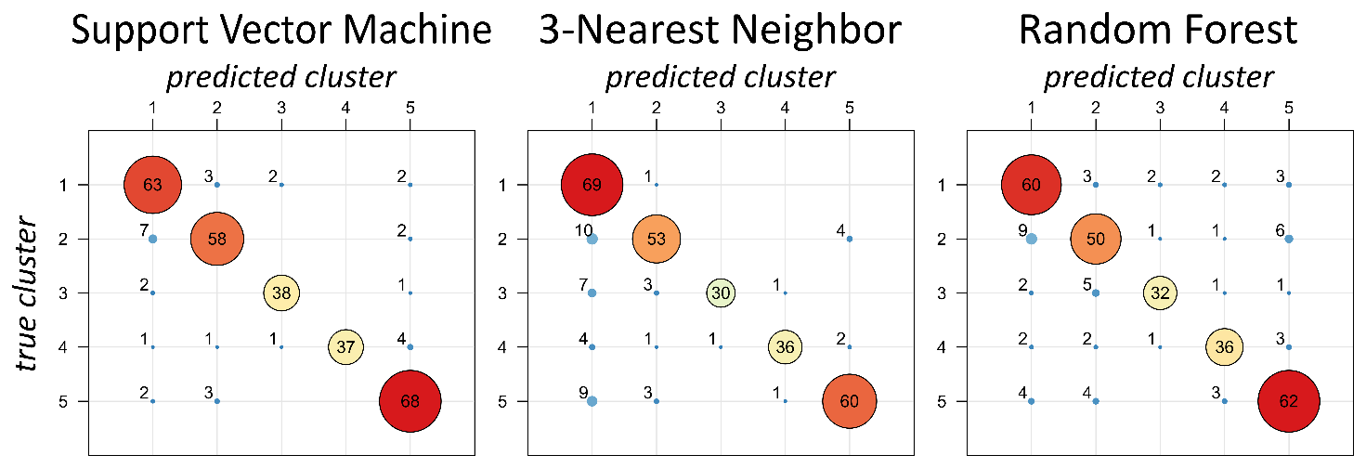
Supplementary Figure S2

Distribution of the histologic groups across the 5 clusters.
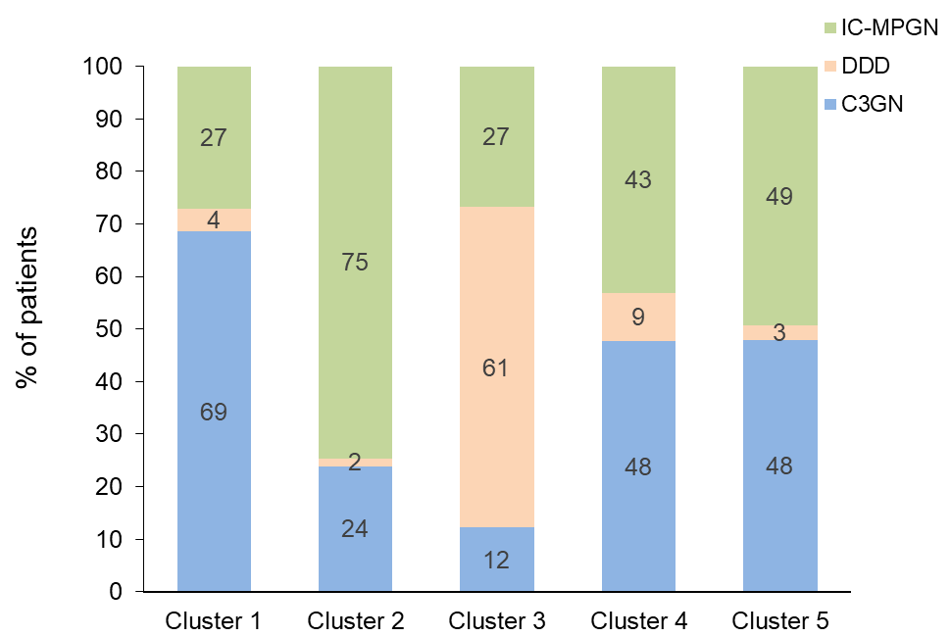

Chi-square test: overall P<0.0001

Supplementary Figure S3

Kaplan-Meier survival analysis assessing the proportion of patients free from end-stage renal disease (ESKD) over time across treatment categories (RAAS inhibition alone, immunosuppression alone, and combined immunosuppression + RAAS inhibition) compared with supportive therapy alone taken as reference. Time: follow-up in years. Survival probability: fraction of patients free from the event ESRD. None: supportive therapy alone; IS: immunuppressive therapy (steroids, MMF, calcineurin inhibitors alone or combined); RAAS: renin angiotensin aldosterone system inhibitors; RAAS_IS: combined RAAS and IS treatment. Patients were censored at last available follow-up or at the event (need of dialysis or transplantation). For patients who received complement inhibitors, the follow-up was discontinued at the last observation before the start of anti-complement therapy.
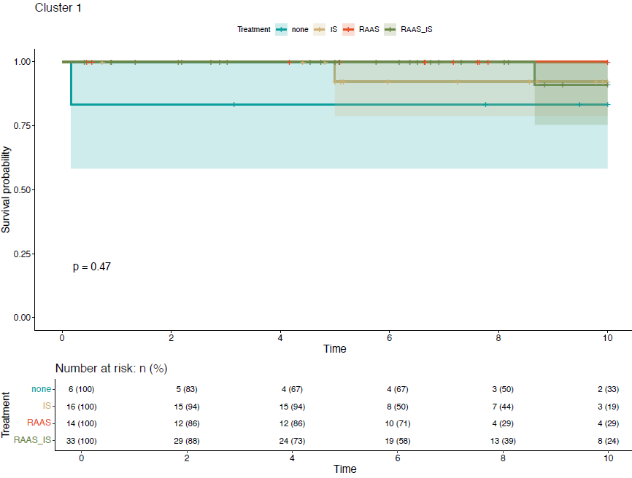
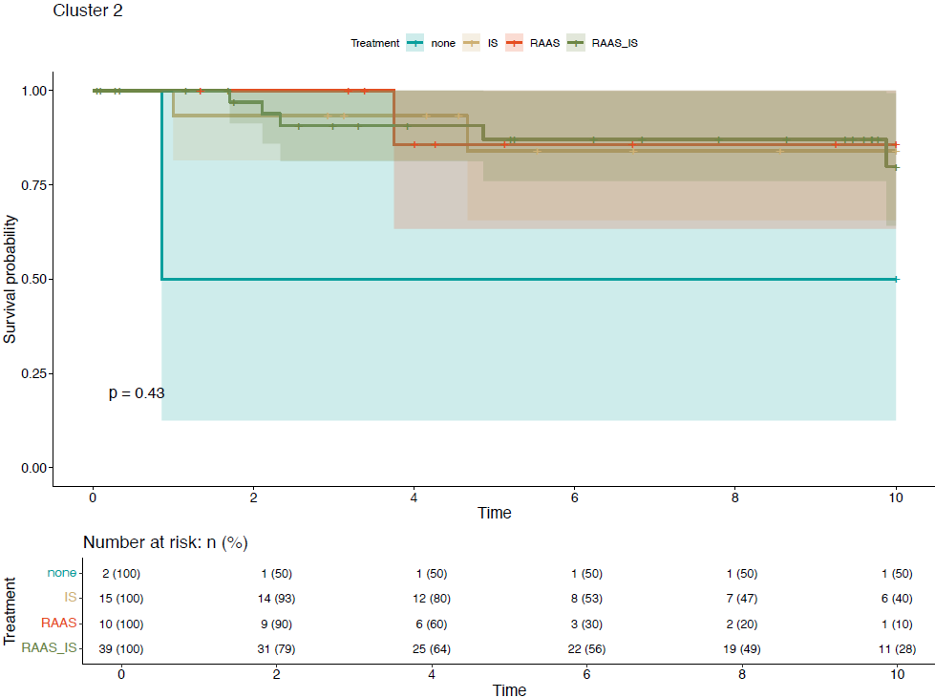

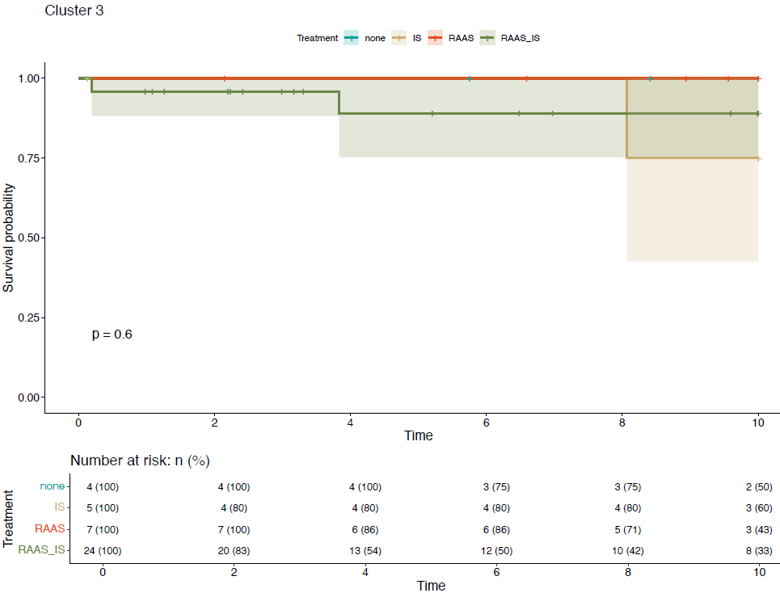

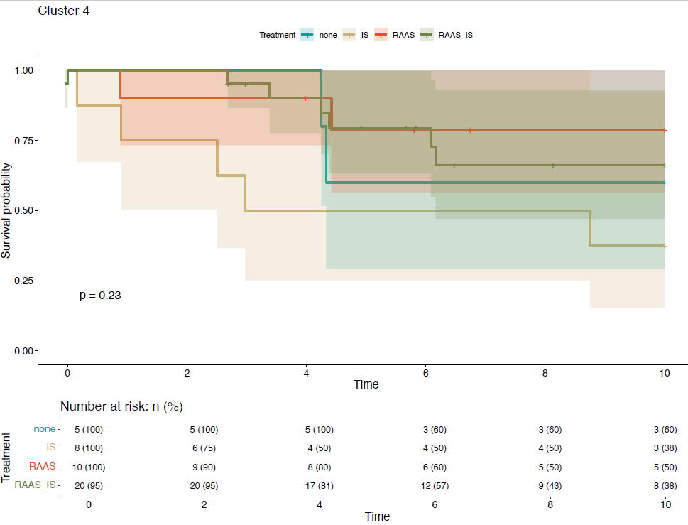
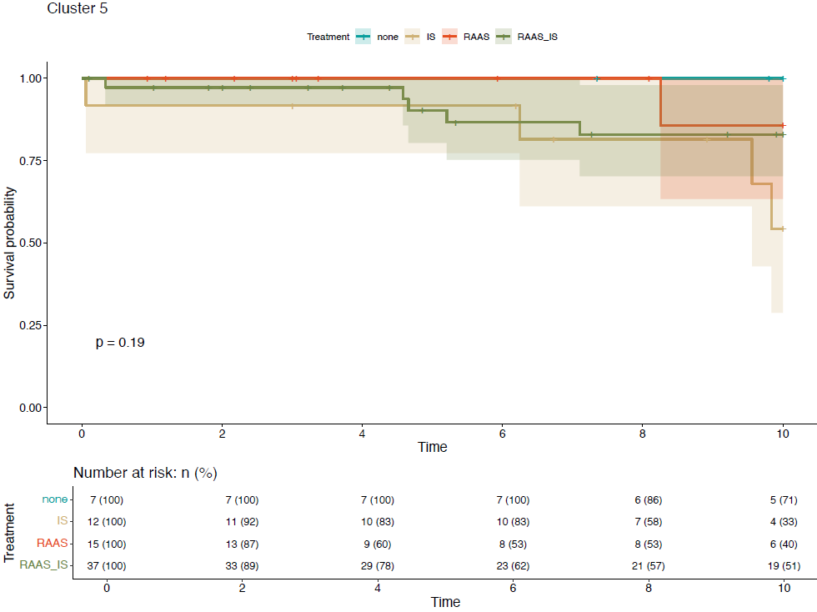

Supplementary Figure S4
Differences in distribution of rare functional LPVs/CNVs across the 5 clusters. CFH/CFHR genetic abnormalities are overrepresented in Cluster 5, whereas C3 variants are broadly distributed.

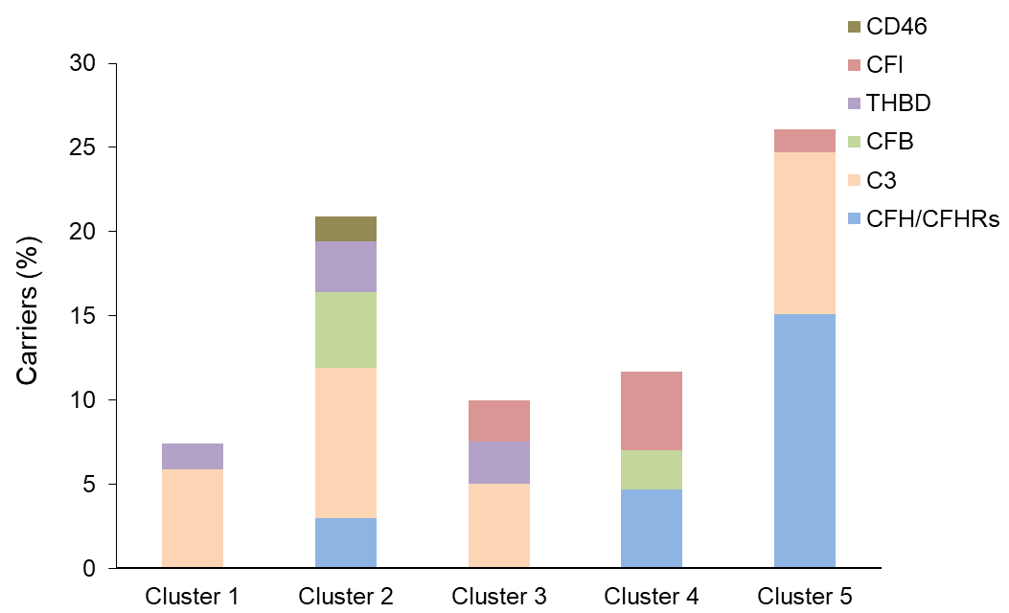
Chi-square test overall P=0.0062

Supplementary Table S5
Kidney parameters at the last available follow-up in patients according to the clusters
Data are given as fraction of patients (n/N: number of patients with raw data available). Renal impairment:serum creatinine; adults male >1.18, female >1.02; newborn: >1.01; infants (<3 years): >0.37; children (3-<15 years):>0.73 mg/dl.
ESKD. Requiring renal replacement therapies (dialysis or transplantation).
Proteinuria. Normal range proteinuria (<0.3 gr/24 h), non nephrotic proteinuria ( 0.3 – 3.49 g/24 h), nephrotic range proteinuria ( ≥3.5 g/24 h).

Supplementary Table S6
Multivariate analysis of the variables associated with end-stage kidney disease in the whole cohort

Univariate analysis of the association with ESKD was done using all the 29 variables included in cluster analysis.
Multivariate analysis was done with the variables (in the table) that showed a significant association (P<0.05) in the univariate analysis.
Ons_age: age of onset (per year of increase)
Ons_PrU: non nephrotic proteinuria at onset.
Ons_NS: nephrotic range proteinuria at onset.
Ons_RF: kidney impairment at onset.
Ons_dialysis: need of dialysis at onset.
Subendoth_Deps: subendothelial deposits (yes).
Crescents and sclerotic glomeruli: per 1% increase.

Supplementary Figure S5
Histologic diagnosis does not predict renal outcome.
Kaplan-Meier analysis for survival from ESKD according to histologic groups. Patients were censored at last available follow-up with clinical information or at the event (need of dialysis or transplantation). For patients who received complement inhibitors, the follow-up was discontinued at the last observation with clinical data before the start of anti-complement therapy.

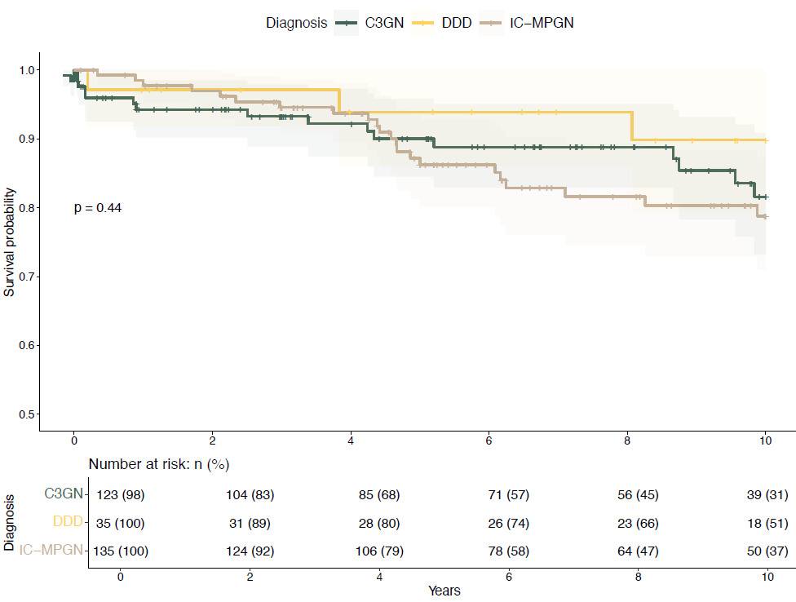

Supplementary results. Evaluation of loss-of-recall in MPGN patient classification
For k-NN, we selected two different neighborhoods of k=3 and k=9 as a small and a broader neighborhood, respectively. SVM and k-NN models were then trained separately with missing variables, respectively, to analyze the relevance of the individual variables for classification. Therefore, we repeated leave-one-out bootstrapping using only 28 of the 29 variables and calculated the ‘loss-of-recall’ for the corresponding left-out variable as the difference of the obtained recall to the original recall (SVM: 89.5%; 3-NN: 86.8%, 9-NN: 84.7%). The average loss-of-recall of the variables across the three models is shown as Supplemental Figure 5, and individual values are given as Supplemental Table 5.
Further, the variables are arranged in diagnostic groups such as primary anamnesis, light microscopy and immunofluorescence, and loss-of-recall was estimated for complete diagnostic groups missing. Results are given as Supplemental Table 6.

Supplementary Figure S6. Loss-of-recall of the individual variables averaged over SVM, 3-NN, and 9-NN classification models.
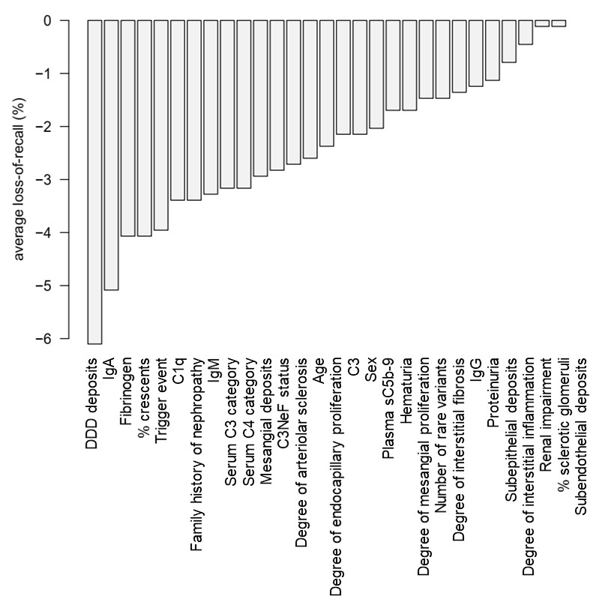
Supplementary Table S8. Loss-of-recall of the individual variables in patient classification.

Diagnostic group & variable | Loss of cluster recallª
Diagnostic group & variable | Average^{b} | SVM | 3-NN | 9-NN
Anamnesis on onset
Gender | 2.1 % | 2.0 % | 2.7 % | 1.7 %
Age | 2.6 % | 1.4 % | 3.7 % | 2.7 %
Hematuria | 1.7 % | 0.3 % | 2.7 % | 2.0 %
Proteinuria at onset | 1.2 % | 0.3 % | 4.4 % | <0.1 %
Renal impairment at onset | 0.5 % | 1.4 % | 1.0 % | <0.1 %
Trigger event at onset | 4.0 % | 3.1 % | 5.4 % | 3.4 %
Family history of nephropathy | 3.4 % | 4.1 % | 4.4 % | 1.7 %
Light microscopy
% Sclerotic glomeruli | 0.1 % | <0.1 % | 0.3 % | <0.1 %
% of crescents | 4.1 % | 3.7 % | 4.4 % | 4.1 %
Degree of mesangial proliferation | 1.7 % | 1.0 % | 2.0 % | 2.0 %
Degree of endocapillary proliferation | 2.4 % | 2.7 % | 2.0 % | 2.4 %
Degree of interstitial inflammation | 0.8 % | 0.3 % | 2.0 % | <0.1 %
Degree of interstitial fibrosis | 1.5 % | 1.4 % | 3.4 % | <0.1 %
Degree of arteriolar sclerosis | 2.7 % | 3.4 % | 4.4 % | 0.3 %
Immunofluorescence
C3 | 2.1 % | 2.0 % | 3.7 % | 0.7 %
IgA | 5.1 % | 3.7 % | 7.1 % | 4.4 %
IgG | 1.4 % | 1.7 % | 1.0 % | 1.4 %
IgM | 3.3 % | 1.7 % | 5.8 % | 2.4 %
C1q | 3.4 % | 3.4 % | 3.4 % | 3.4 %
Fibrinogen | 4.1 % | 4.1 % | 7.5 % | 0.7 %
Electron microscopy
Mesangial deposits | 2.9 % | 2.4 % | 3.4 % | 3.1 %
Subepithelial deposits | 1.1 % | 0.3 % | 1.4 % | 1.7 %
Subendothelial deposits | 0.1 % | <0.1 % | <0.1 % | 1.0 %
Intramembranous dense deposits | 6.1 % | 6.1 % | 7.1 % | 5.1 %
Serum & plasma
Serum C3 | 3.2 % | 4.1 % | 2.7 % | 2.7 %
Serum C4 | 3.2 % | 2.4 % | 4.4 % | 2.7 %
Plasma sC5b-9 | 2.0 % | 2.0 % | 2.4 % | 1.7 %
NeF positivity | 2.8 % | 3.1 % | 1.7 % | 3.7 %
Genetic
Number of alleles with LPV or rare CNV | 1.5 % | 1.7 % | 1.4 % | 1.4 %
ª variables with loss-of-recall exceeding 5% are highlighted in bold
^{b} average of the three classification models

Supplementary Table S9. Loss-of-recall of the diagnostic groups in patient classification. All variables of a group were removed from classification model training and prediction. Group assignment is given in Supplementary Table S8.
Diagnostic group | Loss of cluster recall
Diagnostic group | average¹ | SVM | 3-NN | 9-NN
Anamnesis on onset | 9.0 % | 10.5 % | 12.9 % | 3.7 %
 |  |  | (especially cluster 5²) | (cluster 1 & 5)
Light microscopy | 12.8 % | 12.9 % | 16.6 % | 8.8 %
 |  | (cluster 1) |  | (cluster 1)
Immunofluorescence | 15.6 % | 11.9 % | 21.0 % | 13.9 %
 |  | (cluster 2& 4)
Electron microscopy | 10.4 % | 9.5 % | 13.2 % | 8.5 %
 |  | (cluster 4) | (cluster 1 & 4) | (cluster 3 & 4)
Serum & plasma | 8.5 % | 8.5 % | 10.8 % | 6.1 %
 |  |  | (clusters 1-4) | (clusters 2-5)
Genetic | 1.5 % | 1.7 % | 1.4 % | 1.4 %
 |  |  | (cluster 4) | (cluster 1, 4 & 5)
¹ average of the three classification models
² cluster with cluster-specific loss-of-recall >10% are given in parenthesis

Supplementary Figure S7. Cluster prediction with classification probabilities of newly enrolled patients with primary C3G/IC-MPGN. These patients were not included in 295 cohort used for unsupervised cluster analysis and for training of the computational tool.
Three representative cases are presented.
Case 1: Prototypical Cluster 1 patient

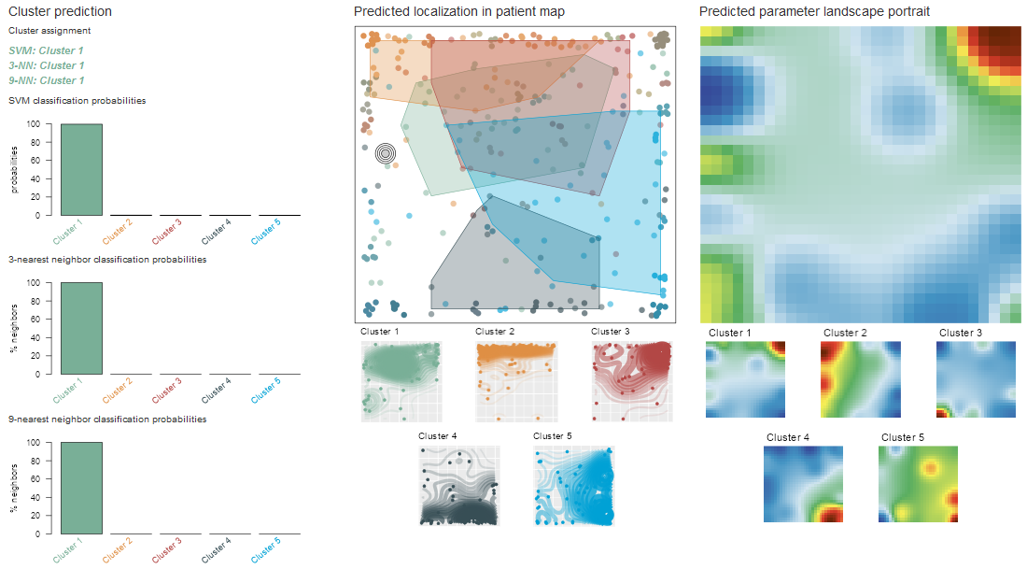

A new patient was assigned to the clusters described in the main article using the interactive classification tool. The above-shown screenshot summarizes classification results derived from SVM, 3-NN, and 9-NN models, the mapping of the patient into the patient landscape, and the generated parameter landscape portrait for direct comparison with the cluster-specific portraits.
Classification models consistently assign this patient to Cluster 1 (left panel), which is supported by its position in the patient map (located close to the Cluster 1 core region; middle panel; compare to the maps below) and a parameter portrait closely resembling that of Cluster 1 (right panel; compare to the cluster-specific portraits below).

Case 2: A Cluster 3 patient

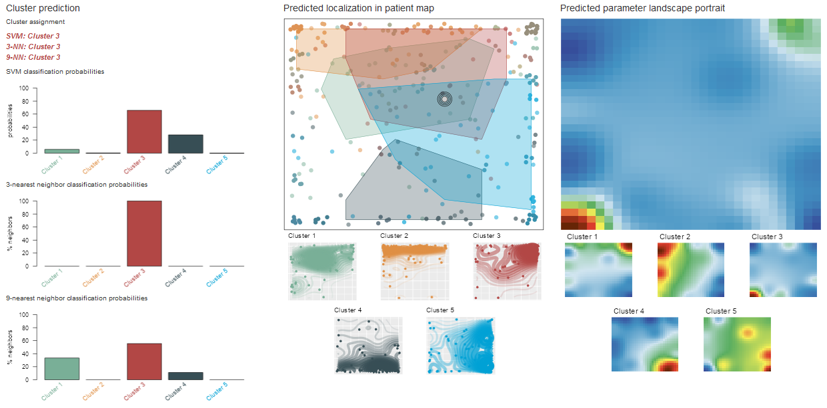

This patient is assigned as Cluster 3 by the tool. The three classification methods consistently show highest scores for this Cluster. Additionally, the parameter portrait reveals close similarity to the Cluster 3 portrait, with minor alteration in the top right corner of the map. This can be attributed to the presence of a trigger event in this patient, which is usually a Cluster 1 characteristic.

Case 3: Cluster 5 patient with some Cluster 3 characteristics

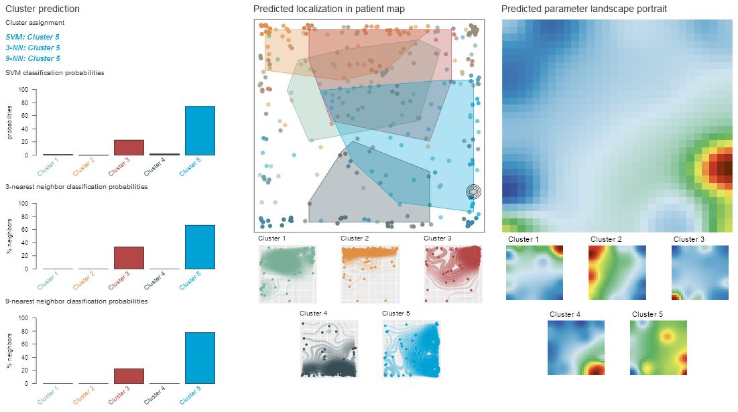

This patient is classified as Cluster 5 with tendencies to Cluster 3. This is revealed by the classification scores, as well as by the parameter portrait: Cluster 5 is characterized a red spot in the bottom right corner, reflecting high serum C3 and C4 categories, and by a blue spot in the bottom left corner, indicating absence of DDD deposits and C3NeF.
This patient is, however, C3NeF positive, which is visualized by the green-to-yellow spot in the bottom left corner of the portrait, and which leads to positive scores for Cluster 3 in the classification models (Cluster 3 mainly collects C3NeF positive patients).

Supplementary References
S1. Valoti E, Alberti M, Iatropoulos P, et al. Rare Functional Variants in Complement Genes and Anti-FH Autoantibodies-Associated aHUS. Front Immunol. 2019;10:853. doi:10.3389/fimmu.2019.00853
S2. Iatropoulos P, Daina E, Curreri M, et al. Cluster Analysis Identifies Distinct Pathogenetic Patterns in C3 Glomerulopathies/Immune Complex–Mediated Membranoproliferative GN. J Am Soc Nephrol. 2018;29(1):283-294. doi:10.1681/ASN.2017030258
S3. Piras R, Breno M, Valoti E, et al. CFH and CFHR Copy Number Variations in C3 Glomerulopathy and Immune Complex-Mediated Membranoproliferative Glomerulonephritis. Front Genet. 2021;12:670727. doi:10.3389/fgene.2021.670727
S4. Frémeaux-Bacchi V, Weiss L, Brun P, Kazatchkine MD. Selective disappearance of C3NeF IgG autoantibody in the plasma of a patient with membranoproliferative glomerulonephritis following renal transplantation. Nephrol Dial Transplant Off Publ Eur Dial Transpl Assoc - Eur Ren Assoc. 1994;9(7):811-814.
S5. Donadelli R, Pulieri P, Piras R, et al. Unraveling the Molecular Mechanisms Underlying Complement Dysregulation by Nephritic Factors in C3G and IC-MPGN. Front Immunol. 2018;9:2329. doi:10.3389/fimmu.2018.02329
S6. Marinozzi MC, Roumenina LT, Chauvet S, et al. Anti-Factor B and Anti-C3b Autoantibodies in C3 Glomerulopathy and Ig-Associated Membranoproliferative GN. J Am Soc Nephrol JASN. 2017;28(5):1603-1613. doi:10.1681/ASN.2016030343
S7. Marinozzi MC, Chauvet S, Le Quintrec M, et al. C5 nephritic factors drive the biological phenotype of C3 glomerulopathies. Kidney Int. 2017;92(5):1232-1241. doi:10.1016/j.kint.2017.04.017
S8. Kowarik A, Templ M. Imputation with the R Package VIM. J Stat Softw. 2016;74(7). doi:10.18637/jss.v074.i07
S9. Gisslander K, White A, Aslett L, et al. Data-driven subclassification of ANCA-associated vasculitis: model-based clustering of a federated international cohort. Lancet Rheumatol. 2024;6(11):e762-e770. doi:10.1016/S2665-9913(24)00187-5
S10. Mahr A, Specks U, Jayne D. Subclassifying ANCA-associated vasculitis: a unifying view of disease spectrum. Rheumatol Oxf Engl. 2019;58(10):1707-1709. doi:10.1093/rheumatology/kez148
S11. Thayakaran R, Goel R, Adderley NJ, et al. Cluster analysis of patients with granulomatosis with polyangiitis (GPA) based on clinical presentation symptoms: a UK population-based cohort study. Arthritis Res Ther. 2022;24(1):201. doi:10.1186/s13075-022-02885-9
S12. McCoy SS, Woodham M, Bartels CM, et al. Symptom-Based Cluster Analysis Categorizes Sjögren’s Disease Subtypes: An International Cohort Study Highlighting Disease Severity and Treatment Discordance. Arthritis Rheumatol Hoboken NJ. 2022;74(9):1569-1579. doi:10.1002/art.42238
S13. Chavent M, Kuentz-Simonet V, Labenne A, Liquet B, Saracco J. Multivariate analysis of mixed data: The R package PCAmixdata. Published online 2017.
S14. The R Core Team. R: A Language and Environment for Statistical Computing. Published online April 4, 2002.
S15. M. Charrad, N. Ghazzali, V. Boiteau, A. Niknafs. NbClust: an R package for determining the relevant number of clusters in a data set. J Stat Softw. 2014;61.

Supplementary Text

A user-friendly classification platform for MPGN patients

Henry Loeffler-Wirth, Interdisciplinary Center for Bioinformatics (IZBI), Leipzig University, Germany

1. Overview
In the frame of the EU-funded project ‘Defining stratification of patients with C3 Glomerulopathies/immune complex-mediated glomerular diseases for better diagnosis and tailored treatment’ (DECODE), we implemented an interactive tool for patient classification to support diagnosis of glomerulopathy subtypes. This computational tool was designed with a clean and user-friendly interface for clinicians, allowing for assignment of patients to a predefined disease cluster and provide a visual control by showing personalized data portraits and cluster centroid landscapes for comparison.
The tool is implemented as interactive browser app and provides essential results of our machine learning-based portraying of the clinical parameter- and patient-landscapes. The key feature of the app, however, is the possibility to classify a patient suffering from membranoproliferative glomerulonephritis (MPGN) into the predefined cluster scheme based on their clinical parameters.
Therefore, multiple methods are included for classification in parameter and patient space. The input data thereby comprises a set of 29 parameters derived from basic clinical assessment of the patient and microscopy and immunofluorescence assessment of a tissue biopsy.

2. Patient landscapes
Patient landscapes give an overview of similarity and dissimilarity relations among the 295 patients of the training data, and allow to judge representativeness of the previously defined disease sub-clusters. The app provides two patient maps based on alternative methods, namely t-SNE and patient SOM. Both methods project the patients into a two-dimensional space with coloring according to the clusters previously defined (Figure 1). Additional cluster-wise accumulation maps indicate regions that are cluster-specific, as well as regions that are shared by multiple clusters (Figure 1, maps below).In the t-SNE map, we observe good accumulation and separation of patients belonging to cluster 3 and 4, while especially patients of clusters 1, 2, and 5 are more intermixed in the map. In the SOM map, clusters 2 and 4 occupy the bottom and top edges, respectively. Cluster 5 accumulates along the right edge, while patients of clusters 1 and 3 are barely separated in this approach. These results show that the two methods selected here for projection are complementary and emphasize independent characteristics of the training data.
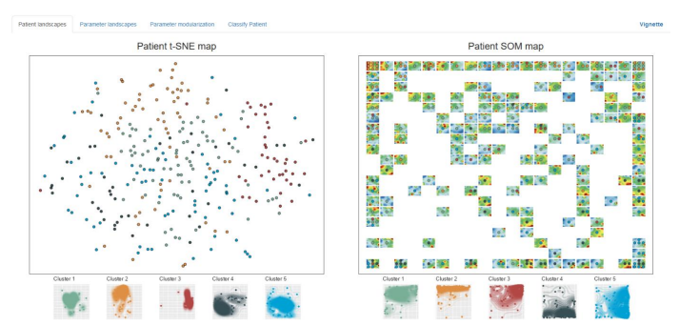

Figure 1: Patient landscapes of the 295 MPGN patients in the training data: t-SNE (left panel) and patient SOM (right panel) approaches project the patients into a two-dimensional map. Each dot represents one patient, colored according to its predefined cluster. The patient SOM map additionally provides characteristic parameter landscape portraits of the patients at a particular position in the map. Cluster-wise accumulation maps indicate cluster-specific and overlapping regions (maps below, respectively).

3. Parameter landscapes

Self-organizing map (SOM) machine learning provides a characteristic fingerprint of the parameter
setting of each individual patient by means of parameter portraits (Figure 2). The algorithm arranges
the 29 parameters into a two-dimensional grid according to similarity over all patients in the training
data. Thereby, similar parameters are located to the same or close positions, dissimilar parameters to
more distant or even diagonal positions (see next chapter). This mapping is fixed for all portraits, making them mutually comparable. Individual parameter landscapes were then generated by appropriate coloring of the map positions according to the underlying parameters of one patient (individual portraits, Figure 2, bottom part) or to the mean parameter values of the clusters (Figure 2, upper part). Thereby, red colors refer to high values, green and blue to intermediate to low values. For example, cluster 4 is characterized by high parameter values near the bottom right corner of the map (referring to module G containing serum parameters C3 and C4, see below), and by low values of the parameters in the bottom left, top left, and top right corner of the map. These selectively show high parameters in cluster 1, 2, and 3, respectively.

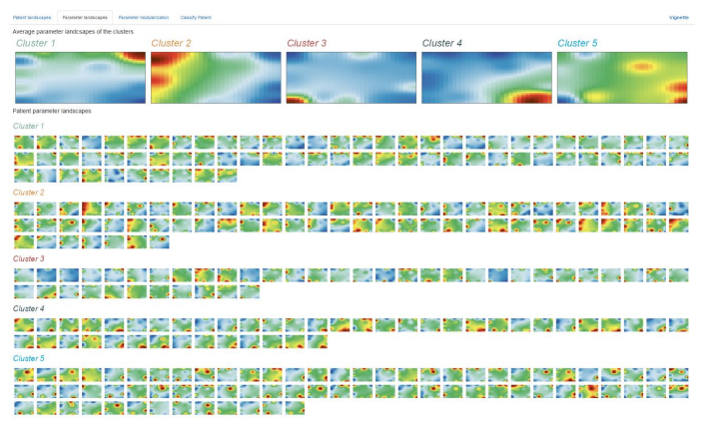

Figure 2: Parameter landscape portraits: Red colors refer to high values, green and blue to intermediate to low values. The portraits were averaged over all individuals in the clusters to compute cluster portraits (upper part), and additionally all 295 individual patient portraits are listed in cluster-sorted layout (bottom part).

4. Parameter modules

The parameter portraits of the patients in the training data show characteristic red spots, each referring to a set of parameters with concertedly high values in this patient. By collecting all of such parameter sets, we generated a summary landscape which was then algorithmically segmented into 14 separate modules of clinical parameters (Figure 3, top left part). These modules contain up to 6 individual parameters, which show similar values across the patients and are therefore located at the same or close positions in the map. However, 7 modules represent a single parameter solely, showing that these parameters carry complementary information compared to the other parameters instead of similar information (Figure 3, bottom part). The parameter values were then averaged over all individual parameters in the modules to generate a module heatmap (Figure 3, top right part). It reveals modules which show mainly high values in a specific cluster, for example modules G and H in cluster 4, or module E in cluster 3. Most modules are nevertheless highly variable in the clusters, motivating utilization of a selection of multi-variate classification approaches as demonstrated below.

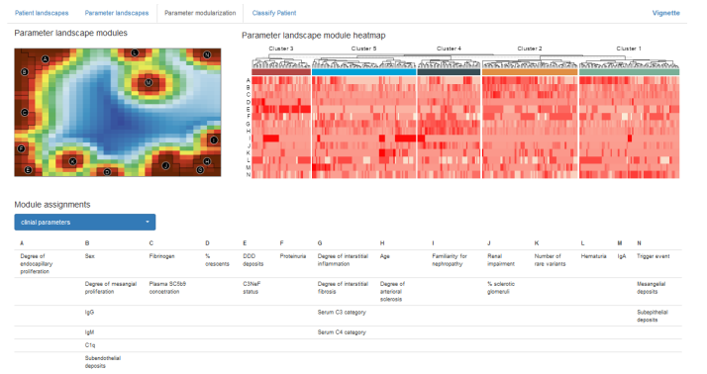

Figure 3: Information on modules defined in the parameter landscape: The parameter landscape was segmented into 14 modules, each emerging as clusters of parameters with high values in at least one patient (top left part). Based on the average parameter values of these modules across all patients, a clustered heatmap was generated, showing both cluster-specific and also highly variable parameter modules (top right). The parameters contained in each module are listed in the assignment table (bottom part), where also mapping of proteomic and metabolomic data can be shown upon selection in the input widget.

5. Classification of a patient

Major goal is the implementation of a computational tool that allows assignment of patients to a cluster using a set of genetic, laboratory and clinical parameters to support diagnostics For this, we verified statistical learning of the original algorithmic MPGN clusters based on the qualitative and quantitative clinical parameters. Based on this benchmarking, we selected two classification methods for patient classification in feature and sample space: Best cluster recall was achieved by Support Vector Machine (SVM; 89%) and k-Nearest Neighbors classification (k-NN; 85%-87% depending on k). For k-NN, we selected k=3 and k=9 representing a small and a broad neighborhood, respectively, and to avoid ties between two clusters. These 3 methods are supplemented by mapping of the newly classified patient into the patient map, and by prediction of a personalized parameter portrait. They complement the SVM and k-NN classification scores by localization in the patient map and by a visual identity to compare with other patient and cluster portraits.

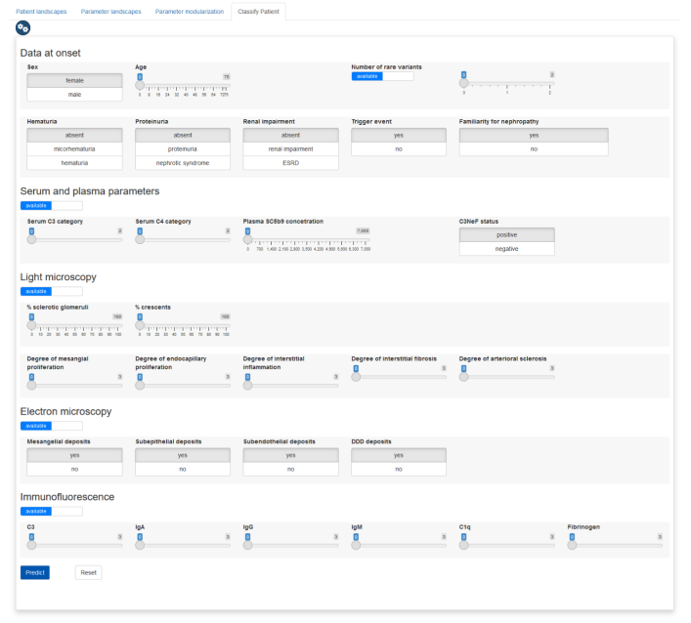
Figure 4: Input screen for clinical parameters: Classification of a patient is based on 29 clinical and laboratory parameters. Input widgets allow to submit categorical and numerical parameters as defined previously. The ‘predict’ button leads the user to the classification results (see below). Genetic, serum, microscopy, and/or immunofluorescence parameters may be missing (switch to ‘unavailable’ if appropriate), however limiting accuracy of the resulting classification.

In the training data, 29 clinical and laboratory parameters were utilized to define the five clusters and to train the classification models. The app provides an interface to input the parameters of a new patient for classification (Figure 4). As not all parameters are always available, the app allows parameter categories to be missing (use the sliders in the interface), except for the basic clinical assessments. However, unavailability of one or multiple parameter categories implies reduced cluster recall in subsequent classification and limits accuracy of patient landscape projection and parameter. After submitting the parameters using the ‘predict’ button, the app computes the classification results
using SVM, 3-NN and 9-NN methods, localization in the patient SOM map, and the corresponding parameter portrait (Figure 5, from left to right). For each classification method, a barplot is shown
visualizing prediction probabilities for each cluster as a result of SVM, and the cluster assignments of the 3 and 9 nearest neighbors (3-NN and 9-NN), respectively (Figure 5, left part). The cluster with
highest probability (SVM) and the majority votes of the two k-NN classifiers are highlighted above the barplots to summarize classification results.
Additional to the statistical learning classification methods, the app maps the patient into the patient
SOM landscape for an additional criterium for diagnosis (Figure 5, middle part). The localization of the patient in the map is indicated with a crosshair and can be evaluated by means of localization in/near a cluster-specific region (Figure 5), or in intermixed regions of the map (Figure 6).
Finally, a parameter landscape of the patient is inferred based on the parameters provided (Figure 5, right part). This portrait can be compared to the cluster portraits to judge similarities and parameter modules with high values shared with selected clusters.

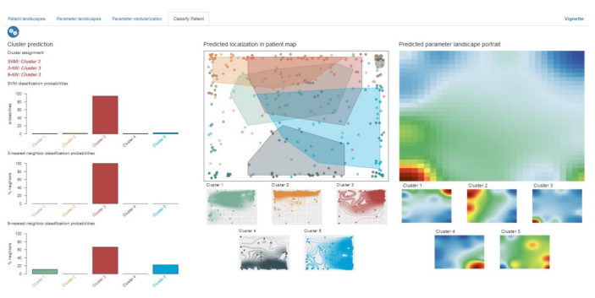

Figure 5: Classification results of a new patient recruited in the project: Classification methods provide
cluster probabilities (SVM) and cluster assignments of the 3 and 9 nearest neighbors (k-NN), respectively, represented a barplots and summarizing cluster assignments (left part). The patient is further mapped into the patient SOM landscape (see crosshair in middle part), and a parameter portrait is predicted for direct comparison with the cluster portraits (right part).

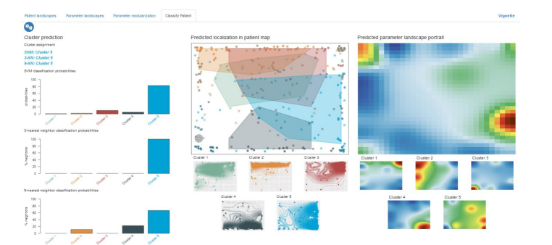

Figure 6: Classification of another new patient recruited in the project. See Figure 5 for details.

