SUPPORTING INFORMATION

Higher-order multicomponent crystals as a strategy to decrease the IC50 parameter: the case of praziquantel, niclosamide and acetic acid

Ilenia D’Abbrunzoª, Lara Gigli^{b}, Nicola Demitri^{b}, Chiara Sabena^{c}, Carlo Nervi^{c,d}, Michele R. Chierotti^{c}, Serena Bertoni^{e}, Irena Škorić^{f}, Cécile Häberli^{g,h}, Jennifer Keiser^{g,h}, Dritan Hasa ^{a,}*, Beatrice Perissutti^{a,}*

ªDepartment of Chemical and Pharmaceutical Sciences, University of Trieste, P.le Europa 1, 34127 Trieste, Italy; ILENIA.D’ABBRUNZO@phd.units.it
^{b}Elettra-Sincrotrone Trieste, S.S. 14 Km 163.5 in Area Science Park, Basovizza–Trieste, Italy; lara.gigli@elettra.eu (L.G.); nicola.demitri@elettra.eu (N.D.)
^{c}Department of Chemistry and NIS Centre, University of Torino, V. Giuria 7, 10125 Torino, Italy; michele.chierotti@unito.it
^{d}Skolkovo Institute of Science and Technology, Bolshoy Boulevard 30, bldg. 1, Moscow 121205, Russia
^{e}Department of Pharmacy and Biotechnology, University of Bologna, V. S. Donato 19/2, 40127 Bologna, Italy
^{f}Department of Organic Chemistry, Faculty of Chemical Engineering and Technology, University of Zagreb, Marulićev trg 19, 10000 Zagreb, Croatia
^{g}Department of Medical Parasitology, Swiss Tropical and Public Health Institute, 4123 Allschwil, Switzerland.
^{h}University of Basel, Basel 4000 Switzerland.

Contents
Description | Page N°
Figure S1. PXRD comparison of PZQ-NCM 1:3 anhydrous cocrystal, new phase discovered by grinding PZQ and NCM with AA and raw PZQ and NCM. | 2
Figure S2. PXRD comparison of PZQ-NCM coground in different molar ratios in the presence of 160 μL of AA. | 2
Figure S3. Characterization analyses of PZQ-NCM 1:1 molar ratio ground with equimolar ratio of AA (38 μl AA). | 3
Figure S4. Characterization analyses of PZQ-NCM 1:1 coamorphous. | 4
Figure S5. TGA curve of mechanochemically prepared PZQ-NCM-AA cocrystal solvate (blue) and its derivative (orange). | 5
Figure S6. Overlay of the FTIR spectra of PZQ-NCM-AA cocrystal solvate (black), pure NCM (red), pure PZQ (blue), and pure AA (green). | 5
Figure S7. Overlay of the ¹³C (150.91 MHz) CPMAS spectrum of PZQ-NCM-AA cocrystal solvate (black), acquired at a spinning speed of 20 kHz at room temperature, with the ¹³C (100.63 MHz) CPMAS spectra of pure NCM (red), pure PZQ (blue), acquired at a spinning speed of 12 kHz at room temperature. | 6
Figure S8. Overlay of the¹³C (150.91 MHz) CPMAS spectrum of PZQ-NCM-AA cocrystal solvate (black), acquired at a spinning speed of 20 kHz at room temperature, with the ¹³C (100.63 MHz) CPMAS spectra of PZQ-NCM 1:3 anhydrous cocrystal (pink), acquired at a spinning speed of 12 kHz at room temperature, and ¹³C (150.91 MHz) CPMAS spectrum of PZQ-AA monosolvate (orange), acquired at a spinning speed of 20 kHz at room temperature. | 6
Figure S9. ¹H-NMR spectra of PZQ-NCM-AA cocrystal solvate. The integrals of the signals are highlighted in red for NCM, in blue for PZQ and in green for AA. The * symbol indicates the signal corresponding to the solvent used for the analysis, deuterated chloroform CDCl₃. | 7
Figure S10. Plot of experimental vs. calculated ¹³C ppm. | 7
Figure S11. ¹H NMR spectra of PZQ (a); NCM (b); PZQ-NCM-AA cocrystal solvate obtained grinding raw PZQ and NCM in the presence of AA for 2 hours (c) and PZQ-NCM-AA cocrystal solvate achieved through neat grinding for 4 hours (to obtain PZQ-NCM 1:1 coamorphous) plus LAG for 2 hours (d). | 8
Figure S12. PXRD comparison of PZQ-NCM-AA cocrystal solvate over time(stored at 20°C and 0% RH). | 8
Figure S13. Samples of pure cocrystal solvate (white) and cocrystal solvate with traces of RIPFOP01 (pink). | 9
Figure S14. PXRD (left) and DSC (right) results of cocrystal solvate physical stability before and after compression. | 9
Figure S15. PXRD (left) and DSC (right) results of cocrystal solvate physical stability before and after grinding. | 10
Figure S16. Schematic representation of physical stability tests for evaluating resistance of the cocrystal solvate to high relative humidity (20°C at 75% RH). | 10

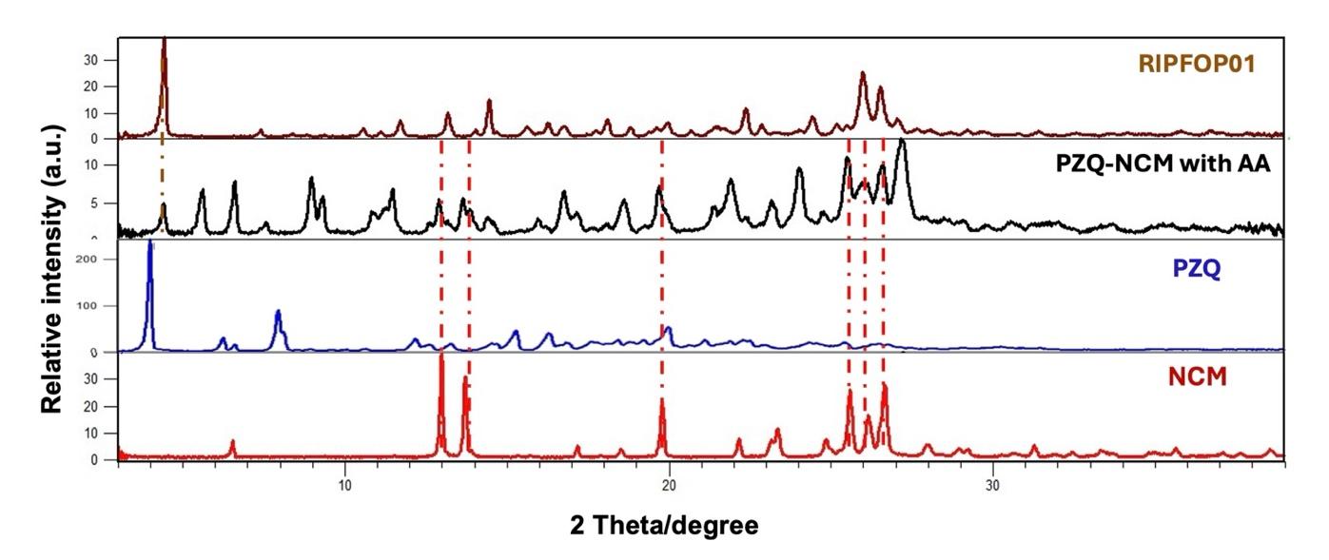
Figure S1. PXRD comparison of PZQ-NCM 1:3 anhydrous cocrystal, new phase obtained by grinding PZQ and NCM with AA and raw PZQ and NCM.

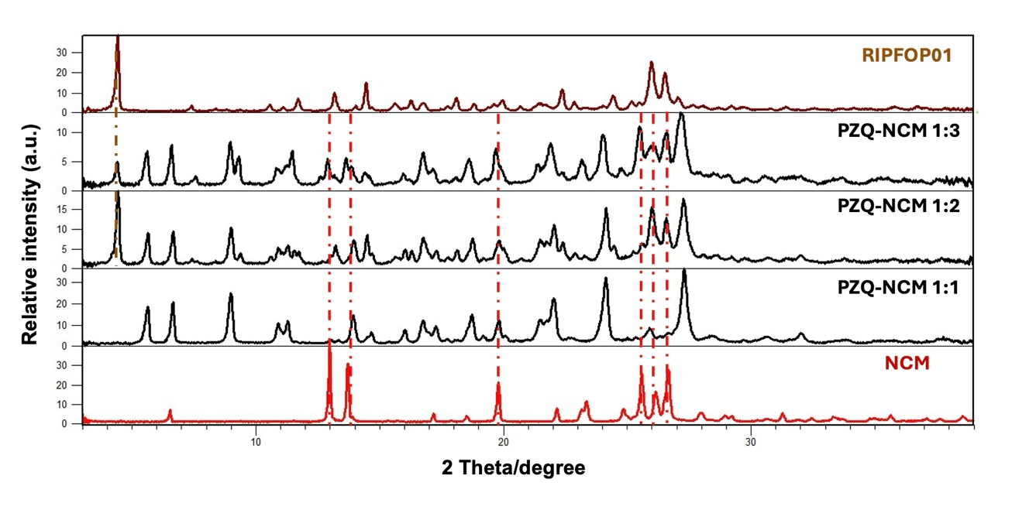
Figure S2. PXRD comparison of PZQ-NCM coground in different molar ratios in the presence of 160 μL of AA.

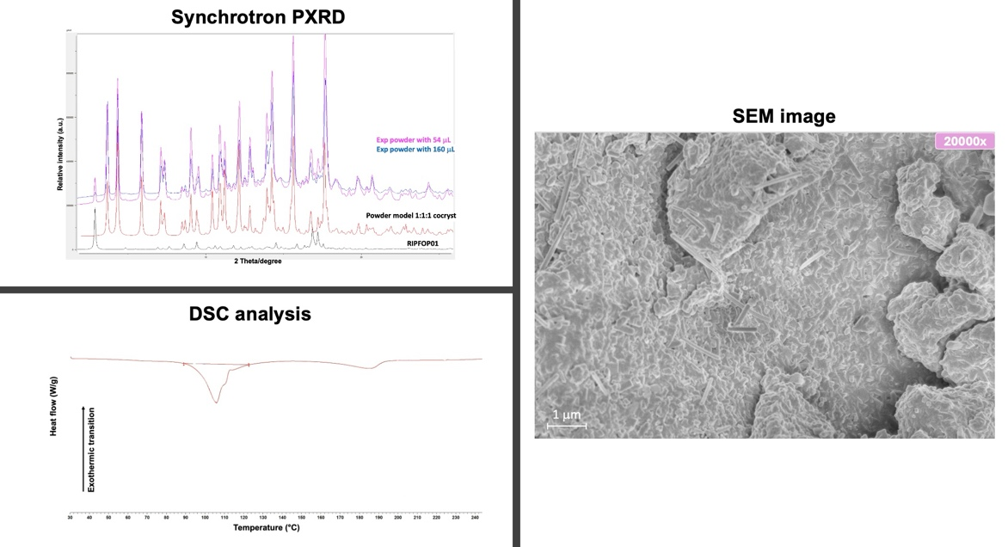

Figure S3. Characterization analyses of PZQ-NCM 1:1 molar ratio ground with equimolar ratio of AA (38 μL AA).

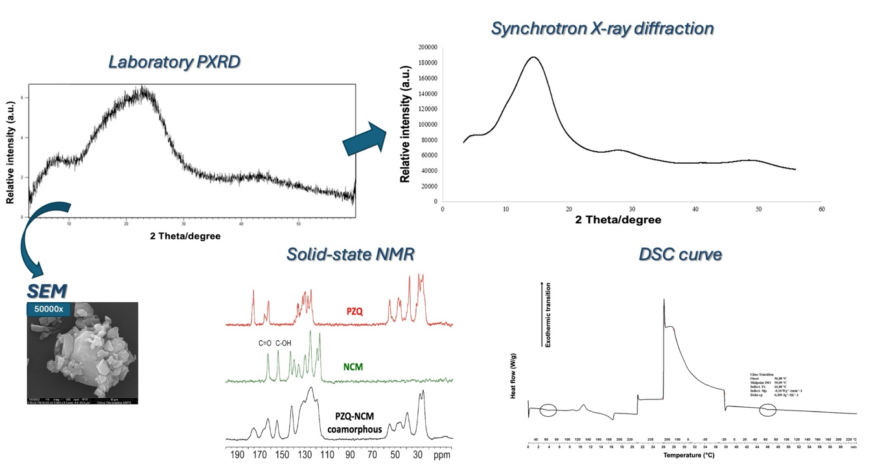

Figure S4. Characterization analyses of PZQ-NCM 1:1 coamorphous.

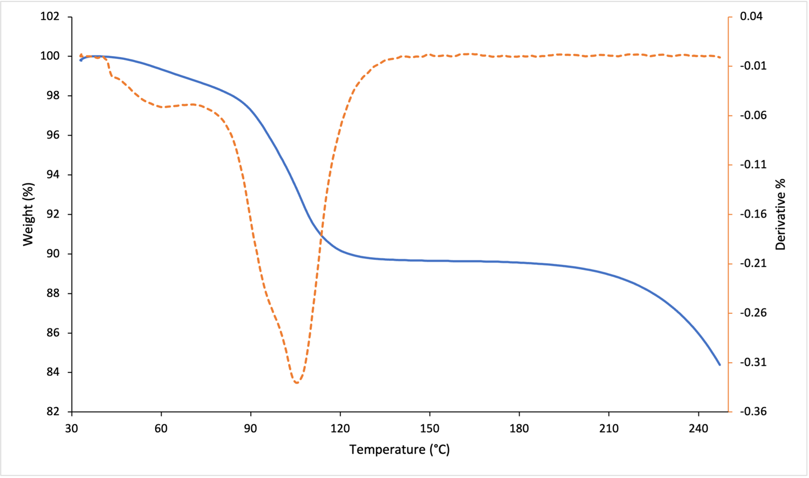
Figure S5. TGA curve of mechanochemically prepared PZQ-NCM-AA cocrystal solvate (blue) and its derivative (orange).
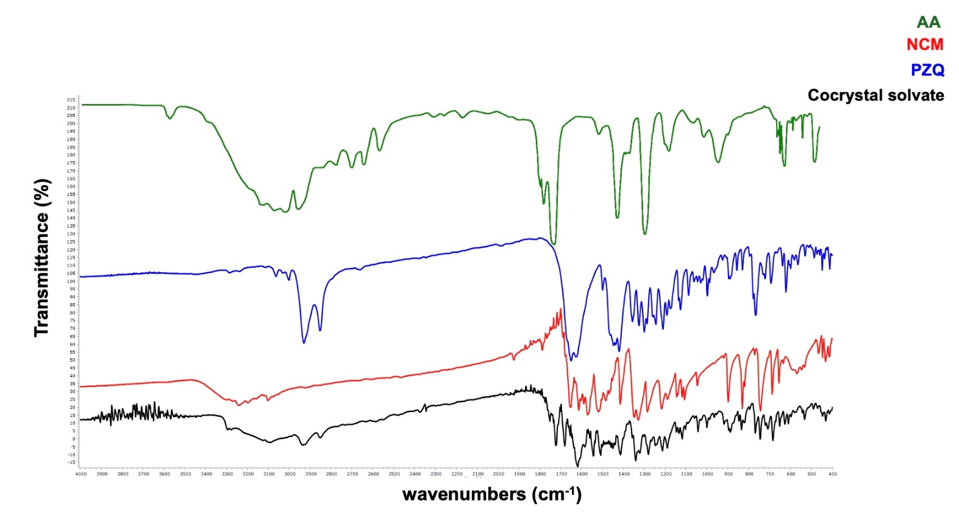
Figure S6. Overlay of the FTIR spectra of PZQ-NCM-AA cocrystal solvate (black), pure NCM (red), pure PZQ (blue), and pure AA (green).

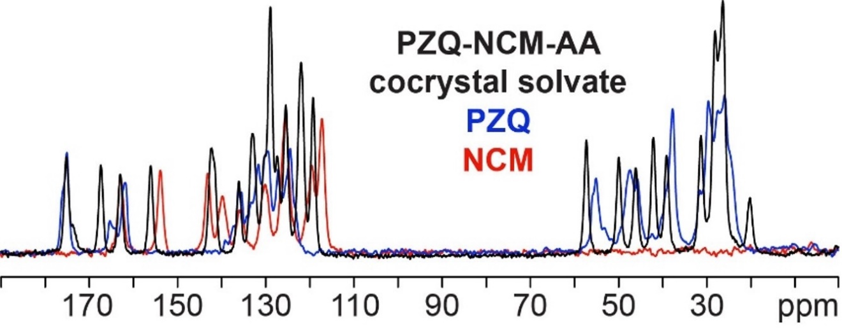

Figure S7. Overlay of the ¹³C (150.91 MHz) CPMAS spectrum of PZQ-NCM-AA cocrystal solvate (black), acquired at a spinning speed of 20 kHz at room temperature, with the ¹³C (100.63 MHz) CPMAS spectra of pure NCM (red), pure PZQ (blue), acquired at a spinning speed of 12 kHz at room temperature.

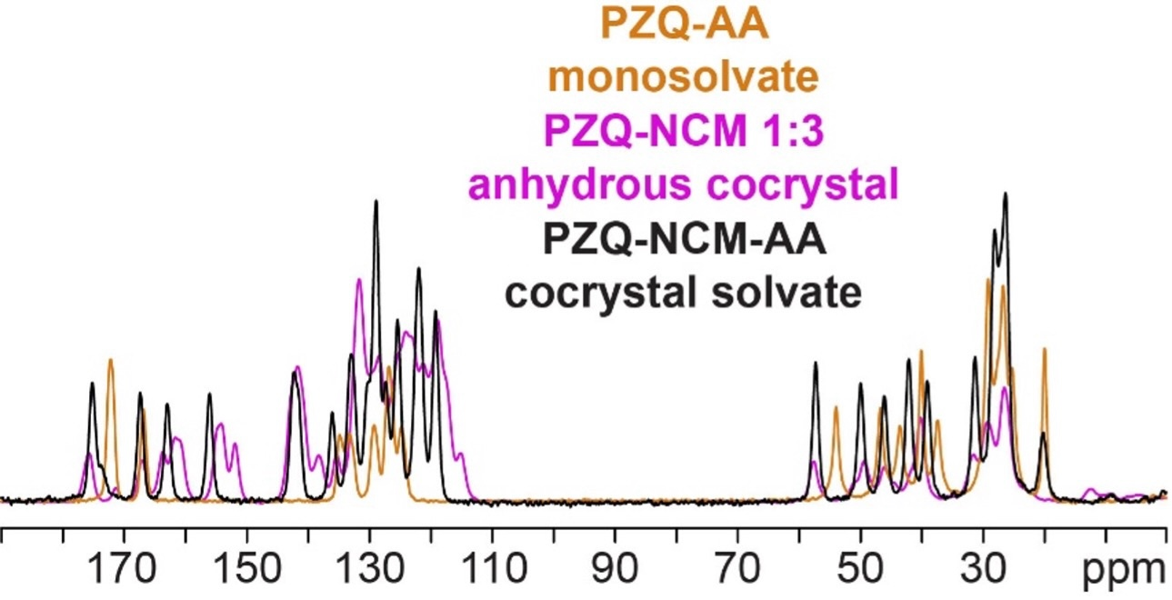

Figure S8. Overlay of the¹³C (150.91 MHz) CPMAS spectrum of PZQ-NCM-AA cocrystal solvate (black), acquired at a spinning speed of 20 kHz at room temperature, with the ¹³C (100.63 MHz) CPMAS spectra of PZQ-NCM 1:3 anhydrous cocrystal (pink), acquired at a spinning speed of 12 kHz at room temperature, and ¹³C (150.91 MHz) CPMAS spectrum of PZQ-AA monosolvate (orange), acquired at a spinning speed of 20 kHz at room temperature.

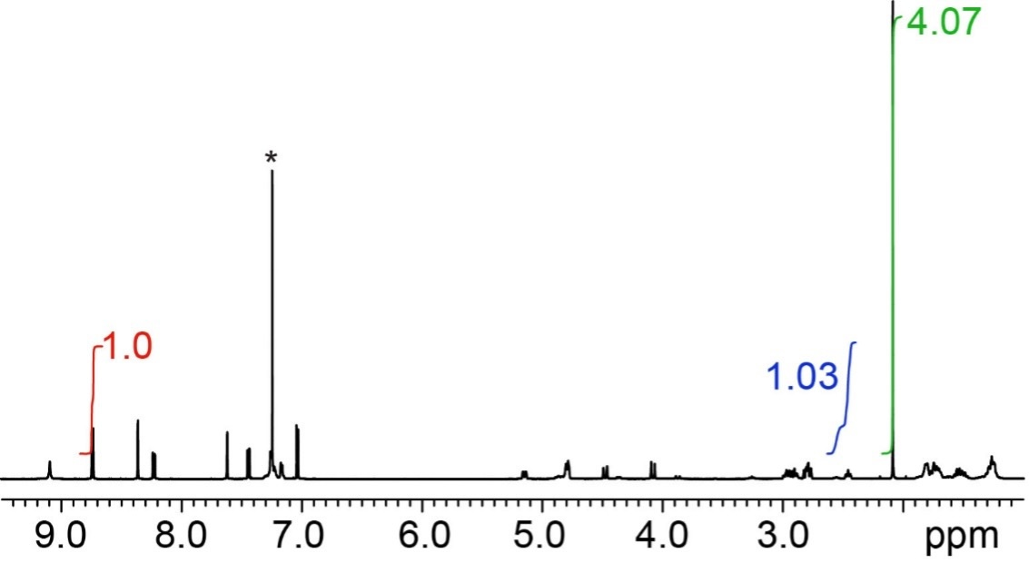

Figure S9. ¹H-NMR spectra of PZQ-NCM-AA cocrystal solvate. The integrals of the signals are highlighted in red for NCM, in blue for PZQ and in green for AA. The * symbol indicates the signal corresponding to the solvent used for the analysis, deuterated chloroform CDCl₃.

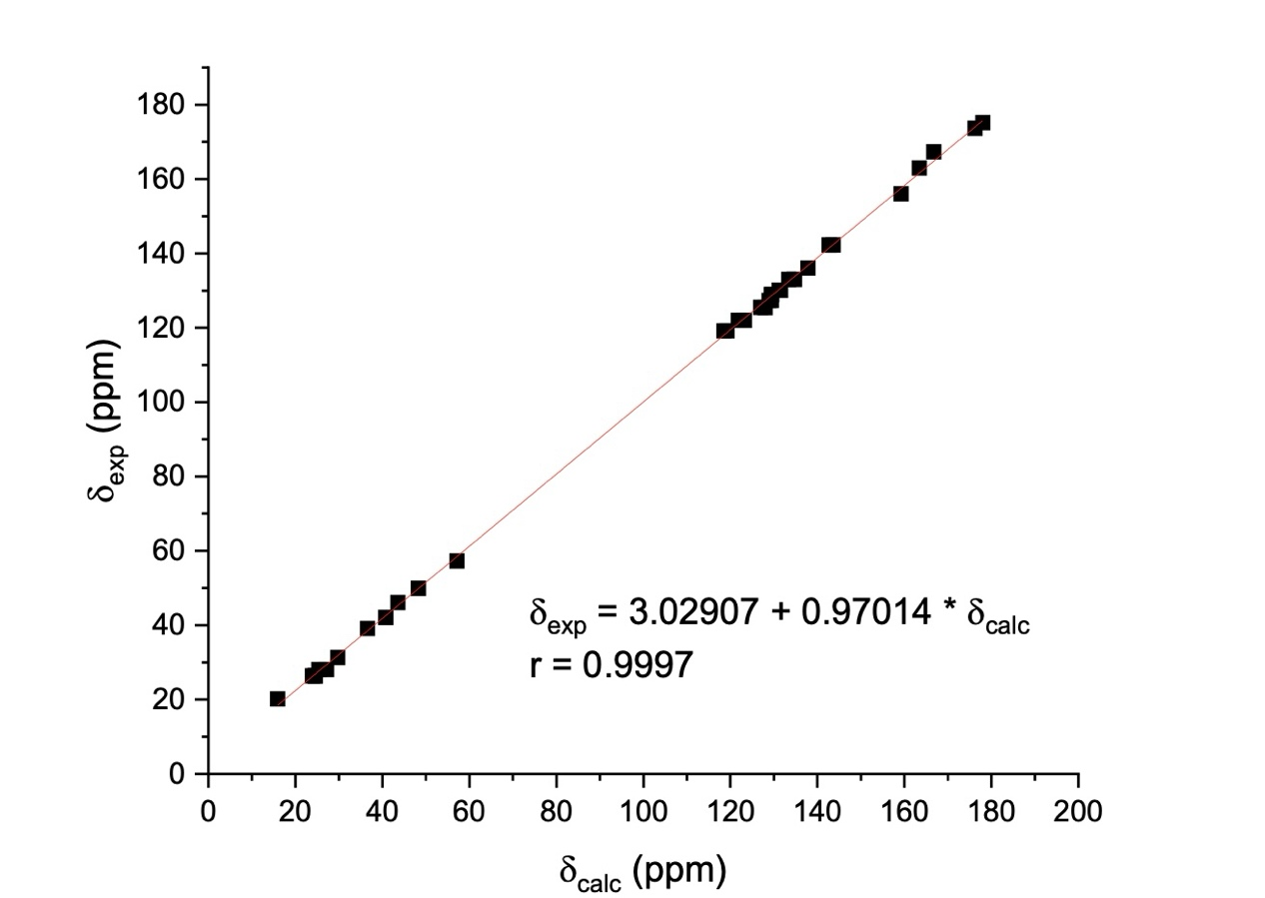
Figure S10. Plot of experimental vs. calculated ¹³C ppm.

Figure S11. ¹H-NMR spectra of PZQ (a); NCM (b); PZQ-NCM-AA cocrystal solvate obtained by grinding raw PZQ and NCM in the presence of AA for 2 hours (c) and PZQ-NCM-AA cocrystal solvate achieved through neat grinding for 4 hours (to obtain PZQ-NCM 1:1 coamorphous) plus LAG for 2 hours (d).

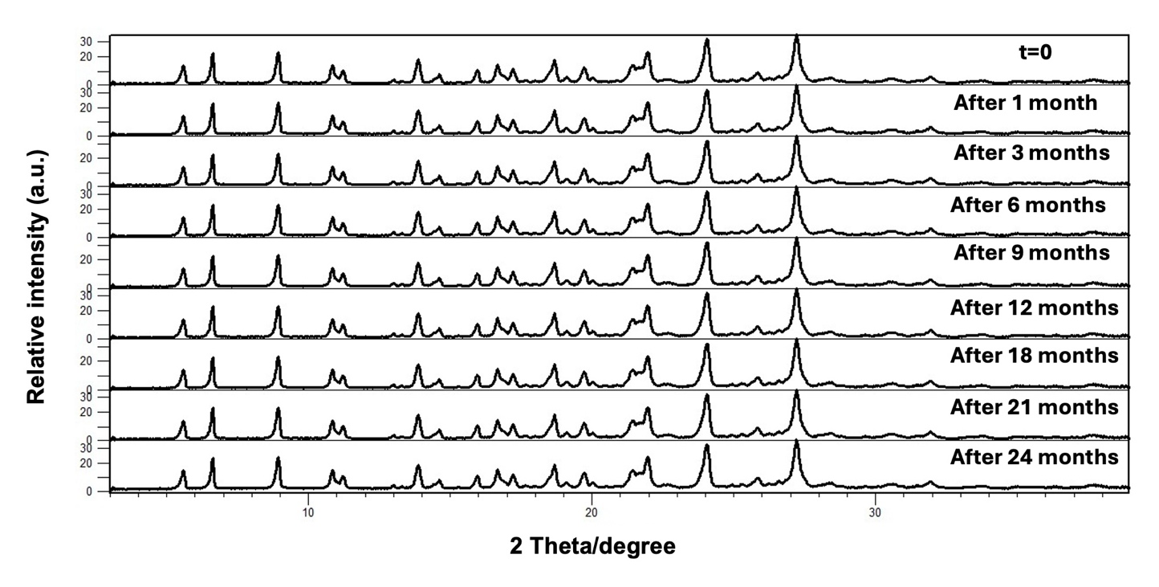

Figure S12. PXRD comparison of PZQ-NCM-AA cocrystal solvate over time (stored at 20°C and 0% RH).

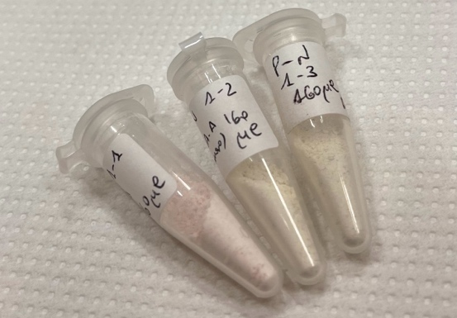
Figure S13. Samples of pure cocrystal solvate (white) and cocrystal solvate with traces of RIPFOP01 (pink).

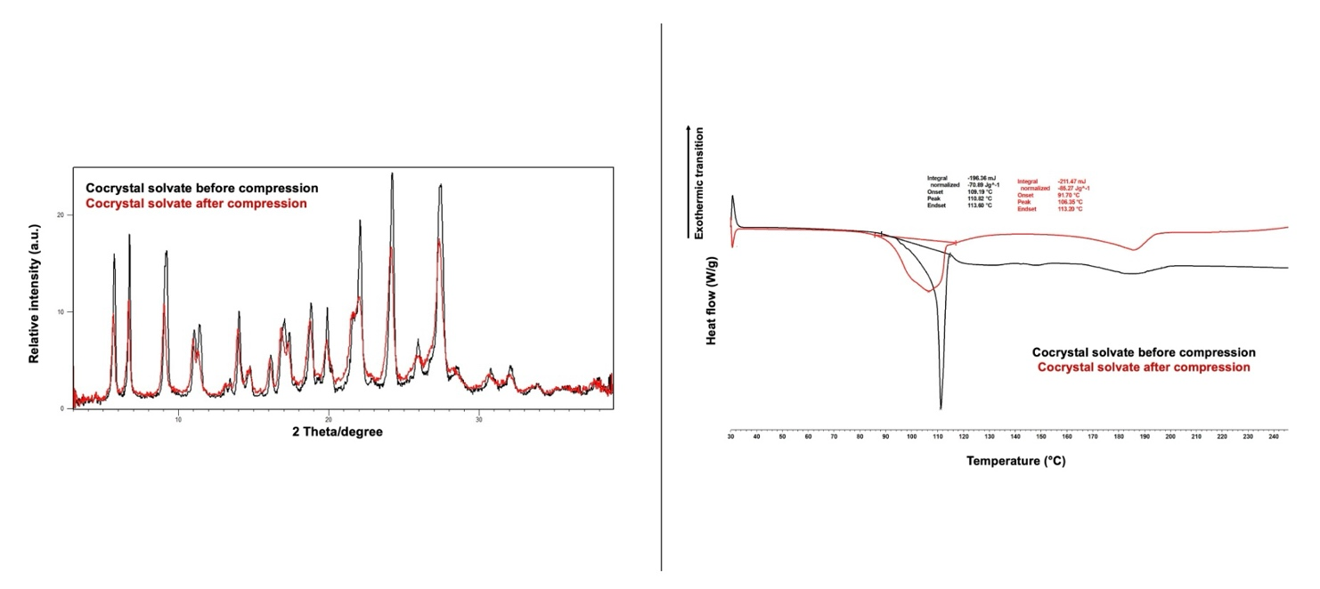
Figure S14. PXRD (left) and DSC (right) results of cocrystal solvate physical stability before and after compression.

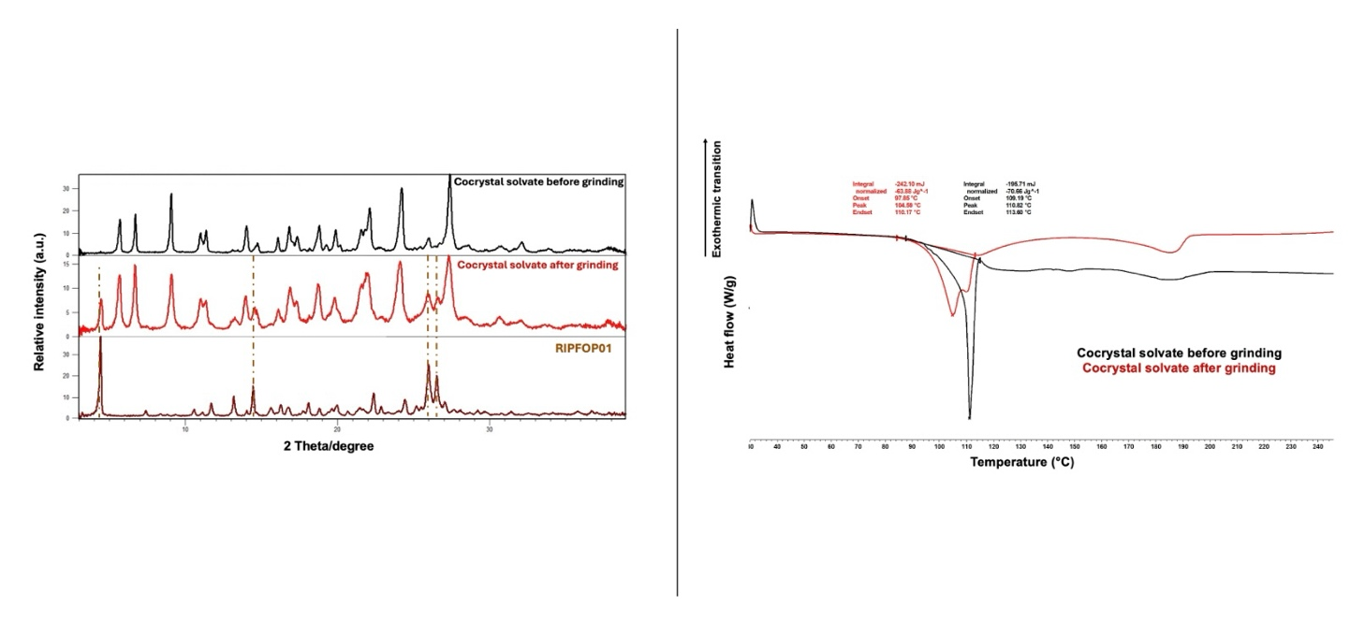
Figure S15. PXRD (left) and DSC (right) results of cocrystal solvate physical stability before and after grinding.

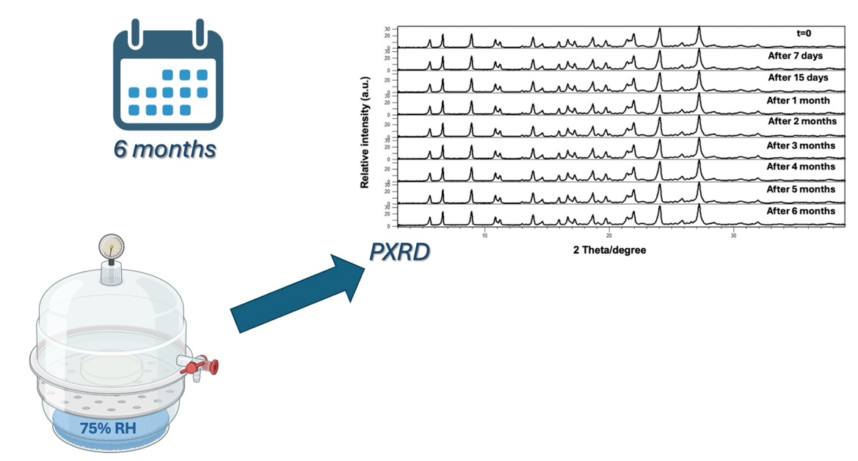
Figure S16. Schematic representation of physical stability tests for evaluating resistance of the cocrystal solvate to high relative humidity (20°C at 75% RH).

